March 31, 2013

Dear Editor,

Please find enclosed the edited manuscript in Word format (file name: 2678-review.doc).

Title: Monitoring photodynamic therapy of head and neck malignancies with optical spectroscopies.

Author: Ulas Sunar

Name of Journal: World Journal of Clinical Cases

ESPS Manuscript NO: 2678

The manuscript has been improved according to the suggestions of reviewers:
1) Format has been updated.

2) To keep the flow of the Conclusion chapter the same as the manuscript, it is decided to keep the Conclusion chapter the same as before.

3) References and typesetting were corrected

Thank you again for publishing the manuscript in the World Journal of Clinical Cases.

Sincerely yours,

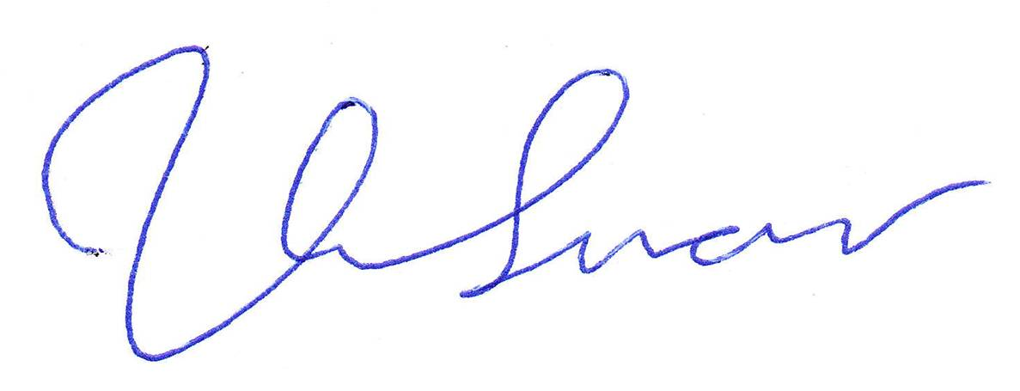

Ulas Sunar, PhD,
Roswell Park Cancer Institute
Cell Stress Biology and PDT Center
Elm and Carlton Streets
Buffalo, NY 14263, United States.
Telephone: +1-716-845-3311 Fax: +1-716-845
Email: ulas.sunar@roswellpark.org

