Name of Journal: World Journal of Clinical Cases
Manuscript NO: 32580
Manuscript Type: Case Report

Effect of double platinum agents, combination of miriplatin-transarterial oily chemoembolization and cisplatin-hepatic arterial infusion chemotherapy, in patients with hepatocellular carcinoma: Report of two cases

Ogawa K et al. Double platinum therapy for hepatocellular carcinoma

Kohei Ogawa, Kenya Kamimura, Yukari Watanabe, Yosuke Motai, Daisuke Kumaki, Ryoya Seki, Akira Sakamaki, Satoshi Abe, Hirokazu Kawai, Takeshi Suda, Satoshi Yamagiwa, Shuji Terai

Kohei Ogawa, Kenya Kamimura, Yukari Watanabe, Yosuke Motai, Daisuke Kumaki, Ryoya Seki, Akira Sakamaki, Satoshi Abe, Hirokazu Kawai, Satoshi Yamagiwa, Shuji Terai, Division of Gastroenterology and Hepatology, Graduate School of Medical and Dental Sciences, Niigata University, Niigata 951-8510, Japan

Takeshi Suda, Department of Gastroenterology and Hepatology, Uonuma Institute of Community Medicine, Niigata Medical and Dental Hospital, Minami-Uonuma, Niigata 949-7302, Japan

Author contributions: Ogawa K, Kamimura K, Watanabe Y, Motai Y, Kumaki D, Seki R, Sakamaki A and Abe S performed procedure; Kawai H, Suda T, Yamagiwa S and Terai S confirmed the therapeutic effects; Kamimura K analyzed data and prepared the manuscript.

Institutional review board statement: The study was reviewed and approved by the Institutional Review Board of Niigata University.

Informed consent statement: Written informed consents were obtained from the patients to present their information.

Conflict-of-interest statement: The authors declare no conflicts of interest.

Open-Access: This article is an open-access article which was selected by an in-house editor and fully peer-reviewed by external reviewers. It is distributed in accordance with the Creative Commons Attribution Non Commercial (CC BY-NC 4.0) license, which permits others to distribute, remix, adapt, build upon this work non-commercially, and license their derivative works on different terms, provided the original work is properly cited and the use is non-commercial. See: http://creativecommons.org/licenses/by-nc/4.0/

Manuscript source: Invited manuscript

Correspondence to: Kenya Kamimura, MD, PhD, Division of Gastroenterology and Hepatology, Graduate School of Medical and Dental Sciences, Niigata University, 1-757 Asahimachido-ri, Chuo-ku, Niigata, 951-8510, Japan. kenya-k@med.niigata-u.ac.jp
Telephone: +81-25-2272207
Fax: +81-25-2270776

Received: January 15, 2017
Peer-review started: January 16, 2017
First decision: March 28, 2017
Revised: March 30, 2017
Accepted: April 18, 2017
Article in press:
Published online:

Abstract
Hepatocellular carcinoma (HCC) is one of the most common cancers and the third highest cause of cancer-associated mortality worldwide. The treatment of HCC is complicated by its variable biological behavior and the frequent coexistence of chronic liver disease, particularly cirrhosis. To date, multiple treatment modalities have been developed according to the stage of the tumor and the hepatic functional reserve, including transarterial treatments such as transarterial chemoembolization, transarterial oily chemoembolization (TOCE), and hepatic arterial infusion chemotherapy (HAIC). We conducted a phase I and II study of the combination therapy with double platinum agents, miriplatin and cisplatin, and confirmed its safety and efficacy. Here, we describe two cases of unresectable HCC who were successfully treated by miriplatin-TOCE/cisplatin-HAIC combination therapy, resulting in complete responses with no significant adverse events. This report will provide that the combination therapy can be the therapeutic option for HCC patients in the advanced stage.

Key words: Hepatocellular carcinoma; Double platinum; Transarterial oily chemoembolization; Hepatic arterial infusion chemotherapy; Combination

© The Author(s) 2017. Published by Baishideng Publishing Group Inc. All rights reserved.

Core tip: To date, multiple treatment modalities of hepatocellular carcinoma (HCC) exist; however, only liver transplantation or surgical resection is curative. Hepatic resection remains the most frequently performed treatment modality, but curative resection cases are limited. Therefore, palliative treatment options are necessary, including transarterial chemoembolization, transarterial oily chemoembolization (TOCE), and hepatic arterial infusion chemotherapy (HAIC). We conducted a clinical trial of combination therapy with miriplatin-TOCE and cisplatin-HAIC and demonstrated its safety and efficacy for patients with unresectable HCC. Here, we presented two cases who showed good response after the several sessions of the combination therapy.

Ogawa K, Kamimura K, Watanabe Y, Motai Y, Kumaki D, Seki R, Sakamaki A, Abe S, Kawai H, Suda T, Yamagiwa S, Terai S. Effect of double platinum agents, combination of miriplatin-transarterial oily chemoembolization and cisplatin-hepatic arterial infusion chemotherapy, in patients with hepatocellular carcinoma: Report of two cases. World J Clin Cases 2017; In press

INTRODUCTION
Hepatocellular carcinoma (HCC) is the sixth most common cancer and the third highest cause of cancer-associated mortality worldwide^{[1,2]}. The treatment of HCC is complicated by its variable biological behavior and the frequent coexistence of chronic liver disease, particularly cirrhosis. To date, multiple treatment modalities exist; however, only liver transplantation or surgical resection is curative. Hepatic resection remains the most frequently performed treatment modality, but curative resection cases are limited^{[3,4]}. Another curative treatment is ablation therapy, including radiofrequency ablation (RFA). These treatments have been adopted for patients who are in Child-Pugh A or B cirrhosis states and have fewer than three tumors, all of which are less than 3 cm in diameter^{[5]}. For many patients whose diagnosis does not fit these criteria, palliative treatment options are necessary, including transarterial treatments such as transarterial chemoembolization (TACE), transarterial oily chemoembolization (TOCE), and hepatic arterial infusion chemotherapy (HAIC).
Among these therapeutic options, TOCE showed equivalent therapeutic effect to TACE for many HCC patients with low hepatic reserve in a randomized phase III trial using zinostatin stimalamer dissolved in lipiodol^{[6]}. Additionally, miriplatin, a third-generation platinum agent that forms a stable suspension with lipiodol^{[7]}, was developed for TOCE in HCC and approved for clinical use in Japan as a novel chemotherapeutic agent^{[8-14]}. On the other hand, HAIC can affect larger areas of the liver without reducing hepatic arterial flow^{[15]}. As the chemotherapeutic agent used in HAIC, a multicenter phase II study in patients with unresectable HCC using cisplatin (CDDP), a first-generation platinum agent, revealed that the response rate with CDDP powder (DDP-H, IA-call®; Nippon Kayaku, Tokyo, Japan) was better than that with other chemotherapeutic agents, such as epirubicin^{[16]} and mitomycin C^{[17]}. Based on these results, we decided to combine TOCE using miriplatin with HAIC using CDDP to improve the efficacy and decrease the risk of hepatic failure. We conducted a phase I study of the combination therapy and determined that both miriplatin and DDP-H can be administered up to the maximum tolerated dose (MTD) of each drug without additional adverse effects^{[18]}. Along with these results, we conducted a phase II study and confirmed the efficacy and safety of the combination therapy in cases with multiple HCC. Here, we report two cases of patients with unresectable HCC who were successfully treated by miriplatin-TOCE/DDP-H-HAIC combination therapy, resulting in complete responses with no significant adverse events.

CASE REPORT
Case presentation
Case 1: A 37-year-old Japanese woman diagnosed with multiple liver tumors was referred to our hospital. She had been a heavy drinker for 20 years. Her physical examination revealed no remarkable changes, and laboratory analysis provided the following results (Table 1): All viral markers, including hepatitis B virus (HBV) and hepatitis C virus (HCV), were negative (HBs Ag 0.32 mIU/mL, anti-HBs 0.01 IU/mL, anti-HBc 0.04 S/CO, anti-HCV 0.03 S/CO). Platelets (7.4 × 10⁴/μL) showed a mild decrease, but serum aspartate aminotransferase (28 IU/L), alanine aminotransferase (20 IU/L), total bilirubin (0.8 mg/dL), albumin (4.5 g/dL), and prothrombin time (PT) (85%) were within normal ranges. Her Child-Pugh grade was A with a score of 5 points. There was no specific familial history of diseases.
Contrast-enhanced ultrasonography (CEUS) using a perflubutane microbubble agent (Sonazoid, Daiichi Sankyo, Tokyo, Japan), angiography, and Gd-EOB-DTPA-enhanced magnetic resonance imaging (EOB-MRI) were performed and showed multiple tumors in the both lobes of the liver (Figure 1). Ultrasonography showed multiple low echoic masses of various sizes, with the maximum diameter of 2.1 cm in the left lobe. CEUS performed for the real-time observation of tumors and hepatic blood flow showed blood flow in the vascular arterial phase in the tumorous lesions with low echoic areas in the Kupffer phase (Figure 1A and B). MRI showed T1 hypointense tumors in both lobes of the liver (Figure 1C). EOB-MRI showed hyperintense tumors with hepatic blood perfusion in the arterial phase (Figure 1D). These tumors were clearly shown to have a drainage of blood perfusion in the delayed phase (Figure 1E), and marked as typical hypointensity tumors in the hepatobiliary phase (Figure 1F). Angiography showed multiple hypervascular tumor staining by the selective hepatic angiogram through the feeding arteries (Figure 1G and H). Although the imaging studies showed typical images for HCC, to confirm the histological diagnosis, we performed a liver biopsy of the tumorous area in the left lobe and confirmed it to be HCC.
Based on these results, the patient was diagnosed with multiple HCCs with liver cirrhosis due to alcohol abuse. Because of the bilaterality and multiplicity of the tumors, we performed transhepatic arterial chemotherapy using a combination therapy. DDP-H was administered as HAIC through the hepatic arteries covering the lobes of the liver with tumors at a concentration of 1.43 mg/mL in saline at a rate of 3 mg/min. Miriplatin was administered through the tumor feeders at a concentration of 20 mg/mL in lipiodol up to 120 mg/body. No other medication was adopted during the procedure. To date, we have performed this treatment in eight sessions without severe adverse events in any session. Dynamic contrast-enhanced CT demonstrated significant improvements in the HCCs after eight sessions of treatment (Figure 2). Based on the REIST classification, her clinical course was classified as a complete response (CR), and no recurrences were seen 2 years after the last therapy, the period of follow-up. The clinical course and time-dependent changes of serum biochemical analyses are shown in Figure 3. AFP showed decreasing whereas albumin, and PT did not change significantly during the eight sessions of combination therapy. This result suggests that this combination therapy can be performed safely and repeatedly without severe adverse events.

Case 2: A 43-year-old Japanese woman was referred to our hospital for rupture of esophageal varices. We performed endoscopic variceal ligation (EVL) for the varices. CT revealed multiple tumors in bilateral lobes of the liver. CEUS and EOB-MRI showed clear enhancement in the arterial phase with detection as low echoic areas in Kupffer phase (Figure 4A and B). T1-weighted MRI revealed a hyperintense tumor with film structure (Figure 4C). EOB-MRI showed a hypointensity tumor in the hepatobiliary phase in the S5 lesion with hepatic blood perfusion in the arterial phase (Figure 4D and E). Several tumorous lesions in the liver besides the S5 lesion were detected as enhanced tumors in the arterial phase of the EOB-MRI study (Figure 4F). Because tumor markers were normal, including carcinoembryonic antigen, carbohydrate antigen 19-9, alpha-fetoprotein (AFP), and des-γ-carboxy prothrombin, angiography was performed for the evaluation of these tumorous lesions which showed multiple hypervascular areas of tumor staining by the selective hepatic angiograms (Figure 4G) followed by the histological diagnosis of HCC by tumor biopsy.
Based on these findings, we diagnosed the patient with multiple HCCs. Laboratory results before the treatment of these tumors (Table 2) showed reduced levels of hemoglobin (10.2 g/dL), platelets (8.6 × 10⁴/μL), cholinesterase (124 IU/L), prothrombin (52%), and albumin (3.1 g/dL) and increased aspartate aminotransferase (63 IU/L), alanine aminotransferase (49 IU/L), γ-glutamyl transpeptidase (83 IU/L), and alkaline phosphatase (471 IU/L). The physical examination showed no remarkable findings and no signs of hepatic encephalopathy or flapping tremor. Based on these results, her Child-Pugh grade was determined to be B with a score of 7 points. All viral markers, including HBV and HCV, were negative (HBs Ag 0.02 mIU/mL, anti-HBs 0.01 IU/mL, anti-HBc 0.02 S/CO, and anti-HCV 0.11 S/CO).
Based on the multiplicity of tumors and the poor hepatic reserve function, we decided to perform combination therapy with the same protocol as described for case 1. Dynamic contrast-enhanced CT demonstrated significant improvement after three sessions of treatment and because this combination therapy was successful for all other tumors, we performed an additional RFA for the tumor in S5 lesion, suspected of retaining a small part of the tumor. (Figure 5). To date, the RECIST evaluation achieved CR, no recurrences were seen for 1 year, the period of follow-up, and no adverse events have been seen.
The clinical course and time-dependent changes of serum biochemical analyses are shown in Figure 6. There were no significant changes in AFP, albumin, or PT during the three sessions of combination therapy or during RFA using Cool-tip®; Medtronic, MN, United States). This result suggests that we can perform this combination therapy safely and repeatedly without adverse events, as with case 1.

DISCUSSION
In this report, we have shown two representative cases with unresectable HCC that were successfully treated by miriplatin-TOCE/DDP-H-HAIC combination therapy, resulting in a CR. Because the therapeutic strategy is determined according to the stage of the tumor and the hepatic functional reserve, several therapeutic options, including surgical resection, RFA, and heavy particle radiotherapy, can be adopted as loco-regional control for cases of limited HCC^{[19,20]}. The use of TACE is strictly limited because it requires a higher hepatic functional reserve^{[21-25]}. However, in a randomized phase III trial of zinostatin stimalamer dissolved in lipiodol, TOCE demonstrated a therapeutic effect, with no difference in the anti-tumor effect in comparison with TACE, for HCC patients with low hepatic reserve^{[6]} TOCE has served as a therapeutic option for patients in advanced stages of HCC with poor hepatic reserve. Miriplatin was developed for TOCE in HCC because it gradually releases active derivatives in situ, enabling the continuous release of platinum in the tumor while avoiding systemic release and toxicity^{[7]}. It has been used since 2010. To date, there have been some reports of the safety and efficacy of miriplatin-TOCE in patients with HCC^{[26]}. Otsuji recently reported that the efficacy and safety of miriplatin for HCC were on the same level as the efficacy and safety of DDP-H in a randomized controlled trial^{[27]}. Compared with TACE and TOCE, HAIC can affect larger areas of the liver without reducing hepatic arterial flow because no embolization was combined. Although various chemotherapeutic agents have been used for treating HCC^{[16,17]}, platinum agents achieved a better response rate in a multicenter phase II study enrolling patients with unresectable HCC^{[28]}. Based on these results and the fact that miriplatin showed no cross-resistance with different generations of platinum agents^{[29]}, we conducted a phase I study^{[18]} and a phase II study of combined therapy with miriplatin-TOCE and DDP-H-HAIC and demonstrated its safety and efficacy for patients with unresectable HCC. In fact, we could repeat the miriplatin-TOCE/DDP-H-HAIC combination therapy for the two cases in the present study without severe adverse effects. The combination therapy may have some adverse events for specific cases with poor hepatic functional reserve. A further study should be conducted to confirm the efficacy and safety of miriplatin-TOCE/DDP-H-HAIC combination therapy for a larger number of patients with poor hepatic functional reserve.

Conclusions
We report two representative cases of patients with unresectable HCC that was successfully controlled by miriplatin-TOCE/DDP-H-HAIC combination therapy. This report suggests that the combination therapy can be performed safely and repeatedly for patients with advanced HCC.

COMMENTS
Case characteristics
Two cases with unresectable hepatocellular carcinoma (HCC).

Clinical diagnosis
HCC diagnosed with multiple imaging modalities.

Differential diagnosis
The imaging modalities clearly demonstrated the typical patterns of HCC.

Laboratory diagnosis
Mild liver injury and increase of tumor markers including alpha-fetoprotein and DCP.

Imaging diagnosis
CEUS showed blood flow in the vascular arterial phase in the tumorous lesions with low echoic areas in the Kupffer phase. Magnetic resonance imaging showed T1 hypointense and hyperintense with hepatic blood perfusion in the arterial phase. Hypointense in the delayed phase and marked as typical hypointensity tumors in the hepatobiliary phase.

Pathological diagnosis
HCC.

Treatment
Combination therapy of miriplatin-transarterial oily chemoembolization and cisplatin-hepatic arterial infusion chemotherapy

Experiences and lessons
This report suggests that the combination therapy can be performed safely and repeatedly for patients with advanced HCC.

Peer-review
These cases appear to have responded which may be an important finding.

REFERENCES
1 Grandhi MS, Kim AK, Ronnekleiv-Kelly SM, Kamel IR, Ghasebeh MA, Pawlik TM. Hepatocellular carcinoma: From diagnosis to treatment. Surg Oncol 2016; 25: 74-85 [PMID: 27312032 DOI: 10.1016/j.suronc.2016.03.002]
2 Siegel RL, Miller KD, Jemal A. Cancer statistics, 2015. CA Cancer J Clin 2015; 65: 5-29 [PMID: 25559415 DOI: 10.3322/caac.21254]
3 Balogh J, Victor D, Asham EH, Burroughs SG, Boktour M, Saharia A, Li X, Ghobrial RM, Monsour HP. Hepatocellular carcinoma: a review. J Hepatocell Carcinoma 2016; 3: 41-53 [PMID: 27785449 DOI: 10.2147/JHC.S61146]
4 Forner A, Reig ME, de Lope CR, Bruix J. Current strategy for staging and treatment: the BCLC update and future prospects. Semin Liver Dis 2010; 30: 61-74 [PMID: 20175034 DOI: 10.1055/s-0030-1247133]
5 EASL-EORTC clinical practice guidelines: management of hepatocellular carcinoma. J Hepatol 2012; 56: 908-943 [PMID: 22424438 DOI: 10.1016/j.jhep.2011.12.001]
6 Okusaka T, Kasugai H, Shioyama Y, Tanaka K, Kudo M, Saisho H, Osaki Y, Sata M, Fujiyama S, Kumada T, Sato K, Yamamoto S, Hinotsu S, Sato T. Transarterial chemotherapy alone versus transarterial chemoembolization for hepatocellular carcinoma: a randomized phase III trial. J Hepatol 2009; 51: 1030-1036 [PMID: 19864035 DOI: 10.1016/j.jhep.2009.09004]
7 Kishimoto S, Ohtani A, Fukuda H, Fukushima S, Takeuchi Y. Relation between intracellular accumulation and cytotoxic activity of cis-[((1R, 2R)-1, 2-cyclohexanediamine-N, N')bis(myristato)]platinum(II) suspended in Lipiodol. Biol Pharm Bull 2003; 26: 683-686 [PMID: 12736512]
8 Shimakura J, Fujimoto K, Komuro S, Nakano M, Kanamaru H. Long-term disposition of a novel lipophilic platinum complex SM-11355 in dog after intrahepatic arterial administration: highly sensitive detection of platinum and radioactivity. Xenobiotica 2002; 32: 399-409 [PMID: 12065062 DOI: 10.1080/00498250110111999]
9 Hanada M, Baba A, Tsutsumishita Y, Noguchi T, Yamaoka T, Chiba N, Nishikaku F. Intra-hepatic arterial administration with miriplatin suspended in an oily lymphographic agent inhibits the growth of tumors implanted in rat livers by inducing platinum-DNA adducts to form and massive apoptosis. Cancer Chemother Pharmacol 2009; 64: 473-483 [PMID: 19104812 DOI: 10.1007/s00280-008-0895-3]
10 Hanada M, Baba A, Tsutsumishita Y, Noguchi T, Yamaoka T. Intra-hepatic arterial administration with miriplatin suspended in an oily lymphographic agent inhibits the growth of human hepatoma cells orthotopically implanted in nude rats. Cancer Sci 2009; 100: 189-194 [PMID: 19037997 DOI: 10.1111/j.1349-7006.2008.01010.x]
11 Hanada M, Takasu H, Kitaura M. Acquired resistance to miriplatin in rat hepatoma AH109A/MP10 is associated with increased Bcl-2 expression, leading to defects in inducing apoptosis. Oncol Rep 2010; 24: 1011-1018 [PMID: 20811683]
12 Fujiyama S, Shibata J, Maeda S, Tanaka M, Noumaru S, Sato K, Tomita K. Phase I clinical study of a novel lipophilic platinum complex (SM-11355) in patients with hepatocellular carcinoma refractory to cisplatin/lipiodol. Br J Cancer 2003; 89: 1614-1619 [PMID: 14583758 DOI: 10.1038/sj.bjc.6601318]
13 Okusaka T, Okada S, Nakanishi T, Fujiyama S, Kubo Y. Phase II trial of intra-arterial chemotherapy using a novel lipophilic platinum derivative (SM-11355) in patients with hepatocellular carcinoma. Invest New Drugs 2004; 22: 169-176 [PMID: 14739665 DOI: 10.1023/B: DRUG.0000011793.72775.d1]
14 Nishikawa H, Inuzuka T, Takeda H, Nakajima J, Sakamoto A, Henmi S, Ishikawa T, Saito S, Kita R, Kimura T, Osaki Y, Koshikawa Y. A case of advanced hepatocellular carcinoma with portal vein tumor thrombus refractory to epirubicin that showed marked decrease in tumor markers after transcatheter arterial infusion with miriplatin. Case Rep Oncol 2011; 4: 327-335 [PMID: 21738504]
15 Niguma T, Mimura T, Tutui N. Adjuvant arterial infusion chemotherapy after resection of hepatocellular carcinoma with portal thrombosis: a pilot study. J Hepatobiliary Pancreat Surg 2005; 12: 249-253 [PMID: 15995815 DOI: 10.1007/s00534-004-0969-5]
16 Nagasue N, Yukaya H, Okamura J, Kuroda C, Kubo Y, Hirai K, Tanikawa K, Okita K, Ando K, Tamura K. [Intra-arterial administration of epirubicin in the treatment of non-resectable hepatocellular carcinoma. Epirubicin Study Group for Hepatocellular Carcinoma]. Gan To Kagaku Ryoho 1986; 13: 2786-2792 [PMID: 3019251]
17 Ishikawa T. Future perspectives on the treatment of hepatocellular carcinoma with cisplatin. World J Hepatol 2009; 1: 8-16 [PMID: 21160960 DOI: 10.4254/wjh.v1.i1.8]
18 Kamimura K, Suda T, Tamura Y, Takamura M, Yokoo T, Igarashi M, Kawai H, Yamagiwa S, Nomoto M, Aoyagi Y. Phase I study of miriplatin combined with transarterial chemotherapy using CDDP powder in patients with hepatocellular carcinoma. BMC Gastroenterol 2012; 12: 127 [PMID: 22994941 DOI: 10.1186/1471-230x-12-127]
19 Villanueva A, Llovet JM. Targeted therapies for hepatocellular carcinoma. Gastroenterology 2011; 140: 1410-1426 [PMID: 21406195 DOI: 10.1053/j.gastro.2011.03.006]
20 Klein J, Dawson LA. Hepatocellular carcinoma radiation therapy: review of evidence and future opportunities. Int J Radiat Oncol Biol Phys 2013; 87: 22-32 [PMID: 23219567 DOI: 10.1016/j.ijrobp.2012.08.043]
21 Marelli L, Stigliano R, Triantos C, Senzolo M, Cholongitas E, Davies N, Tibballs J, Meyer T, Patch DW, Burroughs AK. Transarterial therapy for hepatocellular carcinoma: which technique is more effective? A systematic review of cohort and randomized studies. Cardiovasc Intervent Radiol 2007; 30: 6-25 [PMID: 17103105 DOI: 10.1007/s00270-006-0062-3]
22 Lencioni R. Loco-regional treatment of hepatocellular carcinoma. Hepatology 2010; 52: 762-773 [PMID: 20564355 DOI: 10.1002/hep.23725]
23 Llovet JM, Bruix J. Systematic review of randomized trials for unresectable hepatocellular carcinoma: Chemoembolization improves survival. Hepatology 2003; 37: 429-442 [PMID: 12540794 DOI: 10.1053/jhep.2003.50047]
24 Llovet JM, Real MI, Montaña X, Planas R, Coll S, Aponte J, Ayuso C, Sala M, Muchart J, Solà R, Rodés J, Bruix J. Arterial embolisation or chemoembolisation versus symptomatic treatment in patients with unresectable hepatocellular carcinoma: a randomised controlled trial. Lancet 2002; 359: 1734-1739 [PMID: 12049862 DOI: 10.1016/S0140-6736(02)08649-X]
25 Oliveri RS, Wetterslev J, Gluud C. Transarterial (chemo)embolisation for unresectable hepatocellular carcinoma. Cochrane Database Syst Rev 2011; 16: CD004787 [PMID: 21412886 DOI: 10.1002/14651858.CD004787.pub2]
26 Yukisawa S, Ishii H, Kasuga A, Matsuyama M, Kuraoka K, Takano K, Ozaka M. A transcatheter arterial chemotherapy using a novel lipophilic platinum derivative (miriplatin) for patients with small and multiple hepatocellular carcinomas. Eur J Gastroenterol Hepatol 2012; 24: 583-588 [PMID: 22330234 DOI: 10.1097/MEG.0b013e3283513488]
27 Otsuji K, Takai K, Nishigaki Y, Shimizu S, Hayashi H, Imai K, Suzuki Y, Hanai T, Ideta T, Miyazaki T, Tomita E, Shimizu M, Moriwaki H. Efficacy and safety of cisplatin versus miriplatin in transcatheter arterial chemoembolization and transarterial infusion chemotherapy for hepatocellular carcinoma: A randomized controlled trial. Hepatol Res 2015; 45: 514-522 [PMID: 24961745 DOI: 10.1111/hepr.12376]
28 Yoshikawa M, Ono N, Yodono H, Ichida T, Nakamura H. Phase II study of hepatic arterial infusion of a fine-powder formulation of cisplatin for advanced hepatocellular carcinoma. Hepatol Res 2008; 38: 474-483 [PMID: 18430093 DOI: 10.1111/j.1872-034X.2008.00338.x]
29 Watanabe S, Nitta N, Ohta S, Sonoda A, Otani H, Tomozawa Y, Nitta-Seko A, Tsuchiya K, Tanka T, Takahashi M, Murata K. Comparison of the anti-tumor effects of two platinum agents (miriplatin and fine-powder cisplatin). Cardiovasc Intervent Radiol 2012; 35: 399-405 [PMID: 21584842 DOI: 10.1007/s00270-011-0172-4]

P-Reviewer: Cerwenka HR, Fiorentini G, Smith RC S-Editor: Ji FF L-Editor: E-Editor:

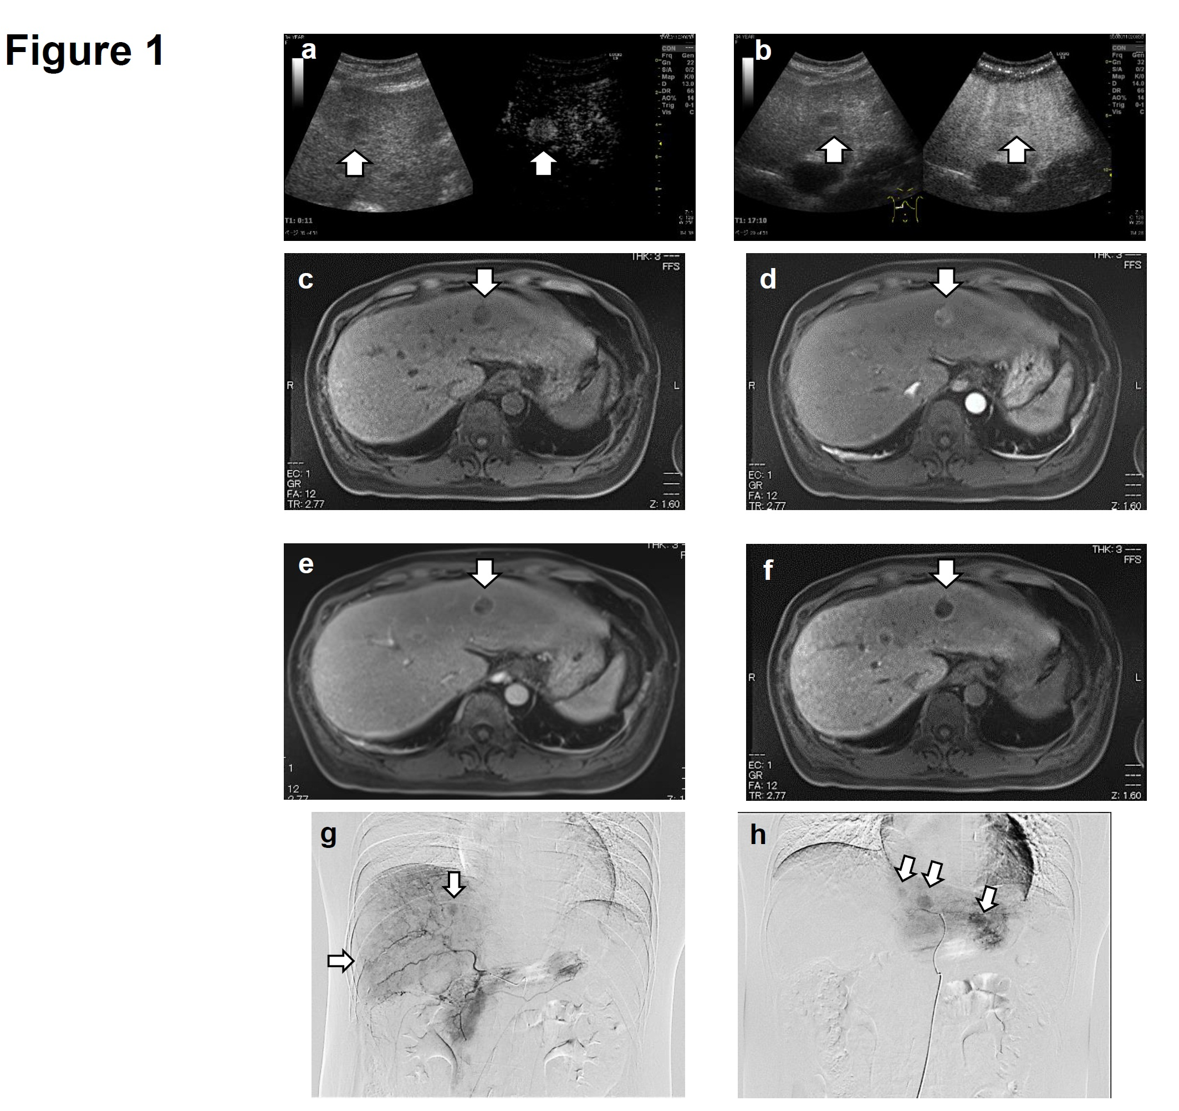
Figure 1 Contrast-enhanced ultrasonography images of case 1 on the admission. A: The vascular arterial phase; B: The Kupffer phase; EOB-MRI images of case 1: C: T1-weighted MRI image; D: The arterial phase; E: The portal phase and (F) the hepatobiliary phase of EOB-MRI; G and H: Angiography images of case 1 before the combination therapy. EOB-MRI: Gd-EOB-DTPA-enhanced magnetic resonance imaging.

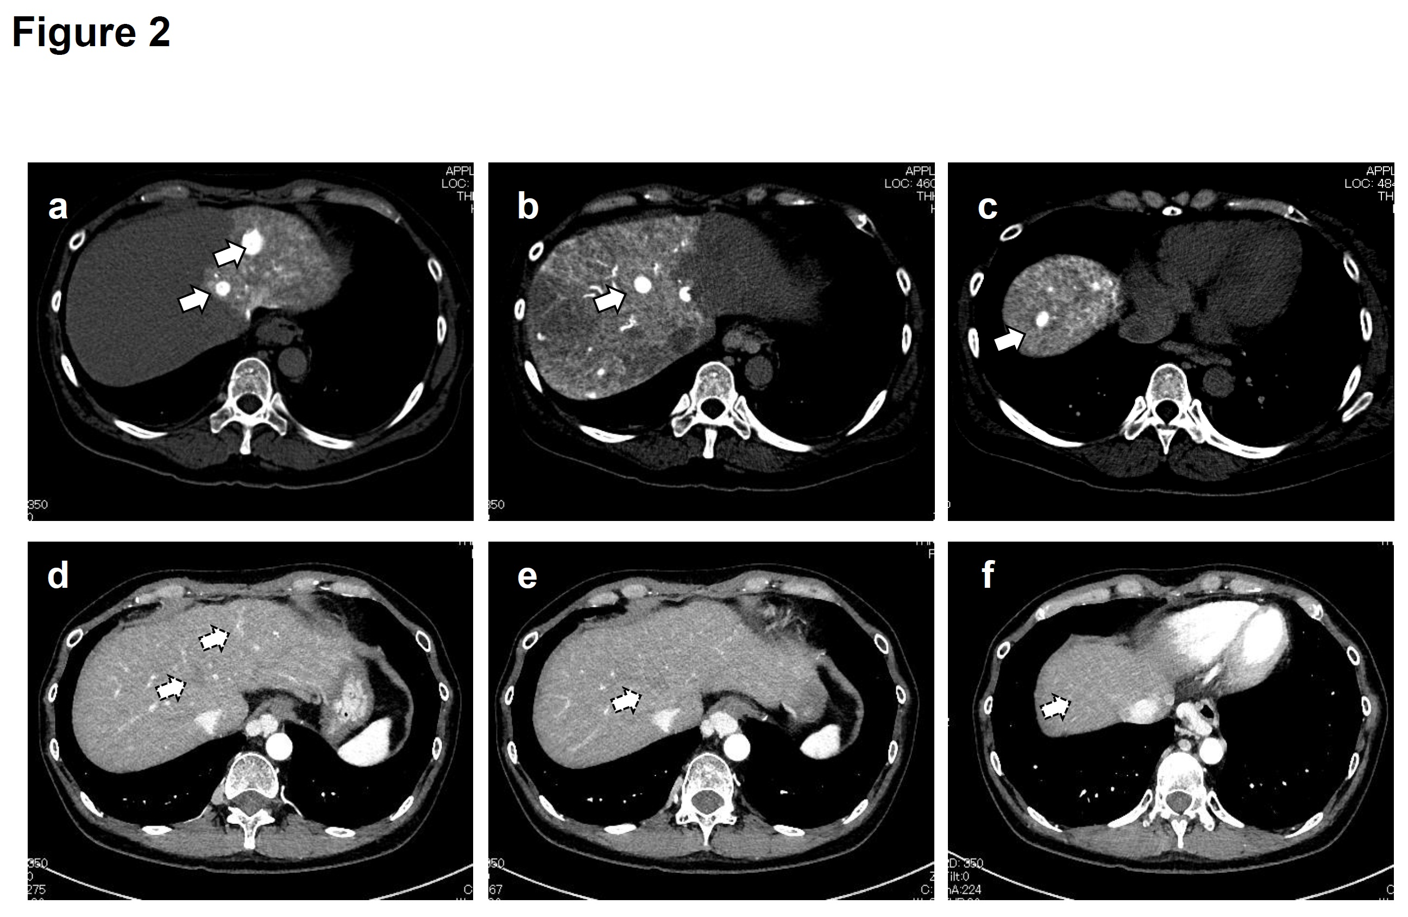
Figure 2 The representative dynamic contrast-enhanced CT images of case 1 before and after eight times of combination therapy. A-C: White arrows indicate tumors before the combination therapy; D-F: White arrows with dotted line indicate the tumor disappearance after eight times of combination therapy.

Figure 3 Changes in alpha-fetoprotein, albumin and prothrombin time after eight combination therapy. None of them did show a significant change after each session. PT: Prothrombin time; AFP: Alpha-fetoprotein.

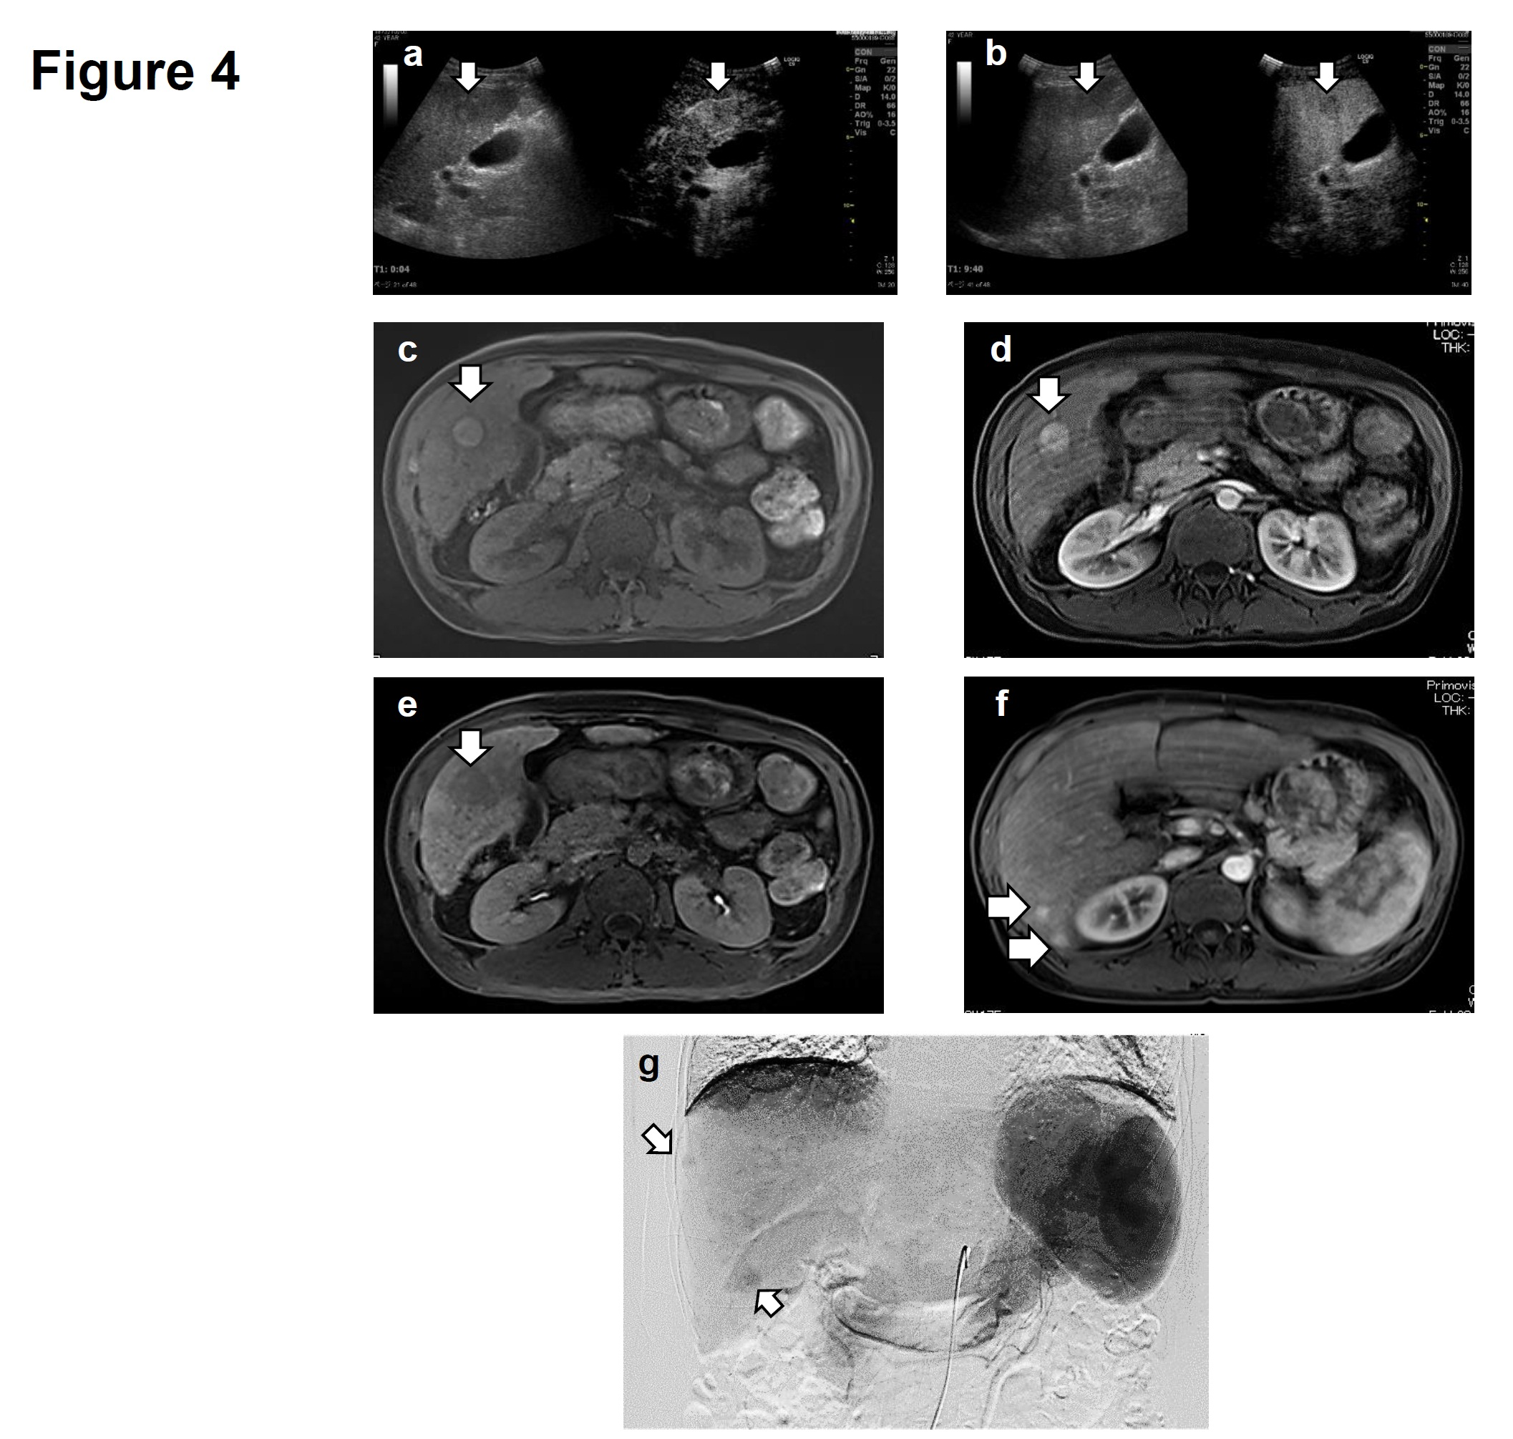
Figure 4 Contrast-enhanced ultrasonography images of case 2 before the combination therapy. The vascular arterial phase (A) and the Kupffer phase (B) of Contrast-enhanced ultrasonography. EOB-MRI images of case 2: C: T1-weighted MRI image; D: The arterial phase; E: The hepatobiliary phase of EOB-MRI; F: Several tumorous lesions in the liver besides S5 lesion in the arterial phase of EOB-MRI study; G: Angiography images of case 1 before the combination therapy. White arrows indicate multiple hypervascular areas of tumor staining. EOB-MRI: Gd-EOB-DTPA-enhanced magnetic resonance imaging.
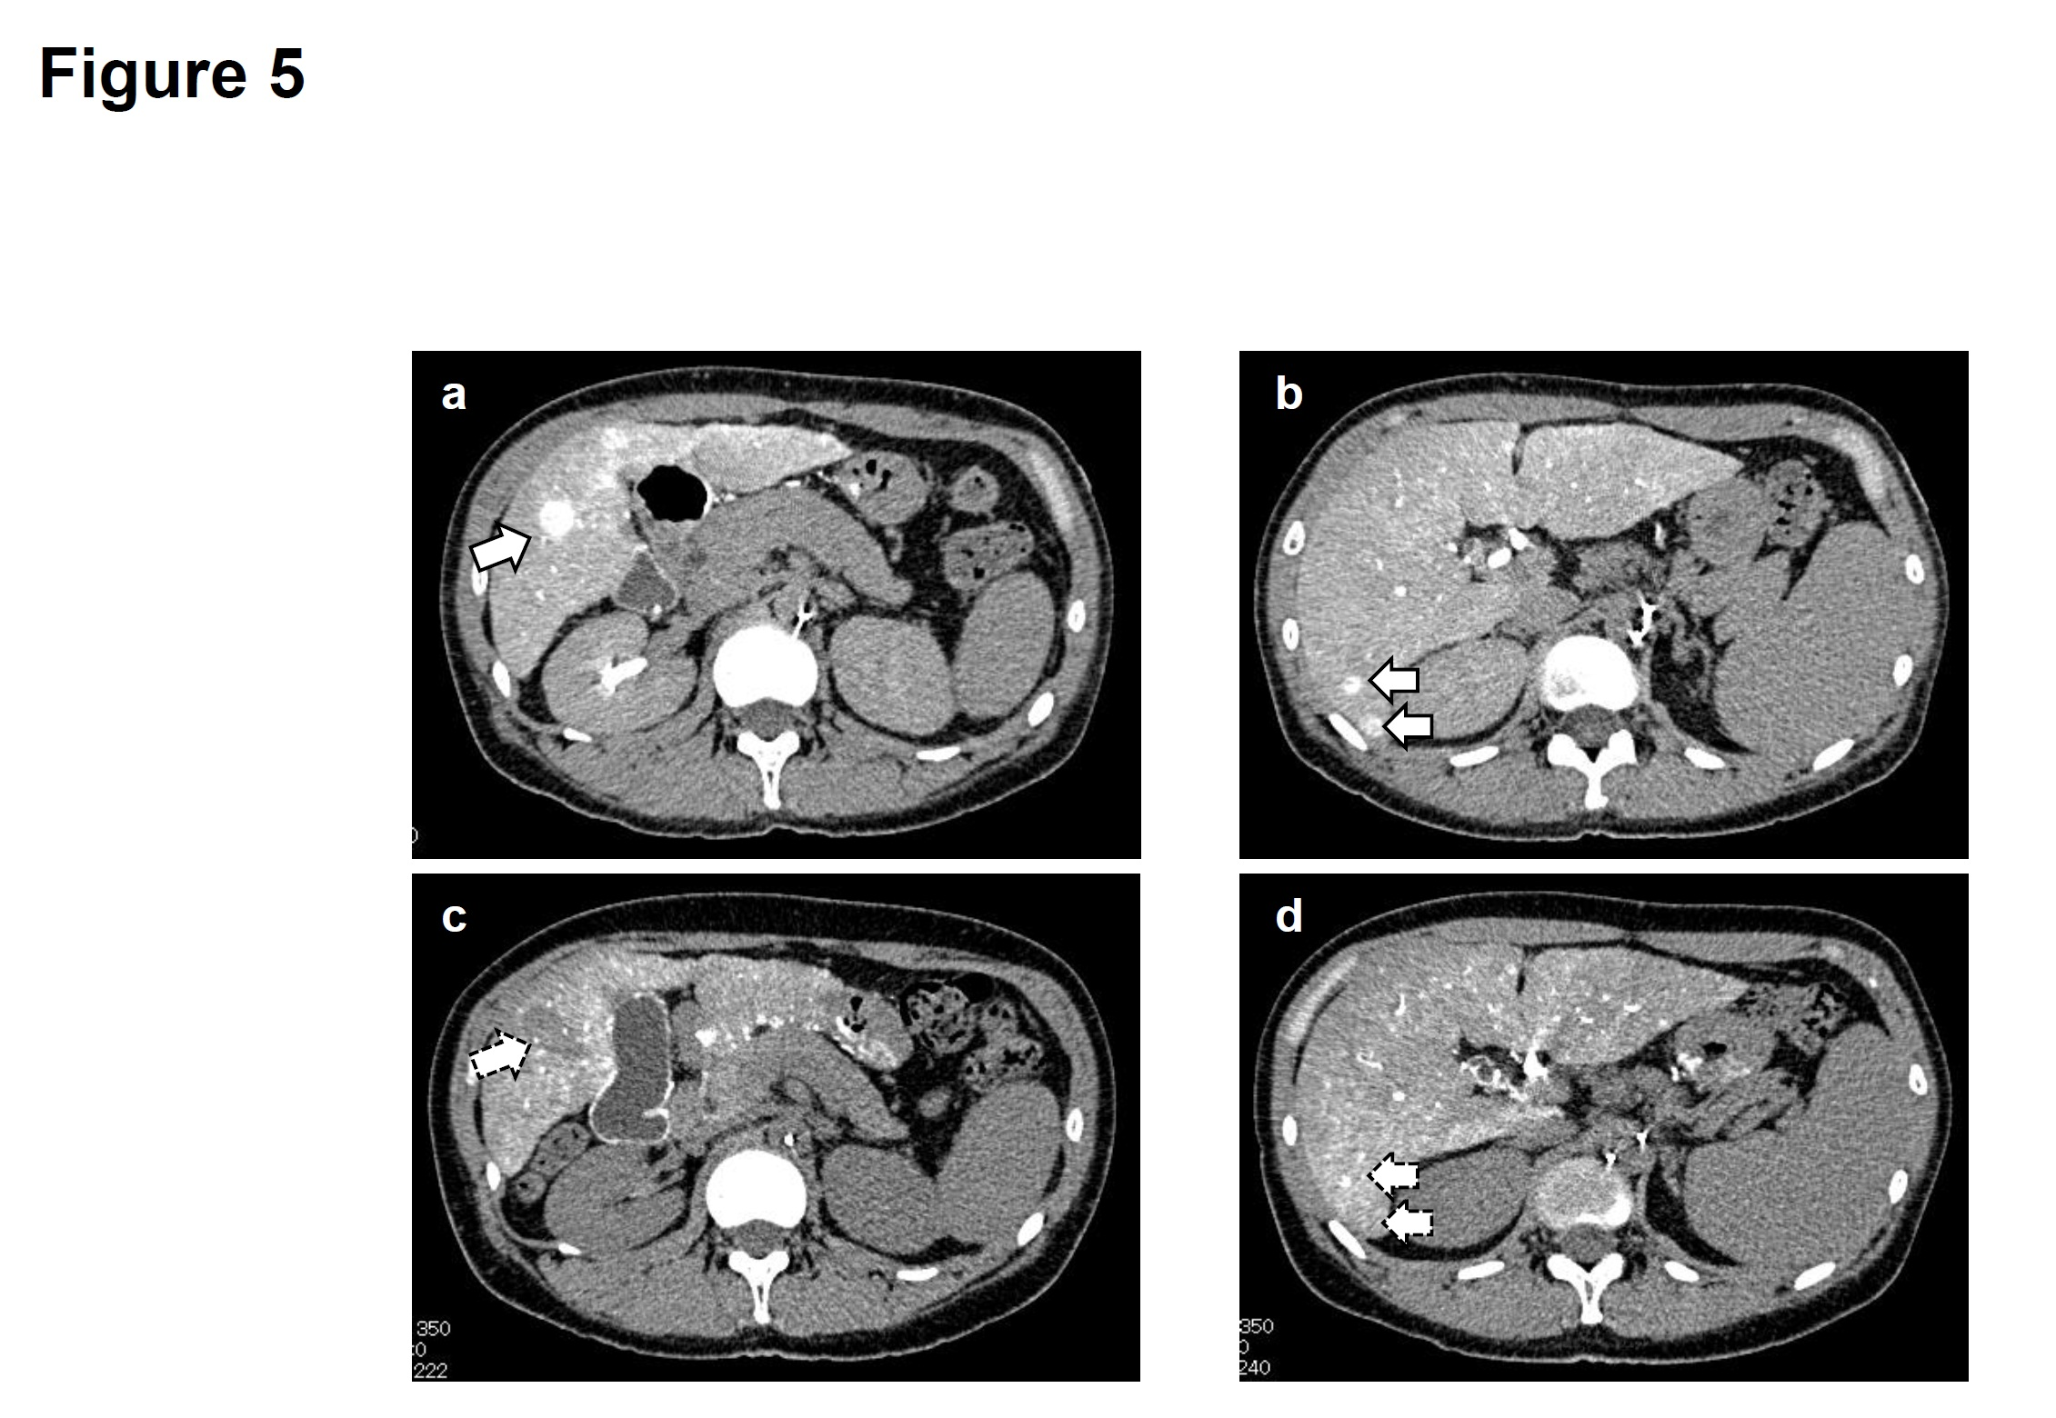
Figure 5 The representative dynamic contrast-enhanced CT images of case 2 before and after three times of combination therapy and radiofrequency ablation. A and B: White arrows indicate tumors before treatment; C and D White arrows with dotted line indicate tumors disappearance or reduction after three times of combination therapy and radiofrequency ablation.

Figure 6 Changes in alpha-fetoprotein, albumin and prothrombin time after three combination therapy and radiofrequency ablation. None of them did show a significant change after each treatment. PT: Prothrombin time; AFP: Alpha-fetoprotein.

Table 1 Results of laboratory investigation of case 1 on the day of the admission
Hematology |  | Biochemistry
WBC | 5100/μL | TP | 7.3 g/dL | Na | 142 mEq/L
RBC | 399 × 10⁴/μL | Alb | 4.5 g/dL | K | 2.9 mEq/L
Hb | 14.1 g/dL | BUN | 7 mg/dL | Cl | 101 mEq/L
Ht | 41.8% | Cre | 0.44 mg/dL | CRP | 0.50 mg/dL
PLT | 7.4 × 10⁴/μL | T-Bil | 0.8 mg/dL | AFP | 7 ng/mL
Coagulation |  | D-Bil | 0.1 mg/dL | AFP-L3 | < 0.5%
PT | 85% | AST | 28 IU/L | PIVKA II | 24 mAU/mL
 |  | ALT | 20 IU/L | CEA | 5.8 ng/mL
 |  | ChE | 211 IU/L | CA 19-9 | 68 U/mL
 |  | LDH | 181 IU/L
 |  | γ-GTP | 256 IU/L

Table 2 Results of laboratory investigation of case 2 before miriplatin- transarterial oily chemoembolization/DDP-H-hepatic arterial infusion chemotherapy combination therapy

Hematology |  | Biochemistry
WBC | 3980 /μL | TP | 7.0 g/dL | Na | 138 mEq/L
RBC | 344 × 10⁴/μL | Alb | 3.1 g/dL | K | 3.5 mEq/L
Hb | 10.2 g/dL | BUN | 11 mg/dL | Cl | 106 mEq/L
Ht | 30.0% | Cre | 0.45 mg/dL | CRP | 0.16 mg/dL
PLT | 8.6 × 10⁴/μL | T-Bil | 0.7 mg/dL | AFP | 4 ng/mL
Coagulation |  | D-Bil | 0.1 mg/dL | AFP-L3 | < 0.5%
PT | 52% | AST | 63 IU/L | PIVKA II | < 15 mAU/mL
 |  | ALT | 49 IU/L | CEA | 2.2 ng/mL
 |  | ChE | 124 IU/L | CA 19-9 | 40 U/mL
 |  | LDH | 143 IU/L
 |  | γ-GTP | 83 IU/L

