Name of journal: World Journal of Gastroenterology
ESPS Manuscript NO: 31577
Manuscript Type: ORIGINAL ARTICLE

Basic Study
Bifidobacterium infantis CGMCC313-2’s protective effect on ovalbumin-induced airway asthma and ß-lactoglobulin-induced intestinal food allergy mouse models

Mengyun L et al. Effect of B. infantis on allergy diseases

Meng-Yun Liu, Zhen-Yu Yang, Wen-Kui Dai, Jian-Qiong Huang, Yin-Hu Li, Juan Zhang, Chuang-Zhao Qiu, Chun Wei, Qian Zhou, Xin Sun, Xin Feng, Dong-Fang Li, He-Ping Wang, Yue-Jie Zheng

Meng-Yun Liu, Jian-Qiong Huang, He-Ping Wang, Yue-Jie Zheng, Department of Respiratory, Shenzhen Children’s Hospital, Shenzhen 518026, Guangdong Province, China

Zhen-Yu Yang, Wen-Kui Dai, Yin-Hu Li, Chuang-Zhao Qiu, Qian Zhou, Xin Feng, Dong-Fang Li, WeHealthGene Co., Shenzhen 518129, Guangdong Province, China

Juan Zhang, Chun Wei, Xin Sun, Xijing Hospital, The Forth Military Medical University, Xi’an 7100032, Shann’xi Province, China

Author contributions: Liu MY, Dai WK and Wang HP designed the study; Liu MY, Yang ZY and Li YH interpreted data and wrote the manuscript; Feng X, Qiu CZ and Zhou Q conducted bioinformatics analysis; Li DF, Huang JQ, Juan Z, Chun W and Xin S contributed to the study design and animal experiments. Liu MY, Yang ZY and Dai WK contributed to this work equally.

Supported by Basic Science Research Program funded by The Innovation of Science and Technology Commission of Shenzhen Municipality, China, No. JCYJ20120828092009036.

Institutional review board statement: The study was reviewed and approved by the Institutional Review Board (IRB) in Shenzhen Children’s Hospital.

Institutional animal care and use committeestatement: The experimental procedures involving animals in the study was reviewed and approved by the Animal Welfare and Ethical Committee in The Fourth Military Medical University (approval ID: 20150902).

Conflict-of-interest statement: The authors declare that they have no competing interests.

Data sharing statement: No additional data are available.

Open-Access: This article is an open-access article which was selected by an in-house editor and fully peer-reviewed by external reviewers. It is distributed in accordance with the Creative Commons Attribution Non Commercial (CC BY-NC 4.0) license, which permits others to distribute, remix, adapt, build upon this work non-commercially, and license their derivative works on different terms, provided the original work is properly cited and the use is non-commercial. See: http://creativecommons.org/licenses/by-nc/4.0/

Manuscript source: Unsolicited manuscript

Correspondence to: Dr. Yue-Jie Zheng, Director, Department of Respiratory, Shenzhen Children’s Hospital, No. 7019 Yitian Road, Shenzhen 518026, Guangdong Province, China. shine1990@sina.com
Telephone: +86-755-83936101
Fax: +86-755-83009800

Received: November 25, 2016
Peer-review started: November 28, 2016
First decision: December 28, 2016
Revised: January 16, 2017
Accepted: February 16, 2017
Article in press:
Published online:
Abstract
AIM
To investigated whether oral administration of Bifidobacterium infantis CGMCC313-2 (B. infantis CGMCC313-2) can inhibit allergen-induced airway inflammation and food allergies in a mouse model.

METHODS
Ovalbumin (OVA)-induced allergic asthma and ß-lactoglobulin-induced food allergy mouse models were used in this study. Following oral administration of B. infantis CGMCC313-2 during or after allergen sensitization, histopathologic changes in the lung and intestine were detected by hematoxylin and eosin (H&E) staining. For the allergic asthma mouse model, we evaluated the proportion of lung-infiltrating inflammatory cells. OVA-specific IgE and IgG1 levels in the serum and cytokine levels in bronchoalveolar lavage fluids (BALF) were also assessed. For the food allergy mouse model, the levels of total IgE and cytokinesin serum were measured.

RESULTS
Oral administration of B. infantis CGMCC313-2 during or after allergens sensitization suppressed allergic inflammation in lung and intestine tissues, while the proportion of infiltrating inflammatory cells was significantly decreased in the BALF of allergic asthma mice. Moreover, B. infantis CGMCC313-2 decreased the serum levels of total IgE in food allergy mice, while the reduction of IgE and IgG1 was also observed in OVA-induced allergic asthma mice. The expressions of interleukin-4 (IL-4) and IL-13 in both serum and BALF were suppressed after the administration of B. infantis CGMCC313-2, while its effect on IL-10 levels in serum was not observed.

CONCLUSION
B. infantis CGMCC313-2 can inhibit the secretion of allergen-induced IgE, IL-4 and IL-13, and attenuate allergic inflammation.

Key words: Bifidobacterium infantis; Asthma; Allergy; Ovalbumin; ß-lactoglobulin

©The Author(s) 2017. Published by Baishideng Publishing Group Inc. All rights reserved.

Core tip: Bifidobacterium infantis CGMCC313-2 could decrease the serum concentration of IgE and IgG1 significantly in asthma and food allergy mice. The number of infiltrating cells in BALF was reduced, and the symptom of eosinophil infiltration on lungs was relieved in asthma mice with B. infantis CGMCC313-2. The weight of food allergy mice was regained, and the inflammation of intestine was relieved in food allergy mice with B. infantis CGMCC313-2. With the administration of B. infantis CGMCC313-2, the concentration of IL-4 and IL-13 were reduced in both asthma and food allergy mice.

Liu MY, Yang ZY, Dai WK, Huang JQ, Li YH, Zhang J, Qiu CZ, Wei C, Zhou Q, Sun X, Feng X, Li DF, Wang HP, Zheng YJ. Bifidobacterium infantis CGMCC313-2’s protective effect on ovalbumin-induced airway asthma and ß-lactoglobulin-induced intestinal food allergy mouse models. World J Gastroenterol 2017; In press

INTRODUCTION
The prevalence of asthma, food allergy, eczema, and allergic rhinitis in developed countries has been increased over the last three decades. Specifically in China, childhood allergic diseases are generally lower than that in Western countries; however, the prevalence of asthma, allergic rhinitis, and eczema in children has increased markedly during the past two decades^{[1-4]}. A number of environmental factors including air pollution, cigarette smoking, and allergen exposure have been proposed to explain the changes in the prevalence of allergic diseases; however, no major risk factors have been identified. A common explanation for the increased incidence rates of childhood allergy and asthma observed in industrialized countries during the past few decades is the ‘hygiene hypothesis,’ which state that a lack of early childhood exposure to infectious agents, symbiotic microorganisms, and parasites increases susceptibility to allergic diseases by suppressing the natural development of the immune system^{[5,6]}. Recent epidemiological and experimental studies have both renewed the “hygiene hypothesis” and extended it to a more specific theorem, the “microflora hypothesis”^{[6-8]}.
Probiotics are live microorganisms that confer a health benefit to the host when administered in adequate amounts^{[9]}. In other words, ingested probiotics can modify microbial flora, which benefit the host^{[10,11]}. Previous studies have shown that probiotics can reduce allergic diseases by modifying the immune system of the host. Some probiotic genera including Lactobacilli and Bifidobacteria are intensively investigated as novel alternative options for the management of allergic diseases including asthma and food allergy^{[12,13]}.
Experimental studies have shown that probiotics have strain-specific effects. In this study, the mice which incubated with nebulized ovalbumin were used as asthma model, while the mice which feed with ß-lactoglobulin were used as food allergy model (details in Materials and Methods). And the effect of Bifidobacterium infantis CGMCC313-2, which is extensively used as a probiotic drug in China, was investigated in these two mouse models during (prevention) or after allergen sensitization (pre-treatment).

MATERIALS AND METHODS
Mice
Male BALB/c mice aged 6–8 weeks were obtained from the Laboratory Animal Center of the Fourth Military Medical University. All experimental procedures involving animals were approved by the Ethics Committee for Animal Studies of the Fourth Military Medical University and performed in accordance with their guidelines (approval ID: 20150902).

Probiotic bacterial preparations
Bifidobacterium infantis CGMCC313-02 powder (Kexing Biotech Company Limited, Shenzhen, China) was stored at -20 °C. Solutions were prepared using normal saline only or normal saline plus B. infantis CGMCC313-2. B. infantis CGMCC313-2 preparations were adjusted at concentrations of 5 × 10¹⁰ colony-forming units (CFU)/mL.

Mouse model of OVA-induced allergic asthma
The mice were divided into four experimental groups, and each group consisted of 10 mice. Four groups of mice were treated as follows: (Group 1) the normal control group received normal saline plus 1.5 mg alum intraperitoneally. The mice were placed in an atomizing chamber (20 cm × 20 cm × 35 cm), and 8 mL saline was nebulized for inhalation. The mice were incubated 30 min each time for 7 continuous days; (Group 2) the positive group (as shown in Figure 1A) received 100 µg ovalbumin (OVA) (Sigma, Buchs, Switzerland) plus 1.5 mg alum intraperitoneally from Day 0 to Day 7, and subsequently challenged with 1% OVA inhaled by nebulizer from Day 21 to Day 28; and (Group 3) the prevention and (Group 4) pre-treatment groups received 100 µg OVA plus alum intraperitoneally and 1% OVA inhaled, and were fed 0.2 mL/d (5 × 10¹⁰ CFU/mL) of B. infantis CGMCC313-2 from Day 0 to Day 14 (prevention group, as shown in Figure 1B), or from Day 15 to Day 28 (pre-treatment group, as shown in Figure 1C). Serum and BALF samples were collected from mice at sacrifice on Day 29.

Mouse model of ß-lactoglobulin-induced food allergy
The mice were divided into four experimental groups, and each group consisted of 10 mice. Four groups of mice were treated as follows: (Group 1) the normal control group were fed normal saline (2 mL each time for 7 continuous days); (Group 2) the positive group (as shown in Figure 2A) received the mixture of 20 mg ß-lactoglobulin(BLG) (Sigma, Buchs, Switzerland) and 10 µg CTX (Cholera toxin, List Biological Laboratories, Campbell, Calif) at days 0, 7, 14 by intragastric gavage (2 mL of the mixture was used each time). Subsequently the mice were challenged with 100 mg BLG (3 mL) on day 21 by intragastric gavage; and (Group 3) the prevention and (Group 4) pre-treatment groups received 20 mg BLG plus 10 µg CTX and challenged by intragastric gavage with 100mg BLG, and were fed 0.2 mL/d (5 × 10¹⁰ CFU/ml) of B. infantis CGMCC313-2 from Day 0 to Day 21 (prevention group, as shown in Figure 2B), or from Day 22 to Day 28 (pre-treatment group, as shown in Figure 2C). Mice body weight was measured on Day 29, and then the serum samples were collected after the mice sacrificed.

Measurement of immunoglobulins in serum
Serum samples from mouse model of OVA-induced allergic asthma were assayed for the levels of OVA-specific IgE and IgG1 using ELISA kits (Chondrex Inc. United States) following the manufacturer’s protocol. The level of total IgE was assayed in the serum of BLG-induced food allergy mice using ELISA kits (Chondrex, Inc. United States).
Measurement of cytokines
IL-4, IL-10, IL-13, and IFN-γ levels in serum (from mouse model of BLG-induced food allergy) or in BALF (from mouse model of OVA-induced allergic asthma) were assayed using the ELISA Kits (R&D Systems, Boston, MA, United States) according to the manufacturer’s protocol.

Cell counts of BALF
For mouse model of OVA-induced allergic asthma, BALF was isolated in 1ml of phosphate buffered saline (PBS). The BALF cellularity was determined using a hemocytometer. A 10ul aliquot of centrifuged cells (4000 rpm, 5 min) was transferred onto slides, and all leukocytes were fixed for staining using Giemsa. The observer counted 200-300 cells per slide, and the standard morphological criteria was adopted to identify the individual leukocyte populations. The number of leukocytes was counted 2 times, and the average value was maintained.

Histological analysis
To assess the pathological changes, samples from either lungs (OVA-induced allergic asthma) or intestine (BLG-induced food allergy) were collected. The samples were fixed in neutrally buffered 10% formaldehyde and embedded in paraffin. -4 µm sections were stained with H&E to detect inflammatory cell infiltration in intestinal tissue (BLG-induced food allergy), or assess the extent of inflammation in lungs (OVA-induced asthma) at 200 × magnification.

Statistical analysis
All data points represent the mean ± SEM in each mouse group. Analysis was performed using the software SPSS 19.0 for Windows. Variance analysis of single factor and multi factor (ANOVA) was conducted to determine the statistical significance. P value lower than 0.05 was considered statistically significant.

RESULTS
B. infantis decreased the levels of IgE and IgG1 in OVA-induced asthma and BLG-induced food allergy mouse models
We detected whether oral B. infantis CGMCC313-2 would affect serum levels of allergen-induced serum specific IgE and IgG1, and ELISA was used for data analysis in OVA-induced allergic asthma mouse model. The serum levels of OVA-specific IgE and IgG1 were significantly elevated after OVA sensitization/challenge (Group 2) compared with the normal control group (Group 1). In groups which received B. infantis CGMCC313-2 for prevention (Group 3) and pre-treatment (Group 4) during the OVA sensitization/challenge, the serum levels of IgE and IgG1 were significantly decreased (P < 0.05; Figure 3A and B). Moreover, the levels of serum IgE in the prevention group was also significantly decreased compared with pre-treatment group (P < 0.05; Figure 3A).
Due to the unavailability of reagents for BLG-specific IgE and IgG1 detection, the serum levels of total IgE were evaluated instead in BLG-induced food allergy mouse model. The serum levels of total IgE were significantly increased after the BLG sensitization/challenge (Group 2) compared with the normal control group (Group 1). In the groups challenged with B. infantis CGMCC313-2 for prevention (Group 3) and pre-treatment (Group 4), the levels of total IgE were significantly decreased. Moreover, the total IgE serum levels in pre-treatment group were also significantly decreased compared with prevention group (P < 0.05; Figure 3C).

B. infantis administration increases body weight of BLG-induced food allergy mice
Compared with normal control, mice in the BLG-sensitized/challenge group showed weight loss. However, the prevention and pre-treatment groups with B. infantis CGMCC313-2 showed weight gains (Figure 4), while the pre-treatment group gained more weight than the prevention group.

B. infantis alters the proportions of lung-infiltrating cells in OVA-induced allergic asthma mice
In order to evaluate the degree of inflammatory cell infiltration in the lungs of OVA-induced allergic asthma mice, leukocytes counts were conducted in BALF tissue. The cell number was significantly increased in the OVA- sensitized/challenged mice compared to the control group. However, the proportion of infiltrating cells in the lung was significantly decreased in the groups treated with B. infantis CGMCC313-2 (Figure 5). Differential cell counts which used Giemsa staining failed to identify cell types in our study.

Impact of B. infantis on allergic inflammation in OVA-induced asthma and BLG-induced food allergy mouse models
The effect of B. infantis CGMCC313-2 on the OVA or BLG-sensitized/challenged mice was evaluated from the perspective of overall lung or intestine inflammation, using histological hematoxylin and eosin staining (Figures 6 and 7, respectively). Compared with normal control mice (Figures 6A and 7A), allergen sensitized/challenged mice (Figures 6B and 7B) had severe inflammation; while the prevention (Figures 6C and 7C) and pre-treatment (Figures 6D and 7D) mice with B. infantis CGMCC313-2 treatment exhibited significantly diminished inflammation signs.

Effect of B. infantis on cytokines in serum and BALF
To further elucidate possible mechanisms that were responsible for the effects of B. infantis CGMCC313-2 on systemic sensitization and allergic inflammation, ELISA was used to determine the expression of IL-4, IL-10, IL-13, and IFN-γ in serum and BALF was collected from BLG-induced food allergy mice and OVA-induced allergic asthma mice respectively. IL-4 and IL-13 in serum (Figure 8A and B) or BALF (Figure 8D and E) increased significantly in the positive control (PC; Group 2) group compared with normal control (NC; Group 1) group. In the groups that received B. infantis CGMCC313-2, the levels of serum IL-4 and IL-13 in the prevention group were significantly decreased. Additionally, the reduction of IL-4 and IL-13 in prevention and treatment groups was also observed in OVA-induced allergic asthma mice. IL-10 in serum (Figure 8C) decreased significantly in the positive control (PC; Group 2) group, prevention (Pre; Group 3) group, and treatment (Tre; Group 4) group compared to normal control (NC; Group 1) group. IL-10 was not detected in BALF from OVA-induced allergic asthma mice, and IFN-γ was not detected in either serum or BALF from any mice.

DISCUSSION
There is increasing evidence that intestinal microbiota and ingested probiotics may induce important metabolic and physiological reactions in the host, and drive the maturation of immune system in early life. Among the diverse probiotics, Lactobacilli and Bifidobacteria, which are part of gut flora in infants, are the most promising candidates that naturally affect immune system development^{[14,15]}. For the same reason, Lactobacilli and Bifidobacteria are the most frequently used probiotics for clinical intervention studies^{[16–20]}. However, the most important characteristic of probiotics is their strain-specificity effects^{[21]}. In this study, we investigated the role of Bifidobacterium infantis CGMCC313-2 in allergic disease prevention and treatment in two mouse models, for the reason that B. infantis CGMCC313-2 has been extensively applied for the treatment and prevention of diarrhea including antibiotic-associated diarrhea (AAD) in China. In OVA-sensitized/challenged mice, severe lung inflammation and infiltrating cells in the lungs were observed, and the application of B. infantis CGMCC313-2 could significantly diminish inflammation. Similarly, in ß-lactoglobulin-induced food allergy mice, the engagement of B. infantis CGMCC313-2 could decrease intestine inflammation, and ameliorate weight loss in BLG-sensitized/challenged mice. These results demonstrate that oral administration of B. infantis CGMCC313-2 during or after allergen sensitization may relieve allergic inflammation in airway and intestine.
In the allergen sensitized/challenged mice, IL-4, IL-13, total IgE, and allergen-induced serum specific IgE and IgG1 levels were highly expressed. Based on immunological basis of allergy, the overexpression of IL-4 and IL-13, which is modulated by type 2 T helper cells, could promote IgE production and eosinophil infiltration in target organs. In the present study, following the oral administration of B. infantis CGMCC313-2, the levels of IL-13 and total IgE were significantly decreased, which was accompanied by relief of inflammation symptoms. We deduced that the metabolites of B. infantis CGMCC313-2, including butyrate and short-chain fatty acids (SCFA), could suppress the inflammatory responses triggered by Th2 cytokines^{[22-28]}. But the level of IL-4 was higher in treatment group, which opposed to the results of IL-13 and IgE. Because of the complexity of immune system and response, the role of IL-4 as allergic disorder marker needed to be detected in our future study. Additionally, the oral administration of probiotics helped in prevention and treatment of airway and intestine allergy.
On the other hand, there was a decrease in serum levels of IL-10 in mice that were sensitized/ challenged with BLG. There is strong evidence indicating that the production of IL-10, which was affected by antigens exposure, was associated with T cell tolerance and Treg secretion, which in turn plays important roles in controlling allergic diseases. However, the administration of B. infantis CGMCC313-2 did not promote the secretion of IL-10. This phenomenon was inconsistent with previous preclinical studies in which probiotic strains could promote Treg responses^{[29,30]}. We deduced that the different probiotic strains adopted in different studies may have strain-specific effects, or the immunomodulatory effect of B. infantis CGMCC313-2 exhibited a suppression of Th2 responses. In our study, the levels of IFN-γ in both serum and BALF were too low to be detected in all mice, and this may be due to the poor sensitivity of determination technique. Admittedly, this is a limitation of our study.
In the present study, which utilized asthma and food allergy mouse models, we found that B. infantis CGMCC313-2 could inhibit the secretion of allergen-induced IgE and Th2 cytokines, and further attenuate the allergic inflammation. Our study also suggested that the modulatory activity of B. infantis CGMCC313-2 was not only confined to intestinal allergic diseases, but also to allergic airway disease. Therefore, B. infantis CGMCC313-2 may be regarded as a candidate probiotic strain in the prevention and treatment of allergic diseases. However, further clinical and experimental studies are required to delineate the potential preventive and treatment effects of B. infantis CGMCC313-2.

ACKNOWLEDGEMENTS
We would like to thank the staff at WeHealthGene who contributed greatly to this work and the laboratory technicians at Shenzhen Children’s Hospital who provided valuable assistance with the animal experiments.

COMMENTS
Background
Probiotics have exhibited beneficial effects on allergies diseases based on “microflora hypothesis”, and experimental studies have also shown that probiotics have strain-specific effects. In this study, they detected the specific effects of B. infantis CGMCC313-2, which widely used as a probiotic drug in China, on asthma and food allergy with mouse models.

Research frontiers
Previous studies indicated that ingested Lactobacilli and Bifidobacteria could modify microbial flora, and it would reduce the symptoms of allergic diseases by modifying the immune system of the host. Meanwhile some probiotic drugs are intensively investigated as novel alternative options for the management of allergic diseases including asthma and food allergy.

Innovations and breakthroughs
In the study, B. infantis CGMCC313-2 was feed to asthma and food allergy mouse models. After probiotic treatment, they found that B. infantis CGMCC313-2 could decrease the serum concentration of IgE and IgG1 significantly, and the concentration of IL-4 and IL-13 were reduced in asthma and food allergy mice too. Meanwhile the symptoms of cell infiltration or inflammation were relieved.

Applications
B. infantis CGMCC313-2 could inhibit the secretion of allergen-induced IgE and Th2 cytokines, and further attenuate the allergic inflammation. B. infantis CGMCC313-2 provided important reference for the prevention and treatment of intestinal and airway allergic diseases.

Terminology
IgE and IgG, which closely related with anaphylaxis, were higher in the patients with allergies diseases. IL-4 and IL-13, which secreted by Th2 cells, involve humoral immune response and indicate the degree of allergy diseases.

Peer-review
The authors performed clear experiments on asthma mouse model and food allergy mouse model to detect the effects of B. infantis on allergy diseases. They found that B. infantis could inhibit the secretion of allergens induced IgG, IgE, IL-4 and IL-13, and allergic inflammation were also attenuated. The study shed the light on the prevention and treatment of intestinal and airway allergic diseases. However, further clinical studies are still required.

REFERENCES
1 Zhao J, Bai J, Shen K, Xiang L, Huang S, Chen A, Huang Y, Wang J, Ye R. Self-reported prevalence of childhood allergic diseases in three cities of China: a multicenter study. BMC Public Health 2010; 10: 551 [PMID: 20836838 DOI: 10.1186/1471-2458-10-551]
2 Yangzong Y, Shi Z, Nafstad P, Håheim LL, Luobu O, Bjertness E. The prevalence of childhood asthma in China: a systematic review. BMC Public Health 2012; 12: 860 [PMID: 23050953 DOI: 10.1186/1471-2458-12-860]
3 Zhang Y, Zhang L. Prevalence of allergic rhinitis in china. Allergy Asthma Immunol Res 2014; 6: 105-113 [PMID: 24587945 DOI: 10.4168/aair.2014.6.2.105]
4 Li F, Zhou Y, Li S, Jiang F, Jin X, Yan C, Tian Y, Zhang Y, Tong S, Shen X. Prevalence and risk factors of childhood allergic diseases in eight metropolitan cities in China: a multicenter study. BMC Public Health 2011; 11: 437 [PMID: 21645361 DOI: 10.1186/1471-2458-11-437]
5 Strachan DP. Family size, infection and atopy: the first decade of the "hygiene hypothesis". Thorax 2000; 55 Suppl 1: S2-10 [PMID: 10943631]
6 Strannegård O, Strannegård IL. The causes of the increasing prevalence of allergy: is atopy a microbial deprivation disorder? Allergy 2001; 56: 91-102 [PMID: 11167368]
7 Kalliomäki M, Isolauri E. Role of intestinal flora in the development of allergy. Curr Opin Allergy Clin Immunol 2003; 3: 15-20 [PMID: 12582309 DOI: 10.1097/01.all.0000053262.39029.a1]
8 Björkstén B. Effects of intestinal microflora and the environment on the development of asthma and allergy. Springer Semin Immunopathol 2004; 25: 257-270 [PMID: 15007630 DOI: 10.1007/s00281-003-0142-2]
9 Food and Agriculture Organization of the United Nations and World Health Organization (FAO-WHO) (2002). Guideline for the evaluation of probiotics in food. FAO of the United Nations and WHO working group report; Online: Available from: URL: http: //who.int/foodsafety/publications.fs-management/probiotics/en/.
10 Zuccotti G, Meneghin F, Aceti A, Barone G, Callegari ML, Di Mauro A, Fantini MP, Gori D, Indrio F, Maggio L, Morelli L, Corvaglia L. Probiotics for prevention of atopic diseases in infants: systematic review and meta-analysis. Allergy 2015; 70: 1356-1371 [PMID: 26198702 DOI: 10.1111/all.12700]
11 Floch MH, Walker WA, Sanders ME, Nieuwdorp M, Kim AS, Brenner DA, Qamar AA, Miloh TA, Guarino A, Guslandi M, Dieleman LA, Ringel Y, Quigley EM, Brandt LJ. Recommendations for Probiotic Use--2015 Update: Proceedings and Consensus Opinion. J Clin Gastroenterol 2015; 49 Suppl 1: S69-S73 [PMID: 26447969 DOI: 10.1097/MCG.0000000000000420]
12 Cuello-Garcia CA, Brożek JL, Fiocchi A, Pawankar R, Yepes-Nuñez JJ, Terracciano L, Gandhi S, Agarwal A, Zhang Y, Schünemann HJ. Probiotics for the prevention of allergy: A systematic review and meta-analysis of randomized controlled trials. J Allergy Clin Immunol 2015; 136: 952-961 [PMID: 26044853 DOI: 10.1016/j.jaci.2015.04.031]
13 Szajewska H, Shamir R, Turck D, van Goudoever JB, Mihatsch WA, Fewtrell M. Recommendations on probiotics in allergy prevention should not be based on pooling data from different strains. J Allergy Clin Immunol 2015; 136: 1422 [PMID: 26329511 DOI: 10.1016/j.jaci.2015.07.022]
14 Saavedra JM. Use of probiotics in pediatrics: rationale, mechanisms of action, and practical aspects. Nutr Clin Pract 2007; 22: 351-365 [PMID: 17507735]
15 Ringel-Kulka T, Cheng J, Ringel Y, Salojärvi J, Carroll I, Palva A, de Vos WM, Satokari R. Intestinal microbiota in healthy U.S. young children and adults--a high throughput microarray analysis. PLoS One 2013; 8: e64315 [PMID: 23717595 DOI: 10.1371/journal.pone.0064315]
16 Weston S, Halbert A, Richmond P, Prescott SL. Effects of probiotics on atopic dermatitis: a randomised controlled trial. Arch Dis Child 2005; 90: 892-897 [PMID: 15863468 DOI: 10.1136/adc.2004.060673]
17 Viljanen M, Savilahti E, Haahtela T, Juntunen-Backman K, Korpela R, Poussa T, Tuure T, Kuitunen M. Probiotics in the treatment of atopic eczema/dermatitis syndrome in infants: a double-blind placebo-controlled trial. Allergy 2005; 60: 494-500 [PMID: 15727582 DOI: 10.1111/j.1398-9995.2004.00514.x]
18 Kalliomäki M, Salminen S, Arvilommi H, Kero P, Koskinen P, Isolauri E. Probiotics in primary prevention of atopic disease: a randomised placebo-controlled trial. Lancet 2001; 357: 1076-1079 [PMID: 11297958 DOI: 10.1016/S0140-6736(00)04259-8]
19 Kalliomäki M, Salminen S, Poussa T, Arvilommi H, Isolauri E. Probiotics and prevention of atopic disease: 4-year follow-up of a randomised placebo-controlled trial. Lancet 2003; 361: 1869-1871 [PMID: 12788576 DOI: 10.1016/S0140-6736(03)13490-3]
20 Rautava S, Kalliomäki M, Isolauri E. Probiotics during pregnancy and breast-feeding might confer immunomodulatory protection against atopic disease in the infant. J Allergy Clin Immunol 2002; 109: 119-121 [PMID: 11799376]
21 Hougee S, Vriesema AJ, Wijering SC, Knippels LM, Folkerts G, Nijkamp FP, Knol J, Garssen J. Oral treatment with probiotics reduces allergic symptoms in ovalbumin-sensitized mice: a bacterial strain comparative study. Int Arch Allergy Immunol 2010; 151: 107-117 [PMID: 19752564 DOI: 10.1159/000236000]
22 Schouten B, van Esch BC, Hofman GA, van Doorn SA, Knol J, Nauta AJ, Garssen J, Willemsen LE, Knippels LM. Cow milk allergy symptoms are reduced in mice fed dietary synbiotics during oral sensitization with whey. J Nutr 2009; 139: 1398-1403 [PMID: 19474160 DOI: 10.3945/jn.109.108514]
23 Thang CL, Baurhoo B, Boye JI, Simpson BK, Zhao X. Effects of Lactobacillus rhamnosus GG supplementation on cow's milk allergy in a mouse model. Allergy Asthma Clin Immunol 2011; 7: 20 [PMID: 22145744 DOI: 10.1186/1710-1492-7-20]
24 Frossard CP, Steidler L, Eigenmann PA. Oral administration of an IL-10-secreting Lactococcus lactis strain prevents food-induced IgE sensitization. J Allergy Clin Immunol 2007; 119: 952-959 [PMID: 17316776 DOI: 10.1016/j.jaci.2006.12.615]
25 Forsythe P, Inman MD, Bienenstock J. Oral treatment with live Lactobacillus reuteri inhibits the allergic airway response in mice. Am J Respir Crit Care Med 2007; 175: 561-569 [PMID: 17204726 DOI: 10.1164/rccm.200606-821OC]
26 Li CY, Lin HC, Hsueh KC, Wu SF, Fang SH. Oral administration of Lactobacillus salivarius inhibits the allergic airway response in mice. Can J Microbiol 2010; 56: 373-379 [PMID: 20555399 DOI: 10.1139/w10-024]
27 Wu CT, Chen PJ, Lee YT, Ko JL, Lue KH. Effects of immunomodulatory supplementation with Lactobacillus rhamnosus on airway inflammation in a mouse asthma model. J Microbiol Immunol Infect 2016; 49: 625-635 [PMID: 25440975 DOI: 10.1016/j.jmii.2014.08.001]
28 Fujimura KE, Demoor T, Rauch M, Faruqi AA, Jang S, Johnson CC, Boushey HA, Zoratti E, Ownby D, Lukacs NW, Lynch SV. House dust exposure mediates gut microbiome Lactobacillus enrichment and airway immune defense against allergens and virus infection. Proc Natl Acad Sci U S A 2014; 111: 805-810 [PMID: 24344318 DOI: 10.1073/pnas.1310750111]
29 Berin MC. Bugs versus bugs: probiotics, microbiome and allergy. Int Arch Allergy Immunol 2014; 163: 165-167 [PMID: 24481028 DOI: 10.1159/000357946]
30 Yoshida T, Fujiwara W, Enomoto M, Nakayama S, Matsuda H, Sugiyama H, Shimojoh M, Okada S, Hattori M. An increased number of CD4+CD25+ cells induced by an oral administration of Lactobacillus plantarum NRIC0380 are involved in antiallergic activity. Int Arch Allergy Immunol 2013; 162: 283-289 [PMID: 24135451 DOI: 10.1159/000354924]

P-Reviewer: Classen CF, Islek A, Watanabe T S-Editor: Qi Y L-Editor: E-Editor:

Specialty type: Gastroenterology and hepatology
Country of origin: China
Peer-review report classification
Grade A (Excellent): A
Grade B (Very good): B
Grade C (Good): C
Grade D (Fair): 0
Grade E (Poor): 0
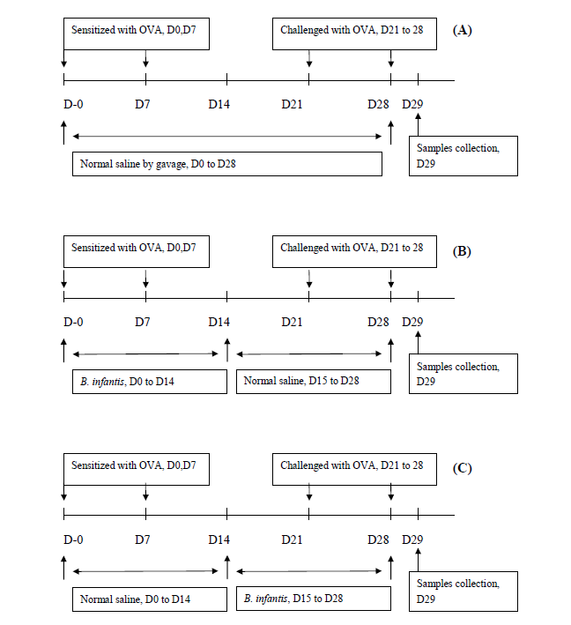
Figure 1 Protocols used for the establishment of mouse models. A: Allergic asthma; B: Prevention; C: Pre-treatment of OVA-induced airway allergy with B. infantis CGMCC313-2.
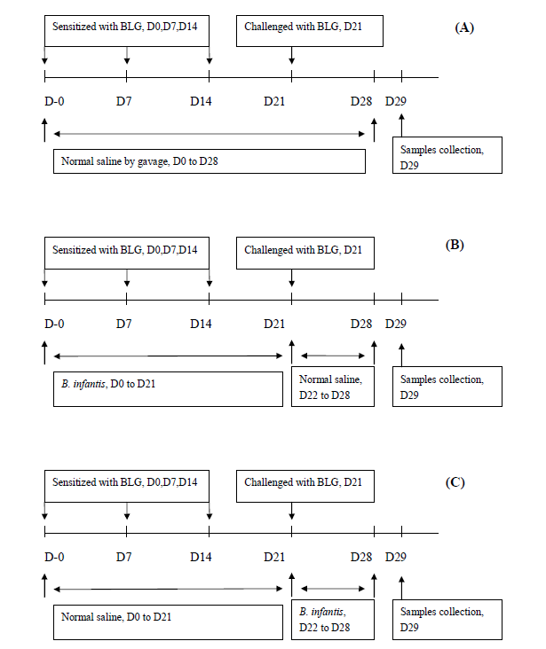
Figure 2 Protocols used for the establishment of mouse models. A: Food allergy; B: Prevention; C: Pre-treatment of ß-lactoglobulin-induced food allergies with B. infantis CGMCC313-2.
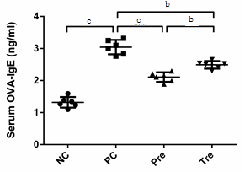
A
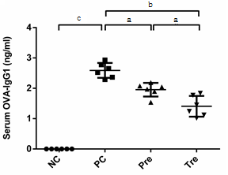
B
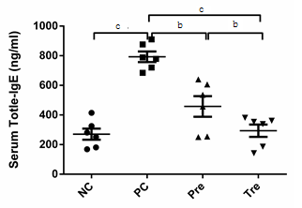
C
Figure 3 Effect of B. infantis CGMCC313-2 on the reversal of IgE and IgG1 in OVA-induced asthma and BLG-induced food allergy mouse models. A and B: There were significant increase of OVA-specific IgE and IgG1 expression in positive control (PC; Group 2) group compared with normal control (NC; Group 1) group in allergic asthma mouse model. While prevention (pre; Group 3) and pre-treatment (tre; Group 4) groups with B. infantisCGMCC313-2 administration had decreased expression. C: There was significant increase of total IgE expression in positive control (PC; Group 2) group compared with normal control (NC; Group 1) group in BLG-induced food allergy mouse model. While prevention (pre; Group 3) and pre-treatment (tre; Group 4) groups with B. infantis CGMCC313-2 administration had decreased expression. The statistical differences are represented as follows: ªP < 0.05; ^{b}P < 0.01, and ^{c}P < 0.001.

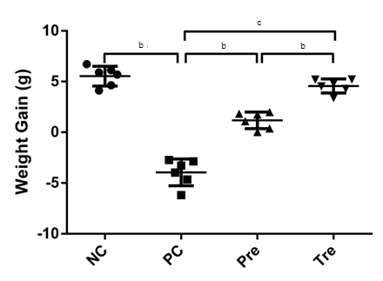
Figure 4 Effect of B. infantis CGMCC313-2 on body weight in BLG-induced food allergy mice. Average body weight decreased significantly in the positive control (PC; Group 2) group compared with normal control (NC; Group 1) group. Prevention (pre; Group 3) and pre-treatment (tre; Group 4) groups with B. infantis CGMCC313-2 administration had increased. The statistical differences are represented as follows: ªP < 0.05; ^{b}P < 0.01, and ^{c}P < 0.001.

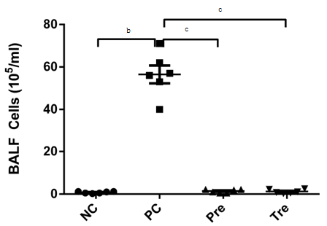
Figure 5 Effects of B. infantis CGMCC313-2 on infiltrating cells in the lungs of ovalbumin-induced allergic asthma mice. Total cell number in BALF increased significantly in the positive control (PC; Group 2) group compared with normal control (NC; Group 1) group. Prevention (pre; Group 3), and pre-treatment (tre; Group 4) groups with B. infantis CGMCC313-2 administration had decreased. The statistical differences are represented as: ªP < 0.05; ^{b}P < 0.01, and ^{c}P < 0.001.

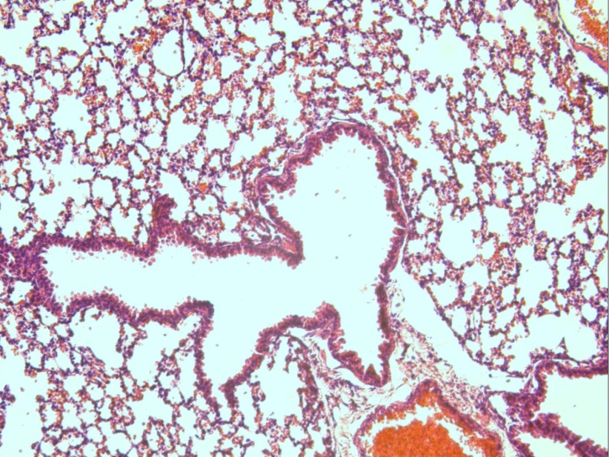
A
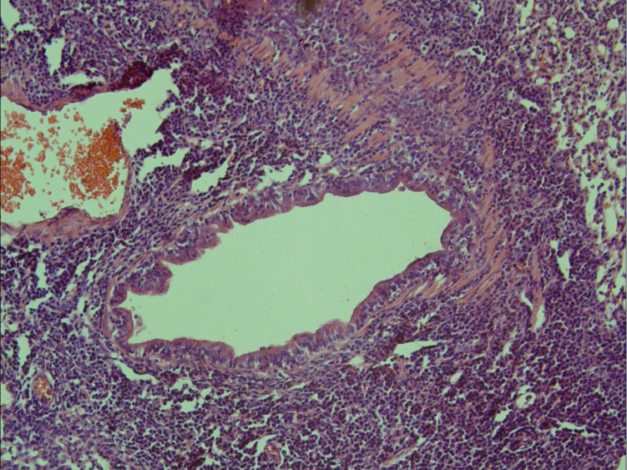
B
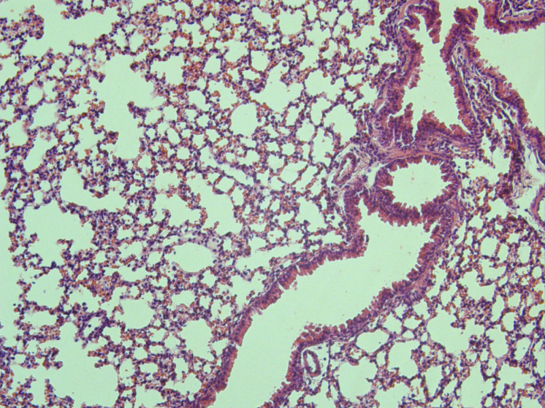
C
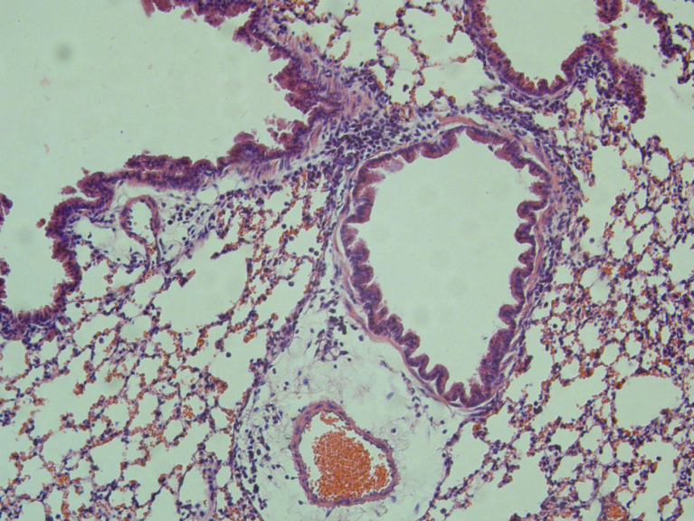
D
Figure 6 Effects of B. infantis CGMCC313-2 on OVA-induced airway inflammation. Besides (C) prevention group and (D) pre-treatment group which were treated with B. infantis CGMCC313-2, lung tissues were also obtained from (A) the normal control group and (B) the ovalbumin -sensitized/challenged group on Day 29. The tissues were stained and imaged under × 200 magnification. The positive control group shows severe airway inflammation, while the groups with B. infantis CGMCC313-2 administration shown relieved airway inflammation.

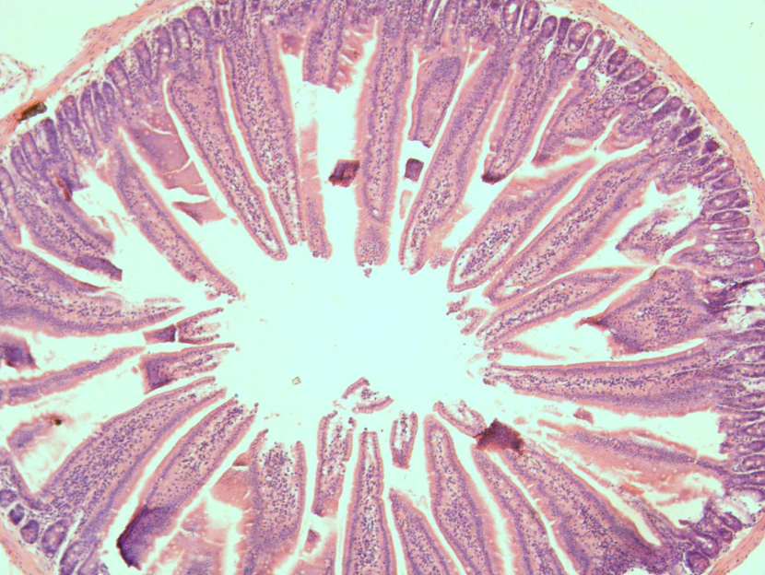
A
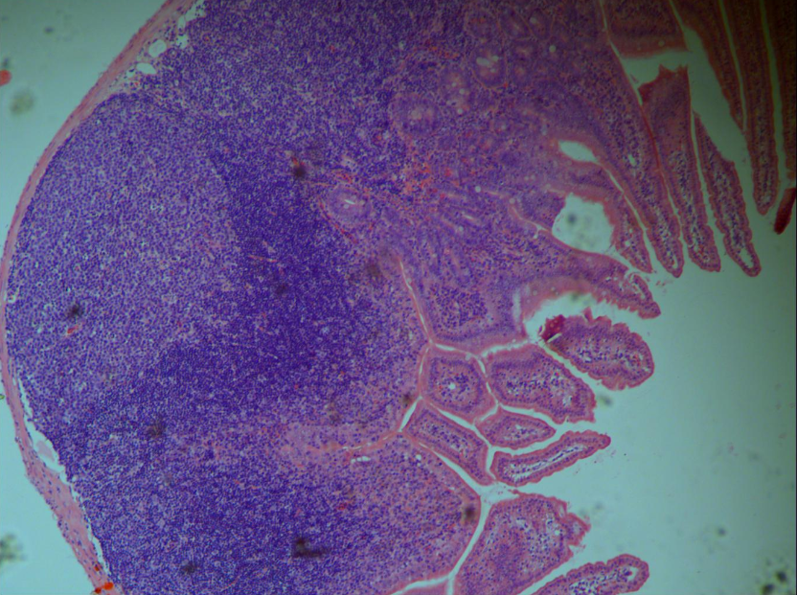
B
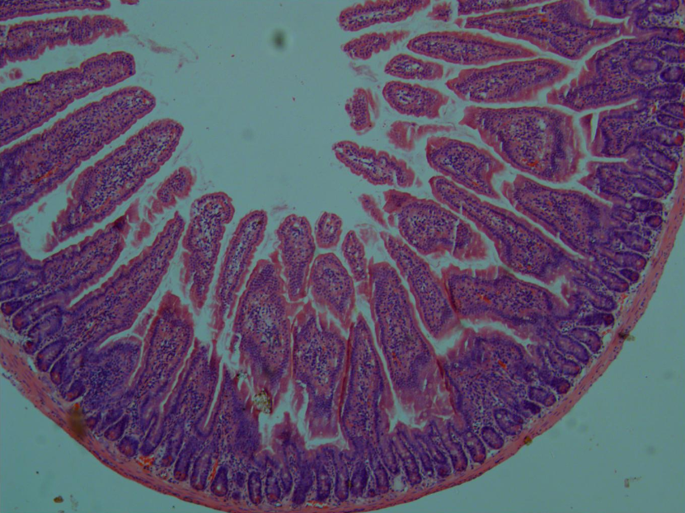
C
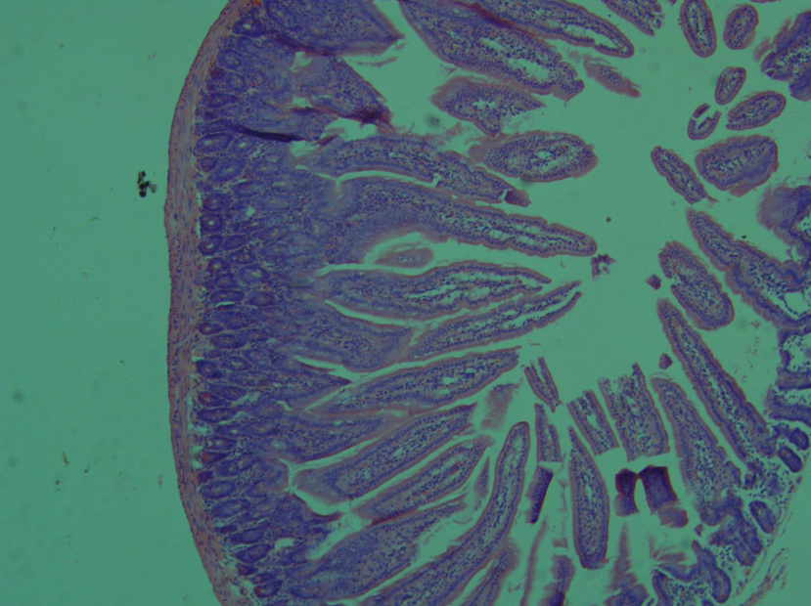
D
Figure 7 Effects of B. infantis CGMCC313-2 on BLG-induced intestine inflammation. Intestine tissues were obtained from (A) the normal control group and (B) the BLG-sensitized/challenged group on Day 29, along with (C) prevention group and (D) pre-treatment group which were treated with B. infantis CGMCC313-2. The tissues were stained and imaged under200x magnification. The positive control group shows severe intestinal inflammation, while the groups with B. infantis CGMCC313-2 administration exhibit relieved intestinal inflammation.

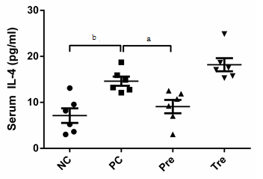
A
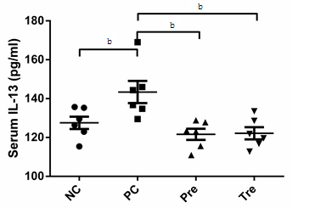
B
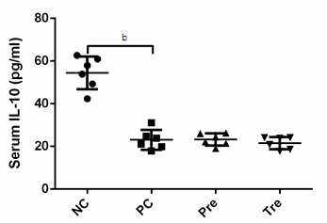
C
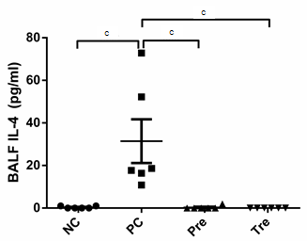
D
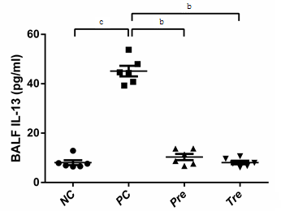
E
Figure 8 Effects of B. infantis CGMCC313-2 on cytokines in serum and BALF. IL-4, IL-10, and IL-13 in serum and BALF were detected in BLG-induced food allergy mice and OVA-induced allergic asthma mice, respectively. A: Serum IL-4 in prevention (pre; Group 3) group; B: serum IL-13 in prevention (pre; Group 3) and pre-treatment (tre; Group 4) groups were significantly decreased compared with positive control (PC; Group 2) group; C: There was no significant difference among positive control group (PC; Group 2), prevention group (pre; Group 3), and pre-treatment (tre; Group 4) group on IL-10, and it decreased significantly when compared with normal control (NC; Group 1) group; D: The concentration of BALF IL-4 and (E) BALF IL-13 were significantly decreased in the prevention (pre; Group 3) group and pre-treatment (tre; Group 4) group which were treated with B. infantisCGMCC313-2. The statistical differences are represented as follows: ªP < 0.05; ^{b}P < 0.01, and ^{c}P < 0.001.

