Name of Journal: World Journal of Hepatology
Manuscript NO: 67756
Manuscript Type: REVIEW

Pediatric non-cirrhotic portal hypertension: Endoscopic outcome and perspectives from developing nations

Sarma MS et al. Pediatric non-cirrhotic portal hypertension

Moinak Sen Sarma, Jayendra Seetharaman

Moinak Sen Sarma, Jayendra Seetharaman, Department of Pediatric Gastroenterology, Sanjay Gandhi Postgraduate Institute of Medical Sciences, Lucknow 226014, Uttar Pradesh, India

Author contributions: Sarma MS performed the conception, final drafting of the manuscript; Seetharaman J performed the primary drafting of the manuscript.

Corresponding author: Moinak Sen Sarma, MD, Associate Professor, Department of Pediatric Gastroenterology, Sanjay Gandhi Postgraduate Institute of Medical Sciences, Lucknow 226014, Uttar Pradesh, India. moinaksen@gmail.com

Received: April 30, 2021
Revised: June 27, 2021
Accepted: September 19, 2021
Published online: October 27, 2021

Abstract
Non-cirrhotic portal hypertension (NCPH) forms an important subset of portal hypertension in children. Variceal bleed and splenomegaly are their predominant presentation. Laboratory features show cytopenias (hypersplenism) and preserved hepatic synthetic functions. Repeated sessions of endoscopic variceal ligation or endoscopic sclerotherapy eradicate esophageal varices in almost all cases. After variceal eradication, there is an increased risk of other complications like secondary gastric varices, cholangiopathy, colopathy, growth failure, especially in extra-hepatic portal vein obstruction (EHPVO). Massive splenomegaly-related pain and early satiety cause poor quality of life (QoL). Meso-Rex bypass is the definitive therapy when the procedure is anatomically feasible in EHPVO. Other portosystemic shunt surgeries with splenectomy are indicated when patients present late and spleen-related issues predominate. Shunt surgeries prevent rebleed, improve growth and QoL. Non-cirrhotic portal fibrosis (NCPF) is a less common cause of portal hypertension in children in developing nations. Presentation in the second decade, massive splenomegaly and patent portal vein are discriminating features of NCPF. Shunt surgery is required in severe cases when endotherapy is insufficient for the varices. Congenital hepatic fibrosis (CHF) presents with firm palpable liver and splenomegaly. Ductal plate malformation forms the histological hallmark of CHF. CHF is commonly associated with Caroli’s disease, renal cysts, and syndromes associated with neurological defects. Isolated CHF has a favourable prognosis requiring endotherapy. Liver transplantation is required when there is decompensation or recurrent cholangitis, especially in Caroli’s syndrome. Combined liver-kidney transplantation is indicated when both liver and renal issues are present.

Key Words: Extrahepatic portal vein obstruction; Non-cirrhotic portal fibrosis; Portosystemic shunt surgery; Congenital hepatic fibrosis

©The Author(s) 2021. Published by Baishideng Publishing Group Inc. All rights reserved.

Citation: Sarma MS, Seetharaman J. Pediatric non-cirrhotic portal hypertension: Endoscopic outcome and perspectives from developing nations. World J Hepatol 2021; 13(10): 1269-1288
URL: https://www.wjgnet.com/1948-5182/full/v13/i10/1269.htm
DOI: https://dx.doi.org/10.4254/wjh.v13.i10.1269

Core Tip: The review discusses the natural history, endoscopic outcome, and management of non-cirrhotic causes of portal hypertension in children, especially in resource constraint developing nations. Extrahepatic portal vein obstruction is the most common cause of portal hypertension in developing countries. Endoscopic variceal ligation and sclerotherapy effectively eradicate the esophageal varices. Other complications require shunt surgery that ultimately reverses portal hypertension. Non-cirrhotic portal fibrosis has favourable outcomes in terms of variceal bleeding and mortality. Isolated congenital hepatic fibrosis (CHF) has a relatively good outcome. Liver transplantation is required when CHF is associated with Caroli’s disease, recurrent cholangitis, and decompensation. The presence of significant renal disease requires combined liver and kidney transplantation.

INTRODUCTION
Portal hypertension refers to a pathological increase in portal pressure. Direct measurement of portal pressure is clinically impractical and cumbersome. The indirect way of estimating of portal pressure is by the measurement of the hepatic venous pressure gradient (HVPG), which is the difference between hepatic venous wedge pressure and free hepatic venous pressure^{[1]}. When the blood flow in the hepatic venous channels is obstructed by a catheter, the proximal static column of blood in the hepatic veins communicates with the hepatic sinusoids reflecting sinusoidal pressure. Normal HVPG is between 1 to 5 mmHg^{[2]}. HVPG ≥ 10 mmHg is defined as clinically significant portal hypertension^{[3]}. HVPG > 12 mmHg predisposes to variceal rupture. Non-cirrhotic portal hypertension (NCPH) refers to the conditions where causes other than liver cirrhosis are responsible for portal hypertension. Causes of NCPH are extra-hepatic portal vein obstruction (EHPVO), non-cirrhotic portal fibrosis (NCPF) and congenital hepatic fibrosis (CHF). NCPH is different from cirrhosis in various aspects. Unlike cirrhosis, NCPH has normal synthetic functions (hypoalbuminemia, coagulopathy), but mostly presents as variceal bleed and splenomegaly^{[1,4]}. The incidence of decompensation and mortality following a variceal bleed is much lower in NCPH as compared to cirrhosis^{[5]}. NCPH is overall uncommon in the West. Issues in developing countries are unique. This review discusses the endoscopic and outcome perspectives of NCPH in children.

EHPVO
Pathophysiological implications
Acute portal vein thrombosis in children is an event that is usually unrecognized and on most occasions, the etiology is unknown. It is perceived that an innocuous insult to the portal vein takes place in infancy or early in childhood. A preceding febrile illness, intra-abdominal infection, or dehydrating illness is usually followed by subtle abdominal pain or transient ascites which may have been forgotten or undetected. In retrospect, a search into the child’s past history is often unyielding and perplexing for the physician. Following this event of portal vein thrombosis, the thrombus begins to organize. To bypass the obstruction, multiple hepatopetal collaterals form in 6-20 d to compensate for the high-volume flow from the splanchnic system draining into the liver. A well-established portal cavernoma forms in 3 wk^{[1,4]}. This “temporary adjustment” by the body is however insufficient to decompress the high portal pressures. As a result, varices, hemorrhoids, collaterals, and spontaneous shunts form between the portal and systemic circulation. As evident from the series by Orloff et al^{[6]}, EHPVO involves portal vein alone in 70%, portal vein and splenic vein in 20%, portal vein and superior mesenteric vein (SMV) in 5%, and all three veins in 10%^{[6]}. A liver biopsy will show mild periportal fibrosis with no signs of hepatocyte injury^{[7]}.

Clinical features
In developed nations, the mean age of presentation is around three years even before the variceal bleed^{[8]}. However, in developing nations, EHPVO predominantly presents as variceal hemorrhage mostly from esophageal varices (77%-84%). The rest present as non-bleeders with isolated splenomegaly (16%-23%)^{[9–11]}. The reason for presentation as variceal bleed in third world countries is due to delay in diagnosis and poor referral systems. The age of presentation is 6.3-9.3 years with a mean number of 1.8-3.1 bleeding episodes per child at the time of presentation^{[11,12]}. Antecedent febrile illness and respiratory tract infection (Valsalva maneuver) tends to rupture the varices. Bleeding is worsened by ingestion of non-steroidal anti-inflammatory drugs (e.g., ibuprofen, diclofenac). Long-standing gastroesophageal reflux also predisposes to erosions over the varices. Episodes of variceal bleeding are recurrent and tend to increase in frequency and severity with age. The presence of postural signs (dizziness, syncope, prostration) and hypotension indicates significant blood loss^{[11]}. Clinical examination reveals isolated splenomegaly without any stigmata of chronic liver disease. The liver may be palpable if the patient is in cardiac failure due to anemia (post-bleeding). Splenic size may acutely decrease just after a massive hemorrhage (to compensate for the volume loss) and resume pre-bleeding size soon after blood transfusion.
Massive splenomegaly causes a dragging sensation, left upper quadrant pain, and early satiety^{[1]}. Though hypersplenism is common, symptoms related to the same (symptomatic anemia, spontaneous skin bleeds) are less common in adults and rare in children (5%)^{[13]}. Chronic dragging sensation and apprehensions of rupture of a massive spleen may preclude them from contact sports. Massive bleeding may be accompanied by diuretic-responsive transient transudative ascites in 4%-18% cases^{[12,14]}. Jaundice is seen in advanced EHPVO due to symptomatic portal cholangiopathy (5%-19%) resulting from obstruction of extrahepatic bile ducts (compression by collaterals or ischemic biliary strictures) but it is extremely rare in children^{[15–17]}. Unscreened blood transfusion in the past may cause chronic hepatitis B or C infection manifesting later with frank liver disease. Growth retardation (stunting and wasting) occurs in up to 33%-54% children^{[18,19]}. Portal colopathy is a complication that presents with bleeding per rectum from anorectal varices and mucosal changes in the colon but is less commonly seen in children^{[20]}. Small bowel ectopic varices are rare yet cause a considerable diagnostic dilemma.

Growth failure and quality of life
Duration and severity of portal hypertension determine the growth of the child. A pediatric series on EHPVO showed that growth retardation (stunting and wasting) occurs in 54% of children^{[19]}. The theories proposed for the same are (1) Malabsorption due to portal enteropathy; (2) Deprivation of hepatotropic factors due to poor portal supply to the liver; (3) Chronic anemia; and (4) Growth hormone resistance as shown by increased levels of growth hormone and decreased levels of insulin-like growth factor-1 and insulin-like growth factor binding protein-3. Menon et al^{[21]} had observed that after shunt surgery there was an improvement in height velocity in 76% of EHPVO children^{[21]}. The study supported the portal enteropathy hypothesis as a reason for growth retardation. In a prospective study in which adequate nutritional intake was ensured, anthropometry, fasting growth hormone, and insulin-like growth factor 1 were compared between 22 well-nourished patients with EHPVO with growth retardation and 35 age-matched well-nourished controls. Insulin-like growth factor scores were significantly lower in patients (-1.48 ± 0.88) than in controls (-0.49 ± 1.09, P < 0.001), whereas basal growth hormone was significantly higher in patients (4.60 ± 3.70 mIU/L) compared to controls (2.66 ± 0.82, P < 0.01)^{[18]}. Improvement in growth parameters seen at 12 and 24 mo after meso-Rex bypass, is possibly due to restoration of blood supply to the liver^{[22]}.
Poor health-related quality of life (QoL) and school performance is contributed by anemia and various social stigmata. EHPVO children have growth retardation and protuberant abdomen as compared to their peers in school. They also have minimal hepatic encephalopathy causing behavioural issues. QoL scores do not show much improvement on variceal eradication but may improve after shunt surgery^{[21,23]}.

Endoscopic outcome of esophageal varices
The majority of EHPVO patients present as variceal bleed. Unlike cirrhosis, adequately tackling the variceal bleed by endoscopic therapy ensures < 5% mortality. The rate of variceal growth in EHPVO varies among different individuals^{[9,10]}. The 1-year, 3-year, and 5-year probability of development of esophageal varices is 2%, 22%, and 22% respectively and growth from small to large size is 13%, 40%, and 54% respectively^{[24]}. Endoscopic therapy of the esophageal varices consists of endoscopic variceal ligation (EVL) and endoscopic sclerotherapy (EST). Both are preferred endoscopic therapies for acute variceal bleeding (Figure 1). The eradication rate of esophageal varices with EST is 88%-100%. However, complications like esophageal ulcers (8%-30%) and strictures (6%-20%) are commonly seen with EST^{[25–27]}. Though EVL has the advantages of rapid eradication of varices requiring fewer sessions and lesser incidence of complications, the studies of EVL are limited in children. EST is preferred for smaller children as there is difficulty in inserting the banding cylinder during EVL. Children lesser than 2 years have a physiologically narrow cricopharynx. Smaller band cylinders are compatible with thinner endoscopes but may not generate adequate pressure suction on the esophageal varices for banding. In developing countries, EST is possibly more cost-effective compared to EVL. In a randomized controlled trial of EST vs EVL in children by Zargar et al^{[28]}, the efficacy of controlling bleeding and rate of variceal eradication was similar in both groups (100% in both and 96% vs 91.7% respectively), but overall EVL was better as it required lesser number of sessions (3.9 vs 6.1), had lower re-bleeding (4% vs 26%) and complication rates (4% vs 25%)^{[28]}. A study from the authors’ center has shown that sequential EVL followed by EST (Group I, n = 101) is superior to EST alone (Group II, n = 60) in a 3 wkly endoscopy regimen till eradication. Group I required significantly fewer sessions (5.2 ± 1.8 vs 6.8 ± 2.8, P < 0.005), less sclerosant (13 ± 8.2 mL vs 30 ± 20 mL, P < 0.001) and had fewer complications (7% vs 28%, P < 0.001) as compared with group II^{[29]}. Many pediatric hepatology centers in Asia consider a 3-weekly protocol of sequential downgrading of large esophageal varices by EVL followed by EST injection into the smaller varices till eradication. While EVL rapidly reduces the size of varices, EST effectively blocks the paraoesophageal perforators which ultimately lowers the risk of recurrence. This is advantageous as the cumulative dose of sclerosants and risk of complications are much lower in sequential therapy as compared to the EST alone^{[30]}. Long-term sequelae of esophageal dysmotility is a concern with cumulative sclerotherapy.

Management and outcome of gastric varices
Gastric varices bleed less frequently but more profusely as compared to esophageal varices^{[31]}. In a study with 274 children with EHPVO, 70% had primary gastric varices at presentation, of which 97% had gastroesophageal varices (GOV) and 3% had isolated gastric varices (IGV)^{[32]}. After esophageal variceal eradication with EST, gastric varices may disappear or persist or develop afresh (secondary gastric varices). Disappearance is seen more often along the lesser curvature of the stomach (GOV1) than the greater curvature (GOV2). In a study from the author’s center, GOV1 decreased from 45% to 30% and GOV2 increased from 8% to 13% during esophageal variceal eradication. Secondary gastric varices develop in 28%. Of these, 87% are constituted by isolated gastric varices in the fundus (IGV1) and the rest in the body and antrum (IGV2)^{[33]}. The reduction of GOV1 is attributable to the fact that GOV1 arises from deep submucosal veins from the left gastric vein into which there has been a flow of sclerosant from the esophageal varices. GOV2 varices are formed by the collaterals from the left gastric and short gastric veins. IGV1 is formed exclusively by the short gastric veins. Short gastric veins do not receive any sclerosant as they do not communicate with the esophageal varices. As the esophageal varices and GOV1 shrink during endoscopic therapy, the blood is diverted through IGV1 and GOV2 to accommodate the persistent portal pressure and blood volume in the portal system. Following eradication of esophageal varices, IGV1 incidence increases significantly from 1% to 14% (P < 0.001), and the incidence of bleeding from gastric varices increases from 0% to 20%^{[32]}. Acute gastric variceal bleeding is managed by 1-2 mL of glue (N-acetyl-2-butyl-cyanoacrylate) injection^{[3]} (Figure 1). Repeated sessions of glue injection have the risk of glue cast fundal ulcers, obliteration of splenic vein for future portosystemic shunt surgery (PSS), and difficulties in the mobilization of the spleen during surgery. Hence, whenever large fundal varices are noticed, it is better to perform PSS if the anatomy is feasible. Antral varices (IGV2) rarely bleed even after eradication of esophageal varices and hence prophylactic endotherapy is not usually required^{[31]}.

Management and outcome of portal hypertensive gastropathy
Frequency, extent, and severity of portal hypertensive gastropathy (PHG) increase after esophageal variceal obliteration by endoscopic therapy. This results from increasing gastric mucosal venous congestion that occurs along with the decreasing collateral blood flow through the varices. In a study from our center, pre-EST PHG was documented in 40% of cases, all were mild. After eradication of esophageal varices, PHG increased to 80%, half were mild and the rest were severe^{[33]}. In another study, the prevalence of mild and severe PHG increased from 25% to 52% and 3.2% to 16% respectively with statistical significance following esophageal variceal eradication. Bleeding from PHG is uncommon in EHPVO children^{[32]}. Repeated sessions of argon plasma coagulation is a promising modality of management for symptomatic gastric antral vascular ectasia.

Natural history and outcome of portal cavernoma cholangiopathy
Portal cavernoma cholangiopathy (PCC) denotes the cholangiographic abnormalities involving both intra-hepatic and extra-hepatic bile ducts including gall bladder wall abnormalities in patients with portal hypertension. It is seen as biliary radical dilatation, filling defects, indentations, angulations, filling defects or a tumor mass (pseudocholangiocarcinoma sign)^{[34]}. They occur due to compression of peri and para choledochal varices. Intracholedochal varices appear as filling defects within the lumen seen on endosonography and choledochoscopy. PCC is most commonly seen in EHPVO (80%-100%) as compared to cirrhosis (0%-33%)^{[1]}. The prevalence of PCC is almost 100% in adults, however, the data is limited in children^{[15,35,36]}. A prospective study conducted in the authors’ center in 72 EHPVO children showed the prevalence of PCC as 92% of which 7% were symptomatic. In this study, the age at presentation and the duration of disease in asymptomatic PCC were 13.9 ± 2.3 and 6.9 ± 4.0 years respectively. This was significantly lower than the symptomatic group where age and duration were 16.1 ± 0.9 and 11.0 ± 1.4 years respectively. Age at presentation and duration of disease had a significant linear correlation^{[37]}. It has been observed symptoms of PCC are more commonly seen in adults as compared to children, implying that the duration of portal hypertension in EHPVO is responsible for progressive bile duct disease to cause symptoms^{[35]}. In a study of adults with symptomatic PCC, the median age of presentation with symptoms of PCC was 41 years^{[38]}. The mean interval between the first presentation with variceal bleed and jaundice was 7.4 years in another adult study^{[39]}. In a study by Llop et al^{[40]} in adults, it was shown that the 5-year and 10-year actuarial probability of developing symptomatic PCC after diagnosis of chronic portal vein thrombosis was 9% and 13%, respectively^{[40]}. Zargar et al^{[41]} followed 69 EHPVO children for 15 years and 4% developed biliary obstruction^{[41]}. Symptoms arise due to obstruction of bile flow and result in cholestatic jaundice, pruritus, cholangitis, and gall stones. The implication of finding symptomatic PCC in children is grave. This would possibly mean tenacious strictures or stones that would entail multiple therapeutic endoscopies. A series of complications are anticipated. The endoscopic biliary interventions have technical limitations in younger children. Biliary drainage is associated with a risk of hemobilia from rupture of intracholedochal varices. Endoscopic intervention is easier for lower biliary strictures than higher strictures, more so in children. Refractory strictures may necessitate bilio-enteric anastomosis. Long-standing disease results in secondary biliary cirrhosis. In EHPVO, secondary biliary cirrhosis is an unfortunate consequence of a problem where a primary liver disease never existed in the first place. Considering the longevity of a child, QoL in the growing years, and gainful living, it is imperative to actively search for asymptomatic biliary changes with serial imaging. There are two hypotheses for biliary changes in EHPVO, extrinsic compression by portal collaterals and ischemic stricture due to bile duct injury or a combination of both^{[15,35,42]}. In a study by Dhiman et al^{[42]}, endoscopic retrograde pancreato-cholangiography (ERCP) done in five cases post shunt surgery showed total disappearance of changes in two, partial response in one, and no improvement in two, indicating the relief of compression alone was not the reason for biliary changes^{[42]}. The definitive diagnosis of PCC is by ERCP but due to its invasive nature, magnetic resonance cholangiopancreatography with gadolinium injection to delineate the cavernoma is preferred in children^{[43]}. Symptomatic PCC should be managed but the requirement of management in asymptomatic PCC is doubtful. Also, steps for management of PCC are not clear. Should shunt surgery be offered in all symptomatic PCC followed by bilioenteric anastomosis (hepaticojejunostomy) or should endoscopic drainage be primarily performed before PSS^{[39,44]}? Prior shunt surgery effectively decompresses the cavernoma in 6-12 mo and makes it easier for subsequent biliary drainage surgeries (Figure 2). Second stage hepaticojejunostomy is required in 28%-50% in adult studies following shunt surgery^{[39,44,45]}. Issues with endoscopic biliary drainage are its invasive nature, need for technical expertise, and lack of smaller-sized endoscopes and biliary metallic stents in children. Meso-Rex shunt restores the blood flow to the liver to decompress the cavernoma adequately. In the study by Gauthier-Villars et al^{[46]}, 2/8 children with symptomatic PCC underwent Rex shunt, and liver biochemistry completely normalized post shunt surgery^{[46]}. Meso-Rex shunt is not possible in most children due to unfavourable vascular anatomy where the left branch of the portal vein or SMV is blocked. Meso-Rex bypass is also ineffective if there is a large spleen at the time of presentation. In the study from the authors’ center, 25 children with EHPVO underwent central end to side splenorenal shunt. Despite the patency of shunt 18 mo post-surgery, asymptomatic PCC did not improve in the majority. All the children who had progressive PCC after shunt surgery had concomitant SMV block. SMV block not only makes meso-Rex shunt non-feasible but also causes severe PCC^{[47]}. The venous plexuses on the common bile duct drain into the portal vein and SMV territories. When the portal vein is occluded, the choked peribiliary collaterals compress upon the bile duct. In such a scenario, SMV is the only pathway for decompression. When the SMV is occluded too, the choking effect of the biliary venous plexuses is near total. Peribiliary collaterals enlarge further and compress the already narrowed common bile duct. A central end to side PSS does not effectively relieve the peribiliary portal hypertension since the connection is between the splenic and left renal vein. Future studies are required to address whether PSS is required in an asymptomatic PCC in children to prevent the burden of complicated PCC and the development of SMV block as they enter adulthood. The management of PCC poses great dilemmas in children. Issues such as choice of shunt surgery, adequate decompression of biliary varices, the appropriate time for bilioenteric anastomosis, and prophylactic biliary dilatation for strictures are well debated. Despite active screening for PCC in all children, we must understand that symptoms arise as a result of procrastination in treating asymptomatic PCC. Symptomatic PCC definitely requires biliary drainage but the requirement of biliary decompression in asymptomatic PCC is a dilemma not only in children but also in adults. After detecting PCC, the logical step forward has to be decompression of portal hypertension with PSS. In those with symptomatic PCC, endoscopic therapy may be required before the shunt surgery. Endoscopic therapy is reserved for selected cases of cholangitis and choledocholithiasis. Limitations such as lack of appropriate sized endoscopes and biliary metallic stents (not approved yet) are unique issues in children. The experience of meso-Rex bypass for relieving PCC is limited. Non-selective shunt surgeries may not have a wholesome outcome in PCC.

Natural history and management of portal colopathy
Portal colopathy is most commonly seen with EHPVO as compared to cirrhosis probably due to selective redistribution of portal pressure with time along the inferior mesenteric vein consequent to thrombosis at the junction of the splenic vein and SMV^{[48,49]}. Similar to PCC, the prevalence of portal colopathy is lower in children compared to adults emphasizing the importance of the duration of portal hypertension. Unlike PCC, PSS effectively reverses colopathy. Portal colopathy is defined as the presence of colitis-like abnormalities (edema, erythema, ulcers), vascular lesions (cherry-red spots, ectasia, and spider angiomas) with or without the presence of colorectal varices (3-5 mm) by endoscopy and/or endosonography. Rectal endosonography is superior to sigmoidoscopy for identifying rectal varices^{[20,50]}. Prevalence of rectal varices in adults is 63%-94%^{[20,49,51]}. In a study from the authors’ center, rectal varices were seen in 36% of 25 EHPVO children by sigmoidoscopy and 76% by rectal endosonography^{[50]}. Rectal varices occur in 80%-90% of adults with EHPVO but the overt bleeding frequency is low (3%-8%). In another study from our center, only 16.6% of EHPVO were symptomatic for colopathy/rectal varices. 94% showed rectal varices and 75% showed colitis-like changes on routine colonoscopy. Colopathy and colitis-like lesions were more common than vascular lesions (36/40 vs 23/40; P = 0.001). Colopathy changes were pancolonic in 52.5%, left-sided in 42.5%, and right-sided in 5% cases. 16% also had ileal changes. Children with colopathy had more often (90% vs 57%; P = 0.01) PHG, more endotherapy sessions (6^{[4-8]} vs 2^{[1-4]}; P = 0.03), and less often large esophageal varices (12.5% vs 43%; P = 0.02) than those without colopathy^{[52]}. Mucosal changes like erythema, friability, and superficial ulcerations should not make the endoscopist suspect inflammatory bowel diseases, especially in the setting of portal hypertension as the shunt surgery effectively reverses the colitis like changes in these cases^{[53]}. Bleeding rectal varices can be managed with sclerotherapy or band ligation^{[20]}. PSS is preferred for large rectal varices and symptomatic colopathy. When PSS is anatomically not feasible, beta-blockers should be considered. Laser photocoagulation and Argon plasma coagulation are tried in adults in severe cases, but the studies in children are limited^{[54]}.

Rare complications in EHPVO
Minimal hepatic encephalopathy (MHE) in EHPVO without shunt surgery has been observed in 32% of cases using neuropsychological testing and 57% by critical flicker frequency techniques^{[55,56]}. EHPVO is an example of type B hepatic encephalopathy where there is a portosystemic bypass in the absence of intrinsic liver disease. The other reasons attributed are chronic deprivation in hepatic blood flow leading to parenchymal extinction, increased brain glutamine, and increased proinflammatory cytokines^{[57]}. Following shunt surgery, as the toxic substances bypass the liver into the systemic circulation, MHE is more prevalent in non-selective shunts as compared to selective shunts. The reversal of MHE following shunt surgery in EHPVO is not well established.
Ascites is an uncommon complication of EHPVO. In a study from the authors’ center, 307 EHPVO children were analyzed, of which 26% developed ascites. 84% of ascites were following variceal bleeding. Younger age of onset, baseline malnutrition, hypoproteinemia are predictors of post-bleed ascites. The time interval between the first bout of bleed to the onset of ascites and hospital admission was 7 (3-20) and 12 (5-45) d respectively. 17% of patients had features of ascitic fluid infection requiring antibiotics. For the resolution of ascites, 32% required only salt restriction, 39% required the addition of diuretics, and 29% required single-time large-volume paracentesis. The overall resolution of ascites was seen in 46%, 76%, 88%, and 100% by days 7, 14, 30, and 60 respectively. In this study, 17 patients re-bled, of which 11 had a recurrence of post-bleeding ascites. None of the patients had any evidence of chronic liver disease on follow-up of 56 (9-112) mo^{[58]}. The mechanism of de novo ascites is not well understood. Secondary causes and hepatic dysfunction are possible responsible factors. Rangari et al^{[14]} analyzed 9 chronic EHPVO adults with ascites who had not bled in the last 3 mo. These patients had raised alanine transaminase, hypoalbuminemia, and deranged coagulation. Ascites in this study were attributable to increased age, longer duration of disease, and PCC. They postulated that the underlying liver dysfunction was caused due to a reduced parenchymal liver mass^{[14]}.
Hepato-pulmonary syndrome (HPS), though common in advanced cirrhosis, is rarely seen in EHPVO also. The prevalence of HPS in EHPVO is 2%-10%^{[59,60]}. The incidence of HPS in EHPVO shows that apart from hepatic dysfunction, portal hypertension per se is responsible for HPS. Hepatic dysfunction is not unseen in EHPVO. It occurs more in the older age due to parenchymal extinction and is more seen with prolonged portal hypertension. PCC is commonly associated with hepatic dysfunction^{[14]}. Portal hypertensive enteropathy is not unusual in children, seen in both cirrhotics and non- cirrhotics. In the study from the authors’ center, children with EHPVO showed features of enteropathy as evident by duodenal morphometric features (60%). The features were lower villous to crypt ratio, dilated capillaries, increased thickness of muscularis mucosae) and increased small intestinal permeability (lactulose excretion test) as compared to healthy controls^{[61]}. Portal hypertensive enteropathy is one of the most important causes of growth failure in children.

Outcome of shunt surgery
Endotherapy significantly improved mortality due to variceal bleeding as compared to the pre-endoscopic era. Endotherapy (EVL/EST) causes eradication of esophageal varices in 90%-95% EHPVO cases^{[62]}. As endotherapy obliterates portosystemic collaterals in the esophageal region, the persistently elevated portal pressure causes rebleed in 7%-41% of cases following endotherapy^{[33,41,62,63]}. There is also a significant risk of developing other complications related to high portal pressures such as ectopic varices, gastropathy, colopathy, cholangiopathy, growth failure, and hypersplenism. A randomized trial comparing endotherapy and shunt surgery showed the risk of rebleeding is significantly higher in the endotherapy group^{[64]}. The study by Krishna et al^{[23]} showed the QoL remained poor even after variceal eradication on endotherapy due to various reasons like growth retardation, cholangiopathy, ectopic varices, massive spleen related pain, early satiety, and infarction^{[23]}.
Shunt surgery is indicated in EHPVO whenever feasible. However, there are various approaches in the surgical management of EHPVO (Figure 3). Baveno VI guidelines recommend that meso-Rex Bypass should be offered for primary, pre-primary, and secondary prophylaxis for all cases of EHPVO^{[3]}. However various factors preclude meso-Rex bypass in all children with EHPVO such as anatomic non-feasibility, the need for technical expertise. Another feasible intervention is PSS, a procedure ideally performed after tackling the first episode of variceal bleed endoscopically. However, in developing nations, the bulk of the disease outweighs the number of centers that have expertise in conventional and physiological shunt surgeries. PSS is a popular shunt surgery for EHPVO as it not alone prevents rebleeding but also improves other complications like colopathy, cholangiopathy, growth, QoL, etc. PSS consists of selective (distal splenorenal shunt) and non-selective shunt (proximal or central-end to side splenorenal shunt with splenomegaly, side to side splenorenal shunt, and mesocaval shunt)^{[65,66]}. Each of the above-mentioned PSS has its own merits and demerits and hence, the choice of surgical procedure is tailored as per the indication for surgery and the anatomy of the splenoportal axis (the patency and diameter of the veins)^{[67,68]}. Broadly, if massive splenomegaly affects QoL adversely, then splenectomy with a central end-to-side splenorenal shunt is indicated. Splenectomy is required when issues related to massive splenomegaly and significant hypersplenism predominate. However, a spleen-preserving shunt is preferred if splenomegaly is not of concern. Side-to-side splenorenal shunts permit a large diameter vascular anastomosis if the splenic vein is of a small diameter (< 5 mm) calibre^{[68]}. The mortality following PSS is 0%-1.9%. Shunt thrombosis occurs in 2.5%-13% following PSS^{[6,67,69–71]}. On a few occasions, other surgical interventions may be required for selected indications when PSS is not feasible due to non-shuntable anatomy. Hepaticojejunostomy is required in symptomatic portal biliopathy, especially related to ischemic strictures. Emergency devascularization procedure is required when endotherapy fails to control acute variceal bleed, interval bleed, or recurrence of bleed following eradication. In the author’s center, 110 children underwent surgical intervention for delayed sequelae post-variceal eradication. PSS was performed in 83% whereas esophagogastric devascularization was performed in 17%. 91% showed shunt patency after a median follow-up duration of 28 mo following shunt surgery. Growth parameters, colopathy, issues related to splenomegaly improved in all^{[72]}.
Meso-Rex bypass requires placement of autologous vein graft between SMV and left branch of the portal vein and it is an ideal curative procedure conceptually. However, there are various limitations of the meso-Rex bypass. Complete patency of intrahepatic portal veins, including the recess of Rex, is required for performing this procedure. In a pediatric EHPVO study, 62% had favourable anatomy before surgery, and eventually, only 37% culminated into a successful meso-Rex bypass^{[73]}. Wedge hepatic venous portography is the gold standard for imaging of intrahepatic portal veins. 15% of all successful meso-Rex bypass need interventional radiological procedures like thrombectomy, shunt dilatation, or stenting to maintain shunt patency^{[74]}. The shunt blockage following meso-Rex bypass is 4%-19%^{[74–77]}. Meso-Rex bypass is not the procedure of choice when there is gross splenomegaly and hypersplenism.

Issues in developing countries
In the author’s understanding, the issues in developing nations are uniquely different from those in developing countries. Due to poor referral systems, the patients are referred to tertiary care centers in an advanced state where one or more of the above complications would have ensued. Meso-Rex bypass is favourable in the early stages where the left branch of portal vein and confluence are patent. In advanced disease, the anatomy is no longer favourable as the entire portal vein and its branches are affected by stasis and progressive local thrombosis. 64% of EHPVO children also have additional thrombosis of SMV or splenic vein which limits the choice of PSS^{[37]}. This possibly occurs at onset or due to local progression of thrombosis at the trijunction confluence. Proximal splenorenal shunt lowers portal pressure but does not ameliorate the PCC. Distal splenorenal shunt and meso-Rex bypass do not ameliorate issues of a large spleen. Those with entire splenoportal axis thrombosis are subjected to esophagogastric devascularization which diverts the blood away from the life-threatening variceal territory but fails to lower the portal pressure. Hence the long-term choice of definitive therapy is that of a compromised one. Keeping in mind the logistic issues in developing countries, it is the authors’ opinion that repeated endoscopic sessions should be performed till variceal eradication and an opportune time must be sought for a PSS if the disease is in an advanced state or if a meso-Rex bypass is not feasible. PSS has low post-operative mortality and good long-term shunt patency. Despite the compromise, PSS may be the only available option for amelioration of the disease.

NCPF
NCPF is also called idiopathic portal hypertension, hepatoportal sclerosis or obliterative venopathy. This is a disorder of no specified etiology characterized by massive splenomegaly, preserved liver function, and patent portal vein^{[1]}.

Pathophysiological implications
Etiopathogenesis of NCPF is not well understood and there are various theories for the same. Infections (Escherichia coli), prothrombotic states, immunological disorders, toxins (arsenic), and genetic factors are possible causative factors^{[75–78]}. Human immunodeficiency virus and hepatic schistosomiasis also are responsible for liver fibrosis similar to NCPF^{[79-83]}. Various theories explain the pathogenesis of NCPF though, none of the theories have been effectively proven. The unifying hypothesis suggested by Sarin and Kumar^{[84]}, suggests a major thrombotic event in a younger age is responsible for EHPVO but, a micro thrombotic event later in life is responsible for the obliteration of small and medium branches of portal veins resulting in NCPF^{[84]}. Schouten et al^{[85]} proposed a dual theory of splenic vein dilatation (due to high levels of nitric oxide synthase in splenic endothelial cells) and intrahepatic portal vein obliteration as the main pathogenesis in the development of NCPF^{[85]}. Sato and Nakanuma^{[86]}, suggested endothelial-mesenchymal transformation theory, according to which endothelial cells in portal vein branches acquire features of myofibroblast due to stress and ischemia thereby causing deposition of collagen in vessel walls causing obliteration^{[86]}. The histological hallmark of NCPF is obliterative portal venopathy. Other prominent features include aberrant vessels in the portal tract (portal angiomatosis), portal tract fibrosis and inflammation, and absence of significant hepatocellular injury. Incomplete nodules and scattered regenerative nodules are seen on a few occasions^{[87]}.

Clinical features
The incidence of idiopathic portal hypertension has reduced in Japan in the past two decades. Though no national registries are available, the incidence in India also seems to have decreased along with EHPVO^{[87]}. The change in the scenario could be due to the reduction in the incidence of umbilical sepsis, reduced diarrheal episodes in infancy due to better sanitation and vaccination programs^{[88,89]}. Studies from India show that NCPF accounts for 3.3%-4.6% of all pediatric portal hypertension^{[90,91]}. NCPF is commonly seen in the third to fourth decade in adults. Various pediatric series suggest that NCPF is not an uncommon entity in children^{[86]}. Variceal bleeding is the most common presentation in adults (72%) with a relatively small proportion presenting as a lump in the left upper quadrant (12%)^{[92,93]}. The scenario is different in children. In the author’s experience, the median age at presentation of NCPF was 14.5 (6-18) years where 49% and 47% presented as variceal bleed and unbled isolated splenomegaly respectively^{[90]}. Another pediatric series from India showed that only 16% presented as variceal bleed and the remaining 84% presented with isolated splenomegaly. Predominant presentation of variceal bleeding in adults is possibly due to a progressive increase in disease severity as age progresses^{[91]}. However, the overall natural history in adults is not different from pediatric series. 87% of NCPF in the authors’ study had hypersplenism with median spleen size 10.5 (1-17.5) cm on examination. Transient ascites and hypoalbuminemia were seen in 20% and 11% patients respectively, mostly after variceal bleeding. A small proportion of patients develop end-stage liver disease requiring liver transplantation^{[90]}.

Endoscopic outcome
The analysis of the NCPF cohort in the authors’ experience showed the predominant presence of esophageal varices (96%) and portal hypertensive gastropathy (89%) followed by primary gastric varices (56%) at presentation. The majority of the children showed eradication of esophageal varices and GOV1 after 5 (2-12) sessions. 36% showed recurrence of esophageal varices in about 1 year of follow-up and 12% developed secondary gastric varices (GOV2 and IGV1). Most of the PHG was mild in severity and PHG was significantly higher in bleeders as compared to non-bleeders probably due to higher portal pressures^{[90]} (Figure 4). Prevalence of esophageal varices in adult NCPF is similar in children (85%-95%) but the gastric varices at presentation were more common in adults compared to children^{[91]}. In a study by Chawla et al^{[94]}, endoscopic sessions in 72 adult NCPF patients showed eradication after a mean of 5.7 sessions of EST, and recurrence of varices occur in 9.2% over a follow-up period of 21 mo^{[94]}. Sarin et al^{[95]} compared adults with cirrhosis with NCPF, and EHPVO. Cirrhotics had a similar recurrence of variceal bleeding as compared to NCPF. Unlike cirrhosis, none of the EHPVO or NCPF died at follow-up suggesting that despite the progression of portal hypertension in NCPF, the liver parenchyma is preserved like in EHPVO^{[95]}.

Natural history and surgical outcome
Pediatric data on long-term follow-up studies are lacking (Table 1). Overall survival of NCPF is favourable. Poor outcomes like death, decompensation, and requirement of surgery were seen in 24% of patients^{[90]}. Adult series by Siramolpiwat et al^{[96]} reported native liver survival of 72% at 5 years^{[96]}. Similarly, the Spanish cohort of adults reported 86% native liver survival at 5 years^{[97]}. In a French follow-up study, 46% of patients develop portal vein thrombosis during a follow-up period of 7.6 years^{[98]}. Thus, the development of portal vein thrombosis is a major factor that also contributes to the progression of portal hypertension in NCPF. There is a paucity of published data on surgical management of NCPF both in children and adults. As most of the patients have predominant spleen-related issues, a non-selective PSS like central end to side splenorenal shunt with splenectomy would be a favourable compromise. Long-term complications of shunt surgery include hepatic encephalopathy, glomerulonephritis, hepatopulmonary syndrome, and ascites^{[99]}. In the authors’ experience, 10% require a central end to side splenorenal shunt with splenectomy^{[90]}.

CHF
CHF is a liver ciliopathy disorder of irregularly shaped proliferating bile ducts and periportal fibrosis. CHF is one of the fibropolycystic diseases, that include Caroli disease/syndrome, autosomal dominant polycystic kidney disease (ADPKD), an autosomal recessive polycystic kidney disease (ARPKD)^{[100]}.

Pathophysiological implications
CHF and related disorders occur as a result of ductal plate malformation (DPM). The ductal plate is the embryonic precursor of intrahepatic bile ducts and it surrounds the portal vein. Remodelling of ductal plate starts at 12 wk of gestation and completes at 20 wk. Defect in the remodelling causes persistence of immature embryonic duct structures called DPM. The persistence of immature ductal elements activates hepatic stellate cells by transforming growth factor-beta secreted by Kupffer cells. The activated stellate cells stimulate the formation of fibrous tissue in the portal tract which is ultimately responsible for recurrent cholangitis and portal hypertension. As embryologically, bile duct development and hepatic vasculature have been closely related, DPM is commonly associated with ‘pollard willow’ malformation of the portal vein, which predisposes the portal vein to undergo thrombosis and cavernomas transformation^{[101]}. Osteopontin gene mutation and microRNA (miR15α) have also been postulated in the pathogenesis of CHF^{[102,103]}.

Clinical features
The age of presentation widely varies with CHF diagnosed as early as infancy to late adulthood. A large systematic review of CHF patients showed the mean age of presentation as 11 years^{[104]}. Four forms of CHF have been identified based on the clinical features, most common being portal hypertension followed by cholangitic, mixed, and latent forms. The associations of CHF also widely vary with renal diseases (ARPKD, ADPKD, Jeune syndrome, juvenile nephronophthisis, dysplastic kidney) and Caroli’s disease/syndrome commonly seen. However, a few cases of CHF present without any association. Most patients present with features of portal hypertension. Physical examination usually shows firm to hard hepatomegaly with predominant left lobe enlargement, splenomegaly and occasionally nephromegaly. Laboratory workup reveals elevated alkaline phosphatase, gamma-glutamyl transpeptidase, and cytopenias. Abnormal renal functions are present in those with significant renal disease^{[100,105]}. There are various syndromes associated with CHF like Caroli’s syndrome (intrahepatic bile duct cysts with CHF), Joubert syndrome (cerebellar vermis, retinitis pigmentosa, nystagmus, ataxia), Senior-Loken syndrome (cerebellar ataxia, skeletal abnormalities, nephronophthisis, retinal dystrophy, sensorineural hearing loss), COACH syndrome (cerebellar vermis hypo/aplasia, oligophrenia, ataxia, coloboma, polydactyly), Meckel syndrome (microcephaly, renal cystic disease, hypoplastic or ambiguous genitalia, polydactyly, congenital heart defect, cleft palate, ocular defects) and Bardet- Biedl syndrome (rod-cone dystrophy, postaxial polydactyly, congenital heart defect, cleft palate, mental retardation, hypogonadism). Table 2 describes a few series of pediatric CHF. In a systematic review of 1230 patients, 64% had associated ARPKD, 26% had Caroli’s syndrome and 9.5% had isolated CHF. 71% had presented with features of portal hypertension (hepatosplenomegaly, variceal bleeding) however, only a small proportion presented with ascites, hepatopulmonary syndrome, and encephalopathy (< 5%). Features of portal hypertension are commonly seen with ARPKD. Cholangitis is seen in 12% which is commonly seen in Caroli’s syndrome^{[104]}. A study from the west (median age at presentation-1.3 years) showed 35% had a neonatal presentation and 78% had associated Caroli’s syndrome. Features of portal hypertension are seen in 86% and cholangitis in 25%^{[106]}. Another study from India also showed features of portal hypertension as predominant presentation^{[105]}. In the author's experience (unpublished data) of 33 children, almost 69% presented with features of portal hypertension, and 11% presented with cholangitis. Only 10% developed ascites during follow-up.

Natural history and outcome
An algorithm for the diagnostic approach and management of CHF is given in Figure 5. Cholangiocarcinoma is seen in 2.5%-16% of Caroli's syndrome but it is less common with isolated CHF^{[100,107,108]}. In the systematic review, 1.5% developed cholangiocarcinoma during median duration of follow-up 7.5 (0-38) years in adults, predominantly in patients with Caroli’s syndrome. The incidence of cholangiocarcinoma is extremely uncommon in children. 23% required transplantation (liver, kidney, and combined liver and kidney). Most of the isolated renal transplantation had ARPKD and the majority of the isolated liver transplantation had Caroli’s syndrome. 6% died during follow-up most commonly due to sepsis (post-transplant cholangitis) and complications related to cholangiocarcinoma. 2.7% of patients required shunt surgery of which approximately three-quarters showed improvement. A small proportion had shunt block and post-shunt encephalopathy^{[104]}. In another pediatric study, all children with neonatal presentation required renal transplant before the second decade due to underlying ARPKD. In comparison only 23% of those presenting later require required liver/kidney transplantation^{[106]}.

CONCLUSION
In developing countries, NCPH is fraught with challenges of advanced presentation and associated complications related to portal hypertension. Though the management of variceal bleeding is taken care of by endoscopic measures, definitive therapy is often compromised. In a small subset of patients, the disease progresses to end-stage liver disease.

REFERENCES
1 Khanna R, Sarin SK. Non-cirrhotic portal hypertension - diagnosis and management. J Hepatol 2014; 60: 421-441 [PMID: 23978714 DOI: 10.1016/j.jhep.2013.08.013]
2 Kumar A, Sharma P, Sarin SK. Hepatic venous pressure gradient measurement: time to learn!. Indian J Gastroenterol 2008; 27: 74-80 [PMID: 18695309]
3 de Franchis R; Baveno VI Faculty. Expanding consensus in portal hypertension: Report of the Baveno VI Consensus Workshop: Stratifying risk and individualizing care for portal hypertension. J Hepatol 2015; 63: 743-752 [PMID: 26047908 DOI: 10.1016/j.jhep.2015.05.022]
4 Garcia-Pagán JC, Hernández-Guerra M, Bosch J. Extrahepatic portal vein thrombosis. Semin Liver Dis 2008; 28: 282-292 [PMID: 18814081 DOI: 10.1055/s-0028-1085096]
5 D'Amico G, Pasta L, Morabito A, D'Amico M, Caltagirone M, Malizia G, Tinè F, Giannuoli G, Traina M, Vizzini G, Politi F, Luca A, Virdone R, Licata A, Pagliaro L. Competing risks and prognostic stages of cirrhosis: a 25-year inception cohort study of 494 patients. Aliment Pharmacol Ther 2014; 39: 1180-1193 [PMID: 24654740 DOI: 10.1111/apt.12721]
6 Orloff MJ, Orloff MS, Girard B, Orloff SL. Bleeding esophagogastric varices from extrahepatic portal hypertension: 40 years' experience with portal-systemic shunt. J Am Coll Surg 2002; 194: 717-28; discussion 728-30 [PMID: 12081062 DOI: 10.1016/s1072-7515(02)01170-5]
7 Sarin SK, Agarwal SR. Extrahepatic portal vein obstruction. Semin Liver Dis 2002; 22: 43-58 [PMID: 11928078 DOI: 10.1055/s-2002-23206]
8 Abd El-Hamid N, Taylor RM, Marinello D, Mufti GJ, Patel R, Mieli-Vergani G, Davenport M, Dhawan A. Aetiology and management of extrahepatic portal vein obstruction in children: King's College Hospital experience. J Pediatr Gastroenterol Nutr 2008; 47: 630-634 [PMID: 18955865 DOI: 10.1097/MPG.0b013e31817b6eea]
9 Arora NK, Lodha R, Gulati S, Gupta AK, Mathur P, Joshi MS, Arora N, Mitra DK. Portal hypertension in north Indian children. Indian J Pediatr 1998; 65: 585-591 [PMID: 10773909 DOI: 10.1007/BF02730901]
10 Mittal SK, Kalra KK, Aggarwal V. Diagnostic upper GI endoscopy for hemetemesis in children: experience from a pediatric gastroenterology centre in north India. Indian J Pediatr 1994; 61: 651-654 [PMID: 7721369 DOI: 10.1007/BF02751973]
11 El-Karaksy HM, El-Koofy N, Mohsen N, Helmy H, Nabil N, El-Shabrawi M. Extrahepatic portal vein obstruction in Egyptian children. J Pediatr Gastroenterol Nutr 2015; 60: 105-109 [PMID: 25546337 DOI: 10.1097/MPG.0000000000000548]
12 Poddar U, Thapa BR, Rao KL, Singh K. Etiological spectrum of esophageal varices due to portal hypertension in Indian children: is it different from the West? J Gastroenterol Hepatol 2008; 23: 1354-1357 [PMID: 17683492 DOI: 10.1111/j.1440-1746.2007.05102.x]
13 Madhu K, Avinash B, Ramakrishna B, Eapen CE, Shyamkumar NK, Zachariah U, Chandy G, Kurian G. Idiopathic non-cirrhotic intrahepatic portal hypertension: common cause of cryptogenic intrahepatic portal hypertension in a Southern Indian tertiary hospital. Indian J Gastroenterol 2009; 28: 83-87 [PMID: 19907954 DOI: 10.1007/s12664-009-0030-3]
14 Rangari M, Gupta R, Jain M, Malhotra V, Sarin SK. Hepatic dysfunction in patients with extrahepatic portal venous obstruction. Liver Int 2003; 23: 434-439 [PMID: 14986818 DOI: 10.1111/j.1478-3231.2003.00879.x]
15 Dilawari JB, Chawla YK. Pseudosclerosing cholangitis in extrahepatic portal venous obstruction. Gut 1992; 33: 272-276 [PMID: 1541425 DOI: 10.1136/gut.33.2.272]
16 Nagi B, Kochhar R, Bhasin D, Singh K. Cholangiopathy in extrahepatic portal venous obstruction. Radiological appearances. Acta Radiol 2000; 41: 612-615 [PMID: 11092484 DOI: 10.1080/028418500127345992]
17 Poddar U, Thapa BR, Bhasin DK, Prasad A, Nagi B, Singh K. Endoscopic retrograde cholangiopancreatography in the management of pancreaticobiliary disorders in children. J Gastroenterol Hepatol 2001; 16: 927-931 [PMID: 11555109 DOI: 10.1046/j.1440-1746.2001.02545.x]
18 Mehrotra RN, Bhatia V, Dabadghao P, Yachha SK. Extrahepatic portal vein obstruction in children: anthropometry, growth hormone, and insulin-like growth factor I. J Pediatr Gastroenterol Nutr 1997; 25: 520-523 [PMID: 9360206 DOI: 10.1097/00005176-199711000-00006]
19 Sarin SK, Bansal A, Sasan S, Nigam A. Portal-vein obstruction in children leads to growth retardation. Hepatology 1992; 15: 229-233 [PMID: 1735525 DOI: 10.1002/hep.1840150210]
20 Heaton ND, Davenport M, Howard ER. Incidence of haemorrhoids and anorectal varices in children with portal hypertension. Br J Surg 1993; 80: 616-618 [PMID: 8518904 DOI: 10.1002/bjs.1800800524]
21 Menon P, Rao KL, Bhattacharya A, Thapa BR, Chowdhary SK, Mahajan JK, Samujh R. Extrahepatic portal hypertension: quality of life and somatic growth after surgery. Eur J Pediatr Surg 2005; 15: 82-87 [PMID: 15877255 DOI: 10.1055/s-2004-830341]
22 Lautz TB, Sundaram SS, Whitington PF, Keys L, Superina RA. Growth impairment in children with extrahepatic portal vein obstruction is improved by mesenterico-left portal vein bypass. J Pediatr Surg 2009; 44: 2067-2070 [PMID: 19944209 DOI: 10.1016/j.jpedsurg.2009.05.016]
23 Krishna YR, Yachha SK, Srivastava A, Negi D, Lal R, Poddar U. Quality of life in children managed for extrahepatic portal venous obstruction. J Pediatr Gastroenterol Nutr 2010; 50: 531-536 [PMID: 20639711 DOI: 10.1097/MPG.0b013e3181b6a55d]
24 Noronha Ferreira C, Seijo S, Plessier A, Silva-Junior G, Turon F, Rautou PE, Baiges A, Bureau C, Bosch J, Hernández-Gea V, Valla D, García-Pagan JC. Natural history and management of esophagogastric varices in chronic noncirrhotic, nontumoral portal vein thrombosis. Hepatology 2016; 63: 1640-1650 [PMID: 26799606 DOI: 10.1002/hep.28466]
25 Poddar U, Thapa BR, Singh K. Endoscopic sclerotherapy in children: experience with 257 cases of extrahepatic portal venous obstruction. Gastrointest Endosc 2003; 57: 683-686 [PMID: 12709697 DOI: 10.1067/mge.2003.194]
26 Thapa BR, Mehta S. Endoscopic sclerotherapy of esophageal varices in infants and children. J Pediatr Gastroenterol Nutr 1990; 10: 430-434 [PMID: 2358974 DOI: 10.1097/00005176-199005000-00003]
27 Howard ER, Stringer MD, Mowat AP. Assessment of injection sclerotherapy in the management of 152 children with oesophageal varices. Br J Surg 1988; 75: 404-408 [PMID: 3390666 DOI: 10.1002/bjs.1800750504]
28 Zargar SA, Javid G, Khan BA, Yattoo GN, Shah AH, Gulzar GM, Singh J, Rehman BU, Din Z. Endoscopic ligation compared with sclerotherapy for bleeding esophageal varices in children with extrahepatic portal venous obstruction. Hepatology 2002; 36: 666-672 [PMID: 12198659 DOI: 10.1053/jhep.2002.35278]
29 Poddar U, Bhatnagar S, Yachha SK. Endoscopic band ligation followed by sclerotherapy: Is it superior to sclerotherapy in children with extrahepatic portal venous obstruction? J Gastroenterol Hepatol 2011; 26: 255-259 [PMID: 21261713 DOI: 10.1111/j.1440-1746.2010.06397.x]
30 Poddar U, Borkar V. Management of extra hepatic portal venous obstruction (EHPVO): current strategies. Trop Gastroenterol 2011; 32: 94-102 [PMID: 21922871]
31 Sarin SK, Lahoti D, Saxena SP, Murthy NS, Makwana UK. Prevalence, classification and natural history of gastric varices: a long-term follow-up study in 568 portal hypertension patients. Hepatology 1992; 16: 1343-1349 [PMID: 1446890 DOI: 10.1002/hep.1840160607]
32 Poddar U, Thapa BR, Singh K. Frequency of gastropathy and gastric varices in children with extrahepatic portal venous obstruction treated with sclerotherapy. J Gastroenterol Hepatol 2004; 19: 1253-1256 [PMID: 15482531 DOI: 10.1111/j.1440-1746.2004.03470.x]
33 Itha S, Yachha SK. Endoscopic outcome beyond esophageal variceal eradication in children with extrahepatic portal venous obstruction. J Pediatr Gastroenterol Nutr 2006; 42: 196-200 [PMID: 16456415 DOI: 10.1097/01.mpg.0000189351.55666.45]
34 Khuroo MS, Rather AA, Khuroo NS, Khuroo MS. Portal biliopathy. World J Gastroenterol 2016; 22: 7973-7982 [PMID: 27672292 DOI: 10.3748/wjg.v22.i35.7973]
35 Khuroo MS, Yattoo GN, Zargar SA, Javid G, Dar MY, Khan BA, Boda MI. Biliary abnormalities associated with extrahepatic portal venous obstruction. Hepatology 1993; 17: 807-813 [PMID: 8491448]
36 Malkan GH, Bhatia SJ, Bashir K, Khemani R, Abraham P, Gandhi MS, Radhakrishnan R. Cholangiopathy associated with portal hypertension: diagnostic evaluation and clinical implications. Gastrointest Endosc 1999; 49: 344-348 [PMID: 10049418 DOI: 10.1016/s0016-5107(99)70011-8]
37 Sen Sarma M, Yachha SK, Rai P, Neyaz Z, Srivastava A, Poddar U. Cholangiopathy in children with extrahepatic portal venous obstruction. J Hepatobiliary Pancreat Sci 2018; 25: 440-447 [PMID: 30259697 DOI: 10.1002/jhbp.582]
38 Oo YH, Olliff S, Haydon G, Thorburn D. Symptomatic portal biliopathy: a single centre experience from the UK. Eur J Gastroenterol Hepatol 2009; 21: 206-213 [PMID: 19212209 DOI: 10.1097/MEG.0b013e3283060ee8]
39 Khare R, Sikora SS, Srikanth G, Choudhuri G, Saraswat VA, Kumar A, Saxena R, Kapoor VK. Extrahepatic portal venous obstruction and obstructive jaundice: approach to management. J Gastroenterol Hepatol 2005; 20: 56-61 [PMID: 15610447 DOI: 10.1111/j.1440-1746.2004.03528.x]
40 Llop E, de Juan C, Seijo S, García-Criado A, Abraldes JG, Bosch J, García-Pagán JC. Portal cholangiopathy: radiological classification and natural history. Gut 2011; 60: 853-860 [PMID: 21270119 DOI: 10.1136/gut.2010.230201]
41 Zargar SA, Yattoo GN, Javid G, Khan BA, Shah AH, Shah NA, Gulzar GM, Singh J, Shafi HM. Fifteen-year follow up of endoscopic injection sclerotherapy in children with extrahepatic portal venous obstruction. J Gastroenterol Hepatol 2004; 19: 139-145 [PMID: 14731122 DOI: 10.1111/j.1440-1746.2004.03224.x]
42 Dhiman RK, Puri P, Chawla Y, Minz M, Bapuraj JR, Gupta S, Nagi B, Suri S. Biliary changes in extrahepatic portal venous obstruction: compression by collaterals or ischemic? Gastrointest Endosc 1999; 50: 646-652 [PMID: 10536320 DOI: 10.1016/s0016-5107(99)80013-3]
43 Condat B, Vilgrain V, Asselah T, O'Toole D, Rufat P, Zappa M, Moreau R, Valla D. Portal cavernoma-associated cholangiopathy: a clinical and MR cholangiography coupled with MR portography imaging study. Hepatology 2003; 37: 1302-1308 [PMID: 12774008 DOI: 10.1053/jhep.2003.50232]
44 Chaudhary A, Dhar P, Sarin SK, Sachdev A, Agarwal AK, Vij JC, Broor SL. Bile duct obstruction due to portal biliopathy in extrahepatic portal hypertension: surgical management. Br J Surg 1998; 85: 326-329 [PMID: 9529484 DOI: 10.1046/j.1365-2168.1998.00591.x]
45 Vibert E, Azoulay D, Aloia T, Pascal G, Veilhan LA, Adam R, Samuel D, Castaing D. Therapeutic strategies in symptomatic portal biliopathy. Ann Surg 2007; 246: 97-104 [PMID: 17592297 DOI: 10.1097/SLA.0b013e318070cada]
46 Gauthier-Villars M, Franchi S, Gauthier F, Fabre M, Pariente D, Bernard O. Cholestasis in children with portal vein obstruction. J Pediatr 2005; 146: 568-573 [PMID: 15812469 DOI: 10.1016/j.jpeds.2004.12.025]
47 Ravindranath A, Sen Sarma M, Yachha SK, Lal R, Singh S, Srivastava A, Poddar U, Neyaz Z, Behari A. Outcome of portosystemic shunt surgery on pre-existing cholangiopathy in children with extrahepatic portal vein obstruction. J Hepatobiliary Pancreat Sci 2020; 27: 141-148 [PMID: 31654467 DOI: 10.1002/jhbp.692]
48 Chawla Y, Dilawari JB. Anorectal varices--their frequency in cirrhotic and non-cirrhotic portal hypertension. Gut 1991; 32: 309-311 [PMID: 2013427 DOI: 10.1136/gut.32.3.309]
49 Ganguly S, Sarin SK, Bhatia V, Lahoti D. The prevalence and spectrum of colonic lesions in patients with cirrhotic and noncirrhotic portal hypertension. Hepatology 1995; 21: 1226-1231 [PMID: 7737627]
50 Yachha SK, Dhiman RK, Gupta R, Ghoshal UC. Endosonographic evaluation of the rectum in children with extrahepatic portal venous obstruction. J Pediatr Gastroenterol Nutr 1996; 23: 438-441 [PMID: 8956183 DOI: 10.1097/00005176-199611000-00014]
51 Goenka MK, Kochhar R, Nagi B, Mehta SK. Rectosigmoid varices and other mucosal changes in patients with portal hypertension. Am J Gastroenterol 1991; 86: 1185-1189 [PMID: 1882798]
52 Ohashi K, Orihata G, Ohta S, Takamori S, Kojima K, Fukazawa M, Beppu T, Futagawa S. [Portal hypertensive gastropathy and colopathy]. Nihon Rinsho 1998; 56: 2369-2375 [PMID: 9780722]
53 Ozgediz D, Devine P, Garcia-Aguilar J, Balibrea JM. Refractory lower gastrointestinal bleeding from portal hypertensive colopathy. J Am Coll Surg 2008; 207: 613 [PMID: 18926469 DOI: 10.1016/j.jamcollsurg.2008.02.040]
54 Rutgeerts P, Van Gompel F, Geboes K, Vantrappen G, Broeckaert L, Coremans G. Long term results of treatment of vascular malformations of the gastrointestinal tract by neodymium Yag laser photocoagulation. Gut 1985; 26: 586-593 [PMID: 3874122 DOI: 10.1136/gut.26.6.586]
55 Sharma P, Sharma BC, Puri V, Sarin SK. Minimal hepatic encephalopathy in patients with extrahepatic portal vein obstruction. Am J Gastroenterol 2008; 103: 1406-1412 [PMID: 18510608 DOI: 10.1111/j.1572-0241.2008.01830.x]
56 Yadav SK, Srivastava A, Srivastava A, Thomas MA, Agarwal J, Pandey CM, Lal R, Yachha SK, Saraswat VA, Gupta RK. Encephalopathy assessment in children with extra-hepatic portal vein obstruction with MR, psychometry and critical flicker frequency. J Hepatol 2010; 52: 348-354 [PMID: 20137823 DOI: 10.1016/j.jhep.2009.12.012]
57 Montgomery JY, Bajaj JS. Advances in the evaluation and management of minimal hepatic encephalopathy. Curr Gastroenterol Rep 2011; 13: 26-33 [PMID: 20924726 DOI: 10.1007/s11894-010-0150-z]
58 Sen Sarma M, Srivastava A, Yachha SK, Poddar U. Ascites in children with extrahepatic portal venous obstruction: Etiology, risk factors and outcome. Dig Liver Dis 2020; 52: 1480-1485 [PMID: 32907787 DOI: 10.1016/j.dld.2020.08.018]
59 Gupta D, Vijaya DR, Gupta R, Dhiman RK, Bhargava M, Verma J, Chawla YK. Prevalence of hepatopulmonary syndrome in cirrhosis and extrahepatic portal venous obstruction. Am J Gastroenterol 2001; 96: 3395-3399 [PMID: 11774955 DOI: 10.1111/j.1572-0241.2001.05274.x]
60 Sari S, Oguz D, Sucak T, Dalgic B, Atasever T. Hepatopulmonary syndrome in children with cirrhotic and non-cirrhotic portal hypertension: a single-center experience. Dig Dis Sci 2012; 57: 175-181 [PMID: 21792618 DOI: 10.1007/s10620-011-1832-6]
61 Borkar VV, Poddar U, Kumari N, Singh S, Roy R, Yachha SK. Duodenal morphometry and small bowel permeability in children with portal hypertension. J Pediatr Gastroenterol Nutr 2015; 60: 171-176 [PMID: 25250680 DOI: 10.1097/MPG.0000000000000578]
62 Thomas V, Jose T, Kumar S. Natural history of bleeding after esophageal variceal eradication in patients with extrahepatic portal venous obstruction; a 20-year follow-up. Indian J Gastroenterol 2009; 28: 206-211 [PMID: 20425640 DOI: 10.1007/s12664-009-0086-0]
63 Maksoud-Filho JG, Gonçalves ME, Cardoso SR, Gibelli NE, Tannuri U. Long-term follow-up of children with extrahepatic portal vein obstruction: impact of an endoscopic sclerotherapy program on bleeding episodes, hepatic function, hypersplenism, and mortality. J Pediatr Surg 2009; 44: 1877-1883 [PMID: 19853741 DOI: 10.1016/j.jpedsurg.2009.02.074]
64 Wani AH, Shah OJ, Zargar SA. Management of variceal hemorrhage in children with extrahepatic portal venous obstruction-shunt surgery versus endoscopic sclerotherapy. Indian J Surg 2011; 73: 409-413 [PMID: 23204696 DOI: 10.1007/s12262-011-0345-z]
65 Chaudhary A, Tatke M, Aranya RC. Endoscopic sclerotherapy: the far and near effects. Br J Surg 1990; 77: 963 [PMID: 2207585 DOI: 10.1002/bjs.1800770904]
66 Lal R, Sarma MS, Gupta MK. Extrahepatic Portal Venous Obstruction: What Should be the Mainstay of Treatment? Indian J Pediatr 2017; 84: 691-699 [PMID: 28612224 DOI: 10.1007/s12098-017-2390-5]
67 Mitra SK, Rao KL, Narasimhan KL, Dilawari JB, Batra YK, Chawla Y, Thapa BR, Nagi B, Walia BN. Side-to-side lienorenal shunt without splenectomy in noncirrhotic portal hypertension in children. J Pediatr Surg 1993; 28: 398-401; discussion 401-2 [PMID: 8468654 DOI: 10.1016/0022-3468(93)90239-h]
68 Rao KL, Goyal A, Menon P, Thapa BR, Narasimhan KL, Chowdhary SK, Samujh R, Mahajan JK. Extrahepatic portal hypertension in children: observations on three surgical procedures. Pediatr Surg Int 2004; 20: 679-684 [PMID: 15351894 DOI: 10.1007/s00383-004-1272-x]
69 Bismuth H, Franco D, Alagille D. Portal diversion for portal hypertension in children. The first ninety patients. Ann Surg 1980; 192: 18-24 [PMID: 7406558 DOI: 10.1097/00000658-198007000-00003]
70 Alvarez F, Bernard O, Brunelle F, Hadchouel P, Odièvre M, Alagille D. Portal obstruction in children. II. Results of surgical portosystemic shunts. J Pediatr 1983; 103: 703-707 [PMID: 6605420 DOI: 10.1016/s0022-3476(83)80461-2]
71 Prasad AS, Gupta S, Kohli V, Pande GK, Sahni P, Nundy S. Proximal splenorenal shunts for extrahepatic portal venous obstruction in children. Ann Surg 1994; 219: 193-196 [PMID: 8129490 DOI: 10.1097/00000658-199402000-00011]
72 Sarma MS, Lal R, Yachha SK, Behari A, Srivastava A. Portosystemic shunt surgery for extrahepatic portal vein obstruction in children: Shifting indications beyond endoscopic variceal eradication. Hepatol Int 2017; 11: 1091–1093 [DOI: 10.1007/s12072-016-9783-9]
73 Bertocchini A, Falappa P, Grimaldi C, Bolla G, Monti L, de Ville de Goyet J. Intrahepatic portal venous systems in children with noncirrhotic prehepatic portal hypertension: anatomy and clinical relevance. J Pediatr Surg 2014; 49: 1268-1275 [PMID: 25092088 DOI: 10.1016/j.jpedsurg.2013.10.029]
74 Guérin F, Bidault V, Gonzales E, Franchi-Abella S, De Lambert G, Branchereau S. Meso-Rex bypass for extrahepatic portal vein obstruction in children. Br J Surg 2013; 100: 1606-1613 [PMID: 24264782 DOI: 10.1002/bjs.9287]
75 Lautz TB, Keys LA, Melvin JC, Ito J, Superina RA. Advantages of the meso-Rex bypass compared with portosystemic shunts in the management of extrahepatic portal vein obstruction in children. J Am Coll Surg 2013; 216: 83-89 [PMID: 23177370 DOI: 10.1016/j.jamcollsurg.2012.09.013]
76 Luoto T, Pakarinen M, Mattila I, Rintala R. Mesoportal bypass using a constructed saphenous vein graft for extrahepatic portal vein obstruction--technique, feasibility, and outcomes. J Pediatr Surg 2012; 47: 688-693 [PMID: 22498382 DOI: 10.1016/j.jpedsurg.2011.10.065]
77 Sharif K, McKiernan P, de Ville de Goyet J. Mesoportal bypass for extrahepatic portal vein obstruction in children: close to a cure for most!. J Pediatr Surg 2010; 45: 272-276 [PMID: 20105620 DOI: 10.1016/j.jpedsurg.2009.08.019]
78 Omanwar S, Rizvi MR, Kathayat R, Sharma BK, Pandey GK, Alam MA, Pandey GK, Malhotra V, Sarin SK. A rabbit model of non-cirrhotic portal hypertension by repeated injections of E.coli through indwelling cannulation of the gastrosplenic vein. Hepatobiliary Pancreat Dis Int 2004; 3: 417-422 [PMID: 15313681]
79 Saito K, Nakanuma Y, Takegoshi K, Ohta G, Obata Y, Okuda K, Kameda H. Non-specific immunological abnormalities and association of autoimmune diseases in idiopathic portal hypertension. A study by questionnaire. Hepatogastroenterology 1993; 40: 163-166 [PMID: 8509048]
80 Besmond C, Valla D, Hubert L, Poirier K, Grosse B, Guettier C, Bernard O, Gonzales E, Jacquemin E. Mutations in the novel gene FOPV are associated with familial autosomal dominant and non-familial obliterative portal venopathy. Liver Int 2018; 38: 358-364 [PMID: 28792652 DOI: 10.1111/liv.13547]
81 Sarin SK, Sharma G, Banerjee S, Kathayat R, Malhotra V. Hepatic fibrogenesis using chronic arsenic ingestion: studies in a murine model. Indian J Exp Biol 1999; 37: 147-151 [PMID: 10641134 DOI: 10.1046/j.1440-1746.2002.02882.x]
82 Gryseels B. Schistosomiasis. Infect Dis Clin North Am 2012; 26: 383-397 [PMID: 22632645 DOI: 10.1016/j.idc.2012.03.004]
83 Vispo E, Moreno A, Maida I, Barreiro P, Cuevas A, Albertos S, Soriano V. Noncirrhotic portal hypertension in HIV-infected patients: unique clinical and pathological findings. AIDS 2010; 24: 1171-1176 [PMID: 20299955 DOI: 10.1097/QAD.0b013e3283389e26]
84 Sarin SK, Kumar A. Noncirrhotic portal hypertension. Clin Liver Dis 2006; 10: 627-651, x [PMID: 17162232 DOI: 10.1016/j.cld.2006.08.021]
85 Schouten JNL, Garcia-Pagan JC, Valla DC, Janssen HLA. Idiopathic noncirrhotic portal hypertension. Hepatology 2011 [DOI: 10.1002/hep.24422]
86 Sato Y, Nakanuma Y. Role of endothelial-mesenchymal transition in idiopathic portal hypertension. Histol Histopathol 2013; 28: 145-154 [PMID: 23275299 DOI: 10.14670/HH-28.145]
87 Sarin SK, Kumar A, Chawla YK, Baijal SS, Dhiman RK, Jafri W, Lesmana LA, Guha Mazumder D, Omata M, Qureshi H, Raza RM, Sahni P, Sakhuja P, Salih M, Santra A, Sharma BC, Sharma P, Shiha G, Sollano J; Members of the APASL Working Party on Portal Hypertension. Noncirrhotic portal fibrosis/idiopathic portal hypertension: APASL recommendations for diagnosis and treatment. Hepatol Int 2007; 1: 398-413 [PMID: 19669336 DOI: 10.1007/s12072-007-9010-9]
88 Joshi N, Yr NK, Kumar A. Age related seroprevalence of antibodies to hepatitis A virus in Hyderabad, India. Trop Gastroenterol 2000; 21: 63-65 [PMID: 10881625]
89 Dhawan PS, Shah SS, Alvares JF, Kher A, Shankaran, Kandoth PW, Sheth PN, Kamath H, Kamath A, Koppikar GV, Kalro RH. Seroprevalence of hepatitis A virus in Mumbai, and immunogenicity and safety of hepatitis A vaccine. Indian J Gastroenterol 1998; 17: 16-18 [PMID: 9465507]
90 Prasad D, Sen Sarma M, Yachha SK, Srivastava A, Poddar U. Pediatric non-cirrhotic portal fibrosis: role of endoscopic management in determining long-term outcome. Hepatol Int 2020; 14: 281-287 [PMID: 31468295 DOI: 10.1007/s12072-019-09979-8]
91 Sood V, Lal BB, Khanna R, Rawat D, Bihari C, Alam S. Noncirrhotic Portal Fibrosis in Pediatric Population. J Pediatr Gastroenterol Nutr 2017; 64: 748-753 [PMID: 28437324 DOI: 10.1097/MPG.0000000000001485]
92 Dhiman RK, Chawla Y, Vasishta RK, Kakkar N, Dilawari JB, Trehan MS, Puri P, Mitra SK, Suri S. Non-cirrhotic portal fibrosis (idiopathic portal hypertension): experience with 151 patients and a review of the literature. J Gastroenterol Hepatol 2002; 17: 6-16 [PMID: 11895549 DOI: 10.1046/j.1440-1746.2002.02596.x]
93 Pande C, Kumar A, Sarin SK. Non-cirrhotic portal fibrosis: a clin- ical profile of 366 patients. Am J Gastroenterol 2006; 101: S191 [DOI: 10.14309/00000434-200609001-00439]
94 Chawla YK, Dilawari JB, Dhiman RK, Goenka MK, Bhasin DK, Kochhar R, Singh K, Kaur U. Sclerotherapy in noncirrhotic portal fibrosis. Dig Dis Sci 1997; 42: 1449-1453 [PMID: 9246045 DOI: 10.1023/a:1018858525312]
95 Sarin SK, Sachdev G, Nanda R. Follow-up of patients after variceal eradication. A comparison of patients with cirrhosis, noncirrhotic portal fibrosis, and extrahepatic obstruction. Ann Surg 1986; 204: 78-82 [PMID: 3729586 DOI: 10.1097/00000658-198607000-00011]
96 Siramolpiwat S, Seijo S, Miquel R, Berzigotti A, Garcia-Criado A, Darnell A, Turon F, Hernandez-Gea V, Bosch J, Garcia-Pagán JC. Idiopathic portal hypertension: natural history and long-term outcome. Hepatology 2014; 59: 2276-2285 [PMID: 24155091 DOI: 10.1002/hep.26904]
97 Schouten JN, Nevens F, Hansen B, Laleman W, van den Born M, Komuta M, Roskams T, Verheij J, Janssen HL. Idiopathic noncirrhotic portal hypertension is associated with poor survival: results of a long-term cohort study. Aliment Pharmacol Ther 2012; 35: 1424-1433 [PMID: 22536808 DOI: 10.1111/j.1365-2036.2012.05112.x]
98 Hillaire S, Bonte E, Denninger MH, Casadevall N, Cadranel JF, Lebrec D, Valla D, Degott C. Idiopathic non-cirrhotic intrahepatic portal hypertension in the West: a re-evaluation in 28 patients. Gut 2002; 51: 275-280 [PMID: 12117894 DOI: 10.1136/gut.51.2.275]
99 Wolff M, Hirner A. Current state of portosystemic shunt surgery. Langenbecks Arch Surg 2003; 388: 141-149 [PMID: 12942328 DOI: 10.1007/s00423-003-0367-5]
100 Shorbagi A, Bayraktar Y. Experience of a single center with congenital hepatic fibrosis: a review of the literature. World J Gastroenterol 2010; 16: 683-690 [PMID: 20135715 DOI: 10.3748/wjg.v16.i6.683]
101 Hernandez-Gea V, Friedman SL. Pathogenesis of liver fibrosis. Annu Rev Pathol 2011; 6: 425-456 [PMID: 21073339 DOI: 10.1146/annurev-pathol-011110-130246]
102 Huang L, Wei MF, Feng JX. Abnormal activation of OPN inflammation pathway in livers of children with biliary atresia and relationship to hepatic fibrosis. Eur J Pediatr Surg 2008; 18: 224-229 [PMID: 18704890 DOI: 10.1055/s-2008-1038483]
103 Chu AS, Friedman JR. A role for microRNA in cystic liver and kidney diseases. J Clin Invest 2008; 118: 3585-3587 [PMID: 18949060 DOI: 10.1172/JCI36870]
104 Srinath A, Shneider BL. Congenital hepatic fibrosis and autosomal recessive polycystic kidney disease. J Pediatr Gastroenterol Nutr 2012; 54: 580-587 [PMID: 22197937 DOI: 10.1097/MPG.0b013e31824711b7]
105 Poddar U, Thapa BR, Vashishta RK, Girish CS, Singh K. Congenital hepatic fibrosis in Indian children. J Gastroenterol Hepatol 1999; 14: 1192-1196 [PMID: 10634156 DOI: 10.1046/j.1440-1746.1999.02028.x]
106 Rawat D, Kelly DA, Milford DV, Sharif K, Lloyd C, McKiernan PJ. Phenotypic variation and long-term outcome in children with congenital hepatic fibrosis. J Pediatr Gastroenterol Nutr 2013; 57: 161-166 [PMID: 23518487 DOI: 10.1097/MPG.0b013e318291e72b]
107 Daroca PJ, Tuthill R, Reed RJ. Cholangiocarcinoma arising in congenital hepatic fibrosis: a case report. Arch Pathol Lab Med 1975 [DOI: 10.1016/s0168-8278(98)81109-4]
108 Morita D, Kagata Y, Ogata S, Tsuda H, Hatsuse K, Mochizuki H, Matsubara O. Combined hepatocellular carcinoma and cholangiocarcinoma with components of mucinous carcinoma arising in a cirrhotic liver. Pathol Int 2006; 56: 222-226 [PMID: 16634969 DOI: 10.1111/j.1440-1827.2006.01950.x]
109 Poddar U, Thapa BR, Puri P, Girish CS, Vaiphei K, Vasishta RK, Singh K. Non-cirrhotic portal fibrosis in children. Indian J Gastroenterol 2000; 19: 12-13 [PMID: 10659480]
110 Franchi-Abella S, Fabre M, Mselati E, De Marsillac ME, Bayari M, Pariente D, Jacquemin E, Bernard O. Obliterative portal venopathy: a study of 48 children. J Pediatr 2014; 165: 190-193.e2 [PMID: 24768253 DOI: 10.1016/j.jpeds.2014.03.025]
111 Parkash A, Cheema HA, Malik HS, Fayyaz Z. Congenital hepatic fibrosis: clinical presentation, laboratory features and management at a tertiary care hospital of Lahore. J Pak Med Assoc 2016; 66: 984-988 [PMID: 27524533 DOI: 10.5455/jpma.291186]
112 Luoto TT, Pakarinen MP, Jahnukainen T, Jalanko H. Liver disease in autosomal recessive polycystic kidney disease: clinical characteristics and management in relation to renal failure. J Pediatr Gastroenterol Nutr 2014; 59: 190-196 [PMID: 24806835 DOI: 10.1097/MPG.0000000000000422]

Footnotes
Conflict-of-interest statement: Authors have no conflict of interest to disclose.

Open-Access: This article is an open-access article that was selected by an in-house editor and fully peer-reviewed by external reviewers. It is distributed in accordance with the Creative Commons Attribution NonCommercial (CC BY-NC 4.0) license, which permits others to distribute, remix, adapt, build upon this work non-commercially, and license their derivative works on different terms, provided the original work is properly cited and the use is non-commercial. See: http://creativecommons.org/Licenses/by-nc/4.0/

Manuscript source: Invited manuscript

Peer-review started: April 30, 2021
First decision: June 15, 2021
Article in press: September 19, 2021

Specialty type: Gastroenterology and hepatology
Country/Territory of origin: India
Peer-review report’s scientific quality classification
Grade A (Excellent): 0
Grade B (Very good): B
Grade C (Good): 0
Grade D (Fair): 0
Grade E (Poor): 0

P-Reviewer: Pawlowska J S-Editor: Fan JR L-Editor: A P-Editor: Guo X

Figure Legends
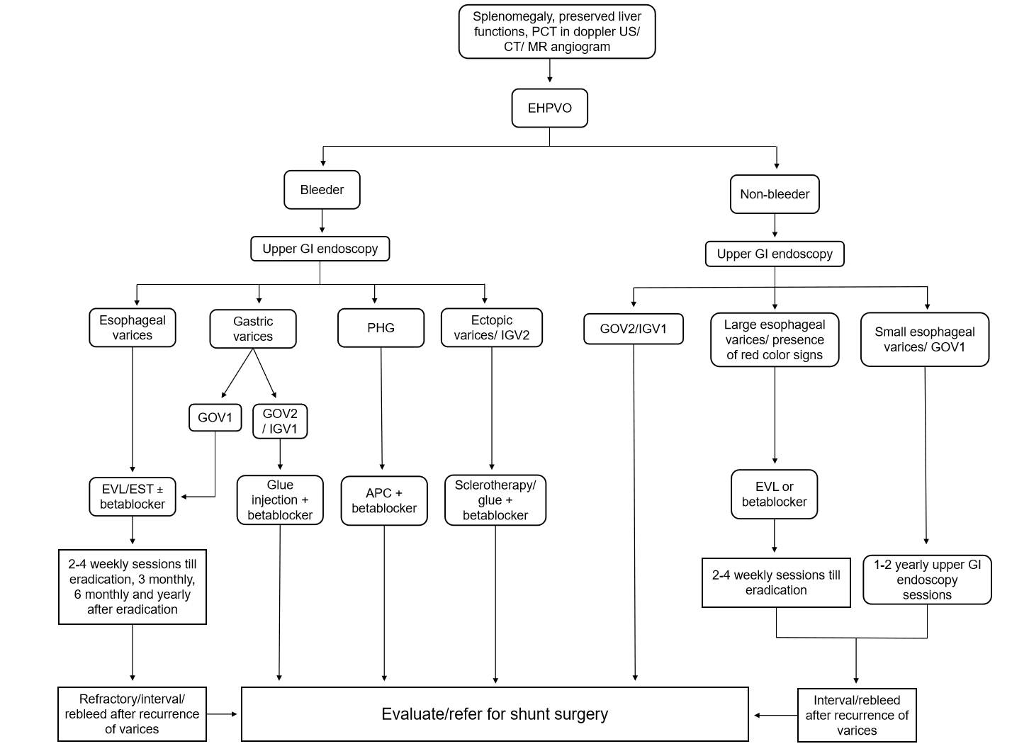
Figure 1 Algorithm for management of esophageal varices and gastric varices in extra-hepatic portal vein obstruction. EHPVO: Extra-hepatic portal vein obstruction; PHG: Portal hypertensive gastropathy; GOV: Gastroesophageal varices; IGV: Isolated gastric varices; EVL: Endoscopic variceal ligation; EST: Endoscopic sclerotherapy; APC: argon plasma coagulation
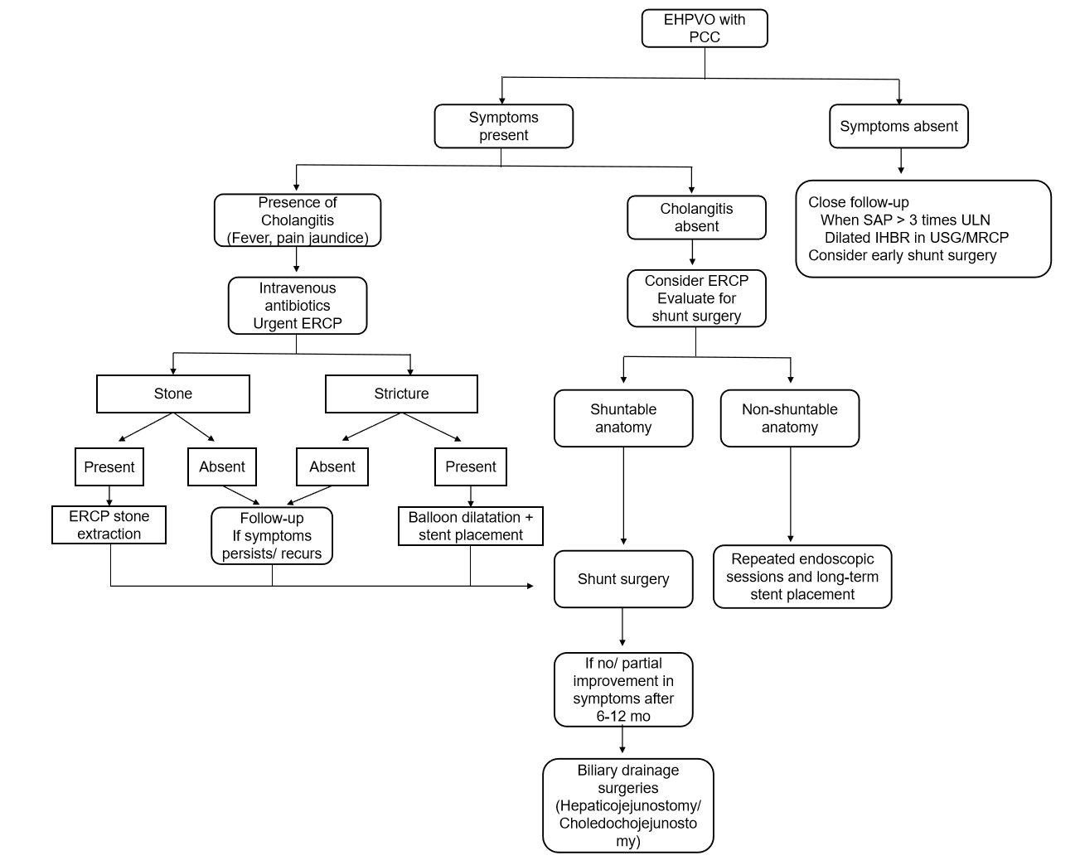
Figure 2 Algorithmic approach for management of portal cavernoma cholangiopathy in extra-hepatic portal vein obstruction. EHPVO: Extra-hepatic portal vein obstruction; PCC: Portal cavernoma cholangiopathy; ERCP: Endoscopic retrograde pancreato-cholangiography; MRCP: Magnetic resonance cholangiopancreatography; SAP: serum alkaline phosphatase; IHBR: intrahepatic biliary radicle; USG: ultrasonography; ULN: upper limit of normal
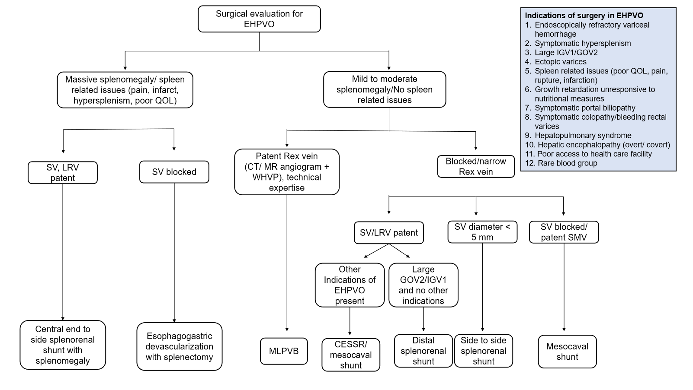
Figure 3 Indications of surgery in extra-hepatic portal vein obstruction and algorithmic approach for surgical management in extra-hepatic portal vein obstruction in developing countries. EHPVO: Extra-hepatic portal vein obstruction; GOV: Gastroesophageal varices; IGV: Isolated gastric varices; EVL: Endoscopic variceal ligation; SV: splenic vein; SMV: superior mesenteric vein; EST: Endoscopic sclerotherapy; CT: Computed tomography, LRV: left renal vein; MR: magnetic resonance, CESSR: central end-to-side splenorenal shunt, QOL: quality of life; WVHP: wedge hepatic venous pressure; MLPVB: mesenterico left portal vein bypass (meso-Rex)

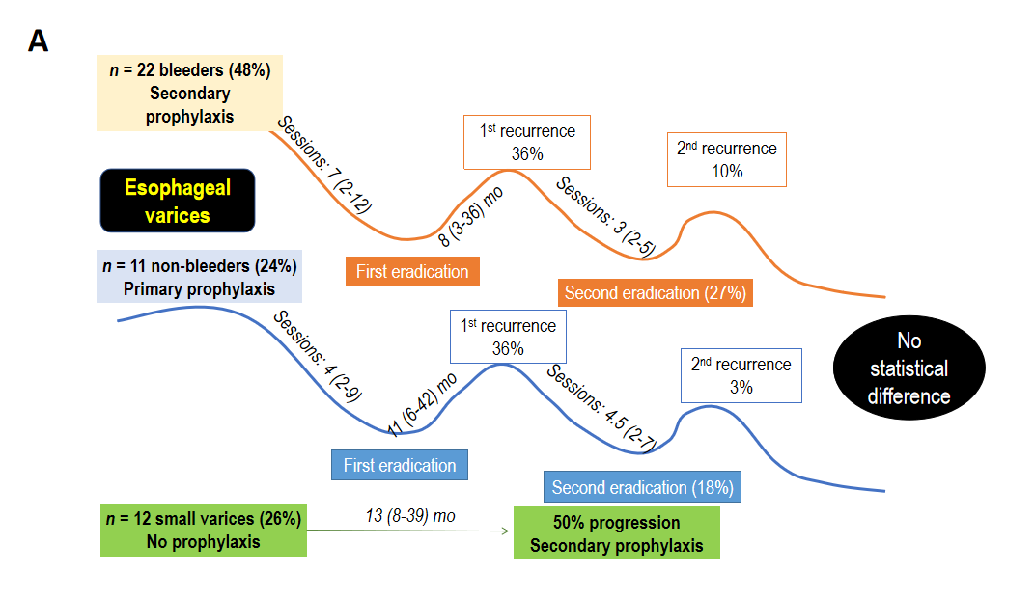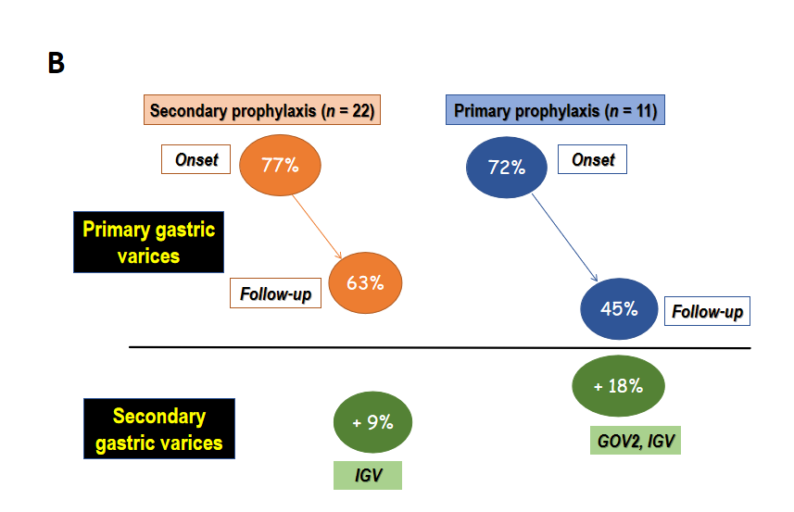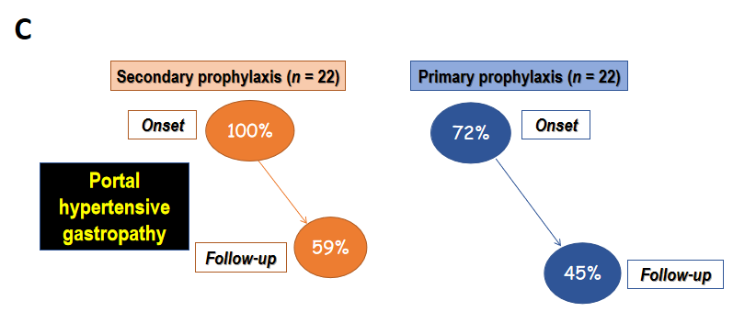
Figure 4 Natural history and follow-up outcome of esophageal varices, gastric varices and portal hypertensive gastropathy in pediatric non-cirrhotic portal fibrosis in author’s experience. A: 22 children presented with variceal bleeding (bleeders), required Endoscopic Variceal Ligation and/or sclerotherapy. 11 children presented with large varices without bleeding (non-bleeders). The incidence of recurrence of varices following eradication is not statistically different between bleeders and non-bleeders. 50% small varices progressed to bleed in the follow-up (median time 13 mo); B: 77% bleeders and 72% non-bleeders had gastric varices (primary) at initial endoscopy. 9% bleeders and 18% non-bleeders develop gastric varices (secondary) in follow-up; C: 100% bleeders and 72% non-bleeders had portal hypertensive gastropathy at initial endoscopy, reduced to 59% and 45% respectively, in follow-up.
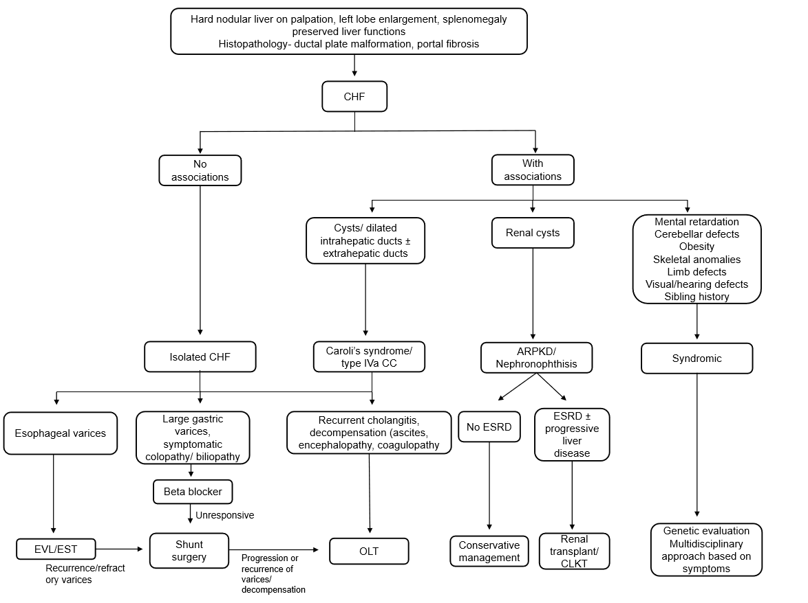
Figure 5 Algorithmic approach to diagnosis and management of congenital hepatic fibrosis. CHF: Congenital hepatic fibrosis; CC: Choledochal cyst; ESRD: End-stage renal disease; EVL: Endoscopic variceal ligation; EST: Endoscopic sclerotherapy; CLKT: Combined liver-kidney transplantation; OLT: Orthotopic liver transplantation, ARPKD: autosomal recessive polycystic kidney disease

Table 1 Clinical characteristics and outcome of non-cirrhotic portal fibrosis in pediatric studies
Parameters |  | Prasad et al^{[90]} (n = 45) | Sood et al^{[91]} (n = 19) | Poddar et al^{[109]} (n = 11) | Franchi-Abella et al^{[110]} (n = 48)
Mean or median (range) age at presentation |  | 14.5 (6-18) yr | 13.8 (5.9-17.6) yr | 11 (5-14) yr | 8.75 (1 mo-16 yr)
At presentation
 | Variceal bleed | 49% | 15.70% | 54.60% | 18.80%
 | Lump upper abdomen | 47% | 84.20% | 45.40% | 43.80%
 | Ascites | 20% | - | 18% | -
 | Spleen size (mean) cm | 10.5 | 12 (4.75–17.25) | 8 | -
 | Variceal recurrence | 39% | - | 18% | -
Poor outcome
 | Decompensation | 4% | 0 | 0 | 12.50%
 | Hepatopulmonary syndrome | 2% | 5% | - | 4.20%
 | Follow-up duration (mean) | 48 (3-120) mo | 18 (2-51) mo | 57.5 (12-78) mo | 15 (1-26) yr
 | Survival without transplant | 93% | 100% | 100% | 88%

Table 2 Clinical characteristics and outcome of congenital hepatic fibrosis in pediatric studies
Parameters |  | Rawat et al^{[106]} (n = 40) | Poddar et al^{[105]} (n = 15) | Parkash et al^{[111]} (n = 25) | Luoto et al^{[112]} (n = 27)
Mean or median age |  | 1.3 yr | 8 yr (10 mo-14 yr) | 8.5 ± 2.7 yr | 2.7 (0-13) yr
Associations
 | Caroli’s syndrome | 52.50% | 9% | 8% | 11%
 | Renal | 92.50% | 81.80% | 24% | 100%
 | CHF | 47.50% | 54.50% | 92% | 37%
Presentations
 | Variceal bleeding | 27% | 54.50% | 60% | 15%
 | Cholangitis | 25% | 9% | 0% | 7.40%
 | Recurrent cholangitis | 7.50% | 9% | 0% | 3.70%
 | Decompensation | 5% | 18.20% | 0% | 19%
 | Endotherapy | 27% | 100% | 60% | 30%
 | Shunt surgery | 0% | 9% | 20% | 3.70%
Transplant
 | Renal transplant | 0% | - | - | 41%
 | Liver transplant | 5% | - | - | 3.70%
 | Combined liver kidney transplant | 45% | - | - | 37%
Survival
 | Overall survival | 90% | 100% [41 (1-80) mo] | 100% | 70% [10.6 (0.6-40) yr]
 | Survival post-transplant (follow-up duration) | 80% [5 (1.2-9)] yr | - | - | 73.30%
 | Survival non-transplant (follow-up duration) | 100% [15 (4.5-19)] yr | - | - | 100%
CHF: Congenital hepatic fibrosis.

Published by Baishideng Publishing Group Inc
7041 Koll Center Parkway, Suite 160, Pleasanton, CA 94566, USA
Telephone: +1-925-3991568
E-mail: bpgoffice@wjgnet.com
Help Desk: https://www.f6publishing.com/helpdesk
https://www.wjgnet.com

© 2021 Baishideng Publishing Group Inc. All rights reserved.

