Name of journal: World Journal of Gastroenterology
ESPS Manuscript NO: 16409
Columns: ORIGINAL ARTICLE

Retrospective Study
Cardiac mucosa at the gastroesophageal junction: An Eastern perspective

Kim A et al. Cardiac mucosa as indicators of reflux

Ahrong Kim, Won-Young Park, Nari Shin, Hyun Jung Lee, Young Keum Kim, So Jeong Lee, Heong-Soo Hwang, Do Youn Park, Gwang Ha Kim, Bong Eun Lee, Hong-Jae Jo

Ahrong Kim, Won-Young Park, Nari Shin, Hyun Jung Lee, Young Keum Kim, So Jeong Lee, Cheong-Soo Hwang, Do Youn Park, Departments of Pathology, Pusan National University Hospital and Pusan National University School of Medicine, and BioMedical Research Institute, Pusan National University Hospital, Busan 602-739, South Korea

Gwang Ha Kim, Bong Eun Lee, Department of Internal Medicine, Pusan National University Hospital and Pusan National University School of Medicine, and BioMedical Research Institute, Pusan National University Hospital, Busan 602-739, South Korea

Hong-Jae Jo, Department of Surgery, Pusan National University Hospital and Pusan National University School of Medicine, Busan 602-739, South Korea

Author contributions: Kim A and Park DY designed the research; Kim A, Park DY, Kim GH and Lee BE performed the research; Park WY, Shin N, Lee HJ, Kim YK, Lee SJ and Hwang CS contributed analytic tools; Kim A and Park DY analyzed the data and wrote the paper; Jo HJ and Kim A performed multivariate analysis and contributed to search the demographic information.

Supported by a grant from the National R and D Program for Cancer Control, Ministry for Health, Welfare and Family affairs, South Korea, No. 0920050.

Ethics approval: The study was performed with waiver of confirmation by Pusan National University Hospital.

Informed consent: The study was performed with waiver of informed consent.

Conflict-of-interest: The authors have no conflict of interest to declare.

Data sharing: No additional data are available.

Open-Access: This article is an open-access article which was selected by an in-house editor and fully peer-reviewed by external reviewers. It is distributed in accordance with the Creative Commons Attribution Non Commercial (CC BY-NC 4.0) license, which permits others to distribute, remix, adapt, build upon this work non-commercially, and license their derivative works on different terms, provided the original work is properly cited and the use is non-commercial. See: http://creativecommons.org/licenses/by-nc/4.0/

Correspondence to: Do Youn Park, MD, PhD, Department of Pathology, Pusan National University Hospital and Pusan National University School of Medicine, 1-10 Ami-Dong, Seo-Gu, Busan 602-739, South Korea. pdy220@pusan.ac.kr
Telephone: +82-51-2407717
Fax: +82-52-2560788
Received: January 15, 2015
Peer-review started: January 16, 2015
First decision: March 10, 2015
Revised: April 6, 2015
Accepted: May 27, 2015

Article in press:
Published online:
Abstract
AIM: To investigate the nature and origin of cardiac mucosa (CM).

METHODS: Biopsy samples from sixty-one individuals were included in this study. The specimens were taken “at” or “just below” or “just above” the gastroesophageal junction (GEJ) including the histologic squamocolumnar junction (SCJ). Clinical data were obtained reviewing electronic medical records for each patient. Any patients with history of stomach adenoma or carcinoma and esophageal carcinoma were excluded and cases which are endoscopically suspicious of Barrett’s esophagus or a polyp were also ruled out. Histologic and endoscopic review were performed blinded to patient’s clinical data. Histologic evaluation was done by two pathologists and endoscopic review was performed by a endoscopist who has a wide experience in the field. Histologically, the columnar epithelium of SCJ, presence and severity of acute and chronic inflammation, atrophy, intestinal metaplasia, and presence of carditis were evaluated. Endoscopically, reflux esophagitis by Los Angeles (LA) calssification, hiatal hernia by Hill grade and gastroesophageal flap valve were assessed.

RESULTS: Fifty nine patients (96.7%) were Korean. And 65.6% (40 cases out of 31 cases) patients of our study got endoscopy according to the schedule of national health insurance program as a screening inspection. Of these, only 20.0% (8 cases out of 40 cases) had any reflux symtoms. The CM was present in 41 (67.2%) individuals. And its presence was associated with older age compared to oxyntocardiac mucosa/oxyntic mucosa (60.59 ± 2.017 years and 51.55 ± 3.353 years, respectively, p = 0.018). The presence of CM was associated with endoscopic diagnosis of esophagitis according to the Los LA classification (p = 0.022). The CM was associated with mononuclear cell infiltration and neutrophilic infiltration, which were statistically significant (p = 0.001, and p = 0.004, respectively). The inflammation of CM, “carditis” showed statistically significant association with endoscopic diagnosis of reflux esophagitis according to the LA classification (p = 0.008).

CONCLUSION: The CM at the GEJ is a common histologic finding in biopsy specimens, although not always present and associated with gastroesophageal reflux disease and severity of carditis.

Key words: Gastroesophageal junction; Histopathology; Cardiac mucosa; Gastroesophageal reflux disease; Carditis

© The Author(s) 2015. Published by Baishideng Publishing Group Inc. All rights reserved.

Core tip: The incidence of gastroesophageal reflux disease (GERD) and gastroesophageal junction (GEJ) adenocarcinomas is increasing especially in Asia, although prevalence is still lower than that of Western countries. The existence and origin of cardiac mucosa (CM) at GEJ is on debate. But most of data were from Western population. In this study, we found that CM at GEJ is a common histologic finding and 4.4% showed direct continuity of oxyntic mucosa and squamous epithelium even in single biopsy specimens. And CM was associated with GERD and severity of carditis, indirectly suggesting CM may be an acquired structure and is associated with reflux stimuli, which are similar results to Western populations.

Kim A, Park WY, Shin N, Lee HJ, Kim YK, Lee SJ, Hwang HS, Park DY, Kim GH, Lee BE, Jo HJ. Cardiac mucosa at the gastroesophageal junction: An Eastern perspective. World J Gastroenterol 2015; In press

INTRODUCTION
The incidence of gastroesophageal reflux disease (GERD) and gastroesophageal junction (GEJ) adenocarcinomas is increasing worldwide, especially in Asia^{[1,2]}, although prevalence is still lower than that in the US and Europe. The existence and origin of cardiac mucosa (CM) at the GEJ is one of the most hotly debated topics among gastroenterologists and pathologists. There are two main opinions about the nature and the origin of the CM at the GEJ: one is that cardia and CM are a normal finding^{[3-5]}, and the other is that CM is not a normal mucosa but rather a metaplastic response to reflux stimuli^{[6-10]}. In our previous study, we suggested that CM originated from the distal esophagus and the presence of CM is a marker of GERD in esophagectomy specimens in the Korean population^{[11]}. In general, distal esophageal squamous epithelium, which cannot tolerate the acidic proteolytic environment, is consistently exposed to reflux damage during the lifetime^{[12]}. The esophagus adapts to the reflux stimuli by metaplasia, converting into columnar epithelium. Furthermore, there are reports suggesting there is an association between CM and GERD^{[6,10,13]} and still others showing different results associating carditis (inflammation of CM) and GERD^{[14-16]}. Recently, the prospective histoGERD trial^{[17]}, which analyzed biopsy specimens, revealed that the presence of CM is associated with symptoms and histologic changes of GERD and endoscopic diagnosis of esophagitis. However, most of these data were from Western countries where there is a high prevalence of GERD. With this background, we investigated the histopathologic nature of GEJ and CM in a single institution. Our data suggest that CM is an indicator of GERD.

MATERIALS AND METHODS
Patients and tissue selection
The tissue samples of GEJ were obtained by endoscopic biopsy carried out at the Pusan National University Hospital (PNUH), Korea, from 2011 to June of 2014. To select the specimens from GEJs, a statistics program in electronic medical record system of PNUH was used. First, using the searching phrase “gastroesophageal junction”, we identified 345 applicable cases. Sixteen cases were excluded from the analysis, because they had a history of esophageal cancer, stomach cancer, or stomach adenoma. The endoscopic findings were reviewed to precisely select cases in which samples were obtained only “at” or “just below” or “just above” the GEJ and to exclude cases that were clinically polyp lesions. This resulted in an additional 35 cases being excluded. And 13 cases suspicious of Barret’s esophagus endoscopically were also excluded. Finally, the histologic features were reviewed by 2 pathologists. Only samples containing histological squamocolumnar junctions (SCJs) were included; thus, an additional 174 cases were excluded. Cases with only surface epithelium without a glandular portion were excluded, and samples with marked acute inflammation or ulcer were also excluded. Thus, the final study cohort consisted of 61 individuals (see Figure 1) with biopsy samples obtained from the GEJ with histologic SCJ and proper amounts of glandular component.

Assessment by endoscopy
All endoscopists had wide experience in the field. The esophagus, GEJ, and stomach of all patients were examined. For endoscopy, a single channel endoscope (GIF-H260 o GIF-Q260; Olympus Co. Ltd., Tokyo, Japan) was used. A highly experienced endoscopist, performing over 500 endoscopies per year for over a decade, reviewed all photographs captured during the endoscopy. In addition, the endoscopist was blind to the clinical and histologic data. The presence or absence of reflux esophagitis and hiatal hernia was evaluated, and the gastroesophageal flap valve (GEFV), which reflects reflux, was graded retrospectively according to the criteria indicated below.
The GEJ was defined as the oral side end of the fold, which is present continuously from the gastric lumen^{[18]}, as well as the end of the anal side of the fine longitudinal vessel, because the veins in the lower part of the esophagus were distributed uniformly, running parallel and longitudinally in the lamina propria^{[19,20]}.

Reflux esophagitis
If esophagitis was present, it was graded according to the Los Angeles (LA) classification^{[21,22]}, which focuses not only on the extent of mucosal breaks but also on minimal changes (see Figure 2). All categories but 0, by the LA classification, were considered to have reflux esophagitis.

Hiatal hernia
Hiatal hernia was defined as a circular extension of the gastric mucosa above the diaphragmatic hiatus greater than 2 cm in the axial length^{[23]}.

GEFV
The GEJ was viewed using a retroflexed endoscope during gastric inflation and GEFV was graded by the recently described grading system by Hill et al.^{[24]} The GEFV is largely classified into 2 groups: the normal appearance (grade I and II) group and the reflux appearance (grade III and IV) group.

Histologic assessment
All samples were fixed in 10% buffered formalin, embedded in paraffin, cut at a minimum of 4 levels, and stained with hematoxylin and eosin (HE) stain. All biopsy samples were assessed by two pathologists who were blinded to clinical data and endoscopic findings. The columnar epithelium of the SCJ was classified according to the type of glandular component present (see Figure 3) as follows: (1) oxyntic mucosa (OM); (2) oxyntocardiac mucosa (OCM); or (3) CM (see Figure 3). The presence and severity of inflammation, atrophy and intestinal metaplasia were evaluated based on the updated Sydney system for evaluation of gastritis^{[25]}. Cardiac mucosal inflammation (carditis) was defined by the presence of neutrophils in the lamina propria or glands (mild or more than mild infiltration of neutrophils by Sydney classification), or the presence of plasma cells, lymphocytes, and eosinophils in the lamina propria (moderate or more than moderate infiltration of mononuclear cells by the Sydney classification). The presence of pancreatic acinar cells, defined as small clusters or lobules of epithelial cells similar to pancreatic acinar cells in CM^{[26]}, was also evaluated.

Statistical analysis
To perform a statistical analysis, we grouped the patients into two categories: (1) patients with CM at GEJ and patients with OM or OCM at GEJ; or (2) patients with carditis and patients without carditis. The data were analyzed for differences between groups by Student’s t test, or χ² tests. Logistic regression was used for multivariate analysis. p < 0.05 was considered statistically significant. Statistical calculations were performed using SPSS version 10.0 for Windows (SPSS Inc., Chicago, IL, Unted States).
The biomedical statistical review of this study was performed by Jinmi Kim, PhD, a clinical trial center research professor at department of biostatics, clinical trial center, Pusan National University Hospital.

RESULTS
The patients ranged in age from 29 years to 80 years (mean age 57.62 years, median age 59.00 years). Fifty nine patients (96.7%) were Korean and the other 2 patients were Russian. The presence of CM was significantly associated with older age compared with OM/OCM (60.59 ± 2.017 years and 51.55 ± 3.353 years, respectively, p = 0.018).
The CM was found in 41 cases (67.2%) and OCM and OM were found in 17 cases (27.9%) and 3 cases (4.9%), respectively. These data indicate that in at least 32.8% of the cases there was no circumferential presence of CM. Pancreatic acinar cells were found in 6 cases (9.8%) and the esophageal gland duct was present in 1 case (1.6%).
Regarding the clinicopathological significance of CM in terms of GERD, Table 1 describes the relationship between the type of mucosa and endoscopic findings. The presence of CM was significantly associated with endoscopic diagnosis of reflux esophagitis according to the modified LA classification (p = 0.02). Furthermore, Table 2 shows that the presence of CM was significantly associated with chronic inflammation (moderate or marked infiltration of mononuclear cells in lamina propria) and activity of inflammation (neutrophilic infiltration in lamina propria and/or glands) (p = 0.001 and p = 0.004, respectively). Table 3 shows the relationship between the presence of carditis and the endoscopic findings. The presence of carditis was associated with endoscopic diagnosis of reflux esophagitis according to the modified LA classification (p = 0.008). On multivariate analysis, mononuclear cell infiltration reflecting chronic inflmamation was significantly associated with cardiac mucosa (Odds ratio 4.230, P = 0.049) and neutrophilic infiltration which means acute inflammatory condition was correlated with presence of cardiac mucosa, though it was not statistically significant (Odds ratio 4.296, P = 0.057).
Interestingly, the presence of pancreatic acinar cells was significantly associated with hiatal hernia (p = 0.039), but there was no association with the presence of pancreatic acinar cells and endoscopic reflux esophagitis, intestinal metaplasia or Helicobacter pylori (H. pylori) infection (data not shown, p = 0.130, p = 0.163, p = 0.202, respectively).The esophageal gland duct was present in 1 case, and the duct was present among the glandular component.

DISCUSSION
In this study, we demonstrated that the presence of CM at GEJ was significantly associated with the presence of GERD severity of carditis. And on multivariate analysis, chronic inflammatory condition was associated with presence of cardiac mucosa, suggesting that the presence of CM reflects the reflux damage and CM can be considered as an indicator of GERD. Our data might indirectly support evidence of a rising incidence of GERD or adenocarcinomas of the GEJ and proximal stomach in Asia, although these results are based on a small retrospective dataset from a single institution.
We previously analyzed 30 esophagogastrectomy specimens^{[11]} and found that the CM was present circumferentially in 66.7% of cases. So, 33.3% of the cases had direct continuity of OM and squamous epithelium. In the present study, even with biopsy samples, we found that 3 cases (4.9%) showed direct continuity of OM and squamous epithelium, even though the samples were not obtained systematically around the GEJ. We also observed a significant association CM with older age.
The Korean ministry of national health and welfare provide nationwide health medical examination by national health insurance. And it includes endoscopic examination targeting adults aged more than 40 years biennially. And 65.6% (40 cases out of 31 cases) patients of our study got endoscopy according to the schedule of national health insurane program as a screening inspection. Of these, only 20.0% (8 cases out of 40cases) had any reflux symtoms.
The cause of carditis is a controversial topic. Currently, it is thought to be a result of gastroesophageal reflux or a proximal extension of H. pylori infection from the remnant of the stomach. Der et al. reported that acute and chronic inflammation of the CM had different etiologic factors, being distal gastritis and H. pylori infection, and acid reflux, respectively^{[14]}. And there are reports elucidating the etiology of carditis by status of H. pylori infection^{[15]} and presence or absence of chronic gastritis of the remainder stomach^{[27]}. The present study was performed retrospectively, and samples from the remainder stomach were not available for evaluation, so we could not evaluate the possibility of gastritis involving GEJ and the status of H. pylori infection of remainder stomach. Although we could not determine the cause of carditis, all of these findings indirectly suggest that CM itself reflects the inflammatory condition associated with reflux stimuli. Regarding the significance of CM in GEJ, Chandrasoma et al^{[13]} reported that the squamo-oxyntic gap (OCM ± CM ± intestinal epithelium between squamous epithelium and the OM) is equivalent to the columnar-lined esophagus and its presence is an indicator of reflux, defining the presence of intestinal metaplasia within the squamo-oxyntic gap as Barrett’s esophagus (BE). Thus, 26.2% (16 out of 61 cases) of our study can be classified as BE, according to Chandrasoma et al.
The origin and the significance of pancreatic acinar cells are reported variably in the literature as being a congenital structure^{[28]} or metaplastic elements^{[29]} related to GERD. In this study, the presence of pancreatic acinar cells was associated with hiatal hernia, but there was no association with endoscopic diagnosis of reflux esophagitis, reflux appearance of GEFV, carditis, or H. pylori infection (data not shown). The nature and significance of the pancreatic acinar cells at GEJ should be further defined.
In this study, we provide data supporting the notion that the CM may be an acquired structure and is associated with reflux stimuli, similar to results derived from Western populations. Our study has many limitations, mainly because we were unable to evaluate the histologic findings in the esophagus and remainder stomach because the study was performed retrospectively. Prospective, systematic, and multi-center studies are required to confirm the data presented herein.

COMMENTS
Background
In Asia, the prevalence of gastroesophageal reflux disease (GERD) and gastroesophageal junction (GEJ) adenocarcinoma is lower than Western population but the incidence is increasing. The existence and origin of cardiac mucosa (CM) at GEJ is a hotly debated topic and there are two main opinions about the nature and the origin of CM at GEJ, being a normal congenital structure and a metaplastic response to reflux stimuli, respectively. And most of the data are from Western countries.

Research frontiers
Histologically, CM was a common finding but 3 cases (4.4%) had oxyntic mucosa even in a single biopsy sample, which means they had direct continuity of squamous epithelium and oxyntic mucosa. And association with inflammatory condition and presence of CM at GEJ suggests that CM may be an acquired structure associated with reflux stimuli which is a similar result to Western datasets.

Innovations and breakthroughs
The present study could not evaluate the possibility of extension of distal gastritis or impact of Helicobacter pylori infection, as the authors performed a retrospective study and the biopsy procedure was not performed systematically. But absence of CM (meaning OCM or OM at GEJ) even in the single biopsy samples reinforces that CM is not located circumferentially, which indirectly suggests that CM may not be a normal congenital structure. And association between severity of inflammation and presence of CM supports that presence of CM at GEJ can be an indicator of reflux stimuli. Also, according to Chandrasoma’s criteria, 30.9% (21 out of 68 cases) of our study cohort belong to Barrent’s esophagus, which may explain the rising incidence of GERD and GEJ adenocarcinoma in Asia.

Applications
The presence of CM at GEJ can be a histologic indicator of reflux stimuli. And this study can be an evidence for necessity of performing multicenter and prospective study to better elucidate the nature and origin of CM at GEJ.

Terminology
The columnar epithelium of squamocolumnar junction was classified according to the type of glandular component : (1) oxyntic mucosa (OM) composed entirely of parietal and chief cells without any mucous cells below the foveolar region; (2) oxyntocardiac mucosa (OCM), which contains a mixture of mucous cells and parietal cells; and (3) cardiac mucosa (CM) composed entirely of mucous cells without any parietal cells.

Peer-review
Well-written, it’s better to add demographic data of the patients and multivariate analysis.

References
1 Kusano C, Gotoda T, Khor CJ, Katai H, Kato H, Taniguchi H, Shimoda T. Changing trends in the proportion of adenocarcinoma of the esophagogastric junction in a large tertiary referral center in Japan. J Gastroenterol Hepatol 2008; 23: 1662-1665 [PMID: 19120859 DOI: 10.1111/j.1440-1746.2008.05572.x]
2 Park JJ, Kim JW, Kim HJ, Chung MG, Park SM, Baik GH, Nah BK, Nam SY, Seo KS, Ko BS, Jang JY, Kim BG, Kim JW, Choi YS, Joo MK, Kim JI, Cho MY, Kim N, Park SH, Jung HC, Chung IS. The prevalence of and risk factors for Barrett's esophagus in a Korean population: A nationwide multicenter prospective study. J Clin Gastroenterol 2009; 43: 907-914 [PMID: 19417682 DOI: 10.1097/MCG.0b013e318196bd11]
3 Kilgore SP, Ormsby AH, Gramlich TL, Rice TW, Richter JE, Falk GW, Goldblum JR. The gastric cardia: fact or fiction? Am J Gastroenterol 2000; 95: 921-924 [PMID: 10763938 DOI: 10.1016/S0002-9270(00)00722-X]
4 Glickman JN, Fox V, Antonioli DA, Wang HH, Odze RD. Morphology of the cardia and significance of carditis in pediatric patients. Am J Surg Pathol 2002; 26: 1032-1039 [PMID: 12170090 DOI: 10.1097/00000478-200208000-00008]
5 De Hertogh G, Van Eyken P, Ectors N, Tack J, Geboes K. On the existence and location of cardiac mucosa: an autopsy study in embryos, fetuses, and infants. Gut 2003; 52: 791-796 [PMID: 12740332 DOI: 10.1136/gut.52.6.791]
6 Chandrasoma PT, Lokuhetty DM, Demeester TR, Bremmer CG, Peters JH, Oberg S, Groshen S. Definition of histopathologic changes in gastroesophageal reflux disease. Am J Surg Pathol 2000; 24: 344-351 [PMID: 10716147 DOI: 10.1097/00000478-200003000-00002]
7 Park YS, Park HJ, Kang GH, Kim CJ, Chi JG. Histology of gastroesophageal junction in fetal and pediatric autopsy. Arch Pathol Lab Med 2003; 127: 451-455 [PMID: 12683873]
8 Chandrasoma PT, Der R, Ma Y, Dalton P, Taira M. Histology of the gastroesophageal junction: an autopsy study. Am J Surg Pathol 2000; 24: 402-409 [PMID: 10716154 DOI: 10.1097/00000478-200003000-00009]
9 Oberg S, Peters JH, DeMeester TR, Chandrasoma P, Hagen JA, Ireland AP, Ritter MP, Mason RJ, Crookes P, Bremner CG. Inflammation and specialized intestinal metaplasia of cardiac mucosa is a manifestation of gastroesophageal reflux disease. Ann Surg 1997; 226: 522-30; discussion 530-2 [PMID: 9351720]
10 Lenglinger J, Ringhofer C, Eisler M, Sedivy R, Wrba F, Zacherl J, Cosentini EP, Prager G, Haefner M, Riegler M. Histopathology of columnar-lined esophagus in patients with gastroesophageal reflux disease. Wien Klin Wochenschr 2007; 119: 405-411 [PMID: 17671821 DOI: 10.1007/s00508-007-0825-0]
11 Kim A, Shin N, Lee HJ, Jo HJ, Kim JY, Kim YK, Park DY, Park WY, I H, Kim GH. Histopathological features of the gastroesophageal junction: an Eastern view. Histol Histopathol 2014 Sep 19; Epub ahead of print [PMID: 25236753]
12 Johnson LF, Demeester TR. Twenty-four-hour pH monitoring of the distal esophagus. A quantitative measure of gastroesophageal reflux. Am J Gastroenterol 1974; 62: 325-332 [PMID: 4432845]
13 Chandrasoma P, Wijetunge S, Demeester SR, Hagen J, Demeester TR. The histologic squamo-oxyntic gap: an accurate and reproducible diagnostic marker of gastroesophageal reflux disease. Am J Surg Pathol 2010; 34: 1574-1581 [PMID: 20871393 DOI: 10.1097/PAS.0b013e3181f06990]
14 Der R, Tsao-Wei DD, Demeester T, Peters J, Groshen S, Lord RV, Chandrasoma P. Carditis: a manifestation of gastroesophageal reflux disease. Am J Surg Pathol 2001; 25: 245-252 [PMID: 11176074 DOI: 10.1097/00000478-200102000-00013]
15 Goldstein NS, Karim R. Gastric cardia inflammation and intestinal metaplasia: associations with reflux esophagitis and Helicobacter pylori. Mod Pathol 1999; 12: 1017-1024 [PMID: 10574598]
16 Goldblum JR, Vicari JJ, Falk GW, Rice TW, Peek RM, Easley K, Richter JE. Inflammation and intestinal metaplasia of the gastric cardia: the role of gastroesophageal reflux and H. pylori infection. Gastroenterology 1998; 114: 633-639 [PMID: 9516382 DOI: 10.1016/S0016-5085(98)70576-1]
17 Langner C, Schneider NI, Plieschnegger W, Schmack B, Bordel H, Höfler B, Eherer AJ, Wolf EM, Rehak P, Vieth M. Cardiac mucosa at the gastro-oesophageal junction: indicator of gastro-oesophageal reflux disease? Data from a prospective central European multicentre study on histological and endoscopic diagnosis of oesophagitis (histoGERD trial). Histopathology 2014; 65: 81-89 [PMID: 24393213 DOI: 10.1111/his.12367]
18 Nandurkar S, Talley NJ. Barrett's esophagus: the long and the short of it. Am J Gastroenterol 1999; 94: 30-40 [PMID: 9934728 DOI: 10.1016/S0002-9270(98)00649-2]
19 Vianna A, Hayes PC, Moscoso G, Driver M, Portmann B, Westaby D, Williams R. Normal venous circulation of the gastroesophageal junction. A route to understanding varices. Gastroenterology 1987; 93: 876-889 [PMID: 3623028]
20 Noda T. Angioarchitectural study of esophageal varices. With special reference to variceal rupture. Virchows Arch A Pathol Anat Histopathol 1984; 404: 381-392 [PMID: 6437071 DOI: 10.1007/BF00695222]
21 Lundell LR, Dent J, Bennett JR, Blum AL, Armstrong D, Galmiche JP, Johnson F, Hongo M, Richter JE, Spechler SJ, Tytgat GN, Wallin L. Endoscopic assessment of oesophagitis: clinical and functional correlates and further validation of the Los Angeles classification. Gut 1999; 45: 172-180 [PMID: 10403727]
22 Hongo M. Minimal changes in reflux esophagitis: red ones and white ones. J Gastroenterol 2006; 41: 95-99 [PMID: 16568367 DOI: 10.1007/s00535-006-1775-4]
23 Kahrilas PJ, Kim HC, Pandolfino JE. Approaches to the diagnosis and grading of hiatal hernia. Best Pract Res Clin Gastroenterol 2008; 22: 601-616 [PMID: 18656819 DOI: 10.1016/j.bpg.2007.12.007]
24 Hill LD, Kozarek RA, Kraemer SJ, Aye RW, Mercer CD, Low DE, Pope CE. The gastroesophageal flap valve: in vitro and in vivo observations. Gastrointest Endosc 1996; 44: 541-547 [PMID: 8934159 DOI: 10.1016/S0016-5107(96)70006-8]
25 Dixon MF, Genta RM, Yardley JH, Correa P. Classification and grading of gastritis. The updated Sydney System. International Workshop on the Histopathology of Gastritis, Houston 1994. Am J Surg Pathol 1996; 20: 1161-1181 [PMID: 8827022]
26 Schneider NI, Plieschnegger W, Geppert M, Wigginghaus B, Höss GM, Eherer A, Wolf EM, Rehak P, Vieth M, Langner C. Pancreatic acinar cells--a normal finding at the gastroesophageal junction? Data from a prospective Central European multicenter study. Virchows Arch 2013; 463: 643-650 [PMID: 23989798 DOI: 10.1007/s00428-013-1471-8]
27 Voutilainen M, Färkkilä M, Mecklin JP, Juhola M, Sipponen P. Chronic inflammation at the gastroesophageal junction (carditis) appears to be a specific finding related to Helicobacter pylori infection and gastroesophageal reflux disease. The Central Finland Endoscopy Study Group. Am J Gastroenterol 1999; 94: 3175-3180 [PMID: 10566710]
28 Wang HH, Zeroogian JM, Spechler SJ, Goyal RK, Antonioli DA. Prevalence and significance of pancreatic acinar metaplasia at the gastroesophageal junction. Am J Surg Pathol 1996; 20: 1507-1510 [PMID: 8944044 DOI: 10.1097/00000478-199612000-00010]
29 Doglioni C, Laurino L, Dei Tos AP, De Boni M, Franzin G, Braidotti P, Viale G. Pancreatic (acinar) metaplasia of the gastric mucosa. Histology, ultrastructure, immunocytochemistry, and clinicopathologic correlations of 101 cases. Am J Surg Pathol 1993; 17: 1134-1143 [PMID: 8214258 DOI: 10.1097/00000478-199311000-00006]
P-Reviewer: Lamarca A S-Editor: Yu J L-Editor: E-Editor:

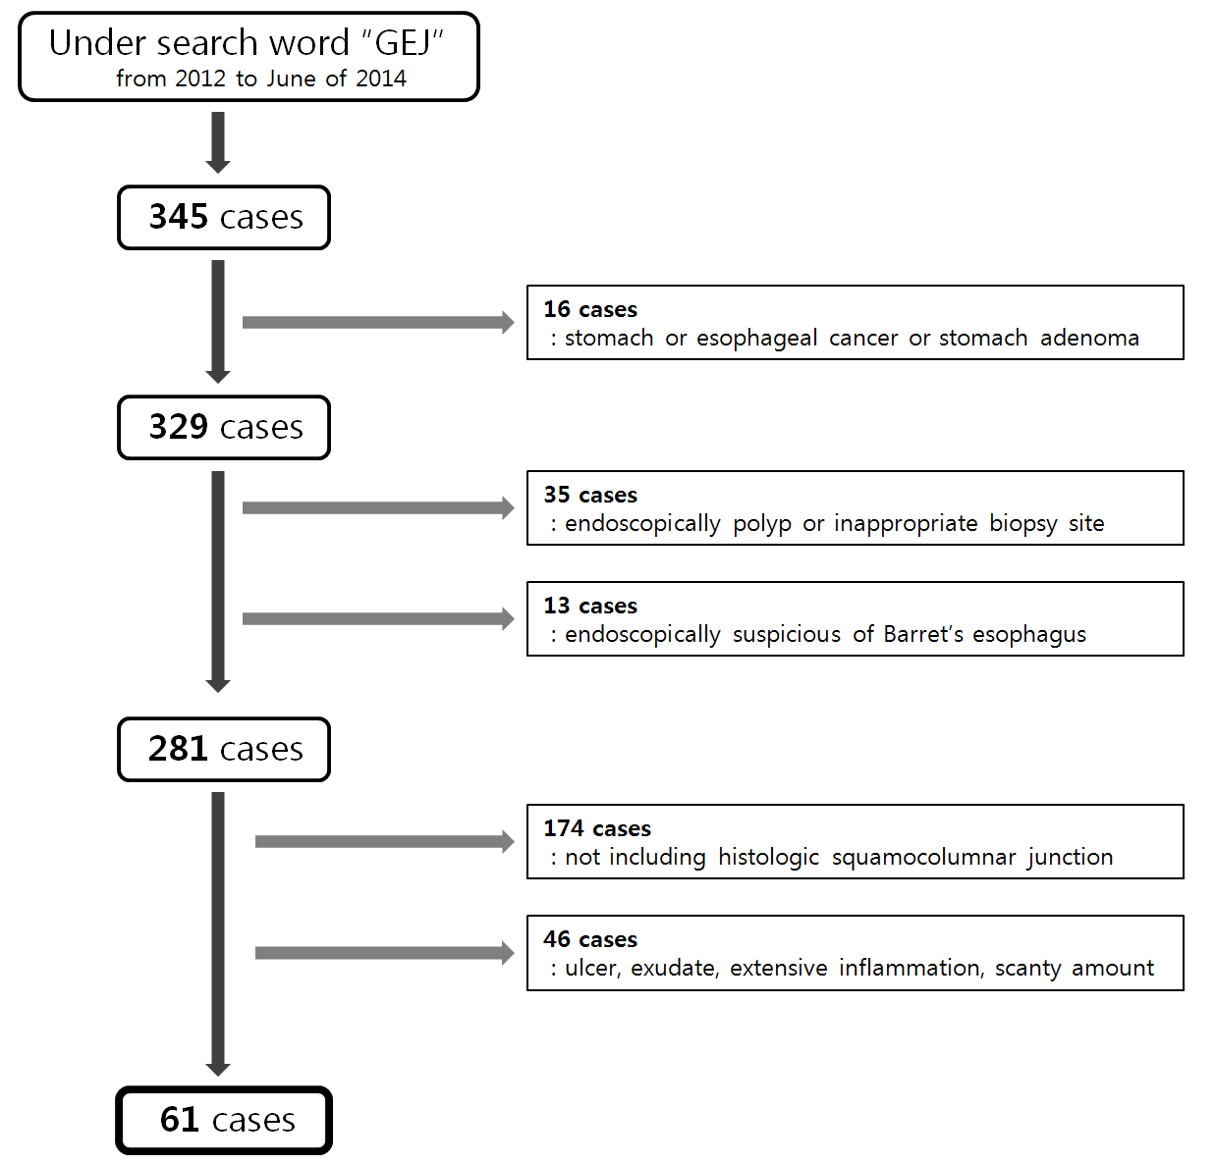
Figure 1 Patient and tissue selection. All included samples were obtained from the gastroesophageal junction (GEJ) with histologic squamo-columnar junction and proper amount of glandular component.

A
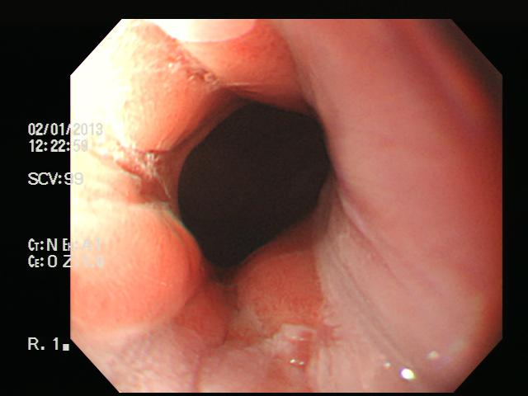
B
C
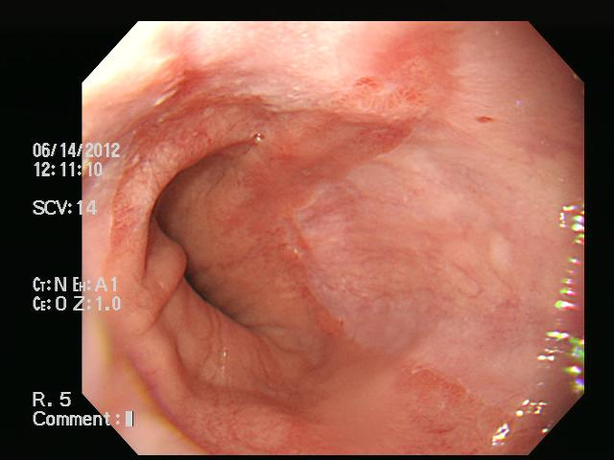
Figure 2 Endoscopic findings of gastroesophageal junction. A: Los Angeles (LA) classification 0 indicates normal gastroesophageal junction (GEJ) with no mucosal breaks; this case showed oxyntic mucosa at GEJ histologically; B: LA classification A indicating one or more mucosal breaks no longer than 5 mm. Microscopically, it showed cardiac mucosa at the GEJ; C: LA classification B with one or more mucosal breaks over 5 mm long; this case had cardiac mucosa at the GEJ.

A
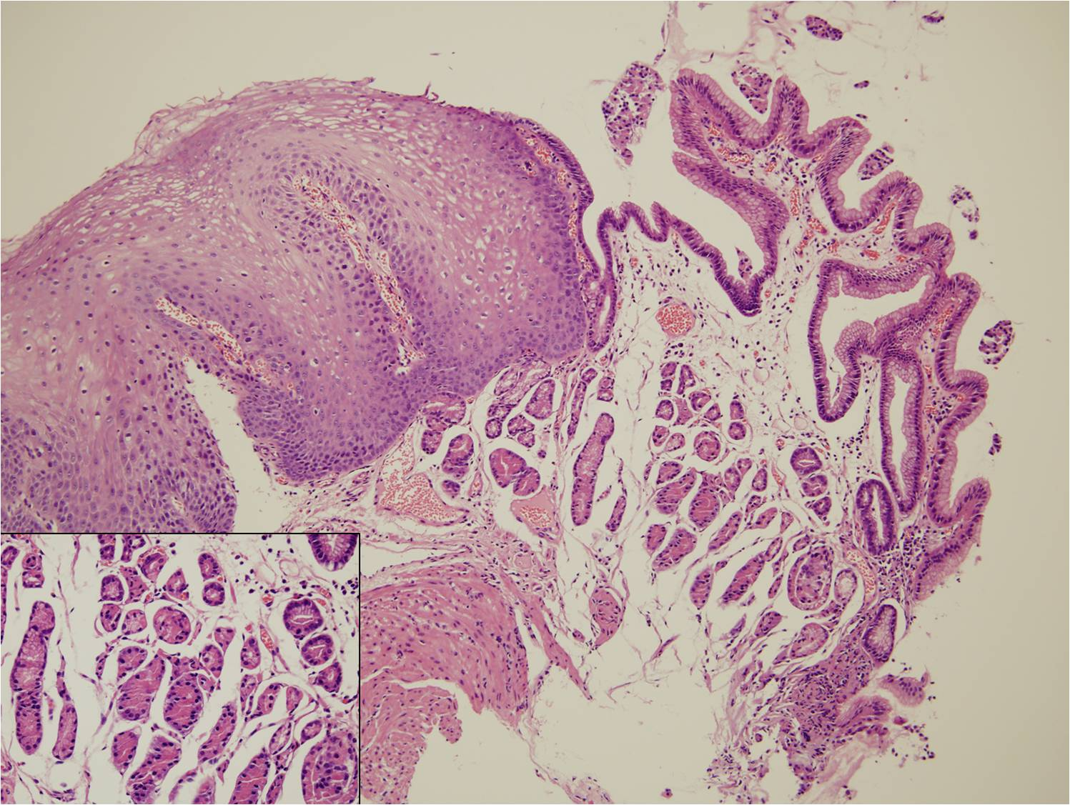
B
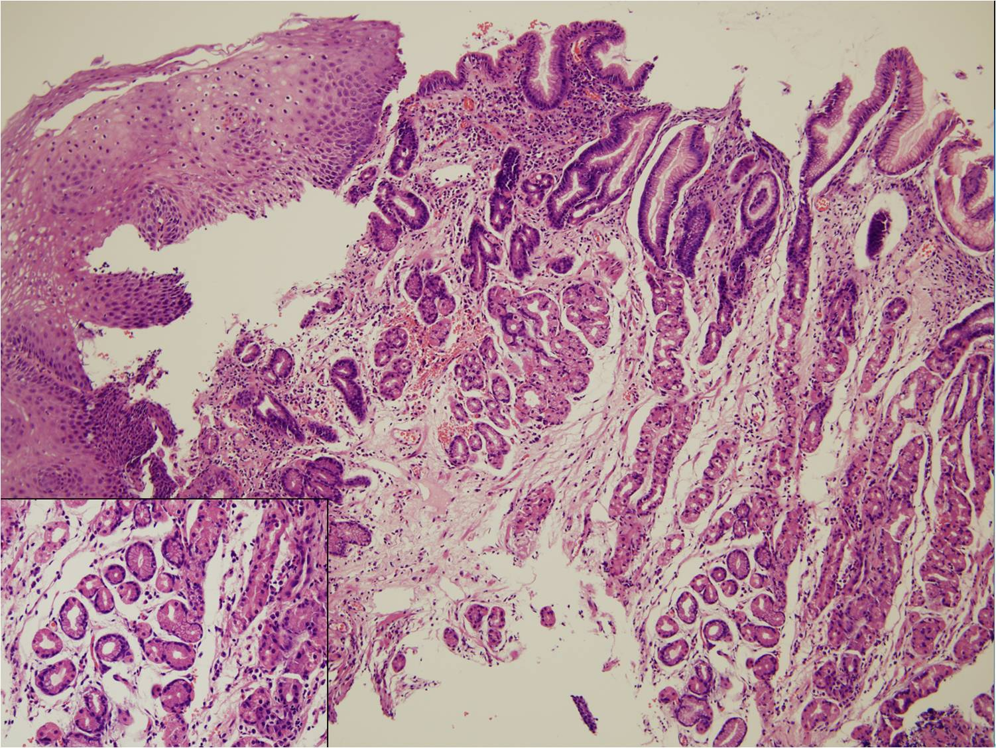
C
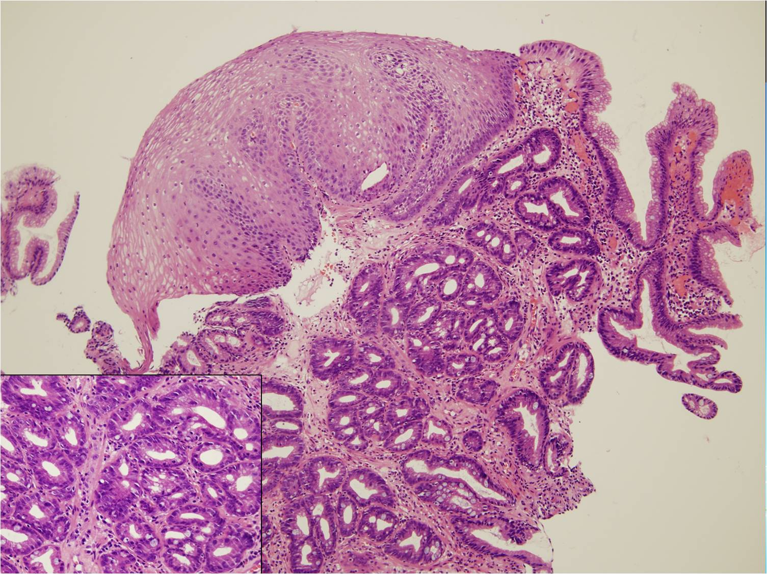
Figure 3 The columnar epithelium of squamocolumnar junction. (hematoxylin-eosin staining, magnification × 100). Insets show high magnification finding (magnification × 400) of glandular component of the gastroesophageal junction (GEJ). A: Oxyntic mucosa (OM) composed entirely of parietal and chief cells without mucous cells below the foveolar region; B: Oxyntocardiac mucosa (OCM) containing a mixture of mucous cells and parietal cells; C: Cardiac mucosa (CM) composed entirely of mucous cells without any parietal cells.

Table 1 Relationship between mucosal type and endoscopic findings n (%)
 | Mucosa type
 | OM/OCM (n = 20) | CM (n = 41) | P value
LA classification
N | 15 (75.0) | 18 (43.9) | 0.022
M, A, B, C, D | 5 (25.0) | 23 (56.1)
Hill grade
normal (1, 2) | 16 (80.0) | 27 (65.9) | 0.255
reflux (3, 4) | 4 (20.0) | 14 (34.1)
Hiatal hernia
absent | 15 (75.0) | 22 (53.7) | 0.109
present | 5 (25.0) | 19 (46.3)
OM: Oxyntic mucosa; OCM: Oxyntocardiac mucosa; CM: Cardiac mucosa.
Table 2 Relationship between mucosal type and severity of inflammation n (%)
 | Mucosa type
 | OM/OCM (n = 20) | CM (n = 41) | P value
Mononuclear cell infiltration
mild | 11 (55.0) | 6 (14.6) | 0.001
moderate, marked | 9 (45.0) | 35 (85.4)
Neutrophil infiltration
absent | 17 (85.0) | 19 (46.3) | 0.004
mild, moderate, marked | 3 (15.0) | 22 (53.7)
Intestinal metaplasia
absent | 17 (85.0) | 28 (68.3) | 0.164
present | 3 (15.0) | 13 (31.7)
Helicobacter pylori infection
absent | 16 (80.0) | 33 (80.5) | 0.964
present | 4 (20.0) | 8 (19.5)
OM: Oxyntic mucosa; OCM: Oxyntocardiac mucosa; CM: Cardiac mucosa.
Table 3 Relationship between carditis and endoscopic findings n (%)
 | Carditis
 | Absent (n = 24) | Present (n = 37) | P value
LA classification
N | 18 (75.0) | 15 (40.5) | 0.008
M, A, B, C, D | 6 (25.0) | 22 (59.5)
Hill grade
normal (1, 2) | 20 (83.3) | 23 (62.2) | 0.077
reflux (3, 4) | 4 (16.7) | 14 (37.8)
Hiatal hernia
absent | 17 (70.8) | 20 (54.1) | 0.190
present | 7 (29.2) | 17 (45.9)
Helicobacter pylori infection
absent | 20 (83.3) | 29 (78.4) | 0.634
present | 4 (16.7) | 8 (21.6)

Table 4 Logistic regression analysis between oxyntic mucosa/ oxyntocardiac mucosa and cardiac mucosa
 | Adjusted odds ratio | 95%CI | P value
Mononuclear cell infiltration | 4.230 | 1.003-17.833 | P=0.050
Neutrophil infiltration | 4.296 | 0.958-19.267 | P=0.057
LA classification | 2.969 | 0.771-11.430 | P=0.114
Age | 1.038 | 0.989-1.089 | P=0.130
OM: Oxyntic mucosa; OCM: Oxyntocardiac mucosa; CM: Cardiac mucosa.

