Name of journal: World Journal of Gastrointestinal Pathophysiology
ESPS Manuscript NO: 17723
Columns: Editorial

Can high resolution manometry parameters for achalasia be obtained by conventional manometry?

Herbella FAM et al. High resolution vs conventional manometry

Fernando AM Herbella, Marco G Patti

Fernando AM Herbella, Hospital Sao Paulo, Surgical Gastroenterology, Division of Esophagus and Stomach, Federal University of Sao Paulo, Sao Paulo 04037-003, Brazil

Marco G Patti, Department of Surgery, Pritzker School of Medicine, University of Chicago, Chicago, IL 60637, United States

Author contributions: Herbella FAM contributed to conception and design, acquisition of data, analysis and interpretation of data, drafting the article, final approval of the version to be published; Patti MG contributed to analysis and interpretation of data, review for intellectual content, final approval of the version to be published.

Conflict-of-interest: There are none. All authors contributed sufficiently to be named as authors and are responsible for the manuscript, no professional or ghost writer was hired.

Open-Access: This article is an open-access article which was selected by an in-house editor and fully peer-reviewed by external reviewers. It is distributed in accordance with the Creative Commons Attribution Non Commercial (CC BY-NC 4.0) license, which permits others to distribute, remix, adapt, build upon this work non-commercially, and license their derivative works on different terms, provided the original work is properly cited and the use is non-commercial. See: http://creativecommons.org/licenses/by-nc/4.0/

Correspondence to: Dr. Fernando AM Herbella, MD, Hospital Sao Paulo, Surgical Gastroenterology, Division of Esophagus and Stomach, Federal University of Sao Paulo, Rua Diogo de Faria 1087 cj 301, Sao Paulo 04037-003, Brazil. herbella.dcir@epm.br

Telephone: +55-11-99922824
Fax: +55-11-39267610

Received: March 20, 2015
Peer-review started: March 22, 2015
First decision: April 10, 2015
Revised: April 22, 2015
Accepted: May 7, 2015
Article in press:
Published online:

Abstract
High resolution manometry (HRM) is a new technology that made important contributions to the field of gastrointestinal physiology. HRM showed clear advantages over conventional manometry and it allowed the creation of different manometric parameters. On the other side, conventional manometry is still wild available. It must be better studied if the new technology made possible the creation and study of these parameters or if they were always there but the colorful intuitive panoramic view of the peristalsis from the pharynx to the stomach HRM allowed the human eyes to distinguish subtle parameters unknown or uncomprehend so far and if HRM parameters can be reliably obtained by conventional manometry and data from conventional manometry still can be accepted in achalasia studies. Conventional manometry relied solely on the residual pressure to evaluate lower esophageal sphincter relaxation while HRM can obtain the Integrated Relaxation Pressure. Esophageal body HRM parameters defines achalasia subtypes, the Chicago classification, based on esophageal pressurization after swallows. The characterization of each subtype is very intuitive by HRM but also easy by conventional manometry since only wave amplitudes need to be measured In conclusion, conventional manometry is still valuable to classify achalasia according to the Chicago classification. HRM permits a better study of the LES.

Key words: Achalasia; Esophagus; High resolution manometry; Conventional manometry; Lower esophageal sphincter; Esophageal body; Chicago classification
© The Author(s) 2015. Published by Baishideng Publishing Group Inc. All rights reserved.

Core tip: High resolution manometry is a new technology with clear advantages over conventional manometry. It is unclear; however, if new parameters created after this technology can be obtained by conventional manometry especially in achalasia cases. We found that conventional manometry is still valuable to classify achalasia according to the Chicago classification but high resolution manometry permits a better study of the lower esophageal sphincter.

Herbella FAM, Patti MG. Can high resolution manometry parameters for achalasia be obtained by conventional manometry? World J Gastrointest Pathophysiol 2015; In press

High resolution manometry (HRM) made important contributions to the field of gastrointestinal physiology. HRM, in comparison to conventional manometry, not only brings more comfort and speediness to the test^{[1]}, a more intuitive comprehension of the plots compared to tracings^{[1]} even for beginners^{[2]}, and a lesser degree of interobserver and intraobserver interpretation variability^{[3]} but also HRM proved to be advantageous in the following parameters: (1) evaluation of gastric motility^{[4]}; (2) the correct evaluation of the lower esophageal sphincter (LES) relaxation and esophagogastric junction flow avoiding movement artifacts and correlating it temporally with swallowing^{[5]}; (3) the identification of segmental defects of peristalsis not covered by the spacing of sensors in conventional systems^{[6]}, and (4) the motility and temporal correlation of the pharyngo-upper esophageal complex due to the rapid response and circunferentiality of the solid-state sensors, and compensation for movement artifacts^{[7]}.
The detailed view provided by HRM permitted the creation of new manometric parameters and a new classification of motility disorders, the Chicago classification^{[8]}, recently simplified and reviewed in his 3.0 version^{[9]} with a 4.0 version under creation to incorporate intraluminal impedance as well. The Chicago classification made 3 major contributions: (1) defined an objective parameter to measure LES relaxation, the integrated relaxation pressure (IRP); (2) classified achalasia in 3 distinct subtypes; and (3) showed a prognostic value of manometry parameters^{[10]}.
It is still elusive; however, if the new technology made possible the creation and study of these parameters or if they were always there but the colorful intuitive panoramic view of the peristalsis from the pharynx to the stomach HRM allowed the human eyes to distinguish subtle parameters unknown or uncomprehend so far (see examples on Figure 1). This lead to questioning if HRM parameters can be obtained by conventional manometry and data from conventional manometry still can be accepted in achalasia studies since HRM is not wildly available due to the high cost of the system and catheters.
Achalasia is a rare primary esophageal motor disorder characterized by aperistalsis and absent or incomplete relaxation of the LES^{[13]}. Dysphagia and regurgitation are common symptoms of the disease that in association with a dilated esophagus on the barium esophagram makes the diagnoses of this disease not difficult^{[14]}. Esophageal manometry; however, is useful not only for the diagnosis in difficult cases, especially without esophageal dilatation, but it seems to predict therapeutic outcomes^{[10]}, usually accomplished via endoscopic forced dilatation of the cardia or surgical Heller’s myotomy and fundoplication^{[15]}.
Conventional manometry relied solely on the residual pressure to evaluate LES relaxation^{[16]}. IRP (Integrated Relaxation Pressure - the average minimum esophagogastric junction pressure for 4 sec of relaxation within 10 s of swallowing) is virtually impossible to be calculated in conventional tracings.
Esophageal body HRM parameters define achalasia subtypes, the Chicago classification, based on esophageal pressurization after swallows. The characterization of each subtype is very intuitive by HRM but also easy by conventional manometry since only wave amplitudes need to be measured (Figure 2). In fact, some well-known papers successfully applied the classification in patients submitted to conventional manometry^{[17,18]}. Moreover, type III corresponds to the old terminology “vigorous achalasia”^{[8]}.
Different studies showed that achalasia type II shows the best response and type III the worst response to either Heller´s myotomy or endoscopic pneumatic dilatation^{[19]}. The prognostic value of manometric parameters to define therapy outcomes is; however, not new to HRM. Long before Chicago classification, some Brazilians surgeons noticed poorer results for patients with lower amplitudes of the simultaneous waves observed at the conventional manometry (< 20 mmHg) precluding the choice of a Heller myotomy opting for an esophagectomy in these cases^{[20]}. Very interestingly too, some authors found prognostic value for the basal pressure of the LES at conventional manometry^{[21]}, but this was never tested for HRM.
In conclusion, conventional manometry is still valuable to classify achalasia according to the Chicago classification. HRM permits a better study of the LES.

REFERENCES
1 Salvador R, Dubecz A, Polomsky M, Gellerson O, Jones CE, Raymond DP, Watson TJ, Peters JH. A new era in esophageal diagnostics: the image-based paradigm of high-resolution manometry. J Am Coll Surg 2009; 208: 1035-1044 [PMID: 19476889 DOI: 10.1016/j.jamcollsurg.2009.02.049]
2 Soudagar AS, Sayuk GS, Gyawali CP. Learners favour high resolution oesophageal manometry with better diagnostic accuracy over conventional line tracings. Gut 2012; 61: 798-803 [PMID: 21997554 DOI: 10.1136/gutjnl-2011-301145]
3 Bogte A, Bredenoord AJ, Oors J, Siersema PD, Smout AJ. Reproducibility of esophageal high-resolution manometry. Neurogastroenterol Motil 2011; 23: e271-e276 [PMID: 21496179 DOI: 10.1111/j.1365-2982.2011.01713.x]
4 Herbella FA, Aprile LR, Patti MG. High-resolution manometry for the evaluation of gastric motility. Updates Surg 2014; 66: 177-181 [PMID: 25106472 DOI: 10.1007/s13304-014-0261-4]
5 Kahrilas PJ, Peters JH. Evaluation of the esophagogastric junction using high resolution manometry and esophageal pressure topography. Neurogastroenterol Motil 2012; 24 Suppl 1: 11-19 [PMID: 22248103 DOI: 10.1111/j.1365-2982.2011.01829.x]
6 Vicentine FP, Herbella FA, Silva LC, Patti MG. High resolution manometry findings in patients with esophageal epiphrenic diverticula. Am Surg 2011; 77: 1661-1664 [PMID: 22273226]
7 Silva LC, Herbella FA, Neves LR, Vicentine FP, Neto SP, Patti MG. Anatomophysiology of the pharyngo-upper esophageal area in light of high-resolution manometry. J Gastrointest Surg 2013; 17: 2033-2038 [PMID: 24078388]
8 Kahrilas PJ, Ghosh SK, Pandolfino JE. Esophageal motility disorders in terms of pressure topography: the Chicago Classification. J Clin Gastroenterol 2008; 42: 627-635 [PMID: 18364587 DOI: 10.1097/MCG.0b013e31815ea291]
9 Kahrilas PJ, Bredenoord AJ, Fox M, Gyawali CP, Roman S, Smout AJ, Pandolfino JE. The Chicago Classification of esophageal motility disorders, v3.0. Neurogastroenterol Motil 2015; 27: 160-174 [PMID: 25469569 DOI: 10.1111/nmo.12477]
10 Richter JE. High-resolution manometry in diagnosis and treatment of achalasia: help or hype. Curr Gastroenterol Rep 2014; 16: 420 [PMID: 25543338]
11 Ghosh SK, Pandolfino JE, Kwiatek MA, Kahrilas PJ. Oesophageal peristaltic transition zone defects: real but few and far between. Neurogastroenterol Motil 2008; 20: 1283-1290 [PMID: 18662328 DOI: 10.1111/j.1365-2982.2008.01169.x]
12 Narawane NM, Bhatia SJ, Mistry FP, Abraham P, Dherai AJ. Manometric mapping of normal esophagus and definition of the transition zone. Indian J Gastroenterol 1998; 17: 55-57 [PMID: 9563221]
13 Herbella FA, Oliveira DR, Del Grande JC. Are idiopathic and Chagasic achalasia two different diseases? Dig Dis Sci 2004; 49: 353-360 [PMID: 15139481]
14 Patti MG, Herbella FA. Achalasia and other esophageal motility disorders. J Gastrointest Surg 2011; 15: 703-707 [PMID: 21394546 DOI: 10.1007/s11605-011-1478-x]
15 Allaix ME, Herbella FA, Patti MG. The evolution of the treatment of esophageal achalasia: a look at the last two decades. Updates Surg 2012; 64: 161-165 [PMID: 22847308 DOI: 10.1007/s13304-012-0169-9]
16 Patti MG, Diener U, Molena D. Esophageal achalasia: preoperative assessment and postoperative follow-up. J Gastrointest Surg 2001; 5: 11-12 [PMID: 11370614]
17 Salvador R, Costantini M, Zaninotto G, Morbin T, Rizzetto C, Zanatta L, Ceolin M, Finotti E, Nicoletti L, Da Dalt G, Cavallin F, Ancona E. The preoperative manometric pattern predicts the outcome of surgical treatment for esophageal achalasia. J Gastrointest Surg 2010; 14: 1635-1645 [PMID: 20830530 DOI: 10.1007/s11605-010-1318-4]
18 Rohof WO, Salvador R, Annese V, Bruley des Varannes S, Chaussade S, Costantini M, Elizalde JI, Gaudric M, Smout AJ, Tack J, Busch OR, Zaninotto G, Boeckxstaens GE. Outcomes of treatment for achalasia depend on manometric subtype. Gastroenterology 2013; 144: 718-25; quiz e13-4 [PMID: 23277105 DOI: 10.1053/j.gastro.2012.12.027]
19 Müller M. Impact of high-resolution manometry on achalasia diagnosis and treatment. Ann Gastroenterol 2015; 28: 3-9 [PMID: 25608535]
20 Herbella FA, Aquino JL, Stefani-Nakano S, Artifon EL, Sakai P, Crema E, Andreollo NA, Lopes LR, de Castro Pochini C, Corsi PR, Gagliardi D, Del Grande JC. Treatment of achalasia: lessons learned with Chagas' disease. Dis Esophagus 2008; 21: 461-467 [PMID: 18430188 DOI: 10.1111/j.1442-2050.2008.00811.x]
21 Arain MA, Peters JH, Tamhankar AP, Portale G, Almogy G, DeMeester SR, Crookes PF, Hagen JA, Bremner CG, DeMeester TR. Preoperative lower esophageal sphincter pressure affects outcome of laparoscopic esophageal myotomy for achalasia. J Gastrointest Surg 2004; 8: 328-334 [PMID: 15019930]

P-Reviewer: Jiang CM, Yamakawa M S-Editor: Ji FF L-Editor: E-Editor:

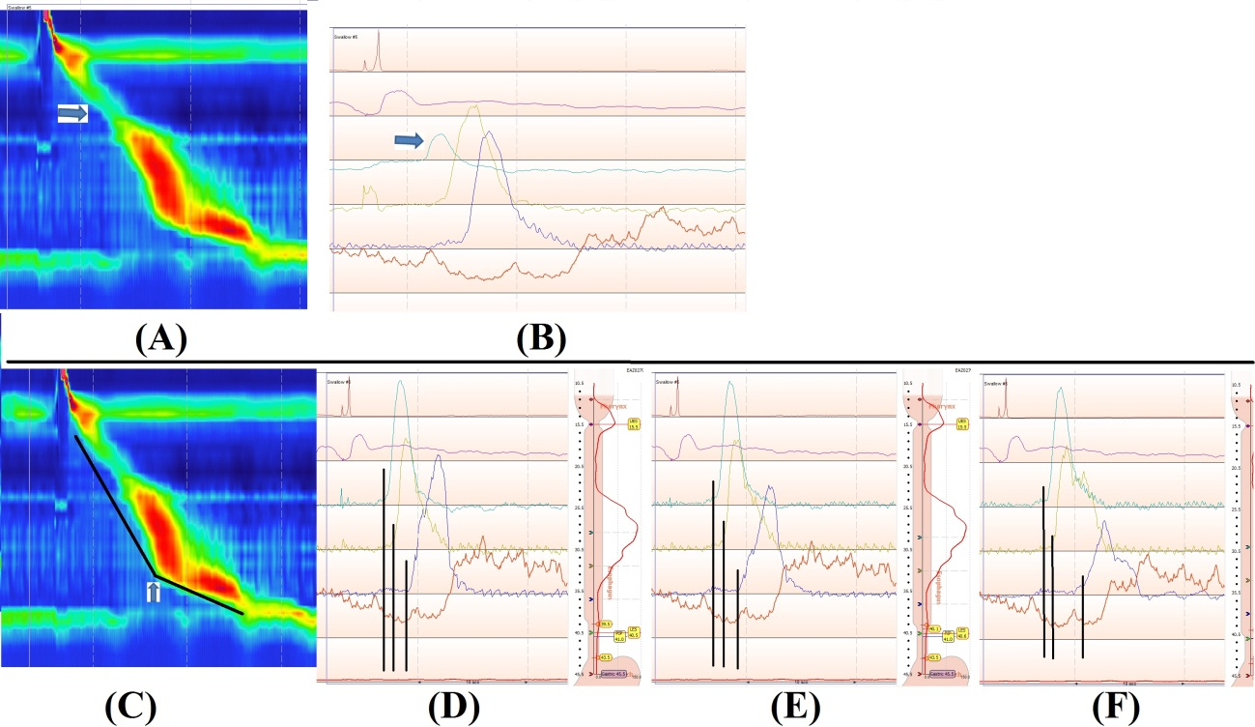
Figure 1 Example of high resolution parameters identifiable at the conventional manometry. A: The peristaltic gap at transition zone (change from striated to smooth muscle in the proximal esophagus - arrow) has been fully explored with high resolution manometry^{[11]} but it was well-known and identifiable as low amplitude waves at the proximal esophagus (arrow), although the clinical significance not comprehended, by conventional manometrists (B)^{[12]}; C: The contractile deceleration point (CDP) represents the inflexion point in the contractile front propagation velocity in the distal esophagus representing the motility of the ampulla (arrow). Conventional manometry neglected time and privileged only amplitudes. A progressive latter onset of the distal wave (CDP) can be noticed from 3 to 1 cm above the lower esophageal sphincter upper border (D-F).

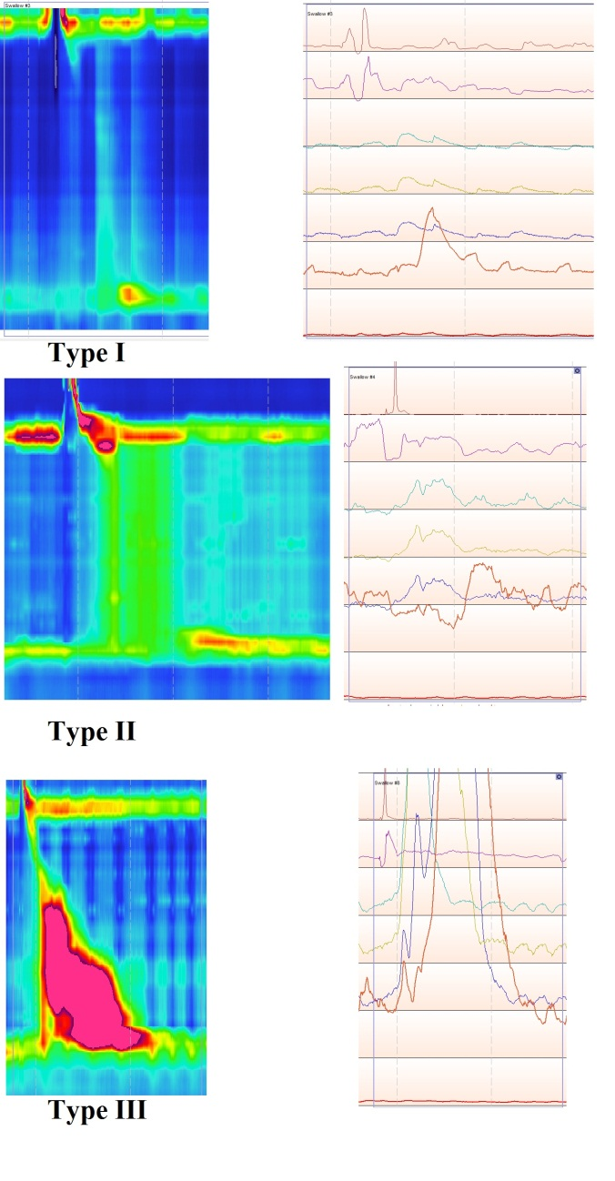
Figure 2 Chicago classification subtypes at the light of high resolution manometry (left) and conventional manometry (right). Type I (no distal pressurization), type II (panesophageal pressurization), and type III (premature spastic contractions).

