Name of Journal: World Journal of Cardiology
ESPS Manuscript NO: 25365
Manuscript Type: Case Report

Rare presentation of intralobar pulmonary sequestration associated with repeated episodes of ventricular tachycardia

Rao DS et al. Coronary steal by intralobar pulmonary sequestration

D Sheshagiri Rao, Ramachandra Barik

D Sheshagiri Rao, Ramachandra Barik, Department of Cardiology, Nizam’s Institute of Medical Sciences, Hyderabad 500082, Telangana, India

Author contributions: Rao DS had suggested the line of management; Barik R had done the procedure and written the manuscript.

Institutional review board statement: This case report was won the approval of the institutional ethical committee and the Review Board standards at Nizam’s Institute of Medical Science, Hyderabad, India.

Informed consent statement: The patient involved in this study gave her written informed consent authorizing use and disclosure of her protected health information.

Conflict-of-interest statement: None.

Open-Access: This article is an open-access article which was selected by an in-house editor and fully peer-reviewed by external reviewers. It is distributed in accordance with the Creative Commons Attribution Non Commercial (CC BY-NC 4.0) license, which permits others to distribute, remix, adapt, build upon this work non-commercially, and license their derivative works on different terms, provided the original work is properly cited and the use is non-commercial. See: http://creativecommons.org/licenses/by-nc/4.0/

Manuscript source: Unsolicited manuscript

Correspondence to: Dr. Ramachandra Barik, Department of Cardiology, Nizam’s Institute of Medical Sciences, Punjagutta, Hyderabad 500082, Telangana, India. cardioramachandra@gmail.com
Telephone: +91-040-23404156
Fax: +91-040-23310076

Received: March 6, 2016
Peer-review started: March 7, 2016
First decision: April 15, 2016
Revised: May 5, 2016
Accepted: May 31, 2016
Article in press:
Published online:

Abstract
Arterial supply of an intralobar pulmonary sequestration (IPS) from the coronary circulation is extremely rare. A significant coronary steal does not occur because of dual or triple sources of blood supply to sequestrated lung tissue. We present a 60-year-old woman who presented to us with repeated episodes of monomorphic ventricular tachycardia (VT) in last 3 mo. Radio frequency ablation was ineffective. On evaluation, she had right lower lobe IPS with dual arterial blood supply, i.e., right pulmonary artery and the systemic arterial supply from the right coronary artery (RCA). Stress myocardial perfusion scan revealed significant inducible ischemia in the RCA territory. Coronary angiogram revealed critical stenosis of proximal RCA just after the origin of the systemic artery supplying IPS. The critical stenosis in the RCA was stented. At 12 mo follow up, she had no further episodes of VT or angina.

Key words: Intralobar pulmonary sequestration; Coronary artery disease; Coronary steal; Ventricular tachycardia; Angioplasty

© The Author(s) 2016. Published by Baishideng Publishing Group Inc. All rights reserved.

Core tip: The intralobar pulmonary sequestration (IPS) of right lower lobe of the lung (RLL) is less than 10% of all the pulmonary sequestration. It is rare to encounter that right coronary artery is being the source of systemic arterial supply to IPS of RLL. This anomalous artery was the reason for ischemia in the area subtended by RCA by coronary steal phenomenon. A significant stenosis of RCA just distal to origin of the anomalous artery supplying the IPS is extremely rare which was further worsening ischemia by incremental steal. We felt excessive stealing from RCA was the reason for ischemic ventricular tachycardia in this patient. Angioplasty of right coronary stenosis relieved ischemia in the area subtended by RCA by removing obstruction and reducing coronary steal.

Rao DS, Barik R. Rare presentation of intralobar pulmonary sequestration associated with repeated episodes of ventricular tachycardia. World J Cardiol 2016; In press

INTRODUCTION
Pulmonary sequestration consists 0.5%-6.4% of all congenital malformation of lung^{[1]}. Intralobar pulmonary sequestration (IPS) accounts for 75%-90% of the total pulmonary sequestration^{[1,2]}. Right lower lobe is involved in 20% of cases of IPS^{[3]}. The non-functioning mass of lung tissue that lacks normal communication with the tracheobronchial tree is supplied by systemic circulation (nutritional branches from abdominal or thoracic aorta) or dual arterial supply (systemic artery and pulmonary artery)^{[4]} or triple arterial supply (systemic, pulmonary and bronchial artery)^{[5]}. Pulmonary sequestration supplied by a normal coronary artery is extremely rare with significant coronary steal^{[6]} or coronary artery disease^{[7]}. Right coronary artery (RCA) is very rarely being the source of blood supply when compared to the left circumflex coronary artery.

CASE REPORT
A 60-year-old female was referred to us for repeated episodes of monomorphic ventricular tachycardia (VT) in the last 12 mo. She had undergone recently radiofrequency ablation (RFA) for VT. Coronary angiogram prior to RFA was reported to have mild RCA disease as was mentioned in referral slip. Her past history reveals she was a known case of right lower lobe IPS accidentally detected in contrast enhanced computed tomography (CECT) of chest when she was under evaluation for right lower lobe pneumonia. The detail of arterial supply to sequestration was evident from the report of past CECT chest. At admission, 12 leads electrocardiography (ECG) and echocardiogram were normal. A chest X-ray revealed non homogenous opacity of right lower lobe. Myocardial stress perfusion scan was positive for inducible ischemia in the RCA territory. Her coronary angiogram showed critical stenosis of proximal dominant RCA (Figure 1A). The anomalous artery to the right sided IPS was just before the critical RCA stenosis (Figure 1B). The follow up in levophase confirmed normal pulmonary venous drainage [Video core tip: Selective RCA angiogram in left anterior oblique 48 degrees (LAO 48°) showed the normal venous drainage from IPS to right lower pulmonary vein]. The lesion in RCA was stented using a drug eluting stent, 3 mm × 12 mm, Xience V (Abbott’s Vascular) with predilatation with a noncompliant coronary balloon (Figure 2). Angioplasty of right coronary stenosis relieved ischemia in the area subtended by RCA by removing obstruction to forward flow and coronary steal. At 12 mo follow up, she had no further episodes of VT and angina. The elective resection of IPS was planned in future as the patient was not willing to undergo surgery at present.

DISCUSSION
In most cases, IPS has a single feeding artery. Sometimes, there are multiple systemic arteries supply to IPS. Arterial supply of pulmonary sequestration mainly originates from thoracic aorta (46.1%-86.1%) and abdominal aorta (6.9%-31.6%)^{[8-10]}. The other feeders are intercostal artery, phrenic artery, branches from aortic arch, subclavian artery, pulmonary artery, left gastric artery, coronary artery, celiac trunk and renal artery^{[8-10]}. Several complications related to IPS include recurrent pulmonary infections, haemoptysis and heart failure from persistent left-to-right shunt. The natural history of sequestration supplied by a coronary artery remains unknown because of rare incidence. In absence of complications, surgical resection is controversial^{[11]} and the exact timing of such surgery is not known^{[12]}. A recent series suggest surgical resection is safe in such cases because of very lower complication rate^{[13]}. Recently, some researchers suggest to resect the sequestration to avoid unpredictable fatal haemoptysis^{[14]}. Surgical resection is recommended for recurrent pulmonary infections or coronary steal. In our case, the detection of IPS was incidental, i.e., detection during evaluation for pneumonia. Significant coronary artery disease of the of the feeder that nourishes IPS is extremely rare^{[15]}. The unique finding in our case was significant coronary steal due to critical stenosis of RCA just distal to the origin of artery which was feeding IPS contributing to significant ischemia in the area subtended by RCA which is the very reason for ischemic VT in our case. The various management approaches in a case are option 1: Surgical resection of IPS, ligation of abnormal feeder t and distal RCA graft; option 2: angioplasty of RCA and elective resection of IPS with ligation of feeder; or option 3: Coil embolization of feeder artery during angioplasty of RCA and elective resection of sequestration. The patient was not willing for lung surgery during current admission, therefore, the best option was coiling of feeder to IPS during angioplasty of RCA. As there was one episode of pneumonia in our patient, we proceeded with the angioplasty of RCA which was the needed most at the time presentation. Therefore, our future plan for our patient is ligation of the feeder artery during the resection of IPS.

COMMENTS
Case characteristics
This is 62-year-old female with previous diagnosis of intralobar sequestration of right lower lobe presented with repeated episodes of ventricular tachycardia (VT) without any response to radiofrequency ablation therapy.

Clinical diagnosis
Repeated episodes of VT.

Differential diagnosis
Coronary artery disease, ischemic VT, idiopathic VT and cardiomyopathy.

Laboratory diagnosis
Right lower lobe intrapulmonary sequestration associated with critical stenosis of right coronary artery (RCA).

Imaging diagnosis
Selective coronary angiogram confirms the diagnosis of critical RCA stenosis associated a branch of right coronary supplying right intralobar pulmonary sequestration (IPS).

Pathological diagnosis
Contrast enhanced computed tomography is suggestive of right lower lobe intrapulmonary sequestration.

Treatment
RCA angioplasty with future plan of resection of intrapulmonary sequestration.

Related reports
Symptomatic IPS should undergo elective surgical resection with ligation of systemic arterial supply to the sequestrated lung.

Term explanation
Pulmonary sequestration is a rare congenital malformation of the lower respiratory tract. It consists of a nonfunctioning mass of normal lung tissue that lacks normal communication with the tracheobronchial tree, and that receives its arterial blood supply from the systemic circulation. It is of three types: IPS, extralobar pulmonary sequestration and bronchopulmonary-foregut malformation.

Experiences and lessons
RCA as source of systemic blood supply to the right IPS is rare. If the same coronary artery acquires coronary artery stenosis distal to the systemic feeder artery to sequestration, it further worsens the ischemia in the RCA territory. The resection of sequestrated lung, ligation of systemic artery to sequestration and coronary artery bypass graft is the ideal treatment in such situation.

Peer-review
This is an interesting and very unusual case.

REFERENCES
1 Gompelmann D, Eberhardt R, Heussel CP, Hoffmann H, Dienemann H, Schuhmann M, Böckler D, Schnabel PA, Warth A, Lopez-Benitez R, Herth FJ. Lung sequestration: a rare cause for pulmonary symptoms in adulthood. Respiration 2011; 82: 445-450 [PMID: 21311173 DOI: 10.1159/000323562]
2 Conran RM, Stocker JT. Extralobar sequestration with frequently associated congenital cystic adenomatoid malformation, type 2: report of 50 cases. Pediatr Dev Pathol 1999; 2: 454-463 [PMID: 10441623 DOI: 10.1007/s100249900149]
3 Wei Y, Li F. Pulmonary sequestration: a retrospective analysis of 2625 cases in China. Eur J Cardiothorac Surg 2011; 40: e39-e42 [PMID: 21459605 DOI: 10.1016/j.ejcts.2011.01.080]
4 Barik R, Patnaik AN, Malempati AR, Nemani L. Pryce type I sequestration: no mosquito shooting. Asian Cardiovasc Thorac Ann 2015; 23: 567-569 [PMID: 24585298 DOI: 10.1177/0218492314522471]
5 Theodoropoulos I, Schwartz MZ. Intralobar pulmonary sequestration: an uncommon case with triple arterial supply and systemic venous drainage. Pediatr Surg Int 2012; 28: 741-744 [PMID: 22526550 DOI: 10.1007/s00383-012-3088-4]
6 Temes RT, Talbot WA, Carrillo YM, Keck GM, Wernly JA. Sequestration of the lung arising from the circumflex coronary artery. Ann Thorac Surg 1998; 65: 257-259 [PMID: 9456133 DOI: 10.1016/S0003-4975(97)01263-0]
7 Marinos T, Bitzikas G, Madesis A, Galanos O. Sequestered hypoplastic pulmonary lobe supplied by the circumflex coronary artery in a patient with coronary artery disease: a case report. Heart Surg Forum 2006; 9: E565-E567 [PMID: 16467062 DOI: 10.1532/HSF98.20051039]
8 Savic B, Birtel FJ, Tholen W, Funke HD, Knoche R. Lung sequestration: report of seven cases and review of 540 published cases. Thorax 1979; 34: 96-101 [PMID: 442005 DOI: 10.1136/thx.34.1.96]
9 Sun X, Xiao Y. Pulmonary sequestration in adult patients: a retrospective study. Eur J Cardiothorac Surg 2015; 48: 279-282 [PMID: 25361546 DOI: 10.1093/ejcts/ezu397]
10 Xie D, Xie H, You X, Chen C, Jiang G. Pulmonary sequestration with aberrant arteries arising from the renal artery and the internal thoracic artery. Ann Thorac Surg 2013; 96: e131 [PMID: 24182513 DOI: 10.1016/j.athoracsur.2013.08.018]
11 Laberge JM, Puligandla P, Flageole H. Asymptomatic congenital lung malformations. Semin Pediatr Surg 2005; 14: 16-33 [PMID: 15770585 DOI: 10.1053/j.sempedsurg.2004.10.022]
12 Gezer S, Taştepe I, Sirmali M, Findik G, Türüt H, Kaya S, Karaoğlanoğlu N, Cetin G. Pulmonary sequestration: a single-institutional series composed of 27 cases. J Thorac Cardiovasc Surg 2007; 133: 955-959 [PMID: 17382633 DOI: 10.1016/j.jtcvs.2006.11.003]
13 Wang LM, Cao JL, Hu J. Video-assisted thoracic surgery for pulmonary sequestration: a safe alternative procedure. J Thorac Dis 2016; 8: 31-36 [PMID: 26904209]
14 Walker CM, Wu CC, Gilman MD, Godwin JD, Shepard JA, Abbott GF. The imaging spectrum of bronchopulmonary sequestration. Curr Probl Diagn Radiol 2014; 43: 100-114 [PMID: 24791614 DOI: 10.1067/j.cpradiol.2014.01.005]
15 Fernandez-Vega A, Vilacosta I, Vedia OA, Pedraja I, Vivas D, Martinez-Vives P. A 'kidnapper' left circumflex coronary artery. Eur Heart J 2016; 37: 919 [PMID: 26705384]

P-Reviewer: Aggarwal A, Firstenberg MS, Lin SL, S-Editor: Ji FF L-Editor: E-Editor:

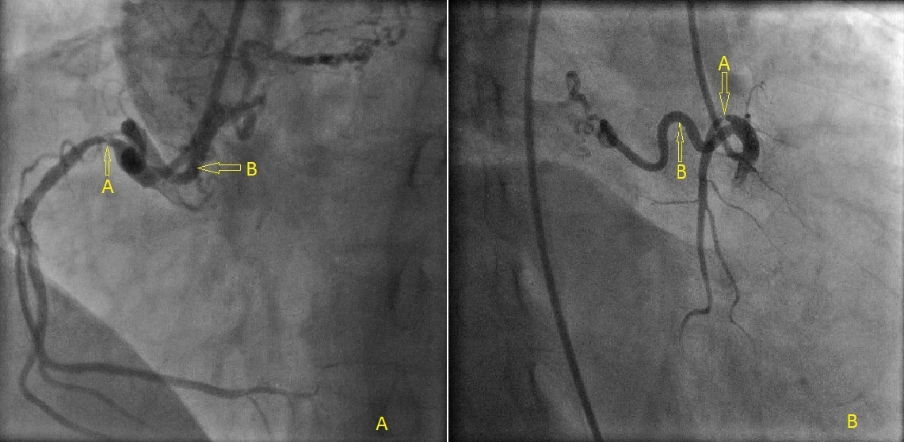

Figure 1 Selective right coronary angiogram from right femoral approach in left anterior oblique 48 degrees and right posterior caudal view view showed tight right coronary artery (A) and aberrant blood supply to right lower lobe intralobar sequestration which the branch of right coronary artery (B).
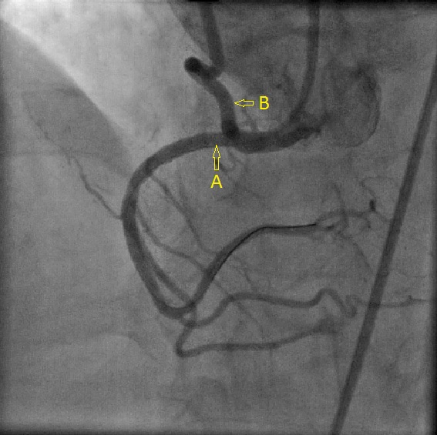

Figure 2 Selective right coronary angiogram after stenting the proximal lesion left anterior oblique 48 degrees (A) which resulted in significant reduction of flow in aberrant blood supply to right lower lobe intralobar sequestration (B).

