Name of Journal: World Journal of Gastroenterology
ESPS Manuscript NO: 24356
Manuscript Type: ORIGINAL ARTICLE

Retrospective Study
Clinical and ABCB11 profiles in Korean infants with progressive familial intrahepatic cholestasis

Park JS et al. clinical and ethnical variations in PFIC2

Ji Sook Park, Jae Sung Ko, Jeong Kee Seo, Jin Soo Moon, Sung Sup Park

Ji Sook Park, Jae Sung Ko, Jeong Kee Seo, Jin Soo Moon, Department of Pediatrics, Seoul National University College of Medicine, Seoul 110-799, South Korea

Sung Sup Park, Department of Laboratory Medicine, Seoul National University College of Medicine, Seoul 110-799, South Korea

Ji Sook Park, Department of Pediatrics, Gyeongsang National University School of Medicine, Jinju, Gyeongnam 660-702, South Korea

Author contributions: Ko JS and Moon JS designed the study; Park SS performed the genetic analyses; Park JS and Seo JK collected and analyzed the clinical data, and wrote the paper.

Institutional review board statement: This study was carried out after obtaining the clearance from the ethical board of the hospital (GNUH 2015-09-004-001).

Conflict-of-interest statement: There was no conflict of interest among the authors.

Open-Access: This article is an open-access article which was selected by an in-house editor and fully peer-reviewed by external reviewers. It is distributed in accordance with the Creative Commons Attribution Non Commercial (CC BY-NC 4.0) license, which permits others to distribute, remix, adapt, build upon this work non-commercially, and license their derivative works on different terms, provided the original work is properly cited and the use is non-commercial. See: http://creativecommons.org/licenses/by-nc/4.0/

Correspondence to: Jeong Kee Seo, MD, PhD, Department of Pediatrics, Seoul National University College of Medicine, Daehak-ro, Jongno-gu, Seoul 110-799, South Korea. jkseo@snu.ac.kr
Telephone: +82-2-20723778
Fax: +82-2-20723917

Received: January 19, 2016
Peer-review started: January 20, 2016
First decision: February 18, 2016
Revised: February 29, 2016
Accepted: March 14, 2016
Article in press:
Published online:

Abstract
Aim: To investigate clinical profiles and mutations of ABCB11 in Koreans with progressive familial intrahepatic cholestasis 2, and review the differences between Koreans and others.

Methods: Of 47 patients with neonatal cholestasis, five infants had chronic intrahepatic cholestasis with normalγ-glutamyl transpeptidase. Direct sequencing analyses of ABCB11 using peripheral blood were done including exon and intron.

Results: Living donor-liver transplantation were done in 4 patients because of rapidly progressive hepatic failure and hepatocellular carcinoma. Three missense mutations were found in two patients, which were compound heterozygous 677C>T (S226L)/3007G>A (G1003R), and heterozygous 2296G>A (G766R), respectively. The mutations were located at near and in transmembranous space.

Conclusion: The transmembranous alterations of bile salt export pump in the Korean infants were different from previous reports in Chinese, Japanease, Taiwanes and European patients.

Key words: Progressive familial intrahepatic cholestasis; Hepatocellular carcinoma; ABCB11; Bile salt export pump

© The Author(s) 2016. Published by Baishideng Publishing Group Inc. All rights reserved.

Core tip: Recently, reports on mutations of ABCB11 in Asian Patients with progressive familial intrahepatic cholestasis have been increasing. However, mutations of Asian progressive familial intrahepatic cholestasis (PFIC) were still less than those of Westerns because of time consuming and expensive diagnostic tools until now. In the present study, the authors would like to report mutations of ABCB11 in Korean infants with PFIC2 and to investigate the differences between Korean and other previous mutations.

Park JS, Ko JS, Seo JK, Moon JS, Park SS. Clinical and ABCB11 profiles in Korean infants with progressive familial intrahepatic cholestasis. World J Gastroenterol 2016; In press

Introduction
Progressive familial intrahepatic cholestasis (PFIC) is an autosomal recessive disorder that manifests as cholestasis during the neonatal period due to defective bile secretion. PFIC is divided into types 1, 2 and 3 according to their different clinical manifestations and genetics. In PFIC1 and PFIC2, cholestasis develops during the neonatal period and γ-glutamyl transpeptidase (GGT) is within normal limits. PFIC3 develops at a later stage than PFIC1 and PFIC2, and features a positive prenatal history of maternal cholestasis. Generally, cholestasis with elevated GGT is associated with PFIC3 rather than PFIC1 and PFIC2. Persistent or repetitive cholestasis develops within 1 year of age and rapidly progresses to liver cirrhosis and hepatic failure in patients with PFIC. Mutations of biliary transporters associated with PFIC have been discovered, which could aid in understanding of diagnosis and pathogenesis. The genes are ATP8B1, ABCB11, and ABCB4, which encode familial intrahepatic cholestasis 1 protein (FIC1), bile salt export pump (BSEP), and multidrug resistance protein 3 (MDR3) in PFIC1, 2, and 3, respectively.
ABCB11 is located on chromosome 2q24. It encodes BSEP, which plays a role in the secretion of conjugated bile acids including taurocholates. BSEP defect can cause cholestasis with normal range of GGT because of bile secretion defect^{[1]}. Over 82 different ABCB11 mutations have been reported^{[2,3]}. Of them, E297G and D482G accounts for 30% of BSEP mutations in European patients with PFIC2. In Asia, mutations of BSEP in Chineses, Japanese and Taiwanese patients with PFIC2 were reported^{[4-7]}.
To the best of our knowledge, there have been less reports of ABCB11 (BSEP) mutations in Asians with PFIC2 than in Europeans^{[2,4-7]}. Because PFIC2 features rapid progression to liver cirrhosis and hepatic failure within the first decade, rapid diagnosis, management, and prediction of prognosis are important. In the present study, the authors investigated clinical profiles of Korean infants with PFIC and performed mutation analysis on the ABCB11 gene. The authors obtained the clearance from the ethical board of the hospital (GNUH 2015-09-004-001)

Materials and Methods
Patients
Between 2005 and 2006, 47 patients visited the Department of Pediatrics in Seoul National University Children’s Hospital for neonatal cholestasis. Examinations included abdominal ultrasonography, duodenal intubation, a hepatobiliary scan, and liver biopsy. Inborn error of metabolism, total parenteral nutrition, drug related cholestasis, congenital infection, and cholestasis secondary to sepsis were excluded. PFIC was suspected based on intrahepatic cholestasis with normal ranged GGT or on the results of the genetic analyses. None had a family history of PFIC.

Genetic analyses
Genetic analyses were performed for diagnosis with parental consent. Direct sequencing analysis of ABCB11 was done using peripheral blood. Exons and flanking intron sequences of the ABCB11 gene (NC_000002.10) were amplified by polymerase chain reaction from total genomic DNA. Polymerase chain reaction products were purified by ExoSAP-IT (USB, Ohio, United States) and subjected to DNA sequencing using the BigDye v3.1 Terminator Chemistry (PE Applied Biosystems, Foster City, CA), followed by separation on an ABI 3100 DNA sequencer (PE AppliedBiosystems Foster City, CA). Sequence data were analyzed manually and were assembled with the Seqscape v2.5 (PE Applied Biosystems, Foster City, CA). As reference control, the ABCB11 genomic sequence was obtained from http://pharmacogenetics.ucsf.edu/set1/BSEPrefseq.html.

Results
Among the 47 patients with cholestatic jaundice presented during the two-year period, extrahepatic biliary atresia was diagnosed in 11, congenital infection with TORCH in 4, neonatal intrahepatic cholestasis caused by citrin deficiency in 3, ARC (arthrogryposis, renal dysfunction, cholestasis) syndrome in 2, neonatal Dubin-Johnson syndrome in 2, Alagille syndrome in 1, and non-syndromic bile duct paucity in 1^{[8]}. PFIC was suspected in five patients with intrahepatic cholestasis and normal GGT. Table 1 summarizes the clinical and laboratory findings of the patients. The chief complaint was cholestatic jaundice in all patients, and onset of the symptom ranged from 20 d to 9 mo after birth. Gallstone was developed in patient 1 and 2, and hepatocellular carcinoma was developed in patient 1 (Figure 1). Hepatic pathologic examinations were performed in all patients. Various degree of periportal fibrosis and inflammatory cell infiltration, canalicular and cytoplasmic bile pigments, cholestasis, and bile ductular dilatation and proliferation were noted in all hepatic specimens of the patients. Hepatocellular carcinoma was proved from an excised liver in patient 1 (Figure 2). Living donor liver transplantations were performed in 4 patients due to hepatic failure between 2.5 mo and 10 years after their initial visits. Three of the ten alleles examined showed mutations. In detail, compound heterozygous 677C>T (S226L)/3007G>T (G1003R) in patient 1, and heterozygous 2296G>A (G776R) in patient 2 (Figure 3). Three of the five patients showed no mutation of ABCB11. The PolyPhen program (http://genetics.bwh.harvard.edu/pph2) predicted that S226L is probably benign with a score of 0.175, but the SIFT program (http://sift.jcvi.org) predicted that S226L deleteriously affects protein function. G1003R and G776R are predicted to be probably damaging with scores of 1.000 by the PolyPhen-2 program and to deleteriously affect protein functions. 3007G/T (G1003R) was a novel mutation of ABCB11.

Discussion
Three mutations were found in two patients with the PFIC phenotype: 677C>T in exon 8 (S226L), 3007G>A in exon 23 (G1003R) in patient 1 and 2296G>A in exon 19 (G766R) in patient 2 (Figure 3). The patients revealed mutations presented chronic intrahepatic cholestasis with normal GGT from the infantile period, rapidly declining liver functions, gallstone without intravascular hemolysis and hepatocellular carcinoma (HCC) (Table 1, Figures 1-3).
PFICs are developed by mutations of bile transporters and the incidence of mutation has not yet been established^{[9]}. In addition, the incidence might be underestimated in Korea because the diagnosis in a patient with suspected PFIC was usually made by time consuming and expensive clinical methods such as clinical courses, laboratory findings, pathologic examination and genetic analysis. Differentiation between PFIC1 and PFIC2 is known to be difficult by clinical manifestations and pathologic findings because of their marked clinical overlap^{[1]}. PFIC1 usually presents diverse extrahepatic symptoms including diarrhea more than in patient with PFIC2^{[10]}. The patients did not show diarrhea or pruritus, except patient 1 in whom gallstone and hepatocellular carcinoma developed.
To the best our knowledge, Asian reports on PFIC2 are relatively lacking in comparison to the Western^{[2,4-7]}. However, reports on mutations of BSEP in Asian patients with PFIC2 are increasing by denaturing high performance liquid chromatography, high-resolution melting analysis and direct sequencing. The reported Asian BSEP mutations were as follows; R575X, E636G, R487H, and V330X in Japanese patients, and 1bp deletion (position 1145), V284L, and G1004D in Taiwanese patients, and twenty mutations including A167T in Chinese patients, respectively^{[4,7,11,12]}. Of hundreds BSEP mutations, E297G and D482G were common European mutations^{[13]}. Most of the previous reported mutations in Chinese and Europeans are located in the canalicular cytoplasm^{[2,4,12]}. However, three different missense mutations (S226L, G1003R, and G775R) in the present study were located at the transmembranous (TM) and near the TM part of BSEP (Figure 4). The transmembranous alterations of BSEP in Korean infants might be suggested the possibility of ethnic differences. But further study was needed because the number of mutations in the Korean patients with PFIC2 was too low.
There was no mutation of ABCB11 in patient 3, 4, and 5. TPJ2 mutations can also cause PFIC2 like phenotype and further genetic analyses of TPJ2 are necessary^{[14]}. Patient 5 showed raised GGT levels and decreased serum total bilirubin in a relatively short clinical course. Therefore, the possibilities of PFIC1 and PFIC2 are less, but careful follow-ups are essential with the possibility of benign recurrent intrahepatic cholestasis.
Compound heterozygotes of 677C>T (S226L) and 3007G>A (G1003R) in patient 1, and one missense mutation of 2296G>A (G766R) in patient 2 were noted (Figure 3). The mutations were predicted to be damaging or deleterious to BSEP, based on the clinical course of the patients and the results of PolyPhen-2 and SIFT program. Unfortunately, the authors could not perform genetic analyses of ABCB11 of the parents.
HCC developed in patient 1 (Figures 2 and 3a). Knisely et al^{[15]} reported BSEP dysfunctions in 10 patients who presented HCC under the age of 5 years. Chronic intrahepatic bile acids or suppressed DNA ligase by protein dysfunctions were suggested previously^{[16,17]} but specific factor contributing to development of HCC have not been evident. Cholangiocarcinoma and hepatoblastoma in patients with PFIC2 has also been reported^{[18,19]}. The level of serum alpha fetoprotein (AFP) are high in > 60% of patients with HCC and hepatoblastoma, and AFP increased markedly into 204000 ng/mL at 21 mo of age in patient 1. In patient 5, significantly high level of AFP was noted on the first laboratory examination. There was no evidence of hepatic mass on liver USG and inborn errors of metabolism on laboratory examination. The level of AFP was decreased into 530000 ng/mL after 1 mo. The decline of AFP and no occurrence of hepatic mass on liver USG could be ruled out the development of hepatic tumor in patient 5. Therefore, the increment of serum AFP and hepatic image can be useful modalities for early detection of hepatic tumors in a patient with PFIC2.
Various degree of periportal fibrosis, inflammatory cell infiltrates, intracytoplasmic and intracanalicular cholestasis, giant cell transformation, and bile ductular proliferation on the pathologic examinations were noted in the present study (Figure 2). Bile duct paucity or bile ductular proliferation was not a typical finding in patient with PFIC. But pathologic findings might depend on the clinical moments when performing a biopsy. Pathologic examinations in the present study did not show typical findings for PFIC because our hepatic specimens were obtained at the time of liver transplantation, except in patient 5. Pathologic differentiation from PFIC1 to PFIC2 depends on the severity of the aforementioned findings and characters of canalicular bile salts. Coarse granular bile salts can suggest PFIC1, while amorphous and filiform bile salts under electron microscopic examination can suggest PFIC2.¹ However, pathologic differentiation seems to depend significantly on clinical moments for biopsy and experience or skill of pathologist.
In conclusion, the present study is the first report on Korean infants with PFIC including early onset HCC, living donor liver transplantations, and novel mutation and ethnic differences of ABCB11. We tentatively suggest the suspicion of PFIC1 or PFIC2 when children are suffering from chronic intrahepatic cholestasis with normal GGT and without other associated anomalies from their infantile periods, regardless of family history. Early genetic analysis for PFIC1 or PFIC2 might be helpful to diagnose, predict prognosis, and make an early treatment plan.

comments
Background
Because progressive familial intrahepatic cholestasis (PFIC)2 features rapid progression to liver cirrhosis and hepatic failure within the first decade, rapid diagnosis, management, and prediction of prognosis are important. The authors investigated clinical profiles of Korean infants with PFIC and performed mutation analysis on the ABCB11 gene, and reviewed the differences between Korean and other previous mutations.

Research frontiers
In the present study, two novel mutations of ABCB11 in Korean infants with PFIC2 and the sites of amino acid alterations were different from previous common European ones.

Innovations and breakthroughs
The authors reported a rare PFIC2 in Korean patients and its genetic novel mutations. The present mutation affected amino acid substitutions of BSEP and the sites were different from previous reports, although the number of mutations were low.

Applications
The present novel mutations of ABCB11 in Korean infants with PFIC2 might be helpful to understand racial differences in the future. However, further study was warranted including larger SNPs database of Koreans.

Peer-review
The reviewers pointed out the number of mutations in Korean infants with PFIC2. However, the focus of this manuscript is potentially interesting and the present report has a significance on the rarity in character of PFIC2 especially in Asian group.

References
1 Harris MJ, Le Couteur DG, Arias IM. Progressive familial intrahepatic cholestasis: genetic disorders of biliary transporters. J Gastroenterol Hepatol 2005; 20: 807-817 [PMID: 15946126 DOI: 10.1111/j.1400-1746.2005.03743.x].]
2 Strautnieks SS, Byrne JA, Pawlikowska L, Cebecauerová D, Rayner A, Dutton L, Meier Y, Antoniou A, Stieger B, Arnell H, Ozçay F, Al-Hussaini HF, Bassas AF, Verkade HJ, Fischler B, Németh A, Kotalová R, Shneider BL, Cielecka-Kuszyk J, McClean P, Whitington PF, Sokal E, Jirsa M, Wali SH, Jankowska I, Pawłowska J, Mieli-Vergani G, Knisely AS, Bull LN, Thompson RJ. Severe bile salt export pump deficiency: 82 different ABCB11 mutations in 109 families. Gastroenterology 2008; 134: 1203-1214 [PMID: 18395098 DOI: 10.1053/j.gastro.2008.01.038].]
3 Francalanci P, Giovannoni I, Candusso M, Bellacchio E, Callea F. Bile salt export pump deficiency: A de novo mutation in a child compound heterozygous for ABCB11. Laboratory investigation to study pathogenic role and transmission of two novel ABCB11 mutations. Hepatol Res 2013; 43: 315-319 [PMID: 23437912 DOI: 10.1111/j.1872-034X.2012.01061.x.]
4 Hu G, He P, Liu Z, Chen Q, Zheng B, Zhang Q. Diagnosis of ABCB11 gene mutations in children with intrahepatic cholestasis using high resolution melting analysis and direct sequencing. Mol Med Rep 2014; 10: 1264-1274 [PMID: 24969679 DOI: 10.3892/mmr.2014.2349]
5 Chen HL, Liu YJ, Su YN, Wang NY, Wu SH, Ni YH, Hsu HY, Wu TC, Chang MH. Diagnosis of BSEP/ABCB11 mutations in Asian patients with cholestasis using denaturing high performance liquid chromatography. J Pediatr 2008; 153: 825-832 [PMID: 18692205 DOI: 10.1016/j.jpeds.2008.06.034]
6 Chen ST, Chen HL, Su YN, Liu YJ, Ni YH, Hsu HY, Chu CS, Wang NY, Chang MH. Prenatal diagnosis of progressive familial intrahepatic cholestasis type 2. J Gastroenterol Hepatol 2008; 23: 1390-1393 [PMID: 18853996 DOI: 10.1111/j.1440-1746.2008.05432.x]
7 Goto K, Sugiyama K, Sugiura T, Ando T, Mizutani F, Terabe K, Ban K, Togari H. Bile salt export pump gene mutations in two Japanese patients with progressive familial intrahepatic cholestasis. J Pediatr Gastroenterol Nutr 2003; 36: 647-650 [PMID: 12717091]
8 Ko JS, Song JH, Park SS, Seo JK. Neonatal intrahepatic cholestasis caused by citrin deficiency in Korean infants. J Korean Med Sci 2007; 22: 952-956 [PMID: 18162705 DOI: 10.3346/jkms.2007.22.6.952]
9 Jansen PL, Strautnieks SS, Jacquemin E, Hadchouel M, Sokal EM, Hooiveld GJ, Koning JH, De Jager-Krikken A, Kuipers F, Stellaard F, Bijleveld CM, Gouw A, Van Goor H, Thompson RJ, Müller M. Hepatocanalicular bile salt export pump deficiency in patients with progressive familial intrahepatic cholestasis. Gastroenterology 1999; 117: 1370-1379 [PMID: 10579978]
10 Alissa FT, Jaffe R, Shneider BL. Update on progressive familial intrahepatic cholestasis. J Pediatr Gastroenterol Nutr 2008; 46: 241-252 [PMID: 18376240 DOI: 10.1097/MPG.0b013e3181596060]
11 Chen HL, Chang PS, Hsu HC, Ni YH, Hsu HY, Lee JH, Jeng YM, Shau WY, Chang MH. FIC1 and BSEP defects in Taiwanese patients with chronic intrahepatic cholestasis with low gamma-glutamyltranspeptidase levels. J Pediatr 2002; 140: 119-124 [PMID: 11815775 DOI: 10.1067/mpd.2002.119993]
12 Liu LY, Wang ZL, Wang XH, Zhu QR, Wang JS. ABCB11 gene mutations in Chinese children with progressive intrahepatic cholestasis and low gamma glutamyltransferase. Liver Int 2010; 30: 809-815 [PMID: 19845854 DOI: 10.1111/j.1478-3231.2009.02112.x.]
13 Hayashi H, Takada T, Suzuki H, Akita H, Sugiyama Y. Two common PFIC2 mutations are associated with the impaired membrane trafficking of BSEP/ABCB11. Hepatology 2005; 41: 916-924 [PMID: 15791618 DOI: 10.1002/hep.20627]
14 Carlton VE, Pawlikowska L, Bull LN. Molecular basis of intrahepatic cholestasis. Ann Med 2004; 36: 606-617 [PMID: 15768832 DOI: 10.1080/07853890410018916]
15 Knisely AS, Strautnieks SS, Meier Y, Stieger B, Byrne JA, Portmann BC, Bull LN, Pawlikowska L, Bilezikçi B, Ozçay F, László A, Tiszlavicz L, Moore L, Raftos J, Arnell H, Fischler B, Németh A, Papadogiannakis N, Cielecka-Kuszyk J, Jankowska I, Pawłowska J, Melín-Aldana H, Emerick KM, Whitington PF, Mieli-Vergani G, Thompson RJ. Hepatocellular carcinoma in ten children under five years of age with bile salt export pump deficiency. Hepatology 2006; 44: 478-486 [PMID: 16871584 DOI: 10.1002/hep.21287]
16 Bernstein H, Bernstein C, Payne CM, Dvorakova K, Garewal H. Bile acids as carcinogens in human gastrointestinal cancers. Mutat Res 2005; 589: 47-65 [PMID: 15652226 DOI: 10.1016/j.mrrev.2004.08.001]
17 Prieto-Alamo MJ, Laval F. Deficient DNA-ligase activity in the metabolic disease tyrosinemia type I. Proc Natl Acad Sci U S A 1998; 95: 12614-12618 [PMID: 9770534]
18 Scheimann AO, Strautnieks SS, Knisely AS, Byrne JA, Thompson RJ, Finegold MJ. Mutations in bile salt export pump (ABCB11) in two children with progressive familial intrahepatic cholestasis and cholangiocarcinoma. J Pediatr 2007; 150: 556-559 [PMID: 17452236 DOI: 10.1016/j.jpeds.2007.02.030]
19 Richter A, Grabhorn E, Schulz A, Schaefer HJ, Burdelski M, Ganschow R. Hepatoblastoma in a child with progressive familial intrahepatic cholestasis. Pediatr Transplant 2005; 9: 805-808 [PMID: 16269056 DOI: 10.1111/j.1399-3046.2005.00380.x]

P-Reviewer: Kamimura K, Vij M, Wang JS S-Editor: Ma YJ L-Editor: E-Editor:

Table 1 Clinical, laboratory findings and mutations of five infants with progressive familial intrahepatic cholestasis
 |  | Age of Symptom onset | Age at LTx | Associated | AST/ALT (IU/L) | T/D. bil (mg/dL) | GGT (IU/L) | AFP (ng/mL) | Mutations of ABCB11
Patient | Sex |  |  | sign | (0-37/0-41) | (0-1.2/0-0.5) | (6-71) | (0-7.0)
1 | F | 20 d | 24 mo | Gallstone, HCC | 602/242 | 11.3/7.9 | 29 | 3,070 | S226L/  G1003R
2 | F | 9 mo | 10 yr | Gallstone | 178/242 | 8.2/5.2 | 25 | <5 | G776R
3 | M | 5 d | 6 mo | - | 416/93 | 35.1/14 | 25 | 21500 | No
4 | M | 1 mo | 3.5 mo | - | 1467/250 | 44.5/25.1 | 50 | - | No
5 | M | 2 mo | - | - | 951/677 | 14.3/8.0 | 52 | 770000 | No
LTx: Liver transplantation; T/D.bil: Total bilirubin/direct bilirubin; GGT: γ-glutamyl transpeptidase (normal values in brackets; Laboratory values were obtained at initial visits of 5 cases).

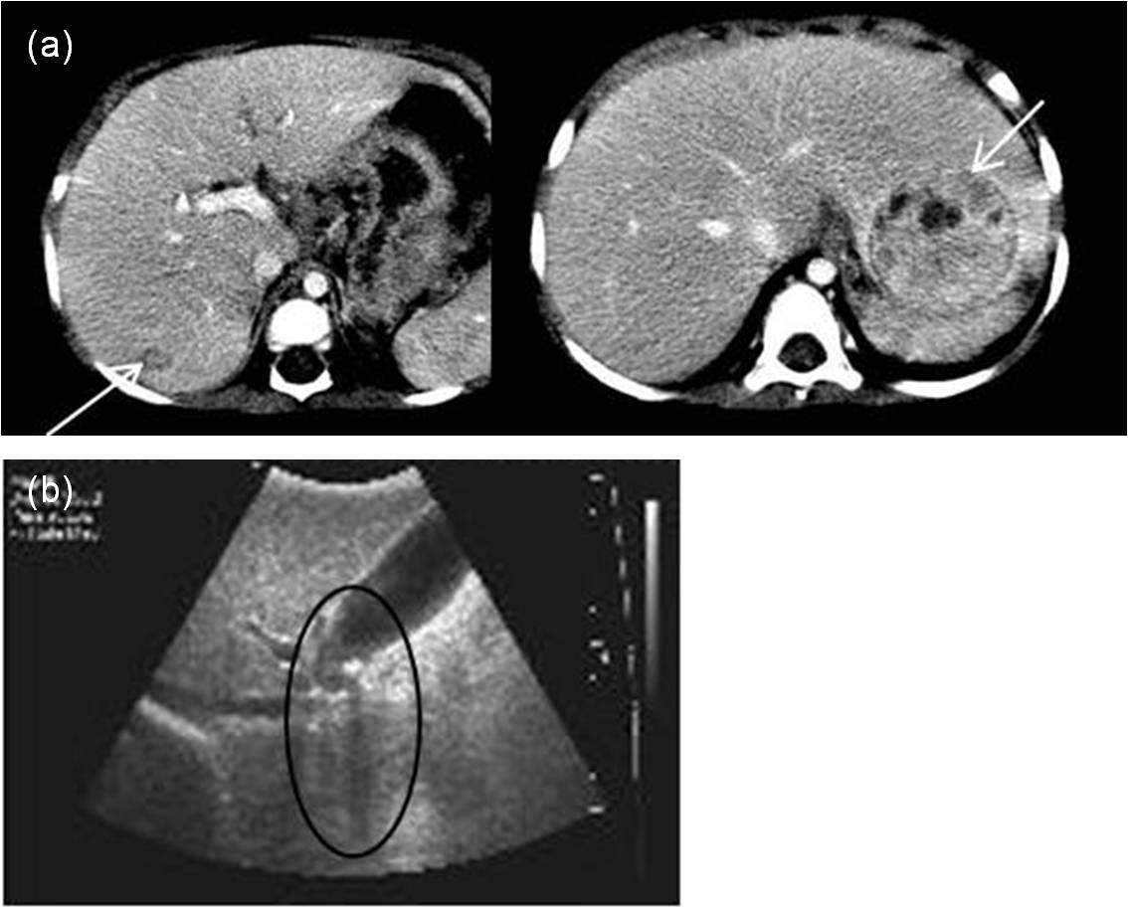
Figure 1 Radiologic hepatic evaluations in patient 1 and 2. A: Abdominal computed tomography of patient 2 revealed two contrast-enhanced hepatic masses (arrows) at 21 months of age; b: Gallstone and its posterior shadow (circle) were observed on liver ultrasonography in patient 2.

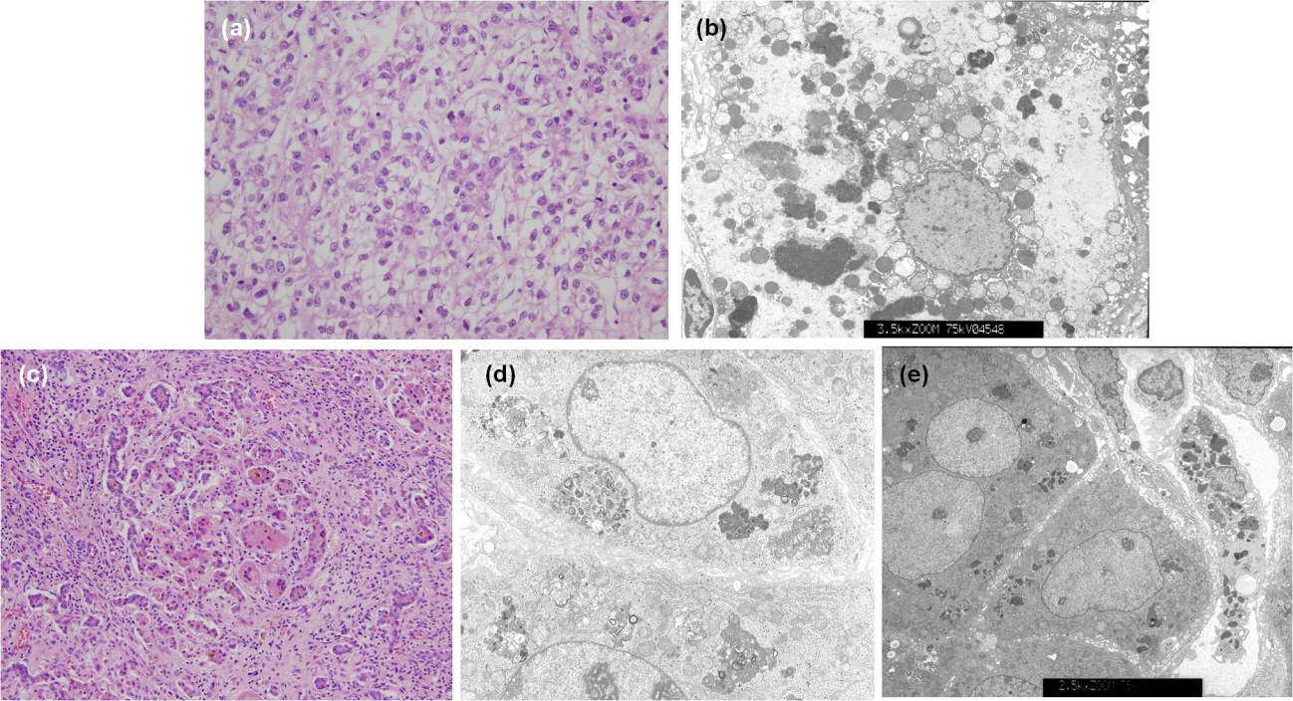
Figure 2 Liver histologic features from infants with chronic intrahepatic cholestasis with normal ranges of γ-glutamyl transpeptidase. A: Hepatocellular carcinoma was proven by liver specimen at hepatectomy taken from patient 1 at 24 mo of age. Cellular atypia with trabecular and acinar type was shown. Microvascular invasion was not identified; hematoxylin-eosin stain, original magnification ⅹ 400; b: Electron microscopic examination of liver specimen from patient 2 shows many globular or curly appearance electron dense materials in the cytoplasm with original magnification of ⅹ 3.5k; c: Liver biopsy at hepatectomy taken at 6 months of age from patient 3 shows periportal fibrosis, inflammatory cell infiltration, intracanalicular bile plugs, giant cell formation, and bile ductular proliferation; hematoxylin-eosin stain, original magnification ⅹ200; d: Electron microscopic examination of liver specimen from patient 4 at 3.5 mo of age reveals amorphous and coarse granular bile pigments in the dilated bile canaliculi. Original magnification ⅹ5.0k; e: Electron microscopic examination of liver specimen from patient 5 shows aggregated bile pigments in the cytoplasm. Original magnification ⅹ2.5k.
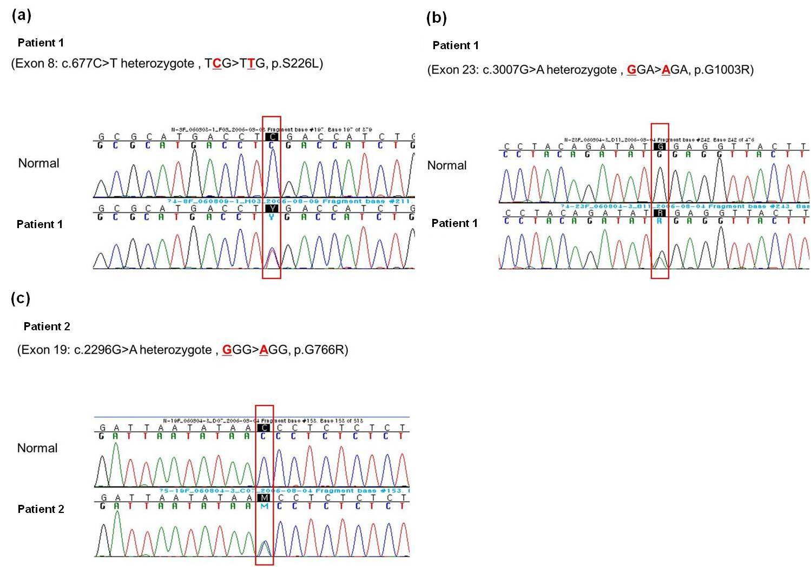
Figure 3 Direct sequencing analysis of the ABCB11 genes demonstrating (a) heterozygous C to T substitution in exon 8 predicting a missense mutation at amino acid position 226(p.S226L) (b) heterozygous G to A in exon 23 predicting a missense mutation at amino acid position 1003 (p.G1003R), and (c) heterozygous G to A in exon 19 predicting a missense mutation at amino acid position 776(p.G776R), (a) and (b) were detected in ABCB11 gene of patient 1 and (c) was detected in patient 2.

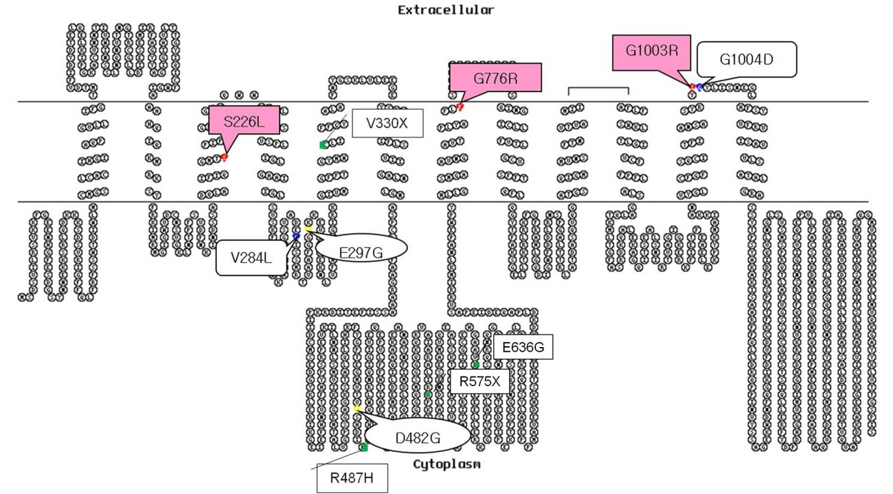
Figure 4 Putative secondary structure of bile salt export pump generated with the TOPO program (http://www.sacs.ucsf.edu/TOPO-run/wtopo.pl). Mutations are represented in red for mutations in patient 1 and 2, green for Japanese, blue for Taiwanese, and yellow for common European mutations, respectively. bile salt export pump alterations in the present study were located at transmembranous (TM) space and near the TM space, which was different from most of mutations of Chineses, Japanese, Taiwanese and European^{[2,5,7,12]}.

