Name of journal: World Journal of Gastroenterology
ESPS Manuscript NO: 31686
Manuscript Type: ORIGINAL ARTICLE

Basic Study
Study of the effects of nesfatin-1 on gastric function in obeserats

Yang GT et al. The gastric function affected by nesfatin-1

Guo-Tao Yang, Hong-Ying Zhao, Yu Kong, Ning-Ning Sun, Ai-Qin Dong

Guo-Tao Yang, Ai-Qin Dong, Department of Third Neurology, Cangzhou Central Hospital, Cangzhou Clinical Medical School of Hebei Medical University, Cangzhou 061001, Hebei Province, China

Hong-Ying Zhao, Department of Elderly Internal Medicine, Cangzhou Central Hospital, Cangzhou Clinical Medical School of Hebei Medical University, Cangzhou 061001, Hebei Province, China

Ning-Ning Sun, Department of First Digestion, Cangzhou Central Hospital, Cangzhou Clinical Medical School of Hebei Medical University, Cangzhou 061001, Hebei Province, China

Yu Kong, Department of Second Digestion, Cangzhou Central Hospital, Cangzhou Clinical Medical School of Hebei Medical University, Cangzhou 061001, Hebei Province, China

Supported by Cangzhou City Science and Technology Plan Projects, No. 151302138.

Institutional review board statement: This study was reviewed and approved by the Cangzhou Clinical Medical School of Hebei Medical University Institutional review board statement.

Conflict-of-interest statement: No potential conflicts of interest relevant to this article were reported.

Data sharing statement: No additional data are available.

Open-Access: This article is an open-access article which was selected by an in-house editor and fully peer-reviewed by external reviewers. It is distributed in accordance with the Creative Commons Attribution Non Commercial (CC BY-NC 4.0) license, which permits others to distribute, remix, adapt, build upon this work non-commercially, and license their derivative works on different terms, provided the original work is properly cited and the use is non-commercial. See: http://creativecommons.org/licenses/by-nc/4.0/

Manuscript source: Unsolicited manuscript

Correspondence to: Dr. Guo-Tao Yang, Department of Third Neurology, Cangzhou Central Hospital, Cangzhou Clinical Medical School of Hebei Medical University, Cangzhou 061001, Hebei Province, China. yangguotaotao@yeah.net
Telephone: +86-317-2179510
Fax: +86-317-2179510

Received: December 1, 2016
Peer-review started: December 2, 2016
First decision: December 28, 2016
Revised: February 15, 2017
Accepted: March 2, 2017
Article in press:
Published online:

Abstract
AIM
To investigate the effects of nesfatin-1 on gastric function in obeserats.

METHODS
The obeseratmodel was induced by high-fat diet. Then,the gastric emptying rate and gastric acid secretory capacity of rats were determined after rats were treated with different drug concentrations of nesfatin-1and administrations routes. Based on this, the expression of H+/K+-ATPase was measured using RT-PCR and western blot to preliminarily explore the mechanism of gastric acid secretionchanges.

RESULTS
Body weight, body length and Lee’s index of rats significantly increased in the high-fat diet-inducedobeserat model. At two hoursafter the lateral intracerebroventricular injection of Nsfactin-1, the gastric emptying rate and gastric acid secretory capacity of rats decreased. At four hoursafter injection, both were restored to normal levels. In addition, the expression of H+/K+-ATPase decreasedandmoved in line with changes ingastric acid secretory capacity. This in vivo experiment revealed that the intracerebroventricular injection of nesfactin-1, instead of intravenous injection, could suppress gastric function in obese rats. Moreover, its effect on the gastric emptying and gastric acid secretory capacity of rats is dose-dependentwithin a certain amount of time.

CONCLUSION
Through this research, we provide a theoretical basis for further studies on potential anti-obesity drug, nesfatin-1.

Key words: Obesity; Nesfatin-1; H⁺/K⁺-ATPase

© The Author(s) 2017. Published by Baishideng Publishing Group Inc. All rights reserved.

Core tip: The high-fat diet-induced fat obese rat model was used to study the effects of nesfatin-1 on the gastric function. We found that the intracerebroventricular injection of nesfactin-1, instead of intravenous injection, could suppress gastric function in a dose-dependent manner within a certain amount of time. What’s more, the expression of H⁺/K⁺ ATPase was down-regulated which may explained the mechanisms of the decrease of gastric acid secretory.

Yang GT, Zhao HY, Kong Y, Sun NN, Dong AQ. Study of the effects of nesfatin-1 on gastric function in obeserats. World J Gastroenterol 2017; In press

INTRODUCTION
Obesity is a global public health priority. With the improvement of people’s living standard, the number of obese Chinese has grown at 38.1% annually over the past years^{[1-4]}. Thus, it is significant to carry out studies on mechanisms linked to obesity. Nesfatin-1, a new anorectic peptide found in 2006, has been proven as an inhibitor of food intake^{[5-8]}. Nesfatin-1 can be expressed in peripheral organs such as the gastrointestinal tract, and plays a role in the regulation of many physiological processes such as carbohydrate metabolism, immunity, and the digestive tract^{[9-13]}. Studies have shown that nesfatin-1 mRNA, together with Ghrelin somatostatin and histidine decarboxylase, which regulates gastric acid secretion ,are co-expressed in oxyntic glands in the fundus of the stomach. That comes to mean that Nesfati-1 may be also involved in gastric acid secretion^{[14-16]}. In vitro studies have shown that nesfatin-1 can inhibit the expression of H⁺/K⁺ ATPase to block gastric acid secretion induced by histamine, as oxyntic cells of the glands secrete gastric acid^{[17,18]}. Researchers have also found that the lateral intracerebroventricular injection of nesfatin-1 can reduce the gastrointestinal mobility of rats^{[19]}. However, the clinical use of nesfatin-1 is limited, since it remains unknown whether the routes of administration of nesfatin-1 influence gastric emptying, and how and when this would affect gastric functions. Therefore, the present study focuses on the effects of the routes of drug administration and drug concentration on gastric functions, as well as the potential mechanisms, in order to provide a preliminary theoretical basis for further studies for determining hownesfatin-1 acts and the development of possible drugs for the treatment of obesity.

MATERIALS AND METHODS
Materials
Healthy and weaned Sprague Dawley (SD) rats, weighing 50 g, were provided by the experimental animal center of Anhui Medical University (Permit number: SYXK (e) 2012-002). Animals were housed in a controlled environment in collective cages (five rats in each cage) at 23 ± 2°C with a 12-h light/dark cycle. Rats were allowed to acclimate to these conditions for a week before being randomized into experimental groups. Phenol red was purchased from TiangenBiotech (Beijing). Five mg of phenol red was dissolved in1.5% methylcellulose to produce the methylcellulose-phenol red solution (100 mL, 50 mg/dL). Anti-nesfatin-1 polyclonal antibody (H-003-22) was obtained from American Phoenix Pharmaceuticals (United States), Rabbit anti-rat histone polyclonal antibody (ab125260) was purchased from Abcam (United States), and Rabbit anti-rat H⁺/K⁺ ATPase subunit-βantibody and rabbit anti-rat H⁺/K⁺ ATPase subunit-αantibody were obtained from Merk (Germany). These experiments were approved by the institute, and all efforts were made to minimize animal suffering.

Methods
Animals: After an adjustable feeding period of one week, 155 rats were randomly assigned into two groups: control group (five normal rats), and high-fat diet group (300 obeserats). In the control group, rats were fed with basic forage. In the high-fat diet group, rats were fed with high-fat forage (15 g of lard, 50 g of egg yolk, 15 g of whole milk and 10 drops of concentrated cod liver oil were added into a per 100 g basic forage). In order to assess the feasibility of the obeserat model, body length and body weight changes of rats were recorded. Then, Lee’s index and serum triglyceride levels were calculated after feeding for six weeks.

Implantation of the cannula into the lateral ventricle: Each rat was anesthetized using 7% chloral hydrate (0.5 mL/100 g) by intraperitoneal injection. Then, the fur on the head was shaved, and each rat was placed on the stereotaxic apparatus. According to the Paxinos-Watoson Rat Brain in stereotaxic coordinates, an incision was made on the skin above the animal’s skull, and a hole was drilled on the skull. A thin catheter was slowly inserted into the right-cerebral ventricle and was fixed with bone cement^{[20,21]}. After surgery, each rat was fed separately and provided with 15000 units of penicillin to avoid infection. Follow-up experiments were carried out after they were fed normally for one week, when the stress reaction was reduced.

Experimental grouping: The 300 obeserats that had a cannula placed in the right lateral-cerebral ventricle were further randomly assigned into two groups: intracerebroventricular injection group, and intravenous injection group. The treatment dose was as follows: intracerebroventricular injection group, 0μg/5μL ofnesfatin-1, 0.5μg/5μL ofnesfatin-1, and 1.0μg/5μL ofnesfatin-1; intravenous injection group, 0μg/5μLof nesfatin-1, 0.5μg/5μL ofnesfatin-1, 1.0 μg/5 μL of nesfatin-1. Each group comprised of 150 rats. Gastrointestinal mobility and gastric acid secretion in rats were measured at 1, 2, 3 and 4 h after drug administration.

Determination of gastrointestinal mobility: Rats received intragastric administration of 2 mL of phenol red. After 20 min, the rats were anesthetized using diethyl ether and sacrificed. Then, the stomach was cut along the greater curvature, washed with distilled water to collect the stomach contents, and diluted with water to 20 mL. Next, 20 mL of 0.5 mol/L of NaOH was added into the suspension before standing for 0.5hours at room temperature. Then, 0.5 mL of trichloroacetic acid (200 g/L) was added into 2.5 mL of the supernatant to remove the proteins. The mixture was centrifuged at 3500 rpm for 10 min. The absorbance of the supernatant was measured at 560 mL. Gastric emptying rate was determined using the following formula: gastric emptying rate = (1- measured phenol red absorbance/ standard phenol red absorbance) × 100%^{[22]}.

Determination of gastric acid secretion: The principle of acid-base titrations was applied to determine the gastric acid secretion. As previously described, gastric juice was collected from the stomach of rats. Then, 0.5 mL of the gastric acid was pipetted into a clean beaker containing 2 mL of distilled water. Next, two drops of phenolphthalein was added, swirled gently to mix well, titrated by slowly adding the NaOH solution (0.5 mol/L), and the beaker was swirled. The titration ended when the solution turned into a faint and persistent color. The volume of NaOH dispensed was recorded: volume of gastric acid secretion= (C [NaOH] ×V [NaOH] ×V [gastric juice] /0.5mL).

Real-time polymerase chain reaction: Twenty mg of gastric mucosal tissues were randomly obtained from different parts. Total RNA was extracted using TRIZOL Reagent and was converted into cDNAs by reverse transcription. With β-actin as the internal control gene, target gene fragments were amplified by real-time polymerase chain reaction (PCR). Five μL of RT-PCR products were subjected to 2% agarose gel electrophoresis. The absorbance of the target gene strands was detected. The relative mRNA expression level of H⁺/K⁺-ATP was determined as the ratio of the absorbance of the target gene to that of β-actin.
The real-time PCR primers are as follows: H⁺/K⁺-ATPase, 5'-CTCTGCTTTGCGGGACTT-3' (forward), 5'-CCTTGGCTGTGATGGGAT-3'(reverse);β-actin, 5’-AGCTGAGAGGGAAATCGTGCG 3’(forward),5’-GTGCCACCAGACAGCACTGTG-3’ (reverse).

Western blot: Twenty mg of gastric mucosal tissues were randomly obtained from different parts, and total proteins were extracted of the samples. Protein concentrations were detected using the BCA method. Protein extracts containing the same quality were subjected to SDS-PAGE using 12% polyacrylamide gel, followed by western blotting. Each membrane was blocked in 5% skim milk for two hours at room temperature. Then, the membrane was incubated for one hour at room temperature with anti-H⁺/K⁺-ATPase antibody. After washing with PBST for three times at five minutes each time, each membrane was incubated with a corresponding secondary fluorescein-labeled antibody for one hour at room temperature. Then, the bands were visualized and imaged using the Odyssey infrared imaging system (LI-COR, Germany).

Statistical analysis
Statistical analysis was performed using SPSS Statistics version 20. Data were expressed as means ± SD. Comparisons of categorical variables were carried out using one-way ANOVA. Dunnett’s t-test was employed to further analyze the differences between groups. P < 0.05 was considered statistically significant.

RESULTS
Establishment of theobeserat model
As shown in Table 1, the body weight, body length, Lee’s index and triglyceride level of rats were much higher in the high-fat diet group than in the control group; and the differences were considered statistically significant (P < 0.05).

Changes in gastric acid secretion and gastrointestinal mobility
Changes in gastric acid secretion and gastrointestinal mobility are shown in Figures 1 and 2. The gastric acid secretory capacity and gastrointestinal mobility of rats that received nesfatin-1 by intravenous injection did not significantly change at each drug dosage and time point. Each group was presented as a gray value histogram (Figures 1A and 2A). However, the intracerebroventricular administration of nesfatin-1 induced a great difference in the gastric acid secretion of rats. The gastric acid secretion level did not significantly change at any of the time points after the administration of nesfatin-1 at a dose of 0 μg/5μL. However, the secretion levels of rats injected with nesfatin-1 at adose of 0.5 μg/5μL and 1.0 μg/5μLinitially decreased, returned to normal levels, and went to the lowest level at two hours after administration (refer to the white and black value histogram in Figure 1B). Changes in gastric emptying revealed similarities as it reached the lowest level at two hours after administration, and this returned to normal levels at four hours after administration (Figure 2B).

Changes in H⁺/K⁺-ATPase expression level in the gastric mucosa
In order to further investigate the potential mechanism of gastric acid secretion induced by intracerebroventricularly administered nesfatin-1, gastric mucosal tissues that receiving 1.0μg/5μL ofnesfatin-1 were obtained to study the expression of H⁺/K⁺-ATPase. A similar tendency was observed in the mRNA expression of H⁺/K⁺-ATPase detected by RT-PCR and western blot. The data revealed that intracerebroventricularly injected nesfatin-1 significantly decreased mRNA expression levels at two hours after administration. The difference was statistically significant (P = 0.000). In addition, at four hours after the injection, the mRNA expression returned to normal levels (P = 0.792). The tendency of the protein level ofH⁺/K⁺-ATPase was similar (Figures 3 and 4).

DISCUSSION
Due to lifestyle changes, obesity has become a major global public health issue that puzzles many countries^{[23]}. As shown in many epidemiologic studies, the morbidity of diabetes and cardiac disease in obesity is higher than that in the normal population; which can bring about heavy financial burden in the society and family. Therefore, the study of obesity is of great significance^{[24-27]}. There is an apparent correlation between obesity and dieting status, and a person’s dietary behavior is tightly controlled by neural and humoral factors^{[28-30]}. In 2006, Japanese scholars found a peptide involved in the regulation of energy homeostasis, and in food and water intake; and this peptide can regulate feeding behavior through the neuro humoral system^{[31-34]}. This project systematically studied the effects of drug-delivery methods and drug concentration on gastric functions, as well as the molecular mechanisms involved in changes in gastric acid secretory capacity. This research can provide a preliminary theoretical basis for the design of anti-obesity drugs.

Establishment of the rat model with nutritional obesity
Given the fact that the main reason of obesity is always eating too much food containing calories, it is of great significant to establish a rat model that has the same reason of obesity as humans^{[35-37]}. Based on the diet characteristics of some individuals (which is high in fat and sugar), the obese rat model establish in six weeks by adding moderate amounts of sugar, fat and protein into rats fed diets. Results revealed that body weight, body length, Lee’s index and postprandial triglyceride levels significantly increased in the obese rat model induced by the high-fat diet. This indicates that the model was successfully established.

Effects of the manner of drug delivery on the gastric emptying rate and gastric acid secretory capacity of obese rats
The precursor of nesfatin-1, NMCB-2, can be hydrolyzed into three pieces by the action of prohormone convertase, including nesfatin-1, nesfatin-2 and nesfatin-3^{[38-41]}. The research carried by Pan W revealed that the permeation of nesfatin-1 between the blood and brain was a non-saturable process. Furthermore, Atsuchi K found that the vagal nerve may be involved in the process of the effect of nesfatin-1 on gastric functions^{[42,43]}. However, our study revealed that the intravenous injection of nesfactin-1 had no significant impact on the volume of gastric juice and the gastric emptying rate. This indicate that nesfatin-1 in the brain took effect on gastric function via some method that include the nervous system, rather than crossing the blood-brain barrier and taking effect.

Changes in the gastric empting rate and gastrointestinal mobility of obeserats after nesfatin-1treatment
Studies have found that the central administration of nesfatin-1 results in the inhibition of gastrointestinal mobility in rats in a dose-dependent manner. In addition, the administration of nesfatin-1 antibody promote food intake^{[44,45]}. This means that nesfatin-1can obviously reduce food intake. Our study further revealed that the intracerebroventricular injection of nesfatin-1, rather than its intravenous injection, can slow down intestinal peristalsis and suppress gastric emptying and gastric acid production. Moreover, these effects are dependent on the drug dosage within a certain amount of time.
Previous studies have shown that a delay in gastric emptying leads to increased stomach content, affecting food intake^{[46]}. Hence, we postulate that nesfatin-1 may cause food refusal by affecting gastrointestinal peristalsis. Nesfatin-1 suppress gastric emptying and secretion of gastric acid within certain amounts of time, which can prolong food stay in the stomach, slow down food digestion and induce satiety. All this leads to food refusal.

Mechanism of the inhibition of gastric acid secretion
H+/K+-ATPase, a key enzyme in gastric acid production, promotes the secretion of gastric acid through phosphorylation in the process of extracellular K⁺ and intracellular H⁺ transmembrane transport^{[47,48]}. The H⁺/K⁺-ATPase serves as a key point in the signal transduction pathway for regulating gastric acid secretion. Its expression levels in cells located in the gastric mucosal gland have a direct effect on gastric acid production^{[49,50]}. Therefore, in the present study, we observed the expression levels of H⁺/K⁺-ATPase to preliminarily explore the potential mechanism of centrally administered nesfatin-1 on gastric acid secretion. Western bolt and RT-PCR analyses demonstrated that the protein and mRNA expression levels of H+/K+-ATPase decreased after the intracerebroventricular injection of nesfatin-1. These levels returned to normal at four hours, and moved in line with the changes in gastric acid production. Our study revealed that centrally administered nesfatin-1 may inhibit the expression of H⁺/K⁺-ATPase in gastric mucosal tissues, suppressing the secretion of gastric acid.
In the meantime, due to the limited time, we were not able explore the relationship between gastric mobility and the vagus nerve, even though centrally administered nesfatin-1 has been reported to play a role in the regulation of gastrointestinal function through the vagus nerve. Further studies are needed to investigate whether the central administration of nesfatin-1 affects the expression of H⁺/K⁺-ATPase through the vagus nerve.
Overall, our in vivo experiment demonstrates that the central administration of nesfatin-1, rather than its peripheral administration, had an effect on gastrointestinal functions in obeserats. Centrally administered nesfatin-1 inhibited gastric mobility and gastric acid secretion in a dose-independent manner over a period of time. This study provides a preliminary theoretical basis for the development of nesfatin-1 for the treatment of obesity.

comments
Background
Obesity has become a major global public health issue that can bring about heavy financial burden in the society and family. Nesfatin-1, a new anorectic peptide, has been proven as an inhibitor of food intake which has the potential to be used in the treatment of obesity. However, the clinical use of nesfatin-1 is limited, since it remains unknown whether the routes of administration of nesfatin-1 influence gastric emptying, and how and when this would affect gastric functions.

Research frontiers
Nesfatin-1 plays a role in the regulation of many physiological processes such as carbohydrate metabolism, immunity, and the digestive tract^{[9-13]}. Studies have shown that nesfatin-1 mRNA, together with Ghrelin somatostatin and histidine decarboxylase, which regulates gastric acid secretion, are co-expressed in oxyntic glands in the fundus of the stomach. In vitro studies have shown that nesfatin-1 can inhibit the expression of H+/K+ ATPase to block gastric acid secretion^{[17,18]}. Researchers have also found that the lateral intracerebroventricular injection of nesfatin-1 can reduce the gastrointestinal mobility of rats^{[19]}.

Innovations and breakthroughs
This in vivo experiment revealed that the intracerebroventricular injection of nesfactin-1could suppress gastric function in obese rats. Moreover, its effect on the gastric emptying and gastric acid secretory capacity of rats is dose-dependent within a certain amount of time. Furthermore, the intracerebroventricular injection of nesfactin-1could also suppress the expression of H+/K+ ATPase in vivo, which may be the mechanisms of the decrease of gastric acid secretory.

Applications
The study demonstrated the intracerebroventricular injection of nesfactin-1 could successful suppress gastric function in obese rats, which means it have the potential to be used to treat obesity. If further researches find the exact molecular mechanism of nesfactin-1, obesity may be also cured someday.

Peer- review
Although obesity is a major global public health issue, there is still no cure for obesity. This study revealed that the intracerebroventricular injection of nesfactin-1 could successful suppress gastric function in dose-dependent manner within a certain amount of time. A preliminary theoretical basis for the development of nesfatin-1 for the treatment of obesity is provided by this research.

REFERENCES
1 Guo Y, Yue XJ, Li HH, Song ZX, Yan HQ, Zhang P, Gui YK, Chang L, Li T. Overweight and Obesity in Young Adulthood and the Risk of Stroke: a Meta-analysis. J Stroke Cerebrovasc Dis 2016; 25: 2995-3004 [PMID: 27618195 DOI: 10.1016/j.jstrokecerebrovasdis.2016.08.018]
2 Li Z, Guo X, Liu Y, Zhang N, Chang Y, Chen Y, Sun Y, Abraham MR. Metabolism rather than obesity is associated with ischemic stroke: a cross-sectional study in rural Northeastern China. Springerplus 2016; 5: 1419 [PMID: 27625973 DOI: 10.1186/s40064-016-3088-2]
3 Tao XG, Su PY, Yuspeh L, Lavin RA, Kalia-Satwah N, Bernacki EJ. Is Obesity Associated With Adverse Workers' Compensation Claims Outcomes? J Occup Environ Med 2016; 58: 880-884 [PMID: 27608149 DOI: 10.1097/JOM.0000000000000834]
4 Zhang T, Cai L, Ma L, Jing J, Chen Y, Ma J. The prevalence of obesity and influence of early life and behavioral factors on obesity in Chinese children in Guangzhou. BMC Public Health 2016; 16: 954 [PMID: 27613102 DOI: 10.1186/s12889-016-3599-3]
5 Algul S, Ozkan Y, Ozcelik O. Serum nesfatin-1 levels in patients with different glucose tolerance levels. Physiol Res 2016; 65: 979-985 [PMID: 27539099]
6 Gulcicek OB, Solmaz A, Yiğitbaş H, Ercetin C, Yavuz E, Ozdogan K, Arici S, Akkalp AK, Sarac T, Çelebi F, Celik A. Comparison of the Effects of Glutamine, Curcumin, and Nesfatin-1 on the Gastric Serosal Surface Neomucosa Formation: An Experimental Rodent Model. Gastroenterol Res Pract 2016; 2016: 2081962 [PMID: 27525002 DOI: 10.1155/2016/2081962]
7 Prinz P, Stengel A. Expression and regulation of peripheral NUCB2/nesfatin-1. Curr Opin Pharmacol 2016; 31: 25-30 [PMID: 27589697 DOI: 10.1016/j.coph.2016.08.012]
8 Prinz P, Stengel A. Nesfatin-1: current status as a peripheral hormone and future prospects. Curr Opin Pharmacol 2016; 31: 19-24 [PMID: 27589696 DOI: 10.1016/j.coph.2016.08.011]
9 Xiao C, Liu J, Tang Y, Chen J, Wu X, Bi F, Zhang J. Expression, purification, and characterization of mouse nesfatin-1 in Escherichia coli. Biotechnol Appl Biochem 2017; 64: 43-49 [PMID: 26592736 DOI: 10.1002/bab.1458]
10 Blanco AM, Bertucci JI, Delgado MJ, Valenciano AI, Unniappan S. Tissue-specific expression of ghrelinergic and NUCB2/nesfatin-1 systems in goldfish (Carassius auratus) is modulated by macronutrient composition of diets. Comp Biochem Physiol A Mol Integr Physiol 2016; 195: 1-9 [PMID: 26805937 DOI: 10.1016/j.cbpa.2016.01.016]
11 Burgos JR, Iresjö BM, Smedh U. MCG101-induced cancer anorexia-cachexia features altered expression of hypothalamic Nucb2 and Cartpt and increased plasma levels of cocaine- and amphetamine-regulated transcript peptides. Oncol Rep 2016; 35: 2425-2430 [PMID: 26780979 DOI: 10.3892/or.2016.4558]
12 Cao X, Zhou X, Cao Y, Liu XM, Zhou LH. Expression of NUCB2/nesfatin-1 in the taste buds of rats. Endocr J 2016; 63: 37-45 [PMID: 26522144 DOI: 10.1507/endocrj.EJ15-0489]
13 Jiang S, Zhou W, Zhang X, Wang D, Zhu H, Hong M, Gong Y, Ye J, Fang F. Developmental expression and distribution of nesfatin-1/NUCB2 in the canine digestive system. Acta Histochem 2016; 118: 90-96 [PMID: 26643216 DOI: 10.1016/j.acthis.2015.11.010]
14 Chen X, Shu X, Cong ZK, Jiang ZY, Jiang H. Nesfatin-1 acts on the dopaminergic reward pathway to inhibit food intake. Neuropeptides 2015; 53: 45-50 [PMID: 26299312 DOI: 10.1016/j.npep.2015.07.004]
15 Ozturk CC, Oktay S, Yuksel M, Akakin D, Yarat A, Kasimay Cakir O. Anti-inflammatory effects of nesfatin-1 in rats with acetic acid - induced colitis and underlying mechanisms. J Physiol Pharmacol 2015; 66: 741-750 [PMID: 26579580]
16 Watanabe A, Mochiki E, Kimura A, Kogure N, Yanai M, Ogawa A, Toyomasu Y, Ogata K, Ohno T, Suzuki H, Kuwano H. Nesfatin-1 suppresses gastric contractions and inhibits interdigestive migrating contractions in conscious dogs. Dig Dis Sci 2015; 60: 1595-1602 [PMID: 25563722 DOI: 10.1007/s10620-014-3505-8]
17 Jia FY, Li XL, Li TN, Wu J, Xie BY, Lin L. Role of nesfatin-1 in a rat model of visceral hypersensitivity. World J Gastroenterol 2013; 19: 3487-3493 [PMID: 23801843 DOI: 10.3748/wjg.v19.i22.3487]
18 Mohan H, Unniappan S. Phylogenetic aspects of nucleobindin-2/nesfatin-1. Curr Pharm Des 2013; 19: 6929-6934 [PMID: 23537083]
19 Tian ZB, Deng RJ, Sun GR, Wei LZ, Kong XJ, Ding XL, Jing X, Zhang CP, Ge YL. Expression of gastrointestinal nesfatin-1 and gastric emptying in ventromedial hypothalamic nucleus- and ventrolateral hypothalamic nucleus-lesioned rats. World J Gastroenterol 2014; 20: 6897-6905 [PMID: 24944480 DOI: 10.3748/wjg.v20.i22.6897]
20 Peredery O, Persinger MA, Parker G, Mastrosov L. Temporal changes in neuronal dropout following inductions of lithium/pilocarpine seizures in the rat. Brain Res 2000; 881: 9-17 [PMID: 11033088]
21 Figini M, Zucca I, Aquino D, Pennacchio P, Nava S, Di Marzio A, Preti MG, Baselli G, Spreafico R, Frassoni C. In vivo DTI tractography of the rat brain: an atlas of the main tracts in Paxinos space with histological comparison. Magn Reson Imaging 2015; 33: 296-303 [PMID: 25482578 DOI: 10.1016/j.mri.2014.11.001]
22 Sobczak M, Cami-Kobeci G, Sałaga M, Husbands SM, Fichna J. Novel mixed NOP/MOP agonist BU08070 alleviates pain and inhibits gastrointestinal motility in mouse models mimicking diarrhea-predominant irritable bowel syndrome symptoms. Eur J Pharmacol 2014; 736: 63-69 [PMID: 24815321 DOI: 10.1016/j.ejphar.2014.04.038]
23 Novotny R, Li F, Fialkowski MK, Bersamin A, Tufa A, Deenik J, Coleman P, Guerrero RL, Wilkens LR. Prevalence of obesity and acanthosis nigricans among young children in the children's healthy living program in the United States Affiliated Pacific. Medicine (Baltimore) 2016; 95: e4711 [PMID: 27631218 DOI: 10.1097/MD.0000000000004711]
24 Armstrong SC, Skinner AC. Defining "Success" in Childhood Obesity Interventions in Primary Care. Pediatrics 2016; 138: [PMID: 27621411 DOI: 10.1542/peds.2016-2497]
25 Macia E, Gueye L, Duboz P. Hypertension and Obesity in Dakar, Senegal. PLoS One 2016; 11: e0161544 [PMID: 27622534 DOI: 10.1371/journal.pone.0161544]
26 Ruhstaller KE, Elovitz MA, Stringer M, Eppersonmd CN, Durnwald CP. Obesity and the Association with Maternal Mental Health Symptoms. J Matern Fetal Neonatal Med 2016; Epub ahead of print [PMID: 27623338 DOI: 10.1080/14767058.2016.1229766]
27 Trayhurn P. Origins and early development of the concept that brown adipose tissue thermogenesis is linked to energy balance and obesity. Biochimie 2017; 134: 62-70 [PMID: 27621146 DOI: 10.1016/j.biochi.2016.09.007]
28 Fetissov SO. Role of the gut microbiota in host appetite control: bacterial growth to animal feeding behaviour. Nat Rev Endocrinol 2017; 13: 11-25 [PMID: 27616451 DOI: 10.1038/nrendo.2016.150]
29 Luchterhand KM, Silva PR, Chebel RC, Endres MI. Association between Prepartum Feeding Behavior and Periparturient Health Disorders in Dairy Cows. Front Vet Sci 2016; 3: 65 [PMID: 27597948 DOI: 10.3389/fvets.2016.00065]
30 Mignon-Grasteau S, Chantry-Darmon C, Boscher MY, Sellier N, Le Bihan-Duval E, Bertin A. Genetic Determinism of Fearfulness, General Activity and Feeding Behavior in Chickens and Its Relationship with Digestive Efficiency. Behav Genet 2017; 47: 114-124 [PMID: 27604231 DOI: 10.1007/s10519-016-9807-1]
31 Li Z, Mulholland M, Zhang W. Regulation of gastric nesfatin-1/NUCB2. Curr Pharm Des 2013; 19: 6981-6985 [PMID: 23537086]
32 Sedbazar U, Maejima Y, Nakata M, Mori M, Yada T. Paraventricular NUCB2/nesfatin-1 rises in synchrony with feeding suppression during early light phase in rats. Biochem Biophys Res Commun 2013; 434: 434-438 [PMID: 23583201 DOI: 10.1016/j.bbrc.2013.03.090]
33 Stengel A, Taché Y. New Developments On NUBC2/Nesfatin-1. Curr Pharm Des 2013; Epub ahead of print [PMID: 23537089]
34 Stengel A, Taché Y. Role of brain NUCB2/nesfatin-1 in the regulation of food intake. Curr Pharm Des 2013; 19: 6955-6959 [PMID: 23537088]
35 Gzielo K, Kielbinski M, Ploszaj J, Janeczko K, Gazdzinski SP, Setkowicz Z. Long-Term Consumption of High-Fat Diet in Rats: Effects on Microglial and Astrocytic Morphology and Neuronal Nitric Oxide Synthase Expression. Cell Mol Neurobiol 2016; Epub ahead of print [PMID: 27541371 DOI: 10.1007/s10571-016-0417-5]
36 Lee JH, Lee JJ, Cho WK, Yim NH, Kim HK, Yun B, Ma JY. KBH-1, an herbal composition, improves hepatic steatosis and leptin resistance in high-fat diet-induced obese rats. BMC Complement Altern Med 2016; 16: 355 [PMID: 27618865 DOI: 10.1186/s12906-016-1265-z]
37 Torres-Villalobos G, Hamdan-Pérez N, Díaz-Villaseñor A, Tovar AR, Torre-Villalvazo I, Ordaz-Nava G, Morán-Ramos S, Noriega LG, Martínez-Benítez B, López-Garibay A, Torres-Landa S, Ceballos-Cantú JC, Tovar-Palacio C, Figueroa-Juárez E, Hiriart M, Medina-Santillán R, Castillo-Hernández C, Torres N. Autologous subcutaneous adipose tissue transplants improve adipose tissue metabolism and reduce insulin resistance and fatty liver in diet-induced obesity rats. Physiol Rep 2016; 4: [PMID: 27582062 DOI: 10.14814/phy2.12909]
38 Feijóo-Bandín S, Rodríguez-Penas D, García-Rúa V, Mosquera-Leal A, Otero MF, Pereira E, Rubio J, Martínez I, Seoane LM, Gualillo O, Calaza M, García-Caballero T, Portolés M, Roselló-Lletí E, Diéguez C, Rivera M, González-Juanatey JR, Lago F. Nesfatin-1 in human and murine cardiomyocytes: synthesis, secretion, and mobilization of GLUT-4. Endocrinology 2013; 154: 4757-4767 [PMID: 24064358 DOI: 10.1210/en.2013-1497]
39 Nakata M, Yada T. Role of NUCB2/nesfatin-1 in glucose control: diverse functions in islets, adipocytes and brain. Curr Pharm Des 2013; 19: 6960-6965 [PMID: 23537085]
40 Vas S, Ádori C, Könczöl K, Kátai Z, Pap D, Papp RS, Bagdy G, Palkovits M, Tóth ZE. Nesfatin-1/NUCB2 as a potential new element of sleep regulation in rats. PLoS One 2013; 8: e59809 [PMID: 23560056 DOI: 10.1371/journal.pone.0059809]
41 Yosten GL, Samson WK. Cardiovascular and antidipsogenic effects of nesfatin-1. Curr Pharm Des 2013; 19: 6973-6975 [PMID: 23537087]
42 Pan W, Hsuchou H, Kastin AJ. Nesfatin-1 crosses the blood-brain barrier without saturation. Peptides 2007; 28: 2223-2228 [PMID: 17950952 DOI: 10.1016/j.peptides.2007.09.005]
43 Atsuchi K, Asakawa A, Ushikai M, Ataka K, Tsai M, Koyama K, Sato Y, Kato I, Fujimiya M, Inui A. Centrally administered nesfatin-1 inhibits feeding behaviour and gastroduodenal motility in mice. Neuroreport 2010; 21: 1008-1011 [PMID: 20827224 DOI: 10.1097/WNR.0b013e32833f7b96]
44 Oh-I S, Shimizu H, Satoh T, Okada S, Adachi S, Inoue K, Eguchi H, Yamamoto M, Imaki T, Hashimoto K, Tsuchiya T, Monden T, Horiguchi K, Yamada M, Mori M. Identification of nesfatin-1 as a satiety molecule in the hypothalamus. Nature 2006; 443: 709-712 [PMID: 17036007 DOI: 10.1038/nature05162]
45 Senin LL, Al-Massadi O, Barja-Fernandez S, Folgueira C, Castelao C, Tovar SA, Leis R, Lago F, Baltar J, Baamonde I, Dieguez C, Casanueva FF, Seoane LM. Regulation of NUCB2/nesfatin-1 production in rat's stomach and adipose tissue is dependent on age, testosterone levels and lactating status. Mol Cell Endocrinol 2015; 411: 105-112 [PMID: 25916958 DOI: 10.1016/j.mce.2015.04.016]
46 Duggan JP, Booth DA. Obesity, overeating, and rapid gastric emptying in rats with ventromedial hypothalamic lesions. Science 1986; 231: 609-611 [PMID: 3511527]
47 Qin H, Zhang Y, Wang R, Du X, Li L, Du H. Puerarin Suppresses Na+-K+-ATPase-Mediated Systemic Inflammation and CD36 Expression, and Alleviates Cardiac Lipotoxicity In Vitro and In Vivo. J Cardiovasc Pharmacol 2016; 68: 465-472 [PMID: 27606935 DOI: 10.1097/FJC.0000000000000431]
48 Walter C, Tanfous MB, Igoudjil K, Salhi A, Escher G, Crambert G. H,K-ATPase type 2 contributes to salt-sensitive hypertension induced by K(+) restriction. Pflugers Arch 2016; 468: 1673-1683 [PMID: 27562425 DOI: 10.1007/s00424-016-1872-z]
49 Miyazaki H, Wangemann P, Marcus DC. The gastric H,K-ATPase in stria vascularis contributes to pH regulation of cochlear endolymph but not to K secretion. BMC Physiol 2016; 17: 1 [PMID: 27515813 DOI: 10.1186/s12899-016-0024-1]
50 Wyckelsma VL, McKenna MJ. Effects of Age on Na(+), K(+)-ATPase Expression in Human and Rodent Skeletal Muscle. Front Physiol 2016; 7: 316 [PMID: 27531982 DOI: 10.3389/fphys.2016.00316]

P-Reviewer: Arredondo M, Berger BM S-Editor: Qi Y L-Editor: E-Editor:

Specialty type: Gastroenterology and hepatology
Country of origin: China
Peer-review report classification
Grade A (Excellent): 0
Grade B (Very good): B
Grade C (Good): C
Grade D (Fair): 0
Grade E (Poor): 0
Table 1 High-fat diet-induced obese rat model

Group | Body weight (g) | Body length (cm) | Lee’s index | Triglyceride (mmol/L)
Control (n = 5) | 329.76 ± 65.23 | 19.8 ± 0.8 | 335.59 ± 12.87 | 1.22 ± 0.24
High-fat diet (n = 40) | 410 ± 53.34 | 21.02 ± 1.0 | 357.40 ± 13.98 | 1.56 ± 0.26
t | -3.101 | -2.616 | -3.125 | -2.776
P | 0.003 | 0.012 | 0.002 | 0.008

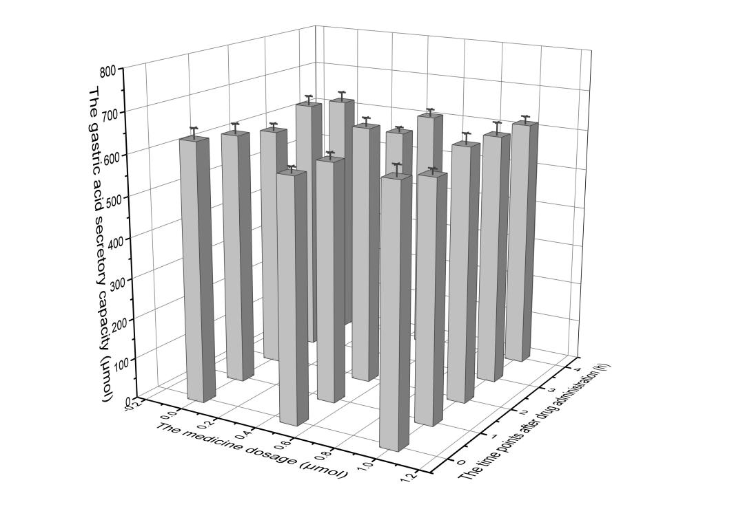
A
(Note: The differences were not statistically significant.)

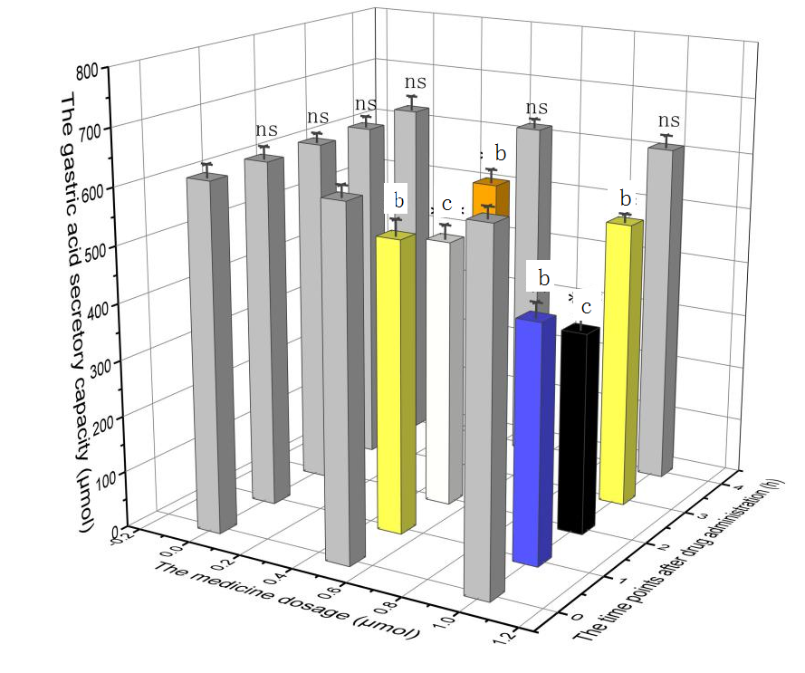
B

Figure 1 Changes in gastric acid secretion in rats. A: Intracerebroventricular injection; B: Intravenous injection. Rats were randomly assigned into 30 groups based on drug dosage and the representative time points after administration. In each group, 15 rats were intracerebroventricularly injected with the drug, while the remaining 15 rats were intravenously injected with the drug. X axis: drug dosage; Y axis: time points after drug administration; Z axis: gastric acid secretory capacity, which was presented as the height of the histogram with its corresponding color (capacity: black < white < yellow < orange < gray). As shown in Figure 1B, the gastric acid secretion level of rats in the 1.0μg/5μLnesfatin-1 group reached 358.85 μmoL at two hours after intravenous injection. This level was much lower than that in rats at zero-hour after intravenous injection (618.27 μmoL). The difference was statistically significant (P = 0.000). ^{c}P < 0.001, ^{b}P < 0.05; NS: No significant difference.

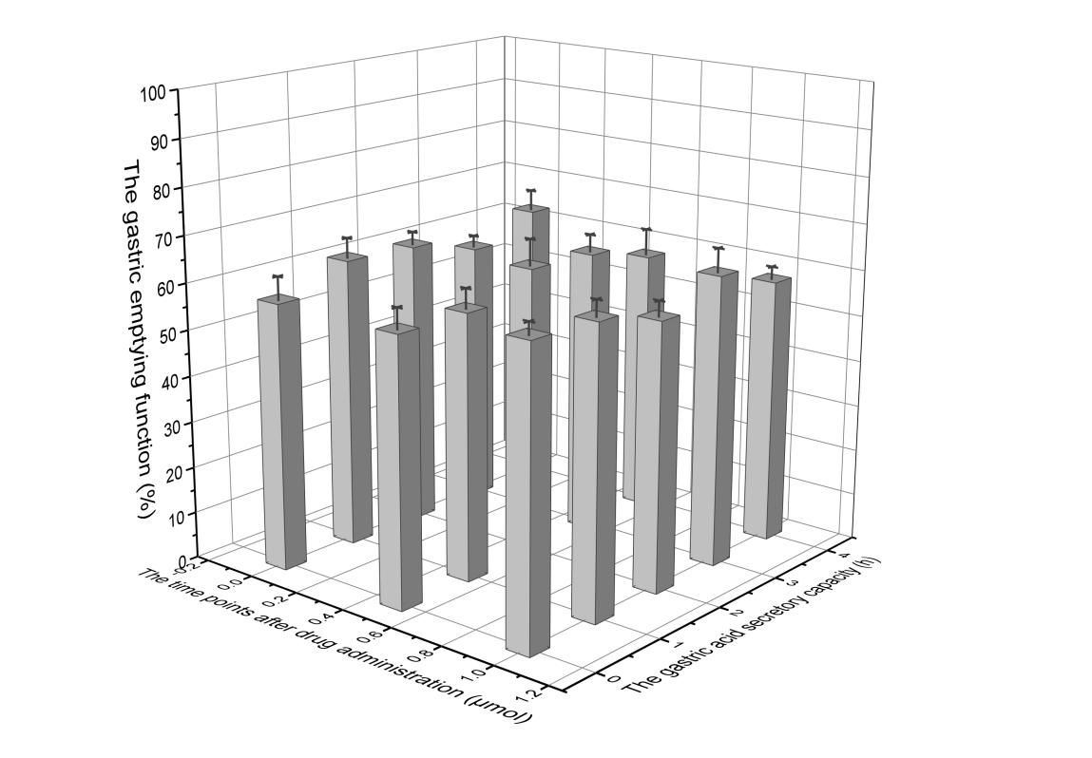
A

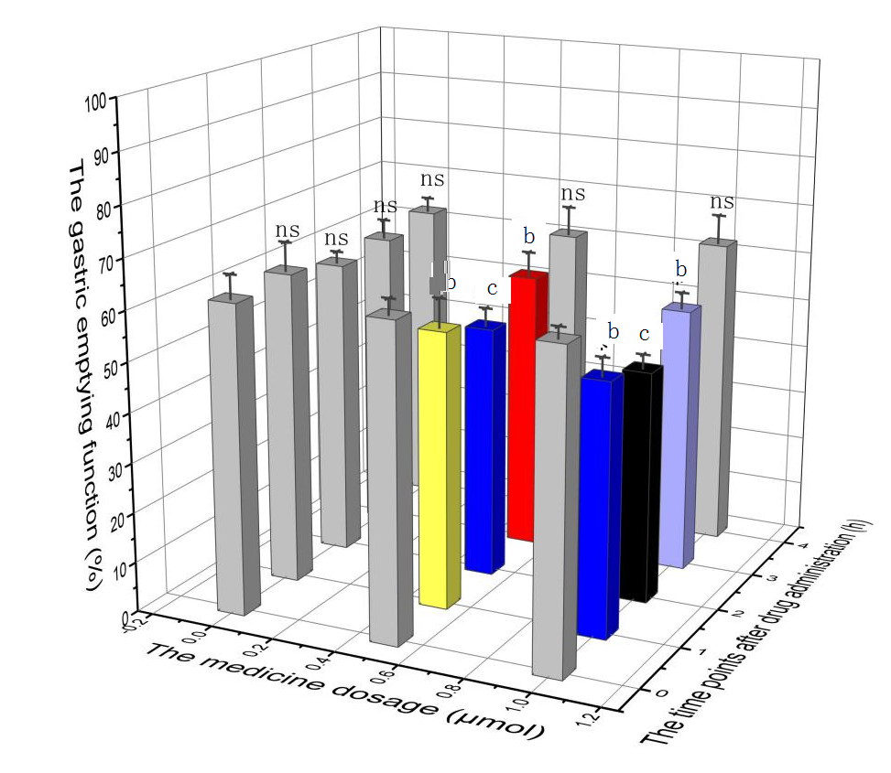
B
Figure 2 Changes in gastric emptying function in rats. A: intracerebroventricular infusion; B: intravenous injection. Rats were randomly assigned into 30 groups based on the drug dosage and representative time points after administration. In each group, and every 15 rats were intracerebroventricularly injected, while 15 rats were intravenously injected. X axis: drug dosage; Y axis: time points after drug administration; Z axis: gastric emptying function, which was presented as the height of the histogram with its corresponding color (capacity: black < blue < light blue < yellow < red < gray). As shown in Figure 2B, the gastric emptying rate of rats in the 1.0μg/5μLnesfatin-1 group reached 46.69% at two hours after intravenous injection. This was much lower than in rats at zero-hour after intravenous injection (62.84%). The difference was statistically significant (P = 0.024). The differences were not statistically significant, ^{c}P < 0.001, ^{b}P < 0.05; NS: No significant difference.

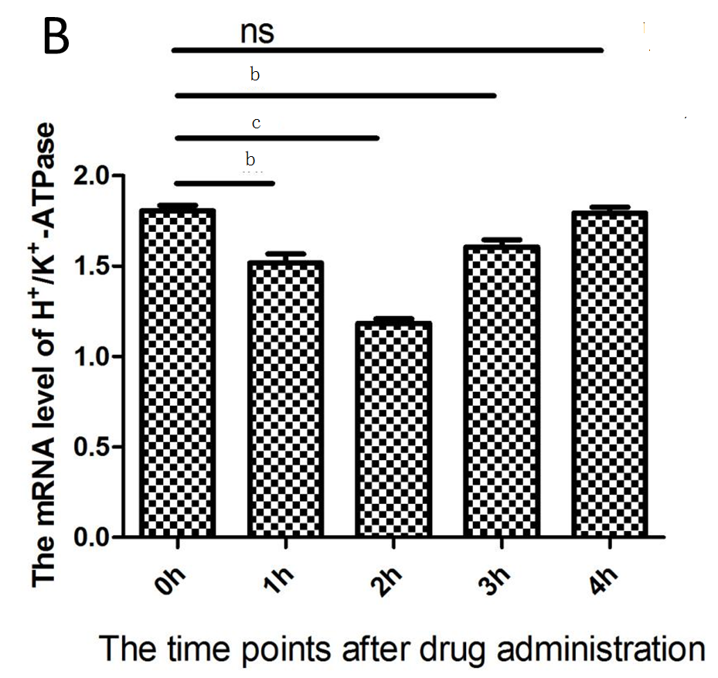

Figure 3 The mRNA expression of H⁺/K⁺-ATPase. A: A typical RT-PCR result; B: The mRNA expression of H+/K+-ATPase in different groups. ^{c}P < 0.001, ^{b}P < 0.05; NS: No significant difference.

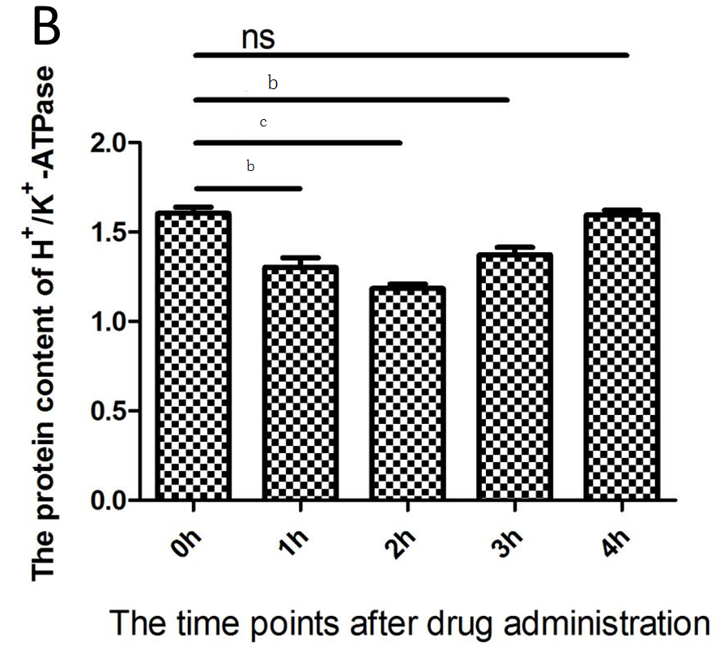
Figure 4 Protein expression of H⁺/K⁺-ATPase. A: A typical of western-blot result; B: The protein expression of H+/K+-ATPase in different groups. ^{c}P < 0.001,^{b}P < 0.05; NS: No significant difference.

