Name of Journal: World Journal of Clinical Cases
Manuscript NO: 73681
Manuscript Type: ORIGINAL ARTICLE

Retrospective Study
Hepatic epithelioid hemangioendothelioma: Clinical characteristics, diagnosis, treatment, and prognosis

Zhao M et al. Hepatic epithelioid hemangioendothelioma

Man Zhao, Fei Yin

Man Zhao, Fei Yin, Department of Gastroenterology, The Fourth Hospital of Hebei Medical University, Shijiazhuang 050000, Hebei Province, China

Author contributions: Yin F designed the research study; Zhao M and Yin F performed the research, analyzed the data, and wrote the manuscript; all authors have read and approved the final manuscript.

Corresponding author: Fei Yin, PhD, Chief Physician, Department of Gastroenterology, The Fourth Hospital of Hebei Medical University, No. 12 Jiankang Road, Shijiazhuang 050000, Hebei Province. China. yinfei_4y@sina.com

Received: December 1, 2021
Revised: January 23, 2022
Accepted: April 15, 2022
Published online:
Abstract
BACKGROUND
Hepatic epithelioid hemangioendothelioma (HEHE) is a rare hepatic vascular tumor with unpredictable malignant potential. The etiology, characteristics, diagnosis, treatment, and prognosis of HEHE are not well-understood, and large-scale retrospective studies are required to understand better this disease.

AIM
To determine the characteristics of HEHE and identify its optimal treatments and prognostic factors.

METHODS
The clinical data of two patients diagnosed with HEHE at the Fourth Hospital of Hebei Medical University and 258 previously reported cases retrieved from the China National Knowledge Infrastructure and PubMed databases between 1996 and 2021 were combined and summarized. All cases were pathologically identified as HEHE. Information such as clinical features, laboratory examination findings, imaging findings, pathological characteristics, treatment, and survival periods was reviewed. Kaplan-Meir curves were used for survival analysis. Prognostic factors were identified by Cox regression analysis.

RESULTS
HEHE primarily affected middle-aged women. The typical manifestations included epigastric pain, hepatosplenomegaly, inappetence, distension, weight loss, and fatigue. Tumor markers were expressed normally. The incidence of extrahepatic metastasis was 34.5% at the time of diagnosis. The most common sites of extrahepatic involvement were the lungs (22.3%), lymph nodes (5.6%), peritoneum (3.6%), bones (6.6%), and spleen (5.1%). Furthermore, “capsular retraction”, “target sign”, and “lollipop sign” were the characteristic features of HEHE on imaging. The immunohistochemical profile for HEHE (expression of vascular markers, such as factor VIII-related antigen, CD31, and CD34; expression levels of D2-40) can facilitate and ensure an accurate diagnosis. The management options for patients with HEHE include liver resection (29.7%), liver transplantation (16.1%), palliative treatments (12.7%), transhepatic arterial chemotherapy and embolization (TACE, 10.2%), chemotherapy (11.0%), antiangiogenic therapy (15.3%), and other treatments (5.1%); the mean survival time was 158.6, 147.3, 4.2, 90.8, 71.4, 83.1, and 55.0 mo, respectively. The survival time of patients who underwent surgical treatment was longer than that of patients who did not. TACE and antiangiogenic therapy tended to prolong survival compared with other nonsurgical treatments. The 1-, 5-, and 10-year survival rates were 82%, 71%, and 64%, respectively. Multivariate analysis showed that liver function (P = 0.045), intrahepatic metastasis (P = 0.029), and treatment (P = 0.045) were independent prognostic factors. The presence of extrahepatic metastases was not an independent risk factor for poor prognosis (P = 0.558).

CONCLUSION
The clinical course of HEHE is rare and variable, and patients with intrahepatic metastases and liver dysfunction may have a poorer prognosis than those without. Surgical intervention, whether liver resection or transplantation, might be warranted regardless of extrahepatic metastasis. For patients without the option for surgery, clinicians should consider the use of TACE with antiangiogenic drugs in the treatment of HEHE.

Key Words: Hepatic epithelioid hemangioendothelioma; Clinical characteristics; Diagnosis; Treatment; Prognosis

Zhao M, Yin F. Hepatic epithelioid hemangioendothelioma: Clinical characteristics, diagnosis, treatment, and prognosis. World J Clin Cases 2022; In press

Core Tip: Hepatic epithelioid hemangioendothelioma (HEHE) is a rare hepatic vascular tumor with unpredictable malignant potential. Patients with intrahepatic metastases and liver dysfunction may have a poorer prognosis than those without. Surgical intervention, whether liver resection or transplantation, might be warranted regardless of extrahepatic metastasis. However, the therapeutic strategy for patients without the option for surgery is particularly controversial. Our experience highlights the efficacy of transhepatic arterial chemotherapy and embolization and antiangiogenic therapy in the management of HEHE.

INTRODUCTION
Hepatic epithelioid hemangioendothelioma (HEHE) is a rare neoplasm of vascular origin^{[1]}. The natural course of this neoplasm is variable, ranging from long-term survival without treatment to a rapidly progressive course with a fatal outcome^{[2]}. The etiology, characteristics, diagnosis, treatment, and prognosis of HEHE are not well-understood, and large-scale retrospective studies are required to understand better this disease.

MATERIALS AND METHODS
The clinical data of two patients diagnosed with HEHE at the Fourth Hospital of Hebei Medical University and previously reported cases retrieved from the literature were combined and summarized.

Data search
We searched PubMed and China National Knowledge Infrastructure databases from January 1996 through December 2021 using search terms including “HEHE” and “epithelioid hemangioendothelioma of liver”. The references of related studies and reviews were also retrieved, if necessary.

Study inclusion and exclusion criteria
The studies that met the following criteria were included: (1) Tumor tissues obtained by liver biopsy or surgery were pathologically identified as HEHE; (2) accurate clinical statistical indicators were provided in the studies; and (3) articles were published in English or Chinese.
The exclusion criteria were: (1) Epithelioid hemangioendothelioma from other sites with liver metastasis; (2) duplicate publications; (3) studies without sufficient data; and (4) care reports, meeting abstracts, meta-analyses, and reviews.

Data extraction
We reviewed all titles and abstracts to identify potentially relevant articles. Two investigators reviewed all potentially relevant full texts for inclusion, with disagreements resolved through discussion and consensus. We used standardized data extraction forms to collect the following information: First author’s name, geographical region and year of publication, study design, inclusion/exclusion criteria, size of the patient cohort, and clinical statistical indicators (age, sex, etiology, clinical features, laboratory tests, radiographic findings, pathological features, treatment, and survival).

Statistical analysis
Statistical analyses were performed using SPSS 26.0 (Armonk, NY, United States). Distributions of patients’ characteristics (age, sex, clinical features, laboratory tests, radiographic findings, pathological features, treatment, and survival) were explored and summarized using descriptive statistics. Survival analysis was performed using the Kaplan-Meier method. The differences between the survival curves were compared using the log-rank test. Multivariate Cox hazard regression analysis was performed on the factors shown to be significant in the univariate analysis. All tests were two-sided, and P values ≤ 0.05 were considered significant.

RESULTS
Two cases diagnosed with HEHE at The Fourth Hospital of Hebei Medical University
Case one: A 53-year-old female patient was admitted to the hospital because of intermittent right upper abdominal pain for > 10 d. Initial liver function tests indicated increased levels of alanine transaminase and alkaline phosphatase. Tumor markers were normal. Computed tomography (CT) revealed two round low-density nodules in the right lobe of the liver. The peripheral rims of the nodules were enhanced using a contrast medium, giving the appearance of cancer metastases, but no tumors were found elsewhere (Figure 1). The preliminary diagnosis for the preoperative liver biopsy was HEHE. The patient subsequently underwent segmental hepatectomy of segments VIII and VI. Immunohistochemically, the tumor cells expressed CD34, vimentin, factor VIII-related antigen (FVIII-RAg), smooth muscle actin (SMA), S-100, and Ki-67 (Figure 2). Based on these histological and immunohistochemical findings, the tumor was pathologically diagnosed as HEHE, which was consistent with the preoperative biopsy results. After 4 years postoperatively, the patient was in good health and had no recurrence.

Case two: A 35-year-old woman was referred to our institution for the management of incidentally discovered nodules in the liver without symptoms. Laboratory examination findings were normal. CT showed multiple hypodense hepatic nodular formations, all of which were slightly enhanced in the arterial phase (Figure 3A). Immunohistochemical staining of the tumor tissue obtained via laparoscopic liver biopsy revealed tumor cells that were positive for CD34, factor VIII-related antigen (FVIII-RAg), SMA, CD68, and vimentin and negative for alpha fetoprotein (AFP), Cal, Me, cytokeratin, and S100. The final pathological diagnosis was HEHE, and the patient was diagnosed with unresectable hepatic disease with no distant metastases. Liver transplantation (LT) was recommended, but the patient refused due to personal reasons. Transhepatic arterial chemotherapy and embolization (TACE) was performed using 1 g of fluorine glycosides, 10 mg of epirubicin, and 10 mL of lipiodol. Unfortunately, repeat CT indicated that the number of lesions had increased (Figure 3B). A decision was then made to change the treatment to interferon (IFN)-α2b with a dose of 3 MU being administered every alternate day. The patient underwent clinical evaluation and laboratory tests every 3 wk and abdominal CT scans every 3.0 mo. As shown in Figure 3C-F, an evaluation of the tumor response using serial CT revealed a favorable response with a decrease in the number of lesions, which finally disappeared 18.0 mo after the initiation of treatment with IFN-α2b.The patient remained tumor-free after 7 years and currently maintains a functional state of health.

Literature results
A total of 2166 related studies were eliminated according to the inclusion and exclusion criteria, and 170 studies with 258 cases were finally included (Supplementary material) after quality evaluation. Reasons for exclusion at time of review are detailed in Figure 4. The total number of cases was 260, including the two confirmed cases from the Fourth Hospital of Hebei Medical University.

Demographics
Among the patients with HEHE, 171 of 260 patients were women (65.8%), and the male-to-female ratio was 2.0:3.8. The mean age was 44.4 years (range: 3-84 years). Further, 27 patients had a history of viral hepatitis, including 2 cases of hepatitis A, 22 cases of hepatitis B, and 3 cases of hepatitis C. Four patients had a history of long-term oral contraceptive use, one patient had a silicone breast implant, and one patient was pregnant.

Clinical features
The clinical manifestations were variable and nonspecific, and 27.2% of the patients were incidentally discovered without symptoms. Among symptomatic patients, the typical manifestations included epigastric pain (39.0%), hepatosplenomegaly (15.4%), inappetence (13.4%), distension (12.2%), weight loss (10.6%), and fatigue (10.2%) in addition to other manifestations like epigastric discomfort, hydrothorax, ascites, fever, and jaundice, with 35.0% of the patients with HEHE presenting with two or more symptoms simultaneously (Table 1).
Most of the patients presented with multiple lesions (85.3%). The incidence of extrahepatic metastases was 34.5% at the time of diagnosis. The most common sites of extrahepatic involvement were the lungs (22.3%), lymph nodes (5.6%), peritoneum (3.6%), bones (6.6%), and spleen (5.1%). The involvement of the pleura and omentum was also described, albeit relatively rarely (Table 1).

Laboratory parameters
Approximately 43.3% of the patients had abnormal liver function. The most common changes were increased levels of alanine transaminase (25.5%), aspartate transaminase (25.5%), total bilirubin (15.3%), γ-glutamyl transpeptidase (20.4%), and alkaline phosphatase (27.4%). The levels of the tumor markers AFP, carcinoembryonic antigen (CEA), and carbohydrate antigen 19-9 (CA-199) were mostly normal (Table 1).

Imaging studies
CT was performed in 198 patients. Low-density patterns were the most common abnormal features (98.5%). High-density and heterogeneous mixed-density lesions were observed in 1.5% of the patients with HEHE. Information on enhancement patterns was available for 163 patients. Enhancement was observed in 84.7% of the patients. Most of the lesions were found along the liver periphery, which tended to occur in groups and coalesce over time, forming large, confluent masses (21.2%). Additional findings included calcification (15.2%), capsular retraction (17.2%), “target sign” (20.2%), and “lollipop sign” (11.7%) (Figure 5 and Table 1).

Histopathology and genetics
The immunohistochemical factors detected in patients with HEHE were varied. FVIII-RAg (99.2%), CD34 (98.6%), CD31 (98.8%), vimentin (98.9%), and D2-40 (63.6%) were positive in the majority of the patients, whereas cytokeratin (46.9%), SMA (44.4%), hepatocytes (13.8%), epithelial membrane antigen (17.6%), and S-100 (9.1%) were positive only in a small group of patients. Some markers, such as AFP, CEA, and desmin, were consistently negative. Moreover, at the genetic level, 75% of the patients had yes-associated protein 1 (YAP1)-transcription factor E3 (TFE3) gene fusion, and 60% of the patients had WW domain-containing transcription regulator 1 (WWTR1)-calmodulin-binding transcription activator 1 (CAMTA1) gene fusion (Table 1).

Treatment and survival rates
The management options for patients with HEHE included liver resection (LR), LT, palliative treatments, TACE, chemotherapy, antiangiogenic therapy, and other treatments, such as traditional Chinese medications and radiofrequency ablation. A number of patients (29.7%) underwent LR, and their mean survival time was 158.6 mo. Some patients (16.1%) underwent LT, and their mean survival time was 147.3 mo. Other patients (12.7%) opted for follow-up without any therapy, and their mean survival time was 4.2 mo. Some patients (10.2%) underwent TACE, and their mean survival time was 90.8 mo. Some patients (11.0%) chose chemotherapy, and their mean survival time was 71.4 mo. Additionally, some patients (15.3%) opted for antiangiogenic therapy, and their mean survival time was 83.1 mo. Further, some patients (5.1%) chose other treatments, and their mean survival time was 55.0 mo. For surgically treated patients, the 1-, 5-, and 10-year survival rates were 87%, 87%, and 77%, respectively. However, for patients who underwent nonsurgical treatment, the 1-, 5-, and 10-year survival rates were 78%, 58%, 52%, respectively. Not considering the type of treatment provided, the 1-, 5-, and 10-year survival rates were 82%, 71%, and 64%, respectively. The survival time of patients who underwent surgical treatment was longer than that of patients who did not. Similarly, the survival time of treated patients was longer than that of untreated ones (Table 2).

Prognostic analysis
We collected nine possible factors from other studies that influenced the survival of these patients. Based on univariate analysis, sex, age, AFP, maximum tumor diameter, and symptoms had no significant prognostic value (P > 0.05); however, extrahepatic metastasis, liver function, treatment, and intrahepatic metastasis significantly affected the prognosis (P < 0.05). Based on multivariate analysis, liver function (P = 0.045), intrahepatic metastasis (P = 0.029), and treatment (P = 0.045) were independent prognostic factors (Figure 6 and Table 3).

DISCUSSION
Epithelioid hemangioendothelioma is a rare tumor of vascular origin with low-to-moderate grade malignant properties. It arises preferentially in the soft tissues, lungs, and bones, and rarely in the liver (with a global incidence of < 1 in 1000000)^{[3]}.

Demographics
HEHE occurs in all age groups, but it primarily affects middle-aged women^{[4]}. The pathogenesis of HEHE remains unclear, and it is speculated that it is related to oral contraceptive use^{[5]}, pregnancy and hormone therapy^{[6]}, vinyl chloride pollution^{[7]}, asbestos^{[8]}, colloidal thorium oxide^{[9]}, trauma repair^{[10]}, and viral hepatitis^{[11]}.

Clinical features
The clinical manifestations of HEHE were variable and nonspecific. Approximately half of the patients had abnormal liver function. Tumor markers were normal in most patients. The incidence of extrahepatic metastasis was 34.5% at the time of diagnosis. The most common sites of extrahepatic involvement were the lungs. The radiologic features of HEHE can vary, and it can present in diffuse, multifocal, or solitary nodular forms. The “target sign”, “capsule retraction sign”, and “lollipop sign”^{[12,13]} support the diagnosis of the disease, but the specificity is not high, and the final diagnosis must rely on pathological examination. Immunohistochemical staining can provide the evidence of endothelial differentiation for the definitive diagnosis of HEHE. Neoplastic cells are positive for endothelial markers (FVIII-RAg, CD31, and CD34)^{[14]}. The lymphatic endothelial marker D2-40 is specifically expressed in 63.6% of epithelioid hemangioendotheliomas. At the genetic level, two specific fusion genes have been identified for HEHE. WWTR1-CAMTA1 and YAP1-TFE3 are pathognomonic for the diagnosis. In this study, WWTR1-CAMTA1 gene fusions were observed in 60% of cases, and YAP1-TFE3 gene fusions were observed in 75% of cases ^{[15-17]}.

Treatments and prognosis
A standard treatment for HEHE has not been established owing to its low incidence. The management of patients with HEHE includes LR, LT, palliative treatments, TACE, chemotherapy, antiangiogenic therapy, and other treatments, such as traditional Chinese medications and radiofrequency ablation.
For localized disease, complete resection of the tumor is preferred to reduce the chances of recurrence. Palliative resection is not suggested because these tumors tend to behave aggressively after LR^{[18]}. In this study, case one had no recurrence 4 years after LR. The mean survival time of patients after LR was better than that after other treatments. The 5-year survival rate after resection was 86%^{[19]}. Radical hepatic resection with negative margins was the best curative approach if feasible and was associated with the best prognosis.
However, in the majority of the patients, oncologic resection is impossible because of the multicentricity of the lesions or anatomic difficulties. LT had been proposed as the treatment of choice in patients with unresectable and diffuse HEHE. In this study, after LT, the mean survival time was lower than that after LR but better than that after other nonsurgical treatments. Notably, unlike other malignant hepatic tumors, limited extrahepatic disease should not be considered as an absolute contraindication to LT as the life expectancy of patients with HEHE is potentially favorable^{[20]}. Zamparelli et al^{[21]} described a patient who showed a good outcome following LT despite lung metastasis. The 5-year survival rate after LT was 54%-88% (superior to the overall survival of other indications for LT)^{[22]}.
The optimal treatment for patients who do not undergo surgical treatment remains uncertain. There is still controversy about the effectiveness of traditional chemotherapeutic drugs. Doxorubicin, 5-fluorouracil, cyclophosphamide, and platinum are the most commonly used drugs for chemotherapy^{[23]}. In this study, one patient with HEHE who had lung metastasis was treated with adriamycin liposomes and was alive after 9 years^{[24]}. Patients who received chemotherapy had significantly better survival than those who did not receive treatment. However, another study suggested that chemotherapy in patients who do not undergo surgical treatment decreased their 5-year survival rate (43.6%) compared with patients who did not receive treatment (82.9%)^{[25]}. These differences in survival can be explained by the very different levels of HEHE aggressiveness and the diversity of chemotherapy regimens in addition to selection biases resulting from the small sample size of the investigated studies. Hence, the effectiveness of traditional chemotherapy drugs for HEHE warrants further investigation.
In this study, 10.2% of the patients underwent TACE, and their mean survival time was 90.8 mo, which showed a trend of prolonged survival compared with other nonsurgical treatments. In this study, one patient was treated with the combination of TACE and the administration of cisplatin, pirarubicin, and hydroxyamptothecin. This patient survived for 112.0 mo^{[26]}. However, another patient died of hepatic failure 4.0 mo after treatment with TACE^{[27]}. Clinicians should be aware of the potential adverse effects of hepatic decompensation that is induced by TACE, particularly in cases of widespread tumor involvement and poorly preserved hepatic function. TACE may be a valid treatment for patients with HEHE who have advanced hepatic lesions and good liver reserve.
Because HEHE originates from vascular endothelial cells, antiangiogenic drugs, such as IFN, sunitinib, thalidomide, sorafenib, and bevacizumab, have attracted the attention of researchers. In this study, the mean survival time of patients treated with antiangiogenic drugs was similar to that of patients treated with TACE. One patient with pulmonary metastasis was treated with sunitinib for 6 years, which resulted in a substantial regression of extrahepatic disease^{[28]}. The French Sarcoma Group previously reported the outcome of sorafenib treatment in a series of 15 patients with HEHE, and the Eastern Cooperative Oncology Group reported the results of bevacizumab treatment in a series of 7 patients with HEHE. Both studies were phase II trials including patients with advanced, unresectable, metastatic diseases. Both drugs could stabilize the disease up to 10.0 mo in 20%-40% of the patients; approximately 10% of the patients showed a partial response up to 6.0 mo^{[29,30]}. IFN therapy for HEHE has also been proposed for tumor reduction and metastasis prevention^{[31]}. IFN has been reported to inhibit cancer cell growth, activate immune cells, inhibit vascularization, and induce cytokines^{[32,33]}. In this study, case two underwent TACE, but the disease was not controlled, and she was subsequently treated with IFN-α2b. The lesion gradually shrank, and the disease was in complete remission for 7 years. TACE can cause ischemia and necrosis of the cancer tissue and control tumor growth. However, hypoxia after treatment can upregulate angiogenic factors, stimulate the proliferation of residual tumor cells, and lead to tumor survival or recurrence^{[34]}. The combination of IFN with TACE can be synergistic for the treatment of HEHE by reducing the stimulation of tumor cells by angiogenic factors and inhibiting tumor angiogenesis. This proved to be an effective, tolerable regimen for a patient with metastatic hepatic hemangioendothelioma. Although LT and LR may be the best options for improved survival, clinicians should consider the use of TACE with antiangiogenic drugs in the treatment of HEHE, particularly in those awaiting LT or nonsurgical candidates.
The clinical course of HEHE is variable, ranging from spontaneous regression and long-term survival without any treatment to a rapidly progressive and deadly course. Makhlouf et al^{[6]} reported one patient who was alive after 27 years without any treatment. However, in this study, the mean survival time of untreated patients was only 4.2 mo. Compared with the untreated patients, the survival time of the treated patients was significantly longer. This may be because most of the untreated patients had poor prognostic factors, 53.3% had abnormal liver function, and 60.0% had intrahepatic metastases. Notably, there are some reports of long-term survival in the presence of stable HEHE without any treatment. However, until the reliable identification of patients with nonaggressive stable disease is possible, a wait-and-see approach is not recommended.
The prognosis of HEHE was much better than that of other hepatic malignant tumors. The 1-, 5-, and 10-year survival rates of all patients were 82%, 71%, and 64%, respectively. The prognostic factors of HEHE remain mostly undetermined till date. This study found that patients with intrahepatic metastasis (diffuse type) and liver dysfunction have a poor prognosis. Unlike other liver malignancies, the presence of extrahepatic metastases was not an independent risk factor for poor prognosis. Active treatment should be considered in cases of liver decompensation or radiological evidence of diffuse or progressive disease.

CONCLUSION
The clinical course of HEHE is rare and variable, and patients with intrahepatic metastases and liver dysfunction may have a poorer prognosis than those without. Surgical intervention, whether LR or transplantation, might be warranted regardless of extrahepatic metastasis. For patients without the option for surgery, clinicians should consider the use of TACE with antiangiogenic drugs in the treatment of HEHE.

ARTICLE HIGHLIGHTS
Research background
Hepatic epithelioid hemangioendothelioma (HEHE) is a rare hepatic vascular tumor with unpredictable malignant potential.

Research motivation
The etiology, characteristics, diagnosis, treatment, and prognosis of HEHE are not well-understood, and large-scale retrospective studies are required to better understand this disease.

Research objectives
To determine the characteristics of HEHE and identify its optimal treatments and prognostic factors.

Research methods
The clinical data of two patients diagnosed with HEHE at the Fourth Hospital of Hebei Medical University and 258 previously reported cases retrieved from the China National Knowledge Infrastructure and PubMed databases between 1996 and 2021 were combined and summarized. Information such as clinical features, laboratory examination findings, imaging findings, pathological characteristics, treatment, and survival periods were reviewed. Kaplan-Meir curves were used for survival analysis. Prognostic factors were identified by Cox regression analysis.

Research results
The management options for patients with HEHE included liver resection (LR, 29.7%), liver transplantation (16.1%), palliative treatments (12.7%), transhepatic arterial chemotherapy and embolization (10.2%), chemotherapy (11.0%), antiangiogenic therapy (15.3%), and other treatments (5.1%); the mean survival time was 158.6, 147.3, 4.2, 90.8, 71.4, 83.1, and 55.0 mo, respectively. Multivariate analysis showed that liver function (P = 0.045), intrahepatic metastasis (P = 0.029), and treatment (P = 0.045) were independent prognostic factors.

Research conclusions
The clinical course of HEHE is rare and variable, and patients with intrahepatic metastases and liver dysfunction may have a poorer prognosis than those without. Surgical intervention, whether LR or transplantation, might be warranted regardless of extrahepatic metastasis. For patients without the option for surgery, clinicians should consider the use of transhepatic arterial chemotherapy and embolization with antiangiogenic drugs in the treatment of HEHE.

Research perspectives
Large prospective studies are needed to determine the best nonsurgical treatment options.

REFERENCES
1 Sardaro A, Bardoscia L, Petruzzelli MF, Portaluri M. Epithelioid hemangioendothelioma: an overview and update on a rare vascular tumor. Oncol Rev 2014; 8: 259 [PMID: 25992243 DOI: 10.4081/oncol.2014.259]
2 Ishak KG, Sesterhenn IA, Goodman ZD, Rabin L, Stromeyer FW. Epithelioid hemangioendothelioma of the liver: a clinicopathologic and follow-up study of 32 cases. Hum Pathol 1984; 15: 839-852 [PMID: 6088383 DOI: 10.1016/s0046-8177(84)80145-8]
3 Bioulac-Sage P, Laumonier H, Laurent C, Blanc JF, Balabaud C. Benign and malignant vascular tumors of the liver in adults. Semin Liver Dis 2008; 28: 302-314 [PMID: 18814083 DOI: 10.1055/s-0028-1085098]
4 Giardino A, Miller FH, Kalb B, Ramalho M, Martin DR, Rodacki K, Woosley JT, Semelka RC. Hepatic epithelioid hemangioendothelioma: a report from three university centers. Radiol Bras 2016; 49: 288-294 [PMID: 27818541 DOI: 10.1590/0100-3984.2015.0059]
5 Singhal S, Jain S, Singla M, Pippal RB, Gondal R, Agarwal A, Kar P. Multifocal epitheloid hemangioendothelioma of liver after long-term oral contraceptive use--a case report and discussion of management difficulties encountered. J Gastrointest Cancer 2009; 40: 59-63 [PMID: 19711203 DOI: 10.1007/s12029-009-9083-x]
6 Makhlouf HR, Ishak KG, Goodman ZD. Epithelioid hemangioendothelioma of the liver: a clinicopathologic study of 137 cases. Cancer 1999; 85: 562-582 [PMID: 10091730 DOI: 10.1002/(sici)1097-0142(19990201)85:3<562::aid-cncr7>3.0.co;2-t]
7 Darras T, Moisse R, Colette JM. Epithelioid hemangioendothelioma of the liver. J Belge Radiol 1988; 71: 722-723 [PMID: 3243752]
8 Al-Shraim M, Mahboub B, Neligan PC, Chamberlain D, Ghazarian D. Primary pleural epithelioid haemangioendothelioma with metastases to the skin. A case report and literature review. J Clin Pathol 2005; 58: 107-109 [PMID: 15623498 DOI: 10.1136/jcp.2004.018937]
9 Soslow RA, Yin P, Steinberg CR, Yang GC. Cytopathologic features of hepatic epithelioid hemangioendothelioma. Diagn Cytopathol 1997; 17: 50-53 [PMID: 9218904 DOI: 10.1002/(sici)1097-0339(199707)17:1<50::aid-dc10>3.0.co;2-9]
10 Terada T, Nakanuma Y, Hoso M, Kono N, Watanabe K. Hepatic epithelioid hemangioendothelioma in primary biliary cirrhosis. Gastroenterology 1989; 97: 810-811 [PMID: 2753340 DOI: 10.1016/0016-5085(89)90675-6]
11 Radin DR, Craig JR, Colletti PM, Ralls PW, Halls JM. Hepatic epithelioid hemangioendothelioma. Radiology 1988; 169: 145-148 [PMID: 3420251 DOI: 10.1148/radiology.169.1.3420251]
12 Gan LU, Chang R, Jin H, Yang LI. Typical CT and MRI signs of hepatic epithelioid hemangioendothelioma. Oncol Lett 2016; 11: 1699-1706 [PMID: 26998064 DOI: 10.3892/ol.2016.4149]
13 Miller WJ, Dodd GD 3rd, Federle MP, Baron RL. Epithelioid hemangioendothelioma of the liver: imaging findings with pathologic correlation. AJR Am J Roentgenol 1992; 159: 53-57 [PMID: 1302463 DOI: 10.2214/ajr.159.1.1302463]
14 Azzam RI, Alshak NS, Pham HP. AIRP best cases in radiologic-pathologic correlation: Hepatic epithelioid hemangioendothelioma. Radiographics 2012; 32: 789-794 [PMID: 22582359 DOI: 10.1148/rg.323115010]
15 Errani C, Zhang L, Sung YS, Hajdu M, Singer S, Maki RG, Healey JH, Antonescu CR. A novel WWTR1-CAMTA1 gene fusion is a consistent abnormality in epithelioid hemangioendothelioma of different anatomic sites. Genes Chromosomes Cancer 2011; 50: 644–653 [PMID: 21584898 DOI: 10.1002/gcc.20886]
16 Kou K, Chen YG, Zhou JP, Sun XD, Sun DW, Li SX, Lv GY. Hepatic epithelioid hemangioendothelioma: Update on diagnosis and therapy. World J Clin Cases 2020; 8: 3978-3987 [PMID: 33024754 DOI: 10.12998/wjcc.v8.i18.3978]
17 Lee SJ, Yang WI, Chung WS, Kim SK. Epithelioid hemangioendotheliomas with TFE3 gene translocations are compossible with CAMTA1 gene rearrangements. Oncotarget 2016; 7: 7480-7488 [PMID: 26840265 DOI: 10.18632/oncotarget.7060]
18 Penn I. Hepatic transplantation for primary and metastatic cancers of the liver. Surgery 1991; 110: 726-34; discussion 734-5 [PMID: 1656538]
19 Grotz TE, Nagorney D, Donohue J, Que F, Kendrick M, Farnell M, Harmsen S, Mulligan D, Nguyen J, Rosen C, Reid-Lombardo KM. Hepatic epithelioid haemangioendothelioma: is transplantation the only treatment option? HPB (Oxford) 2010; 12: 546-553 [PMID: 20887322 DOI: 10.1111/j.1477-2574.2010.00213.x]
20 Lai Q, Feys E, Karam V, Adam R, Klempnauer J, Oliverius M, Mazzaferro V, Pascher A, Remiszewski P, Isoniemi H, Pirenne J, Foss A, Ericzon BG, Markovic S, Lerut JP; European Liver Intestine Transplant Association (ELITA). Hepatic Epithelioid Hemangioendothelioma and Adult Liver Transplantation: Proposal for a Prognostic Score Based on the Analysis of the ELTR-ELITA Registry. Transplantation 2017; 101: 555-564 [PMID: 28212256 DOI: 10.1097/TP.0000000000001603]
21 Gigante E, Lai Q, Lerut JP, Nault JC. Hepatic haemangioendothelioma: A proteiform disease. Dig Liver Dis 2020; 52: 1039-1040 [PMID: 32553702 DOI: 10.1016/j.dld.2020.05.041]
22 Remiszewski P, Szczerba E, Kalinowski P, Gierej B, Dudek K, Grodzicki M, Kotulski M, Paluszkiewicz R, Patkowski W, Zieniewicz K, Krawczyk M. Epithelioid hemangioendothelioma of the liver as a rare indication for liver transplantation. World J Gastroenterol 2014; 20: 11333-11339 [PMID: 25170219 DOI: 10.3748/wjg.v20.i32.11333]
23 Pallotti MC, Nannini M, Agostinelli C, Leoni S, Scioscio VD, Mandrioli A, Lolli C, Saponara M, Pileri S, Bolondi L, Biasco G, Pantaleo MA. Long-term durable response to lenalidomide in a patient with hepatic epithelioid hemangioendothelioma. World J Gastroenterol 2014; 20: 7049-7054 [PMID: 24944501 DOI: 10.3748/wjg.v20.i22.7049]
24 Grenader T, Vernea F, Reinus C, Gabizon A. Malignant epithelioid hemangioendothelioma of the liver successfully treated with pegylated liposomal doxorubicin. J Clin Oncol 2011; 29: e722-e724 [PMID: 21788568 DOI: 10.1200/JCO.2011.35.5891]
25 Thomas RM, Aloia TA, Truty MJ, Tseng WH, Choi EA, Curley SA, Vauthey JN, Abdalla EK. Treatment sequencing strategy for hepatic epithelioid haemangioendothelioma. HPB (Oxford) 2014; 16: 677-685 [PMID: 24308564 DOI: 10.1111/hpb.12202]
26 Li YY, Liu J. Clinical Analysis of Hepatic Epithelioid Hemangioendothelioma:Five Cases Report. Zhongguo Zhongliu Zazhi 2013; 19 (11): 905-908 [DOI:10.11735/j.issn.1671-170X.2013.11.B019]
27 Hsu CY, Liu YC, Li CP, Huang PH, Lin CH, Chao Y. Malignant hepatic epithelioid hemangioendothelioma with high-output heart failure: successful management of heart failure with transcatheter arterial chemoembolization. Asia Pac J Clin Oncol 2014; 10: e118-e121 [PMID: 23384412 DOI: 10.1111/ajco.12056]
28 Saada E, Saint Paul MC, Gugenheim J, Follana P, François E. Metastatic hepatic epithelioid hemangio-endothelioma: long-term response to sunitinib malate. Oncol Res Treat 2014; 37: 124-126 [PMID: 24685916 DOI: 10.1159/000360208]
29 Chevreau C, Le Cesne A, Ray-Coquard I, Italiano A, Cioffi A, Isambert N, Robin YM, Fournier C, Clisant S, Chaigneau L, Bay JO, Bompas E, Gauthier E, Blay JY, Penel N. Sorafenib in patients with progressive epithelioid hemangioendothelioma: a phase 2 study by the French Sarcoma Group (GSF/GETO). Cancer 2013; 119: 2639-2644 [PMID: 23589078 DOI: 10.1002/cncr.28109]
30 Agulnik M, Yarber JL, Okuno SH, von Mehren M, Jovanovic BD, Brockstein BE, Evens AM, Benjamin RS. An open-label, multicenter, phase II study of bevacizumab for the treatment of angiosarcoma and epithelioid hemangioendotheliomas. Ann Oncol 2013; 24: 257-263 [PMID: 22910841 DOI: 10.1093/annonc/mds237]
31 Kayler LK, Merion RM, Arenas JD, Magee JC, Campbell DA, Rudich SM, Punch JD. Epithelioid hemangioendothelioma of the liver disseminated to the peritoneum treated with liver transplantation and interferon alpha-2B. Transplantation 2002; 74: 128-130 [PMID: 12134111 DOI: 10.1097/00007890-200207150-00022]
32 Asmana Ningrum R. Human interferon alpha-2b: a therapeutic protein for cancer treatment. Scientifica (Cairo) 2014; 2014: 970315 [PMID: 24741445 DOI: 10.1155/2014/970315]
33 Zhang L, Tai YT, Ho MZG, Qiu L, Anderson KC. Interferon-alpha-based immunotherapies in the treatment of B cell-derived hematologic neoplasms in today's treat-to-target era. Exp Hematol Oncol 2017; 6: 20 [PMID: 28725493 DOI: 10.1186/s40164-017-0081-6]
34 Kawaoka T, Aikata H, Hyogo H, Morio R, Morio K, Hatooka M, Fukuhara T, Kobayashi T, Naeshiro N, Miyaki D, Hiramatsu A, Imamura M, Kawakami Y, Takahashi S, Waki K, Tsuji K, Kohno H, Kohno H, Moriya T, Chayama K. Comparison of hepatic arterial infusion chemotherapy versus sorafenib monotherapy in patients with advanced hepatocellular carcinoma. J Dig Dis 2015; 16: 505-512 [PMID: 26121102 DOI: 10.1111/1751-2980.12267]

Footnotes
Institutional review board statement: The study was reviewed and approved by the Ethics Committee and Institutional Review Board of The Fourth Hospital of Hebei Medical University.

Conflict-of-interest statement: There are no conflicts of interest to report.

Data sharing statement: The data that support the findings of this study are available from the corresponding author, upon reasonable request.

Open-Access: This article is an open-access article that was selected by an in-house editor and fully peer-reviewed by external reviewers. It is distributed in accordance with the Creative Commons Attribution NonCommercial (CC BY-NC 4.0) license, which permits others to distribute, remix, adapt, build upon this work non-commercially, and license their derivative works on different terms, provided the original work is properly cited and the use is non-commercial. See: https://creativecommons.org/Licenses/by-nc/4.0/

Provenance and peer review: Unsolicited article; Externally peer reviewed.
Peer-review model: Single blind

Peer-review started: December 1, 2021
First decision: January 12, 2022
Article in press:

Specialty type: Gastroenterology and hepatology
Country/Territory of origin: China
Peer-review report’s scientific quality classification
Grade A (Excellent): 0
Grade B (Very good): B
Grade C (Good): C, C
Grade D (Fair): 0
Grade E (Poor): 0

P-Reviewer: Garbuzenko DV, Russia; Yu EYW, Netherlands S-Editor: Chen YL L-Editor: Wang TQ P-Editor: Chen YL

Figure Legends
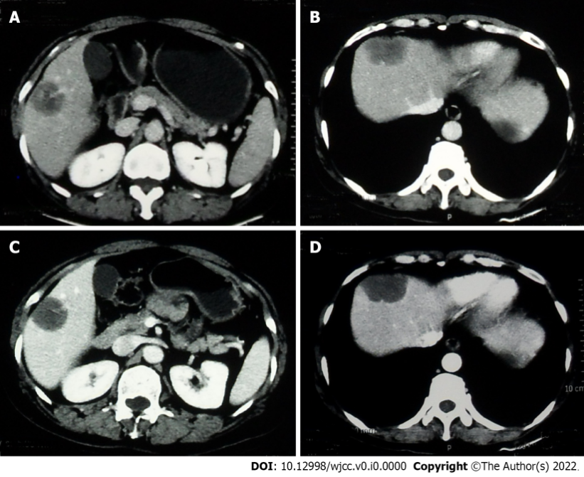
Figure 1 Abdominal computed tomography of case one. A and B: Computed tomography (CT) showed two round low-density nodules in the right lobe of the liver; C and D: Contrast-enhanced CT showed that the peripheral rim of the nodules was enhanced.
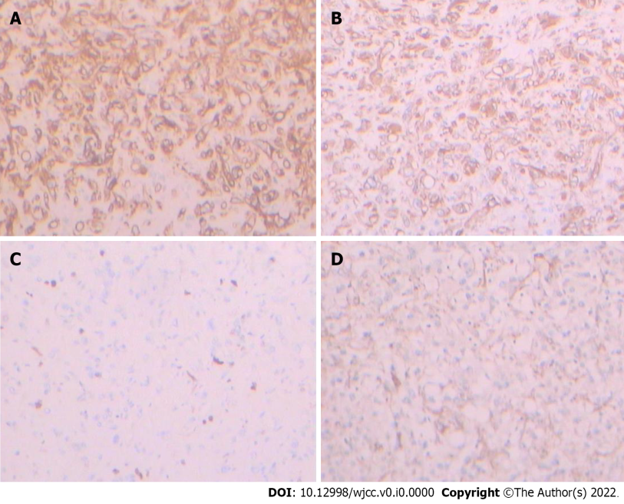
Figure 2 Immunohistochemical staining of case one. A: Positivity for CD34 in case one (magnification, × 200); B: Positivity for vimentin in case one (magnification, × 200); C: Positivity for Ki-67 in case one (magnification, × 200); D: Positivity for smooth muscle actin in case one (magnification, × 200).
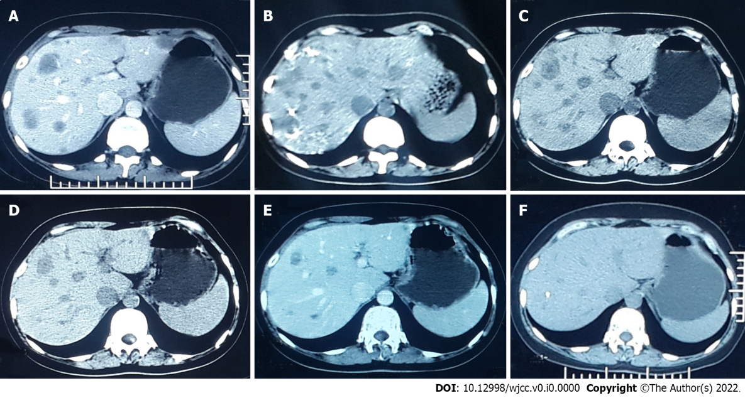
Figure 3 Abdominal computed tomography of case two. A: Computed tomography showed multiple hypodense hepatic nodular formations, all of which were slightly enhanced during the arterial phase; B: After four cycles of transhepatic arterial chemotherapy and embolization, the number of lesions increased; C-F: After 18 mo of interferon treatment, the lesions were gradually reduced and disappeared.
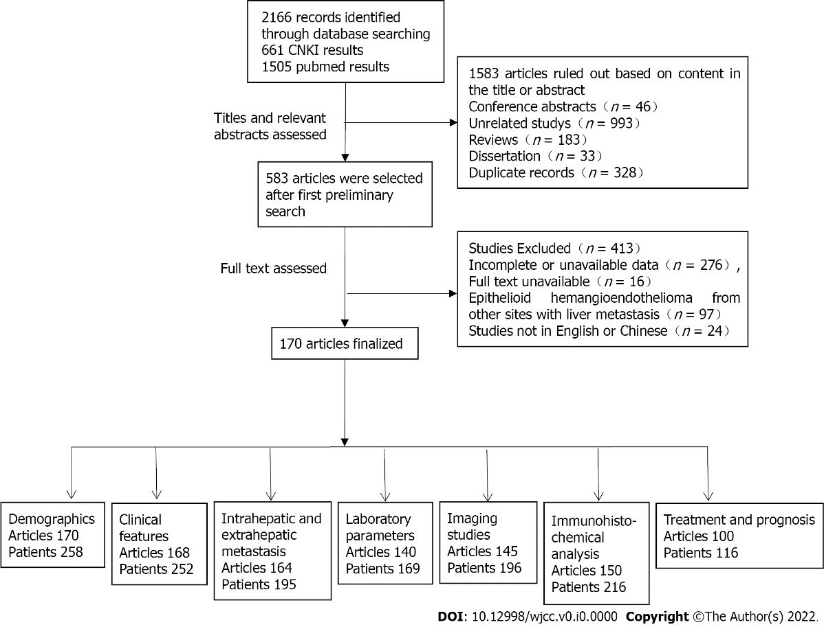
Figure 4 Search and selection process. CNKI: China National Knowledge Infrastructure.
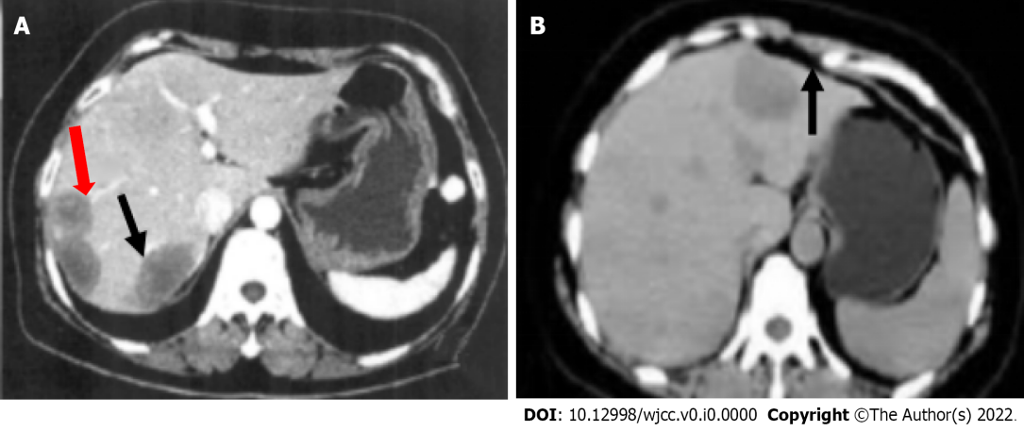
Figure 5 Abdominal computed tomography of hepatic epithelioid hemangioendothelioma. A: Target sign (black arrow) and lollipop sign (red arrow); B: Capsular retraction (black arrow).

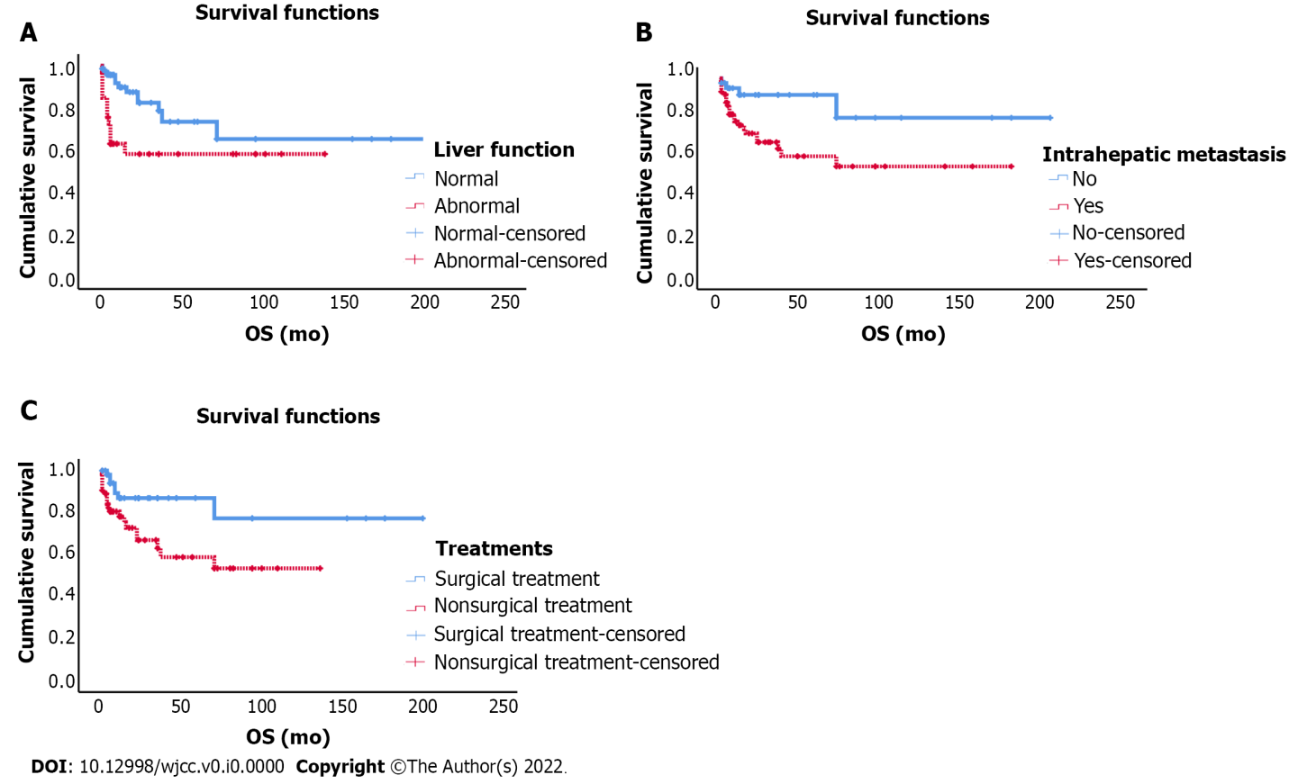
Figure 6 Overall survival of patients with hepatic epithelioid hemangioendothelioma. A-C: Overall survival according to liver function (A), intrahepatic metastasis (B), and treatment (C). OS: Overall survival.
Table 1 General features of patients with hepatic epithelioid hemangioendothelioma
General feature | No. of patients | %
Presence of symptoms, n = 254
Asymptomatic | 69 | 27.2
Symptomatic | 185 | 72.8
Epigastric pain | 99 | 39.0
Hepatosplenomegaly | 39 | 15.4
Inappetence | 34 | 13.4
Abdominal distension | 31 | 12.2
Weight loss | 27 | 10.6
Fatigue | 26 | 10.2
Epigastric discomfort | 25 | 9.8
Hydrothorax and ascite | 18 | 7.1
Fever | 12 | 4.7
Jaundice | 24 | 9.4
Thoracalgia and humeral back pain | 20 | 7.9
Nausea and vomiting | 10 | 3.9
Edema | 8 | 3.1
Cough and expectoration | 9 | 3.5
Abdominal mass | 2 | 0.8
Hematemesis and melena | 2 | 0.8
Intrahepatic involvement type, n = 197
Multinodular type (including diffuse type) | 168 | 85.3
Mononodular type | 29 | 14.7
Type of involvement, n = 197
Intrahepatic involvement | 129 | 65.5
Extrahepatic involvement | 68 | 34.5
Lung | 44 | 22.3
Lymph node | 11 | 5.6
Bone | 13 | 6.6
Peritoneum | 7 | 3.6
Spleen | 10 | 5.1
Pleura | 4 | 2.0
Omentum | 2 | 1.0
Liver function, n = 157
Normal | 89 | 56.7
Abnormal | 68 | 43.3
Elevated ALT in U/L | 40 | 25.5
Elevated AST in U/L | 40 | 25.5
Elevated TBIL in μmol/L | 24 | 15.3
Elevated ALP in U/L | 43 | 27.4
Elevated GGT in U/L | 32 | 20.4
Tumor markers
Elevated AFP in ng/mL | 8/171 | 4.7
Elevated CEA in ng/mL | 7/130 | 5.4
Elevated CA19-9 in U/mL | 13/135 | 9.6
Elevated CA125 in U/mL | 14/53 | 26.4
Plain CT scan, n = 198
Low density lesions | 195/198 | 98.6
High density or uneven density lesions | 3/198 | 1.4
Calcification | 30/198 | 15.2
Capsular retraction | 34/198 | 17.2
Confluent masses | 42/198 | 21.2
Contrast-enhanced CT, n = 163
Tumor edge enhancement | 138/163 | 84.7
Tumor edge without enhancement | 25/163 | 15.3
Target sign | 33/163 | 20.2
Lollipop sign | 19/163 | 11.7
Immunohistopathological markers
FVIII-RAg | 117/118 | 99.2
CD34 | 215/218 | 98.6
CD31 | 171/173 | 98.8
Vimentin | 94/95 | 98.9
SMA | 12/27 | 44.4
Desmin | 0/13 | NA
Hepatocyte | 8/58 | 13.8
CK | 38/81 | 46.9
EMA | 6/34 | 17.6
AFP | 0/34 | NA
CEA | 0/11 | NA
S-100 | 1/33 | 9.1
D2-40 | 7/11 | 63.6
Genetics
YAP1-TFE3 | 3/4 | 75.0
WWTR1-CAMTA1 | 3/5 | 60.0
HEHE: Hepatic epithelioid hemangioendothelioma; CT: Computed tomography; AST: Aspartate aminotransferase; ALT: Alanine aminotransferase; CEA: Carcinoembryonic antigen; AFP: Alpha fetoprotein; CK: Cytokeratin; GGT: Gamma-glutamyl transferase; SMA: Smooth muscle actin; EMA: Epithelial membrane antigen; FVIII-RAg: Factor VIII-related antigen; YAP-1: Yes-associated protein 1; TFE3: Transcription factor E3; WWTR1: WW domain-containing transcription regulator 1; CAMTA1: Calmodulin-binding transcription activator 1.

Table 2 Treatments and prognosis of patients with hepatic epithelioid hemangioendothelioma
Treatment and outcome, n = 118 | n (%) | Mean survival time in months, mean ± SD
LR | 35 (29.7) | 158.6 ± 20.5
LT | 19 (16.1) | 147.3 ± 13.8
Palliative treatment | 15 (12.7) | 4.2 ± 0.8
TACE | 12 (10.2) | 90.8 ± 13.4
Chemotherapy | 13 (11.0) | 71.4 ± 23.5
Other treatments | 6 (5.1) | 55.0 ± 17.0
Antiangiogenic therapy | 18 (15.3) | 83.1 ± 9.7
LR: Liver resection; LT: Liver transplantation; TACE: Transhepatic arterial chemotherapy and embolization.

Table 3 Results of univariable and multivariate analysis
Parameter | Univariate analysis |  | Multivariate analysis
 | HR (95% CI) | P value | HR (95% CI) | P value
Sex, male/female | 1.175 (0.549-2.513) | 0.678
Age, > 45 yr/≤ 45 yr | 0.952 (0.447-2.027) | 0.898
Symptoms, symptomatic/asymptomatic | 3.047 (0.911-10.185) | 0.070
AFP, elevated/normal | 1.261 (0.555-2.863) | 0.579
Liver function, abnormal/normal | 2.720 (1.236-5.988) | 0.013 | 2.258 (1.017-5.009) | 0.045
Maximum diameter of tumor, ≥ 5 cm/< 5 cm | 2.430 (0.856-6.901) | 0.096
Intrahepatic metastasis, yes/no | 3.553 (1.228-10.277) | 0.019 | 3.930 (1.152-13.404) | 0.029
Extrahepatic metastasis, yes/no | 2.328 (1.065-5.089) | 0.034 |  | 0.558
Treatments, nonsurgical treatment/surgical treatment | 2.831 (1.195-6.704) | 0.018 | 2.591 (1.022-6.565) | 0.045
HR: Hazard ratio; CI: Confidence interval; AFP: Alpha fetoprotein.

