Name of Journal: World Journal of Clinical Cases
Manuscript NO: 91158
Manuscript Type: CASE REPORT

Thymic carcinoid with multiple bone metastases: A case report

Chen CQ et al. TC with multiple bone metastasis

Chun-Qiao Chen, Ming-Yue Huang, Min Pan, Qiu-Qiu Chen, Fei-Fei Wei, Hui Huang

Chun-Qiao Chen, Ming-Yue Huang, Min Pan, Qiu-Qiu Chen, Fei-Fei Wei, Hui Huang, Department of Oncology, People’s Hospital of Guilin, Guilin 541000, Guangxi Zhuang Autonomous Region, China

Co-first authors: Chun-Qiao Chen and Ming-Yue Huang.

Author contributions: Chen CQ and Huang H designed the research; Chen CQ, Huang MY, Pan M and Chen QQ performed the research; Wei FF analyzed the data; Chen CQ, Huang MY and Huang H wrote the paper; Chen CQ and Huang MY contributed equally to the manuscript.

Supported by Guangxi Guilin Science and Technology Fund, No. 20190218-7-6.

Corresponding author: Hui Huang, MD, Doctor, Department of Oncology, People’s Hospital of Guilin, No. 12 Wenming Road, Guilin 541000, Guangxi Zhuang Autonomous Region, China. huanghui25002@163.com

Received: December 23, 2023
Revised: February 9, 2024
Accepted: March 28, 2024
Published online:

Abstract
BACKGROUND
Thymic carcinoid (TC) is a rare entity among anterior mediastinal malignancies. TCs are neuroendocrine carcinomas that constitute approximately 2%–5% of all thymic epithelial tumors.

CASE SUMMARY
The study reported a rare TC with multiple bone metastases. A 77-year-old man presented with a 2-month history of lower back pain and weight loss of 5 kg. Magnetic resonance imaging scans revealed damage to the lumbar spine, sacrocaudal vertebrae and iliac crest, suggesting bone metastasis; computed tomography (CT) scan of the thorax showed a calcified anterior mediastinal mass; positron emission tomography-CT demonstrated multiple abnormal bone signals; and laboratory work-up showed no endocrine abnormalities. Fine-needle aspiration biopsy revealed predominantly single small, round to oval cells with scant cytoplasm and some loose clusters, suggesting endocrine manifestations. The pathological diagnosis was atypical carcinoid, which tend to originate from the thymus and was classified as intermediate-highly invasive. The patient underwent anlotinib-targeted therapy. Anlotinib (12 mg) was administered daily for 2 wk, after which the patient was allowed to rest for 21 d. Follow-up CT after one year demonstrated that the tumor had shrunk by approximately 29% after therapy. Treatment has a long stable disease benefit of more than 2.5 years.

CONCLUSION
These findings demonstrated that anlotinib is a promising treatment regimen for patients with TC and multiple bone metastases.

Key Words: Thymic carcinoid; Anlotinib; Multitargeted tyrosine kinase inhibitor; Bone metastasis; Case report

Chen CQ, Huang MY, Pan M, Chen QQ, Wei FF, Huang H. Thymic carcinoid with multiple bone metastases: A case report. World J Clin Cases 2024; In press

Core Tip: Here, we report a 77-year-old man diagnosed with thymic carcinoid (TC) with multiple bone metastases, and the study reports the rapid contraction of thymoid carcinoma after therapy with the multitargeted tyrosine kinase inhibitor anlotinib. The treatment has shown good efficacy, with a long stable disease benefit of more than 2.5 years (until March 2022). These findings demonstrated that anlotinib is a promising treatment regimen for TC tumors with multiple bone metastases.

INTRODUCTION
Thymic carcinoid (TC) tumors are malignant and clinically rare tumors originating from thymic neuroendocrine cells. These tumors are different from thymomas and thymic carcinomas and have their own clinical and pathological characteristics. These tumors were first described as separate entities by Rosai and Higa^{[1]} in 1972 and were named TC tumors. The latest World Health Organization classification from 2015 grouped lung and thymic neuroendocrine tumors within one unique group^{[2]}. TC tumors, also known as highly differentiated neuroendocrine tumors, are divided into typical carcinoid tumors and atypical carcinoid tumors according to their morphology, among which atypical carcinoid tumors have a greater degree of malignancy and invasion. There is a lack of understanding of thymic carcinogenesis and no clear standardized diagnosis or treatment strategies due to the rarity of this disease; therefore, further knowledge is required for its clinical diagnosis and treatment. This report describes a 77-year-old man diagnosed with TC with multiple bone metastases, and the study reports the rapid contraction of thymoid carcinoma after therapy with the multitargeted tyrosine kinase inhibitor anlotinib.

CASE PRESENTATION
Chief complaints
A 77-year-old man presented with a complaint of a 2-month history of lower back pain and weight loss of 5 kg.

History of present illness
Initial symptoms included two months of lower back pain and a weight loss of 5 kg.

History of past illness
He had a past medical history of coronary heart disease, hypertension and lacunar cerebral infarction. The patient’s past medical history was not significant for night sweats, fevers, facial flushing, or diarrhea.

Personal and family history
The patient denied any family history of malignant tumors.

Physical examination
Physical examination revealed marked tenderness to percussion over the lumbar 2 vertebra, an Eastern Cooperative Oncology Group score above 1 and a pain score above 4. His physical examination revealed no signs of adenopathy or organomegaly.

Laboratory examinations
Laboratory tests showed an increase in serum neuron specific enolase (NSE) levels, reaching 32.05 mg/L (normal range < 13 mg/L); alpha-fetoprotein 3.29 ng/mL; alkaline phosphatase 95 U/L; β2-MB 2.15 mg/L.
The original percutaneous needle biopsy of the mediastinal mass revealed predominantly single small, round to oval cells with scant cytoplasm and some loose clusters with a mitotic rate > 2/10 high power fields (Figure 1A). Immunohistochemical staining showed positive for common neuroendocrine markers, such as chromogranin A, cytokeratin-Pan, CD56 and synaptophysin, but negative results for cytokeratin7 and thyroid transcription factor-1. The Ki67 index of the tumor moderately increased.

Imaging examinations
Magnetic resonance imaging of the lumbar region of the spine revealed multifocal metastatic lesions, an L2 vertebral compression fracture, and an L1/2-L5/S1 fusion with degenerative disc disease (Figure 1B and C). On computed tomography (CT), CT with intravenous contrast medium showed enhancement in the periphery of the mass (Figure 1D and E). And there was a round, heterogeneous, anterosuperior mediastinal mass measuring 8.1 cm × 7.9 cm × 6.1 cm (Figure 1F), Patchy nodular opacities were also observed in both lungs (Figure 1G). OctreoScan imaging revealed a large focus of increased tracer uptake in the chest corresponding to the mediastinal mass as well as the cervical, lumbar, rib, sternum, and iliac crest regions noted on positron emission tomography CT.

FINAL DIAGNOSIS
In summary, the patient was diagnosed with moderately differentiated neuroendocrine carcinoma (atypical carcinoid).

TREATMENT
Tumor cells extensively invade the lung and various bones and cannot be removed surgically. The patient was administered anlotinib (12 mg) on June 6, 2018, which was administered orally daily before breakfast for 2 weeks with a week of rest in every cycle of 21 d.

OUTCOME AND FOLLOW-UP
Treatment has shown good efficacy, with a long stable disease (SD) benefit of more than 2.5 years (until March 2022) (Figure 2). During the year of anlotinib-targeted therapy, a follow-up CT scan of the chest taken in June 2019 demonstrated that the tumor measured approximately 5.7 cm × 3.8 cm × 5.7 cm (Figure 2B), and the tumor had shrunk by approximately 29% after therapy. The patient reported significant relief of lower back pain (Figure 2F and G). His pain score was reduced to above 1. There was no evidence of disease progression after treatment, and the NSE index continued to decrease (Table 1). The patient died on May 10, 2022 due to respiratory and circulatory failure.

DISCUSSION
TCs are uncommon lesions. The clinical characteristics of TC tumors are male predominance, difficult diagnosis, high malignancy, frequent recurrence and extrathoracic metastasis over a long period of time^{[3]}. In fact, TC tumors are amine precursor uptake and decarboxylation tumors and thus can exhibit endocrine function. TCs associated with Cushing’s syndrome are more common than other types of carcinoids and account for 29% to 38% of all TCs^{[4]}. In addition, TCs are usually slow-growing tumors that cause symptoms only when they begin to exert pressure on adjacent structures. Some patients have no clinical symptoms at all, and only thymic masses are found at physical examination. Symptoms can vary greatly, as in our case, in which the disease was acutely manifested as lumbar pain caused by lumbar metastasis compression and nerve root stimulation. Such cases have not been previously reported.
TC tumors have a greater rate of metastatic disease than carcinoid tumors in other locations. The 5-year survival rate of TCs is 60%, and recurrence is common^{[3]}. The prognosis of these tumors is poor, even in patients whose tumors appear favorable in terms of resectability and histology. With the development of molecular pharmacology, targeted therapy has gradually become possible^{[5]}. In fact, in this case, the patient was assessed as inoperable due to tumor invasion into the mediastinum and multiple bone metastases from thymic cancer, and a new adjuvant strategy was adopted to induce tumor response and improve quality of life.
Anlotinib, a multiple tyrosine kinase receptor, is a potent anti-angiogenic and anti-tumor drug that inhibits signal transduction vascular endothelial growth factor receptor (VEGFR), platelet-derived growth factor receptors, fibroblast growth factor receptor, and c-KIT^{[6]}. Anlotinib has been shown to inhibit the osteosarcoma cell lines by affecting cell proliferation and the protein levels of the VEGFR2 and MET signaling pathways^{[7]}. Additionally, anlotinib inhibits cell viability and induces apoptosis in lung cancer cells, which in turn enhances the cytotoxicity of anlotinib and amplifies its antiangiogenic effect through Janus kinase 2/signal transducer and activator of transcription 3/vascular endothelial growth factor A signaling^{[8]}. In human trials, Han et al^{[9]} and Zhang et al^{[10]} reported that, compared with placebo, anlotinib is well tolerated and significantly improves progression-free survival (PFS) and overall survival. Additionally, anlotinib is a promising treatment option for patients with relapsed small-cell lung cancer who have experienced treatment failure with two lines of chemotherapy^{[11]}. The use of anlotinib in previously treated, recurrent or metastatic esophageal squamous cell carcinoma patients significantly improved PFS and the disease control rate compared with those of patients treated with a placebo^{[12]}.
However, in our patient, anlotinib therapy was administered with the neoadjuvant intent of increasing the disease control rate and quality of life. The patient was started on anlotinib (12 mg) on June 6, 2018, which was administered orally daily for 2 wk with a week of rest in every cycle of 21 d. The follow-up included CT imaging. One year after treatment, a CT scan indicated that the tumor was approximately 5.7 cm × 3.8 cm × 5.7 cm, and approximately 29% of the tumors had shrunk before and after therapy. The patient was discharged in good clinical condition and did not receive further radiation and chemotherapy treatment. There were no signs of disease progression after treatment with anlotinib. After receiving long-term anlotinib therapy, his pain score decreased from 4 to above 1, and his SD reached 2.5 years (until March 2022), indicating the effectiveness of anlotinib treatment.

CONCLUSION
This report demonstrates that anlotinib is a promising treatment regimen for TC tumors with multiple bone metastases.

REFERENCES
1 Rosai J, Higa E. Mediastinal endocrine neoplasm, of probable thymic origin, related to carcinoid tumor. Clinicopathologic study of 8 cases. Cancer 1972; 29: 1061-1074 [PMID: 4111691 DOI: 10.1002/1097-0142(197204)29:4<1061::aid-cncr2820290456>3.0.co;2-3]
2 Marx A, Chan JK, Coindre JM, Detterbeck F, Girard N, Harris NL, Jaffe ES, Kurrer MO, Marom EM, Moreira AL, Mukai K, Orazi A, Ströbel P. The 2015 World Health Organization Classification of Tumors of the Thymus: Continuity and Changes. J Thorac Oncol 2015; 10: 1383-1395 [PMID: 26295375 DOI: 10.1097/JTO.0000000000000654]
3 Bakhos CT, Salami AC, Kaiser LR, Petrov RV, Abbas AE. Thymic Neuroendocrine Tumors and Thymic Carcinoma: Demographics, Treatment, and Survival. Innovations (Phila) 2020; 15: 468-474 [PMID: 32938293 DOI: 10.1177/1556984520949287]
4 Filosso PL, Ruffini E, Solidoro P, Roffinella M, Lausi PO, Lyberis P, Oliaro A, Guerrera F. Neuroendocrine tumors of the thymus. J Thorac Dis 2017; 9: S1484-S1490 [PMID: 29201451 DOI: 10.21037/jtd.2017.10.83]
5 Liang Y, Ji S, Yu X, Chen J. [Updates on medical treatment for neuroendocrine neoplasm]. Zhongguo Aizheng Zazhi 2022; 32: 757-764 [DOI: 10.19401/j.cnki.1007-3639.2022.09.001]
6 Shen G, Zheng F, Ren D, Du F, Dong Q, Wang Z, Zhao F, Ahmad R, Zhao J. Anlotinib: a novel multi-targeting tyrosine kinase inhibitor in clinical development. J Hematol Oncol 2018; 11: 120 [PMID: 30231931 DOI: 10.1186/s13045-018-0664-7]
7 Wang G, Sun M, Jiang Y, Zhang T, Sun W, Wang H, Yin F, Wang Z, Sang W, Xu J, Mao M, Zuo D, Zhou Z, Wang C, Fu Z, Wang Z, Duan Z, Hua Y, Cai Z. Anlotinib, a novel small molecular tyrosine kinase inhibitor, suppresses growth and metastasis via dual blockade of VEGFR2 and MET in osteosarcoma. Int J Cancer 2019; 145: 979-993. [PMID: 30719715 DOI: 10.1002/ijc.32180]
8 Liang L, Hui K, Hu C, Wen Y, Yang S, Zhu P, Wang L, Xia Y, Qiao Y, Sun W, Fei J, Chen T, Zhao F, Yang B, Jiang X. Autophagy inhibition potentiates the anti-angiogenic property of multikinase inhibitor anlotinib through JAK2/STAT3/VEGFA signaling in non-small cell lung cancer cells. J Exp Clin Cancer Res 2019; 38: 71 [PMID: 30755242 DOI: 10.1186/s13046-019-1093-3]
9 Han B, Li K, Wang Q, Zhang L, Shi J, Wang Z, Cheng Y, He J, Shi Y, Zhao Y, Yu H, Zhao Y, Chen W, Luo Y, Wu L, Wang X, Pirker R, Nan K, Jin F, Dong J, Li B, Sun Y. Effect of Anlotinib as a Third-Line or Further Treatment on Overall Survival of Patients With Advanced Non-Small Cell Lung Cancer: The ALTER 0303 Phase 3 Randomized Clinical Trial. JAMA Oncol 2018; 4: 1569-1575 [PMID: 30098152 DOI: 10.1001/jamaoncol.2018.3039]
10 Zhang RS, Liu J, Deng YT, Wu X, Jiang Y. The real-world clinical outcomes and treatment patterns of patients with unresectable locally advanced or metastatic soft tissue sarcoma treated with anlotinib in the post-ALTER0203 trial era. Cancer Med 2022; 11: 2271-2283 [PMID: 35191609 DOI: 10.1002/cam4.4613]
11 Cheng Y, Wang Q, Li K, Shi J, Liu Y, Wu L, Han B, Chen G, He J, Wang J, Lou D, Yu H, Qin H, Li XL. Overall survival (OS) update in ALTER 1202: Anlotinib as third-line or further-line treatment in relapsed small-cell lung cancer (SCLC). Ann Oncol 2019; 30: v711 [DOI: 10.1093/annonc/mdz264]
12 Huang J, Xiao J, Fang W, Lu P, Fan Q, Shu Y, Feng J, Zhang S, Ba Y, Zhao Y, Liu Y, Bai C, Bai Y, Tang Y, Song Y, He J. Anlotinib for previously treated advanced or metastatic esophageal squamous cell carcinoma: A double-blind randomized phase 2 trial. Cancer Med 2021; 10: 1681-1689 [PMID: 33586360 DOI: 10.1002/cam4.3771]

Footnotes
Informed consent statement: Informed written consent was obtained from the patient for publication of this report and any accompanying images.

Conflict-of-interest statement: The authors declare that they have no conflicts of interest to disclose.

CARE Checklist (2016) statement: The authors have read the CARE Checklist (2016), and the manuscript was prepared and revised according to the CARE Checklist (2016).

Open-Access: This article is an open-access article that was selected by an in-house editor and fully peer-reviewed by external reviewers. It is distributed in accordance with the Creative Commons Attribution NonCommercial (CC BY-NC 4.0) license, which permits others to distribute, remix, adapt, build upon this work non-commercially, and license their derivative works on different terms, provided the original work is properly cited and the use is non-commercial. See: https://creativecommons.org/Licenses/by-nc/4.0/

Provenance and peer review: Unsolicited article; Externally peer reviewed.

Peer-review model: Single blind

Peer-review started: December 23, 2023
First decision: January 30, 2024
Article in press:

Specialty type: Medicine, research and experimental
Country/Territory of origin: China
Peer-review report’s scientific quality classification
Grade A (Excellent): 0
Grade B (Very good): 0
Grade C (Good): C
Grade D (Fair): 0
Grade E (Poor): 0

P-Reviewer: Mallin MM, United States S-Editor: Che XX L-Editor: A P-Editor:
Figure Legends
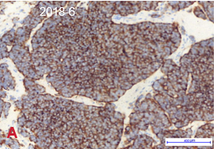
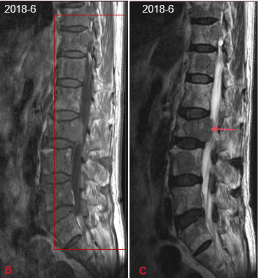
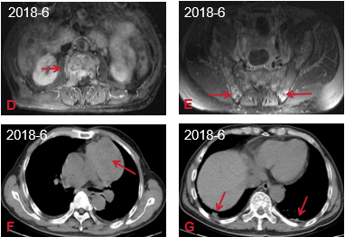
Figure 1 Thymic carcinoid with multiple bone metastases. A: The original percutaneous needle biopsy of the mediastinal mass showed predominantly single small, round to oval cells with scant cytoplasm and some loose clusters (hematoxylin-eosin staining, × 400); B: Magnetic resonance imaging scans of the lumbar spine showed multiple abnormal signals to the lumbar spine, sacrocaudal vertebrae and iliac crest, indicating bone metastasis; C: L2 vertebral compression fracture and L1/2-L5/S1 with degenerative disc disease; D and E: Lumbar vertebrae axial computed tomography (CT) scan showing bone erosion of the T1 vertebra; F and G: CT scan of the thorax showing a calcified anterior mediastinal mass and a nodular shadow in the subpleural area of both lungs.

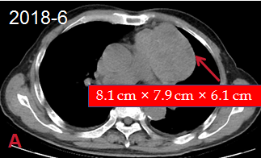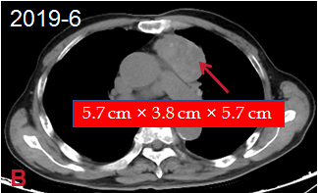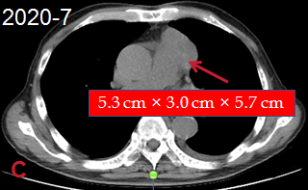
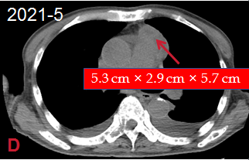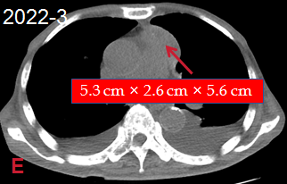
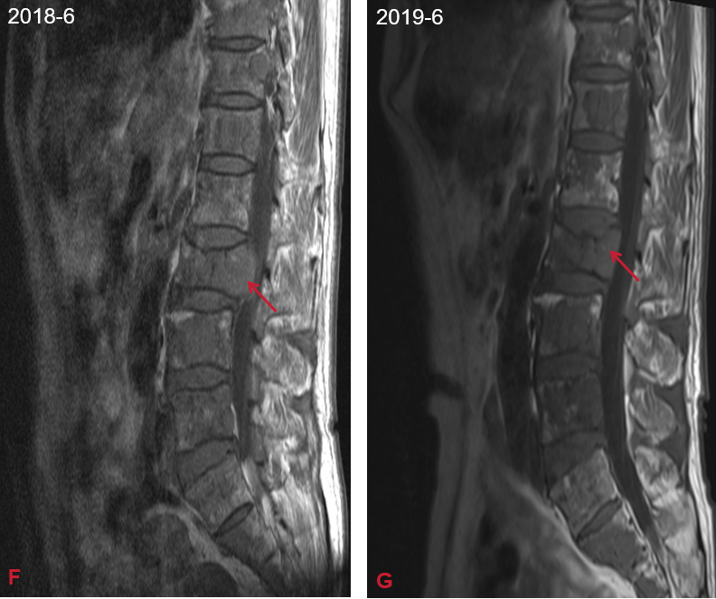
Figure 2 Tumor shrinkage before and after therapy. A-E: Heterogenous, mediastinal, soft tissue mass observed via computed tomography scan. The mass was measured at the level of branching of the main pulmonary artery; F and G: The vertebral compression fractures improved significantly.
Table 1 Neuron specific enolase indicators
Date | 2018-06 | 2018-08 | 2019-06 | 2020-07 | 2021-05 | 2022-03
NSE (ng/mL) | 32.05 | 111.6 | 51.6 | 35.83 | 41.51 | 25.34
NSE: Neuron specific enolase.

