Name of Journal: World Journal of Gastroenterology
Manuscript NO: 79484
Manuscript Type: ORIGINAL ARTICLE

Clinical Trials Study
Diagnostic evaluation of endoscopic ultrasonography with submucosal saline injection for differentiating between T1a and T1b early gastric cancer

Park JY et al. Endoscopic ultrasound for diagnosis of EGC

Ji Young Park, Tae Joo Jeon

Ji Young Park, Tae Joo Jeon, Department of Internal Medicine, Inje University College of Medicine, Sanggye Paik Hospital, Seoul 01757, South Korea

Ji Young Park, Department of Internal Medicine, Yonsei University College of Medicine, Seoul 03722, South Korea

Author contributions: Jeon TJ and Park JY contributed to conception and design; Park JY contributed to acquisition of data (acquired and managed patients); Jeon TJ contributed to development of methodology; Jeon TJ and Park JY contributed to analysis and interpretation of data; Park JY contributed to writing and review of manuscript; Park JY and Jeon TJ contributed to study supervision.

Corresponding author: Tae Joo Jeon, MD, PhD, Professor, Department of Internal Medicine, Inje University College of Medicine, Sanggye Paik Hospital, 1342, Dongil-ro, Nowon-gu, Seoul, Seoul 01757, South Korea. drjtj@paik.ac.kr

Received: August 24, 2022
Revised: September 22, 2022
Accepted: November 22, 2022
Published online: December 14, 2022

Abstract
BACKGROUND
Endoscopic ultrasonography (EUS) has become a reliable method for predicting the invasion depth of early gastric cancer (EGC). However, diagnostic accuracy of EUS is affected by several factors. In particular, it is difficult to differentiate between T1a and T1b EGC through EUS.

AIM
To confirm whether submucosal saline injection (SSI) could improve the accuracy of EUS in distinguishing T1a and T1b lesions in EGC.

METHODS
Twenty-four patients with EGC were examined by EUS and subsequently by SSI combined EUS to compare the degree of tumor invasion. Then, they underwent endoscopic or surgical resection within 7 d. The diagnostic accuracy of EUS and SSI combined EUS was evaluated based on the final pathological findings postoperatively. Saline injected into the submucosa acted as an echoic contrast enhancing agent and had the effect of distinguishing the mucosal and submucosal layers clearly.

RESULTS
Of total 24 patients, 23 were diagnosed with EGC (T1 cancer: 13 as T1a, and 10 as T1b). Standard EUS identified 6 of 13 T1a cancer patients and 3 of 10 T1b cancer patients. Whereas, EUS-SSI identified 12 of 13 T1a cancer patients and 6 of 10 T1b cancer patients. In this study, SSI combined EUS was more accurate than EUS alone in diagnosing T1a and T1b lesions of EGC (75.0% and 37.5%, respectively).

CONCLUSION
SSI improved the diagnostic accuracy of EUS in distinguishing between the T1a and T1b stages in EGC.

Key Words: Endoscopic ultrasonography; Gastric cancer; Endoscopy; Surgery

©The Author(s) 2022. Published by Baishideng Publishing Group Inc. All rights reserved.

Citation: Park JY, Jeon TJ. Diagnostic evaluation of endoscopic ultrasonography with submucosal saline injection for differentiating between T1a and T1b early gastric cancer. World J Gastroenterol 2022; 28(46): 6564-6572
URL: https://www.wjgnet.com/1007-9327/full/v28/i46/6564.htm
DOI: https://dx.doi.org/10.3748/wjg.v28.i46.6564

Core Tip: Submucosal saline injection improved the diagnostic accuracy of endoscopic ultrasonography in distinguishing between the T1a and T1b stages in early gastric cancer.

INTRODUCTION
Early gastric cancer (EGC) is a malignant lesion confined to the mucosa or submucosa (SM), regardless of lymph-node metastasis^{[1,2]}. Endoscopic submucosal dissection (ESD) is widely used to treat EGC, and the indications for ESD are expanded in the cases assumed to have a low risk of lymph-node metastasis^{[3-5]}. Even if the pathological depth of invasion is T1b (tumor invading the SM), ESD can be performed if the invasion is confined to SM1 (submucosal invasion to < 500 μm from the muscularis mucosae)^{[6,7]}. However, an additional surgery is recommended for EGC when deep submucosal invasion is identified by pathological evaluation after ESD (more than SM2; depth of submucosal invasion, ≥ 500 μm) owing to the risk of lymph-node metastasis^{[8]}. Therefore, the depth of invasion (T-stage) of gastric cancer is vital for determining the treatment strategy^{[3-7]}. Endoscopic ultrasonography (EUS) has been used for T-staging of gastric cancer^{[9,10]}. Although previous studies showed the clinical efficacy of EUS in T-staging of gastric cancer, the results have revealed a wide level of variability^{[1,2,11]}. The diagnostic accuracy may be affected by endoscopic findings, lesion location, tumor size, and the skill of the examiner^{[1,12]}. Specifically, EUS is difficult to distinguish between T1a (tumor invading the lamina propria and muscularis mucosae) and T1b lesions because the boundary between the mucosa and submucosa is thin and the difference in echogenicity is unclear^{[1,10]}.
Submucosal saline injection (SSI) is routinely administered prior to ESD to prevent damage to the surrounding tissue of the gastric wall and to avoid perforation during ESD^{[13]}. SSI creates a cushion within the loose connective tissues of the submucosa, which has been reported as an effective medium and echoic contrast-enhancing agent for ultrasound transmission, enabling good distinction between the mucosal and submucosal layers^{[13-15]}. Moreover, saline can increase the thickness of the submucosa^{[13-15]}. According to previous studies, SSI improved the performance of EUS in characterizing the invasion depth of esophageal and colorectal cancers^{[13-15]}. Therefore, this study was conducted to confirm whether SSI could be a method to improve the accuracy of EUS in distinguishing T1a and T1b lesions even in EGC and determine the feasibility of EUS for beginners.

MATERIALS AND METHODS
Case series
Methods: During March–April 2019, 24 endoscopically diagnosed EGC lesions in 24 patients were examined by EUS. The macroscopic tumor classification was as follows: type I (protruded), type IIa (superficial elevated), type IIb (flat), type IIc (superficial depressed), and type III (excavated). Types I and IIa were classified as the elevated type, and IIb IIc, and III as the depressed type. All patients underwent standard EUS followed by EUS with SSI (EUS-SSI). EUS findings of T1a gastric cancers were defined as low-echoic lines of muscularis mucosae that were clearly demarcated from the submucosa, and T1b gastric cancers on EUS were defined as low-echoic line lesions that were not clearly distinguished from the boundary of submucosal layer. Subsequently, they underwent endoscopic or surgical resection within 7 d. Definitive classification was determined based on the postoperative pathology. All recruited patients agreed to be enrolled as participants in this clinical trial and were provided informed consent. This study was approved by the Institutional Review Board of the Inje University Sanggye Paik Hospital (SGPAIK2021-10-019).
EUS examination and staging were simultaneously conducted by one endoscopist with only 6 mo’ experience with EUS. The examiner performed EUS with a 12-MHz ultrasonic probe (Olympus GF-UE260-AL5 Endoscopic System, Olympus Co., Tokyo, Japan). SSI was thereafter conducted as follows: after the lesion was confirmed by conventional endoscopy and subsequently by iodine dye-enhanced endoscopy, the examiner injected 3–5 mL saline slowly into the submucosa using a single-use 22G mucosal needle (Endo-Flex Co., Voerde, Germany). The puncture points were located 0.5 cm beyond the edge of the lesion, and saline injection was stopped once the gastric mucosa had been elevated by approximately 1 cm. After SSI, the examiner determined the depth of the lesion using EUS.

RESULTS
All patients showed good tolerance of EUS-SSI without severe adverse events, such as significant bleeding, asphyxia, perforation, or problems related to anesthetics.
Of total 24 patients, 23 were diagnosed with EGC (T1 cancer: 13 as T1a, and 10 as T1b), except for one who was diagnosed with T2 cancer after the surgery. According to the macroscopic classification of tumors, there were 4 patients with elevated type lesions and 20 with depressed-type lesions. In 12 of the patients, the pathological T-stage was different between the standard EUS and EUS-SSI. Among them, EUS-SSI findings were consistent with the final pathological findings in 10 patients and standard EUS findings were consistent in one patient. The other patient was diagnosed with EGC stage-T2, which differed before and after the surgery (Table 1).
EGC was observed by using standard EUS as a localized thickening of the gastric mucosa or depression of the mucosal wall with a relatively low echogenicity. In patients with stage T1a disease, the muscularis mucosae was displayed as a low-echoic line between the mucosa and submucosa (Figure 1A). On the other hand, in patients with stage T1b, the muscularis mucosae was not clearly distinguished, and the boundary between the submucosal layer and the lower margin of the lesion was blurred, making it difficult to determine the degree of invasion of the submucosal layer on standard EUS (Figure 2A). After SSI, the mucosa had relatively enhanced echogenicity compared to the submucosa that was filled with saline. The boundary between the edge of the lesion and submucosa was apparent after SSI due to the saline-formed cushion in the submucosa (Figure 1B and 2B). Since the echoic difference between the lesion and the surrounding normal tissue became clear in EUS-SSI, the extent of tumor invasion was more distinct than that demonstrated by standard EUS (Figure 3).
Standard EUS identified 6 of 13 T1a cancer patients and 3 of 10 T1b cancer patients. Whereas, EUS-SSI identified 12 of 13 T1a cancer patients and 6 of 10 T1b cancer patients. The diagnostic accuracies of the standard EUS and EUS-SSI are shown in Table 2 (37.5% and 75.0%, respectively).

DISCUSSION
EUS accurately characterizes the locoregional stage of gastric cancer and although the diagnostic accuracy of EUS in evaluating the invasion of depth of EGC has been reported, the results lack a consensus and have varying accuracy rates of 64.8%-92%^{[9-11]}. Several studies also concluded that EUS has no significant advantage over conventional endoscopy in predicting the invasion depth^{[16]}. Hence, it has been clarified that the accuracy of EUS can vary greatly depending on the experience of the endoscopist, macroscopic type of tumor, presence of ulceration, tumor located in the stomach, tumor size, and differentiation type^{[1,9,10,12]}. Regarding ulcerative lesions, submucosal fibrosis occurs, which is observed on EUS as a hypoechoic lesion, similar to tumor invasion^{[2,10,16]}. For lesions in the upper third of the stomach, the accuracy of EUS may decrease because of the different thicknesses of the stomach layer and presence of fibrosis or blood vessels surrounding the tumor^{[10,16]}. In addition, it is difficult to fill the deaerated water and locate the EUS probe near the lesion because of the angulation of the EUS scope^{[10,16]}. Previous studies have reported that a large tumor size is a risk factor for misdiagnosing the depth of invasion^{[10]}. This is probably because the lesions might not extend even if the deaerated water is stored in cases of large tumors^{[11]}. Undifferentiated-type tumors might have a diffuse or vesicular invasion of tumor cells to the submucosal layer of the gastric wall compared to differentiated-type tumors^{[11]}. Thus, EUS cannot visualize these microinvasions and might underestimate the depth of invasion^{[11]}. In our study, reviewing 15 patients with different results between final pathology and EUS-only findings, all patients had tumors located in the upper third of the stomach, sized ≥ 2 cm, ulcerative lesions, or undifferentiated type.
Regardless of the tumor characteristics, the diagnostic accuracy of EUS in predicting the T-stage of EGC in this study was 37.5%, which is low compared to that reported in previous studies. This study was conducted by a beginner endoscopist with approximately 6 mo’ experience. To increase the diagnostic accuracy of EUS for staging of gastric cancer, an endoscopist with a high experience and proficiency is required, but some techniques are also required for the classification of EGC. EUS may overestimate the depth of invasion due to underlying inflammation or fibrosis^{[10,11,16]}. EUS-SSI showed improved results in reducing the overestimation and overall diagnostic accuracy (Table 3). By reducing over-staging, an unnecessary surgery can be avoided, surgery-related adverse events can be prevented, the recovery period can be further shortened, and the patient’s quality of life can be improved.
As limitations, we noted that EUS-SSI required a longer examination time than EUS-only, which may cause more patient discomfort. However, the patients in this study did not complain of discomfort and did not develop any adverse events related to SSI.
In our study, SSI improved the diagnostic accuracy of EUS in distinguishing between the T1a and T1b stages in EGC. This is probably because the saline injected into the submucosa serves as an echoic contrast-enhancing agent for the clear visualization of the boundary between the mucosa and the submucosa. However, our study is a clinical study conducted at a single institution, and the sample size is small, so there is a limit to interpreting the results. Therefore, a large-scale, prospective, randomized clinical trials for this are needed in the future. In particular, we suggest that beginners who are beginning EUS should try the EUS-SSI method when evaluating the depth of invasion of gastric cancer.

CONCLUSION
SSI improved the diagnostic accuracy of EUS in distinguishing between the T1a and T1b stages in EGC in this study. However, this needs to be confirmed in large-scale, prospective, randomized clinical trials in the future.

ARTICLE HIGHLIGHTS
Research background
Although endoscopic ultrasound (EUS) is a method to predict the depth of invasion in early gastric cancer (EGC), it is still difficult to differentiate between T1a and T1b EGCs via EUS.

Research motivation
In particular, we considered a method to increase the accuracy of diagnosis for endoscopists who are beginning to perform EUS. It was thought that submucosal saline injection (SSI) during endoscopic mucosal resection may be helpful for examination because it can expand the submucosal layer.

Research objectives
The objectives of this study was to confirm whether SSI could be a method to improve the accuracy of EUS in distinguishing T1a and T1b lesions even in EGC and determine the feasibility of EUS for beginners.

Research methods
During March-April 2019, 24 endoscopically diagnosed EGC lesions in 24 patients were examined by EUS. All patients underwent standard EUS followed by EUS with SSI (EUS-SSI). Thereafter, endoscopic or surgical resection was performed within 7 days. T1a and T1b lesions were diagnosed based on the final pathology results after treatment. The diagnostic accuracy of EUS and EUS-SSI for T stage was compared.

Research results
Standard EUS identified 6 of 13 T1a cancer patients and 3 of 10 T1b cancer patients. Whereas, EUS-SSI identified 12 of 13 T1a cancer patients and 6 of 10 T1b cancer patients. In this study, SSI combined EUS was more accurate than EUS alone in diagnosing T1a and T1b lesions of EGC (75.0% and 37.5%, respectively).

Research conclusions
SSI improved the diagnostic accuracy of EUS in distinguishing between the T1a and T1b stages in EGC in this study. However, this needs to be confirmed in large-scale, prospective, randomized clinical trials in the future.

Research perspectives
In our study, SSI improved the diagnostic accuracy of EUS in distinguishing between the T1a and T1b stages in EGC. In particular, we suggest that beginners who are beginning EUS should try the EUS-SSI method when evaluating the depth of invasion of gastric cancer. However, our study is a clinical study conducted at a single institution, and the sample size is small. Therefore, a large-scale, prospective, randomized clinical trials for this are needed in the future.

REFERENCES
1 Tsuzuki T, Okada H, Kawahara Y, Nasu J, Takenaka R, Inoue M, Kawano S, Kita M, Hori K, Yamamoto K. Usefulness and problems of endoscopic ultrasonography in prediction of the depth of tumor invasion in early gastric cancer. Acta Med Okayama 2011; 65: 105-112 [PMID: 21519368 DOI: 10.18926/AMO/45269]
2 Park JS, Kim H, Bang B, Kwon K, Shin Y. Accuracy of endoscopic ultrasonography for diagnosing ulcerative early gastric cancers. Medicine (Baltimore) 2016; 95: e3955 [PMID: 27472672 DOI: 10.1097/MD.0000000000003955]
3 Fukunaga S, Nagami Y, Shiba M, Ominami M, Tanigawa T, Yamagami H, Tanaka H, Muguruma K, Watanabe T, Tominaga K, Fujiwara Y, Ohira M, Hirakawa K, Arakawa T. Long-term prognosis of expanded-indication differentiated-type early gastric cancer treated with endoscopic submucosal dissection or surgery using propensity score analysis. Gastrointest Endosc 2017; 85: 143-152 [PMID: 27365265 DOI: 10.1016/j.gie.2016.06.049]
4 Lee S, Choi KD, Han M, Na HK, Ahn JY, Jung KW, Lee JH, Kim DH, Song HJ, Lee GH, Yook JH, Kim BS, Jung HY. Long-term outcomes of endoscopic submucosal dissection vs surgery in early gastric cancer meeting expanded indication including undifferentiated-type tumors: a criteria-based analysis. Gastric Cancer 2018; 21: 490-499 [PMID: 29052052 DOI: 10.1007/s10120-017-0772-z]
5 Fujiya K, Takizawa K, Tokunaga M, Kawata N, Hikage M, Makuuchi R, Tanizawa Y, Bando E, Kawamura T, Tanaka M, Kakushima N, Ono H, Terashima M. The value of diagnostic endoscopic submucosal dissection for patients with clinical submucosal invasive early gastric cancer. Gastric Cancer 2018; 21: 124-132 [PMID: 28484889 DOI: 10.1007/s10120-017-0724-7]
6 Sanomura Y, Oka S, Tanaka S, Noda I, Higashiyama M, Imagawa H, Shishido T, Yoshida S, Hiyama T, Arihiro K, Chayama K. Clinical validity of endoscopic submucosal dissection for submucosal invasive gastric cancer: a single-center study. Gastric Cancer 2012; 15: 97-105 [PMID: 21785925 DOI: 10.1007/s10120-011-0076-7]
7 Ojima T, Takifuji K, Nakamura M, Nakamori M, Yamaue H. Feasibility of Endoscopic Submucosal Dissection for Submucosal-invasive Gastric Cancer and the Predictors of Residual or Recurrent Cancer. Surg Laparosc Endosc Percutan Tech 2016; 26: 401-405 [PMID: 27636148 DOI: 10.1097/SLE.0000000000000315]
8 Gotoda T, Yanagisawa A, Sasako M, Ono H, Nakanishi Y, Shimoda T, Kato Y. Incidence of lymph node metastasis from early gastric cancer: estimation with a large number of cases at two large centers. Gastric Cancer 2000; 3: 219-225 [PMID: 11984739 DOI: 10.1007/pl00011720]
9 Hwang SW, Lee DH. Is endoscopic ultrasonography still the modality of choice in preoperative staging of gastric cancer? World J Gastroenterol 2014; 20: 13775-13782 [PMID: 25320515 DOI: 10.3748/wjg.v20.i38.13775]
10 Kuroki K, Oka S, Tanaka S, Yorita N, Hata K, Kotachi T, Boda T, Arihiro K, Chayama K. Clinical significance of endoscopic ultrasonography in diagnosing invasion depth of early gastric cancer prior to endoscopic submucosal dissection. Gastric Cancer 2021; 24: 145-155 [PMID: 32572791 DOI: 10.1007/s10120-020-01100-5]
11 Shi D, Xi XX. Factors Affecting the Accuracy of Endoscopic Ultrasonography in the Diagnosis of Early Gastric Cancer Invasion Depth: A Meta-analysis. Gastroenterol Res Pract 2019; 2019: 8241381 [PMID: 31933632 DOI: 10.1155/2019/8241381]
12 Ahn HS, Lee HJ, Yoo MW, Kim SG, Im JP, Kim SH, Kim WH, Lee KU, Yang HK. Diagnostic accuracy of T and N stages with endoscopy, stomach protocol CT, and endoscopic ultrasonography in early gastric cancer. J Surg Oncol 2009; 99: 20-27 [PMID: 18937292 DOI: 10.1002/jso.21170]
13 Li JJ, Shan HB, Gu MF, He L, He LJ, Chen LM, Luo GY, Xu GL. Endoscopic ultrasound combined with submucosal saline injection for differentiation of T1a and T1b esophageal squamous cell carcinoma: a novel technique. Endoscopy 2013; 45: 667-670 [PMID: 23807801 DOI: 10.1055/s-0033-1344024]
14 He LJ, Xie C, Wang ZX, Li Y, Xiao YT, Gao XY, Shan HB, Luo LN, Chen LM, Luo GY, Yang P, Zeng SC, Xu GL, Li JJ. Submucosal Saline Injection Followed by Endoscopic Ultrasound vs Endoscopic Ultrasound Only for Distinguishing between T1a and T1b Esophageal Cancer. Clin Cancer Res 2020; 26: 384-390 [PMID: 31615934 DOI: 10.1158/1078-0432.CCR-19-1722]
15 Watanabe H, Miwa H, Terai T, Imai Y, Ogihara T, Sato N. Endoscopic ultrasonography for colorectal cancer using submucosal saline solution injection. Gastrointest Endosc 1997; 45: 508-511 [PMID: 9199910 DOI: 10.1016/s0016-5107(97)70182-2]
16 Kim J, Kim SG, Chung H, Lim JH, Choi JM, Park JY, Yang HJ, Han SJ, Oh S, Kim MS, Kim HJ, Hong H, Lee HJ, Kim JL, Lee E, Jung HC. Clinical efficacy of endoscopic ultrasonography for decision of treatment strategy of gastric cancer. Surg Endosc 2018; 32: 3789-3797 [PMID: 29435750 DOI: 10.1007/s00464-018-6104-5]

Footnotes
Institutional review board statement: The study was reviewed and approved by the Institutional Review Board of the Inje University Sanggye Paik Hospital (SGPAIK2021-10-019).

Clinical trial registration statement: This study is registered at “Clinical Research Information Service (https://cris.nih.go.kr)”. The registration identification number is KCT0007919.

Informed consent statement: All study participants, or their legal guardian, provided informed written consent prior to study enrollment.

Conflict-of-interest statement: Dr Ji Young Park and Tae Joo Jeon declare that they have no conflicts of interest.

Data sharing statement: No additional data are available.

CONSORT 2010 statement: The authors have read the CONSORT 2010 statement, and the manuscript was prepared and revised according to the CONSORT 2010 statement.

Open-Access: This article is an open-access article that was selected by an in-house editor and fully peer-reviewed by external reviewers. It is distributed in accordance with the Creative Commons Attribution NonCommercial (CC BY-NC 4.0) license, which permits others to distribute, remix, adapt, build upon this work non-commercially, and license their derivative works on different terms, provided the original work is properly cited and the use is non-commercial. See: https://creativecommons.org/Licenses/by-nc/4.0/

Provenance and peer review: Invited article; Externally peer reviewed.
Peer-review model: Single blind

Peer-review started: August 24, 2022
First decision: September 2, 2022
Article in press: November 22, 2022

Specialty type: Gastroenterology and hepatology
Country/Territory of origin: South Korea
Peer-review report’s scientific quality classification
Grade A (Excellent): 0
Grade B (Very good): B
Grade C (Good): C, C
Grade D (Fair): 0
Grade E (Poor): E

P-Reviewer: Arigami T, Japan; Ban T, Japan; Bestetti AM, Brazil S-Editor: Liu JH L-Editor: A P-Editor: Liu JH
Figure Legends
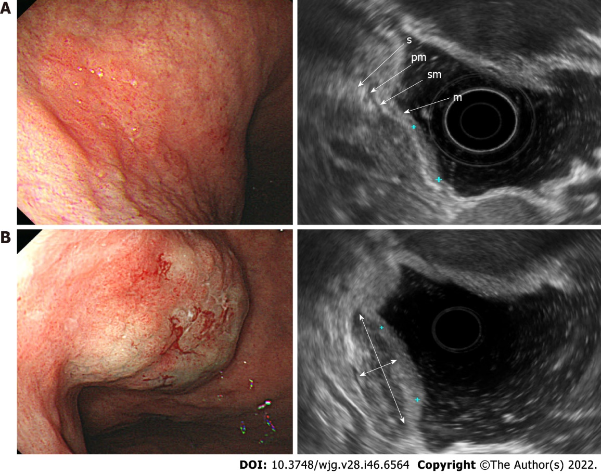
Figure 1 Endoscopic and ultrasonographic images and associated schematic diagrams of T1a early gastric cancer. A: Standard endoscopic ultrasonography (EUS) showing that it is difficult to differentiate the extent of invasion from the mucosal layer to the submucosal layer; B: EUS after submucosal saline injection showing clearly the boundary between the mucosa and the submucosa, meaning that the T1a stage can be easily identified. m: Mucosa; sm: Submucosa; pm: Proper muscle; s: Serosa; double arrow, saline layer.
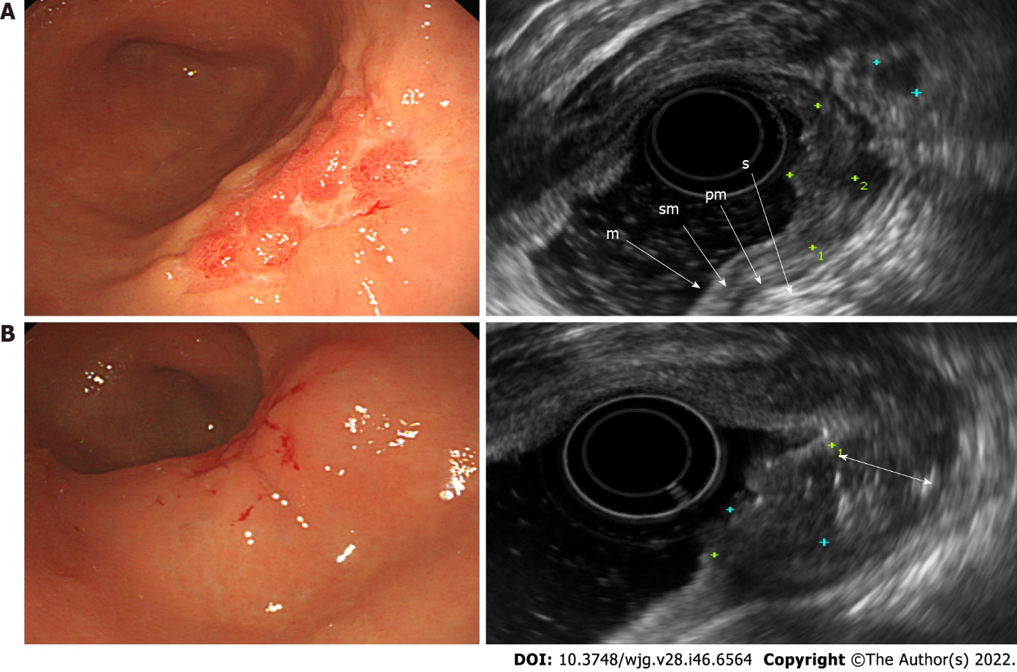
Figure 2 Endoscopic and ultrasonographic images and associated schematic diagrams of T1b early gastric cancer. A: Standard endoscopic ultrasonography (EUS) showing that it is difficult to differentiate the extent of invasion from the mucosal layer to the submucosal layer; B: EUS after submucosal saline injection (SSI) showing clearly the boundary between the mucosa and the submucosa, meaning that the lesion, its infiltration depth into the mucosa, and the submucosa can be easily identified. m: Mucosa; sm: Submucosa; pm: Proper muscle; s: Serosa; double arrow, saline layer.
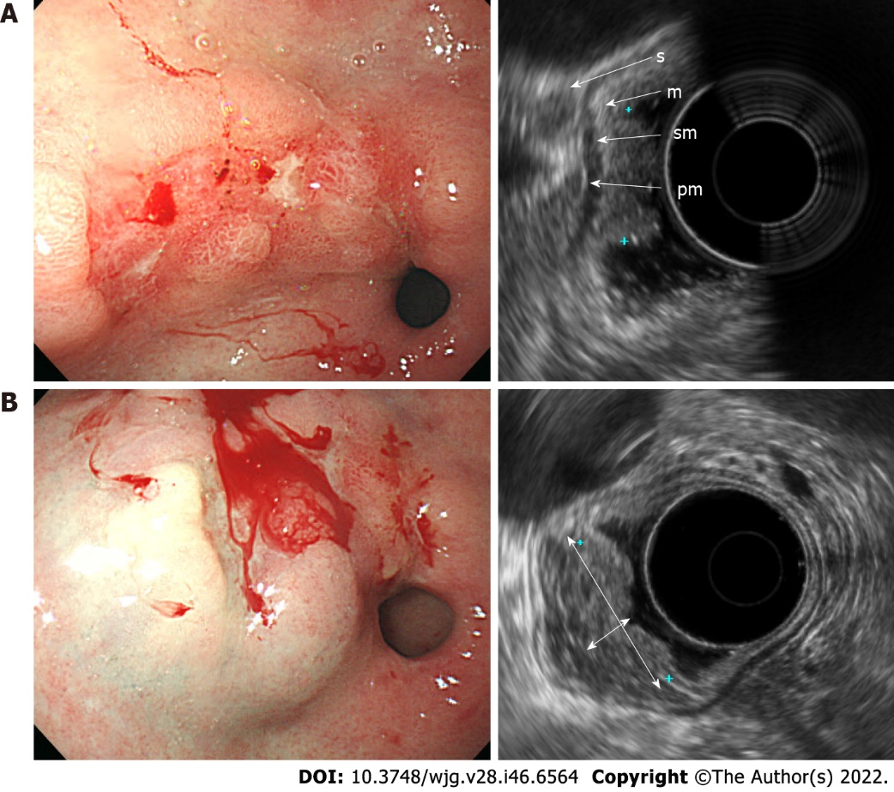
Figure 3 Endoscopic and ultrasonographic images and associated schematic diagrams of T1a early gastric cancer. A: With the use of standard endoscopic ultrasonography (EUS), the boundary between the lesion and the submucosal layer was unclear. The distance between the mucosa and the submucosa was short. This lesion was diagnosed as T1b as it appeared to partially invade the submucosa when observed with standard EUS; B: With the use of endoscopic ultrasonography after submucosal saline injection (EUS-SSI), the boundary between the lesion and the submucosal layer was apparent. It was much easier to determine whether the lesion had invaded the submucosal layer due to the increased thickness of the gastric wall and an effect of increasing echoic contrast by saline cushion. This lesion was diagnosed as T1a as the submucosal layer was intact when observed with EUS-SSI. m: Mucosa; sm: Submucosa; pm: Proper muscle; s: Serosa; double arrow, saline layer.

Table 1 Clinical features, endoscopic ultrasonography findings before and after submucosal saline injection, and pathological results of 24 patients with early gastric cancer
Patient No. | Age | Sex | Location | Size (max, mm) | Endoscopic morphology (EGC type) | Ulcer | EUS-assessed preoperative stage |  | Final pathology | Type of resection | Differentiation | Regional LN invasion | Vascular invasion
 |  |  |  |  |  |  | Before SSI (EUS-only) | After SSI (EUS-SSI)
1 | 72 | M | Lower third | 20 | 0-III | Y | T1a | T1b | T1b (sm3) | Surgery | Mod
2 | 64 | M | Lower third | 20 | 0-IIc |  | T1b | T1b | T1b (sm1) | Surgery | Poor (signet ring) | Y
3 | 59 | M | Lower third | 10 | 0-IIc |  | T1b | T1b | T1b (sm1) | Surgery | Poor
4 | 53 | M | Upper third | 27 | 0-IIa |  | T1a | T1a | T1a | Surgery | Mod
5 | 56 | F | Lower third | 38 | 0-IIc |  | T1b | T1a | T1a | Surgery | Poor
6 | 73 | M | Upper third | 22 | 0-IIc |  | T1b | T1a | T1a | Surgery | Mod
7 | 62 | M | Mid third | 65 | 0-IIc |  | T1b | T1a | T1a | Surgery | Mod
8 | 68 | M | Upper third | 8 | 0-IIb |  | T1a | T1a | T1a | ESD | Well
9 | 69 | M | Lower third | 15 | 0-IIa |  | T1a | T1a | T1a | ESD | Well
10 | 71 | M | Lower third | 17 | 0-IIb |  | T1b | T1a | T1a | ESD | Poor
11 | 54 | F | Lower third | 25 | 0-IIc |  | T1b | T1a | T1a | Surgery | Poor (signet ring)
12 | 82 | M | Upper third | 15 | 0-IIb |  | T1a | T1a | T1b (sm1) | ESD | Poor
13 | 71 | F | Lower third | 25 | 0-IIc |  | T1b | T1b | T1b (sm3) | Surgery | Poor | Y | Y
14 | 36 | F | Lower third | 20 | 0-IIc |  | T1a | T1b | T1b (sm3) | Surgery | Poor | Y
15 | 60 | M | Lower third | 10 | 0-IIc |  | T1a | T1a | T1a | ESD | Mod
16 | 62 | F | Mid third | 50 | 0-IIc |  | T2 | T1b | T1b (sm3) | Surgery | Poor
17 | 74 | F | Upper third | 25 | 0-IIb |  | T1a | T1a | T1b (sm1) | Surgery | Poor
18 | 60 | F | Upper third | 15 | 0-IIa |  | T1a | T1b | T2 | Surgery | Poor (signet ring)
19 | 80 | F | Lower third | 15 | 0-IIb |  | T1a | T1b | T1a | ESD | Poor
20 | 48 | F | Lower third | 45 | 0-IIc |  | T1a | T1a | T1b (sm3) | Surgery | Poor
21 | 72 | F | Lower third | 10 | 0-IIc |  | T1a | T1a | T1b (sm1) | ESD | Mod
22 | 50 | M | Lower third | 27 | 0-IIb |  | T1a | T1a | T1a | ESD | Well
23 | 74 | M | Upper third | 15 | 0-IIc |  | T1b | T1a | T1a | Surgery | Mod
24 | 76 | M | Upper third | 23 | 0-Is |  | T1b | T1a | T1a | Surgery | Well
EGC: Early gastric cancer; EUS: Endoscopic ultrasonography; SSI: Submucosal saline injection.

Table 2 Preoperative and postoperative stages for early gastric cancer in the endoscopic ultrasonography after submucosal saline injection and endoscopic ultrasonography -only examinations
Preoperative EUS reported stage | Postoperative pathologic stage
 | T1a | T1b
EUS-SSI, n (%)
T1a | 12 (92.3) | 4 (40)
T1b | 1 (7.7) | 6 (60)
EUS-only, n (%)
T1a | 6 (46.2) | 6 (66.7)
T1b | 7 (53.8) | 3 (33.3)
EUS: Endoscopic ultrasonography; SSI: Submucosal saline injection.

Table 3 The misdiagnosis rate for T staging of early gastric cancer in the endoscopic ultrasonography after submucosal saline injection and endoscopic ultrasonography -only examinations
 | EUS-only | EUS-SSI
Overstaging, n (%) | 8 (33.3) | 1 (4.2)
Understaging, n (%) | 7 (29.2) | 5 (20.8)
EUS: Endoscopic ultrasonography; SSI: Submucosal saline injection.

Published by Baishideng Publishing Group Inc
7041 Koll Center Parkway, Suite 160, Pleasanton, CA 94566, USA
Telephone: +1-925-3991568
E-mail: bpgoffice@wjgnet.com
Help Desk: https://www.f6publishing.com/helpdesk
https://www.wjgnet.com

© 2022 Baishideng Publishing Group Inc. All rights reserved.

