Name of Journal: World Journal of Orthopedics
Manuscript NO: 85725
Manuscript Type: ORIGINAL ARTICLE

Basic Study
Comparative study in vivo of the osseointegration of 3D-printed and plasma-coated titanium implants

Bondarenko S et al. Titanium implants osseointegration in rats

Stanislav Bondarenko, Volodymyr Filipenko, Nataliya Ashukina, Valentyna Maltseva, Gennadiy Ivanov, Iurii Lazarenko, Dmytro Sereda, Ran Schwarzkopf

Stanislav Bondarenko, Volodymyr Filipenko, Department of Joint Pathology, Sytenko Institute of Spine and Joint Pathology National Academy of Medical Sciences of Ukraine, Kharkiv 61024, Ukraine

Nataliya Ashukina, Valentyna Maltseva, Laboratory of Connective Tissue Morphology, Sytenko Institute of Spine and Joint Pathology National Academy of Medical Sciences of Ukraine, Kharkiv 61024, Ukraine

Gennadiy Ivanov, Experimental Pathology, Sytenko Institute of Spine and Joint Pathology National Academy of Medical Sciences of Ukraine, Kharkiv 61024, Ukraine

Iurii Lazarenko, Department of Traumatology, Military medical clinical center of the Central region, Vinnytsia 21018, Ukraine

Dmytro Sereda, Department of Surgery, Odesa city hospital 11, Odesa 65006, Ukraine

Ran Schwarzkopf, Hospital for Joint Diseases, NYU Langone Orthopedic Hospital, NY 10003, United States

Author contributions: All authors contributed to the study conception and design; Bondarenko S, Maltseva V and Ashukina N wrote the first draft version of the manuscript; Filipenko V supervised the study and performed critical revision of the article; Maltseva V performed data analysis and interpretation; Ivanov G, Lazarenko I and Sereda D performed experimental surgery, collection and interpretation data; Schwarzkopf R performed critical revision of the article; all authors revised and approved the final version of the manuscript.

Corresponding author: Stanislav Bondarenko, DSc, MD, PhD, Associate Professor, Department of Joint Pathology, Sytenko Institute of Spine and Joint Pathology National Academy of Medical Sciences of Ukraine, 80 Pushkinska St., Kharkiv 61024, Ukraine. bondarenke@gmail.com

Received: May 12, 2023
Revised: July 26, 2023
Accepted: August 7, 2023
Published online: September 18, 2023

Abstract
BACKGROUND
Total hip arthroplasty is a common surgical treatment for elderly patients with osteoporosis, particularly in postmenopausal women. In such cases, highly porous acetabular components are a favorable option in achieving osseointegration. However, further discussion is needed if use of such acetabular components is justified under the condition of normal bone mass.

AIM
To determine the features of osseointegration of two different types of titanium implants [3-dimensional (3D)-printed and plasma-coated titanium implants] in bone tissue of a distal metaphysis in a rat femur model.

METHODS
This study was performed on 20 white male laboratory rats weighing 300-350 g aged 6 mo. Rats were divided into two groups of 10 animals, which had two different types of implants were inserted into a hole defect (2 × 3 mm) in the distal metaphysis of the femur: Group I: 3D-printed titanium implant (highly porous); Group II: Plasma-coated titanium implant. After 45 and 90 d following surgery, the rats were sacrificed, and their implanted femurs were extracted for histological examination. The relative perimeter (%) of bone trabeculae [bone-implant contact (BIC%)] and bone marrow surrounding the titanium implants was measured.

RESULTS
Trabecular bone tissue was formed on the 45th day after implantation around the implants regardless of their type. 45 d after surgery, group I (3D-printed titanium implant) and group II (plasma-coated titanium implant) did not differ in BIC% (83.51 ± 8.5 vs 84.12 ± 1 .73; P = 0.838). After 90 d, the BIC% was higher in group I (87.04 ± 6.99 vs 81.24 ± 7.62; P = 0.049), compared to group II. The relative perimeter of the bone marrow after 45 d did not differ between groups and was 16.49% ± 8.58% for group I, and 15.88% ± 1.73% for group II. Futhermore, after 90 d, in group I the relative perimeter of bone marrow was 1.4 times smaller (12.96 ± 6.99 vs 18.76 ± 7.62; P = 0.049) compared to the relative perimeter of bone marrow in group II.

CONCLUSION
The use of a highly porous titanium implant, manufactured with 3D printing, for acetabular components provides increased osseointegration compared to a plasma-coated titanium implant.

Key Words: Rats; Hip arthroplasty; Femur; Porosity; 3-dimensional printing; Microscopy

©The Author(s) 2023. Published by Baishideng Publishing Group Inc. All rights reserved.

Citation: Bondarenko S, Filipenko V, Ashukina N, Maltseva V, Ivanov G, Lazarenko I, Sereda D, Schwarzkopf R. Comparative study in vivo of the osseointegration of 3D-printed and plasma-coated titanium implants. World J Orthop 2023; 14(9): 682-689
URL: https://www.wjgnet.com/2218-5836/full/v14/i9/682.htm
DOI: https://dx.doi.org/10.5312/wjo.v14.i9.682

Core Tip: The use of porous titanium materials was shown to be the most favorable solution for osseointegration for total hip arthroplasty, especially in the case of osteoporosis. Is the use of highly porous acetabular components justified under the condition of normal bone mass? We conducted a study on rats, in which we compared the osseointegration of 3-dimensional (3D)-printed or plasma-coated titanium implants into femoral bone defect by assessing the relative perimeter (%) of bone trabeculae. The highly porous titanium implant, manufactured with 3-dimensional printing, for acetabular components provides increased osseointegration compared to a plasma-coated titanium implant.

INTRODUCTION
Titanium has long been used for the manufacture of medical implants. Among them, highly porous titanium created using additive technologies [used, in particular, for acetabular component manufacturing for total hip arthroplasty (THA)] was shown to be the most favorable material for osseointegration^{[1-3]}. This is due to the similarity of the structure and biomechanical qualities of this material with bone tissue^{[4,5]}. THA is a common surgical treatment for elderly patients, women are equally represented among THA patients. A common challenge is matching the structure of the material to the structure of the bone, this becomes even more important due to the possibility of osteoporosis^{[6]} or slowing of bone tissue formation due to age changes, endocrine diseases, menopause, hormonal therapy, etc.^{[7,8]}. The use of acetabular components with a porous surface formed by plasma spraying has also proven itself in clinical practice^{[9–11]}. Previously, we reported the comparative osseointegration of four types of highly porous materials from which the acetabular components of endoprostheses are made^{[12].} No established difference was seen between them in healthy rats, in contrast differences were seen in postmenopausal osteoporotic animals^{[12]}. Additionally, an in vivo study in sheep also showed that surface modification by chemical treatment of porous titanium can improve osseointegration^{[13]}. It has been shown in clinical settings that the use of porous titanium cups was accompanied by a higher intensity of pain during the first 5 years after THA compared to cups made of titanium with plasma spraying^{[14]}. Conflicting data has been published regarding better primary stability of porous titanium cups compared to plasma sprayed titanium cups^{[4,15]}. The question arises: Is the use of highly porous acetabular components justified under the condition of normal bone mass?
Aim of the study was to establish the features of osseointegration of two different types of titanium implants [3-dimensional (3D)-printed and plasma-coated titanium implants] in a distal femoral metaphisial rat model.

MATERIALS AND METHODS
The study was conducted in compliance with the national guidelines, the European Convention for the Protection of Vertebrate Animals used for Experimental and Other Scientific Purposes (1986, ETS 123) and Directive 2010/63/EU. The protocol of the study was approved by the local Bioethics Committee (protocol No. 211 dated February 01, 2021).

Experiment design
The experimental study was performed on 20 white male laboratory rats weighing 300-350 g of 6 mo of age (Figure 1A), which were kept under conditions of standard food for rodents, free access to drinking water, and 12-h light day/night. The rats were divided into two groups of 10 animals each depending on the type of implanted titanium material: Group I: 3D-printed titanium implant (highly porous); Group II: Plasma-coated titanium implant (Figure 1A).

Implants
The cylindrical implants (2 mm diameter and 3 mm length) were made from the material of one of the two types of acetabular cups from (AK Medical H.L. Beijing, China): AK 3D ACT Titanium Alloy Trabecular Acetabular Cup^{[16]} or AK A Series Bio-Type Acetabular Cup^{[17]}. The difference between the coatings was in the method of their production and the resulting structure. In particular, the AK 3D ACT Titanium Alloy Trabecular Acetabular Cup is a highly porous titanium cup with open controlled porosity (approximately 80%) manufactured using additive technologies (Figure 1B); AK A Series Bio-Type Acetabular Cup is created by plasma spraying of titanium on the surface of the cup and has closed porosity (Figure 1C).

Surgical intervention
Surgical interventions were performed under aseptic and antiseptic conditions under general anesthesia (aminazine 10 mg/kg and ketamine 50 mg/kg intramuscularly). After preparation of the operative field [shaving the hair on the left knee and thigh, treatment with Kodan® forte antiseptic (Schülke & Mayr GmbH, Germany)], the distal metaphysis of the femur was opened through an anterolateral approach (Figure 1D). In the animal distal femoral metaphysis, a hole defect with a diameter of 2 mm was created with a dental boron, where 3D-printed or plasma-coated titanium implants were installed (Figure 1E and F). After that, the soft tissues and skin were sutured with knotted sutures and treated with Kodan® antiseptic. The condition of the rats after surgery did not necessitate pharmacological treatment.
At 45 and 90 d after surgery, rats were euthanized with a lethal dose of anaesthetic (sodium thiopental, 90 mg/kg intramuscularly) and implanted femurs were removed for histological examination.

Histological examination
Removed femurs with titanium implants were cleaned of soft tissue, then fixed in 10% buffered formalin for 5 d. After fixation, the bones were transferred to 70° ethyl alcohol for dehydration. After a day, three longitudinal sections with a thickness of approximately 0.5 mm were made from each distal metaphysis of the femur in the area of implantation of the titanium cylinders with a diamond saw. The obtained slices were stored in 70° ethyl alcohol and dried with filter paper before taking measurements.

Histomorphometry
Bone sections together with the implant were photographed using an Olympus BX-63 microscope (Olympus, Japan) with × 4 magnification in fluorescent light (U-FBW filter, blue excitation; Olympus, Japan), X-Lite lamp (Olympus, Japan), camera DP73 (Olympus, Japan). The relative perimeter (%) of bone trabeculae [bone-implant contact (BIC%)] and bone marrow around titanium implants were measured using ImageJ software.

Statistical analysis
The obtained results are presented as mean and standard deviation. To detect the influence of the type of titanium material on tissue formation, as well as to detect changes in tissue formation during the experiment (45 and 90 d), Mann–Whitney U test was used. The difference between groups was considered statistically significant if P < 0.05. Statistical analysis was performed using IBM SPSS Statistics 19.0 software.

RESULTS
Forty-five days after the index surgery, both implant groups, formed spongy bone tissue of the lamellar type, in which lacunae with osteocytes were observed (Figure 2). 90 d after the index surgery, no qualitative changes in the structure of the bone tissue around both types of implants were detected.
Forty-five days after surgery, group I (3D-printed titanium implant) and group II (plasma-coated titanium implant) did not differ in BIC% (Figure 3) (83.51 ± 8.5 vs 84.12 ± 1 .73; P = 0.838). After 90 d, the BIC% was higher in group I (87.04 ± 6.99 vs 81.24 ± 7.62; P = 0.049), compared to group II (Figure 3). The relative perimeter of the bone marrow after 45 d did not differ between groups and was 16.49% ± 8.58% for group I, and 15.88% ± 1.73% for group II, respectively. In comparison after 90 d in group I, the relative perimeter of the bone marrow was 1.4 times smaller (12.96 ± 6.99 vs 18.76 ± 7.62; P = 0.049) compared to the relative perimeter of the bone marrow in group II.
During the experimental study (45 d and 90 d after the index surgery), the BIC% indicator and the relative perimeter of the bone marrow did not significantly change in both groups of differing titanium implants (Figure 3).

DISCUSSION
The results of this study show that both types of cylindrical titanium implants (made by 3D printing with controlled open porosity and by plasma spraying with closed porosity) contribute to the formation of bone tissue, with corresponding structure, 45 d after installation in the femoral distal metaphysis in a rat model. The study shown that the BIC% in rats was more than 80% for both types of titanium implants and did not differ significantly between implant groups. The successful formation of bone tissue is primarily related to the chemical composition of the implants^{[18]}. In addition, the surface structure of the implanted samples has an important influence on the osteointegration process. In particular, in vitro experiments have shown that cell adhesion and proliferation are slowed down on the rough surface of titanium plasma sprayed implants compared to the smooth surface of an identical titanium alloy^{[19,20]}. However, based on the analysis of bone formation markers (type I procollagen peptide, alkaline phosphatase, osteocalcin, osteoprotegerin), a greater degree of differentiation of cultured cells into osteoblasts on the rough surface of titanium plasma sprayed implants was established^{[21]}. On the other hand, as a result of the comparison of titanium samples with a porous surface (one created using plasma spraying, the other using additive technologies) in the culture of osteoblasts, no difference between them was found either in terms of cell adhesion, nor in the rate of their proliferation and alkaline phosphatase activity^{[21]}. Other researchers^{[22]} have shown both in in vitro and in vivo experiments the dependence of bone formation on the technology used to create a porous titanium surface. For this, they compared titanium samples with a porous titanium coating created using titanium plasma spray (TPS) and two 3D printing techniques: The powder bed fusion and direct energy deposition (DED). In human osteoblast cultures, after 14 d of cultivation, the largest number of cells and the highest activity of alkaline phosphatase were established in tested DED samples. In an in vivo study in rabbits, the best integration at 6 wk after implantation into the distal femoral metaphysis, as determined by BIC%, was found in the DED group, but the difference disappeared at 12 wk^{[22]}.
In our study, we observed bone formation around both titanium specimens 45 d after their implantation without statistical difference in BIC%. The time frame in a rat model for bone tissue formation is similar to bone recovery under conditions of a closed fracture, which is reported at 42 d^{[23]}.
At 90 d postoperatively, we found a significantly higher BIC% for the 3D-printed highly porous titanium implant group compared to the plasma-coated titanium implant group. This may be due to the fact that in rats, newly formed bone tissue covers titanium implants by the 30th day, but the process of rebuilding the regenerate may last up to the 90th day^{[24]}. Results similar to ours were reported in a sheep model, where two different types of titanium implants, one etched sandblasted and the other a porous surface were, studied. Better results were found for the porous material but only for the final observation period (56 d after index surgery)^{[25]}. In addition, the positive influence of the porous material created with the help of 3D printing was observed, one finding was the proliferation of human 1.19 fetal osteoblast-like cells and calcium production compared to a TPS coated surface in orthopedic spinal implants^{[26]}.
In our study, autofluorescence of bone tissue was used, which made it possible to distinguish between bone trabeculae and bone marrow around titanium implants in the rat femoral sections. Bone autofluorescence is associated with the content of type I collagen^{[27]}, which is absent in bone marrow. Due to the above mentioned characteristic structures can be distinguished and bone sections can be analyzed without additional staining.
Our study is not without limitations, first of all the conducted research is limited by it’s methodological simplicity, which is stipulated by the goal: In vivo evaluation to substantiate the utility of the use of porous titanium implants as acetabular components for patients with normal bone mass, as such we can not answer study questions about different bone qualities. At the same time, despite the already known results of effective osseointegration of porous titanium materials compared to smooth ones, there is a paucity of in vivo studies comparing porous titanium materials with plasma sprayed titanium acetabular components.

CONCLUSION
The use of a highly porous titanium implant, manufactured using 3D printing, for acetabular components showed a larger amount of bone tissue integration around it, thus it may provide better osseointegration compared to a plasma-coated titanium implant.

ARTICLE HIGHLIGHTS
Research background
Total hip arthroplasty is a common surgical treatment for elderly patients with osteoporosis and further discussion is needed if use of such acetabular components is justified under the condition of normal bone mass.

Research motivation
There is a need to perform studies to compare of osseintegration of two different types of titanium implants [3-dimensional (3D)-printed and plasma-coated titanium implants].

Research objectives
To determine the features of osseointegration of two different types of titanium implants (3D-printed and plasma-coated titanium implants) in bone tissue of a distal metaphysis in a rat femur model.

Research methods
This study was performed in a rat femur model. Histological examination of the femur was carried out by measuring the relative perimeter of bone trabeculae [bone-implant contact (BIC%)] and bone marrow surrounding of 3D-printed titanium implant (highly porous) and plasma-coated titanium implant.

Research results
Trabecular bone tissue was formed on the 45th day after implantation around the implants regardless of their type. Forty-five days after surgery groups with different implants did not differ in BIC%, but after 90 d, the BIC% was higher in 3D-printed titanium implant group.

Research conclusions
The use of a highly porous titanium implant, manufactured with 3D printing, for acetabular components provides increased osseointegration compared to a plasma-coated titanium implant.

Research perspectives
Further research studies on the use of other histological and biomechanical methods will help to determine the optimal materials of acetabular implants in terms of structure and complexity of their manufacture to be used in patients with normal bone mass.

REFERENCES
1 Dall’Ava L, Hothi H, Di Laura A, Henckel J, Hart A. 3D printed acetabular cups for total hip arthroplasty: A review article. Metals (Basel) 2019; 9: 729 [DOI: 10.3390/met9070729]
2 Chen H, Han Q, Wang C, Liu Y, Chen B, Wang J. Porous Scaffold Design for Additive Manufacturing in Orthopedics: A Review. Front Bioeng Biotechnol 2020; 8: 609 [PMID: 32626698 DOI: 10.3389/fbioe.2020.00609]
3 Malahias MA, Kostretzis L, Greenberg A, Nikolaou VS, Atrey A, Sculco PK. Highly Porous Titanium Acetabular Components in Primary and Revision Total Hip Arthroplasty: A Systematic Review. J Arthroplasty 2020; 35: 1737-1749 [PMID: 32070658 DOI: 10.1016/j.arth.2020.01.052]
4 Dall'Ava L, Hothi H, Henckel J, Di Laura A, Tirabosco R, Eskelinen A, Skinner J, Hart A. Osseointegration of retrieved 3D-printed, off-the-shelf acetabular implants. Bone Joint Res 2021; 10: 388-400 [PMID: 34235940 DOI: 10.1302/2046-3758.107.BJR-2020-0462.R1]
5 Small SR, Berend ME, Howard LA, Rogge RD, Buckley CA, Ritter MA. High initial stability in porous titanium acetabular cups: a biomechanical study. J Arthroplasty 2013; 28: 510-516 [PMID: 23142455 DOI: 10.1016/j.arth.2012.07.035]
6 Karachalios TS, Koutalos AA, Komnos GA. Total hip arthroplasty in patients with osteoporosis. Hip Int 2020; 30: 370-379 [PMID: 31672068 DOI: 10.1177/1120700019883244]
7 Zhang H, Lewis CG, Aronow MS, Gronowicz GA. The effects of patient age on human osteoblasts' response to Ti-6Al-4V implants in vitro. J Orthop Res 2004; 22: 30-38 [PMID: 14656656 DOI: 10.1016/S0736-0266(03)00155-4]
8 Wiznia DH, Schwarzkopf R, Iorio R, Long WJ. Factors That Influence Bone-Ingrowth Fixation of Press-Fit Acetabular Cups. JBJS Rev 2019; 7: e2 [PMID: 31166219 DOI: 10.2106/JBJS.RVW.18.00147]
9 Berend KR, Adams JB, Morris MJ, Lombardi AV Jr. Three-Year Results with a Ringless Third-Generation Porous Plasma Sprayed Acetabular Component in Primary Total Hip Arthroplasty. Surg Technol Int 2017; 30: 295-299 [PMID: 28072898]
10 Yoshino K, Tsukeoka T, Tsuneizumi Y, Lee TH, Nakamura J, Suzuki M, Ohtori S. Revision Total Hip Arthroplasty Using a Cementless Cup Supporter and Iliac Autograft: A Minimum of 15-Year Follow-Up. J Arthroplasty 2017; 32: 3495-3501 [PMID: 28697865 DOI: 10.1016/j.arth.2017.06.026]
11 Crawford DA, Berend KR, Adams JB, Lombardi AV. Survival of a Second-Generation Porous Plasma-Sprayed Acetabular Component at Minimum 15-Year Follow-up. J Surg Orthop Adv 2019; 28: 31-34 [PMID: 31074734]
12 Bondarenko S, Ashukina N, Maltseva V, Ivanov G, Badnaoui AA, Schwarzkopf R. Evaluation of the bone morphology around four types of porous metal implants placed in distal femur of ovariectomized rats. J Orthop Surg Res 2020; 15: 296 [PMID: 32746931 DOI: 10.21203/rs.3.rs-33209/v1]
13 Canciani E, Ragone V, Biffi CA, Valenza F, D'Ambrosi R, Olimpo M, Cristofalo A, Galliera E, Dellavia C. Understanding the Role of Surface Modification of Randomized Trabecular Titanium Structures in Bone Tissue Regeneration: An Experimental Study. Medicina (Kaunas) 2022; 58 [PMID: 35208638 DOI: 10.3390/medicina58020315]
14 Lindgren V, Galea VP, Nebergall A, Greene ME, Rolfson O, Malchau H; Multicenter Writing Committee. Radiographic and Clinical Outcomes of Porous Titanium-Coated and Plasma-Sprayed Acetabular Shells: A Five-Year Prospective Multicenter Study. J Bone Joint Surg Am 2018; 100: 1673-1681 [PMID: 30277997 DOI: 10.2106/JBJS.17.00729]
15 Tsikandylakis G, Mortensen KRL, Gromov K, Troelsen A, Malchau H, Mohaddes M. The Use of Porous Titanium Coating and the Largest Possible Head Do Not Affect Early Cup Fixation: A 2-Year Report from a Randomized Controlled Trial. JB JS Open Access 2020; 5 [PMID: 33376932 DOI: 10.2106/JBJS.OA.20.00107]
16 AK Medical. AK 3D ACT Titanium Alloy Trabecular Acetabular Cup_3D Printed Products_Product And Technology_AK Medical. [cited 24 April 2023]. Available from: https://www.ak-medical.net/en/product/details_44_261.html
17 AK Medical. AK A Series Bio-Type Acetabular Cup_Hip Implants _Product And Technology_AK Medical. [cited 24 April 2023]. Available from: https://www.ak-medical.net/en/product/details_42_288.html
18 Hanawa T. Titanium-Tissue Interface Reaction and Its Control With Surface Treatment. Front Bioeng Biotechnol 2019; 7: 170 [PMID: 31380361 DOI: 10.3389/fbioe.2019.00170]
19 Levin M, Spiro RC, Jain H, Falk MM. Effects of Titanium Implant Surface Topology on Bone Cell Attachment and Proliferation in vitro. Med Devices (Auckl) 2022; 15: 103-119 [PMID: 35502265 DOI: 10.2147/MDER.S360297]
20 Saldaña L, González-Carrasco JL, Rodríguez M, Munuera L, Vilaboa N. Osteoblast response to plasma-spray porous Ti6Al4V coating on substrates of identical alloy. J Biomed Mater Res A 2006; 77: 608-617 [PMID: 16506177 DOI: 10.1002/jbm.a.30671]
21 Shin T, Lim D, Kim YS, Kim SC, Jo WL, Lim YW. The biological response to laser-aided direct metal-coated Titanium alloy (Ti6Al4V). Bone Joint Res 2018; 7: 357-361 [PMID: 29922456 DOI: 10.1302/2046-3758.75.BJR-2017-0222.R1]
22 Ryu DJ, Jung A, Ban HY, Kwak TY, Shin EJ, Gweon B, Lim D, Wang JH. Enhanced osseointegration through direct energy deposition porous coating for cementless orthopedic implant fixation. Sci Rep 2021; 11: 22317 [PMID: 34785741 DOI: 10.1038/s41598-021-01739-9]
23 Handool KO, Ibrahim SM, Kaka U, Omar MA, Abu J, Yusoff MSM, Yusof LM. Optimization of a closed rat tibial fracture model. J Exp Orthop 2018; 5: 13 [PMID: 29721763 DOI: 10.1186/s40634-018-0128-6]
24 Mello AS da S, dos Santos PL, Marquesi A, Queiroz TP, Margonar R, de Souza Faloni AP. Some aspects of bone remodeling around dental implants. Rev Clínica Periodoncia, Implantol y Rehabil Oral 2016; In press [DOI: 10.1016/j.piro.2015.12.001]
25 Stübinger S, Mosch I, Robotti P, Sidler M, Klein K, Ferguson SJ, von Rechenberg B. Histological and biomechanical analysis of porous additive manufactured implants made by direct metal laser sintering: a pilot study in sheep. J Biomed Mater Res B Appl Biomater 2013; 101: 1154-1163 [PMID: 23564723 DOI: 10.1002/jbm.b.32925]
26 MacBarb RF, Lindsey DP, Bahney CS, Woods SA, Wolfe ML, Yerby SA. Fortifying the Bone-Implant Interface Part 1: An In Vitro Evaluation of 3D-Printed and TPS Porous Surfaces. Int J Spine Surg 2017; 11: 15 [PMID: 28765799 DOI: 10.14444/4015]
27 Prentice AI. Autofluorescence of bone tissues. J Clin Pathol 1967; 20: 717-719 [PMID: 5602982 DOI: 10.1136/jcp.20.5.717]

Footnotes
Institutional review board statement: The study was reviewed and approved by the Sytenko Institute of Spine and Joint Pathology Review Board.

Institutional animal care and use committee statement: All applicable national guidelines for the care and use of animals were followed. The in vivo study was approved by the Ethical Clearance Bioethics Committee State Institution (Sytenko Institute of Spine and Joint Pathology NAMS of Ukraine), Kharkiv, Ukraine (protocol number 211 of 01 Feb 2021).

Conflict-of-interest statement: The authors declare that they have no conflict of interest.

Data sharing statement: No additional data are available.

ARRIVE guidelines statement: The authors have read the ARRIVE guidelines, and the manuscript was prepared and revised according to the ARRIVE guidelines.

Open-Access: This article is an open-access article that was selected by an in-house editor and fully peer-reviewed by external reviewers. It is distributed in accordance with the Creative Commons Attribution NonCommercial (CC BY-NC 4.0) license, which permits others to distribute, remix, adapt, build upon this work non-commercially, and license their derivative works on different terms, provided the original work is properly cited and the use is non-commercial. See: https://creativecommons.org/Licenses/by-nc/4.0/

Provenance and peer review: Unsolicited article; Externally peer reviewed.

Peer-review model: Single blind

Peer-review started: May 12, 2023
First decision: July 19, 2023
Article in press: August 7, 2023

Specialty type: Orthopedics
Country/Territory of origin: Ukraine
Peer-review report’s scientific quality classification
Grade A (Excellent): 0
Grade B (Very good): 0
Grade C (Good): C
Grade D (Fair): D
Grade E (Poor): 0

P-Reviewer: Oommen AT, India; Stogov MV, Russia S-Editor: Lin C L-Editor: A P-Editor: Xu ZH
Figure Legends
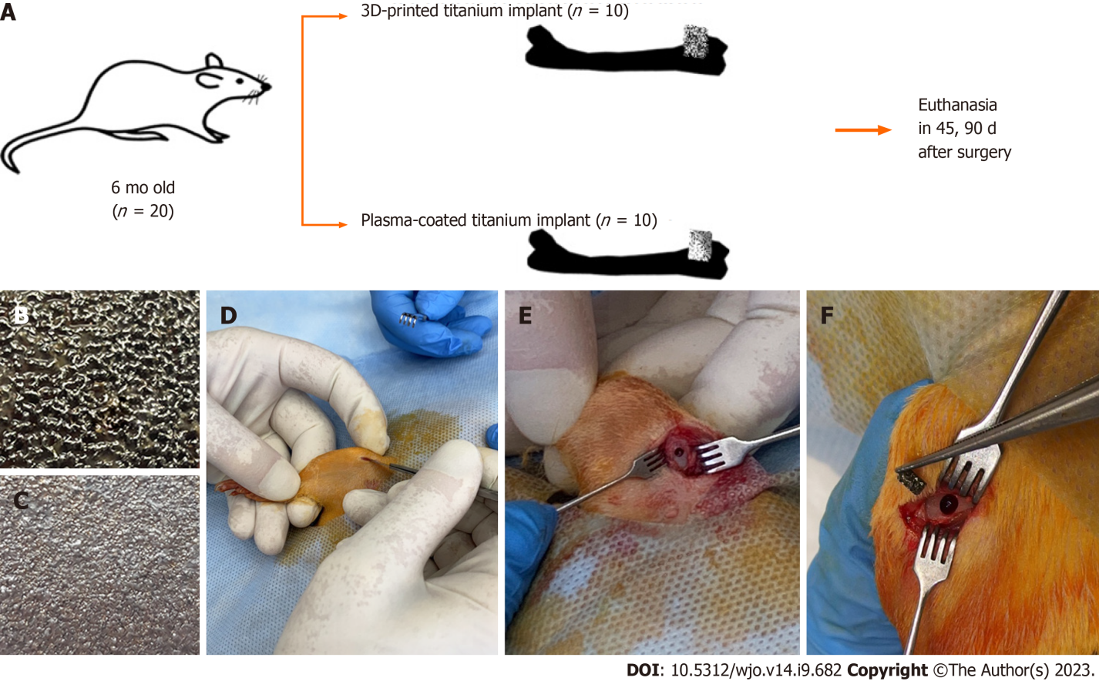
Figure 1 Design of study with characteristics of implanted material and stages of index surgery. A: Design of an experimental study on rats with a demonstration of the features of the implant materials used; B: 3D-printed titanium implant; C: Plasma-coated titanium implant; D-F: Stages of surgical intervention.

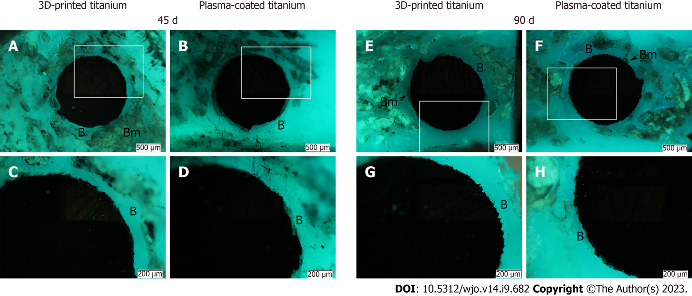Figure 2 Fluorescence microscopy of rat femoral sections after index surgery. Titanium implants (black color) with 3D-printed or plasma-coated titanium in the distal metaphysis of the rat femur. Bone trabeculae are formed along the perimeter of implants with areas of bone marrow. White rectangles show fragments of the corresponding photos taken at a higher magnification. Longitudinal sections. A-D: 45 d (n = 10) after implantation; E-H: 90 d (n = 10). B: Bone trabeculae; Bm: Bone marrow.

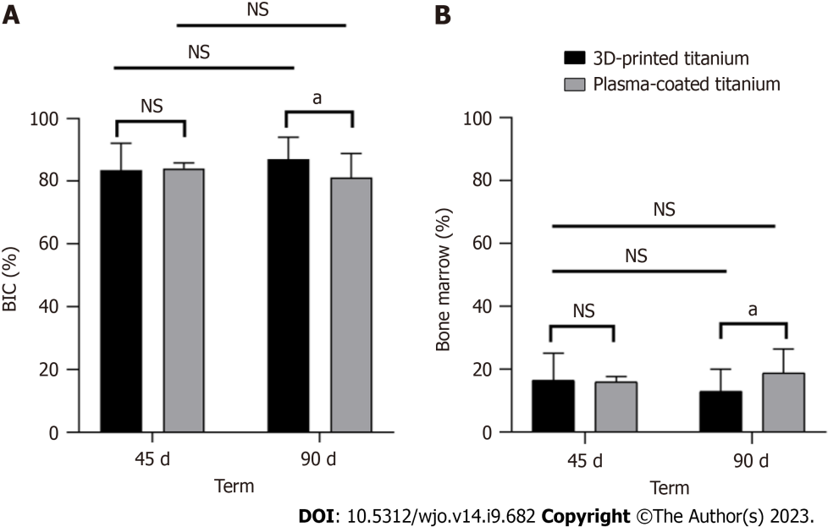
Figure 3 Bone tissue formation (Bone-implant-contact%; Bone marrow%) around two types of titanium implants. 3D-printed and plasma-coated titanium implants 45 d (n = 10) and 90 d (n = 10) after implantation in the distal metaphysis of the femur of rats. Data are presented as mean ± SD. A: Bone-implant contact (Bone-implant-contact%) is significantly higher at day 90 for the implant with 3D-printed titanium; B: Bone marrow% is significantly lower at day 90 for the implant with 3D-printed titanium. NS: Not significant; ªP < 0.05.

Published by Baishideng Publishing Group Inc
7041 Koll Center Parkway, Suite 160, Pleasanton, CA 94566, USA
Telephone: +1-925-3991568
E-mail: bpgoffice@wjgnet.com
Help Desk: https://www.f6publishing.com/helpdesk
https://www.wjgnet.com

© 2023 Baishideng Publishing Group Inc. All rights reserved.

