Name of Journal: World Journal of Hepatology
ESPS Manuscript NO: 18477
Manuscript Type: MINIREVIEWS

Neurosurgical procedures in patients with liver cirrhosis: A review

Chen CC et al. Liver cirrhosis in neurosurgery

Ching-Chang Chen, Yin-Cheng Huang, Chun-Nan Yeh

Ching-Chang Chen, Yin-Cheng Huang, Department of Neurosurgery, Chang Gung Memorial Hospital, Taoyuan City 333, Taiwan

Ching-Chang Chen, Yin-Cheng Huang, Chun-Nan Yeh, Department of Medicine, Chang Gung University, Taoyuan City 333, Taiwan

Chun-Nan Yeh, Department of General Surgery, Chang Gung Memorial Hospital, Linkouand, Taoyuan 333, Taiwan

Author contributions: Chen CC and Huang YC contributed equally as 1st authors; Huang YC and Yeh CN contributed equally for corresponding authorship; Chen CC and Huang YC contributed to the drafting of this manuscript; Huang YC and Yeh CN revised the manuscript and co-correspond to this review article.

Conflict-of-interest statement: All the authors declare no conflicts of interests.

Open-Access: This article is an open-access article which was selected by an in-house editor and fully peer-reviewed by external reviewers. It is distributed in accordance with the Creative Commons Attribution Non Commercial (CC BY-NC 4.0) license, which permits others to distribute, remix, adapt, build upon this work non-commercially, and license their derivative works on different terms, provided the original work is properly cited and the use is non-commercial. See: http://creativecommons.org/licenses/by-nc/4.0/

Correspondence to: Yin-Cheng Huang, MD, Department of Neurosurgery, Chang Gung Memorial Hospital, Chaiyi, No6, West Sec. Chiapu Rd, Putzu city, Chiayi county, Taoyuan City 333, Taiwan. ns3068@gmail.com
Telephone: +886-5-3621000-2854
Fax: +886-5-3623002

Received: April 21, 2015
Peer-review started: April 22, 2015
First decision: June 2, 2015
Revised: June 22, 2015
Accepted: August 30, 2015
Article in press:
Published online:

Abstract
Liver cirrhosis, a devastating liver fibrosis caused by hepatitis/inflammation or tumors, is a major comorbid factor in known surgery fields, such as cardiovascular and abdominal surgeries. It is important to review possible comorbid results in neurosurgical procedures in cirrhotic patients. In the reviewed literature, Child-Pugh and model for end-stage liver disease scores are commonly used in the assessment of surgical risks for cirrhotic patients undergoing abdominal, cardiovascular or neurosurgical procedures. The major categories of neurosurgery are traumatic brain injury (TBI), spontaneous intracranial hemorrhage (SICH), brain tumors, and spinal instrumentation procedures. TBI was reported with surgical mortality as high as 34.5% and a complication rate of 87.2%. For SICH, mortality ranged from 22.7% to 47.0%, while complications were reported to be 43.2%. Less is discussed in brain tumor patients; still the postoperative hemorrhage rate approached 26.7%. In spinal fusion instrumentation procedures, the complication rate was as high as 41.0%. Preoperative assessment and correction could possibly decrease complications such as hemorrhage, wound infection and other cirrhosis-related complications (renal, pulmonary, ascites and encephalopathy). In this study, we reviewed the neurosurgical-related literature with regard to liver cirrhosis as a prognostic factor influencing neurosurgical outcomes.

Key words: Neurosurgery; Liver cirrhosis; Traumatic brain injury; Spontaneous intracranial hemorrhage; Brain tumor; Spine surgery; Complications; Surgical risks

© The Author(s) 2015. Published by Baishideng Publishing Group Inc. All rights reserved.

Core tip: Liver cirrhosis is a major comorbid factor for surgical patients, including neurosurgery. We reviewed published articles in the field of neurosurgical procedures. For the high incidence of morbidity/mortality rate, in cirrhotic patients, procedures should be carefully assessed and managed aggressively toward the coagulopathy and nutritional status.

Chen CC, Huang YC, Yeh CN. Neurosurgical procedures in patients with liver cirrhosis: A review. World J Hepatol 2015; In press

Introduction
Liver cirrhosis has been identified as a risk factor for increased morbidity and mortality in surgical patients^{[1-9]}, trauma patients^{[3-5,9]}, and patients undergoing emergent major surgery such as laparotomy, cardiac, and thoracic surgery^{[1,5,9-12]}. A search of the literature found overall mortality rates as high as 45%-50% for patients with liver cirrhosis undergoing emergent nonhepatic surgery^{[8,13-17]} and 40% for trauma surgery^{[3-5]}. Furthermore, liver cirrhosis was also associated with increased postoperative morbidity and longer hospitalization in patients undergoing elective nonhepatic surgery^{[13-15,18]}. Liver cirrhosis, and its associated bleeding tendency, is also a challenge for neurosurgeons in brain and spine surgery. For example, spontaneous intracranial hemorrhage (SICH)^{[19,20]} and traumatic head injury^{[21, 22]} in cirrhotic patients have been reported in the literature; however, such reports have been sporadic, and relatively little has been published regarding cirrhotic patients who undergo neurosurgical procedures.
In our previous study^{[21]}, we found the overall complication rate for brain surgery with liver cirrhosis was 52.1% and the mortality rate was 24.3%. These high rates emphasize the importance of reviewing the recommendations for patients harboring this devastating systemic disease, including for patients needing neurosurgical procedures. The following study reviewed the risks and outcomes accompanying neurosurgical procedures in patients with liver cirrhosis.

Traumatic brain injury in patients with liver cirrhosis
For patients with traumatic brain injury (TBI), liver cirrhosis is a significant risk factor for postoperative complications. Over a 5-year-period, according to the National Trauma Databank in America^{[22]}, cirrhotic patients with TBI significantly experienced more ventilator days compared with noncirrhotic patients (2.9 ± 6.4 d vs 2.0 ± 6.4 d, p < 0.001). In addition, overall mortality was almost two-fold higher for cirrhotic compared with noncirrhotic TBI patients (34.0 % vs 18.1%, OR = 2.34, 95%CI: 1.05-5.20, p = 0.035).
In our previous study^{[21]} , we found the complication, rebleeding and mortality rates reached 84.4%, 68.8%, and 37.5%, respectively, in acute TBI patients. According to the Child-Pugh score system (Child), the complication rate increased in a step-wise fashion from 38.7% to 60.0% and then 84.2%, the rebleeding rate from 29.3% to 48.0% and then 63.2%, and the mortality rate from 5.3% to 38.0% and then 63.2% for Child A, B and C patients, respectively. Child classification was significantly associated with higher risk of complication [Child B vs A with odds ratio: 2.84 (95%CI: 1.28-6.29), and Child C vs A: 5.39 (95%CI: 1.32-22.02)] and risk of mortality [Child C vs A: 30.43 (95%CI: 7.71-120.02), and Child B vs A: 10.88 (95%CI: 3.42-34.63)].
Notably, in patients undergoing minimally invasive burr holes for chronic subdural hemorrhage, the rebleeding/recurrent rate was 66.7% (10/15 patients) and mortality rate was 33.3% (5/15 patients). Uncontrolled encephalopathy, varices bleeding or associated pneumonia, sepsis and multiple organ failure were hypothesized to be causes of mortality.

Spontaneous intracranial hemorrhage/hemorrhagic stroke in patients with liver cirrhosis
Liver cirrhosis is a well-known risk factor for SICH^{[19,20,23]}, despite the relatively rare occurrence of SICH in cirrhotic patients (incidence ranged from 0.7% to 0.8%)^{[19,20]}. However, SICH is life-threatening and is sometimes overlooked due to the similarities of neurologic deficits caused by hepatic encephalopathy; most of the cirrhotic patients who developed SICH were sent to the emergency room for resuscitation and then admitted to the neurosurgery wards for surgical intervention or to the neurology wards for medical treatment if no surgical indication.
Surgical procedures to decrease intracranial pressure in SICH cases, such as craniotomy (hematoma removal) or ventricular drainage (cerebrospinal fluid diversion), were performed only in life-threatening instances. As shown in our previous study, the surgical complication rate was 43.2%, the rebleeding rate was 36.4%, and the mortality rate was 22.7%^{[21]}.
Thus, some cirrhotic patients with SICH who underwent medical treatment experienced poor neurologic outcomes even after surgery, including brainstem failure due to delayed medical intervention or severe coagulopathy. The overall mortality rate of cirrhotic patients with SICH, with or without surgery, has been reported as high as 47.0%^{[20]}. Outcomes were associated with the size of the hematoma (P < 0.005) and with the initial Glasgow Coma Scale score (P < 0.05) and the Child–Pugh classification (P = 0.05)^{[20]}.

Brain tumor surgery in patients with liver cirrhosis
There is little literature discussing the outcome for cirrhotic patients with brain tumors who underwent craniotomy. Jiang et al^{[24]} reported a median survival of 3 (range 2.2-3.8) months for 41 cases even with successful intracranial excision of brain metastasis from hepatocellular carcinoma (HCC). We reported 15 cases of brain tumor (meningioma, glioma, pituitary adenoma, lymphoma, and metastasis from breast cancer and HCC) patients who received neurosurgical procedures (craniotomy/biopsy)^{[21]}. Four of these patients (26.7%) had immediate postoperative intracranial hemorrhage.
Despite the lack of clear evidence-based indications nor contraindications for cirrhotic patients with brain tumors, we presumed that the preoperative assessment of neurological deficits, Karnofsky performance scale, and corrections of pre-existing coagulopathy may be crucial for the patients’ outcome.

Spine surgery in patients with liver cirrhosis
Spine surgery is a common procedure in some neurosurgery centers (up to 70% of daily practice). Most spine surgeries are elective and less invasive, involving a small amount of intraoperative blood loss. Instrumentations for spinal stability have been widely used in patients with degenerative lumbar and cervical spine diseases to enhance stability and improve clinical results. However, instrumentation inevitably encounters more extensive wound exposure, bony destruction, and intraoperative blood loss. Published literature has shown that the complication rate of lumbar fusion instrumentation ranged from 3% to 15%^{[25,26]}. In a retrospective study of lumbar instrumentation by Liao et al^{[27]}, patients in the cirrhotic group had significantly more blood loss (p = 0.049) and significantly longer hospitalization (p = 0.023). Complication rate was also significantly higher in the cirrhotic patient group than in the control group (41% vs 10%, p = 0.007). Patients with Child Class B score had a significantly higher incidence of complications than those with Child Class A (86% vs 27%, p = 0.006). Subanalysis in patients with Child Class A showed that those with a Child score of 6 also had higher complication rates than those with a score of 5 (p = 0.001).
Child score, hypoalbuminemia, ascites, and increased blood loss were identified risk factors for complications, and deteriorated hepatic encephalopathy would contribute to unsatisfactory outcomes. Whenever elective instrumented lumbar surgeries are being considered for cirrhotic patients, preoperative correction could reduce or avoid these postoperative complications.

Preoperative evaluation and correction of coagulopathy
For patients with cirrhotic liver, Child-Pugh^{[28]} and model for end-stage liver disease (MELD)^{[29]} scores are both relied on for the prognosis prediction. The Child system contains serum bilirubin/albumin level, prothrombin time, ascites, and hepatic encephalopathy, while MELD includes serum bilirubin, creatinine, and etiology. Concerns for surgical procedures in cirrhotic patients mostly focused on the impact on coagulopathy, including clotting and the fibrinolytic system. We proposed an algorithm to assess the risk for complications and management of cirrhotic patients receiving regular neurosurgical procedures (Figure 1).
Vitamin K is essential for factor II, VII, IX and X and protein C, S and Z^{[30]}. Liver cirrhosis is a common etiology for vitamin K deficiency due to poor nutrition or cholestasis. In a meta-analysis, intravenous vitamin K supplement from 1 to 5 mg may reverse the excess anticoagulants^{[31]}. Thus, in spontaneous intracranial hemorrhage patients with anticoagulation medications, Degos et al^{[32]} suggested 5-10 mg of vitamin K if INR > 1.5 preoperatively.
Fresh frozen plasma transfusion could correct almost all coagulation factors. Youssef et al^{[33]} suggested higher units (> 6 units) of flash frozen plasma is considered to reverse the prolonged prothrombin time. A concentrated blood product, prothrombin complex concentrate^{[34]}, is shown in a clinical trial (phase IIIb study) for its superiority and safety in patients with coagulopathy^{[34,35]}.
For thrombocytopenia, evidence has shown that platelet counts should be > 50000/μl before implementation of an invasive procedure^{[36]}. However, for patients taking antiplatelet medication who have normal platelet counts, the evidence for platelet transfusion is not as clear. Evidence from a Stage IIb indicates that transfusion with concentrated platelets would be beneficial for patients taking antiplatelet medication^{[32]}.
In addition, serum albumin level is possibly related to surgical outcome in patients with liver cirrhosis. In a retrospective study, corrections of pre- and postoperative serum albumin levels in cirrhotic patients who underwent microsurgery for free-flap reconstruction were shown to decrease the intensive care unit stay and complications^{[37]}.
Because there was no consensus regarding a standard procedure for emergent neurosurgical interventions, we proposed an algorithm (Figure 2). Emergent, mostly life-threatening, procedures mandate that surgeons make fast and effective decisions. Prospective studies are urgently needed to demonstrate the most essential components to prevent intraoperative bleeding, wound infection, and other associated complications, such as pneumonia, consciousness disturbance, or hepatorenal syndrome.

Conclusion
Liver cirrhosis is a diffuse process characterized by fibrosis and conversion of normal liver architecture into structurally abnormal nodules^{[38]}. It was a major chronic devastating disease with high mortality rate (up to 72.7 deaths/10000 population) distributed most frequently in central Asia and the sub-Saharan region^{[39]}. Studies have shown significantly high morbidity/mortality rates in cirrhotic patients undergoing major surgery. Neurosurgical procedures, which have not been researched extensively, have been performed conservatively on cirrhotic patients. However, the need for neurosurgery often precludes the potential cirrhotic complications.
In this review, we discussed the outcome from different etiologies, including TBI, SICH, brain tumor, and spine procedures (Table 1). Preoperative assessment and correction of coagulopathy and nutritional status may be important, despite lack of evidence. Still, the high morbidity/mortality rate in this devastating underlying disease may demand the need to develop evidence-based studies to elucidate the timing and parameters for appropriate correction leading to better surgical outcome in neurosurgical procedures.

Acknowledgements
We acknowledge Department of Neurosurgery and General Surgery, Chang Gung Memorial Hospital, Linkou, Taiwan.

References
1 An Y, Xiao YB, Zhong QJ. Open-heart surgery in patients with liver cirrhosis: indications, risk factors, and clinical outcomes. Eur Surg Res 2007; 39: 67-74 [PMID: 17283429 DOI: 10.1159/000099145]
2 Chen CC, Hsu PW, Erich Wu TW, Lee ST, Chang CN, Wei KC, Chuang CC, Wu CT, Lui TN, Hsu YH, Lin TK, Lee SC, Huang YC. Stereotactic brain biopsy: Single center retrospective analysis of complications. Clin Neurol Neurosurg 2009; 111: 835-839 [PMID: 19765887 DOI: 10.1016/j.clineuro.2009.08.013]
3 Christmas AB, Wilson AK, Franklin GA, Miller FB, Richardson JD, Rodriguez JL. Cirrhosis and trauma: a deadly duo. Am Surg 2005; 71: 996-1000 [PMID: 16447467]
4 Dangleben DA, Jazaeri O, Wasser T, Cipolle M, Pasquale M. Impact of cirrhosis on outcomes in trauma. J Am Coll Surg 2006; 203: 908-913 [PMID: 17116560 DOI: 10.1016/j.jamcollsurg.2006.08.001]
5 Demetriades D, Constantinou C, Salim A, Velmahos G, Rhee P, Chan L. Liver cirrhosis in patients undergoing laparotomy for trauma: effect on outcomes. J Am Coll Surg 2004; 199: 538-542 [PMID: 15454135 DOI: 10.1016/j.jamcollsurg.2004.06.017]
6 Doberneck RC, Sterling WA, Allison DC. Morbidity and mortality after operation in nonbleeding cirrhotic patients. Am J Surg 1983; 146: 306-309 [PMID: 6604465]
7 Fang JF, Chen RJ, Lin BC, Hsu YB, Kao JL, Chen MF. Liver cirrhosis: an unfavorable factor for nonoperative management of blunt splenic injury. J Trauma 2003; 54: 1131-116; discussion 1136 [PMID: 12813334 DOI: 10.1097/01.TA.0000066123.32997.BB]
8 Garrison RN, Cryer HM, Howard DA, Polk HC. Clarification of risk factors for abdominal operations in patients with hepatic cirrhosis. Ann Surg 1984; 199: 648-655 [PMID: 6732310]
9 Georgiou C, Inaba K, Teixeira PG, Hadjizacharia P, Chan LS, Brown C, Salim A, Rhee P, Demetriades D. Cirrhosis and trauma are a lethal combination. World J Surg 2009; 33: 1087-1092 [PMID: 19184637 DOI: 10.1007/s00268-009-9923-7]
10 Talving P, Lustenberger T, Okoye OT, Lam L, Smith JA, Inaba K, Mohseni S, Chan L, Demetriades D. The impact of liver cirrhosis on outcomes in trauma patients: a prospective study. J Trauma Acute Care Surg 2013; 75: 699-703 [PMID: 24064886 DOI: 10.1097/TA.0b013e31829a2c19]
11 Thielmann M, Mechmet A, Neuhäuser M, Wendt D, Tossios P, Canbay A, Massoudy P, Jakob H. Risk prediction and outcomes in patients with liver cirrhosis undergoing open-heart surgery. Eur J Cardiothorac Surg 2010; 38: 592-599 [PMID: 20413316 DOI: 10.1016/j.ejcts.2010.02.042]
12 Tinkoff G, Rhodes M, Diamond D, Lucke J. Cirrhosis in the trauma victim. Effect on mortality rates. Ann Surg 1990; 211: 172-177 [PMID: 2301996]
13 Csikesz NG, Nguyen LN, Tseng JF, Shah SA. Nationwide volume and mortality after elective surgery in cirrhotic patients. J Am Coll Surg 2009; 208: 96-103 [PMID: 19228510 DOI: 10.1016/j.jamcollsurg.2008.09.006]
14 Eker HH, van Ramshorst GH, de Goede B, Tilanus HW, Metselaar HJ, de Man RA, Lange JF, Kazemier G. A prospective study on elective umbilical hernia repair in patients with liver cirrhosis and ascites. Surgery 2011; 150: 542-546 [PMID: 21621237 DOI: 10.1016/j.surg.2011.02.026]
15 Gray SH, Vick CC, Graham LA, Finan KR, Neumayer LA, Hawn MT. Umbilical herniorrhapy in cirrhosis: improved outcomes with elective repair. J Gastrointest Surg 2008; 12: 675-681 [PMID: 18270782 DOI: 10.1007/s11605-008-0496-9]
16 Mansour A, Watson W, Shayani V, Pickleman J. Abdominal operations in patients with cirrhosis: still a major surgical challenge. Surgery 1997; 122: 730-75; discussion 730-75; [PMID: 9347849]
17 Sirinek KR, Burk RR, Brown M, Levine BA. Improving survival in patients with cirrhosis undergoing major abdominal operations. Arch Surg 1987; 122: 271-273 [PMID: 3827564]
18 Marrocco-Trischitta MM, Kahlberg A, Astore D, Tshiombo G, Mascia D, Chiesa R. Outcome in cirrhotic patients after elective surgical repair of infrarenal aortic aneurysm. J Vasc Surg 2011; 53: 906-911 [PMID: 21215574 DOI: 10.1016/j.jvs.2010.10.095]
19 Grønbaek H, Johnsen SP, Jepsen P, Gislum M, Vilstrup H, Tage-Jensen U, Sørensen HT. Liver cirrhosis, other liver diseases, and risk of hospitalisation for intracerebral haemorrhage: a Danish population-based case-control study. BMC Gastroenterol 2008; 8: 16 [PMID: 18501016 DOI: 10.1186/1471-230X-8-16]
20 Huang HH, Lin HH, Shih YL, Chen PJ, Chang WK, Chu HC, Chao YC, Hsieh TY. Spontaneous intracranial hemorrhage in cirrhotic patients. Clin Neurol Neurosurg 2008; 110: 253-258 [PMID: 18194837 DOI: 10.1016/j.clineuro.2007.11.010]
21 Chen CC, Hsu PW, Lee ST, Chang CN, Wei KC, Wu CT, Hsu YH, Lin TK, Lee SC, Huang YC. Brain surgery in patients with liver cirrhosis. J Neurosurg 2012; 117: 348-353 [PMID: 22631693 DOI: 10.3171/2012.4.JNS111338]
22 Lustenberger T, Talving P, Lam L, Inaba K, Branco BC, Plurad D, Demetriades D. Liver cirrhosis and traumatic brain injury: a fatal combination based on National Trauma Databank analysis. Am Surg 2011; 77: 311-314 [PMID: 21375843]
23 Boudouresques G, Hauw JJ, Meininger V, Escourolle R, Pertuiset B, Buge A, Lhermitte F, Castaigne P. Hepatic cirrhosis and intracranial hemorrhage: significance of the association in 53 pathological cases. Ann Neurol 1980; 8: 204-205 [PMID: 7425582 DOI: 10.1002/ana.410080221]
24 Jiang XB, Ke C, Zhang GH, Zhang XH, Sai K, Chen ZP, Mou YG. Brain metastases from hepatocellular carcinoma: clinical features and prognostic factors. BMC Cancer 2012; 12: 49 [PMID: 22292912 DOI: 10.1186/1471-2407-12-49]
25 Bjarke Christensen F, Stender Hansen E, Laursen M, Thomsen K, Bünger CE. Long-term functional outcome of pedicle screw instrumentation as a support for posterolateral spinal fusion: randomized clinical study with a 5-year follow-up. Spine (Phila Pa 1976) 2002; 27: 1269-1277 [PMID: 12065973]
26 Kim KT, Lee SH, Lee YH, Bae SC, Suk KS. Clinical outcomes of 3 fusion methods through the posterior approach in the lumbar spine. Spine (Phila Pa 1976) 2006; 31: 1351-137; discussion 1358 [PMID: 16721298 DOI: 10.1097/01.brs.0000218635.14571.55]
27 Liao JC, Chen WJ, Chen LH, Niu CC, Fu TS, Lai PL, Tsai TT. Complications associated with instrumented lumbar surgery in patients with liver cirrhosis: a matched cohort analysis. Spine J 2013; 13: 908-913 [PMID: 23541455 DOI: 10.1016/j.spinee.2013.02.028]
28 Child CG. Surgery and portal hypertension. Philadlphia, 1964: 50-64
29 Malinchoc M, Kamath PS, Gordon FD, Peine CJ, Rank J, ter Borg PC. A model to predict poor survival in patients undergoing transjugular intrahepatic portosystemic shunts. Hepatology 2000; 31: 864-871 [PMID: 10733541 DOI: 10.1053/he.2000.5852]
30 Mann KG. Biochemistry and physiology of blood coagulation. Thromb Haemost 1999; 82: 165-174 [PMID: 10605701]
31 Dezee KJ, Shimeall WT, Douglas KM, Shumway NM, O'malley PG. Treatment of excessive anticoagulation with phytonadione (vitamin K): a meta-analysis. Arch Intern Med 2006; 166: 391-397 [PMID: 16505257 DOI: 10.1001/.391]
32 Degos V, Westbroek EM, Lawton MT, Hemphill JC, del Zoppo GJ, Young WL. Perioperative management of coagulation in nontraumatic intracerebral hemorrhage. Anesthesiology 2013; 119: 218-227 [PMID: 23695175 DOI: 10.1097/ALN.0b013e318297c18a]
33 Youssef WI, Salazar F, Dasarathy S, Beddow T, Mullen KD. Role of fresh frozen plasma infusion in correction of coagulopathy of chronic liver disease: a dual phase study. Am J Gastroenterol 2003; 98: 1391-1394 [PMID: 12818286 DOI: 10.1111/j.1572-0241.2003.07467.x]
34 Sarode R, Milling TJ, Refaai MA, Mangione A, Schneider A, Durn BL, Goldstein JN. Efficacy and safety of a 4-factor prothrombin complex concentrate in patients on vitamin K antagonists presenting with major bleeding: a randomized, plasma-controlled, phase IIIb study. Circulation 2013; 128: 1234-1243 [PMID: 23935011 DOI: 10.1161/CIRCULATIONAHA.113.002283]
35 Dickneite G, Pragst I. Prothrombin complex concentrate vs fresh frozen plasma for reversal of dilutional coagulopathy in a porcine trauma model. Br J Anaesth 2009; 102: 345-354 [PMID: 19168856 DOI: 10.1093/bja/aen391]
36 Tosetto A, Balduini CL, Cattaneo M, De Candia E, Mariani G, Molinari AC, Rossi E, Siragusa S; Italian Society for Haemostasis and Thrombosis. Management of bleeding and of invasive procedures in patients with platelet disorders and/or thrombocytopenia: Guidelines of the Italian Society for Haemostasis and Thrombosis (SISET). Thromb Res 2009; 124: e13-e18 [PMID: 19631969 DOI: 10.1016/j.thromres.2009.06.009]
37 Kao HK, Chen WF, Chen CH, Shyu VB, Cheng MH, Chang KP. The roles of albumin levels in head and neck cancer patients with liver cirrhosis undergoing tumor ablation and microsurgical free tissue transfer. PLoS One 2012; 7: e52678 [PMID: 23285146 DOI: 10.1371/journal.pone.0052678]
38 Anthony PP, Ishak KG, Nayak NC, Poulsen HE, Scheuer PJ, Sobin LH. The morphology of cirrhosis: definition, nomenclature, and classification. Bull World Health Organ 1977; 55: 521-540 [PMID: 304393]
39 Mokdad AA, Lopez AD, Shahraz S, Lozano R, Mokdad AH, Stanaway J, Murray CJ, Naghavi M. Liver cirrhosis mortality in 187 countries between 1980 and 2010: a systematic analysis. BMC Med 2014; 12: 145 [PMID: 25242656 DOI: 10.1186/s12916-014-0145-y]

P-Reviewer: Barone DG, Tai DI S-Editor: Ma YJ L-Editor: E-Editor:

Table 1 Studies of neurosurgical procedures for cirrhotic patients
Neurosurgical type/Author | Patient no. | Overall morbidity | Child A | Child B | Child C | Overall mortality | Child A | Child B | Child C
TBI  Lustenberger et al^{[22]}  Chen et al^{[21]} | 47  32 | NA  84.4% | NA  38.7% | NA  60.0% | NA  84.2% | 34%  37.5% | NA  5.3% | NA  38.0% | NA  63.2%
SICH  Chen et al^{[21]}  Huang et al^{[20]} | 44  36 | 43.2%  NA | NA  NA | NA  NA | NA  NA | 22.7%  47% | NA  11.1% | NA  27.7% | NA  8.3%
Brain tumor  Chen et al^{[21]} | 15 | 26.7% | NA | NA | NA | NA | NA | NA | NA
Spine surgery  Liao et al^{[27]} | 29 | 41.0% | 27.0% | 86.0% | NA | NA | NA | NA | NA
The Child-Pugh score is a classification system used in the prognosis of cirrhosis. NA: Not available; no.: Number; SICH: Spontaneous intracranial hemorrhage; TBI: Traumatic brain injury.

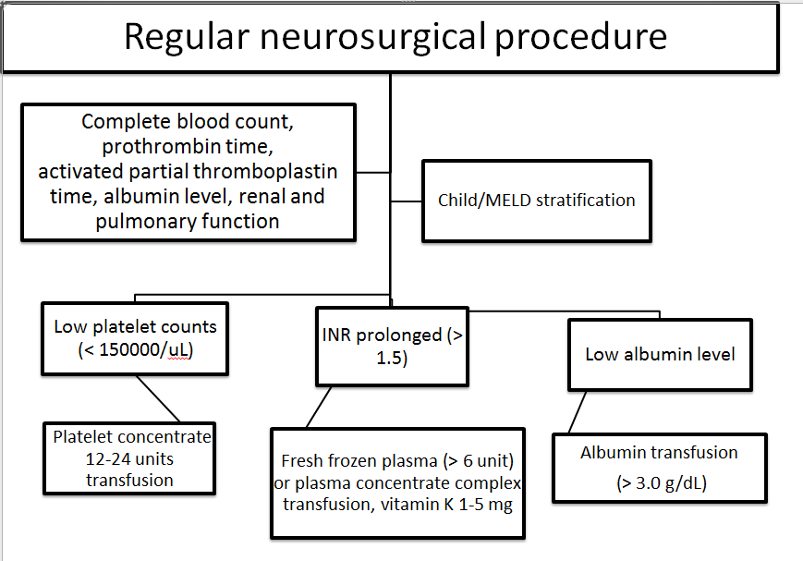
Figure 1 Preoperative assessment and management for patients planned receiving regular neurosurgical procedures.

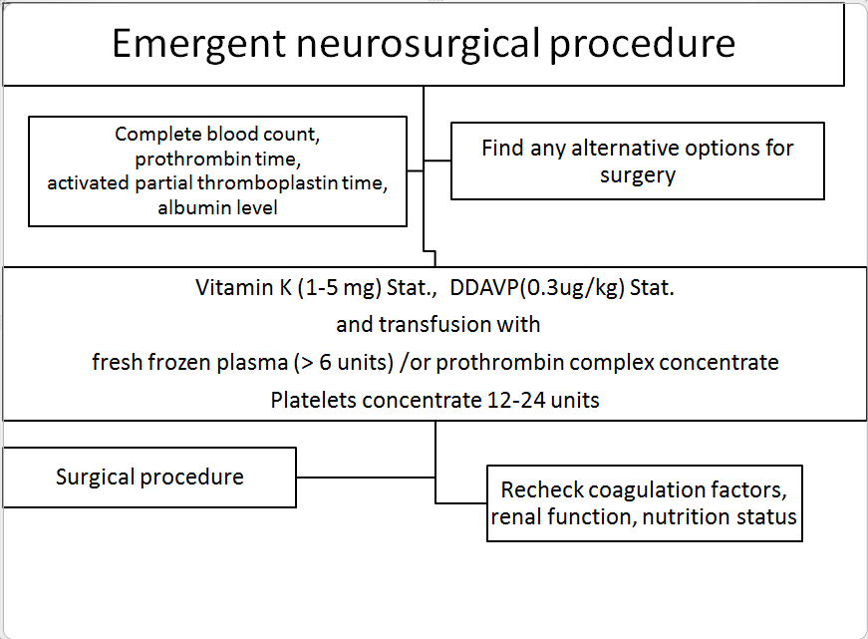
Figure 2 Management for patients receiving emergent neurosurgical procedures.

