Name of Journal: World Journal of Clinical Cases
Manuscript NO: 73227
Manuscript Type: ORIGINAL ARTICLE

Retrospective Study
Oral and maxillofacial pain as the first sign of metastasis of an occult primary tumour: A fifteen-year retrospective study

Shan S et al. A fifteen-year retrospective research of MAJ

Shan Shan, Shu Liu, Zhen-Yu Yang, Tie-Mei Wang, Zi-Tong Lin, Ying-Lian Feng, Seyiti Pakezhati, Xiao-Feng Huang, Lei Zhang, Guo-Wen Sun

Shan Shan, Shu Liu, Zhen-Yu Yang, Tie-Mei Wang, Zi-Tong Lin, Ying-Lian Feng, Seyiti Pakezhati, Department of Dentomaxillofacial Radiology, The Affiliated Stomatology Hospital of Medical School, Nanjing University, Nanjing 210008, Jiangsu Province, China

Xiao-Feng Huang, Lei Zhang, Department of Oral Pathology, The Affiliated Stomatology Hospital of Medical School, Nanjing University, Nanjing 210008, Jiangsu Province, China

Guo-Wen Sun, Department of Oral and Maxillofacial Surgery, The Affiliated Stomatology Hospital of Medical School, Nanjing University, Nanjing 210008, Jiangsu Province, China

Author contributions: Wang TM contributed to the conception of the work, manuscript editing and integrity of any part of the work; Shan S designed the research study and wrote the manuscript; Liu S, Yang ZY, Lin ZT and Feng YL performed the research; Pakezhati S, Huang XF, Zhang L and Sun GW analyzed the data; all authors have read and approve the final manuscript.

Supported by the Jiangsu Province Natural Science Foundation of China, No. BK20150089; and the Nanjing Science and Technology Development Fund, No. 201503038.

Corresponding author: Tie-Mei Wang, PhD, Chief Physician, Department of Dentomaxillofacial Radiology, The Affiliated Stomatology Hospital of Medical School, Nanjing University, No. 30 Zhongyang Road, Nanjing 210008, Jiangsu Province, China. tiemei106@126.com

Received: November 16, 2021
Revised: January 5, 2022
Accepted: March 16, 2022
Published online: May 16, 2022

Abstract
BACKGROUND
Metastatic adenocarcinoma of the jaw (MAJ) is a rare disease that accounts for 1%-3% of all oral and maxillofacial malignant tumours. Oral and maxillofacial pain may be the first symptom of metastatic spread of an occult primary tumour. Therefore, early identification of oral and maxillofacial pain by dental professionals is critical.

AIM
To explore the clinical and computerized tomography (CT) features of MAJ with oral and maxillofacial pain as the first symptom.

METHODS
The medical records of all patients who were treated in our hospital between January 2006 and February 2020, and diagnosed with MAJ with oral and maxillofacial pain as the first symptom, were reviewed retrospectively. Clinical data were collected on age, sex, medical history, clinical manifestations, site of metastasis, and site of the primary lesion. CT features were analysed in detail, and a radiological classification scheme comprising five types: Osteolytic, osteoblastic, mixed, cystic, and alveolar bone resorption was proposed.

RESULTS
The primary sites of MAJ were the lungs (n = 6), liver (n = 4), kidneys (n = 2), prostate (n = 1), and gastric cardia (n = 1). Five tumours were classified as the osteolytic type, all with a permeative margin (100%, P < 0.05), and three were classified as the mixed type, mostly with a moth-eaten margin (80%, P < 0.05). The cystic (n = 3) and alveolar bone resorption (n = 1) types had geographic margins, and the osteoblastic type (n = 1) had sclerotic margins. Moreover, nine tumours showed periosteal reaction and five showed a localised soft tissue mass, while the occurrence of jaw expansion was relatively rare.

CONCLUSION
MAJ has complex clinical and CT features. Oral and maxillofacial pain may be the first sign of a primary tumour affecting other sites.

Key Words: Metastasis; Adenocarcinoma; Oral and maxillofacial; Clinical features; Computed tomography; Diagnosis

©The Author(s) 2022. Published by Baishideng Publishing Group Inc. All rights reserved.

Citation: Shan S, Liu S, Yang ZY, Wang TM, Lin ZT, Feng YL, Pakezhati S, Huang XF, Zhang L, Sun GW. Oral and maxillofacial pain as the first sign of metastasis of an occult primary tumour: A fifteen-year retrospective study. World J Clin Cases 2022; 10(14): 4436-4445
URL: https://www.wjgnet.com/2307-8960/full/v10/i14/4436.htm
DOI: https://dx.doi.org/10.12998/wjcc.v10.i14.4436

Core Tip: Metastatic adenocarcinoma of the jaw (MAJ) occurs predominantly in middle-aged and elderly men, most commonly in the posterior mandible. To our knowledge, this study is the first to propose cystic and alveolar bone resorption types based on the structure of the jawbone. MAJ is typified by numb chin syndrome, as well as rapidly progressive osteolytic bone destruction with periosteal reaction and a localised soft tissue mass, usually without jaw expansion on computerized tomography. These features may provide a basis for the clinical diagnosis of MAJ.

INTRODUCTION
Metastatic tumours of the oral and maxillofacial region are relatively rare, accounting for only 1%-3% of all oral and maxillofacial malignant tumours^{[1]}. Metastatic adenocarcinoma of the jaw (MAJ) is even less common. Oral and maxillofacial pain may be the first indication of an occult malignancy in 22%-33% of cases^{[2,3]}. Therefore, it is crucial to identify and diagnose jaw metastases early to improve survival. The diagnostic criteria for metastatic tumours^{[4]} are as follows: (1) Both the primary and metastatic lesions must be confirmed by histopathology and ancillary examination; (2) the pathological results of the primary and metastatic lesions must be consistent; (3) when the metastatic lesion is close to the primary lesion, the possibility of direct invasion should be ruled out, i.e., the lesions must be well defined and have tumour-free tissues between them; and (4) there must be no history of a primary tumour at the site of metastasis.
A previous study^{[5]} classified metastases in the extremities or trunk into three categories: Osteolytic, osteoblastic, and mixed. However, the classification of jaw metastases has only briefly been described in a limited number of case reports or series. The jawbone is an irregular bone with a complex anatomical structure. Odontogenic tumours, non-odontogenic tumours, and tumor-like lesions are not only related to the structure of the jawbone, but are also closely related to the teeth. Therefore, unlike metastases in the extremities or trunk, the imaging features of jaw metastases are more complicated. In this study, we retrospectively reviewed 14 cases of MAJ in which oral and maxillofacial pain was the first symptom. Computerized tomography (CT) features were analysed in detail, and a radiological classification scheme comprising five types was proposed: Osteolytic, osteoblastic, mixed, cystic, and alveolar bone resorption. We anticipate that this study will aid in the early identification of primary tumours in MAJ patients.

MATERIALS AND METHODS
The local institutional research ethics board has approved this study (Approval No: NJSH-IRB-V3.0).
The medical records of all patients treated at our hospital between January 2006 and February 2020 were reviewed. The inclusion criteria were a diagnosis of metastasis to the jawbones and a diagnosis of adenocarcinoma based on pathology. Patients who did not meet the inclusion criteria were excluded. Patients with incomplete clinical data and those with undetermined primary lesions were excluded. Finally, fourteen patients were included in this study.
The following clinical data were collected: Age, sex, lesion location, medical history, primary lesions, and clinical manifestations. The lesion location was classified as anterior or posterior according to the affected tooth. The region extending from the midline to the distal surface of the canine was defined as the anterior region, and the region extending from the mesial surface of the first premolar to the condyle (mandible) or tuberosity (maxilla) was defined as the posterior region^{[6]}.
The following radiological features were evaluated: Radiological classification, lesion margin, jaw expansion, periosteal reaction, soft tissue mass, and invasion of surrounding structures. Specifically, MAJ was classified into the following five types according to the morphology and sites of bone destruction: (1) Osteolytic type, where the radiodensity of the lesions mainly decreased; (2) osteoblastic type, in which the radiodensity of the lesions mainly increased; (3) mixed type, which had both osteolytic and osteoblastic lesions; (4) cystic type, similar to cysts with homogeneous density; and (5) alveolar bone resorption type, in which bone destruction was confined to the alveolar bone. The surrounding structures included the adjacent teeth, maxillary sinus, and inferior alveolar canal. The lesion margin was classified as having geographic-, sclerotic-, moth-eaten-, or permeative-like changes based on lodwick’s grading system^{[7,8]}. A geographic-like change corresponded to a well-defined focal lesion without a sclerotic rim, and a sclerotic-like change corresponded to obvious sclerosis around the bone destruction area with a relatively well-defined boundary. A moth-eaten-like change corresponded to patchy and speckled destruction with a substantially ill-defined boundary, and a permeative-like change corresponded to radiographically numerous lesions presenting a mutually integrated area of destruction without a clear boundary between the normal tissues. Two attending physicians, who were blinded to the details of the cases, reviewed all imaging data on the same liquid-crystal display monitor. In the event of disagreement, a consensus was reached through consultation with a third chief physician.
All statistical analyses were performed using IBM SPSS statistics software (version 26.0, IBM Corp, Armonk, NY, United States). Categorical variables are expressed as numbers and constitute ratios. Differences in lesion margins were analysed using the fisher’s exact test. The threshold for significance was set at P < 0.05.

RESULTS
The clinical data of the 14 patients are summarised in Table 1. Patient ages ranged from 41 to 79 years, with a median of 63 years. The male to female ratio was 2.5: 1. The main site of metastasis was the mandible in 12 cases (12/14) and the maxilla in one case (1/14). One case (1/14) involved both the mandible and the maxilla. One case (1/14) involved the anterior part, 12 cases (12/14) involved the posterior part, and one (1/14) involved the entire mandible. Of the 14 cases, three were on the right side and 11 were on the left side. The primary tumours were located in the lung (6/14), liver (4/14), kidney (2/14), gastric cardia (1/14), and prostate (1/14). Four patients (4/14) had a known tumour history, and the remaining ten (10/14) had jaw metastases as the first indication of an occult malignancy. The most common symptom was numbness of the lower lip, tongue, or chin, which was present in 11 patients (11/14). Seven patients (7/14) experienced maxillofacial pain.
The 14 patients with MAJ were grouped into five types according to the radiological classification scheme, and the typical images of each type are shown in Figures 1 and 2. The most common types were osteolytic (5/14) and mixed-type (4/14) lesions. The lesion margin in the osteolytic type had mostly permeative-like changes, which were significantly more numerous than in the other four radiological types (fisher’s exact test, P = 0.0005), showing extensive osteolytic cavities fused to each other without a clear boundary between normal tissues. The lesion margin in the mixed type had mostly moth-eaten-like changes (3/4), which were significantly more numerous than in the other four radiological types (fisher’s exact test, P = 0.011), showing generalised mixed density lesions with continuous or discontinuous cortical bone. The cystic, alveolar bone resorption, and osteoblastic types accounted for 3/14, 1/14, and 1/14 of the cases, respectively.
Figure 3 summarises the relationship between radiological type and lesion margin. Only three cases (3/14) exhibited jaw expansion, which is in agreement with a recent study indicating a low incidence of bone expansion^{[9]}. However, in contrast to previous studies^{[9-11]}, periosteal reaction was relatively more common, and was seen in 9 of 14 cases. Soft tissue masses were formed in five cases (5/14). All of the masses were localised and did not exceed 3.5 cm in diameter. Regarding invasion of the surrounding structures, root resorption occurred in five cases (5/14), and tooth displacement occurred in three cases (3/14). Ten patients (10/14) displayed resorption of the inferior alveolar canal wall, and one patient (1/14) with MAJ in the maxilla had unilateral maxillary sinusitis. Notably, one patient in this study experienced pain and numbness in the mandibular region four months after tooth extraction. Considerable osteolytic bone destruction was observed on cone beam CT (CBCT), and subsequently, primary liver cancer and systemic metastases were detected by positron emission tomography/CT (PET/CT) (Figure 4).

DISCUSSION
Clinical characteristics of MAJ
Most oral and maxillofacial metastatic tumours appear to be of epithelial origin. Histologically, adenocarcinoma shows the highest rate of metastasis; therefore, it was selected as the research object for the present study. In our study, MAJ mainly occurred in patients aged 52-70 years (median: 63 years), predominantly in the mandible. This is consistent with previous literature^{[1,12]} suggesting that the prevalence of MAJ is highest between the fifth and seventh decades of life. In addition, approximately 85% of the MAJ cases were detected in the posterior area of the mandible^{[2]}, as was observed in the current sample. However, the conclusions of published studies^{[4,13,14]} on sex differences are not consistent. Different sex ratios may be related to the region and race of the included patients.
It has been reported^{[3,15]} that in 30% of cases, jaw metastasis is the first indication of an occult malignancy, which usually manifests as pain, swelling, numbness of the lower lip, and unexplained toothache. The most common symptom in the present study was numbness of the lower lip, tongue, or chin, which was present in 11 patients (11/14). Numb chin syndrome (NCS) refers to unilateral hypoesthesia or paraesthesia in the region supplied by the mental nerve or its branches. Since the nerve contains only sensory fibres, no taste or movement disturbances would develop. In previous studies^{[14,16]}, NCS was reported in 90% of the patients with mandibular metastasis, which is consistent with our finding.
A 59-year-old woman presented with recurrent pain from a lower right wisdom tooth as the main complaint. She denied a history of any special disease, including infectious diseases, such as hepatitis. Physical examination revealed swelling of the gingiva surrounding the wisdom tooth with slight mobility, and panoramic radiography showed periodontal bone loss around the involved tooth. The initial diagnosis was periodontal-endodontic lesion. Therefore, a tooth extraction was performed. At the two-month follow-up visit, the extraction wound had not completely healed, and there was no pain relief. However, for her own reasons, the patient refused to return for examination, visited a local dental clinic, and asked for the removal of the right mandibular first molar. Four months later, she revisited our hospital, complaining of a non-healing extraction socket and progressive numbness of the chin. CBCT revealed an extensive lytic lesion with a permeative margin, which involved the inferior alveolar canal, resulting in resorption of the wall; therefore, a more aggressive process was suspected. Biopsy of the lesion was performed, and pathological examination revealed metastatic adenocarcinoma. PET/CT scans were then performed to screen the entire body for a primary lesion, which revealed an asymptomatic liver as the primary site with metastases to multiple bones, including the right mandible. A review of the literature^{[17]}revealed that in many painful cases, tooth extraction leads to the detection of jaw metastasis, and tender granulation tissue filling the extraction socket is the most common symptom. Therefore, care must be taken to avoid extraction of the involved teeth because accelerated production of inflammatory factors due to dental extraction can promote proliferation, invasion, and metastasis of tumour cells^{[3,18]}.
In our study, the primary lesions were mainly located in the lungs (5/14), liver (4/14), and kidneys (3/14). The proportion of primary lesions has varied in different studies. The most common primary tumours are in the breast, lung, kidney, and prostate in western countries^{[12,14]}, while thyroid, liver, and stomach tumours are more commonly encountered in China^{[19,20]}. This pattern may be determined in part by the prevalence of primary tumours, as the incidences of lung and liver cancer in China are higher than the world averages^{[21]}. However, some researchers believe that the frequency of MAJ is not always related to the incidences of primary tumours, but is instead associated with the biological behaviour and affinity of oral tissues for primary tumours, rather than with their incidences^{[1]}. For instance, the proportions of breast, prostate, pancreatic, and stomach cancers in patients with MAJ are lower than those of all malignancies, while the proportions of lung and liver cancers are significantly higher^{[18]}.

Imaging classification associated with bone invasion of MAJ
Previous studies^{[1,5,22]} have classified CT findings of metastases in the extremities or trunk into three categories: Osteolytic, osteoblastic, and mixed. However, we found that four cases in our series were not consistent with any of the above three types.
Three cases presented with homogeneous density and geographic margins, similar to those observed in cysts. Among them, in two cases, lesions in the mandibular molar area originated from the kidney (Figure 2B and C), and in one case, the lesion in the anterior maxillary area originated from the gastric cardia (Figures 1E and 2A). Some studies^{[23,24]} have reported that jaw metastases are the most frequently reported malignant lesions mimicking endodontic periapical pathologies. Therefore, this particular type, which was different from the osteolytic, osteoblastic, and mixed types, was placed into a separate category and named the “cystic” type. Additionally, the spiral-CT (SCT) bone window of another patient with lung cancer showed a saucer-like defect confined to the alveolar bone, and the margin of the lesion showed a geographic-like change, with a small soft tissue on the lingual side (Figure 1F). This form of destruction has never been reported before, so we have introduced a novel type and named it “alveolar bone resorption type” to generalise this rare presentation of MAJ. A cystic type and an alveolar bone resorption type have never been reported in metastases to the extremities and the trunk, therefore we question if there could be a relationship between these two types and the structure of the jawbone and teeth.
There was a correlation between radiological classification and primary lesions. In our study, there were five cases of the osteolytic type, including three cases of lung cancer and two cases of liver cancer. Moreover, the MAJ originating from prostate cancer presents as an osteoblastic type. These results are consistent with those of previous studies showing that osteolytic lesions are more common in lung and liver cancers, whereas osteoblastic lesions are more common in prostate cancer patients^{[1]}. This is because the primary lesions in the lung and liver indicate more active osteoclasts and degradation of the bone collagen matrix. However, the sites of metastasis of prostate lesions are rich in growth factors, showing greater osteoblastic activity, which is observed in 70.9% of cases^{[1,4,12]}. Previous studies^{[7,25]} have suggested that the growth rate of lesions can be predicted according to different forms of marginal changes: Moth-eaten- and permeative-like changes, accounting for 8/14 in our study, are usually potential markers of increased biological activity. This suggests that in most cases, MAJ lesions progressed rapidly.
Due to variable clinical and imaging features, MAJ should be distinguished from secondary lesions, predominantly oral cancers, and primary tumours such as osteosarcoma and primary intraosseous squamous cell carcinoma (PIOSCC). As the most common primary malignant bone tumour, a previous study^{[26]} showed that the mean mass size in osteosarcoma is approximately 5.6 ± 1.8 cm; this may be distinguished from a localized soft tissue mass in MAJ. In addition, it has been reported that matrix mineralization is observed in almost all patients with osteosarcoma, which is relatively rare in MAJ^{[26]}. PIOSCC generally occurs in men with a median age of 57 years and locates in the posterior area of the mandible^{[27]}. Its clinical symptoms-pain, swelling, and paraesthesia of the lower lip-are similar to those of MAJ, with the difference being that in PIOSCC, a mixed-density lesion and periosteal reaction tend to be minimal or absent, whereas a higher incidence of periosteal reaction in MAJ was shown in the current study^{[28]}. Moreover, MAJ needs to be differentiated from carcinomas originating in the oral cavity, especially the gingiva and floor of the mouth. CT features of the latter often include soft tissue and adjacent bone involvement. The alveolar bone resorption type in MAJ should be distinguished from gingival carcinoma, which often presents with cauliflower-like masses. Furthermore, when middle-aged and elderly patients complain of toothache, attention should be paid to distinguish MAJ from simple endodontic, periapical, or periodontal lesions. To date, few studies have focused on the diversity of imaging features, and no studies have classified the CT findings of MAJ.
In summary, as a rare clinical entity, MAJ has variable radiological presentations. Five types were proposed in this study: Osteolytic, osteoblastic, mixed, cystic, and alveolar bone resorption.

CONCLUSION
Oral and maxillofacial pain may be the first sign of metastatic spread of an occult primary tumour. This study suggests that when middle-aged and elderly patients present with NCS, and CT images reveal rapidly progressive osteolytic bone destruction with moth-eaten and permeative margins, clinicians should be aware of the possibility of MAJ and attempt to and identify the primary lesion early in order to improve survival.

ARTICLE HIGHLIGHTS
Research background
Metastatic adenocarcinoma of the jaw (MAJ) is a rare disease that accounts for 1%-3% of all oral and maxillofacial malignant tumours. To date, few studies have focused on the diversity of imaging features, and no study has classified the computed tomography (CT) findings of MAJ.

Research motivation
Oral and maxillofacial pain may be the first symptom of metastatic spread of an occult primary tumour. Therefore, early identification of oral and maxillofacial pain by dental professionals is important.

Research objectives
To explore the clinical and CT features of MAJ with oral and maxillofacial pain as the first symptom.

Research methods
Fourteen cases of MAJ from 2006 to 2020 in our hospital were collected, and clinical and the CT features were analysed retrospectively.

Research results
MAJ occurs predominantly in middle-aged and elderly men, with the most common site being the posterior mandible. MAJ is marked by numb chin syndrome (NCS), as well as rapidly progressive osteolytic bone destruction with periosteal reaction and a localised soft tissue mass, usually without jaw expansion on CT.

Research conclusions
MAJ has complex clinical and CT features. Oral and maxillofacial pain may be the first sign of a primary tumour affecting other sites. When middle-aged and elderly patients present with NCS, and CT images reveal rapidly progressive osteolytic bone destruction with moth-eaten and permeative margins, clinicians should be aware of the possibility of MAJ and attempt to identify the primary lesion early to improve survival.

Research perspectives
Further studies with larger sample sizes are required to confirm our results.

ACKNOWLEDGEMENTS
We thank all the patients involved in the study.

REFERENCES
1 Kirschnick LB, Schuch LF, Cademartori MG, Vasconcelos ACU. Metastasis to the oral and maxillofacial region: A systematic review. Oral Dis 2022; 28: 23-32 [PMID: 32790941 DOI: 10.1111/odi.13611]
2 Ayranci F, Omezli MM, Torul D, Ay M. Metastatic Prostate Adenocarcinoma of the Mandible Diagnosed With Oral Manifestations. J Craniofac Surg 2020; 31: e220-e222 [PMID: 31688259 DOI: 10.1097/SCS.0000000000006025]
3 Owosho AA, Xu B, Kadempour A, Yom SK, Randazzo J, Ghossein RA, Huryn JM, Estilo CL. Metastatic solid tumors to the jaw and oral soft tissue: A retrospective clinical analysis of 44 patients from a single institution. J Craniomaxillofac Surg 2016; 44: 1047-1053 [PMID: 27270028 DOI: 10.1016/j.jcms.2016.05.013]
4 Baum SH, Mohr C. Metastases from distant primary tumours on the head and neck: clinical manifestation and diagnostics of 91 cases. Oral Maxillofac Surg 2018; 22: 119-128 [PMID: 29344820 DOI: 10.1007/s10006-018-0677-y]
5 Macedo F, Ladeira K, Pinho F, Saraiva N, Bonito N, Pinto L, Goncalves F. Bone Metastases: An Overview. Oncol Rev 2017; 11: 321 [PMID: 28584570 DOI: 10.4081/oncol.2017.321]
6 Mao WY, Lei J, Lim LZ, Gao Y, Tyndall DA, Fu K. Comparison of radiographical characteristics and diagnostic accuracy of intraosseous jaw lesions on panoramic radiographs and CBCT. Dentomaxillofac Radiol 2021; 50: 20200165 [PMID: 32941743 DOI: 10.1259/dmfr.20200165]
7 Caracciolo JT, Temple HT, Letson GD, Kransdorf MJ. A Modified Lodwick-Madewell Grading System for the Evaluation of Lytic Bone Lesions. AJR Am J Roentgenol 2016; 207: 150-156 [PMID: 27070373 DOI: 10.2214/AJR.15.14368]
8 Amoretti N, Thariat J, Nouri Y, Foti P, Hericord O, Stolear S, Coco L, Hauger O, Huwart L, Boileau P. [Imaging of bone metastases]. Bull Cancer 2013; 100: 1109-1114 [PMID: 24184968 DOI: 10.1684/bdc.2013.1833]
9 Nel C, Uys A, Robinson L, Nortjé CJ. Radiological spectrum of metastasis to the oral and maxillofacial region. Oral Radiol 2022; 38: 37-48 [PMID: 33743130 DOI: 10.1007/s11282-021-00523-9]
10 Ida M, Tetsumura A, Kurabayashi T, Sasaki T. Periosteal new bone formation in the jaws. A computed tomographic study. Dentomaxillofac Radiol 1997; 26: 169-176 [PMID: 9442603 DOI: 10.1038/sj.dmfr.4600234]
11 Salvador JC, Rosa D, Rito M, Borges A. Atypical mandibular metastasis as the first presentation of a colorectal cancer. BMJ Case Rep 2018; 2018 [PMID: 29866691 DOI: 10.1136/bcr-2018-225094]
12 McClure SA, Movahed R, Salama A, Ord RA. Maxillofacial metastases: a retrospective review of one institution's 15-year experience. J Oral Maxillofac Surg 2013; 71: 178-188 [PMID: 22705221 DOI: 10.1016/j.joms.2012.04.009]
13 Hirshberg A, Shnaiderman-Shapiro A, Kaplan I, Berger R. Metastatic tumours to the oral cavity - pathogenesis and analysis of 673 cases. Oral Oncol 2008; 44: 743-752 [PMID: 18061527 DOI: 10.1016/j.oraloncology.2007.09.012]
14 Irani S. Metastasis to the Jawbones: A review of 453 cases. J Int Soc Prev Community Dent 2017; 7: 71-81 [PMID: 28462174 DOI: 10.4103/jispcd.JISPCD_512_16]
15 Savithri V, Suresh R, Janardhanan M, Aravind T. Metastatic adenocarcinoma of mandible: in search of the primary. BMJ Case Rep 2018; 11 [PMID: 30567274 DOI: 10.1136/bcr-2018-227862]
16 Fortunato L, Amato M, Simeone M, Bennardo F, Barone S, Giudice A. Numb chin syndrome: A reflection of malignancy or a harbinger of MRONJ? A multicenter experience. J Stomatol Oral Maxillofac Surg 2018; 119: 389-394 [PMID: 29680775 DOI: 10.1016/j.jormas.2018.04.006]
17 Gultekin SE, Senguven B, Isik Gonul I, Okur B, Buettner R. Unusual Presentation of an Adenocarcinoma of the Lung Metastasizing to the Mandible, Including Molecular Analysis and a Review of the Literature. J Oral Maxillofac Surg 2016; 74: 2007.e1-2007.e8 [PMID: 27376181 DOI: 10.1016/j.joms.2016.06.004]
18 Hirshberg A, Berger R, Allon I, Kaplan I. Metastatic tumors to the jaws and mouth. Head Neck Pathol 2014; 8: 463-474 [PMID: 25409855 DOI: 10.1007/s12105-014-0591-z]
19 Zhang FG, Hua CG, Shen ML, Tang XF. Primary tumor prevalence has an impact on the constituent ratio of metastases to the jaw but not on metastatic sites. Int J Oral Sci 2011; 3: 141-152 [PMID: 21789963 DOI: 10.4248/IJOS11052]
20 Shen ML, Kang J, Wen YL, Ying WM, Yi J, Hua CG, Tang XF, Wen YM. Metastatic tumors to the oral and maxillofacial region: a retrospective study of 19 cases in West China and review of the Chinese and English literature. J Oral Maxillofac Surg 2009; 67: 718-737 [PMID: 19304027 DOI: 10.1016/j.joms.2008.06.032]
21 Bray F, Ferlay J, Soerjomataram I, Siegel RL, Torre LA, Jemal A. Global cancer statistics 2018: GLOBOCAN estimates of incidence and mortality worldwide for 36 cancers in 185 countries. CA Cancer J Clin 2018; 68: 394-424 [PMID: 30207593 DOI: 10.3322/caac.21492]
22 Lee YH, Lee JI. Metastatic carcinoma of the oral region: An analysis of 21 cases. Med Oral Patol Oral Cir Bucal 2017; 22: e359-e365 [PMID: 28390123 DOI: 10.4317/medoral.21566]
23 Schuch LF, Vieira CC, Uchoa Vasconcelos AC. Malignant Lesions Mimicking Endodontic Pathoses Lesion: A Systematic Review. J Endod 2021; 47: 178-188 [PMID: 32918962 DOI: 10.1016/j.joen.2020.08.023]
24 Sirotheau Corrêa Pontes F, Paiva Fonseca F, Souza de Jesus A, Garcia Alves AC, Marques Araújo L, Silva do Nascimento L, Rebelo Pontes HA. Nonendodontic lesions misdiagnosed as apical periodontitis lesions: series of case reports and review of literature. J Endod 2014; 40: 16-27 [PMID: 24331985 DOI: 10.1016/j.joen.2013.08.021]
25 Benndorf M, Bamberg F, Jungmann PM. The Lodwick classification for grading growth rate of lytic bone tumors: a decision tree approach. Skeletal Radiol 2022; 51: 737-745 [PMID: 34302499 DOI: 10.1007/s00256-021-03868-8]
26 Luo Z, Chen W, Shen X, Qin G, Yuan J, Hu B, Lyu J, Wen C, Xu W. Head and neck osteosarcoma: CT and MR imaging features. Dentomaxillofac Radiol 2020; 49: 20190202 [PMID: 31642708 DOI: 10.1259/dmfr.20190202]
27 Geetha P, Avinash Tejasvi ML, Babu BB, Bhayya H, Pavani D. Primary intraosseous carcinoma of the mandible: A clinicoradiographic view. J Cancer Res Ther 2015; 11: 651 [PMID: 26458629 DOI: 10.4103/0973-1482.140814]
28 Lopes Dias J, Borges A, Lima Rego R. Primary intraosseous squamous cell carcinoma of the mandible: a case with atypical imaging features. BJR Case Rep 2016; 2: 20150276 [PMID: 30460013 DOI: 10.1259/bjrcr.20150276]

Footnotes
Institutional review board statement: This study was reviewed and approved by the Nanjing Stomatological Hospital Medical School of Nanjing University.

Informed consent statement: All study participants, or their legal guardian, provided informed written consent prior to study enrollment.

Conflict-of-interest statement: All the Authors have no conflict of interest related to the manuscript.

Data sharing statement: No additional data are available.

Open-Access: This article is an open-access article that was selected by an in-house editor and fully peer-reviewed by external reviewers. It is distributed in accordance with the Creative Commons Attribution NonCommercial (CC BY-NC 4.0) license, which permits others to distribute, remix, adapt, build upon this work non-commercially, and license their derivative works on different terms, provided the original work is properly cited and the use is non-commercial. See: https://creativecommons.org/Licenses/by-nc/4.0/

Provenance and peer review: Unsolicited article; Externally peer reviewed.
Peer-review model: Single blind

Peer-review started: November 16, 2021
First decision: December 27, 2021
Article in press: March 16, 2022

Specialty type: Dentistry, Oral surgery and medicine
Country/Territory of origin: China
Peer-review report’s scientific quality classification
Grade A (Excellent): 0
Grade B (Very good): B
Grade C (Good): C
Grade D (Fair): 0
Grade E (Poor): 0

P-Reviewer: Jabbarpour Z, Iran; Kamalabadi-Farahani M, Iran S-Editor: Guo XR L-Editor: A P-Editor: Guo XR

Figure Legends
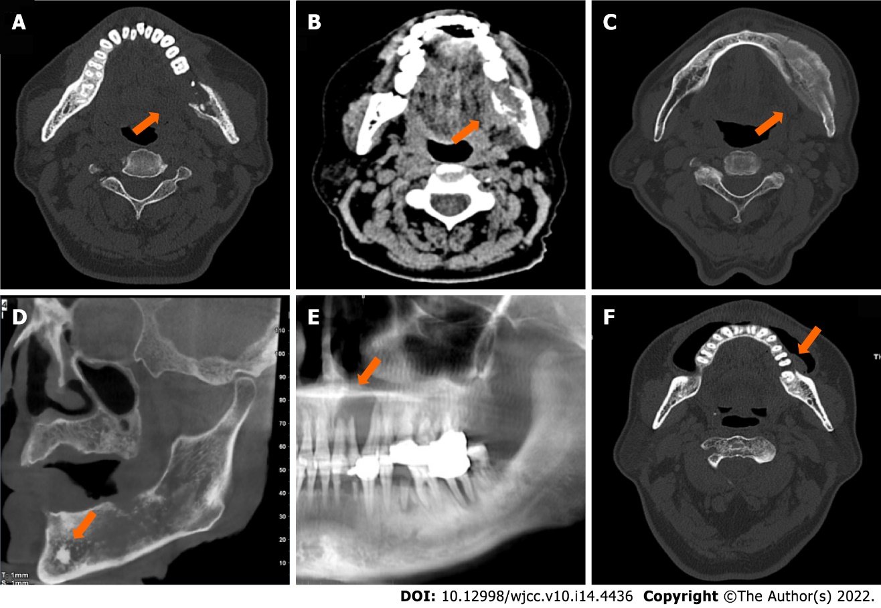
Figure 1 Five types of metastatic adenocarcinoma of the jaw. A: Osteolytic type. Axial spiral-computed tomography (SCT) with bone window showed decreased radiodensity of the lesion (arrow) with a permeative margin. The multi-layered periosteal reaction was observed on the buccal and lingual sides of the left mandibular ramus; B: Osteolytic type. Axial SCT with soft-tissue window showed a confined soft tissue mass (arrow) at the lingual side of the left mandibular ramus; C: Osteoblastic type. Axial SCT with bone window showed increased radiodensity of the lesion (arrow) with a sclerotic margin; D: Mixed type. Oblique sagittal cone beam CT showed both osteolytic and osteoblastic lesions (arrow) with a moth-eaten margin, and an “ivory” pattern of osseous tumour matrix was centred in the left mandibular at the location of mental foramen; E: Cystic type. Partial panorama reconstruction radiograph showed homogeneous radiodensity of the lesion (arrow) in the anterior part of the maxilla with a geographic margin. Teeth displacement and root resorption were observed; F: Alveolar bone resorption type. Axial SCT with bone window showed bone destruction was confined to the alveolar bone with a geographic margin. A soft tissue component was at the buccal side.

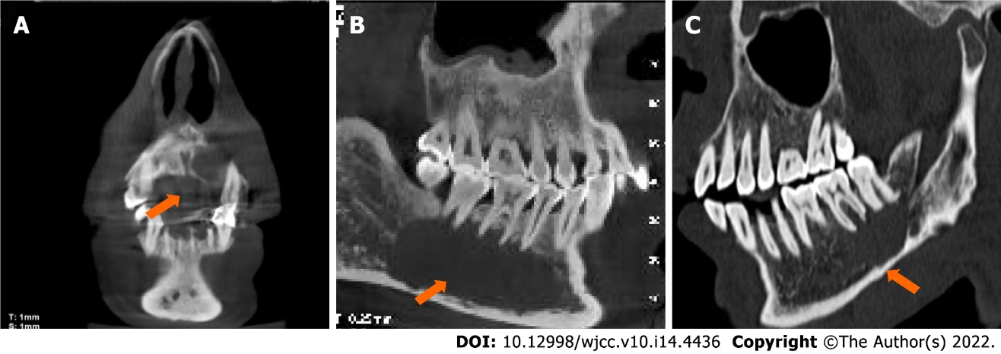
Figure 2 Three cases of the cystic type of metastatic adenocarcinoma of the jaw. A: Coronal cone beam computed tomography (CBCT), is the same case as in Figure 1E; B: Oblique sagittal spiral-CT; C: CBCT revealed homogeneous radiodensity of the lesions (arrow) with geographic margins.
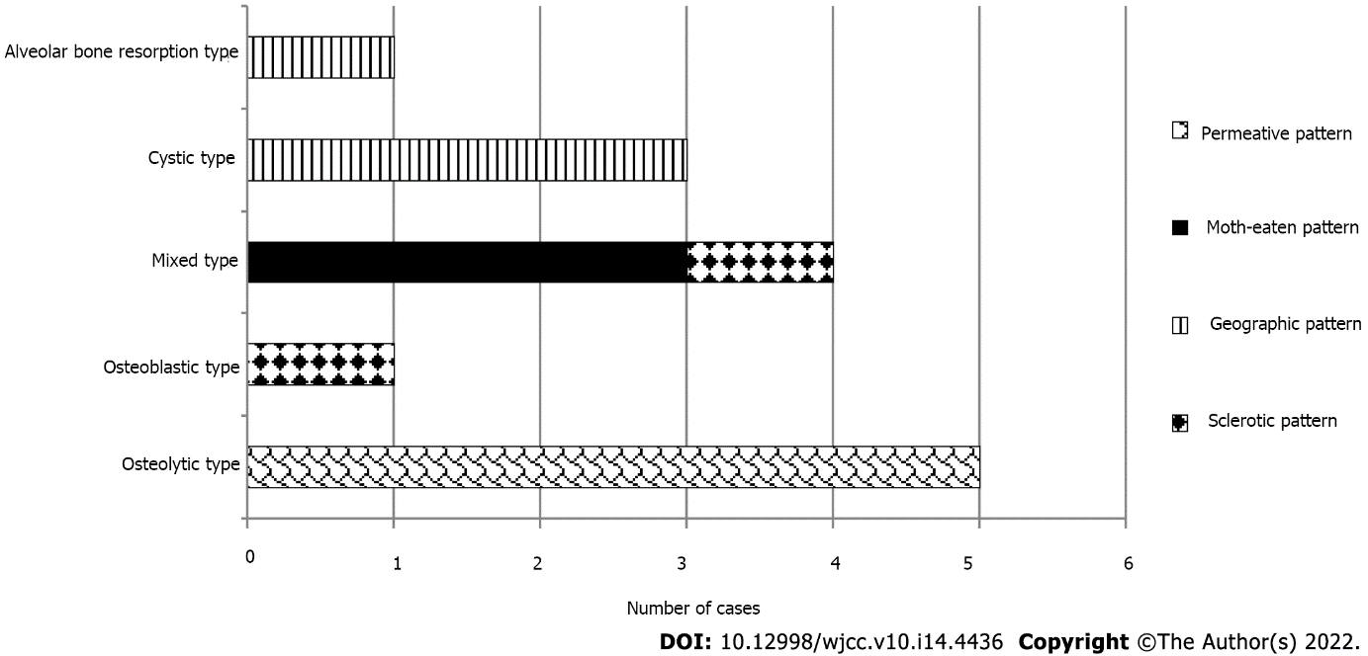
Figure 3 Radiological classifications and lesion margins in 14 patients with metastatic adenocarcinoma of the jaw.
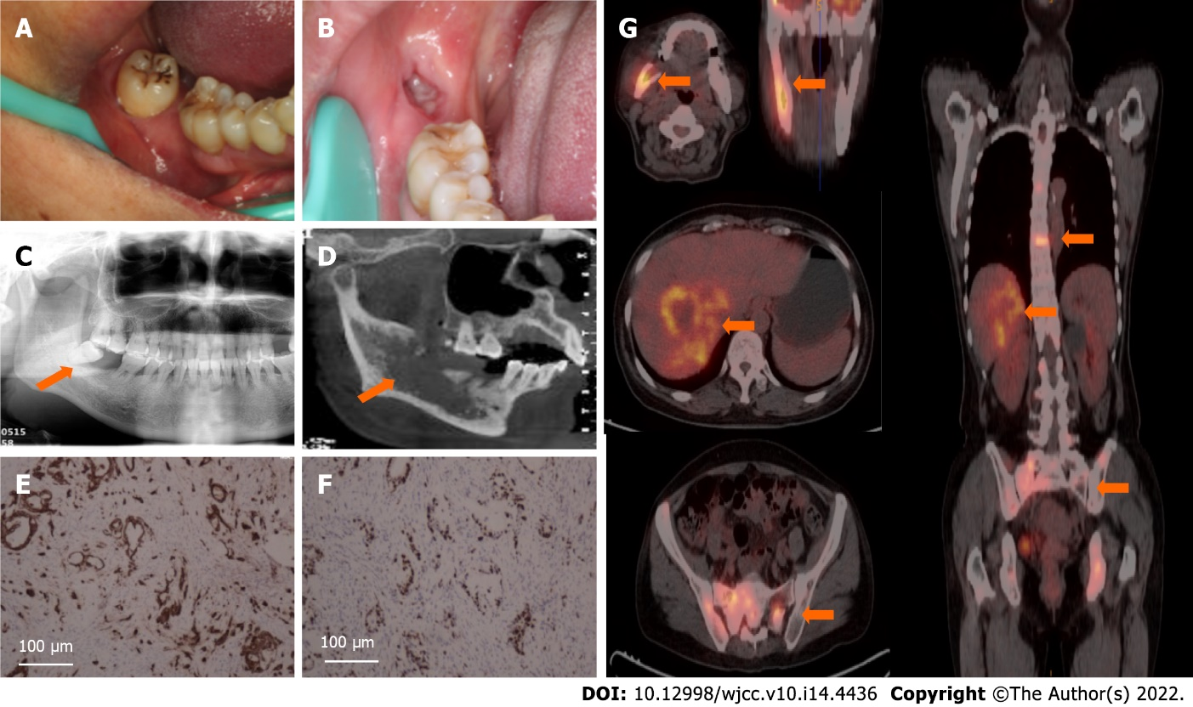
Figure 4 A patient with metastatic adenocarcinoma of the jaw of primary liver cancer. A: Intraoral image before tooth extraction showed swelling of the gingival surrounding the wisdom tooth (arrow); B: Panorama radiograph before tooth extraction showed periodontal bone loss around the involved tooth (arrow); C: At a two-month follow-up visit, the extraction wound did not heal completely; D: Four months after tooth extraction, oblique sagittal cone beam computed tomography (CT) showed lesion (arrow) turned bulky with a permeative margin. The wall of the inferior alveolar nerve was invisible; E: Immunohistochemistry for the expression of CK8/18 revealed uniform positivity in the cytoplasm of tumour cells (Magnification: 100 ×); F: Immunohistochemistry for the expression of Ki-67 revealed scattered positivity in more than 65% of the tumour cells (Magnification: 100 ×); G: Positron emission tomography-CT scans showed asymptomatic hepatocellular carcinoma as the primary site and multiple metastases mainly involving the right mandible, spine, and bilateral pelvic bone (arrows).

Table 1 Clinical data of the patients
Case | Sex | Age (year) | History | Location | Primary site | Clinical signs
1 | M | 41 | 3 yr after surgery | Mandible, posterior | Kidney | Mandible swelling, facial swelling, numbness
2 | M | 45 | 6 mo after RT | Mandible, posterior | Liver | Facial swelling, numbness, tenderness, limited mouth opening
3 | M | 53 | None | Mandible, posterior | Kidney | Facial swelling, numbness, tenderness
4 | F | 57 | None | Mandible, posterior | Lung | Facial swelling, tenderness, limited mouth opening
5 | M | 59 | 6 mo after tooth extraction | Mandible, posterior | Lung | Facial swelling
6 | F | 59 | 4 mo after tooth extraction | Mandible, posterior | Liver | Facial swelling, numbness, toothache
7 | M | 61 | 4 yr after RT | Maxilla, anterior | Gastric cardia | Maxilla swelling, loose tooth
8 | M | 65 | None | Mandible, posterior | Liver | Facial swelling, numbness, tenderness, toothache, loose tooth
9 | F | 66 | None | Maxilla, posterior;  Mandible, posterior | Liver | Mandible swelling, numbness, tenderness,
10 | F | 67 | None | Mandible, posterior | Lung | Numbness, toothache
11 | M | 72 | None | Mandible, posterior | Lung | Painless mass
12 | M | 73 | 6 mo after surgery | Mandible, posterior | Lung | Mass, tenderness, numbness
13 | M | 75 | None | Mandible, posterior | Lung | Facial swelling, tenderness, numbness
14 | M | 79 | None | Mandible, anterior and posterior | Prostate | Facial swelling, tenderness, numbness
M: Male; F: Female; RT: Radiotherapy.

Published by Baishideng Publishing Group Inc
7041 Koll Center Parkway, Suite 160, Pleasanton, CA 94566, USA
Telephone: +1-925-3991568
E-mail: bpgoffice@wjgnet.com
Help Desk: https://www.f6publishing.com/helpdesk
https://www.wjgnet.com

© 2022 Baishideng Publishing Group Inc. All rights reserved.

