Name of Journal: World Journal of Gastrointestinal Oncology
Manuscript NO: 53727
Manuscript Type: ORIGINAL ARTICLE

Clinical Trials Study
Endoscopic ultrasound-guided fiducial marker placement for neoadjuvant chemoradiation therapy for resectable pancreatic cancer

Ashida R et al. EUS-FP for NACRT for resectable PC

Reiko Ashida, Nobuyasu Fukutake, Ryoji Takada, Tatsuya Ioka, Kazuyoshi Ohkawa, Kazuhiro Katayama, Hirofumi Akita, Hidenori Takahashi, Shingo Ohira, Teruki Teshima

Reiko Ashida, Tatsuya Ioka, Department of Cancer Survey and Gastrointestinal Oncology, Osaka International Cancer Institute, Osaka 541-8567, Japan

Nobuyasu Fukutake, Ryoji Takada, Kazuyoshi Ohkawa, Kazuhiro Katayama, Department of Hepatobiliary and Pancreatic Oncology, Osaka International Cancer Institute, Osaka 541-8567, Japan

Hirofumi Akita, Department of Gastroenterological Surgery, Osaka University Graduate School of Medicine, Osaka 565-0871, Japan

Hidenori Takahashi, Department of Surgery, Osaka International Cancer Institute, Osaka 541-8567, Japan

Shingo Ohira, Teruki Teshima, Department of Radiation Oncology, Osaka International Cancer Institute, Osaka 541-8567, Japan

Author contributions: Ashida R and Fukutake N designed the research; Ashida R, Fukutake N, Takada R, Ioka T, Ohkawa K, Katayama K, Akita H, Takahashi H, Ohira S and Teshima T performed the research; Teshima T contributed the grant; Ashida R, Fukutake N and Ohira S analyzed the data; Ashida R wrote the paper; All authors have read and agreed to the final manuscript.

Supported by the JSPS KAKENHI Grant [Grant-in Aid for Scientific Research (B)], No. 15H04913.

Corresponding author: Reiko Ashida, MD, PhD, Attending Doctor, Department of Cancer Survey and Gastrointestinal Oncology, Osaka International Cancer Institute, 3-1-69 Otemae, Chuo-ku, Osaka 541-8567, Japan. rashida@goo.jp

Received: February 3, 2020
Revised: April 13, 2020
Accepted: May 12, 2020
Published online: July 15, 2020

Abstract
BACKGROUND
Preoperative neoadjuvant chemoradiation therapy (NACRT) is applied for resectable pancreatic cancer (RPC). To maximize the efficacy of NACRT, it is essential to ensure the accurate placement of fiducial markers for image-guided radiation. However, no standard method for delivering fiducial markers has been established to date, and the nature of RPC during NACRT remains unclear.

AIM
To determine the feasibility, safety and benefits of endoscopic ultrasound-guided (EUS) fiducial marker placement in patients with RPC.

METHODS
This was a prospective case series of 29 patients (mean age, 67.5 years; 62.1% male) with RPC referred to our facility for NACRT. Under EUS guidance, a single gold marker was placed into the tumor using either a 19- or 22-gauge fine-needle aspiration needle. The differences in daily marker positioning were measured by comparing simulation computed tomography and treatment computed tomography.

RESULTS
In all 29 patients (100%) who underwent EUS fiducial marker placement, fiducials were placed successfully with only minor, self-limiting bleeding during puncture observed in 2 patients (6.9%). NACRT was subsequently administered to all patients and completed in 28/29 (96.6%) cases, with one patient experiencing repeat cholangitis. Spontaneous migration of gold markers was observed in 1 patient. Twenty-four patients (82.8%) had surgery with 91.7% (22/24) R0 resection, and two patients experienced complete remission. No inflammatory changes around the marker were observed in the surgical specimen. The daily position of gold markers showed large positional changes, particularly in the superior-inferior direction. Moreover, tumor location was affected by food and fluid intake as well as bowel gas, which changes daily.

CONCLUSION
EUS fiducial marker placement following NACRT for RPC is feasible and safe. The RPC is mobile and is affected by not only aspiration, but also food and fluid intake and bowel condition.

Key words: Endoscopic ultrasound-guided fine-needle aspiration; Interventional endoscopic ultrasound; Pancreatic cancer; Fiducial marker; Chemoradiation; Resectable

Ashida R, Fukutake N, Takada R, Ioka T, Ohkawa K, Katayama K, Akita H, Takahashi H, Ohira S, Teshima T. Endoscopic ultrasound-guided fiducial marker placement for neoadjuvant chemoradiation therapy for resectable pancreatic cancer. World J Gastrointest Oncol 2020; 12(7): 768-781
URL: https://www.wjgnet.com/1948-5204/full/v12/i7/768.htm
DOI: https://dx.doi.org/10.4251/wjgo.v12.i7.768

Core tip: Currently, chemoradiation therapy for pancreatic cancer is mainly performed for patients with unresectable or borderline resectable pancreatic cancer (RPC). Although image-guided radiation therapies rely on fiducial marker placement, no standard delivery method has been established, and the nature of RPC during chemoradiation therapy remains unclear. In the present study, we report the feasibility and safety of endoscopic ultrasound-guided fiducial marker placement for RPC as well as the specificity of RPC, including daily tumor positional changes, which are affected by not only respiration but also food intake, fluid intake and bowel condition.

INTRODUCTION
To suppress recurrence after surgery and improve the prognosis of patients with resectable pancreatic cancer (RPC), preoperative neoadjuvant chemoradiation therapy (NACRT) is actively carried out^{[1,2]}. Thanks to recent advances in radiation therapy, radiation treatments are administered using image-guided radiation therapies, such as intensity-modulated radiation therapy, respiration synchronization and irradiation tracking with the CyberKnife system. Furthermore, treatments with high radiation doses, such as stereotactic body radiation therapy and heavy particle therapy, are becoming increasingly more common^{[3,4]}. While these radiation therapies are expected to be effective, they retain the risk of complications such as bleeding, ulceration and perforation, necessitating more precise irradiation. For this reason, the accurate placement of fiducial markers is essential, and the establishment of safe procedures for fiducial marker placement is required.
Endoscopic ultrasound-guided fiducial marker placement (EUS-FP) was first reported by Pishvaian et al^{[5]} in a 2006 study in which fiducials were successfully placed in six of seven pancreatic cancer (PC) patients. Since then, EUS-FP has been reported for many cancer types, such as mediastinal tumors, prostate cancer and gastrointestinal (GI) malignancies (including PCs)^{[6,7]}. Several reports have been published on EUS-FP for locally advanced and recurrent PC with technical success rates ranging from 85% to 100%^{[5,7-10]}.
At our hospital, we have aggressively administered NACRT for RPC and have reported promising results^{[11,12]}. However, the risk of complications such as ulceration and GI tract bleeding remains. Therefore, the present study examined the feasibility, safety and potential benefits of EUS-FP for patients with RPC who are undergoing preoperative NACRT.

MATERIALS AND METHODS
Patient selection
Between April 2013 and June 2017, 258 patients diagnosed with RPC through pathological assessment were scheduled to undergo NACRT at the Osaka International Cancer Institute. RPC was defined as follows: (1) A tumor without extension into the superior mesenteric artery, celiac artery or common hepatic artery; (2) A tumor with an abutment/encasement or a short segment of occlusion into the superior mesenteric vein and portal vein; or (3) A tumor which achieved down staging after neoadjuvant chemotherapy from T4 to above criteria.
Among these, 29 patients with an unclear cancer margin that was thought to be difficult to identify by cone-beam computed tomography (CBCT) during radiation therapy were referred for EUS-FP (Figure 1). A multidisciplinary team consisting of surgeons, radiation oncologists and experienced endosonographers determined the eligibility for NACRT and feasibility of EUS-FP based on reviews of abdominal cross-sectional EUS imaging and pancreatic protocol computed tomography (CT). The protocol of this study was approved by the Osaka International Cancer Institute Institutional Review Board (IRB No. 1302271178), and written informed consent was obtained from the patients before beginning the procedure (UMIN000010418). Exclusion criteria were: (1) An inability to safely receive conscious sedation; (2) An inability to reach the lesion site due to anatomic reasons (postsurgical changes, stricture not amenable to dilation); (3) An inability to understand and sign informed consent; (4) Pregnancy; and (5) Coagulopathy (international normalized ratio of 1.5 or platelet count < 5 × 10⁴/μL).

Fiducial marker placement
For all patients, EUS was performed using a linear-array echoendoscope (GF-UCT 240-AL5 or GF-UCT 260-AL5; Olympus Corp., Tokyo, Japan) under conscious sedation. Fiducial markers were placed using an EUS-fine-needle aspiration (FNA) needle (EXPECT: 22G or Flex needle 19G; Boston Scientific, United States). For this study, Visicoil markers (RadioMed Corporation, Bartlett, TN, United States) measuring 0.75 mm or 0.5 mm in diameter × 5 mm in length or Gold Anchor™ markers (Naslund Medical AB, Huddinge, Sweden) measuring 0.28 mm × 10 mm were implanted. Visicoil markers were placed as described previously^{[13]}. Gold Anchor markers also came preloaded on a percutaneously designed delivery device, but this device was small enough to be back-loaded directly into an FNA needle.
The FNA needle loaded with a marker was advanced through the operating channel of the echoendoscope. Upon needle insertion into the target lesion, the fiducial was deployed by advancing the stylet under EUS guidance. This procedure was performed by experienced endosonographers (Ashida R, Fukutake N) who have performed EUS-FNA in more than 500 cases. To confirm the success of placement and the location of the fiducial markers, abdominal radiography was performed after the procedure (Figure 2). Intravenous antibiotics (Sulperazone, 1 g × 2 d) were administered prophylactically to all patients. All patients were admitted for this procedure and monitored overnight for symptoms such as fever, abdominal pain and nausea.

Chemoradiation therapy
After fiducial marker placement, irradiation fields were constructed with the aid of 3D radiation planning. The clinical target volume included the primary pancreatic cancer lesion, retropancreatic soft tissues, the para-aortic region and the celiac and superior mesenteric arteries, which could not be removed surgically. The planning target volume was generated by adding 5-10 mm margins in three directions (anterior-posterior, superior-inferior, left-right). A total radiation dose of 60 Gy was delivered in daily fractions of 2.4 Gy five times per week (25 fractions total). During the treatment schedule, CBCT or four-dimensional CT images were acquired, and the marker displacement against the simulation CT acquired for the treatment planning was measured (details of the method were reported differently^{[14]}). Gemcitabine (1000 mg/m²) was administered to 21 patients on days 1, 8 and 15 of each 28-d cycle. S-1 monotherapy was administered to 2 patients for 4wk at 2-wk intervals. One patient switched from gemcitabine to S-1 due to side effects such as a severe skin reaction. One patient was administered a combination of gemcitabine (1000 mg/m²) and S-1 (120 mg/d) for three cycles. These preoperative treatments were administered at our outpatient clinic. Five patients received a combination of gemcitabine (600 mg/m²) and nab-paclitaxel (75 mg/m²), which were administered on days 1, 8 and 15 of each 28-d cycle.

Pathological evaluation
Histologic grading of the extent of residual tumor was evaluated using the Evans classification^{[15]}, which is a 4-tiered grading system that quantifies the extent of residual tumor based on the grading by assessing the percentage of viable tumor cells (destruction of tumor cells) in the posttreatment specimens as follows: grade I, little (< 10%) or no tumor cell destruction; grade IIa, destruction of 10% to 50% of tumor cells; grade IIb, destruction of 51% to 90% of tumor cells; grade III, few (< 10%) viable tumor cells; and grade IV, no viable tumor cells.

Outcomes
Primary outcome measurements included technical success rate, complications and technical limitations of EUS-FP. Secondary outcome was the percentage of cases that successfully completed NACRT and subsequent surgery after marker placement. Technical success was defined as the ability to place fiducials in the desired location. A chart review for procedure-related complications was performed until NACRT following surgery had been accomplished.

RESULTS
Population and tumor characteristics
A total of 29 patients (18 males, 11 females) with pathologically confirmed resectable adenocarcinoma with unclear margin for NACRT were referred for EUS-guided fiducial marker placement, as shown in Figure 2. The mean age of the patients was 66.9 ± 9.2 (range, 38-78) years. Fifteen (51.7%) tumors were located in the head of the pancreas, thirteen (44.8%) were in the body of the pancreas, and one (3.4%) was in the tail. The mean size of the tumors was 20.2 ± 7.7 cm (range 8.5-40 cm). The number of patients for each location and the size of marker are described in Table 1.

EUS-guided fiducial marker placement
All fiducials were successfully deployed. Marker placement with a 19G FNA needle and 0.75 mm × 5 mm Visicoil was performed in 3 (10.3%) patients with tumors in the body of the pancreas. A 22G FNA needle with 0.5 mm × 5 mm Visicoil was used in 15 (51.7%) patients with tumors in the head and 8 (27.6%) with tumors in the body of the pancreas. A 22G FNA needle with 0.28 mm × 10 mm Gold Anchor was applied to 2 (6.9%) patients with tumors in the body of the pancreas and 1 patient with a tumor in the tail of the pancreas. All implanted markers were identifiable on abdominal radiographs after the placement procedure and simulation CT for radiation therapy (Figure 2).

Complications
In terms of procedure-related complications, 2 cases (6.9%) of self-limiting minor luminal bleeding were seen with no significant decrease in hemoglobin. Otherwise, no complications occurred during the 24 h of monitoring immediately following marker placement. Marker migration occurred in one case (3.4%) 11 d after marker placement during NACRT, although no migration-related complications occurred (Figure 3). One patient developed a fever due to cholangitis 2 d after the procedure and was admitted to the hospital. This patient was treated with antibiotics and endoscopic biliary drainage, and the infection was resolved. However, this patient developed recurrent cholangitis, and physicians thought that continuing NACRT would be too difficult. Therefore, this patient underwent surgery as soon as radiation therapy was completed.

Marker location during daily radiation therapy
Among 24 out of 29 cases, the marker displacement between the simulation CT and CBCT or 4DCT images during the treatment schedule is shown in Figure 3. For the anterior-posterior and left-right directions, 2 patients showed 95% confidence intervals > 5 mm, which was the minimal planning target volume margin for radiation therapy. The positional differences of RPC between simulation and treatment were remarkable, particularly in the superior-inferior direction, and 6 patients showed a confidence interval > 5 mm. Moreover, it became clear that cancer location was affected by the change in stomach shape due to either food or fluid intake. Even lesions in the pancreatic head were affected by bowel gas as shown in Figure 4.

NACRT and subsequent surgery
After fiducial placement, all patients completed NACRT, except for one patient who developed recurrent cholangitis (Table 2). During NACRT, 4 patients developed GI complications, such as gastric ulcers or erosion, and one patient had both a pressure fracture at L1 and L3 and interstitial lung disease. Two patients declined surgery, two patients had liver metastasis, and one patient developed dissemination during NACRT. In total, 24 patients underwent surgery (24/29; 82.8%), among whom 16 underwent pancreaticoduodenectomy, 7 underwent distal pancreatectomy, and 1 underwent total pancreatectomy with 91.7% of these patients experiencing R0 resection.

Pathological specimens
To investigate the effects of marker placement on tumor tissue, all surgical specimens underwent pathological examination. Except for one case of migration, placement of the gold markers was confirmed in the resected specimens. No significant changes, such as the accumulation of inflammatory cells or fibrosis, were observed around the markers in any pathological specimen (Figure 6). Regarding the effectiveness of NACRT, there were 2 cases with complete remission. Regarding Evans classification, 2 patients showed grade IV, 4 patients showed grade III, 7 patients showed grade IIa, 8 patients showed grade IIb, and 3 patients showed grade I^{[15]}.

DISCUSSION
PC is currently the fourth leading cause of cancer-related death worldwide and has a very poor prognosis. Patients with RPC who received preoperative treatment had an estimated median survival of 23.3 mo, whereas those who did not undergo preoperative treatment had an estimated median survival of 16.9–20.2 mo^{[16]}. Therefore, preoperative neoadjuvant therapy is increasingly recognized as important.
Among the available preoperative regimens, NACRT is thought to confer a lower incidence of local recurrence after subsequent resection because it may provide macroscopic and microscopic levels of down staging^{[12,17]}. However, radiation therapy requires high-level techniques, and complications such as GI bleeding or perforation of the GI tract are serious problems that could preclude surgery. Therefore, it is thought to be important to place fiducial markers in order to confirm the radiation field.
Fiducial markers have been inserted either during surgery or percutaneously under CT or US guidance^{[18,19]}. However, surgery is invasive, and percutaneous procedures involve risks such as bleeding or needle tract tumor seeding. In recent years, the placement of fiducial markers under EUS guidance has been recommended due to its safety and accuracy. Although several reports related to EUS-FP have been published for unresectable locally advanced PC or borderline RPC, to date no study has focused only on RPC. Therefore, the present study focused on the feasibility and safety of EUS-FP for RPC undergoing NACRT.
In terms of feasibility, EUS-FP was successfully performed in all 29 patients (100%) with a single marker placement in the middle of the tumor to confirm the tumor location daily for radiation therapy. During the early period of this study, a 19-gauge FNA needle loaded with a Visicoil 0.75 mm in diameter × 0.5 cm in length was used for lesions of the pancreatic body or tail through the stomach, and a 22-gauge needle loaded with a Visicoil 0.5 mm in diameter × 0.5 cm in length was used for the lesions in the pancreatic head through the duodenum. However, after several cases were successfully treated using the smaller Visicoil with adequate delineation by CBCT, all cases were shifted to the use of small markers due to their ease of manipulation although a thicker fiducial marker would be more clearly visible during radiation therapy.
Previous reports have stated that during preparation the Visicoil markers must be removed once from the percutaneous puncture needle and reloaded into the FNA needle. However, we experienced some cases in which markers were bent during back-loading. Following these instances of Visicoil malfunction, we switched the marker from Visicoil to Gold Anchor so that the markers could be reloaded directly into the FNA needle. To avoid the recurrence of such malfunctions, it will be necessary to develop a dedicated device for EUS-FP. In addition, when multiple markers must be placed, it is currently necessary to place them one by one despite the increasing risk of complications, such as needle tract seeding due to the repeated puncturing of a tumor using the same needle. Although several techniques such as the antegrade, front-loading approach^{[8]} or the hydrostatic technique using a BNX needle aspiration system (Covidien, Dublin, Ireland) have been reported^{[20]}, dedicated needles with multiple preloaded markers need to become more widely available for commercial use as quickly as possible^{[21]}.
Similar to previously reported results^{[6-10]}, the overall complication rate was 6.9% in the present study and included self-limiting minor luminal bleeding. One patient (3.4%) showed marker migration 11 d after placement during NACRT (Figure 2). Migration depends on the type of fiducial marker used, and previous studies have shown that coiled fiducials migrate less than traditional fiducials^{[22]}. However, the notched design of the Gold Anchor might be advantageous because the fiducial shape can be modified to either a ball or linear shape depending on the insertion technique, and the fiducial consequently remains more stable in the tumor (Figure 7)^{[23]}. Our radiation oncologists prefer the ball shape to the linear shape due to better visibility on CBCT.
All surgical specimens were examined to investigate the impact of marker placement on the tumor tissue. Except in one case of migration, all the gold markers were confirmed to be present at the initial placement site in the resected specimen. No significant changes around the markers, such as the accumulation of inflammatory cells or fibrosis, were observed in any pathological specimen (Figure 5). Therefore, the influence of the marker placement itself on NACRT or resection was small.
In terms of the benefits of placing fiducial markers in RPC, the results of the present study demonstrate that RPC is more mobile than initially expected, particularly along the superior-inferior axis, which is not dependent on respiratory effects, but on food intake or bowel gas. As shown in Figure 3, these differences show large individual variation.
It was previously considered that the positional change in the pancreas was small because the pancreas is a retroperitoneal organ. Moreover, unresectable PC is usually less mobile because of its infiltration into the retroperitoneum. However, as shown in Figure 5, RPC is very mobile, not only due to respiratory effects but also due to food or even water intake. Therefore, we adjusted the radiation protocol to no longer allow patients to eat before undergoing radiation. This may increase the efficacy of radiation therapy as well as reduce the side effects.
The results of the present study suggest several areas for further investigation. First, the optimal location and number of fiducial markers that should be inserted into the tumor for adequate image guided radiotherapy are still unclear. This question may depend on the type of radiation treatment. For example, at our institution, a single gold marker was placed to confirm the tumor location daily. However, multiple marker placements are necessary if synchronizing respiration or tracking irradiation is to be performed. Furthermore, if radiation with strong GI toxicity, such as heavy particle therapy or proton beam therapy, is planned, it may be necessary to place the marker in the vicinity of the GI tract so that appropriate precautions can be made during radiation planning to avoid irradiating the digestive tract, which can cause GI bleeding or perforation.
In addition, the actual advantage of placing fiducial markers on the NACRT remains unclear. As the present study was a single arm study and the radiation field was not changed from the conventional method, it was difficult to discuss the superiority of image guided radiotherapy on tumor size reduction or overall survival. However, given the large tumor movement during daily treatment, image guided radiotherapy with fiducial markers may become an indispensable treatment for improving the prognosis of PC in the future.
In summary, EUS-FP is feasible and safe in patients with RPC who are undergoing NACRT. This technique not only has a high technical success rate and a very low complication rate, it provides accurate tumor location information during daily radiation therapy.

ARTICLE HIGHLIGHTS
Research background
Preoperative neoadjuvant chemoradiation therapy (NACRT) is applied for resectable pancreatic cancer (RPC). To maximize the efficacy of NACRT, it is essential to ensure the accurate placement of fiducial markers for image-guided radiation. However, no standard method for delivering fiducial markers has been established.

Research motivation
For the accurate placement of fiducial markers, endoscopic ultrasound-guided fiducial marker placement (EUS-FP) have been published for unresectable locally advanced PC or borderline RPC showing promising results. However, there is no study that has focused only on RPC. Therefore, the present study focused on the feasibility and safety of EUS-FP for RPC undergoing NACRT as well as the nature of RPC during NACRT.

Research objectives
A total of 29 patients (18 males, 11 females) with pathologically confirmed resectable adenocarcinoma with unclear margin for NACRT were referred for EUS-FP.

Research methods
Under EUS guidance, a single gold marker was placed into the tumor using either a 19- or 22-gauge fine-needle aspiration needle. The differences in daily marker positioning were measured by comparing simulation computed tomography and treatment computed tomography.

Research results
In all 29 patients (100%) who underwent EUS-FP, fiducials were placed successfully with only minor, self-limiting bleeding during puncture observed in 2 patients (6.9%). NACRT was subsequently administered to all patients and completed in 28/29 (96.6%) cases, with one patient experiencing repeat cholangitis. Spontaneous migration of gold markers was observed in 1 patient. Twenty-four patients (82.8%) had surgery with 91.7% (22/24) R0 resection, and two patients experienced complete remission. No inflammatory changes around the marker were observed in the surgical specimen. The daily position of gold markers showed large positional changes, particularly in the superior-inferior direction. Moreover, tumor location was affected by food and fluid intake as well as bowel gas, which changes daily.

Research conclusions
EUS-FP for RPC not only has a high technical success rate and a very low complication rate, it provides accurate tumor location information during daily radiation therapy.

Research perspectives
A prospective randomized controlled study with a larger sample size of patients is needed to further evaluate the role EUS-FP following NACRT for RPC.

REFERENCES
1 Evans DB, Varadhachary GR, Crane CH, Sun CC, Lee JE, Pisters PW, Vauthey JN, Wang H, Cleary KR, Staerkel GA, Charnsangavej C, Lano EA, Ho L, Lenzi R, Abbruzzese JL, Wolff RA. Preoperative gemcitabine-based chemoradiation for patients with resectable adenocarcinoma of the pancreatic head. J Clin Oncol 2008; 26: 3496-3502 [PMID: 18640930 DOI: 10.1200/JCO.2007.15.8634]
2 Satoi S, Toyokawa H, Yanagimoto H, Yamamoto T, Kamata M, Ohe C, Sakaida N, Uemura Y, Kitade H, Tanigawa N, Inoue K, Matsui Y, Kwon AH. Neo-adjuvant chemoradiation therapy using S-1 followed by surgical resection in patients with pancreatic cancer. J Gastrointest Surg 2012; 16: 784-792 [PMID: 22160780 DOI: 10.1007/s11605-011-1795-0]
3 Shinoto M, Yamada S, Terashima K, Yasuda S, Shioyama Y, Honda H, Kamada T, Tsujii H, Saisho H; Working Group for Pancreas Cancer. Carbon Ion Radiation Therapy With Concurrent Gemcitabine for Patients With Locally Advanced Pancreatic Cancer. Int J Radiat Oncol Biol Phys 2016; 95: 498-504 [PMID: 26883565 DOI: 10.1016/j.ijrobp.2015.12.362]
4 de Geus SWL, Eskander MF, Kasumova GG, Ng SC, Kent TS, Mancias JD, Callery MP, Mahadevan A, Tseng JF. Stereotactic body radiotherapy for unresected pancreatic cancer: A nationwide review. Cancer 2017; 123: 4158-4167 [PMID: 28708929 DOI: 10.1002/cncr.30856]
5 Pishvaian AC, Collins B, Gagnon G, Ahlawat S, Haddad NG. EUS-guided fiducial placement for CyberKnife radiotherapy of mediastinal and abdominal malignancies. Gastrointest Endosc 2006; 64: 412-417 [PMID: 16923491 DOI: 10.1016/j.gie.2006.01.048]
6 Fernandez DC, Hoffe SE, Barthel JS, Vignesh S, Klapman JB, Harris C, Almhanna K, Biagioli MC, Meredith KL, Feygelman V, Rao NG, Shridhar R. Stability of endoscopic ultrasound-guided fiducial marker placement for esophageal cancer target delineation and image-guided radiation therapy. Pract Radiat Oncol 2013; 3: 32-39 [PMID: 24674261 DOI: 10.1016/j.prro.2012.02.006]
7 Choi JH, Seo DW, Park DH, Lee SK, Kim MH. Fiducial placement for stereotactic body radiation therapy under only endoscopic ultrasonography guidance in pancreatic and hepatic malignancy: practical feasibility and safety. Gut Liver 2014; 8: 88-93 [PMID: 24516706 DOI: 10.5009/gnl.2014.8.1.88]
8 Ammar T, Coté GA, Creach KM, Kohlmeier C, Parikh PJ, Azar RR. Fiducial placement for stereotactic radiation by using EUS: feasibility when using a marker compatible with a standard 22-gauge needle. Gastrointest Endosc 2010; 71: 630-633 [PMID: 20189527 DOI: 10.1016/j.gie.2009.11.023]
9 Park WG, Yan BM, Schellenberg D, Kim J, Chang DT, Koong A, Patalano C, Van Dam J. EUS-guided gold fiducial insertion for image-guided radiation therapy of pancreatic cancer: 50 successful cases without fluoroscopy. Gastrointest Endosc 2010; 71: 513-518 [PMID: 20189509 DOI: 10.1016/j.gie.2009.10.030]
10 Varadarajulu S, Trevino JM, Shen S, Jacob R. The use of endoscopic ultrasound-guided gold markers in image-guided radiation therapy of pancreatic cancers: a case series. Endoscopy 2010; 42: 423-425 [PMID: 20232282 DOI: 10.1055/s-0029-1243989]
11 Ohigashi H, Ishikawa O, Eguchi H, Takahashi H, Gotoh K, Yamada T, Yano M, Nakaizumi A, Uehara H, Tomita Y, Nishiyama K. Feasibility and efficacy of combination therapy with preoperative full-dose gemcitabine, concurrent three-dimensional conformal radiation, surgery, and postoperative liver perfusion chemotherapy for T3-pancreatic cancer. Ann Surg 2009; 250: 88-95 [PMID: 19561477 DOI: 10.1097/SLA.0b013e3181ad65cc]
12 Takahashi H, Ohigashi H, Gotoh K, Marubashi S, Yamada T, Murata M, Ioka T, Uehara H, Yano M, Ishikawa O. Preoperative gemcitabine-based chemoradiation therapy for resectable and borderline resectable pancreatic cancer. Ann Surg 2013; 258: 1040-1050 [PMID: 23799421 DOI: 10.1097/SLA.0b013e31829b3ce4]
13 Owens DJ, Savides TJ. EUS placement of metal fiducials by using a backloaded technique with bone wax seal. Gastrointest Endosc 2009; 69: 972-973 [PMID: 19152903 DOI: 10.1016/j.gie.2008.05.052]
14 Ohira S, Isono M, Ueda Y, Hirata T, Ashida R, Takahashi H, Miyazaki M, Takashina M, Koizumi M, Teshima T. Assessment with cone-beam computed tomography of intrafractional motion and interfractional position changes of resectable and borderline resectable pancreatic tumours with implanted fiducial marker. Br J Radiol 2017; 90: 20160815 [PMID: 28256908 DOI: 10.1259/bjr.20160815]
15 Evans DB, Rich TA, Byrd DR, Cleary KR, Connelly JH, Levin B, Charnsangavej C, Fenoglio CJ, Ames FC. Preoperative chemoradiation and pancreaticoduodenectomy for adenocarcinoma of the pancreas. Arch Surg 1992; 127: 1335-1339 [PMID: 1359851 DOI: 10.1001/archsurg.1992.01420110083017]
16 Gillen S, Schuster T, Meyer Zum Büschenfelde C, Friess H, Kleeff J. Preoperative/neoadjuvant therapy in pancreatic cancer: a systematic review and meta-analysis of response and resection percentages. PLoS Med 2010; 7: e1000267 [PMID: 20422030 DOI: 10.1371/journal.pmed.1000267]
17 He J, Blair AB, Groot VP, Javed AA, Burkhart RA, Gemenetzis G, Hruban RH, Waters KM, Poling J, Zheng L, Laheru D, Herman JM, Makary MA, Weiss MJ, Cameron JL, Wolfgang CL. Is a Pathological Complete Response Following Neoadjuvant Chemoradiation Associated With Prolonged Survival in Patients With Pancreatic Cancer? Ann Surg 2018; 268: 1-8 [PMID: 29334562 DOI: 10.1097/SLA.0000000000002672]
18 Sotiropoulou E, Stathochristopoulou I, Stathopoulos K, Verigos K, Salvaras N, Thanos L. CT-guided fiducial placement for cyberknife stereotactic radiosurgery: an initial experience. Cardiovasc Intervent Radiol 2010; 33: 586-589 [PMID: 19908085 DOI: 10.1007/s00270-009-9748-7]
19 Kim JH, Hong SS, Kim JH, Park HJ, Chang YW, Chang AR, Kwon SB. Safety and efficacy of ultrasound-guided fiducial marker implantation for CyberKnife radiation therapy. Korean J Radiol 2012; 13: 307-313 [PMID: 22563268 DOI: 10.3348/kjr.2012.13.3.307]
20 Khara HS, Pineda-Bonilla JJ, Chaput KJ, Johal AS. Endoscopic ultrasound-guided placement of fiducial markers using a novel "wet-fill technique" without a bone wax seal. Endoscopy 2013; 45 Suppl 2 UCTN: E426-E427 [PMID: 24338173 DOI: 10.1055/s-0033-1358809]
21 Draganov PV, Chavalitdhamrong D, Wagh MS. Evaluation of a new endoscopic ultrasound-guided multi-fiducial delivery system: a prospective non-survival study in a live porcine model. Dig Endosc 2013; 25: 615-621 [PMID: 23489989 DOI: 10.1111/den.12046]
22 Khashab MA, Kim KJ, Tryggestad EJ, Wild AT, Roland T, Singh VK, Lennon AM, Shin EJ, Ziegler MA, Sharaiha RZ, Canto MI, Herman JM. Comparative analysis of traditional and coiled fiducials implanted during EUS for pancreatic cancer patients receiving stereotactic body radiation therapy. Gastrointest Endosc 2012; 76: 962-971 [PMID: 23078921 DOI: 10.1016/j.gie.2012.07.006]
23 Dávila Fajardo R, Lekkerkerker SJ, van der Horst A, Lens E, Bergman JJ, Fockens P, Bel A, van Hooft JE. EUS-guided fiducial markers placement with a 22-gauge needle for image-guided radiation therapy in pancreatic cancer. Gastrointest Endosc 2014; 79: 851-855 [PMID: 24518121 DOI: 10.1016/j.gie.2013.12.027]

Footnotes
Institutional review board statement: The protocol of this study was approved by the Osaka International Cancer Institute Institutional Review Board.

Clinical trial registration statement: This registration policy applies to the prospective study only.

Informed consent statement: All study participants, or their legal guardians, provided informed written consent prior to study enrollment.

Conflict-of-interest statement: Tatsuya Ioka received an advisor’s role and speaker’s fee from Taiho Pharmaceutical, and he also received a speaker’s fee from Yakult Honsha. The other authors declare no conflict of interests for this paper.

Data sharing statement: No additional data are available.

CONSORT 2010 statement: The authors have read the CONSORT 2010 Statement, and the manuscript was prepared and revised according to the CONSORT 2010 Statement.

Open-Access: This article is an open-access article that was selected by an in-house editor and fully peer-reviewed by external reviewers. It is distributed in accordance with the Creative Commons Attribution NonCommercial (CC BY-NC 4.0) license, which permits others to distribute, remix, adapt, build upon this work non-commercially, and license their derivative works on different terms, provided the original work is properly cited and the use is non-commercial. See: http://creativecommons.org/licenses/by-nc/4.0/

Manuscript source: Invited manuscript

Corresponding Author's Membership in Professional Societies: American Society for Gastrointestinal Endoscopy (Fellow) and Japanese Society of Gastroenterology (Fellow).

Peer-review started: February 3, 2020
First decision: March 24, 2020
Article in press: May 12, 2020

Specialty type: Oncology
Country/Territory of origin: Japan
Peer-review report’s scientific quality classification
Grade A (Excellent): 0
Grade B (Very good): B, B
Grade C (Good): 0
Grade D (Fair): D
Grade E (Poor): 0

P-Reviewer: Cao ZF, Lin Q, Sun SY S-Editor: Tang JZ L-Editor: Filipodia E-Editor: Qi LL

Figure Legends
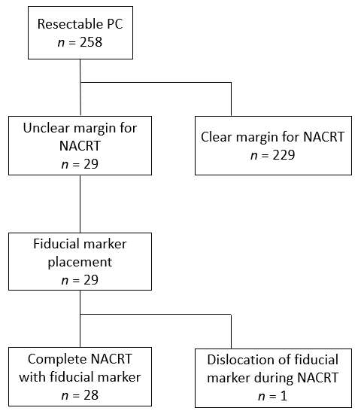
Figure 1 Flow chart for 29 patients with fiducial marker placement. NACRT: Neoadjuvant chemoradiation therapy; PC: Pancreatic cancer.

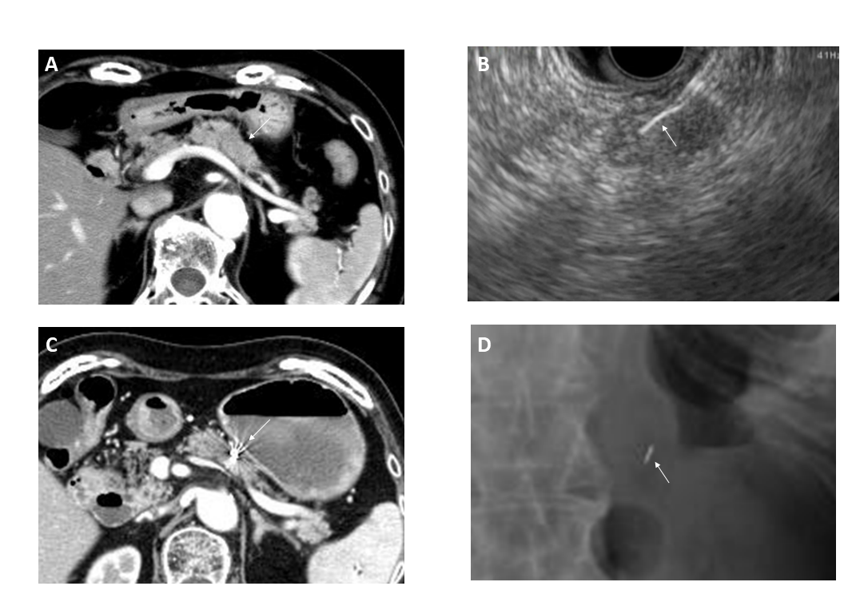
Figure 2 Endoscopic ultrasound-guided fiducial marker placement. A: Abdominal computed tomography. The white arrow indicates the mass in the pancreatic body; B: Needle inserting the fiducial marker into the pancreatic mass. The white arrow indicates fiducial marker placed into the pancreatic mass; C: Abdominal computed tomography after marker placement. The white arrow indicates the fiducial marker placed into the pancreatic mass; D: Abdominal radiograph showing the fiducial marker. The white arrow indicates the fiducial marker.

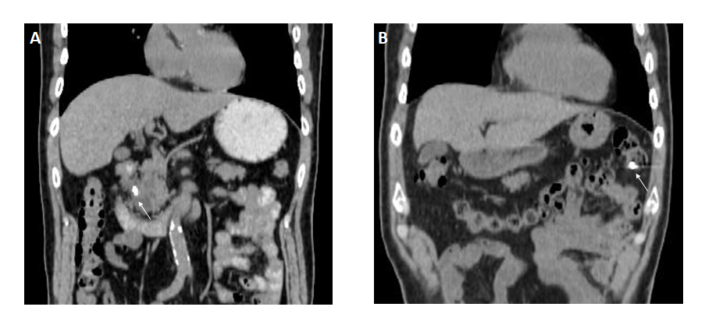
Figure 3 Fiducial marker migration. A: Fiducial marker location immediately after marker placement. The white arrow indicates fiducial marker in the pancreas head; B: Fiducial marker location 11 d after marker placement. The white arrow indicates migrated fiducial marker into colon.

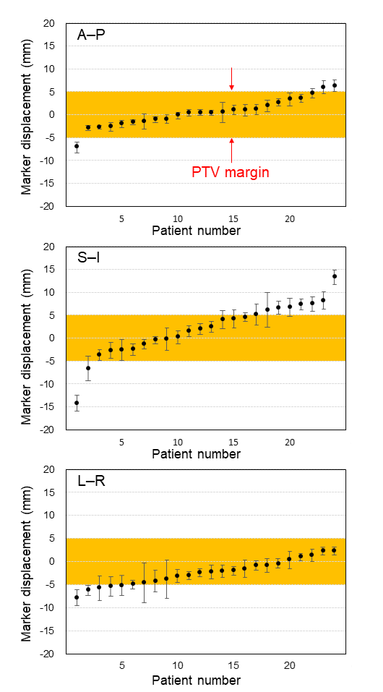
Figure 4 Positional differences in resectable pancreatic cancer between simulation and during treatment in three directions. Error bars indicates the 95% confidence intervals. Positive values of marker displacement indicate that the position of the marker during treatment moves to the anterior, inferior, or left directions from the simulation. Positional differences in resectable pancreatic cancer between simulation and treatment were marked, particularly in the superior-inferior direction. Yellow area between red arrows indicate planning target volume margin. A–P: Antero-posterior; S–I: Superior-inferior; L–R: Left–right; PTV: Planning target volume.

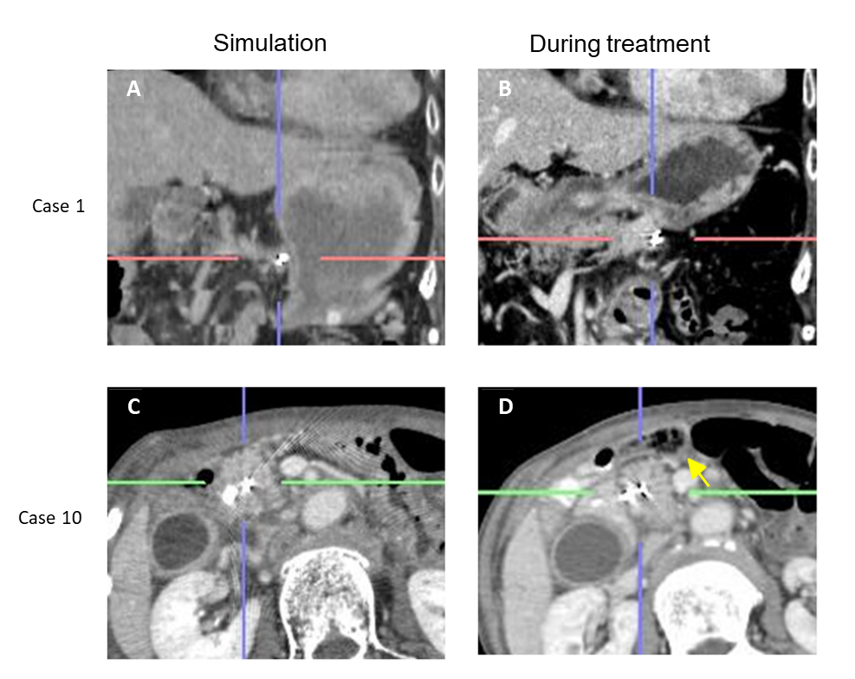Figure 5 Differences in tumor location during radiation treatment due to food in the stomach. A: Simulation computed tomography (CT); B: Cone-beam CT during treatment; C: Simulation CT; D: Cone-beam CT during treatment. The yellow arrow indicates bowel gas in front of the pancreas. Case 1 suggests that cancer location was affected by the stomach shape due to either food or fluid intake. Case 10 suggests the lesion in the pancreatic head was affected by bowel gas.

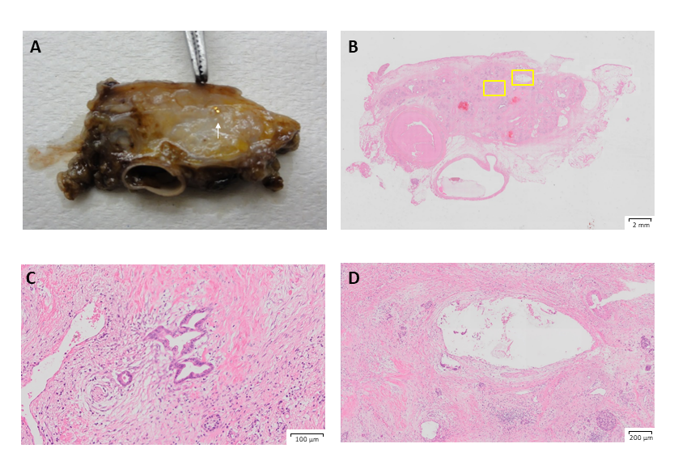
Figure 6 Histological findings. A: White arrow indicates the gold marker; B: hematoxylin and eosin staining of the pathological specimen after chemoradiation therapy. Left yellow square indicates magnified area shown in C and right yellow square indicates magnified area shown in D; C: Very few residual cancer observed with Evans grade III status; D: The hollow area is where the marker was inserted. No significant changes around this area, such as accumulation of inflammatory cells or fibrosis, were observed.

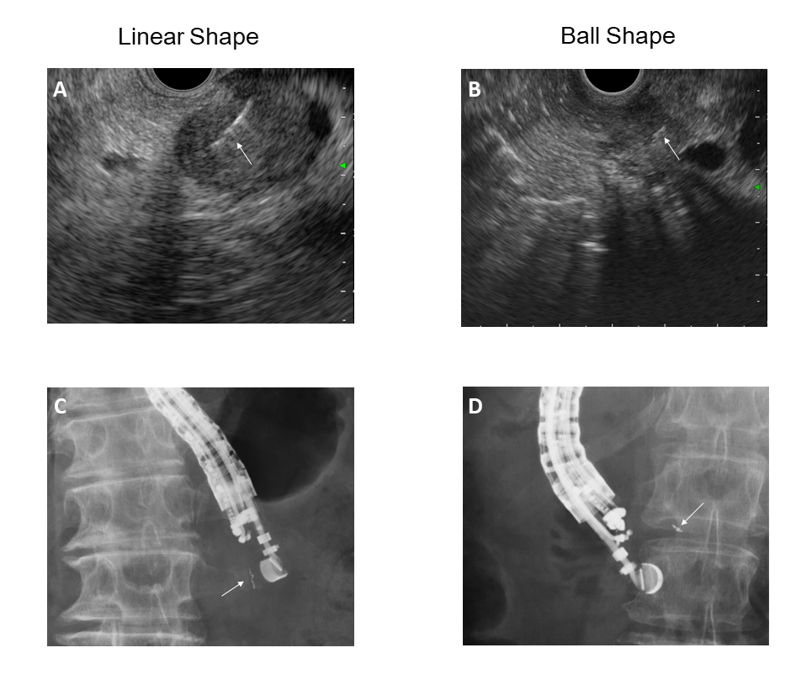 Figure 7 Various insertion techniques for gold anchor. Linear shape insertion. A: Endoscopic ultrasound image for linear shape insertion; B: Endoscopic ultrasound image for ball shape insertion; C: X-ray image for linear shape insertion. D: X-ray image for ball shape insertion. White arrow indicates gold anchor placed in either linear (A, C) or ball (B, D) shape.

Table 1 Patients and procedural characteristics for endoscopic ultrasound-guided fiducial placement
Case | Age in yr/sex | Tumor size in mm | cStage, UICC | Tumor location | Puncture route | Marker type | Marker size in mm | Needle gauge in G
1 | 78/F | 25 | IIA | B | G | Visicoil | 0.75 × 5 | 19
2 | 63/F | 24 | IIA | H | D2 | Visicoil | 0.5 × 5 | 22
3 | 77/F | 18 | IIB | H | G | Visicoil | 0.5 × 5 | 22
4 | 55/M | 30 | IIA | B | G | Visicoil | 0.75 × 5 | 19
5 | 72/M | 20 | IIA | H | D2 | Visicoil | 0.5 × 5 | 22
6 | 68/F | 32 | Ⅲ | B | G | Visicoil | 0.75 × 5 | 19
7 | 68/F | 14 | IIA | B | G | Visicoil | 0.5 × 5 | 22
8 | 70/M | 18 | IIA | H | D1 | Visicoil | 0.5 × 5 | 22
9 | 64/F | 15 | IIA | B | G | Visicoil | 0.5 × 5 | 22
10 | 73/F | 15 | IIA | H | D2 | Visicoil | 0.5 × 5 | 22
11 | 78/F | 11 | IIA | B | D1 | Visicoil | 0.5 × 5 | 22
12 | 68/M | 25 | IIB | B | G | Visicoil | 0.5 × 5 | 22
13 | 60/M | 20 | IIA | B | G | Visicoil | 0.5 × 5 | 22
14 | 78/F | 22 | IIA | H | D2 | Visicoil | 0.5 × 5 | 22
15 | 52/M | 15 | IIA | H | D1 | Visicoil | 0.5 × 5 | 22
16 | 73/M | 35 | IIA | B | G | Visicoil | 0.5 × 5 | 22
17 | 61/M | 15 | IIA | B | G | Visicoil | 0.5 × 5 | 22
18 | 66/M | 29 | IIA | H | D2 | Visicoil | 0.5 × 5 | 22
19 | 38/M | 19 | IIA | H | G | Visicoil | 0.5 × 5 | 22
20 | 58/M | 18 | IIA | H | D1 | Visicoil | 0.5 × 5 | 22
21 | 71/F | 12 | IIB | B | G | Visicoil | 0.5 × 5 | 22
22 | 57/M | 19 | IIA | H | D2 | Visicoil | 0.5 × 5 | 22
23 | 64/M | 21 | IIA | H | D2 | Visicoil | 0.5 × 5 | 22
24 | 78/M | 11 | IIA | H | D2 | Visicoil | 0.5 × 5 | 22
25 | 66/M | 21 | IIA | H | D2 | Visicoil | 0.5 × 5 | 22
26 | 68/M | 14 | IA | H | D2 | Visicoil | 0.5 × 5 | 22
27 | 77/M | 12 | IIA | T | G | Gold Anchor | 0.28 × 10 | 22
28 | 74/M | 40 | IIB | B | G | Gold Anchor | 0.28 × 10 | 22
29 | 66/F | 8.5 | IIA | B | G | Gold Anchor | 0.28 × 10 | 22
M: Male, F: Female; B: Body of pancreas; H: Head of pancreas; T: Tail of pancreas; G: Gastric; D1: Duodenal bulb; D2: Second portion of duodenum.

Table 2 Complications and results of neoadjuvant chemoradiation therapy following surgery after endoscopic ultrasound-guided fiducial placement
Case | CRT | Complication during EUS-FP | Complication during NACRT | Surgery | Operation type | pStage, UICC | Evans classification
1 | G-RT | 0 | 0 | surgery | DP | IA | III
2 | G-RT | 0 | repeat cholangitis | surgery | PD | IIB | I
3 | G-RT | minor bleeding | 0 | surgery | PD | IIA | IIa
4 | G-RT | 0 | 0 | surgery | DP, left adrenal | IIA | III
5 | G-RT | 0 | GE | surgery | PD | IIA | IIa
6 | G-RT | 0 | GU | dissemination | - | - | -
7 | GS-RT | 0 | GE | surgery | DP, left adrenal | IIA | IIa
8 | G-RT | 0 | 0 | surgery | PD | IIB | IIa
9 | G-RT | 0 | 0 | surgery | DP | no residual carcinoma | IV
10 | G-RT | 0 | 0 | surgery | PD | IIA | IIb
11 | G-RT | 0 | GU | surgery | PD | IIA | IIa
12 | G-RT | minor bleeding | 0 | surgery | TP | 0(cis) | III
13 | G-RT | 0 | 0 | liver met | - | - | -
14 | G-RT | 0 | pressure fractureL1.3, ILD | surgery | PD | IIA | IIb
15 | G-RT | 0 | 0 | surgery | PD | IIB | IIb
16 | GNab-RT | 0 | 0 | declined | - | - | -
17 | G-RT | 0 | 0 | liver met | - | - | -
18 | G-RT | 0 | 0 | surgery | PD | IIB | IIb
19 | GNab-RT | 0 | 0 | surgery | PD | IA | IIb
20 | G-RT | 0 | 0 | surgery | PD | no residual carcinoma | IV
21 | GNab-RT | 0 | 0 | surgery | DP | IIA | IIb
22 | GNab-RT | 0 | 0 | surgery | PD | IIB | IIa
23 | GNab-RT | 0 | 0 | surgery | PD | IIA | IIa
24 | G-RT→S-RT | 0 | 0 | surgery | PD | IIA | I
25 | G-RT | 0 | migration | surgery | PD | IA | I
26 | G-RT | 0 | NA | declined | - | - | -
27 | G-RT | 0 | 0 | surgery | PD | IA | IIb
28 | G-RT | 0 | 0 | surgery | DP | IIB | IIb
29 | S-RT | 0 | 0 | surgery | DP | IA | III
CRT: Chemoradiation therapy; EUS-FP: Endoscopic ultrasound-guided fiducial marker placement; NACRT: Neoadjuvant chemoradiation therapy; G-CRT: Gemcitabine + radiation; GNab-CRT: Gemcitabine + nabPaclitaxel + radiation; S-RT: S-1 + radiation; PD: Pancreatoduodenectomy; DP: Distal pancreatectomy; TP: Total pancreatectomy; GE: Gastric erosion; GU: Gastric ulcer; ILD: Interstitial lung disease; Cis: Carcinoma in situ; NA: Not available.
.

