Name of Journal: World Journal of Clinical Cases
Manuscript NO: 41994
Manuscript Type: META-ANALYSIS

Body mass index vs short-term impacts after laparoscopy gastrectomy in Asian patients: A meta-analysis

Chen HK et al. BMI vs LG short-term impacts: A meta-analysis

Heng-Kai Chen, Guang-Wei Zhu, Yong-Jian Huang, Wei Zheng, Shu-Gang Yang, Jian-Xin Ye

Heng-Kai Chen, Guang-Wei Zhu, Yong-Jian Huang, Wei Zheng, Shu-Gang Yang, Jian-Xin Ye, Department of Gastrointestinal Surgery 2 Section, the First Hospital Affiliated to Fujian Medical University, Fuzhou 350005, Fujian Province, China

Heng-Kai Chen, Guang-Wei Zhu, Yong-Jian Huang, Wei Zheng, Shu-Gang Yang, Jian-Xin Ye, Key Laboratory of Ministry of Education for Gastrointestinal Cancer, Fujian Medical University, Fuzhou 350000, Fujian Province, China

ORCID number: Heng-Kai Chen (0000-0001-6894-9819); Guang-Wei Zhu (0000-0003-3011-9101); Yong-Jian Huang (0000-0001-9554-6425); Wei Zheng (0000-0002-0972-0309); Shu-Gang Yang (0000-0001-6964-8989); Jian-Xin Ye (0000-0002-6118-8583).

Author contributions: Chen HK, Zhu GW, Huang YJ, Zheng W and Yang SG designed this work, collected and interpreted data, and drafted the manuscript; Ye JX designed this work, critically revised the manuscript, and overall supervision; all authors contributed to final approval, accountability for the manuscript.

Supported by the Project of Science and Technology Research Program in Fujian Province, No. 2016B044; the Fujian Provincial Natural Science Foundation, No. 2017J01279; the Nursery Garden Scientific Research Fund of Fujian Medical University, No. 2015MP024; Startup Fund for scientific research, Fujian Medical University, the Fujian Provincial Health Department Youth Foundation Project, No. 2017-1-51; and the National Clinical Key Specialty Construction Project (General Surgery) of China.

Conflict-of-interest statement: The authors deny any conflict of interest.

PRISMA 2009 Checklist statement: The authors have read the PRISMA 2009 Checklist, and the manuscript was prepared and revised according to the PRISMA 2009 Checklist.

Open-Access: This article is an open-access article which was selected by an in-house editor and fully peer-reviewed by external reviewers. It is distributed in accordance with the Creative Commons Attribution Non Commercial (CC BY-NC 4.0) license, which permits others to distribute, remix, adapt, build upon this work non-commercially, and license their derivative works on different terms, provided the original work is properly cited and the use is non-commercial. See: http://creativecommons.org/licenses/by-nc/4.0/

Manuscript source: Unsolicited manuscript

Correspondence to: Jian-Xin Ye, MD, Professor, Department of Gastrointestinal Surgery 2 Section, the First Hospital Affiliated to Fujian Medical University, 20th, Chazhong Road, Fuzhou 350005, Fujian Province, China. yejianxinfuyi@126.com
Telephone: +86-591-87982080

Received: September 12, 2018
Peer-review started: September 12, 2018
First decision: October 15, 2018
Revised: October 17, 2018
Accepted: October 31, 2018
Article in press:
Published online:

Abstract
AIM
To investigate the correlation between body mass index (BMI) and the short-term impacts after laparoscopy gastrectomy (LG) for gastric cancer (GC) in Asian patients, a meta-analysis was performed.

METHODS
The PubMed, Cochrane, EMBASE, and Web of Science databases were searched for studies that focused on the short-term impacts of obesity on LG for GC in Asian patients who were classified into the high BMI (BMI ≥ 25 kg/m²) or low BMI group (BMI < 25 kg/m²). The results are expressed using the pooled odds ratio (OR) for binary variables and standard mean differences (SMDs) for continuous variables with 95% confidence intervals (CIs) and were calculated according to the fixed-effects model while heterogeneity was not apparent or a random-effects model while heterogeneity was apparent.

RESULTS
Nine studies, with a total sample size of 6077, were included in this meta-analysis. Compared with the low BMI group, the high BMI group had longer operative times (SMD = 0.26, 95%CI: 0.21 to 0.32, P < 0.001), greater blood loss (SMD = 0.19, 95%CI: 0.12 to 0.25, P < 0.001) and fewer retrieved lymph nodes (SMD = -0.13, 95%CI: 0.18 to 0.07, P < 0.001). There were no significant differences between the high and low BMI groups in postoperative complications (OR = 1.12, 95%CI: 0.95 to 1.33, P = 0.169), the duration of postoperative hospital stay (SMD = 0.681, 95%CI: -0.05 to 0.07, P = 0.681), postoperative mortality (OR = 1.95, 95%CI: 0.78 to 4.89, P = 0.153) and time to starting diet (SMD = 0.00, 95%CI: -0.06 to 0.06, P = 0.973).

CONCLUSION
Our meta-analysis provides strong evidence that despite the longer operative time, greater blood loss and fewer retrieved lymph nodes, the association between BMI and the short-term impacts including postoperative complications, the duration of postoperative hospital stay, postoperative mortality and time to starting to diet after LG for GC in Asian patients were not significant. BMI could be a poor risk factor for short-term impacts after LG. Other indices should be taken into account.

Key words: Obesity; Body mass index; Laparoscopy gastrectomy; Gastric cancer; Meta-analysis

© The Author(s) 2018. Published by Baishideng Publishing Group Inc. All rights reserved.

Core tip: The short-term impacts of body mass index (BMI) on laparoscopy gastrectomy (LG) for gastric cancer in Asian patients have been controversial due to previous studies. Our meta-analysis demonstrates that despite the longer operative time, greater blood loss and fewer retrieved lymph nodes, a high BMI could not be significantly associated with short-term impacts after LG in Asian patients performed LG. BMI could be a poor risk factor for short-term impacts after LG. Other indices should be taken into account.

Chen HK, Zhu GW, Huang YJ, Zheng W, Yang SG, Ye JX. Body mass index vs short-term impacts after laparoscopy gastrectomy in Asian patients: A meta-analysis. World J Clin Cases 2018; In press

INTRODUCTION
Gastric cancer (GC), the second most prevalent cause of cancer-related deaths worldwide, has been a source of increasing concern^{[1]}. Since 1994, when laparoscopic techniques were first used for GC^{[2-6]}, laparoscopy gastrectomy (LG) has become increasingly popular for treating early GC (EGC) in patients due to decreased intraoperative blood loss, less pain and shorter hospital durations^{[7-10]}. The prevalence of obesity is increasing steadily in Asian countries. Obesity may increase the risk of health disorders, such as hypertension, cardiovascular disease, and type 2 diabetes mellitus^{[11,12]} and is regarded as a risk factor for worse surgical outcomes of complicated surgical procedures^{[13]}. Furthermore, patients with obesity have a higher risk of operative difficulties, as well as wound infection^{[14-16]}. Recently, the short-term impacts of obesity on LG in patients have been controversial due to several studies. Obesity leads to a longer duration of postoperative hospital stay and time to starting diet in studies performed by Chen et al^{[17]} and Yang et al^{[18]}, while Jung et al^{[19]} reported that obesity was not a risk factor for these impacts. The studies performed by Chen et al^{[20]}, Shimada et al^{[21]} and Yamada et al^{[22]} reported that the association between obesity and LG was significant, while Shin et al^{[23]} and Oki et al^{[24]} reported the opposite conclusion.
To date, although several studies evaluating the BMI as the index to assess obesity and short-term impacts after LG, the results have been controversial and limited. Hence, we conducted this meta-analysis to summarize all of the available evidence.

MATERIALS AND METHODS
Search strategy
The PubMed, Cochrane, EMBASE, and Web of Science databases were searched up to July 30, 2018 using the search terms (obesity) OR (metabolically benign) OR (obesity, morbid) OR (pediatric) OR (overweight) AND (body mass index) OR (index, body mass) OR (quetelet index) OR (index, quetelet) OR (quetelet’s index) OR (quetelets index) AND (stomach neoplasms) OR (neoplasm, stomach) OR (stomach neoplasm) OR (gastric neoplasms) OR (gastric neoplasm) OR (neoplasm, gastric) OR (neoplasms, gastric) OR (cancer of stomach) OR (stomach cancers) OR (gastric cancer) OR (cancer, gastric) OR (cancers, gastric) OR (gastric cancers) OR (stomach cancer) OR (cancer, stomach) OR (cancers, stomach) OR (cancer of the stomach) OR (gastric cancer, familial diffuse) AND (laparoscopy) OR (laparoscopies) OR (celioscopy) OR (celioscopies) OR (peritoneoscopy) OR (peritoneoscopies) OR (surgical procedures, laparoscopic) OR (laparoscopic surgical procedure) OR (procedure, laparoscopic surgical) OR (procedures, laparoscopic surgical) OR (surgery, laparoscopic) OR (laparoscopic surgical procedures) OR (laparoscopic surgery) OR (laparoscopic surgeries) OR (surgeries, laparoscopic) OR (surgical procedure, laparoscopic) AND within the “Title/Abstract” and “Asian” limits. No restrictions were applied for language, country or publication date. Moreover, lists of all relevant review articles were manually screened to identify further studies.

Selection criteria
Studies were included if they met the following predefined criteria: (1) all patients underwent LG; (2) all patients were diagnosed by esophagogastroduodenoscopy, postoperative pathological diagnosis, endoscopic ultrasound, or computed tomography (CT) scans; (3) all studies were included without “age”, “pathological stage” limit; and (4) the risk estimates were adjusted for other confounding factors. Meeting abstracts, systematic reviews, case reports, studies without usable or extractable data and those solely focusing on laparoscopic total gastrectomy (LTG) were all excluded. Publications with smaller data sets were excluded, while the data were presented in more than one publication.

Outcomes measured analyzed
Operation time, blood loss and the number of retrieved lymph nodes were defined as indices of the difficulties in LG. Postoperative complications, the duration of postoperative hospital stay, postoperative mortality and time to starting to diet were estimated as the short-term impacts of BMI after LG. The cutoff points to divided patients into high BMI and normal BMI group based on World Health Organization definitions (overweight BMI ≥ 25 kg/m²; healthy-weight BMI < 25 kg/m²)^{[25,26]}. Postoperative complications were defined as anyone who required surgical or conservative treatment according to the Clavein-Dindo classification system. All of the postoperative complications observed in the included studies conform to this definition.

Data extraction and quality assessment
Data were extracted from the included studies by two independent investigators, and disagreements were resolved through consensus or consultation with a third investigator. Study characteristics such as the authors' names, year of publication, number of participants, operative time, blood loss, number of retrieved lymph nodes, postoperative complications, duration of postoperative hospital stay, postoperative mortality and time to starting to diet were recorded. The Newcastle-Ottawa Scale was used to assess the quality of the included studies.

Statistical analysis
The pooled odds ratio (OR) for binary variables and standard mean differences (SMD) for continuous variables with 95% confidence intervals (CIs) were calculated using a fixed-effects model, while heterogeneity was not apparent or a random-effects model while heterogeneity was apparent. P for I² statistics was used to evaluate the heterogeneity in this meta-analysis. P for I² < 0.05 suggested substantial heterogeneity among the included studies. The Galbraith plot test was performed to assess the potential source of heterogeneity. A sensitivity analysis was performed (when the number of included studies ≥ 9) to evaluate the stability of the results by excluding each study from the meta-analysis in one turn. Publication bias was evaluated using funnel plots and the Egger’s test (when the number of included studies ≥ 9). Duval’s trim and fill method was used to solve publication bias. Statistical analyses were performed using STATA 12.1 (StataCorp, Texas, United States). A P value < 0.05 indicated statistical significance.

RESULTS
Of the 224 studies identified by the predefined search strategy, 207 were excluded after screening titles and abstracts because they did not meet the predefined criteria; they were duplicates, or their full-text could not be accessed and insufficient data to make calculations from the abstracts. After performing full-text evaluations, 8 studies were excluded, including 2 for using the same date, 2 for solely including the patients receiving LTG, 2 for including patients with “pathological stage” limit, 2 for not basing on WHO definitions to classify 2 cohorts. Thus, 9 studies^{[17-24,27]} with a sample size of 6.077 were included in the meta-analysis (Figure 1). The outcomes of the quality assessment are shown in Table 1. All of the included studies obtained at least 8 points, meaning that they were defined as high-quality.

Meta-analysis
Correlations between BMI and short-term impacts after LG: There were no significant differences between the 2 cohorts in overall postoperative complications (OR = 1.12, 95%CI: 0.95 to 1.33, P = 0.169, Figure 2A), various postoperative complications (Table 2), the duration of postoperative hospital stay (SMD = 0.681, 95%CI: -0.05 to 0.07, P = 0.681, Figure 2B), postoperative mortality (OR = 1.95, 95%CI: 0.78 to 4.89, P = 0.153, Figure 2C) and time to starting diet (SMD = 0.00, 95%CI: -0.06 to 0.06, P = 0.973, Figure 2D). Heterogeneity was not apparent in any of these outcome results according to the fixed-effects model. Sensitivity analysis demonstrated that no study could affect the pooled OR for postoperative complications (Figure 3A). Visual assessments of the funnel plots (Figure 4A) and Egger’s test (Figure 5A) showed no evidence of publication bias was detected for postoperative complications (P = 0.849).

Correlations between BMI and difficulties in LG: The high BMI group had longer operative times (SMD = 0.26, 95%CI: 0.21 to 0.32, P < 0.001, Figure 2E), greater blood loss (SMD = 0.19, 95%CI: 0.12 to 0.25, P < 0.001, Figure 2F) and fewer retrieved lymph nodes (SMD = -0.13, 95%CI: 0.18 to 0.07, P < 0.001, Figure 6). Heterogeneity was not apparent in any of these 3 outcome results according to the fixed-effects model. Sensitivity analysis demonstrated that no study could affect the pooled SMD for the operative time (Figure 3B). Visual assessment of the funnel plots (Figure 4B) and Egger’s test (Figure 5B) showed no evidence of publication bias was detected for the operative time (P = 0.887).

DISCUSSION
Obesity is traditionally considered a challenge for many surgeons who perform abdominal operations^{[28-30]}. Until now, the short-term impacts of obesity after LG for GC has been controversial^{[29,31]}. This meta-analysis, including 9 retrospective cohorts, aimed to investigate the correlation between obesity and the short-term impacts after LG. Patients included were divided into high BMI (overweight BMI ≥ 25 kg/m²) and normal BMI (healthy-weight BMI < 25 kg/m²) groups based on the World Health Organization definition of obesity. Splenic hilum lymph node dissection is necessary for LTG, but it is difficult to expose the deep location of splenic hilum and the complicated vessel. LTG has been regarded as a risk factor for short-term impacts after LG for GC^{[17]}; therefore, studies solely focusing on LTG were excluded. Additionally, owing to the insufficient representativeness of the sample in the study with “pathological stage” limit, we excluded 2 studies with this limit (1 for solely including patients with early stage GC and 1 for solely including patients with advanced GC).
Operative time, blood loss and the number of retrieved lymph nodes were defined as indices of difficulties in LG. Our study has clearly demonstrated that the correlations between BMI and operative difficulties were significant. Patients undergoing LG with a high BMI have longer operative times (SMD = 0.26, 95%CI: 0.21 to 0.32, P < 0.001), greater blood loss (SMD = 0.19, 95%CI: 0.12 to 0.25, P < 0.001) and fewer retrieved lymph nodes (SMD = -0.13, 95%CI: 0.18 to 0.07, P < 0.001). Likely due to hindered exposure to the stomach and pancreas, LG performed in patients with obesity is more technically demanding. The thickened mesentery, omentum and ligamentum are very common in obese patients under certain circumstances and may lead to difficulties in the operative procedure, especially in ligation, dissection, or anatomy of the vessels and lymph nodes. Fatty stomach and omentum can also result in severe challenges owing to the stomach pulled by the surgeon. Blood bleed during the operation, caused by excessive incrassate and fat mesenteries, is hard to stop in this narrow area surrounded by adipose tissue. It can be inferred that sensation recovery from anesthesia would be delayed in virtue of distribution of anesthetic agents affected by increased technical difficulties during exposure of an adequate operative field. Each of these potential factors contribute to longer surgical times and increased blood loss^{[19]}. As to the lower number of retrieved lymph nodes, it may be conferred that dissection of lymph nodes for patients with obesity could be limited by excess adipose tissue and structures. Obtaining lymph nodes from a mass of fat tissue could be more difficult than normal tissue and may be regarded as the other contributing factor to fewer retrieved lymph nodes; however, in all studies, the number of retrieved lymph nodes in the obese group was greater than the standards (> 15) recommended by the National Comprehensive Cancer Network (NCCN) guidelines, which suggests that LG can also ensure the curative effect in obese patients with GC.
Postoperative complications, the duration of postoperative hospital stay, postoperative mortality and time to starting diet were estimated as the short-term impacts of BMI after LG. Our meta-analysis provided strong evidence that the correlations between BMI and postoperative short-term impacts were not significant. In addition, anastomotic leakage, anastomotic stricture, anastomotic bleeding, abdominal abscess, pancreatic leakage, ileus, and wound infection would also be included in subgroup analysis. The results show that BMI is not significant associated with neither overall postoperative complications nor a particular one. The most critical factor contributing to this condition would be anastomosis. The excessive torsion of remnant stomach and duodenum could be avoided during the procedure of anastomosis performed by an experienced surgeon, especially in totally laparoscopic gastrectomy (TLG) which is becoming prevalent in Asian areas^{[25]}. In addition, the lower number of retrieved lymph nodes resulting from increased surgical difficulties also indicates that surgeons would be more careful and cautious during the operative procedure, and the injury of tissues and structures would be avoided to some extent. High quality pre- and postoperative management could also help surgeons to improve the patients’ overall conditions and identify minor problems through observed indices on time, such as the amount of intro-abdominal bile drainage and the wound healing condition. Milder procedures and smaller wounds as well as careful pre- and postoperative management result in lower rates of postoperative complications^{[21]}. Furthermore, to an extent, the results suggest that the assessment of obesity based solely on BMI may be insufficient. The distribution and amount of abdominal fat in an individual patient may not be accurately reflected by BMI, since it is a simple calculation based on weight and height^{[23]}. For instance, patients with a large amount of subcutaneous fat may have normal amounts of visceral and intra-abdominal fat that would not increase the difficulties and short-term impacts of LG. Recent studies confer that visceral fat area is a more accurate predictor of intro- and postoperative impacts than high BMI in obese patients due to its feasibility to evaluate the distribution of intra-abdominal fat^{[32-34]}.

Limitations
Although we have searched recent publication databases using a rigorous search strategy, there are still some limitations to this meta-analysis. First, although all of the included studies obtained at least 8 points, almost all of them were retrospective cohort studies. Although the randomized clinical trials (RCTs) are the gold standard for study design, it is hardly feasible to allocate patients with different BMIs randomly. Second, 9 studies were included with a total sample size of 6077 which is relatively small. A larger sample size is needed to support the evidence. Third, as patients in Western Areas have a higher BMI compared to Asian patients, our results should be considered carefully when being applied to other races, and more relevant studies should be performed worldwide.
In conclusion, our meta-analysis clearly supports that although high BMI in Asian patients with GC could increase the difficulties in LG in consideration of operative time, blood loss and the number of retrieved lymph nodes, there was no significant association between BMI and postoperative short-term impacts, including postoperative complications, the duration of the postoperative hospital stay, postoperative mortality and time to starting to diet in Asian patients. It strongly demonstrates that a high BMI may not be a risk factor for short-term impacts of patients undergoing LG if performed by an experienced surgeon with careful pre- and post-operative management, in contrast with the perspectives reported by previous studies. It may not be enough to estimate difficulties and postoperative impacts in patients with GC undergoing LG using BMI as the only one index to assess obesity. Other indices, for instance, VSA, should be taken into account.

ARTICLE HIGHLIGHTS
Research background
Gastric cancer (GC) is the second most prevalent cause of cancer-related deaths worldwide. Since 1994, laparoscopy gastrectomy (LG) has become increasingly popular for treating early GC in patients. The prevalence of obesity is increasing steadily in Asian countries. Obesity is regarded as a risk factor for worse surgical outcomes of complicated surgical procedures. Furthermore, patients with obesity have a higher risk of operative difficulties, as well as wound infection.

Research motivation
Recently, the short-term impacts of obesity on LG in patients have been controversial due to several studies. For instance, some studies reported that the association between obesity and LG was significant, while others reported the opposite conclusion.

Research objectives
To date, although several studies evaluating the body mass index (BMI) as the index to assess obesity and short-term impacts after LG, the results have been controversial and limited. Hence, we conducted this meta-analysis to summarize all of the available evidence.

Research methods
The PubMed, Cochrane, EMBASE, and Web of Science databases were searched for studies that focused on the short-term impacts of obesity on LG for GC in Asian patients who were classified into the high BMI (BMI ≥25 kg/m²) or low BMI group (BMI < 25 kg/m²). The results are expressed using the pooled odds ratio (OR) for binary variables and standard mean differences (SMDs) for continuous variables with 95% confidence intervals (CIs) and were calculated according to the fixed-effects model while heterogeneity was not apparent or a random-effects model while heterogeneity was apparent.

Research results
Nine studies, with a total sample size of 6077, were included in this meta-analysis. Compared with the low BMI group, the high BMI group had longer operative times (SMD = 0.26, 95%CI: 0.21 to 0.32, P < 0.001), greater blood loss (SMD = 0.19, 95%CI: 0.12 to 0.25, P < 0.001) and fewer retrieved lymph nodes (SMD = -0.13, 95%CI: 0.18 to 0.07, P < 0.001). There were no significant differences between the high and low BMI groups in postoperative complications (OR = 1.12, 95%CI: 0.95 to 1.33, P = 0.169), the duration of postoperative hospital stay (SMD = 0.681, 95%CI: -0.05 to 0.07, P = 0.681), postoperative mortality (OR = 1.95, 95%CI: 0.78 to 4.89, P = 0.153) and time to starting diet (SMD = 0.00, 95%CI: -0.06 to 0.06, P = 0.973).

Research conclusions
Our meta-analysis provides strong evidence that despite the longer operative time, greater blood loss and fewer retrieved lymph nodes, the association between BMI and the short-term impacts including postoperative complications, the duration of postoperative hospital stay, postoperative mortality and time to starting to diet after laparoscopy gastrectomy for GC in Asian patients were not significant. BMI could be a poor risk factor for short-term impacts after LG. Other indices should be taken into account.

ACKNOWLEDGMENTS
We are grateful to Professor Xu, Jin-Fu Zhuang, Jing-Zhou Wang, Yi-Ling Lin, Chun-Lin lin, Hai-Tao Yang, Tian Zou and Ying Wang for useful advice, guidance and encouragement. In addition, Heng-Kai Chen especially wishes to thank his families and Dan Lin, his wife, for giving him complete spiritual support over the past years.
REFERENCES
1 Jemal A, Bray F, Center MM, Ferlay J, Ward E, Forman D. Global cancer statistics. CA Cancer J Clin 2011; 61: 69-90 [PMID: 21296855 DOI: 10.3322/caac.20107]
2 Adachi Y, Shiraishi N, Shiromizu A, Bandoh T, Aramaki M, Kitano S. Laparoscopy-assisted Billroth I gastrectomy compared with conventional open gastrectomy. Arch Surg 2000; 135: 806-810 [PMID: 10896374 DOI: 10.1001/archsurg.135.7.806]
3 Lin JX, Huang CM, Zheng CH, Li P, Xie JW, Wang JB, Jun L, Chen QY, Lin M, Tu R. Evaluation of laparoscopic total gastrectomy for advanced gastric cancer: results of a comparison with laparoscopic distal gastrectomy. Surg Endosc 2016; 30: 1988-1998 [PMID: 26208499 DOI: 10.1007/s00464-015-4429-x]
4 Lee HJ, Yang HK, Ahn YO. Gastric cancer in Korea. Gastric Cancer 2002; 5: 177-182 [PMID: 12378346 DOI: 10.1007/s101200200031]
5 Kim YW, Bae JM, Lee JH, Ryu KW, Choi IJ, Kim CG, Lee JS, Rho JY. The role of hand-assisted laparoscopic distal gastrectomy for distal gastric cancer. Surg Endosc 2005; 19: 29-33 [PMID: 15531976 DOI: 10.1007/s00464-004-8119-3]
6 Lee JH, Ryu KW, Doh YW, Bae JS, Kim YW, Bae JM. Liver lift: A simple suture technique for liver retraction during laparoscopic gastric surgery. J Surg Oncol 2007; 95: 83-85 [PMID: 17013820 DOI: 10.1002/jso.20611]
7 Hayashi H, Ochiai T, Shimada H, Gunji Y. Prospective randomized study of open versus laparoscopy-assisted distal gastrectomy with extraperigastric lymph node dissection for early gastric cancer. Surg Endosc 2005; 19: 1172-1176 [PMID: 16132323 DOI: 10.1007/s00464-004-8207-4]
8 Kim MC, Kim KH, Kim HH, Jung GJ. Comparison of laparoscopy-assisted by conventional open distal gastrectomy and extraperigastric lymph node dissection in early gastric cancer. J Surg Oncol 2005; 91: 90-94 [PMID: 15999352 DOI: 10.1002/jso.20271]
9 Mochiki E, Nakabayashi T, Kamimura H, Haga N, Asao T, Kuwano H. Gastrointestinal recovery and outcome after laparoscopy-assisted versus conventional open distal gastrectomy for early gastric cancer. World J Surg 2002; 26: 1145-1149 [PMID: 12209244 DOI: 10.1007/s00268-002-6286-8]
10 Noshiro H, Nagai E, Shimizu S, Uchiyama A, Tanaka M. Laparoscopically assisted distal gastrectomy with standard radical lymph node dissection for gastric cancer. Surg Endosc 2005; 19: 1592-1596 [PMID: 16247578 DOI: 10.1007/s00464-005-0175-9]
11 Pereira MA. Diet beverages and the risk of obesity, diabetes, and cardiovascular disease: a review of the evidence. Nutr Rev 2013; 71: 433-440 [PMID: 23815142 DOI: 10.1111/nure.12038]
12 National Task Force on the Prevention and Treatment of Obesity. Overweight, obesity, and health risk. Arch Intern Med 2000; 160: 898-904 [PMID: 10761953 DOI: 10.1001/archinte.160.7.898]
13 Lee JH, Paik YH, Lee JS, Ryu KW, Kim CG, Park SR, Kim YW, Kook MC, Nam BH, Bae JM. Abdominal shape of gastric cancer patients influences short-term surgical outcomes. Ann Surg Oncol 2007; 14: 1288-1294 [PMID: 17225982 DOI: 10.1245/s10434-006-9235-1]
14 Aronne LJ, Brown WV, Isoldi KK. Cardiovascular disease in obesity: A review of related risk factors and risk-reduction strategies. J Clin Lipidol 2007; 1: 575-582 [PMID: 21291699 DOI: 10.1016/j.jacl.2007.10.005]
15 Mozaffarian D. Dietary and Policy Priorities for Cardiovascular Disease, Diabetes, and Obesity: A Comprehensive Review. Circulation 2016; 133: 187-225 [PMID: 26746178 DOI: 10.1161/CIRCULATIONAHA.115.018585]
16 Nepogodiev D, Chapman SJ, Glasbey J, Kelly M, Khatri C, Drake TM, Kong CY, Mitchell H, Harrison EM, Fitzgerald JE, Bhangu A; STARSurg Collaborative. Determining Surgical Complications in the Overweight (DISCOVER): a multicentre observational cohort study to evaluate the role of obesity as a risk factor for postoperative complications in general surgery. BMJ Open 2015; 5: e008811 [PMID: 26195471 DOI: 10.1136/bmjopen-2015-008811]
17 Chen K, Pan Y, Zhai ST, Cai JQ, Chen QL, Chen DW, Zhu YP, Zhang Y, Zhang YP, Maher H, Wang XF. Laparoscopic gastrectomy in obese gastric cancer patients: a comparative study with non-obese patients and evaluation of difference in laparoscopic methods. BMC Gastroenterol 2017; 17: 78 [PMID: 28629379 DOI: 10.1186/s12876-017-0638-1]
18 Yang H, Xing J, Cui M, Zhang C, Yao Z, Zhang N, Su X. [Efficacy evaluation of laparoscopy-assisted radical gastrectomy in obese patients with gastric cancer]. Zhonghua Weichang Waike Zazhi 2014; 17: 776-780 [PMID: 25164893]
19 Jung JH, Ryu SY, Jung MR, Park YK, Jeong O. Laparoscopic distal gastrectomy for gastric cancer in morbidly obese patients in South Korea. J Gastric Cancer 2014; 14: 187-195 [PMID: 25328764 DOI: 10.5230/jgc.2014.14.3.187]
20 Chen JX, Huang CM, Zheng CH, Li P, Xie JW, Wang JB, Lin JX. [Impact of obesity on laparoscopic-assisted radical gastrectomy for gastric cancer]. Zhonghua Weichang Waike Zazhi 2011; 14: 781-784 [PMID: 22030777]
21 Shimada S, Sawada N, Ishiyama Y, Nakahara K, Maeda C, Mukai S, Hidaka E, Ishida F, Kudo SE. Impact of obesity on short- and long-term outcomes of laparoscopy assisted distal gastrectomy for gastric cancer. Surg Endosc 2018; 32: 358-366 [PMID: 28656334 DOI: 10.1007/s00464-017-5684-9]
22 Yamada H, Kojima K, Inokuchi M, Kawano T, Sugihara K. Effect of obesity on technical feasibility and postoperative outcomes of laparoscopy-assisted distal gastrectomy--comparison with open distal gastrectomy. J Gastrointest Surg 2008; 12: 997-1004 [PMID: 17955310 DOI: 10.1007/s11605-007-0374-x]
23 Shin HJ, Son SY, Cui LH, Byun C, Hur H, Lee JH, Kim YC, Han SU, Cho YK. Is There any Role of Visceral Fat Area for Predicting Difficulty of Laparoscopic Gastrectomy for Gastric Cancer? J Gastric Cancer 2015; 15: 151-158 [PMID: 26468412 DOI: 10.5230/jgc.2015.15.3.151]
24 Oki E, Sakaguchi Y, Ohgaki K, Saeki H, Chinen Y, Minami K, Sakamoto Y, Toh Y, Kusumoto T, Okamura T, Maehara Y. The impact of obesity on the use of a totally laparoscopic distal gastrectomy in patients with gastric cancer. J Gastric Cancer 2012; 12: 108-112 [PMID: 22792523 DOI: 10.5230/jgc.2012.12.2.108]
25 Physical status: the use and interpretation of anthropometry. Report of a WHO Expert Committee. World Health Organ Tech Rep Ser 1995; 854: 1-452 [PMID: 8594834]
26 Seidell JC, Flegal KM. Assessing obesity: classification and epidemiology. Br Med Bull 1997; 53: 238-252 [PMID: 9246834 DOI: 10.1093/oxfordjournals.bmb.a011611]
27 Lee HJ, Kim HH, Kim MC, Ryu SY, Kim W, Song KY, Cho GS, Han SU, Hyung WJ, Ryu SW; Korean Laparoscopic Gastrointestinal Surgery Study Group. The impact of a high body mass index on laparoscopy assisted gastrectomy for gastric cancer. Surg Endosc 2009; 23: 2473-2479 [PMID: 19343439 DOI: 10.1007/s00464-009-0419-1]
28 Dhar DK, Kubota H, Tachibana M, Kotoh T, Tabara H, Masunaga R, Kohno H, Nagasue N. Body mass index determines the success of lymph node dissection and predicts the outcome of gastric carcinoma patients. Oncology 2000; 59: 18-23 [PMID: 10895061 DOI: 10.1159/000012131]
29 Inagawa S, Adachi S, Oda T, Kawamoto T, Koike N, Fukao K. Effect of fat volume on postoperative complications and survival rate after D2 dissection for gastric cancer. Gastric Cancer 2000; 3: 141-144 [PMID: 11984727 DOI: 10.1007/PL00011708]
30 Tsujinaka T, Sasako M, Yamamoto S, Sano T, Kurokawa Y, Nashimoto A, Kurita A, Katai H, Shimizu T, Furukawa H, Inoue S, Hiratsuka M, Kinoshita T, Arai K, Yamamura Y; Gastric Cancer Surgery Study Group of Japan Clinical Oncology Group. Influence of overweight on surgical complications for gastric cancer: results from a randomized control trial comparing D2 and extended para-aortic D3 lymphadenectomy (JCOG9501). Ann Surg Oncol 2007; 14: 355-361 [PMID: 17146738 DOI: 10.1245/s10434-006-9209-3]
31 Bickenbach KA, Denton B, Gonen M, Brennan MF, Coit DG, Strong VE. Impact of obesity on perioperative complications and long-term survival of patients with gastric cancer. Ann Surg Oncol 2013; 20: 780-787 [PMID: 22976377 DOI: 10.1245/s10434-012-2653-3]
32 Kunisaki C, Makino H, Takagawa R, Sato K, Kawamata M, Kanazawa A, Yamamoto N, Nagano Y, Fujii S, Ono HA, Akiyama H, Shimada H. Predictive factors for surgical complications of laparoscopy-assisted distal gastrectomy for gastric cancer. Surg Endosc 2009; 23: 2085-2093 [PMID: 19116746 DOI: 10.1007/s00464-008-0247-8]
33 Hiki N, Fukunaga T, Yamaguchi T, Ogura T, Miyata S, Tokunaga M, Ohyama S, Sano T. Increased fat content and body shape have little effect on the accuracy of lymph node retrieval and blood loss in laparoscopic distal gastrectomy for gastric cancer. J Gastrointest Surg 2009; 13: 626-633 [PMID: 19089516 DOI: 10.1007/s11605-008-0768-4]
34 Ueda J, Ichimiya H, Okido M, Kato M. The impact of visceral fat accumulation on laparoscopy-assisted distal gastrectomy for early gastric cancer. J Laparoendosc Adv Surg Tech A 2009; 19: 157-162 [PMID: 19215214 DOI: 10.1089/lap.2008.0113]

P-Reviewer: Kocazeybek B, Musella M S-Editor: Ji FF L-Editor: E-Editor:

Specialty type: Medicine, research and experimental
Country of origin: China
Peer-review report classification
Grade A (Excellent): 0
Grade B (Very good): B
Grade C (Good): C
Grade D (Fair): 0
Grade E (Poor): 0

Table 1 Characteristics of 11 studies included in the meta-analysis
Study | Country | Study type | Inclusion period | Sample size | Type of gastrectomy | BMI cutoff point | Adjustment | Quality
Chen et al^{[20]} | China | RC | 2007-2010 | 531 | LG | 25 | 1, 3, 5 | 9
Chen et al^{[17]} | China | RC | 2004-2016 | 1691 | LAG TLG | 25 | 1, 2, 4, 5, 6, 7 | 8
Jung et al^{[19]} | South Korea | RC | 2006-2012 | 1512 | LDG | 25 | 1, 2, 3, 4, 6, 7 | 8
Lee et al^{[27]} | South Korea | RC | -2005 | 1485 | LAG | 25 | 1, 2, 3, 4, 5, 7 | 9
Oki et al^{[24]} | Japan | RC | 2005-2009 | 138 | TLDG | 25 | 1, 2, 4, 5, 6, 7 | 8
Shimada et al^{[21]} | Japan | RC | 2007-2014 | 173 | LADG | 25 | 1, 2, 3, 4, 5, 6, 7 | 8
Shin et al^{[23]} | South Korea | RC | 2003-2005 | 192 | LG | 25 | 1, 2, 5, 6, 7 | 8
Yamada et al^{[22]} | Japan | RC | 1999-2005 | 141 | LADG | 25 | 1, 5, 6, 7 | 9
Yang et al^{[18]} | China | RC | 2009-2012 | 214 | LAG | 25 | 1, 2, 3, 5, 6, 7 | 8
1: Postoperative complication; 2: Postoperative hospital stay; 3: Mortality; 4: Time to starting diet; 5: Operative time; 6: Blood loss; 7: Retrieved lymph nodes. RC: Retrospective cohort.

Table 2 Summary statistics of pooled odds ratio on various postoperative complications comparing high body mass index and normal body mass index group receiving laparoscopy gastrectomy
Complication variables | Studies | Pooled patients | Pooled OR | 95%CI | Test of heterogeneity | Test of overall effect
 |  |  |  |  | p value | p value
Overall complications | 9 | 6077 | 1.12 | 0.95-1.33 | 0.734 | 0.169
Anastomotic leakage | 6 | 3939 | 1.31 | 0.62-2.79 | 0.642 | 0.476
Anastomotic stricture | 4 | 3587 | 0.85 | 0.27-2.66 | 0.489 | 0.775
Anastomotic bleeding | 5 | 3798 | 0.63 | 0.27-1.45 | 0.942 | 0.277
Abdominal abscess | 5 | 3801 | 1.56 | 0.91-2.67 | 0.615 | 0.103
Pancreatic leakage | 6 | 3937 | 0.52 | 0.20-1.35 | 0.581 | 0.179
Ileus | 4 | 3584 | 1.96 | 0.79-4.83 | 0.382 | 0.144
Wound | 6 | 3939 | 1.77 | 0.92-3.42 | 0.289 | 0.087

OR: Odds ratio; CI: Confidence interval.

Additional records identified through other sources
(n = 8 )
Records identified through database searching
(n = 216 )

Studies excluded for duplication
(n = 87 )
Original studies included
(n = 224 )

Records screened
(n = 137 )
Records excluded
(n=120)

Full-text articles excluded, with reasons: 8 studies were excluded, including 2 for using the same date, 2 for solely including the patients recieving LTG, 2 for including patients with ”pathological stage” limit, 2 for not basing on WHO definitions to classify 2 cohorts.
(n = 7)
Full-text articles assessed for eligibility
(n = 17 )

Studies included in qualitative synthesis
(n = 9 )

Studies included in quantitative synthesis (meta-analysis)
(n = 9 )

Figure 1 Flowchart of study selection in the meta-analysis. LTG: Laparoscopic total gastrectomy.

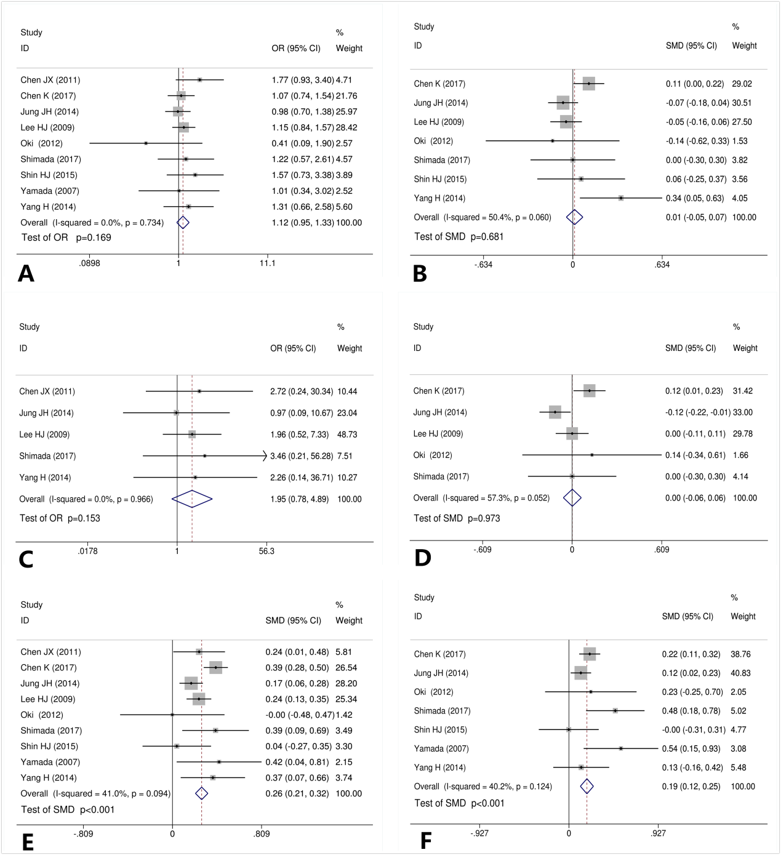
Figure 2 Correlation between body mass index and short-term impacts/difficulties in laparoscopy gastrectomy. A: Correlation between body mass index (BMI) and postoperative complications in laparoscopy gastrectomy; B: Correlation between BMI and the duration of the postoperative hospital stay; C: Correlation between BMI and postoperative mortality; D: Correlation between BMI and the time to starting diet; E: Correlation between BMI and the operative time; F: Correlation between BMI and blood loss. SMD: Standard mean difference.

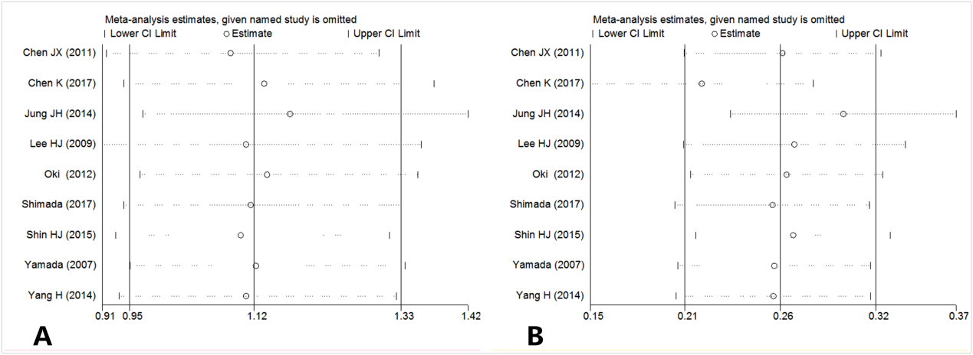
Figure 3 Sensitive analysis of postoperative complications and operative time, associated with body mass index. A: Sensitive analysis of correlation between body mass index (BMI) and postoperative complications in laparoscopy gastrectomy; B: Sensitive analysis of correlation between BMI and the operative time.
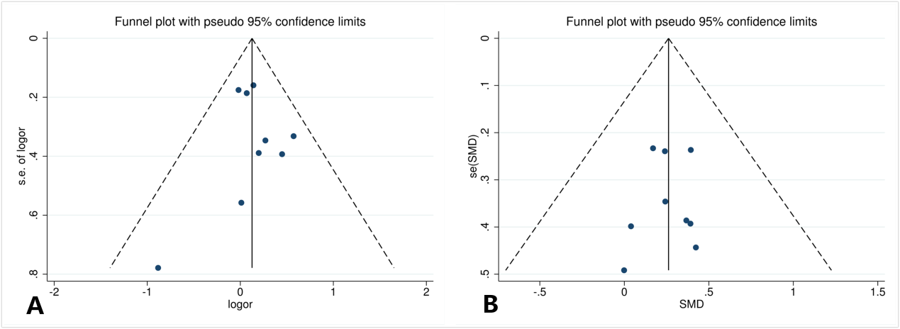
Figure 4 Funnel plot analysis of postoperative complications and operative time, associated with body mass index. A: Funnel plot analysis of correlation between body mass index (BMI) and postoperative complications in laparoscopy gastrectomy; B: Funnel plot analysis of correlation between BMI and the operative time. SMD: Standard mean difference.
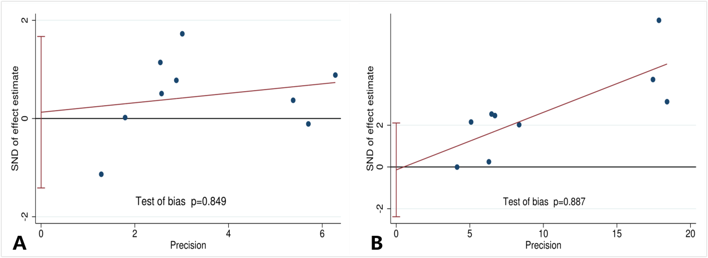
Figure 5 Egger’s test of postoperative complications and operative time, associated with body mass index. A: Egger’s test of correlation between body mass index (BMI) and postoperative complications in laparoscopy gastrectomy; B: Egger’s test of correlation between BMI and the operative time.
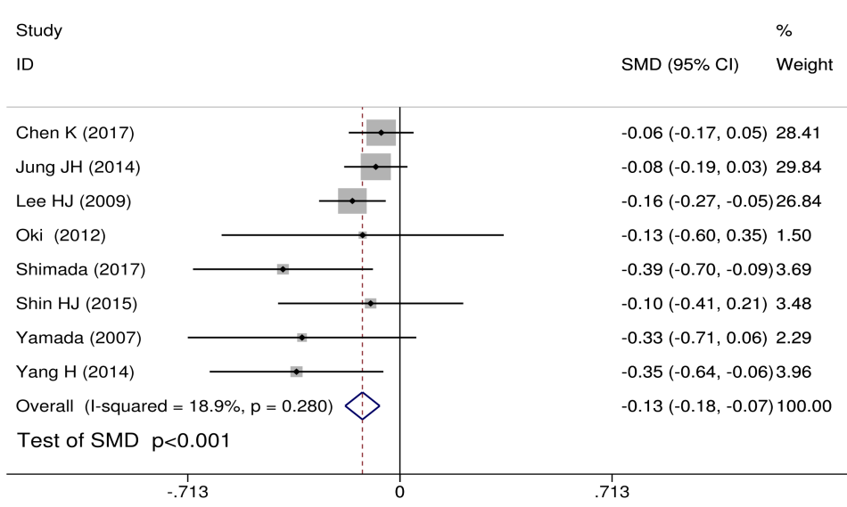
Figure 6 Correlation between body mass index and the number of retrieved lymph node. SMD: Standard mean difference.

