Name of Journal: World Journal of Clinical Cases
Manuscript NO: 76256
Manuscript Type: CASE REPORT

Intra-abdominal ectopic bronchogenic cyst with a mucinous neoplasm harboring a GNAS mutation: A case report

Murakami T et al. Abdominal bronchogenic cyst with GNAS mutation

Takashi Murakami, Hiroaki Shimizu, Kazuto Yamazaki, Hiroyuki Nojima, Akihiro Usui, Chihiro Kosugi, Kiyohiko Shuto, Shuntaro Obi, Takahisa Sato, Masato Yamazaki, Keiji Koda

Takashi Murakami, Hiroaki Shimizu, Hiroyuki Nojima, Akihiro Usui, Chihiro Kosugi, Kiyohiko Shuto, Masato Yamazaki, Keiji Koda, Department of Surgery, Teikyo University Chiba Medical Center, Ichihara 299-0111, Chiba, Japan

Kazuto Yamazaki, Department of Pathology, Teikyo University Chiba Medical Center, Ichihara 299-0111, Chiba, Japan

Shuntaro Obi, Takahisa Sato, Department of Internal Medicine, Teikyo University Chiba Medical Center, Ichihara 299-0111, Chiba, Japan

Author contributions: Murakami T, Shimizu H, Nojima H, and Yamazaki M performed surgery; Murakami T and Shimizu H contributed to manuscript drafting; Yamazaki K contributed to pathological diagnosis and manuscript drafting; Usui A, Kosugi C, and Shuto K contributed to preoperative diagnosis; Sato T, Obi S, and Koda K contributed to medical follow-up; Murakami T, Shimizu H, and Koda K were responsible for the manuscript revision; all authors made final approval for the manuscript to be submitted.

Corresponding author: Hiroaki Shimizu, MD, PhD, Professor, Department of Surgery, Teikyo University Chiba Medical Center, 3426-3, Anesaki, Ichihara 299-0111, Chiba, Japan. h-shimizu@med.teikyo-u.ac.jp

Received: March 10, 2022
Revised: April 23, 2022
Accepted: July 18, 2022
Published online:

Abstract
BACKGROUND
Bronchogenic cysts are congenital cysts caused by abnormal sprouting from the ventral foregut during fetal life. They usually occur in the mediastinum or lung, but there are very rare cases of ectopic bronchogenic cysts that develop in the abdominal cavity. A unique intra-abdominal ectopic bronchogenic cyst with a mucinous neoplasm that was producing carcinoembryonic antigen (CEA), harboring a GNAS mutation, is reported. The present case may contribute to clarifying the mechanism of tumorigenesis and malignant transformation of ectopic bronchogenic cysts.

CASE SUMMARY
In 2007, a man in his 50s was incidentally found to have an intra-abdominal cystic mass, 8 cm in diameter. Surgical resection was recommended, but he preferred to remain under observation. In 2020, his serum CEA level increased to 26.7 ng/mL, and abdominal computed tomography showed a 15 cm × 12 cm, multifocal, cystic mass located predominantly on the lesser curvature of the stomach. Since malignancy could not be ruled out, he finally underwent surgical resection. Histologically, the cystic wall was lined by ciliated columnar epithelium, accompanied by bronchial gland-like tissue, bronchial cartilage, and smooth muscle. Part of the cyst consisted of atypical columnar epithelium with an MIB-1 index of 5% and positive for CEA. Moreover, a GNAS mutation (p.R201C) was detected in the atypical epithelium, leading to a diagnosis of an ectopic bronchogenic cyst with a low-grade mucinous neoplasm. The patient is currently undergoing outpatient follow-up without recurrence.

CONCLUSION
An extremely rare case of an abdominal bronchogenic cyst with a low-grade mucinous neoplasm harboring a GNAS mutation was reported.

Key Words: Congenital, hereditary, and neonatal diseases and abnormalities; Ectopic bronchogenic cyst; Abdominal neoplasms; GNAS mutation; Carcinoembryonic antigen; Case report

Murakami T, Shimizu H, Yamazaki K, Nojima H, Usui A, Kosugi C, Shuto K, Obi S, Sato T, Yamazaki M, Koda K. Intra-abdominal ectopic bronchogenic cyst with a mucinous neoplasm harboring a GNAS mutation: A case report. World J Clin Cases 2022; In press

Core Tip: A man in his 60s had an intra-abdominal, 15-cm, multifocal, cystic mass located on the lesser curvature of the stomach, and he underwent surgical resection. Histologically, the resected cystic wall was lined by ciliated columnar epithelium, accompanied by bronchial gland-like tissue, bronchial cartilage, and smooth muscle. Part of the cyst consisted of atypical columnar epithelium with an MIB-1 index of 5% that was positive for carcinoembryonic antigen. Moreover, a GNAS mutation (p.R201C) was detected in the atypical epithelium, leading to a diagnosis of an ectopic bronchogenic cyst with a low-grade mucinous neoplasm.

INTRODUCTION
Bronchogenic cysts are congenital cysts caused by abnormal sprouting from the ventral foregut during fetal life from the 3rd to 7th weeks^{[1]}. Bronchogenic cysts usually occur in the mediastinum or lung, but there are rare cases of ectopic bronchogenic cysts that develop in the abdominal cavity or retroperitoneum^{[2,3]}. There are some reports of malignant transformation in bronchogenic cysts, but the mechanism of tumorigenesis and malignant transformation is still unknown^{[1]}. An extremely rare case of an intra-abdominal ectopic bronchogenic cyst with carcinoembryonic antigen (CEA) production, in which a mucinous neoplasm harboring a GNAS gene mutation was observed, is presented. The present case may contribute to clarifying the mechanism of tumorigenesis and malignant transformation of ectopic bronchogenic cysts.

CASE PRESENTATION
Chief complaints
The patient had no symptoms.

History of present illness
A man in his 50s underwent magnetic resonance imaging (MRI) for the follow-up of chronic pancreatitis in 2007 and was incidentally found to have an 8-cm-diameter intra-abdominal mass. His physician referred him to the Department of Surgery, but he preferred to remain under observation because he had no symptoms. In 2020, his serum CEA level increased to 26.7 ng/mL, suggesting possible malignancy, and he was finally referred to our department.

History of past illness
The patient had a history of gastroesophageal reflux disease and thoracic compression fracture.

Personal and family history
The patient had no relevant family history.

Physical examination
A large, soft mass was palpable in the left upper quadrant.

Laboratory examinations
The CEA level was elevated to 26.7 ng/mL, whereas the carbohydrate antigen (CA)19-9 level was within the normal limit. Blood counts, blood biochemistry, and coagulation function were all normal.

Imaging examinations
MRI T2-weighted imaging showed a high-intensity, multifocal, cystic mass between the stomach and lateral lobe of the liver (Figure 1). A mass the size of a child’s head was palpable in the left upper quadrant, but he had no symptoms. Contrast-enhanced computed tomography (CT) showed that the multifocal cystic mass had increased to 15 cm in diameter, and part of the cystic wall showed calcification and partial thickness, but there were no obvious intra-cystic nodules (Figure 2A and B). The surrounding organs such as the stomach, pancreas, and liver were markedly compressed by the mass, but the borders of the mass were clear.

Endoscopic examinations
Esophagogastroduodenoscopy showed compression of the lesser curvature, but no neoplastic lesions were found in the gastric mucosa (Figure 2C). Colonoscopy did not show any neoplastic lesions.

FINAL DIAGNOSIS
The final diagnosis was an intra-abdominal ectopic bronchogenic cyst with a low-grade mucinous neoplasm harboring a GNAS mutation.

TREATMENT
These findings suggested that the primary site of the tumor was within the lesser omentum. Although he was not diagnosed definitely, malignancy was suspected due to the increasing size of the mass and elevated CEA level. Therefore, he finally underwent surgical resection after his informed consent was obtained.
After laparotomy and resection of the lesser omentum, a smooth-surfaced mass, 15 cm in diameter, was exposed. Most of the mass was loosely attached to surrounding organs and easily dissected, though the mass adhered to the lesser curvature of the stomach (Figure 3A). Therefore, partial resection of the seromuscular layer of the stomach was required to remove the mass (Figure 3B). The defected seromuscular layer was sutured. The operation time was 2 h and 46 min, and intraoperative bleeding was 450 g.

Pathological examinations
On gross examination of the resected specimen, the mass was multifocal and filled with viscous mucus, with size of 15 cm × 12 cm × 12 cm and weight of 1240 g (Figure 3C). Part of the cystic wall consisted of cartilage (Figure 3D). Histologically, the majority of the cystic wall was lined by ciliated columnar epithelium, and bronchial gland-like tissue, cartilage, and smooth muscle were observed in the deeper layer, leading to the diagnosis of an ectopic bronchogenic cyst (Figure 4A and B). Meanwhile, part of the cystic wall, about 5 cm in size, was lined by high columnar epithelium containing mucus in the cytoplasm (Figure 4C and D). This columnar epithelium was folded, making papillary structures, which was considered to be a low-grade mucinous neoplasm. The MIB-1 index was 5% at the site of the low-grade mucinous neoplasm (Figure 5A). Immunohistochemical staining showed that the area with the low-grade mucinous neoplasm was positive for CK20 and CDX2, and negative for CK7, indicating intestinal metaplasia (Figure 5B and C). In addition, the neoplastic lesion showed positive staining for CEA, suggesting CEA production (Figure 5D).

Gene mutation analysis
GNAS mutation analysis by the Sanger method of the lesion with the low-grade mucinous neoplasm showed a missense mutation at codon 201 (p.R201C, c.601C>T; Figure 6).

OUTCOME AND FOLLOW-UP
The patient had grade II delayed gastric emptying, but he recovered and was discharged on the 25th postoperative day. His serum CEA level normalized. He continues to be under observation without evidence of recurrence at 1-year follow-up.

DISCUSSION
This is the first report of a case of an intra-abdominal ectopic bronchogenic cyst with a mucinous neoplasm that was producing CEA, harboring a GNAS mutation.
Bronchogenic cysts are congenital cysts that are established by persistent secretion from abnormal sprouting lung buds that lack continuity with the tracheobronchial system during fetal life^{[4,5]}. Most bronchogenic cysts develop in the lungs or mediastinum; if abnormal lung buds sprout before 4 wk of fetal life, bronchogenic cysts are located in the mediastinum, and if they sprout after 4 wk of fetal life, bronchogenic cysts are located in the lungs^{[6,7]}. The thoracic cavity and abdominal cavity are connected by the pericardioperitoneal canal, but they become separated by the diaphragm, which develops from the septum transversum, dorsal esophageal mesentery, and pleuroperitoneal fold by 7 wk of fetal life^{[6,8,9]}. Therefore, intra-abdominal bronchogenic cysts are considered to be caused by abnormally sprouted lung buds that wandered into the abdominal cavity prior to diaphragmatic formation through the pericardioperitoneal canal.
Ectopic bronchogenic cysts are very rare and have been reported to occur in the abdominal cavity, retroperitoneum, neck, tongue, and scapula^{[10]}. Subphrenic ectopic bronchogenic cysts develop more often on the left side of the patient, with fewer intra-abdominal cases than retroperitoneal cases^{[5]}. In 2011, Ubukata et al^{[5]} summarized 12 cases of intra-abdominal bronchogenic cysts, 9 of which were located close to the stomach, suggesting that intra-abdominal bronchogenic cysts tend to develop around the stomach. In a report of a rare case, a bronchogenic cyst attached to the gastric wall was invaded by adjacent gastric cancer^{[11]}.
Bronchogenic cysts are visualized as spherical masses with clear borders, but CT values of the cystic contents vary from as low as normal cysts to as high as solid tumors^{[12]}. With regard to MRI, Murakami et al^{[13]} and Martín et al^{[14]} stated that high intensity of cystic contents on T1-weighted images is more useful than CT for differential diagnosis, but there are also some cases with low intensity of cystic contents on T1-weighted imaging. Due to the rarity of intra-abdominal bronchogenic cysts and the diversity of imaging findings, preoperative diagnosis is considered to be extremely difficult^{[12]}. Due to the risk of tumor cell dissemination, histological or cytological diagnosis by puncture of cysts is not indicated. The definite diagnosis of bronchogenic cysts is based on histological examination of resected specimens, and they are characterized by a bronchial-like histology such as ciliated columnar epithelium, cartilage, bronchial gland, and smooth muscle in the cystic wall^{[1]}.
Since ectopic bronchogenic cysts are extremely rare, details of their prognosis are still unclear. Malignant transformation has been reported in a few cases of retroperitoneal bronchogenic cysts^{[1]}. The tumor diameter of malignant cases (11.7 ± 4.7 cm) was reported to be larger than that of benign cases (5.5 ± 2.9 cm)^{[12]}. Moreover, levels of serum tumor markers such as CEA, CA19-9, or CA125 were high in malignant cases^{[1,12]}. The increasing serum CEA level in the present case suggested potential malignant transformation.
Regarding the indications for surgery, cases with possible malignant transformation, such as those with increasing tumor diameter or elevated serum tumor marker levels, should be treated with surgical resection^{[1,12]}. Moreover, there are reports recommending complete surgical resection for all bronchogenic cysts, because malignancy can be found after surgical resection, and recurrence or infection can occur even in benign cases^{[15,16]}. Similar to the present case, there was a report of a patient with an intra-abdominal bronchogenic cyst that developed in the gastric cardia who underwent partial resection of the seromuscular layer of the stomach^{[17]}. Some cases of intra-abdominal bronchogenic cysts underwent laparoscopic tumor resection^{[18,19]}. Since the tumor was large and suspected to have malignant transformation in the present case, open laparotomy was preferred to maintain the intraoperative field of view and to avoid incidental tumor cell dissemination due to accidental perforation of the mass.
As for pathological findings, CK20-positive and CK7-negative are specific for gastric, small intestinal, and colonic epithelium, and CDX2 encodes an intestine-specific transcription factor that is expressed in the nuclei of epithelial cells in the small intestine and colorectum^{[20]}. In the present case, the area with low-grade adenoma was positive for CK20 and CDX2 and negative for CK7, suggesting a background intestinal metaplasia. GNAS is a proto-oncogene encoding a stimulatory G protein α subunit (GSα), which is a signal mediator of the G protein-coupled receptor signaling pathway located at 20q13.3^{[21]}. GNAS mutations have been found in intraductal papillary mucinous neoplasms (IPMNs) of the pancreas, colorectal villous adenomas, gastric pyloric gland adenomas, appendiceal mucinous neoplasms, and a bronchial mucous gland adenoma^{[22-25]}. Most GNAS mutations observed in IPMN are caused by R201H or R201C mutations, missense mutations at codon 201, which result in reducing intrinsic hydrolytic activity of GSα, prolonging activation of cell proliferation signals^{[23]}. The GNAS mutation is considered to play a central role in mucus production in appendiceal mucinous neoplasms^{[25]}. In the present case, a low-grade mucinous neoplasm was thought to be caused by the GNAS mutation at the site of intestinal metaplasia. Since the GNAS mutation has also been observed in some appendiceal mucinous carcinomas, a low-grade mucinous neoplasm in bronchogenic cysts may undergo malignant transform to mucinous carcinoma^{[26]}. Since this is the first report describing a GNAS mutation in a bronchogenic cyst, further investigation of the association between GNAS mutations and tumorigenesis both in ectopic and normotopic bronchogenic cysts through accumulation of additional cases is expected.

CONCLUSION
An extremely rare case of a huge abdominal bronchogenic cyst with a low-grade mucinous neoplasm harboring a GNAS mutation was reported. The present case may contribute to elucidating the pathogenesis and natural history of ectopic bronchogenic cysts.

REFERENCES
1 Sullivan SM, Okada S, Kudo M, Ebihara Y. A retroperitoneal bronchogenic cyst with malignant change. Pathol Int 1999; 49: 338-341 [PMID: 10365854 DOI: 10.1046/j.1440-1827.1999.00869.x]
2 Subramanian JB, K S S, Selvarangam S. A case report- retroperitoneal bronchogenic cyst in relation to the hindgut. Int J Surg Case Rep 2020; 75: 140-142 [PMID: 32950943 DOI: 10.1016/j.ijscr.2020.09.038]
3 Choi KK, Sung JY, Kim JS, Kim MJ, Park H, Choi DW, Choi SH, Heo JS. Intra-abdominal bronchogenic cyst: report of five cases. Korean J Hepatobiliary Pancreat Surg 2012; 16: 75-79 [PMID: 26388911 DOI: 10.14701/kjhbps.2012.16.2.75]
4 Coselli MP, de Ipolyi P, Bloss RS, Diaz RF, Fitzgerald JB. Bronchogenic cysts above and below the diaphragm: report of eight cases. Ann Thorac Surg 1987; 44: 491-494 [PMID: 3675053 DOI: 10.1016/s0003-4975(10)62106-6]
5 Ubukata H, Satani T, Motohashi G, Konishi S, Goto Y, Watanabe Y, Nakada I, Tabuchi T. Intra-abdominal bronchogenic cyst with gastric attachment: report of a case. Surg Today 2011; 41: 1095-1100 [PMID: 21773899 DOI: 10.1007/s00595-010-4398-6]
6 Tanaka G, Yamashita H, Yasui A, Suka Y, Nagai M, Ohira Y, Suzuki Y. Laparoscopic resection of a retroperitoneal bronchogenic cyst: A case report. J Jpn Surg Assoc 2020; 81: 367-373 [DOI: 10.3919/jjsa.81.367]
7 Gomes MN, Hufnagel CA. Intrapericardial bronchogenic cysts. Am J Cardiol 1975; 36: 817-822 [PMID: 1199940 DOI: 10.1016/0002-9149(75)90466-x]
8 Sumiyoshi K, Shimizu S, Enjoji M, Iwashita A, Kawakami K. Bronchogenic cyst in the abdomen. Virchows Arch A Pathol Anat Histopathol 1985; 408: 93-98 [PMID: 3933174 DOI: 10.1007/BF00739965]
9 Merrell AJ, Kardon G. Development of the diaphragm -- a skeletal muscle essential for mammalian respiration. FEBS J 2013; 280: 4026-4035 [PMID: 23586979 DOI: 10.1111/febs.12274]
10 Tang J, Zeng Z, Deng S, Lin F. Ectopic bronchogenic cyst arising from the diaphragm: a rare case report and literature review. BMC Surg 2021; 21: 321 [PMID: 34376164 DOI: 10.1186/s12893-021-01317-w]
11 Shibahara H, Arai T, Yokoi S, Hayakawa S. Bronchogenic cyst of the stomach involved with gastric adenocarcinoma. Clin J Gastroenterol 2009; 2: 80-84 [PMID: 26192170 DOI: 10.1007/s12328-008-0042-z]
12 Eguchi H, Ohigashi H, Ishikawa O, Kasugai T, Yokoyama S, Sasaki Y, Miyashiro I, Doki Y, Murata K, Imaoka S. A case of retroperitoneal bronchogenic cysts with malignant regeneration. Jpn J Gastroenterol Surg 2004; 37: 584-589 [DOI: 10.5833/jjgs.37.584]
13 Murakami R, Machida M, Kobayashi Y, Ogura J, Ichikawa T, Kumazaki T. Retroperitoneal bronchogenic cyst: CT and MR imaging. Abdom Imaging 2000; 25: 444-447 [PMID: 10926202 DOI: 10.1007/s002610000019]
14 Martín R, Sanz E, de Vicente E, Ortega P, Labrador E, Paumard A, Gómez-Durán J, Quijano Y, Santamaría L. Differential diagnosis of asymptomatic retroperitoneal cystic lesion: a new case of retroperitoneal bronchogenic cyst. Eur Radiol 2002; 12: 949-950 [PMID: 11960255 DOI: 10.1007/s003300101119]
15 Cuypers P, De Leyn P, Cappelle L, Verougstraete L, Demedts M, Deneffe G. Bronchogenic cysts: a review of 20 cases. Eur J Cardiothorac Surg 1996; 10: 393-396 [PMID: 8817131 DOI: 10.1016/s1010-7940(96)80103-5]
16 Hasegawa T, Murayama F, Endo S, Sohara Y. Recurrent bronchogenic cyst 15 years after incomplete excision. Interact Cardiovasc Thorac Surg 2003; 2: 685-687 [PMID: 17670158 DOI: 10.1016/S1569-9293(03)00204-4]
17 Xiao J, Zhang R, Chen W, Wu B. Ectopic bronchogenic cyst of the gastric cardia considered to be a gastrointestinal stromal tumor before surgery: a case report. BMC Surg 2020; 20: 42 [PMID: 32122361 DOI: 10.1186/s12893-020-00704-z]
18 Trehan M, Singla S, Singh J, Garg N, Mahajan A. A Rare Case of Intra-Abdominal Bronchogenic Cyst- A Case Report. J Clin Diagn Res 2015; 9: PD03-PD04 [PMID: 26675877 DOI: 10.7860/JCDR/2015/12949.6761]
19 Díaz Nieto R, Naranjo Torres A, Gómez Alvarez M, Ruiz Rabelo JF, Pérez Manrique MC, Ciria Bru R, Valverde Martínez A, Roldán de la Rúa J, Alonso Gómez J, Rufián Peña S. Intraabdominal bronchogenic cyst. J Gastrointest Surg 2010; 14: 756-758 [PMID: 19475460 DOI: 10.1007/s11605-009-0932-5]
20 Lee BH, Kim N, Lee HS, Kang JM, Park HK, Jo HJ, Shin CM, Lee SH, Park YS, Hwang JH, Kim JW, Jeong SH, Lee DH, Jung HC, Song IS. The Role of CDX2 in Intestinal Metaplasia Evaluated Using Immunohistochemistry. Gut Liver 2012; 6: 71-77 [PMID: 22375174 DOI: 10.5009/gnl.2012.6.1.71]
21 Ritterhouse LL, Vivero M, Mino-Kenudson M, Sholl LM, Iafrate AJ, Nardi V, Dong F. GNAS mutations in primary mucinous and non-mucinous lung adenocarcinomas. Mod Pathol 2017; 30: 1720-1727 [PMID: 28776576 DOI: 10.1038/modpathol.2017.88]
22 Kojima R, Morimoto J, Ishida Y, Sugano I, Yamazaki K. A bronchial mucous gland adenoma harboring GNAS R201C mutation. Diagn Cytopathol 2021; 49: E203-E206 [PMID: 33237605 DOI: 10.1002/dc.24674]
23 Furukawa T, Kuboki Y, Tanji E, Yoshida S, Hatori T, Yamamoto M, Shibata N, Shimizu K, Kamatani N, Shiratori K. Whole-exome sequencing uncovers frequent GNAS mutations in intraductal papillary mucinous neoplasms of the pancreas. Sci Rep 2011; 1: 161 [PMID: 22355676 DOI: 10.1038/srep00161]
24 Matsubara A, Sekine S, Kushima R, Ogawa R, Taniguchi H, Tsuda H, Kanai Y. Frequent GNAS and KRAS mutations in pyloric gland adenoma of the stomach and duodenum. J Pathol 2013; 229: 579-587 [PMID: 23208952 DOI: 10.1002/path.4153]
25 Nishikawa G, Sekine S, Ogawa R, Matsubara A, Mori T, Taniguchi H, Kushima R, Hiraoka N, Tsuta K, Tsuda H, Kanai Y. Frequent GNAS mutations in low-grade appendiceal mucinous neoplasms. Br J Cancer 2013; 108: 951-958 [PMID: 23403822 DOI: 10.1038/bjc.2013.47]
26 Garland-Kledzik M, Scholer A, Ensenyat-Mendez M, Orozco JIJ, Khader A, Santamaria-Barria J, Fischer T, Pigazzi A, Marzese DM. Establishing Novel Molecular Subtypes of Appendiceal Cancer. Ann Surg Oncol 2022; 29: 2118-2125 [PMID: 34718915 DOI: 10.1245/s10434-021-10945-8]

Footnotes
Informed consent statement: The patient in the present report underwent surgical resection after his informed consent was obtained.

Conflict-of-interest statement: The authors have no conflict-of-interest.

CARE Checklist (2016) statement: The authors have read the CARE Checklist (2016), and the manuscript was prepared and revised according to the CARE Checklist (2016).

Open-Access: This article is an open-access article that was selected by an in-house editor and fully peer-reviewed by external reviewers. It is distributed in accordance with the Creative Commons Attribution NonCommercial (CC BY-NC 4.0) license, which permits others to distribute, remix, adapt, build upon this work non-commercially, and license their derivative works on different terms, provided the original work is properly cited and the use is non-commercial. See: https://creativecommons.org/Licenses/by-nc/4.0/

Provenance and peer review: Unsolicited article; Externally peer reviewed.
Peer-review model: Single blind

Corresponding Author's Membership in Professional Societies: Japanese Society of Hepato-Biliary-Pancreatic Surgery.

Peer-review started: March 10, 2022
First decision: April 10, 2022
Article in press:

Specialty type: Gastroenterology and hepatology
Country/Territory of origin: Japan
Peer-review report’s scientific quality classification
Grade A (Excellent): 0
Grade B (Very good): B, B
Grade C (Good): 0
Grade D (Fair): 0
Grade E (Poor): 0

P-Reviewer: Feng J, China; Navarrete Arellano M, Mexico S-Editor: Yan JP L-Editor: A P-Editor: Yan JP

Figure Legends
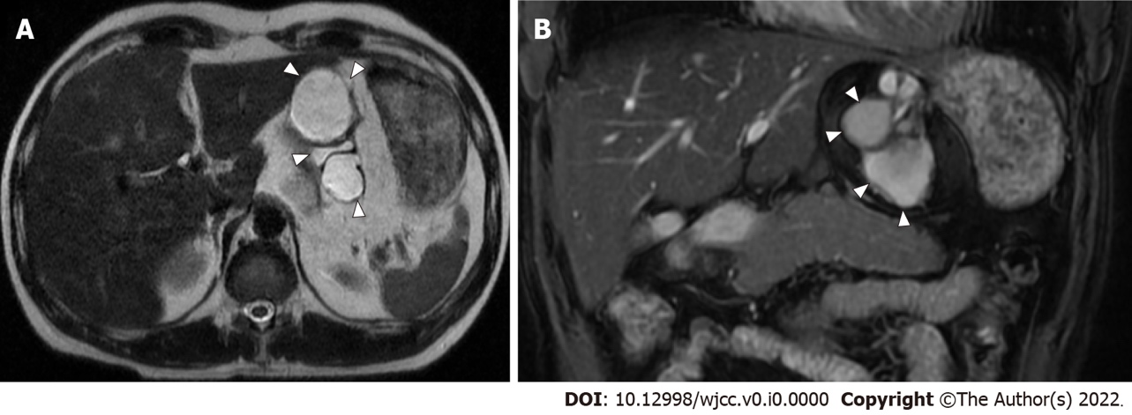

Figure 1 Abdominal magnetic resonance imaging findings in 2007. Axial and coronal views of magnetic resonance imaging T2-weighted images show a multifocal, cystic mass with a diameter of 8 cm between the stomach and left lateral lobe of the liver. The white arrowhead indicates the mass. A: Axial view; B: Coronal view.

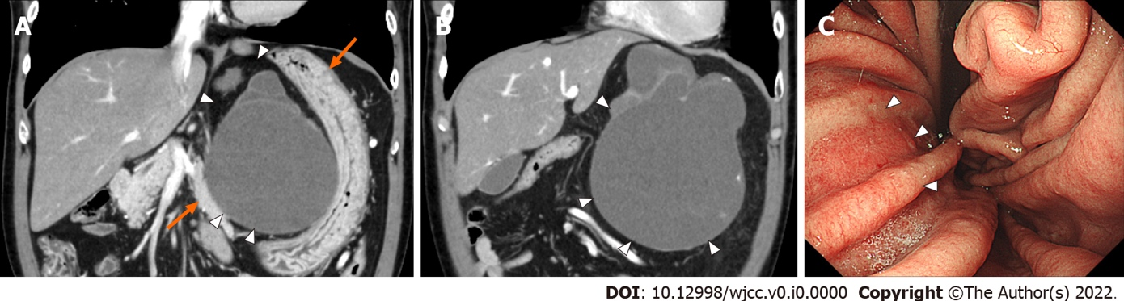

Figure 2 Abdominal contrast-enhanced computed tomography and endoscopic findings in 2020. A and B: Coronal view of abdominal contrast-enhanced computed tomography shows that the size of the mass has increased to 15 cm (white arrowhead). Part of the wall of the mass shows thickness and contains calcification, but no obvious intracystic nodules are seen. Stomach and pancreas were compressed (orange arrows); C: Esophagogastroduodenoscopy shows that the lesser curvature of the stomach is compressed by the mass (white arrowhead).

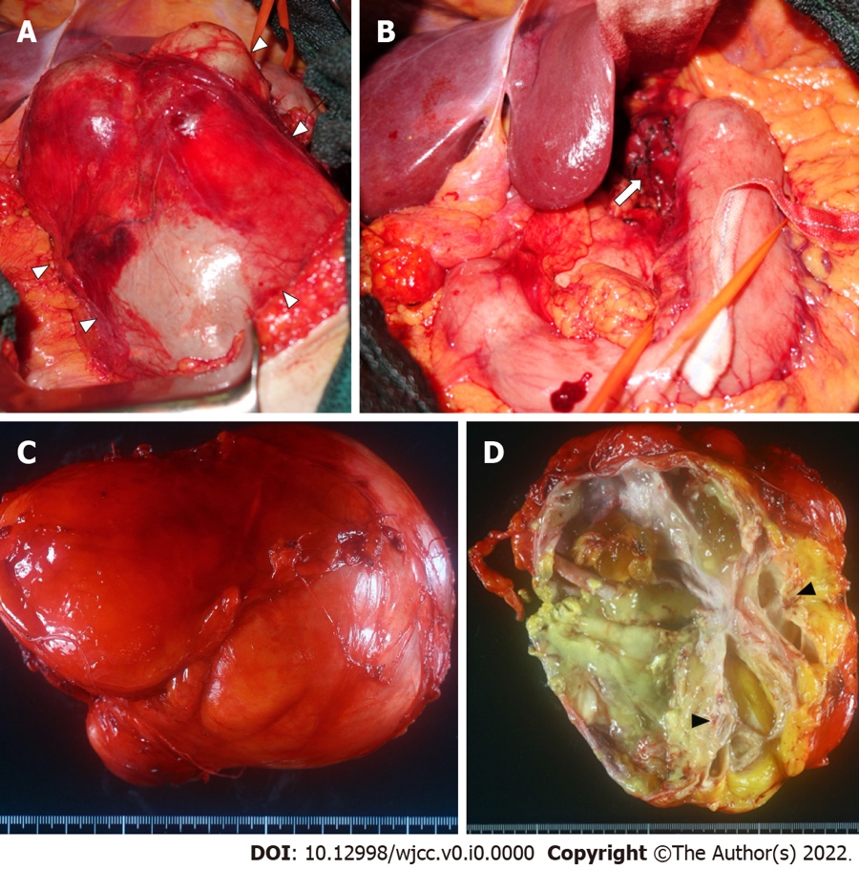

Figure 3 Intraoperative findings and macroscopic findings of the resected specimen. A: A smooth surfaced mass (white arrowhead) is exposed after resection of the lesser omentum; B: The mass is resected with a part of the seromuscular layer of the lessor curvature of the stomach (white arrow) and removed; C: The resected specimen is a multifocal mass filled with viscous mucus, 15 cm × 12 cm × 12 cm in size and weighing 1240 g; D: Cartilage-like tissue (black arrowhead) is observed in part of the cystic wall.

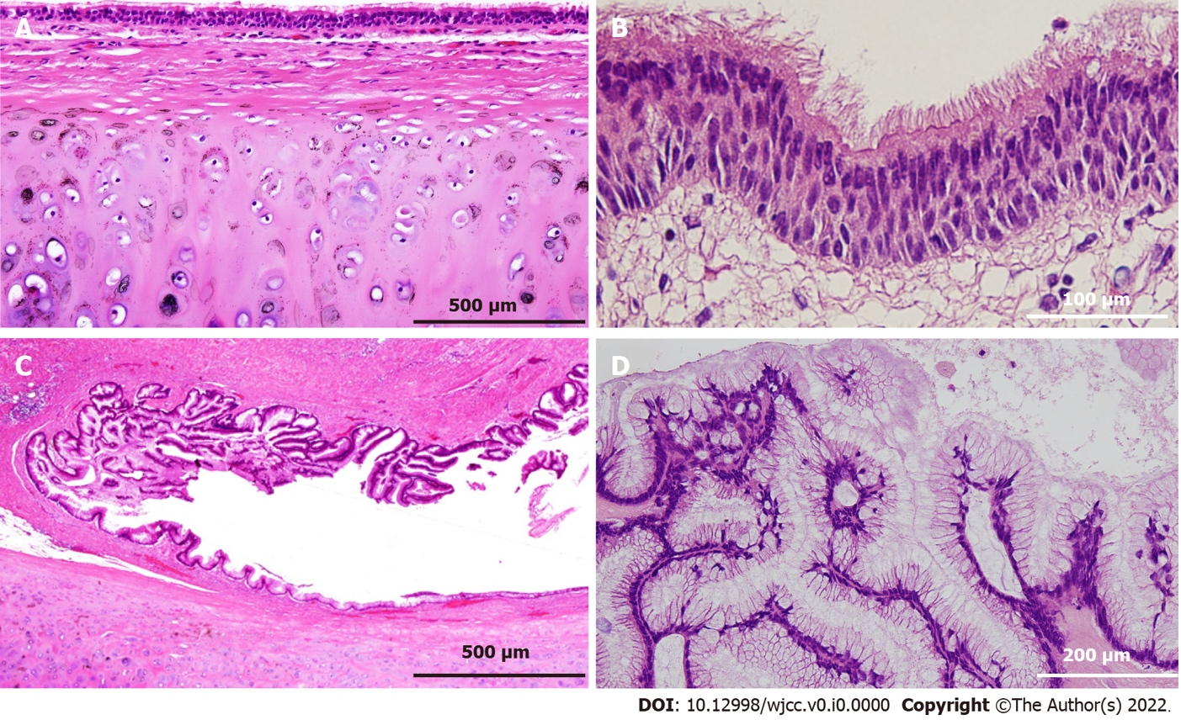

Figure 4 Histological findings of the resected specimen. A and B: The majority of the cystic wall is lined by ciliated columnar epithelium, and bronchial cartilage is observed in the deeper layer of the mucosa (A, × 100; B, × 400); C and D: High columnar epithelium containing mucus in the cytoplasm is observed in part of the cystic epithelium, considered to be a low-grade mucinous neoplasm (C, × 100; D, × 200).

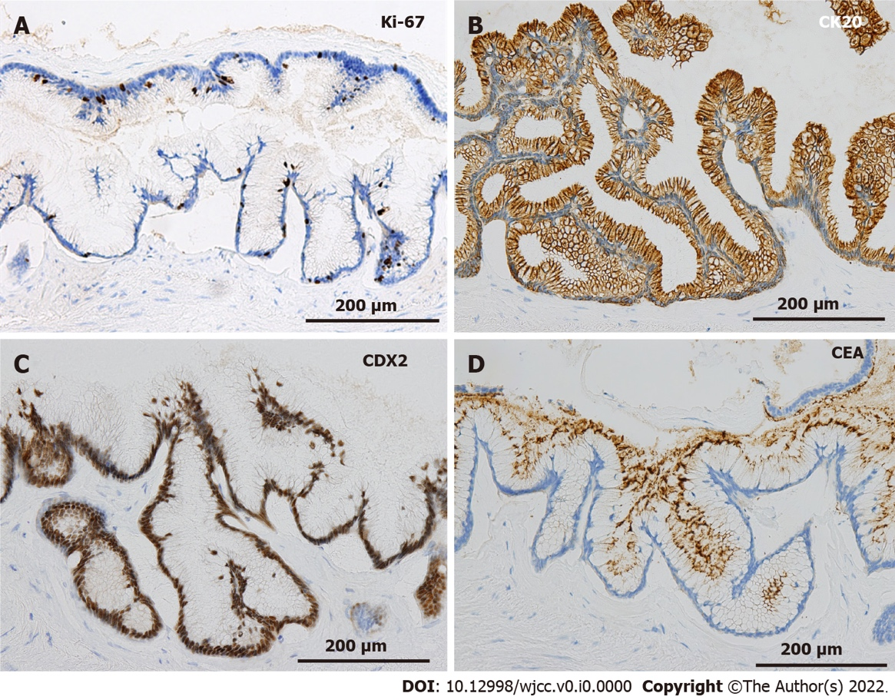

Figure 5 Immunohistochemical staining at the site of the low-grade mucinous neoplasm. A: The MIB-1 index is 5% at the site of the low-grade mucinous neoplasm (× 200); B-D: The area with the low-grade mucinous neoplasm is positive for CK20, CDX2, and carcinoembryonic antigen (× 200).

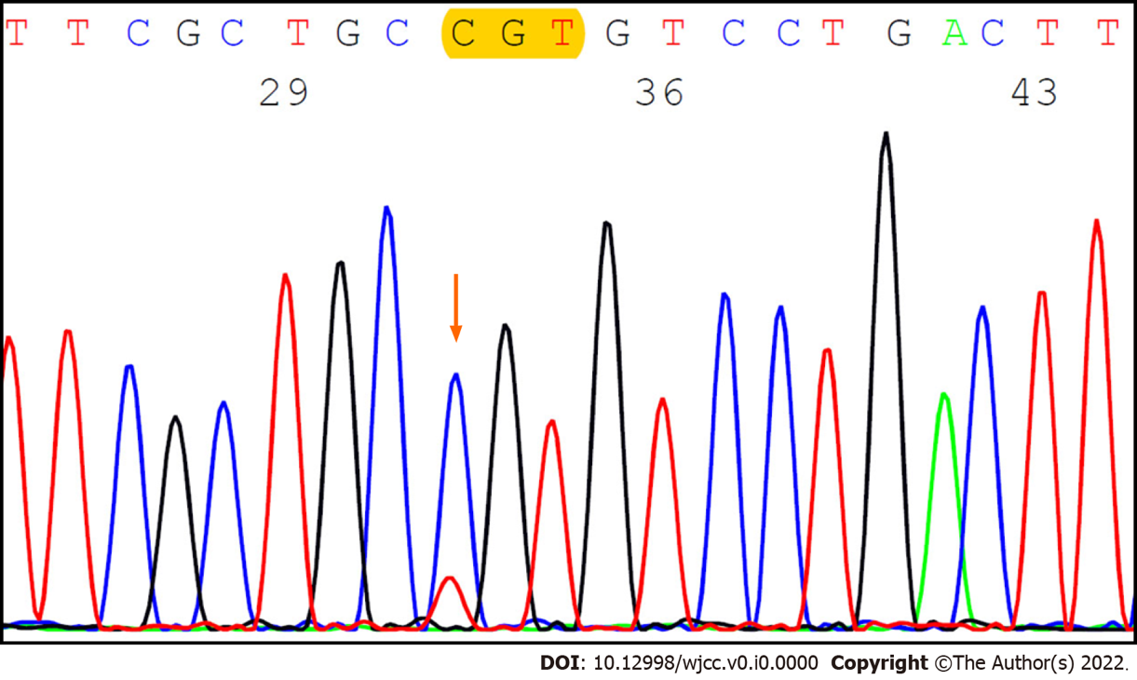
Figure 6 GNAS expression analysis by the Sanger method. The Sanger method shows a missense alteration on codon 201 (p.R201C) in the lesion with the low-grade mucinous neoplasm.

