Name of Journal: World Journal of Clinical Cases
Manuscript NO: 85714
Manuscript Type: META-ANALYSIS

Laparoscopic vs open radical resection in management of gallbladder carcinoma: A systematic review and meta-analysis

He S et al. LRR vs ORR in GBC: A meta-analysis

Shiin He, Tu-Nan Yu, Jia-Sheng Cao, Xue-Yin Zhou, Zhe-Han Chen, Wen-Bin Jiang, Liu-Xin Cai, Xiao Liang

Shiin He, Tu-Nan Yu, Jia-Sheng Cao, Xue-Yin Zhou, Wen-Bin Jiang, Liu-Xin Cai, Xiao Liang, Department of General Surgery, Sir Run-Run Shaw Hospital of Zhejiang University School of Medicine, Hangzhou 310016, Zhejiang Province, China

Xue-Yin Zhou, School of Medicine, Wenzhou Medical University, Wenzhou 325035, Zhejiang Province, China

Zhe-Han Chen, The Second Clinical Medical College, Zhejiang Chinese Medical University, Hangzhou 310053, Zhejiang Province, China

Zhe-Han Chen, Department of Hepatobiliary Surgery, Fuyang First People’s Hospital Affiliated to Zhejiang Chinese Medical University, Hangzhou 311400, Zhejiang Province, China

Author contributions: He S acquired, analyzed, and interpreted the data, drafted the manuscript, and approved the final manuscript; Yu TN, Cao JS, and Cai LX revised the manuscript and approved the final manuscript; Zhou XY and Chen ZH interpreted the data, revised the manuscript, and approved the final manuscript; Jiang WB acquired and interpreted the data, and approved the final manuscript; Liang X conceptualized and designed the study, critically revised the manuscript, and approved the final manuscript.

Corresponding author: Xiao Liang, MD, PhD, Attending Doctor, Professor, Surgeon, Department of General Surgery, Sir Run-Run Shaw Hospital of Zhejiang University School of Medicine, No. 3 East Qingchun Road, Hangzhou 310016, Zhejiang Province, China. srrshlx@zju.edu.cn

Received: May 20, 2023
Revised: June 29, 2023
Accepted: July 24, 2023
Published online:

Abstract
BACKGROUND
Radical resection offers the only hope for the long-term survival of patients with gallbladder carcinoma (GBC) above the T1b stage. However, whether it should be performed under laparoscopy for GBC is still controversial.

AIM
To compare laparoscopic radical resection (LRR) with traditional open radical resection (ORR) in managing GBC.

METHODS
A comprehensive search of online databases, including Medline (PubMed), Cochrane Library, and Web of Science, was conducted to identify comparative studies involving LRR and ORR in GBCs till March 2023. A meta-analysis was subsequently performed.

RESULTS
A total of 18 retrospective studies were identified. In the long-term prognosis, the LRR group was comparable with the ORR group in terms of overall survival and tumor-free survival (TFS). LRR showed superiority in terms of TFS in the T2/tumor-node-metastasis (TNM) Ⅱ stage subgroup vs the ORR group (P = 0.04). In the short-term prognosis, the LRR group had superiority over the ORR group in the postoperative length of stay (POLS) (P < 0.001). The sensitivity analysis showed that all pooled results were robust.

CONCLUSION
The meta-analysis results show that LRR is not inferior to ORR in all measured outcomes and is even superior in the TFS of patients with stage T2/TNM Ⅱ disease and POLS. Surgeons with sufficient laparoscopic experience can perform LRR as an alternative surgical strategy to ORR.

Key Words: Gallbladder carcinoma; Laparoscopic radical resection; Open radical resection; Outcome; Systematic review; Meta-analysis

He S, Yu TN, Cao JS, Zhou XY, Chen ZH, Jiang WB, Cai LX, Liang X. Laparoscopic vs open radical resection in management of gallbladder carcinoma: A systematic review and meta-analysis. World J Clin Cases 2023; In press

Core Tip: Using laparoscopic surgery to treat gallbladder carcinoma (GBC) is still controversial. This is the first meta-analysis to directly compare laparoscopic radical resection and open radical resection in GBC. Unlike previous similar meta-analyses, we excluded interference from simple cholecystectomy cases in our study and conducted a subgroup analysis. We also tested the publication bias and conducted a sensitivity analysis.

INTRODUCTION
Gallbladder carcinoma (GBC) carries one of the most dismal prognoses among all types of malignancies. The 5-year survival rates range from 5% to 15%^{[1,2]}. The most common pathological type of GBC is adenocarcinoma, which accounts for more than 80% of all GBCs^{[3,4]}. Others types include adenosquamous carcinoma, squamous carcinoma, neuroendocrine carcinoma, and so forth. It has a remarkable propensity to spread early by invading the liver and other adjacent organs directly or metastasizing to lymph nodes. Thus, it is generally believed that simple cholecystectomy (SC) is not sufficient for GBC staged T1b and above. Radical resection, which includes partial hepatectomy and lymph node dissection, offers the only hope for long-term survival^{[5,6]}.
Systemic therapy has consistently played an essential role in treating GBC and biliary tract cancer (BTC), considering the low resection rate at the diagnosis. The main chemotherapy regimen employed for advanced GBC, even today, remains cisplatin combined with gemcitabine (CisGem)^{[7]}. In the last decade, immune checkpoint inhibitors (ICIs) have made major breakthroughs in the field of cancer treatment and changed the treatment pattern of several malignant tumors, especially malignancies with deficient mismatch repair, high tumor mutational burden, or high microsatellite instability^{[8-10]}. However, the role of ICIs in BTC needs further exploration. Also, their combination with other anti-cancer drugs (chemotherapy, targeted agents, etc.) may be a more promising direction^{[10-15]}. Additionally, researchers are actively investigating the relationship between ICIs and other therapeutic targets, such as breast cancer susceptibility genes (BRCA) 1/2 mutations (BRCAm), to provide patients with more personalized and precise treatment^{[16]}.
Laparoscopic surgery has been widely performed in most cancers, including colon, gastric, and liver cancers. Compared with traditional open surgery, laparoscopic radical surgery shows the advantage of minimal invasion and achieves satisfactory long-term survival^{[17-20]}. However, for a long time, laparoscopic surgery has only been recommended for treating benign gallbladder diseases, staging and biopsying of GBC, or resecting GBC in very early stages (Tis and T1a)^{[21-23]}. GBC with T1b stage or above has always been considered contraindicated, requiring a radical resection. In recent years, many surgeons have tried to apply laparoscopic technology to manage GBCs. Several meta-analyses have discussed this issue and reached optimistic conclusions^{[24-27]}. However, whether laparoscopic radical resection (LRR) is feasible in treating GBC staged T1b and above still has not been fully demonstrated because the studies included in these meta-analyses contained several SC cases. Thus, a new meta-analysis focusing on the feasibility of LRR by excluding all SC cases should be performed.

MATERIALS AND METHODS
Search strategy and study selection
A systematic review of the published studies till March 2023 was performed to screen studies comparing the outcomes of patients who underwent LRR vs open radical resection (ORR) for GBCs. We searched the abstracts in PubMed, Cochrane Library, and Web of Science using the following keywords: Laparoscopic OR minimally invasive AND gallbladder cancer OR GBC OR gallbladder neoplasm. Searches were limited to human studies and English-language publications. The citation lists of retrieved studies were manually filtered to identify other studies. Two researchers independently searched for studies and compared the results.

Study selection
Eligible studies were required to meet the following criteria: (1) The study must have a comparative design and evaluate LRR and ORR for GBC; and (2) the study should be a human study published in English.
The study was excluded from the analysis for the following reasons: (1) Case report or case series studies; (2) studies enrolling patients who just underwent laparoscopic simple cholecystectomy (LSC) or whose surgical method was unclear; and (3) studies including other tumors, such as intrahepatic bile duct cancer, in which GBC data could not be extracted separately. The literature search and selection strategy are demonstrated in Figure 1. The modified Newcastle-Ottawa scale was used to assess the quality of included studies^{[28]}.

Data extraction and outcome measures
The data extraction was performed independently by two authors. The following details were extracted: Study period, study design, country/region, number of patients, sex, age, type of surgery, tumor stage, operation time, blood loss, complications, postoperative length of stay (POLS), resection margin, and so forth.
The primary outcomes were overall survival (OS) and tumor-free survival (TFS). If the hazard ratio (HR) and 95% confidence interval (CI) of survival were not reported, they were extracted from the survival curve using Engauge Digitizer 11.1 software. Subsequently, the HR and 95%CI were calculated and converted into lnHR and its standard error for further analysis^{[29]}. The secondary outcomes included the following: The number of lymph nodes harvested (No. LNH), operation time, blood loss, R0 resection rate, POLS, and complication rate. In cases where the aforementioned information was a a median (range) for a continuous variable, it was converted into the mean ± standard deviation using established methods^{[30,31]}. Two authors independently extracted and compared the data to eliminate the errors. Due to unavailable data, not all included studies could participate in every outcome analysis.

Statistical analysis
The studies from which valid data could be extracted were included in the final meta-analysis. For dichotomous data, the odds ratio (OR) and 95%CI were calculated; for continuous data, the mean difference (MD) and 95%CI were calculated. For survival data, we calculated HR and 95%CI. The chi-square test and I² statistic were used to measure heterogeneity. For example, the chi-square test P < 0.05 or I² > 50% indicated significant heterogeneity. In this case, a random-effects model was adopted when appropriate; otherwise, a fixed-effects model was used. All meta-analyses were performed using the statistical software [Review Manager (RevMan) version 5.3, Copenhagen, Denmark: The Nordic Cochrane Centre, The Cochrane Collaboration; 2014]. A P value < 0.05 indicated a statistically significant difference.

Risk of bias
Begg’s and Egger’s tests were used to evaluate potential publication bias quantitatively. A P value or corrected P value of < 0.05 in the test indicated the presence of significant statistical publication bias. The results are shown in Table 1. Besides, sensitivity analysis was conducted to assess the stability of the pooled results of major measured outcomes. The results of the sensitivity analysis are presented in Figure 2. Begg’s test, Egger’s test, and sensitivity analysis were conducted using Stata software (version 17.0).

Subgroup analysis
Subgroup analysis was conducted to reduce interference from tumor stage and other factors. Based on the available data, we found that fewer data on T1/tumor-node-metastasis (TNM) Ⅰstage and T3/TNM Ⅲ stage could be extracted. Therefore, we conducted a subgroup analysis for T1/TNM Ⅰ + T2/TNM Ⅱ stage, T2/TNM Ⅱ stage, and T2/TNM Ⅱ + T3/TNM Ⅲ stage. In addition, we also conducted a subgroup analysis of the data after propensity score matching (PSM).

RESULTS
Study selection and characteristics
Eighteen retrospective studies were identified after screening based on the inclusion criteria and assessing the full text of potentially eligible studies^{[32-49]}. The characteristics and quality evaluation of the 18 included studies for meta-analysis are summarized in Table 2. These studies included 3513 patients with GBC who underwent surgery with curative intention, of which 1422 were in the LRR group and 2091 in the ORR group. The details about these patients are listed in Table 3. One study^{[33]} included 12 cases of LSC; we retained this study and only included data from its T2 and T3 subgroups comprising no LSC cases. Another study^{[47]} initially included eight LSC cases. However, the laparoscopic and open surgery groups were reduced to four cases following PSM. This adjustment had less impact on the analysis results, thus warranting the retention of this study. The data after PSM was available in 6 of the 18 studies.

Long-term outcomes
OS and TFS: The OS data were available in 1615 studies, and no significant heterogeneity existed [c² = 17.31, df = 15 (P = 0.30), I² = 13%]. Therefore, a fixed-effects model was used. The result showed no difference in OS between the LRR and ORR groups (HR: 0.92, 95%CI: 0.80-1.05, P = 0.22; Figure 3A).
The TFS data were available in 10 studies, and no significant heterogeneity existed [c² = 9.32, df = 9 (P = 0.41), I² = 3%]. Therefore, a fixed-effects model was used. The result showed no difference in TFS between the LRR and ORR groups (HR: 0.93, 95%CI: 0.66-1.31, P = 0.70; Figure 3B).

OS and TFS after PSM: The OS data after PSM were available in five studies, and no
significant heterogeneity existed [c² = 1.15, df = 4 (P = 0.89), I² = 0%]. Therefore, a fixed-effects model was used. The result showed no difference in OS between the LRR and ORR groups (HR: 0.71, 95%CI: 0.39-1.30, P = 0.27; Figure 3C).
The TFS data after PSM were available in four studies, and no significant heterogeneity existed [c² = 0.96, df = 3 (P = 0.81), I² = 0%]. Therefore, a fixed-effects model was used. The result showed no difference in TFS between the LRR and ORR groups (HR: 1.00, 95%CI: 0.63-1.57, P = 0.99; Figure 3D).

OS and TFS in T2/TNM Ⅱ subgroup: The OS data of patients with stage T2/TNM Ⅱ disease were available in seven studies, and no significant heterogeneity existed [c² = 3.66, df = 6 (P = 0.72), I² = 0%]. Therefore, a fixed-effects model was used. The result showed no difference in OS between the LRR and ORR groups for the T2/TNM Ⅱ subgroup (HR: 0.94, 95%CI: 0.53-1.65, P = 0.83; Figure 4A).
The TFS data of patients with stage T2/TNM Ⅱ disease were available in five studies, and no significant heterogeneity existed [c² = 4.12, df = 4 (P = 0.39), I² = 3%]. Therefore, a fixed-effects model was used. The LRR group showed a better TFS than the ORR group for the T2/TNM Ⅱ subgroup (HR: 0.50, 95%CI: 0.26-0.96, P = 0.04; Figure 4B).

OS and TFS in T1/TNM Ⅰ + T2/TNM Ⅱ subgroup: The OS data of patients with stage T1/TNM Ⅰ or T2/TNM Ⅱ disase were available in 11 studies, and no significant heterogeneity existed [c² = 7.06, df = 11 (P = 0.79), I² = 0%]. Therefore, a fixed-effects model was used. The result showed no difference in OS between the LRR and ORR groups for the T1/TNM Ⅰ + T2/TNM Ⅱ subgroup (HR: 1.35, 95%CI: 0.95-1.92, P = 0.09; Figure 4C).
The TFS data of patients with stage T1/TNM Ⅰ or T2/TNM Ⅱ disease were available in seven studies, and no significant heterogeneity existed [c² = 8.23, df = 6 (P = 0.22), I² = 27%]. Therefore, a fixed-effects model was used. A significant difference was detected in TFS between the LRR and ORR groups for the T1/TNM Ⅰ or T2/TNM Ⅱ subgroup (HR: 0.83, 95%CI: 0.54-1.27, P = 0.39; Figure 4D).

OS and TFS in T2/TNM Ⅱ + T3/TNM Ⅲ subgroup: The OS data of patients with stage T2/TNM Ⅱ or T3/TNM Ⅲ disease were available in nine studies, and no significant heterogeneity existed [c² = 4.56, df = 10 (P = 0.92), I² = 0%]. Therefore, a fixed-effects model was used. The result showed no difference in OS between the LRR and ORR groups for the T2/TNM Ⅱ + T3/TNM Ⅲ subgroup (HR: 0.82, 95%CI: 0.64-1.05, P = 0.12; Figure 4E).
The TFS data of patients with stage T2/TNM Ⅱ or T3/TNM Ⅲ disease was available in seven studies, and no significant heterogeneity existed [c² = 7.79, df = 6 (P = 0.25), I² = 23%]. Therefore, a fixed-effects model was used. A significant difference was detected in TFS between the LRR and ORR groups for the T2/TNM Ⅱ + T3/TNM Ⅲ subgroup (HR: 0.81, 95%CI: 0.52-1.24, P = 0.32; Figure 4F).

Short-term outcomes
Number of LNH: The data regarding the No. LNH were reported in 17 studies. Significant heterogeneity existed between these studies [c² = 131.34, df = 16 (P < 0.001), I² = 88%]. Therefore, a random-effects model was used. The results showed no significant difference in the No. LNH between the LRR and ORR groups (MD: -0.73, 95%CI: -1.87 to 0.41, P = 0.21; Figure 5A).
The data regarding the No. LNH after PSM were reported in six studies. Significant heterogeneity was found between these studies [c² = 78.43, df = 5 (P < 0.001); I² = 94%]. Therefore, a random-effects model was used. The results showed no significant difference in the No. LNH between the LRR and ORR groups (MD: -1.52, 95%CI: -4.20 to 1.15, P = 0.26; Figure 6A).

Operation time: The data on operation time were reported in 16 studies. Significant heterogeneity existed between these studies [c² = 288.26, df = 15 (P < 0.001), I² = 95%]. Therefore, a random-effects model was used. The results showed no significant difference in the operation time between the LRR and ORR groups (MD: 7.72, 95%CI: -16.28 to 31.72, P = 0.53; Figure 5B).
The data on operation time after PSM were reported in six studies. Significant heterogeneity existed between these studies [c² = 81.27, df = 5 (P < 0.001), I² = 94%]. Therefore, a random-effects model was used. The results showed no significant difference in the operation time between the LRR and ORR groups (MD: 22.69, 95%CI: -12.93 to 58.31, P = 0.21; Figure 6B).

Intraoperative blood loss: The data on intraoperative blood loss were reported in 14 studies. Significant heterogeneity existed between these studies [c² = 516.12, df = 13 (P < 0.001), I² = 97%]. Therefore, a random-effects model was used. The LRR group showed lesser intraoperative blood loss than the ORR group (MD: -60.58, 95%CI: -102.94 to -18.23, P = 0.005; Figure 5C).
The data on intraoperative blood loss after PSM were reported in four studies. Significant heterogeneity existed between these studies [c² = 237.8, df = 3 (P < 0.001), I² = 99%]. Therefore, a random-effects model was used. The results showed no significant difference in the intraoperative blood loss between the LRR and ORR groups (MD: -94.71, 95%CI: -262.26 to 72.83, P = 0.27; Figure 6C).

POLS: The data regarding POLS were reported in 17 studies. Significant heterogeneity existed between these studies [c² = 212.98, df = 16 (P < 0.001), I² = 92%]. Therefore, a random-effects model was used. The LRR group showed a shorter POLS than the ORR group (MD: -3.31, 95%CI: -4.38 to -2.24, P < 0.001; Figure 5D).
The data regarding POLS after PSM were reported in six studies. Significant heterogeneity was found between these studies [c² = 139.03, df = 5 (P < 0.001);, I² = 96%]. Therefore, a random-effects model was used. The LRR group showed a shorter POLS than the ORR group (MD: -4.11, 95%CI: -6.10 to 2.12, P < 0.001; Figure 6D).

Complications: The data on complications were reported in 15 studies. No significant heterogeneity existed [c² = 7.68, df = 14 (P = 0.91); I² = 0%]. Therefore, a fixed-effects model was used. The LRR group showed a lower complication rate than the ORR group (OR: 0.69, 95%CI: 0.49-0.96, P = 0.03; Figure 5E).
The data on complications after PSM were reported in six studies. No significant heterogeneity existed [c² = 18.04, df = 15 (P = 0.26), I² = 17%]. Therefore, a fixed-effects model was used. The results showed no significant difference in the complications between the LRR and ORR groups (OR: 1.00, 95%CI: 0.78-1.28, P = 1.00; Figure 6E).

Complications (Clavien-Dindo 3-4): The data on complications (Clavien-Dindo 3-4) were reported in eight studies. No significant heterogeneity existed [c² = 3.18, df = 4 (P = 0.53), I² = 0%]. Therefore, a fixed-effects model was used. The results showed no significant difference in the complications (Clavien-Dindo 3-4) between the LRR and ORR groups (OR: 0.59, 95%CI: 0.26-1.32, P = 0.20; Figure 5F).
The data on complications (Clavien-Dindo 3-4) after PSM were reported in five studies. No significant heterogeneity existed [c² = 0.55, df = 1 (P = 0.46); I² = 0%]. Therefore, a fixed-effects model was used. The results showed no significant difference in the complications (Clavien-Dindo 3-4) between the LRR and ORR groups (OR: 1.00, 95%CI: 0.24-4.19, P = 1.00; Figure 6F).

R0 resection rate: The data regarding the R0 resection rate were reported in eight studies. No significant heterogeneity existed [c² = 1.77, df = 6 (P = 0.94), I² = 0%]. Therefore, a fixed-effects model was used. The LRR group showed a significantly higher R0 resection rate compared with the ORR group (OR: 1.23, 95%CI: 1.01-1.50, P = 0.04; Figure 5G). The data of the R0 resection rate after PSM were not enough for pooled analysis.

Early-stage rate
We defined the T1-2 stage and TNM Ⅰ-Ⅱ stage as the early-stage group, and the T3-4 stage and TNM Ⅲ-Ⅳ stage as the late-stage group. Of the 18 studies included, 9 comprised only early-stage or late-stage cases. We included the remaining nine studies for analysis. Significant heterogeneity existed between these studies [c² = 17.40, df = 8 (P = 0.03), I² = 54%]. Therefore, a random-effects model was used. The LRR group showed a significantly higher early-stage rate compared with the ORR group (OR: 1.54, 95%CI: 1.08-2.18, P = 0.02; Figure 5H).

Evaluation of publication bias and sensitivity analysis
Egger’s test, Begg’s test, and sensitivity analysis were performed to evaluate major measured outcomes, including the No. LNH, operation time, blood loss, POLS, complications, complications (Clavien-Dindo 3-4), R0 resection rate, OS, and TFS. A remarkable asymmetry was detected using Egger’s test in the No. LNH, operation time, and POLS; however, no publication bias was detected using Begg’s test in all measured outcomes. The results of Egger’s and Begg’s tests are presented in Table 1. The sensitivity analysis showed that the pooled results of all of the major outcomes were stable and robust. The results of the sensitivity analysis are presented in Figure 6.

DISCUSSION
In the analysis of long-term prognosis, the LRR group was comparable with the ORR group in terms of OS and TFS. The same result was obtained even after PSM. Then, the subgroup analysis on T2/TNM Ⅱ stage, T1/TNM Ⅰ + T2/TNM Ⅱ stage, and T2/TNM Ⅱ + T3/TNM Ⅲ stage was performed. The results showed that the LRR group had a superiority over the ORR group in terms of TFS only in the T2/Ⅱ stage subgroup (P = 0.04). In the analysis of short-term prognosis, the LRR group had superiority over the ORR group in terms of blood loss (P = 0.005), POLS (P < 0.001), complication rate (P = 0.03), and R0 resection rate (P = 0.04). After PSM, the advantage in the POLS persisted (P < 0.001), but the differences in the blood loss (P = 0.27) and complication rate (P = 0.29) were no longer significant. The R0 resection rate could not be analyzed after PSM due to the unavailability of data. The LRR and ORR groups did not exhibit significant differences in other short-term outcomes, such as No. LNH, surgical time, and complication rate (Clavien-Dindo 3-4), regardless of whether PSM was done. Although Egger’s and Begg’s tests indicated the presence of publication bias, the sensitivity analysis confirmed the stability and robustness of all pooled results.
In recent years, several meta-analyses have been published comparing laparoscopic and open surgery for treating GBC, and similar results were obtained^{[24-27]}. However, we believed that conducting this meta-analysis was necessary because it significantly differed from previous studies. First, all previous meta-analyses included numerous studies with a substantial number of SC cases. For example, the study by Jang et al^{[50]} included 197 cases. However, in their study, 94 cases in the laparoscopic group and 30 in the open surgery group just underwent SC, and only 73 cases in the open surgery group underwent ORR. This study aimed to explore the feasibility of LSC for T1 GBC. In the study performed by Goetze and Paolucci^{[51]}, 837 patients were included. A total of 492 patients underwent LSC, 200 underwent open surgery, and 142 initially underwent LSC using the primary access technique, but required conversion to open surgery. Furthermore, among the 300 patients who underwent re-resection, the stratification was based on the primary surgical approach, and whether LRR was performed was not clearly mentioned. Based on the content and time of the research, it was highly likely that the re-resection procedures were carried out as open surgery. This study aimed to explore the impact of the primary access technique (laparoscopy vs primary open surgery) on the prognosis of GBCs. The aforementioned two studies were included in all of the previous meta-analyses and made important contributions to the pooled results because of their large sample sizes. Similar situations existed in many other included studies^{[52-61]}, and they did not discuss the impact of the approach of radical resection on the prognosis of GBC. Therefore, these studies were not included based on our inclusion criteria. This is the biggest difference between our meta-analysis and the previous meta-analyses. Second, we analyzed the results of TFS, which were not used in the previous meta-analyses. The results of the overall recurrence rate were pooled in the meta-analysis performed by Lv et al^{[26]} and Nakanishi et al^{[27]}. However, we presumed that it was unreasonable to directly pool the overall recurrence rate results because the follow-up times of the included studies were not the same and the HR used in our study was more reasonable. Third, we analyzed the data after PSM to minimize the influence of other factors on the results, which was not reported in the previous meta-analyses. Fourth, we pooled the staging data and found that the cases included in the LRR group had an earlier stage than those in the ORR group. Tumor staging is one of the most important factors affecting the prognosis, suggesting that our interpretation of the overall results should be conservative and that we should pay more attention to subgroup analysis.
Laparoscopic surgery has been thought to worsen the prognosis of GBC, which was first described in the 1990s^{[62-64]}. Since then, it has been controversial, and the focus is on the possible port-site recurrence and peritoneal metastasis after laparoscopic surgery, which was considered to be associated with intraoperative gallbladder perforation and pneumoperitoneum and suggested a poor prognosis^{[65-67]}. The submucosa of the gallbladder wall is absent, and the muscularis propria is extremely thin. Thus, gallbladder perforation is more likely to occur in laparoscopic surgery. Around the 2000s, the gallbladder perforation rate in laparoscopic surgery was reported to be 20%-36%^{[64,67-69]}. However, currently, gallbladder perforation is not as common as earlier, which may be attributed to the improvement in the operation skills of the surgeons. Of the 18 studies included in our meta-analysis, only the study by Feng et al^{[33]} reported perforations caused by gallbladder decompression due to incarcerated gallstones or severe inflammation, and the incidence showed no difference between the laparoscopic and open surgery groups. Besides, the routine use of retrieval bags avoided the direct contact between the surgical specimen and the extraction port, significantly reduced the risk of port-site metastasis^{[64]}. In the 1990s, the incidence of port-site metastases in incidental GBC was reported as high as 17%^{[70]}. However, the incidence decreased to 10% in a recent systematic review, and the recurrence rate of incisions after open surgery remained at about 7%^{[71]}. Further, the incidence of peritoneal carcinomatosis was even higher in the ORR group than in the LRR group in the study by Vega et al^{[38]}.
Another concern is about whether laparoscopic surgery is competent for the radical resection of GBC, which includes partial hepatectomy (wedge resection/Ⅳb + Ⅴ segment resection) and lymph node dissection. In the past, such a complicated surgery was not appropriate to be performed in laparoscopy. However, the development of laparoscopic surgery for other cancers has changed this view. Numerous reports have been published regarding the use of laparoscopic techniques in complex liver resections, including procedures like right hemi-hepatectomy, caudate lobe resection, and so forth. These reports consistently demonstrate improved short-term prognosis and comparable long-term survival^{[72-74]}. The laparoscopic techniques have also been reported in live liver donation^{[75,76]}. More extensive lymph node dissection is performed under laparoscopy for treating gastric cancer^{[17,77]}. Thus, from a purely technical perspective, the current laparoscopic techniques can fully meet the requirements of radical resection for elective GBC, and it seems that LRR should no longer be considered a contraindication for GBC.
The treatment of GBC will be a comprehensive pattern based on surgery, with chemotherapy, immunotherapy, and targeted therapy combined. And it is developing towards the trend of being minimally invasive, precise, and individualized. In this study, LRR not only provided satisfactory survival, but also demonstrated the advantages of minimally invasive and enhanced postoperative recovery. It may inevitably play a more critical role in treating of GBC. In addition, the rapid development of targeted agents and immunotherapy may provide more treatment options for GBC.
This meta-analysis had some limitations. First, all included studies were retrospective, and no randomized controlled or prospective studies were included. Second, significant heterogeneities were found in some analyses, the reasons for which were difficult to find; we could only reduce their impact by choosing random-effects models. Third, we found using Egger’ test that a publication bias might exist, which was difficult to eliminate. Fourth, the estimated HR extracted from the survival curve was rough and might introduce bias. Fifth, related confounding factors were difficult to extract from the study, and few studies were included in the subgroup analysis of staging and the analysis after PSM. Sixth, most of the included studies did not report detailed adjuvant therapy data, therefore it was difficult to judge the impact of adjuvant therapy on long-term prognosis. This study was not impeccable; however, it truly described the current state in this field and provided reasonable support for the further exploration of LRR in treating GBC.

CONCLUSION
Our analysis enrolled a large number of comparative studies. This is the first study to compare LRR and ORR in treating GBC. While excluding the interference of SC cases, the data after PSM was analyzed for the first time. The results of the meta-analysis showed that LRR was not inferior to ORR in all measured outcomes and even showed superiority in the TFS of patients with stage T2/TNM Ⅱ disease and POLS. Surgeons with sufficient laparoscopic experience can perform LRR as an alternative surgical strategy to ORR. This may not be the final conclusion, and a more comprehensive meta-analysis is necessary.

ARTICLE HIGHLIGHTS
Research background
Laparoscopic surgery has been widely used in the treatment of a variety of tumors, but it is still controversial in the treatment of gallbladder cancer. This is the first meta-analysis to compare laparoscopic radical resection (LRR) and open radical resection (ORR) in gallbladder carcinoma (GBC) directly.

Research motivation
This study compared LRR with traditional ORR in the management of GBC. It aimed to resolve the disputes faced by LRR and provide support for further research.

Research objectives
This study aimed to clarify the feasibility of LRR in GBC treatment, and encourage more surgeons to further carry out research on LRR, and move the minimally invasive treatment of gallbladder cancer forward.

Research methods
We systematically reviewed the literature on the LRR and ORR in GBC, and integrated the available data for meta-analysis. The Begg’s test and Egger’s test were used to assess potential publication bias, and sensitivity analysis was performed to evaluate the stability of the results.

Research results
This study found that the LRR group was comparable with the ORR group in long-term and short-term prognosis, and even showed advantages in some aspects, such as tumor-free survival (TFS) in the T2/tumor-node-metastasis (TNM) Ⅱ stage subgroup and postoperative length of stay (POLS). Although there is still a lack of support from randomized controlled trials (RCTs), this result will encourage surgeons to conduct further and more in-depth research.

Research conclusions
The meta-analysis results showed that LRR was not inferior to ORR in all measured outcomes and even showed superiority in the TFS of patients with stage T2/TNM Ⅱ disease and POLS. It is the first meta-analysis that excluded interference from simple cholecystectomy cases, and it is also the first time to conduct a subgroup analysis of the data after propensity score matching.

Research perspectives
LRR will inevitably play a more important role in the treatment of GBC, considering its minimally invasive characteristics and the advantage of enhanced postoperative recovery. But it requires further research, such as RCT or research on the combination of LRR and adjuvant therapy.

ACKNOWLEDGEMENTS
We are grateful to our colleagues for their assistance in checking the data of the studies.

REFERENCES
1 Hundal R, Shaffer EA. Gallbladder cancer: epidemiology and outcome. Clin Epidemiol 2014; 6: 99-109 [PMID: 24634588 DOI: 10.2147/CLEP.S37357]
2 Hariharan D, Saied A, Kocher HM. Analysis of mortality rates for gallbladder cancer across the world. HPB (Oxford) 2008; 10: 327-331 [PMID: 18982147 DOI: 10.1080/13651820802007464]
3 Lee W, Chandan VS. Gallbladder carcinomas: review and updates on morphology, immunohistochemistry, and staging. Hum Pathol 2023; 132: 149-157 [PMID: 35753408 DOI: 10.1016/j.humpath.2022.06.013]
4 Giraldo NA, Drill E, Satravada BA, Dika IE, Brannon AR, Dermawan J, Mohanty A, Ozcan K, Chakravarty D, Benayed R, Vakiani E, Abou-Alfa GK, Kundra R, Schultz N, Li BT, Berger MF, Harding JJ, Ladanyi M, O'Reilly EM, Jarnagin W, Vanderbilt C, Basturk O, Arcila ME. Comprehensive Molecular Characterization of Gallbladder Carcinoma and Potential Targets for Intervention. Clin Cancer Res 2022; 28: 5359-5367 [PMID: 36228155 DOI: 10.1158/1078-0432.CCR-22-1954]
5 Garg PK, Pandey D, Sharma J. The surgical management of gallbladder cancer. Expert Rev Gastroenterol Hepatol 2015; 9: 155-166 [PMID: 25155211 DOI: 10.1586/17474124.2014.943188]
6 Benson AB, D'Angelica MI, Abbott DE, Abrams TA, Alberts SR, Anaya DA, Anders R, Are C, Brown D, Chang DT, Cloyd J, Covey AM, Hawkins W, Iyer R, Jacob R, Karachristos A, Kelley RK, Kim R, Palta M, Park JO, Sahai V, Schefter T, Sicklick JK, Singh G, Sohal D, Stein S, Tian GG, Vauthey JN, Venook AP, Hammond LJ, Darlow SD. Guidelines Insights: Hepatobiliary Cancers, Version 2.2019. J Natl Compr Canc Netw 2019; 17: 302-310 [PMID: 30959462 DOI: 10.6004/jnccn.2019.0019]
7 Valle J, Wasan H, Palmer DH, Cunningham D, Anthoney A, Maraveyas A, Madhusudan S, Iveson T, Hughes S, Pereira SP, Roughton M, Bridgewater J; ABC-02 Trial Investigators. Cisplatin plus gemcitabine versus gemcitabine for biliary tract cancer. N Engl J Med 2010; 362: 1273-1281 [PMID: 20375404 DOI: 10.1056/NEJMoa0908721]
8 Rizzo A, Mollica V, Massari F. Expression of Programmed Cell Death Ligand 1 as a Predictive Biomarker in Metastatic Urothelial Carcinoma Patients Treated with First-line Immune Checkpoint Inhibitors Versus Chemotherapy: A Systematic Review and Meta-analysis. Eur Urol Focus 2022; 8: 152-159 [PMID: 33516645 DOI: 10.1016/j.euf.2021.01.003]
9 Herbst RS, Baas P, Kim DW, Felip E, Pérez-Gracia JL, Han JY, Molina J, Kim JH, Arvis CD, Ahn MJ, Majem M, Fidler MJ, de Castro G Jr, Garrido M, Lubiniecki GM, Shentu Y, Im E, Dolled-Filhart M, Garon EB. Pembrolizumab versus docetaxel for previously treated, PD-L1-positive, advanced non-small-cell lung cancer (KEYNOTE-010): a randomised controlled trial. Lancet 2016; 387: 1540-1550 [PMID: 26712084 DOI: 10.1016/S0140-6736(15)01281-7]
10 Borghaei H, Paz-Ares L, Horn L, Spigel DR, Steins M, Ready NE, Chow LQ, Vokes EE, Felip E, Holgado E, Barlesi F, Kohlhäufl M, Arrieta O, Burgio MA, Fayette J, Lena H, Poddubskaya E, Gerber DE, Gettinger SN, Rudin CM, Rizvi N, Crinò L, Blumenschein GR Jr, Antonia SJ, Dorange C, Harbison CT, Graf Finckenstein F, Brahmer JR. Nivolumab versus Docetaxel in Advanced Nonsquamous Non-Small-Cell Lung Cancer. N Engl J Med 2015; 373: 1627-1639 [PMID: 26412456 DOI: 10.1056/NEJMoa1507643]
11 Santoni M, Rizzo A, Kucharz J, Mollica V, Rosellini M, Marchetti A, Tassinari E, Monteiro FSM, Soares A, Molina-Cerrillo J, Grande E, Battelli N, Massari F. Complete remissions following immunotherapy or immuno-oncology combinations in cancer patients: the MOUSEION-03 meta-analysis. Cancer Immunol Immunother 2023; 72: 1365-1379 [PMID: 36633661 DOI: 10.1007/s00262-022-03349-4]
12 Rizzo A, Ricci AD, Brandi G. Recent advances of immunotherapy for biliary tract cancer. Expert Rev Gastroenterol Hepatol 2021; 15: 527-536 [PMID: 33215952 DOI: 10.1080/17474124.2021.1853527]
13 Rizzo A, Brandi G. First-line Chemotherapy in Advanced Biliary Tract Cancer Ten Years After the ABC-02 Trial: "And Yet It Moves!". Cancer Treat Res Commun 2021; 27: 100335 [PMID: 33592561 DOI: 10.1016/j.ctarc.2021.100335]
14 Ricci AD, Rizzo A, Brandi G. Immunotherapy in Biliary Tract Cancer: Worthy of a Second Look. Cancer Control 2020; 27: 1073274820948047 [PMID: 32806956 DOI: 10.1177/1073274820948047]
15 Morizane C, Ueno M, Ikeda M, Okusaka T, Ishii H, Furuse J. New developments in systemic therapy for advanced biliary tract cancer. Jpn J Clin Oncol 2018; 48: 703-711 [PMID: 29893894 DOI: 10.1093/jjco/hyy082]
16 Ricci AD, Rizzo A, Brandi G. The DNA damage repair (DDR) pathway in biliary tract cancer (BTC): a new Pandora's box? ESMO Open 2020; 5: e001042 [PMID: 32994319 DOI: 10.1136/esmoopen-2020-001042]
17 Kim HH, Han SU, Kim MC, Kim W, Lee HJ, Ryu SW, Cho GS, Kim CY, Yang HK, Park DJ, Song KY, Lee SI, Ryu SY, Lee JH, Hyung WJ; Korean Laparoendoscopic Gastrointestinal Surgery Study (KLASS) Group. Effect of Laparoscopic Distal Gastrectomy vs Open Distal Gastrectomy on Long-term Survival Among Patients With Stage I Gastric Cancer: The KLASS-01 Randomized Clinical Trial. JAMA Oncol 2019; 5: 506-513 [PMID: 30730546 DOI: 10.1001/jamaoncol.2018.6727]
18 Kitano S, Inomata M, Mizusawa J, Katayama H, Watanabe M, Yamamoto S, Ito M, Saito S, Fujii S, Konishi F, Saida Y, Hasegawa H, Akagi T, Sugihara K, Yamaguchi T, Masaki T, Fukunaga Y, Murata K, Okajima M, Moriya Y, Shimada Y. Survival outcomes following laparoscopic versus open D3 dissection for stage II or III colon cancer (JCOG0404): a phase 3, randomised controlled trial. Lancet Gastroenterol Hepatol 2017; 2: 261-268 [PMID: 28404155 DOI: 10.1016/S2468-1253(16)30207-2]
19 Xiang L, Li J, Chen J, Wang X, Guo P, Fan Y, Zheng S. Prospective cohort study of laparoscopic and open hepatectomy for hepatocellular carcinoma. Br J Surg 2016; 103: 1895-1901 [PMID: 27716899 DOI: 10.1002/bjs.10294]
20 Zheng HL, Lu J, Zheng CH, Li P, Xie JW, Wang JB, Lin JX, Chen QY, Lin M, Tu RH, Huang CM. Short- and Long-Term Outcomes in Malnourished Patients After Laparoscopic or Open Radical Gastrectomy. World J Surg 2018; 42: 195-203 [PMID: 28741200 DOI: 10.1007/s00268-017-4138-9]
21 Agarwal AK, Kalayarasan R, Javed A, Gupta N, Nag HH. The role of staging laparoscopy in primary gall bladder cancer--an analysis of 409 patients: a prospective study to evaluate the role of staging laparoscopy in the management of gallbladder cancer. Ann Surg 2013; 258: 318-323 [PMID: 23059504 DOI: 10.1097/SLA.0b013e318271497e]
22 Aloia TA, Járufe N, Javle M, Maithel SK, Roa JC, Adsay V, Coimbra FJ, Jarnagin WR. Gallbladder cancer: expert consensus statement. HPB (Oxford) 2015; 17: 681-690 [PMID: 26172135 DOI: 10.1111/hpb.12444]
23 Lee SE, Jang JY, Lim CS, Kang MJ, Kim SW. Systematic review on the surgical treatment for T1 gallbladder cancer. World J Gastroenterol 2011; 17: 174-180 [PMID: 21245989 DOI: 10.3748/wjg.v17.i2.174]
24 Zhao X, Li XY, Ji W. Laparoscopic versus open treatment of gallbladder cancer: A systematic review and meta-analysis. J Minim Access Surg 2018; 14: 185-191 [PMID: 28782743 DOI: 10.4103/jmas.JMAS_223_16]
25 Feng X, Cao JS, Chen MY, Zhang B, Juengpanich S, Hu JH, Topatana W, Li SJ, Shen JL, Xiao GY, Cai XJ, Yu H. Laparoscopic surgery for early gallbladder carcinoma: A systematic review and meta-analysis. World J Clin Cases 2020; 8: 1074-1086 [PMID: 32258078 DOI: 10.12998/wjcc.v8.i6.1074]
26 Lv TR, Yang C, Regmi P, Ma WJ, Hu HJ, Liu F, Yin CH, Jin YW, Li FY. The role of laparoscopic surgery in the surgical management of gallbladder carcinoma: A systematic review and meta-analysis. Asian J Surg 2021; 44: 1493-1502 [PMID: 33895048 DOI: 10.1016/j.asjsur.2021.03.015]
27 Nakanishi H, Miangul S, Oluwaremi TT, Sim BL, Hong SS, Than CA. Open versus laparoscopic surgery in the management of patients with gallbladder cancer: A systematic review and meta-analysis. Am J Surg 2022; 224: 348-357 [PMID: 35256156 DOI: 10.1016/j.amjsurg.2022.03.002]
28 Stang A. Critical evaluation of the Newcastle-Ottawa scale for the assessment of the quality of nonrandomized studies in meta-analyses. Eur J Epidemiol 2010; 25: 603-605 [PMID: 20652370 DOI: 10.1007/s10654-010-9491-z]
29 Tierney JF, Stewart LA, Ghersi D, Burdett S, Sydes MR. Practical methods for incorporating summary time-to-event data into meta-analysis. Trials 2007; 8: 16 [PMID: 17555582 DOI: 10.1186/1745-6215-8-16]
30 Luo D, Wan X, Liu J, Tong T. Optimally estimating the sample mean from the sample size, median, mid-range, and/or mid-quartile range. Stat Methods Med Res 2018; 27: 1785-1805 [PMID: 27683581 DOI: 10.1177/0962280216669183]
31 Wan X, Wang W, Liu J, Tong T. Estimating the sample mean and standard deviation from the sample size, median, range and/or interquartile range. BMC Med Res Methodol 2014; 14: 135 [PMID: 25524443 DOI: 10.1186/1471-2288-14-135]
32 Agarwal AK, Javed A, Kalayarasan R, Sakhuja P. Minimally invasive versus the conventional open surgical approach of a radical cholecystectomy for gallbladder cancer: a retrospective comparative study. HPB (Oxford) 2015; 17: 536-541 [PMID: 25727091 DOI: 10.1111/hpb.12406]
33 Feng JW, Yang XH, Liu CW, Wu BQ, Sun DL, Chen XM, Jiang Y, Qu Z. Comparison of Laparoscopic and Open Approach in Treating Gallbladder Cancer. J Surg Res 2019; 234: 269-276 [PMID: 30527484 DOI: 10.1016/j.jss.2018.09.025]
34 Itano O, Oshima G, Minagawa T, Shinoda M, Kitago M, Abe Y, Hibi T, Yagi H, Ikoma N, Aiko S, Kawaida M, Masugi Y, Kameyama K, Sakamoto M, Kitagawa Y. Novel strategy for laparoscopic treatment of pT2 gallbladder carcinoma. Surg Endosc 2015; 29: 3600-3607 [PMID: 25740638 DOI: 10.1007/s00464-015-4116-y]
35 Jang JY, Han HS, Yoon YS, Cho JY, Choi Y. Retrospective comparison of outcomes of laparoscopic and open surgery for T2 gallbladder cancer - Thirteen-year experience. Surg Oncol 2019; 29: 142-147 [PMID: 31196480 DOI: 10.1016/j.suronc.2019.05.007]
36 Nag HH, Sachan A, Nekarakanti PK. Laparoscopic versus open extended cholecystectomy with bi-segmentectomy (s4b and s5) in patients with gallbladder cancer. J Minim Access Surg 2021; 17: 21-27 [PMID: 31603079 DOI: 10.4103/jmas.JMAS_98_19]
37 Ong CT, Leung K, Nussbaum DP, Sun Z, Gloor B, Blazer DG 3rd, Worni M. Open versus laparoscopic portal lymphadenectomy in gallbladder cancer: is there a difference in lymph node yield? HPB (Oxford) 2018; 20: 505-513 [PMID: 29472106 DOI: 10.1016/j.hpb.2017.10.015]
38 Vega EA, De Aretxabala X, Qiao W, Newhook TE, Okuno M, Castillo F, Sanhueza M, Diaz C, Cavada G, Jarufe N, Munoz C, Rencoret G, Vivanco M, Joechle K, Tzeng CD, Vauthey JN, Vinuela E, Conrad C. Comparison of oncological outcomes after open and laparoscopic re-resection of incidental gallbladder cancer. Br J Surg 2020; 107: 289-300 [PMID: 31873948 DOI: 10.1002/bjs.11379]
39 Wang Z, Xu Y, Hu D, Wu X, Chen Y, Ye Q, Wang J, Zhu J. Laparoscopy Versus Open Reoperation for Incidental Gallbladder Carcinoma After Laparoscopic Cholecystectomy. J Laparoendosc Adv Surg Tech A 2020; 30: 764-768 [PMID: 32429744 DOI: 10.1089/lap.2019.0802]
40 Regmi P, Hu HJ, Chang-Hao Y, Liu F, Ma WJ, Ran CD, Wang JK, Paudyal A, Cheng NS, Li FY. Laparoscopic surgery for oncologic extended resection of T1b and T2 incidental gallbladder carcinoma at a high-volume center: a single-center experience in China. Surg Endosc 2021; 35: 6505-6512 [PMID: 33174099 DOI: 10.1007/s00464-020-08146-7]
41 Navarro JG, Kang I, Hwang HK, Yoon DS, Lee WJ, Kang CM. Oncologic safety of laparoscopic radical cholecystectomy in pT2 gallbladder cancer: A propensity score matching analysis compared to open approach. Medicine (Baltimore) 2020; 99: e20039 [PMID: 32443308 DOI: 10.1097/MD.0000000000020039]
42 Lee W, Kim KM, Kwak BJ, Park Y, Jun E, Song KB, Hwang DW, Kim SC, Lee JH. Clinical Outcomes Between a Minimally Invasive and Open Extended Cholecystectomy for T2 Gallbladder Cancer: A Propensity Score Matching Analysis. J Laparoendosc Adv Surg Tech A 2022; 32: 538-544 [PMID: 34382818 DOI: 10.1089/lap.2021.0417]
43 Lee JW, Kwon JH, Lee JW. Oncologic and Long-Term Outcomes of Laparoscopic and Open Extended Cholecystectomy for Gallbladder Cancer. J Clin Med 2022; 11 [PMID: 35456227 DOI: 10.3390/jcm11082132]
44 Huang L, Zhang C, Tian Y, Liao C, Yan M, Qiu F, Zhou S, Lai Z, Wang Y, Lin Y, Chen S. Laparoscopic segment 4b+5 liver resection for stage T3 gallbladder cancer. Surg Endosc 2022; 36: 8893-8907 [PMID: 35906460 DOI: 10.1007/s00464-022-09325-4]
45 D'Silva M, Han HS, Yoon YS, Cho JY. Comparative Study of Laparoscopic Versus Open Liver Resection in Gallbladder Cancer. J Laparoendosc Adv Surg Tech A 2022; 32: 854-859 [PMID: 34842448 DOI: 10.1089/lap.2021.0670]
46 Cao J, Wang Y, Zhang B, Hu J, Topatana W, Li S, Juengpanich S, Lu Z, Cai X, Chen M. Comparison of Outcomes After Primary Laparoscopic Versus Open Approach for T1b/T2 Gallbladder Cancer. Front Oncol 2021; 11: 758319 [PMID: 34778076 DOI: 10.3389/fonc.2021.758319]
47 Cho JK, Kim JR, Jang JY, Kim HG, Kim JM, Kwag SJ, Park JH, Kim JY, Ju YT, Jeong CY. Comparison of the Oncological Outcomes of Open versus Laparoscopic Surgery for T2 Gallbladder Cancer: A Propensity-Score-Matched Analysis. J Clin Med 2022; 11 [PMID: 35566770 DOI: 10.3390/jcm11092644]
48 Dou C, Zhang C, Zhang C, Liu J. Propensity Score Analysis of Outcomes Following Laparoscopic or Open Radical Resection for Gallbladder Cancer in T2 and T3 Stages. J Gastrointest Surg 2022; 26: 1416-1424 [PMID: 35296956 DOI: 10.1007/s11605-022-05288-y]
49 AlMasri S, Nassour I, Tohme S, Adam MA, Hoehn RS, Bartlett DL, Lee KK, Zureikat AH, Paniccia A. Long-term survival following minimally invasive extended cholecystectomy for gallbladder cancer: A 7-year experience from the National Cancer Database. J Surg Oncol 2020 [PMID: 32531820 DOI: 10.1002/jso.26062]
50 Jang JY, Heo JS, Han Y, Chang J, Kim JR, Kim H, Kwon W, Kim SW, Choi SH, Choi DW, Lee K, Jang KT, Han SS, Park SJ. Impact of Type of Surgery on Survival Outcome in Patients With Early Gallbladder Cancer in the Era of Minimally Invasive Surgery: Oncologic Safety of Laparoscopic Surgery. Medicine (Baltimore) 2016; 95: e3675 [PMID: 27258495 DOI: 10.1097/MD.0000000000003675]
51 Goetze TO, Paolucci V. Prognosis of incidental gallbladder carcinoma is not influenced by the primary access technique: analysis of 837 incidental gallbladder carcinomas in the German Registry. Surg Endosc 2013; 27: 2821-2828 [PMID: 23404149 DOI: 10.1007/s00464-013-2819-5]
52 Zhang WJ, Xu GF, Tian ZQ, Wu GZ, Wang H, Guan WX. Surgical approach does not influence the outcome of incidental gallbladder carcinoma. Int J Clin Exp Med 2015; 8: 869-875 [PMID: 25785068]
53 Yoshida T, Matsumoto T, Sasaki A, Morii Y, Ishio T, Bandoh T, Kitano S. Laparoscopic cholecystectomy in the treatment of patients with gall bladder cancer. J Am Coll Surg 2000; 191: 158-163 [PMID: 10945359 DOI: 10.1016/s1072-7515(00)00285-4]
54 Sarli L, Contini S, Sansebastiano G, Gobbi S, Costi R, Roncoroni L. Does laparoscopic cholecystectomy worsen the prognosis of unsuspected gallbladder cancer? Arch Surg 2000; 135: 1340-1344 [PMID: 11074893 DOI: 10.1001/archsurg.135.11.1340]
55 Losada HF, Curitol SM, Díaz MN, Troncoso AI, Silva JA. Impact on Survival by Surgical Approach to Simple Cholecystectomy in T1a Gallbladder Tumors. Am Surg 2018; 84: 749-752 [PMID: 29966580]
56 Hu L, Wang B, Liu X, Lv Y. Unsuspected gallbladder cancer: a clinical retrospective study. Arch Iran Med 2013; 16: 631-635 [PMID: 24206403]
57 Ha TY, Yoon YI, Hwang S, Park YJ, Kang SH, Jung BH, Kim WJ, Sin MH, Ahn CS, Moon DB, Song GW, Jung DH, Lee YJ, Park KM, Kim KH, Lee SG. Effect of reoperation on long-term outcome of pT1b/T2 gallbladder carcinoma after initial laparoscopic cholecystectomy. J Gastrointest Surg 2015; 19: 298-305 [PMID: 25373705 DOI: 10.1007/s11605-014-2692-0]
58 de Aretxabala XA, Roa IS, Mora JP, Orellana JJ, Riedeman JP, Burgos LA, Silva VP, Cuadra AJ, Wanebo HJ. Laparoscopic cholecystectomy: its effect on the prognosis of patients with gallbladder cancer. World J Surg 2004; 28: 544-547 [PMID: 15366742 DOI: 10.1007/s00268-004-6886-6]
59 Cucinotta E, Lorenzini C, Melita G, Iapichino G, Currò G. Incidental gall bladder carcinoma: does the surgical approach influence the outcome? ANZ J Surg 2005; 75: 795-798 [PMID: 16173995 DOI: 10.1111/j.1445-2197.2005.03528.x]
60 Chan KM, Yeh TS, Jan YY, Chen MF. Laparoscopic cholecystectomy for early gallbladder carcinoma: long-term outcome in comparison with conventional open cholecystectomy. Surg Endosc 2006; 20: 1867-1871 [PMID: 17031747 DOI: 10.1007/s00464-005-0195-5]
61 Cavallaro A, Piccolo G, Di Vita M, Zanghì A, Cardì F, Di Mattia P, Barbera G, Borzì L, Panebianco V, Di Carlo I, Cavallaro M, Cappellani A. Managing the incidentally detected gallbladder cancer: algorithms and controversies. Int J Surg 2014; 12 Suppl 2: S108-S119 [PMID: 25182380 DOI: 10.1016/j.ijsu.2014.08.367]
62 Paolucci V. Port site recurrences after laparoscopic cholecystectomy. J Hepatobiliary Pancreat Surg 2001; 8: 535-543 [PMID: 11956905 DOI: 10.1007/s005340100022]
63 Drouard F, Delamarre J, Capron JP. Cutaneous seeding of gallbladder cancer after laparoscopic cholecystectomy. N Engl J Med 1991; 325: 1316 [PMID: 1833645 DOI: 10.1056/NEJM199110313251816]
64 Romano F, Franciosi C, Caprotti R, De Fina S, Porta G, Visintini G, Uggeri F. Laparoscopic cholecystectomy and unsuspected gallbladder cancer. Eur J Surg Oncol 2001; 27: 225-228 [PMID: 11373097 DOI: 10.1053/ejso.2000.1036]
65 Tian YH, Ji X, Liu B, Yang GY, Meng XF, Xia HT, Wang J, Huang ZQ, Dong JH. Surgical treatment of incidental gallbladder cancer discovered during or following laparoscopic cholecystectomy. World J Surg 2015; 39: 746-752 [PMID: 25403888 DOI: 10.1007/s00268-014-2864-9]
66 Isambert M, Leux C, Métairie S, Paineau J. Incidentally-discovered gallbladder cancer: When, why and which reoperation? J Visc Surg 2011; 148: e77-e84 [PMID: 21478068 DOI: 10.1016/j.jviscsurg.2011.02.005]
67 Goetze TO, Paolucci V. Use of retrieval bags in incidental gallbladder cancer cases. World J Surg 2009; 33: 2161-2165 [PMID: 19636610 DOI: 10.1007/s00268-009-0163-7]
68 Kimura T, Goto H, Takeuchi Y, Yoshida M, Kobayashi T, Sakuramachi S, Harada Y. Intraabdominal contamination after gallbladder perforation during laparoscopic cholecystectomy and its complications. Surg Endosc 1996; 10: 888-891 [PMID: 8703144 DOI: 10.1007/BF00188476]
69 Ouchi K, Mikuni J, Kakugawa Y; Organizing Committee, The 30th Annual Congress of the Japanese Society of Biliary Surgery. Laparoscopic cholecystectomy for gallbladder carcinoma: results of a Japanese survey of 498 patients. J Hepatobiliary Pancreat Surg 2002; 9: 256-260 [PMID: 12140616 DOI: 10.1007/s005340200028]
70 Schaeff B, Paolucci V, Thomopoulos J. Port site recurrences after laparoscopic surgery. A review. Dig Surg 1998; 15: 124-134 [PMID: 9845574 DOI: 10.1159/000018605]
71 Berger-Richardson D, Chesney TR, Englesakis M, Govindarajan A, Cleary SP, Swallow CJ. Trends in port-site metastasis after laparoscopic resection of incidental gallbladder cancer: A systematic review. Surgery 2017; 161: 618-627 [PMID: 27743715 DOI: 10.1016/j.surg.2016.08.007]
72 Ciria R, Gomez-Luque I, Ocaña S, Cipriani F, Halls M, Briceño J, Okuda Y, Troisi R, Rotellar F, Soubrane O, Abu Hilal M. A Systematic Review and Meta-Analysis Comparing the Short- and Long-Term Outcomes for Laparoscopic and Open Liver Resections for Hepatocellular Carcinoma: Updated Results from the European Guidelines Meeting on Laparoscopic Liver Surgery, Southampton, UK, 2017. Ann Surg Oncol 2019; 26: 252-263 [PMID: 30390167 DOI: 10.1245/s10434-018-6926-3]
73 Peng L, Zhou Z, Xiao W, Hu X, Cao J, Mao S. Systematic review and meta-analysis of laparoscopic versus open repeat hepatectomy for recurrent liver cancer. Surg Oncol 2019; 28: 19-30 [PMID: 30851898 DOI: 10.1016/j.suronc.2018.10.010]
74 Kasai M, Cipriani F, Gayet B, Aldrighetti L, Ratti F, Sarmiento JM, Scatton O, Kim KH, Dagher I, Topal B, Primrose J, Nomi T, Fuks D, Abu Hilal M. Laparoscopic versus open major hepatectomy: a systematic review and meta-analysis of individual patient data. Surgery 2018; 163: 985-995 [PMID: 29555197 DOI: 10.1016/j.surg.2018.01.020]
75 Kwon CHD, Choi GS, Kim JM, Cho CW, Rhu J, Soo Kim G, Sinn DH, Joh JW. Laparoscopic Donor Hepatectomy for Adult Living Donor Liver Transplantation Recipients. Liver Transpl 2018; 24: 1545-1553 [PMID: 30021060 DOI: 10.1002/lt.25307]
76 Song JL, Yang J, Wu H, Yan LN, Wen TF, Wei YG, Yang JY. Pure laparoscopic right hepatectomy of living donor is feasible and safe: a preliminary comparative study in China. Surg Endosc 2018; 32: 4614-4623 [PMID: 30251141 DOI: 10.1007/s00464-018-6214-0]
77 Best LM, Mughal M, Gurusamy KS. Laparoscopic versus open gastrectomy for gastric cancer. Cochrane Database Syst Rev 2016; 3: CD011389 [PMID: 27030300 DOI: 10.1002/14651858.CD011389.pub2]

Footnotes
Conflict-of-interest statement: The authors deny any conflict of interest for this article.

PRISMA 2009 Checklist statement: The authors have read the PRISMA 2009 Checklist, and the manuscript was prepared and revised according to the PRISMA 2009 Checklist.

Open-Access: This article is an open-access article that was selected by an in-house editor and fully peer-reviewed by external reviewers. It is distributed in accordance with the Creative Commons Attribution NonCommercial (CC BY-NC 4.0) license, which permits others to distribute, remix, adapt, build upon this work non-commercially, and license their derivative works on different terms, provided the original work is properly cited and the use is non-commercial. See: https://creativecommons.org/Licenses/by-nc/4.0/

Provenance and peer review: Unsolicited article; Externally peer reviewed.

Peer-review model: Single blind

Peer-review started: May 20, 2023
First decision: June 15, 2023
Article in press:

Specialty type: Medicine, research and experimental
Country/Territory of origin: China
Peer-review report’s scientific quality classification
Grade A (Excellent): A, A
Grade B (Very good): 0
Grade C (Good): C
Grade D (Fair): 0
Grade E (Poor): 0

P-Reviewer: Neri V, Italy; Rizzo A, Italy S-Editor: Qu XL L-Editor: Wang TQ P-Editor:
Figure Legends
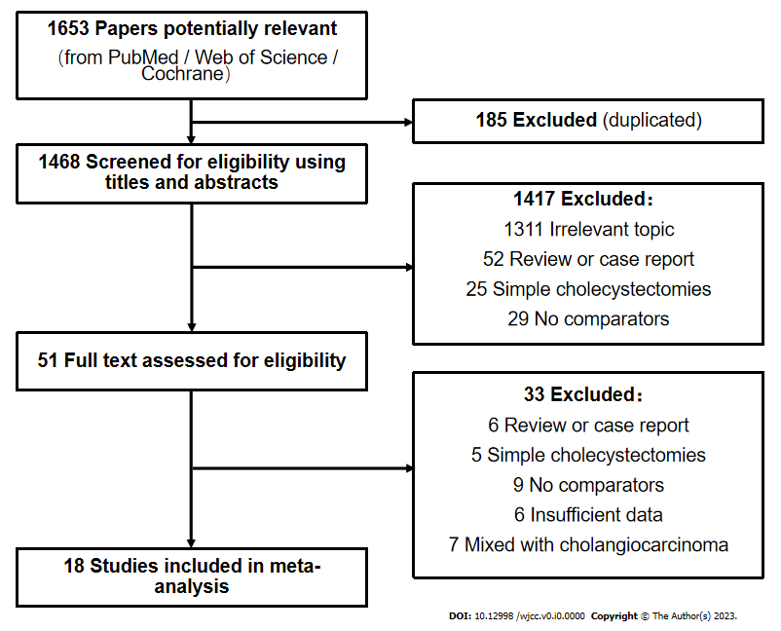
Figure 1 Search strategy and identification of studies for the systematic review and meta-analysis.
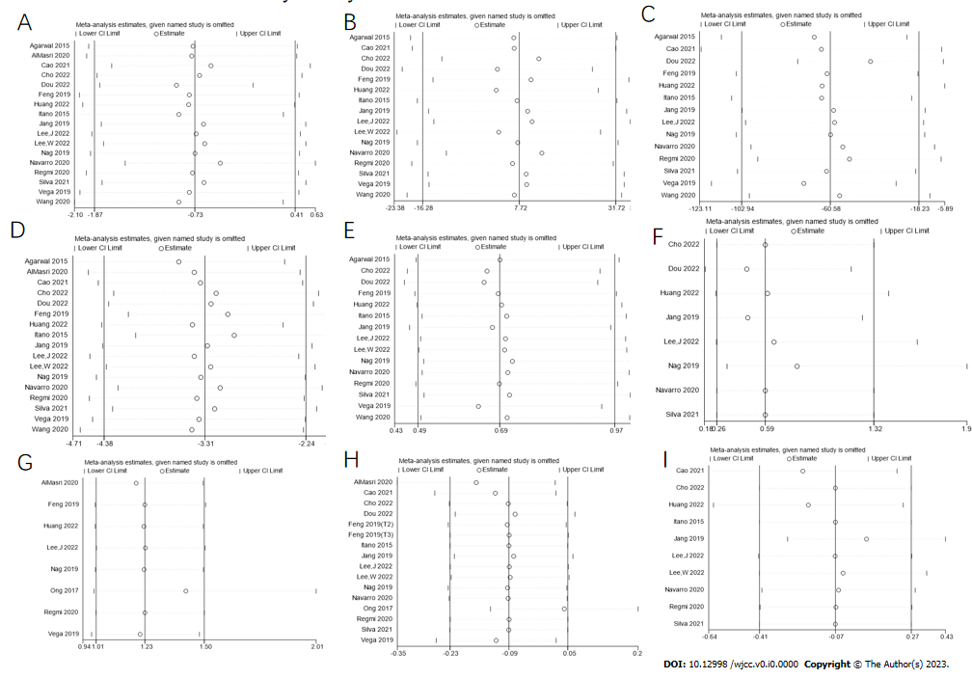
Figure 2 Results of sensitivity analysis on major measured outcomes. A: Number of lymph nodes harvested; B: Operation time; C: Intraoperative blood loss; D: Postoperative length of stay; E: Postoperative complications; F: Postoperative complications (Clavien-Dindo 3-4); G: R0 resection rate; H: Overall survival; I: Tumor-free survival.
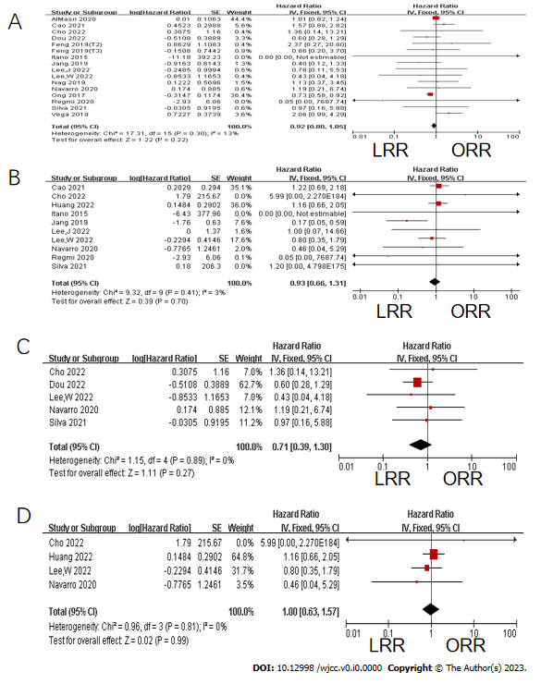
Figure 3 Forest plots of pooled hazard ratio for survival outcomes. A: Overall survival (OS); B: Tumor-free survival (TFS); C: OS after propensity score matching (PSM); D: TFS after PSM. LRR: Laparoscopic radical resection; ORR: Open radical resection; CI: Confidence interval.

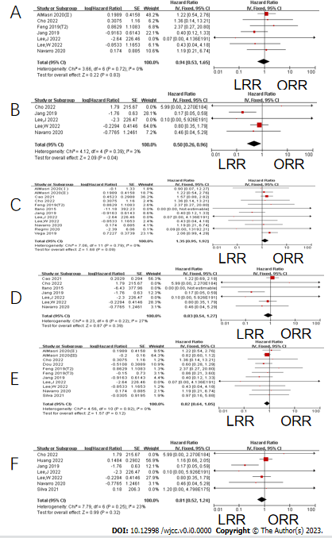
Figure 4 Forest plots of pooled hazard ratio for survival outcomes in subgroup analysis. A: Overall survival (OS) in the T2/tumor-node-metastasis (TNM) Ⅱ subgroup; B: Tumor-free survival (TFS) in the T2/TNM Ⅱ subgroup; C: OS in the T1/TNM Ⅰ + T2/TNM Ⅱ subgroup; D: TFS in the T1/TNM Ⅰ + T2/TNM Ⅱ subgroup; E: OS in the T2/TNM Ⅱ + T3/TNM Ⅲ subgroup; F: TFS in the T2/TNM Ⅱ + T3/TNM Ⅲ subgroup. LRR: Laparoscopic radical resection; ORR: Open radical resection; CI: Confidence interval.

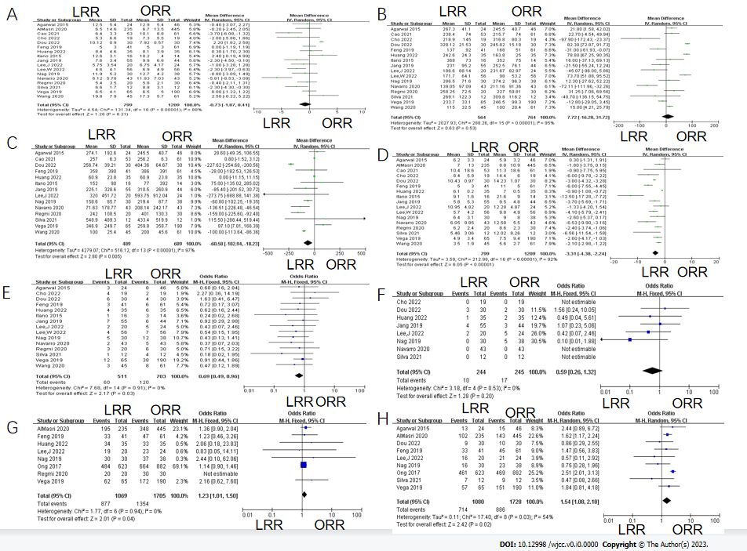
Figure 5 Forest plots of pooled odds ratio or weighted mean difference of short-term outcomes. A: Number of lymph nodes harvested; B: Operation time; C: Intraoperative blood loss; D: Postoperative length of stay; E: Postoperative complications; F: Postoperative complications (Clavien-Dindo 3-4); G: R0 margin rate; H: Early-stage rate (≤ T2/tumor-node-metastasis Ⅱ stage). LRR: Laparoscopic radical resection; ORR: Open radical resection; CI: Confidence interval.

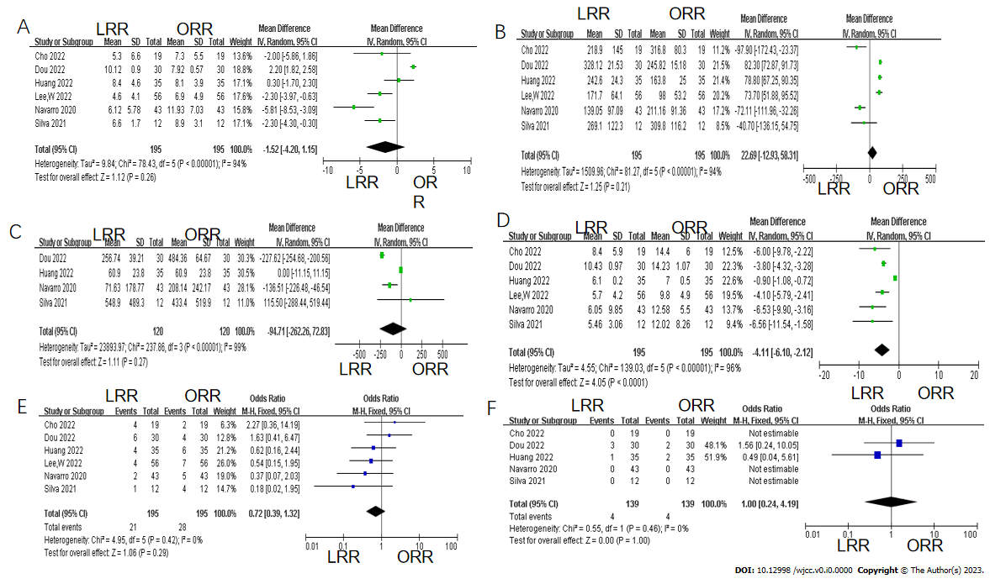
Figure 6 Forest plots of pooled odds ratio or weighted mean difference of short-term outcomes after propensity score matching. A: Number of lymph nodes harvested; B: Operation time; C: Intraoperative blood loss; D: Postoperative length of stay; E: Postoperative complications; F: Postoperative complications (Clavien-Dindo 3-4). LRR: Laparoscopic radical resection; ORR: Open radical resection; CI: Confidence interval.

Table 1 Publication bias test of major measured outcomes
 | No. of studies | No. of patients |  | Egger's test |  | Begg's test (continuity corrected)
 |  | LRR | ORR | t | P > |t| | z | P > |z|
No. LNH | 17 | 799 | 1209 | -5.1 | < 0.001 | 0.37 | 0.711
Operation time | 16 | 564 | 764 | 1.57 | 0.139 | 0.86 | 0.392
Blood loss | 14 | 489 | 689 | -2.18 | 0.050 | 1.86 | 0.063
POLS | 17 | 799 | 1209 | -3.03 | 0.008 | 0.04 | 0.967
R0 rate | 8 | 1609 | 1705 | 1.64 | 0.162 | 0.00 | 1.000
Complications | 15 | 511 | 703 | -1.67 | 0.119 | 1.29 | 0.198
Complications (Clavien-Dindo 3-4) | 8 | 244 | 245 | -1.85 | 0.162 | 0.73 | 0.462
OS | 15 | 1299 | 1936 | 0.3 | 0.767 | 0.68 | 0.499
TFS | 10 | 339 | 338 | -1.04 | 0.329 | 0.36 | 0.721
No. LNH: Number of lymph node harvested; POLS: Postoperative length of stay; OS: Overall survival; TFS: Tumor-free survival; LRR: Laparoscopic radical resection; ORR: Open radical resection.

Table 2 Characteristics of included comparative studies
Ref. | Yr | Country | Study design | NOS | Group | Patients  (n) | Age | F/M | T stage/TNM stage(n) | Follow-up (mo)
Agarwal et al^{[32]} | 2015 | India | Retrospective | 7 | LRR | 24 | 44 (21-61) | 17/7 | Ⅰ: 3; Ⅱ: 10; Ⅲ: 11 | 18 (6-34)
 |  |  |  |  | ORR | 46 | 49 (23-70) | 34/12 | Ⅰ: 5; Ⅱ: 10; Ⅲ: 31
Feng et al^{[33]} | 2019 | China | Retrospective | 7 | LRR | 41 | 64 ± 14 | 17/24 | Tis: 9; T1: 10; T2: 14; T3: 8 | 12 (2-93)
 |  |  |  |  | ORR | 61 | 66 ± 10 | 22/39 | Tis: 4; T1: 9; T2: 1 32; T3: 16
Itano et al^{[34]} | 2015 | Japan | Retrospective | 6 | LRR | 16 | 68.1 ± 19.9 | 7/9 | T1: 3; T2: 13 | 37
 |  |  |  |  | ORR | 14 | 71.5 ± 13.2 | 9/5 | T1-T2: 14 | 48
Jang et al^{[35]} | 2019 | Korea | Retrospective | 7 | LRR | 55 | 70.1 ± 8.1 | 36/19 | T2: 55 | 35.2 (3-139)
 |  |  |  |  | ORR | 44 | 65.5 ± 10.5 | 21/23 | T2: 44 | 38.6 (4-160)
Nag et al^{[36]} | 2019 | India | Retrospective | 7 | LRR | 30 | 49.6 ± 12.8 | 27/3 | T1: 8; T2: 8; T3: 8; T4: 2 | NA
 |  |  |  |  | ORR | 38 | 49 ± 10.1 | 23/15 | T1: 6; T2: 17; T3: 15; T4: 0 | NA
Ong et al^{[37]} | 2017 | United States | Retrospective | 6 | LRR | 623 | 70 (61-79) | 442/181 | T1 + T2: 461; T3: 146; UKN: 16 | NA
 |  |  |  |  | ORR | 882 |  | 587/295 | T1 + T2: 469; T3: 374; UKN: 39 | NA
Vega et al^{[38]} | 2019 | United States  Chile | Retrospective | 8 | LRR | 65 | 68 (59-76) | 49/141 | T1: 14; T2: 43; T3: 8 | Survivors: 70.8 (95%CI: 53.6-87.3)
 |  |  |  |  | ORR | 190 |  | 11/54 | T1: 5; T2: 126; T3: 39
Cao et al^{[46]} | 2021 | China | Retrospective | 8 | LRR | 53 | 61 (48-77) | 35 | T1b: 3; T2: 50 | NA
 |  |  |  |  | ORR | 61 | 64 (39-79） | 47 | T1b: 5; T2: 56 | NA
Dou et al^{[48]} | 2022 | China | Retrospective | 7 | LRR (PSM) | 30 | > 60: 21 | 23 | T2: 9; T3: 21 | NA
 |  |  |  |  | ORR (PSM) | 30 | > 60: 19 | 25 | T2: 10; T3: 20 | NA
Lee et al^{[43]} | 2022 | Korea | Retrospective | 8 | LRR | 20 | 71.85 ± 9.11 | 15 | T1: 4; T2: 12; T3: 4 | NA
 |  |  |  |  | ORR | 24 | 68.08 ± 10.64 | 13 | T1: 5; T2: 16; T3: 3 | NA
Navarro et al^{[41]} | 2020 | Korea | Retrospective | 7 | LRR (PSM) | 43 | 66.7 ± 10.3 | 18 | T2: 43 | 32 (2-125)
 |  |  |  |  | ORR (PSM) | 43 | 65.4 ± 7.6 | 15 | T2: 43
Regmi et al^{[40]} | 2020 | China | Retrospective | 7 | LRR | 20 | > 70y: 4 | 13 | T1b: 10; T2: 10 | 21.28 (12-29)
 |  |  |  |  | ORR | 30 | > 70y: 3 | 19 | T1b: 13; T2: 17 | 20.4 (12.25-29.50)
Huang et al^{[44]} | 2022 | China | Retrospective | 8 | LRR (PSM) | 35 | 58.7 ± 10.5 | 19 | T3: 35 | NA
 |  |  |  |  | ORR (PSM) | 35 | 60.4 ± 10.6 | 18 | T3: 35 | NA
D'Silva et al^{[45]} | 2021 | China | Retrospective | 7 | LRR (PSM) | 12 | 68.5 ± 10.56 | 7 | T2: 7;T3: 9 | 21.5 (9-80)
 |  |  |  |  | ORR (PSM) | 12 | 67.5 ± 12.88 | 7 | T2: 5;T3: 3
Lee et al^{[42]} | 2022 | Korea | Retrospective | 8 | LRR (PSM) | 56 | 62.0 ± 13.7 | 27 | T2: 56 | 26.2
 |  |  |  |  | ORR (PSM) | 56 | 62.5 ± 15.0 | 28 | T2: 56
Wang et al^{[39]} | 2020 | China | Retrospective | 8 | LRR | 45 | 62.6 (45-76) | 29 | Tb: 30; T2: 15 | 38 (3-84)
 |  |  |  |  | ORR | 61 | 65.2 (51-82) | 37 | Tb: 35;T2: 26 | 33 (6-72)
AlMasri et al^{[49]} | 2020 | United States | Retrospective | 8 | LRR | 235 | 66.1 ± 11.8 | 64 | I: 24; II: 78; III: 133 | NA
 |  |  |  |  | ORR | 445 | 65.8 ± 11.2 | 294 | I: 29; II: 114; III: 302 | NA
Cho et al^{[47]} | 2022 | Korea | Retrospective | 7 | LRR (PSM) | 19 | 69.9 ± 9.1 | 11 | T2: 19 | 26
 |  |  |  |  | ORR (PSM) | 19 | 66.7 ± 7.8 | 7 | T2: 19 | 70
UKN: Unknown; LRR: Laparoscopic radical resection; ORR: Open radical resection; PSM: Propensity score matching; NOS: The modified Newcastle–Ottawa scale; TNM: Tumor-node-metastasis; NA: Not available; F: Female; M: Male; CI: Confidence interval.

Table 3 Perioperative outcomes of included comparative studies
Ref. | Group | Pts | No. LNH | R0 margin  (n) | Operation time (min) | Blood loss (mL) | POLS | Complications | Complications  (Clavien-Dindo 3-4)
Agarwal et al^{[32]} | LRR | 24 | 12.5 ± 5.4 | NA | 270 (180-340) | 200 (100-850) | 5 (3-16) | 3 | NA
 | ORR | 46 | 12.9 ± 5.4 | NA | 240 (180-360) | 275 (100-800) | 5 (3-17) | 8 | NA
Feng et al^{[33]} | LRR | 41 | 5 ± 3 | 33 | 137 ± 92 | 358 ± 390 | 5 ± 3 | 3 | NA
 | ORR | 61 | 5 ± 3 | 47 | 168 ± 51 | 386 ± 391 | 11 ± 5 | 6 | NA
Itano et al^{[34]} | LRR | 16 | 12.6 ± 3.1 | NA | 368 ± 73 | 152 ± 90 | 9.1 ± 1.6 | 1 | NA
 | ORR | 14 | 10.2 ± 4.0 | NA | 352 ± 75 | 777 ± 392 | 21.6 ± 9.0 | 3 | NA
Jang et al^{[35]} | LRR | 55 | 7.6 ± 3.4 | NA | 231.0 ± 95.2 | 225.1 ± 328.6 | 5.8 ± 5.3 | 7 | 4
 | ORR | 44 | 9.9 ± 6.8 | NA | 252.5 ± 76.1 | 310.5 ± 260.9 | 9.5 ± 4.8 | 6 | 3
Nag et al^{[36]} | LRR | 30 | 11.9 ± 5.2 | 30 | 286.5 ± 71.6 | 158.6 ± 85.7 | 6.4 ± 3.1 | 5 | 0
 | ORR | 38 | 12.7 ± 4.2 | 37 | 274.2 ± 96.3 | 219.4 ± 87.7 | 9 ± 8.0 | 12 | 5
Ong et al^{[37]} | LRR | 623 | NA | 484 | NA | NA | NA | NA | NA
 | ORR | 882 | NA | 664 | NA | NA | NA | NA | NA
Vega et al^{[38]} | LRR | 65 | 6 (0-19) | 62 | 240 (120-275) | 300 (30-1200) | 4 (2-18) | 12 | NA
 | ORR | 190 | 6 (0-27) | 172 | 240 (60-600) | 200 (50-2000) | 6 (1-52) | 38 | NA
Cao et al^{[46]} | LRR | 53 | 6 (1-16) | NA | 238.4 | 257 ± 6.3 | 10.4 ± 18.6 | NA | NA
 | ORR | 61 | 8 (1-42) | NA | 215.7 | 256.2 ± 6.3 | 11.3 ± 18.6 | NA | NA
Dou et al^{[48]} | LRR (PSM) | 30 | 10.12 ± 0.90 | NA | 328.12 ± 21.53 | 256.74 ± 39.21 | 10.43 ± 0.97 | 6 | 3
 | ORR (PSM) | 30 | 7.92 ± 0.57 | NA | 245.82 ± 15.18 | 484.36 ± 64.67 | 14.23 ± 1.07 | 4 | 2
Lee et al^{[43]} | LRR | 20 | 5.75 ± 3.54 | 19 | 186.60 ± 88.14 | 320.00 ± 451.72 | 10.95 ± 4.82 | 2 | 2
 | ORR | 24 | 6.75 ± 4.17 | 23 | 231.67 ± 82.97 | 593.75 ± 912.04 | 12.80 ± 4.87 | 5 | 5
Navarro et al^{[41]} | LRR (PSM) | 43 | 6.12 ± 5.78 | NA | 139.05 ± 97.09 | 71.63 ± 178.77 | 6.05 ± 9.846 | 0 | 0
 | ORR(PSM) | 43 | 11.93 ± 7.03 | NA | 211.16 ± 91.36 | 208.14 ± 242.165 | 12.58 ± 5.504 | 4 | 0
Regmi et al^{[40]} | LRR | 20 | 5.4 ± 3.5 | 20 | 258.25 ± 72.50 | 242 ± 108.5 | 6.2 ± 2.4 | 3 | NA
 | ORR | 30 | 5.8 ± 2.1 | 30 | 227.00 ± 59.81 | 401 ± 130.3 | 8.6 ± 2.3 | 6 | NA
Huang et al^{[44]} | LRR (PSM) | 35 | 8.4 ± 4.6 | 34 | 245.0 (183.0-285.0) | 50.0 (50.0-150.0) | 6.0 (6.0-7.0) | 4 | 1
 | ORR (PSM) | 35 | 8.1 ± 3.9 | 33 | 160.0 (125.0-230.0) | 50.0 (50.0-150.0) | 7.0 (6.0-8.0) | 6 | 2
Silva et al^{[45]} | LRR (PSM) | 12 | 6.5 (4-9.5) | NA | 237.5 (120-520) | 300 (150-1750) | 4.5 (2-12) | 1 | 0
 | ORR (PSM) | 12 | 8.5 (4.5-14.5) | NA | 272.5 (180-560) | 275 (100-1800) | 8 (5-32) | 4 | 0
Lee et al^{[42]} | LRR (PSM) | 56 | 4.6 ± 4.1 | NA | 171.7 ± 64.1 | NA | 5.7 ± 4.2 | 4 | NA
 | ORR (PSM) | 56 | 6.9 ± 4.9 | NA | 98.0 ± 53.2 | NA | 9.8 ± 4.9 | 7 | NA
Wang et al^{[39]} | LRR | 45 | 19.8 ± 7.9 | NA | 115 ± 32.5 | 100 ± 25.4 | 3.5 ± 1.9 | 3 | NA
 | ORR | 61 | 17.3 ± 5.7 | NA | 100 ± 20.4 | 200 ± 45.6 | 5.6 ± 2.7 | 8 | NA
AlMasri et al^{[49]} | LRR | 235 | 6.5 ± 14.6 | 195 | NA | NA | 7.0 ± 13.0 | NA | NA
 | ORR | 445 | 6.7 ± 13.5 | 348 | NA | NA | 8.8 ± 10.9 | NA | NA
Cho et al^{[47]} | LRR (PSM) | 19 | 5.3 ± 6.6 | NA | 218.9 ± 145.0 | NA | 8.4 ± 5.9 | 4 | 0
 | ORR (PSM) | 19 | 7.3 ± 5.5 | NA | 316.8 ± 80.3 | NA | 14.4 ± 6.0 | 2 | 0
Pts: Patients; No. LNH: Number of lymph node harvested; LRR: Laparoscopic radical resection; ORR: Open radical resection; POLS: Postoperative length of stay; NA: Not available; PSM: Propensity score matching.

