Name of Journal: World Journal of Clinical Cases
Manuscript NO: 73198
Manuscript Type: CASE REPORT

Laparoscopic repair of diaphragmatic hernia associating with radiofrequency ablation for hepatocellular carcinoma: A case report

Tsunoda J et al. Laparoscopic repair of diaphragmatic hernia

Junya Tsunoda, Tomohiko Nishi, Takafumi Ito, Gaku Inaguma, Tomohiko Matsuzaki, Hiroaki Seki, Nobutaka Yasui, Michio Sakata, Akihiko Shimada, Hidetoshi Matsumoto

Junya Tsunoda, Tomohiko Nishi, Gaku Inaguma, Tomohiko Matsuzaki, Hiroaki Seki, Nobutaka Yasui, Michio Sakata, Akihiko Shimada, Hidetoshi Matsumoto, Department of Surgery, Keiyu Hospital, Yokohama 220-8521, Japan

Takafumi Ito, Department of Internal Medicine, Keiyu Hospital, Yokohama 220-8521, Japan

Author contributions: Tsunoda J interpreted the patient data based on the case notes and drafted the manuscript; Nishi T performed the surgery and supervised the manuscript; all other members equally contributed to the medical treatment.

Corresponding author: Tomohiko Nishi, MD, PhD, Deputy Director, Department of Surgery, Keiyu Hospital, 3-7-3 Minatomirai Nishi-ku, Yokohama 220-8521, Japan. brilliantladybird@yahoo.co.jp

Received: November 15, 2021
Revised: April 21, 2022
Accepted: May 27, 2022
Published online:

Abstract
BACKGROUND
Radiofrequency ablation (RFA) is an effective treatment for early-stage hepatocellular carcinoma (HCC). Although RFA is a relatively safe technique compared with surgery, several complications have been reported to be following/accompanying this treatment. Delayed diaphragmatic hernia caused by RFA is rare; however, the best surgical approach for its treatment is uncertain. We present a case of laparoscopic repair of diaphragmatic hernia due to RFA.

CASE SUMMARY
An 80-year-old woman with segment VIII HCC was treated twice in 5 years with RFA; 28 mo after the second RFA, the patient complained of right hypochondriac pain. Computed tomography revealed that the small intestine was incarcerated in the right thorax. The patient was diagnosed with diaphragmatic hernia and underwent laparoscopic repair by non-absorbable running sutures. The patient’s postoperative course was favorable, and the patient was discharged on postoperative day 12. The diaphragmatic hernia has not recurred 24 mo after surgery.

CONCLUSION
Laparoscopic treatment of iatrogenic diaphragmatic hernia is effective and minimally invasive.

Key Words: Diaphragmatic hernia; Radiofrequency ablation; Hepatocellular carcinoma; Complication; Laparoscopic surgery; Case report

Tsunoda J, Nishi T, Ito T, Inaguma G, Matsuzaki T, Seki H, Yasui N, Sakata M, Shimada A, Matsumoto H. Laparoscopic repair of diaphragmatic hernia associating with radiofrequency ablation for hepatocellular carcinoma: A case report. World J Clin Cases 2022; In press

Core Tip: Radiofrequency ablation (RFA) is an effective treatment for hepatocellular carcinoma (HCC). Delayed diaphragmatic hernia caused by RFA is uncommon; however, the best surgical approach to its treatment has not been determined. Herein, we present a rare case of delayed-onset diaphragmatic hernia due to RFA and its treatment with laparoscopic repair. This case highlights the ultimate importance of that RFA for HCC located close to the diaphragm should be performed using artificial ascites under computed tomography guidance to prevent an injury to the diaphragm. Laparoscopic treatment of iatrogenic diaphragmatic hernia is effective and minimally invasive.
INTRODUCTION
Hepatocellular Carcinoma (HCC) is ranked as the sixth most common neoplasm and the third leading cause of death to cancer^{[1]}. Surgical resection, transplantation, ablation, transarterial chemoembolization and the use of tyrosine-kinase inhibitors are treatments with proven survival benefit. Radiofrequency ablation (RFA) is an effective treatment for early-stage HCC. Although RFA is a relatively safe technique compared with surgery, several complications have been identified^{[2-7]}. In an analysis of 3670 patients who underwent RFA for HCC, Mulier et al^{[3]} reported an overall complication rate of 8.9%. The major complications following RFA were abdominal bleeding, abdominal infection, and biliary tract damage; 5 cases (0.1%) of injury to the diaphragm were also reported. Delayed diaphragmatic hernia caused by RFA is uncommon; however, the best surgical approach to its treatment has not been determined. Here, we present a case of delayed-onset diaphragmatic hernia resulting from RFA and its treatment with laparoscopic repair, along with the review of the relevant literature.

CASE PRESENTATION
Chief complaints
An 80-year-old woman had been followed up for autoimmune hepatitis-related liver cirrhosis and recurrent HCC. Colonoscopy for chronic diarrhea revealed rectal cancer, and the patient was accordingly admitted to our hospital for resection of the tumor. High anterior resection was performed. On postoperative day 10, the patient complained of right hypochondriac pain.

History of present illness
The patient had been followed up for autoimmune hepatitis-related liver cirrhosis and recurrent HCC. The patient’s condition was classified as Child-Pugh Class B (7 points) with hypoalbuminemia (2.1 g/dL) without encephalopathy or ascites. Gadoxetate sodium enhanced magnetic resonance imaging revealed masses that were highly suspicious for HCC located in the Segment VIII (S8) near the liver surface (Figure 1A). RFA was performed under ultra-sonographic guidance using an expandable needle (LeVeen™ Needle Electrode; Boston Scientific, Inc., Natick, MA, United States) 55 mo before hernia repair, with no early complications. No artificial pleural effusion or artificial ascites was used. Twenty-eight months before the hernia repair, the patient underwent repeat RFA for recurrent HCC located in S8 near the inferior vena cava (Figure 1B). Artificial pleural effusion was used during the second RFA.

History of past illness
The patient had medical histories of hypertension, hyperuricemia, heart failure, pneumonia, and laparoscopic cholecystectomy.

Personal and family history
There was no family history of malignant tumors.

Physical examination
On her physical examination, the patient showed tenderness of the right hypochondrium without rebound tenderness, although the vital signs were normal.

Laboratory examinations
A blood test revealed normal white cell count (4800/μL; normal range, 3500-8000/μL) and C-reactive protein level (0.22 mg/dL; normal < 0.30 mg/dL). It also revealed low albumin level (2.1 g/dL) and coagulopathy, including low platelet count (8.7 × 10⁴/μL; normal range, 15-35 × 10⁴/μL) and high international normalized ratio of prothrombin time (1.29; normal range, 0.80-1.20) due to liver cirrhosis.

Imaging examinations
A contrast-enhanced computed tomography (CT) scan revealed small intestine incarcerated in the right thorax (Figure 2). No findings suggested intestinal ischemia.

FINAL DIAGNOSIS
The final diagnosis of the presented case is diaphragmatic hernia due to RFA for HCC.

TREATMENT
The patient immediately underwent emergency surgery. The patient underwent laparoscopic hernia repair in the dorsosacral position under general anesthesia. Four trocars were inserted into the abdomen (Figure 3). The first 12-mm trocar was introduced in the left-upper abdomen using the open-entry technique so as to avoid adhesions between the abdominal wall and visceral organs due to the previous surgery. After pneumoperitoneum by carbon dioxide insufflation, three more trocars were inserted at the right lateral abdomen, the mid-upper abdomen (12-mm trocars for operator) and near the umbilicus (a 5-mm trocar for scopist). Small intestine had slipped through the diaphragmatic defect and was observed to be incarcerated in the right thorax (Figure 4A). The small intestine was gently pulled back into the abdominal cavity using laparoscopic bowel-grasping forceps (Figure 4B). Bowel resection was not required. The hernia defect was estimated to be approximately 5 cm in diameter (Figure 4C). Intra-abdominal air pressure was reduced from 8 mmHg to 6 mmHg because the intrathoracic air pressure was increased through the defect and the pulmonary ventilation volume was decreased.
The defect was repaired using synthetic non-absorbable monofilament polypropylene sutures (3-0 PROLENE; Ethicon Inc., Somerville, NJ, United States) in the running fashion (Figure 4D). No drainage tube was placed. The operative duration was 76 min, and the estimated blood loss was < 5 mL.

OUTCOME AND FOLLOW-UP
The patient’s postoperative course was favorable, and the patient was discharged on postoperative day 12. The diaphragmatic hernia has not recurred 24 mo after the surgery.

DISCUSSION
Diaphragmatic hernia associated with RFA is an uncommon complication. However, diaphragmatic hernia is fatal for patients of liver cirrhosis. Therefore, it is important to recognize the risks of diaphragmatic hernia and provide prompt treatment. Twenty cases of diaphragmatic hernia due to RFA have been reported in English including our case. The background of the patients and the details of RFA are given in Table 1^{[8-21]}. The details of diaphragmatic hernia and the treatment are presented in Table 2. The median age of the cases under study was 71 years [Interquartile range (IQR) 61-79]. There were 11 (55%) males and 9 females (45%) in the current study. The most common (13 patients, 65%) cause underlying liver diseases in patients was Hepatitis C. In the present study, 16 patients (80%) had the tumor located in S8. Diaphragmatic hernia tends to occur frequently after RFA for S8 HCC, as the location of the tumor is adjacent to the diaphragm. Physical and thermal damage to the diaphragm can result in a defect in diaphragm because of poor wound healing in patients with liver cirrhosis^{[22]}.
In most cases including ours, RFA was performed under sonographic guidance. Yamagami et al^{[12]} reported that the tip of the RFA electrode is relatively difficult to detect by sonography as compared to CT while performing RFA for HCC located close to the diaphragm. According to the surgical findings, the scar on the liver caused by the first RFA was close to the hernia orifice (Figure 4D), suggesting that the first RFA had caused the diaphragmatic hernia. In only 2 out of 20 cases, RFA was performed using artificial pleural effusion, while in 18 cases (90%) RFA was performed without using artificial pleural effusion or ascites. Wang and Kao^{[23]} have reported that the use of artificial ascites protected the abdominal wall and adjacent organs from burn injuries during RFA for HCC. Clinicians and radiologists should therefore consider the use of artificial ascites during RFA to prevent diaphragmatic heat injury. Furthermore, some studies have reported that laparoscopic RFA is also useful for preventing physical injury to the diaphragm^{[24-26]}.
The median duration of time between occurrence of hernia and the previous RFA was 17 mo (IQR 12-25) in the current study. Diaphragmatic hernia is a late-onset complication of RFA. In the present case, diaphragmatic hernia occurred 28 mo after the final RFA. With the progression of liver atrophy, the space between the diaphragm and the liver enlarges, and intestines can move onto the liver, a phenomenon called Chilaiditi syndrome^{[27]}. Clinicians should be aware of the possibility of the occurrence of delayed-onset diaphragmatic hernia after RFA.
Diaphragmatic hernia is a fatal disease that generally requires emergency surgery. However, 2 cases took conservative management because there were no symptoms of a strangulated hernia and they considered the risks of surgery^{[12,13]}. The best surgical approach to treat diaphragmatic hernia has not been established. Liver cirrhosis is an important risk factor in surgery due to the factors, such as coagulopathy, poor nutritional status, adaptive immune dysfunction, cirrhotic cardiomyopathy, and renal and pulmonary dysfunction^{[28]}. In 4 cases out of 20 cases, the laparoscopic approach was adopted. The laparoscopic approach is safer and more feasible than open surgery, considering the possibility of postoperative complications followed by reduced collateral circulation in the abdominal wall^{[16,29]}. Furthermore, the laparoscopic approach is useful for securing a field of view over the surgical site, as the location of the hernia defect is deep. However, insufficient respiratory function may preclude the laparoscopic approach because of the risks of pneumoperitoneum and pneumothorax. In our case, we reduced abdominal air pressure from 8 mmHg to 6 mmHg because thoracic air pressure increased through the hernia orifice and pulmonary ventilation volume decreased.
We repaired the diaphragmatic hernia by non-absorbable running sutures. In most cases, the hernia repair was performed by non-absorbable interrupted sutures. Regardless of the suture techniques, absorbable sutures should not be used to prevent the recurrence of hernia^{[30]}. On the other hand, we did not use a mesh owing to the possibility of HCC recurrence, as the use of a mesh patch could preclude another RFA. However, if the diaphragmatic hernia recurs without the need for bowel resection, the use of mesh should be considered.

CONCLUSION
RFA for HCC located close to the diaphragm should be performed using artificial ascites under CT guidance to prevent an injury to the diaphragm. Clinicians should also monitor patients who have undergone RFA, staying alert to the possibility of delayed-onset diaphragmatic hernia. Laparoscopic treatment of iatrogenic diaphragmatic hernia is effective and minimally invasive.

REFERENCES
1 Forner A, Reig M, Bruix J. Hepatocellular carcinoma. Lancet 2018; 391: 1301-1314 [PMID: 29307467 DOI: 10.1016/S0140-6736(18)30010-2]
2 Curley SA, Izzo F, Ellis LM, Nicolas Vauthey J, Vallone P. Radiofrequency ablation of hepatocellular cancer in 110 patients with cirrhosis. Ann Surg 2000; 232: 381-391 [PMID: 10973388 DOI: 10.1097/00000658-200009000-00010]
3 Mulier S, Mulier P, Ni Y, Miao Y, Dupas B, Marchal G, De Wever I, Michel L. Complications of radiofrequency coagulation of liver tumours. Br J Surg 2002; 89: 1206-1222 [PMID: 12296886 DOI: 10.1046/j.1365-2168.2002.02168.x]
4 Kong WT, Zhang WW, Qiu YD, Zhou T, Qiu JL, Zhang W, Ding YT. Major complications after radiofrequency ablation for liver tumors: analysis of 255 patients. World J Gastroenterol 2009; 15: 2651-2656 [PMID: 19496197 DOI: 10.3748/wjg.15.2651]
5 Bertot LC, Sato M, Tateishi R, Yoshida H, Koike K. Mortality and complication rates of percutaneous ablative techniques for the treatment of liver tumors: a systematic review. Eur Radiol 2011; 21: 2584-2596 [PMID: 21858539 DOI: 10.1007/s00330-011-2222-3]
6 Izzo F, Granata V, Grassi R, Fusco R, Palaia R, Delrio P, Carrafiello G, Azoulay D, Petrillo A, Curley SA. Radiofrequency Ablation and Microwave Ablation in Liver Tumors: An Update. Oncologist 2019; 24: e990-e1005 [PMID: 31217342 DOI: 10.1634/theoncologist.2018-0337]
7 Maeda M, Saeki I, Sakaida I, Aikata H, Araki Y, Ogawa C, Kariyama K, Nouso K, Kitamoto M, Kobashi H, Sato S, Shibata H, Joko K, Takaki S, Takabatake H, Tsutsui A, Takaguchi K, Tomonari T, Nakamura S, Nagahara T, Hiraoka A, Matono T, Koda M, Mandai M, Mannami T, Mitsuda A, Moriya T, Yabushita K, Tani J, Yagi T, Yamasaki T. Complications after Radiofrequency Ablation for Hepatocellular Carcinoma: A Multicenter Study Involving 9,411 Japanese Patients. Liver Cancer 2020; 9: 50-62 [PMID: 32071909 DOI: 10.1159/000502744]
8 Koda M, Ueki M, Maeda N, Murawaki Y. Diaphragmatic perforation and hernia after hepatic radiofrequency ablation. AJR Am J Roentgenol 2003; 180: 1561-1562 [PMID: 12760919 DOI: 10.2214/ajr.180.6.1801561]
9 Shibuya A, Nakazawa T, Saigenji K, Furuta K, Matsunaga K. Diaphragmatic hernia after radiofrequency ablation therapy for hepatocellular carcinoma. AJR Am J Roentgenol 2006; 186: S241-S243 [PMID: 16632682 DOI: 10.2214/AJR.04.0931]
10 di Francesco F, di Sandro S, Doria C, Ramirez C, Iaria M, Navarro V, Silvestry S, Needleman L, Frank A. Diaphragmatic hernia occurring 15 mo after percutaneous radiofrequency ablation of a hepatocellular cancer. Am Surg 2008; 74: 129-132 [PMID: 18306862 DOI: 10.1177/000313480807400207]
11 Singh M, Singh G, Pandey A, Cha CH, Kulkarni S. Laparoscopic repair of iatrogenic diaphragmatic hernia following radiofrequency ablation for hepatocellular carcinoma. Hepatol Res 2011; 41: 1132-1136 [PMID: 22032681 DOI: 10.1111/j.1872-034X.2011.00865.x]
12 Yamagami T, Yoshimatsu R, Matsushima S, Tanaka O, Miura H, Nishimura T. Diaphragmatic hernia after radiofrequency ablation for hepatocellular carcinoma. Cardiovasc Intervent Radiol 2011; 34 Suppl 2: S175-S177 [PMID: 20237779 DOI: 10.1007/s00270-010-9832-z]
13 Kim JS, Kim HS, Myung DS, Lee GH, Park KJ, Cho SB, Joo YE, Choi SK. A case of diaphragmatic hernia induced by radiofrequency ablation for hepatocellular carcinoma. Korean J Gastroenterol 2013; 62: 174-178 [PMID: 24077629 DOI: 10.4166/kjg.2013.62.3.174]
14 Zhou M, He H, Cai H, Chen H, Hu Y, Shu Z, Deng Y. Diaphragmatic perforation with colonic herniation due to hepatic radiofrequency ablation: A case report and review of the literature. Oncol Lett 2013; 6: 1719-1722 [PMID: 24260068 DOI: 10.3892/ol.2013.1625]
15 Nakamura T, Masuda K, Thethi RS, Sako H, Yoh T, Nakao T, Yoshimura N. Successful surgical rescue of delayed onset diaphragmatic hernia following radiofrequency ablation for hepatocellular carcinoma. Ulus Travma Acil Cerrahi Derg 2014; 20: 295-299 [PMID: 25135026 DOI: 10.5505/tjtes.2014.03295]
16 Nomura R, Tokumura H, Furihata M. Laparoscopic repair of a diaphragmatic hernia associated with radiofrequency ablation for hepatocellular carcinoma: lessons from a case and the review of the literature. Int Surg 2014; 99: 384-390 [PMID: 25058770 DOI: 10.9738/INTSURG-D-14-00025.1]
17 Saito T, Chiba T, Ogasawara S, Inoue M, Wakamatsu T, Motoyama T, Kanogawa N, Suzuki E, Ooka Y, Tawada A, Matsubara H, Yokosuka O. Fatal Diaphragmatic Hernia following Radiofrequency Ablation for Hepatocellular Carcinoma: A Case Report and Literature Review. Case Rep Oncol 2015; 8: 238-245 [PMID: 26120308 DOI: 10.1159/000431310]
18 Abe T, Amano H, Takechi H, Fujikuni N, Sasada T, Yoshida M, Yamaki M, Nakahara M, Noriyuki T. Late-onset diaphragmatic hernia after percutaneous radiofrequency ablation of hepatocellular carcinoma: a case study. Surg Case Rep 2016; 2: 25 [PMID: 26976615 DOI: 10.1186/s40792-016-0148-3]
19 Nagasu S, Okuda K, Kuromatsu R, Nomura Y, Torimura T, Akagi Y. Surgically treated diaphragmatic perforation after radiofrequency ablation for hepatocellular carcinoma. World J Gastrointest Surg 2017; 9: 281-287 [PMID: 29359034 DOI: 10.4240/wjgs.v9.i12.281]
20 Morito A, Nakagawa S, Imai K, Uemura N, Okabe H, Hayashi H, Yamashita YI, Chikamoto A, Baba H. Successful surgical rescue of delayed onset diaphragmatic hernia following radiofrequency ablation using a thoracoscopic approach for hepatocellular carcinoma: a case report. Surg Case Rep 2021; 7: 130 [PMID: 34037868 DOI: 10.1186/s40792-021-01213-8]
21 Ushijima H, Hida JI, Yane Y, Kato H, Ueda K, Kawamura J. Laparoscopic repair of diaphragmatic hernia after radiofrequency ablation for hepatocellular carcinoma: Case report. Int J Surg Case Rep 2021; 81: 105728 [PMID: 33820734 DOI: 10.1016/j.ijscr.2021.105728]
22 Kayashima H, Maeda T, Harada N, Masuda T, Guntani A, Ito S, Matsuyama A, Hamatake M, Tsutsui S, Matsuda H, Ishida T. Risk factors for incisional hernia after hepatic resection for hepatocellular carcinoma in patients with liver cirrhosis. Surgery 2015; 158: 1669-1675 [PMID: 26116049 DOI: 10.1016/j.surg.2015.06.001]
23 Wang CC, Kao JH. Artificial ascites is feasible and effective for difficult-to-ablate hepatocellular carcinoma. Hepatol Int 2015; 9: 514-519 [PMID: 26108302 DOI: 10.1007/s12072-015-9639-8]
24 Herbold T, Wahba R, Bangard C, Demir M, Drebber U, Stippel DL. The laparoscopic approach for radiofrequency ablation of hepatocellular carcinoma--indication, technique and results. Langenbecks Arch Surg 2013; 398: 47-53 [PMID: 23093087 DOI: 10.1007/s00423-012-1018-5]
25 Jiang K, Zhang W, Su M, Liu Y, Zhao X, Wang J, Yao M, Ogbonna J, Dong J, Huang Z. Laparoscopic radiofrequency ablation of solitary small hepatocellular carcinoma in the caudate lobe. Eur J Surg Oncol 2013; 39: 1236-1242 [PMID: 23993049 DOI: 10.1016/j.ejso.2013.08.002]
26 Tanaka K, Kojima T, Hiraguchi E, Hashida H, Noji T, Hirano S. Laparoscopy-Guided Transthoracic Transdiaphragmatic Radiofrequency Ablation for Hepatic Tumors Located Beneath the Diaphragm. J Laparoendosc Adv Surg Tech A 2016; 26: 180-184 [PMID: 26859794 DOI: 10.1089/lap.2015.0380]
27 Orr J, Elson CO 3rd. Abdominal Pain With an Unusual Radiographic Image. Gastroenterology 2016; 151: 241-242 [PMID: 27376522 DOI: 10.1053/j.gastro.2016.03.047]
28 Lopez-Delgado JC, Ballus J, Esteve F, Betancur-Zambrano NL, Corral-Velez V, Mañez R, Betbese AJ, Roncal JA, Javierre C. Outcomes of abdominal surgery in patients with liver cirrhosis. World J Gastroenterol 2016; 22: 2657-2667 [PMID: 26973406 DOI: 10.3748/wjg.v22.i9.2657]
29 Belli G, D'Agostino A, Fantini C, Cioffi L, Belli A, Russolillo N, Langella S. Laparoscopic incisional and umbilical hernia repair in cirrhotic patients. Surg Laparosc Endosc Percutan Tech 2006; 16: 330-333 [PMID: 17057574 DOI: 10.1097/01.sle.0000213745.15773.c1]
30 Muysoms FE, Antoniou SA, Bury K, Campanelli G, Conze J, Cuccurullo D, de Beaux AC, Deerenberg EB, East B, Fortelny RH, Gillion JF, Henriksen NA, Israelsson L, Jairam A, Jänes A, Jeekel J, López-Cano M, Miserez M, Morales-Conde S, Sanders DL, Simons MP, Śmietański M, Venclauskas L, Berrevoet F; European Hernia Society. European Hernia Society guidelines on the closure of abdominal wall incisions. Hernia 2015; 19: 1-24 [PMID: 25618025 DOI: 10.1007/s10029-014-1342-5]

Footnotes
Informed consent statement: Written informed consent was obtained from the patient for the publication of this case report and the accompanying images.

Conflict-of-interest statement: All the authors report no relevant conflicts of interest for this article.

CARE Checklist (2016) statement: The authors have read the CARE Checklist (2016), and the manuscript was prepared and revised according to the CARE Checklist (2016).

Open-Access: This article is an open-access article that was selected by an in-house editor and fully peer-reviewed by external reviewers. It is distributed in accordance with the Creative Commons Attribution NonCommercial (CC BY-NC 4.0) license, which permits others to distribute, remix, adapt, build upon this work non-commercially, and license their derivative works on different terms, provided the original work is properly cited and the use is non-commercial. See: https://creativecommons.org/Licenses/by-nc/4.0/

Provenance and peer review: Unsolicited article; Externally peer reviewed.
Peer-review model: Single blind

Peer-review started: November 15, 2021
First decision: April 16, 2022
Article in press:

Specialty type: Medicine, research and experimental
Country/Territory of origin: Japan
Peer-review report’s scientific quality classification
Grade A (Excellent): 0
Grade B (Very good): B
Grade C (Good): 0
Grade D (Fair): 0
Grade E (Poor): 0

P-Reviewer: Wu SZ, China A-Editor: Yao QG, China S-Editor: Gao CC L-Editor: P-Editor:

Figure Legends
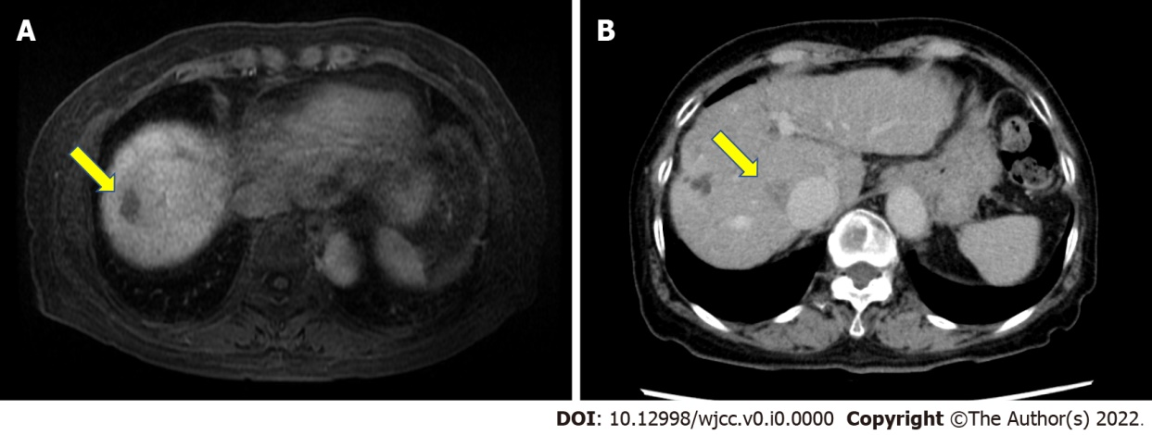
Figure 1 Location of tumors. A: Gadolinium ethoxybenzyl diethylenetriamine pentaacetic acid-enhanced magnetic resonance imaging revealed a low-intensity area in segment VIII (S8) near the surface of the liver in the hepatobiliary phase (arrow); B: Abdominal contrast-enhanced computed tomography revealed a nodular lesion (20 mm) in S8 of the liver near the inferior vena cava, indicating washout in the delayed phase (arrow).

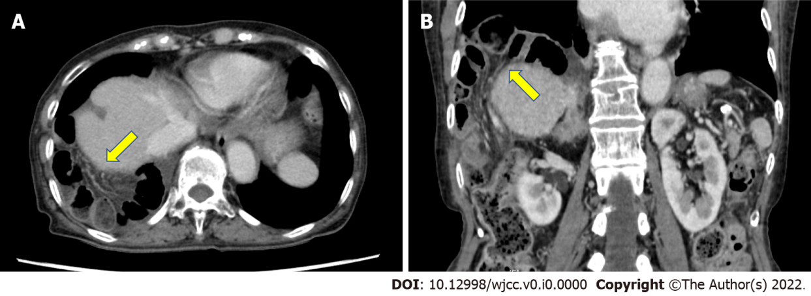
Figure 2 Contrast-enhanced computed tomography image at the onset of diaphragmatic hernia. Contrast-enhanced CT revealed small intestine incarcerated in the right thorax (arrow). A: Horizontal plane; B: Coronal plane.

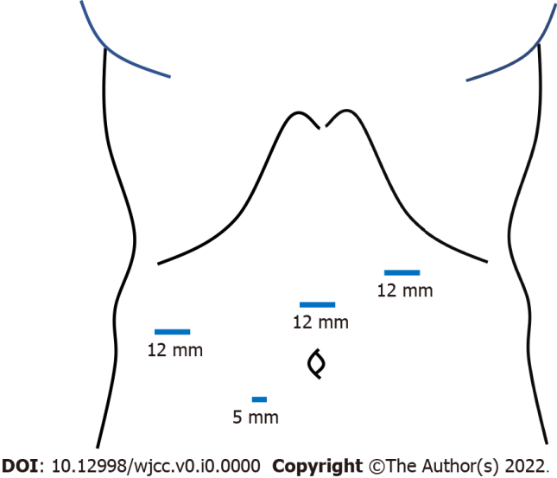
Figure 3 Scheme of trocars placement. Four trocars were inserted into the abdomen. The first 12-mm trocar was introduced in the left-upper abdomen using the open-entry technique, while avoiding adhesions between the abdominal wall and visceral organs due to the previous surgery. After pneumoperitoneum by carbon dioxide insufflation, three more trocars were inserted at the right lateral abdomen, the mid-upper abdomen (12-mm trocars for operator) and near the umbilicus (a 5-mm trocar for scopist).

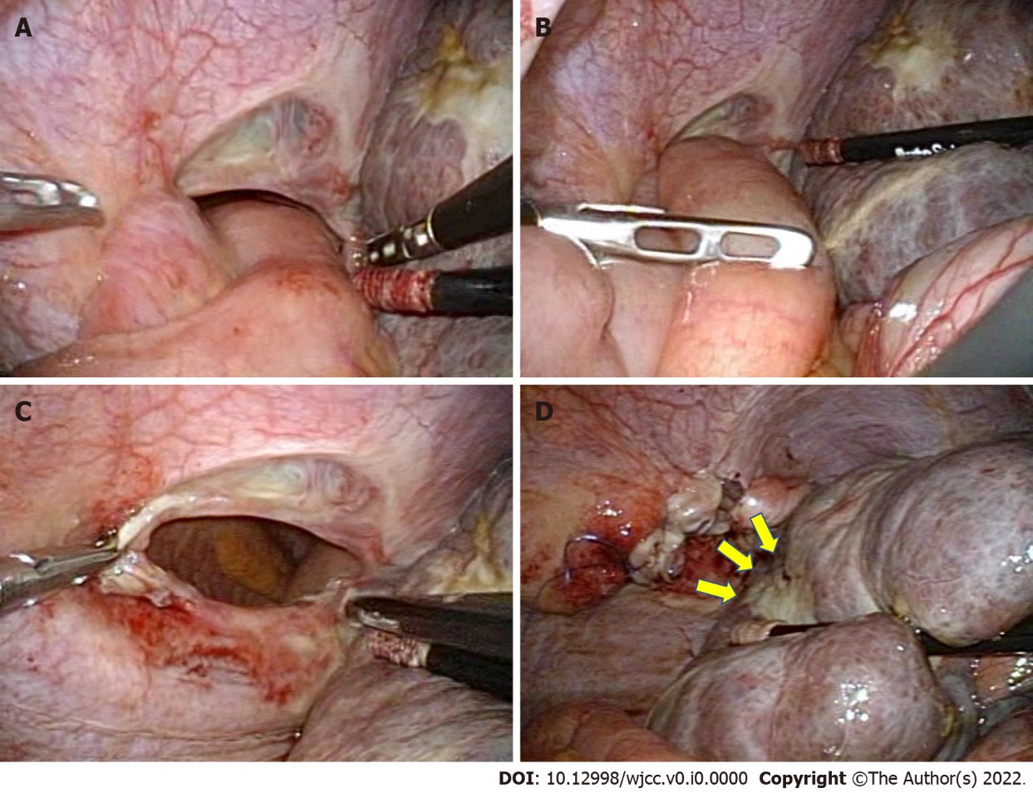
Figure 4 Surgical findings. A: The small intestine had migrated through the diaphragmatic defect and was incarcerated in the right thorax; B: The small intestine was pulled back gently into the abdominal cavity by using laparoscopic bowel-grasping forceps; C: The size of the hernia orifice was estimated to be approximately 5 cm in diameter; D: The scar on the liver resulting from the first RFA was found to be close to the hernia opening (arrowheads). The defect was repaired using synthetic non-absorbable monofilament polypropylene sutures in the running fashion.

Table 1 The background and the details of radiofrequency ablation in the reported cases
Case | Ref. | Age | Sex | Underlying liver disease | Child-Pugh classification | Tumor location (size) | Guiding modality | Artificial ascites/pleural effusion | Type of needle | The number of RFA
1 | Koda et al^{[8]}, 2003 | 61 | F | HB | B | S6, S8 (15 mm, 10 mm, 25 mm) | Sonography | None | Expandable | 2
2 | Shibuya et al^{[9]}, 2006 | 72 | M | AH | NA | S4/S8 (28 mm) | Sonography | None | Expandable | 2
3 | di Francesco et al^{[10]}, 2008 | 49 | M | AH and HC | NA | S8 (54 mm) | NA | None | Cool-tip | 1
4 | Yamagami et al^{[12]}, 2011 | 71 | F | HC | B | S7 (24 mm) | CT | None | Cool-tip | 1
5 | Singh et al^{[11]}, 2011 | 46 | F | AH and HB | A | S2/S3, S5/S8 (17 mm, 18 mm) | Sonography | None | Cool-tip | 1
6 | Kim et al^{[13]}, 2013 | 61 | M | AH | A | S5, S8 (13 mm, 11 mm) | Sonography | None | Cool-tip | 2
7 | Zhou et al^{[14]}, 2013 | 61 | F | HB | NA | S8 (15 mm) | NA | NA | NA | 1
8 | Nakamura et al^{[15]}, 2014 | 81 | M | HC | NA | S4, S8 (19 mm, 24 mm) | Sonography | None | Cool-tip | 1
9 | Nomura et al^{[16]}, 2014 | 62 | M | HC | C | S8 (21 mm) | Sonography | None | Cool-tip | 1
10 | Saito et al^{[17]}, 2015 | 81 | M | HC | C | S3, S5, S5/S8, S8 (NA) | NA | NA | NA | 3
11 | Abe et al^{[18]}, 2016 | 72 | F | HC | B | S5 (NA) | NA | NA | NA | Several times
12 | Nagasu et al^{[19]}, 2017 | 49 | M | AH | A | S4 (17 mm) | Sonography | None | Cool-tip | Several times
13 | Nagasu et al^{[19]}, 2017 | 79 | F | HC | B | S8 (19 mm) | Sonography | None | Cool-tip | Several times
14 | Nagasu et al^{[19]}, 2017 | 68 | M | HC | C | S8 (26 mm) | CT | None | Expandable | 1
15 | Nagasu et al^{[19]}, 2017 | 70 | F | HC | C | S6 (23 mm) | Sonography | None | Cool-tip | 1
16 | Nagasu et al^{[19]}, 2017 | 65 | M | HC | B | S8 (21 mm) | Sonography | None | Cool-tip | 1
17 | Nagasu et al^{[19]}, 2017 | 76 | F | HC | A | S8 (20 mm) | Sonography | None | Cool-tip | Several times
18 | Morito et al^{[20]}, 2021 | 78 | M | HC | NA | S6/S7, S8 (NA) | Thoracoscopic | Artificial pleural effusion | NA | 2
19 | Ushijima et al^{[21]}, 2021 | 82 | M | HC | B | S6, S4/5, S8 (NA) | NA | NA | NA | 3
20 | Current case | 83 | F | AIH | B | S8 (20 mm) | Sonography | Artificial pleural effusion | Expandable | 2
F: Female; M: Male; RFA: Radiofrequency ablation; HB: Hepatitis B; AH: Alcoholic hepatitis; HC: Hepatitis C; AIH: Autoimmune hepatitis; HCC: Hepatocellular carcinoma; CM: Conservative management; CT: Computed tomography; OS: Open surgery; LS: Laparoscopic surgery; NA: Not available.
Table 2 The details of diaphragmatic hernia and the corresponding treatments in the reported cases
Case | Ref. | Times from last RFA (mo) | Symptoms | Herniated viscera | Size of hernia orifice (cm) | Necrosis of intestines | Surgical approach | Suture/mesh | Postoperative complication | Prognosis
1 | Koda et al^{[8]}, 2003 | 32 | Dyspnea | Colon | 5 | No | OS | Suture | Hemorrhage from rupture of the HCC | Died of HCC rupture
2 | Shibuya et al^{[9]}, 2006 | 18 | Right upper abdominal pain and dyspnea | Small intestine | NA | NA | Surgery | Suture | None | Alive
3 | di Francesco et al^{[10]}, 2008 | 15 | Nausea and vomiting | Small intestine | 3 | No | OS | Suture | None | Alive
4 | Yamagami et al^{[12]}, 2011 | 36 | Dyspnea | Colon | NA | No | CM | - | - | Alive
5 | Singh et al^{[11]}, 2011 | 19 | Right upper abdominal pain and dyspnea | Colon | 5 | No | LS | Non-absorbable interrupted suture | None | Alive
6 | Kim et al^{[13]}, 2013 | 9 | None | Mesenteric fat | 2 | No | CM | - | - | Alive
7 | Zhou et al^{[14]}, 2013 | 12 | Lower abdominal pain, nausea and vomiting | Transverse colon | 4 | Yes | OS | Suture | None | Alive
8 | Nakamura et al^{[15]}, 2014 | 18 | Right upper abdominal pain and dyspnea | Small intestine | 5 | Yes | OS | Non-absorbable interrupted suture | None | Alive
9 | Nomura et al^{[16]}, 2014 | 96 | Nausea | Right colon | 4 | No | LS | Non-absorbable interrupted suture | Recurrence of diaphragmatic hernia | Alive
10 | Saito et al^{[17]}, 2015 | 28 | Right upper abdominal pain | Small intestine | 4 | No | OS | Suture | Liver failure | Died of liver failure
11 | Abe et al^{[18]}, 2016 | 15 | Right upper abdominal pain and dyspnea | Transverse colon | 10 | No | OS | Non-absorbable suture | None | Alive
12 | Nagasu et al^{[19]}, 2017 | 17 | None | None | NA | No | OS | Interrupted suture | None | Alive
13 | Nagasu et al^{[19]}, 2017 | 9 | Abdominal pain | Small intestine | NA | No | OS | Interrupted suture | None | Alive
14 | Nagasu et al^{[19]}, 2017 | 21 | Abdominal pain | Mesenteric fat | NA | No | OS | Interrupted suture | None | Died of liver failure
15 | Nagasu et al^{[19]}, 2017 | 8 | Dyspnea | Colon | NA | Yes | OS | Interrupted suture | None | Died of liver failure
16 | Nagasu et al^{[19]}, 2017 | 16 | Abdominal pain | Colon | NA | No | OS | Interrupted suture | None | Died of liver failure
17 | Nagasu et al^{[19]}, 2017 | 6 | None | None | NA | No | OS | Interrupted suture | None | Alive
18 | Morito et al^{[20]}, 2021 | 12 | Nausea and abdominal pain | Small intestine | 8 | Yes | OS | Non-absorbable interrupted suture | None | Alive
19 | Ushijima et al^{[21]}, 2021 | 16 | Dyspnea | Transverse colon | 2 | No | LS | Non-absorbable suture and mesh | None | Alive
20 | Current case | 28 | Right upper abdominal pain | Small intestine | 5 | No | LS | Non-absorbable running suture | None | Alive
RFA: Radiofrequency ablation; HB: Hepatitis B; AH: Alcoholic hepatitis; HC: Hepatitis C; AIH: Autoimmune hepatitis; HCC: Hepatocellular carcinoma; CM: Conservative management; OS: Open surgery; LS: Laparoscopic surgery; NA: Not available.

