Name of Journal: World Journal of Clinical Cases
Manuscript NO: 90797
Manuscript Type: ORIGINAL ARTICLE

Case Control Study
Detection and analysis of serum bile acid profile in patients with colonic polyps

Ji X et al. Colonic polyp and BA

Xin Ji, Hong Chen

Xin Ji, School of Medicine, Southeast University, Nanjing 210009, Jiangsu Province, China

Hong Chen, Department of Gastroenterology, Zhongda Hospital Southeast University, Nanjing 210009, Jiangsu Province, China

Author contributions: Ji X and Chen H provided the conception and design of the research; Ji X collected and analyzed the data, wrote the manuscript.

Corresponding author: Hong Chen, Doctor, Professor, Department of Gastroenterology, Zhongda Hospital Southeast University, No. 87 Dingjiaqiao, Gulou District, Nanjing 210009, Jiangsu Province, China. njchenhong66@163.com

Received: December 14, 2023
Revised: February 21, 2024
Accepted: March 28, 2024
Published online:

Abstract
BACKGROUND
Analyzing the variations in serum bile acid (BA) profile can provide a certain biological basis for early warning and prevention of various diseases. There is currently no comprehensive study on the relationship between the serum BA profile and colonic polyps.

AIM
To study the serum BA profile detection results of patients with colonic polyps, and analyze the correlation between BA and colonic polyps.

METHODS
From January 1, 2022, to June 1, 2023, 204 patients with colonic polyps who were diagnosed and treated at Zhongda Hospital Southeast University were chosen as the study subjects, and 135 non-polyp people who underwent physical examination were chosen as the control group. Gathering all patients' clinical information, typical biochemical indicators, and BA profile.

RESULTS
Compared with the control group, the serum levels of taurocholic acid, glycocholic acid, glycochenodeoxycholic acid, and taurochenodeoxycholic acid in the colonic polyp group were significantly higher than those in the control group, while the content of deoxycholic acid (DCA) was lower than that in the control group (P < 0.05). When colonic polyps were analyzed as subgroups, it was shown that there was a strong correlation between changes in the BA profile and polyp diameter, location, morphology, pathological kind, etc.

CONCLUSION
The serum BA profile showed significant changes in patients with colonic polyps, with a significant increase in primary conjugated BA content and a decrease in secondary free bile acid DCA content. There is a certain correlation between primary free BA and pathological parameters of polyps.

Key Words: Serum; Bile acid profile; Colonic polyps; Bile acid metabolism

Ji X, Chen H. Detection and analysis of serum bile acid profile in patients with colonic polyps. World J Clin Cases 2024; In press

Core Tip: This study shows that the serum primary conjugated bile acid (BA) levels in the colonic polyp group were significantly higher than those in the control group (P < 0.05), while the secondary free BA, deoxycholic acid content was lower than that in the control group. Patients with various polyp sizes, locations, morphologies, and pathological types had variable serum BA profile, according to subgroup study of colonic polyps. Therefore, analyzing the changes in serum BA profile may provide new ideas for finding new targets for the treatment of colonic tumors.

INTRODUCTION
Colonic polyps are lesions that protrude from the mucosal surface into the large intestine lumen, and they can be further classified into adenomatous polyps and non-adenomatous polyps based on their pathology^{[1]}. The second-highest death rate of all malignancies is associated with colon cancer, which is the third most frequent malignancy worldwide^{[2]}. Colonic polyps are precancerous lesions of colonic cancer, especially adenomatous polyps. Over 50% of colonic cancer is derived from adenomas, which make up about two-thirds of colonic polyps^{[3]}. Early-stage colon cancer is typically found via a colonoscopy and does not typically present with any overt clinical symptoms. The incidence of colonic cancer can be decreased and the survival rate increased by early detection of precancerous lesions, early diagnosis, and early treatment. At present, the initial diagnosis of the disease mainly relies on endoscopic examination, further diagnosis requires pathological biopsy^{[4]}. Therefore, finding ways to lessen them and enhancing the degree of non-invasive colonic polyp identification and treatment can help to some extent reduce the incidence of colonic cancer.
Bile acid (BA) is a major component of bile, synthesized by cholesterol in the liver and stored in the gallbladder. It is secreted into the small intestine after eating to promote the digestion and absorption of lipids and lipophilic vitamins^{[5]}. Meanwhile, as a cellular signaling molecule, BA also regulates biological processes by stimulating various signaling pathways, participating in the regulation of glucose metabolism, energy homeostasis, and immune response in the body. Analyzing the variations in serum BA profile can provide a certain biological basis for early warning and prevention of various diseases. There is currently no comprehensive study on the relationship between the serum bile acid profile and colonic polyps, despite the fact that numerous studies have demonstrated that high levels of total bile acid (TBA) are a risk factor for colonic cancer^{[6]}. In this study, the levels of 15 serum BA components were compared between patients with colonic polyps and healthy people. Additionally, alterations in the serum BA profile of patients with colonic polyps were initially explored, and the relationship between BA components and colonic polyps was analyzed.

MATERIALS AND METHODS
Research object
204 individuals who were hospitalized and diagnosed with colonic polyps at Zhongda Hospital Southeast University between January 1, 2022, and June 1, 2023 were chosen as the colonic polyp group by reviewing the electronic medical record system. There were 114 men and 90 women in this group, with an average age of (57.19 ± 9.43) years. Inclusion criteria: (1) Patients with pathological diagnosis of colonic polyps through colonoscopy, aged between 30 and 75 years old; and (2) Routine biochemical tests and serum BA profile have been completed before undergoing colonoscopy. Exclusion criteria: (1) Previous history of inflammatory bowel disease; (2) Previous intestinal surgery (excluding appendectomy); (3) Previous liver and biliary system diseases, such as viral liver disease, cirrhosis, autoimmune hepatitis, sclerosing cholangitis, etc.; (4) Severe cardiopulmonary and renal dysfunction; (5) Patients with other malignant tumors; and (6) Patients who have received chemotherapy or immunotherapy. The control group consisted of up of 135 healthy people who were examined by colonoscopy in our institution throughout the same time period but were not found to have any significant abnormalities. They had an average age of (55.35 ± 8.79) years, with 61 men and 74 women. The exclusion criteria are the same as those for the colonic polyp group. This study was approved by the Ethics Committee of Zhongda Hospital (2021ZDSYLL297-P01). Retrospective study without informed consent.

Research methods
Gathering demographic data and clinical test results about the research subjects, such as age, gender, body mass index (BMI), alanine transaminase (ALT), aspartate transaminase (AST), total cholesterol (TC), and serum BA profile. Additionally, gathering the pathological characteristics of colonic polyps, including their number, size, location, and whether or not they have a pedicle. 15 different types of BA were identified in the BA profile using high-performance liquid chromatography tandem mass spectrometry (LC-MS/MS), including: (1) Primary free BAs: cholic acid (CA), chenodeoxycholic acid (CDCA); (2) primary conjugated BAs: taurocholic acid (TCA), glycocholic acid (GCA), taurochenodeoxycholic acid (TCDCA), glycochenodeoxycholic acid (GCDCA); (3) secondary free BAs: deoxycholic acid (DCA), ursodeoxycholic acid (UDCA), lithocholic acid (LCA); and (4) secondary conjugated BAs: Tauroursodeoxycholic acid (TDCA), glycodeoxycholic acid (GDCA), tauroursodeoxycholic acid (TUDCA), glycoursodeoxycholic acid (GUDCA), taurolithocholic acid, and glycolithocholic acid.

Statistical analysis
Statistical analysis was conducted using SPSS 26.0 software. The normality test of the data was conducted using the Kolmogorov-Smirnon test. The measurement data of normal distribution was expressed by mean ± SD, and the comparison between the two groups is conducted using independent sample t-test. The measurement data of skewed distribution were represented by median and interquartile spacing [M (P25, P75)]. The independent sample non parametric Mann Whitney U test is used for comparison between the two groups, and the Kruskal-Wallis H rank sum test is used for comparison between multiple groups. Chi-square test was used for counting data between groups. The risk factors for colonic polyps were analyzed using univariate and multivariate logistic regression analysis, and the results were expressed using odds ratio (OR) and 95% Confidence Interval (95%CI). P values < 0.05 were considered statistically significant. Using the Metabianalyst platform to draw heat maps, perform orthogonal partial least squares discriminant analysis (OPLS-DA), and calculate the variable importance in projection (VIP) of predicted variables; And combined with SPSS 26.0 software for analysis, differential BA components were screened under conditions of P < 0.05 and VIP > 1.

RESULTS
Comparison of research subjects' overall situations
In this retrospective analysis, 204 people made up the colonic polyp group and 135 people made up the control group. Age, BMI, gender, ALT, AST, and TC did not statistically differ between the two groups (P > 0.05), demonstrating comparability (Table 1).

Comparison of serum TBA levels between colonic polyp group and control group
The TBA content did not differ statistically significantly between the colonic polyp group and the control group, according to an analysis of the 15 different forms of BA present in the serum of the two groups (Colonic polyp group: 2990.100 (1384.950，5489.750), Control group: 2490.500 (1337.300, 4519.400), P = 0.138).

Comparison of differences in serum BA composition between colonic polyp group and control group
The results of two sets of BA profile detection are shown in Table 2. Using the OPLS-DA model to search for differential metabolites between the colonic polyp group and the control group, it can be observed from the score chart (Figure 1A) that the sample points of the two groups are relatively concentrated, and the differences between the data groups are not significant. To further screen for BA with discrepancies, use VIP values (Figure 1B). It is evident that the two groups' BAs differ in the following ways: GDCA, DCA, GCA, GCDCA, TCA, TCDCA (VIP > 1). DCA, GCA, GCDCA, TCA, and TCDCA were all statistically different (P < 0.05) between the two groups, according to SPSS software analysis. While the concentration of DCA was lower than that of the control group, it was significantly greater than that of GCDCA, GCA, TCA, and TCDCA in the colonic polyp group. The other BA components (Table 2) showed no statistically significant change (P > 0.05). Differential BA components GCA, GCDCA, TCA, TCDCA, and DCA were screened under the conditions of P < 0.05 and VIP > 1. Additionally, the heat map (Figure 2) can be used to reference the expression of BA profiles in distinct samples.

Analysis of the relationship between serum BA levels and clinical pathological parameters of colonic polyps
Colonic polyps can be classified using subgroup analysis in accordance with different pathological types, numbers, sizes, locations, and shapes (Table 3). Through subgroup analysis, we found that: (1) In terms of CA, CDCA, UDCA, and TUDCA, there was a statistically difference (P < 0.05) between the adenomatous colonic group and the non-adenomatous polyp group. In comparison to the non-adenomatous polyp group, the CA, CDCA, UDCA, and TUDCA content in the adenomatous polyp group was lower (Table 4); (2) There is no statistical difference in the composition of BA between the single and multiple groups (P > 0.05) (Table 5); (3) There was a statistical difference (P < 0.05) between the two groups with polyp diameter < 1 cm and ≥ 1 cm in CA, CDCA, UDCA, GUDCA, and TUDCA, and the content of CA, CDCA, UDCA, GUDCA, and TUDCA in the group with polyp diameter ≥ 1cm was higher than that in the group with polyp diameter < 1 cm (Table 6); (4) There were statistical differences (P < 0.05) among CA, CDCA, GCA, and GCDCA in the left colon group, right colon group, and total colon group (Table 7). Through pairwise analysis, it was found that there was a significant statistical difference in GCDCA between the left and right colon groups (P = 0.008), and the GCDCA content in the right colon group was significantly higher than that in the left colon group; There was a significant statistical difference (P = 0.000) between the left colon group and the whole colon group in terms of CA content. The content of CA in the left colon group was significantly higher than that in the whole colon group; There is a statistical difference between the right colon group and the whole colon group in terms of CA (P = 0.008), GCA (P = 0.005), and GCDCA (P = 0.015). The content of CA, GCA, and GCDCA in the right colon group is significantly higher than that in the whole colon group; and (5) There was a statistical difference (P < 0.05) between the pedicle polyp group and the sessile polyp group in terms of CA, CDCA, UDCA, and GUDCA. The content of CA, CDCA, UDCA, and GUDCA in the pedicle polyp group was significantly higher than that in the sessile polyp group (Table 8). Therefore, we speculate that the changes in BA profile are closely related to polyp diameter, polyp site, polyp morphology, pathological type, etc.

Logistic regression model analysis of risk factors for colonic polyps
A univariate logistic regression analysis using the presence or absence of colonic polyps as the dependent variable and other indicators as the independent variables was carried out to evaluate the risk factors for colonic polyps. The results showed that CDCA (B = 0.000, OR = 1.000), GCDCA (B = 0.000, OR = 1.000), and primary BA (B = 0.000, OR = 1.000) were associated with the risk of colonic polyps and were risk factors for colonic polyps (P < 0.05), as shown in Table 9. The results of multivariate logistic regression analysis using the statistically differences in the aforementioned univariate analysis indicators revealed that CDCA, GCDCA and primary BA were not independent risk factors for the development of colonic polyps (P > 0.05).

DISCUSSION
This study found that compared with the control group, the serum primary conjugated BAs, TCA, GCA, GCDCA, and TCDCA levels in the colonic polyp group were significantly higher than those in the control group (P < 0.05), while the secondary free BAs, DCA content was lower than that in the control group. Kühn et al^{[7]} included 581 cases of primary colonic cancer diagnosed between 1993 and 2008, found that five primary conjugated BAs, GCA, TCA, GCDCA, TCDCA, and GHCA, as well as two secondary conjugated BAs, GDCA and TDCA were positively correlated with colonic cancer risk. Experts believed that an increase in primary conjugated BAs can promote the occurrence of colonic cancer, and the outcomes of this investigation supported those of our study. The concentration of fecal BA is the main subject of several relevant investigations. Sun et al^{[8]} demonstrated that CDCA, DCA, and LCA increased in the feces of colon cancer patients whereas GCDCA decreased. By comparing the Alaskan aboriginals (AN) with the highest incidence rate of colonic cancer and the African rural people (RA) with the lowest incidence rate, Ocvirk et al^{[9]} discovered that the detection rate of colonic polyps in the AN population was higher than that in the RA population, and the concentration of DCA, CA, and CDCA in the AN population's feces was also significantly higher than that of the RA sample. Kawano et al^{[10]} compared the concentration of BA in fecal samples from 366 patients who underwent endoscopic resection of colonic tumors (tumor group) and 24 control groups (control group) with no abnormalities in the large intestine, and followed up the tumor group. The findings revealed that while there was no change in CA levels between the two groups, the fecal DCA levels in the tumor group were considerably greater than those in the control group. In the tumor group, the subgroup with high fecal DCA levels is more likely than the subgroup with low DCA levels to experience a recurrence of large adenomas (> 3 mm) after four years. On the basis of the aforementioned studies, we discovered that DCA may be linked to the development of colonic cancers, particularly when fecal DCA concentration rises and serum DCA concentration falls. On the pattern of alterations in other BA components in colon cancer patients, there is yet no unified conclusion. The outcomes of various research detection and analysis varies substantially. However, it is evident that colon cancer patients' serum BA profiles have changed from those of healthy people, and that these alterations in the BA spectrum are somewhat correlated with the formation and progression of colon cancer.
Previous studies have analyzed the role and mechanism of BA profile in the occurrence and development of colonic tumors. The commonly accepted theory holds that while increasing the concentration of UDCA may restrict the onset and development of cancers, increasing the concentration of DCA in the BA profile may promote the emergence of colonic malignancies^{[11,12]}. In 1940, DCA was first proven to be a carcinogen capable of causing mouse colonic cancer^{[11]}. It can induce excessive proliferation of colonic epithelium, disrupt cell membranes, promote excessive production of reactive oxygen species and reactive nitrogen species, cause oxidative stress, damage DNA, induce gene mutations, and nuclear factor kappa B (NF-κB) activation by activating epidermal growth factor receptor and protein kinase C leads to pathological changes in the tissue^{[13]}. The activation of NF-κB in intestinal inflammation can induce the expression of cytokines to support inflammation related tissue damage, such as tumor necrosis factor alpha, interleukin-6, and other chemokines. Therefore, NF-κB may also promote the occurrence of colonic cancer by maintaining a continuous inflammatory process in the intestinal tissue^{[14]}. In addition, studies^{[15]} have found that DCA induces β-catenin signaling increases the expression of cyclin D1 involved in cell cycle progression, degrades tumor suppressor p53, promotes resistance to cell apoptosis, increases cell proliferation and invasion, ultimately leads to the development and further malignant transformation of adenomas^{[16]}. The study by Liu et al^{[17]} provides a new perspective that DCA plays a role in intestinal tumors by regulating the intestinal barrier. By feeding DCA to Apc^{min/+} mice, it was found that the number and size of adenomas in their intestines increased, and the adenoma adenocarcinoma sequence increased. In addition, cytoplasmic tight adhesin-1 and intestinal cells, such as goblet cells and Paneth cells, were found to be decreased in the intestinal mucosa of mice treated with DCA. Secretory immunoglobulin A levels were also shown to be significantly reduced. According to the findings, DCA can damage the intestinal mucosa's mechanical and immune defenses, promote cell proliferation, prevent cell apoptosis, and exacerbate the occurrence of intestinal tumors. UDCA is believed to inhibit the occurrence of colonic cancer^{[12]}. Patients with colonic adenomas who have taken UDCA for a long time have a lower probability of recurrence after resection of colonic adenomas, and the proliferation of colonic epithelium is significantly reduced^{[18]}. In the azoxymethane (AOM) model of experimental rodent colonic cancer, Khare et al^{[19]} discovered that DCA greatly promotes tumor formation, but UDCA can inhibit DCA-induced p38 activation and reduce CCAAT/enhancer binding protein beta upregulation of cyclooxygenase-2, hence limiting the carcinogenesis of AOM. In addition, activator protein 1 (AP-1) and NF-κB activation caused by DCA can likewise be inhibited by UDCA^{[20]}. Interventions targeting NF-κB and AP-1 may play an important role in inhibiting the growth of colonic cancer. The Hippo/Yes Associated Protein (YAP) pathway plays an important role in the development of cancer. In AOM/dextran sodium sulfate induced colonic cancer models, UDCA can be found to reduce YAP expression in a concentration dependent manner, inhibiting tumor growth^{[21]}. In this study, the serum DCA content of patients with colonic polyps was lower than that of the control group (colonic polyp group: 142.00 (30.90424.25), control group: 234.00 (82.60502.00), P = 0.011), while the UDCA content in the colonic polyp group was higher than that in the control group (colonic polyp group: 73.70 (23.03221.50), control group: 70.70 (19.00199.00), P = 0.545). In other words, it can be considered that in this situation, the DCA content in the intestinal contents of colonic polyp patients increases, while the UDCA content decreases, which is consistent with the above mechanism. However, this study did not actually analyze the BA levels in the feces of colonic polyp patients and healthy control groups, and this part of the study can be added in future studies.
This study went on to conduct grouping analysis based on a comparison of the BA profile detection results between the colonic polyp group and the control group. The results showed that the CA, CDCA, UDCA, and TUDCA contents of the adenomatous polyp group were lower than those of the non adenomatous polyp group. The content of CA, CDCA, UDCA, GUDCA, TUDCA in the group with polyp diameter ≥ 1 cm was higher than that in the group with polyp diameter < 1 cm. The GCDCA content in the right colon group was significantly higher than that in the left colon group, and the CA content in the left colon group was significantly higher than that in the whole colon group. The CA, GCA, and GCDCA content in the right colon group was significantly higher than that in the whole colon group. The content of CA, CDCA, UDCA, and GUDCA in the group with pedicle polyps was significantly higher than that in the group without pedicle polyps. In the study by Kawano et al^{[10]}, they monitored the tumor group and discovered that, compared to the subgroup with low DCA levels, the high DCA subgroup had a higher risk of large adenomas (> 3 mm) recurring after four years, and this trend was more pronounced in the left colon. According to Cai et al^{[22]}, right colon tumors had much higher levels of the 12 bile acids than left colon tumors did. In addition, in male patients, the secondary bile acids (DCA, LCA, UDCA) of the right colonic tumor increased compared to the left colonic tumor, but no difference in tumor location was observed in women. Research has shown that the distribution of BA abundance in cancer patients is specific to tumor location, age, and gender, and is related to patient prognosis. From the perspective of pathological characteristics of polyps, this study found that the changes in BA profile are closely related to polyp diameter, polyp site, polyp morphology, pathological type, etc. However, the specific role relationship is still unclear, which may be related to the small sample size included in this study. Due to the retrospective nature of this study, additional confounding factors such as inconsistent colonoscopy operators, inconsistent current gastrointestinal symptoms, inconsistent past medical histories of patients, and mismatched colonic polyp group and control group may also have an effect on the research results. However, by taking into account the pathological characteristics of colonic polyps, this study offers new suggestions for the treatment of individuals with colonic cancer.
In summary, the serum BA profile showed significant changes in patients with colonic polyps. The etiology of colon cancers may be intimately associated with secondary bile acid DCA, one of them. At present, the widely recognized view on the role of serum BA metabolism in the occurrence and development of colon polyps is that BA can induce changes in the colon environment by activating various signaling pathways in the body, thereby promoting the occurrence of colonic polyps and even colonic cancer. Among them, a large number of studies have shown that DCA can induce NF-κB activation, β-catenin signaling and regulation of intestinal barrier to promote the development of adenomas and the formation of adenocarcinoma. And UDCA can inhibit tumor growth by inhibiting DCA induced NF-κB activation and inhibiting YAP signaling. However, there is still controversy about whether other components in the BA spectrum can become therapeutic targets for colonic tumors, and further research is needed. This study indicates that controlling the content and composition of serum BA in the absence of intestinal abnormalities, even during the stage of colonic polyps, can to some extent reduce the production of polyps and prevent them from further developing into cancer. In addition, this study provides a new and effective approach for disease screening and postoperative follow-up of colonic polyps from the perspective of characteristic changes in serum BA profile. There are also many shortcomings in this study, and further improvement is needed in future experimental design. Further in-depth research can be conducted by expanding the sample size, collecting fecal samples, and collaborating with other hospitals to conduct multicenter studies, providing a basis for finding effective targets to reduce the production of colonic polyps and the incidence of colonic cancer.

CONCLUSION
This study shows that the serum BA profile of patients with colonic polyps has changed compared to normal individuals. The serum GCA, GCDCA, TCA, and TCDCA levels in the colonic polyp group are significantly higher than those in the control group (P < 0.05), while the DCA content is lower than that in the control group. Patients with various polyp sizes, locations, morphologies, and pathological types had variable serum BA profile, according to subgroup study of colonic polyps. Therefore, analyzing the changes in serum BA profile may provide new ideas for finding new targets for the treatment of colonic tumors.

REFERENCES
1 Sullivan BA, Noujaim M, Roper J. Cause, Epidemiology, and Histology of Polyps and Pathways to Colorectal Cancer. Gastrointest Endosc Clin N Am 2022; 32: 177-194 [PMID: 35361330 DOI: 10.1016/j.giec.2021.12.001]
2 Sung H, Ferlay J, Siegel RL, Laversanne M, Soerjomataram I, Jemal A, Bray F. Global Cancer Statistics 2020: GLOBOCAN Estimates of Incidence and Mortality Worldwide for 36 Cancers in 185 Countries. CA Cancer J Clin 2021; 71: 209-249 [PMID: 33538338 DOI: 10.3322/caac.21660]
3 Cao PX, Shen YZ, Huang YQ, Jiang CX, Ma HQ, Wang ZY. Clinical characteristics and pathological types of 7408 cases of intestinal lesions found in colorectal cancer screening. Zhonghua Xiaohua Neijing Zazhi 2018; 35: 630-633
4 Shaukat A, Levin TR. Current and future colorectal cancer screening strategies. Nat Rev Gastroenterol Hepatol 2022; 19: 521-531 [PMID: 35505243 DOI: 10.1038/s41575-022-00612-y]
5 Marin JJ, Macias RI, Briz O, Banales JM, Monte MJ. Bile Acids in Physiology, Pathology and Pharmacology. Curr Drug Metab 2015; 17: 4-29 [PMID: 26526836 DOI: 10.2174/1389200216666151103115454]
6 Qi L, Chen Y. Circulating Bile Acids as Biomarkers for Disease Diagnosis and Prevention. J Clin Endocrinol Metab 2023; 108: 251-270 [PMID: 36374935 DOI: 10.1210/clinem/dgac659]
7 Kühn T, Stepien M, López-Nogueroles M, Damms-Machado A, Sookthai D, Johnson T, Roca M, Hüsing A, Maldonado SG, Cross AJ, Murphy N, Freisling H, Rinaldi S, Scalbert A, Fedirko V, Severi G, Boutron-Ruault MC, Mancini FR, Sowah SA, Boeing H, Jakszyn P, Sánchez MJ, Merino S, Colorado-Yohar S, Barricarte A, Khaw KT, Schmidt JA, Perez-Cornago A, Trichopoulou A, Karakatsani A, Thriskos P, Palli D, Agnoli C, Tumino R, Sacerdote C, Panico S, Bueno-de-Mesquita B, van Gils CH, Heath AK, Gunter MJ, Riboli E, Lahoz A, Jenab M, Kaaks R. Prediagnostic Plasma Bile Acid Levels and Colon Cancer Risk: A Prospective Study. J Natl Cancer Inst 2020; 112: 516-524 [PMID: 31435679 DOI: 10.1093/jnci/djz166]
8 Sun L, Zhang Y, Cai J, Rimal B, Rocha ER, Coleman JP, Zhang C, Nichols RG, Luo Y, Kim B, Chen Y, Krausz KW, Harris CC, Patterson AD, Zhang Z, Takahashi S, Gonzalez FJ. Bile salt hydrolase in non-enterotoxigenic Bacteroides potentiates colorectal cancer. Nat Commun 2023; 14: 755 [PMID: 36765047 DOI: 10.1038/s41467-023-36089-9]
9 Ocvirk S, Wilson AS, Posma JM, Li JV, Koller KR, Day GM, Flanagan CA, Otto JE, Sacco PE, Sacco FD, Sapp FR, Wilson AS, Newton K, Brouard F, DeLany JP, Behnning M, Appolonia CN, Soni D, Bhatti F, Methé B, Fitch A, Morris A, Gaskins HR, Kinross J, Nicholson JK, Thomas TK, O'Keefe SJD. A prospective cohort analysis of gut microbial co-metabolism in Alaska Native and rural African people at high and low risk of colorectal cancer. Am J Clin Nutr 2020; 111: 406-419 [PMID: 31851298 DOI: 10.1093/ajcn/nqz301]
10 Kawano A, Ishikawa H, Kamano T, Kanoh M, Sakamoto K, Nakamura T, Otani T, Sakai T, Kono K. Significance of fecal deoxycholic acid concentration for colorectal tumor enlargement. Asian Pac J Cancer Prev 2010; 11: 1541-1546 [PMID: 21338194]
11 Cook J, Kennaway E, Kennaway N. Production of Tumours in Mice by Deoxycholic Acid. Nature 1940; 145: 627 [DOI: 10.1038/145627a0]
12 Fang Y, Yan C, Zhao Q, Xu J, Liu Z, Gao J, Zhu H, Dai Z, Wang D, Tang D. The roles of microbial products in the development of colorectal cancer: a review. Bioengineered 2021; 12: 720-735 [PMID: 33618627 DOI: 10.1080/21655979.2021.1889109]
13 Di Ciaula A, Wang DQ, Molina-Molina E, Lunardi Baccetto R, Calamita G, Palmieri VO, Portincasa P. Bile Acids and Cancer: Direct and Environmental-Dependent Effects. Ann Hepatol 2017; 16: s87-s105 [PMID: 29080344 DOI: 10.5604/01.3001.0010.5501]
14 Wang S, Liu Z, Wang L, Zhang X. NF-kappaB signaling pathway, inflammation and colorectal cancer. Cell Mol Immunol 2009; 6: 327-334 [PMID: 19887045 DOI: 10.1038/cmi.2009.43]
15 Jia W, Xie G, Jia W. Bile acid-microbiota crosstalk in gastrointestinal inflammation and carcinogenesis. Nat Rev Gastroenterol Hepatol 2018; 15: 111-128 [PMID: 29018272 DOI: 10.1038/nrgastro.2017.119]
16 Ocvirk S, O'Keefe SJD. Dietary fat, bile acid metabolism and colorectal cancer. Semin Cancer Biol 2021; 73: 347-355 [PMID: 33069873 DOI: 10.1016/j.semcancer.2020.10.003]
17 Liu L, Dong W, Wang S, Zhang Y, Liu T, Xie R, Wang B, Cao H. Deoxycholic acid disrupts the intestinal mucosal barrier and promotes intestinal tumorigenesis. Food Funct 2018; 9: 5588-5597 [PMID: 30339173 DOI: 10.1039/c8fo01143e]
18 Serfaty L, De Leusse A, Rosmorduc O, Desaint B, Flejou JF, Chazouilleres O, Poupon RE, Poupon R. Ursodeoxycholic acid therapy and the risk of colorectal adenoma in patients with primary biliary cirrhosis: an observational study. Hepatology 2003; 38: 203-209 [PMID: 12830003 DOI: 10.1053/jhep.2003.50311]
19 Khare S, Mustafi R, Cerda S, Yuan W, Jagadeeswaran S, Dougherty U, Tretiakova M, Samarel A, Cohen G, Wang J, Moore C, Wali R, Holgren C, Joseph L, Fichera A, Li YC, Bissonnette M. Ursodeoxycholic acid suppresses Cox-2 expression in colon cancer: roles of Ras, p38, and CCAAT/enhancer-binding protein. Nutr Cancer 2008; 60: 389-400 [PMID: 18444174]
20 Shah SA, Volkov Y, Arfin Q, Abdel-Latif MM, Kelleher D. Ursodeoxycholic acid inhibits interleukin 1 beta [corrected] and deoxycholic acid-induced activation of NF-kappaB and AP-1 in human colon cancer cells. Int J Cancer 2006; 118: 532-539 [PMID: 16106402 DOI: 10.1002/ijc.21365]
21 Zhang H, Xu H, Zhang C, Tang Q, Bi F. Ursodeoxycholic acid suppresses the malignant progression of colorectal cancer through TGR5-YAP axis. Cell Death Discov 2021; 7: 207 [PMID: 34365464 DOI: 10.1038/s41420-021-00589-8]
22 Cai Y, Shen X, Lu L, Yan H, Huang H, Gaule P, Muca E, Theriot CM, Rattray Z, Rattray NJW, Lu J, Ahuja N, Zhang Y, Paty PB, Khan SA, Johnson CH. Bile acid distributions, sex-specificity, and prognosis in colorectal cancer. Biol Sex Differ 2022; 13: 61 [PMID: 36274154 DOI: 10.1186/s13293-022-00473-9]

Footnotes
Institutional review board statement: This study was reviewed and approved by the Zhongda Hospital Institutional Review Board (Approval No.2021ZDSYLL297-P01).

Informed consent statement: This study was a retrospective study that collected existing clinical data from relevant populations through the hospital's electronic case system for statistical analysis. Therefore, we apologize that we are unable to provide informed consent.

Conflict-of-interest statement: All authors have no conflicts of interest to disclose.

Data sharing statement: Data supporting the research article are available from the corresponding author or first author on reasonable request.

STROBE Statement: The authors have read the STROBE Statement – checklist of items, and the manuscript was prepared and revised according to the STROBE Statement – checklist of items.

Open-Access: This article is an open-access article that was selected by an in-house editor and fully peer-reviewed by external reviewers. It is distributed in accordance with the Creative Commons Attribution NonCommercial (CC BY-NC 4.0) license, which permits others to distribute, remix, adapt, build upon this work non-commercially, and license their derivative works on different terms, provided the original work is properly cited and the use is non-commercial. See: https://creativecommons.org/Licenses/by-nc/4.0/

Provenance and peer review: Unsolicited article; Externally peer reviewed.
Peer-review model: Single blind

Peer-review started: December 14, 2023
First decision: February 12, 2024
Article in press:

Specialty type: Gastroenterology & hepatology
Country/Territory of origin: China
Peer-review report’s scientific quality classification
Grade A (Excellent): 0
Grade B (Very good): 0
Grade C (Good): C
Grade D (Fair): 0
Grade E (Poor): 0

P-Reviewer: Wu YH, Taiwan S-Editor: Liu JH L-Editor: A P-Editor:
Figure Legends
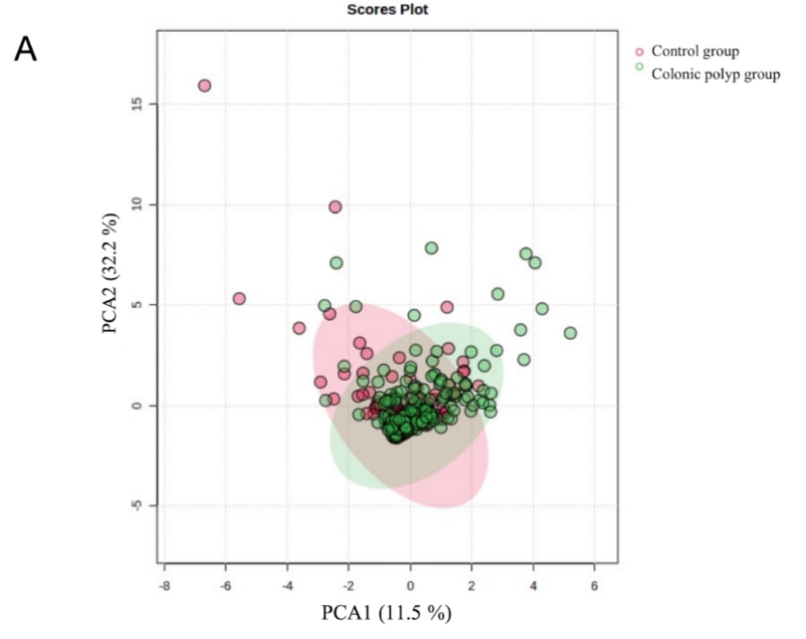
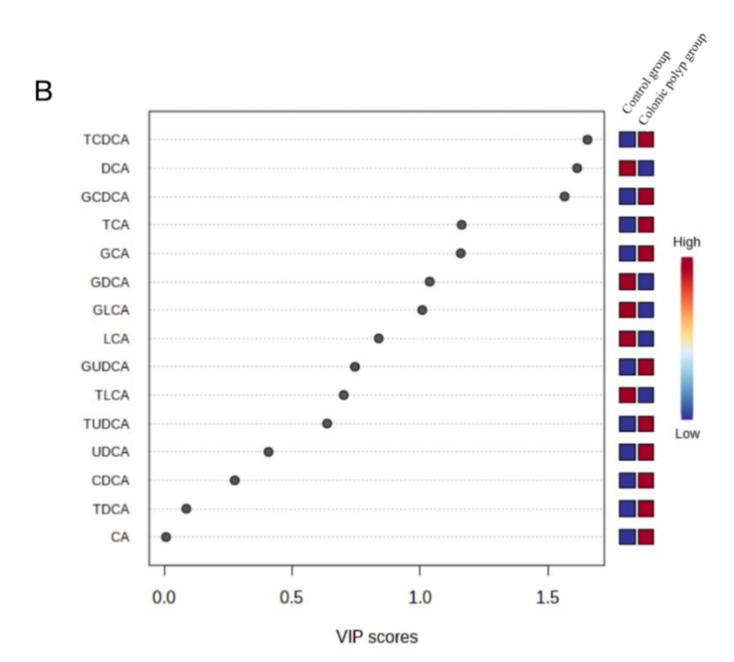
Figure 1 Orthogonal partial least squares discriminant analysis of the control group and colonic polyp group. A: Score map; B: Variable importance in projection score map. PCA: Principal Component Analysis; CA: Cholic acid; CDCA: Chenodeoxycholic acid; TCA: Taurocholic acid; GCA: Glycocholic acid; TCDCA: Taurochenodeoxycholic acid; GCDCA: Glycochenodeoxycholic acid; DCA: Deoxycholic acid; UDCA: Ursodeoxycholic acid; LCA: Lithocholic acid; TDCA: Tauroursodeoxycholic acid; GDCA: Glycodeoxycholic acid; TUDCA: Tauroursodeoxycholic acid; GUDCA: Glycoursodeoxycholic acid; TLCA: Taurolithocholic acid; GLCA: Glycolithocholic acid.
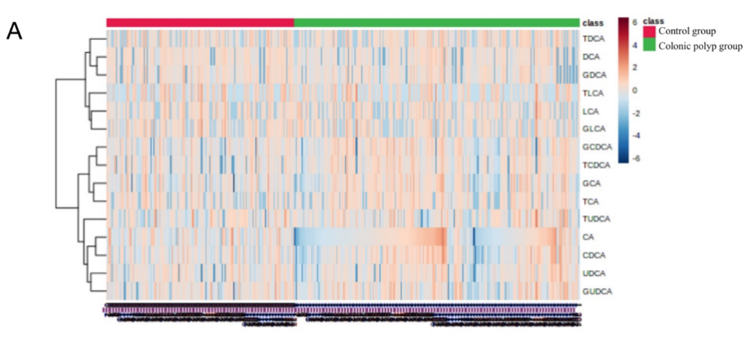
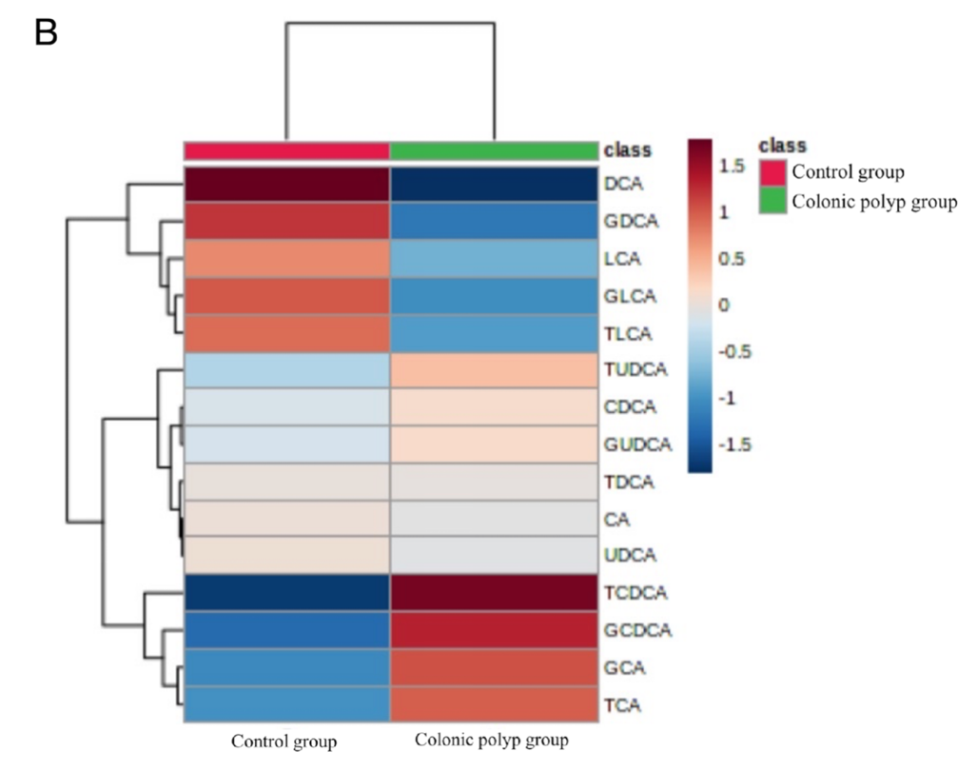
Figure 2 Heat map analysis of the serum bile acid profile of the subjects. A: The values of each sample; B: The average values of each group. The abscissa represents the sample size, and the ordinate represents the bile acid (BA) profile. The main part represents the expression of BA profile in the sample, and the color in the heat map reflects the changes in the content of BA profile. Figure 2A shows the values of each sample, while Figure 2B shows the average values of each group. CA: Cholic acid; CDCA: Chenodeoxycholic acid; TCA: Taurocholic acid; GCA: Glycocholic acid; TCDCA: Taurochenodeoxycholic acid; GCDCA: Glycochenodeoxycholic acid; DCA: Deoxycholic acid; UDCA: Ursodeoxycholic acid; LCA: Lithocholic acid; TDCA: Tauroursodeoxycholic acid; GDCA: Glycodeoxycholic acid; TUDCA: Tauroursodeoxycholic acid; GUDCA: Glycoursodeoxycholic acid; TLCA: Taurolithocholic acid; GLCA: Glycolithocholic acid.
Table 1 Comparison of general conditions between the colonic polyp group and the control group, n (%)
General information | Colonic polyp group (n = 204) | Control group  (n = 135) | P value
Age (year) | 57.19 ± 9.43 | 55.35 ± 8.79 | 0.072
BMI (kg/m²) | 23.82 ± 2.28 | 23.52 ± 2.37 | 0.244
Gender |  |  | 0.054
Males | 114 (55.88) | 61 (45.19)
Females | 90 (44.12) | 74 (54.81)
ALT (U/L) | 18.00 (13.00, 26.00) | 17.00 (13.00, 24.00) | 0.277
AST (U/L) | 20.00 (17.00, 24.00) | 19.00 (16.00, 23.00) | 0.155
TC (mmol/L) | 4.49 ± 0.84 | 4.56 ± 0.91 | 0.463
BMI: Body mass index; ALT: Alanine transaminase; AST: Aspartate transaminase; TC: Total cholesterol; Reference value range: ALT 9-50U/L; AST 15-40U/L; TC 0.00-6.20 mmol/L.

Table 2 Detection results of serum bile acid profiles in the colonic polyp group and the control group (nmol/L)
BA components | Colonic polyp group (n = 204) | Control group (n = 135) | P value
Primary free BAs
CA | 62.75 (24.33, 232.00) | 53.80 (27.60, 149.00) | 0.571
CDCA | 382.50 (105.50, 851.50) | 294.00 (130.00, 625.00) | 0.164
Primary conjugated BAs
TCA | 21.85 (5.50, 50.50) | 12.70 (1.50, 32.30) | 0.015ª
GCA | 166.50 (76.60, 330.00) | 126.00 (52.90, 234.00) | 0.025ª
GCDCA | 935.50 (430.50, 1967.50) | 708.00 (298.00, 1250.00) | 0.005ª
TCDCA | 74.35 (27.20, 164.50) | 41.60 (18.30, 119.00) | 0.006ª
Secondary free BAs
DCA | 142.00 (30.90, 424.25) | 234.00 (82.60, 502.00) | 0.011ª
LCA | 6.20 (0.13, 17.10) | 6.40 (0.60, 21.00) | 0.539
UDCA | 73.70 (23.03, 221.50) | 70.70 (19.00, 199.00) | 0.545
Secondary conjugated BAs
TDCA | 8.50 (0.05, 32.65) | 7.70 (0.00, 35.30) | 0.615
GDCA | 113.50 (12.08, 248.50) | 125.00 (34.60, 335.00) | 0.274
TLCA | 0.00 (0.00, 2.40) | 0.10 (0.00, 4.00) | 0.255
GLCA | 4.60 (0.00, 16.35) | 5.40 (0.00, 18.10) | 0.399
TUDCA | 7.65 (3.15, 15.00) | 8.20 (2.50, 15.00) | 0.369
GUDCA | 137.50 (47.25, 343.00) | 122.00 (63.80, 283.00) | 0.604
ªP < 0.05, there is a statistical difference in this indicator between the two groups.
BA: Bile acid; CA: Cholic acid; CDCA: Chenodeoxycholic acid; TCA: Taurocholic acid; GCA: Glycocholic acid; TCDCA: Taurochenodeoxycholic acid; GCDCA: Glycochenodeoxycholic acid; DCA: Deoxycholic acid; UDCA: Ursodeoxycholic acid; LCA: Lithocholic acid; TDCA: Tauroursodeoxycholic acid; GDCA: Glycodeoxycholic acid; TUDCA: Tauroursodeoxycholic acid; GUDCA: Glycoursodeoxycholic acid; TLCA: Taurolithocholic acid; GLCA: Glycolithocholic acid.

Table 3 Clinical and pathological parameters of colonic polyps in the polyp group
Group | Cases, n (%)
Pathological type
Adenomatous polyp
Tubular adenoma | 30 (14.71)
Villous tubular adenoma | 109 (53.43)
High grade intraepithelial neoplasia | 6 (2.94)
Non adenomatous polyp
Hyperplastic polyp | 59 (28.92)
Number of polyps
Single polyp | 73 (35.78)
Multiple polyps | 131 (64.22)
Size of polyp
Diameter < 1 cm | 169 (82.84)
Diameter ≥ 1 cm | 35 (17.16)
Location of polyp
Left colon | 114 (55.88)
Right colon | 48 (23.53)
Total colon | 42 (20.59)
The polyp is pedicled or not
Pedicled polyp | 22 (10.78)
Sessile polyp | 182 (89.22)
If the patient has multiple polyps in the colon, the grouping of polyp size is based on the maximum polyp diameter in the colon; If there is a pedunculated polyp, it will be classified as a pedunculated group. Polyps can be seen in the ascending colon, transverse colon, descending colon, and sigmoid colon in the whole colon group. If proliferative polyps and adenomatous polyps coexist in the pathological report of polyps, they are classified as adenomatous polyps.

Table 4 Bile acid levels in colonic polyps of different pathological types (nmol/L)
 | Non adenomatous polyp group | Adenomatous polyp group | P value
Primary free BAs
CA | 107.00 (39.50, 357.00) | 53.20 (20.35, 185.50) | 0.003ª
CDCA | 408.00 (191.00, 1130.00) | 373.00 (80.50, 785.00) | 0.034ª
Primary conjugated BAs
TCA | 24.80 (8.90, 71.50) | 20.10 (5.45, 45.80) | 0.189
GCA | 160.00 (81.70, 423.00) | 174.00 (72.60, 326.00) | 0.676
GCDCA | 866.00 (458.00, 2190.00) | 961.00 (397.00, 1785.00) | 0.465
TCDCA | 113.00(40.70, 185.00) | 64.50 (24.60, 152.50) | 0.060
Secondary free BAs
DCA | 182.00 (38.50, 448.00) | 118.00 (21.25, 401.00) | 0.226
LCA | 5.30 (0.00, 16.80) | 6.70 (0.50, 17.20) | 0.588
UDCA | 107.00 (49.00, 311.00) | 64.00 (16.15, 190.00) | 0.003ª
Secondary conjugated BAs
TDCA | 17.90 (2.50, 39.10) | 6.80 (0.00, 24.35) | 0.078
GDCA | 135.00 (7.40, 398.00) | 107.00 (19.25, 229.00) | 0.593
TLCA | 0.00 (0.00, 2.10) | 0.00 (0.00, 2.55) | 0.566
GLCA | 4.40 (0.00, 20.30) | 4.60 (0.00, 15.50) | 0.646
TUDCA | 11.70 (4.50, 20.10) | 6.50 (2.95, 15.00) | 0.023ª
GUDCA | 220.00 (58.10, 543.00) | 114.00 (43.55, 303.00) | 0.067
ªP < 0.05, there is a statistical difference in this indicator between the two groups.
BA: Bile acid; CA: Cholic acid; CDCA: Chenodeoxycholic acid; TCA: Taurocholic acid; GCA: Glycocholic acid; TCDCA: Taurochenodeoxycholic acid; GCDCA: Glycochenodeoxycholic acid; DCA: Deoxycholic acid; UDCA: Ursodeoxycholic acid; LCA: Lithocholic acid; TDCA: Tauroursodeoxycholic acid; GDCA: Glycodeoxycholic acid; TUDCA: Tauroursodeoxycholic acid; GUDCA: Glycoursodeoxycholic acid; TLCA: Taurolithocholic acid; GLCA: Glycolithocholic acid.

Table 5 Bile acid levels in single polyp group and multiple polyps group (nmol/L)
 | Single polyp group | Multiple polyps group | P value
Primary free BAs
CA | 92.40 (35.40, 275.50) | 59.70 (23.50, 170.00) | 0.067
CDCA | 492.00 (193.50, 905.50) | 357.00 (84.80, 836.00) | 0.185
Primary conjugated BAs
TCA | 23.50 (8.70, 47.35) | 20.20 (5.00, 52.10) | 0.809
GCA | 203.00 (93.35, 330.00) | 157.00 (60.90, 342.00) | 0.363
GCDCA | 1050.00 (506.50, 1945.00) | 881.00 (354.00, 2030.00) | 0.346
TCDCA | 80.70 (29.70, 170.50) | 69.10 (25.10, 165.00) | 0.707
Secondary free BAs
DCA | 119.00 (10.90, 401.00) | 145.00 (32.30, 437.00) | 0.588
LCA | 5.50 (0.25, 15.50) | 6.70 (0.00, 17.60) | 0.715
UDCA | 74.90 (33.15, 210.00) | 73.70 (17.20, 253.00) | 0.540
Secondary conjugated BAs
TDCA | 7.60 (0.00, 24.70) | 11.20 (0.70, 36.10) | 0.371
GDCA | 116.00 (10.60, 239.00) | 113.00 (12.70, 253.00) | 0.991
TLCA | 0.00 (0.00, 2.10) | 0.00 (0.00, 2.80) | 0.520
GLCA | 2.70 (0.00, 16.70) | 5.50 (0.00, 16.20) | 0.340
TUDCA | 9.10 (3.05, 15.00) | 6.90 (3.30, 15.00) | 0.865
GUDCA | 169.00 (47.20, 399.50) | 115.00 (47.10, 340.00) | 0.482
BA: Bile acid; CA: Cholic acid; CDCA: Chenodeoxycholic acid; TCA: Taurocholic acid; GCA: Glycocholic acid; TCDCA: Taurochenodeoxycholic acid; GCDCA: Glycochenodeoxycholic acid; DCA: Deoxycholic acid; UDCA: Ursodeoxycholic acid; LCA: Lithocholic acid; TDCA: Tauroursodeoxycholic acid; GDCA: Glycodeoxycholic acid; TUDCA: Tauroursodeoxycholic acid; GUDCA: Glycoursodeoxycholic acid; TLCA: Taurolithocholic acid; GLCA: Glycolithocholic acid.

Table 6 Bile acid levels in colonic polyps of different sizes (nmol/L)
 | Diameter < 1cm group | Diameter ≥ 1 cm group | P value
Primary free BAs
CA | 55.80 (22.70, 200.00) | 155.00 (32.30, 343.00) | 0.005ª
CDCA | 365.00 (85.20, 835.00) | 586.00 (278.00, 1130.00) | 0.015ª
Primary conjugated BAs
TCA | 21.70 (5.50, 46.85) | 22.00 (11.50, 75.50) | 0.391
GCA | 167.00 (84.05, 329.50) | 166.00 (57.50, 416.00) | 0.927
GCDCA | 961.00 (389.00, 1845.00) | 900.00 (556.00, 2410.00) | 0.333
TCDCA | 69.10 (24.05, 152.50) | 90.20 (40.70, 262.00) | 0.060
Secondary free BAs
DCA | 127.00 (21.90, 389.00) | 274.00 (77.30, 525.00) | 0.063
LCA | 5.50 (0.00, 16.15) | 8.50 (2.10, 21.60) | 0.163
UDCA | 64.50 (16.75, 182.50) | 196.00 (52.70, 421.00) | 0.003ª
Secondary conjugated BAs
TDCA | 8.20 (0.00, 29.80) | 13.30 (3.10, 37.10) | 0.317
GDCA | 108.00 (12.65, 235.00) | 144.00 (10.80, 324.00) | 0.610
TLCA | 0.00 (0.00, 2.30) | 0.80 (0.00, 3.20) | 0.189
GLCA | 4.60 (0.00, 15.80) | 2.50 (0.00, 21.20) | 0.736
TUDCA | 7.00 (3.00, 15.00) | 14.10 (3.90, 34.60) | 0.034ª
GUDCA | 122.00 (42.95, 315.50) | 234.00 (59.00, 556.00) | 0.030ª
ªP < 0.05, there is a statistical difference in this indicator between the two groups.
BA: Bile acid; CA: Cholic acid; CDCA: Chenodeoxycholic acid; TCA: Taurocholic acid; GCA: Glycocholic acid; TCDCA: Taurochenodeoxycholic acid; GCDCA: Glycochenodeoxycholic acid; DCA: Deoxycholic acid; UDCA: Ursodeoxycholic acid; LCA: Lithocholic acid; TDCA: Tauroursodeoxycholic acid; GDCA: Glycodeoxycholic acid; TUDCA: Tauroursodeoxycholic acid; GUDCA: Glycoursodeoxycholic acid; TLCA: Taurolithocholic acid; GLCA: Glycolithocholic acid.

Table 7 Bile acid levels in different parts of polyps (nmol/L)
 | Left colon group | Right colon group | Total colon group | P value
Primary free BAs
CA | 108.00 (24.53, 334.00) | 65.60 (48.23, 126.00) | 23.20 (11.05, 157.48) | 0.000ª
CDCA | 447.00 (130.25, 1000.00) | 448.00 (191.00, 813.00) | 135.50 (41.43, 678.00) | 0.047ª
Primary conjugated BAs
TCA | 20.75 (4.88, 53.78) | 34.70 (12.73, 58.85) | 15.00 (4.15, 39.43) | 0.148
GCA | 156.50 (65.53, 342.25) | 257.00 (136.00, 373.00) | 134.00 (42.95, 204.00) | 0.006ª
GCDCA | 812.50 (334.00, 1822.50) | 1420.00 (764.00, 2387.50) | 655.50 (290.50, 1622.50) | 0.005ª
TCDCA | 73.95 (23.68, 154.25) | 110.00 (45.63, 257.00) | 64.20 (28.18, 125.50) | 0.060
Secondary free BAs
DCA | 185.00 (48.85, 466.25) | 105.50 (3.18, 383.75) | 110.50 (18.08, 280.75) | 0.098
LCA | 6.20 (0.68, 15.08) | 8.85 (0.00, 17.20) | 5.50 (0.00, 28.83) | 0.963
UDCA | 73.55 (27.00, 209.50) | 102.50 (29.80, 212.75) | 46.45 (9.78, 252.75) | 0.314
Secondary conjugated BAs
TDCA | 8.50 (1.25, 34.63) | 8.50 (0.00, 22.825) | 7.55 (0.00, 30.33) | 0.635
GDCA | 122.50 (20.03, 278.50) | 118.00 (6.48, 242.00) | 86.70 (7.18, 213.75) | 0.464
TLCA | 0.00 (0.00, 2.30) | 0.45 (0.00, 3.00) | 0.65 (0.00, 2.48) | 0.478
GLCA | 4.60 (0.00, 15.90) | 3.35 (0.00, 18.25) | 5.85 (0.38, 19.28) | 0.555
TUDCA | 9.10 (2.20, 15.00) | 6.40 (4.13, 15.00) | 6.75 (3.83, 15.00) | 0.933
GUDCA | 113.00 (34.43, 341.00) | 228.50 (83.25, 514.50) | 112.00 (47.55, 308.75) | 0.064
ªP < 0.05, there is a statistical difference in this indicator between the two groups.
BA: Bile acid; CA: Cholic acid; CDCA: Chenodeoxycholic acid; TCA: Taurocholic acid; GCA: Glycocholic acid; TCDCA: Taurochenodeoxycholic acid; GCDCA: Glycochenodeoxycholic acid; DCA: Deoxycholic acid; UDCA: Ursodeoxycholic acid; LCA: Lithocholic acid; TDCA: Tauroursodeoxycholic acid; GDCA: Glycodeoxycholic acid; TUDCA: Tauroursodeoxycholic acid; GUDCA: Glycoursodeoxycholic acid; TLCA: Taurolithocholic acid; GLCA: Glycolithocholic acid.
Table 8 Bile acid levels in colonic polyps with or without pedicle (nmol/L)
 | Pedicled polyp group | Sessile polyp group | P value
Primary free BAs
CA | 420.00 (32.48, 791.00) | 59.80 (24.08, 173.00) | 0.006ª
CDCA | 711.00 (214.75, 2845.00) | 373.50 (94.68, 834.50) | 0.016ª
Primary conjugated BAs
TCA | 17.90 (11.00, 94.98) | 22.10 (5.30, 49.90) | 0.635
GCA | 166.50 (92.35, 491.25) | 168.50 (73.75, 330.00) | 0.709
GCDCA | 1230.00 (625.25, 2775.00) | 900.00 (413.25, 1860.00) | 0.096
TCDCA | 111.50 (44.68, 307.50) | 68.15 (25.35, 162.00) | 0.075
Secondary free BAs
DCA | 155.50 (0.68, 806.00) | 142.00 (34.03, 418.25) | 0.976
LCA | 3.50 (0.00, 22.13) | 6.45 (0.50, 15.93) | 0.662
UDCA | 228.00 (64.38, 454.75) | 64.90 (19.63, 196.50) | 0.003ª
Secondary conjugated BAs
TDCA | 13.90 (0.00, 56.58) | 8.15 (0.50, 30.33) | 0.539
GDCA | 118.15 (0.00, 494.50) | 113.50 (18.50, 238.00) | 0.595
TLCA | 0.25 (0.00, 3.78) | 0.00 (0.00, 2.30) | 0.540
GLCA | 3.40 (0.00, 30.45) | 4.65 (0.00, 16.05) | 0.723
TUDCA | 7.20 (4.15, 24.43) | 7.65 (3.08, 15.00) | 0.472
GUDCA | 330.50 (133.75, 573.00) | 114.50 (44.40, 314.75) | 0.008ª
ªP < 0.05, there is a statistical difference in this indicator between the two groups.
BA: Bile acid; CA: Cholic acid; CDCA: Chenodeoxycholic acid; TCA: Taurocholic acid; GCA: Glycocholic acid; TCDCA: Taurochenodeoxycholic acid; GCDCA: Glycochenodeoxycholic acid; DCA: Deoxycholic acid; UDCA: Ursodeoxycholic acid; LCA: Lithocholic acid; TDCA: Tauroursodeoxycholic acid; GDCA: Glycodeoxycholic acid; TUDCA: Tauroursodeoxycholic acid; GUDCA: Glycoursodeoxycholic acid; TLCA: Taurolithocholic acid; GLCA: Glycolithocholic acid.

Table 9 Risk factors for colonic polyps: Univariate and multivariate logistic regression analysis
Variable | Univariate analysis |  | Multivariate analysis
 | OR (95%CI) | P value | OR (95%CI) | P value
TBA | 1.000 (1.000, 1.000) | 0.104
CA | 1.000 (1.000, 1.001) | 0.181
CDCA | 1.000 (1.000, 1.000) | 0.046 | 1.001 (1.000, 1.001) | 0.073
DCA | 1.000 (1.000, 1.000) | 0.799
LCA | 1.000 (0.999, 1.001) | 0.636
UDCA | 1.000 (1.000, 1.001) | 0.329
GCA | 1.000 (1.000, 1.001) | 0.512
GCDCA | 1.000 (1.000, 1.000) | 0.027 | 1.001 (1.000, 1.001) | 0.074
GDCA | 1.000 (0.999, 1.000) | 0.080
GLCA | 1.000 (0.999, 1.001) | 0.394
GUDCA | 1.000 (1.000, 1.001) | 0.154
TCA | 1.000 (0.998, 1.002) | 0.927
TCDCA | 1.00 1(0.999, 1.002) | 0.328
TDCA | 0.998 (0.995, 1.002) | 0.310
TLCA | 0.999 (0.989, 1.009) | 0.900
TUDCA | 1.005 (0.993, 1.018) | 0.413
primary BA | 1.000 (1.000, 1.000) | 0.018 | 1.000 (0.999, 1.000) | 0.182
primary free BA | 1.000 (1.000, 1.000) | 0.053
primary conjugated BA | 1.000 (1.000, 1.000) | 0.071
secondary BA | 1.000 (1.000, 1.000) | 0.720
secondary free BA | 1.000 (1.000, 1,000) | 0.710
secondary conjugated BA | 1.000 (1.000, 1.000) | 0.363
BA: Bile acid; CA: Cholic acid; CDCA: Chenodeoxycholic acid; TCA: Taurocholic acid; GCA: Glycocholic acid; TCDCA: Taurochenodeoxycholic acid; GCDCA: Glycochenodeoxycholic acid; DCA: Deoxycholic acid; UDCA: Ursodeoxycholic acid; LCA: Lithocholic acid; TDCA: Tauroursodeoxycholic acid; GDCA: Glycodeoxycholic acid; TUDCA: Tauroursodeoxycholic acid; GUDCA: Glycoursodeoxycholic acid; TLCA: Taurolithocholic acid; GLCA: Glycolithocholic acid.

