Name of Journal: World Journal of Clinical Cases
Manuscript NO: 66236
Manuscript Type: ORIGINAL ARTICLE

Observational Study
Validated tool for early prediction of intensive care unit admission in COVID-19 patients

Huang HF et al. Early Prediction of ICU admission in COVID-19

Hao-Fan Huang, Yong Liu, Jin-Xiu Li, Hui Dong, Shan Gao, Zheng-Yang Huang, Shou-Zhi Fu, Lu-Yu Yang, Hui-Zhi Lu, Liao-You Xia, Song Cao, Yi Gao, Xia-Xia Yu

Hao-Fan Huang, Shan Gao, Zheng-Yang Huang, Yi Gao, Xia-Xia Yu, School of Biomedical Engineering, Health Science Center, Shenzhen University, Shenzhen 518060, Guangdong Province, China

Yong Liu, Expert Panel of Shenzhen 2019-nCoV Pneumonia, Shenzhen Hospital, Southern Medical University, Shenzhen 518000, Guangdong Province, China

Jin-Xiu Li, Department of Critical Care Medicine, Shenzhen Third People’s Hospital, Second Hospital Affiliated to Southern University of Science and Technology, Shenzhen 518112, Guangdong Province, China

Hui Dong, Shou-Zhi Fu, Lu-Yu Yang, Hui-Zhi Lu, Liao-You Xia, Song Cao, Department of ICU/Emergency, Wuhan Third Hospital, Wuhan University, Wuhan 430000, Hubei Province, China

Author contributions: Yu XX and Gao Y conceived and coordinated the study, designed, performed and analyzed the experiments and wrote the paper; Dong H, Fu SZ, Liu Y, Lu HZ, Xia LY and Cao S carried out the data collection and preprocess of the raw data; Huang HF, Gao S and Huang ZY performed the data analysis; Liu Y and Li JX revised the paper; All authors reviewed the results and approved the final version of the manuscript.

Supported by Shenzhen Municipal Government’s "Peacock Plan", No. KQTD2016053112051497.

Corresponding author: Xia-Xia Yu, PhD, Assistant Professor, School of Biomedical Engineering, Health Science Center, Shenzhen University, No. 3688 Nanhai Avenue, Shenzhen 518060, Guangdong Province, China. xiaxiayu@szu.edu.cn

Received: April 13, 2021
Revised: May 12, 2021
Accepted: August 16, 2021
Published online:

Abstract
BACKGROUND
The novel coronavirus disease 2019 (COVID-19) pandemic is a global threat caused by the severe acute respiratory syndrome coronavirus-2.

AIM
To develop and validate a risk stratification tool for the early prediction of intensive care unit (ICU) admission among COVID-19 patients at hospital admission.

METHODS
The training cohort included COVID-19 patients admitted to the Wuhan Third Hospital. We selected 13 of 65 baseline laboratory results to assess ICU admission risk, which were used to develop a risk prediction model with the random forest (RF) algorithm. A nomogram for the logistic regression model was built based on six selected variables. The predicted models were carefully calibrated, and the predictive performance was evaluated and compared with two previously published models.

RESULTS
There were 681 and 296 patients in the training and validation cohorts, respectively. The patients in the training cohort were older than those in the validation cohort (median age: 63.0 vs 49.0 years, P < 0.001), and the percentages of male gender were similar (49.6% vs 49.3%, P = 0.958). The top predictors selected in the RF model were neutrophil-to-lymphocyte ratio, age, lactate dehydrogenase, C-reactive protein, creatinine, D-dimer, albumin, procalcitonin, glucose, platelet, total bilirubin, lactate and creatine kinase. The accuracy, sensitivity and specificity for the RF model were 91%, 88% and 93%, respectively, higher than those for the logistic regression model. The area under the receiver operating characteristic curve of our model was much better than those of two other published methods (0.90 vs 0.82 and 0.75). Model A underestimated risk of ICU admission in patients with a predicted risk less than 30%, whereas the RF risk score demonstrated excellent ability to categorize patients into different risk strata. Our predictive model provided a larger standardized net benefit across the major high-risk range compared with model A.

CONCLUSION
Our model can identify ICU admission risk in COVID-19 patients at admission, who can then receive prompt care, thus improving medical resource allocation.

Key Words: COVID-19; Intensive care units; Machine learning; Prognostic predictive model; Risk stratification

Huang HF, Liu Y, Li JX, Dong H, Gao S, Huang ZY, Fu SZ, Yang LY, Lu HZ, Xia LY, Cao S, Gao Y, Yu XX. Validated tool for early prediction of intensive care unit admission in COVID-19 patients. World J Clin Cases 2021; In press

Core Tip: This study established a risk stratification tool for the early prediction of intensive care unit admission among coronavirus disease 2019 patients at hospital admission to enable such patients to receive immediate appropriate care, thus improving medical resource allocation. The model with 13 indicators selected from 65 laboratory results collected at hospital admission could be used to assess the risk of intensive care unit admission. This study provided a simple probability prediction model to identify intensive care unit admission risk in coronavirus disease 2019 patients at admission.

INTRODUCTION
The coronavirus disease 2019 (COVID-19) outbreak started in Wuhan, China in December 2019^{[1,2]}. Since then, COVID-19 spread rapidly to pandemic proportions. This disease is caused by severe acute respiratory syndrome coronavirus 2. The disease is associated with symptoms of varying severity. While some patients remain asymptomatic, some exhibit more severe symptoms that rapidly progress to acute respiratory distress syndrome, metabolic acidosis, coagulopathy and septic shock^{[3,4]}. Therefore, patients with severer forms of the disease often require intensive care unit (ICU) care.
The severity and prognosis of COVID-19 varies widely. The clinical characteristics of COVID-19 that impact the disease course can serve as a guide in clinical decision-making^{[5,6]}. Currently, COVID-19 research has focused on the epidemiology and the clinical characteristics of patients^{[3,7]}; however, very few studies have reported the early prediction of prognosis, especially in terms of disease course severity or probability of ICU admission.
Due to the rapidly expanding number of patients and the limited resources in the ICU, prediction models for COVID-19 are crucial in clinical decision-making and medical resource micro-allocation. However, although approximately 50 prognostic models have been built so far, including eight models to predict progression to severe or critical disease^{[8]}, only four of the models predicted ICU admission^{[9-12]}. Among the four studies, only two calibrated their models, resulting in underestimation of the risk of poor outcomes and miscalibration risks during external validation^{[11,12]}. Several prognostic predictive models mainly based on laboratory tests have been developed to predict disease progression to a severe or critical state, and the estimated C index of model performance was approximately 0.85^{[13-15]}. Similarly, one of these studies reported perfect calibration. However, the method to check calibration may have been suboptimal^{[8]}.
At the start of the pandemic, there was no antiviral agent or vaccine that existed to target this virus, and none of the existing antiretroviral treatments had been recommended for this disease. On October 22, 2020, remdesivir was approved by the Food and Drug Administration as a drug for treating hospitalized COVID-19 patients aged 12 years or more^{[16]}. Since then, ledipasvir and paritaprevir, which have been approved by the Food and Drug Administration, have also been shown to have potential in the treatment of COVID-19. The United States Food and Drug Administration has granted Emergency Use Authorization for the use of two messenger RNA vaccines against COVID-19^{[17]}. However, even highly effective vaccines cannot keep the pandemic under check unless they cover a high percentage of the population. Therefore, it is necessary to stratify patients by illness severity risk or ICU admission risk so that patients who are at higher risk of requiring ICU admission can be identified; this can help reduce the burden of ICU usage, particularly in resource-limited settings. The development of a prognostic model is crucial to address the problem of micro-allocation of scarce healthcare resources in the face of a pandemic^{[18]}.
Therefore, the present study aimed to develop and validate a risk stratification tool for the early prediction of ICU admission among COVID-19-positive patients with reference to previously published literature and expert opinion together with data-driven methods. To this end, we externally validated the predicted model on another dataset, and its performance was carefully calibrated.

MATERIALS AND METHODS
Study design and participants
In this retrospective study, all patients with a positive COVID-19 diagnosis according to any one of the following diagnostic criteria were included in the present study: (1) Respiratory tract or blood specimens were positive for severe acute respiratory syndrome coronavirus 2 nucleic acids by real-time fluorescence reverse transcription-polymerase chain reaction; (2) Genetic sequencing of respiratory tract or blood specimens revealed that the material had high homology with severe acute respiratory syndrome coronavirus 2; and (3) Suspected cases with imaging features of pneumonia consistent with that described in the “Diagnosis and treatment plan for pneumonia infected with new coronavirus [trial version 5]” issued by the National Health Commission of China (this standard was limited to Hubei Province).
Consecutive patients diagnosed with COVID-19 in the Wuhan Third Hospital between December 2019 and March 2020 were included in the training cohort. There were 681 patients in the training cohort. The predictive model was built and internally validated using the above data. The features evaluated for the predictive model included baseline demographics and laboratory data of each patient obtained at their first examination after admission. All blood and urinary samples were processed within 2 h of collection. Figure 1 presents a flowchart illustrating the patients in the training and validation cohorts. The data for each cohort was obtained and analyzed retrospectively. Cases in need of ICU admission were defined according to the following criteria^{[19]}: (1) Respiratory rate ≥ 30 times/min; (2) Pulse oximeter oxygen saturation ≤ 93% at rest; and (3) Partial pressure of arterial oxygen/fraction of inspired oxygen ≤ 300 mmHg.

Prediction algorithm
The proposed algorithm used in this study was built on the basis of the random forest (RF) algorithm^{[20]}, with modifications made to improve the selection of features (Figure 2). The number of trees was set to 480, and the number of variables selected at each split was set to 4.

Feature selection
Feature selection consisted of the following two steps. First, the least absolute shrinkage and selection operator logistic regression (LR) and univariate LR were used to determine which variables were associated with disease prognosis. We performed a tenfold cross-validation of the training set to calculate the weight of least absolute shrinkage and selection operator penalty. Furthermore, physicians’ knowledge, together with previously published predictors significantly associated with COVID-19 severity^{[21]} were also used to guide feature selection. Then, since each feature’s relative rank could reflect its relative significance^{[22-24]}, the information gain algorithm based on entropy and out-of-bag error assessment were used to screen the selected variables for training the RF model. Furthermore, we carried out stepwise multivariate regression analysis to screen the selected variables for training the LR model. We used variables with a P < 0.05 to build the model.

Model construction
A tree-based ensembled machine learning algorithm, RF, was used to build a risk prediction model based on 13 selected variables. GridsearchCV was performed to search the best parameter for the optimal model. A nomogram for the LR model was built based on six selected variables, which were then screened by multivariate logistic regression analysis. The models were developed in Python version 3.6.5. The reporting followed the TRIPOD statements^{[25]}.

Performance evaluation
Here, we comparatively assessed the predictive performances of scores yielded by the present and conventionally used models, as described below:

Discrimination: To evaluate discrimination, we used the area under the receiver operating characteristic curve, accuracy, specificity, sensitivity, box plots of predicted probabilities of ICU admission and corresponding discrimination slopes, defined as the differences between the mean predicted risks for ICU admission.

Calibration: The conventional Hosmer-Lemeshow statistic was avoided due to its shortcomings^{[26,27]}. Calibration of the predictive model was assessed by the visual representation of the relationship between the predicted and observed values^{[28]}. We constructed calibration curves by plotting the predicted risk of ICU admission divided into 20 groups based on the model risk score against the observed ICU admission.

Reclassification
The net reclassification index (NRI), which has been devised to overcome the limitations of usual discrimination and calibration measures, was computed to compare our proposed algorithm to the other scores^{[29]}. The NRI comparing risk score A of ICU admission to score B was defined as two times the difference between the proportion of no ICU admission and ICU admission groups, respectively, which deemed the risk of ICU admission to be higher according to score A than according to score B^{[30]}. Positive values of the NRI indicated that score A had better discriminative ability than score B, whereas negative values indicated the opposite.

Decision curve analysis
A decision curve analysis (DCA) was used to estimate the clinical usefulness and net benefit of the intervention^{[31]}. The decision curve^{[32]} is a novel and clever graphical device used to assess the potential population impact of adopting a risk prediction instrument into clinical practice. It is grounded in a decision-theoretical framework that accounts for both the benefits of intervention and the costs of intervention to a patient who cannot benefit from the intervention.

External validation
A completely independent dataset was then used to externally validate the predictive performance of the algorithm developed herein. To this end, we randomly collected patients with COVID-19 that had been clinically confirmed by reverse transcription-polymerase chain reaction between January 19, 2020 and March 14, 2020, in Shenzhen Third People’s Hospital, which is a tertiary-care teaching hospital. Informed consents were obtained from all patients or from their families by telephone before their data were used in this study. All patient privacy data were protected under the confidentiality policy. Data were analyzed using the statistical software package R, version 3.4.3 (R Core Team, 2017) and EmpowerStats (X&Y solutions, Inc. Boston, Massachusetts).

Model comparison
The performance of the proposed predictive model was compared to other recently published models on the same external validation data. For convenience, the two published models were designated model A^{[33]} and model B^{[34]}.

Statistical analysis
All participants’ baseline demographic and clinical characteristics were obtained at admission. Continuous variables were presented as means ± standard deviation or medians (interquartile ranges), whereas categorical variables were presented using frequencies (percentages). Intergroup differences were analyzed with the χ² test, one-way analysis of variance and Kruskal-Wallis test for categorical variables, normal variables and continuous variables with skewed distribution, respectively. A P < 0.05 was considered statistically significant.

RESULTS
Study population
This study describes the development of an algorithm for the early prediction of ICU admission among COVID-19 patients at hospital admission. For developing the prediction model, we first used a training cohort consisting of 681 patients from Wuhan Third Hospital and analyzed their basic baseline demographic and laboratory data obtained at the first admission. We then calibrated the performance of this prediction tool using an entirely different sample set of 296 patients from Shenzhen Third People’s Hospital.
Table 1 presents a comparison of the baseline clinical and laboratory characteristics between the training and validation cohorts. The patients in the training cohort were older than those in the validation cohort (median age: 63.0 vs 49.0 years, P < 0.001), and the percentages of male gender were similar (49.6% vs 49.3%, P = 0.958). There was also some heterogeneity in laboratory results among the different patient groups. Table 1 presents all the patient characteristics.

Feature selection for the predictive model
We selected a total of 65 baseline clinical features for use in our prediction tool. Those with missing values were deleted (n = 18), and the remaining 47 features with complete data were used as potential predictors of critical illness requiring ICU admission. Twenty-three predictors with non-zero coefficients were selected in the least absolute shrinkage and selection operator LR model. Of these, those with P > 0.05 were excluded, and 19 predictors with P < 0.05 were selected for the univariate LR analysis (Table 2). After adjusting the model based on expert opinion, a total of 17 predictors were decided.
The information gain of each variable and its importance were calculated and ranked based on entropy and out-of-bag error. Figure 3 depicts the relative importance of each of the features. Variables were dropped from the bottom of the list, starting from the variable that was deemed least important and progressing in ascending order. The least classification error was obtained when gender, alanine transaminase, aspartate aminotransferase and white blood cell were dropped from the prediction model. Hence, these four features were removed. Figure 4 shows the relationship between the number of discarded variables and classification error. After all, a final of 13 predictors were selected. SHapley Additive exPlanations value was calculated to explain the output of the RF model (Figure 5). It connected optimal credit allocation with local explanations using the classic Shapley values from game theory and their related extensions^{[35]}. In the next step, six predictors [neutrophil-to-lymphocyte ratio (NLR), age, lactate dehydrogenase, creatinine, glucose and albumin] with P < 0.05 were selected to build the multivariate LR model (Table 2). The personalized nomogram was then used to show the probability of ICU admission (Figure 6).

Internal validation performance
After feature selection, two predictive models, LR and RF, were built on the basis of the selected variables. For internal validation, the area under the receiver operating characteristic curve for the RF model was found to be 0.94, which was higher than that for the LR model at 0.91 (P = 0.111, DeLong’s test). The accuracy, sensitivity and specificity for the RF model were 91%, 88% and 93%, respectively, higher than those for the LR model (87%, 82%, and 89%, respectively) (Figure 7).

External validation performance
Moreover, we compared our results with those of previously published methods in the external validation dataset as well (Figure 7). The area under the receiver operating characteristic curves for the RF, LR, model A and model B models were 0.90, 0.86, 0.82 and 0.75, respectively. The DeLong’s test between these models was: P = 0.135 (RF vs LR), P = 0.004 (RF vs model A), P = 0.006 (RF vs model B), P = 0.333 (LR vs model A), P = 0.045 (LR vs model B) and P = 0.185 (model A vs model B). The accuracy for the RF, LR and model A models were 86%, 83% and 76%, respectively. The sensitivity was 82%, 79% and 82%, respectively. The specificity was 86%, 83% and 75%, respectively. Since model B showed the lowest performance in this validation set, only the predictive performance of LR, RF and model A were compared for the following experiments.
Figure 8A, 8C and 8E shows the observed risk of ICU admission vs model-predicted risk in groups based on the calculated model risk score. The overestimation and underestimation in the probability range of ICU admission risk were evident from the plots. Model A underestimated risk in patients with a predicted risk less than 30%. The RF and LR models show a perfect calibration. The RF risk score demonstrated an excellent ability to categorize patients in separate risk strata. Figure 8B, 8D and 8F shows the differences in the predicted probability values between ICU admission and no ICU admission using each of the prediction models. The discrimination slope for the RF, LR and model A models were 0.281, 0.246 and 0.143, respectively. The plots indicated a lack of fit for the model A.
We further calculated the risk of each individual in the entire testing cohort and divided all patients into three groups based on the risk cut-off at 95% sensitivity and 95% specificity^{[36]}. Then we computed the NRI with RF as the second model, and LR and model A as the first models. In this scenario, a positive NRI value would indicate that the RF model has better discriminative ability compared to the other models, while a negative value would indicate the converse. Table 3 summarizes the results of this analysis.
Finally, DCA was used to facilitate the comparison between different prediction models. As shown in Figure 9, the DCA graphically shows the clinical usefulness of each model based on a continuum of potential thresholds for major high risk and the standardized net benefit of using the model to stratify patients relative to assuming that there were no ICU admission patients. As shown from our results, the standardized net benefit yielded by the models developed in this study was larger across the major high-risk range compared with model A.

DISCUSSION
Due to the rapidly expanding number of patients and the limited resources in the ICU, prediction models for patients with COVID-19 are crucial in clinical decision-making and medical resource micro-allocation. In the present study, a training cohort of 681 COVID-19 patients were recruited from Wuhan Third Hospital. A risk prediction model was successfully established to assess the chance of ICU admission based on the lab results obtained at the time of hospital admission. Furthermore, we performed an external validation on a total of 296 confirmed COVID-19 patients from Shenzhen Third People’s Hospital. Comparing with the recent published methods on the same validation data, our results revealed that the newly developed model (RF) exhibited relatively better discriminatory power, and the external verification was also satisfactory. In addition, our model showed a better discriminatory power in diverse populations from hospitals of different levels with varying death rates and varying baseline physical conditions, indicating that our models that were developed in the current study can be applied to a wide variety of settings.
Meanwhile, when creating a new prediction model, we recommend selecting predictors based on previous literature and expert opinion, rather than in a purely data-driven way^{[8]}. In this case, we developed a mixed-knowledge feature selection process, including machine-selection and clinicians’ knowledge, together with previous published predictors^{[21]}. Although the more information used during the developing step, the better performance the models would be, we would like to limit the number of the predictors while achieving similar performance in order to ease the user experience. Several studies have shown that lung imaging can help assess disease severity in COVID-19^{[37]}, which is one of the clinical diagnostic criteria. However, our predictive model was able to achieve good results by using only the biochemical indicators obtained on the first day of admission, thereby reducing the physical strain and economic burden on patients and governments.
Furthermore, based on the selected variables, two clinical predictive models were built. The LR model used only six of the selected variables but performed better than the other two published methods^{[33,34]} on our external validated dataset. One step further, in order to improve the predictive ability of the mode, a more sophisticated machine learning method, RF, was introduced in our model building step.
The predictive performance of the models built in the present study were carefully evaluated and calibrated. As we all know, poorly calibrated models will underestimate or overestimate the outcome of interest, while an excellent model will show strong calibration for different groups of patients. A model with adequate calibration by predicted risk strata will provide useful information for clinical decision making^{[28]}. In our results, visual representation of the relationship between predicted and observed values were shown to evaluation calibration. Discrimination and calibration results show that the RF model demonstrated an excellent ability to categorize patients in separate risk strata and the values predicted by the model agree with the observed values, which indicated that both the RF and LR models performed better than other published methods, and the RF model performed the best. Furthermore, when comparing the performance of all the three models, the reclassification result revealed that the RF model resulted in the reclassification of a large number of patients, and a positive NRI value indicated that the RF model performed better than the other models.
The following six variables were the most important in prediction of a risk of ICU admission among COVID-19 patients, in decreasing order of importance: NLR, age, lactate dehydrogenase, C-reactive protein, creatinine, D-dimer and albumin.
The NLR represents inflammation and is a known indicator of the systemic inflammatory response^{[38]}. Yang et al^{[38]} stated that elevated NLR could be considered an independent biomarker of indicating poor clinical outcomes in the outcome following COVID-19. Age was the second most important factor in the model, and age has been very well known as an important biomarker of poor clinical outcomes in the context of COVID-19. Lactate dehydrogenase and C-reactive protein have also been found to be associated with poorer outcomes such as respiratory failure in COVID-19 patients^{[39]}. These results are in agreement with the findings of our study.
Finally, the clinical model developed in this study may be able to assist medical professionals to identify high-risk patients at their first assessment in settings where medical resources are limited. Based on the results of the DCA, the standardized net benefit was the highest with the RF model across the major high-risk range. This model can aid doctors infer the likely course of COVID-19 at an early stage so that they can guide the patients toward more appropriate treatments. Therefore, patients that are more likely to develop a severe case of COVID-19 can get close attention and high-level treatments in advance.
The present study has some limitations. First, the participants included patients who tested positive for COVID-19 in Wuhan; therefore, studies across larger areas need to be carried out to further verify our findings. Second, any medications taken prior to hospital admission and the time interval between hospital admission and disease onset could have affected the data records. Third, we did not analyze some data points, e.g., the body mass index and viral load, which are potential risk factors of infection severity, in our study. Despite these limitations, our predictive models yielded good discriminatory power when we verified the models in a heterogeneous population. Fourth, some data that may be critical to a patient’s prognosis, such as mechanical ventilation data, were not collected in this study. However, in China, treatment for COVID-19 among all hospitals is carried out in line with the National Health Commission of China guidelines^{[26]}. Here, we devised predictive models using patient information obtained from tests done at admission. In the future, research should include repeated measures data to identify whether any temporal changes in clinical indicators are better able to predict disease prognosis in COVID-19.

CONCLUSION
In the present study, we used the first day of laboratory results to build a model for the early prediction of the need for ICU admission among patients diagnosed with COVID-19 infection. Upon external verification, the discriminatory powers exhibited by our predictive models were relatively satisfactory. The models developed in this study can aid high-risk patients to achieve early intervention and provide guidance to ensure the rational allotment of medical resources.

ARTICLE HIGHLIGHTS
Research background
The novel coronavirus disease 2019 (COVID-19) pandemic is a global threat caused by the severe acute respiratory syndrome coronavirus-2.

Research motivation
The development of a prognostic model is crucial to address the problem of micro-allocation of scarce healthcare resources in the face of a pandemic.

Research objectives
To develop and validate a risk stratification tool for the early prediction of intensive care unit admission among COVID-19 patients at hospital admission.

Research methods
We selected 13 of 65 baseline laboratory results and developed a risk prediction model with the random forest algorithm. A nomogram for the logistic regression model was built based on six selected variables.

Research results
The accuracy, sensitivity and specificity for the random forest model were 91%, 88% and 93%, respectively, higher than those for the logistic regression model. The area under the receiver operating characteristic curve of our model was much better than those of two other published methods (0.90 vs 0.82 and 0.75).

Research conclusions
Our model can identify intensive care unit admission risk in COVID-19 patients at admission, who can then receive prompt care, thus improving medical resource allocation.

Research perspectives
In the future, research should include repeated measures data to identify whether temporal changes in clinical indicators are better able to predict disease prognosis in COVID-19.

REFERENCES
1 Lu H, Stratton CW, Tang YW. Outbreak of pneumonia of unknown etiology in Wuhan, China: The mystery and the miracle. J Med Virol 2020; 92: 401-402 [PMID: 31950516 DOI: 10.1002/jmv.25678]
2 Hui DS, I Azhar E, Madani TA, Ntoumi F, Kock R, Dar O, Ippolito G, Mchugh TD, Memish ZA, Drosten C, Zumla A, Petersen E. The continuing 2019-nCoV epidemic threat of novel coronaviruses to global health - The latest 2019 novel coronavirus outbreak in Wuhan, China. Int J Infect Dis 2020; 91: 264-266 [PMID: 31953166 DOI: 10.1016/j.ijid.2020.01.009]
3 Huang C, Wang Y, Li X, Ren L, Zhao J, Hu Y, Zhang L, Fan G, Xu J, Gu X, Cheng Z, Yu T, Xia J, Wei Y, Wu W, Xie X, Yin W, Li H, Liu M, Xiao Y, Gao H, Guo L, Xie J, Wang G, Jiang R, Gao Z, Jin Q, Wang J, Cao B. Clinical features of patients infected with 2019 novel coronavirus in Wuhan, China. Lancet 2020; 395: 497-506 [PMID: 31986264 DOI: 10.1016/S0140-6736(20)30183-5]
4 Chen N, Zhou M, Dong X, Qu J, Gong F, Han Y, Qiu Y, Wang J, Liu Y, Wei Y, Xia J, Yu T, Zhang X, Zhang L. Epidemiological and clinical characteristics of 99 cases of 2019 novel coronavirus pneumonia in Wuhan, China: a descriptive study. Lancet 2020; 395: 507-513 [PMID: 32007143 DOI: 10.1016/S0140-6736(20)30211-7]
5 Topçu HO, Kokanalı K, Güzel AI, Tokmak A, Erkılınç S, Ümit C, Doğanay M. Risk factors for adverse clinical outcomes in patients with tubo-ovarian abscess. J Obstet Gynaecol 2015; 35: 699-702 [PMID: 25546525 DOI: 10.3109/01443615.2014.991294]
6 Sun Y, Koh V, Marimuthu K, Ng OT, Young B, Vasoo S, Chan M, Lee VJM, De PP, Barkham T, Lin RTP, Cook AR, Leo YS; National Centre for Infectious Diseases COVID-19 Outbreak Research Team. Epidemiological and Clinical Predictors of COVID-19. Clin Infect Dis 2020; 71: 786-792 [PMID: 32211755 DOI: 10.1093/cid/ciaa322]
7 Chan JF, Yuan S, Kok KH, To KK, Chu H, Yang J, Xing F, Liu J, Yip CC, Poon RW, Tsoi HW, Lo SK, Chan KH, Poon VK, Chan WM, Ip JD, Cai JP, Cheng VC, Chen H, Hui CK, Yuen KY. A familial cluster of pneumonia associated with the 2019 novel coronavirus indicating person-to-person transmission: a study of a family cluster. Lancet 2020; 395: 514-523 [PMID: 31986261 DOI: 10.1016/S0140-6736(20)30154-9]
8 Wynants L, Van Calster B, Collins GS, Riley RD, Heinze G, Schuit E, Bonten MMJ, Dahly DL, Damen JAA, Debray TPA, de Jong VMT, De Vos M, Dhiman P, Haller MC, Harhay MO, Henckaerts L, Heus P, Kammer M, Kreuzberger N, Lohmann A, Luijken K, Ma J, Martin GP, McLernon DJ, Andaur Navarro CL, Reitsma JB, Sergeant JC, Shi C, Skoetz N, Smits LJM, Snell KIE, Sperrin M, Spijker R, Steyerberg EW, Takada T, Tzoulaki I, van Kuijk SMJ, van Bussel B, van der Horst ICC, van Royen FS, Verbakel JY, Wallisch C, Wilkinson J, Wolff R, Hooft L, Moons KGM, van Smeden M. Prediction models for diagnosis and prognosis of covid-19 infection: systematic review and critical appraisal. BMJ 2020; 369: m1328 [PMID: 32265220 DOI: 10.1136/bmj.m1328]
9 Colombi D, Bodini FC, Petrini M, Maffi G, Morelli N, Milanese G, Silva M, Sverzellati N, Michieletti E. Well-aerated Lung on Admitting Chest CT to Predict Adverse Outcome in COVID-19 Pneumonia. Radiology 2020; 296: E86-E96 [PMID: 32301647 DOI: 10.1148/radiol.2020201433]
10 Das AK, Mishra S, Gopalan SS. Predicting community mortality risk due to CoVID-19 using machine learning and development of a prediction tool. 2020
11 Singh K, Valley TS, Tang S, Li BY, Kamran F, Sjoding MW, Wiens J, Otles E, Donnelly JP, Wei MY, McBride JP, Cao J, Penoza C, Ayanian JZ, Nallamothu BK. Evaluating a Widely Implemented Proprietary Deterioration Index Model Among Hospitalized COVID-19 Patients. medRxiv 2020 [PMID: 32511650 DOI: 10.1101/2020.04.24.20079012]
12 Zhang H, Shi T, Wu X, Zhang X, Guthrie B. Risk Prediction for Poor Outcome and Death in Hospital In-Patients with COVID-19: Derivation in Wuhan, China and External Validation in London, UK. SSRN Electronic J 2020
13 Bai X, Fang C, Zhou Y, Bai S, Liu Z, Xia L, Chen Q, Xu Y, Xia T, Gong S. Predicting COVID-19 Malignant Progression with AI Techniques. Social ence Electronic Publishing
14 Gong J, Ou J, Qiu X, Jie Y, Chen Y, Yuan L, Cao J, Tan M, Xu W, Zheng F, Shi Y, Hu B. A Tool for Early Prediction of Severe Coronavirus Disease 2019 (COVID-19): A Multicenter Study Using the Risk Nomogram in Wuhan and Guangdong, China. Clin Infect Dis 2020; 71: 833-840 [PMID: 32296824 DOI: 10.1093/cid/ciaa443]
15 Huang J, Cheng A, Lin S, Zhu Y, Chen G. Individualized prediction nomograms for disease progression in mild COVID-19. J Med Virol 2020; 92: 2074-2080 [PMID: 32369205 DOI: 10.1002/jmv.25969]
16 Rubin D, Chan-Tack K, Farley J, Sherwat A. FDA Approval of Remdesivir - A Step in the Right Direction. N Engl J Med 2020; 383: 2598-2600 [PMID: 33264539 DOI: 10.1056/NEJMp2032369]
17 Gostin LO, Salmon DA, Larson HJ. Mandating COVID-19 Vaccines. JAMA 2021; 325: 532-533 [PMID: 33372955 DOI: 10.1001/jama.2020.26553]
18 Kent DM, Paulus JK, Sharp RR, Hajizadeh N. When predictions are used to allocate scarce health care resources: three considerations for models in the era of Covid-19. Diagn Progn Res 2020; 4: 11 [PMID: 32455168 DOI: 10.1186/s41512-020-00079-y]
19 Wang F, Nie J, Wang H, Zhao Q, Xiong Y, Deng L, Song S, Ma Z, Mo P, Zhang Y. Characteristics of Peripheral Lymphocyte Subset Alteration in COVID-19 Pneumonia. J Infect Dis 2020; 221: 1762-1769 [PMID: 32227123 DOI: 10.1093/infdis/jiaa150]
20 Breiman L. Bagging Predictors. Machine Learning 1996; 24: 123-140 [DOI: 10.1023/A:1018054314350]
21 Bellou V, Tzoulaki I, Evangelou E, Belbasis L. Risk factors for adverse clinical outcomes in patients with COVID-19: A systematic review and meta-analysis. 2020 Preprint. Available from: medRxiv:2020.2005.2013.20100495 [DOI: 10.1101/2020.05.13.20100495]
22 Lieske JC, Chawla L, Kashani K, Kellum JA, Koyner JL, Mehta RL. Biomarkers for acute kidney injury: where are we today? Where should we go? Clin Chem 2014; 60: 294-300 [PMID: 23958848 DOI: 10.1373/clinchem.2012.201988]
23 Parikh RB, Schwartz JS, Navathe AS. Beyond Genes and Molecules - A Precision Delivery Initiative for Precision Medicine. N Engl J Med 2017; 376: 1609-1612 [PMID: 28445664 DOI: 10.1056/NEJMp1613224]
24 Chang CT, Tsai TY, Liao HY, Chang CM, Jheng JS, Huang WH, Chou CY, Chen CJ. Double Filtration Plasma Apheresis Shortens Hospital Admission Duration of Patients With Severe Hypertriglyceridemia-Associated Acute Pancreatitis. Pancreas 2016; 45: 606-612 [PMID: 26491906 DOI: 10.1097/MPA.0000000000000507]
25 Collins GS, Reitsma JB, Altman DG, Moons KGM; members of the TRIPOD group. Transparent Reporting of a Multivariable Prediction Model for Individual Prognosis or Diagnosis (TRIPOD): The TRIPOD Statement. Eur Urol 2015; 67: 1142-1151 [PMID: 25572824 DOI: 10.1016/j.eururo.2014.11.025]
26 Kramer AA, Zimmerman JE. Assessing the calibration of mortality benchmarks in critical care: The Hosmer-Lemeshow test revisited. Crit Care Med 2007; 35: 2052-2056 [PMID: 17568333 DOI: 10.1097/01.ccm.0000275267.64078.b0]
27 Bertolini G, D'Amico R, Nardi D, Tinazzi A, Apolone G. One model, several results: the paradox of the Hosmer-Lemeshow goodness-of-fit test for the logistic regression model. J Epidemiol Biostat 2000; 5: 251-253
28 Alba AC, Agoritsas T, Walsh M, Hanna S, Iorio A, Devereaux PJ, McGinn T, Guyatt G. Discrimination and Calibration of Clinical Prediction Models: Users' Guides to the Medical Literature. JAMA 2017; 318: 1377-1384 [PMID: 29049590 DOI: 10.1001/jama.2017.12126]
29 Pencina MJ, D'Agostino RB Sr, D'Agostino RB Jr, Vasan RS. Evaluating the added predictive ability of a new marker: from area under the ROC curve to reclassification and beyond. Stat Med 2008; 27: 157-72; discussion 207-12 [PMID: 17569110 DOI: 10.1002/sim.2929]
30 Pirracchio R, Petersen ML, Carone M, Rigon MR, Chevret S, van der Laan MJ. Mortality prediction in intensive care units with the Super ICU Learner Algorithm (SICULA): a population-based study. Lancet Respir Med 2015; 3: 42-52 [PMID: 25466337 DOI: 10.1016/S2213-2600(14)70239-5]
31 Vickers AJ, Cronin AM, Elkin EB, Gonen M. Extensions to decision curve analysis, a novel method for evaluating diagnostic tests, prediction models and molecular markers. BMC Med Inform Decis Mak 2008; 8: 53 [PMID: 19036144 DOI: 10.1186/1472-6947-8-53]
32 Kerr KF, Brown MD, Zhu K, Janes H. Assessing the Clinical Impact of Risk Prediction Models With Decision Curves: Guidance for Correct Interpretation and Appropriate Use. J Clin Oncol 2016; 34: 2534-2540 [PMID: 27247223 DOI: 10.1200/JCO.2015.65.5654]
33 Wu S, Du Z, Shen S, Zhang B, Yang H, Li X, Cui W, Cheng F, Huang J. Identification and Validation of a Novel Clinical Signature to Predict the Prognosis in Confirmed Coronavirus Disease 2019 Patients. Clin Infect Dis 2020; 71: 3154-3162 [PMID: 32556293 DOI: 10.1093/cid/ciaa793]
34 Shi Y, Yu X, Zhao H, Wang H, Zhao R, Sheng J. Host susceptibility to severe COVID-19 and establishment of a host risk score: findings of 487 cases outside Wuhan. Crit Care 2020; 24: 108 [PMID: 32188484 DOI: 10.1186/s13054-020-2833-7]
35 Lundberg SM, Erion G, Chen H, DeGrave A, Prutkin JM, Nair B, Katz R, Himmelfarb J, Bansal N, Lee SI. From Local Explanations to Global Understanding with Explainable AI for Trees. Nat Mach Intell 2020; 2: 56-67 [PMID: 32607472 DOI: 10.1038/s42256-019-0138-9]
36 Liang W, Yao J, Chen A, Lv Q, Zanin M, Liu J, Wong S, Li Y, Lu J, Liang H, Chen G, Guo H, Guo J, Zhou R, Ou L, Zhou N, Chen H, Yang F, Han X, Huan W, Tang W, Guan W, Chen Z, Zhao Y, Sang L, Xu Y, Wang W, Li S, Lu L, Zhang N, Zhong N, Huang J, He J. Early triage of critically ill COVID-19 patients using deep learning. Nat Commun 2020; 11: 3543 [PMID: 32669540 DOI: 10.1038/s41467-020-17280-8]
37 Li J, Yu X, Hu S, Lin Z, Xiong N, Gao Y. COVID-19 targets the right lung. Crit Care 2020; 24: 339 [PMID: 32539769 DOI: 10.1186/s13054-020-03033-y]
38 Yang AP, Liu JP, Tao WQ, Li HM. The diagnostic and predictive role of NLR, d-NLR and PLR in COVID-19 patients. Int Immunopharmacol 2020; 84: 106504 [PMID: 32304994 DOI: 10.1016/j.intimp.2020.106504]
39 Poggiali E, Zaino D, Immovilli P, Rovero L, Losi G, Dacrema A, Nuccetelli M, Vadacca GB, Guidetti D, Vercelli A, Magnacavallo A, Bernardini S, Terracciano C. Lactate dehydrogenase and C-reactive protein as predictors of respiratory failure in CoVID-19 patients. Clin Chim Acta 2020; 509: 135-138 [PMID: 32531257 DOI: 10.1016/j.cca.2020.06.012]

Footnotes
Institutional review board statement: The study protocol was approved by the Ethics Committees of the Third People’s Hospital of Shenzhen and Wuhan Third Hospital.

Informed consent statement: Informed consent was waived by the committee because of the retrospective nature of the study.

Conflict-of-interest statement: There are no conflicts of interest to report.

Data sharing statement: No additional data are available.

STROBE statement: The authors have read the STROBE Statement—checklist of items, and the manuscript was prepared and revised according to the STROBE Statement—checklist of items.

Open-Access: This article is an open-access article that was selected by an in-house editor and fully peer-reviewed by external reviewers. It is distributed in accordance with the Creative Commons Attribution NonCommercial (CC BY-NC 4.0) license, which permits others to distribute, remix, adapt, build upon this work non-commercially, and license their derivative works on different terms, provided the original work is properly cited and the use is non-commercial. See: http://creativecommons.org/Licenses/by-nc/4.0/

Manuscript source: Unsolicited manuscript

Peer-review started: April 13, 2021
First decision: May 11, 2021
Article in press:

Specialty type: Medical informatics
Country/Territory of origin: China
Peer-review report’s scientific quality classification
Grade A (Excellent): A, A, A
Grade B (Very good): 0
Grade C (Good): C, C
Grade D (Fair): 0
Grade E (Poor): 0

P-Reviewer: Balakrishnan DS, Islam SMRU, Naswhan AJ, Patel J, Ssekandi AM S-Editor: Wu YXJ L-Editor: Filipodia P-Editor:

Figure Legends
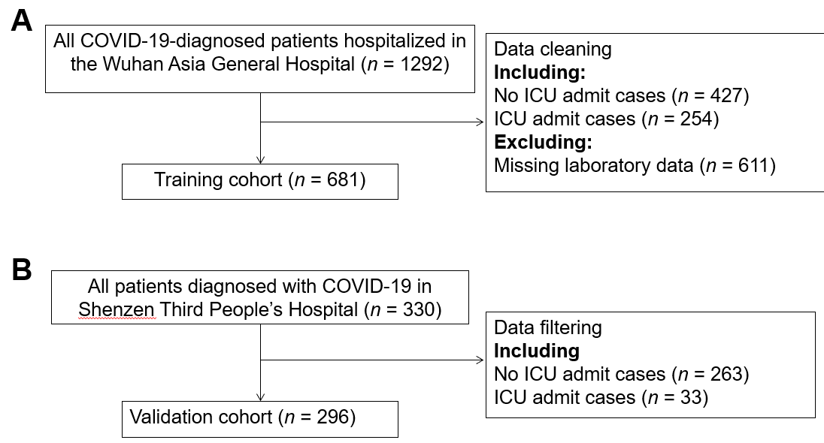
Figure 1 The flowchart illustrating the patients in the training and validation cohorts. The data for each cohort was obtained and analyzed retrospectively. A: Patients in the training cohort; B: Patients in the validation cohort. COVID-19: Coronavirus disease 2019; ICU: Intensive care unit.

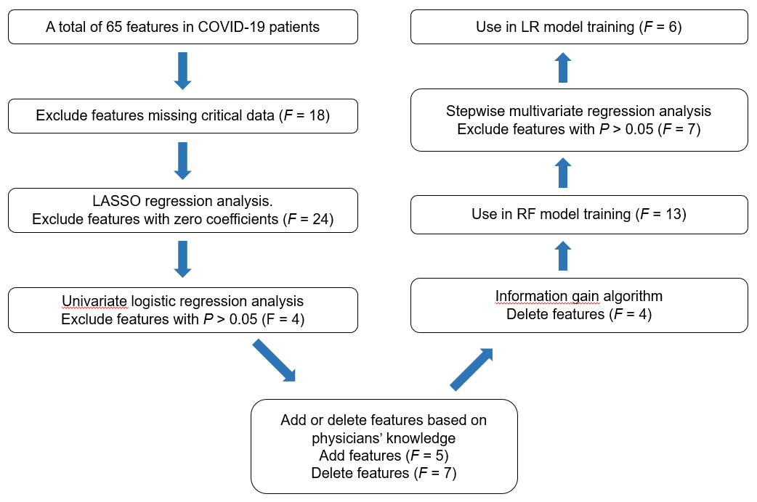
Figure 2 Feature selection. Thirteen predictors were selected in the information gain algorithm and were to train the random forest (RF) model. Six predictors with P < 0.05 were selected in the multivariate logistic regression (LR) analysis and were used to train the LR model. COVID-19: Coronavirus disease 2019; LASSO: Least absolute shrinkage and selection operator.

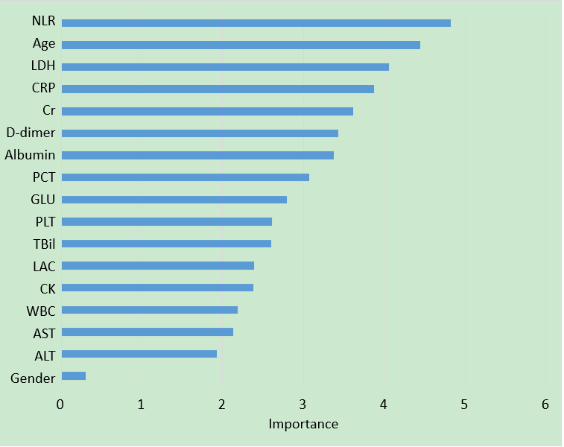
Figure 3 Importance of the variables included in the predictive model for coronavirus disease 2019 events based on the random forest algorithm. ALT: Alanine transaminase; AST: Aspartate aminotransferase; CK: Creatine kinase; Cr: Creatinine; CRP: C-reactive protein; GLU: Glucose; LAC: Lactate; LDH: Lactate dehydrogenase; NLR: Neutrophil-to-lymphocyte ratio; PCT: Procalcitonin; PLT: Platelet; TBil: Total bilirubin; WBC: White blood cell.

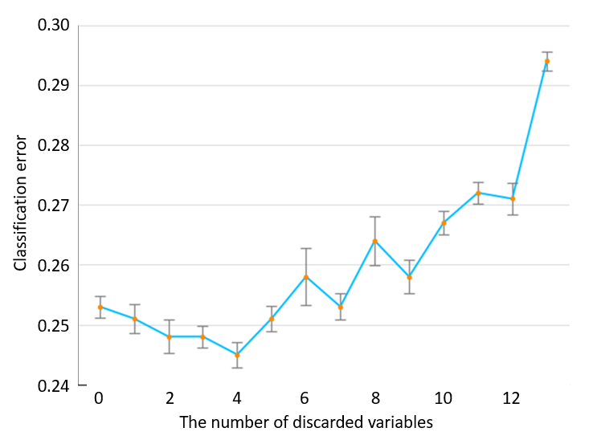
Figure 4 Relationship between the number of discarded variables and classification error.

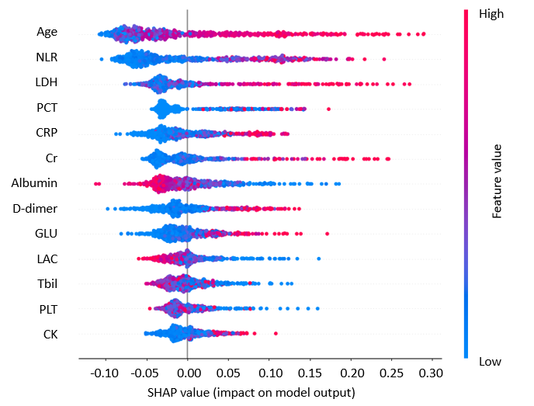
Figure 5 SHapley Additive exPlanations values of every feature used to train the random forest model for every sample. Each dot corresponds to an individual person in the study. The dot’s position on the X axis shows the impact that feature has on the model’s prediction for that person. The color represents the feature value (red high, blue low). This reveals for example that an older age increases the predicted intensive care unit admission probability. CK: Creatine kinase; Cr: Creatinine; CRP: C-reactive protein; GLU: Glucose; LAC: Lactate; LDH: Lactate dehydrogenase; NLR: Neutrophil-to-lymphocyte ratio; PCT: Procalcitonin; PLT: Platelet; TBil: Total bilirubin.

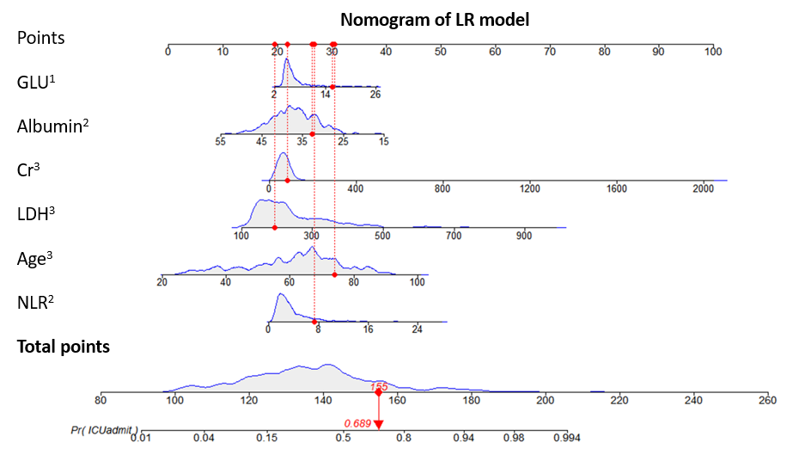
Figure 6 Nomogram of the logistic regression model to triage coronavirus disease 2019 patients. One patient had a total nomogram score of 155 points, and the probability of intensive care unit admission was 0.689. ¹Shows significance between 0.01 and 0.05; ²Shows significance between 0.001 and 0.01; ³Shows significance at a value of < 0.001. Cr: Creatinine; GLU: Glucose; LDH: Lactate dehydrogenase; LR: Logistic regression; NLR: Neutrophil-to-lymphocyte ratio.

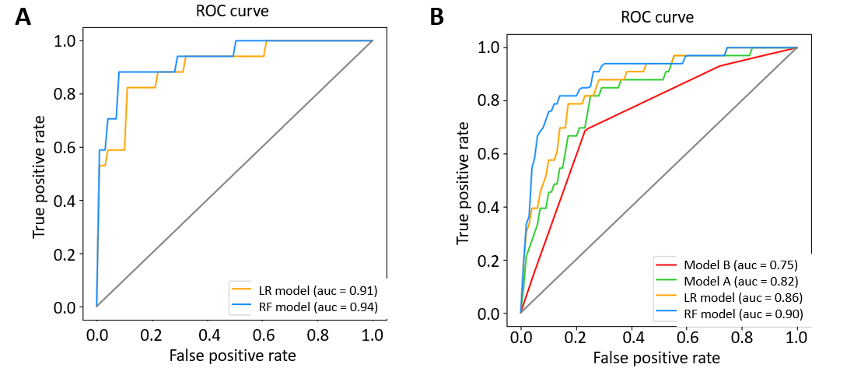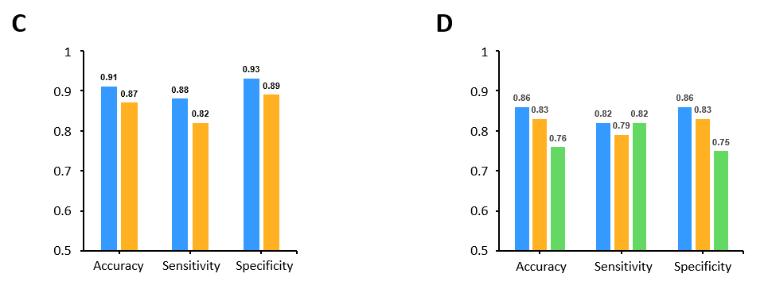
Figure 7 Performances of the newly developed prediction models and traditional scoring systems for internal and external validation. A: The receiver operating characteristic (ROC) curve for the random forest (RF) model and the logistic regression (LR) model; B: Receiver operating characteristic curve for models RF, LR, A and B; C: The performance matrix comparison for the RF model and the LR model; D: The performance matrix for models RF, LR and A. Internal validation: A and C. External validation: B and D. The performance matrix of RF, LR and model A models are shown in blue, orange and green, respectively. AUC: Area under the receiver operating characteristic curve.
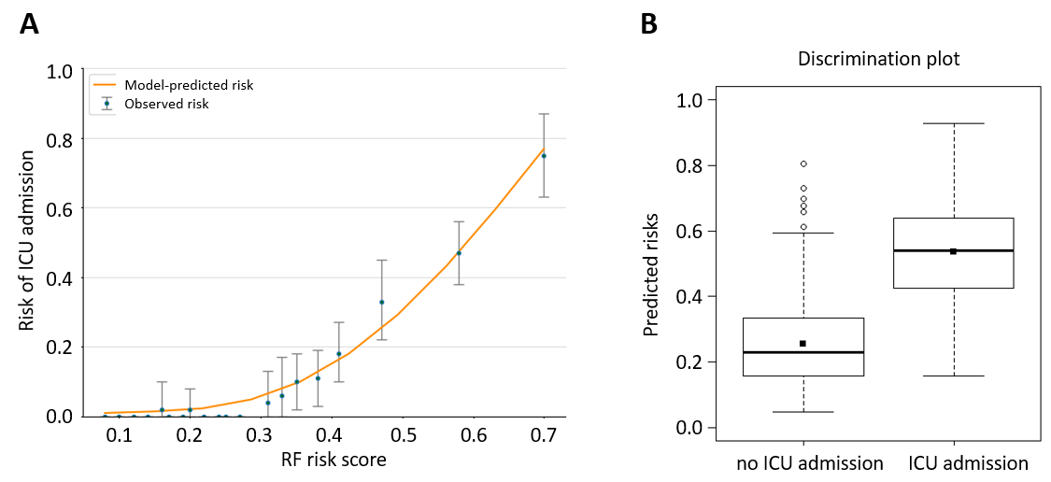
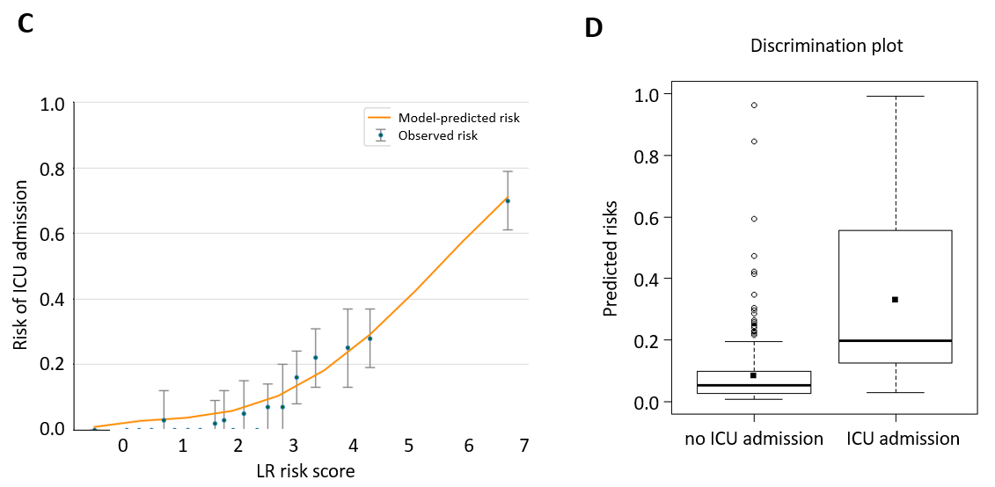
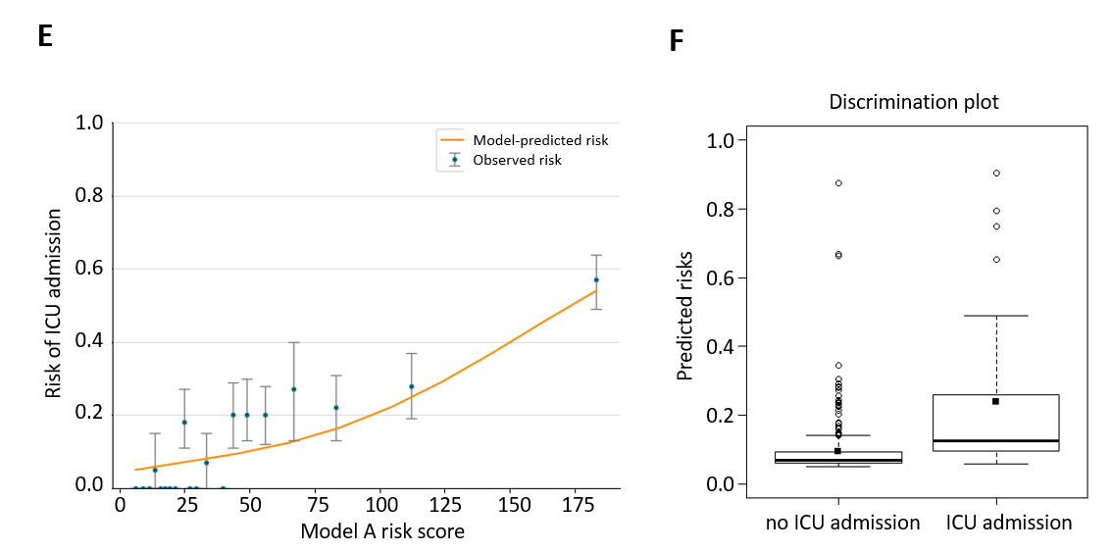
Figure 8 The calibration and discrimination of model random forest, logistic regression and A in external validation dataset. A, C and E: The graph represents the relationship between observed (data markers represent the mean and the error bars represent the 95% confidence interval) and predicted risk of intensive care unit (ICU) admission using the models (orange line); B, D and F: The discrimination potentials of the random forest (RF), logistic regression (LR) and model A models. The values of the discrimination slope were 0.281, 0.246 and 0.143, respectively.

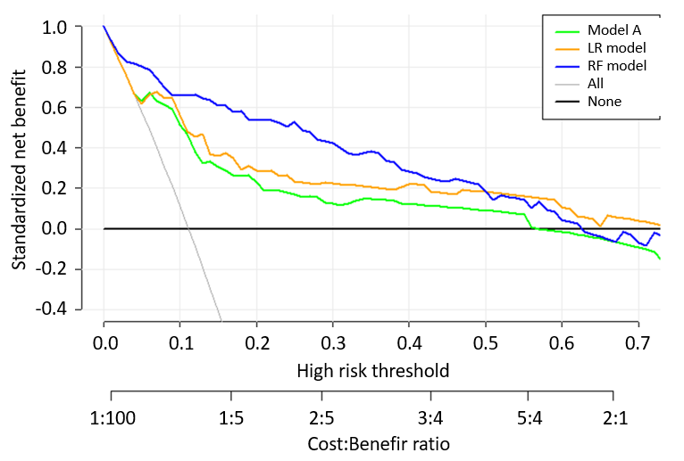
Figure 9 Decision curve analysis for the model A, logistic regression and random forest risk prediction models. The vertical axis displays standardized net benefit. The two horizontal axes show the correspondence between high-risk threshold and cost: benefit ratio. The thin gray line is the standardized net benefit of allocating intensive care unit resources to all patients; the thick black line is the standardized net benefit of no intensive care unit admission. Decision curve analysis shows that our models had more significant standardized net benefits in the major threshold probabilities interval than model A, demonstrating that our models have better clinical benefit. LR: Logistic regression; RF: Random forest.

Table 1 Baseline clinical and laboratory characteristics
Characteristics | Training cohort,  n = 681 | Validation cohort,  n = 296 | P value
Age (yr) | 63.0 (51.0-71.0) | 49.0 (36.0-61.0) | < 0.001
Gender (male) | 338 (49.6%) | 146 (49.3%) | 0.985
BNP (ng/L) | 27.9 (11.5-64.5) | 37.6 (37.6-37.8) | < 0.001
CRP (mg/L) | 13.7 (2.5-53.6) | 11.4 (5.0-26.2) | 0.073
D-dimer (mg/L) | 0.6 (0.3-1.4) | 0.4 (0.3-0.5) | < 0.001
Albumin (g/L) | 37.4 (33.7-40.8) | 43.0 (40.7-44.8) | < 0.001
C3 (g/L) | 1.1 (1.0-1.2) | 1.1 (1.1-1.1) | 0.382
AST (U/L) | 27.0 (20.0-38.0) | 26.3 (21.0-34.2) | 0.230
APTT (s) | 29.7 (26.5-33.5) | 35.1 (32.4-37.8) | < 0.001
K⁺ (mmol/L) | 3.9 (3.6-4.3) | 3.8 (3.6-4.0) | < 0.001
LYMPH (10⁹/L) | 1.1 (0.8-1.5) | 1.3 (1.0-1.7) | < 0.001
IgA (g/L) | 2.6 (2.0-3.3) | 2.0 (2.0-2.0) | < 0.001
LDH (U/L) | 214.0 (169.0-294.0) | 224.0 (179.0-397.8) | 0.001
Hgb (g/L) | 126.0 (116.0-135.0) | 137.0 (126.0-146.0) | < 0.001
GLU (mmoL/L) | 5.4 (4.7-6.8) | 5.8 (5.3-6.6) | < 0.001
NEUT (10⁹/L) | 3.2 (2.4-4.4) | 2.8 (2.0-3.6) | < 0.001
CK (U/L) | 71.0 (46.0-133.0) | 61.0 (61.0-61.0) | 0.001
Cr (μmoI/L) | 65.9 (53.6-81.5) | 63.0 (52.5-77.0) | 0.033
ALT (U/L) | 24.0 (15.0-37.0) | 24.0 (16.0-35.3) | 0.465
PLT (10⁹/L) | 192.0 (152.0-258.0) | 184.0 (143.8-227.0) | 0.002
PCT (ug/L) | 0.05 (0.05-0.06) | 0.04 (0.03-0.06) | < 0.001
TBil (μmol/L) | 8.9 (6.6-11.9) | 10.2 (7.9-13.9) | < 0.001
WBC (10⁹/L) | 5.0 (3.9-6.3) | 4.7 (3.7-5.8) | 0.032
NLR | 2.8 (1.9-4.5) | 2.1 (1.4-3.2) | < 0.001
LAC (mmoL/L) | 2.8 (2.3-3.4) | 1.4 (1.1-1.5) | < 0.001
ALT: Alanine aminotransferase; APTT: Activated partial thromboplastin time; AST: Aspartate aminotransferase; BNP: Brain natriuretic peptide; CK: Creatine kinase; Cr: Creatinine; CRP: C-reactive protein; GLU: Glucose; Hgb: Hemoglobin; IgA: Immunoglobulin A; LAC: Lactate; LDH: Lactate dehydrogenase; LYMPH: Lymphocyte; NEUT: Neutrophils; NLR: Neutrophil-to-lymphocyte ratio; PCT: Procalcitonin; PLT: Platelet; TBil: Total bilirubin; WBC: White blood cell.

Table 2 Multivariate logistic regression models of risk severity in the training cohort
Feature | Univariate logistic regression |  | Multivariate LR
 | OR (95%CI) | P value | OR (95%CI) | P value
Age, yr | 2.64 (2.06–3.37) | < 0.001 | 2.68 (1.99-3.61) | < 0.001
BNP | 1.53 (1.34–1.75) | < 0.001
CRP | 2.01 (1.68–2.40) | < 0.001
D-dimer | 1.13 (1.06–1.20) | < 0.001
Albumin | 0.37 (0.29–0.48) | < 0.001 | 0.62 (0.46–0.83) | 0.001
Hcv_ab | 1.005 (0.999–1.011) | 0.083
AST | 1.50 (1.29–1.75) | < 0.001
CysC | 1.32 (1.19–1.46) | < 0.001
APTT | 1.80 (1.45–2.23) | < 0.001
Cr | 1.10 (1.05–1.16) | < 0.001 | 1.11 (1.06–1.15) | < 0.001
Myoglobin | 1.64 (1.44–1.88) | < 0.001
CK | 1.12 (1.05–1.20) | < 0.001
PCT | 1.008 (1.003–1.014) | < 0.001
Tp_ab | 1.001 (0.999–1.003) | 0.231
BUN | 1.70 (1.44–1.99) | < 0.001
PT | 1.65 (1.36–1.99) | < 0.001
LAC | 0.81 (0.68–0.98) | 0.012
LDH | 2.36 (1.91–2.93) | < 0.001 | 2.09 (1.61–2.7) | < 0.001
Hgb | 0.69 (0.58–0.82) | < 0.001
GLU | 1.28 (1.15–1.44) | < 0.001 | 1.16 (1.02–1.31) | 0.023
HBeAg | 1.010 (0.920–1.108) | 0.156
HBsAg | 0.999 (0.995–1.003) | 0.577
NLR | 1.90 (1.61–2.25) | < 0.001 | 1.27 (1.06–1.51) | 0.008
APTT: Activated partial thromboplastin time; AST: Aspartate transaminase; BNP: Brain natriuretic peptide; BUN: Blood urea nitrogen; CI: Confidence interval; CK: Creatine kinase; Cr: Creatinine; CRP: C-reactive protein; CysC: Cystatin C; GLU: Glucose; HBeAg: Hepatitis B e antigen; HBsAg: Hepatitis B surface antigen Hcv_ab: Hepatitis C virus antibody; Hgb: Hemoglobin; LAC: Lactate; LDH: Lactate dehydrogenase; LR: Logistic regression; NLR: Neutrophil-to-lymphocyte ratio; OR: Odds ratio; PCT: Procalcitonin; PT: prothrombin time; Tp_ab: Treponema pallidium antibody.

Table 3 Reclassification
Initial model | Updated model |  | Predicted probability according to initial model |  |  |  | Statistics
 |  |  | < 13% | 13%-20% | > 20% | % Reclassified | NRI (95%CI) | P value
Model A | RF | < 13% | 189 | 46 | 9 | 23 | 0.363  (0.148-0.579) | < 0.001
 |  | 13%-20% | 6 | 12 | 5 | 48
 |  | > 20% | 2 | 13 | 14 | 52
 | LR | < 13% | 208 | 17 | 19 | 15 | 0.246  (0.029-0.463) | 0.026
 |  | 13%-20% | 14 | 3 | 6 | 87
 |  | > 20% | 8 | 4 | 17 | 41
LR | RF | < 13% | 194 | 36 | 0 | 16 | 0.167  (-0.024-0.357) | 0.087
 |  | 13%-20% | 3 | 17 | 4 | 29
 |  | > 20% | 0 | 18 | 24 | 43
CI: Confidence interval; LR: Logistic regression; NRI: Net Reclassification Index; RF: Random forest.

