Name of journal: World Journal of Gastroenterology
ESPS Manuscript NO: 23858
Manuscript Type: ORIGINAL ARTICLE

Basic Study

Inhibitory effect of miR-125b on hepatitis C virus core protein-induced TLR2/MyD88 signaling in THP-1 cells

Peng C et al. miR-125b on HCV induced TLR2/MyD88 signaling

Cheng Peng, Hua Wang, Wen-Jing Zhang, Sheng-Hua Jie, Qiao-Xia Tong, Meng-Ji Lu, Dong-Liang Yang

Cheng Peng, Hua Wang, Wen-Jing Zhang, Sheng-Hua Jie, Qiao-Xia Tong, Dong-Liang Yang, Department of Infectious Diseases, Union Hospital, Tongji Medical College, Huazhong University of Science and Technology, Wuhan 430022, Hubei Province, China

Meng-Ji Lu, Institute of Virology, University Hospital of Essen, University of Duisburg-Essen, 45122 Essen, Germany

Author contributions: Peng C and Yang DL designed research; Lu MJ instructed on the whole study; Peng C, Wang H and Zhang WJ performed research; Tong QX contributed new reagents or analytic tools; Peng C and Jie SH analyzed data; Peng C, Lu MJ and Yang DL wrote the paper.

Supported by the National Natural Science Foundation of China, No. 81202321 and No. 81461130019; Transregio-SFB (TRR) of the Deutsche Forschungsgemeinschaft (DFG), No. TRR60.

Institutional review board statement: This study was approved by the Institutional Review Board of Union Hospital, Tongji Medical College, Huazhong University of Science and Technology, China.

Conflict-of-interest statement: We declare that we have no financial and personal relationships with other people or organizations that can inappropriately influence our work, there is no professional or other personal interest of any nature or kind in any product, service and company. The authors declare that there is no conflict of interests regarding the publication of this paper.

Data sharing statement: Technical appendix, statistical code, and dataset available from the corresponding author at dlyang@hust.edu.cn. Participants gave informed consent for data sharing. No additional data are available.

Open-Access: This article is an open-access article which was selected by an in-house editor and fully peer-reviewed by external reviewers. It is distributed in accordance with the Creative Commons Attribution Non Commercial (CC BY-NC 4.0) license, which permits others to distribute, remix, adapt, build upon this work non-commercially, and license their derivative works on different terms, provided the original work is properly cited and the use is non-commercial. See: http://creativecommons.org/licenses/by-nc/4.0/

Correspondence to: Dong-Liang Yang, MD, PhD, DSc. (Med), Professor, Chief, Department of Infectious Diseases, Union Hospital, Tongji Medical College, Huazhong University of Science and Technology. No. 1277 Liberation Avenue, Wuhan 430022, Hubei Province, China. dlyang@hust.edu.cn
Telephone: +86-27-85726978
Fax: +86-27-85726978

Received: December 20, 2015
Peer-review started: December 31, 2015
First decision: Jnauary 28, 2016
Revised: February 22, 2016
Accepted: March 13, 2016
Article in press:
Published online:

Abstract
AIM: To investigate the role of miR-125b in regulating monocyte immune responses induced by hepatitis C virus (HCV) core protein.

METHODS: Monocytic THP-1 cells were treated with various concentrations of recombinant HCV core protein and cytokines and miR-125b expressions in these cells were analyzed. The requirement of Toll-like receptor 2 (TLR2) or MyD88 genes for HCV core protein-induced immune responses was determined by the transfection of THP-1 with gene knockdown vectors expressing either TLR2 siRNA or MyD88 siRNA. The effect of miR-125b overexpression on TLR2/MyD88 signaling was examined by transfecting THP-1 cells with miR-125b mimic RNA oligos.

RESULTS: In response to HCV core protein stimulation, cytokine production was up-regulated and miR-125b expression was down-regulated in THP-1 cells. The modulatory effect of HCV core protein on cellular events was dose-dependent and required functional TLR2 or MyD88 genes. Forced miR-125b expression of abolished the HCV core protein-induced enhancement of tumor necrosis factor-α, interleukin (IL)-6, and IL-10 expression for 66%, 54%, and 66%, respectively (P < 0.001), by inhibiting MyD88-mediated signaling, including phosphorylation of NF-Bp65, ERK, and P38.

CONCLUSION: The inverse correlation between miR-125b and cytokine expression after HCV core challenge suggests that miR-125b may negatively regulate HCV-induced immune responses by targeting TLR2/MyD88 signaling in monocytes.

Key word: miR-125b; Hepatitis virus C; Toll like receptor 2; Monocytes; Innate immunity

© The Author(s) 2016. Published by Baishideng Publishing Group Inc. All rights reserved.

Core tip: Increasingly more studies have shown that microRNAs are critical regulators of the innate immune response. Many anti-pathogen pathways, including the pattern recognition Toll-like receptor (TLR)–mediated signaling pathway, are known to be regulated by a network of microRNAs. Here we investigated the possible role of miR-125b in regulating the monocyte immune responses induced by HCV core protein through TLR2/MyD88 signaling. Our findings indicated that miR-125b may function as a negative regulator of HCV-induced cellular events and may provide insight into the role of miR-125b in the innate immune responses of monocytes to HCV.

Peng C, Wang H, Zhang WJ, Jie SH, Tong QX, Lu MJ, Yang DL. Inhibitory effect of miR-125b on hepatitis C virus core protein-induced TLR2/MyD88 signaling in THP-1 cells. World J Gastroenterol 2016; In press

INTRODUCTION
Hepatitis C virus (HCV), one of the primary causes of chronic hepatitis, end-stage cirrhosis, and hepatocellular carcinoma (HCC), comprises an estimated 200 million chronic infections worldwide and 3–4 million more each year^{[1]}. HCV is a small enveloped RNA virus belonging to the family Flavivridae family. The HCV genome encodes a polyprotein precursor of approximately 3000 amino acids that is processed by host and viral proteases into at least 10 different proteins. The viral core protein, a major cleaved product of HCV polyprotein by host peptidases, is known for its role in mediating HCV-induced pathogenesis. The RNA-binding HCV core protein is involved not only in the formation of the viral nucleocapsid but is capable of directly interacting with various host cell components, resulting in cellular dysfunction and carcinogenesis^{[2]}.
HCV not only infects hepatocytes, it replicates in other immune cells, including B cells, T cells, NK cells and monocytes/macrophages^{[3,4]}. It has been postulated that HCC is a consequence of prolonged liver injuries induced by chronic and persistent HCV infections. Numerous reports have indicated that defective host innate and adaptive immune systems are the major culprits facilitating the host’s inability to eradicate viruses^{[5]}. While there is clear evidence that the synthesis of anti-viral cytokines, interferon (IFN)-γand IFN-γ were defective in chronic HCV infected patients^{[6]}, various others cytokines, such as tumor necrosis factor (TNF)-α, interleukin(IL)-6 and IL-10, were excessively expressed in patients with HCV viremia^{[7]}. These skewed cytokine productions have been suggested to play a key role in liver injury, viral persistence and the progression to chronic HCV infection^{[8]}.
Monocytes/macrophages function as both innate immune cells by killing pathogens directly, and producing anti-pathogens cytokines and as adaptive immune cells by presenting antigens to other immune cells to produces antibodies. Although monocytes/macrophages dysfunction has been documented in patients with chronic HCV infection, particularly defective response to TLR ligand stimulation^{[9]}, the precise mechanism as how these cells are involved in the pathogenesis remains unclear.
MicroRNAs are highly conserved endogenous non-coding small RNAs that act as translational repressors to regulate a wide range of biological processes^{[10]}. MicroRNAs have also been implicated in the pathogenesis, diagnosis and therapeutic aspects of HCV infections^{[11]}. Recent studies have shown that several microRNAs, including miR-21, miR-146a and miR-155, were involved in regulation of virus-host interactions and may play important roles in the pathogenesis of HCV infection^{[12-14]}.
Since miR-125b is highly expressed in peripheral blood mononuclear cells, particularly in monocytes/macrophages^{[15]}, and its expression was found to be inversely associated with better treatment outcome of chronic HCV infection^{[16]}, we explored the role of miR-125b in modulating HCV-induced events in monocytic THP-1 cells. Here we show that miR-125b expression was negatively correlated with HCV core-induced cytokines expression in a TLR2/MyD88-dependent manner.

MATERIALS AND METHODS
Cell culture and reagents
The THP-1 human monocytic leukemia cell line was obtained from the Institute of Biochemistry and Cell Biology at the Shanghai Institute for Biological Sciences and cultured in RPMI 1640 medium supplemented with 10% fetal bovine serum, penicillin (100 IU/mL), and streptomycin (100 mg/mL). Bacterial HCV core recombinant protein was obtained from Immune Technology Co., China.Stability-enhanced miR-125b RNA oligonucleotide, miR-125b Mimic (miR-125bM), and the control non-targeting RNA oligonucleotide were purchased from GenePharma.

RNA extraction and real-time quantitative reverse transcription polymerase chain reaction analyses for cellular and miRNA genes
Total RNA (cellular and miRNA) was extracted from 1-3 × 10⁶ THP-1 cells using TRIzol reagent (Life Technologies). For cellular gene expression, first strand cDNA and real-time quantitative polymerase chain reaction (RT-qPCR) analyses of TLR2 and MyD88 were performed according to the manufacturer’s instructions (Kakara). The following PCR primers were used in this study: TLR2 (F:5’-TGGCATGTGCTGTGCTCTGTT-3’; R:5’-AGCTTTCCTGGGCTTCCTTTT-3’); MyD88 (F:5’-CTCCTCCACATCCT CCCTTC-3’ ; R: 5’-GCTTGTGTCTCCAGTTGCC-3’); internal control β-actin (F:5’-CACGATGGAGGGGCCGGACTCATC-3’; R:5’-TAAAGACCTCTATGCCA ACACAGT-3’). The reaction conditions for PCR were 95 ºC for 60 s, 53 ºC for 60 s, and 72 ºC for 60 s for 40 cycles, followed by an extension at 72 ºC for 8 min. The relative gene expression of TLR2 and MyD88 was calculated using 2^{-ddCt}, where ddCt=(Ct[gene]-Ct[β-actin] and Ct is the crossing threshold value returned by the PCR instrument for each gene amplification.
To measure miRNA expression, total RNA was reversely transcribed at 16 ºC for 30 min, 42 ºC for 30 min and 85ºC for 5 min using miRNA gene specific primer (has-miR-125-5p and U6 snRNA NR_004394; Applied Biosystems). MicroRNA expressions were determined by quantitative PCR using TaqMan Universal PCR System (Life Technologies) in 20 μL reactions, containing 1 μL TaqMan Probes. The reaction was performed at 95 ºC for 10 min, followed by 95 ºC for 15 s and 60 ºC at 60 s for 40 cycles. Expressions of target genes were calculated as relative to that of the internal U6 snRNA.

Short interfering RNA Knockdown vectors and transfections
TLR2–short interfering RNA (TLR2-siRNA) and MyD88-siRNA were constructed as previously described^{[12,13]}. In brief, double-stranded oligonucleotides corresponding to the 164-182 position of TLR2 gene (NM_003264) or the 880-898 position of the MyD88 gene (NM_001172566) sequences were selected according to BLOCK-iT™ RNA Designer (Life Technologies) and cloned into Bsa I/Sac I sites of the pBSilence1.1 plasmid (Sirui Biologicl Co.). The recombinant plasmids were verified by sequencing from both ends. Silencing of TLR2 or MyD88 in THP-1 cells was performed using Lipofectamine 2000 (Life Technologies) and 50 nM siRNA vector DNA according to the manufacturer’s protocol. Cells transfected with empty pBSilence1.1 vector was used as a transfection control. Twenty-four hours after transfection, the cells were analyzed for RNA (by RT-qPCR) or protein (by Western blotting) expression.
Transfection of miR-125b mimic or control RNA oligos was similarly performed using Lipofectamine 2000. Six hours post-transfections, the cells were treated with 5 μg/mL HCV core protein and incubated for an additional 6 hours at 37 ºC prior to further assays.

Enzyme-linked immunosorbent assay
The levels of TNF-α, IL-6 and IL-10 in the supernatants were measured using a Human ELISA kit (elabscience) according to the manufacturer’s instructions. The detection ranges of TNF-α, IL-6 and IL-10 are > 8 pg/mL, > 4 pg/mL, and 7.813–500 pg/mL, respectively.

Western blot analysis
Cell lysates were prepared in a sodium dodecyl sulfate (SDS) sample buffer (62.5 mM Tris-HCl [pH 6.8], 2% SDS, 10% glycerol, 50 mM 1,4-dithiothreitol, and 0.1% bromophenol blue) containing a mixture of protease and phosphatase inhibitors. Lysates (25 μg) were separated on 12% acrylamide gels and transferred to a nitrocellulose membrane in Tris-glycine buffer containing 20% methanol. The membranes were then blocked with 5% milk in 1 × Tris-buffered saline and 0.1% Tween-20 for 1 h at room temperature and probed with various diluted primary monoclonal antibodies overnight at 4 ºC with constant rocking. After extensive washing, the membranes were incubated with horseradish peroxidase-conjugated anti-mouse immunoglobulin G (Boster Biological Tech) at room temperature for 2 h. Protein expression was determined using a chemiluminesence method (Thermo Scientific). Antibodies recognizing TLR2 and total NF-kBp65, phosphor-NF-kBp65 (Abcam), MyD88(Bioworld),phospho-ERK (Cell Signaling), phospho-P38 (Santa Cruz Biotech) were used to probe the membranes. To control protein loading, the blots were stripped and re-probed with an anti-glyceraldehyde 3-phosphate dehydrogenase antibody (Xianzhi Lifescience).

Statistical analysis
Data are shown as mean ± SEM. Unpaired two-tailed Student’s t-test was used to compare two independent groups. Graphpad 5.0 software (San Diego, CA) was used for all of the statistical analyses, and values of P < 0.05 were considered statistically significant.

RESULTS
HCV core protein up-regulated TNF-α, IL-6 and IL-10 expression and down-regulated miR-125b expression in THP-1 cells
We first tested whether treatment of HCV core protein regulates miRNA expression. THP-1 was incubated with various concentrations (0.5, 1, 5 μg/mL) of HCV core protein for different time periods. Expression of miR-125b, miR-146 and miR-155, along with selected cytokine genes (TNF-α, IL-6 and IL-10) were examined by RT-qPCR analyses. Consistent with those of Yao et al^{[17]}, our results (Figure 1) showed that HCV core protein could directly stimulate THP-1 cells to express TNF-α, IL-6 and IL-10. The induction was dose-dependent; HCV core protein at 0.5 μg/mL significantly induced these cytokines more than two folds. The induction was also rapid; it peaked at 6 h after HCV core protein stimulation and slowly leveled off through the study period (24 h).
In parallel to the cytokine induction, miR-146 and miR-155 expressions were also induced (data not shown)^{[12]}. In contrast, miR-125 expression was down-regulated by HCV core stimulation in a dose-dependent manner. The miR-125b expression reached the lowest level (decreased by 68%) at 6 h with 5.0 μg/mL HCV core protein challenge. An inverse correlation between miR-125b expression and that of cytokines suggests that miR-125b may play a regulatory role in HCV-induced cellular responses.

TLR2 or MyD88 genes knockdown abolished the suppressive effect of HCV core protein on miR-125b expression
TLR2 and its downstream signing protein Myd88 pathway play a prominent role in HCV core-induced inflammatory responses^{[18]}. We employed a gene knockdown strategy to test if TLR2 or Myd88 could be directly involved in the repression of miR-125b. THP-1 cells were transfected with siRNA plasmids that could silence TLR2,MyD88 or the control plasmid for 24 h. The transfected cells were challenged with HCV core at 5µg/mL foran additional 6 h. The miR-125b level was detected by RT-qPCR analysis. As shown in Figure 2A and 2B, we found that TLR2 and MyD88 RNA and protein were reduced more than 2.5-fold when cells were transfected with these siRNA plasmids. When these transfected cells were exposed to HCV core protein, miR-125b expression was significantly restored compared to that of control-transfected cells. (P < 0.05, n = 3, Figure 2C). This result suggests that the suppression of miR-125b expression by HCV core treatment, depends at least in part on the TLR2/MyD88 signaling.

Upregulation of cytokines by HCV core protein was abrogated by the miR-125b mimic
The inverse correlation noted between cytokine and miR-125b in HCV core protein-treated cells prompts us to examine whether miR-125b can directly participate in regulation these HCV core protein-induced events. We transfected THP-1 cells with a chemically modified miR-125bM (miR-125b mimic) RNA oligos or the control RNA oligos for 24 h, followed by HCV core stimulation at 5.0 µg/mL for 6 h and examined the expression of TNF-α, IL-6 and IL-10. The effectiveness of miR-125b mimic transfection is shown in Figure 3A. In the experiment in which cells were treated with HCV core protein (Figure 3B), we found that transfection with control miRNA has no effect on the enhancement of cytokine expression by HCV core stimulation but that transfection with miR-125b mimic abrogated TNF-α, IL-6 and IL-10 upregulated expression for 66%, 54% and 66%, respectively,compared with the control. These results indicates that overexpression of miR-125b down-regulates HCV-mediated cytokines induction.

MiR-125b mimic suppressed TLR2/MyD88 signaling
To understand the mechanism of miR-125b in regulating cytokine expression in HCV core protein-treated cells, we performed immunoblot analyses to determine the expression levels of the signaling molecules possible involved in the TLR signaling pathways. THP-1 cells were transfected with, or without miR-125b mimic and incubated with 5 μg/mL HCV core protein. The expression of various TLR signaling proteins were analyzed. As shown in Figure 4A, expression of TLR2 and MyD88 and the phosphorylation of their downstream signaling proteins, ERK1/2, NF-kBp5 and p38 were up-regulated by HCV core treatments. The transfection of cells with the miR-125b mimic did not change of expression of TLR2 or NF-kBp65 but slightly down-regulated that of MyD88. In contrast,the phosphorylation of NF-kBp65, p38 and ERK1/2 were significantly down-regulated. Quantitation of three independent experiments showed two-fold down-regulation (Figure 4B).

DISCUSSION
In this study, we used recombinant HCV core protein-treated THP-1 cells as a model to investigate the interaction between HCV and monocytes. HCV core protein has been shown capable of directly interacting with various cellular proteins including TLR2 and resulting in activation of TLR2-MyD88 signaling cascade in monocytes^{[18]}. In agreement with these findings, our current findings indicate that HCV core protein can induce a similar profile of cytokine production in THP-1 cells. We further extended the study by demonstrating for the first time that treatment with HCV core protein suppressed the expression of miR-125b in a dose- and time- dependent manner (Figure 1). In addition, we demonstrated that this suppression was dependent on the TLR2/MyD88 pathway (Figure 2). However, the mechanism by which miR-125b expression is inhibited by HCV core protein treatment remains unknown.
MiR-125b has gained special interest in the field of cancer research because of its dysregulation in a broad variety of tumors^{[19]}. Studing its role in tumorigenesis suggests that miR-125b could have the opposite effect depending on cellular context; miR-125b is upregulated in some tumors such as colon cancer and hematopoietic tumors, suggesting its oncogenic potential capability of facilitating cell proliferation and blocking apoptotic pathways^{[20,21]}. On the other hand, miR-125b is down-regulated in other types of tumors, such as mammary tumors and HCC. The overexpression of miR-125b inhibits HCC cell proliferation via promoting apoptosis and other anti-tumor mechanisms^{[22]}.
Our findings that forced expression of miR-125b suppressed HCV core protein- induced cytokine production (Figure 3) and phosphorylation of the TLR/MyD88 signaling cascade (Figure 4) support the notion that miR-125b suppresses HCV core protein-mediated events by inhibition of TLR2/MyD88 signaling. Although many receptors, signaling molecules, and transcriptional factors of the TLR signaling pathways have been verified to be regulated by various miRNAs^{[23]}, the molecules targeted by miR-125b in the TLR2/MyD88 signaling pathway remain unknown. Like other microRNAs, it is assumed that miR-125b exerts its biological function by directly targeting the 3′ untranslated (3′UTR) region of genes. Target site predictions using web-accessible miRNA database search programs(http://www.microrna.org,http://www.miRBase.org and http://www.targetscan.org) identified a miR-125b target site within a 1.3 kB 3′UTR of murine MyD88 mRNA. A study by Wang et al^{[24]} indicated that the treatment of mouse macrophages with a miR-125b inhibitor induced MyD88 expression and that cellular transfection with a murine miR-125b mimic down-regulated the reporter gene activities mediated by 3′UTR MyD88 construct. These results provided clear evidence that murine miR-125b suppress TLR/MyD88 by directly targeting MyD88 mRNA. We are currently testing this hypothesis by transfecting HCV core protein-treated THP-1 cells with a 3′UTR of MyD88 reporter construct.
In summary, our findings indicated that miR-125b may function as a negative regulator for HCV core protein-induced cellular events, which may provide insight into the role of miR-125b in the innate immune responses against HCV in monocytes. Our study may lay some groundwork for the development of a novel therapeutic approach for treating HCV core protein-induced inflammation and immune activation.

COMMENTS
Background
Macrophages/Monocytes have been shown to be important immune cells mediating both innate and adaptive immunity in hepatitis C virus (HCV)-infected patients. Many anti-pathogen pathways, including pattern recognition Toll-like receptors (TLRs) mediating signaling, are known to be regulated by a network of microRNAs. MiR-125b is highly expressed in peripheral blood mononuclear cells, particularly monocytes/macrophages; however, its role in regulating monocyte immune responses induced by HCV have not yet been investigated.

Research frontiers
Recent studies have shown that several microRNAs, including miR-21, miR-146a and miR-155, are involved in regulation of virus-host interactions and may play important roles in the pathogenesis of HCV infection.

Innovations and breakthroughs
This is the first study to report that miR-125b may negatively regulate HCV core protein-induced host immune responses by targeting TLR2/MyD88 signaling in monocytes.

Applications
The present findings indicated that miR-125b may function as a negative regulator for HCV induced cellular events and may provide insight into the role of miR-125b in the innate immune responses against HCV in monocytes. This study may lay some groundwork for the development of a novel therapeutic approach for treating HCV-induced inflammation and immune activation.

Terminology
MicroRNAs are highly conserved endogenous non-coding small RNA that act as translational repressors to regulate a wide range of biological processes. They have also been implicated in the pathogenesis, diagnosis, and therapeutic aspects of HCV infections. miR-125b is highly expressed in peripheral blood mononuclear cells, particularly in monocytes/macrophages, and its expression is inversely associated with better treatment outcomes for chronic HCV infection.

Peer-review
The authors investigated the possible role of miR-125b in regulating monocyte immune responses induced by HCV core protein. This study found that cytokine production was up-regulated and miR-125b expression was down-regulated by HCV core protein treatment through TLR2/MyD88 signaling in THP-1 cells. Overexpression of miR125b resulted in suppressed MAPK and NF-kB activity and cytokine production. This research is novel and manuscript presentation and readability are good. Additionally, the manuscript is well organized and its results are sound with respect to the integrity of the paper.
REFERENCES
1 Mohd Hanafiah K, Groeger J, Flaxman AD, Wiersma ST. Global epidemiology of hepatitis C virus infection: new estimates of age-specific antibody to HCV seroprevalence. Hepatology 2013; 57: 1333-1342 [PMID: 23172780 DOI: 10.1002/hep.26141]
2 Li HC, Ma HC, Yang CH, Lo SY. Production and pathogenicity of hepatitis C virus core gene products. World J Gastroenterol 2014; 20: 7104-7122 [PMID: 24966583 DOI: 10.3748/wjg.v20.i23.7104]
3 Bouffard P, Hayashi PH, Acevedo R, Levy N, Zeldis JB. Hepatitis C virus is detected in a monocyte/macrophage subpopulation of peripheral blood mononuclear cells of infected patients. J Infect Dis 1992; 166: 1276-1280 [PMID: 1385547]
4 Lerat H, Berby F, Trabaud MA, Vidalin O, Major M, Trépo C, Inchauspé G. Specific detection of hepatitis C virus minus strand RNA in hematopoietic cells. J Clin Invest 1996; 97: 845-851 [PMID: 8609243 DOI: 10.1172/JCI118485]
5 Heim MH, Thimme R. Innate and adaptive immune responses in HCV infections. J Hepatol 2014; 61: S14-S25 [PMID: 25443342 DOI: 10.1016/j.jhep.2014.06.035]
6 Lechmann M, Woitas RP, Langhans B, Kaiser R, Ihlenfeldt HG, Jung G, Sauerbruch T, Spengler U. Decreased frequency of HCV core-specific peripheral blood mononuclear cells with type 1 cytokine secretion in chronic hepatitis C. J Hepatol 1999; 31: 971-978 [PMID: 10604568]
7 Woitas RP, Petersen U, Moshage D, Brackmann HH, Matz B, Sauerbruch T, Spengler U. HCV-specific cytokine induction in monocytes of patients with different outcomes of hepatitis C. World J Gastroenterol 2002; 8: 562-566 [PMID: 12046093 DOI: 10.3748/wjg.v8.i3.562]
8 Zampino R, Marrone A, Restivo L, Guerrera B, Sellitto A, Rinaldi L, Romano C, Adinolfi LE. Chronic HCV infection and inflammation: Clinical impact on hepatic and extra-hepatic manifestations. World J Hepatol 2013; 5: 528-540 [PMID: 24179612 DOI: 10.4254/wjh.v5.i10.528]
9 Villacres MC, Literat O, DeGiacomo M, Du W, Frederick T, Kovacs A. Defective response to Toll-like receptor 3 and 4 ligands by activated monocytes in chronic hepatitis C virus infection. J Viral Hepatitis 2008; 15: 137-144 [PMID: 18184197 DOI: 10.1111/j.1365-2893.2007.00904.x]
10 Ambros V, Chen X. The regulation of genes and genomes by small RNAs. Development 2007; 134: 1635-1641 [PMID: 17409118 DOI: 10.1242/dev.002006]
11 Gragnani L, Piluso A, Fognani E, Zignego AL. MicroRNA expression in hepatitis C virus-related malignancies: A brief review. World J Gastroenterol 2015; 21: 8562-8568 [PMID: 26229398 DOI: 10.3748/wjg.v21.i28.8562]
12 Chen Y, Chen J, Wang H, Shi J, Wu K, Liu S, Liu Y, Wu J. HCV-induced miR-21 contributes to evasion of host immune system by targeting MyD88 and IRAK1. PLoS Pathog 2013; 9: e1003248 [PMID: 23633945 DOI: 10.1371/journal.ppat.1003248]
13 Zhang WJ, Wang H, Tong QX, Jie SH, Yang DL, Peng C. Involvement of TLR2-MyD88 in abnormal expression of miR-146a in peripheral blood monocytes of patients with chronic hepatitis C. J Huazhong Univ Sci Technolog Med Sci 2015; 35: 219-224 [PMID: 25877355 DOI: 10.1007/s11596-015-1414-5]
14 Bala S, Tilahun Y, Taha O, Alao H, Kodys K, Catalano D, Szabo G. Increased microRNA-155 expression in the serum and peripheral monocytes in chronic HCV infection. J Transl Med 2012; 10: 151 [PMID: 22846613 DOI: 10.1186/1479-5876-10-151]
15 Chaudhuri AA, So AY, Sinha N, Gibson WS, Taganov KD, O'Connell RM, Baltimore D. MicroRNA-125b potentiates macrophage activation. J Immunol 2011; 187: 5062-5068 [PMID: 22003200 DOI: 10.4049/jimmunol.1102001]
16 Hsi E, Huang CF, Dai CY, Juo SH, Chou WW, Huang JF, Yeh ML, Lin ZY, Chen SC, Wang LY, Chuang WL, Yu ML. Peripheral blood mononuclear cells microRNA predicts treatment outcome of hepatitis C virus genotype 1 infection. Antiviral Res 2014; 105: 135-142 [PMID: 24637254 DOI: 10.1016/j.antiviral.2014.03.003]
17 Yao Z, Song X, Cao S, Liang W, Lu W, Yang L, Zhang Z, Wei L. Role of the exogenous HCV core protein in the interaction of human hepatocyte proliferation and macrophage sub-populations. PLoS One 2014; 9: e108278 [PMID: 25265479 DOI: 10.1371/journal.pone.0108278]
18 Chung H, Watanabe T, Kudo M, Chiba T. Hepatitis C virus core protein induces homotolerance and cross-tolerance to Toll-like receptor ligands by activation of Toll-like receptor 2. J Infect Dis 2010; 202: 853-861 [PMID: 20677943 DOI: 10.1086/655812]
19 Banzhaf-Strathmann J, Edbauer D. Good guy or bad guy: the opposing roles of microRNA 125b in cancer. Cell Commun Signal 2014; 12: 30 [PMID: 24774301 DOI: 10.1186/1478-811X-12-30]
20 Willimott S, Wagner SD. miR-125b and miR-155 contribute to BCL2 repression and proliferation in response to CD40 ligand (CD154) in human leukemic B-cells. J Biol Chem 2012; 287: 2608-2617 [PMID: 22139839 DOI: 10.1074/jbc.M111.285718]
21 Nishida N, Yokobori T, Mimori K, Sudo T, Tanaka F, Shibata K, Ishii H, Doki Y, Kuwano H, Mori M. MicroRNA miR-125b is a prognostic marker in human colorectal cancer. Int J Oncol 2011; 38: 1437-1443 [PMID: 21399871 DOI: 10.3892/ijo.2011.969]
22 Alpini G, Glaser SS, Zhang JP, Francis H, Han Y, Gong J, Stokes A, Francis T, Hughart N, Hubble L, Zhuang SM, Meng F. Regulation of placenta growth factor by microRNA-125b in hepatocellular cancer. J Hepatol 2011; 55: 1339-1345 [PMID: 21703189 DOI: 10.1016/j.jhep.2011.04.015]
23 O'Neill LA, Sheedy FJ, McCoy CE. MicroRNAs: the fine-tuners of Toll-like receptor signalling. Nat Rev Immunol 2011; 11: 163-175 [PMID: 21331081 DOI: 10.1038/nri2957]
24 Wang Z, Filgueiras LR, Wang S, Serezani AP, Peters-Golden M, Jancar S, Serezani CH. Leukotriene B4 enhances the generation of proinflammatory microRNAs to promote MyD88-dependent macrophage activation. J Immunol 2014; 192: 2349-2356 [PMID: 24477912 DOI: 10.4049/jimmunol.1302982]
P-Reviewer: Celikbilek M, Lee WH, Sunbul M S-Editor: Yu J
L-Editor: E-Editor:

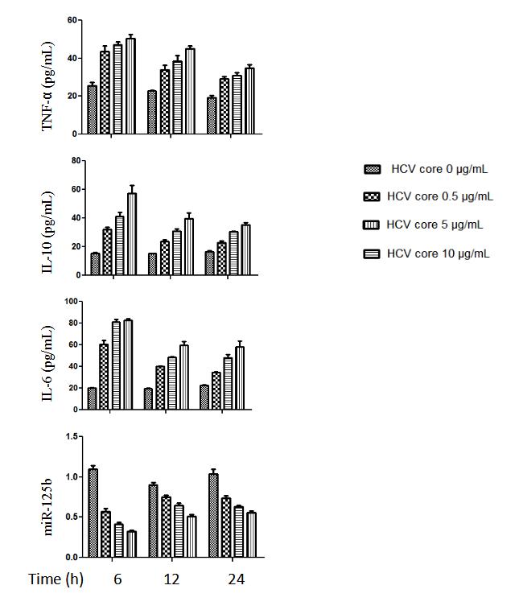

Figure 1 Increased cytokine expression and decreased miR-125b expression in hepatitis C virus core protein treated THP-1 cells. THP-1 cells were treated with HCV core recombinant protein at the final concentrations of 0.5, 1.0 and 5.0 μg/mL and incubated for 6, 12 and 24 h. The levels of tumor necrosis factor (TNF)-α, interleukin (IL)-10, and IL-6 in culture supernatants were analyzed by enzyme-linked immunosorbent assay. The cellular miR-125b levels were determined by real-time quantitative polymerase chain reaction. The data are representative of three experiments and shown as mean ± SEM.
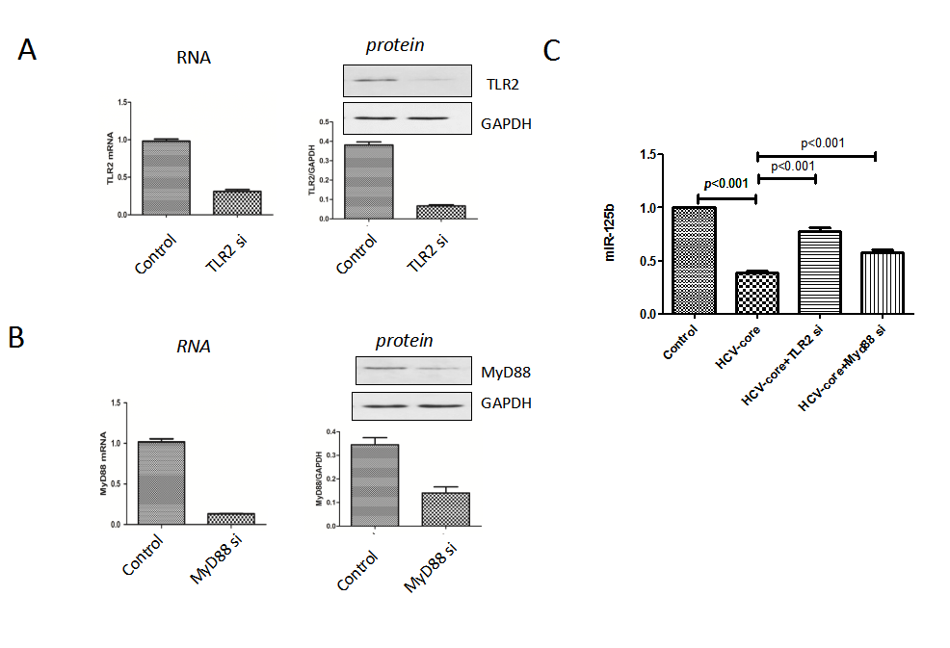
Figure 2 TLR2-MyD88 pathway dependent of HCV core protein-induced miR-125b repression. TLR2 (A) or MyD88 (B) mRNA were analyzed by real-time quantitative polymerase chain reaction (RT-qPCR) and protein lysates were analyzed by Western blotting at 6 h post-transfection. The transfected cells were infected with HCV core protein at 5 μg/mL for 6 h and miR-125b expression was detected by RT-qPCR analysis (C). Cell data are representative of three experiments and are shown as mean ± SEM (P < 0.001 by unpaired two-tailed Student’s t-test).

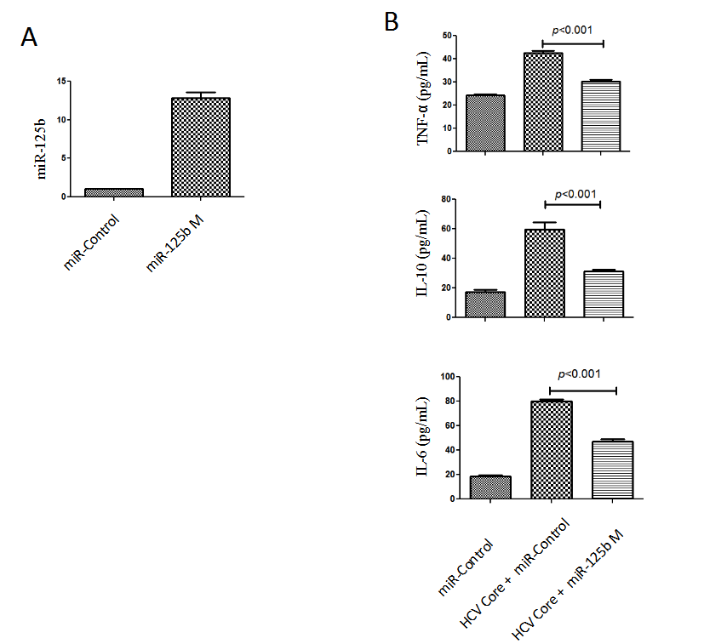
Figure 3 The miR-125b mimics abrogated hepatitis C virus core protein-induced upregulation of cytokines. A: Real-time quantitative polymerase chain reaction analysis of miR-125b levels in THP-1 cells transfected with 0.4 nM miRNA negative control (miR-control) or miR-125b mimic (miR-125b M), respectively; B: Twenty four hours after transfection, cells were treated with 5.0 μg/mL HCV core protein for an additional 6 h. The concentration of tumor necrosis factor (TNF)-α, interleukin (IL)-10 and IL-6 in culture supernatants were analyzed by enzyme-linked immunosorbent assay. These data are representative of three experiments and shown as mean ± SEM (P < 0.001 by unpaired two-tailed Student’s t-test)
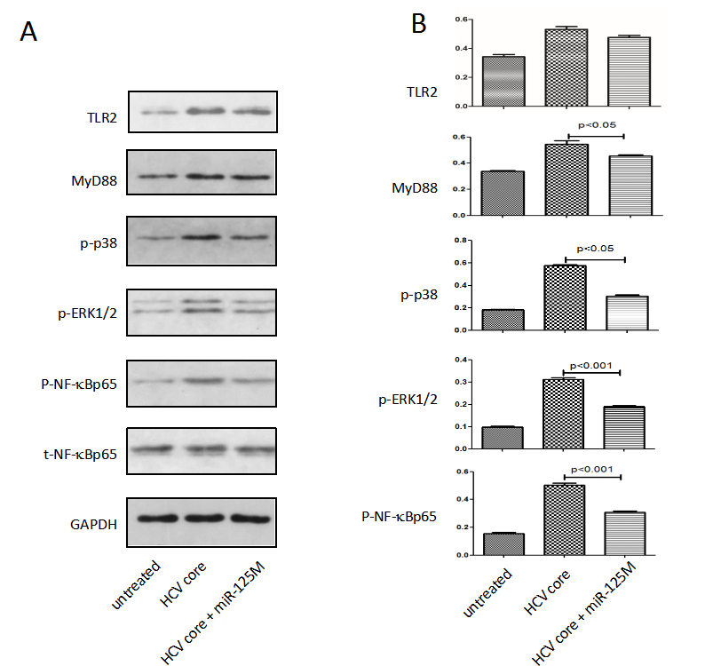
Figure 4 MiR-125b suppressed phosphorylation of NF-kBp65, ERK1/2 and p38. A: THP-1 cells were transfected with control or miR-125b mimic (miR-125bM) for 24 h, followed by incubation with hepatitis C virus (HCV) core protein at 5.0 μg/mL for 6 h. Western blot analysis of Toll-like receptor 2 (TLR2), MyD88, NF-ĸB, and phosphorylated NF-ĸB phosphorylated ERK1/2 and phosphorylated P38 in the collected cells; B: Densitometric quantification of the western blot gel data was performed using Quantity One Software. These data are representative of three experiments and shown as mean ± SEM (P < 0.05, P < 0.001 by unpaired two-tailed Student’s t-test).

