Name of Journal: World Journal of Gastrointestinal Surgery
Manuscript No: 40735
Manuscript Type: CASE REPORT

Coexistence of duodenum derived aggressive fibromatosis and paraduodenal hydatid cyst: A case report and review of literature

Akbulut S et al. Approach to desmoid type fibromatosis

Sami Akbulut, Mehmet Yilmaz, Saadet Alan, Mehmet Kolu, Nese Karadag

Sami Akbulut, Department of Surgery and Liver Transplant Institute, Inonu University Faculty of Medicine, Malatya 244280, Turkey

Mehmet Yilmaz, Department of Surgery, Inonu University Faculty of Medicine, Malatya 244280, Turkey

Saadet Alan, Nese Karadag, Department of Pathology, Inonu University Faculty of Medicine, Malatya 244280, Turkey

Mehmet Kolu, Department of Radiology, Inonu University Faculty of Medicine, Malatya 244280, Turkey

ORCID number: Sami Akbulut (0000-0002-6864-7711); Mehmet Yilmaz (0000-0002-5475-7290); Saadet Alan (0000-0003-2329-151X); Mehmet Kolu (0000-0001-9659-6053); Nese Karadag (0000-0003-0886-8122).

Author contributions: Akbulut S designed the report; Akbulut S and Yilmaz M performed surgical procedure; Akbulut S and Yilmaz M collected the patient’s clinical data; Alan S and Karadag N provided histopathological information; Kolu M provided radiological information; Akbulut S analyzed the data and wrote the paper.

Informed consent statement: Written informed consent was obtained from the patient for publication of this case report and accompanying images.

Conflict-of-interest statement: The author declares no potential conflict of interest.

CARE Checklist (2013) statement: The manuscript was revised according to the CARE Checklist (2013).

Open-Access: This article is an open-access article which was selected by an in-house editor and fully peer-reviewed by external reviewers. It is distributed in accordance with the Creative Commons Attribution Non Commercial (CC BY-NC 4.0) license, which permits others to distribute, remix, adapt, build upon this work non-commercially, and license their derivative works on different terms, provided the original work is properly cited and the use is non-commercial. See: http://creativecommons.org/licenses/by-nc/4.0/

Manuscript source: Invited manuscript

Correspondence to: Sami Akbulut, MD, Associate Professor, FICS, FACS, Department of Surgery and Liver Transplant Institute, Inonu University Faculty of Medicine, Elazig Yolu 10. Km, Malatya 44280, Turkey. sami.akbulut@inonu.edu.tr
Telephone: +90-422-3410660
Fax: +90-422-3410036

Received: July 6, 2018
Peer-review started: July 6, 2018
First decision: July 29, 2018
Revised: August 5, 2018
Accepted: October 17, 2018
Article in press:
Published online:

Abstract
Intraabdominal aggressive fibromatosis is a locally aggressive tumor mostly originating from the mesentery or retroperitoneal space, infiltrating adjacent tissues, and very rarely metastasizing to distant organs. There are only two case reports in the English language literature where intraabdominal aggressive fibromatosis originated from the intestinal wall. In this study we aimed to report a case of aggressive fibromatosis originating from the muscularis propria layer of the duodenum and invading pancreas. Another interesting aspect of this case is that a primary paraduodenal hydatid cyst was incidentally detected in the surgical specimen. A 46-year-old woman presented to our clinic with postprandial nausea and vomiting. A contrast-enhanced abdominal computerized tomography revealed a mass lesion with a size of 100 × 80 mm which originated from distal pancreas and compressed gastric pilor externally. On exploration the distal part of duodenum, proximal jejunum, and pancreatic mass were noted to form a conglomerated structure. Therefore, the fourth part of duodenum, a 25 cm part of proximal jejunum, distal pancreas, and the spleen were excised en-bloc. The pathology report of the specimen indicated fibromatosis with a diameter of 55 mm that originated from the muscularis propria of the duodenum and extended into pancreatic parenchyma. There was also an incidentally detected paraduodenal hydatid cyst with a size of 10 mm. No tumor recurrence was detected at a follow-up period of 24 mo. In conclusion, the most ideal treatment of desmoid type fibromatosis is surgical resection of the mass lesion with clean surgical borders. Despite rare, this tumor may originate from intestinal wall. Histopathological verification is of great significance for a proper diagnosis.

Key words: Agressive fibromatosis; Desmoid tumor; Desmoid type fibromatosis; Intraabdominal fibromatosis; Duodenal wall; Hydatid cyst

© The Author(s) 2018. Published by Baishideng Publishing Group Inc. All rights reserved.
Core Tip: Fibromatosis can be categorized into two broad categories depending on their localization: superficial and deep (aggressive fibromatosis or desmoid tumor). Desmoid type fibromatoses can be categorized into three groups depending on their localization, namely extra-abdominal, abdominal wall and intraabdominal fibromatosis. Intraabdominal desmoid type fibromatosis may develop from small intestinal mesentery, omentum, retroperitoneum, pelvis, and very rarely, intestinal wall such as our case. We aimed to report a case of aggressive fibromatosis originating from the muscularis propria layer of the duodenum and invading pancreas. Another interesting aspect of this case is that a primary paraduodenal hydatid cyst was incidentally detected.

Akbulut S, Yilmaz M, Alan S, Kolu M, Karadag N. Coexistence of duodenum derived aggressive fibromatosis and paraduodenal hydatid cyst: A case report and review of literature. World J Gastrointest Surg 2018; In press

INTRODUCTION
Intraabdominal aggressive fibromatosis (desmoid tumor) is a locally aggressive tumor mostly originating from the retroperitoneal space or musculoaponeurotic tissues in mesentery, showing fibroblast/myofibroblast proliferation, infiltrating adjacent tissues, and very rarely metastasizing to distant organs^{[1,2]}. The most significant risk factors for intraabdominal aggressive fibromatosis are positive family history, female gender, APC gene mutation, pregnancy, hormone therapy, and a history of surgical procedure and trauma. The tumor is mostly asymptomatic when it first emerges^{[1-5]}. When it grows and starts to invade adjacent tissues or organs, however, it may produce signs and symptoms including abdominal discomfort, pain, palpable mass, intestinal obstruction, perforation, fistula and inguinal hernia^{[1-3]}. Depending on tumor size, growth pattern, and symptomatology, a staging model has been developed, which usually forms the basis for treatment planning^{[6]}. The majority of publications about intraabdominal aggressive fibromatosis have stated that the tumor originated from mesentery. Despite this, however, only two papers have been published about aggressive fibromatosis originating from the intestinal wall^{[2,4]}. In this paper we aimed to report a case of aggressive fibromatosis originating from the muscularis propria layer of the duodenum and invading the pancreas.

CASE REPORT
A 46-year-old woman presented to out outpatient clinic with postprandial nausea and vomiting. She stated that these complaints had started 6 mo earlier and had recently become worse. Her past medical history was not remarkable. On physical examination she only had tenderness in epigastric region. Her biochemical parameters and tumor markers were within normal limits. Oral and intravenous contrast enhanced computerized tomography revealed a mass lesion with an approximate size of 100 mm × 80 mm that originated from the body of pancreas and extended inferiorly (Figures 1 and 2). As the mass did not invade vascular structures, a surgical intervention was planned. The abdominal cavity was entered via midline incision. After opening the gastrocolic ligament, the dense structure whose diameter was measured about 120 mm × 100 mm was noted to originate from the pancreatic body, cause severe adhesions with adjacent tissues, and form a conglomerated structure together with the fourth part of duodenum and proximal jejunal loops. The mass was also severely adhered to the prepyloric antrum of the stomach. First, dense adhesions between the stomach and the mass were dissected with sharp dissection. Then, the extremely close anatomic relations of the mass with both the portal vein and the superior mesenteric artery were cut with sharp dissection. The conglomerated fourth part of the duodenum, proximal jejunum, distal pancreas, and the spleen were removed en-bloc. Then, an end-to-end anastomosis was formed between the third part of duodenum and proximal jejunum (Figure 3). Supportive serosal stiches were placed along the anastomosis line. A jejunal tube extending to the proximal part of the anastomosis was placed in order to protect the anastomosis. The patient was discharged uneventfully. The histopathological examination of the pathology specimen revealed a lesion with an approximate diameter of 55 mm and an appearance consistent with fibromatosis, which originated from the muscularis propria layer of the duodenum and extended into the pancreatic parenchyma (Figures 4 and 5). Immunohistochemically, the tumor was stained positively with vimentin (strong staining), beta catenin, cluster of differentiation 99 (CD99), smooth muscle actin (weak staining), calponin (patchy staining) and Ki67 proliferation index (5%) whereas it was negatively stained with B-cell lymphoma 2, CD68, low molecular weight keratin, high molecular weight keratin, CD117 and pan-cytokeratin. Additionally, a hydatid cyst lesion having a diameter of 10 mm was detected in the neighborhood of the tumor (Figure 6). The patient was administered etodolac for a total of 3 mo at the postoperative period. The tumor did not recur for a period of 24 mo postoperatively.

DISCUSSION
Fibromatosis can be categorized into two broad categories depending on their localization: Superficial (palmar, plantar, and penile) and deep (aggressive fibromatosis = desmoid tumor = desmoid type fibromatosis). Superficial fibromatoses are typically small and grow slowly. Deep fibromatoses are locally aggressive tumors that are bigger and grow more rapidly than superficial ones. Deep fibromatoses develop as a result of the proliferation of clonal fibroblasts found in deep soft tissues. The term aggressive fibromatosis was first defined by McFarlane in 1832^{[7,8]}. In 1838 Mueller suggested the use of the term desmoid tumor instead of the term aggressive fibromatosis^{[7,8]}. Finally, World Health Organization (WHO) categorized all the terms deep fibromatosis, aggressive fibromatosis and desmoid tumor under the title of ‘’desmoid type fibromatosis’’. WHO put desmoid type fibromatoses into the intermediate (locally aggressive) types of fibroblastic/myofibroblastic tumors.
Desmoid type fibromatoses can be categorized into three groups depending on their localization, namely extra-abdominal (50%-60%), abdominal wall (25%), and intraabdominal fibromatosis (12%-15%)^{[1,2]}. Extra-abdominal desmoid type fibromatoses most commonly originate from soulder, chest wall, neck, back, and soft tissues of leg. Abdominal wall desmoid type fibromatosis mostly develop from rectus abdominis or internal oblique muscle fasciae. Intraabdominal desmoid type fibromatosis may develop from small intestinal mesentery (80%), ileocolic mesentery, omentum, retroperitoneum, pelvis, and very rarely, intestinal wall itself^{[5]}. Desmoid type fibromatosis occurs sporadically in 85%-90% of cases whereas the remainders are related to APC gene mutation [Familial adenomatous polyposis (FAP), Gardner syndrome].
Desmoid type fibromatosis constitutes 0.03% of all tumors and less than 3% of all soft tissue tumors in humans. The estimated annual incidence of desmoid type fibromatosis in general population is 2-5 people per one million^{[5]}. Although desmoid type fibromatosis mostly affects persons aged 15 to 60 years, it peaks around the age of 30. It is more common in women than men^{[1]}.
Demonstration of a mass showing an infiltrative growth pattern in contrast-enhanced computerized tomography or magnetic resonance imaging is of great value for making the provisional diagnosis of desmoid type fibromatosis. Observing spindle cells with small and regular nuclei, which are surrounded by abundant collagen in biopsy material taken from the mass is typical for the disorder. On immunohistochemical staining the lesion is positively stained with muscle cell marker actin, vimentin, and desmin, while it is negatively stained with CD34. However, definitive diagnosis is made by showing the mutation in the β-catenin gene (CTNNB1). Among cases with sporadic desmoid type fibromatosis, 85% have been reported to have somatic mutations in CTNNB1 gene encoding beta-catenin. The differential diagnosis of desmoid type fibromatosis includes gastrointestinal stromal tumors, solitary fibrous tumors, inflammatory myofibroblastic tumors, sclerosing mesenteritis, retroperitoneal fibrosis, and lymphoma. Therefore, histopathological verification and demonstration of gene mutation if possible are of paramount importance prior to instituting treatment^{[9]}.
In general, desmoid type fibromatosis is treated with one or several of the treatment options including surgical resection, nonsteroidal anti-inflammatory drugs (sulindac, meloxicam, etodolac, indomethacin), hormonotherapy (tamoxifen, raloxifene, toremifene, progesterone, testolactone), chemotherapy (doxorubicin, doxorubicin + dacarbazine, epirubicin, methotrexate + vinblastine), radiotherapy (neoadjuvant, adjuvant), and targeted therapy with tyrosine kinase inhibitors (imatinib, sorafenib, pazopanib)^{[1,6]}. Irrespective of tumor localization, the most ideal treatment approach is R0 surgical resection with 2 to 3 cm clean surgical borders^{[1,2]}. In cases where R0 resection is not an option, recurrence rates could be dramatically reduced by combining one of the above mentioned treatment modalities with debulking tumor surgery.
We would like to discuss the case presented in this paper with regard to its several aspects. Whereas almost all intraabdominal desmoid type fibromatosis cases published so far were of gut mesentery in origin, the tumor reported here originated from the intestinal wall itself. To our best knowledge, a total of two such cases have been reported, one from duodenal wall^{[2]} and the other from cecal wall^{[4]}. Hence, it is difficult to make any suggestion on how to approach these cases. However, the general R0 resection rule also applies here. The tumor of duodenal origin gave a radiological appearance of pancreatic origin. This case indeed appeared as a pancreatic mass compressing duodenum since a proliferation in the duodenal wall extended to pancreatic parenchyma. The back table appearance of the specimen was also compatible with a pancreatic mass. However, the histopathological examination revealed that this was in fact caused by the invasion of the pancreas by a proliferation of duodenal origin. Being female, having a history of four pregnancies, and using oral contraceptives for years are each risk factors for desmoid tumor development for the patient presented here. Both endoscopy and colonoscopy were performed in order to demonstrate any other risk factor such as FAP, but both failed to reveal any finding consistent with FAP. Another important point to consider is the anastomosis technique. To date, we placed a tube passing from distal jejunum to proximal part of the anastomosis in order to reduce anastomosis pressure in all three cases where we had to resect the fourth part of duodenum for various indications and then we performed end-to-end duodeno-jejunal anastomosis with the help of a stapler. We did not experience anastomosis leak problem in any of our patients.
Despite totally irrelevant with this subject, it is quite interesting to detect a 10 mm paraduodenal hydatid cyst in the surgical specimen incidentally. A postoperative serum echinococcus enzyme-linked immunosorbent assay test was reported negative. Additionally, the thoracoabdominal computed tomography images were retrospectively examined and no other hydatid cyst lesion could be identified in any other location. The cystic lesion detected in the patient was considered a primary paraduodenal hydatid cyst. Thus, postoperative albendazole treatment was not commenced. Here, the question for which we request readers’ opinion is that whether hydatid cyst could be triggering factor the desmoid reaction? It is not easy to answer this question. However, it is a known fact that hydatid disease can causes inflammation in the surrounding tissue. It is clear that this case report needs to be supported by other studies.
In conclusion, desmoid type fibromatosis is a locally aggressive tumor that does not metastasize to distant organs. The most ideal treatment is surgical resection of the mass lesion with clean surgical borders. Despite rare, desmoid type fibromatosis may originate from intestinal wall. Histopathological verification is of great significance for a proper diagnosis.

ARTICLE HIGHLIGHTS
Case characteristics
A 46-year-old woman presented to out outpatient clinic with postprandial nausea and vomiting.

Clinical diagnosis
Upper gastrointestinal obstruction due to pancreatic/duodenal tumor.

Differential diagnosis
Pancreatic mass, Duodenal mass.

Laboratory diagnosis
Both biochemical parameters and tumor markers were measured as within normal limits.

Imaging diagnosis
A contrast-enhanced abdominal computerized tomography revealed a mass lesion with a size of 100 × 80 mm which originated from distal pancreas.

Pathological diagnosis
Agressive fibromatosis also known as desmoid tumor originated from the muscularis propria of the duodenum and paraduodenal hydatid cyst.

Treatment
Fourth part of the duodenum, proximal jejunum, distal pancreas, and the spleen were removed en-bloc. After then, an end-to-end anastomosis was performed between the third part of duodenum and proximal jejunum.

Related reports
There are only two case report have been published about aggressive fibromatosis originating from the intestinal wall. Herein, we present the third case in the English language literature.

Term explanation
Fibromatosis can be categorized into two groups: Superficial and deep. Deep fibromatosis also known as aggressive fibromatosis, desmoid tumor and desmoid type fibromatosis. Desmoid type fibromatosis can be categorized into three groups: extra-abdominal, abdominal wall, intraabdominal fibromatosis.

REFERENCES
1 Liu X, Zong S, Cui Y, Yue Y. Misdiagnosis of aggressive fibromatosis of the abdominal wall: A case report and literature review. Medicine (Baltimore) 2018; 97: e9925 [PMID: 29517699 DOI: 10.1097/MD.0000000000009925]
2 Li J, Le H, Chai W, Zhou Y, Jin L, Liu T, Zhang K. Duodenum-derived fibromatosis that invaded the muscular layer of intestinal wall: A rare case report. Medicine (Baltimore) 2017; 96: e7684 [PMID: 28767596 DOI: 10.1097/MD.0000000000007684]
3 Turgutalp K, Tabakan F, Kara T, Gübür O, Altıntaş E, Türkmenoğlu O, Ozhan O, Kıykım A, Apaydın FD. An unusual cause of duodenal obstruction: mesenteric fibromatosis in a patient with type I Mayer-Rokitansky-Kuster-Hauser syndrome. Turk J Gastroenterol 2014; 25: 92-95 [PMID: 24918139 DOI: 10.5152/tjg.2014.3928]
4 Toydemir T, Ertuğrul G. Fibromatosis of the cecum presenting with acute appendicitis: a case report. Int J Gen Med 2012; 5: 1-3 [PMID: 22259254 DOI: 10.2147/IJGM.S23237]
5 Li Destri G, Ferraro MJ, Calabrini M, Pennisi M, Magro G. Desmoid-type fibromatosis of the mesentery: report of a sporadic case with emphasis on differential diagnostic problems. Case Rep Med 2014; 2014: 850180 [PMID: 25349618 DOI: 10.1155/2014/850180]
6 Gülmez S, Gündeş E, Senger AS, Uzun O, Aday U, Çiyiltepe H, Ali Çetin D, Bozdağ E, Değer KC, Polat E. Local recurrence of sporadic mesenteric fibromatosis following radical surgery attacking the proximal jejunum. Prz Gastroenterol 2017; 12: 229-234 [PMID: 29123587 DOI: 10.5114/pg.2017.70478]
7 Rampone B, Pedrazzani C, Marrelli D, Pinto E, Roviello F. Updates on abdominal desmoid tumors. World J Gastroenterol 2007; 13: 5985-5988 [PMID: 18023087 DOI: 10.3748/wjg.v13.45.5985]
8 Liu X, Zong S, Cui Y, Yue Y. Misdiagnosis of aggressive fibromatosis of the abdominal wall: A case report and literature review. Medicine (Baltimore) 2018; 97: e9925 [PMID: 29517699 DOI: 10.1097/MD.0000000000009925]
9 Huang K, Stuart H, Lyapichev K, Rosenberg AE, Livingstone AS. Mesenteric desmoid tumour presenting with recurrent abdominal abscess and duodenal fistula: A case report and review of literature. Int J Surg Case Rep 2017; 37: 119-123 [PMID: 28666150 DOI: 10.1016/j.ijscr.2017.06.007]

P-Reviewer: Isik A, Kato J S-Editor: Ying D L-Editor: E-Editor:

Specialty type: Gastroenterology and hepatology
Country of origin: Turkey
Peer-review report classification
Grade A (Excellent): 0
Grade B (Very good): B
Grade C (Good): C
Grade D (Fair): 0
Grade E (Poor): 0

Figure 1 Oral and intravenous contrast-enhanced multidetector computed tomography. A: Axial cross-sectional views of the multidetector computed tomography (MDCT) scan; B: Coronal reformant cross-sectional views of the MDCT scan. A space occupying mass lesion with homogenous density showing minimal contrast uptake is seen in preaortic area in the abdominal midline (thick white arrow). Coronal reformant MDCT images show that the mass is in the fourth part of the duodenum (curved black arrow). There is only slight oral contrast passage to jejunal loops (thin black arrow) and the duodenum and stomach had a ptotic appearance due to mechanical obstruction caused by the mass.

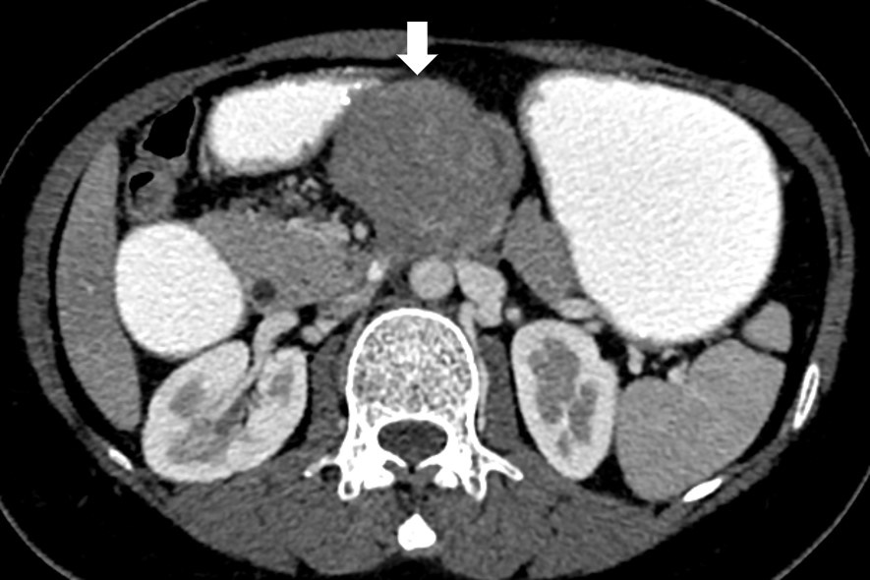
A
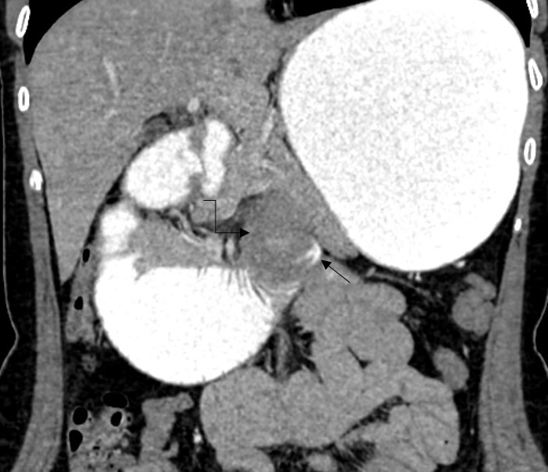
B

Figure 2 Intraoperative views. The image of the anastomosis formed with circular stapler between the third part of the duodenum and proximal jejunum after the resection. Circumferential serosal sutures with prolyene were placed to reinforce the anastomosis.
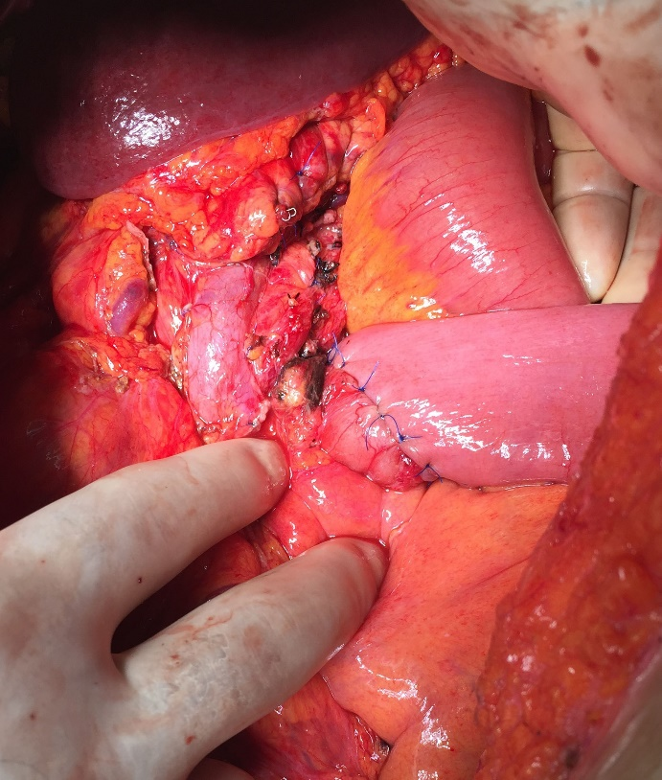

Figure 3 Appearance of back-table stage of surgery. It’s the image of the resected specimen after the transection of the pancreas. It was seen that the mass originated from the duodenum and invaded pancreas.
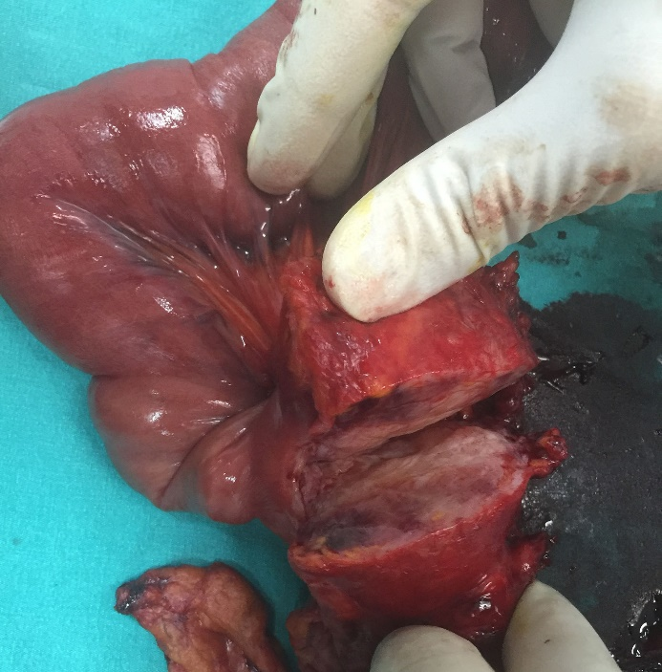

Figure 4 Microscopic appearance of duodenal wall tissue stained with hematoxylin and eosin. Spindle cell tumor originating from the muscularis propria under duodenal mucosa (HE × 40).
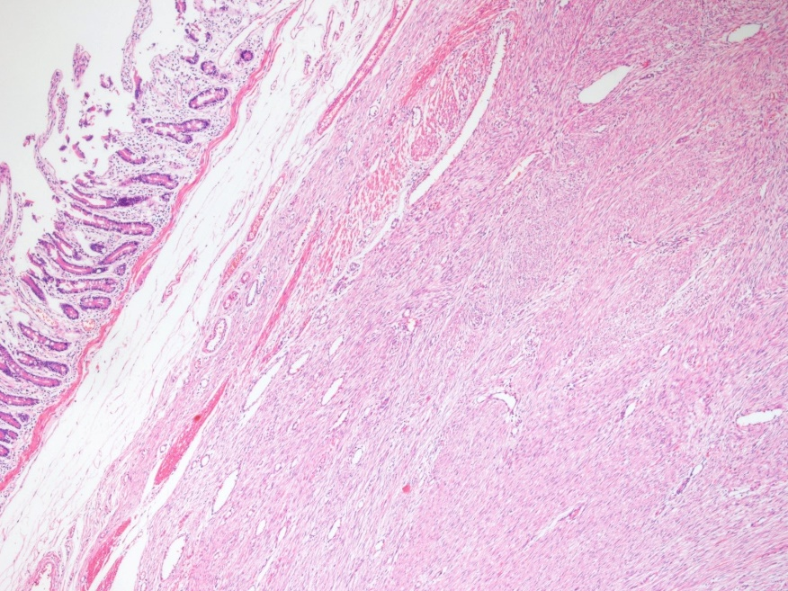

Figure 5 Microscopic appearance of pancreatic tissue stained with hematoxylin and eosin. It shows extension to pancreatic parenchyma (HE × 40).
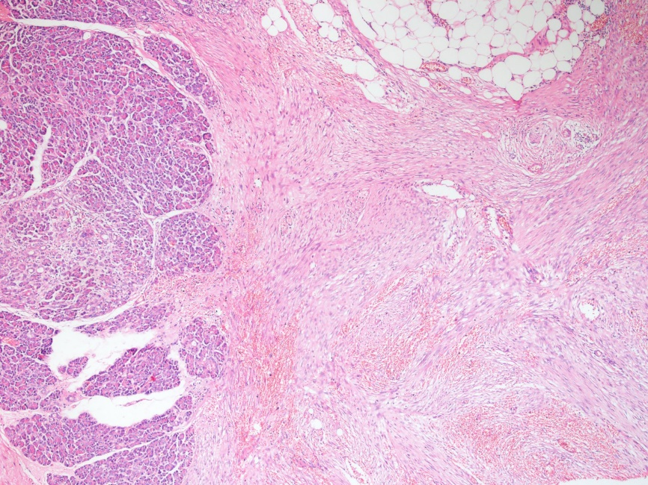

Figure 6 Microscopic appearance of hydatid cyst tissue stained with hematoxylin and eosin acellular membrane of a hydatid cyst (HE ×40).
