Name of Journal: World Journal of Gastroenterology
Manuscript NO: 49421
Manuscript Type: META-ANALYSIS

Is there an association between Helicobacter pylori infection and irritable bowel syndrome? A meta-analysis

Ng QX et al. H. pylori infection and IBS

Qin Xiang Ng, Nadine Xinhui Foo, Wayren Loke, Yun Qing Koh, Vanessa Jing Min Seah, Alex Yu Sen Soh, Wee Song Yeo

Qin Xiang Ng, Nadine Xinhui Foo, Wayren Loke, Yun Qing Koh, Vanessa Jing Min Seah, Medicine, MOH Holdings Pte Ltd, Singapore 099253, Singapore

Qin Xiang Ng, General and Community Psychiatry, Institute of Mental Health, Singapore 117597, Singapore

Nadine Xinhui Foo, Yun Qing Koh, Vanessa Jing Min Seah, Department of General Medicine, Tan Tock Seng Hospital, 11 Jalan Tan Tock Seng, Singapore 308433, Singapore

Alex Yu Sen Soh, Wee Song Yeo, Department of Gastroenterology and Hepatology, National University Hospital, National University Health System, Singapore 119074, Singapore

Alex Yu Sen Soh, Wee Song Yeo, Yong Loo Lin School of Medicine, National University of Singapore, Singapore 117597, Singapore

ORCID number: Qin Xiang Ng (0000-0001-8561-2513); Nadine Xinhui Foo (0000-0003-1043-7751); Wayren Loke (0000-0003-4498-9773); Yun Qing Koh (0000-0002-0891-1701); Vanessa Jing Min Seah (0000-0001-5516-6145); Alex Yu Sen Soh (0000-0002-1981-1941); Wee Song Yeo (0000-0002-2201-2673).

Author contributions: Ng QX conceived the original idea; Soh AYS and Yeo WS supervised the study; Ng QX, Foo NX, Loke W and Koh YQ carried out the study, and the relevant data analysis and interpretation; Seah VJM, Soh AYS and Yeo WS contributed to the data analysis and interpretation; all authors discussed the results, contributed to the writing of the paper and approved the final manuscript.

Conflict-of-interest statement: There is no conflict of interest associated with any of the senior author or other coauthors contributed their efforts in this manuscript. All the authors have no conflict of interest related to the manuscript.

PRISMA 2009 Checklist statement: The authors have read the PRISMA 2009 Checklist, and the manuscript was prepared and revised according to the PRISMA 2009 Checklist.

Open-Access: This article is an open-access article which was selected by an in-house editor and fully peer-reviewed by external reviewers. It is distributed in accordance with the Creative Commons Attribution Non Commercial (CC BY-NC 4.0) license, which permits others to distribute, remix, adapt, build upon this work non-commercially, and license their derivative works on different terms, provided the original work is properly cited and the use is non-commercial. See: http://creativecommons.org/licenses/by-nc/4.0/

Manuscript source: Invited manuscript

Corresponding author: Qin Xiang Ng, MBBS, Doctor, General and Community Psychiatry, Institute of Mental Health, Buangkok Green Medical Park, 10 Buangkok View, 539747, Singapore 117597, Singapore. ng.qin.xiang@u.nus.edu
Telephone: +65-66386979

Received: May 29, 2019
Peer-review started: May 30, 2019
First decision: July 21, 2019
Revised: July 30, 2019
Accepted: September 9, 2019
Article in press:
Published online:

Abstract
BACKGROUND
Irritable bowel syndrome (IBS) is a prevalent and debilitating gastrointestinal condition. Research has reported persistent, low-grade mucosal inflammation and significant overlaps between patients with IBS and those with dyspepsia, suggesting a possible pathogenic role of Helicobacter pylori (H. pylori) in IBS. This study therefore aimed to provide the first systematic review and meta-analysis on the association between H. pylori infection and IBS.

AIM
To investigate the association between H. pylori infection and IBS.

METHODS
Using the keywords “H. pylori OR Helicobacter OR Helicobacter pylori OR infection” AND “irritable bowel syndrome OR IBS”, a preliminary search of PubMed, Medline, Embase, Cochrane Database of Systematic Reviews, Web of Science, Google Scholar and WanFang databases yielded 2924 papers published in English between 1 January 1960 and 1 June 2018. Attempts were also made to search grey literature.

RESULTS
A total of 13 clinical studies were systematically reviewed and nine studies were included in the final meta-analysis. Random-effects meta-analysis found a slight increased likelihood of H. pylori infection in patients with IBS, albeit this was not statistically significant (pooled odds ratio 1.47, 95% confidence interval: 0.90-2.40, P = 0.123). It must also be acknowledged that all of the available studies reported only crude odd ratios. H. pylori eradication therapy also does not appear to improve IBS symptoms. Although publication bias was not observed in the funnel plot, there was a high degree of heterogeneity amongst the studies included in the meta-analysis (I² = 87.38%).

CONCLUSION
Overall, current evidence suggests a tenuous association between IBS and H. pylori infection. Further rigorous and detailed studies with larger sample sizes and after H. pylori eradication therapy are warranted.

Key words: Irritable bowel syndrome; Functional; Helicobacter pylori; Infection; Meta-analysis

© The Author(s) 2019. Published by Baishideng Publishing Group Inc. All rights reserved.

Core tip: This is the first systematic review to examine the association of Helicobacter pylori (H. pylori) infection and irritable bowel syndrome (IBS). 13 clinical studies were systematically reviewed and nine studies were included in the final meta-analysis. Random-effects meta-analysis suggests a tenuous association between the two (pooled odds ratio 1.47, 95% confidence interval: 0.90-2.40, P = 0.123). H. pylori eradication therapy also does not appear to improve IBS symptoms in the limited studies available. Further detailed trials with larger sample sizes and after H. pylori eradication therapy are necessary to elucidate the relationship between H. pylori infection and IBS pathogenesis.

Ng QX, Foo NX, Loke W, Koh YQ, Seah VJM, Soh AYS, Yeo WS. Is there an association between Helicobacter pylori infection and irritable bowel syndrome? A meta-analysis. World J Gastroenterol 2019; In press

INTRODUCTION
Irritable bowel syndrome (IBS) is one of the most common gastrointestinal (GI) disorders, characterized by chronic abdominal pain and a change in the frequency or form of stool^{[1]}. It affects an estimated 10% to 15% of the global population^{[2]} and carries a significant disease burden in terms of decreased productivity, increased healthcare costs and reduced health-related quality of life^{[3]}.
Despite the global prevalence of IBS, its pathophysiology remains unclear. Studies have reported disturbances in gut microbiota and persistent, subclinical systemic and mucosal inflammation in individuals with IBS^{[4]}. Significant overlaps also exist between patients with IBS and those with dyspepsia^{[5]}, hinting at a possible pathogenic role of Helicobacter pylori (H. pylori) in IBS. H. pylori is a prevalent gram-negative bacterium that grows in the gut of more than half of the world’s population, and it is even more common in developing countries^{[6]}. The mode of transmission of H. pylori is unclear, but believed to be fecal-oral. H. pylori, especially strains that produce cytotoxin-associated gene A (CagA) protein, causes chronic inflammation in the stomach and duodenum, microbial dysbiosis^{[7]} as well as elevated systemic inflammation^{[8]}. H. pylori infection has been linked to several conditions, including dyspepsia and even hyperemesis gravidarum^{[9]}.
However, its role in the pathogenesis of IBS remains largely unknown. Some studies have highlighted increased rates of H. pylori infection in patients with IBS compared to healthy controls^{[10,11]}, while others have disputed this and found no association between H. pylori infection and IBS^{[12]}. This association has been challenged as H. pylori is thought to affect mainly the upper GI trait instead of the lower GI tract. Some also contend that the association is merely fortuitous given the widespread prevalence of H. pylori infection globally^{[6]}. This meta-analysis thus aimed to investigate and better clarify the role of H. pylori in the pathogenesis of IBS. A better understanding of the pathogenesis of IBS has important clinical implications.

MATERIALS AND METHODS
Literature search was performed in accordance with Meta-analysis of Observational Studies in Epidemiology guidelines. By using the keywords “H. pylori OR Helicobacter OR Helicobacter pylori OR infection” AND ”irritable bowel syndrome OR IBS”, a preliminary search of PubMed, Medline, Embase, Cochrane Database of Systematic Reviews, Web of Science, Google Scholar and WanFang databases yielded 2924 papers published in English between 1 January 1960 and 1 June 2018. Attempts were made to search grey literature as well, using Google search engine and the Open System for Information on Grey Literature in Europe database. Title/abstract screening were performed independently by three researchers (Q.X.N., N.X.F. and W.R.L.) to identify articles of interest. For relevant abstracts, full articles were obtained, reviewed and also checked for references of interest. If necessary, the authors of the articles were contacted to provide additional data.
Full articles were obtained for all selected abstracts and reviewed by four researchers (Q.X.N., N.X.F, W.R.L. and Y.Q.K.) for inclusion. The inclusion criteria for this review were: (1) Published case-control or cross-sectional study; (2) patients with IBS; and (3) confirmed/laboratory testing for presence of H. pylori infection. Any disagreement was resolved by discussion and consensus amongst the three researchers. Each study was carefully reviewed and the primary outcome measure of interest was the proportion of H. pylori infection in patients with IBS compared to a control group. Odds ratio (OR) were calculated for each individual study, and estimates were pooled and where appropriate, 95% confidence intervals (95%CI) and P-values were calculated.
Heterogeneity amongst the different studies pooled was examined using the I² statistic and Cochran’s Q test. Publication bias was assessed using a funnel plot and Egger test. All analyses were performed using MedCalc Statistical Software version 14.8.1 (MedCalc Software bvba, Ostend, Belgium; http://www.medcalc.org; 2014) and STATA version 13.0 (2000; STATA Corp., College Station, TX, United States).

RESULTS
The literature search and abstraction process (and reasons for exclusion) was detailed in Figure 1. The key details of each study were extracted and summarized in Table 1^{[10-22]}. A total of 13 studies were systematically reviewed. Four studies were excluded from the final meta-analysis as three did not have a control group while one did not detect H. pylori infection in either patients with IBS or healthy controls, hence no OR could be calculated.
As seen in Figure 2, the studies had an overall high degree of heterogeneity (I² = 87.38%), likely due to the different study designs and method of detection of H. pylori employed. Random-effects meta-analysis found that patients with IBS did not have a significantly increased likelihood of H. pylori infection, as the pooled OR was 1.47 (95%CI: 0.90-2.40, P = 0.123). Separate subgroup analyses and sensitivity analyses were likely underpowered and hence, were not conducted due to the small number of studies available. With regard to the possibility of publication bias, visual inspection of the funnel plot revealed a roughly symmetrical distribution of studies (Figure 3) and encouragingly, Egger test was not significant for publication bias (P = 0.189).

DISCUSSION
Overall, current evidence suggests that patients with IBS may have an increased likelihood of H. pylori infection, but this is not statistically significant (pooled OR 1.47, 95%CI: 0.90-2.40, P = 0.123). It must also be acknowledged that all of the available studies reported only crude odd ratios and did not adjust for potential confounders, further weakening any potential association between IBS and H. pylori infection. To the best of our knowledge, this review is the first to examine the association between IBS and H. pylori infection. The current meta-analysis is therefore a novel and significant contribution to current literature.
It is well demonstrated that H. pylori infection leads to chronic inflammation and is involved in the etiopathogenesis of atrophic gastritis, intestinal metaplasia and peptic ulcers^{[23]}. Patients with IBS have been found to have increased lamina propria immune cells in the colonic mucosa^{[24]} and significantly reduced levels of oleoylethanolamide (a fatty acid amide with anti-inflammatory properties) when compared to healthy controls^{[25]}. These are suggestive of chronic, subclinical inflammation at the microscopic level^{[26]}. Increased infiltration of mucosal mast cells have also been reported in the GI tract of patients with IBS when compared to healthy controls^{[27]}. In considering the possible pathogenic mechanisms of H. pylori in relation to IBS, H. pylori infection has been associated with elevated inflammatory markers^{[8]}, increased mast cell activation^{[28]} and gastric mucosal and neural remodeling^{[29]}. Vacuolating cytotoxin A^{[30]} and the neutrophil-activating protein^{[28]} of H. pylori are both potent mast cell stimulators. Although a definite and consistent pattern of immune dysregulation has yet to be established in patients with IBS, increased mast cell activation and immune activity in the gut may correlate with symptoms of visceral hypersensitivity^{[31]}.
Furthermore, in a study utilizing the rectal barostat to elicit abdominal symptoms in patients with IBS, positive results were seen almost exclusively in H. pylori-positive patients with IBS, suggesting a potential role of H. pylori in stimulating visceral hypersensitivity^{[16]}. Preclinical and clinical studies have often reported a link between increased intestinal mucosal inflammation and changes in sensory-motor function^{[32,33]}. As such, H. pylori infection may result in gastric dysmotility and neuroplastic changes in the afferent neural pathways, giving rise to visceral hypersensitivity and prototypical IBS symptoms.
On the other hand, contrary findings have also been reported. A study on patients with functional dyspepsia found no association between H. pylori infection and increased pain perception of gastric distension^{[34]}. Studies that investigated the effect of H. pylori eradication therapy on IBS symptoms also found no significant differences at follow-up^{[11,21]}. However, the relationship is difficult to analyse as it may be confounded by the fact that H. pylori is eradicated with antibiotics, which is also associated with a significantly increased risk of developing IBS^{[35]} and may also aggravate IBS symptoms^{[36]}.
A fundamental understanding of the pathogenesis of IBS is still lacking. Additionally, psychological factors such as stress, depression and anxiety are known to contribute to the pathogenesis^{[37]}. Our study has found another potential contributory factor. Patients with IBS may have an increased likelihood of H. pylori infection albeit this is not statistically significant. The role of H. pylori eradication therapy is also unclear as it does not appear to improve IBS symptoms in the limited studies available.
Other limitations of current evidence that must be discussed include the fact that some of the available studies^{[13,18]} used a self-report symptom questionnaire in the diagnosis of IBS. There is a known wide variability in the definition of constipation and diarrhoea^{[38]}, and the subjectivity and inter-study variability in the diagnosis of IBS could further affect the reliability of current findings. Also, some of the studies^{[13,18]} included in the meta-analysis did not investigate study participants for organic disease that may contribute to IBS-like symptoms. Limited studies also performed CagA testing. In one study^{[18]}, CagA antibody positivity but not H. pylori seropositivity was found to be significantly associated with IBS. Future studies should examine the effect of CagA positivity as the CagA toxin is an important H. pylori virulence factor associated with a greater inflammatory response^{[39]}. There was also a significant degree of heterogeneity amongst the various studies included in the meta-analysis (I² = 87.38%). This could stem from the subjectivity and different definitions used in the diagnosis of IBS as previously discussed, as well as the differing tests used to detect H. pylori infection, e.g., serum IgG antibodies, urea breath test and stool antigen assay. Moreover, the commonly-used serologic test is unable to distinguish between current and previous H. pylori infection as it remains positive for years, even after H. pylori eradication therapy^{[40]}. Although some studies carefully selected only individuals who have no history of previous H. pylori eradication therapy^{[16]}, it was less clear in other studies. The duration of H. pylori infection may also affect our analysis as study subjects with more longstanding infection may have greater mucosal inflammation and more significant GI symptoms.
Last but not least, the influence of H. pylori on the composition of distal gut microbiota is an important area that deserves further study. Microbial dysbiosis is a known hallmark of IBS^{[41]}. However, it is unclear how H. pylori, which is thought to affect mainly the upper GI tract, may affect the lower GI tracts^{[42]}.
In conclusion, current evidence suggests a tenuous association between IBS and H. pylori infection. Patients with IBS may have a slight increased likelihood of H. pylori infection albeit this is not statistically significant. This relationship is complicated by admittedly problematic study designs and potential confounding factors. The role of H. pylori eradication therapy also remains unclear as it does not appear to improve IBS symptoms. Further rigorous and detailed studies with larger sample sizes, carefully selected subjects, and after H. pylori eradication therapy are warranted. The influence of H. pylori on gut microbiota should also be investigated.

ARTICLE HIGHLIGHTS
Research background
Helicobacter pylori (H. pylori) is a prevalent gram-negative bacterium found in the human gut. H. pylori infection has been linked to several conditions, including dyspepsia and even hyperemesis gravidarum. However, its role in the pathogenesis of irritable bowel syndrome (IBS) remains largely unknown.

Research motivation
An improved understanding of the pathogenic mechanisms of IBS may lead to more effective therapeutics.

Research objectives
To investigate the association between H. pylori infection and IBS.

Research methods
A comprehensive search of PubMed, Medline, Embase, Cochrane Database of Systematic Reviews, Web of Science, Google Scholar and WanFang databases was performed using the keywords “H. pylori OR Helicobacter OR Helicobacter pylori OR infection” AND “irritable bowel syndrome OR IBS”.

Research results
Of 13 clinical studies were systematically reviewed and nine studies were included in the final meta-analysis. Random-effects meta-analysis found a slight increased likelihood of H. pylori infection in patients with IBS, albeit this was not statistically significant (pooled odds ratio 1.47, 95% confidence interval: 0.90-2.40, P = 0.123). H. pylori eradication therapy also does not appear to improve IBS symptoms in the limited studies available.

Research conclusions
Patients with IBS may have a slight increased likelihood of H. pylori infection albeit this is not statistically significant. This relationship is complicated by admittedly problematic study designs and potential confounding factors. H. pylori is eradicated with antibiotics, which is also associated with a significantly increased risk of developing IBS and may also aggravate IBS symptoms.

Research perspectives
Further rigorous and detailed trials with larger sample sizes, carefully selected subjects, and after H. pylori eradication therapy are warranted. The influence of H. pylori on gut microbiota also remains unknown and should be investigated.

REFERENCES
1 Drossman DA. Functional Gastrointestinal Disorders: History, Pathophysiology, Clinical Features and Rome IV. Gastroenterology 2016: pii: S0016-5085(16)00223-7 [PMID: 27144617 DOI: 10.1053/j.gastro.2016.02.032]
2 Lovell RM, Ford AC. Global prevalence of and risk factors for irritable bowel syndrome: a meta-analysis. Clin Gastroenterol Hepatol 2012; 10: 712-721.e4 [PMID: 22426087 DOI: 10.1016/j.cgh.2012.02.029]
3 Akehurst RL, Brazier JE, Mathers N, O'Keefe C, Kaltenthaler E, Morgan A, Platts M, Walters SJ. Health-related quality of life and cost impact of irritable bowel syndrome in a UK primary care setting. Pharmacoeconomics 2002; 20: 455-462 [PMID: 12093301 DOI: 10.2165/00019053-200220070-00003]
4 Barbara G, Cremon C, De Giorgio R, Dothel G, Zecchi L, Bellacosa L, Carini G, Stanghellini V, Corinaldesi R. Mechanisms underlying visceral hypersensitivity in irritable bowel syndrome. Curr Gastroenterol Rep 2011; 13: 308-315 [PMID: 21537962 DOI: 10.1007/s11894-011-0195-7]
5 Agréus L, Svärdsudd K, Nyrén O, Tibblin G. Irritable bowel syndrome and dyspepsia in the general population: overlap and lack of stability over time. Gastroenterology 1995; 109: 671-680 [PMID: 7657095 DOI: 10.1016/0016-5085(95)90373-9]
6 Hooi JKY, Lai WY, Ng WK, Suen MMY, Underwood FE, Tanyingoh D, Malfertheiner P, Graham DY, Wong VWS, Wu JCY, Chan FKL, Sung JJY, Kaplan GG, Ng SC. Global Prevalence of Helicobacter pylori Infection: Systematic Review and Meta-Analysis. Gastroenterology 2017; 153: 420-429 [PMID: 28456631 DOI: 10.1053/j.gastro.2017.04.022]
7 Kim YJ, Chung WC, Kim BW, Kim SS, Kim JI, Kim NJ, Yoo J, Kim SH. Is Helicobacter pylori Associated Functional Dyspepsia Correlated With Dysbiosis? J Neurogastroenterol Motil 2017; 23: 504-516 [PMID: 28992674 DOI: 10.5056/jnm17066]
8 Jackson L, Britton J, Lewis SA, McKeever TM, Atherton J, Fullerton D, Fogarty AW. A population-based epidemiologic study of Helicobacter pylori infection and its association with systemic inflammation. Helicobacter 2009; 14: 108-113 [PMID: 19751435 DOI: 10.1111/j.1523-5378.2009.00711.x]
9 Ng QX, Venkatanarayanan N, De Deyn MLZQ, Ho CYX, Mo Y, Yeo WS. A meta-analysis of the association between Helicobacter pylori (H. pylori) infection and hyperemesis gravidarum. Helicobacter 2018; 23 [PMID: 29178407 DOI: 10.1111/hel.12455]
10 Abdelrazak MA, Walid F, Abdelrahman M, Mahmoud M. Interrelation between helicobacter pylori infection, infantile colic, and irritable bowel syndrome in pediatric patients. J Gastrointest Dig Syst 2015 [DOI: 10.4172/2161-069X.S1.026]
11 Yang Y, Chen LF. Role of Helicobacter pylori Eradication in Diarrhea-predominant Irritable Bowel Syndrome. Wei Chang Bing Xue 2017; 22: 482-485 [DOI: 10.3969/j.issn.1008-7125.2017.08.009]
12 Malinen E, Rinttilä T, Kajander K, Mättö J, Kassinen A, Krogius L, Saarela M, Korpela R, Palva A. Analysis of the fecal microbiota of irritable bowel syndrome patients and healthy controls with real-time PCR. Am J Gastroenterol 2005; 100: 373-382 [PMID: 15667495 DOI: 10.1111/j.1572-0241.2005.40312.x]
13 Agréus L, Engstrand L, Svärdsudd K, Nyrén O, Tibblin G. Helicobacter pylori seropositivity among Swedish adults with and without abdominal symptoms. A population-based epidemiologic study. Scand J Gastroenterol 1995; 30: 752-757 [PMID: 7481542 DOI: 10.3109/00365529509096323]
14 Corsetti M, Caenepeel P, Fischler B, Janssens J, Tack J. Impact of coexisting irritable bowel syndrome on symptoms and pathophysiological mechanisms in functional dyspepsia. Am J Gastroenterol 2004; 99: 1152-1159 [PMID: 15180740 DOI: 10.1111/j.1572-0241.2004.30040.x]
15 El-Badry AA, Abd El Wahab WM, Hamdy DA, Aboud A. Blastocystis subtypes isolated from irritable bowel syndrome patients and co-infection with Helicobacter pylori. Parasitol Res 2018; 117: 127-137 [PMID: 29138961 DOI: 10.1007/s00436-017-5679-4]
16 Gerards C, Leodolter A, Glasbrenner B, Malfertheiner P. H. pylori infection and visceral hypersensitivity in patients with irritable bowel syndrome. Dig Dis 2001; 19: 170-173 [PMID: 11549828 DOI: 10.1159/000050673]
17 Hasan AS, Jaafer AM, Athab AM. Rate of Helicobacter pylori infection among patients with irritable bowel syndrome. Gulf Med J 2017; 6: 16-21
18 Locke CR 3rd, Talley NJ, Nelson DK, Haruma K, Weaver AL, Zinsmeister AR, Melton LJ 3rd. Helicobacter pylori and dyspepsia: a population-based study of the organism and host. Am J Gastroenterol 2000; 95: 1906-1913 [PMID: 10950034 DOI: 10.1111/j.1572-0241.2000.02251.x]
19 McDonald K, Shopinski S, Wilkinson A, Meza C, Cok J, Bussalleu A, Valdivieso M. Correlation between functional gastrointestinal disorders and gastric mucosa histopathology findings, including Helicobacter pylori infection, in Lima, Peru. Revista de Gastroenterología del Perú 2017
20 Su YC, Wang WM, Wang SY, Lu SN, Chen LT, Wu DC, Chen CY, Jan CM, Horowitz M. The association between Helicobacter pylori infection and functional dyspepsia in patients with irritable bowel syndrome. Am J Gastroenterol 2000; 95: 1900-1905 [PMID: 10950033 DOI: 10.1111/j.1572-0241.2000.02252.x]
21 Xiong F, Xiong M, Ma Z, Huang S, Li A, Liu S. Lack of Association Found between Helicobacter pylori Infection and Diarrhea-Predominant Irritable Bowel Syndrome: A Multicenter Retrospective Study. Gastroenterol Res Pract 2016; 2016: 3059201 [PMID: 27493660 DOI: 10.1155/2016/3059201]
22 Yakoob J, Abbas Z, Naz S, Islam M, Jafri W. Virulence markers of Helicobacter pylori in patients with diarrhoea-dominant irritable bowel syndrome. Br J Biomed Sci 2012; 69: 6-10 [PMID: 22558797 DOI: 10.1080/09674845.2012.11669914]
23 Crowe SE. Helicobacter infection, chronic inflammation, and the development of malignancy. Curr Opin Gastroenterol 2005; 21: 32-38 [PMID: 15687882]
24 Salzmann JL, Peltier-Koch F, Bloch F, Petite JP, Camilleri JP. Morphometric study of colonic biopsies: a new method of estimating inflammatory diseases. Lab Invest 1989; 60: 847-851 [PMID: 2733385]
25 Cremon C, Stanghellini V, Barbaro MR, Cogliandro RF, Bellacosa L, Santos J, Vicario M, Pigrau M, Alonso Cotoner C, Lobo B, Azpiroz F, Bruley des Varannes S, Neunlist M, DeFilippis D, Iuvone T, Petrosino S, Di Marzo V, Barbara G. Randomised clinical trial: the analgesic properties of dietary supplementation with palmitoylethanolamide and polydatin in irritable bowel syndrome. Aliment Pharmacol Ther 2017; 45: 909-922 [PMID: 28164346 DOI: 10.1111/apt.13958]
26 Ng QX, Soh AYS, Lim DY, Yeo WS. Agomelatine, a novel therapeutic option for the management of irritable bowel syndrome. J Clin Pharm Ther 2018; 43: 752-756 [PMID: 30014556 DOI: 10.1111/jcpt.12749]
27 O'Sullivan M, Clayton N, Breslin NP, Harman I, Bountra C, McLaren A, O'Morain CA. Increased mast cells in the irritable bowel syndrome. Neurogastroenterol Motil 2000; 12: 449-457 [PMID: 11012945 DOI: 10.1046/j.1365-2982.2000.00221.x]
28 Montemurro P, Nishioka H, Dundon WG, de Bernard M, Del Giudice G, Rappuoli R, Montecucco C. The neutrophil-activating protein (HP-NAP) of Helicobacter pylori is a potent stimulant of mast cells. Eur J Immunol 2002; 32: 671-676 [PMID: 11857341 DOI: 10.1002/1521-4141(200203)32:3<671::AID-IMMU671>3.0.CO;2-5]
29 Stead RH, Hewlett BR, Lhotak S, Colley ECC, Frendo M, Dixon MF. Do gastric mucosal nerves remodel in H. pylori gastritis? In: Hunt RH, Tytgat GNJ, eds. Helicobacter pylori. Springer, Dordrecht; 1994: 281-291
30 Supajatura V, Ushio H, Wada A, Yahiro K, Okumura K, Ogawa H, Hirayama T, Ra C. Cutting edge: VacA, a vacuolating cytotoxin of Helicobacter pylori, directly activates mast cells for migration and production of proinflammatory cytokines. J Immunol 2002; 168: 2603-2607 [PMID: 11884423 DOI: 10.4049/jimmunol.168.6.2603]
31 Ohman L, Simrén M. Pathogenesis of IBS: role of inflammation, immunity and neuroimmune interactions. Nat Rev Gastroenterol Hepatol 2010; 7: 163-173 [PMID: 20101257 DOI: 10.1038/nrgastro.2010.4]
32 Rao SS, Read NW, Brown C, Bruce C, Holdsworth CD. Studies on the mechanism of bowel disturbance in ulcerative colitis. Gastroenterology 1987; 93: 934-940 [PMID: 3653643 DOI: 10.1016/0016-5085(87)90554-3]
33 Stanghellini V, Barbara G, de Giorgio R, Tosetti C, Cogliandro R, Cogliandro L, Salvioli B, Corinaldesi R. Review article: Helicobacter pylori, mucosal inflammation and symptom perception--new insights into an old hypothesis. Aliment Pharmacol Ther 2001; 15 Suppl 1: 28-32 [PMID: 11488659 DOI: 10.1046/j.1365-2036.2001.00104.x]
34 Mearin F, de Ribot X, Balboa A, Salas A, Varas MJ, Cucala M, Bartolomé R, Armengol JR, Malagelada JR. Does Helicobacter pylori infection increase gastric sensitivity in functional dyspepsia? Gut 1995; 37: 47-51 [PMID: 7672680 DOI: 10.1136/gut.37.1.47]
35 Ianiro G, Tilg H, Gasbarrini A. Antibiotics as deep modulators of gut microbiota: between good and evil. Gut 2016; 65: 1906-1915 [PMID: 27531828 DOI: 10.1136/gutjnl-2016-312297]
36 Maxwell PR, Rink E, Kumar D, Mendall MA. Antibiotics increase functional abdominal symptoms. Am J Gastroenterol 2002; 97: 104-108 [PMID: 11808932 DOI: 10.1111/j.1572-0241.2002.05428.x]
37 Grinsvall C, Törnblom H, Tack J, Van Oudenhove L, Simrén M. Psychological factors selectively upregulate rectal pain perception in hypersensitive patients with irritable bowel syndrome. Neurogastroenterol Motil 2015; 27: 1772-1782 [PMID: 26467837 DOI: 10.1111/nmo.12689]
38 Soh AYS, Kang JY, Siah KTH, Scarpignato C, Gwee KA. Searching for a definition for pharmacologically refractory constipation: A systematic review. J Gastroenterol Hepatol 2018; 33: 564-575 [PMID: 28960557 DOI: 10.1111/jgh.13998]
39 Jafarzadeh A, Hassanshahi GH, Nemati M. Serum levels of high-sensitivity C-reactive protein (hs-CRP)in Helicobacter pylori-infected peptic ulcer patients and its association with bacterial CagA virulence factor. Dig Dis Sci 2009; 54: 2612-2616 [PMID: 19160050 DOI: 10.1007/s10620-008-0686-z]
40 Ricci C, Holton J, Vaira D. Diagnosis of Helicobacter pylori: invasive and non-invasive tests. Best Pract Res Clin Gastroenterol 2007; 21: 299-313 [PMID: 17382278 DOI: 10.1016/j.bpg.2006.11.002]
41 Collins SM. A role for the gut microbiota in IBS. Nat Rev Gastroenterol Hepatol 2014; 11: 497-505 [PMID: 24751910 DOI: 10.1038/nrgastro.2014.40]
42 Schulz C, Koch N, Schütte K, Pieper DH, Malfertheiner P. H. pylori and its modulation of gastrointestinal microbiota. J Dig Dis 2015; 16: 109-117 [PMID: 25624012 DOI: 10.1111/1751-2980.12233]
P-Reviewer: Grawish ME, Jadallah KA, Tsukanov V, Yang SS S-Editor: Yan JP
L-Editor: E-Editor:
Specialty type: Gastroenterology and hepatology
Country of origin: Singapore
Peer-review report classification
Grade A (Excellent): 0
Grade B (Very good): B, B, B
Grade C (Good): C
Grade D (Fair): 0
Grade E (Poor): 0

Table 1 Characteristics of all studies included in this meta-analysis (arranged alphabetically by first author’s last name)
First author, Year | Study design | Study sample (n) | Country | Diagnosis of IBS | Method of H. pylori detection | Odds ratio (95%CI) | Conclusions
Abdelrazak et al^{[10]}, 2015 | Case control | 550 | Egypt | Rome III criteria | Stool antigen test or ¹³C-urea breath test positive | 8.56 (4.06, 18.05) | Significantly higher rate of H. pylori detection in pediatric patients with IBS compared to healthy controls
Agreus et al^{[13]}, 1995 | Case control | 150 | Sweden | More than 2 of the following symptoms (feeling of incomplete defecation, mucous stools, abdominal distension, abdominal pain or discomfort on defecation or relieved by defecation) and diarrhoea/constipation/or alternating diarrhoea and constipation and abdominal discomfort | Serum IgG by ELISA | 0.56 (0.25, 1.25) | No association between H. pylori seropositivity and dyspepsia or IBS
Corsetti et al^{[14]}, 2004 | Case control | 309 | Belgium | Rome II criteria | Gastric biopsy specimens | 0.74 (0.36, 1.51) | The prevalence of H. pylori infection did not differ between patients with functional dyspepsia alone and patients with functional dyspepsia and IBS
El-Badry et al^{[15]}, 2018 | Cross sectional | 115 | Egypt | Rome III criteria | H. pylori stool coproantigen | NA | H. pylori was detected in 55.7% of patients with IBS
Gerards et al^{[16]}, 2001 | Case control | 46 | Germany | Not specified | ¹³C-urea breath test | 0.96 (0.24, 3.87) | Rectal distension produced abdominal pain only in patients with IBS and who were H. pylori infected. H. pylori may contribute to visceral hypersensitivity
Hasan et al^{[17]}, 2017 | Cross sectional | 184 | Iraq | Based on clinical  and ultrasonography results | Serum IgG by ELISA | 0.54 (0.278, 1.03) | Rate of H. pylori infection similar between patients with IBS and healthy controls
Locke et al^{[18]}, 2000 | Cross sectional | 148 | United States | Abdominal pain with at least two of six Manning criteria symptoms | Serum IgG by ELISA and CagA IgG | 7.22 (2.91, 17.9) | After adjusting for age, CagA-positivity but not H. pylori seropositivity was associated with IBS
Malinen et al^{[12]}, 2005 | Case control | 49 | Finland | Rome II criteria | Real-time PCR analysis of fecal samples | NA | H. pylori was not detected in any of the control or test subjects. PCR assay may lack sensitivity
McDonald et al^{[19]}, 2017 | Cross sectional | 112 | Peru | Rome III criteria | Endoscopy specimens | NA | H. pylori infection was detected in 58 (57.4%) of patients with IBS
Su et al^{[20]}, 2000 | Cross sectional | 69 | Taiwan | Rome I criteria | ¹³C-urea breath test and endoscopy specimens | NA | H. pylori infection was detected in 33 (47.8%) of patients with IBS
Xiong et al^{[21]}, 2016 | Case control | 502 | China | Rome III criteria | Not specified (presumably seropositivity) | 0.96 (0.77, 1.19) | The prevalence of H. pylori infection in patients with IBS-D was similar to the general population and eradication therapy did not improve symptoms
Yakoob et al^{[22]}, 2012 | Case control | 330 | Pakistan | Rome III criteria | Gastric biopsy specimens | 1.76 (1.12, 2.75) | H. pylori infection was common in patients with IBS-D, and was associated with predominantly cagAs1-positive strains
Yang et al^{[11]}, 2017 | Case control | 670 | China | Rome III criteria | Positive for rapid urease test and ¹⁴C-urea breath test | 1.62 (1.19, 2.20) | The rate of H. pylori infection was significantly higher in patients with IBS-D than healthy controls, however, eradication of H. pylori did not improve symptoms
H. pylori: Helicobacter pylori; CagA: Cytotoxin-associated gene A; ELISA: Enzyme-linked immunosorbent assay; IBS: Irritable bowel syndrome; IBS-D: Irritable bowel syndrome associated with diarrhea; NA: Not available.

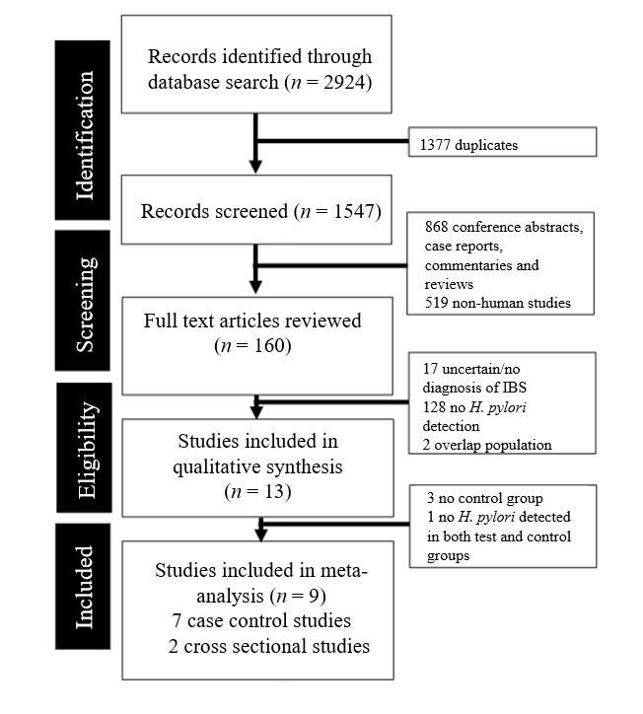
Figure 1 Meta-analysis of observational studies flowchart showing the studies identified during the literature search and abstraction process. H. pylori: Helicobacter pylori; IBS: Irritable bowel syndrome.

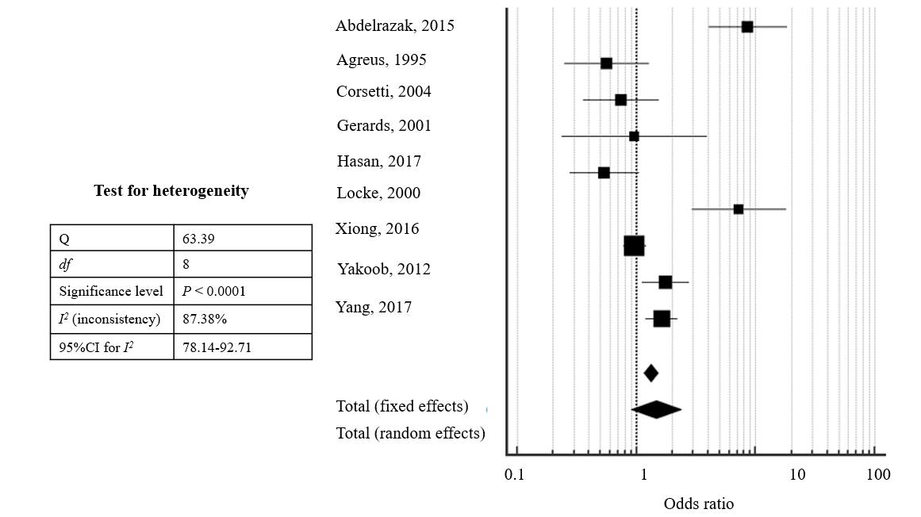
Figure 2 Forest plot showing the odds ratios and 95% confidence intervals of studies on the likelihood of Helicobacter pylori infection in patients with irritable bowel syndrome.

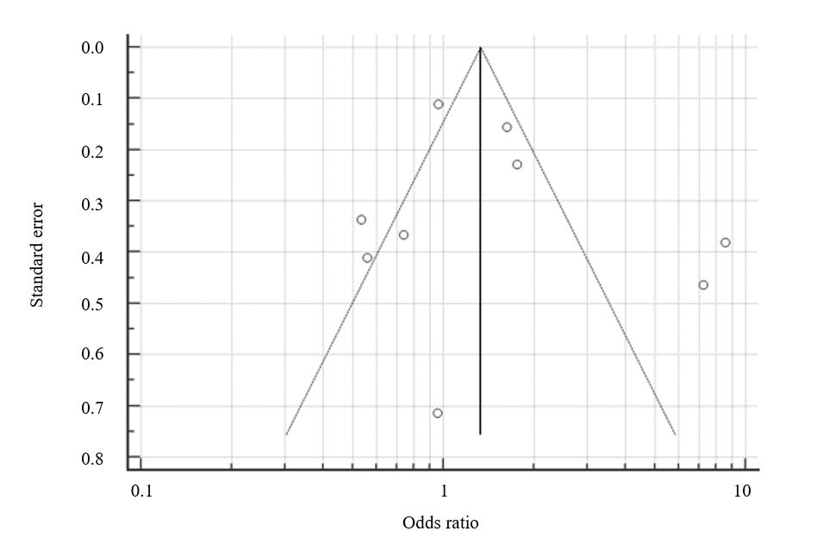
Figure 3 Funnel plot (with pseudo 95% confidence intervals) to assess publication bias. Egger test for publication bias = 1.28, 95% confidence interval: 0.80-3.36, P = 0.189.

