Name of journal: World Journal of Clinical Cases
ESPS Manuscript NO: 15330
Columns: Editorial

Crohn’s disease with gastroduodenal involvement: Diagnostic approach

Ingle SB et al. Gastroduodenal Crohn’s disease

Sachin B Ingle, Baban D Adgaonkar, Nawab P Jamadar, Saleha Siddiqui, Chitra R Hinge

Sachin B Ingle, Saleha Siddiqui, Department of Pathology, MIMSR Medical College, Latur, Maharashtra 4132512, India

Baban D Adgaonkar, Chitra R Hinge, Department of Physiology, MIMSR Medical College, Latur, Maharashtra 4132512, India

Nawab P Jamadar, Department of Anesthesia, MIMSR Medical College, Latur, Maharashtra 4132512, India

Author contributions: Ingle SB, Adgaonkar BD, Siddiqui S and Hinge CR prepared the manuscript; Ingle SB and Jamadar NP critically revised the intellectual content and gave final approval of manuscript.

Conflict-of-interest: None is to be declared.

Open-Access: This article is an open-access article which was selected by an in-house editor and fully peer-reviewed by external reviewers. It is distributed in accordance with the Creative Commons Attribution Non Commercial (CC BY-NC 4.0) license, which permits others to distribute, remix, adapt, build upon this work non-commercially, and license their derivative works on different terms, provided the original work is properly cited and the use is non-commercial. See: http://creativecommons.org/licenses/by-nc/4.0/

Correspondence to: Sachin B Ingle, Professor, Department of Pathology, MIMSR Medical College, Ambajogai Road, Vishwanathpuram, Latur, Maharashtra 413531, India. dr.sachiningle@gmail.com

Telephone: +91-2382-227424
Fax: +91-2382-228939

Received: November 21, 2014
Peer-review started: November 22, 2014
First decision: December 12, 2014
Revised: April 14, 2015
Accepted: April 27, 2015
Article in press:
Published online:

Abstract
Crohn’s disease (CD) is a chronic idiopathic inflammatory disease of gastrointestinal tract characterized by segmental and transmural involvement of gastrointestinal tract. Ileocolonic and colonic/anorectal is a most common and account for 40% of cases and involvement of small intestine is about 30%. Isolated involvement of stomach is an extremely unusual presentation of the disease accounting for less than 0.07% of all gastrointestinal CD. To date there are only a few documented case reports of adults with isolated gastric CD and no reports in the pediatric population. The diagnosis is difficult to establish in such cases with atypical presentation. In the absence of any other source of disease and in the presence of nonspecific upper gastrointestinal endoscopy and histological findings, serological testing can play a vital role in the diagnosis of atypical CD. Recent studies have suggested that perinuclear anti-neutrophil cytoplasmic antibody and anti-Saccharomycescervisia antibody may be used as additional diagnostic tools. The effectiveness of infliximab in isolated gastric CD is limited to only a few case reports of adult patients and the long-term outcome is unknown.

Key words: Gastrointestinal tract; Crohn’s disease; Isolated gastric involvement; Perinuclear anti-neutrophil cytoplasmic antibody; Anti-Saccharomycescervisia antibody

© The Author(s) 2015. Published by Baishideng Publishing Group Inc. All rights reserved.

Core tip: The stomach is rarely the sole or predominant site of Crohn’s disease (CD) accounting for less than 0.07% of all gastrointestinal CD. Serological testing and meticulous histopathological examination by excluding other causes of granulomatous gastritis can play a vital role to arrive at the correct diagnosis.

Ingle SB, Adgaonkar BD, Jamadar NP, Siddiqui SS, Hinge CR. Crohn’s disease with gastroduodenal involvement: Diagnostic approach. World J Clin Cases 2015; In press

INTRODUCTION
Crohn’s disease (CD) can affect any region from mouth to the anus. Isolated Gastroduodenal involvement is an extremely unusual event. The CD is diagnosed usually on the basis of clinical, laboratory, upper gastrointestinal (GI) scopy and histopathology. The anti-Saccharomycescervisia antibody (ASCA) is relatively good specific marker with minimal sensitivity. However, it is difficult to diagnose it in patients with isolated involvement of stomach and duodenum. In such circumstances other granulomatous conditions must be excluded with careful evaluation of the patient to hit the accurate pathological cause^{[1,2]}.
The famous criteria to diagnose this rare condition are: (1) Evidence of noncaseating granulomas on histopathology; and (2) Confirmation of changes of Crohn’s disease on endoscopy or radiography^{[3-10]}.

EPIDEMIOLOGY
Incidence
It occurs in 0.5% to 4% patients of CD^{[3-6]}. Isolated stomach and duodenum involvement accounts for less than 0.07% of all cases of CD^{[1]}.

Pattern of involvement
Most patients show involvement of terminal ileum and distal segment of large intestine^{[4,5,7]}. Contiguous involvement of stomach and duodenal involvement is most common (60%)^{[6,10-12]}.

PATHOPHYSIOLOGY
For pathogenesis of isolated gastric CD multiple hypothesis were postulated: (1) The hygiene hypothesis relatively less trained and weak immunological system leading to ineffective immune response to newer antigens; (2) The environmental factors i.e., geography, smoking, drugs, diet are also main contributing factors^{[13,14]}; (3) Immune mechanism - It is being postulated that the immune reactivity in this disease is due to “loss of immune tolerance” to self antigens of intestinal flora, resulting into an inappropriate granulomatous immune response of Chron’s disease^{[15,16]}; and (4) Role of chemical mediators - interferon-γ, interleukin (IL)-12, IL18 and increased expression of T-bet^{[17-19]}. T-cells are not undergoing apoptosis ^{[20-25]}.

CLINICAL PRESENTATIONS
Age
The disease mainly seen in the age group 30-40 years^{[6]}.

Sex predilection
Male to female ratio is 1.2:1^{[6,12]}.

Symptoms and signs
Majority of the patients are usually symptomless^{[9]}. Most of the patients are presenting with pain in epigastric region, relieved by antacids and food intake^{[4,9,11]}. In cases with stricture formation persistent pain, nausea and vomiting are common^{[4]}. Many times,it may simulates acid peptic disease clinically^{[4]}. Acute blood loss may rarely occur ^{[4,9,11,26,27]}.

Uncommon presentations
Uncommon presentations of CD may manifest as a single symptom or sign, such as impairment of linear growth, delayed puberty, perianal disease, mouth ulcers, clubbing, chronic iron deficiency anemia or extra-intestinal manifestations preceding the gastrointestinal symptoms, mainly arthritis or arthralgia and rarely osteoporosis^{[2]}. In such cases, the diagnosis is challenging and can remain elusive for some time.

DIAGNOSTIC EVALUATION
Radiological signs
Aphthous ulcer is the early feature on radiography^{[28]}. The characteristic features are presence of nodularity in the mucosa giving classic appearance of “cobblestone,”^{[4]}. Radiography examination using double-contrast medium is useful in cases with stenoses or strictures which are mainly seen in advanced disease^{[6,12,27,29,30]}. A barium enema should be done in suspected cases of gastro colic fistula^{[4]}.

Endoscopy
Endoscopy with biopsy is an effective diagnostic modality^{[6,9,27,30]}. Endoscopic findings include patchy erythema, gastric outlet narrowing (Figure 1) mucosa is friable, thickening of mucosa and ulcerations linear as well as aphthous^{[4,7,9,12]}. The ulcers of CD are typically linear or serpiginous in contrast to the peptic ulcers^{[27]}. In cases with diffuse stomach involvement a linitis plastica appearance,is seen^{[31,32]}. Sophisticated endoscopic features such as, bamboo-joint-like appearance and notched sign can be seen^{[33]}.

Biopsy findings
The biopsy findings are often nonspecific. Exclusion of other causes of granulomatous lesions is important. Granulomas without caeseation are noted in 5% to 83% of cases (Figure 2)^{[9,12]}. The differential diagnosis of granulomatous gastritis are H. pylori infection, gastric sarcoidosis, tuberculosis, syphilis, etc^{[7,9,32]}. So presence of granuloma is not a definitive criterion to arrive at the diagnosis. H. pylori negative chronic gastritis is common feature.
Additional histological features are mucosal edema, crypt abscesses, lymphoid aggregates and fibrosis^{[32-34]}.

Serological markers
Currently, it has been stated that perinuclear anti-neutrophil cytoplasmic antibody (pANCA) and ASCA can be used as supportive diagnostic tools. Indeed, ASCA is detected in 55%-60% of children and adults with CD and only 5%-10% of controls with other gastrointestinal disorders. This finding pANCA highlights the relatively good specificity but poor sensitivity of ASCA as a marker for CD. pANCA on the other hand is more specific to ulcerative colitis.

Genetic studies
In addition, some NOD2/ CARD15 gene polymorphisms were found to be associated with Chron’s disease with gastroduodenal involvement. It is possible that these genes might also help to support the diagnosis in the atypical presentation of CD in the future^{[2]}.

DIFFERENTIAL DIAGNOSIS
The differential diagnosis includes corrosive gastritis due to ingestion of lye, gastric scirrhous carcinoma, Ménétrier's disease. Pseudolymphoma, amyloidosis can also mimic CD^{[29]}. Although Ménétrier's disease can involve the entire stomach and produce ulcérations, it does not cause transmural disease^{[29]}. Malignant and infiltrative processes are to be ruled out by the histological findings.

TREATMENT
Medical treatment
Proton pump inhibitors in combination with steroids are the first line of treatment in active CD. Some of the studies proved steroid-induced remission in active disease^{[10,11,35-39]}. But, 6-Mercaptopurine and azathioprine are proved to be helpful to maintain steroid induced remission.

Balloon dialation
Strictures are treated successfully with balloon dialation^{[4,5,40-43].}

Surgical intervention
Some of the patients requires surgical intervention, where patients are not responding to medical treatment^{[44]}. Other situations are massive and persistent upper gastrointestinal hemorrhage, gastric outlet obstruction, and fistula or abscess formation^{[4,5,7,10,12,45]}. The important indication is duodenal obstruction^{[6]}. The surgical modalities of treatment include bypass surgery with gastrojejunostomy^{[6,7,9]}. Gastrojejunostomy with highly selective vagotomy is an ideal line of management^{[44]}. Delayed gastric emptying is a postoperative complication seen in 24% of cases, but this may be seen in stricturoplasty also^{[6,46,47]}. Additional post operative complications are anastomotic leak, enterocutaneous fistula, intraabdominal abscess, and stomal ulceration^{[48]} .

CONCLUSION
To conclude, Crohn’s disease with isolated gastric involvement is an extremely unusual event in clinical practice. Endoscopic biopsy along with battery of laboratory tests is an effective tool to hit the correct diagnosis by exclusion of various causes of granulomatous gastritis. This prevents untoward mortality and /morbidity related to disease and treatment.

REFERENCES
1 Ingle SB, Pujari GP, Patle YG, Nagoba BS. An unusual case of Crohn's disease with isolated gastric involvement. J Crohns Colitis 2011; 5: 69-70 [PMID: 21272809 DOI: 10.1016/j.crohns.2010.10.001]
2 Ingle SB, Hinge CR, Dakhure S, Bhosale SS. Isolated gastric Crohn's disease. World J Clin Cases 2013; 1: 71-73 [PMID: 24303469 DOI: 10.12998/wjcc.v1.i2.71]
3 Isaacs KL. Upper gastrointestinal tract endoscopy in inflammatory bowel disease. Gastrointest Endosc Clin N Am 2002; 12: 451-462, vii [PMID: 12486938 DOI: 10.1016/S1052-5157(02)00006-5]
4 Burakoff R. Gastroduodenal Crohn’s disease. In: Bayless TM, Hanauer SB, editors. Advanced therapy of inflammatory bowel disease. Hamilton, Ontario: BC Decker, 2001: 421–423
5 Banerjee S, Peppercorn MA. Inflammatory bowel disease. Medical therapy of specific clinical presentations. Gastroenterol Clin North Am 2002; 31: 185-202, x [PMID: 12122731 DOI: 10.1016/S0889-8553(01)00012-7]
6 Reynolds HL, Stellato TA. Crohn's disease of the foregut. Surg Clin North Am 2001; 81: 117-135, viii [PMID: 11218159 DOI: 10.1016/S0039-6109(05)70276-0]
7 van Hogezand RA, Witte AM, Veenendaal RA, Wagtmans MJ, Lamers CB. Proximal Crohn's disease: review of the clinicopathologic features and therapy. Inflamm Bowel Dis 2001; 7: 328-337 [PMID: 11720325 DOI: 10.1097/00054725-200111000-00010]
8 Sands BE. Crohn’s disease. In: Feldman M, Friedman LS, Sleisenger MH, editors. Sleisenger and Fordtran’s gastrointestinal and liver disease, 7th ed. Philadelphia: Saunders, 2002: 2005–2038
9 Loftus EV. Upper gastrointestinal tract Crohn’s disease. Clin Perspect Gastroenterol 2002; 5: 188–191
10 Nugent FW, Richmond M, Park SK. Crohn's disease of the duodenum. Gut 1977; 18: 115-120 [PMID: 856671 DOI: 10.1136/gut.18.2.115]
11 Nugent FW, Roy MA. Duodenal Crohn's disease: an analysis of 89 cases. Am J Gastroenterol 1989; 84: 249-254 [PMID: 2919581]
12 Wagtmans MJ, Verspaget HW, Lamers CB, van Hogezand RA. Clinical aspects of Crohn's disease of the upper gastrointestinal tract: a comparison with distal Crohn's disease. Am J Gastroenterol 1997; 92: 1467-1471 [PMID: 9317064]
13 Bach JF. The effect of infections on susceptibility to autoimmune and allergic diseases. N Engl J Med 2002; 347: 911-920 [PMID: 12239261 DOI: 10.1056/NEJMra020100]
14 Danese S, Sans M, Fiocchi C. Inflammatory bowel disease: the role of environmental factors. Autoimmun Rev 2004; 3: 394-400 [PMID: 15288007 DOI: 10.1016/j.autrev.2004.03.002]
15 Lodes MJ, Cong Y, Elson CO, Mohamath R, Landers CJ, Targan SR, Fort M, Hershberg RM. Bacterial flagellin is a dominant antigen in Crohn disease. J Clin Invest 2004; 113: 1296-1306 [PMID: 15124021 DOI: 10.1172/JCI200420295]
16 Targan SR, Landers CJ, Yang H, Lodes MJ, Cong Y, Papadakis KA, Vasiliauskas E, Elson CO, Hershberg RM. Antibodies to CBir1 flagellin define a unique response that is associated independently with complicated Crohn's disease. Gastroenterology 2005; 128: 2020-2028 [PMID: 15940634 DOI: 10.1053/j.gastro.2005.03.046]
17 Neurath MF, Weigmann B, Finotto S, Glickman J, Nieuwenhuis E, Iijima H, Mizoguchi A, Mizoguchi E, Mudter J, Galle PR, Bhan A, Autschbach F, Sullivan BM, Szabo SJ, Glimcher LH, Blumberg RS. The transcription factor T-bet regulates mucosal T cell activation in experimental colitis and Crohn's disease. J Exp Med 2002; 195: 1129-1143 [PMID: 11994418 DOI: 10.1084/jem.20011956]
18 Monteleone G, Biancone L, Marasco R, Morrone G, Marasco O, Luzza F, Pallone F. Interleukin 12 is expressed and actively released by Crohn's disease intestinal lamina propria mononuclear cells. Gastroenterology 1997; 112: 1169-1178 [PMID: 9098000 DOI: 10.1016/S0016-5085(97)70128-8]
19 Pizarro TT, Michie MH, Bentz M, Woraratanadharm J, Smith MF, Foley E, Moskaluk CA, Bickston SJ, Cominelli F. IL-18, a novel immunoregulatory cytokine, is up-regulated in Crohn's disease: expression and localization in intestinal mucosal cells. J Immunol 1999; 162: 6829-6835 [PMID: 10352304]
20 Ina K, Itoh J, Fukushima K, Kusugami K, Yamaguchi T, Kyokane K, Imada A, Binion DG, Musso A, West GA, Dobrea GM, McCormick TS, Lapetina EG, Levine AD, Ottaway CA, Fiocchi C. Resistance of Crohn's disease T cells to multiple apoptotic signals is associated with a Bcl-2/Bax mucosal imbalance. J Immunol 1999; 163: 1081-1090 [PMID: 10395708]
21 Sturm A, Leite AZ, Danese S, Krivacic KA, West GA, Mohr S, Jacobberger JW, Fiocchi C. Divergent cell cycle kinetics underlie the distinct functional capacity of mucosal T cells in Crohn's disease and ulcerative colitis. Gut 2004; 53: 1624-1631 [PMID: 15479683 DOI: 10.1136/gut.2003.033613]
22 Sakaguchi S. Naturally arising Foxp3-expressing CD25+CD4+ regulatory T cells in immunological tolerance to self and non-self. Nat Immunol 2005; 6: 345-352 [PMID: 15785760 DOI: 10.1038/ni1178]
23 Maul J, Loddenkemper C, Mundt P, Berg E, Giese T, Stallmach A, Zeitz M, Duchmann R. Peripheral and intestinal regulatory CD4+ CD25(high) T cells in inflammatory bowel disease. Gastroenterology 2005; 128: 1868-1878 [PMID: 15940622 DOI: 10.1053/j.gastro.2005.03.043]
24 Hart AL, Al-Hassi HO, Rigby RJ, Bell SJ, Emmanuel AV, Knight SC, Kamm MA, Stagg AJ. Characteristics of intestinal dendritic cells in inflammatory bowel diseases. Gastroenterology 2005; 129: 50-65 [PMID: 16012934 DOI: 10.1053/j.gastro.2005.05.013]
25 Wehkamp J, Harder J, Weichenthal M, Schwab M, Schäffeler E, Schlee M, Herrlinger KR, Stallmach A, Noack F, Fritz P, Schröder JM, Bevins CL, Fellermann K, Stange EF. NOD2 (CARD15) mutations in Crohn's disease are associated with diminished mucosal alpha-defensin expression. Gut 2004; 53: 1658-1664 [PMID: 15479689 DOI: 10.1136/gut.2003.032805]
26 Rogler G. Update in inflammatory bowel disease pathogenesis. Curr Opin Gastroenterol 2004; 20: 311-317 [PMID: 15703658 DOI: 10.1097/00001574-200407000-00003]
27 Rutgeerts P, Onette E, Vantrappen G, Geboes K, Broeckaert L, Talloen L. Crohn's disease of the stomach and duodenum: A clinical study with emphasis on the value of endoscopy and endoscopic biopsies. Endoscopy 1980; 12: 288-294 [PMID: 7428736 DOI: 10.1055/s-2007-1021762]
28 Levine MS. Crohn's disease of the upper gastrointestinal tract. Radiol Clin North Am 1987; 25: 79-91 [PMID: 3823395]
29 Cary ER, Tremaine WJ, Banks PM, Nagorney DM. Isolated Crohn's disease of the stomach. Mayo Clin Proc 1989; 64: 776-779 [PMID: 2770360 DOI: 10.1016/S0025-6196(12)61750-9]
30 Danzi JT, Farmer RG, Sullivan BH, Rankin GB. Endoscopic features of gastroduodenal Crohn's disease. Gastroenterology 1976; 70: 9-13 [PMID: 1245289]
31 Alcántara M, Rodriguez R, Potenciano JL, Carrobles JL, Muñoz C, Gomez R. Endoscopic and bioptic findings in the upper gastrointestinal tract in patients with Crohn's disease. Endoscopy 1993; 25: 282-286 [PMID: 8330547 DOI: 10.1055/s-2007-1010315]
32 Fenoglio-Preiser CM, Noffsinger AE, Stemmermann GN, Lantz PE, Listrom MB, Rilke FO. The non neoplastic stomach. In: Gastrointestinal Pathology. 2nd ed. Philadelphia: Lippincott-Raven, 1999: 153–236
33 Hashiguchi K, Takeshima F, Akazawa Y, Matsushima K, Minami H, Yamaguchi N, Shiozawa K, Ohnita K, Ichikawa T, Isomoto H, Nakao K. Bamboo joint-like appearance of the stomach: a stable endoscopic landmark for Crohn's disease regardless of anti-tumor necrosis factor alpha treatment. Med Sci Monit 2014; 20: 1918-1924 [PMID: 25308423 DOI: 10.12659/MSM.891060]
34 Halme L, Kärkkäinen P, Rautelin H, Kosunen TU, Sipponen P. High frequency of helicobacter negative gastritis in patients with Crohn's disease. Gut 1996; 38: 379-383 [PMID: 8675090 DOI: 10.1136/gut.38.3.379]
35 Oberhuber G, Püspök A, Oesterreicher C, Novacek G, Zauner C, Burghuber M, Vogelsang H, Pötzi R, Stolte M, Wrba F. Focally enhanced gastritis: a frequent type of gastritis in patients with Crohn's disease. Gastroenterology 1997; 112: 698-706 [PMID: 9041230 DOI: 10.1053/gast.1997.v112.pm9041230]
36 Parente F, Cucino C, Bollani S, Imbesi V, Maconi G, Bonetto S, Vago L, Bianchi Porro G. Focal gastric inflammatory infiltrates in inflammatory bowel diseases: prevalence, immunohistochemical characteristics, and diagnostic role. Am J Gastroenterol 2000; 95: 705-711 [PMID: 10710061 DOI: 10.1111/j.1572-0241.2000.01851.x]
37 Miehsler W, Püspök A, Oberhuber T, Vogelsang H. Impact of different therapeutic regimens on the outcome of patients with Crohn's disease of the upper gastrointestinal tract. Inflamm Bowel Dis 2001; 7: 99-105 [PMID: 11383598 DOI: 10.1097/00054725-200105000-00004]
38 Valori RM, Cockel R. Omeprazole for duodenal ulceration in Crohn's disease. BMJ 1990; 300: 438-439 [PMID: 2107896 DOI: 10.1136/bmj.300.6722.438]
39 Griffiths AM, Alemayehu E, Sherman P. Clinical features of gastroduodenal Crohn's disease in adolescents. J Pediatr Gastroenterol Nutr 1989; 8: 166-171 [PMID: 2709248 DOI: 10.1097/00005176-198902000-00008]
40 Korelitz BI, Adler DJ, Mendelsohn RA, Sacknoff AL. Long-term experience with 6-mercaptopurine in the treatment of Crohn's disease. Am J Gastroenterol 1993; 88: 1198-1205 [PMID: 8338087]
41 Matsui T, Hatakeyama S, Ikeda K, Yao T, Takenaka K, Sakurai T. Long-term outcome of endoscopic balloon dilation in obstructive gastroduodenal Crohn's disease. Endoscopy 1997; 29: 640-645 [PMID: 9360875 DOI: 10.1055/s-2007-1004271]
42 Dancygier H, Frick B. Crohn's disease of the upper gastrointestinal tract. Endoscopy 1992; 24: 555-558 [PMID: 1396364 DOI: 10.1055/s-2007-1010544]
43 Murthy UK. Repeated hydrostatic balloon dilation in obstructive gastroduodenal Crohn's disease. Gastrointest Endosc 1991; 37: 484-485 [PMID: 1916177 DOI: 10.1016/S0016-5107(91)70789-X]
44 Marcello PW, Schoetz DJ. Gastroduodenal Crohn’s disease: surgical management. In: Bayless TM, Hanauer SB, editors. Advanced therapy of inflammatory bowel disease. Hamilton, Ontario: BC Decker, 2001: 461-463
45 Murray JJ, Schoetz DJ, Nugent FW, Coller JA, Veidenheimer MC. Surgical management of Crohn's disease involving the duodenum. Am J Surg 1984; 147: 58-65 [PMID: 6691553 DOI: 10.1016/0002-9610(84)90035-7]
46 Worsey MJ, Hull T, Ryland L, Fazio V. Strictureplasty is an effective option in the operative management of duodenal Crohn's disease. Dis Colon Rectum 1999; 42: 596-600 [PMID: 10344680 DOI: 10.1007/BF02234132]
47 Yamamoto T, Bain IM, Connolly AB, Allan RN, Keighley MR. Outcome of strictureplasty for duodenal Crohn's disease. Br J Surg 1999; 86: 259-262 [PMID: 10100799 DOI: 10.1046/j.1365-2168.1999.01022.x]
48 Yamamoto T, Allan RN, Keighley MR. An audit of gastroduodenal Crohn disease: clinicopathologic features and management. Scand J Gastroenterol 1999; 34: 1019-1024 [PMID: 10563673 DOI: 10.1080/003655299750025138]

P- Reviewer: Chen JQ, Caviglia R, Hokama A S- Editor: Gong XM
L- Editor: E- Editor:

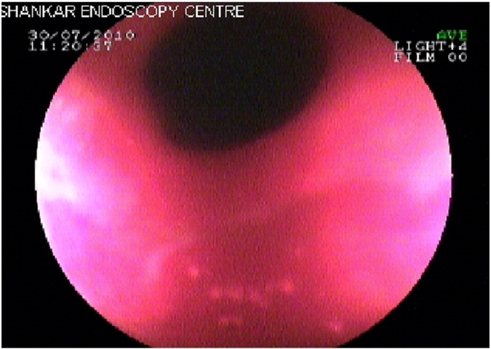
Figure 1 Endoscopic findings include patchy erythematic, gastric outlet narrowing.

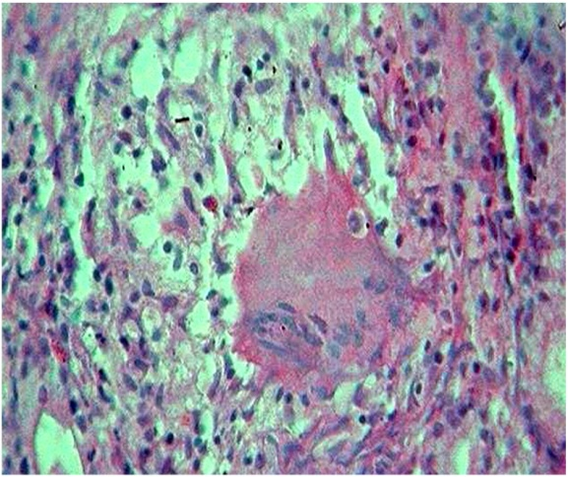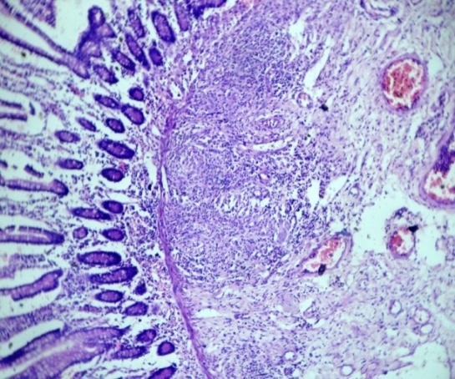
A B
Figure 2 Biopsy showing non-caseating granulomas and oedema in the submucosa (hematoxylin and eosin stain; 10× × 10×). A: Non-caseating granulomas; B: Oedema alongwith granulation tissue.

