Name of Journal: World Journal of Clinical Cases
Manuscript NO: 71880
Manuscript Type: CASE REPORT

Giant nontraumatic myositis ossificans in a child: A case report

Xia AN et al. A case report of nontraumatic myositis ossifican

An-Ning Xia, Jiang-Sheng Wang

An-Ning Xia, Jiang-Sheng Wang, Department of Orthopedic, Shenzhen Children’s Hospital, Shenzhen 518000, Guangdong Province, China

Author contributions: Wang JS was responsible for designed and reviewed the papers; Xia AN was mainly responsible for collected data and manuscript drafting.

Corresponding author: Jiang-Sheng Wang, MM, Deputy Director, Surgeon, Department of Orthopaedics, Shenzhen Children’s Hospital, No. 7019 Yitian Road, Futian District, Shenzhen 518000, Guangdong Province, China. zhzlgkzl@163.com

Received: September 27, 2021
Revised: November 2, 2021
Accepted: February 15, 2022
Published online:

Abstract
BACKGROUND
Nontraumatic myositis ossificans is a rare disease whose specific pathogenesis is unclear. Early diagnosis of this disease is very difficult in children because of difficulties in determining medical history and nonspecific early clinical manifestations, which may lead to the failure of timely and effective diagnosis and treatment in some patients. We report the diagnosis and treatment of a child with nontraumatic myositis ossificans and summarize the clinical characteristics and diagnosis and treatment of the disease.

CASE SUMMARY
An 8-year-old girl first came to our hospital for more than a week with pain in the right lower limb. There was no history of trauma or strenuous activities. On physical examination, no mass on the right thigh was found, and the movement of the right lower extremity was limited. Ultrasonography showed synovitis of the hip, and bed rest was recommended. Three days later, the child’s pain persisted and worsened, accompanied by fever and other discomforts. She came to our hospital again and a mass was found on the right thigh with redness and swelling on the surface. The images showed a soft tissue tumor on the right thigh with calcification. Routine blood tests revealed that the inflammation index was significantly increased. In case of infection, the patient was given antibiotics, and the pain was relieved soon after, without fever. However, the right thigh mass persisted and hardened. The patient underwent incision biopsy more than 1 mo later, and the postoperative pathology showed nontraumatic myositis ossificans. After approximately 9 mo of observation, the tumor still persisted, which affected the life of the child, and then resection was performed. Since follow-up, there has been no recurrence.

CONCLUSION
Due to the difficulty in discerning a child's medical history and the diverse early manifestations, it is difficult to diagnose nonossifying muscle disease in children in its early stage. Measures such as timely follow-up and periodic image monitoring are conducive to early diagnosis of the disease. The disease has a certain degree of self-limitation, and it can be observed and treated first. If the tumor persists in the later stage or affects functioning, then surgery is considered.

Key Words: Myositis ossificans; Nontraumatic myositis ossificans; Child; Case report

Xia AN, Wang JS. Giant nontraumatic myositis ossificans in a child: A case report. World J Clin Cases 2022; In press

Core Tip: If the child has no history of trauma, a mass is found, images show the appearance of calcification, and early blood tests indicate that some inflammation indicators are high, then these conditions suggest that nontraumatic myositis ossificans is possible, but it must be differentiated from other diseases. In the early stage of the disease, close follow-up observation and symptomatic treatment are performed. In the later stage, if the disease affects functioning, the tumor can be surgically removed.

INTRODUCTION
Myositis ossificans was first reported by French physician Guy Patin in 1692, and it is a rare benign disease. At present, myositis ossificans are divided into three categories: Traumatic myositis ossificans, progressive myositis ossificans, and nontraumatic/pseudomalignant myositis ossificans, with the least common being nontraumatic ossification myositis^{[1]}. There is a zoning phenomenon in pathology, which will facilitate the diagnosis of the disease^{[2,3]}. Due to the unclear medical history and different early clinical symptoms, some patients have no signs, such as masses. Early diagnosis of nontraumatic myositis ossificans in children is difficult, and some patients may be misdiagnosed. Combined with the diagnosis and treatment processes of a patient admitted to our hospital with giant nontraumatic myositis ossificans of the right thigh (the child had no history of trauma), a large mass appeared in the right thigh and imaging examination indicated continuous calcific changes. However, it was accompanied by some manifestations similar to an infectious process, which was difficult to diagnose. We will share the case characteristics, diagnosis points, differential diagnosis, and treatment options of the disease to facilitate a better understanding for everyone with this type of disease.

CASE PRESENTATION
Chief complaints
An 8-year-old girl presented with pain in her right lower extremity and a mass on her right thigh for 1 mo.

History of present illness
The child came to our hospital on January 31, 2019, due to intermittent pain in the right lower limb for more than one week. There was no history of trauma or strenuous activities. The pain was aggravated during activities and was accompanied by a limp in the right lower limb; however, there was no fever and no numbness in the right lower limb. The physical examination showed that the movement of the right hip joint was limited, and there was no obvious mass in the right lower limb. Ultrasound indicated synovitis of the hip, and bed rest was recommended. However, the pain was not relieved and gradually worsened, accompanied by fever. She came to our hospital again on February 3, 2019. Physical examination revealed that a mass was palpable on the back of the right thigh, and the skin surface was red (Figure 1). Ultrasound, images, and routine blood tests were performed, which revealed soft tissue tumors of the right thigh. Infection and calcification of the right thigh were considered, and antibiotic treatment was given. Her temperature dropped to normal, and the pain was relieved, but the mass still persisted, and became hard. She visited our hospital again on March 3, 2019, and was hospitalized.

History of past illness
She was physically healthy and had no history of special disease.

Personal and family history
No family history of inherited diseases and malignant tumor diseases was recorded.

Physical examination
On physical examination, the patient had a giant mass on the back of the right thigh; it measured 20 cm × 10 cm × 8 cm. The surface skin of the mass was slightly red, and the temperature was slightly increased. The quality of the mass was hard; the mass had no tenderness with no sense of fluctuation; the boundary was clear, and the active and passive activities of the right hip and right knee joints were limited (Figure 1).

Laboratory examinations
Some inflammatory indicators were abnormally high, and blood calcium was slightly low at the time of admission. Blood analysis revealed white blood cells of 11.3 × 10^9/L, platelets of 858 × 10^9/L, C-reactive protein of 74.1 mg/L, erythrocyte sedimentation rate of 98 mm/h, and blood calcium of 2.04 nmol/L.

Imaging examinations
Radiographs and computed tomography (CT) scans showed a large soft tissue mass on the upper right posterior thigh with progressive calcification inside the mass (Figure 2 and Figure 3).

Further diagnostic work-up
Performing the relevant examination and limiting the movement of the limb, the CT examination on March 22, 2019, showed that the periosteal reaction had increased compared with the previous period, and the possibility of malignant transformation was not ruled out. An incision biopsy was performed under anesthesia on March 25, 2019. The postoperative pathology found no evidence of malignant a tumor, and nontraumatic myositis ossificans was suggested.

FINAL DIAGNOSIS
Nontraumatic myositis ossificans of the right thigh.

TREATMENT
After 9 mo of conservative treatment, the child was treated with nontraumatic myositis ossificans resection of the right thigh on October 14, 2019, because the mass still persisted and affected the child's sitting posture. The right hip joint was placed in flexion and abduction positions, a longitudinal incision was made along the skin medial to the surface of the mass, and the surrounding muscle tissues were separated. Exploration showed that the mass was located between the adductor magnus and the vastus medialis, partly adhered to the surrounding muscle tissues, and reached the lesser trochanter (Figure 4A). The mass was completely excised, and the wound was completely hemostatic. The excised mass was 14 cm × 8.7 cm × 8.2 cm in size and had a complete capsule (Figure 4B). Postoperative pathology showed a zonation phenomenon (Figure 4C). She recovered and was discharged one week postoperatively.

OUTCOME AND FOLLOW-UP
Following-up after more than 1 year, the tumor did not recur, and the patient's lower limbs moved freely. The child was satisfied.

DISCUSSION
Nontraumatic myositis ossificans, which is rare, has no large case report article^{[4,5]}, and such a huge case of nontraumatic ossifying myositis in children is very rare. Nontraumatic myositis ossificans is a benign, self-limiting condition in which calcified masses occur within skeletal muscle, and the most common sites are located in the muscle groups of the extremities^{[6]}. At present, the pathogenesis of nontraumatic myositis ossificans is incompletely understood. The release of inflammatory factors leads to the formation of nontraumatic myositis ossificans due to some conditions that lead to tissue ischemia^{[7,8]}. Kan et al^{[9]} demonstrated that, when skeletal muscle injury induces a local inflammatory cascade, resulting in the release of cytokines (bone morphogenetic protein-2 and transforming growth factor), it causes local stem cell dysfunction and thus heterotopic bone formation. When vascular endothelial cells of skeletal muscle are exposed to an inflammation-rich environment, these endothelial-derived mesenchymal stem cells may differentiate into chondrocytes or osteoblasts, which in turn form chondro-osteoblasts in the extraosseous tissue^{[10]}. However, the specific mechanisms of these local inflammatory cascades are still different. At present, the clinical staging of nontraumatic myositis ossificans is defined similarly to the stages of traumatic myositis ossificans, which are early, intermediate, and mature.
The patient was an 8-year-old female child who was previously healthy. There was no history of trauma, and the early presentation was primarily pain and restriction of movement in the right lower limb. Early blood tests indicated that some inflammation indices were too high, and the images displayed that the lesions showed signs of gradual calcification. Because nontraumatic myositis ossificans has different presentations in the early stage, such as pain, fever, and limited mobility, and the disease progresses rapidly, diagnosis is difficult^{[11]}. The mass can appear as the disease progresses. Blood tests indicated that some inflammation indicators were high. Images indicated that there was a tumor in the soft tissue, some of which appeared to be calcified. At this time, the possibility of nontraumatic myositis ossificans should be considered, but other diseases should also be considered and differentiated.
The child had fever and redness on the skin surface of the mass in the early stage. Blood tests showed that the inflammation index was increased. The infection should be differentially diagnosed. The child had no rash and no recent history of upper respiratory tract infection, and the fever symptoms were short-lived and low-grade. The mass was not fluctuant on palpation. Images showed irregularities in the dense calcification of the tumor. These are different from soft tissue infections. The fever symptoms of soft tissue infections in children are more obvious and easier to repeat, but the patient is not. If the infected site was relatively superficial, it easily felt fluctuation and obvious tenderness, but the mass was hard to palpate. Images and ultrasound showed that the lesions were edema and necrotic liquefaction, and calcification was relatively rare and occurred later, but the patient had calcification early^{[12-14]}.
There was a giant calcification-like tumor in the thigh muscle tissue, and it needed to be distinguished from calcified myonecrosis disease. Calcified myonecrosis disease is more common in trauma, such as fractures complicated by ischemic muscle necrosis, calcification, and other types of masses that gradually appear. The common site is the lower leg, and compartment syndrome is a potential cause^{[15]}. Radiographs show prismatic masses with calcifications of plaques distributed longitudinally along the compartment. Calcifications are manifested around the muscles. The central area is mostly liquefied tissue, which can cause bone destruction and periosteal reaction. When the mass increases gradually and the pressure increases, it can produce layered changes in cortical bone^{[16,17]}. This is similar to the patient's magnetic resonance imaging results, but the patient had never received fracture surgery in the past, there was no history of trauma, and the patient was only 8 years old.
A tumor was found in the upper right thigh of this child, and the disease progressed rapidly. This phenomenon needed to be differentiated from malignant tumors. For example, extraosseous osteosarcoma is more aggressive on imaging, and calcifications are usually distributed inside soft tissue masses^{[18]}. There are atypical tumor cells in pathologically. Bone tissue is the most obvious in the center of the tumor, with denser surrounding cells, which is contrary to the pathology of nontraumatic myositis ossificans; nontraumatic myositis ossificans are characterized by zonaled hyperplasia of fibroblasts and osteoblastic osteoblasts, which continue to progress with the course of the disease^{[2,3]}. However, nontraumatic myositis ossificans can also become cancerous or become combined with cancer. When the diagnosis of the disease is difficult, a biopsy can be performed to assist in the diagnosis, but early biopsy is not currently recommended^{[19]}. If other diseases can be excluded well and ultrasound and imaging are in line with the typical showing of nontraumatic myositis ossificans, biopsy may not be rushed, and close observation and follow-up can be performed. The patient received a biopsy to assist in the diagnosis at approximately 9 wk after the onset of disease. To reduce the test error, we adopted an open biopsy. To obtain sufficient pathological specimens, samples were taken from the periphery to the core of the lesion. To prevent the spread of the lesion, we also combined puncture needles and other tools to assist in obtaining specimens.
At present, nontraumatic myositis ossificans is still treated conservatively, mainly by close observation and symptomatic treatment. There are reports suggesting that drugs such as ibuprofen can be used for treatment^{[20,21]}. The child was treated with ibuprofen for anti-inflammatory and analgesic treatment, which had a certain effect. This child was treated with antibiotics because it could not be differentiated from the infectious disease in the early stage. However, reviewing the evolution of the disease, if the disease can be diagnosed early, such as by obtaining blood culture test results, unnecessary antibiotic use can be avoided. For whether to undergo surgical resection, the indications are the same as in previous studies, in which those afflictions that have affected the appearance or function of the child and that cannot resolve spontaneously, or if malignant transformation is suspected, surgical treatment should be considered^{[1]}. The patient underwent surgical resection approximately 9 mo after the onset of the disease. To reduce the possibility of recurrence, hemostasis was completely achieved during the operation and postoperative immobilization (2 wk) was mandated. The child had no recurrence and is now recovering as before.

CONCLUSION
Although the medical history of nontraumatic myositis ossificans is not typical, the early symptoms can present differently, and the images shown in different stages are different, which increases the difficulty of diagnosis, especially in the early stage, through close follow-up and periodic review of imaging examination, if necessary combined with biopsy as early as possible. Treatment is still based on conservative treatment and surgical resection if necessary.

ACKNOWLEDGEMENTS
We would like to thank Dr. Han JM for guidance on the treatment of the child.

REFERENCES
1 Walczak BE, Johnson CN, Howe BM. Myositis Ossificans. J Am Acad Orthop Surg 2015; 23: 612-622 [PMID: 26320160 DOI: 10.5435/JAAOS-D-14-00269]
2 Sumiyoshi K, Tsuneyoshi M, Enjoji M. Myositis ossificans. A clinicopathologic study of 21 cases. Acta Pathol Jpn 1985; 35: 1109-1122 [PMID: 3866484 DOI: 10.1111/j.1440-1827.1985.tb01002.x]
3 Ogilvie-Harris DJ, Fornasier VL. Pseudomalignant myositis ossificans: heterotopic new-bone formation without a history of trauma. J Bone Joint Surg Am 1980; 62: 1274-1283 [PMID: 6934174 DOI: 10.2106/00004623-198062080-00006]
4 Sferopoulos NK, Kotakidou R, Petropoulos AS. Myositis ossificans in children: a review. Eur J Orthop Surg Traumatol 2017; 27: 491-502 [PMID: 28275867 DOI: 10.1007/s00590-017-1932-x]
5 Say F, Coşkun S, Bülbül M, Alici Ö. Myositis ossificans on the forearm in a 10-year-old girl. J Pediatr Orthop B 2015; 24: 223-225 [PMID: 25647566 DOI: 10.1097/BPB.0000000000000152]
6 Kransdorf MJ, Meis JM, Jelinek JS. Myositis ossificans: MR appearance with radiologic-pathologic correlation. AJR Am J Roentgenol 1991; 157: 1243-1248 [PMID: 1950874 DOI: 10.2214/ajr.157.6.1950874]
7 Kan L, Kessler JA. Evaluation of the cellular origins of heterotopic ossification. Orthopedics 2014; 37: 329-340 [PMID: 24810815 DOI: 10.3928/01477447-20140430-07]
8 Sharifi R, Kamali Hakim L, Hasani Mehraban S, Asadi A. Non-traumatic myositis ossificans of the Right masseter muscle: a case report and review of the literature. Clin Case Rep 2021; 9: e04608 [PMID: 34429994 DOI: 10.1002/ccr3.4608]
9 Kan L, Liu Y, McGuire TL, Berger DM, Awatramani RB, Dymecki SM, Kessler JA. Dysregulation of local stem/progenitor cells as a common cellular mechanism for heterotopic ossification. Stem Cells 2009; 27: 150-156 [PMID: 18832590 DOI: 10.1634/stemcells.2008-0576]
10 Medici D, Olsen BR. The role of endothelial-mesenchymal transition in heterotopic ossification. J Bone Miner Res 2012; 27: 1619-1622 [PMID: 22806925 DOI: 10.1002/jbmr.1691]
11 WEINSTEIN L, FRAERMAN SH, LEWIN P. Difficulties in early diagnosis of myositis ossificans. J Am Med Assoc 1954; 154: 994-996 [PMID: 13129082 DOI: 10.1001/jama.1954.02940460026006f]
12 Bystritsky R, Chambers H. Cellulitis and Soft Tissue Infections. Ann Intern Med 2018; 168: ITC17-ITC32 [PMID: 29404597 DOI: 10.7326/AITC201802060]
13 Turecki MB, Taljanovic MS, Stubbs AY, Graham AR, Holden DA, Hunter TB, Rogers LF. Imaging of musculoskeletal soft tissue infections. Skeletal Radiol 2010; 39: 957-971 [PMID: 19714328 DOI: 10.1007/s00256-009-0780-0]
14 Robben SG. Ultrasonography of musculoskeletal infections in children. Eur Radiol 2004; 14 Suppl 4: L65-L77 [PMID: 14752567 DOI: 10.1007/s00330-003-2029-y]
15 Angelini A, Mavrogenis AF, Pagliarini E, Trovarelli G, Fanelli GN, Cappellesso R, Ruggieri P. Calcific Myonecrosis of the Leg: A Rare Entity. Medicina (Kaunas) 2019; 55 [PMID: 31466356 DOI: 10.3390/medicina55090542]
16 Larson RC, Sierra RJ, Sundaram M, Inwards C, Scully SP. Calcific myonecrosis: a unique presentation in the upper extremity. Skeletal Radiol 2004; 33: 306-309 [PMID: 14991247 DOI: 10.1007/s00256-003-0740-z]
17 O'Dwyer HM, Al-Nakshabandi NA, Al-Muzahmi K, Ryan A, O'Connell JX, Munk PL. Calcific myonecrosis: keys to recognition and management. AJR Am J Roentgenol 2006; 187: W67-W76 [PMID: 16794141 DOI: 10.2214/AJR.05.0245]
18 Tyler P, Saifuddin A. The imaging of myositis ossificans. Semin Musculoskelet Radiol 2010; 14: 201-216 [PMID: 20486028 DOI: 10.1055/s-0030-1253161]
19 Martin DA, Senanayake S. Images in clinical medicine. Myositis ossificans. N Engl J Med 2011; 364: 758 [PMID: 21345105 DOI: 10.1056/NEJMicm1005605]
20 Lacout A, Jarraya M, Marcy PY, Thariat J, Carlier RY. Myositis ossificans imaging: keys to successful diagnosis. Indian J Radiol Imaging 2012; 22: 35-39 [PMID: 22623814 DOI: 10.4103/0971-3026.95402]
21 Nieuwenhuizen CJ, van Veldhoven PLJ, van Oosterom RF. Rare case of a traumatic myositis ossificans in the tibialis anterior muscle. BMJ Case Rep 2020; 13 [PMID: 32816878 DOI: 10.1136/bcr-2019-233210]

Footnotes
Informed consent statement: Informed written consent was obtained from the patient for publication of this report and any accompanying images.

Conflict-of-interest statement: The authors declare that they have no conflict of interest.

CARE Checklist (2016) statement: The authors have read the CARE Checklist (2016), and the manuscript was prepared and revised according to the CARE Checklist (2016).

Open-Access: This article is an open-access article that was selected by an in-house editor and fully peer-reviewed by external reviewers. It is distributed in accordance with the Creative Commons Attribution NonCommercial (CC BY-NC 4.0) license, which permits others to distribute, remix, adapt, build upon this work non-commercially, and license their derivative works on different terms, provided the original work is properly cited and the use is non-commercial. See: http://creativecommons.org/Licenses/by-nc/4.0/

Provenance and peer review: Unsolicited article; Externally peer reviewed.
Peer-review model: Single blind

Peer-review started: September 27, 2021
First decision: October 22, 2021
Article in press:

Specialty type: Oncology
Country/Territory of origin: China
Peer-review report’s scientific quality classification
Grade A (Excellent): 0
Grade B (Very good): B, B
Grade C (Good): C
Grade D (Fair): 0
Grade E (Poor): 0

P-Reviewer: Salama II, Selva-O'Callaghan A, Zacharia B S-Editor: Xing YX L-Editor: A P-Editor: Xing YX

Figure Legends
Figure 1 Appearance photo of right thigh. A large mass at the posterior of the right thigh with redness and swelling.
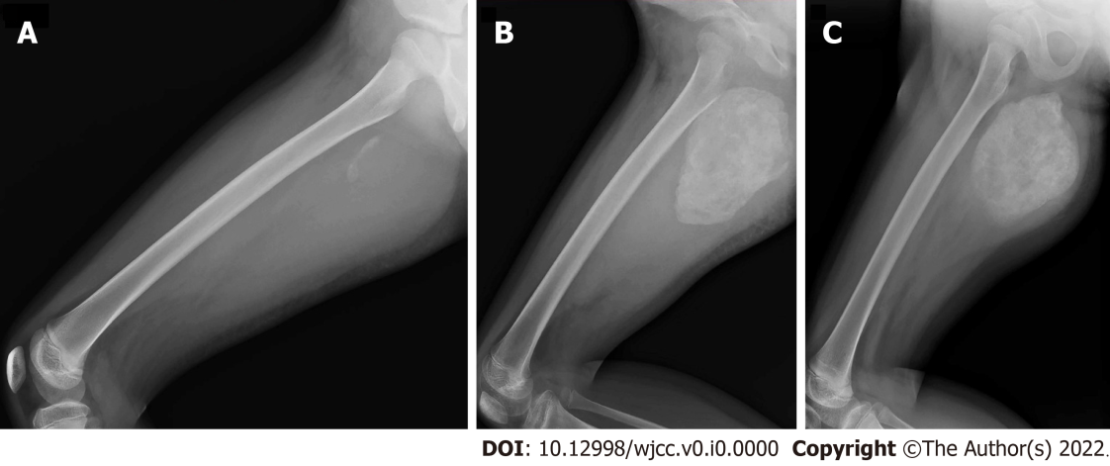
Figure 2 Radiographic images of the right thigh over time. A: Lateral view radiograph at the 2nd week, soft tissue in the posterior of the right upper femur was swollen, and there was faint calcification; B: Lateral view radiograph at the 7th week. A large mass of calcification appeared at the original location; C: Lateral view radiograph at 9th months, the mass of calcification is denser than before.
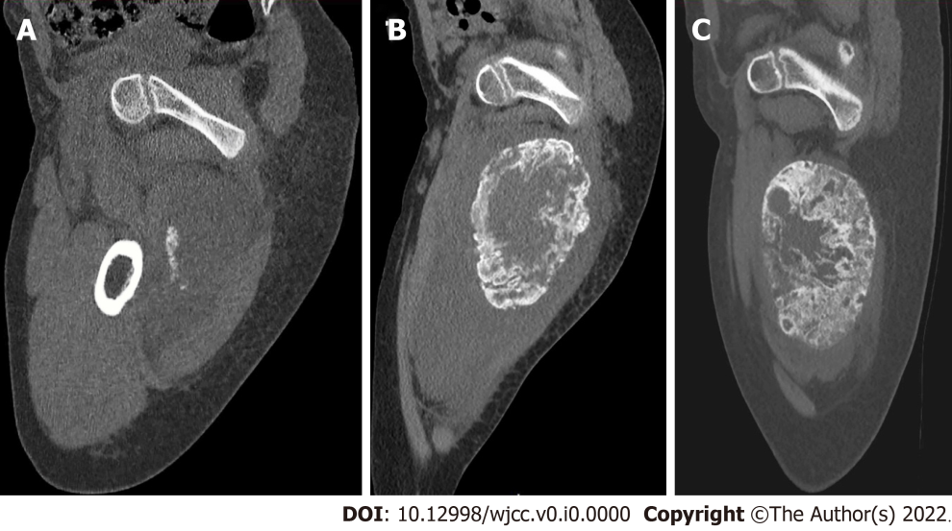
Figure 3 Computed tomography of the right thigh over time. A: Sagittal view of Computed tomography (CT) at 2nd week. Mass can be seen in the muscle tissue of the posterior upper right thigh, which has a slightly low density and irregular flaky calcification; B: Sagittal view of CT at 7th week. The mass is larger than before, and calcification is like an eggshell with peripheral calcified rim and low density in the central zone compared to muscle; C: Sagittal view of CT at the 9th month. This calcification is denser than before. CT: Computed tomography.
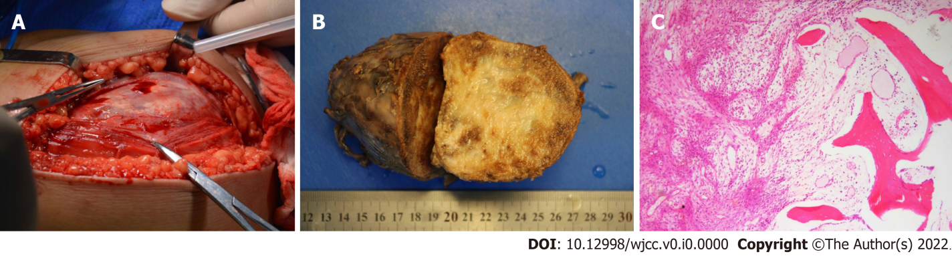
Figure 4 Intraoperative surgical pictures and gross appearance and microscopic pictures of the tumor. A: The mass is located between muscle spaces and has a complete capsule; B: Specimens of gross appearance, gray–red hard mass, size approximately 14.0 cm × 8.7 cm × 8.2 cm. C: (40 ×) The tumor shows zoning, fibroblast/myofibroblast hyperplasia in the center, inflammatory cell infiltration, and multinucleated giant cell formation, and the surrounding bone trabeculae are arranged in a mesh, and the surrounding osteoblasts are attached.

