Name of Journal: World Journal of Clinical Cases
Manuscript NO: 56737
Manuscript Type: CASE REPORT

Low-grade fibromyxoid sarcoma of the liver: A case report

Dugalic V et al. Low-grade fibromyxoid sarcoma of the liver

Vladimir Dugalic, Igor I Ignjatovic, Jelena Djokic Kovac, Nikola Ilic, Jelena Sopta, Slavenko R Ostojic, Dragan Vasin, Marko D Bogdanovic, Igor Dumic, Tamara Milovanovic

Vladimir Dugalic, Igor I Ignjatovic, Slavenko R Ostojic, Marko D Bogdanovic, Department of Hepatobiliary & Pancreatic Surgery, Clinic for Digestive Surgery, Clinical Center of Serbia, Belgrade 11000, Serbia

Jelena Djokic Kovac, Dragan Vasin, Department of Radiology, Clinical Center of Serbia, Belgrade 11000, Serbia

Nikola Ilic, Clinic for Vascular and Endovascular Surgery, Clinical Center of Serbia, Belgrade 11000, Serbia

Jelena Sopta, Institute of Pathology, University of Belgrade, Belgrade 11000, Serbia

Igor Dumic, Mayo Clinic Health System, Mayo Clinic College of Medicine and Science, Rochester, NY 10029, United States

Tamara Milovanovic, Clinic for Gastroenterology and Hepatology, Clinical Center of Serbia, School of Medicine, University of Belgrade, Belgrade 11000, Serbia

Author contributions: Dugalic V and Ilic N performed surgery; Dugalic V and Igrnjatovic II wrote the paper, study conception and design; Bogdanovic MD and Ostojic SR analyzed and collected data; Dumic I performed language revision; Milovanovic T critical review of manuscript; Sopta J performed the histopatologic analysis; Kovac JD and Vasin D analyzed and interpreted the imaging findings; all authors issued final approval for the version to be submitted.

Corresponding author: Tamara Milovanovic, MD, PhD, Professor, Clinic for Gastroenterology and Hepatology, Clinical Center of Serbia, School of Medicine, University of Belgrade, 2, Dr Koste Todorovica Street, Belgrade 11000, Serbia. tamara.alempijevic@med.bg.ac.rs

Received: May 25, 2020
Revised: September 15, 2020
Accepted: November 21, 2020
Published online:

Abstract
BACKGROUND
Low grade fibromyxoid sarcoma (LGFMS) is a rare and benign mesenchymal tumor with indolent course, most commonly found in young or middle-aged men. The majority of the LGFMSs are located in the trunk and deep soft tissue of the lower extremities. They appear as well circumscribed, although not encapsulated, which often leads to incomplete surgical resection. Despite their seemingly benign appearance, these tumors have aggressive behavior with high metastatic and recurrence rates. Accurate histopathologic examination of the specimen and its immunohistochemical analysis are mandatory for a precise diagnosis.

CASE SUMMARY
We report a case of a 38 year-old-man who presented with jaundice and upper abdominal discomfort. Multi-detector computed tomography and magnetic resonance imaging showed a large left liver tumor mass, extending to the hepatoduodenal ligament. Left hepatectomy was performed with resection and reconstruction of hepatic artery and preservation of middle hepatic vein. Histopathologic examination confirmed the tumor being a low-grade fibromyxoid sarcoma. Three and a half years after surgery, the patient died after being diagnosed with spine metastasis.

CONCLUSION
Due to poor response to all modalities of adjuvant treatment, we consider that the focus of treatment should be on surgery as the only option for curing the disease.

Key Words: Fibromyxoid sarcoma; Liver; Resection; Histopathology; case report

Dugalic V, Ignjatovic II, Kovac JD, Ilic N, Sopta J, Ostojic SR, Vasin D, Bogdanovic MD, Dumic I, Milovanovic T. Low-grade fibromyxoid sarcoma of the liver: A case report. World J Clin Cases 2020; In press

Core Tip: Low grade fibromyxoid sarcoma (LGFMS) is very rare mesenchymal tumors with indolent course but aggressive biological behavior. There are no effective diagnostic procedures to achieve an accurate preoperative diagnosis. Symptoms are usually caused by compression on adjacent organs and structures. This report describes the case of a large left liver LGFMS in male patient, extending to the hepatoduodenal ligament, which was detected with abdominal ultrasound and confirmed by multi-detector computed tomography and magnetic resonance imaging. Left hepatectomy was performed and the tumor was completely removed at laparotomy.

INTRODUCTION
Low grade fibromyxoid sarcoma (LGFMS) is a rare, deceptively benign, mesenchymal tumor. It was first described by Evans in 1987^{[1]}. All the reports of this tumor come from Asia and the western countries^{[2]}. LGFMS accounts for less than 1% of all malignancies and typically develop in young or middle-aged men, with most common localization (in 50%) on the trunk and the lower extremities^{[3]}. Other, frequently involved sites include the axilla, chest wall, inguinal region, and buttocks^{[4]}. Intraabdominal LGFMSs are very rare, such as those in the retroperitoneum, small bowel mesentery, large bowel, falciform ligament and pancreas^{[2,5-8]}. Three cases of pelvic LGFMS have been described previously^{[9]}. In spite of their seemingly benign appearance, LGFMSs show aggressive behavior with high rates of tumor recurrence following surgery and high metastatic potential. These tumors are detected with standard imaging modalities such as ultrasound, multi-detector computed tomography (MDCT) and magnetic resonance imaging (MRI). However, laboratory and imaging findings are nonspecific, and definitive diagnosis is obtained only after histopathologic and immunohistochemical (IHC) examination. In this report, we present a case of a large left liver LGFMS in a male patient, which was visualized by ultrasound, MDCT and MRI and completely surgically removed at laparotomy.

CASE PRESENTATION
Chief complaints
A 38-year-old man complained of upper abdominal pain and discomfort.

History of present illness
A 38-years-old man was admitted with jaundice, upper abdominal pain and discomfort.

History of past illness
The patient suffered from depression but was healthy otherwise, without medical problems.

Personal and family history
The patient suffered from depression but was healthy otherwise, without medical problems.

Physical examination
Physical examination revealed a firm mass under the right costal margin.

Laboratory examinations
On admission, serum bilirubin levels were elevated (180 U/L). Tumor markers, carcinoembryonic antigen and alpha fetoprotein were within normal range, while CA19-9 was moderately elevated (83 U/L).

Imaging examinations
Abdominal ultrasound showed a large tumor mass (10 cm × 7.6 cm), with irregular calcification, in the projection of the left liver lobe, extending to the liver hilum, with infiltration of the common hepatic duct and bile duct confluence.
MDCT revealed, well circumscribed and encapsulated tumor mass (10 cm × 9 cm × 7 cm), in the epigastric region. The tumor was predominantly located in the left liver lobe. In its caudal aspect tumor mass extended to the hepatoduodenal ligament with infiltration of the left bile duct and bile duct confluence, common bile duct, left branch of the portal vein, and hepatic artery, from the bifurcation of gastroduodenal artery to the level of right second branching. The tumor was in close contact with the pancreas and the stomach, but without any evidence of infiltration. Hepatic artery was infiltrated in the length of 6cm, from the level of its origin from gastroduodenal artery (Figure 1). MRI with magnetic resonance cholangiopancreatography finding was in concordance with MDCT.
An upper endoscopy showed extramural compression on the lesser curve of the stomach, without infiltration of gastric mucosa. Endoscopic ultrasound guided fine needle aspiration was performed and histopatological findings were highly suggestive of a low grade mesenchymal tumor.

FINAL DIAGNOSIS
Tumor was graded as T3, with no lymph node metastasis (N0, 0/12). There was venular (V1) but no perineural involvement (PN0). Residual status was classified as R0. Histological examination of the tumor demonstrated a nodular biphasic growth pattern. Fibrous and myxoid areas with moderate to low cellularity were present. There were bland-appearing spindle cells, with no or slight nuclear pleomorphism, and rare mitotic figures. Intense hypocellular fibrotic areas, with thick collagen bundles, were also described. Fibromyxoid matrix was present focally, arranged in giant pseudo-rosettes (Figure 4).
IHC showed that the tumor cells were diffusely and strongly positive for vimentin and MUC4 with CD99 and epithelial membrane antigen diffuse but slightly expressed (Figure 5). Cytokeratin, smooth muscle actin, S-100 protein and neuron specific enolase were negative. Proliferative index counted by Ki67 was 8% in hot spots. According to morphology, IHC and in concordance with preoperative imaging and intraoperative finding, the tumor was classified to be low grade fibromyxoid sarcoma of the liver.

TREATMENT
Subsequently, laparotomy was performed. At laparotomy, preoperative, imaging-techniques findings were confirmed (Figure 2). Left hepatectomy was performed with resection of hepatic artery and preservation of middle hepatic vein.
Hepatic artery was reconstructed with reverse saphenous vein graft interposition (Figure 3). After liver resection and reconstruction of the hepatic artery, hepatico-jejunostomy (end-to-side) with isolated jejunal Roux-en-Y loop, on the right hepatic bile duct, was created. Postoperative color-Doppler ultrasound of the vein graft showed regular blood flow. Patient’s postoperative recovery was prolonged due to the presence of an asymptomatic bile collection at the surgical site, which was eventually treated with percutaneous drainage. His liver function tests eventually normalized and he was discharged from the hospital three weeks after the surgery.

OUTCOME AND FOLLOW-UP
Regular follow-up was done every three months during the first two years after surgery, and bi-annually afterwards. This included full blood biochemical analysis and ultrasound/MDCT imaging. Two years following the surgery, there was no local recurrence or intraabdominal metastasis (Figure 6A).
Unfortunately, two and a half years after surgery patient suffered pathological vertebral fracture and was subsequently diagnosed with lumbar vertebral metastasis (Figure 6B). He was treated with lumbar spine stabilization. Spine lesion biopsy was performed and was consistent with metastatic disease (Figure 7). The mitotic rate in metastatic tumor was 20%-25% in "hot spots". After the spine stabilisation surgery patient did not show on regular check-ups, preventing him from receiving potential adjuvant treatment. One year after, the patient died from septic complications of metastatic spine disease and the complications from venous thromboembolism.

DISCUSSION
LGFMS typically presents in young or middle aged men as a painless deep soft tissue mass. These tumors are slow growing and are often large at the time of diagnosis. The most common locations of these tumors include the deep soft tissues of the lower extremities, especially the thigh, axilla/chest wall area, shoulder area, buttocks, and the inguinal area^{[10]}. Intra-abdominal LGFMS are exceptionally rare with only several cases published thus far. Some of the rare locations of LGFMS reported to date include those of the retroperitoneum, small bowel mesentery, large bowel, falciform ligament and pancreas^{[2,5-8]}. Abdominal localization of the tumor is characterized by its slow progression and long recurrence-free intervals. There have been few reports of the LGFMSs of the renal capsule, paravertebral region, and broad ligament^{[10]}. Mediastinal LGFMS is extremely rare, with only one case reported in the English literature^{[11]}. Histopathologic analysis of the biopsy specimen in our patient, confirmed the diagnosis of low grade fibromyxoid sarcoma of the liver.
Following the review of EMBASE and MEDLINE databases we have found our case to be only the second case of liver LGFMS. The first case was described by Jin et al^{[12]}. Although it most commonly occurs in middle-aged patients, LGFMS could develop at extremes of age with the youngest patient reported in the literature being 3 years old and the oldest patient being 78 years old^{[10,13]}.
Due to their large diameter, these tumors, become symptomatic when they compress adjacent organs and/or structures. Majority of the LGFMS appear well circumscribed, but they lack the capsule, which often renders surgical excision incomplete. Dilated, friable veins, are often present on the tumor surface. Prolonged INR may be present in laboratory findings as the result of consumption coagulopathy by the tumor. In our patients, surgical excision was complete (R0).
LGFMSs show tendency to recur with rates of local recurrence, as high as 65%. Recurrence free interval range from several months to up to 50 years after initial surgery. Prolonged survival is possible, moreover probable, even in the presence of metastatic disease. Most common site of metastatic disease is lungs which is not surprising given sarcomas’ tendency to spread hematogenously. Interestingly, our patient was diagnosed with lumbar spine metastasis in the absence of local recurrence, two and half years after surgery. The patient died one year after spine surgery due to septic complications of metastatic spine disease and the complications from venous thromboembolism.
The current standard treatment for patients with metastatic soft tissue sarcoma (excluding gastrointestinal stromal tumors, Ewing-like sarcomas, and other small blue round cell tumors) is systemic therapy with doxorubicin or ifosfamide, both resulting in poor survival rates^{[14]}. Even the blandest LGMFS still carries a recurrent potential that cannot be predicted by either different grading schemes or other clinicopathologic parameters. However, disease-specific mortality rate is significantly related to tumor necrosis, large tumor volume, and decreased myxoid area. Tumors having necrosis or exceeding 5 cm are at significant risk of metastatic relapse^{[15]}. Our patient did not have early distant metastases, since the spine metastasis was detected two and a half years after surgery. The main reason for distant spread in this case was large size of the tumor (over 10 cm), positive venular involvement (V1) and infiltration of the major blood vessels. Although, patient was presented to a multidisciplinary team (surgeon, pathologist, oncologist and radiologist) the decision was that no adjuvant therapy was needed, since there was no evidence of R1 resection or metastatic spread of the disease. In addition, in the present literature, there is no clear evidence of benefit of adjuvant therapy.
As with many other tumors, an accurate diagnosis rests on detailed histopathological examination. Most common histopathologic features include swirling pattern of tumor cells which form variable vascular arcades within alternate, myxoid, and cellular collagenous areas. These are composed of oval to spindle-shaped tumor cells, which can be seen in 50% to 88.2% of cases^{[10,16]} . Tumor cells show a few or no mitosis. While there is no significant necrosis inside the tumor, foci of hemorrhage are usually present. It is important to distinguish LGFMS from myxofibrosarcoma, as they have different clinical course, and the later more frequently metastasize. Other malignancies to be excluded are malignant peripheral nerve sheath tumor, spindle-cell liposarcoma, and malignant fibrohistiocytic tumor^{[2]}. LGFMSs are often mistaken for benign tumors such as mixoid neurofibroma, desmoid fibromatosis, perineurinoma and nodular fasciitis. Proper histopathologic evaluation of the tumor and IHC is necessary for making an accurate diagnosis. IHC classically shows positive staining with vimentin, and, rarely, immunoreactivity could be seen for smooth muscle actin, desmin, cytokeratin and CD34. MUC4 was found to be a diagnostically useful biomarker for LGFMS and it can be used as an excellent screening tool^{[17]}. Cytogenetic analyses have identified a recurrent balanced translocation t (7; 16) (q32-34; p11), later shown to result in a novel fusion genes, FUS/CREB3L2 and FUS-CREB3L1, which can be used as an excellent tool in differentiating LGFMS from other similar entities^{[18]}. Li et al^{[19]} published a study of 10 genetically confirmed cases in a Chinese population.

CONCLUSION
Due to its poor response to all modalities of adjuvant therapy, the focus of treatment should be on surgery as the only option for the cure. Achieving the tumor-free resection margins, gives patients the best chance for prolonged survival, and minimize the possibility of the tumor recurrence. As we demonstrated in this case, radical surgery with clear margins does not always preclude the occurrence of metastatic disease. Even in the absence of local tumor recurrence and relatively long disease free interval metastatic disease might occur in distant places necessitating another surgery with its associated complications.

REFERENCES
1 Evans HL. Low-grade fibromyxoid sarcoma. A report of two metastasizing neoplasms having a deceptively benign appearance. Am J Clin Pathol 1987; 88: 615-619 [PMID: 3673943 DOI: 10.1093/ajcp/88.5.615]
2 Alatise OI, Oke OA, Olaofe OO, Omoniyi-Esan GO, Adesunkanmi AR. A huge low-grade fibromyxoid sarcoma of small bowel mesentery simulating hyper immune splenomegaly syndrome: a case report and review of literature. Afr Health Sci 2013; 13: 736-740 [PMID: 24250315 DOI: 10.4314/ahs.v13i3.31]
3 Citores-Pascual MA, Tinoco-Carrasco C, Arenal-Vera JJ, Benito-Fernández C, Torres-Nieto Mde L, Zamora-Martínez T. [Low grade fibromixoid sarcoma: a purpose of 3 cases and review of the bibliography]. Cir Cir 2013; 81: 333-339 [PMID: 25063899]
4 Goodlad JR, Mentzel T, Fletcher CD. Low grade fibromyxoid sarcoma: clinicopathological analysis of eleven new cases in support of a distinct entity. Histopathology 1995; 26: 229-237 [PMID: 7797200 DOI: 10.1111/j.1365-2559.1995.tb01436.x]
5 Harish K, Ashok AC, Alva NK. Low grade fibromyxoid sarcoma of the falciform ligament: a case report. BMC Surg 2003; 3: 7 [PMID: 14507419 DOI: 10.1186/1471-2482-3-7]
6 Winfield HL, De Las Casas LE, Greenfield WW, Santin AD, McKenney JK. Low-grade fibromyxoid sarcoma presenting clinically as a primary ovarian neoplasm: a case report. Int J Gynecol Pathol 2007; 26: 173-176 [PMID: 17413985 DOI: 10.1097/01.pgp.0000228145.36807.43]
7 Park IJ, Kim HC, Yu CS, Kim JS, Jang SJ, Kim JC. Low-grade fibromyxoid sarcoma of the colon. Dig Liver Dis 2007; 39: 274-277 [PMID: 16522382 DOI: 10.1016/j.dld.2006.01.015]
8 Colović R, Grubor N, Misev M, Jovanović M, Radak V. [Fibromyxoid sarcoma of the pancreas]. Srp Arh Celok Lek 2008; 136: 158-161 [PMID: 18720751 DOI: 10.2298/sarh0804158c]
9 Ud Din N, Ahmad Z, Zreik R, Horvai A, Folpe AL, Fritchie K. Abdominopelvic and Retroperitoneal Low-Grade Fibromyxoid Sarcoma: A Clinicopathologic Study of 13 Cases. Am J Clin Pathol 2018; 149: 128-134 [PMID: 29385413 DOI: 10.1093/ajcp/aqx137]
10 Folpe AL, Lane KL, Paull G, Weiss SW. Low-grade fibromyxoid sarcoma and hyalinizing spindle cell tumor with giant rosettes: a clinicopathologic study of 73 cases supporting their identity and assessing the impact of high-grade areas. Am J Surg Pathol 2000; 24: 1353-1360 [PMID: 11023096 DOI: 10.1097/00000478-200010000-00004]
11 Takanami I, Takeuchi K, Naruke M. Low-grade fibromyxoid sarcoma arising in the mediastinum. J Thorac Cardiovasc Surg 1999; 118: 970-971 [PMID: 10534712 DOI: 10.1016/s0022-5223(99)70076-0]
12 Jin B, Du G, Li T. Right Upper Abdominal Distension and Discomfort Caused by a Massive Hepatic Tumor. Gastroenterology 2017; 153: e24-e26 [PMID: 28583841 DOI: 10.1053/j.gastro.2016.11.012]
13 Canpolat C, Evans HL, Corpron C, Andrassy RJ, Chan K, Eifel P, Elidemir O, Raney B. Fibromyxoid sarcoma in a four-year-old child: case report and review of the literature. Med Pediatr Oncol 1996; 27: 561-564 [PMID: 8888818 DOI: 10.1002/(SICI)1096-911X(199612)27:6<561::AID-MPO10>3.0.CO;2-B]
14 Grimme FAB, Seesing MFJ, van Hillegersberg R, van Coevorden F, de Jong KP, Nagtegaal ID, Verhoef C, de Wilt JHW; On behalf of the Dutch Liver Surgery Working Group. Liver Resection for Hepatic Metastases from Soft Tissue Sarcoma: A Nationwide Study. Dig Surg 2019; 36: 479-486 [PMID: 30253419 DOI: 10.1159/000493389]
15 Huang HY, Lal P, Qin J, Brennan MF, Antonescu CR. Low-grade myxofibrosarcoma: a clinicopathologic analysis of 49 cases treated at a single institution with simultaneous assessment of the efficacy of 3-tier and 4-tier grading systems. Hum Pathol 2004; 35: 612-621 [PMID: 15138937 DOI: 10.1016/j.humpath.2004.01.016]
16 Rekhi B, Deshmukh M, Jambhekar NA. Low-grade fibromyxoid sarcoma: a clinicopathologic study of 18 cases, including histopathologic relationship with sclerosing epithelioid fibrosarcoma in a subset of cases. Ann Diagn Pathol 2011; 15: 303-311 [PMID: 21550274 DOI: 10.1016/j.anndiagpath.2011.02.005]
17 Mustafa S, VandenBussche CJ, Ali SZ, Siddiqui MT, Wakely PE Jr. Cytomorphologic findings of low-grade fibromyxoid sarcoma. J Am Soc Cytopathol 2020; 9: 191-201 [PMID: 32197967 DOI: 10.1016/j.jasc.2020.01.006]
18 Vernon SE, Bejarano PA. Low-grade fibromyxoid sarcoma: a brief review. Arch Pathol Lab Med 2006; 130: 1358-1360 [PMID: 16948525 DOI: 10.1043/1543-2165(2006)130[1358:LFSABR]2.0.CO;2]
19 Li M, Chen H, Shi D, Chen M, Zhang Z, Zhang H. Low-grade fibromyxoid sarcoma: a clinicopathologic and molecular study of 10 genetically confirmed cases. Int J Clin Exp Pathol 2018; 11: 5860-5868 [PMID: 31949672]

Footnotes
Informed consent statement: Informed written consent was obtained from the patient for publication of this report and any accompanying images.

Conflict-of-interest statement: The authors declare that they have no conflict of interest.

CARE Checklist (2016) statement: The authors have read the CARE Checklist (2016), and the manuscript was prepared and revised according to the CARE Checklist (2016).

Open-Access: This article is an open-access article that was selected by an in-house editor and fully peer-reviewed by external reviewers. It is distributed in accordance with the Creative Commons Attribution NonCommercial (CC BY-NC 4.0) license, which permits others to distribute, remix, adapt, build upon this work non-commercially, and license their derivative works on different terms, provided the original work is properly cited and the use is non-commercial. See: http://creativecommons.org/Licenses/by-nc/4.0/

Manuscript source: Unsolicited manuscript

Corresponding Author's Membership in Professional Societies: Association of Serbian Gastroenterologists.

Peer-review started: May 25, 2020
First decision: June 12, 2020
Article in press:

Specialty type: Surgery
Country/Territory of origin: Serbia
Peer-review report’s scientific quality classification
Grade A (Excellent): 0
Grade B (Very good): B, B
Grade C (Good): C
Grade D (Fair): 0
Grade E (Poor): E

P-Reviewer: Fahrner R, Han JH, Suc B, Zhang YT S-Editor: Zhang H L-Editor: P-Editor:
Figure Legends
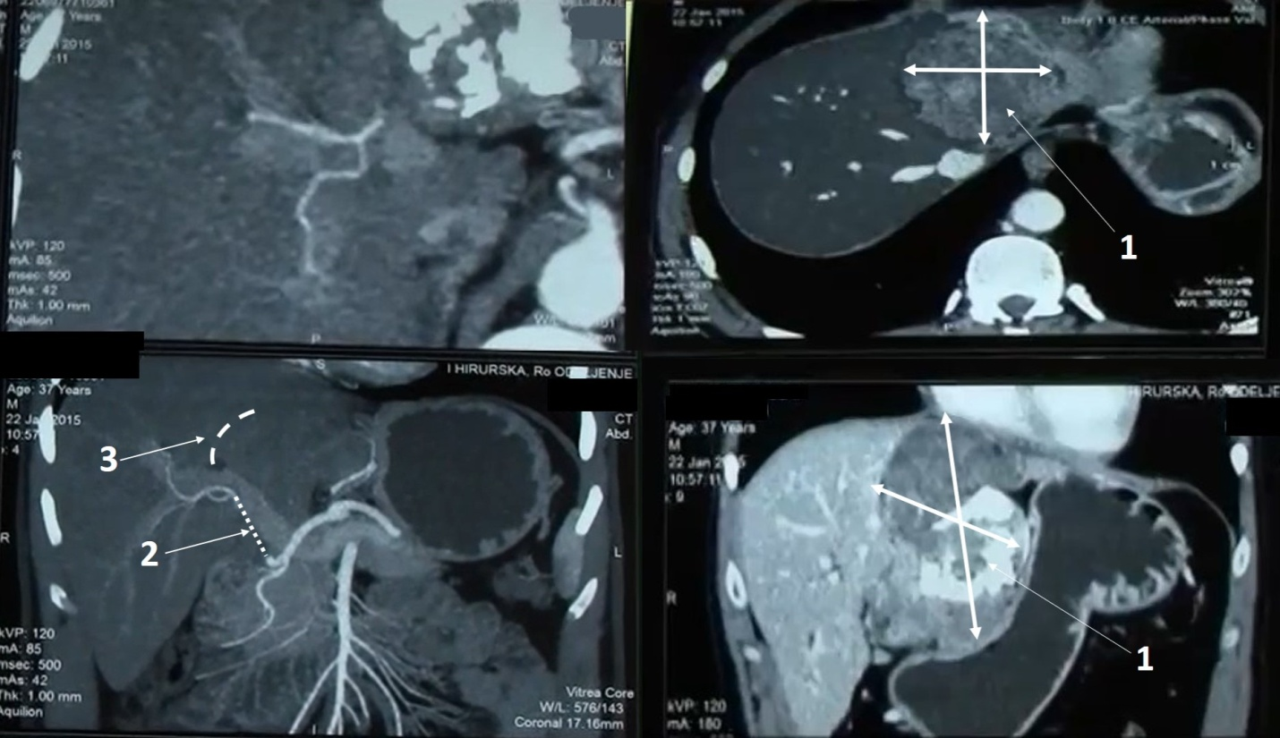
Figure 1 Multi-detector computed tomography of the abdomen. 1: Tumor; 2: Infiltration of proper hepatic artery from the origin of the gastro-duodenal aretry up to the right second branching 3-complete infiltration of the left portal vein.
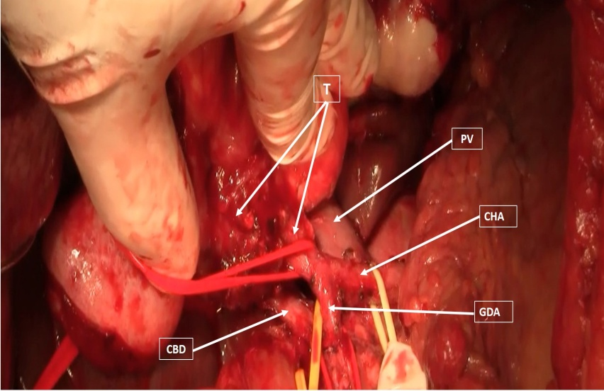
Figure 2 Intraoperative finding. T: Tumor; PV: Portal vein; CHA: Common hepatic artery; GDA: Gastroduodenal artery; CBD: Common bile duct.

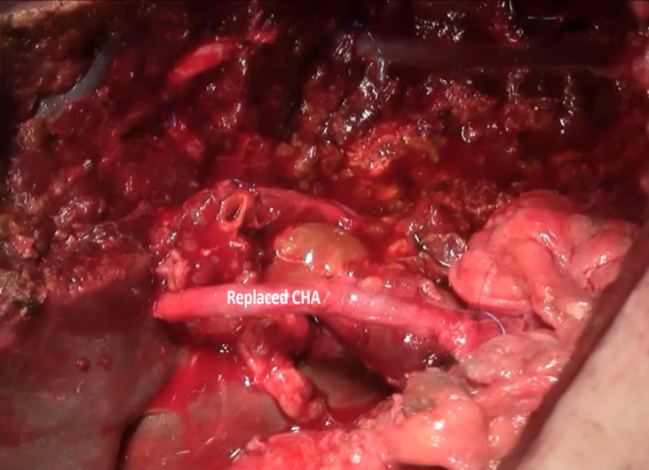
Figure 3 Reconstruction of the common hepatic artery with saphenous vein graft. CHA: Common hepatic artery.

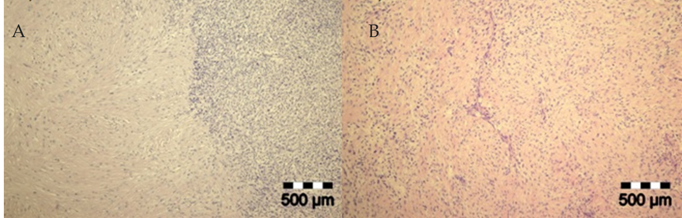
Figure 4 Histopathology. A: Mix of heavily collagenizedhypocellular zones -giant rosettes and cell-rich part of tumor [hematoxylin eosin staining (HE), 40 ×]; B: Short fascicular and characteristic whorling growth patterns are often seen. There are arcades of curvilinear blood vessels accompanied by perivascular hyaline degeneration (HE, 100 ×).
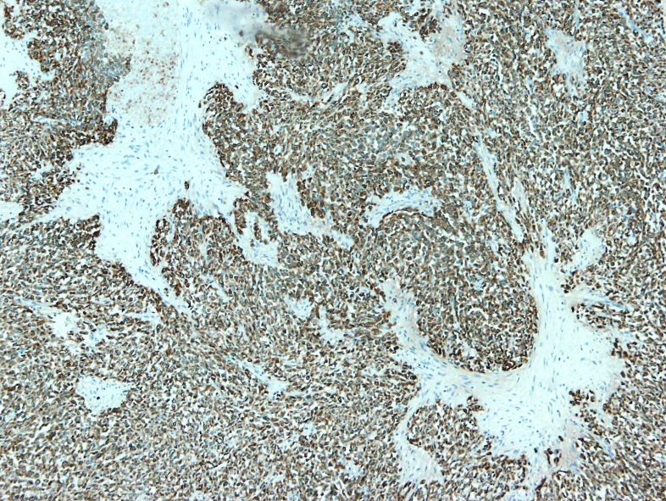
Figure 5 Immunohistochemistry. Tumor cells were diffusely and strongly positive for vimentin and MUC4, CD99 and epithelial membrane antigen were diffuse and slight expressed, and cytokeratin, smooth muscle actin, S-100 protein and neuron specific enolase were negative.
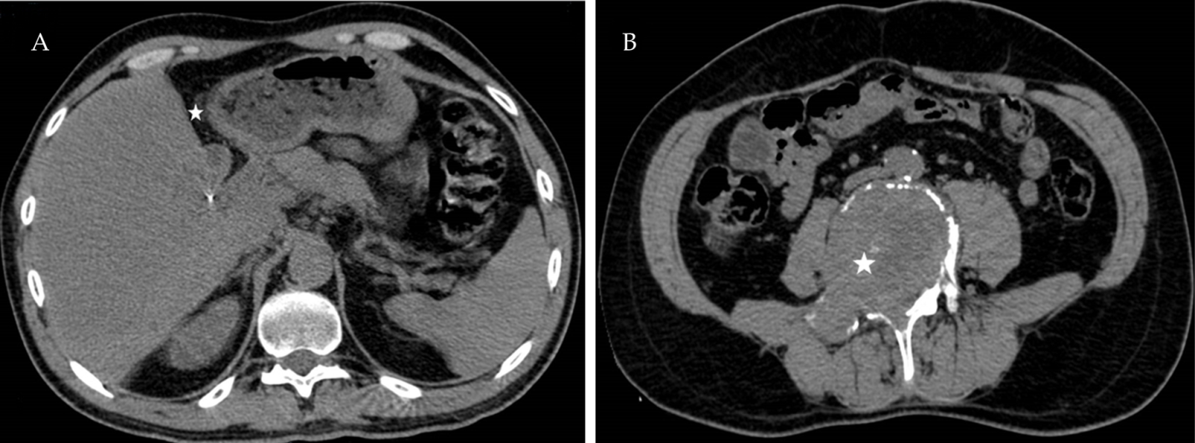
Figure 6 Abdominal and pelvic computed tomography after left hepatectomy-axial images. A: There is no tumor reccurence on surgical margin (white star) and no focal lesions in right liver lobe; B: An ill-defined lytic lesion (white star) of the L5 vertebral body is seen without periosteal reaction, representing solitary osseous metastasis of liver sarcoma.
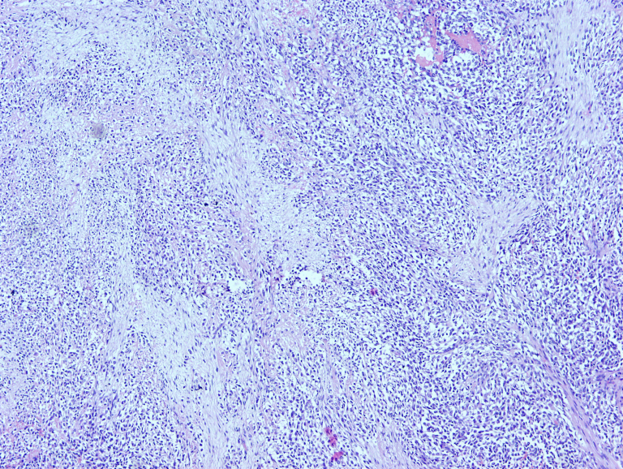
Figure 7 Histopathology. Prominent vascularity in myxoid areas and perivascular hypercellularity seen in metastatic tumor corelate with changes in primary tumor.

