Name of journal: World Journal of Anesthesiology
ESPS Manuscript NO: 9649
Columns: Case Report

Anesthetic challenges in ventilating patients with tracheal diverticulum: Case reports and review of literature

Afzal M et al. Anesthetic challenges in ventilating patients with tracheal diverticulum

Mussarat Afzal, Ikram Chaudhary

Mussarat Afzal, Prince Muhammad Bin AbdulAziz Hospital, Riyad 11676, Riyadh Region, Saudi Arabia

Ikram Chaudhary, King Fahad Specialist Hospital, Dammam 31444, Eastern Province, Saudi Arabia

Author contributions: Afzal M did the conception, design and drafting of the report with collection of all the material for references and discussion; Chaudhary I is the thoracic surgeon who performed the procedure.

Correspondence to: Dr. Mussarat Afzal, Consultant Anesthetist, Prince Muhammad Bin AbdulAziz Hospital, Al Imam Ahmad Ibn Hanbal, Riyad 11676, Riyadh Region, Saudi Arabia. dr_mussarat_a@hotmail.com

Telephone: +966-11-2616666 Fax: +966-11-2616666

Received: February 22, 2014 Revised: June 6, 2014
Accepted: June 27, 2014

Published online:

Abstract
The spectrum of disorders involving the trad1eobronchial tree is diverse and tracheal diverticulum is one of an extremely rare entity and hardly accounts for 1%-2% of cases. Mostly these are asymptomatic and discovered incidentally either on radiological examination or after autopsy. We hereby report two cases of tracheal diverticulum with hoarseness in one case and dysphagia in the second one, having difficulty in intubation in both cases. However, we successfully managed with LMA in case one and intubation in case two.

© 2014 Baishideng Publishing Group Inc. All rights reserved.

Key words: Tracheal diverticulum; Dysphagia; Hoarseness of voice; Difficult intubation

Core tip: Tracheal diverticula are extremely rare. They are usually asymptomatic .We report two cases of tracheal diverticulum with dysphagia and hoarseness of voice. Difficult intubation is exceedingly rare but we encountered difficulty in intubation in both cases. With recent imaging methods future anesthetic management of a patient with tracheal diverticulum, performing the intubation under bronchscopic guidance and ventilation strategies, is indicated to prevent fatal complications.

Afzal M, Chaudhary I. Anesthetic challenges in ventilating patients with tracheal diverticulum: Case reports and review of literature. World J Anesthesiol 2014; In press

INTRODUCTION
Tracheal diverticula are extremely rare. This is an uncommon entity and seen incidentally at post-mortem examinations and it has an incidence of 1%-2% approximately^{[1]}. Common symptoms include chronic cough, recurrent respiratory tract infections, chronic bronchitis, recurrent pneumonia in elderly and occasionally dysphagia. Differential diagnosis of diverticula includes laryngocele, bronchogenic cysts, esophageal diverticula and apical lung hernia^{[2]}. In anesthetic point of view these tracheal diverticula can sometimes cause difficulty in ventilation and intubation with profound or fatal consequences if not detected and corrected expediently. Paratracheal air shadow on X ray chest indicates that there could be paratracheal cyst or tracheocele. We hereby report two cases of tracheal diverticulum successfully operated under general anesthesia without any complications.

CASE REPORT
Case report 1
A 54-year-old lady was scheduled for excision of tracheal diverticulum. She had mild cough and hoarseness of voice since 2 mo with no history of dyspnea on exertion, hemoptysis, or dysphagia. Physical examination of the neck and the chest was unremarkable. Computed tomography (CT) scan of the neck and chest with 3D reconstruction of the scan revealed a 3 cm × 4 cm tracheal diverticulum in the right postero-lateral retrotracheal position (Figure 1). Routine blood investigation, barium swallow, X-ray chest, E.C.G and lung function tests were all normal.
After general anesthesia, an endotracheal tube of size 7.5 mm was passed under direct vision, however it was unable to proceed below the vocal cords, after which endotracheal tubes of sizes 7, 6.5 and 6 mm were inserted but resistance was felt every time they passed the vocal cords.
Gum elastic bougie was also tried without any excessive force. As manual ventilation was easy, a size 4 supreme laryngeal mask airway was placed. The whole procedure was uneventful. An X-ray of chest was done to rule out mediastinal, subcutaneous emphysema and pneumothorax. Histopathology revealed cystic mass lined with respiratory epithelium with no cartilages consistent with acquired tracheal diverticulum. At three week follow up, her voice returned back to normal. A follow up flexible bronchoscopic examination revealed normal movement of the right vocal cord. A follow up CT scan of neck was normal.

Case report 2
A 40-year-old female had presented for resection of tracheal diverticulum. She had mild cough and cervical dysphagia since one month without associated respiratory or digestive symptoms. Oropharyngeal, neck and chest examinations were normal. Neck and chest CT scans and 3D reconstruction revealed a 3 cm × 3.5 cm tracheal diverticulum in the right posterolateral position (Figure 2A, B). Routine blood investigation, spirometric values and barium swallow was unremarkable (Figure 2C). Flexible bronchoscopy showed a diverticula, opening in proximal trachea. Resection of diverticulum was planned. After induction of anesthesia intubation was attempted with size 7.5 mm endotracheal tube, but it could not be advanced for about 1 cm beyond the vocal cords, even, with progressively smaller size tubes. Resistance was felt on gentle manual ventilation.
A flexible bronchoscopy revealed endotracheal tube impinging on the tracheal diverticulum. An endotracheal tube of size 6 mm was placed successfully in the trachea beyond the diverticulum. The intra operative course was uneventful. X ray chest was done to rule out any perforation or Pneumothorax. At two weeks follow up, her dysphagia had resolved. A follow up neck CT scan was normal (Figure 2D).

DISCUSSION
Tracheal diverticulum or paratracheal cyst is an uncommonly encountered and reported clinical entity and only handful of cases have been described in the literature. Rokinsky described it first time in 1838^{[3]}. Tracheal diverticula is rare entity with prevalence of 1% at autopsy^{[4]}. Mostly, they are diagnosed as incidental finding on computed tomography or bronchoscopy in otherwise asymptomatic patients. Only three cases of difficult intubation in presence of tracheal diverticula are reported worldwide^{[5]}. It should be ruled out to avoid airway complications^{[6]}. As in both our cases, we were unable to pass the endotracheal tube beyond the vocal cords although diagnosis of tracheal diverticulum was done.
Exact prevalence of tracheal diverticulum is unknown, but in an autopsy series of more than 800 patients, the prevalence was 1%^{[7]}. Usually, they present with symptoms of recurrent laryngeal nerve palsy^{[8]} or tracheocele^{[9]}.
Tracheal diverticula can cause difficult ventilation^{[10]} or pneumomediastinum secondary to tracheal perforation during intubation^{[11]}. The two recognized types of tracheal diverticula include congenital and acquired. Congenital type present as tracheal out pouching connected to trachea via isthmus. Acquired tracheal cyst is herniation of tracheal mucosa through weak tracheal wall due to an increased luminal pressure^{[12]}. Right posterolateral wall of the trachea is the most common site of tracheal diverticula in both congenital and acquired types. The most probable cause is the absence of support offered by presence of aortic arch and esophagus as on left side^{[13]}.
Direct visualization through a bronchoscope is the diagnostic^{[14]}. In our case, we already knew about the tracheal diverticulum, thus an excessive force during manual ventilation or after intubation was not done. Tracheal cyst should be considered in differential diagnosis of difficult intubation as it is rare but recognized cause of difficult intubation^{[15,16]}. In surgically corrected tracheoesophageal fistula, unexpected ventilatory difficulties may be encountered secondary to large tracheal diverticulum^{[10]}. A tracheal bronchus better known as displaced or supernumerary can be mistaken as tracheal diverticulum especially when the supernumerary end blindly. The treatment of asymptomatic cases is generally conservative. Treatment with surgical resection is reserved for young including extirpation and reinforcement of the tracheal wall; and conservative, symptomatic treatment in the elderly^{[8]}. In our two cases, the patients were symptomatic with dysphagia and hoarseness of voice therefore surgical intervention was carried out.
In conclusion, to prevent lethal complications even in diagnosed tracheal diverticulum, Advanced imaging methods like multidetector CT and 3 dimensional reconstruction helps in future anesthetic management. Intubation under bronchoscopic guidance and ventilation strategies are indicated to prevent fatal complications.

COMMENTS
Case characteristics
A 54-year-old lady was scheduled for excision of tracheal diverticulum. She had mild cough and hoarseness of voice since 2 mo with no history of dyspnea on exertion, hemoptysis, or dysphagia. A 40-year-old female had presented for resection of tracheal diverticulum. She had mild cough and cervical dysphagia since one month without associated respiratory or digestive symptoms.

Clinical diagnosis
Physical examination of the neck and the chest was unremarkable in case 1. Oropharyngeal, neck and chest examinations were normal in case 2.

Laboratory diagnosis
Routine blood investigation, barium swallow, X-ray chest, ECG and lung function tests were all normal for case 1. Routine blood investigation, spirometric values and barium swallow was unremarkable for case 2.

Imaging diagnosis
Computed tomography (CT) scan of the neck and chest with 3D reconstruction of the scan revealed a 3 cm × 4 cm tracheal diverticulum in the right postero-lateral retrotracheal position for case 1. Neck and chest CT scans and 3D reconstruction revealed a 3 cm × 3.5 cm tracheal diverticulum in the right posterolateral position for case 2.

Pathological diagnosis
Histopathology revealed cystic mass lined with respiratory epithelium with no cartilages consistent with acquired tracheal diverticulum in case 1.

Peer review
This is an interesting topic. The images are of excellent quality and help to illustrate the authors’ cases.

REFERENCES
1 Soto-Hurtado EJ, Peñuela-Ruíz L, Rivera-Sánchez I, Torres-Jiménez J. Tracheal diverticulum: a review of the literature. Lung 2006; 184: 303-307 [PMID: 17086467 DOI: 10.1007/s00408-006-0010-7]
2 Polverosi R, Carloni A, Poletti V. Tracheal and main bronchial diverticula: the role of CT. Radiol Med 2008; 113: 181-9 [DOI: 10.1007/s11547-008-0249-6]
3 Frenkiel S, Assimes IK, Rosales JK. Congenital tracheal diverticulum. A case report. Ann Otol Rhinol Laryngol ; 89: 406-408 [PMID: 6776862]
4 Goo JM, Im JG, Ahn JM, Moon WK, Chung JW, Park JH, Seo JB, Han MC. Right paratracheal air cysts in the thoracic inlet: clinical and radiologic significance. AJR Am J Roentgenol 1999; 173: 65-70 [PMID: 10397101 DOI: 10.2214/ajr.173.1.10397101]
5 Carmona SP, Congregado M, Loscertales J. Acquired Tracheal Diverticulum as the Cause of Complicated Orotracheal Intubation. Arch Bronconeumol 2012; 48: 64-5 [DOI: 10.1016/j.arbr.2011.11.001]
6 Salhotra R, Sharma C, Tyagi A, Kumar S, Sethi AK, Bhatt S. An unanticipated difficult airway in Lesch - Nyhan syndrome. Anesthesiol Clin Pharmacol 2012; 28; 239-241 [DOI: 10.4103/0970-9185.94909]
7 Infante M, Mattavelli F, Valente M, Alloisio M, Preda F, Ravasi G. Tracheal diverticulum: a rare cause and consequence of chronic cough. Eur J Surg 1994; 160: 315-316 [PMID: 8075205]
8 Caversaccio MD, Becker M, Zbären P. Tracheal diverticulum presenting with recurrent laryngeal nerve paralysis. Ann Otol Rhinol Laryngol 1998; 107: 362-364 [PMID: 9557775]
9 Mathur NN, Sardana P, Singh VP, Bais AS. Adult tracheocele with large cervical presentation. J Laryngol Otol 1999; 113: 364-365 [PMID: 10474676 DOI: 10.1017/S0022215100143993]
10 Dinner M, Ward R, Yun E. Ventilation difficulty secondary to a tracheal diverticulum. Anesthesiology 1992; 77: 586-587 [PMID: 1519795]
11 Möller GM, ten Berge EJ, Stassen CM. Tracheocele: a rare cause of difficult endotracheal intubation and subsequent pneumomediastinum. Eur Respir J 1994; 7: 1376-1377 [PMID: 7925920]
12 Hernández Pérez L, Pac Ferrer J, Uribe-Etxebarría Lugariza-Aresti N, Jiménez Maestre U, Oleagoitia Cilaurre JM. [Tracheal diverticulum: a cause of dysphagia]. Cir Esp 2010; 88: 197-198 [PMID: 20074709 DOI: 10.1016/j.ciresp.2009.11.016]
13 Pinot D, Breen D, Peloni JM, Gaubert JY, Dutau H, Vervloet D. An incidental finding in a 34-year-old male under investigation for haemoptysis. Diagnosis: The radiological and endoscopic images demonstrate a complex defect along the posterior tracheal wall consistent with acquired tracheal diverticulum. Eur Respir J 2009; 33: 1227-1229 [PMID: 19407058 DOI: 10.1183/09031936.00131908]
14 Ching SL, Chow MY, Ng HN. Difficult lung isolation in a patient with an undiagnosed tracheal diverticulum. J Cardiothorac Vasc Anesth 2003; 17: 355-356 [PMID: 12827586 DOI: 10.1016/S1053-0770(03)00063-6]
15 Davies R. Difficult tracheal intubation secondary to a tracheal diverticulum and a 90 degree deviation in the trachea. Anaesthesia 2000; 55: 923-925 [PMID: 10947774 DOI: 10.1046/j.1365-2044.2000.01664-18.x]
16 Gaissert HA, Grillo HC. Complications of the tracheal diverticulum after division of congenital tracheoesophageal fistula. J Pediatr Surg 2006; 41: 842-844 [PMID: 16567205 DOI: 10.1016/j.jpedsurg.2005.12.038]

P-Reviewer: Cichero JAY S-Editor: Song XX L-Editor: E-Editor:

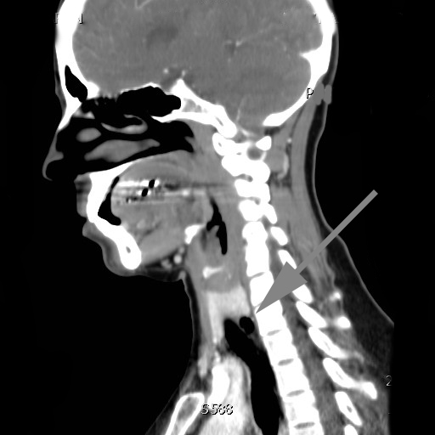
Figure 1 Neck computed tomography scan showing an air-containing cyst adjacent to the tracheal wall.

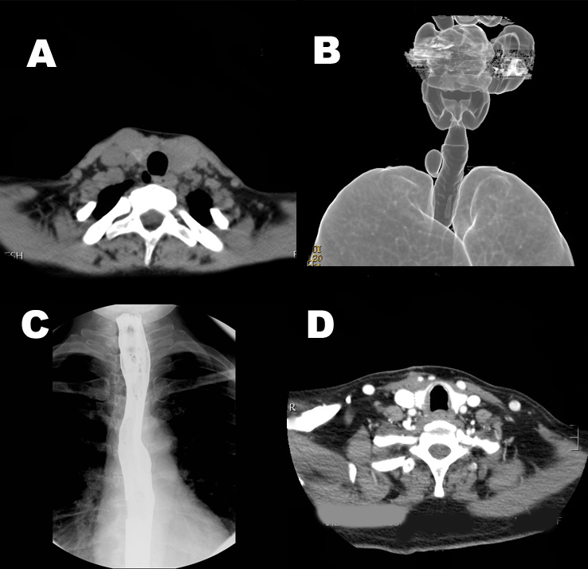
Figure 2 Neck computed tomography scan. A: Neck computed tomography (CT) scan showing an air-containing cyst adjacent to the right tracheal wall; B: Reconstructed image of the airway showing the tracheal diverticulum at the thoracic inlet; C: Normal esophagogram; D: CT scan of the neck after surgery.

