Name of journal: World Journal of Gastroenterology
ESPS Manuscript NO: 14604
Columns: CASE REPORT

Fatal submucosal invasive gastric adenosquamous carcinoma detected at surveillance after gastric endoscopic submucosal dissection

Shirahige A et al. Fatal submucosal invasive gastric adenosquamous carcinoma

Akinori Shirahige, Haruhisa Suzuki, Ichiro Oda, Masau Sekiguchi, Genki Mori, Seiichiro Abe, Satoru Nonaka, Shigetaka Yoshinaga, Shigeki Sekine, Ryoji Kushima, Yutaka Saito, Takeo Fukagawa, Hitoshi Katai

Akinori Shirahige, Haruhisa Suzuki, Ichiro Oda, Masau Sekiguchi, Genki Mori, Seiichiro Abe, Satoru Nonaka, Shigetaka Yoshinaga, Yutaka Saito, Endoscopy Division, National Cancer Center Hospital, Tokyo 104-0045, Japan

Shigeki Sekine, Pathology Division, National Cancer Center Hospital, Tokyo 104-0045, Japan

Ryoji Kushima, Department of Clinical Laboratory Medicine and Diagnostic Pathology, Shiga University of Medical Science, Otsu 520-2192, Japan

Takeo Fukagawa, Hitoshi Katai, Gastric Surgery Division, National Cancer Center Hospital, Tokyo 104-0045, Japan

Author contributions: Shirahige A, Suzuki H and Oda I wrote the manuscript; Sekiguchi M, Mori G, Abe S, Nonaka S, Yoshinaga S, Sekine S, Kushima R, Saito Y, Fukagawa T and Katai H contributed to the manuscript discussion and reviewed the manuscript.

Informed consent: All study participants, or their legal guardian, provided informed written consent prior to study enrollment.

Conflict-of-interest: No conflict of interest was declared by the authors.

Open-Access: This article is an open-access article which was selected by an in-house editor and fully peer-reviewed by external reviewers. It is distributed in accordance with the Creative Commons Attribution Non Commercial (CC BY-NC 4.0) license, which permits others to distribute, remix, adapt, build upon this work non-commercially, and license their derivative works on different terms, provided the original work is properly cited and the use is non-commercial. See: http://creativecommons.org/licenses/by-nc/4.0/

Correspondence to: Haruhisa Suzuki, MD, Endoscopy Division, National Cancer Center Hospital, 5-1-1 Tsukiji, Chuo-ku, Tokyo 104-0045, Japan. harusuzu@ncc.go.jp
Telephone: +81-3-35422511
Fax: +81-3-35423815
Received: October 14, 2014
Peer-review started: October 15, 2014
First decision: November 14, 2014
Revised: November 28, 2014
Accepted: January 30, 2015

Article in press:
Published online:

Abstract
An 80-year-old man was under annual surveillance esophagogastroduodenoscopy after endoscopic submucosal dissection (ESD) for early gastric cancer (EGC). Two years after the initial ESD, a 0-IIc type metachronous EGC lesion, 8 mm in size, without an ulcer scar was found in the gastric antrum. The estimated tumor depth was up to the mucosa, and biopsy revealed well and poorly differentiated adenocarcinoma. ESD was performed for this lesion and en bloc resection with negative margins was achieved. Histopathological examination revealed an adenosquamous carcinoma 8 mm in size invading the deep submucosal layer (1600 μm), with lymphovascular invasion, consistent with the diagnosis of non-curative resection. Additional gastrectomy was recommended for this patient, however, two months after the ESD, preoperative computed tomography revealed multiple liver metastases, and the patient was considered as an unsuitable candidate for surgical resection. Systemic chemotherapy was therefore started, however, the patient died of gastric cancer 27 mo after the second ESD. Early gastric adenosquamous carcinoma localized to the mucosa and submucosa is extremely rare and its clinical behavior is not well known. The present report is very significant in that it underscores the distinct possibility of gastric adenosquamous carcinoma being very aggressive and fatal even when detected at an early cancer.

Key words: Early gastric cancer; Endoscopic submucosal dissection; Gastric adenosquamous carcinoma; Gastric cancer-related death; Liver metastasis; Metachronous cancer; Surveillance

© The Author(s) 2015. Published by Baishideng Publishing Group Inc. All rights reserved.

Core tip: Herein is described a rare case of gastric adenosquamous carcinoma which resulted in liver metastasis and gastric cancer-related death, even though the tumor was detected at an early cancer by periodic surveillance esophagogastroduodenoscopy after gastric endoscopic submucosal dissection. Early gastric adenosquamous carcinoma is extremely rare and its clinical behavior is not well known. The present study is very significant in that it underscores the distinct possibility of gastric adenosquamous carcinoma being very aggressive and fatal even when detected at an early cancer.

Shirahige A, Suzuki H, Oda I, Sekiguchi M, Mori G, Abe S, Nonaka S, Yoshinaga S, Sekine S, Kushima R, Saito Y, Fukagawa T, Katai H. Fatal submucosal invasive gastric adenosquamous carcinoma detected at surveillance after gastric endoscopic submucosal dissection. World J Gastroenterol 2015; In press

INTRODUCTION
Adenosquamous carcinoma is an exceedingly rare tumor, accounting for only 0.14%-1.9% of all cases of gastric cancer^{[1-6]}. It is a very aggressive cancer, and in the majority of cases, these tumors are already at an advanced stage at diagnosis, with lymph node metastasis and liver metastasis. This type of cancer is associated with a very poor prognosis, with the 5-year survival rate of 0-22%^{[1,3,6-8]}. There are few reports on early gastric adenosquamous carcinoma localized to the mucosa and submucosa, therefore, the clinical behavior of this type of cancer is still not well known^{[6,9,10]}. We document a rare case of gastric adenosquamous carcinoma which resulted in liver metastasis and gastric cancer-related death, even though the tumor was detected at an early cancer by periodic surveillance esophagogastroduodenoscopy (EGD) two years after curative endoscopic submucosal dissection (ESD) for early gastric cancer (EGC).

CASE REPORT
An 80-year-old man was admitted to our hospital in June 2005 for endoscopic treatment of EGC. We performed ESD for the initial EGC lesion, a 0-IIa type well differentiated adenocarcinoma limited to mucosa measuring 10 mm in diameter, with no ulcer scar, on the lesser curvature of the middle gastric body (Figure 1). Histopathological findings revealed a well differentiated mucosal adenocarcinoma measuring 10 mm in diameter without lymphovascular involvement or ulcer scar, and tumor-free margins. This lesion fulfilled the absolute pathological criteria and was diagnosed as a curative resection^{[11]}. After the initial ESD, EGD was performed annually, and revealed no evidence of tumor recurrence; the serum levels of tumor markers such as carcinoembryonic antigen (CEA) also remained within normal range. However, in November 2007, 0-IIc type metachronous gastric cancer (MGC), 8 mm in diameter, with no ulcer scar, was found on the greater curvature of the gastric antrum (Figure 2). The estimated tumor depth was up to the mucosa and biopsy revealed well and poorly differentiated adenocarcinoma. ESD was performed for this lesion and en-bloc resection with negative margins was achieved. Histopathological examination revealed an adenosquamous carcinoma invading the deep submucosal layer (1600 μm), 8 mm in diameter, with lymphovascular invasion, consistent with the diagnosis of non-curative resection (Figure 3). Immunohistchemical staining was focally positive for CK5/6, CEA, CDX2, and a few cells were positive for CK14, P63, findings that were suggestive of adenosquamous differentiation of the tumor (Figure 4). Additional gastrectomy was recommended for the patient. However, two months after the ESD (in January 2008), preoperative computerized tomography (CT) revealed multiple liver metastases (Figure 5), and the patient was considered as an unsuitable candidate for surgical resection. Systemic chemotherapy was therefore started, however, the patient died of gastric cancer 27 mo after the second ESD.

DISCUSSION
Rolleston et al^{[12]} first reported gastric adenosquamous carcinoma in 1905. Gastric adenosquamous carcinoma consists of both adenocarcinomatous and squamous cell carcinomatous components, more than a quarter of the tumor being composed of the squamous cell carcinoma component^{[13]}. Gastric adenosquamous carcinoma is exceedingly rare, accounting for 0.14% to 1.9% of all cases of gastric cancer^{[1-6]}. In the majority of cases of gastric adenosquamous carcinoma, the tumor is already at an advanced stage at diagnosis. The tumor carries a devastating prognosis, with 5-year survival rates ranging from 0 to 22%^{[1,3,6-8]}. Early gastric adenosquamous carcinoma extending to the mucosa and submucosa is extremely rare. Samejima et al^{[9]} first reported early gastric adenosquamous carcinoma in 1974 and there have been only 10 case reports of this type of carcinoma since, including the present case^{[6,9,10]}. Among the 10 cases of early gastric adenosquamous carcinoma, five died of gastric cancer (50%) (four with liver metastases and one with distant lymph node metastasis). As compared to the excellent prognosis of the common type of early gastric adenocarcinoma, with 5-year survival rates of about 90%^{[14]}, the prognosis of early gastric adenosquamous carcinoma is much poorer. In addition, among the five fatal cases, including the present case, 3 were found to have liver metastasis or distant lymph node metastasis by the time of surgery; the present case had multiple liver metastases on a CT obtained two months after the ESD. Therefore, the present case report is very significant in that it underscores the distinct possibility of gastric adenosquamous carcinoma being very aggressive and fatal even when detected at an early cancer.
The histogenesis of adenosquamous carcinoma is not clear, although there are five hypotheses^{[1,4,6-8,10,15-17]}: (1) squamous metaplasia of an adenocarcinoma; (2) cancerization of metaplastic non-neoplastic squamous cells; (3) cancerization of ectopic squamous epithelium; (4) differentiation of multipotential undifferentiated cancer cells toward both squamous and glandular cells; and (5) collision of concurrent adenocarcinoma and squamous cell carcinoma. Most of the squamous cell carcinomatous components were located at invasive site, in contrast to the adenocarcinomatous components being located in the mucosal region adjacent to the squamous cell carcinoma component. Therefore, many authors now believe that the squamous neoplastic component results from metaplastic change of the adenocarcinoma component. Our present case also showed pathological findings that were consistent with this hypothesis.
The tumor in the present patient was detected as a MGC during periodic EGD two years after curative ESD for an EGC lesion fulfilling the absolute indications for ESD^{[11]}. Higher incidence of MGCs (in the range of 1.8% to 12.8%) after endoscopic treatment for EGC has been reported previously^{[18-22]}. Among the 1537 EGC patients who underwent curative ESD for absolute indications or for expanded indications from 1999 to 2006 at our hospital, a total of 348 MGC lesions were detected in 244 patients (15.9%), consistent with previous reports. Unfortunately, we encountered seven cases of MGC with gastric cancer-related death, even though radical resection can be performed in most cases. Among these, in four cases, the advanced MGC was detected over 5 years after the initial ESD, because periodic surveillance examinations were not performed over 5 years. On the other hand, in the remaining three patients including the present case, the MGCs were of a higher malignancy grade at the time of their detection, despite the patient receiving periodic follow-up examinations. Thus, it is necessary to bear in mind the possibility of development of such fatal MGCs during periodic follow-up examinations after curative gastric ESD.
In conclusion, we have described a rare case of submucosal invasive gastric adenosquamous carcinoma that resulted in gastric cancer-related death, even though this tumor was detected at an early cancer during periodic surveillance examinations after curative gastric ESD.

COMMENTS
Case characteristics
An 80-year-old man was under annual surveillance esophagogastroduodenoscopy (EGD) after endoscopic submucosal dissection (ESD) for early gastric cancer (EGC).

Clinical diagnosis
0-IIc type metachronous gastric cancer.

Differential diagnosis
Common type of early gastric cancer.

Laboratory diagnosis
The serum levels of tumor markers such as carcinoembryonic antigen were within normal range.

Imaging diagnosis
EGD revealed small gastric cancer clinically estimated as intramucosal lesion.

Pathological diagnosis
Histopathological examination of ESD resected specimen revealed an adenosquamous carcinoma invading the deep submucosal layer with lymphovascular invasion.

Treatment
The patient received systemic chemotherapy for multiple liver metastases detected after the ESD.

Related reports
Early gastric adenosquamous carcinoma localized to the mucosa and submucosa is extremely rare and its clinical behavior is not well known.

Term explanation
Gastric adenosquamous carcinoma consists of both adenocarcinomatous and squamous cell carcinomatous components, more than a quarter of the tumor being composed of the squamous cell carcinoma component.

Experiences and lessons
Herein is described a rare case of gastric adenosquamous carcinoma which resulted in liver metastasis and gastric cancer-related death, even though the tumor was detected at an early cancer by periodic surveillance EGD after gastric ESD.

Peer-review
This case report reveals the distinct possibility of gastric adenosquamous carcinoma being very aggressive and fatal even when detected at an early cancer.

REFERENCES
1 Sand J, Airo I, Hiltunen KM, Mattila J, Nordback I. Changes in biliary bacteria after endoscopic cholangiography and sphincterotomy. Am Surg 1992; 58: 324-328 [PMID: 1622015]
2 Kurumado K, Nagai T, Kondo Y, Abe H. Long-term observations on morphological changes of choledochal epithelium after choledochoenterostomy in rats. Dig Dis Sci 1994; 39: 809-820 [PMID: 8149847 DOI: 10.1007/BF02087428]
3 Freeman ML, Nelson DB, Sherman S, Haber GB, Herman ME, Dorsher PJ, Moore JP, Fennerty MB, Ryan ME, Shaw MJ, Lande JD, Pheley AM. Complications of endoscopic biliary sphincterotomy. N Engl J Med 1996; 335: 909-918 [PMID: 8782497 DOI: 10.1056/NEJM199609263351301]
4 May GR, Cotton PB, Edmunds SE, Chong W. Removal of stones from the bile duct at ERCP without sphincterotomy. Gastrointest Endosc 1996; 39: 749-754 [PMID: 8293895 DOI: 10.1016/S0016-5107(93)70258-8]
5 Mac Mathuna P, White P, Clarke E, Lennon J, Crowe J. Endoscopic sphincteroplasty: a novel and safe alternative to papillotomy in the management of bile duct stones. Gut 1994; 35: 127-129 [PMID: 8307433 DOI: 10.1136/gut.35.1.127]
6 Mathuna PM, White P, Clarke E, Merriman R, Lennon JR, Crowe J. Endoscopic balloon sphincteroplasty (papillary dilation) for bile duct stones: efficacy, safety, and follow-up in 100 patients. Gastrointest Endosc 1995; 42: 468-474 [PMID: 8566640 DOI: 10.1016/S0016-5107(95)70052-8]
7 Baron TH, Harewood GC. Endoscopic balloon dilation of the biliary sphincter compared to endoscopic biliary sphincterotomy for removal of common bile duct stones during ERCP: a metaanalysis of randomized, controlled trials. Am J Gastroenterol 2004; 99: 1455-1460 [PMID: 15307859 DOI: 10.1111/j.1572-0241.2004.30151.x]
8 Ersoz G, Tekesin O, Ozutemiz AO, Gunsar F. Biliary sphincterotomy plus dilation with a large balloon for bile duct stones that are difficult to extract. Gastrointest Endosc 2003; 57: 156-159 [PMID: 12556775 DOI: 10.1067/mge.2003.52]
9 Maydeo A, Bhandari S. Balloon sphincteroplasty for removing difficult bile duct stones. Endoscopy 2007; 39: 958-961 [PMID: 17701853 DOI: 10.1055/s-2007-966784]
10 Yoshida K, Manabe T, Tsunoda T, Kimoto M, Tadaoka Y, Shimizu M. Early gastric cancer of adenosquamous carcinoma type: report of a case and review of literature. Jpn J Clin Oncol 1996; 26: 252-257 [PMID: 8765185 DOI: 10.1093/oxfordjournals.jjco.a023224]
11 Japanese gastric cancer treatment guidelines 2010 (ver. 3). Gastric Cancer 2011; 14: 113-123 [PMID: 21573742 DOI: 10.1007/s10120-011-0042-4]
12 Rolleston HD, Trevor RS. A case of columnar-celled carcioma of stomach showing squamous celled metaplasia. J Pathol Bacteriol 1905; 10: 418-422 [DOI: 10.1002/path.1700100412]
13 Japanese Research Society for Gastric Cancer: Japanese Classification of Gastric Carcinoma. 1st English ed. Tokyo kanehara-Shuppan publisher, 1995: 42
14 Nashimoto A, Akazawa K, Isobe Y, Miyashiro I, Katai H, Kodera Y, Tsujitani S, Seto Y, Furukawa H, Oda I, Ono H, Tanabe S, Kaminishi M. Gastric cancer treated in 2002 in Japan: 2009 annual report of the JGCA nationwide registry. Gastric Cancer 2013; 16: 1-27 [PMID: 22729699 DOI: 10.1007/s10120-012-0163-4]
15 Sailer S. Diffuse metaplastic gastritis in a patient with prolonged cachexia and macrocystic anemia. Arch Pathol 1943; 35: 730-743
16 Wood DA. Adenoacanthoma of the pyloric end of the stomach. Arch Pathol 1943; 36: 177-189
17 Boswell JT, Helwig EB. Squamous cell carcinoma and adenoacanthoma of the stomach: a clinicopathologic study. Cancer 1965; 18: 181-192 [PMID: 14254074 DOI: 10.1002/1097-0142(196502)18: 2<181: : AID-CNCR2820180209>3.0.CO; 2-3]
18 Takekoshi T, Baba Y, Ota H, Kato Y, Yanagisawa A, Takagi K, Noguchi Y. Endoscopic resection of early gastric carcinoma: results of a retrospective analysis of 308 cases. Endoscopy 1994; 26: 352-358 [PMID: 8076567 DOI: 10.1055/s-2007-1008990]
19 Kojima T, Parra-Blanco A, Takahashi H, Fujita R. Outcome of endoscopic mucosal resection for early gastric cancer: review of the Japanese literature. Gastrointest Endosc 1998; 48: 550-54; discussion 550-54; [PMID: 9831855 DOI: 10.1016/S0016-5107(98)70108-7]
20 Nakajima T, Oda I, Gotoda T, Hamanaka H, Eguchi T, Yokoi C, Saito D. Metachronous gastric cancers after endoscopic resection: how effective is annual endoscopic surveillance? Gastric Cancer 2006; 9: 93-98 [PMID: 16767364 DOI: 10.1007/s10120-006-0372-9]
21 Kobayashi M, Narisawa R, Sato Y, Takeuchi M, Aoyagi Y. Self-limiting risk of metachronous gastric cancers after endoscopic resection. Dig Endosc 2010; 22: 169-173 [PMID: 20642604 DOI: 10.1111/j.1443-1661.2010.00987.x]
22 Han JS, Jang JS, Choi SR, Kwon HC, Kim MC, Jeong JS, Kim SJ, Sohn YJ, Lee EJ. A study of metachronous cancer after endoscopic resection of early gastric cancer. Scand J Gastroenterol 2011; 46: 1099-1104 [PMID: 21668406 DOI: 10.3109/00365521.2011.591427]
P-Reviewer: Kiriyama S S-Editor: Yu J L-Editor: E-Editor:

A 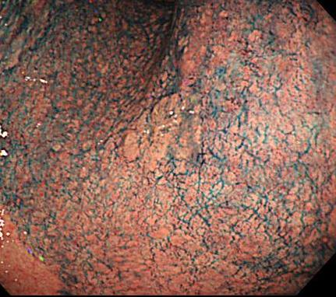
B 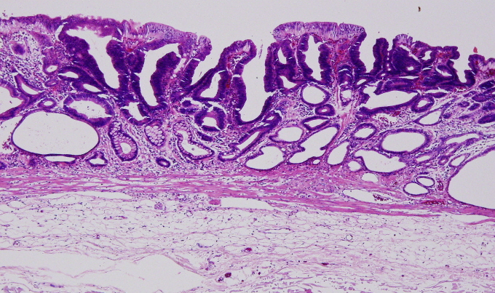
Figure 1 Initial early gastric cancer lesion in June 2005. A: 0-IIa type well differentiated adenocarcinoma limited to the mucosa, 10 mm in size, without an ulcer scar, on the lesser curvature of the middle gastric body; B: Histopathological findings revealed a well differentiated mucosal adenocarcinoma, 10 mm in size, without lymphovascular involvement or ulcerative finding as well as tumor-free margins.

A 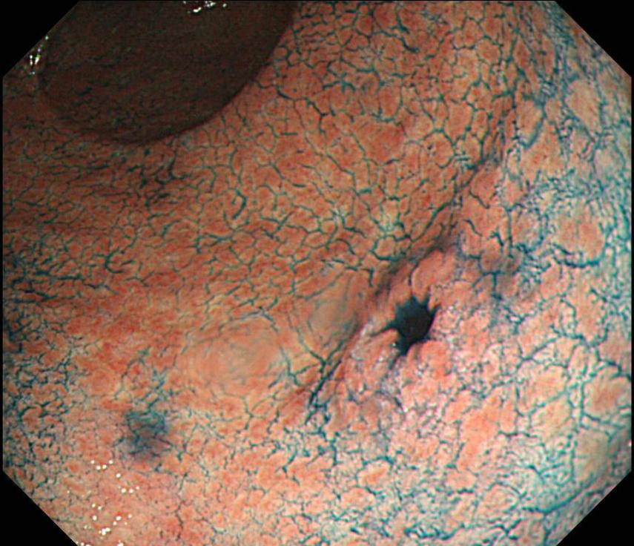
B 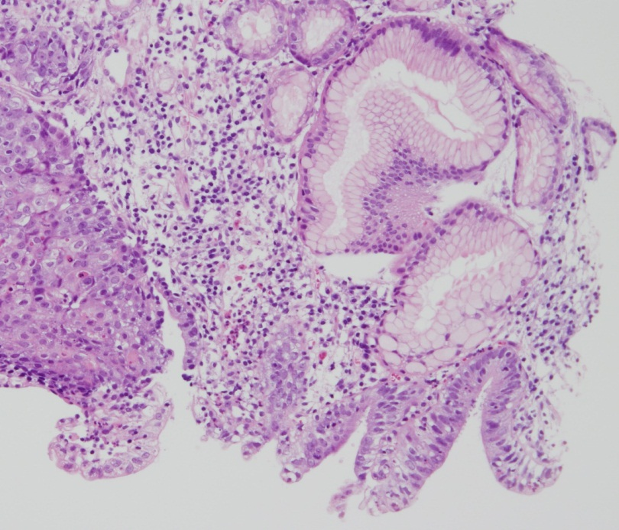
Figure 2 Metachronous early gastric cancer lesion in November 2007. A: 0-IIc type metachronous early gastric cancer lesion, 8 mm in size, without an ulcer scar, on the greater curvature of gastric antrum. The estimated tumor depth was up to the mucosa; B: Biopsy revealed well and poorly differentiated adenocarcinoma (HE staining).

A 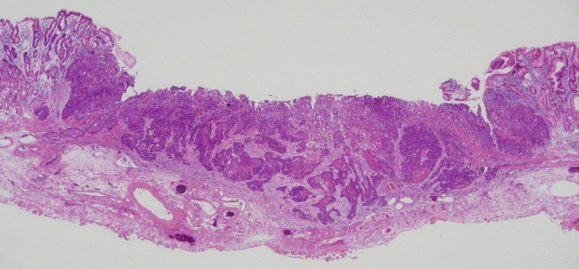
B 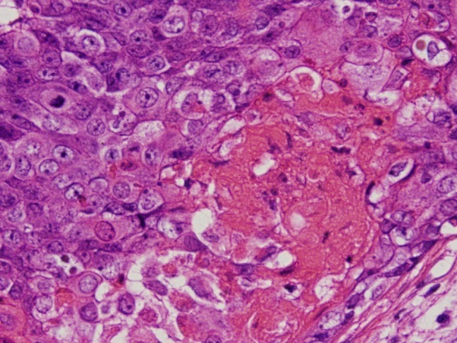
Figure 3 Histopathological findings of endoscopic submucosal dissection specimens. A: Low magnification view with hematoxylin and eosin staining. endoscopic submucosal dissection specimen revealed adenosquamous carcinoma invading the deep submucosal layer (1600 μm); B: High magnification view of yellow box in A. The tumor shows a solid growth pattern and prominent keratinization suggesting squamous cell carcinomatous component.

A 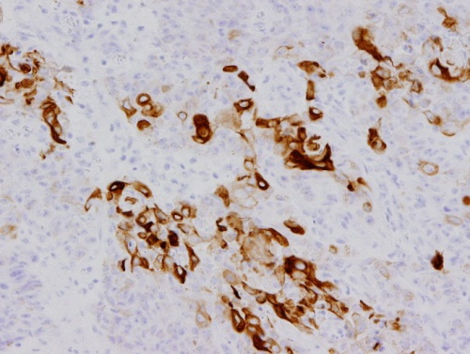
B 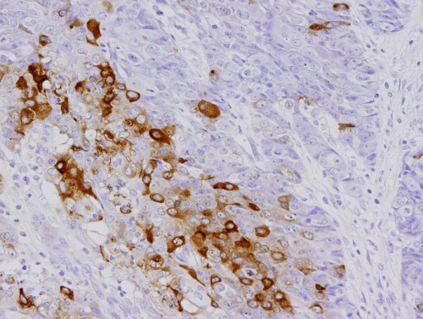
C 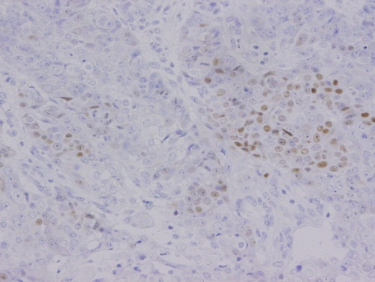
D 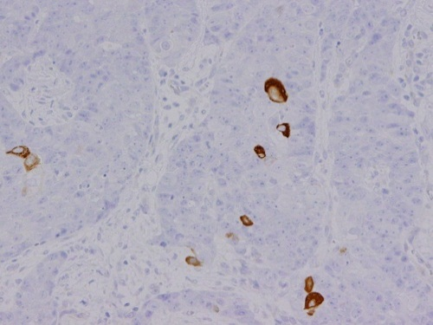
E 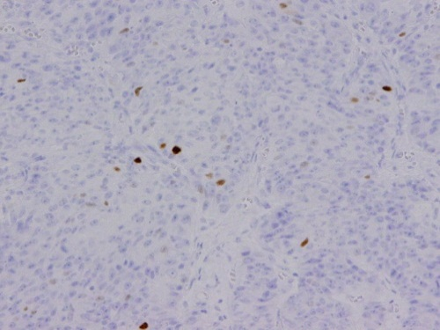
Figure 4 Immunochemical staining. Immunohistchemical staining was focally positive for CK5/6 (A), CEA (B), CDX2 (C), and a few cells were positive for CK14 (D), P63 (E).

A 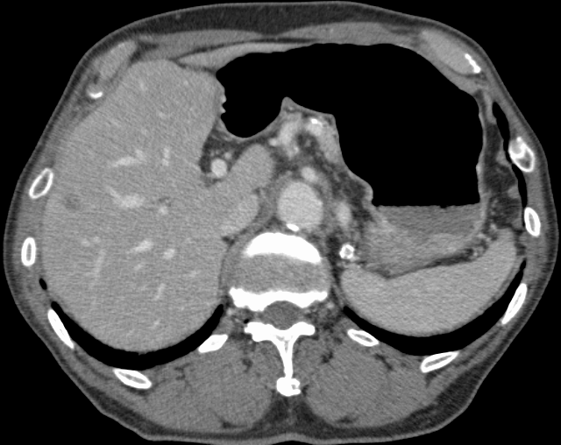
B 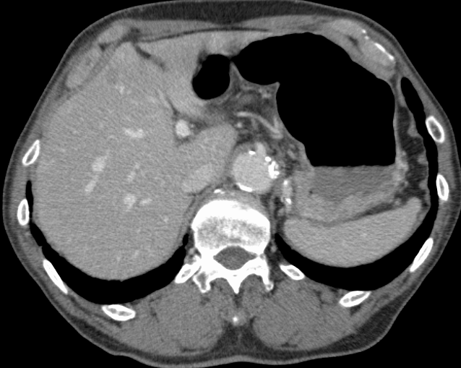
Figure 5 Computerized tomography in January 2008 (two mo after the endoscopic submucosal dissection). A and B: Enhanced computerized tomography revealed multiple low density areas suggesting liver metastases (indicated by arrows).

