Name of journal: World Journal of Gastroenterology
ESPS Manuscript NO: 29071
Manuscript type: CASE REPORT

Ileo-ileal intussusception caused by lymphangioma of the small bowel treated by single-incision laparoscopic-assisted ileal resection

Kohga A et al. Ileo-ileal intussusception caused by lymphangioma

Atsushi Kohga, Akihiro Kawabe, Yuto Hasegawa, Kiyoshige Yajima, Takuya Okumura, Kimihiro Yamashita, Jun Isogaki, Kenji Suzuki, Akira Komiyama

Atsushi Kohga, Akihiro Kawabe, Yuto Hasegawa, Kiyoshige Yajima, Takuya Okumura, Kimihiro Yamashita, Jun Isogaki, Kenji Suzuki, Division of Surgery, Fujinomiya City General Hospital, Fujinomiya, Shizuoka 4180076, Japan

Akira Komiyama, Division of Pathology, Fujinomiya City General Hospital, Fujinomiya, Shizuoka 4180076, Japan

Author contributions: All authors contributed to the acquisition of data and the writing and revision of this manuscript.

Institutional review board statement: This study was approved by the Institutional Review Board of Fujinomiya City General Hospital.

Informed consent statement: This case report is provided for academic communication only, not for other purposes. In this case report, the images do not disclose the patient’s personal information. Consent was acquired from the patient for publication of this case report.

Conflict-of-interest statement: The authors declare no conflicts of interest.

Open-Access: This article is an open-access article which was selected by an in-house editor and fully peer-reviewed by external reviewers. It is distributed in accordance with the Creative Commons Attribution Non Commercial (CC BY-NC 4.0) license, which permits others to distribute, remix, adapt, build upon this work non-commercially, and license their derivative works on different terms, provided the original work is properly cited and the use is non-commercial. See: http://creativecommons.org/licenses/by-nc/4.0/

Manuscript source: Unsolicited manuscript

Correspondence to: Atsushi Kohga, MD, Division of Surgery, Fujinomiya City General Hospital, 3-1, Nishiki-cho, Fujinomiya, Shizuoka 4180076, Japan. akohga11@yahoo.co.jp
Telephone: +81-54-4273151
Fax: +81-54-4237232

Received: July 27, 2016
Peer-review started: July 30, 2016
First decision: September 28, 2016
Revised: October 7, 2016
Accepted: October 30, 2016
Article in press:
Published online:

Abstract
Intraabdominal lymphangiomas are uncommon; additionally, those affecting the gastrointestinal tract are rare and account for less than 1% of cases. Intussusception caused by a cystic lymphangioma of the small bowel is extremely rare. The patient was a 20-year-old woman who visited our emergency room with a complaint of abdominal pain. A computed tomography image revealed ileo-ileal intussusception with a leading hypovascular mass measuring 1 cm in a diameter. Single-incision laparoscopic-assisted ileal resection was performed. The surgical specimen consisted of a soft polycystic mass. Macroscopically, a pedunculated polyp with a convolutional pattern was found. Microscopically, the inner surfaces of the cysts were covered with a single layer of endothelial cells. On immunohistochemical examination, the endothelial cells were partially positive for D2-40 and CD34. Smooth muscle cells were also found around the cysts. The lesion was diagnosed as a cystic lymphangioma. Dozens of cases of small bowel lymphangiomas have previously been reported. Of these, cases with intussusception were very rare. This is the first case of small bowel intussusception due to lymphangioma treated by single-incision laparoscopic-assisted surgery.

Key words: Intussusception; Single-incision laparoscopic-assisted surgery; Lymphangioma

© The Author(s) 2016. Published by Baishideng Publishing Group Inc. All rights reserved.

Core tip: We observed an extremely rare case of small bowel intussusception caused by cystic lymphangioma. Dozens of lymphangiomas of the small bowel have previously been reported. Of these, few cases with intussusception have been reported. In the present case, single-incision laparoscopic-assisted surgery was useful for treating the telescoped lesion. To our knowledge, no cases of small bowel intussusception due to lymphangioma have been treated by laparoscopic surgery.

Kohga A, Kawabe A, Hasegawa Y, Yajima K, Okumura T, Yamashita K, Isogaki J, Suzuki K, Komiyama A. Ileo-ileal intussusception caused by lymphangioma of the small bowel treated by single-incision laparoscopic-assisted ileal resection. World J Gastroenterol 2016; In press

Introduction
Compared to the rate observed in children, intussusception in adults is uncommon. Ninety-five percent of cases of intussusception occur in children^{[1,2]}. Small bowel neoplasms such as metastatic tumours, adenocarcinoma, gastrointestinal tumours, lymphoma, carcinoid tumours and other tumours including benign lesions may induce intussusception in adults^{[3,4]}. Lymphangioma is a congenital lymphatic system malformation^{[5]}, and a small proportion of lymphangiomas occur in the gastrointestinal tract^{[6]}. Intussusception caused by lymphangioma of the small bowel is extremely rare^{[7]}. Here, we report the case of a young woman with intussusception caused by lymphangioma of the small bowel who was treated by single-incision laparoscopic-assisted ileal resection.

Case Report
The patient was a 20-year-old woman who visited our emergency room due to a complaint of abdominal pain. A physical examination revealed mild tenderness in the upper right abdomen without peritoneal irritation signs. The patient had no past history of co-morbid medical or surgical illness. Laboratory data showed slight leukocytosis (WBC 108 × 10²/µL) with a moderately elevated C-reactive protein level (CRP, 4.19 mg/dl).
Ultrasonography of the upper right abdomen indicated no significant findings. A computed tomography (CT) image revealed ileo-ileal intussusception in the lower abdomen with a leading hypovascular mass measuring 1 cm in a diameter (Figure 1). The preoperative diagnosis was intussusception of the small bowel due to inverted Meckel’s diverticulum or a benign tumour.
Single-incision laparoscopic-assisted ileal resection was immediately performed. A single incision measuring approximately 2.5 cm long was performed at the umbilicus, and two 5-mm trocars were placed in the incision using a disposable protractor, one for camera port and the other for the forceps. An ileo-ileal intussusception was found via laparoscopic inspection. The involved segment of the small bowel was removed through the incision using forceps and hands (Figure 2). The intussusception was released by applying the Hutchinson manoeuvre. We then observed that the soft mass was the leading point of the intussusception (Figure 3). Ileal resection was performed, and the mass was resected.
The surgical specimen consisted of a soft polycystic mass. Macroscopically, a pedunculated polyp with a convolutional pattern was found. A polycystic appearance was noted on the cut surface. We performed additional resection of the ileum on both the oral and anal side due to an insufficient margin. The cut sections of the specimen revealed multiple cystic lesions located mainly in the mucosal to submucosal layer (Figure 4). Microscopically, the inner surfaces of the cysts were covered with a single layer of endothelial cells. No blood cells were found in the cysts (Figure 5). On immunohistochemical examination, the endothelial cells were partially positive for D2-40 and CD34. Smooth muscle cells were also found around the cysts (Figure 6). The lesion was diagnosed as cystic lymphangioma. The postoperative course was uneventful, and the patient was discharged on the 7th postoperative day without postoperative complications.

Discussion
In the present report, we present an extremely rare case of small bowel intussusception caused by cystic lymphangioma of the ileum. Cystic lymphangioma was first described by Radenbacker^{[8]}. Lymphangioma is a congenital disease and occurs more frequently in the head, neck and axilla; however, intraabdominal lymphangiomas are uncommon, and those that affect the gastrointestinal tract are rare and account for less than 1% of cases^{[5,9,10]}.
Generally, lymphangiomas primarily occur in children. However, reported cases of small bowel lymphangiomas exhibit a wide age range. Morris et al. reported that a Japanese/Taiwanese predisposition to small bowel lymphangiomas may exist^{[11]}. According to the Japanese literature, Kurokawa reviewed 40 patients with small bowel lymphangiomas and suggested a slight male predominance^{[12]}.
Pathologically, lymphangiomas are divided into three groups: simple capillary lymphangioma, cavernous lymphangioma, and cystic lymphangioma^{[7,13,14]}. Of these, the present case was diagnosed as a cystic lymphangioma consisting of a large macroscopic lymphatic space with investitures of collagen and smooth muscle^{[15]}.
Small bowel lymphangiomas usually present no symptoms but can sometimes cause melena, abdominal pain, intussusception, ileus and protein-losing gastroenteropathy^{[5,16]}. Although CT images are useful for the diagnosis of intussusception, radiologic studies are not a conclusive test for diagnosis^{[1,7]}.
In the present case, the presence of a mild tenderness in the upper right abdomen interfered with the diagnosis of ileo-ileal intussusception by ultrasonography.
Dozens of lymphangiomas of the small bowel have previously been reported^{[17-20]}. Of these, a few cases have been reported to result in intussusception^{[7,21]}. In the Japanese literature, Kurokawa reported 7 cases of small bowel lymphangioma with intussusception^{[12]}.
Surgical resection is the standard treatment. Relapses may occur if vesicles or part of the tumour remain unresectable^{[5,22-24]}. Therefore, it seems plausible that additional resection should be performed if the surgical margin is not sufficient.
Generally, single-incision laparoscopic-assisted surgery (SILS) is considered a less invasive and more aesthetic method than conventional multi-port laparoscopic surgery^{[25]}. However, SILS currently has limitations for its indication^{[26,27]}. With regard to small intestine resection, Nickerson et al^{[28]} suggested that SILS is effective and feasible for resection of small bowel tumours. Additionally, some authors have reported cases of small bowel intussusception treated by SILS^{[25,29]}. In the present case, we removed the telescoped segment through the umbilical incision; then, reduction was performed under direct vision. We consider SILS a feasible procedure for small bowel intussusception only if the intussusception is thought to be caused by a benign lesion and the telescoped segment is sufficiently short to pass the umbilical incision. To our knowledge, no cases of small bowel intussusception due to lymphangioma have been treated by laparoscopic surgery or SILS.
Recently, several cases of small bowel lymphangioma causing intestinal bleeding have been treated by endoscopic polypectomy using double-balloon enteroscopy^{[16,30]}. Endoscopic polypectomy might be a useful method to treat small bowel lymphangioma without intussusception.
In conclusion, we reported a rare case of small bowel intussusception caused by a cystic lymphangioma. SILS was useful for the small bowel intussusception caused by a benign lesion in the present case.

COMMENTS
Case characteristics
A 20-year-old woman presented with an abdominal pain. Mild tenderness in upper right abdomen without peritoneal irritation signs was found.

Clinical diagnosis
Intussusception of small bowel.

Differential diagnosis
Intussusception of small bowel due to inverted Meckel’s diverticulum or a benign tumor.

Laboratory diagnosis
Laboratory data showed slight leukocytosis (WBC, 108 × 10²/µL) with moderately elevated C-reavtive protein (CRP, 4.19 mg/dl), suggesting presence of inflammation.

Imaging diagnosis
Ileo-ileal intussusception in the lower abdomen with the leading point of hypovascular mass measuring 1cm in a diameter.

Pathological diagnosis
Cystic lymphangioma of ileum

Treatment
Surgical resection

Related reports
Previously, dozens of lymphangioma of the small bowel had been reported. Of these, a few cases have been reported to set up intussusception.

Term explanation
Lymphangiomas is congenital disease and occur more frequently in the head, neck and axilla, however, intraabdominal lymphangiomas are uncommon. Pathologically, Lymphangiomas are divided into three groups: simple capillary lymphangioma, cavernous lymphangioma, and cystic lymphangioma.

Experiences and lessons
The authors experienced a rare case of small bowel intussusception caused by cystic lymphangioma. single-incision laparoscopic-assisted surgery was useful for the small bowel intussusception caused by benign lesion as the present case.

Peer-review
The authors offered an interesting case with well treatment. Indeed, it is rare. The authors described a patient got ileo-ileal intussusception caused by lymphangioma of small bowel, and treated by single-incision lapascopic-assisted ileal resection.

References
1 Begos DG, Sandor A, Modlin IM. The diagnosis and management of adult intussusception. Am J Surg 1997; 173: 88-94 [PMID: 9074370 DOI: 10.1016/S0002-9610(96)00419-9]
2 Marinis A, Yiallourou A, Samanides L, Dafnios N, Anastasopoulos G, Vassiliou I, Theodosopoulos T. Intussusception of the bowel in adults: a review. World J Gastroenterol 2009; 15: 407-411 [PMID: 19152443 DOI: 10.3748/wjg.15.407]
3 Hodin RA, Matthews JB. Small intestine. In: Norton JA, Barie PS, Bollinger RR, Chang AE, Lowry SF, Mulfihill SJ, et al., editors. Surgery: Basic Science and Clinical Evidence. 2nd ed. New York: Springer; 2008: 963-990
4 Coco C, Rizzo G, Manno A, Mattana C, Verbo A. Surgical treatment of small bowel neoplasms. Eur Rev Med Pharmacol Sci 2010; 14: 327-333 [PMID: 20496543]
5 Uncu H, Erdem E, Kuterdem E. Lymphangiomas of the ileum: a report of two cases and a review of the literature. Surg Today 1997; 27: 542-545 [PMID: 9306548 DOI: 10.1007/BF02385808]
6 Good CA. Tumors of the small intestine. Am J Roentgenol Radium Ther Nucl Med 1963; 89: 685-705 [PMID: 13949051]
7 Limaiem F, Khalfallah T, Marsaoui L, Bouraoui S, Lahmar A, Mzabi S. Jejunal lymphangioma: an unusual cause of intussusception in an adult patient. Pathologica 2015; 107: 19-21 [PMID: 26591627]
8 Daniel S, Lazarevic B, Attia A. Lymphangioma of the mesentery of the jejunum: report of a case and a brief review of the literature. Am J Gastroenterol 1983; 78: 726-729 [PMID: 6637962]
9 Huguet KL, Metzger PP, Menke DM. Colorectal lymphangioma. Am Surg 2007; 73: 414-416 [PMID: 17439042]
10 Wan YL, Lee TY, Hung CF, Ng KK. Ultrasound and CT findings of a cecal lymphangioma presenting with intussusception. Eur J Radiol 1998; 27: 77-79 [PMID: 9587772 DOI: 10.1016/S0720-048X(97)00061-2]
11 Morris-Stiff G, Falk GA, El-Hayek K, Vargo J, Bronner M, Vogt DP. Jejunal cavernous lymphangioma. BMJ Case Rep 2011; 2011: [PMID: 22696733 DOI: 10.1136/bcr.03.2011.4022]
12 Kurokawa T, Kanai M, Kaneko Y, Takahashi, Motohara T. A case of Lymphangioma of the Jejunum Presenting with Intussusception. Jpn J Gastroenterol Surg 2011; 44: 1597-1603 [DOI: 10.5833/jjgs.44.1597]
13 Wegener G. Ueber. lymphangiome. Arch Klin Chir 1877; 20: 641-707
14 Chen CW, Hsu SD, Lin CH, Cheng MF, Yu JC. Cystic lymphangioma of the jejunal mesentery in an adult: a case report. World J Gastroenterol 2005; 11: 5084-5086 [PMID: 16124074 DOI: 10.3748/wjg.v11.i32.5084]
15 Rieker RJ, Quentmeier A, Weiss C, Kretzschmar U, Amann K, Mechtersheimer G, Bläker H, Herwart OF. Cystic lymphangioma of the small-bowel mesentery: case report and a review of the literature. Pathol Oncol Res 2000; 6: 146-148 [PMID: 10936792 DOI: 10.1007/BF03032366]
16 Kida A, Matsuda K, Hirai S, Shimatani A, Horita Y, Hiramatsu K, Matsuda M, Ogino H, Ishizawa S, Noda Y. A pedunculated polyp-shaped small-bowel lymphangioma causing gastrointestinal bleeding and treated by double-balloon enteroscopy. World J Gastroenterol 2012; 18: 4798-4800 [PMID: 23002353 DOI: 10.3748/wjg.v18.i34.4798]
17 Childs WA, Rosenstiel HC. Lymphangioma of the small intestine. Surgery 1955; 37: 650-652 [PMID: 14373279]
18 Barquist ES, Apple SK, Jensen DM, Ashley SW. Jejunal lymphangioma. An unusual cause of chronic gastrointestinal bleeding. Dig Dis Sci 1997; 42: 1179-1183 [PMID: 9201081 DOI: 10.1023/A: 1018889620827]
19 Kunimura T, Inagaki T, Hayashi R, Katou H, Iwaku K, Morohoshi T. A case of multiple colonic lymphangiomas causing intussusception. J Gastroenterol 2005; 40: 316-318 [PMID: 15830294 DOI: 10.1007/s00535-004-1544-1]
20 Bucciero F, Marsico M, Galli A, Tarocchi M. Small bowel lymphangioma: A rare case of intestinal bleeding. Dig Liver Dis 2015; 47: 815 [PMID: 25936693 DOI: 10.1016/j.dld.2015.03.025]
21 Oshita M, Okazaki T, Yamataka A, Kusafuka J, Lane GJ, Matsumoto T, Miyano T. Jejuno-jejunal intussusception secondary to submucosal lymphangioma in a child. Pediatr Surg Int 2005; 21: 1001-1003 [PMID: 16235059 DOI: 10.1007/s00383-005-1529-z]
22 Raszkowski HJ, Rehbock DJ, Cooper FG. Mesenteric and retroperitoneal lymphangioma. Am J Surg 1959; 97: 363-367 [PMID: 13627371 DOI: 10.1016/0002-9610(59)90321-6]
23 Chen CF, Chuang CH, Lu CY, Hu C, Kuo TL, Hsieh JS. Adult intussusception secondary to lymphangioma of the cecum: a case report. Kaohsiung J Med Sci 2009; 25: 347-352 [PMID: 19561001 DOI: 10.1016/S1607-551X(09)70527-3]
24 Fernandes BF, Moraes ÉN, de Oliveira FR, Benevides GN, Felipe-Silva A, Ferreira CR, de Alcântara PS, Tokeshi F, Martinês JA, Ferronato ÂE. Subserous lymphangioma of the sigmoid colon: an uncommon cause of acute abdomen in pediatric patients. Autops Case Rep 2015; 5: 65-70 [PMID: 26894047 DOI: 10.4322/acr.2015.026]
25 Yu H, Wu S, Zhu R, Yu X. Single-incision laparoscopic-assisted ileal resection for adult intussusception. J Minim Access Surg 2016; 12: 182-185 [PMID: 27073316 DOI: 10.4103/0972-9941.169986]
26 Kim SG, Moon JI, Choi IS, Lee SE, Sung NS, Chun KW, Lee HY, Yoon DS, Choi WJ. Risk factors for conversion to conventional laparoscopic cholecystectomy in single incision laparoscopic cholecystectomy. Ann Surg Treat Res 2016; 90: 303-308 [PMID: 27274505 DOI: 10.4174/astr.2016.90.6.303]
27 Trastulli S, Cirocchi R, Desiderio J, Guarino S, Santoro A, Parisi A, Noya G, Boselli C. Systematic review and meta-analysis of randomized clinical trials comparing single-incision versus conventional laparoscopic cholecystectomy. Br J Surg 2013; 100: 191-208 [PMID: 23161281 DOI: 10.1002/bjs.8937]
28 Nickerson TP, Aho JM, Bingener J. Single-incision laparoscopic resection of small bowel tumours: Making it easier for patient and surgeon. J Minim Access Surg 2016; 12: 235-239 [PMID: 27279394 DOI: 10.4103/0972-9941.158958]
29 Pitiakoudis M, Romanidis K, Giatromanolaki A, Courcoutsakis N, Nagorni EA, Foutzitzi S, Tsaroucha A, Zezos P, Kouklakis G. Single-incision assisted laparoscopic surgery (SILS) in the treatment of an intussusception induced by a solitary hamartomatous polyp: a case report and review of the literature. J Med Case Rep 2015; 9: 125 [PMID: 26031291 DOI: 10.1186/s13256-015-0606-8]
30 Li F, Osuoha C, Leighton JA, Harrison ME. Double-balloon enteroscopy in the diagnosis and treatment of hemorrhage from small-bowel lymphangioma: a case report. Gastrointest Endosc 2009; 70: 189-190 [PMID: 19152891 DOI: 10.1016/j.gie.2008.09.036]
P-Reviewer: Lakatos PL, Lee HC S-Editor: Gong ZM
L-Editor: E-Editor:
Specialty type: Gastroenterology and hepatology
Country of origin: Japan
Peer-review report classification
Grade A (Excellent): 0
Grade B (Very good): 0
Grade C (Good): C, C
Grade D (Fair): 0
Grade E (Poor): 0

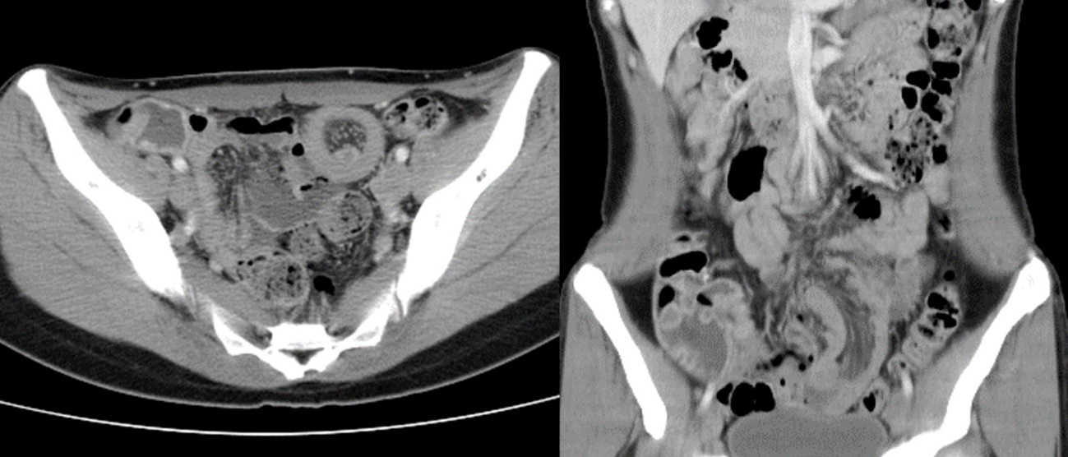
Figure 1 Computed tomography of abdomen: Computed tomography revealed an ileo-ileal intussusception. The leading point revealed hypovascular mass measuring 1cm in a diameter.

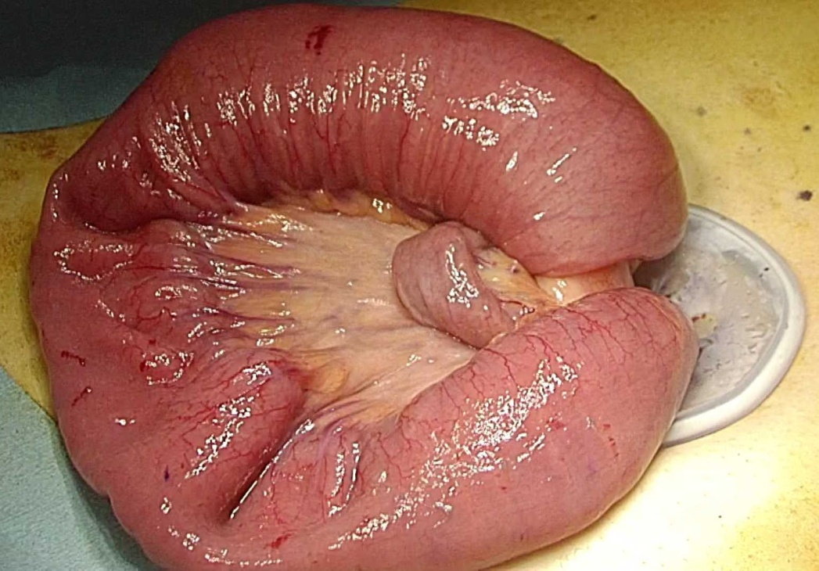
Figure 2 The lesion was externalized using forceps and hands through the umbilical incision.

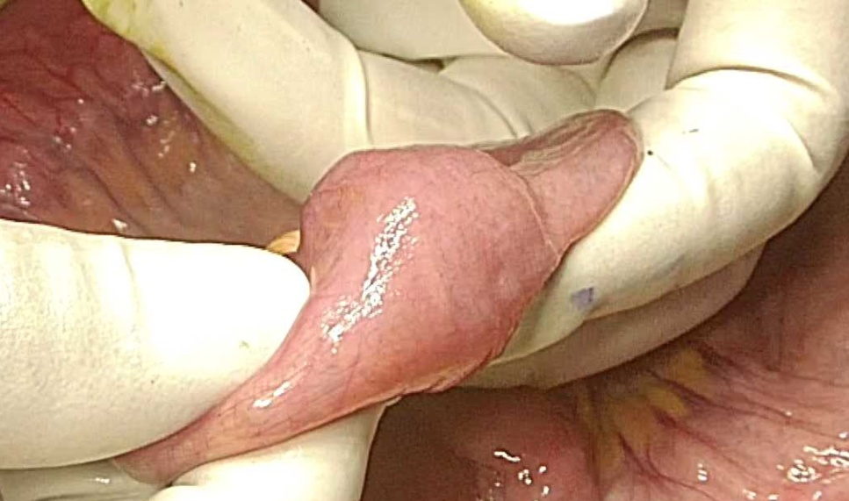
Figure 3 Leading point of intussusception was palpable and soft mass was confirmed.

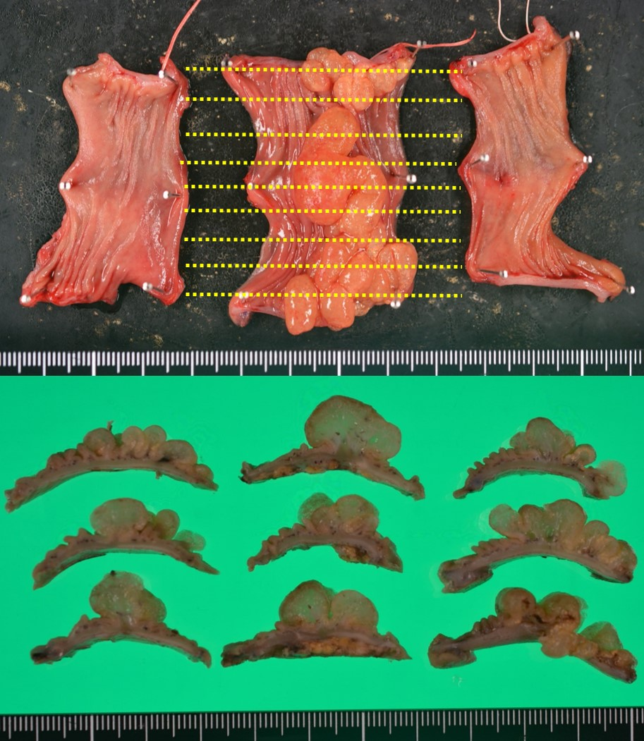
Figure 4 Microscopic findings of the resected specimen. Polycystic mass with convolutional pattern was found. Cutting lines are shown by lines.

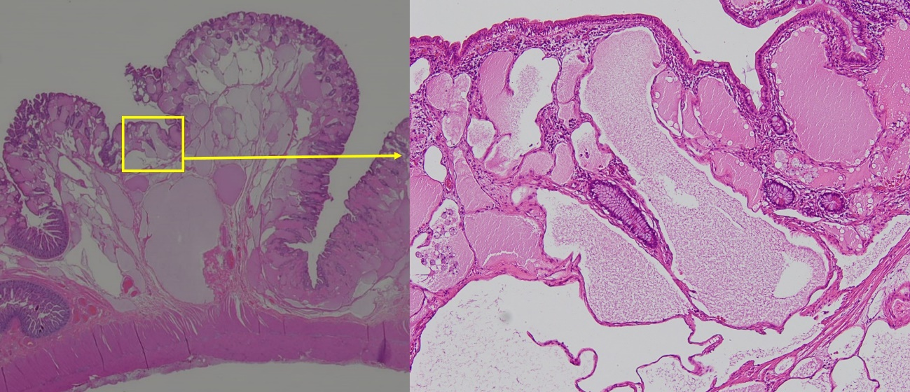
Figure 5 Microscopic findings: Cysts were lined by a flat epithelial endothelium. No blood cells were found.

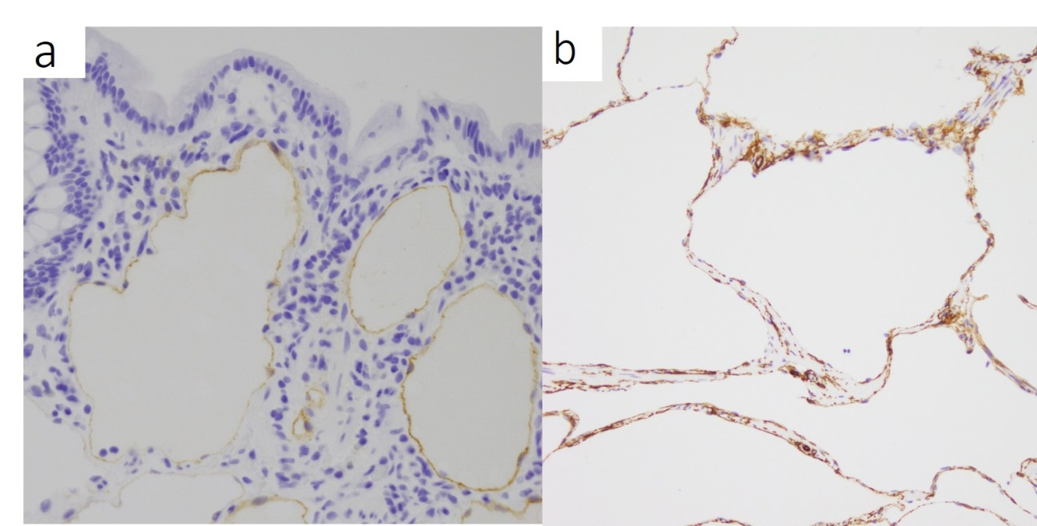
Figure 6 Immunohistochemical examination: The endothelial cells were partially positive for D2-40 (a) and CD34 (b).

