Name of Journal: World Journal of Clinical Cases
Manuscript NO: 84511
Manuscript Type: MINIREVIEWS

Low-dose immunotherapy as a potentiator to increase the response with neo-adjuvant chemotherapy in oral cancers

Rathinasamy N et al. Low-dose immunotherapy in oral cancers

Narmadha Rathinasamy, Sathish Muthu, Anand Krishnan

Narmadha Rathinasamy, Department of Medical Oncology, PSG Institute of Medical Science and Research, Coimbatore 641004, Tamil Nadu, India

Sathish Muthu, Department of Orthopaedics, Orthopaedic Research Group, Coimbatore 641045, Tamil Nadu, India

Sathish Muthu, Department of Biotechnology, School of Engineering and Technology, Sharda University, New Delhi 201310, Uttar Pradesh, India

Sathish Muthu, Department of Biotechnology, Faculty of Engineering, Karpagam Academy of Higher Education, Coimbatore 641021, Tamil Nadu, India

Anand Krishnan, Department of Chemical Pathology, School of Pathology, Faculty of Health Sciences, University of the Free State, Bloemfontein 9300, South Africa

Author contributions: Rathinasamy N performed the conceptualization; Muthu S did the data curation; Rathinasamy N and Muthu S did the data analysis; the manuscript writing and revision by all authors.

Corresponding author: Sathish Muthu, DNB, MS, Research Head, Department of Orthopaedics, Orthopaedic Research Group, Ramanathapuram, Coimbatore 641045, Tamil Nadu, India. drsathishmuthu@gmail.com

Received: March 17, 2023
Revised: May 12, 2023
Accepted: May 17, 2023
Published online:

Abstract
Neo-adjuvant chemotherapy (NACT) is utilized in locally advanced oral cancers to reduce the tumor burden and downstage the tumor to be amenable for definitive surgical management. Its long-term results compared to upfront surgical resection was not encouraging. Immunotherapy has now been used not only in recurrence and metastatic setting but also in the locally advanced tumor management regimens. The purpose of this concept paper is to bring forward the rationale to use a fixed low-dose immunotherapy agent as a potentiator to the standard NACT regimen and recommend their future investigation in oral cancer management.

Key Words: Immunotherapy; Neo-adjuvant chemotherapy; Oral cancer

Rathinasamy N, Muthu S, Krishnan A. Low-dose immunotherapy as a potentiator to increase the response with neo-adjuvant chemotherapy in oral cancers. World J Clin Cases 2023; In press

Core Tip: There is a need to potentiate the effect of neo-adjuvant chemotherapy (NACT) in oral cancers. The utilization of immunotherapy to enhance NACT has been shown to reduce metastasis and recurrence. Hence, the concept of low-dose immunotherapy as a potentiator of NACT could be implemented in routine practice. Moreover, low-dose immunotherapy-enhanced NACT helps us understand the predictors of treatment response.

INTRODUCTION
Neo-adjuvant chemotherapy (NACT) has been tried in locally advanced oral cancers to obtain a favorable pathological response (< 10% viable tumor cells) along with downstaging the tumor to be amenable for definitive surgical management^{[1]}. However, the long-term results of such management did not result in a significant long-term survival compared to upfront surgical resection without chemo-induction^{[1]}. Hence, there is a need for a synergistic combination with the chemotherapy regimen to potentiate their action and mark a significant effect upon implementation. The increasing evidence demonstrating the effectiveness of immunotherapy in the recurrent and metastatic setting has widened its horizons of utility into the locally advanced tumor management regimens for a host of reasons^{[2,3]}. First, the incorporation of immunotherapy into the curative management protocol would reduce their progression to metastasis and local recurrence. Second, their potential to downsize the tumor thereby reducing the morbidity and the extent of surgical resection are intriguing. Moreover, the addition of immunotherapy in the neo-adjuvant setting would help us understand the predictors of response to such therapy combinations^{[4]}. However, the heightened cost of such a combination limits their investigation. The purpose of this concept paper is to bring forward the rationale to use a fixed low-dose immunotherapy agent as a potentiator to the standard NACT regimen and recommend their future investigation in oral cancer management.

RATIONALE OF LOW DOSE IMMUNOTHERAPY
The receptor occupancy assays of the programmed cell death ligand 1 (PD-L1) molecules expressed on the peripheral blood lymphocytes with the use of a varying dose of anti-PD-1 immunotherapy agents demonstrated saturation kinetics at doses as low as 0.1-0.3 mg/kg demonstrating their avidity to the host receptors^{[5]}. Such affinity at low dose concentrations also lasted for nearly 3 mo post-administration similar to the higher dose regimens. Hence an anti-PD-1 immunotherapy agent such as nivolumab at a concentration as low as 0.1 mg/kg would be sufficient to produce a therapeutic receptor blockade compared to the standard dosing regimens^{[6]}. Moreover, phase-1 studies validated the concept with their finding that the response of the immunotherapy agent does not decrease with the decreased dose thereby demonstrating a non-linear dose-response curve for immunotherapy agents^{[5–7]}.

RATIONALE FOR COMBINING NEO-ADJUVANT IMMUNOTHERAPY WITH CHEMOTHERAPY
Immunotherapy orchestrates their action through cytotoxic lymphocytes which react with cancer cells to get activated resulting in cancer cell lysis. However, the effect of immunotherapy agents is limited by the permeability of the cytotoxic lymphocytes and their contact with the cancer cells expressing their respective antigens. The situation is also compounded by the immune suppression counter-mechanisms acting at the tumor site. On the other hand, chemotherapy results in disruption of the tumor stroma thereby increasing the permeability of the cytotoxic lymphocytes and decreasing the production of immune suppressive cytokines produced by the cancer cells. Moreover, chemotherapy increases the expression of tumor antigens to be detected by the cytotoxic lymphocytes as shown in Figure 1^{[8]}.

LIMITATIONS
The main limitation behind the introduction of the immunotherapy agents into the treatment regimens could be the economic burden to the patient or the payers. With the introduction of the fixed lose-dose strategy in immunotherapy, the major burden is lifted thereby making the advantages of the therapy affordable to the patient^{[9]}. However, even at low-doses addition of immunotherapy agents to the existing potentiation chemotherapy regimens increase the cost of treatment but it could be considered a cost-efficient alternative to reduce the events of recurrence or metastasis^{[3]}. Moreover, alternate strategies are being devised to identify the therapeutic efficiency of the immunotherapy apart from the dosage regimen traditionally utilized^{[10]}.
The recent clinical trial results of Patil et al^{[11]} comparing the overall survival of patients treated with traditional metronomic chemotherapy combined with a low dose (20 mg) of nivolumab in head and neck squamous cell carcinoma demonstrated superiority in overall survival compared to the traditional metronomic chemotherapy. The encouraging results of this study would recommend the addition of fixed low-dose immunotherapy in the routine NACT regimens in oral cancers to gain additional benefits without any financial constrain from the traditional dosing regimens.

CONCLUSION
Combining the advantages of two classes of induction agents, chemotherapy and immunotherapy, when used in combination in the curative setting of locally advanced oral cancers would benefit the patient to downstage the tumor effectively to make curative surgical resection less morbid and more successful^{[12]}. Taking the pharmacokinetics, receptor occupancy analysis, and synergistic co-stimulation, low-dose anti-PD-1 immunotherapy agents proves to be a valuable addition to the existing neo-adjuvant induction chemotherapy regimens to potentiate their action in locally advanced oral cancers counteracting the economic burden involved with the immunotherapy treatment combinations.

REFERENCES
1 Zhong LP, Zhang CP, Ren GX, Guo W, William WN Jr, Hong CS, Sun J, Zhu HG, Tu WY, Li J, Cai YL, Yin QM, Wang LZ, Wang ZH, Hu YJ, Ji T, Yang WJ, Ye WM, Li J, He Y, Wang YA, Xu LQ, Zhuang Z, Lee JJ, Myers JN, Zhang ZY. Long-term results of a randomized phase III trial of TPF induction chemotherapy followed by surgery and radiation in locally advanced oral squamous cell carcinoma. Oncotarget 2015; 6: 18707-18714 [PMID: 26124084 DOI: 10.18632/oncotarget.4531]
2 Gillison ML, Trotti AM, Harris J, Eisbruch A, Harari PM, Adelstein DJ, Jordan RCK, Zhao W, Sturgis EM, Burtness B, Ridge JA, Ringash J, Galvin J, Yao M, Koyfman SA, Blakaj DM, Razaq MA, Colevas AD, Beitler JJ, Jones CU, Dunlap NE, Seaward SA, Spencer S, Galloway TJ, Phan J, Dignam JJ, Le QT. Radiotherapy plus cetuximab or cisplatin in human papillomavirus-positive oropharyngeal cancer (NRG Oncology RTOG 1016): a randomised, multicentre, non-inferiority trial. Lancet 2019; 393: 40-50 [PMID: 30449625 DOI: 10.1016/S0140-6736(18)32779-X]
3 Mohan SP, Bhaskaran MK, George AL, Thirutheri A, Somasundaran M, Pavithran A. Immunotherapy in Oral Cancer. J Pharm Bioallied Sci 2019; 11: S107-S111 [PMID: 31198321 DOI: 10.4103/JPBS.JPBS_31_19]
4 Stafford M, Kaczmar J. The neoadjuvant paradigm reinvigorated: a review of pre-surgical immunotherapy in HNSCC. Cancers Head Neck 2020; 5: 4 [PMID: 32195008 DOI: 10.1186/s41199-020-00052-8]
5 Brahmer JR, Drake CG, Wollner I, Powderly JD, Picus J, Sharfman WH, Stankevich E, Pons A, Salay TM, McMiller TL, Gilson MM, Wang C, Selby M, Taube JM, Anders R, Chen L, Korman AJ, Pardoll DM, Lowy I, Topalian SL. Phase I study of single-agent anti-programmed death-1 (MDX-1106) in refractory solid tumors: safety, clinical activity, pharmacodynamics, and immunologic correlates. J Clin Oncol 2010; 28: 3167-3175 [PMID: 20516446 DOI: 10.1200/JCO.2009.26.7609]
6 Feng Y, Wang X, Bajaj G, Agrawal S, Bello A, Lestini B, Finckenstein FG, Park JS, Roy A. Nivolumab Exposure-Response Analyses of Efficacy and Safety in Previously Treated Squamous or Nonsquamous Non-Small Cell Lung Cancer. Clin Cancer Res 2017; 23: 5394-5405 [PMID: 28916617 DOI: 10.1158/1078-0432.CCR-16-2842]
7 Agrawal S, Feng Y, Roy A, Kollia G, Lestini B. Nivolumab dose selection: challenges, opportunities, and lessons learned for cancer immunotherapy. J Immunother Cancer 2016; 4: 72 [PMID: 27879974 DOI: 10.1186/s40425-016-0177-2]
8 Ramakrishnan R, Gabrilovich DI. Mechanism of synergistic effect of chemotherapy and immunotherapy of cancer. Cancer Immunol Immunother 2011; 60: 419-423 [PMID: 20976448 DOI: 10.1007/s00262-010-0930-1]
9 Patil VM, Noronha V, Joshi A, Abhyankar A, Menon N, Banavali S, Gupta S, Prabhash K. Low doses in immunotherapy: Are they effective? Cancer Res Stat Treat 2019; 2: 54 [DOI: 10.4103/CRST.CRST_29_19]
10 Chen C, Fan X, Zhang L, Xu P, Zou H, Zhao X, Gupta M, Feng YS, Xu XS, Yan X. Clearance as an Early Indicator of Efficacy for Therapeutic Monoclonal Antibodies: Circumventing Dose Selection Challenges in Oncology. Clin Pharmacokinet 2023; 62: 705-713 [PMID: 36930421 DOI: 10.1007/s40262-023-01231-9]
11 Patil VM, Noronha V, Menon N, Rai R, Bhattacharjee A, Singh A, Nawale K, Jogdhankar S, Tambe R, Dhumal S, Sawant R, Alone M, Karla D, Peelay Z, Pathak S, Balaji A, Kumar S, Purandare N, Agarwal A, Puranik A, Mahajan A, Janu A, Kumar Singh G, Mittal N, Yadav S, Banavali S, Prabhash K. Low-Dose Immunotherapy in Head and Neck Cancer: A Randomized Study. J Clin Oncol 2023; 41: 222-232 [PMID: 36265101 DOI: 10.1200/JCO.22.01015]
12 Li X, Fang Q, Du W, Zhang X, Dai L, Qiao Y. Induction chemotherapy combined with immunotherapy in locally advanced head and neck squamous cell carcinoma. BMC Cancer 2021; 21: 622 [PMID: 34044810 DOI: 10.1186/s12885-021-08373-8]

Footnotes
Conflict-of-interest statement: All the authors report no relevant conflicts of interest for this article.

Open-Access: This article is an open-access article that was selected by an in-house editor and fully peer-reviewed by external reviewers. It is distributed in accordance with the Creative Commons Attribution NonCommercial (CC BY-NC 4.0) license, which permits others to distribute, remix, adapt, build upon this work non-commercially, and license their derivative works on different terms, provided the original work is properly cited and the use is non-commercial. See: https://creativecommons.org/Licenses/by-nc/4.0/

Provenance and peer review: Invited article; Externally peer reviewed.

Peer-review model: Single blind

Peer-review started: March 17, 2023
First decision: May 12, 2023
Article in press:

Specialty type: Medicine, research and experimental
Country/Territory of origin: India
Peer-review report’s scientific quality classification
Grade A (Excellent): 0
Grade B (Very good): B
Grade C (Good): C
Grade D (Fair): 0
Grade E (Poor): 0

P-Reviewer: Rohani B, Iran; Wang LH, China S-Editor: Fan JR L-Editor: A P-Editor: Fan JR
Figure Legends
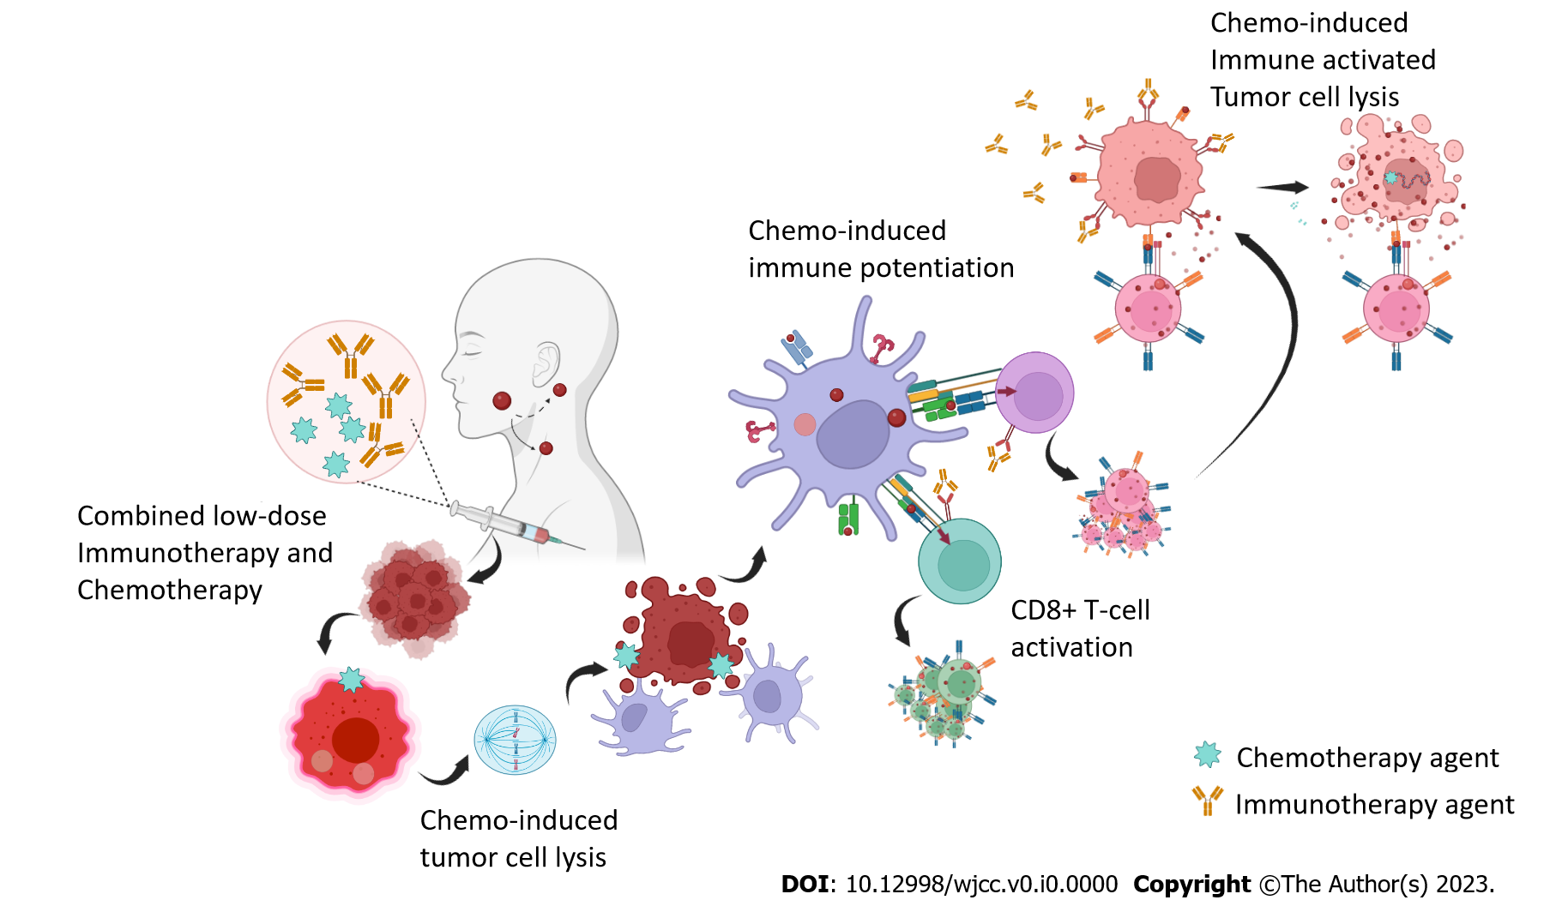
Figure 1 The potentiation role of low-dose immunotherapy with the standard potentiation neo-adjuvant chemotherapy in oral cancers.

