Name of Journal: World Journal of Clinical Cases
Manuscript NO: 64314
Manuscript Type: CASE REPORT

Cytomegalovirus colitis induced segmental colonic hypoganglionosis in an immunocompetent patient: A case report

Kim BS et al. CMV colitis induced hypoganglionosis

Ban Seok Kim, Seon-Young Park, Dong Hyun Kim, Nah Ihm Kim, Jae Hyun Yoon, Jae Kyun Ju, Chang Hwan Park, Hyun Soo Kim, Sung Kyu Choi

Ban Seok Kim, Seon-Young Park, Dong Hyun Kim, Jae Hyun Yoon, Chang Hwan Park, Hyun Soo Kim, Sung Kyu Choi, Department of Gastroenterology, Chonnam National University Hospital, Gwangju 501-757, South Korea

Nah Ihm Kim, Department of Pathology, Chonnam National University Hospital, Gwangju 501-757, South Korea

Jae Kyun Ju, Department of Surgery, Chonnam University Hospital, Gwangju 501-757, South Korea

Author contributions: Kim BS and Park SY conceived and designed the study, and contributed to manuscript drafting; Kim DH and Yoon JH performed literature review; Kim NI and Ju JK took the images; Park CH and Kim HS contributed to manuscript drafting; Choi SK reviewed the cases and edited the manuscript; all authors have read and approved the final manuscript.

Supported by Chonnam National University Hospital Research Institute of Clinical Medicine, No. BCRI20023.

Corresponding author: Seon-Young Park, MD, PhD, Professor, Department of Gastroenterology, Chonnam National University Hospital, 42 Jaebong-ro, Donggu, Gwangju 501-757, South Korea. drpsy@naver.com

Received: February 18, 2021
Revised: May 2, 2021
Accepted: June 1, 2021
Published online: July 16, 2021

Abstract
BACKGROUND
Cytomegalovirus (CMV) colitis is usually seen in immunocompromised patients with risk factors such as human immunodeficiency virus infection, solid organ transplant, inflammatory bowel disease, or malignancy. Therefore, many clinicians usually do not consider the possibility of CMV colitis in immunocompetent patients. We reported a rare case of segmental colonic hypoganglionosis associated with CMV colitis in an immunocompetent patient.

CASE SUMMARY
A 48-year-old woman with no underlying disease was admitted to our hospital for severe abdominal pain and constipation. Computed tomography of the abdomen showed diffuse dilatation of the small intestine and the entire colon. Initial sigmoidoscopic findings and result of polymerase chain reaction (PCR) for CMV revealed the compatible findings of CMV colitis, the patient was treated with intravenous ganciclovir. After treatment, sigmoidoscopic findings and CMV PCR results improved. However the patient continued to suffered from constipation. Eight months after the initial admission, patient visited the emergency department with severe abdominal pain and imaging revealed aggravation of fecal impaction and bowel dilatation. We performed subtotal colectomy to control patient’s symptom. Histological examination of the resected specimen showed significantly reduced number of mature ganglion cells in the sigmoid colon compared to that in the proximal colon.

CONCLUSION
Our case demonstrates that CMV colitis can develop even in patients with no other underlying disease, and that CMV colitis can be one of the causes for developing colonic hypoganglionosis.

Key Words: Colonic pseudo-obstruction; Colitis; Cytomegalovirus; Ganglia; Case report

©The Author(s) 2021. Published by Baishideng Publishing Group Inc. All rights reserved.

Citation: Kim BS, Park SY, Kim DH, Kim NI, Yoon JH, Ju JK, Park CH, Kim HS, Choi SK. Cytomegalovirus colitis induced segmental colonic hypoganglionosis in an immunocompetent patient: A case report. World J Clin Cases 2021; 9(20): 5631-5636
URL: https://www.wjgnet.com/2307-8960/full/v9/i20/5631.htm
DOI: https://dx.doi.org/10.12998/wjcc.v9.i20.5631

Core Tip: Cytomegalovirus (CMV) colitis is usually seen in immunocompromised patients such as those with human immunodeficiency virus infection, solid organ transplant, inflammatory bowel disease, or malignancy. In this paper, we report a rare case of CMV colitis induced segmental colonic hypoganglionosis in an immunocompetent patient. This case highlights the importance of clinical suspicion of CMV infection in immunocompetent patients with colonic ulcers and atypical symptoms to ensure its early diagnosis and favorable outcomes.

INTRODUCTION
Cytomegalovirus (CMV) colitis is a common manifestation of CMV tissue-invasive end-organ disease, usually seen in immunocompromised patients with risk factors such as human immunodeficiency virus infection, solid organ transplant, inflammatory bowel disease, or malignancy^{[1-4]}. Recent studies have reported CMV colitis in immunocompetent patients, but there were risk factors such as old age, blood transfusion, and recent steroid use in most patients. Therefore, many clinicians usually do not consider the possibility of CMV colitis in immunocompetent patients^{[5]}.
Hypoganglionosis is characterized by a decreased in the number of ganglion cells in the submucosa and myenteric plexuses of the colon. While hypoganglionosis is usually congenital and occurs at infancy or early childhood, acquired hypoganglionosis (adult-onset form) is extremely uncommon and cause intractable constipation or pseudo-obstruction.
Here, we presented a case of segmental colonic hypoganglionosis associated with CMV colitis in an immunocompetent patient.

CASE PRESENTATION
Chief complaints
Severe abdominal pain and constipation.

History of present illness
A 48-year-old woman with unremarkable medical history other than intermittent constipation, was presented to the emergency department (ED) complaining of severe abdominal pain and absence of spontaneous bowel movements.

History of past illness
The patients had no remarkable history of any underlying disease or prior surgery.

Physical examination
Physical examination revealed abdominal distension with hyperactive bowel sounds and diffuse abdominal tenderness.

Laboratory examinations
Routine laboratory evaluation was normal, including complete blood cell count, urine analysis, biochemical tests and thyroid function test.

Imaging examinations
Abdominal X-ray and computed tomography (CT) scan showed diffuse dilation of the small intestine and the entire colon without any definite obstructive lesion (Figure 1A and B). Sigmoidoscopy showed multiple geographic friable ulcerative lesions in the sigmoid colon (Figure 2A).

Further diagnostic work-up
Pathologic findings showed necro-inflammatory mucosal change with positive CMV immunohistochemical stain. CMV polymerase chain reaction (PCR) for colonic mucosa (1.7 × 10⁵ copies/mL) and blood (4.5 × 10² copied/mL) were also positive.

FINAL DIAGNOSIS
CMV colitis induced segmental hypoganglionosis.

TREATMENT
Based on the Sigmoidoscopic imaging, pathologic findings and positive CMV PCR result, this patient was diagnosed with CMV colitis, despite of the patient had no underlying disease.
Partial improvement of clinical symptoms was achieved with intravenous (IV) ganciclovir (5 mg/kg, every 12 h for 2 wk) and oral laxatives. Follow-up colonoscopy after 3 mo showed improvement of previous ulcerative lesions (Figure 2B) and blood CMV PCR results turned negative, even though the patient was still suffering from constipation.
Eight months after initial admission, she visited the ED again due to severe constipation with abdominal pain. CT scan revealed aggravation of fecal impaction and bowel dilatation from the ascending to the descending colon with edematous colonic wall thickening in the sigmoid colon (Figure 1C and D). As she had suffered from recurrent symptoms of colonic pseudo-obstruction, we decided to perform surgery to relieve her symptoms. Histological examination of the resected specimen showed normal feature of mucosa and submucosal vascular congestion. However, the myenteric plexus contained a significantly reduced number of mature ganglion cells in the sigmoid colon compared to that in the proximal colon (Figure 3).

OUTCOME AND FOLLOW-UP
The patient was followed-up for 1 year after operation with improvement in her bowel habits after colectomy.

DISCUSSION
Even though CMV colitis has been known to occur in immunocompromised hosts^{[6]}, recent studies suggested an increasing trend of CMV colitis in immunocompetent patients, especially with risk factors such as old age, renal failure, recent use of steroid or a recent history of blood transfusion^{[1,2]}. However, in the current case, risk factors that may have affected the immune system such as underlying disease or a recent history of using immunosuppressant medication were not present.
Symptoms of CMV colitis are variable and include diarrhea, fever, abdominal pain, hemorrhage, colonic pseudo-obstruction or perforation^{[3-5]}.
Even though spontaneous remission without antiviral therapy might occur in immunocompetent patients^{[6]}, the treatment of choice for CMV colitis is antiviral therapy with ganciclovir or foscarnet. Previous reports showed no treatment failure in immunocompetent patients diagnosed with CMV colitis who were treated with IV ganciclovir^{[1]}. In this case, the clinical symptoms such as abdominal pain and stool passage partially improved and follow-up colonoscopy revealed resolution of prior colonic mucosal ulcers. However, despite complete healing of mucosal ulceration, histopathological examination of the resected specimen showed a decreased number of ganglion cells in the myenteric plexus, which may suggest irreversible nerve damage of the colonic wall. This finding was in line with those of previous studies, which showed that a viral infection might result in degeneration and loss of ganglion cells in patients with colonic pseudo-obstruction^{[7-9]}.
Since the patient had intermittent constipation, the possibility of the exacerbation of preexisting colonic hypoganglionosis caused by CMV colitis cannot be excluded. However, according to previous report, the mean duration of constipation in acquired hypoganglionosis was 7 years, whereas in this case patient, the duration of constipation was not long^{[10]}. And she regarded as her symptoms as mild, which were controlled by intermittent taking laxatives such as bulking agents or osmotic laxatives. Furthermore, since the patient's symptoms improved after the initial treatment with CMV colitis, and constipation gradually worsened afterward, it was thought to be more likely to develop acquired hypoganglionosis due to CMV colitis.
This case suggested the importance of clinical suspicion of CMV infection in immunocompetent patients presenting with colonic ulcer and atypical symptoms to ensure early diagnosis and favorable outcomes.

CONCLUSION
We report a rare case of CMV colitis induced segmental hypoganglionosis in immunocompetent patient. This case highlights that CMV colitis can develop even in patients with no other underlying disease, and that CMV colitis can be one of the causes of colonic hypoganglionosis

REFERENCES
1 Ko JH, Peck KR, Lee WJ, Lee JY, Cho SY, Ha YE, Kang CI, Chung DR, Kim YH, Lee NY, Kim KM, Song JH. Clinical presentation and risk factors for cytomegalovirus colitis in immunocompetent adult patients. Clin Infect Dis 2015; 60: e20-e26 [PMID: 25452594 DOI: 10.1093/cid/ciu969]
2 Cho JH, Choi JH. Cytomegalovirus ileo-pancolitis presenting as toxic megacolon in an immunocompetent patient: A case report. World J Clin Cases 2020; 8: 552-559 [PMID: 32110666 DOI: 10.12998/wjcc.v8.i3.552]
3 Yerushalmy-Feler A, Padlipsky J, Cohen S. Diagnosis and Management of CMV Colitis. Curr Infect Dis Rep 2019; 21: 5 [PMID: 30771028 DOI: 10.1007/s11908-019-0664-y]
4 Orloff JJ, Saito R, Lasky S, Dave H. Toxic megacolon in cytomegalovirus colitis. Am J Gastroenterol 1989; 84: 794-797 [PMID: 2545094]
5 Shimada Y, Iiai T, Okamoto H, Suda T, Hatakeyama K, Honma T, Ajioka Y. Toxic megacolon associated with cytomegalovirus infection in ulcerative colitis. J Gastroenterol 2003; 38: 1107-1108 [PMID: 14673733 DOI: 10.1007/s00535-003-1217-5]
6 Galiatsatos P, Shrier I, Lamoureux E, Szilagyi A. Meta-analysis of outcome of cytomegalovirus colitis in immunocompetent hosts. Dig Dis Sci 2005; 50: 609-616 [PMID: 15844689 DOI: 10.1007/s10620-005-2544-6]
7 Holland-Cunz S, Göppl M, Rauch U, Bär C, Klotz M, Schäfer KH. Acquired intestinal aganglionosis after a lytic infection with varicella-zoster virus. J Pediatr Surg 2006; 41: e29-e31 [PMID: 16516611 DOI: 10.1016/j.jpedsurg.2005.12.060]
8 Taguchi T, Masumoto K, Ieiri S, Nakatsuji T, Akiyoshi J. New classification of hypoganglionosis: congenital and acquired hypoganglionosis. J Pediatr Surg 2006; 41: 2046-2051 [PMID: 17161202 DOI: 10.1016/j.jpedsurg.2006.08.004]
9 Song EM, Kim JW, Lee SH, Chang K, Hwang SW, Park SH, Yang DH, Jung KW, Ye BD, Byeon JS, Yang SK, Lee HJ, Yu CS, Kim CW, Park SH, Kim J, Myung SJ. Colonic Pseudo-obstruction With Transition Zone: A Peculiar Eastern Severe Dysmotility. J Neurogastroenterol Motil 2019; 25: 137-147 [PMID: 30646485 DOI: 10.5056/jnm18121]
10 Do MY, Myung SJ, Park HJ, Chung JW, Kim IW, Lee SM, Yu CS, Lee HK, Lee JK, Park YS, Jang SJ, Kim HJ, Ye BD, Byeon JS, Yang SK, Kim JH. Novel classification and pathogenetic analysis of hypoganglionosis and adult-onset Hirschsprung's disease. Dig Dis Sci 2011; 56: 1818-1827 [PMID: 21222160 DOI: 10.1007/s10620-010-1522-9]

Footnotes
Informed consent statement: Written informed consent was obtained from the patient for the publication of this report and any accompanying images.

Conflict-of-interest statement: The authors declare that they have no conflicts of interests.

CARE Checklist (2016) statement: The authors have read the CARE Checklist (2016), and the manuscript was prepared and revised according to the CARE Checklist (2016).

Open-Access: This article is an open-access article that was selected by an in-house editor and fully peer-reviewed by external reviewers. It is distributed in accordance with the Creative Commons Attribution NonCommercial (CC BY-NC 4.0) license, which permits others to distribute, remix, adapt, build upon this work non-commercially, and license their derivative works on different terms, provided the original work is properly cited and the use is non-commercial. See: http://creativecommons.org/Licenses/by-nc/4.0/

Manuscript source: Unsolicited manuscript

Peer-review started: February 18, 2021
First decision: April 24, 2021
Article in press: June 1, 2021

Specialty type: Medicine, research and experimental
Country/Territory of origin: South Korea
Peer-review report’s scientific quality classification
Grade A (Excellent): 0
Grade B (Very good): 0
Grade C (Good): C
Grade D (Fair): 0
Grade E (Poor): 0

P-Reviewer: Jin B S-Editor: Fan JR L-Editor: A P-Editor: Wang LYT

Figure Legends
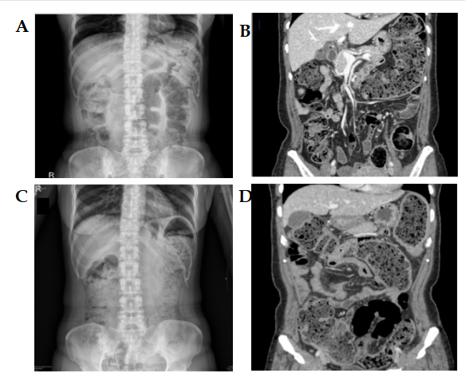
Figure 1 Abdominal X-ray and computed tomography images. A and B: Abdominal X-ray and computed tomography (CT) scan at initial admission showed fecal impaction and diffuse dilatation of the entire colon; C and D: Abdominal X-ray and CT scan 8 mo after initial admission showed aggravation of fecal impaction and bowel dilatation involving both the ascending and the descending colon with edematous colonic wall thickening in the sigmoid colon.
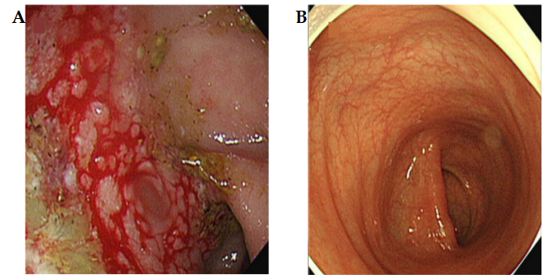
Figure 2 Sigmoidoscopic images. A: Initial sigmoidoscopy showed geographic ulcerative lesions with extremely friable mucosa in the sigmoid colon, which could bleed easily when touch; B: 3 mo after intravenous ganciclovir administration, ulcerative lesions had improved on sigmoidoscopy.
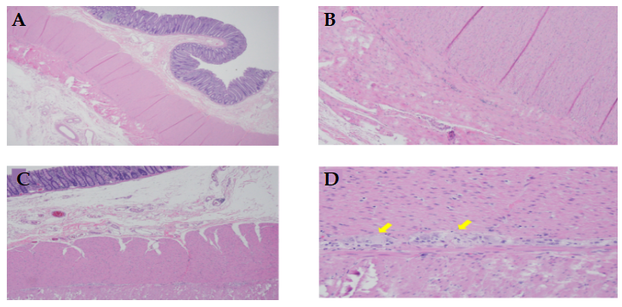
Figure 3 Histopathological findings. A and B: Reduced number of ganglion cells in the sigmoid colon; C and D: Number of ganglion cells was relatively maintained in the proximal colon. Arrow: Normal ganglion cell (D).

Published by Baishideng Publishing Group Inc
7041 Koll Center Parkway, Suite 160, Pleasanton, CA 94566, USA
Telephone: +1-925-3991568
E-mail: bpgoffice@wjgnet.com
Help Desk: https://www.f6publishing.com/helpdesk
https://www.wjgnet.com

© 2021 Baishideng Publishing Group Inc. All rights reserved.

