Name of Journal: World Journal of Gastroenterology
ESPS Manuscript NO: 22893
Manuscript Type: Review

Estrogen receptors in gastric cancer: advances and perspectives

Rahman MS et al. Estrogen receptors in gc

Muhammad Saif Ur-Rahman, Jiang Cao

Muhammad Saif Ur-Rahman, Jiang Cao, Clinical Research Center, The Second Affiliated Hospital, Zhejiang University School of Medicine, Hangzhou 310009, Zhejiang Province, China

Author contributions: Rahman MS and Cao J solely contributed to this paper.

Supported by the National Natural Science Foundation of China, No. 30271450, No. 30471955, No. 30672365 and No. 81172516.

Conflict-of-interest statement: The authors declare no conflict of interests for this article.

Open-Access: This article is an open-access article which was selected by an in-house editor and fully peer-reviewed by external reviewers. It is distributed in accordance with the Creative Commons Attribution Non Commercial (CC BY-NC 4.0) license, which permits others to distribute, remix, adapt, build upon this work non-commercially, and license their derivative works on different terms, provided the original work is properly cited and the use is non-commercial. See: http://creativecommons.org/licenses/by-nc/4.0/

Correspondence to: Jiang Cao, PhD, Clinical Research Center, The Second Affiliated Hospital, Zhejiang University School of Medicine, No. 88 Jiefang Road, Hangzhou 310009, Zhejiang Province, China. caoj@zju.edu.cn
Telephone: +86-571-87315202
Fax: +86-571-87315201

Received: September 30, 2015
Peer-review started: October 1, 2015
First decision: November 5, 2015
Revised: November 23, 2015
Accepted: December 12, 2015
Article in press:
Published online:

Abstract
Gastric cancer is one of the most common malignancies worldwide with high mortality. Extensive investigations are being conducted in various aspects of the development and progression of gastric cancer in order to furnish us with better understanding and more effective means in prevention, diagnosis and therapy of the disease. Estrogen receptors (ERs) are steroid hormone receptors that regulate cellular activities in many physiological and pathological processes of different tissues. There are two distinct forms of ERs, namely ER alpha (ERα) and ER beta (ERβ), with several alternative-splicing isoforms for each. They show distinct tissue distribution patterns and exert different biological functions. Dysregulation of ERs has been found to be associated closely with many diseases including cancer. A number of studies have been conducted to investigate the roles ERs play in gastric cancer, the possible mechanisms for these roles, and the clinical relevance of deregulated ERs in gastric cancer patients. Inconsistent associations of different ERs with gastric cancer have been reported up to date. The inconsistence may be caused by the variables in in vitro cell models and clinical samples, including assay conditions and protocols with regard to different forms of the ERs. Expecting the potentials of the deregulated ERs as diagnostic/prognostic markers or therapeutic targets for gastric cancer, it will be important to identify/confirm the association of each ER isoform with gastric cancer, the specific roles and interactions of these individual ER isoforms play under specific conditions in the development and/or progression of gastric cancer, and to elucidate the precise mechanisms. In this review we summarize the achievements from early ERs studies in gastric cancer to the most up-to-date discoveries with an effort to provide a comprehensive understanding of ERs’ roles and possible mechanisms in gastric cancer, and propose directions for future investigations.

Key words: Gastric cancer; Estrogen receptor; Isoform; Carcinogenesis; Mechanism; Genomic pathway; Non-genomic pathway

© The Author(s) 2015. Published by Baishideng Publishing Group Inc. All rights reserved.

Core tip: Gastric cancer is one of the common malignancies worldwide with high mortality. Estrogen receptors (ERs) are steroid hormone receptors that regulate cellular activities in many physiological and pathological processes of different tissues. Dysregulation of ERs is associated with many diseases including gastric cancer. Studies have been conducted to investigate the roles and possible mechanisms that ERs play in gastric cancer and the clinical relevance of deregulated ERs in gastric cancer patients. This review focuses on the current understandings of ERs in gastric cancer and proposes directions for future investigations.

Ur-Rahman MS, Cao J. Estrogen receptors in gastric cancer: advances and perspectives. World J Gastroenterol 2015; In press

INTRODUCTION
Gastric cancer is one of the most common types of cancer and one of the leading causes of cancer-related deaths world-wide, with an estimated 723100 deaths and 951600 new cases in 2012^{[1]}. Currently tremendous efforts are being made to investigate various cellular and molecular mechanisms leading to the development and progression of gastric cancer, hoping to improve the prevention, early diagnosis and precise and personalized treatment with approaches based on the new findings.
Estrogens are a class of steroids that was initially found to regulate the development and growth of human reproductive system. Estrogens exert their influences on specific cells via their receptors (estrogen receptors, ERs). Estrogens/ERs are now also found to be involved in other physiological/pathological processes of cardiovascular, skeletal and neuroendocrine systems^{[2]}. ERα and ERβ were first cloned from human breast cancer MCF-7 cells and from rat prostate in 1986 and 1996 respectively^{[3]}. ERα and ERβ are members of a superfamily of nuclear receptor that can transduce extracellular signals into transcriptional response, with distinct protein structural characteristics, tissue distributions and functions^{[4,5]}. In certain ligands, cell-types, and promoter contexts ERα and ERβ have different activities^{[6]}.
As illustrated in Figure 1, ERs share conserved domains for ligand binding (LBD), DNA binding (DBD), transcription activation (AF1 and AF2) and nuclear translocation (NLS). Three isoforms for ERα have been identified, designated as ERα66, ERα46 and ERα36 respectively based on their protein molecular weights^{[7]}. ER66 functions as a ligand-dependent transcription factor that modulates the gene expression by binding to estrogen response elements (EREs) in the transcriptional regulatory region in genomic DNA^{[5]}. Despite lacking of the AF-1 activation domain, ERα46 can still bind to EREs and form heterodimers with ERα66^{[8,9]}. The subcellular localization and activation of Src/PI3k/AKT pathways upon estrogen-signaling also indicate possible roles for ERα46 in non-genomic estrogen signaling^{[10-12]}. For ERα36, both activation domains (AF-1 and AF-2) are absent, but it retains the ability of dimerization, nuclear translocation and DNA binding, with an even broader ligand-binding spectrum and may mediates rapid estrogen signaling^{[7,13]}. Five alternatively spliced isoforms for ER have been identified (ER1-ER5). ER appears to have a weaker corresponding AF-1 domain and its transcriptional activation function depends more on the AF-2 domain rather than AF-1 domain.
Expressions of ERs have been well documented in a variety of human tumors, including gastric cancer^{[14-24]}. Hormonal therapy targeting ERs for the treatment of breast cancer has played a remarkable role^{[25,26]}. Investigation on the roles and mechanisms of these ERs in gastric cancer will surely provide us more means for the management of the disease.
In this review we summarize the achievements from early ERs studies in gastric cancer to the most up-to-date discoveries with an effort to provide a comprehensive understanding of ERs’ roles and possible mechanisms in gastric cancer, and propose directions for future investigations.

EXPRESSIONAL AND FUNCTIONAL INVESTIGATIONS ON ESTROGEN RECEPTORS IN GASTRIC CANCER
ERα66 (ERα)
Most of the literatures use terms “ER” or “ERα” when actually referring to the specific isoform ERα66 as it is the major and first identified isoform. Early investigation on ER expression in gastric cancer was initiated by the observation of the association between breast cancer and gastrointestinal cancer, but no correlation between ER expression and gastric cancer was found^{[27]}. The ER positive rate in gastric carcinoma was not significantly different between male and female cases^{[27,28]}, but the incidence in poorly differentiated adenocarcinoma being significantly higher than that of well differentiated adenocarcinoma^{[28]}. Later studies further showed the correlation of ER status to tumor grades in gastric cancer^{[29,30]}, and ER expression was found to be associated with diffuse type gastric cancer and shorter disease free survival^{[31]}. At mRNA level, the ERα expression between gastric cancer tissues and matched normal tissues had no statistically significant difference, but ERα-positive expression correlated with poorer overall survival^{[15]}.
However, some investigations showed inconsistent results in established cell lines. More cell lines showed ERα expression by RT-PCR than that by Western blotting^{[31,32]}, which may be due to the differences of sensitivity between the assays. ERα overexpression significantly inhibited cell growth and proliferation, promoted cell apoptosis, blocked cell entry into the G₁/G₀ phase. In addition, ERα reduced the motility and invasion of gastric cancer cells. Over expression of ER  decreases β-catenin expression, this phenomena may partly explain this expression level. By suppressing β-catenin, ERα overexpression effectively inhibited cell growth and cancer progression in gastric cancer^{[33]}.

ERα36
Although no work has been reported on ERα46 in gastric cancer up to date, there are some studies investigated the clinical significance and functions of ERα36 in gastric cancer. ERα36 is found to be highly expressed in human gastric cancer, and such expression is correlated with lymph node metastasis and may be used as a predictive marker for lymph node metastasis of gastric cancer^{[34]}. Both mRNA and protein of ERα36 were detected in the established gastric cancer cell lines examined. Higher ERα36 mRNA level were expressed in tumor specimens examined compared to the paired normal tissues. ERα36 protein was mainly expressed on the plasma membrane and in the cytoplasm of the established gastric cancer cells^{[34]}.

ER
For the clinical relevance of ERβ with gastric cancer, ERβ-positive group was associated with lower tumor stage, negative perineural invasion, and Lauren’s intestinal type and free of recurrence. Presence of ERβ in gastric cancer could have a protective effect against invasiveness of gastric cancer^{[32]}, similar to the functions of ER in inhibiting proliferation, invasion and tumor formation of breast cancer cells^{[35-37]}. In multivariate analysis, the absence of ERβ was a significant independent prognostic factor which associated with poor overall survival^{[15]}.
A more recent study, however, showed that although ERs are present in both gastric tumors and normal tissues, their expression levels were extremely low except for the predominance of ERβ, and they may only be partly involved in gastric carcinogenesis but their clinicopathological and prognostic significance in gastric cancer appears to be limited^{[38]}.
For the transcription variants of ERβ in gastric cancer tissues, higher ERβ5 mRNA level was correlated with pTNM stage of the tumor, the lymph node metastasis compared to their matched normal tissues while ERβ1 and β2 were not correlated with lymph node metastasis, gender, age, tumor size, tumor grade and pTNM stage^{[39]} (Table 1).

MECHANISMS FOR ERS’ FUNCTIONS IN GASTRIC CANCER
Current knowledge on the mechanisms for ERs’ functions in cancer mainly comes from investigations in breast cancer, which may be extendable to other cancers including gastric cancer. Estrogens exert their functions via ERs through both genomic and non-genomic ways^{[40]}. As illustrated in Figure 2, in the genomic way, estrogen-bound ERs translocate into the nucleus and bind to estrogen response elements (EREs) in genomic DNA and regulate the expression of downstream genes. In the non-genomic way, ERs interact with some other signaling molecules in several pathways such as PI3K/Akt or MAPK signaling pathways. ERα and ERα play different roles in both genomic and non-genomic ways, where ER functions as a transdominant inhibitor/competitor of ERα transcriptional activity at sub-saturating hormone levels^{[41]}.
Recently more investigations were conducted on ERα36-related mechanisms in gastric cancer due to the special characteristics of this newly identified type of isoform. In established gastric cancer cells, ERα36 protein mainly expressed on the plasma membrane and in the cytoplasm. The dysregulation of multiple signaling pathways in relation to ERα36 involved in cell proliferation, metastasis and invasion has been described in gastric cancer^{[42,43]}.

ERα36 and GRP94
ERα36 is linked to GRP94 as its expression level is positively associated with lymph node metastasis and GRP94 expression levels^{[34,44,45]}. Higher expression of ERα36 in human gastric cancer is involved in the malignant growth of gastric carcinoma cells^{[34,44]}. AKt signaling pathway is responsible in ERα36-mediated estrogen signaling via GPR-94 in gastric cancer^{[46]}. ERα36 and GRP94 have high expression in gastric cancer. With knockdown of ERα36 in gastric cancer SGC-7901 cells, the expression of GRP-94 and phosphorylated Akt (Ser-473-Akt) level reduced significantly. Clinically the GRP94 expression level is significantly correlated with gender, tumor stage, lymph node metastasis. It is known that estrogen induces the expression of GRPs, which proposed that GRP94 may have some role in gastric carcinogenesis through ERα36-mediated estrogen signaling.

ERα36 and c-Src
C-Src also takes part in ERα36-mediated regulation of gastric cancer cells proliferation by activating the membrane-initiated c-Src signaling pathways. C-Src in breast cancer cells, is also reported to serve as a switch through STAT5/EGFR pathway in ERα36 mediated biphasic estrogen signaling^{[47]}. It is reported that ERα36 also interact physically with Src/Shc/EGFR complex^{[48]}. As seen from these observations, in breast cancer c-Src also functions in similar manner as it does in ERα36-positive gastric cancer^{[44]}. Revealed by E₂-ERα36-c-Src pathway, c-Src transduces signals that are responsible for adhesion, growth, differentiation and invasion of gastric cancer cells^{[49]}. An important mechanism of c-Src tyrosine kinase activity monitoring is comprised of its phosphorylation status control. C-Src protein has two major phosphorylation sites, Tyr416 and Tyr527. The activity of c-Src is positively regulated when Tyr-416 is phosphorylated, and it is negatively regulated when Tyr-416 is dephosphorylated^{[50,51]}. The phosphorylation status of c-Src-Tyr416 and c-Src-Tyr527 depends on concentration of estrogen; and serves to switch on and off non-genomic estrogen signaling^{[44]}. E₂-ERα36 regulates phosphorylation of c-Src-Tyr-416 and Tyr-527; as a result gastric cancer growth is promoted, which further indicates that E₂-ERα36-c-Src is important for proliferation of gastric cancer cells. C-Src and ERα36 are known to interact in the presence of E₂β, while PP2 doesn’t effect this interaction. However, PP2 inhibits activation of c-Src.

ERα36 and cyclin D1
ERα36 upregulates cyclin D1 (CD1) when activating c-Src signaling pathway which leads to the proliferation of gastric cancer cells^{[34]}. In ERα36 up-regulated cells E₂β induces c-Src-Tyr416 phosphorylation^{[46]}. Whereas E₂β is unable to induce c-Src-Tyr527 phosphorylation in cells knocked down by ERα36. The level of CDI expression is increased by C-Src-Tyr416 phosphorylation in ERα36 up-regulated SGC7901 cells and promoted cell proliferation, while in ERα36-knockdown SGC7901 cells the opposite occurred. A noteworthy regulatory factor for cell cycle progression is CDI, it mediates the transition from G1 to S, which in turn results in DNA synthesis and cell cycle progression^{[52]}. Various carcinomas are reported to be result of CDI overexpression, including gastric cancer. A gender difference in Methyl-nitro-nitroso-guanidine (MNNG) -induced rat gastric carcinogenesis showed CD1/cdk4 expression^{[53]}. To support these observations further, nude mice tumor, the xenograft with up-regulated ERα36 showed the positive correlation between CD1 and ERα36^{[46]}.

OTHER ASPECTS OF ERs IN GASTRIC CANCER
ERα is expressed in 20-30% of human gastric cancers^{[15]}. Epidemiological studies indicate the predominance of gastric cancer in males globally, with the ratio to female as 2:1^{[54,55]}. Antiestrogen and tamoxifen agents have been shown to induce tumor progression and enhance the overall chances of gastric adenocarcinoma^{[56]}. These findings indicate a connection between pathogenesis of gastric cancer and estrogen signaling. Hormone therapy may be a useful strategy for the treatment of gastric cancer in case of hormone-dependent tumor growth^{[32]}.
While the clinicopathological and prognostic relevance of ERs in gastric cancer appears to be significant^{[16,43]}, the interaction between the two receptors α and β is yet clinically unclear. Moreover, the positive rate for ER expression in gastric cancer differs from study to study, with ERβ expressed more abundantly than ERα and showed different patterns by subtypes of gastric cancer. Inconsistent results also arouse from different studies; some studies showed that aberrant expression of ERα and ERβ mRNAs in tumors is associated to liver metastasis and lymph node metastasis, while some other studies showed that there was no association between expression of ER and any of the clinical variables^{[57]}. Furthermore, the mechanism of carcinogenesis linked to ERβ is unclear, and the use of estrogen for the therapeutic purpose may increase the risk of other cancers (breast or ovarian cancer), and the side effects of estrogen are also problematic^{[15,39,57]}. The fractional agonist activity of tamoxifen evident through ERα in some circumstances can be entirely abolished upon co-expression of ERβ^{[15]}. One possible role of ERβ is to moderate ERα transcriptional activity, and thus the relative expression level of the two isoforms might be a key factor of cellular responses to agonists and antagonists. Aromatase expression has been reported in gastric cancer cells recently, and in short incubation period gastric cancer can produce estradiol^{[58]}.
Noticeably, the function of estrogen that stimulates the growth of gastric cancer cells is associated with the concentration of estrogen^{[59]}. A physiologically low concentration of estrogen is recognized to stimulate the expression of ERα36 and growth of gastric cancer cells, while high concentrations of estrogen repressed the expression of ERα36 and the growth of gastric cancer cells. This association in concentration of estrogen and its functions may explain the predominance of gastric cancer in males^{[60]}.

PERSPECTIVES
Many studies have been conducted on the expression and association of different isoforms of ERs with gastric cancer with various conclusions up to date. Some of the inconsistencies may be caused by the variables in these studies such as in vitro gastric cancer cell models, clinical samples, assay protocols, with regard to different isoforms of the ERs. Detailed investigations regarding individual isoforms using specific assay protocols (such as specific primer pairs for reverse transcription polymerase chain reaction, antibodies against specific epitopes for each individual isoforms) will no doubt reveal more insight into ERs’ involvement in gastric cancer. Expecting the potentials of the deregulated ERs as diagnostic/prognostic markers or therapeutic targets for gastric cancer, it will be important to identify/confirm the specific roles of each isoform of these ERs (including their tissue-specific ligands) play under specific conditions in the development and/or progression of gastric cancer, interactions of these isoforms and to elucidate the mechanisms at all levels including molecular, cellular, tissue/organ and individual. This will give us a systematic understanding of ERs and provide the basis for developing preventive, diagnostic and therapeutic approaches with precise targets in ER-related gastric cancer. Furthermore, as new isoforms of ER being identified and studied in breast cancer, extensive investigations of ER in gastric cancer will sure to provide us more knowledge of the development and progression of gastric cancer, and therefore will also provide us more means in the dealing with gastric cancer.

ACKNOWLEDGEMENTS
We would like extend our gratitude to Adeeba Mahmood for her help in language polishing of our revised manuscript.

REFERENCES
1 Torre LA, Bray F, Siegel RL, Ferlay J, Lortet-Tieulent J, Jemal A. Global cancer statistics, 2012. CA Cancer J Clin 2015; 65: 87-108 [PMID: 25651787 DOI: 10.3322/caac.21262]
2 Lee HR, Kim TH, Choi KC. Functions and physiological roles of two types of estrogen receptors, ERα and ERβ, identified by estrogen receptor knockout mouse. Lab Anim Res 2012; 28: 71-76 [PMID: 22787479 DOI: 10.5625/lar.2012.28.2.71]
3 Welboren WJ, Sweep FC, Span PN, Stunnenberg HG. Genomic actions of estrogen receptor alpha: what are the targets and how are they regulated? Endocr Relat Cancer 2009; 16: 1073-1089 [PMID: 19628648 DOI: 10.1677/erc-09-0086]
4 Lee HR, Hwang KA, Park MA, Yi BR, Jeung EB, Choi KC. Treatment with bisphenol A and methoxychlor results in the growth of human breast cancer cells and alteration of the expression of cell cycle-related genes, cyclin D1 and p21, via an estrogen receptor-dependent signaling pathway. Int J Mol Med 2012; 29: 883-890 [PMID: 22307313 DOI: 10.3892/ijmm.2012.903]
5 Park MA, Hwang KA, Choi KC. Diverse animal models to examine potential role(s) and mechanism of endocrine disrupting chemicals on the tumor progression and prevention: Do they have tumorigenic or anti-tumorigenic property? Lab Anim Res 2011; 27: 265-273 [PMID: 22232634 DOI: 10.5625/lar.2011.27.4.265]
6 Zhao C, Dahlman-Wright K, Gustafsson J-A. ESR2 (Estrogen Receptor 2 (ER beta). Atlas Genet Cytogenet Oncol Haematol 2009; 13: 4 [DOI: 10.4267/2042/44425]
7 Wang Z, Zhang X, Shen P, Loggie BW, Chang Y, Deuel TF. Identification, cloning, and expression of human estrogen receptor-alpha36, a novel variant of human estrogen receptor-alpha66. Biochem Biophys Res Commun 2005; 336: 1023-1027 [PMID: 16165085]
8 Flouriot G, Brand H, Denger S, Metivier R, Kos M, Reid G, Sonntag-Buck V, Gannon F. Identification of a new isoform of the human estrogen receptor-alpha (hER-alpha) that is encoded by distinct transcripts and that is able to repress hER-alpha activation function 1. EMBO J 2000; 19: 4688-4700 [PMID: 10970861 DOI: 10.93/emboj/19.17.4688]
9 Penot G, Le Péron C, Mérot Y, Grimaud-Fanouillère E, Ferrière F, Boujrad N, Kah O, Saligaut C, Ducouret B, Métivier R, Flouriot G. The human estrogen receptor-alpha isoform hERalpha46 antagonizes the proliferative influence of hERalpha66 in MCF7 breast cancer cells. Endocrinology 2005; 146: 5474-5484 [PMID: 16150902 DOI: 10.1210/en.2005-0866]
10 Kim KH, Bender JR. Rapid, estrogen receptor-mediated signaling: why is the endothelium so special? Sci STKE 2005; 2005: pe28 [PMID: 15956360 DOI: 10.1126/stke.2882005pe28]
11 Li L, Haynes MP, Bender JR. Plasma membrane localization and function of the estrogen receptor alpha variant (ER46) in human endothelial cells. Proc Natl Acad Sci USA 2003; 100: 4807-4812 [PMID: 12682286 DOI: 10.1073/pnas.0831079100]
12 Moriarty K, Kim KH, Bender JR. Minireview: estrogen receptor-mediated rapid signaling. Endocrinology 2006; 147: 5557-5563 [PMID: 16946015 DOI: 10.1210/en.2006-0729]
13 Xu C, Li J, Lu Y, Jiang Z. Estrogen receptor α and hedgehog signal pathway developmental biology of gastric adenocarcinoma. Hepatogastroenterology 2012; 59: 1319-1322 [PMID: 22281977 DOI: 10.5754/hge11549]
14 Fisher RI, Neifeld JP, Lippman ME. Oestrogen receptors in human malignant melanoma. Lancet 1976; 2: 337-339 [PMID: 60569]
15 Xu CY, Guo JL, Jiang ZN, Xie SD, Shen JG, Shen JY, Wang LB. Prognostic role of estrogen receptor alpha and estrogen receptor beta in gastric cancer. Ann Surg Oncol 2010; 17: 2503-2509 [PMID: 20339947 DOI: 10.1245/s10434-010-1031-2]
16 Tokunaga A, Nishi K, Matsukura N, Tanaka N, Onda M, Shirota A, Asano G, Hayashi K. Estrogen and progesterone receptors in gastric cancer. Cancer 1986; 57: 1376-1379 [PMID: 3948119]
17 Donnell MS, Meyer GA, Donegan WL. Estrogen-receptor protein in intracranial meningiomas. J Neurosurg 1979; 50: 499-502 [PMID: 423006]
18 Kobayashi S, Mizuno T, Tobioka N, Ichimura H, Samoto T, Tanaka H, Masaoka A, Wakabayashi S, Umemura S, Fukuoka H, Nagai H. Sex steroid receptors in diverse human tumors. Gan 1982; 73: 439-445 [PMID: 6290306]
19 Ranelletti FO, Carmignani M, Marchetti P, Natoli C, Iacobelli S. Estrogen binding by neoplastic human thymus cytosol. Eur J Cancer 1980; 16: 951-955 [PMID: 7428787]
20 Greenway B, Iqbal MJ, Johnson PJ, Williams R. Oestrogen receptor proteins in malignant and fetal pancreas. Br Med J (Clin Res Ed) 1981; 283: 751-753 [PMID: 6791734]
21 Nemenoff RA, Winn RA. Role of nuclear receptors in lung tumourigenesis. Eur J Cancer 2005; 41: 2561-2568 [PMID: 16199155 DOI: 10.1016/j.ejca.2005.08.015]
22 Shen SS, Smith CL, Hsieh JT, Yu J, Kim IY, Jian W, Sonpavde G, Ayala GE, Younes M, Lerner SP. Expression of estrogen receptors-alpha and -beta in bladder cancer cell lines and human bladder tumor tissue. Cancer 2006; 106: 2610-2616 [PMID: 16700038 DOI: 10.1002/cncr.21945]
23 Hayashi S, Yamaguchi Y. Estrogen signaling pathway and hormonal therapy. Breast Cancer 2008; 15: 256-261 [PMID: 18818989 DOI: 10.1007/s12282-008-0070-z]
24 Wigle DT, Turner MC, Gomes J, Parent ME. Role of hormonal and other factors in human prostate cancer. J Toxicol Environ Health B Crit Rev 2008; 11: 242-259 [PMID: 18368555 DOI: 10.1080/10937400701873548]
25 Hershberger PA, Vasquez AC, Kanterewicz B, Land S, Siegfried JM, Nichols M. Regulation of endogenous gene expression in human non-small cell lung cancer cells by estrogen receptor ligands. Cancer Res 2005; 65: 1598-1605 [PMID: 15735050 DOI: 10.1158/0008-5472.CAN-04-2694]
26 Lewis-Wambi JS, Jordan VC. Treatment of Postmenopausal Breast Cancer with Selective Estrogen Receptor Modulators (SERMs). Breast Dis 2006; 24: 93-105 [PMID: 16917142]
27 Sica V, Nola E, Contieri E, Bova R, Masucci MT, Medici N, Petrillo A, Weisz A, Molinari AM, Puca GA. Estradiol and progesterone receptors in malignant gastrointestinal tumors. Cancer Res 1984; 44: 4670-4674 [PMID: 6467220]
28 Yokozaki H, Takekura N, Takanashi A, Tabuchi J, Haruta R, Tahara E. Estrogen receptors in gastric adenocarcinoma: a retrospective immunohistochemical analysis. Virchows Arch A Pathol Anat Histopathol 1988; 413: 297-302 [PMID: 2845639]
29 Matsui M, Kojima O, Uehara Y, Takahashi T. Characterization of estrogen receptor in human gastric cancer. Cancer 1991; 68: 305-308 [PMID: 2070329]
30 Singh S, Poulsom R, Wright NA, Sheppard MC, Langman MJ. Differential expression of oestrogen receptor and oestrogen inducible genes in gastric mucosa and cancer. Gut 1997; 40: 516-520 [PMID: 9176081]
31 Yi JH, Do IG, Jang J, Kim ST, Kim KM, Park SH, Park JO, Park YS, Lim HY, Kang WK, Lee J. Anti-tumor efficacy of fulvestrant in estrogen receptor positive gastric cancer. Sci Rep 2014; 4: 7592 [PMID: 25534230 DOI: 10.1038/srep07592]
32 Ryu WS, Kim JH, Jang YJ, Park SS, Um JW, Park SH, Kim SJ, Mok YJ, Kim CS. Expression of estrogen receptors in gastric cancer and their clinical significance. J Surg Oncol 2012; 106: 456-461 [PMID: 22422271 DOI: 10.1002/jso.23097]
33 Zhou J, Teng R, Xu C, Wang Q, Guo J, Xu C, Li Z, Xie S, Shen J, Wang L. Overexpression of ERα inhibits proliferation and invasion of MKN28 gastric cancer cells by suppressing β-catenin. Oncol Rep 2013; 30: 1622-1630 [PMID: 23843035 DOI: 10.3892/or.2013.2610]
34 Deng H, Huang X, Fan J, Wang L, Xia Q, Yang X, Wang Z, Liu L. A variant of estrogen receptor-alpha, ER-alpha36 is expressed in human gastric cancer and is highly correlated with lymph node metastasis. Oncol Rep 2010; 24: 171-176 [PMID: 20514458]
35 Lazennec G, Bresson D, Lucas A, Chauveau C, Vignon F. ER beta inhibits proliferation and invasion of breast cancer cells. Endocrinology 2001; 142: 4120-4130 [PMID: 11517191 DOI: 10.1210/endo.142.9.8395]
36 Weihua Z, Andersson S, Cheng G, Simpson ER, Warner M, Gustafsson JA. Update on estrogen signaling. FEBS Lett 2003; 546: 17-24 [PMID: 12829231]
37 Paruthiyil S, Parmar H, Kerekatte V, Cunha GR, Firestone GL, Leitman DC. Estrogen receptor beta inhibits human breast cancer cell proliferation and tumor formation by causing a G2 cell cycle arrest. Cancer Res 2004; 64: 423-428 [PMID: 14729654]
38 Gan L, He J, Zhang X, Zhang YJ, Yu GZ, Chen Y, Pan J, Wang JJ, Wang X. Expression profile and prognostic role of sex hormone receptors in gastric cancer. BMC Cancer 2012; 12: 566 [PMID: 23199240 DOI: 10.1186/1471-2407-12-566]
39 Guo JL, Xu CY, Jiang ZN, Dong MJ, Xie SD, Shen JG, Cao J, Wang LB. Estrogen receptor beta variants mRNA expressions in gastric cancer tissues and association with clinicopathologic parameters. Hepatogastroenterology 2009; 57: 1584-1588 [PMID: 21443125]
40 Barzi A, Lenz AM, Labonte MJ, Lenz HJ. Molecular pathways: Estrogen pathway in colorectal cancer. Clin Cancer Res 2013; 19: 5842-5848 [PMID: 23965904 DOI: 10.1158/1078-0432.CCR-13-0325]
41 Kousteni S, Bellido T, Plotkin LI, O'Brien CA, Bodenner DL, Han L, Han K, DiGregorio GB, Katzenellenbogen JA, Katzenellenbogen BS, Roberson PK, Weinstein RS, Jilka RL, Manolagas SC. Nongenotropic, sex-nonspecific signaling through the estrogen or androgen receptors: dissociation from transcriptional activity. Cell 2001; 104: 719-730 [PMID: 11257226]
42 Zhao XH, Gu SZ, Liu SX, Pan BR. Expression of estrogen receptor and estrogen receptor messenger RNA in gastric carcinoma tissues. World J Gastroenterol 2003; 9: 665-669 [PMID: 12679906 DOI: 10.3748/wjg.v9.i4.665]
43 Matsuyama S, Ohkura Y, Eguchi H, Kobayashi Y, Akagi K, Uchida K, Nakachi K, Gustafsson JA, Hayashi S. Estrogen receptor beta is expressed in human stomach adenocarcinoma. J Cancer Res Clin Oncol 2002; 128: 319-324 [PMID: 12073050 DOI: 10.1007/s00432-002-0336-3]
44 Wang X, Deng HAO, Zou F, Fu Z, Chen Y, Wang Z, Liu L. ER-α36-mediated gastric cancer cell proliferation via the c-Src pathway. Oncol Lett 2013; 6: 329-335 [PMID: 24137325 DOI: 10.3892/ol.2013.1416]
45 Fu Z, Deng H, Wang X, Yang X, Wang Z, Liu L. Involvement of ER-α36 in the malignant growth of gastric carcinoma cells is associated with GRP94 overexpression. Histopathology 2013; 63: 325-333 [PMID: 23829397 DOI: 10.1111/his.12171]
46 Fu Z, Zhen H, Zou F, Wang X, Chen Y, Liu L. Involvement of the Akt signaling pathway in ER-α36/GRP94-mediated signaling in gastric cancer. Oncol Lett 2014; 8: 2077-2080 [PMID: 25295093 DOI: 10.3892/ol.2014.2514]
47 Zhang XT, Ding L, Kang LG, Wang ZY. Involvement of ER-α36, Src, EGFR and STAT5 in the biphasic estrogen signaling of ER-negative breast cancer cells. Oncol Rep 2012; 27: 2057-2065 [PMID: 22426783 DOI: 10.3892/or.2012.1722]
48 Zhang XT, Kang LG, Ding L, Vranic S, Gatalica Z, Wang ZY. A positive feedback loop of ER-α36/EGFR promotes malignant growth of ER-negative breast cancer cells. Oncogene 2011; 30: 770-780 [PMID: 20935677 DOI: 10.1038/onc.2010.458]
49 Frame MC. Src in cancer: deregulation and consequences for cell behaviour. Biochim Biophys Acta 2002; 1602: 114-130 [PMID: 12020799]
50 Xu W, Harrison SC, Eck MJ. Three-dimensional structure of the tyrosine kinase c-Src. Nature 1997; 385: 595-602 [PMID: 9024657 DOI: 10.1038/385595a0]
51 Xu W, Doshi A, Lei M, Eck MJ, Harrison SC. Crystal structures of c-Src reveal features of its autoinhibitory mechanism. Mol Cell 1999; 3: 629-638 [PMID: 10360179]
52 Sherr CJ. D-type cyclins. Trends Biochem Sci 1995; 20: 187-190 [PMID: 7610482]
53 Motohashi M, Wakui S, Muto T, Suzuki Y, Shirai M, Takahashi H, Hano H. Cyclin D1/cdk4, estrogen receptors α and β, in N-methyl-N'-nitro-N-nitrosoguanidine-induced rat gastric carcinogenesis: immunohistochemical study. J Toxicol Sci 2011; 36: 373-378 [PMID: 21628965]
54 Brenner H, Rothenbacher D, Arndt V. Epidemiology of stomach cancer. Methods Mol Biol 2009; 472: 467-477 [PMID: 19107449 DOI: 10.1007/978-1-60327-492-0_23]
55 Jemal A, Bray F, Center MM, Ferlay J, Ward E, Forman D. Global cancer statistics. CA Cancer J Clin 2011; 61: 69-90 [PMID: 21296855 DOI: 10.3322/caac.20107]
56 Chandanos E, Lindblad M, Rubio CA, Jia C, Warner M, Gustafsson JA, Lagergren J. Tamoxifen exposure in relation to gastric adenocarcinoma development. Eur J Cancer 2008; 44: 1007-1014 [PMID: 18394879 DOI: 10.1016/j.ejca.2008.02.049]
57 Park S, Song J, Joe CO, Shin I. Akt stabilizes estrogen receptor alpha with the concomitant reduction in its transcriptional activity. Cell Signal 2008; 20: 1368-1374 [PMID: 18450422 DOI: 10.1016/j.cellsig.2008.03.004]
58 Maruyama S, Fujimoto N, Asano K, Ito A. Suppression by estrogen receptor beta of AP-1 mediated transactivation through estrogen receptor alpha. J Steroid Biochem Mol Biol 2001; 78: 177-184 [PMID: 11566442]
59 Wang M, Pan JY, Song GR, Chen HB, An LJ, Qu SX. Altered expression of estrogen receptor alpha and beta in advanced gastric adenocarcinoma: correlation with prothymosin alpha and clinicopathological parameters. Eur J Surg Oncol 2007; 33: 195-201 [PMID: 17046193 DOI: 10.1016/j.ejso.2006.09.009]
60 Sipponen P, Correa P. Delayed rise in incidence of gastric cancer in females results in unique sex ratio (M/F) pattern: etiologic hypothesis. Gastric Cancer 2002; 5: 213-219 [PMID: 12491079 DOI: 10.1007/s101200200037]

P-Reviewer: Aurello P, Kim gh S-Editor: Ma YJ L-Editor: E-Editor:

Table 1 Summary of association of estrogen receptor isoforms with gastric cancer
Estrogen receptors | Isoform | Association with gastric cancer
ERα | ERa66 | No significant correlation between ERα66 and gastric cancer is found^{[27]}  No positive significant difference in both male and female^{[27,28]}  Incidence higher in poorly differentiated adenocarcinoma^{[28]}  Association with diffused type Gastric cancer is found^{[31]}  Associated with poor overall survival^{[31]}.
 | ERa46 | No reported result has been up to date.
 | ERa36 | Expressed highly in Gastric cancer^{[34]}.  Expression correlated with lymph node metastasis^{[34]}.  Expressed in plasma membrane and cytoplasm of Gastric cancer^{[34]}
ERβ | ERβ1  ERβ2  ERβ3  ERβ4  ERb5 | Associated with low tumor grades^{[32]}.  Presence could have protective effect against invasion^{[32]}.  Absence of ERβ a significant independent prognostic factor for poor OS^{[15]}.
 |  | ERβ5 is associated with PTNM stage^{[39]}.

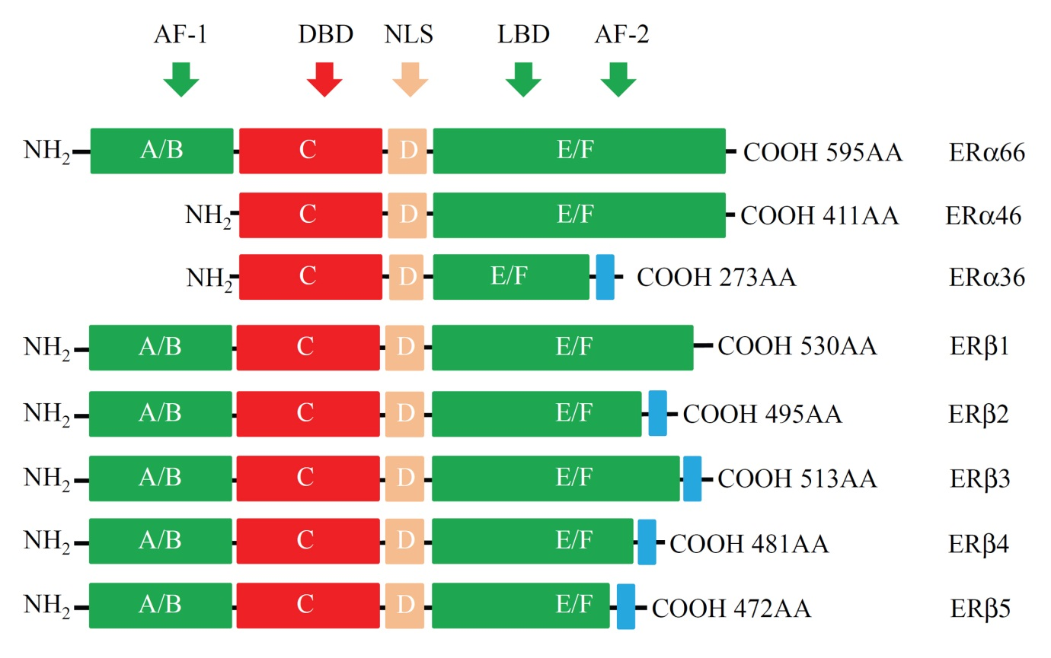
Figure 1 protein structure of estrogen receptors. Two different forms of ER are encoded by two distinct genes located in chromosomes 6 and 14 and produce two proteins with 595 and 530 amino acids in full length respectively. Six evolutionary conserved domains, namely A-F, are shared by different ERs. For ERα isoforms, compared to the full length ERα66, ERα46 lacks AF-1 domain (A/M), ERα36 lacks AF-1 and partial AF-2 domains but equipped an extra different C-terminal. For alternatively-spliced ERβ isoforms, they differ mainly at their C-terminals. AF-1: Transcriptional activation factor-1; DBD: DNA-binding domain; NLS: Nuclear localization signals; LBD: Ligand binding domain; AF-2: Transcriptional activation factor-2.

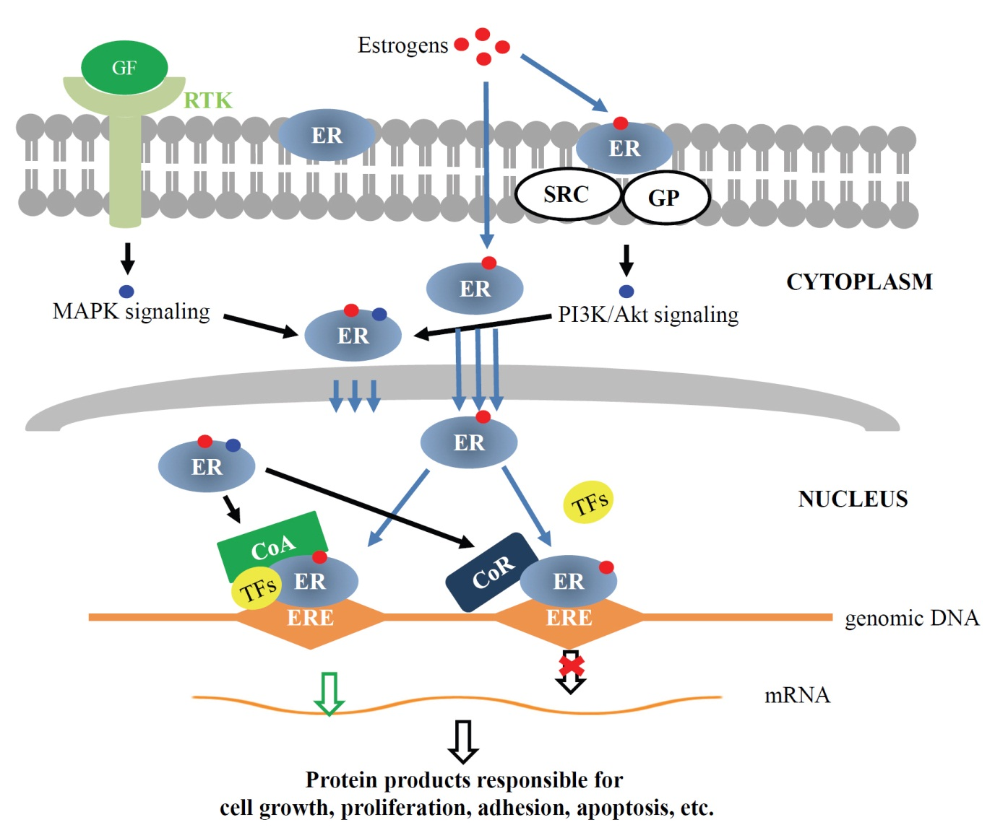
Figure 2 Molecular mechanisms for estrogen receptors’ functions. Genomic pathway: Estrogen binding leads to dimerization of ERs, then ERs translocate into nucleus and interact with transcriptional co-activators and/or co-repressor, and bind to genomic DNA at specific sequences known as estrogen response elements (EREs) to activate or repress the transcription of specific genes. Non-genomic signaling pathway: Membrane ERs interact with SRC/G protein and activate PI3K/Akt signaling. Both MAPK signaling initiated by binding of growth factors to receptor tyrosine kinases and PI3K/Akt signaling can modify cytosolic ERs, which may interact with other transcription factors and modulate the transcription of specific genes. GF: Growth factor; RTK: Receptor tyrosine kinase; GP: G proteins; CoA: Transcription co-activator; CoR: Transcription co-receptor; TFs: Transcription factors; ERE: Estrogen response element.

