Name of Journal: World Journal of Clinical Cases
Manuscript NO: 63584
Manuscript Type: CASE REPORT

Primary intratracheal schwannoma misdiagnosed as severe asthma in an adolescent: a case report

Huang HR et al. PIS misdiagnosed as asthma in an adolescent

Hui-rong Huang, Pei-qiang Li, Yi-xin Wan

Hui-Rong Huang, Yi-Xin Wan, Department of Respiratory Medicine, Lanzhou University Second Hospital, Lanzhou 730030, Gansu Province, China

Pei-qiang Li, School of Basic Medical Sciences, Lanzhou University, Lanzhou 730000, Gansu Province, China

Author contributions: Huang HR and Wan YX were the patient’s pulmonary physicians; Huang HR was involved in data curation, provision of resources, investigation and writing of the original draft; Wan YX reviewed the literature and contributed to manuscript drafting; Li PQ was responsible for the revision of the manuscript for important intellectual content; All authors approved submission of final version for publication.

Supported by Natural Science Foundation of Gansu Province, China, No. 20JR5RA335.

Corresponding author: Pei-qiang Li, PhD, Research Fellow, School of Basic Medical Sciences, Lanzhou University, No. 199 Donggang West Road, Chengguan district, Lanzhou 730000, Gansu Province, China. lipq@lzu.edu.cn

Received: February 2, 2021
Revised: March 14, 2021
Accepted: April 8, 2021
Published online: June 16, 2021

Abstract
BACKGROUND
Primary intratracheal schwannoma is an extremely rare type of benign airway tumor, especially in adolescents. The presenting symptoms are typically prolonged cough and wheezing that can be misdiagnosed as asthma in adolescent patients.

CASE SUMMARY
A 16-year-old adolescent girl admitted to a local hospital with symptoms of an irritating cough and wheezing was diagnosed with bronchial asthma and treated with budesonide and formoterol. Over the next year, the patient's wheezing and coughing symptoms gradually worsened and the antiasthma treatment was ineffective. One week prior to this admission, the patient developed dyspnea after catching a cold and was transferred to our hospital with a diagnosis of severe asthma. However, chest computed tomography and bronchoscopy showed a mass in the trachea. Primary intratracheal schwannoma was diagnosed by biopsy. Her symptoms were relieved by endoscopic resection by electrosurgical snaring combined with argon plasma coagulation. No relapse occurred during an 18 mo follow-up.

CONCLUSION
Primary intratracheal schwannoma should be considered in the differential diagnosis in adolescents with recurrent asthma-like attacks.

Key Words: Intratracheal schwannoma; Adolescent; Severe asthma; Misdiagnosis; Endoscopic resection; Case report

©The Author(s) 2021. Published by Baishideng Publishing Group Inc. All rights reserved.

Citation: Huang HR, Li PQ, Wan YX. Primary intratracheal schwannoma misdiagnosed as severe asthma in an adolescent: a case report. World J Clin Cases 2021; 9(17): 4388-4394
URL: https://www.wjgnet.com/2307-8960/full/v9/i17/4388.htm
DOI: https://dx.doi.org/10.12998/wjcc.v9.i17.4388

Core Tip: Primary intratracheal schwannoma is a rare benign airway tumor in adolescents. The presenting symptoms are typically prolonged cough and wheezing, and antiasthma treatment was ineffective in this patient. Chest computed tomography and bronchoscopy should be performed as soon as possible to clarify the diagnosis. Here we report a 16-year-old female patient with a primary intratracheal schwannoma misdiagnosed as severe asthma. This case report is intended to increase awareness for it and help avoid future misdiagnoses by physicians.

INTRODUCTION
Primary tracheal tumors can be either benign or malignant, but malignant tumors are more common. Benign tracheal tumors have a low incidence, and the common types include papillomas, hamartomas, and hemangiomas. Primary intratracheal schwannoma is an extremely rare benign airway tumor, with an incidence of about 0.2% and few published reports of cases in child or adolescents^{[1-3]}. Primary intratracheal schwannoma has no characteristic clinical manifestations in the early stage, but when the tumor grows to a certain size, it can cause symptoms associated with blockage of the tracheal lumen that can be easily misdiagnosed. Here we report an adolescent patient with a primary intratracheal schwannoma misdiagnosed as severe asthma.

CASE PRESENTATION
Chief complaints
A 16-year-old adolescent girl had an intermittent cough with shortness of breath and wheezing for 1 year that had become worse in the previous week.

History of present illness
The patient visited a local hospital with symptoms of an irritating cough and wheezing. A chest X-ray showed no abnormalities. She was diagnosed with bronchial asthma and treated with budesonide and formoterol. Over the next year, the wheezing and cough symptoms gradually worsened, and the treatment was not effective. One week before admission, the patient's cough and wheezing symptoms worsened after catching a cold, and she experienced wheezing and a feeling of suffocation even when resting. A chest X-ray revealed blurred markings in both lungs (Figure 1). Allergen testing was not performed. She was diagnosed with acute onset of asthma and treated with Ventolin (salbutamol sulfate solution for inhalation) and intravenous methylprednisolone for 1 wk, but the symptoms were not relieved. She was then transferred to the respiratory department of our hospital.

History of past illness
The patient had no other previous medical history.

Personal and family history
The patient had no relevant family medical history.

Physical examination
The patient had a body temperature of 36.7 ℃, blood pressure of 128/80 mmHg, heart rate of 103 beats/min, respiratory rate of 28 breaths/min, and an SPO₂ of 98%. The patient had clear consciousness and was in a semi-supine position. The three concave sign was positive, her inspiratory phase was prolonged, and bidirectional wheezing could be heard.

Laboratory evaluation
Routine blood tests showed a white blood cell count of 12.0 × 10⁹/L, hemoglobin of 122 g/L, and a neutrophil ratio of 85%. Arterial blood gas analysis showed a pH of 7.45, a PaO₂ 60 mmHg, and a PaCO₂ of 33 mmHg. Liver and kidney function was normal and neuron-specific enolase was 16.5 ng/mL (normal range: 0-15.2 ng/mL). The patient did not undergo pulmonary function tests due because of her dyspnea.

Imaging examinations
Chest computed tomography (CT) at the T2/T3 vertebral level showed a nodular mass in the trachea that obstructed about 90% of the lumen without invading the tracheal wall and its surrounding tissues (Figure 2).

Further diagnostic workup
A bronchoscopy was done with the patient's consent to determine the nature of the intratracheal mass. The bronchoscopy showed a pedicled dumbbell-shaped reddish-brown mass with a smooth surface and small blood vessels in the middle part of the trachea, about 4 cm below the vocal cords (Figure 3). The mass obstructed about 90% of the airway. Pathological examination of the tracheal mass showed that the tumor cells were long and shuttle-shaped, with an uneven distribution and fenestrated arrangement in some areas (Figure 4A). The sample cells were incubated with mouse antihuman monoclonal antibodies against S100, desmin, CD117, and Ki-67 (MXB Biotechnologies, China). Immunohistochemistry (IHC) was performed with a VENTANA BenchMARK Ultra automated staining instrument following the manufacturer’s instructions. IHC revealed s-100 (++), desmin (-), CD117 (-), and a Ki-67 positivity of < 1%. The pathological diagnosis was tracheal schwannoma.

FINAL DIAGNOSIS
Primary intratracheal schwannoma.

TREATMENT
Using an ERBR ICC-200 high-frequency electrosurgical unit, the tumor was removed by electronic snaring with a flexible bronchoscope, followed by further clearance of residual tissue at the base of the tumor by argon plasma coagulation. After the tumor was removed, its root was visible in the mid trachea at approximately a 5 o'clock position (Figure 5).

OUTCOME AND FOLLOW-UP
The patient's cough and dyspnea symptoms disappeared immediately following endoscopic resection of the tumor. During an 18-mo postoperative follow-up, the patient had no early or late complications or tumor recurrence. Bronchoscopic surveillance showed a minor scar on the trachea at the site of the original lesion (Figure 6). The patient is still being followed.

DISCUSSION
Schwannomas, also known as neurilemmomas, originate from the cell membranes of neurons derived from the embryonic neural crest. Schwannomas have a low incidence and can occur in all parts of the body, but are more common in the head/neck and the flexors of all four extremities^{[4]}. Schwannomas occur rarely in the airway. Intratracheal schwannomas were first described by Straus and Guckien^{[5]} in 1951. Intratracheal schwannomas are benign tumors, most often located near the ramus of the lower 1/3 of the trachea, followed by the upper 1/3 and then the middle 1/3 of the trachea. They have an intact envelope, grow slowly, and cause no symptoms in the early stage^{[6-10]}. In the present case, the tumor was located in the middle portion of the trachea, a site that is rarely encountered in the clinical setting, and the diagnosis can be easily missed.
Intratracheal schwannomas are more common in young adults, especially in women. The common clinical manifestations of intratracheal schwannomas include cough, shortness of breath, dyspnea, and other symptoms of upper airway obstruction, which can be related to body position. Occasionally, patients also suffer from hemoptysis, hoarseness, and chest pain^{[11]}. Due to the nonspecific nature of these symptoms, diagnosis of this rare condition is often delayed. The average time to diagnosis from the onset of initial symptoms was approximately 17 mo^{[7,12]}, and half the patients are reported to be misdiagnosed with asthma before the diagnosis is finally confirmed^{[13]}. In the early stage, the tumor is small and grows slowly, often presenting as an irritating dry cough that can persist for months or even years. As the tumor grows and obstructs more than 1/2 of the tracheal lumen or when the resistance increases significantly, the patient gradually develops shortness of breath, dyspnea, and other symptoms. At that stage, chest X-ray films, especially anteroposterior films, show no obvious abnormalities in 30%-75% of the patients because the tumor is still covered by mediastinal soft tissues^{[8,14]}. As early treatment with glucocorticoids and bronchodilator can temporarily relieve symptoms, intratracheal schwannomas are often misdiagnosed as asthma, and further diagnosis and treatment are often delayed. When the tracheal obstruction worsens and the above treatments are ineffective, the disease is easily misdiagnosed as refractory asthma or severe asthma. However, there are differences in symptoms and signs between those two conditions. Wheezing caused by schwannomas is mostly manifested as progressive aggravation, and both expiratory and inspiratory wheezing can be heard during auscultation. The sound is strong in the proximal part of the airway and gradually decreases in the distal part, showing inspiratory dyspnea. In contrast, asthma is reversible, episodic, and recurrent, causing expiratory dyspnea, and the sound is mostly diffuse and in the expiration phase. This patient was misdiagnosed with bronchial asthma at a local hospital for up to 1 year. The possibility of an intratracheal schwannoma should be considered in adolescent patients with a long-term irritating cough accompanied mostly by inspiratory dyspnea, especially in adolescents who have failed to respond to conventional treatments.
Thoracic CT and 3-dimensional reconstruction are valuable in identifying the mass, assessing the location and size of the tracheal tumor, the degree of airway obstruction, the involvement of the mediastinum, and in determining treatment options^{[7,10,15]}. The CT presentation of schwannomas is diverse, especially multiple forms of heterogeneous enhancement that can be observed on contrast-enhanced CT. Because of the lack of specific symptoms, intratracheal schwannomas can be easily misdiagnosed as other benign tumors of the trachea^{[10]}.
Bronchoscopy is the most effective method to diagnose intratracheal schwannomas. The main bronchoscopic manifestations include: (1) A broad base, with the mass growing along the longitudinal axis of the tracheobronchus and a round or oval protrusion into the lumen; (2) A pedicled tumor with a polyp-like growth into the lumen; and (3) A dumbbell-shaped tumor growing into the lumen. The final confirmation of the diagnosis depends on histopathological evaluation. Biopsy sampling is often difficult because of the tough texture of the tumor. If the biopsy site is shallow, microscopy may only reveal chronic inflammation of the mucosa. Therefore, the biopsy site should be sufficiently deep. If necessary, resected tissues may also be sent for pathological examination. Pathologically, schwannomas often have an intact envelope, a well-arranged internal structure, cell-rich bundles, (an Antoni type-A area), and a loose mucus-like reticular zone (an Antoni type-B area. The tumor cells have the morphological characteristics of Schwann cells in terms of immunophenotype and ultrastructure. S-100(+) immunohistochemical staining also helps to confirm the diagnosis^{[7,16]}.
The current treatment options for intratracheal schwannomas include surgical resection plus airway reconstruction and interventional bronchoscopic resection^{[7,8]}. The choice of treatment depends on tumor location, relationship of the mass with surrounding tissues, tracheal wall infiltration, risk of tracheal resection, and presence of extratracheal components^{[6,17]}. With the rapid development of respiratory interventional techniques in recent years, bronchoscopic cutting with electrocautery snaring, argon plasma coagulation, cryotherapy, and laser resection have also become available^{[18-20]}. High-frequency electrocoagulation ablation is a safe treatment for endotracheal tumors, with a low incidence of complications.

CONCLUSION
Intratracheal schwannoma is a relatively rare benign airway tumor. Its diagnosis is difficult because of the lack of specific clinical presentations and nonspecific chest X-ray findings. The incidence of intratracheal schwannoma is low in children and adolescents, and misdiagnosis may easily occur. If standard treatment is ineffective in patients with recurrent asthma-like attacks, especially children or adolescents, then chest CT and bronchoscopy should be performed as soon as possible to clarify the diagnosis.

REFERENCES
1 Yukawa T, Shimizu K, Hirami Y, Okita R, Saisho S, Maeda A, Yasuda K, Nakata M. A case report of intrapulmonary schwannoma. Gen Thorac Cardiovasc Surg 2014; 62: 252-254 [PMID: 23526133 DOI: 10.1007/s11748-013-0233-5]
2 Ohtsuka T, Nomori H, Naruke T, Orikasa H, Yamazaki K, Suemasu K. Intrapulmonary schwannoma. Jpn J Thorac Cardiovasc Surg 2005; 53: 154-156 [PMID: 15828297 DOI: 10.1007/s11748-005-0023-9]
3 Zhang L, Tang W, Hong QS, Lv PF, Jiang KM, Du R. Case report: A tracheobronchial schwannoma in a child. Respir Med Case Rep 2020; 30: 101047 [PMID: 32346506 DOI: 10.1016/j.rmcr.2020.101047]
4 Grillo HC, Mathisen DJ. Primary tracheal tumors: treatment and results. Ann Thorac Surg 1990; 49: 69-77 [PMID: 2153371 DOI: 10.1016/0003-4975(90)90358-d]
5 Straus GD, Guckien JL. Schwannoma of the tracheobronchial tree. A case report. Ann Otol Rhinol Laryngol 1951; 60: 242-246 [PMID: 14819937 DOI: 10.1177/000348945106000122]
6 Kang HJ, Shin SJ, Kang ES. Schwannomas of the upper extremity. J Hand Surg Br 2000; 25: 604-607 [PMID: 11106529 DOI: 10.1054/jhsb.2000.0472]
7 Sharma PV, Jobanputra YB, Perdomo Miquel T, Schroeder JR, Wellikoff A. Primary intratracheal schwannoma resected during bronchoscopy using argon plasma coagulation. BMJ Case Rep 2018; 2018 [PMID: 30232068 DOI: 10.1136/bcr-2018-225140]
8 Ge X, Han F, Guan W, Sun J, Guo X. Optimal treatment for primary benign intratracheal schwannoma: A case report and review of the literature. Oncol Lett 2015; 10: 2273-2276 [PMID: 26622833 DOI: 10.3892/ol.2015.3521]
9 Han DP, Xiang J, Ye ZQ, He DN, Fei XC, Wang CF, Che JM, Hang JB, Li HC. Primary tracheal schwannoma treated by surgical resection: a case report. J Thorac Dis 2017; 9: E249-E252 [PMID: 28449512 DOI: 10.21037/jtd.2017.02.85]
10 Miyake KK, Nakamoto Y, Kataoka TR, Ueshima C, Higashi T, Terashima T, Nakatani K, Saga T, Minami S, Togashi K. Clinical, Morphologic, and Pathologic Features Associated With Increased FDG Uptake in Schwannoma. AJR Am J Roentgenol 2016; 207: 1288-1296 [PMID: 27657364 DOI: 10.2214/AJR.15.14964]
11 Righini CA, Lequeux T, Laverierre MH, Reyt E. Primary tracheal schwannoma: one case report and a literature review. Eur Arch Otorhinolaryngol 2005; 262: 157-160 [PMID: 15060831 DOI: 10.1007/s00405-004-0778-0]
12 Hamouri S, Novotny NM. Primary tracheal schwannoma a review of a rare entity: current understanding of management and followup. J Cardiothorac Surg 2017; 12: 105 [PMID: 29183345 DOI: 10.1186/s13019-017-0677-2]
13 Horovitz AG, Khalil KG, Verani RR, Guthrie AM, Cowan DF. Primary intratracheal neurilemoma. J Thorac Cardiovasc Surg 1983; 85: 313-317 [PMID: 6823150]
14 Sughrue ME, Yeung AH, Rutkowski MJ, Cheung SW, Parsa AT. Molecular biology of familial and sporadic vestibular schwannomas: implications for novel therapeutics. J Neurosurg 2011; 114: 359-366 [PMID: 19943731 DOI: 10.3171/2009.10.JNS091135]
15 Meyers BF, Mathisen DJ. Management of Tracheal Neoplasms. Oncologist 1997; 2: 245-253 [PMID: 10388056]
16 Tang LF, Chen ZM, Zou CC. Primary intratracheal neurilemmoma in children: case report and literature review. Pediatr Pulmonol 2005; 40: 550-553 [PMID: 16175598 DOI: 10.1002/ppul.20279]
17 Uhlmann EJ, Plotkin SR. Neurofibromatoses. Adv Exp Med Biol 2012; 724: 266-277 [PMID: 22411249 DOI: 10.1007/978-1-4614-0653-2_20]
18 Shi XQ, Luo JF, Yang Y, Chen X, Qu WS, Wang YB, Cheng FB. [A case of schwannoma in cervical trachea]. Lin Chung Er Bi Yan Hou Tou Jing Wai Ke Za Zhi 2017; 31: 810-811 [PMID: 29771052 DOI: 10.13201/j.issn.1001-1781.2017.10.020]
19 Rusch VW, Schmidt RA. Tracheal schwannoma: management by endoscopic laser resection. Thorax 1994; 49: 85-86 [PMID: 8153948 DOI: 10.1136/thx.49.1.85]
20 Jung YY, Hong ME, Han J, Kim TS, Kim J, Shim YM, Kim H. Bronchial schwannomas: clinicopathologic analysis of 7 cases. Korean J Pathol 2013; 47: 326-331 [PMID: 24009627 DOI: 10.4132/KoreanJPathol.2013.47.4.326]

Footnotes
Informed consent statement: All study participants, or their legal guardian, provided informed written consent prior to study enrollment.

Conflict-of-interest statement: The authors declare that they have no conflicts of interest.

CARE Checklist (2016) statement: The authors have read the CARE Checklist (2016), and the manuscript was prepared and revised according to the CARE Checklist (2016).

Open-Access: This article is an open-access article that was selected by an in-house editor and fully peer-reviewed by external reviewers. It is distributed in accordance with the Creative Commons Attribution NonCommercial (CC BY-NC 4.0) license, which permits others to distribute, remix, adapt, build upon this work non-commercially, and license their derivative works on different terms, provided the original work is properly cited and the use is non-commercial. See: http://creativecommons.org/Licenses/by-nc/4.0/

Manuscript source: Unsolicited manuscript

Peer-review started: February 2, 2021
First decision: February 28, 2021
Article in press: April 8, 2021

Specialty type: Medicine, research and experimental
Country/Territory of origin: China
Peer-review report’s scientific quality classification
Grade A (Excellent): 0
Grade B (Very good): 0
Grade C (Good): C, C
Grade D (Fair): 0
Grade E (Poor): 0

P-Reviewer: Elpek GO, Li XM S-Editor: Gong ZM L-Editor: Filipodia P-Editor: Wang LL

Figure Legends
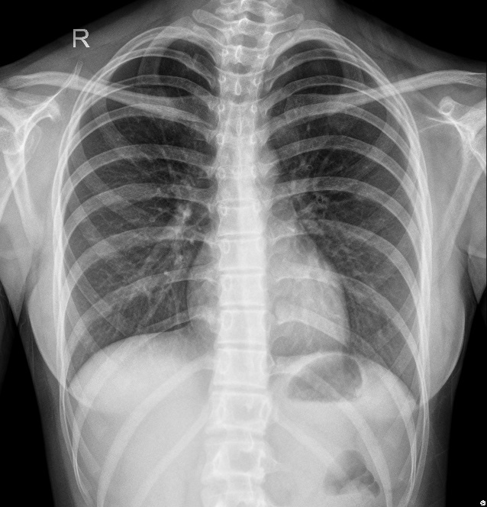
Figure 1 Chest X-ray showing thickness of texture in both lungs.
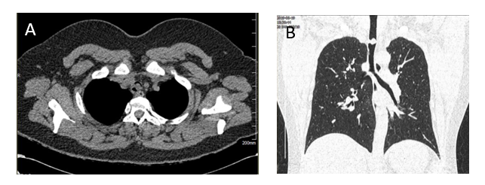
Figure 2 chest computed tomography A: At the plane of the T2/T3 vertebrae; B: A coronal reconstruction showing a nodular mass in the lumen of the trachea.
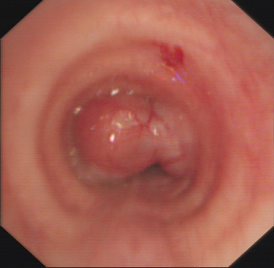
Figure 3 Bronchoscopy image showing a mid-tracheal, pedicled dumbbell-shaped mass with small blood vessels on its surface.
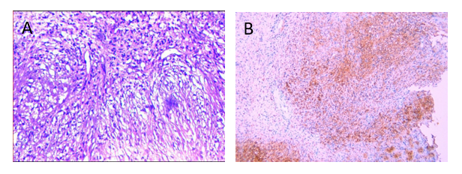
Figure 4 Pathological and immunohistochemical images. A: Showing long, shuttle-shaped tumor cells with an uneven distribution and fenestrated arrangement in some areas (hematoxylin and eosin, magnification, × 100); B: Positive immunohistochemical staining of S-100 protein (magnification, × 100).
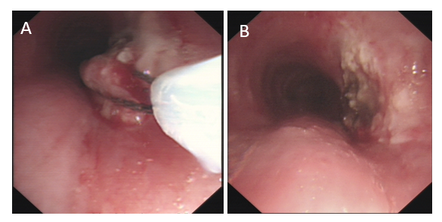
Figure 5 Bronchoscopy images. A: Removal of the mass by high-frequency electrosurgery; B: Residual anatomy after mass removal.
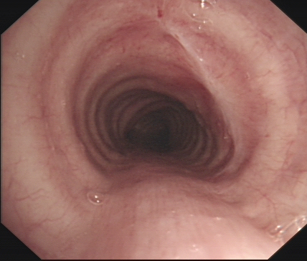
Figure 6 Bronchoscopy image showing slight scarring of the trachea at the site of the original lesion.

Published by Baishideng Publishing Group Inc
7041 Koll Center Parkway, Suite 160, Pleasanton, CA 94566, USA
Telephone: +1-925-3991568
E-mail: bpgoffice@wjgnet.com
Help Desk: https://www.f6publishing.com/helpdesk
https://www.wjgnet.com

© 2021 Baishideng Publishing Group Inc. All rights reserved.

