Name of Journal: World Journal of Clinical Cases
Manuscript NO: 68934
Manuscript Type: CASE REPORT

Ultrasound guiding the rapid diagnosis and treatment of perioperative pneumothorax: a case report

Zhang G et al. Ultrasound guiding pneumothorax diagnosis and treatment

Gang Zhang, Xiao-yan Huang, Lan Zhang

Gang Zhang, Lan Zhang, Department of Anesthesia, Sichuan Provincial Orthopedic Hospital (Chengdu Sports Hospital and Chengdu Research Institute for Sports Injury), Chengdu 610041, Sichuan province, China

Xiao-yan Huang, Department of Operation Room, the Third People's Hospital of Chengdu, Chengdu 610041, Sichuan province, China

Author contributions: Zhang G conceived the clinical concept described; Zhang G and Huang XY contributed to the clinical conduct of the study, data collection, and writing of the manuscript; Zhang Lan contributed to analysis and interpretation of the collected data, writing, preparation of accompanying figures and material, and revision of the manuscript.

Corresponding author: Lan Zhang, MD, Director, Doctor, Department of Anesthesia, Sichuan Provincial Orthopedic Hospital (Chengdu Sports Hospital and Chengdu Research Institute for Sports Injury), No. 132 West Section 1, First-Ring Road, Wuhou District, Chengdu 610041, Sichuan province, China. mzzhanggang@hotmail.com

Received: June 9, 2021
Revised: July 27, 2021
Accepted: September 15, 2021
Published online:

Abstract
BACKGROUND
Pneumothorax is one of the most common causes of acute dyspnea. In patients under general anesthesia, the symptoms may not be obvious, which may diagnosis and treatment. Computed tomography is the gold standard for the diagnosis of pneumothorax, but is not suitable for rapid diagnosis of this complication. In contrast, lung ultrasonography can provide rapid diagnosis and treatment of pneumothorax.

CASE SUMMARY
The patient was a 53-year-old man admitted for rupture of the spleen caused by an accidental fall; emergency splenectomy was planned. Anesthesia was induced, and tracheal intubation was performed successfully with a video laryngoscope. About 2 min after tracheal intubation, the airway peak pressure increased to 50 cm H₂O and the oxygen saturation dropped to 70%. According to the BLUE protocol, a recommended area of the chest was scanned by ultrasound. The pleural slide sign disappeared and obvious parallel line sign could be seen in the left lung. The boundary of pneumothorax (lung points) were rapidly confirmed by ultrasound. To avoid lung injury, a closed thoracic drainage tube was placed in the involved area. On day 9 after surgery, the patient was discharged from the hospital without any complications.

CONCLUSION
Perioperative pneumothorax is rare but dangerous. It can be rapidly diagnosed and treated with ultrasound guidance.

Key Words: Ultrasound; Perioperative; Pneumothorax; BLUE protocol; Case report

Zhang G, Huang XY, Zhang L. Ultrasound guiding the rapid diagnosis and treatment of perioperative pneumothorax: a case report. World J Clin Cases 2021; In press

Core Tip: Perioperative pneumothorax is a rare but dangerous complication that requires rapid diagnosis and urgent treatment. Computed tomography is the gold standard for diagnosis but is not applicable to confirm pneumothorax during surgery. Lung ultrasonography, with the advantages of being radiation-free and convenient, can provide rapid diagnosis and treatment of this complication.

INTRODUCTION
Pneumothorax is one of the most common causes of acute dyspnea. Sudden chest pain, shortness of breath, or even respiratory failure are the main clinical features. Because of the sudden change in pressure in the pleural cavity, the venous return blood flow is blocked and the stability of the circulatory system is affected. Therefore, early diagnosis and treatment are urgently needed. In patients under general anesthesia, the symptoms may not be obvious, which can delay diagnosis and treatment. Pneumothorax is a rare but serious perioperative complication leading to perilous hypoxemia during general anesthesia. Especially for patients with poor cardiopulmonary reserve, early diagnosis has a great impact on the prognosis^{[1]}.
Although chest computed tomography (CT) is the gold standard for the diagnosis of pneumothorax^{[2]}, it is not suitable for rapid diagnosis because of its high radiation exposure and long transport time. In contrast, lung ultrasound (LUS) has the advantages of being radiation-free and convenient, which can provide dynamic assessment and rapid diagnosis^{[3]}.
It was first reported that pneumothorax can be diagnosed by ultrasound in 1987. Wernecke et al^{[4]} reported that it can be indicated by the disappearance of lung sliding. When pneumothorax is suspected during surgery, ultrasound scanning can be performed rapidly in the suspected area following the BLUE protocol^{[5]}. Abnormal sonographic signs such as the pleural slide sign, parallel line sign in M-mode, and lung points indicate pneumothorax. Moreover, lung points can not only be a gold standard for the diagnosis of pneumothorax, but also determine the boundary of the pneumothorax and guide the placement of a closed thoracic drainage tube. It takes 2-3 min to complete the examination, and pneumothorax can be excluded or diagnosed within 1 min^{[6]}. In this case, the prompt ultrasound diagnosis and treatment of pneumothorax resulted in an excellent patient prognosis.

CASE PRESENTATION
Chief complaints
A 53-year-old man (85 kg and 170 cm) was admitted for rupture of spleen caused by an accidental fall.

History of present illness
Emergency splenectomy was planned under general anesthesia. Preoperative emergency ultrasound examination including the heart, chest, and abdomen were performed, and it was found that spleen had been ruptured and was accompanied by active bleeding, complicated with progressive hemochrome reduction, which the main reason for the patient to undergo emergency surgery. Preoperative ultrasound showed no heart or chest abnormalities. The patient did not complain of dyspnea preoperatively, and preoperative CT showed no hemothorax or pneumothorax (Figure 1). Initial vital signs before anesthesia were a blood pressure of 126/82 mm Hg, heart rate of 75 bpm, and an oxygen partial pressure (SpO₂) of 95% while inhaling air. Anesthesia was induced with sufentanil 0.3 µg/kg, rocuronium 0.1 mg/kg, and propofol 3 mg/kg. Tracheal intubation was successfully performed with video laryngoscopy, and positive pressure ventilation was performed with an airway peak pressure of 14 cm H₂O. Because the patient's thick chest wall, breath sounds were difficult to auscultate. About 2 min after tracheal intubation, ventilation was difficult. The airway peak pressure increased progressively, reaching a maximum of 50 cm H₂O and SpO₂ dropped, reaching a minimum of 70%. Because of obesity and the thick chest wall, the cause of respiratory failure could not be determined by traditional auscultation. Following the BLUE protocol, a recommended area of the chest was scanned by bedside ultrasound. The pleural slide sign disappeared in the upper and lower blue points of the left lung, and in M-mode, an obvious parallel line sign could be seen below the pleura. The boundary of pneumothorax (lung points) was rapidly confirmed by ultrasound. To avoid lung injury and secondary pneumothorax, a closed thoracic drainage tube was placed in the area guided by ultrasound. The interval from suspicion of pneumothorax to placement of the drainage tube was less than 3 min. After many bubbles had emerged from the water seal bottle, the airway pressure dropped to 20 cm H₂O and the SpO₂ returned to 96%-100%. After the patient's vital signs stabilized, the splenectomy continued and was successfully completed. The patient was sent to the intensive care unit (ICU) with a endotracheal tube for further treatment after surgery. On day 1 after surgery, the endotracheal tube was removed. On day 6, the closed thoracic drainage tube was removed. On day 9, the patient was discharged from the hospital without any complications.

Laboratory examinations
Anemia (hemoglobin 85 g/L).

Imaging examinations
Focused assessment with sonography in trauma (FAST) has been extensively utilized and studied in blunt and penetrating trauma^{[7]}. Following the FAST protocol, organ damage can be rapidly evaluated by the amount of free fluid in the chest, abdominal, and pelvic cavities. In this case, preoperative emergency ultrasound examination of the heart, chest and abdomen found that spleen had been ruptured and active bleeding was complicated by progressive hemochrome reduction, which was also the main reason for the patient to undergo emergency surgery. Preoperative ultrasound showed no abnormalities in the heart or chest. Following the BLUE protocol, LUS confirmed that the pleural slide sign had disappeared in the recommended area of the left lung, and in M-mode, an obvious parallel line sign was seen below the pleura (Figure 2B). The boundary of the pneumothorax (lung points) was rapidly confirmed by ultrasound (Figure 2C).

FINAL DIAGNOSIS
A clear diagnosis perioperative pneumothorax was based on imaging examination and intraoperative findings.

TREATMENT
To avoid lung injury and secondary pneumothorax, a closed thoracic drainage tube was placed in the area guided by ultrasound. From suspicion of pneumothorax to the placement of closed thoracic drainage tube, the total time was less than 3 min.

OUTCOME AND FOLLOW-UP
After a large number of bubbles emerged from the water seal bottle, the airway pressure dropped to 20 cm H₂O and the oxygen saturation returned to 96%-100%. After the patient's vital signs stabilized, the splenectomy continued and was successfully completed. The patient was sent to ICU with a endotracheal tube for further treatment after surgery. On day 1 after surgery, the endotracheal tube was removed. On day 6, the drainage tube was removed. On day 9, the patient was discharged from the hospital without any complications.

DISCUSSION
If pneumothorax occurs under general anesthesia, positive pressure ventilation causes accumulation of a large amount of air in the pleural space, leading to intractable hypoxemia. Because of absence of specific symptoms like chest pain, cough, and dyspnea under general anesthesia, pneumothorax may be not diagnosed promptly. Pathological changes leading by pneumothorax can provide a large amount of diagnostic information. Because of the high sensitivity of CT, it is the gold standard for the diagnosis of pneumothorax. However, patients often require long-distance transport for CT examination, which is time-consuming and risky for critical patients. It is not suitable for the rapid diagnosis required for perioperative pneumothorax. Ultrasound is a reliable modality to provide rapid and accurate information, it has been shown that pulmonary ultrasound is superior to X-ray for the diagnosis of lung disease^{[8]}. The diagnostic accuracy of ultrasound for a variety of lung diseases is comparable to CT, and it is becoming the preferred tool for rapid assessment of pulmonary disease^{[9]}.

How ultrasound is performed: BLUE protocol
The examiner's hands placed on the patient's anterior chest wall (excluding the thumbs), with the little finger of the upper hand close to the clavicle and the fingertips close to the median sternal line. The upper BLUE point is at the third and fourth metacarpophalangeal joints of the upper hand, and the lower BLUE point is at the center of the lower palm. The two points are thought to be the highest points at which gas is the most concentrated. The two BLUE points are recommended for rapid diagnosis or exclusion of pneumothorax during the perioperative period. (Figure 3) It was reported that small-volume pneumothorax caused by blunt trauma mainly occurs in the parasternal regions^{[10]}, which is consistent with the BLUE protocol recommendation for the rapid localization of the upper and lower BLUE dots adjacent to the sternum to diagnose the complication^{[11]}.

How to diagnose pneumothorax by ultrasound features
Ultrasound diagnosis of pneumothorax is based on both exclusion and confirmed diagnosis. If pneumothorax is suspected in perioperative period, bedside ultrasound should be performed immediately. Pneumothorax can be excluded by the pleural slide sign^{[12]}, which is a normal pulmonary sign of relative movement between the visceral and parietal pleura which is visible by ultrasound during respiratory movement. The negative predictive value for the diagnosis of pneumothorax by pleural slide sign has been reported as 100%. Pneumothorax can thus be excluded quickly and accurately by the existence of the surface pleural slide sign^{[13]}. When pneumothorax is present, the visceral and parietal pleurae will be separated by gas. Therefore, the disappearance of the pleural slide sign on ultrasound is the initial step in the diagnosis of pneumothorax^{[14]}. However, the positive predictive value of the disappearance of pleural slide sign for the diagnosis of pneumothorax is estimated as 87% in the normal population, 56% in ICU patients, and only 27% in cases of respiratory failure^{[15]}. Tracheal intubation, single lung ventilation, atelectasis, pulmonary fibrosis, ARDS, pleural adhesion, phrenic nerve palsy, cardiac and respiratory arrest, and other factors may also lead disappearance of the pleural slide sign. In M-mode echocardiography, normal lung tissue resembles a beach with respiratory movement. (Figure 2) Without respiratory movement, lung tissue in cases of pneumothorax resembles parallel lines. (Figure 2) Ultrasound diagnosis of pneumothorax depends on lung point and is regarded as a gold standard with a specificity of 100%. For the patients with pneumothorax, as the probe moves laterally along the chest wall, a specific area (lung point) can be detected. A pleural slide sign, meaning that the parietal pleura is in contact with the visceral pleura, is observed on one side, and no slide is observed on the other, which means that the pleurae are separated by air^{[16]}. The lung points can slide along the pleural line with respiratory movements, and determine the boundary of pneumothorax^{[15]}. Lung point indicates the area of transition between collapsed lung tissue, with loss of sliding between the pleurae, and normal lung tissue. In M-mode echocardiography, A "beach sign," which indicates normal tissue, suddenly changes to a "parallel lines sign," which indicates pneumothorax^{[14]} (Figure 2).
In addition to the rapid diagnosis of perioperative pneumothorax, pulmonary ultrasound can also be used to guide the management of pneumothorax. In this case, once the pneumothorax was diagnosed, ultrasound was used to guide the placement of a closed thoracic drainage tube by indicating the pneumothorax boundary (lung points). After drainage, the patient's airway pressure significantly decreased and oxygenation returned to normal. Pulmonary ultrasound to guide catheter location has the advantages of increased safety and reduced risk. A meta-analysis has shown that ultrasound-guided thoracic puncture reduced the incidence of secondary pneumothorax^{[17]}. Patel et al^{[18]} reported that ultrasound-guided thoracic catheterization reduced the cost of treatment, length of hospital stay, and incidence of complications such as pneumothorax and hemorrhage. Lung ultrasound is easy to learn. In a randomized controlled trial, anesthesiologists were found to be proficient in diagnosing pneumothorax by ultrasound after 4 wk of online or classroom training^{[19]}.
Although ultrasound can help anesthesiologists diagnose pneumothorax quickly and conveniently, there are limitations. It is difficult to obtain satisfactory images in patients with open trauma, obesity, or pulmonary disease, which may lead a missed diagnosis of pneumothorax^{[20]}. Many studies have confirmed lung points as the gold standard to diagnose pneumothorax by ultrasound, but a lung point detected by ultrasound in an 83-year-old patient, was found to be a pulmonary bulla on CT and X-ray examination. That was the first reported case of lung points in a patient who not diagnosed with pneumothorax^{[14]}. Mild and moderate pneumothorax can be diagnosed by lung points, but lung points may not be seen in severe pneumothorax because of complete disappearance of lung sliding and the parallel lines sign, which are recommended to diagnose this complication.

CONCLUSION
Perioperative pneumothorax is a rare but dangerous complication requiring urgent diagnosis and treatment. Once it occurs, the positive pressure generated by mechanical ventilation may cause the lung on the affected side to collapse rapidly, leading to intractable hypoxemia. Lung ultrasound is a bedside modality that is becoming widely and for the rapid diagnosis and treatment of pneumothorax

ACKNOWLEDGEMENTS
The authors thank the patient and his family for the consent to share this case.

REFERENCES
1 Mirabile C, Malekzadeh-Milani S, Vinh TQ, Haydar A. Intraoperative hypoxia secondary to pneumothorax: The role of lung ultrasound. Paediatr Anaesth 2018; 28: 468-470 [PMID: 29603862 DOI: 10.1111/pan.13369]
2 Husain LF, Hagopian L, Wayman D, Baker WE, Carmody KA. Sonographic diagnosis of pneumothorax. J Emerg Trauma Shock 2012; 5: 76-81 [PMID: 22416161 DOI: 10.4103/0974-2700.93116]
3 Volpicelli G, Elbarbary M, Blaivas M, Lichtenstein DA, Mathis G, Kirkpatrick AW, Melniker L, Gargani L, Noble VE, Via G, Dean A, Tsung JW, Soldati G, Copetti R, Bouhemad B, Reissig A, Agricola E, Rouby JJ, Arbelot C, Liteplo A, Sargsyan A, Silva F, Hoppmann R, Breitkreutz R, Seibel A, Neri L, Storti E, Petrovic T; International Liaison Committee on Lung Ultrasound (ILC-LUS) for International Consensus Conference on Lung Ultrasound (ICC-LUS). International evidence-based recommendations for point-of-care lung ultrasound. Intensive Care Med 2012; 38: 577-591 [PMID: 22392031 DOI: 10.1007/s00134-012-2513-4]
4 Wernecke K, Galanski M, Peters PE, Hansen J. Pneumothorax: evaluation by ultrasound--preliminary results. J Thorac Imaging 1987; 2: 76-78 [PMID: 3298684]
5 Lichtenstein DA. Ultrasound examination of the lungs in the intensive care unit. Pediatr Crit Care Med 2009; 10: 693-698 [PMID: 19675509 DOI: 10.1097/PCC.0b013e3181b7f637]
6 Dulchavsky SA, Schwarz KL, Kirkpatrick AW, Billica RD, Williams DR, Diebel LN, Campbell MR, Sargysan AE, Hamilton DR. Prospective evaluation of thoracic ultrasound in the detection of pneumothorax. J Trauma 2001; 50: 201-205 [PMID: 11242282 DOI: 10.1097/00005373-200102000-00003]
7 Richards JR, McGahan JP. Focused Assessment with Sonography in Trauma (FAST) in 2017: What Radiologists Can Learn. Radiology 2017; 283: 30-48 [PMID: 28318439 DOI: 10.1148/radiol.2017160107]
8 Ma H, Huang D, Zhang M, Huang X, Ma S, Mao S, Li W, Chen Y, Guo L. Lung ultrasound is a reliable method for evaluating extravascular lung water volume in rodents. BMC Anesthesiol 2015; 15: 162 [PMID: 26563098 DOI: 10.1186/s12871-015-0146-1]
9 Lanks CW, Correa V. Advantages of Cardiopulmonary Ultrasound in Post-Cardiopulmonary Resuscitation Tension Pneumothorax. J Ultrasound Med 2018; 37: 819-822 [PMID: 28960428 DOI: 10.1002/jum.14437]
10 Hefny AF, Kunhivalappil FT, Paul M, Almansoori TM, Zoubeidi T, Abu-Zidan FM. Anatomical locations of air for rapid diagnosis of pneumothorax in blunt trauma patients. World J Emerg Surg 2019; 14: 44 [PMID: 31497066 DOI: 10.1186/s13017-019-0263-0]
11 Lichtenstein D. Novel approaches to ultrasonography of the lung and pleural space: where are we now? Breathe (Sheff) 2017; 13: 100-111 [PMID: 28620429 DOI: 10.1183/20734735.004717]
12 Yin MG, Wang XT, Liu DW, Chao YG, Guan XD, Kang Y, Yan J, Ma XC, Tang YQ, Hu ZJ, Yu KJ, Chen DC, Ai YH, Zhang LN, Zhang HM, Wu J, Liu LX, Zhu R, He W, Zhang Q, Ding X, Li L, Li Y, Liu HT, Zeng QB, Si X, Chen H, Zhang JW, Xu QH, Chen WJ, Chen XK, Huang DZ, Cai SH, Shang XL, Guan J, Du J, Zhao L, Wang MJ, Cui S, Wang XM, Zhou R, Zeng XY, Wang YP, Lyu LW, Zhu WH, Zhu Y, Duan J, Yang J, Yang H; Chinese Critical Ultrasound Study Group; Gritical Hemodynamic Therapy Collabration Group. [Technical specification for clinical application of critical ultrasonography]. Zhonghua Nei Ke Za Zhi 2018; 57: 397-417 [PMID: 29925125 DOI: 10.3760/cma.j.issn.0578-1426.2018.06.004]
13 Trovato FM, Catalano D, Trovato GM. Thoracic ultrasound: An adjunctive and valuable imaging tool in emergency, resource-limited settings and for a sustainable monitoring of patients. World J Radiol 2016; 8: 775-784 [PMID: 27721940 DOI: 10.4329/wjr.v8.i9.775]
14 Aziz SG, Patel BB, Ie SR, Rubio ER. The Lung Point Sign, not Pathognomonic of a Pneumothorax. Ultrasound Q 2016; 32: 277-279 [PMID: 27556193 DOI: 10.1097/RUQ.0000000000000199]
15 Abbas A, Embarak S, Walaa M, Lutfy SM. Role of diaphragmatic rapid shallow breathing index in predicting weaning outcome in patients with acute exacerbation of COPD. Int J Chron Obstruct Pulmon Dis 2018; 13: 1655-1661 [PMID: 29849456 DOI: 10.2147/COPD.S161691]
16 Skaarup SH, Folkersen BH. Ultrasound-assisted aspiration of loculated pneumothorax: A new technique. J Clin Ultrasound 2016; 44: 326-330 [PMID: 26676092 DOI: 10.1002/jcu.22326]
17 Gordon CE, Feller-Kopman D, Balk EM, Smetana GW. Pneumothorax following thoracentesis: a systematic review and meta-analysis. Arch Intern Med 2010; 170: 332-339 [PMID: 20177035 DOI: 10.1001/archinternmed.2009.548]
18 Patel PA, Ernst FR, Gunnarsson CL. Ultrasonography guidance reduces complications and costs associated with thoracentesis procedures. J Clin Ultrasound 2012; 40: 135-141 [PMID: 21994047 DOI: 10.1002/jcu.20884]
19 Edrich T, Stopfkuchen-Evans M, Scheiermann P, Heim M, Chan W, Stone MB, Dankl D, Aichner J, Hinzmann D, Song P, Szabo AL, Frendl G, Vlassakov K, Varelmann D. A Comparison of Web-Based with Traditional Classroom-Based Training of Lung Ultrasound for the Exclusion of Pneumothorax. Anesth Analg 2016; 123: 123-128 [PMID: 27159073 DOI: 10.1213/ANE.0000000000001383]
20 Shostak E, Brylka D, Krepp J, Pua B, Sanders A. Bedside sonography for detection of postprocedure pneumothorax. J Ultrasound Med 2013; 32: 1003-1009 [PMID: 23716522 DOI: 10.7863/ultra.32.6.1003]

Footnotes
Informed consent statement: Informed written consent was obtained from the patient for publication of this report and any accompanying images.

Conflict-of-interest statement: The authors declare that they have no conflicting interests.

CARE Checklist (2016) statement: The authors have read the CARE Checklist (2016), and the manuscript was prepared and revised according to the CARE Checklist (2016).

Open-Access: This article is an open-access article that was selected by an in-house editor and fully peer-reviewed by external reviewers. It is distributed in accordance with the Creative Commons Attribution NonCommercial (CC BY-NC 4.0) license, which permits others to distribute, remix, adapt, build upon this work non-commercially, and license their derivative works on different terms, provided the original work is properly cited and the use is non-commercial. See: http://creativecommons.org/Licenses/by-nc/4.0/

Manuscript source: Unsolicited manuscript

Peer-review started: June 9, 2021
First decision: July 16, 2021
Article in press:

Specialty type: Anesthesiology
Country/Territory of origin: China
Peer-review report’s scientific quality classification
Grade A (Excellent): A
Grade B (Very good): B
Grade C (Good): C, C
Grade D (Fair): 0
Grade E (Poor): 0

P-Reviewer: Deshwal H, Hefny AF, Rathnaswami A, Sharma S S-Editor: Gong ZM L-Editor: Filipodia P-Editor:

Figure Legends
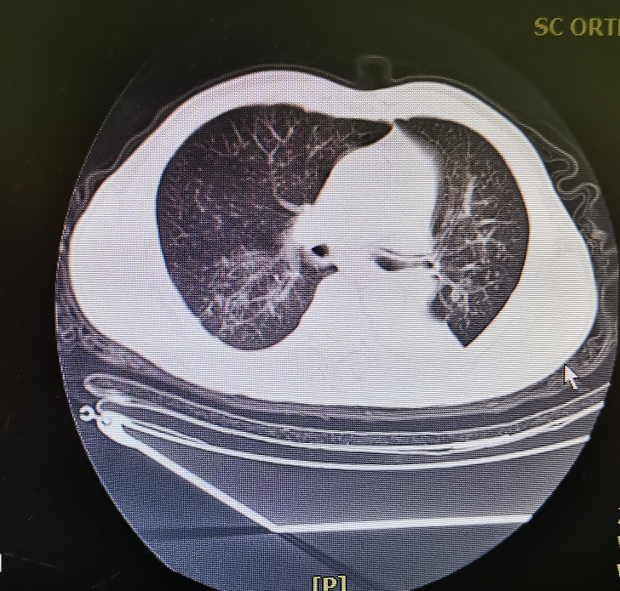
Figure 1 Preoperative computed tomography showing the absence of hemothorax or pneumothorax.
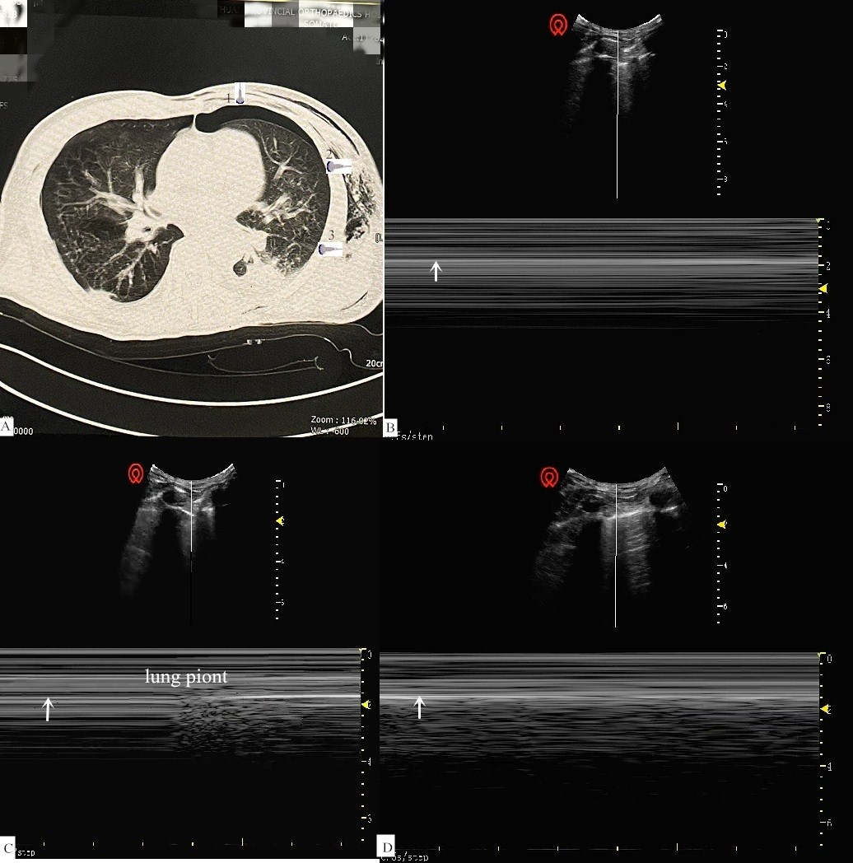
Figure 2 Chest computed tomography and ultrasound. A: Computed tomography of pneumothorax. position 1: pneumothorax; Position 2: boundary of pneumothorax (lung point); Position 3: no pneumothorax; B: Parallel lines sign with the sonography probe at position 1; C: Lung point sign with the sonography probe at position 2; D: Beach sign with the sonography probe at position 3. White arrows indicate the pleura.
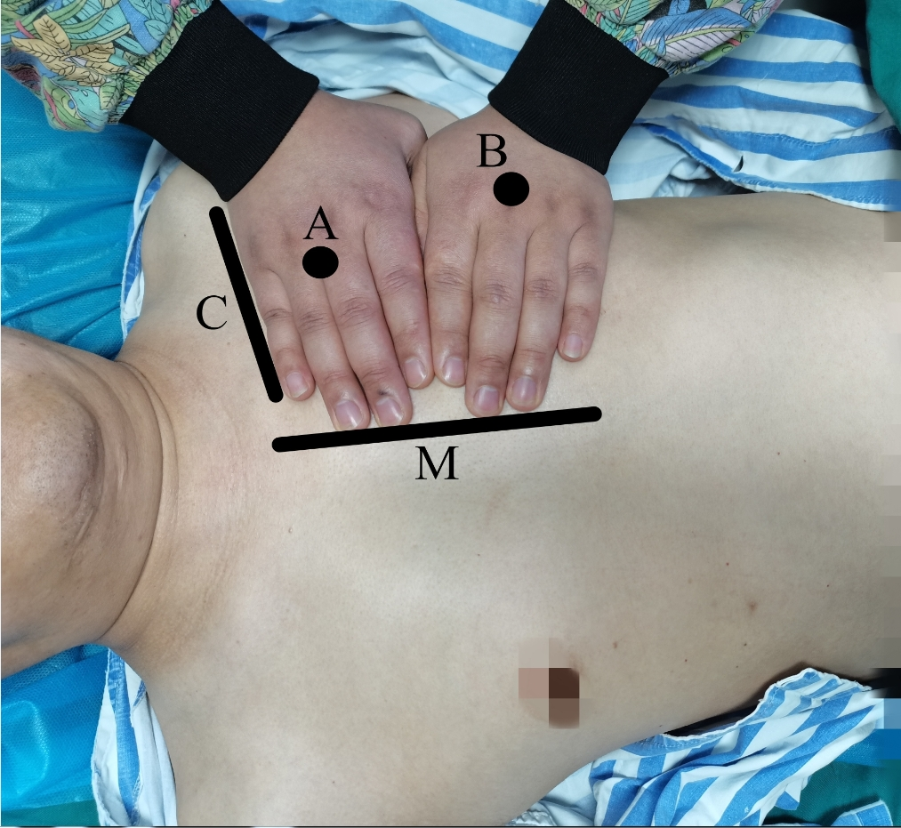
Figure 3 BLUE points recommended for rapid diagnosis or exclusion of perioperative pneumothorax. A: The upper BLUE point is at the third and fourth metacarpophalangeal joints of the upper hand; B: The lower BLUE point is at the center of the lower palm; C: The black line indicates the clavicle; M: The black line indicates the medial sternal line.

