Name of Journal: World Journal of Gastroenterology
ESPS Manuscript NO: 31733
Manuscript Type: ORIGINAL ARTICLE

Observational Study
Can mean platelet volume play a role in evaluating the severity of acute pancreatitis?

Lei JJ et al. MPV predicts AP severity

Jing-Jing Lei, Li Zhou, Qi Liu, Can Xiong, Chun-Fang Xu

Jing-Jing Lei, Chun-Fang Xu, Department of Gastroenterology, The First Affiliated Hospital of Soochow University, Suzhou 215006, Jiangsu Province, China

Jing-Jing Lei, Li Zhou, Qi Liu, Can Xiong, Department of Gastroenterology, The Affiliated Baiyun Hospital of Guizhou Medical University, Guiyan 550014, Guizhou Province, China

Author contributions: Lei JJ, Xu CF and Zhou L designed the study; Lei JJ, Liu Q and Xiong C participated in the acquisition the clinical data; Lei JJ, Zhou L and Xu CF participated in the analysis and interpretation of the data; Lei JJ drafted the initial manuscript; Xu CF was the guarantor and revised the article critically for important intellectual content.

Supported by the Joint Foundation of Guizhou Province Departmetnt of Science and Techology, No. [2016]7408.

Institutional review board statement: The study was reviewed and approved by Institutional Review Board of the Affiliated Baiyun Hospital of Guizhou Medical University.

Informed consent statement: All study participants, or their legal guardian, provided informed written consent prior to study enrollment.

Conflict-of-interest statement: All authors declare that they have no conflicting interests (such as commercial, personal, political, intellectual or religious or other equity interest) with regard to the subject matter or materials discussed in this manuscript.

Data sharing statement: No additional data are available.

Open-Access: This article is an open-access article which was selected by an in-house editor and fully peer-reviewed by external reviewers. It is distributed in accordance with the Creative Commons Attribution Non Commercial (CC BY-NC 4.0) license, which permits others to distribute, remix, adapt, build upon this work non-commercially, and license their derivative works on different terms, provided the original work is properly cited and the use is non-commercial. See: http://creativecommons.org/licenses/by-nc/4.0/

Manuscript source: Unsolicited manuscript

Correspondence to: Chun-Fang Xu, Professor, Department of Gastroenterology, The First Affiliated Hospital of Soochow University, 188 Shizi Street, Suzhou 215006, Jiangsu Province, China. xcf601@163.com
Telephone: +86-512-67780357
Fax: +86-512-65228072

Received: December 4, 2016
Peer-review started: December 6, 2016
First decision: January 10, 2017
Revised: January 28, 2017
Accepted: February 16, 2017
Article in press:
Published online:

Abstract
AIM
To investigate serum mean platelet volume (MPV) levels in acute pancreatitis (AP) patients and assess whether MPV effectively predict disease severity in AP.

METHODS

We included 117 consecutive patients with acute pancreatitis and 34 consecutive patients with colorectal polyps (before endoscopic treatment) as a control group. Full blood counts, liver function, platelet indices (MPV), coagulation parameters, lactate dehydrogenase (LDH) and C-reactive protein (CRP) were measured on days 1, 2, 3 and 7 after admission. Receiver operating characteristic curves were used to compare the sensitivity and specificity of MPV, white blood cell (WBC), LDH and CRP in predicting AP severity. A Modified Glasgow Prognostic Score (mGPS) and the 2012 revised Atlanta criteria were used to evaluate the disease severity in AP.

RESULTS
MPV levels were significantly lower in the AP patients than in the control group on day 1 (P = 0.000), day 2 (P = 0.029) and day 3 (P = 0.001) after admission. In addition, MPV values were lower on day 1 after admission than on day 2 (P = 0.012), day3 (P = 0.000) and day 7 ((P = 0.002) in all AP patients. Based on the mGPS, 78 patients (66.7%) were diagnosed with mild and 39 patients (33.3%) were diagnosed with severe AP. There was no significant difference in mean MPV levels between patients diagnosed with mild and severe AP based on the mGPS (P = 0.424). Based on the 2012 revised Atlanta criteria, there were 98 patients (83.8%) without persistent organ failure (OF) [non-severe acute pancreatitis (SAP) group] and 19 patients (16.2%) with persistent OF (SAP group). MPV levels were significantly lower in the SAP than in the non-SAP group on day 1 after admission (P = 0.002). On day 1 after admission when we applied a cut-off value of 6.65fl, the overall accuracy of MPV in predicting SAP according to the 2012 revised Atlanta criteria (AUC = 0.716) , had a sensitivity of 91.8% and a specificity of 47.4% , and was superior to the accuracy of traditional markers WBC (AUC = 0.700), and LDH (AUC = 0.697).

CONCLUSION
MPV can be used at no additional cost as a useful, non-invasive biomarkers that distinguishes AP with persistent OF from AP without persistent OF on day1 of hospital admission.

Key words: Acute pancreatitis; Mean platelet volume; White blood cell; C-reactive protein; Lactate dehydrogenase; Persistent organ failure

© The Author(s) 2017. Published by Baishideng Publishing Group Inc. All rights reserved.

Core tip: Mean platelet volume (MPV) is a machine-calculated measurement of average platelet size that is easily obtained using automatic blood count equipment at no additional cost and is often overlooked by clinicians. However, the relationship between MPV and acute pancreatitis (AP) remained unclear, and previous studies limited and have produced conflicting results. In the present study, we demonstrate that MPV was significantly lower in AP than in controls during the first three days, and especially on day 1 after admission. Moreover, on day1 of hospital admission, white blood cell, lactate dehydrogenase and C-reactive protein was not as sensitive as MPV in predicting persistent organ failure in AP patients.

Lei JJ, Zhou L, Liu Q, Xiong C, Xu CF. Can mean platelet volume play a role in evaluating the severity of acute pancreatitis? World J Gastroenterol 2017; In press

INTRODUCTION
Severe acute pancreatitis (SAP) is a critical illness in which both the inflammatory and coagulation system are considered ticking time bombs. The most extreme cases can result in multiple organ dysfunction and disseminated intravascular coagulation. Platelet activation appears to play an important role in both the inflamed pancreas itself and remote organ failure^{[1]}. Complex interactions occur between inflammation and hemostasis. Inflammation increases procoagulant factors, and coagulation augments inflammation. Because it is associated with systemic complications and high mortality, and because approximately half of SAP patients show no clinical signs of organ failure (OF) during the first hours or even days of hospitalization^{[2-4]}, it is important to identify the mechanisms that induce the switch from mild to severe AP and to determine at what point this occurs. The adjunctive use of additional markers may add significant benefit by allowing us to predict disease severity and achieve improved diagnostic accuracy.
Mean platelet volume (MPV) is a parameter in complete blood count (CBC) analys that measures average platelet size. As an indicator of thrombocytic activity, it has been investigated in various proinflammatory and prothrombotic clinical states^{[5]}. Increased MPV has been associated with the risk of thrombosis and observed in patients with acute myocardial infarction, acute cerebral ischemia, and transient ischemic attack^{[6–9]}. High-grade inflammatory conditions such as inflammatory bowel disease^{[10]}, ulcerative colitis^{[11]}, acute appendicitis^{[12-14]}, acute cholecystitis^{[15]} , chronic hepatitis B^{[16]}, rheumatoid arthritis and familial Mediterranean fever, are characterized by small platelets, disease remission is characterized by large platelets^{[7,17-19]}. However, the relationship between MPV and AP remains unclear. In addition, there are few previous studies in this area, and their results have been conflicting^{[20-22]}. Objective of the present study was to evaluate serum MPV levels in AP and determine whether MPV is more useful than previously established single biochemical markers in predicting AP severity.

MATERIALS AND METHODS
In this study, 117 patients were diagnosed with a first attack of AP, and an additional, 34 consecutive patients with colorectal polyps who had not yet undergone endoscopic treatment were used as the control group. Extensive demographic, radiographic, and laboratory data were prospectively collected for all included patients. The following exclusion criteria were applied: (1) pancreatic tumor; (2) > five-year history of heavy drinking (> 50 g/d); (3) younger than 18 years old; (4) admitted more than 24 h after the onset of the disease; and (5) pre-existing chronic pancreatitis and a previous history of AP. This study was approved by the Institutional Review Board of the Affiliated Baiyun Hospital of Guizhou Medical University and conformed to the the requirements of the Declaration of Helsinki. Informed and written consent was obtained from all participants.
AP was diagnosed if a patient presented more than two of the three following findings: (1) abdominal pain characteristic of AP (i.e., acute onset of persistent and severe epigastric pain that often radiated to the back); (2) elevated of serum amylase and/or lipase levels higher than three times the upper normal limit; and (3) characteristic findings in imaging studies, including abdominal ultrasonography or computed tomography (CT), consistent with AP^{[23]}. Hyperlipidemic AP was considered when serum triglyceride levels were higher than 11.3 mmol/L in parallel with clinical manifestations, or when blood triglyceride levels were 5.56-11.30 mmol/L in cases where chylous effusion is confirmed while other diseases are excluded^{[24]}. Biliary AP was diagnosed when a gallstone or biliary sludge was observed on abdominal ultrasonography or CT. Alcohol was considered a cause of AP in patients who had a history of alcohol consumption within 48 h before symptom onset and in whom other possible causes were ruled out. The etiology was considered idiopathic when causative factors could not be identified from a detailed clinical and drug history or after initial investigations.
A Modified Glasgow Prognostic Score (mGPS) and the 2012 revised Atlanta criteria were used to evaluate disease severity in AP.
According to the mGPS^{[25]}, eight variables (age > 55 years old; WBC count > 15 × 10⁹/L; blood glucose > 10 mmol/L; blood urea > 16 mmol/L; arterial oxygen partial pressure < 8.0 kPa; serum albumin < 32 g/L; serum calcium < 2.0 mmol/L; and LDH > 600 U/L) were analyzed and patients were subsequently graded as presenting mild AP (score < 3)or severe (score ≥ 3) AP.
Patients were categorized into the following three groups based on the most recent 2012 revised Atlanta Classification^{[23]}: MAP: patients without OF and without local complications; MSAP: patients with OF for less than 48 h or local complications; and SAP: patients with OF for more than 48h. The main purpose of this study was to distinguish SAP in the early stage of the disease; Hence, MSAP and MAP were merged with the non-SAP group, while AP with persistent OF was considered as SAP group.
The following criteria were used for OF: (1) respiratory failure: an oxygenation index (OI) lower than 300; (2) renal failure: a serum creatinine level higher than 170 μmol/L or 1.9 mg/dL; and (3) cardiac failure: systolic blood pressure (SBP) lower than 90 mmHg, and no response to fluid resuscitation.
The withdrawal criterion was that the patient himself/herself or the authorized person requested to be withdrawn from the study. Indications for discontinuing therapy included the following: (1) the disappearance of specific abdominal symptoms, (2) a Marshall score < 2, and (3) triglycerides < 5.6 mmol/L^{[23]}. Contrast-enhanced computed tomography (CECT) was performed in required cases on day 4 after admission to look for pancreatic necrosis (PNec), local complications, and possible AP etiology.
Clinical data, including the patient’s’ gender, age, body temperature, pulse, blood pressure, respiratory rate, full blood cell count, platelet count, chemical examination results, monitoring indicators, and hematocrit, glucose, creatinine, blood urea nitrogen (BUN), and electrolyte levels were collected on days 1, 2, 3 and 7 after admission.

Statistical analysis
Data were collected and enter into a Microsoft Excel database. After data collection was completed, the database was imported into SPSS for Windows (21.0, SPSS, Chicago, IL, USA). Data are presented as the mean ± SD for normally distributed continuous variables and as the median ± IQR for skewed distributed continuous variables. Paired samples t test was used for normally distributed and Mann–Whitney U test for skewed distributed continuous variables to identify differences between 2 groups. One-Way ANOVA was used to identify differences among multiple groups with normally distributed variables. Diagnostic accuracy was portrayed as the area under the curve (AUC) for receiver-operator curves (ROCs). When a significant cut-off value was observed, the sensitivity, specificity, and positive and negative predictive values are presented. Two-sided of P < 0.05 values were considered to indicated statistical significant. Categorical variables are expressed as absolute numbers and proportions. Pearson’s χ² test or Fisher’s exact test was used to compare categorical variables. A P value of < 0.05 was considered statistically significant.

RESULTS
A total of 117 patients with AP and 34 control subjects were enrolled in the present study. Clinical differences and laboratory results of the study participants are summarized in Table 1. There were no significant differences in sex and age between the AP and control groups. Serum MPV and antithrombin Ⅲ (AT-Ⅲ) levels were significantly lower in the AP patients than in the control group, and WBC, serum fibrinogen (FIB) and D-dimers (DD2) levels were significantly higher in the AP patients than in the control group.
The most common cause of AP was a biliary origin in 51 (43.6%) patients, and this was followed by hyperlipidemic acute pancreatitis in 45 (38.5%), idiopathic etiology in 18 (15.4%) and excessive alcohol consumption in 3 (2.6%) patients. No patient who was induced using drug and endoscopic retrograde cholangiopancreatography (ERCP) was included in this study (Figure 1).
MPV levels were significantly lower in patients with AP than in the control group (F = 13.92, P = 0.000). Table 2 and Figure 2 shows the mean MPV values in the AP and control patients on days 1, 2, 3 and 7 after admission. MPV levels were significantly lower in the AP patients than in the control group on day 1 (P = 0.000), day 2 (P = 0.029) and day 3 (P = 0.001) after admission. In addition, MPV levels significantly lower in patients on day 1 than on day 2 (P = 0.012) , day 3 (P = 0.000) and day 7 (P = 0.002).
According to the mGPS, 78 patients (66.7%) were classified as MAP and 39 patients (33.3%) were classified SAP. Serum MPV, WBC, LDH and CRP levels were calculated in MAP and SAP according to the mGPS on days1, 2, 3, and 7 after admission, as shown in Table 3. There was no significant difference in mean MPV levels between the MAP and SAP groups according to the mGPS on days 1, 2, 3 and 7 after admission. There were significantly higher C-reactive protein (CRP) levels in the SAP group than in the MAP group on days 2, 3 and 7 after admission. There were significant higher WBC and LDH levels in the SAP group than in the MAP group on days 1, 2, 3 and 7 after admission. An analysis of ROC curves showed that the overall accuracy of MPV in predicting SAP (AUC = 0.540) was less accurate than traditional WBC and LDH (AUC = 0.737, 0.669 respectively) on day 1 after admission, less accurate than CRP (AUC = 0.651), LDH (AUC=0.753) and WBC (AUC = 0.675) on day 2 after admission, and less accurate than WBC (AUC = 0.681), LDH (AUC = 0.724) and CRP (AUC = 0.754) on day 3 after admission (Table 4 and Figure 3).
Patients were divided into the three following groups according to the 2012 revised Atlanta criteria: 24 (20.5%) patients were classified as mild, 74(63.2%) patients were classified as moderate and 19 (16.2%) patients were classified as severe. Because SAP is characterized by persistent OF (≥ 48 h) and have different prognoses and high mortality, patients with persistent OF were viewed as a single group, while patients with mild and moderate were merged into another group. A subgroup analysis was performed between these two groups (i.e., the non-SAP and SAP groups). There were 98 patients (83.8%) in the non-SAP group and 19 patients (16.2%) in the SAP group. The results of comparisons between the SAP (According to the 2012 revised Atlanta criteria) and non-SAP groups in MPV, WBC, LDH and CRP on days 1, 2, 3 and 7after admission are shown in Table 5. Mean MPV levels were significantly lowing in the SAP group than in the non-SAP on day 1 after admission. In addition, the overall accuracy of MPV in predicting persistent OF (according to the 2012 revised Atlanta criteria) (AUC = 0.716), was superior to that of traditional WBC (AUC = 0.700), LDH (AUC = 0.697) on day 1 after admission, superior to that of CRP (AUC = 0.667), and WBC (AUC = 0.676) on day 2 after admission, and superior to that of LDH(AUC=0.655) on day 3 after admission. However, the accuracy of MPV was inferior to that of LDH (AUC = 0.740) on day 2 after admission, and to that of WBC (AUC = 0.735) and CRP (AUC = 0.749) on day 3 after admission (Figure 4, Table 6).

DISCUSSION
MPV is a machine-calculated measurement of average platelet size, that is easily measured by using automatic blood count equipment at no additional cost and is often overlooked by clinicians. Many studies have reported that MPV is a commonly used marker of platelet production and function, and it has also been shown to reflect inflammatory burden. Evidence, especially data derived from prospective studies and a meta-analysis, have suggested that there is a correlation between an increase in MPV and the risk of thrombosis and between a decrease in MPV in patients with inflammation and a reversal in the course of anti-inflammatory treatment^{[5]}. AP presents as acute inflammation that is accompany by thrombosis and bleeding disorders, and platelet activation plays an important role in AP. Because established serum biomarkers are only modestly useful in reflecting disease activity in AP, alternative, cheap, easy applicable and non-invasive markers are needed. We therefore performed this study to evaluate the role of MPV in predicting AP severity and to compare its efficacy with that of other serologic markers such as WBC, LDH and CRP.
Several previous studies have explored MPV in AP, with conflicting results. Okuturlar et al^{20]} found that MPV levels were significantly lower in both biliary and non-biliary AP patients; Mimidis et al^{[21]}, in a study of 54 AP patients, found that MPV values were lower at onset (9.1 fl) than remission(9.5fl). However, Erdem Akbal et al^{[22]} reported that MPV was significantly higher at admission in acute edematous pancreatitis patients (8.6 ± 1.4 fl) than controls (7.6 ± 0.7 fl) (P < 0.005). The results of our study revealed that serum MPV levels are lower in AP patients during the first week after admission than the levels observed in controls. Furthermore, MPV levels were higher after treatment, consistent with the results described in Okuturlar et al^{[20]} and Mimidis et al^{[21]}, but in conflict with the results described in Erdem Akbal et al^{[22]} . The exact reason that MPV is lower in AP patients remains unclear, but it has been speculated that platelets not only control thrombosis and hemostasis but that they may also regulate inflammatory processes. A lower MPV in AP maybe reflect an increase in the consumption of large platelets at sites of pancreatics and distant organ inflammation, which may occur well before clinical manifestation of AP attacks appear^{[5]}. A higher MPV in AP is thought to reflect hypercoagulable state in acute edematous pancreatitis, as suggested by Akbal et al^{[22]} and Boos et al^{[26]} suggested that this may be due to inappropriate blood sampling and storing.
Only two reports^{[27,28]} have explored the role of MPV in the severity of AP. Beyazit et al^{[27]} reported that according to the mGPS, the overall accuracy of MPV for identifying severe AP was 72.7% with a sensitivity, specificity, NPV and PPV of 70.6%, 73.9%, 81.9%, and 60.0%, respectively (AUC: 0.762). Erbis et al^{[28]} found that MPV was lower in acute necrotizing pancreatitis(ANP) patients (7.2 ± 0.52fl) than in edematous pancreatitis(AEP) (7.9 ± 0.53 fl), (P < 0.001). When they compared the study groups using a ROC analysis, the results demonstrated that the cut-off value for necrotizing pancreatitis patients was 7.8fl (AUC: 0.857), with a sensitivity of 86.1% and specificity of 72.5%. Our results show that MPV is significantly lower in pancreatitis patients with persistent OF than in patients without persistent OF, with a cut-off value of 6.65 fl, that had a sensitivity of 91.8% and specificity of 47.4% (AUC: 0.716) in predicting AP with persistent OF. Sensitivity and specificity represent the proportions of severe and mild attacks in AP respectively. Hence, observing good sensitivity in the early stage of AP ensures that high-risk patients was to be distinguish from those with mild, self-limiting disease, and this is important because it allow clinicians to identify potential OF patient and to initiate appropriate supportive treatments and intervention . However, in this study, we found that there was no advantage in predicting the severity of AP according to the mGSP. Potential reasons for this discrepancy include the following: first, our study is prospective, but the results reported by Beyazit et al^{[27]} were obtained from retrospective studies；second, in their study the second most common cause of AP was alcohol consumption whereas in our study, it was hypertriglyceridemia.
LDH, a glycolytic enzyme, is present in the cytoplasm of all living cells, but is found at higher concentrations in the heart, kidneys, and skeletal muscles. We found that LDH levels were significantly higher in the SAP group (according to mGPS) than in MAP group in the first week after admission, and serum LDH levels were also significantly higher in the SAP group than in non-SAP in the first week after admission, based on the 2012 revised Altanta criteria. Moreover, the cut-off LDH level on day 1 after admission for SAP according to the mGPS was 192.45 IU/L, with a sensitivity of 92.3% and specificity of 42.3%, whereas the cut-off LDH level on day 3 after admission for severe AP according to the mGPS was 255.96 U/L with a specificity of 94.9% and a sensitivity of 41.0% , These results suggest that dynamic monitoring of serum LDH level is key to making a correct diagnosis; The cut-off LDH level on day 1 after admission for persistent OF, according to the 2012 revised Atlanta criteria was 239.08 U/L, with a sensitivity of 73.7% and specificity of 62.2%. On day 2 and 3 after admission, the LDH cut-off values were 263.28 U/L and 260.87 U/L, respectively, with relative higher specificity (86.7% and 89.7%, respectively) and lower sensitivity (52.6% and 42.1%, respectively) for predicting persistent OF. The normal reference value for LDH was 9-245 U/L, suggesting that if the LDH levels do not significantly increase, the probability that persistent OF and SAP will occur is small. Our results are consistent with those described in studies by Tasić et al^{[29]} and Zrnić et al^{[30]}. Those authors observed that LDH levels were significantly higher in patients with severe pancreatitis than in a group with moderated pancreatitis (P < 0.01).They also found that specificity and diagnostic accuracy were highest for LDH on the first day (67.74%; 57%) when predicting complications of acute pancreatitis.
CRP is a neutrophil-activating peptide (acute phase protein) that is synthesized in hepatocytes in multiple cell lines. Its production is induced by the release of interleukins (IL) 1 and 6. Our results showed that on day 1 after admission, plasma CRP levels were not significantly different between MAP and SAP according to the mGPS, and there was no significant difference between the non-SAP group and SAP that were defined based on the 2012 revised Atlanta criteria, suggesting that in AP patients, CRP levels are not likely to reflect the severity of the disease when measured during its early phase after onset. However, on day 3 after admission, CRP levels peaked (AUC 0.754) in a ROC curve analysis and were superior to WBC and LDH for predicting SAP according to the mGPS (Figure 3C, Table 4) and persistent OF (AUC 0.749) according to the 2012 revised Atlanta criteria (Figure 4C, Table 6). These results suggest that despite its delayed increase, which results in CRP peaking no earlier than 72 h after symptoms onset, among single biochemical markers, CRP still considered the most useful^{[31]} serum biochermical for predicting the severity and progression of acute pancreatitis.
In conclusion, in the present study, we demonstrated that MPV levels were lower in AP patients during the first week after admission than in a control group. In addition, lower MPV levels were observed in patients with persistent OF than in those without persistent OF. Furthermore MPV had higher sensitivity than were observed for WBC, LDH and CRP for predicting AP with persistent OF on day 1 after admission. Serum MPV levels may be a useful tool for predicting SAP as defined by the latest 2012 Atlanta classification during the early stage of the disease.

COMMENTS
Background
Many studies have suggested that there is a correlation between an increase in mean platelet volume (MPV) and the risk of thrombosis and between a decrease in MPV in patients with acute inflammation and the reversal of the course of anti-inflammation treatment. Acute pancreatitis (AP) is an acute inflammatory condition that is accompanied by thrombosis and bleeding disorders, and platelet activation therefore plays an important role in AP. The currently established serum biomarkers are only modestly useful for predicting disease activity of AP. Hence, cheap, easily applicable and non-invasive markers are needed. In light of this purpose, this study was performed to evaluate the efficacy of using MPV to predicting AP severity in comparison to the results of using other serological markers, such as white blood cell (WBC), lactate dehydrogenase (LDH) and C-reactive protein (CRP)..

Research frontiers
AP is a potentially life-threatening disease with a wide spectrum of severity. The overall mortality rate for AP is approximately 5% and as high as 20%-30% in patients with severe AP. While it is generally recognized predicting the severity of the disease is import for manage individual patient, it is also recognized that making such predictions is very difficult. Even though CRP still remains considered the most useful biochermical serum marker for predicting the severity and progression of AP, it can only predict severity at after 48 h after the patients has been admitted to the hospital, which can be more than 72 h after disease onset. This may be too late, because early aggressive fluid resuscitation is a cornerstone of AP therapy. One focus of research in this topic should be centered on introducing MPV as a useful, non-invasive biomarker that can be evaluated with no additional cost and that can distinguish AP with persistent organ failure (OF) from that without on day 1 of hospital admission.

Innovations and breakthroughs
Studies have been performed over the last few decades attempt to identify new biochemical markers that accurately predict the severity of pancreatitis. However, no gold standard has emerged for predict of the course of AP. The present study is the first prospective clinical study to measure MPV in AP patients in an attempt to predict persistent OF in the early stage of AP.

Applications
The results of this study suggest that on day 1 after admission, the overall accuracy of MPV for predicting SAP (defined according to the 2012 revised Atlanta criteria) was superior to the overall accuracy of traditional WBC and LDH. MPV may therefore be a useful biochemical marker for predicting persistent OF during the early stage of AP. Furthermore, this study also provided readers with important information about the predictive value of LDH on day 2 after admission, and of WBC and CRP on day 3 after admission.

Terminology
MPV is a machine-calculated measurement of average platelet size that is easily measured at no additional cost by using automatic blood count equipment and is often overlooked by clinicians. Many studies have reported that MPV is a commonly used marker of platelet production and function, and it has also been shown to reflect inflammatory burden.

Peer-review
In this observational, prospective clinical study article, the authors evaluate the efficacy of measuring MPV to predicting the severity of AP. This is an important study because conflicting result have been reported regarding the levels of MPV in AP patients. The authors have demonstrated that lower in MPV levels were observed in AP patients than in controls during the first week of hospital admission. Moreover, the results indicated that the MPV level was lower in patients with persistent OF on day 1 of hospital admission than in those without persistent OF. These results may assist clinicians in achieving more accurate early diagnoses of AP patients with persistent OF.

REFERENCES
1 Aksu K, Donmez A, Keser G. Inflammation-induced thrombosis: mechanisms, disease associations and management. Curr Pharm Des 2012; 18: 1478-1493 [PMID: 22364132]
2 Johnson CD, Kingsnorth AN, Imrie CW, McMahon MJ, Neoptolemos JP, McKay C, Toh SK, Skaife P, Leeder PC, Wilson P, Larvin M, Curtis LD. Double blind, randomised, placebo controlled study of a platelet activating factor antagonist, lexipafant, in the treatment and prevention of organ failure in predicted severe acute pancreatitis. Gut 2001; 48: 62-69 [PMID: 11115824]
3 Maksimow M, Kyhälä L, Nieminen A, Kylänpää L, Aalto K, Elima K, Mentula P, Lehti M, Puolakkainen P, Yegutkin GG, Jalkanen S, Repo H, Salmi M. Early prediction of persistent organ failure by soluble CD73 in patients with acute pancreatitis*. Crit Care Med 2014; 42: 2556-2564 [PMID: 25126879 DOI: 10.1097/CCM.0000000000000550]
4 Nieminen A, Maksimow M, Mentula P, Kyhälä L, Kylänpää L, Puolakkainen P, Kemppainen E, Repo H, Salmi M. Circulating cytokines in predicting development of severe acute pancreatitis. Crit Care 2014; 18: R104 [PMID: 24886762 DOI: 10.1186/cc13885]
5 Gasparyan AY, Ayvazyan L, Mikhailidis DP, Kitas GD. Mean platelet volume: a link between thrombosis and inflammation? Curr Pharm Des 2011; 17: 47-58 [PMID: 21247392]
6 Giles H, Smith RE, Martin JF. Platelet glycoprotein IIb-IIIa and size are increased in acute myocardial infarction. Eur J Clin Invest 1994; 24: 69-72 [PMID: 8187810]
7 Leader A, Pereg D, Lishner M. Are platelet volume indices of clinical use? A multidisciplinary review. Ann Med 2012; 44: 805-816 [PMID: 22413913]
8 Chu SG, Becker RC, Berger PB, Bhatt DL, Eikelboom JW, Konkle B, Mohler ER, Reilly MP, Berger JS. Mean platelet volume as a predictor of cardiovascular risk: a systematic review and meta-analysis. J Thromb Haemost 2010; 8: 148-156 [PMID: 19691485 DOI: 10.1111/j.1538-7836.2009.03584]
9 Balcik ÖS, Bilen S, Ulusoy EK, Akdeniz D, Uysal S, Ikizek M, Ak F, Kosar A. Thrombopoietin and mean platelet volume in patients with ischemic stroke. Clin Appl Thromb Hemost 2001; 19: 92-95 [PMID: 22327824 DOI: 10.1177/1076029611434528]
10 Kapsoritakis AN, Koukourakis MI, Sfiridaki A, Potamianos SP, Kosmadaki MG, Koutroubakis IE, Kouroumalis EA. Mean platelet volume: a useful marker of inflammatory bowel disease activity. Am J Gastroenterol 2001; 96: 776-781 [PMID: 11280550]
11 Yüksel O, Helvaci K, Başar O, Köklü S, Caner S, Helvaci N, Abayli E, Altiparmak E. An overlooked indicator of disease activity in ulcerative colitis: mean platelet volume. Platelets 2009; 20: 277-281 [PMID: 19459134 DOI: 10.1080/09537100902856781]
12 Albayrak Y, Albayrak A, Albayrak F, Yildirim R, Aylu B, Uyanik A, Kabalar E, Güzel IC. Mean platelet volume: a new predictor in confirming acute appendicitis diagnosis. Clin Appl Thromb Hemost 2011; 17: 362-366 [PMID: 20460349 DOI: 10.1177/1076029610364520]
13 Fan Z, Pan J, Zhang Y, Wang Z, Zhu M, Yang B, Shi L, Jing H. Mean Platelet Volume and Platelet Distribution Width as Markers in the Diagnosis of Acute Gangrenous Appendicitis. Dis Markers 2015; 2015: 542013 [PMID: 26688600 DOI: 10.1155/2015/542013]
14 Kucuk E, Kucuk I. Mean Platelet Volume is Reduced in Acute Appendicitis. Turk J Emerg Med 2015; 15: 23-27 [PMID: 27331191 DOI: 10.5505/1304.7361.2015.32657]
15 Sayit AT, Gunbey PH, Terzi Y. Is the Mean Platelet Volume in Patients with Acute Cholecystitis an Inflammatory Marker? J Clin Diagn Res 2015; 9: TC05-TC07 [PMID: 26266183 DOI: 10.7860/JCDR/2015/12028.6061]
16 Turhan O, Coban E, Inan D, Yalcin AN. Increased mean platelet volume in chronic hepatitis B patients with inactive disease. Med Sci Monit 2010; 16: CR202-CR205 [PMID: 20357720]
17 Kisacik B, Tufan A, Kalyoncu U, Karadag O, Akdogan A, Ozturk MA, Kiraz S, Ertenli I, Calguneri M. Mean platelet volume (MPV) as an inflammatory marker in ankylosing spondylitis and rheumatoid arthritis. Joint Bone Spine 2008; 75: 291-294 [PMID: 18403245 DOI: 10.1016/j.jbspin.2007.06.016]
18 Gasparyan AY, Sandoo A, Stavropoulos-Kalinoglou A, Kitas GD. Mean platelet volume in patients with rheumatoid arthritis: the effect of anti-TNF-α therapy. Rheumatol Int 2010; 30: 1125-1129 [PMID: 20066426 DOI: 10.1007/s00296-009-1345-1]
19 Yazici S, Yazici M, Erer B, Erer B, Calik Y, Bulur S, Ozhan H, Ataoglu S. The platelet functions in patients with ankylosing spondylitis: anti-TNF-alpha therapy decreases the mean platelet volume and platelet mass. Platelets 2010; 21: 126-131 [PMID: 20050759 DOI: 10.3109/09537100903470306]
20 Okuturlar Y, Soylu A, Dogan H, Cakmak S, Kirac Utku I, Oztosun B, Akarsu C, Ocak Serin S, Avci A, Kones O, Ozucelik DN, Guzey D, Harmankaya O, Kumbasar A. Mean platelet volume in patients with biliary and non-biliary acute pancreatitis. Int J Clin Exp Pathol 2015; 8: 2051-2056 [PMID: 25973103]
21 Mimidis K, Papadopoulos V, Kotsianidis J, Filippou D, Spanoudakis E, Bourikas G, Dervenis C, Kartalis G. Alterations of platelet function, number and indexes during acute pancreatitis. Pancreatology 2004; 4: 22-27 [PMID: 14988655 DOI: 10.1159/000077024]
22 Akbal E, Demirci S, Koçak E, Köklü S, Başar O, Tuna Y. Alterations of platelet function and coagulation parameters during acute pancreatitis. Blood Coagul Fibrinolysis 2013; 24: 243-246 [PMID: 23425662 DOI: 10.1097/MBC.0b013e32835aef51]
23 Banks PA, Bollen TL, Dervenis C, Gooszen HG, Johnson CD, Sarr MG, Tsiotos GG, Vege SS. Classification of acute pancreatitis--2012: revision of the Atlanta classification and definitions by international consensus. Gut 2013; 62: 102-111 [PMID: 23100216 DOI: 10.1136/gutjnl-2012-302779]
24 Takaishi K, Miyoshi J, Matsumura T, Honda R, Ohba T, Katabuchi H. Hypertriglyceridemic acute pancreatitis during pregnancy: prevention with diet therapy and omega-3 fatty acids in the following pregnancy. Nutrition 1984; 25: 1094-1097 [PMID: 19524405 DOI: 10.1016/j.nut.2009.04.009]
25 Blamey SL, Imrie CW, O'Neill J, Gilmour WH, Carter DC. Prognostic factors in acute pancreatitis. Gut 1984; 25: 1340-1346 [PMID: 6510766]
26 Boos CJ, Balakrishnan B, Lip GY. The effects of coronary artery disease severity on time-dependent changes in platelet activation indices in stored whole blood. J Thromb Thrombolysis 2008; 25: 135-140 [PMID: 17574521 DOI: 10.1007/s11239-007-0034-8]
27 Beyazit Y, Sayilir A, Torun S, Suvak B, Yesil Y, Purnak T, Oztas E, Kurt M, Kekilli M, Ibis M. Mean platelet volume as an indicator of disease severity in patients with acute pancreatitis. Clin Res Hepatol Gastroenterol 2012; 36: 162-168 [PMID: 22088974 DOI: 10.1016/j.clinre.2011.10.003]
28 Erbis H, Aliosmanoglu I, Turkoglu MA, Ay E, Turkoglu A, Ulger BV. Evaluating mean platelet volume as a new indicator for confirming the diagnosis of necrotizing pancreatitis. Ann Ital Chir 2014; 86: 132-136 [PMID: 25707448]
29 Tasić T, Grgov S, Nagorni A, Benedeto-Stojanov D. [Comparison of biohumoral and morphological parameters in acute pancreatitis]. Srp Arh Celok Lek 2007; 142: 29-33 [PMID: 24684028]
30 Zrnić IK, Milić S, Fisić E, Radić M, Stimac D. [C-reactive protein and lactate dehydrogenase as single prognostic factors of severity in acute pancreatitis]. Lijec Vjesn 2010; 129: 1-4 [PMID: 17489509]
31 Dambrauskas Z, Gulbinas A, Pundzius J, Barauskas G. Value of the different prognostic systems and biological markers for predicting severity and progression of acute pancreatitis. Scand J Gastroenterol 2010; 45: 959-970 [PMID: 20367283 DOI: 10.3109/00365521003770244]
P-Reviewer: Inal V, Ulmasov B S-Editor: Yu J L-Editor: E-Editor:
Specialty type: Gastroenterology and hepatology
Country of origin: China
Peer-review report classification
Grade A (Excellent): A
Grade B (Very good): 0
Grade C (Good): C
Grade D (Fair): 0
Grade E (Poor): 0

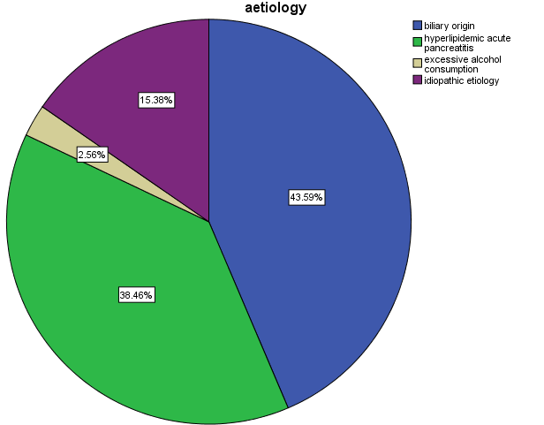
Figure 1 Distribution of acute pancreatitis patients according to etiology.

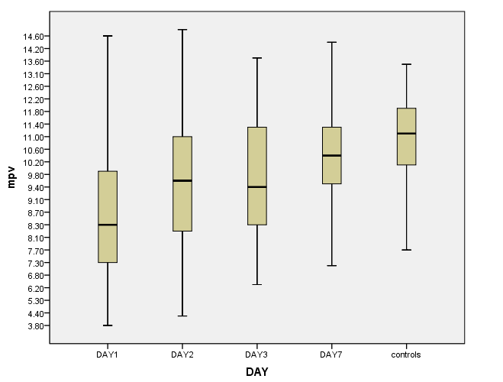
Figure 2 Mean platelet volume levels in acute pancreatitis patients (on days 1, 2, 3 and 7 after admission) and controls.

A
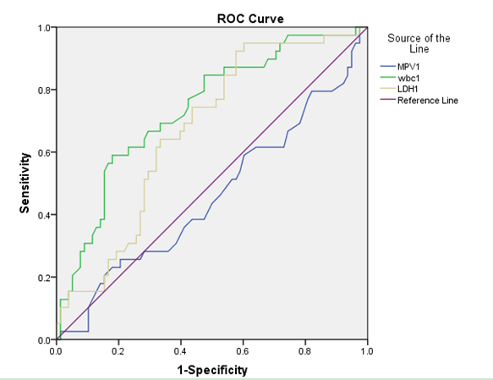
B
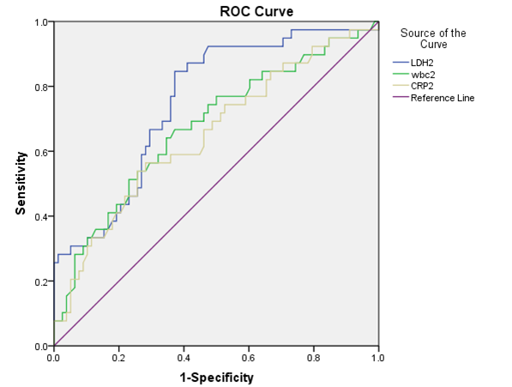
C
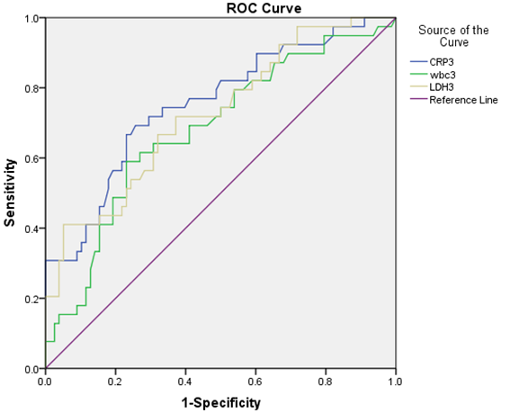
Figure 3 Receiver operating characteristic curve for mean platelet volume and other inflammation markers on days 1, 2 and 3 after admission for the severe acute pancreatitis according to the Modified Glasgow Prognostic Score. A：Receiver operating characteristic (ROC) curve for mean platelet volume (MPV) and other inflammation markers on day 1 after admission; B: ROC curve for inflammation markers on day 2 after admission; C: ROC curve for inflammation markers on day 3 after admission.

A
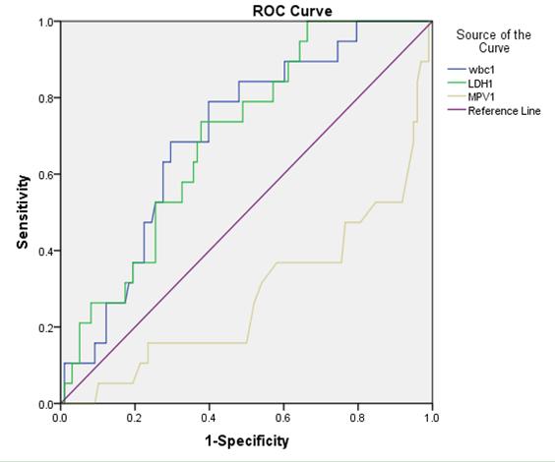
B
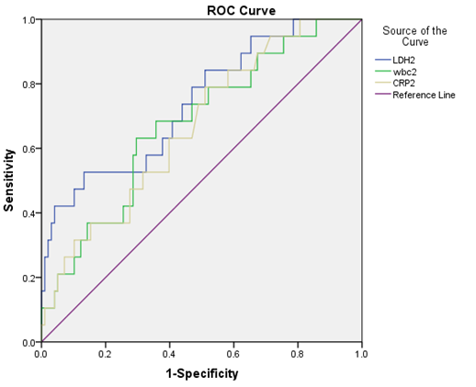
C
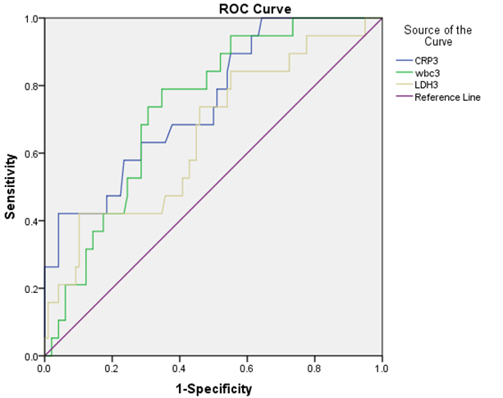
Figure 4 Receiver operating characteristic curve for mean platelet volume and other inflammation markers on days 1, 2 and 3 after admission for persistent organ failure according to the 2012 revised Atlanta criteria. A: Receiver operating characteristic (ROC) curve for mean platelet volume (MPV) and other inflammation markers on day 1 after admission; B: ROC curve of inflammation markers on day 2 after admission; C: ROC curve of inflammation markers on day3 after admission.

Table 1 Demographic features and laboratory values of the patients and controls
 | Acute pancreatitis (n = 117) | Control group (n = 34) | P value
Age (yr)  Gender (M/F)  MPV (fl)  WBC  Platelet  AT-III  APTT  PT  FIB  DD2  Hb  Hct | 46.98 ± 14.42  72 (61.5%) /45(38.5%)  8.72 ± 2.37  13.28 ± 3.84  180.00 ± 65.04  90.93 ± 19.00  37.96 ± 14.12  12.85 ± 1.14  3.68 ± 1.45  1.16 ± 1.14  143.69 ± 26.04  42.91 ± 6.46 | 50.53 ± 12.18  19(55.9%)/15(44.1%)  10.98 ± 1.40  5.99 ± 1.64  203.56 ± 52.73  101.44 ± 10.36  36.79 ± 4.14  12.63 ± 0.62  2.91 ± 0.51  0.27 ± 0.16  147.53 ± 14.76  44.75 ± 4.51 | 0.117¹  0.557²  0.000b¹  0.000¹  0.060¹  0.000¹  0.635¹  0.144¹  0. 000¹  0. 000¹  0 .421¹  0 .128¹
¹t-test; ²χ² test. MPV: Mean platelet volume; WBC: White blood cells; AT-Ⅲ: AntithrombinⅢ; APTT: Activated partial prothrombin time; PT: Prothrombin time; FIB: Fibrinogen; DD2: D-dimers; Hb: Hemoglobin; Hct: Hematrocrit.

Table 2 Mean platelet volume levels in acute pancreatitis patients (on days 1, 2, 3 and 7 after admission) and controls
Patients |  |  |  | Controls | F value | P value
MPV1ª | MPV2^{a,b} | MPV3^{a,b} | MPV7^{b}
8.72 ± 2.37 | 9.67 ± 2.37 | 9.77 ± 1.84 | 10.44 ± 1.66 | 10.98 ± 1.40 | 13.92 | 0.000
ªP < 0.05 vs control group; ^{b}P < 0.05 vs mean platelet volume (MPV) on day 1 after admission.

Table 3 Mean platelet volume, WBC, LDH and CRP on days 1, 2, 3 and 7 after admission between in MAP and severe acute pancreatitis according to the modified Glasgow Prognostic Score
 | Mild pancreatitis (n = 78) | Severe pancreatitis (n = 39) | t | P value
MPV1  MPV2  MPV3  MPV7  WBC1  WBC2  WBC3  WBC7  LDH1  LDH2  LDH3  LDH7  CRP1  CRP2  CRP3  CRP7 | 8.85 ± 2.32  9.66 ± 2.32  9.68 ± 1.84  10.40 ± 1.59  12.26 ± 3.62  10.52 ± 3.63  8.51 ± 0.19  6.82 ± 2.26  230.70 ± 79.79  187.49 ± 51.72  181.17 ± 44.77  180.29 ± 46.22  42.53 ± 71.33  76.83 ± 69.50  68.62 ± 61.01  23.12 ± 31.93 | 8.47 ± 2.49  9.67 ± 2.49  9.96 ± 1.84  10.52 ± 1.80  15.33 ± 3.47  13.26 ± 4.78  10.69 ± 3.56  9.53 ± 3.80  280.15 ± 102.28  258.95 ± 103.09  242.05 ± 84.61  227.25 ± 58.69  66.85 ± 96.00  129.77 ± 111.28  154.05 ± 114.50  66.49 ± 57.40 | 0.802  -0.024  -0.791  -0.357  -4.387  -3.456  -3.356  -4.831  -2.870  -4.080  -4.209  -4.366  -1.398  -2.718  -4.361  -4.391 | 0.424  0.981  0.430  0.721  0.000  0.001  0.001  0.001  0.005  0.000  0.000  0.000  0.167  0.009  0.000  0.000
MPV: Mean platelet volume; WBC: White blood cells; LDH: Lactate dehydrogenase; CRP: C-reactive protein.

Table 4 Overall accuracy of mean platelet volume and other inflammation makers in predicting severe acute pancreatitis on days 1, 2 and 3 after admission according to modified Glasgow Prognostic Score
 | Cut-off value | AUC | Sensitivity | Specificity | PPV | NPV | Overall accuracy (%)
MPV1 | 7.45 | 0.540 | 73.1 | 38.5 | 41.67 | 70.37 | 61.54
WBC1 | 15.20 | 0.737 | 59.0 | 82.1 | 62.16 | 80 | 74.36
LDH1 | 192.45 | 0.669 | 92.3 | 42.3 | 44.44 | 91.67 | 58.97
WBC2 | 11.47 | 0.675 | 64.1 | 65.4 | 48.08 | 78.46 | 64.96
LDH2 | 189.60 | 0.753 | 84.6 | 62.8 | 55.53 | 89.09 | 70.09
CRP2 | 98.00 | 0.651 | 56.4 | 71.8 | 50.00 | 76.71 | 66.67
WBC3 | 9.755 | 0.681 | 59.0 | 76.9 | 56.10 | 78.95 | 70.94
LDH3 | 255.96 | 0.724 | 41.0 | 94.9 | 80.00 | 76.28 | 76.92
CRP3 | 101.00 | 0.754 | 69.2 | 74.4 | 57.45 | 82.65 | 72.65
AUC: Area under curve; PPV: Positive predictive value; NPV: Negative predictive value; MPV: Mean platelet volume; WBC: White blood cells; LDH: Lactate dehydrogenase; CRP: C-reactive protein.

Table 5 Mean platelet volume, WBC, LDH and CRP on days 1, 2, 3 and 7 after admission between in the non-severe acute pancreatitis and SAP groups according to the 2012 revised Atlanta criteria
 | Non-SAP group (n = 98) | SAP (n = 19) | t | P value
MPV1  MPV2  MPV3  MPV7  WBC1  WBC2  WBC3  WBC7  LDH1  LDH2  LDH3  LDH7  CRP1 (mg/L)  CRP2 (mg/L)  CRP3 (mg/L)  CRP7 (mg/L) | 9.02 ± 2.27  9.84 ± 2.30  9.74 ± 1.88  10.39 ± 1.66  12.85 ± 3.79  10.95 ± 3.89  8.81 ± 3.38  7.22 ± 2.66  238.82 ± 90.06  196.39 ± 57.82  193.37 ± 57.37  190.58 ± 52.58  48.29 ± 79.96  84.56 ± 76.89  80.71 ± 68.79  29.96 ± 37.14 | 7.19 ± 2.34  8.77 ± 2.56  9.92 ± 1.61  10.72 ± 1.67  15.52 ± 3.36  13.94 ± 5.08  11.46 ± 3.02  10.31 ± 4.05  290.32 ± 82.45  288.30 ± 125.57  243.25 ± 95.41  223.59 ± 61.12  63.05 ± 86.57  145.63 ± 125.27  181.58 ± 140.16  76.84 ± 68.26 | 3.198  1.825  -0.387  -0.798  -2.864  -2.909  -3.174  -3.187  -2.311  -3.127  -2.203  -2.438  -.0.726  -2.051  -3.066  -2.912 | 0.002  0.071  0.699  0.426  0.005  0.004  0.002  0.004  0.023  0.005  0.039  0.016  0.469  0.053  0.006  0.009
MPV: Mean platelet volume; WBC: White blood cells; LDH: Lactate dehydrogenase; CRP: C-reactive protein.

Table 6 Overall accuracy of mean platelet volume and other inflammation makers in predicting persistent organ failure on days 1, 2 and 3 after admission according to the 2012 revised Atlanta criteria
 | Cut off  value | AUC | Sensitivity  (%) | Specificity  (%) | PPV  (%) | NPV  (%) | Overall  accuracy (%)
MPV1  WBC1 | 6.65  13.55 | 0.716  0.700 | 91.8  60.2 | 47.4  78.9 | 52.49  27.78 | 70.00  93.65 | 67.52  63.25
LDH1 | 239.08 | 0.697 | 73.7 | 62.2 | 27.45 | 92.42 | 64.1
WBC2 | 12.36 | 0.676 | 63.2 | 70.4 | 29.27 | 90.8 | 69.23
LDH2 | 263.28 | 0.740 | 52.6 | 86.7 | 43.48 | 90.43 | 81.2
CRP2 | 63.50 | 0.667 | 78.9 | 49.0 | 38.46 | 92.31 | 53
WBC3 | 9.32 | 0.735 | 78.9 | 65.3 | 30.61 | 94.12 | 67.52
LDH3 | 260.87 | 0.655 | 42.1 | 89.7 | 44.44 | 88.89 | 82.05
CRP3 | 206.50 | 0.749 | 42.1 | 95.9 | 66.67 | 89.52 | 87.17
AUC: Area under curve; PPV: Positive predictive value; NPV: Negative predictive value; MPV: Mean platelet volume; WBC: White blood cell; LDH: Lactate dehydrogenase; CRP: C-reactive protein.

