Name of journal: World Journal of Gastroenterology
ESPS Manuscript NO: 24138
Manuscript Type: ORIGINAL ARTICLE

Retrospective Study
Contrast-enhanced ultrasound of histologically proven hepatic epithelioid hemangioendothelioma

Dong Y et al. CEUS of HEHE

Yi Dong, Wen-Ping Wang, Vito Cantisani, Mirko D’Onofrio, Andre Ignee, Lorenzo Mulazzani, Adrian Saftoiu, Zeno Sparchez, Ioan Sporea, Christoph F Dietrich

Yi Dong, Wen-Ping Wang, Department of Ultrasound, Zhongshan Hospital, Fudan University, Shanghai 200032, China

Vito Cantisani, Department of Radiological Sciences, Oncology and Pathology, Policlinico Umberto I, University Sapienza, 00185 Rome, Italy

Mirko D’Onofrio, Department of Radiology, GB Rossi University Hospital, University of Verona, 37121 Verona, Italy

Christoph F Dietrich, Andre Ignee, Medizinische Klinik 2, Caritas-Krankenhaus Bad Mergentheim, 97980 Bad Mergentheim, Germany

Lorenzo Mulazzani, Department of Medical and Surgical Sciences, St. Orsola-Malpighi Hospital, University of Bologna, 40126 Bologna, Italy

Adrian Saftoiu, Department of Gastroenterology, Research Center of Gastroenterology and Hepatology, University of Medicine and Pharmacy, 200349 Craiova, Romania

Adrian Saftoiu, Department of Endoscopy, Gastrointestinal Unit, Copenhagen University Hospital, DK-2730 Herlev, Denmark

Zeno Spârchez, Department of Gastroenterology, Institute for Gastroenterology and Hepatology, University of Medicine and Pharmacy, “Iuliu Hatieganu" Cluj-Napoca and Institute for Gastroenterology and Hepatology "O.Fodor", 200349 Craiova, Romania

Ioan Sporea, Department of Gastroenterology and Hepatology, University of Medicine and Pharmacy Victor Babes, 300041 Timisoara, Romania

Author contributions: Dietrich CF is accepting full responsibility for the conduct of the study, he and all others had access to the data, all had control of the decision to publish; Christoph F planning the study; Dietrich CF, Dong Yi, Mirko D’Onofrio and Vito Cantisani drafting the manuscript; Dietrich CF and Dong Y statistical analysis; Each author made a statement that they approved the final draft submitted; all authors conducting the study, collecting and/or interpreting data, and critical revision of the manuscript for important intellectual content.

Institutional review board statement: This study was a Retrospective Study, Institutional review board statement was appilcable to our cuurent study.

Informed consent statement: This study was a Retrospective Study, patients Informed consent statement was appilcable to our cuurent study.

Conflict-of-interest statement: No potential conflicts of interest relevant to this article were reported.

Data sharing statement: Each author gives permission to the graphic designers to alter the visual aspect of figures, tables, or graphs.

Open-Access: This article is an open-access article which was selected by an in-house editor and fully peer-reviewed by external reviewers. It is distributed in accordance with the Creative Commons Attribution Non Commercial (CC BY-NC 4.0) license, which permits others to distribute, remix, adapt, build upon this work non-commercially, and license their derivative works on different terms, provided the original work is properly cited and the use is non-commercial. See: http://creativecommons.org/licenses/by-nc/4.0/

Correspondence to: Christoph F Dietrich, MD, PhD, MBA, Professor, Chief, Medizinische Klinik 2, Caritas Krankenhaus Bad Mergentheim Uhlandstr 7, D-97980 Bad Mergentheim, Germany. christoph.dietrich@ckbm.de
Telephone: +49-7931-582201
Fax: +49-7931-582290

Received: January 8, 2016
Peer-review started: January 10, 2016
First decision: February 18, 2016
Revised: March 15, 2016
Accepted: April 7, 2016
Article in press:
Published online:

Abstract
AIM: To analyse contrast-enhanced ultrasound (CEUS) features of histologically proven hepatic epithelioid hemangioendothelioma (HEHE), in comparison to other multilocular benign focal liver lesions (FLL).

METHODS: Twenty-five patients with histologically proven HEHE and 45 patients with histologically proven multilocular benign FLL were retrospectively reviewed. Four radiologists assessed the CEUS enhancement pattern in consensus.

RESULTS: HEHE manifested as a single (n = 3) or multinodular (n = 22) FLL. On CEUS, HEHE showed rim like (18/25, 72%) or heterogeneously hyperenhancement (7/25, 28%) in the arterial phase and hypoenhancement (25/25, 100%) in the portal venous and late phases (PVLP) as a sign of malignancy. Eighteen patients showed central unenhanced area (18/25, 72%). In seven patients (7/25, 28%) more lesions could be detected in the PVLP. In contrast, all patients with hemangioma and focal nodular hyperplasia showed hyperenhancment as the most distinctive feature (P < 0.01).

CONCLUSION: CEUS allows characterisation of unequivocal FLL. By analysing the hypoenhancement in the PVLP, CEUS allows to determine the malignant nature of HEHE.

Key words: Guidelines; Recommendations; Liver tumor; Biopsy; Liver transplantation Contrast enhanced ultrasound

©The Author(s) 2016. Published by Baishideng Publishing Group Inc. All rights reserved.

Core tip: Large cohort of very rare histologically proven hemangioendothelioma (HEHE). Retrospective study contrast-enhanced ultrasound (CEUS) allows improved detection of multilocular HEHE. HEHE shows typical enhancement patterns on CEUS. CEUS allows determining the malignant nature of HEHE.

Dong Y, Wang WP, Cantisani V, D’Onofrio M, Ignee A, Mulazzani L, Saftoiu A, Sparchez Z, Sporea I, Dietrich CF. Contrast-enhanced ultrasound of histologically proven hepatic epithelioid hemangioendothelioma. World J Gastroenterol 2016; In press

INTRODUCTION
Hepatic epithelioid hemangioendothelioma (HEHE) is a rare vascular neoplasm of endothelial origin, with primary liver involvement characterized by the presence of epithelioid endothelial cells^{[1]}. Weiss and Enzinger first reported 41 patients of this unique tumor in 1982^{[2]}. This tumor is histologically characterized by an epithelial appearance and endothelial nature of tumor cells^{[3]}. Currently no more than 200 patients with HEHE have been reported since its first description and most of them were small series^{[4,5]}.
No definite etiopathogenetic factors, apart from an association with oral contraceptives, trauma and exposure to vinyl chloride have so far been ascribed to HEHE^{[1,6]}. The tumor generally affects adults, with a strong female predominance and a peak incidence occurring between 30 and 40 years of age. The clinical manifestations and laboratory of HEHE are nonspecific, usually presenting with nonspecific symptoms such as right upper quadrant pain or weight loss. Some patients may present with liver failure, Budd-Chiari syndrome or portal hypertension, while others may be asymptomatic. Its clinical course and prognosis are variable and unpredictable^{[7]}. Due to its nonspecific clinical manifestations and prolonged clinical course, establishing diagnosis even with histopathological findings can often be challenging^{[8]}.
HEHE carries an intermediate malignant potential and has a potential for long term cure with transplantation^{[9]}. Therefore, the recognition of the imaging features of this rare neoplasm may be helpful for the detection and further surgical treatment of this potentially curable disease. Also, it is important to distinguish HEHE from other primary and secondary benign and malignant hepatic tumors, such as atypical (multilobulated) hemangioma and hemangiomatosis, hepatocellular adenoma and hepatocellular carcinoma, intrahepatic cholangiocarcinomas, lymphoma, and liver metastases^{[10]}. Radiologists should be aware of its imaging findings and raise suspicion in the proper clinical setting^{[8,11]}.
Conventional ultrasound is the most commonly used imaging method for real time diagnosis of FLL. However, the most frequent imaging finding of often multilocular HEHE are nonspecific^{[11]}. The often multiple HEHE on conventional ultrasound might be difficult to differentiate from other atypical multilocular FLLs^{[12,13]}. As a result, the final diagnosis of HEHE depends on biopsy and histological findings^{[14,15]}.
Contrast enhanced ultrasound (CEUS) allows differentiation of most benign and malignant liver tumors in the portal venous and late phases (PVLP) and this knowledge has been summarized in the European Federation of Societies for Ultrasound in Medicine and Biology (EFSUMB) guidelines and recommendations for the use of CEUS in liver^{[16,17]}. Benign FLL are typically iso- or hyperenhancing in the PVLP whereas malignant primary and secondary liver tumours almost always show hypoenhancement in the PVLP since they do not contain the respective specific hepatic vessels. This hypoenhancement in the PVLP is decisive if a lesion should be biopsied or not^{[18,19]}. In addition and to our best knowledge, CEUS findings of HEHE have not been well addressed. Therefore, the aim of our study is to analyse the CEUS features of histologically proven HEHE in comparison to other multilocular benign FLL including hemangiomas and focal nodular hyperplasia (FNH), since they are the most important differential diagnosis. We want to assess the clinical value of CEUS to define the malignant nature of the disease with hypoenhancement in the PVLP. To our best knowledge, CEUS features of HEHE have not been reported.

MATERIALS AND METHODS

Patients

Hemangioendothelioma: Between September 2004 and October 2015, 25 patients (male 8, female 17, mean age, 46 ± 14 years; range 24 - 78 years) were retrospectively analysed. In our current retrospective study, all lesions were histologically proven, by hepatic surgery (n = 6) and the remaining by 18-gauge core needle biopsy (n = 19).
Three patients had a single FLL, whereas 22 patients had multiple FLL (Table 1). In patients with multiple FLL, the selected lesions were those in which biopsies had been performed.

Multilocular hemangioma and FNH
Forty five patients (male 9, female 36, mean age, 46 ± 14 years; range 23 - 74 years) with multilocular hemangioma and FNH were also retrospectively analysed. All lesions were histologically proven by 18-gauge core needle biopsy.

Examination technique
Conventional ultrasound and CEUS were performed by five ultrasound systems: LOGIQ E9 (GE Healthcare, Milwaukee, WI, United States; C1-5 convex array probes, 1-5MHz), Acuson Sequoia (Siemens Helathcare, Erlangen, Germany, 3.5 MHz), Philips iU22 unit (Philips Bothell, WA, United States; C5-1 convex array probes, 1-5MHz), Technos MPX Scanner and MyLab70 (Esaote, Genova, Italy; ca431 convex array probe 1-8 MHz).
CEUS were performed using contrast harmonic real time imaging at a low MI 0.05-0.30. Each examination lasted about 5 min after the bolus injection. The contrast agent used was SonoVue® (Bracco Imaging Spa, Milan, Italy). For each CEUS examination, a dose of 1.5 - 2.4 mL of SonoVue® was injected as a quick bolus via a 20 gauge intravenous catheter placed in the cubital vein, and followed by 5 - 10 mL of 0.9% normal saline flush. Repeated injection of SonoVue® was performed when necessary.
To characterize the lesion, SonoVue® enhancement during the arterial phase (10 - 30 s), portal venous (20 - 120 s) and late vascular phases (120 - 300 s) were evaluated^{[17]}. All examinations were digitally recorded.

Image analysis
All HEHE images were read by four independent radiologists (15, 17, 23 and 27 years of experience with abdominal ultrasound imaging) blinded to clinical and pathologic data in consensus. Criteria evaluated included number of lesions, maximum diameter, echogenicity (hyperechoic, hypoechoic or isoechoic; homogeneous or heterogeneous; which were visually compared with the echogenicity of the surrounding liver parenchyma), shape (regular or lobulated), margin (ill- or well defined appearance), and color Doppler imaging (CDI) features. Using CEUS, the pattern of contrast enhancement of the lesion in comparison to the surrounding liver parenchyma (hypoenhancing, hyperenhancing, isoenhancing), homogeneity of enhancement (homogeneous, heterogeneous) and additional features of enhancement during the arterial, portal venous and late phases were noted as well, e.g., rim like or peripheral nodular enhancement, central or eccentric arterial enhancement).
CEUS features of 45 patients of histologically proven multilocular liver hemangioma and FNH were also retrospectively evaluated, to compare the CEUS features for differential diagnosis. Digital cineloops were registered both during baseline and post contrast US scanning. All cineloops were digitally stored in a PC based workstation connected to the ultrasound systems.

Pathologic examination
The final pathologic diagnosis was based on hematoxylin-eosin stained sections and immunohistochemical staining results. The immunohistochemical staining including endothelial markers, such as CD 34, CD 31 and factor VIII-related antigen (FVIII Ag)^{[20]}.

Statistical analysis
Data were expressed as mean ± SD. All statistical analyses were performed with SPSS 17.0 software package (SPSS, Chicago, IL, United States). The χ² test was used to compare HEHE with liver hemangiomas and FNH in terms of enhancement pattern. For the features that played a statistically significant role in the differentiation diagnosis, we calculated sensitivity and specificity. A difference was considered statistically significant with P < 0.05.

RESULTS

Clinical and general pathologic features
All patients were incidentally found to have hepatic lesions by conventional ultrasound screening. Conventional laboratory tests (including transaminases, bilirubin, gamma-glutamyl transpeptidase (gGT) were within normal limits or only slightly elevated in all patients. Alpha-fetoprotein, carcinoembryonic antigen, and cancer antigen 19-9, as well as HBsAg and HCV were normal respective negative in all patients.
Final pathologic diagnosis of HEHE showed the typically fibrosclerotic center and cellular periphery on hematoxylin-eosin stained specimens. Immunohistochemically, tumors were positive for at least one endothelial marker, including CD 34 (n = 20), CD 31 (n = 20) or FVIII Ag (n = 11).

Features with conventional ultrasound in HEHE
HEHE manifested as single (3/25, 12%) or multiple FLL (22/25, 88%) with ill-defined margins on grayscale ultrasound. The lesions were mainly hypoechoic (23/25, 92%) to adjacent liver parenchyma, but also a heterogeneous echogenicity with mixed with hypo- or hyperechoic FLL was observed (2/25, 8%).
Color Doppler imaging detected branched intralesional vessels in 84 % (21/25) of HEHE. The Doppler spectrum was measured in 13 patients. The mean value of resistive index (RI) was 0.64 ± 0.07 (Figure 1 and Table 2).

CEUS features
On CEUS, HEHE presented peripheral rim like (18/25, 72%) (Figure 2) or heterogeneously hyperenhancement (7/25, 28%) at the arterial phase (Figure 3), hypoenhancement (100%, 25/25) at PVLP (Figure 4), central unenhanced area were observed at 72 % (18/25) HEHE in the late phases. After CEUS, more lesions could be detected in 7 patients of HEHE by comparing with conventional ultrasound. Liver hemangioma typically demonstrated peripheral nodular contrast enhancement in all patients whereas FNH showed central or eccentric arterial blood supply in the arterial phase, also in all patients and both entities showed hyperenhancment in the PVLP in all patients as a sign of the benign nature of the lesion. Comparing to multilocular liver hemangioma and FNH, peripheral rim like hyperenhancement in the arterial phase and quick washout in the PVLP with central unenhanced area in late phase were characteristic CEUS features of HEHE (P < 0.01) (Table 3).
The sensitivity for peripheral rim like hyperenhancement at arterial phase was 72%; for quick washout in the PVLP was 100%; for central unenhanced area at late phase was 72%; and for the combination of both, 85%(Tables 3 and 4).

DISCUSSION
To our best knowledge, CEUS features of HEHE have not been well characterized. Up till now only few imaging studies have investigated HEHE, and most of them were of limited patients series^{[4,15,21]}. So far CEUS features of HEHE have been described only in few patients^{[15,21,22]}. In many patients, CEUS is the first and decisive imaging technique for detecting and characterizing liver tumors^{[23-25]}. The use of ultrasounds contrast agents improved detection and made it possible to assess the benign or malignant nature of liver tumors in most patients^{[13,26-28]}. Previously, three forms of HEHE have been described; single nodular, multifocal nodular, and the diffuse type^{[1]}. Consistent with our current study, most HEHE present as multiple FLL. After CEUS, more lesions could be detected in 7/25 (28%) patients^{[29]}. As HEHE had ill-defined margins on grayscale ultrasound, CEUS may be helpful to detect more lesions with more sharp and clear margins.
In our current retrospective study, we can discovery that CEUS reliably showed typical signs of HEHE in most patients with hyperenhancement in the arterial phase, hypoenhancement in the PVLP, which might be useful in determination of biopsy for suspected malignant lesions. In correlation with pathologic classification, histologically, HEHE possesses two distinctive characteristics, which have direct relations to the echogenicity and enhancement pattern of HEHE on ultrasound images^{[1,20,30,31]}. First, HEHE are composed of dendritic and epithelioid cells with intracytoplasmic lumina containing red blood cells. However, the peripheral proliferation remains actively and forms a lot of arterial-venous shunts, which could account for the fast rim like enhancement in the arterial phase and quick washout in the PVLP during CEUS^{[7]}. Second, tumor cells and stroma of HEHE are in variable proportions, and the central stromal portion of the lesion can vary from myxoid to densely fibrotic. With the growth of the tumor, the central stroma degenerate gradually and be sclerotic and its blood supply become less^{[20]}. In our results, hypoenhancement with central unenhanced area at PVLP of CEUS were mostly common in HEHE. Moreover additional lesions were detected at CEUS improving the liver staging.
Alomari et al^{[32]} first described the lollipop sign as a new cross-sectional sign of HEHE on CT and MRI: a well-defined peripherally enhancing (or non-enhancing) lesion with an avascular core on enhanced images (the candy in the lollipop) and a histologically occluded vein (the stick). Concerning the CT imaging, focal calcifications were reported in 20 % of patients, capsular retraction in 10% - 25% of patients^{[20]}. The lesions demonstrated peripheral rim like hyperenhancement in the arterial phase with even stronger enhancement in the portal venous phase by contrast enhanced MRI. Central areas of reduced signal may correspond to areas of haemorrhage, coagulation necrosis, and calcification^{[7]}. We could show that peripheral rim like hyperenhancement in the arterial phase and hypoenhancement in the PVLP with central unenhanced areas could be detected in 72% HEHE patients. Therefore, the contrast enhanced image modalities demonstrate similar enhancement pattern of this disease. CEUS can be considered at least equal to, and in some ways (real time observation, no radiation, less expensive) superior to, CT and MRI as a diagnostic tool^{[33]}.
Most of HEHE lesions were multinodular (88%) and hypoechoic (92%) in our current study. As were set out in the current literature and in textbooks, the origin of hypoechoic lesions is considerably more varied and confusing^{[13,23]}. All hypoechogenic lesions should be investigated using a contrast enhanced imaging technique^{[16,18]}. Evaluation with CEUS in the PVLP is determinant in this context, and contrast medium hypoenhancement in the late phase is a decisive indication for liver biopsy^{[23]}.
HEHE has a variable clinical and biological course between that of benign endothelial tumors (haemangiomas) and malignant angiosarcomas with a slowly progressive phenotype. The tumor can even be difficult to diagnose on the basis of biopsy specimens^{[34]}. CEUS differentiation of different liver tumors is essential because of different therapeutic approaches^{[35]}. HEHE should be differentiated from atypical multilocular liver haemangioma and FNH, because both of them could demonstrate as multilocular hypoechonic liver lesions. Although, benign FLL are commonly iso- or hyperenhancing in the PVLP whereas malignant primary and secondary liver tumours almost always show hypoenhancement in the PVLP^{[18,19]}. Based on results of our retrospective analysis, we believe that peripheral rim like hyperenhancement at arterial phase and quick washout at PVLP with central unenhanced area are hallmark features that should suggest a diagnosis of possible HEHE. In contrary, both multilocular hemangiomas and FNH showed hyperenhancement and remained iso or hyperenhancement in PVLP.
Furthermore, in the clinical setting, medical history without extrahepatic malignant tumor, patients with no symptom, as well as laboratory tests are also helpful for the differential diagnosis^{[35]}.
In conclusion, CEUS imaging findings reliably compile typical signs of HEHE, differentiate effectively with other multilocular hypoechoic hepatic lesions, including liver hemangioma and FNH. CEUS can help to improve the diagnostic confidence of HEHE as a rare hepatic tumor, and the liver staging of the disease better guiding the further work up.

COMMENTS
Background
To our best knowledge, contrast-enhanced ultrasound (CEUS) features of hepatic epithelioid hemangioendothelioma (HEHE) have not been well characterized. Up till now only few imaging studies have investigated HEHE, and most of them were of limited patients series.

Research frontiers
We reported CEUS features of HEHE, which has not been reported.

Innovations and breakthroughs
CEUS imaging findings reliably compile typical signs of HEHE, differentiate effectively with other multilocular hypoechoic hepatic lesions, including liver hemangioma and focal nodular hyperplasia.

Applications
CEUS can help to improve the diagnostic confidence of HEHE as a rare hepatic tumor, and the liver staging of the disease better guiding the further work up.

Terminology
Contrast enhanced ultrasound allows differentiation of most benign and malignant liver tumors in the portal venous and late phases.

Peer-review
The aim of our current retrospective study is to analyse the CEUS features of histologically proven HEHE in comparison to other multilocular benign focal liver lesions which might be important differential diagnosis, and to assess the clinical value of CEUS to define the malignant nature of HEHE with hypoenhancement in the portal-venous and late phase.

REFERENCES
1 Makhlouf HR, Ishak KG, Goodman ZD. Epithelioid hemangioendothelioma of the liver: a clinicopathologic study of 137 cases. Cancer 1999; 85: 562-582 [PMID: 10091730 DOI: 10.1002/(SICI)1097-0142(19990201)85]
2 Weiss SW, Enzinger FM. Epithelioid hemangioendothelioma: a vascular tumor often mistaken for a carcinoma. Cancer 1982; 50: 970-981 [PMID: 7093931 DOI: 10.1002/1097-0142(19820901)50]
3 Furui S, Itai Y, Ohtomo K, Yamauchi T, Takenaka E, Iio M, Ibukuro K, Shichijo Y, Inoue Y. Hepatic epithelioid hemangioendothelioma: report of five cases. Radiology 1989; 171: 63-68 [PMID: 2648478 DOI: 10.1148/radiology.171.1.2648478]
4 Chen Y, Yu RS, Qiu LL, Jiang DY, Tan YB, Fu YB. Contrast-enhanced multiple-phase imaging features in hepatic epithelioid hemangioendothelioma. World J Gastroenterol 2011; 17: 3544-3553 [PMID: 21941423 DOI: 10.3748/wjg.v17.i30.3544]
5 Casadei Gardini A, Pieri F, Fusaroli P, Oboldi D, Passardi A, Monti M, Rosetti P, Calpona S, Valgiusti M, Ragazzini A, Amadori D, Frassineti GL. Hemangioblastoma of the gastrointestinal tract: a first case. Int J Surg Pathol 2013; 21: 192-196 [PMID: 23516170 DOI: 10.1177/1066896912475082]
6 Gelin M, Van de Stadt J, Rickaert F, De Prez C, Levarlet M, Adler M, Lambilliotte JP. Epithelioid hemangioendothelioma of the liver following contact with vinyl chloride. Recurrence after orthotopic liver transplantation. J Hepatol 1989; 8: 99-106 [PMID: 2646369 DOI: 10.1016/0168-8278(89)90168-2]
7 Amin S, Chung H, Jha R. Hepatic epithelioid hemangioendothelioma: MR imaging findings. Abdom Imaging 2011; 36: 407-414 [PMID: 21079951 DOI: 10.1007/s00261-010-9662-0]
8 Mehrabi A, Kashfi A, Fonouni H, Schemmer P, Schmied BM, Hallscheidt P, Schirmacher P, Weitz J, Friess H, Buchler MW, Schmidt J. Primary malignant hepatic epithelioid hemangioendothelioma: a comprehensive review of the literature with emphasis on the surgical therapy. Cancer 2006; 107: 2108-2121 [PMID: 17019735 DOI: 10.1002/cncr.22225]
9 Agrawal N, Parajuli S, Zhao P, Satoskar R, Laurin J, Azumi N, Matsumoto C, Shetty K. Liver transplantation in the management of hepatic epithelioid hemangioendothelioma: a single-center experience and review of the literature. Transplant Proc 2011; 43: 2647-2650 [PMID: 21911139 DOI: 10.1016/j.transproceed.2011.06.035]
10 Orlando G, Adam R, Mirza D, Soderdahl G, Porte RJ, Paul A, Burroughs AK, Seiler CA, Colledan M, Graziadei I, Garcia Valdecasas JC, Pruvot FR, Karam V, Lerut J. Hepatic hemangiosarcoma: an absolute contraindication to liver transplantation--the European Liver Transplant Registry experience. Transplantation 2013; 95: 872-877 [PMID: 23354302 DOI: 10.1097/TP.0b013e318281b902]
11 Perera B, Østbye T. Prevalence and correlates of sexual abuse reported by late adolescent school children in Sri Lanka. Int J Adolesc Med Health 2009; 21: 203-211 [PMID: 19702200 DOI: 10.1111/j.1445-5994.2009.02043.x.]
12 Fröhlich E, Jenssen C, Schuler A, Dietrich CF. [Contrast-enhanced ultrasound for characterisation of focal liver lesions, practical advice]. Z Gastroenterol 2015; 53: 1099-1107 [PMID: 26367027 DOI: 10.1055/s-0035-1553491]
13 Dietrich CF, Cui XW, Boozari B, Hocke M, Ignee A. Contrast-enhanced ultrasound (CEUS) in the diagnostic algorithm of hepatocellular and cholangiocellular carcinoma, comments on the AASLD guidelines. Ultraschall Med 2012; 33 Suppl 1: S57-S66 [PMID: 22723030 DOI: 10.1055/s-0032-1312903]
14 Azzam RI, Alshak NS, Pham HP. AIRP best cases in radiologic-pathologic correlation: Hepatic epithelioid hemangioendothelioma. Radiographics 2012; 32: 789-794 [PMID: 22582359 DOI: 10.1148/rg.323115010]
15 Cui XW, Ignee A, Woenckhaus M, Dietrich CF. Hemangioendothelioma, an Imaging Challenge. Endheu 2014; 27: 34-36 [DOI: 10.1055/s-0034-1366060]
16 Claudon M, Dietrich CF, Choi BI, Cosgrove DO, Kudo M, Nolsøe CP, Piscaglia F, Wilson SR, Barr RG, Chammas MC, Chaubal NG, Chen MH, Clevert DA, Correas JM, Ding H, Forsberg F, Fowlkes JB, Gibson RN, Goldberg BB, Lassau N, Leen EL, Mattrey RF, Moriyasu F, Solbiati L, Weskott HP, Xu HX. Guidelines and good clinical practice recommendations for contrast enhanced ultrasound (CEUS) in the liver--update 2012: a WFUMB-EFSUMB initiative in cooperation with representatives of AFSUMB, AIUM, ASUM, FLAUS and ICUS. Ultraschall Med2013; 34: 11-29 [PMID: 23129518 DOI: 10.1055/s-0032-1325499]
17 Claudon M, Dietrich CF, Choi BI, Cosgrove DO, Kudo M, Nolsøe CP, Piscaglia F, Wilson SR, Barr RG, Chammas MC, Chaubal NG, Chen MH, Clevert DA, Correas JM, Ding H, Forsberg F, Fowlkes JB, Gibson RN, Goldberg BB, Lassau N, Leen EL, Mattrey RF, Moriyasu F, Solbiati L, Weskott HP, Xu HX. Guidelines and good clinical practice recommendations for Contrast Enhanced Ultrasound (CEUS) in the liver - update 2012: A WFUMB-EFSUMB initiative in cooperation with representatives of AFSUMB, AIUM, ASUM, FLAUS and ICUS. Ultrasound Med Biol 2013; 39: 187-210 [PMID: 23137926 DOI: 10.1016/j.ultrasmedbio]
18 Strobel D, Seitz K, Blank W, Schuler A, Dietrich CF, von Herbay A, Friedrich-Rust M, Bernatik T. Tumor-specific vascularization pattern of liver metastasis, hepatocellular carcinoma, hemangioma and focal nodular hyperplasia in the differential diagnosis of 1,349 liver lesions in contrast-enhanced ultrasound (CEUS). Ultraschall Med 2009; 30: 376-382 [PMID: 19688669 DOI: 10.1055/s-0028-1109672]
19 Bernatik T, Seitz K, Blank W, Schuler A, Dietrich CF, Strobel D. Unclear focal liver lesions in contrast-enhanced ultrasonography--lessons to be learned from the DEGUM multicenter study for the characterization of liver tumors. Ultraschall Med 2010; 31: 577-581 [PMID: 20740399 DOI: 10.1055/s-0029-1245649]
20 Lin J, Ji Y. CT and MRI diagnosis of hepatic epithelioid hemangioendothelioma. Hepatobiliary Pancreat Dis Int 2010; 9: 154-158 [PMID: 20382586]
21 Mermuys K, Vanhoenacker PK, Roskams T, D'Haenens P, Van Hoe L. Epithelioid hemangioendothelioma of the liver: radiologic-pathologic correlation. Abdom Imaging 2004; 29: 221-223 [PMID: 15290949 DOI: 10.1007/s00261-003-0094-y]
22 Schweitzer N, Soudah B, Gebel M, Manns MP, Boozari B. Gray scale and contrast-enhanced ultrasound imaging of malignant liver tumors of vascular origin. United European Gastroenterol J 2015; 3: 63-71 [PMID: 25653860 DOI: 10.1177/2050640614560604]
23 Dietrich CF, Sharma M, Gibson RN, Schreiber-Dietrich D, Jenssen C. Fortuitously discovered liver lesions. World J Gastroenterol 2013; 19: 3173-3188 [PMID: 23745019 DOI: 10.3748/wjg.v19.i21.3173]
24 Dietrich CF. Liver tumor characterization--comments and illustrations regarding guidelines. Ultraschall Med 2012; 33 Suppl 1: S22-S30 [PMID: 22723025 DOI: 10.1055/s-0032-1312892]
25 Dietrich CF, Cui XW, Schreiber-Dietrich DG, Ignee A. EFSUMB guidelines 2011: comments and illustrations. Ultraschall Med 2012; 33 Suppl 1: S11-S21 [PMID: 22723024]
26 Dietrich CF, Ignee A, Trojan J, Fellbaum C, Schuessler G. Improved characterisation of histologically proven liver tumours by contrast enhanced ultrasonography during the portal venous and specific late phase of SHU 508A. Gut 2004; 53: 401-405 [PMID: 14960524 DOI: 10.1136/gut.2003.026260]
27 Dietrich CF, Cui XW, Barreiros AP, Hocke M, Ignee A. EFSUMB guidelines 2011: comment on emergent indications and visions. Ultraschall Med 2012; 33 Suppl 1: S39-S47 [PMID: 22723028 DOI: 10.1055/s-0032-1312895]
28 Seitz K, Strobel D, Bernatik T, Blank W, Friedrich-Rust M, Herbay Av, Dietrich CF, Strunk H, Kratzer W, Schuler A. Contrast-Enhanced Ultrasound (CEUS) for the characterization of focal liver lesions - prospective comparison in clinical practice: CEUS vs. CT (DEGUM multicenter trial). Parts of this manuscript were presented at the Ultrasound Dreiländertreffen 2008, Davos. Ultraschall Med 2009; 30: 383-389 [PMID: 19688670 DOI: 10.1055/s-0028-1109673]
29 Dietrich CF, Kratzer W, Strobe D, Danse E, Fessl R, Bunk A, Vossas U, Hauenstein K, Koch W, Blank W, Oudkerk M, Hahn D, Greis C. Assessment of metastatic liver disease in patients with primary extrahepatic tumors by contrast-enhanced sonography versus CT and MRI. World J Gastroenterol 2006; 12: 1699-1705 [PMID: 16586537 DOI: 10.3748/wjg.v12.i11.1699]
30 Kim EH, Rha SE, Lee YJ, Yoo IeR, Jung ES, Byun JY. CT and MR imaging findings of hepatic epithelioid hemangioendotheliomas: emphasis on single nodular type. Abdom Imaging 2015; 40: 500-509 [PMID: 25179888 DOI: 10.1007/s00261-014-0229-3]
31 Miller WJ, Dodd GD, Federle MP, Baron RL. Epithelioid hemangioendothelioma of the liver: imaging findings with pathologic correlation. AJR Am J Roentgenol 1992; 159: 53-57 [PMID: 1302463 DOI: 10.2214/ajr.159.1.1302463]
32 Alomari AI. The lollipop sign: a new cross-sectional sign of hepatic epithelioid hemangioendothelioma. Eur J Radiol 2006; 59: 460-464 [PMID: 16644166 DOI: 10.1016/j.ejrad.2006.03.022]
33 Chiorean L, Cantisani V, Jenssen C, Sidhu PS, Baum U, Dietrich CF. Focal masses in a non-cirrhotic liver: The additional benefit of CEUS over baseline imaging. Eur J Radiol 2015; 84: 1636-1643 [PMID: 26049958 DOI: 10.1016/j.ejrad.2015.05.007]
34 Liu YI, Brown SS, Elihu A, Bonham CA, Concepcion W, Longacre TA, Kamaya A. Hepatic epithelioid hemangioendothelioma. Dig Dis Sci 2011; 56: 303-306 [PMID: 21053076 DOI: 10.1007/s10620-010-1470-4]
35 Dietrich CF, Mertens JC, Braden B, Schuessler G, Ott M, Ignee A. Contrast-enhanced ultrasound of histologically proven liver hemangiomas. Hepatology 2007; 45: 1139-1145 [PMID: 17464990 DOI: 10.1002/hep.21615]

P-Reviewer: Balaban YH, Kaya M, Zhang XC S-Editor: Qi Y
L-Editor: E-Editor:

Fig 1-a

Fig 1-b
Fig 1-c

Fig 1-d

Figure 1 Multiple hepatic epithelioid hemangioendotheliomas in a 31 year female.
A: Grayscale ultrasound showed a distinct hypoechoic focal liver lesion (FLL) (arrow); B: Multiple hypoechoic lesions (arrows) were also detected in this patient; C: Color Doppler imaging (CDFI) showed peripheral and intra-lesion color flow signals; D: The resistive index (RI) of color flow was 0.70.

Fig 2-a

Fig 2-b

Fig 2-c

Fig 2-d

Figure 2 Contrast-enhanced ultrasound feature of hepaticepithelioid hemangioendothelioma in a 31 year female. A: Rim like enhancement. In arterial phase (16 s after injection of SonoVue), peripheral rim like enhancement was demonstrated; B: In peak enhancement (24 s after injection of SonoVue), the degree of the rim like enhancement was equivalent to the liver parenchyma; C: In portal venous phase (45 s after injection of SonoVue), the lesion washed out fast and showed hypoenhancement; D: In late phase (65 s after injection of SonoVue), the lesion remained hypoenhancement with central unenhanced area.

Fig 3-a

Fig 3-b

Fig 3-c

Fig 3-d
Figure 3 Contrast-enhanced ultrasound feature of hepatic epithelioid hemangioendothelioma in a 25 year female. A: Heterogeneously enhancement pattern. In the arterial phase (16 s after injection of SonoVue), the lesion showed heterogeneous enhancement; B: The enhancement gradually decreased (22 s after injection of SonoVue); C: In the portal venous phase (40 s after injection of SonoVue), the lesion washed out fast than the liver parenchyma and showed hypoenhancement. D: In the late phase (165 s after injection of SonoVue), the lesion remained hypoenhancement.

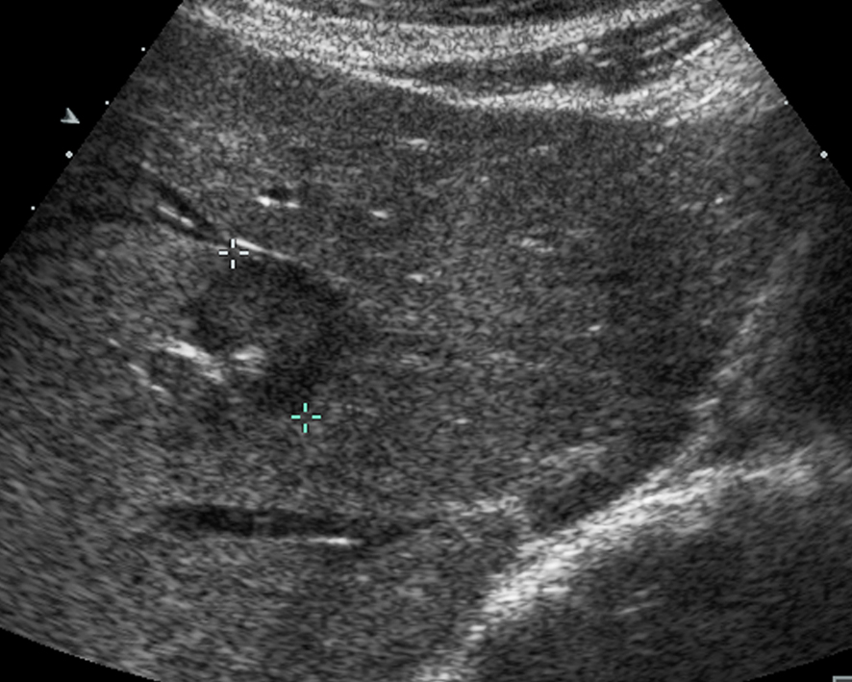
A
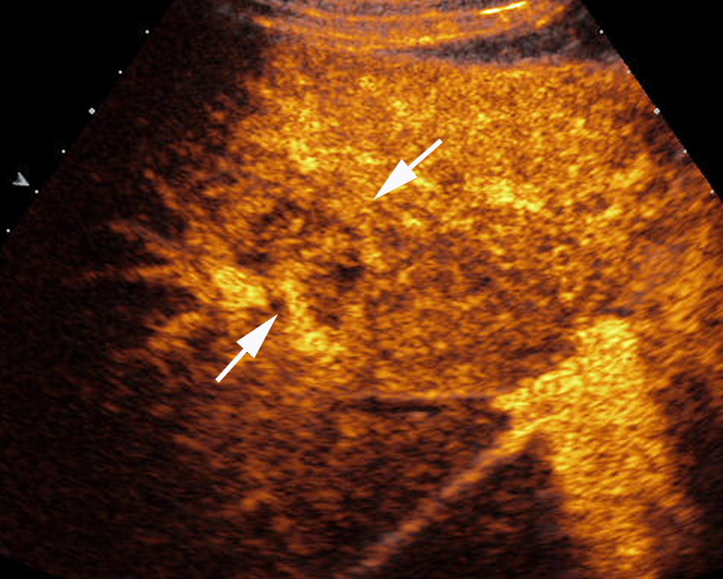
B

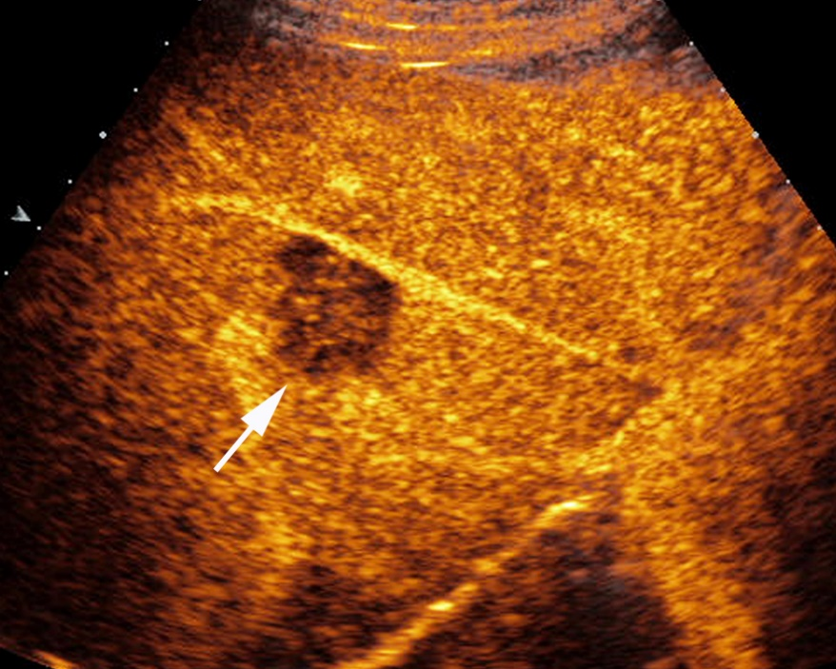
C
Figure 4 Contrast-enhanced ultrasound feature of hepatic epithelioid hemangioendothelioma in right lobe of liver. A: Grayscale ultrasound showed a hypoechoic FLL; B: In the arterial phase the lesion showed heterogeneous enhancement (22 s after injection of SonoVue); C: In the portal venous phase (53 s after injection of SonoVue), the lesion washed out fast and showed hypoenhancement.

Table 1 Baseline characteristics of patients included in our study
Characteristic | HEHE  (n = 25 patients) | Hemangioma and FNH  (n = 45 patients)
Age (yr)
mean ± SD | 46 ± 14 | 46 ± 14
range | 24 - 78 | 23 - 74
Male/female | 8/17 | 9/36
Number of FLL (single/multiple) | 3/22 | 0/45
Histological results
hepatic surgery | 6 | 0
core needle biopsy | 19 | 45
HEHE: Hepatic epithelioid haemangioendothelioma; FNH: focal nodular hyperplasia; FLL: focal liver lesions.

Table 2 Conventional ultrasound features of hepatic epithelioid haemangioendothelioma and hemangioma / Focal nodular hyperplasia n (%)
Characteristic | HEHE  (n = 25 patients) | Hemangioma/FNH  (n = 45 patients)
Number of nodules (single/multiple) | 3/22 | 0/45
Size of nodules (mm)
mean ± SD | 41.5 ± 25.6 | 50.4 ± 25.7
range | 12 - 120 | 20 - 138
Echogenicity of nodules
Hyperechoic | 2 (8) | 19 (42.2)
Hypoechoic | 23 (92) | 9 (20.0)
Isoechoic | 0 | 17 (37.8)
Homogenous/heterogeneous | 9/16 | 15/30
HEHE: Hepatic epithelioid haemangioendothelioma; FNH: Focal nodular hyperplasia.

Table 3 Contrast enhanced ultrasound imaging features of hepatic epithelioid haemangioendothelioma and multilocular hemangioma/ focal nodular hyperplasia n (%)
Characteristic | HEHE  (n = 25 patients) | Hemangioma/FNH  (n = 45 patients)
Arterial phase
Rim like hyperenhancement | 18 (72) | 0
Heterogeneously hyperenhancement | 7 (28) | 6 (13.3)
Peripheral nodular enhancement | 0 | All hemangioma
Central arterial blood supply |  | All FNH
Portal-venous phase
Hyperenhancement | 0 | 100 (100.0%)
Hypoenhancement | 25 (100) | 0
Isoenhancement | 0 | 0
Late phase
Hyperenhancement | 0 | 45 (100.0%)
Hypoenhancement | 25 (100) | 0
Isoenhancement | 0 | 0
Sensitivity
Rim like hyperenhancement | 18/25 (72) | 0
Hypoenhancement at portal venous phase | 25/25 (100) | 0
Central unenhanced area at late phase
Yes | 18 (72) | 13 (28.9)
No | 7 (28) | 32 (71.1)
CEUS: Contrast enhanced ultrasound; HEHE: Hepatic epithelioid haemangioendothelioma; FNH: Focal nodular hyperplasia.

