Name of Journal: World Journal of Gastroenterology
Manuscript NO: 74991
Manuscript Type: META-ANALYSIS

Network meta-analysis of randomized controlled trials on esophagectomies in esophageal cancer: The superiority of minimally invasive surgery

Szakó L et al. Superiority of minimally invasive surgery

Lajos Szakó, Dávid Németh, Nelli Farkas, Szabolcs Kiss, Réka Zsuzsa Dömötör, Marie Anne Engh, Péter Hegyi, Balint Eross, András Papp

Lajos Szakó, Nelli Farkas, Marie Anne Engh, Péter Hegyi, Institute of Translational Medicine, University of Pécs, Medical School, Pécs 7624, Hungary

Lajos Szakó, János Szentágothai Research Centre, University of Pécs, Medical School, Pécs 7624, Hungary

Dávid Németh, Réka Zsuzsa Dömötör, Institute for Translational Medicine, University of Pécs, Medical School, Pécs 7624, Hungary

Dávid Németh, Nelli Farkas, Institute of Bioanalysis, University of Pécs, Medical School, Pécs 7624, Hungary

Szabolcs Kiss, Insittute of Translational Medicine, University of Pécs, Medical School, Pécs 7624, Hungary

Szabolcs Kiss, Doctoral School of Clinical Medicine, University of Szeged, Medical School, Szeged 6720, Hungary

Péter Hegyi, First Department of Medicine, University of Szeged, Medical School, Szeged 6725, Hungary

Balint Eross, Institute of Translational Medicine, University of Pecs, Medical School, Pecs 7624, Hungary

András Papp, Department of Surgery, Clinical Center, University of Pécs, Medical School, Pécs 7624, Hungary

Author contributions: Szakó L conceptualized the work, contributed to establishment of the search key, selection strategy, data extraction, interpretation of the results, and writing of the manuscript; Németh D and Farkas N performed the bio-statistical analyses, and contributed to the interpretation of the results and writing of the manuscript; Kiss S helped was involved in the conceptualization, coordination of the work, and writing the manuscript; Dömötör RZ conceptualized, wrote, and critically appraised the manuscript; Engh MA was involved in the conceptualization, data extraction, risk of bias assessment, writing of the manuscript, and language revision of the manuscript; Hegyi P contributed to the conceptualization, interpretation of the results, critical appraisal, and writing of the manuscript; Erőss BM conceptualized the work, interpreted the results, critically appraised and wrote the manuscript; Papp A provided supervision, and was involved in the conceptualization, interpretation of the results, critical appraisal, and writing of the manuscript.

Corresponding author: András Papp, PhD, Associate Professor, Department of Surgery, Clinical Center, University of Pécs, Medical School, 13 Ifjúság útja, Pécs 7624, Hungary. papp.andras@pte.hu

Received: January 16, 2022
Revised: April 26, 2022
Accepted: July 16, 2022
Published online: August 14, 2022

Abstract
BACKGROUND
Previous meta-analyses, with many limitations, have described the beneficial nature of minimal invasive procedures.

AIM
To compare all modalities of esophagectomies to each other from the results of randomized controlled trials (RCTs) in a network meta-analysis (NMA).

METHODS
We conducted a systematic search of the MEDLINE, Embase, Reference Citation Analysis (https://www.referencecitationanalysis.com/) and CENTRAL databases to identify RCTs according to the following population, intervention, control, outcome (commonly known as PICO): P: patients with resectable esophageal cancer; I/C: transthoracic, transhiatal, minimally invasive (thoracolaparoscopic), hybrid, and robot-assisted esophagectomy; O: survival, total adverse events, adverse events in subgroups, length of hospital stay, and blood loss. We used the Bayesian approach and the random effects model. We presented the geometry of the network, results with probabilistic statements, estimated intervention effects and their 95% confidence interval (CI), and the surface under the cumulative ranking curve to rank the interventions.

RESULTS
We included 11 studies in our analysis. We found a significant difference in postoperative pulmonary infection, which favored the minimally invasive intervention compared to transthoracic surgery (risk ratio 0.49; 95%CI: 0.23, 0.99). The operation time was significantly shorter for the transhiatal approach compared to transthoracic surgery (mean difference -85 min; 95%CI: -150, -29), hybrid intervention (mean difference -98 min; 95%CI: -190, -9.4), minimally invasive technique (mean difference -130 min; 95%CI: -210, -50), and robot-assisted esophagectomy (mean difference -150 min; 95%CI: -240, -53). Other comparisons did not yield significant differences.

CONCLUSION
Based on our results, the implication of minimally invasive esophagectomy should be favored.

Key Words: Surgery; Esophageal cancer; Esophagectomy; Network meta-analysis; Minimally invasive; Laparoscopy

©The Author(s) 2022. Published by Baishideng Publishing Group Inc. All rights reserved.

Citation: Szakó L, Németh D, Farkas N, Kiss S, Dömötör RZ, Engh MA, Hegyi P, Eross B, Papp A. Network meta-analysis of randomized controlled trials on esophagectomies in esophageal cancer: The superiority of minimally invasive surgery. World J Gastroenterol 2022; 28(30): 4201-4210
URL: https://www.wjgnet.com/1007-9327/full/v28/i30/4201.htm
DOI: https://dx.doi.org/10.3748/wjg.v28.i30.4201

Core Tip: Minimally invasive laparoscopic techniques should be the preferred approach for the treatment of esophageal cancer, due to the lower incidence of postoperative pulmonary complications.

INTRODUCTION
Esophageal cancer is the eighth most common type of cancer worldwide^{[1]}, with an incidence of 5.2 per 100000 for squamous cell cancer (SCC) and 0.7 per 100000 for adenocarcinoma (AC)^{[2]}. While the prognosis varies between the two histological diagnoses, both AC and SCC are associated with poor clinical outcomes, with a 5-year survival rate of 20%^{[3]}.
Surgical therapy plays an essential role in the treatment of esophageal cancer. However, it cannot be routinely used due to the late diagnosis, as symptoms usually occur when the cancer is already unresectable^{[4]}. Traditionally, open surgical interventions are performed, including transhiatal and transthoracic techniques. A meta-analysis comparing these two open surgical modalities did not find a significant difference in 5-year survival^{[5]}. While both techniques are successful in terms of removing the neoplasm, open esophagectomies are associated with significant limitations, most importantly, postoperative morbidity^{[6,7]}.
A transition to non-open surgical techniques has been the trend in almost every field of surgery in recent years^{[8]}. A wide variety of non-open techniques are available, including minimally invasive surgery (thoracolaparoscopic) surgery or even robot-assisted esophagectomy^{[9,10]}. In the form of hybrid surgical intervention, a combination of open and non-open technique is available^{[11]}.
Previous meta-analyses have compared the different types of surgical techniques, with variable success and significant limitations^{[12-19]}. To date, convincing evidence is missing regarding the optimal surgical approach of resectable esophageal cancer, as it is presented in a recent guideline^{[20]}.
network meta-analysis (NMA) is a relatively novel methodology, which allows the direct and indirect comparison of multiple interventions, thus providing more information than traditional meta-analyses. Indirect comparisons can be made in the case of missing trials comparing two interventions if those are compared with a third intervention^{[21]}. Several meta-analyses were carried out focusing on esophageal cancer surgery, but none of those addressed the problem of the wide variety of surgical techniques.
The purpose of our study was to provide objective evidence considering the surgical treatment of resectable esophageal cancer by comparing each treatment modality in the form of an NMA and possibly rank the different approaches.

MATERIALS AND METHODS
The NMA was conducted according to the Preferred Reporting Items for Systematic Reviews and Meta-Analyses-NMA guideline^{[22]}.

Protocol
The NMA protocol was registered in advance in PROSPERO under the number CRD42020160978. Analyses of the mortality and quality of life could not be carried out due to the low number of reporting articles. The risk of bias was assessed using an updated risk assessment tool.

Search strategy and inclusion criteria
We conducted a systematic search of the MEDLINE (via PubMed), Embase, Reference Citation Analysis (https://www.referencecitationanalysis.com/) and Cochrane Central Register of Controlled Trials (CENTRAL) from initiation until 2019 November to identify studies, comparing at least two types of esophagectomies from transthoracic, transhiatal, hybrid, laparoscopic or robot-assisted approach treating esophageal cancer without the restriction of histological subtype and an NMA was performed. The following search key was used: (((esophagus OR oesophagus OR esophageal OR oesophageal) AND (tumor OR tumour OR malign* OR cancer OR adenocarcinoma OR carcinoma)) AND (esophagectomy OR oesophagectomy OR Ivor-Lewis OR „Ivor Lewis” OR hybrid OR laparoscop* OR „minimal invasive”)) AND random*. We also reviewed the reference lists of eligible articles for further studies. Only randomized controlled trials (RCTs) were included.

Selection and data extraction
After the removal of duplications, two independent reviewers (Szakó L, Engh MA) executed the selection first by title, second by abstract, last by full text following pre-discussed aspects. Data extraction was done by the same two independent reviewers (Szakó L, Engh MA) onto a pre-established Excel worksheet (Office 365, Microsoft, Redmond, WA, United States). Extracted data consisted of the year of publication, name of the first author, study design, country, applied surgical modalities, mortality, overall survival rate (referred as survival), adverse events (AEs), blood loss, length of hospitalization, length of surgical procedure, and demographic data including age, male-female ratio, and SCC/AC ratio. Disagreements regarding both selection and data extraction were resolved by consensus. If consensus could not be reached, a third reviewer (Dömötör RZ) resolved the disagreement.

Statistical analysis
The Bayesian method was used to perform pairwise meta-analyses and NMAs. All analyses were carried out using a random effects model. To ensure the interpretability of the NMA results (pooled of direct and indirect data), we presented the geometry of the network, the results with probabilistic statements, and estimates of intervention effects along with their corresponding 95% confidence intervals (CIs), as well as forest plots for ranking the interventions, we chose to use the surface under the cumulative ranking (SUCRA) curve, which provides a numerical summary of the rank distribution of each treatment.

Risk of bias assessment and quality of evidence
The risk of bias assessment was performed at the individual study level, according to the Revised Cochrane risk-of-bias tool for RCTs^{[23]}.
The Grading of Recommendations Assessment, Development, and Evaluation system was used to assess the certainty of evidence into four levels: high, moderate, low, and very low. The certainty of the evidence was classified into four levels: high, moderate, low, and very low. Two independent reviewers (Szakó L, Engh MA) decided the overall quality of the evidence^{[24]}. Disagreements were resolved by consensus. If consensus could not be reached, a third reviewer (Dömötör RZ) resolved the disagreement.

RESULTS
Selection process
The database search yielded 3335 records, of which 2002 articles were left after removing duplicates. Twenty-one full-text articles were screened for eligibility. Finally, we included 11 RCTs (25-35), including 1525 patients, in the quantitative synthesis (Figure 1). Baseline characteristics of the enrolled studies are presented in Table 1^{[25-35]}.

Outcomes
A significant difference was found for pulmonary infection, which favored the minimally invasive intervention compared to transthoracic surgery (relative risk [RR]: 0.49, 95%CI: 0.23-0.99) (Figure 2). Operation time was significantly shorter for the transhiatal approach compared to transthoracic surgery (mean difference: -86 min, 95%CI: -150 to -29 min), hybrid intervention (mean difference -99 min, 95%CI: -190 to -9.4 min), minimally invasive technique (mean difference -130 min, 95%CI: -210 to -53 min), and robot-assisted esophagectomy (mean difference -150 min, 95%CI: -250 to -52 min) (Figure 3). We did not find significant differences regarding survival (Supplementary Figures 1-5), total AEs (Supplementary Figure 6), cardiac AEs (Supplementary Figure 7), anastomotic leakage (Supplementary Figure 8), atrial fibrillation (Supplementary Figure 9), wound infection (Supplementary Figure 10), total pulmonary AEs (Supplementary Figure 11), vocal chord paralysis (Supplementary Figure 12), length of hospital stay (Supplementary Figure 13), and blood loss (Supplementary Figure 14). The ranking and detailed results of the comparisons of the interventions are presented in the supplementary files (Supplementary Figures 1-14).

Risk of bias assessment and grade of evidence
Results of the risk of bias assessment for the outcome of survival were assessed following the Cochrane Risk of Bias Assessment Tool 2. Details are shown in Table 2.
The results of the certainty of evidence are presented in Supplementary Table 1.

DISCUSSION
Our NMA confirmed the superiority of the minimally invasive esophagectomy over transthoracic open surgery regarding one of the main complications during these procedures, namely pulmonary infection. On the other hand, non-open surgical techniques require significantly more time to perform compared to open techniques. While statistically significant results were only achieved in the case of pulmonary infection, a clear tendency was demonstrated by the SUCRA curves, showing a preference for non-open techniques, which is also supported by the individual studies.
The results of previous meta-analyses and systematic reviews are not congruent regarding the comparison of minimally invasive and open surgical techniques. Kauppila et al^{[14]} described the superiority of minimally invasive esophagectomy (MIE) regarding quality of life (QoL), which our work failed to analyze, as there were not enough RCTs reporting on QoL. Guo et al^{[13]} also described the advantages of minimally invasive techniques regarding total complication rate, intraoperative blood loss, wound infection, and pulmonary infection, supporting our findings. MIE was also favorable in the analysis of Wang et al^{[19]} considering blood loss. Besides blood loss and hospital stay, fewer respiratory complications were also shown by MIE in a meta-analysis conducted by Nagpal et al^{[15]}. The work of Yibulayin et al^{[18]} also supports the superiority of MIE in terms of in-hospital mortality and postoperative morbidity. By contrast, Dantoc et al^{[12]} focused on oncological outcomes in their meta-analysis, where significant differences could not be proven. Sgourakis et al^{[17]} showed that open surgery was more beneficial in terms of anastomotic stricture, while morbidity favored MIE. Oor et al^{[16]} also described the benefit of open surgery in the case of hiatal hernia. The above comprehensive studies show that the inclusion of non-randomized studies carries a notable limitation.
Although the results of our analysis are only supportive in terms of pulmonary complication, the future perspectives are promising regarding minimally invasive esophagectomy, as the limelight shifts towards robot-assisted surgical techniques. The technique is time consuming, but with the development of new robotic platforms, the benefit of less AEs and more precise procedure will overcome this limitation^{[36]}. The steep learning curve will be possibly managed by allowing the intervention to be carried out only in larger centers, as it has been seen in northern countries^{[37]}. Despite the missing cumulative evidence, minimal invasive techniques have become the gold standard interventions for esophageal cancer since the TIME study. The results of this RCT provide evidence for using minimally invasive surgery for patients with resectable esophageal cancer aimed toward improving postoperative outcomes (especially pulmonary complication) and QoL with comparable oncologic results^{[25]}.
Considering the strengths of our analysis, by the inclusion of only RCTs, we managed to achieve a higher quality of evidence than previous works. Furthermore, a thorough methodology was applied. With the application of NMA, we were also able to make indirect comparisons. To date, this work is the most comprehensive review of the available RCTs.
One of the limiting factors of our study was the low number of cases and limited number of direct comparisons. Other limitations were the different enrollment criteria of the individual studies considering the histological subtype and stage of esophageal cancer. Furthermore, our analysis included many indirect comparisons, with weak direct comparisons. Additionally, we only included studies published until 2019.
We emphasize the application of MIE over open surgical techniques. Further analyses should focus on the outcomes of robot-assisted esophagectomies, and direct comparisons should be carried out between robot-assisted esophagectomy and thoracolaparoscopic intervention. Following recent trends, the centralization of upper gastrointestinal surgery is suggested, thus achieving the possibility of the implementation of such techniques without the limitation originating from the low number of cases and the learning curve of minimally invasive techniques.

CONCLUSION
While practice is already shifting towards the application of minimally invasive techniques, it should be noted that clear evidence is still needed to form guidelines. As we aimed to fill this void, we were only able to prove the beneficial nature of these techniques regarding pulmonary infection. To further assess any other potential differences between the techniques, RCTs and systematic analysis of these trials are needed.

ARTICLE HIGHLIGHTS
Research background
The differences considering esophagectomies as the most applied curative methodology in the case of esophageal cancer are not clearly described. Minimally invasive techniques have become more popular in the belief of their superiority, although objective evidence is missing.

Research motivation
Recent guidelines are not yet clear considering the usage of minimally invasive esophagectomies. The authors wanted to provide the most objective evidence available, considering the differences between every subtype of minimally invasive and open esophagectomies.

Research objectives
The authors aimed to find every randomized controlled trial (RCT) providing comparative information about at least two types of esophagectomies, and pool the results using NMA .

Research methods
After establishing our clinical question using the population, intervention, control, outcome (commonly known as (PICO) framework a systemic search was carried out using three different databases. The results of the search were pooled, duplications were removed, suitable studies were selected, from which the data extraction was carried out onto a data sheet. With the help of biostatisticians, a network meta-analysis was performed. The quality of the included studies was assessed, as well as the grade of evidence.

Research results
Eleven articles were included in our analysis, according to which the minimally invasive surgical technique was superior compared to the transthoracic open approach in terms of pulmonary infection, while transthoracic surgery took less time to perform than any other surgical technique.

Research conclusions
The authors conclude that minimally invasive surgical techniques should be performed, whenever possible, for resectable esophageal cancer.

Research perspectives
The conduction of additional RCTs evaluating the same problem would be welcomed, while we hope that our work will help clinicians in the decision-making of the selection of the right surgical technique.

REFERENCES
1 Zhang Y. Epidemiology of esophageal cancer. World J Gastroenterol 2013; 19: 5598-5606 [PMID: 24039351 DOI: 10.3748/wjg.v19.i34.5598]
2 Arnold M, Soerjomataram I, Ferlay J, Forman D. Global incidence of oesophageal cancer by histological subtype in 2012. Gut 2015; 64: 381-387 [PMID: 25320104 DOI: 10.1136/gutjnl-2014-308124]
3 Howlader N, Noone AM, Krapcho M, Miller D, Brest A, Yu M, Ruhl J, Tatalovich Z, Mariotto A, Lewis DR, Chen HS, Feuer EJ, Cronin K A. SEER Cancer Statistics Review, 1975-2016, National Cancer Institute. Bethesda, MD, based on November 2018 SEER data submission, posted to the SEER web site, April 2019. Available from: https://seer.cancer.gov/csr/1975_2016/
4 Enzinger PC, Mayer RJ. Esophageal cancer. N Engl J Med 2003; 349: 2241-2252 [PMID: 14657432 DOI: 10.1056/nejmra035010]
5 Boshier PR, Anderson O, Hanna GB. Transthoracic versus transhiatal esophagectomy for the treatment of esophagogastric cancer: a meta-analysis. Ann Surg 2011; 254: 894-906 [PMID: 21785341 DOI: 10.1097/SLA.0b013e3182263781]
6 Alanezi K, Urschel JD. Mortality secondary to esophageal anastomotic leak. Ann Thorac Cardiovasc Surg 2004; 10: 71-75 [PMID: 15209546 DOI: 10.1308/003588413x13511609956255]
7 Morita M, Nakanoko T, Fujinaka Y, Kubo N, Yamashita N, Yoshinaga K, Saeki H, Emi Y, Kakeji Y, Shirabe K, Maehara Y. In-hospital mortality after a surgical resection for esophageal cancer: analyses of the associated factors and historical changes. Ann Surg Oncol 2011; 18: 1757-1765 [PMID: 21207167 DOI: 10.1245/s10434-010-1502-5]
8 Himal HS. Minimally invasive (laparoscopic) surgery. Surg Endosc 2002; 16: 1647-1652 [PMID: 12098024 DOI: 10.1007/s00464-001-8275-7]
9 Levy RM, Wizorek J, Shende M, Luketich JD. Laparoscopic and thoracoscopic esophagectomy. Adv Surg 2010; 44: 101-116 [PMID: 20919517 DOI: 10.1016/j.yasu.2010.05.002]
10 van Hillegersberg R, Seesing MF, Brenkman HJ, Ruurda JP. Robot-assisted minimally invasive esophagectomy. Chirurg 2017; 88: 7-11 [PMID: 27470056 DOI: 10.1007/s00104-016-0200-7]
11 Allaix ME, Long JM, Patti MG. Hybrid Ivor Lewis Esophagectomy for Esophageal Cancer. J Laparoendosc Adv Surg Tech A 2016; 26: 763-767 [PMID: 27541591 DOI: 10.1089/lap.2016.29011.mea]
12 Dantoc M, Cox MR, Eslick GD. Evidence to support the use of minimally invasive esophagectomy for esophageal cancer: a meta-analysis. Arch Surg 2012; 147: 768-776 [PMID: 22911078 DOI: 10.1001/archsurg.2012.1326]
13 Guo W, Ma X, Yang S, Zhu X, Qin W, Xiang J, Lerut T, Li H. Combined thoracoscopic-laparoscopic esophagectomy versus open esophagectomy: a meta-analysis of outcomes. Surg Endosc 2016; 30: 3873-3881 [PMID: 26659248 DOI: 10.1007/s00464-015-4692-x]
14 Kauppila JH, Xie S, Johar A, Markar SR, Lagergren P. Meta-analysis of health-related quality of life after minimally invasive versus open oesophagectomy for oesophageal cancer. Br J Surg 2017; 104: 1131-1140 [PMID: 28632926 DOI: 10.1002/bjs.10577]
15 Nagpal K, Ahmed K, Vats A, Yakoub D, James D, Ashrafian H, Darzi A, Moorthy K, Athanasiou T. Is minimally invasive surgery beneficial in the management of esophageal cancer? A meta-analysis. Surg Endosc 2010; 24: 1621-1629 [PMID: 20108155 DOI: 10.1007/s00464-009-0822-7]
16 Oor JE, Wiezer MJ, Hazebroek EJ. Hiatal Hernia After Open versus Minimally Invasive Esophagectomy: A Systematic Review and Meta-analysis. Ann Surg Oncol 2016; 23: 2690-2698 [PMID: 26926480 DOI: 10.1245/s10434-016-5155-x]
17 Sgourakis G, Gockel I, Radtke A, Musholt TJ, Timm S, Rink A, Tsiamis A, Karaliotas C, Lang H. Minimally invasive versus open esophagectomy: meta-analysis of outcomes. Dig Dis Sci 2010; 55: 3031-3040 [PMID: 20186484 DOI: 10.1007/s10620-010-1153-1]
18 Yibulayin W, Abulizi S, Lv H, Sun W. Minimally invasive oesophagectomy versus open esophagectomy for resectable esophageal cancer: a meta-analysis. World J Surg Oncol 2016; 14: 304 [PMID: 27927246 DOI: 10.1186/s12957-016-1062-7]
19 Wang B, Zuo Z, Chen H, Qiu B, Du M, Gao Y. The comparison of thoracoscopic-laparoscopic esophagectomy and open esophagectomy: A meta-analysis. Indian J Cancer 2017; 54: 115-119 [PMID: 29199673 DOI: 10.4103/ijc.IJC_192_17]
20 Lordick F, Mariette C, Haustermans K, Obermannová R, Arnold D; ESMO Guidelines Committee. Oesophageal cancer: ESMO Clinical Practice Guidelines for diagnosis, treatment and follow-up. Ann Oncol 2016; 27: v50-v57 [PMID: 27664261 DOI: 10.1093/annonc/mdw329]
21 Rouse B, Chaimani A, Li T. Network meta-analysis: an introduction for clinicians. Intern Emerg Med 2017; 12: 103-111 [PMID: 27913917 DOI: 10.1007/s11739-016-1583-7]
22 Hutton B, Salanti G, Caldwell DM, Chaimani A, Schmid CH, Cameron C, Ioannidis JP, Straus S, Thorlund K, Jansen JP, Mulrow C, Catalá-López F, Gøtzsche PC, Dickersin K, Boutron I, Altman DG, Moher D. The PRISMA extension statement for reporting of systematic reviews incorporating network meta-analyses of health care interventions: checklist and explanations. Ann Intern Med 2015; 162: 777-784 [PMID: 26030634 DOI: 10.7326/M14-2385]
23 Sterne JAC, Savović J, Page MJ, Elbers RG, Blencowe NS, Boutron I, Cates CJ, Cheng HY, Corbett MS, Eldridge SM, Emberson JR, Hernán MA, Hopewell S, Hróbjartsson A, Junqueira DR, Jüni P, Kirkham JJ, Lasserson T, Li T, McAleenan A, Reeves BC, Shepperd S, Shrier I, Stewart LA, Tilling K, White IR, Whiting PF, Higgins JPT. RoB 2: a revised tool for assessing risk of bias in randomised trials. BMJ 2019; 366: l4898 [PMID: 31462531 DOI: 10.1136/bmj.l4898]
24 Brozek JL, Akl EA, Alonso-Coello P, Lang D, Jaeschke R, Williams JW, Phillips B, Lelgemann M, Lethaby A, Bousquet J, Guyatt GH, Schünemann HJ; GRADE Working Group. Grading quality of evidence and strength of recommendations in clinical practice guidelines. Part 1 of 3. An overview of the GRADE approach and grading quality of evidence about interventions. Allergy 2009; 64: 669-677 [PMID: 19210357 DOI: 10.1111/j.1398-9995.2009.01973.x]
25 Straatman J, van der Wielen N, Cuesta MA, Daams F, Roig Garcia J, Bonavina L, Rosman C, van Berge Henegouwen MI, Gisbertz SS, van der Peet DL. Minimally Invasive Versus Open Esophageal Resection: Three-year Follow-up of the Previously Reported Randomized Controlled Trial: the TIME Trial. Ann Surg 2017; 266: 232-236 [PMID: 28187044 DOI: 10.1097/SLA.0000000000002171]
26 van der Sluis PC, van der Horst S, May AM, Schippers C, Brosens LAA, Joore HCA, Kroese CC, Haj Mohammad N, Mook S, Vleggaar FP, Borel Rinkes IHM, Ruurda JP, van Hillegersberg R. Robot-assisted Minimally Invasive Thoracolaparoscopic Esophagectomy Versus Open Transthoracic Esophagectomy for Resectable Esophageal Cancer: A Randomized Controlled Trial. Ann Surg 2019; 269: 621-630 [PMID: 30308612 DOI: 10.1097/SLA.0000000000003031]
27 Mariette C, Markar S, Dabakuyo-Yonli TS, Meunier B, Pezet D, Collet D, D'Journo XB, Brigand C, Perniceni T, Carrere N, Mabrut JY, Msika S, Peschaud F, Prudhomme M, Bonnetain F, Piessen G; FRENCH, FREGAT. Health-related Quality of Life Following Hybrid Minimally Invasive Versus Open Esophagectomy for Patients With Esophageal Cancer, Analysis of a Multicenter, Open-label, Randomized Phase III Controlled Trial: The MIRO Trial. Ann Surg 2020; 271: 1023-1029 [PMID: 31404005 DOI: 10.1097/SLA.0000000000003559]
28 Guo M, Xie B, Sun X, Hu M, Yang Q, Lei Y. A comparative study of the therapeutic effect in two protocols: video-assisted thoracic surgery combined with laparoscopy versus right open transthoracic esophagectomy for esophageal cancer management. Zhongde Linchuang Zhongliuxue Zazhi 2013; 12: 68-71 [DOI: 10.1007/s10330-012-0966-0]
29 Ma G, Cao H, Wei R, Qu X, Wang L, Zhu L, Du J, Wang Y. Comparison of the short-term clinical outcome between open and minimally invasive esophagectomy by comprehensive complication index. J Cancer Res Ther 2018; 14: 789-794 [PMID: 29970654 DOI: 10.4103/jcrt.JCRT_48_18]
30 Jacobi CA, Zieren HU, Müller JM, Pichlmaier H. Surgical therapy of esophageal carcinoma: the influence of surgical approach and esophageal resection on cardiopulmonary function. Eur J Cardiothorac Surg 1997; 11: 32-37 [PMID: 9030787 DOI: 10.1016/s1010-7940(96)01106-2]
31 Goldminc M, Maddern G, Le Prise E, Meunier B, Campion JP, Launois B. Oesophagectomy by a transhiatal approach or thoracotomy: a prospective randomized trial. Br J Surg 1993; 80: 367-370 [PMID: 8472154 DOI: 10.1002/bjs.1800800335]
32 Chu KM, Law SY, Fok M, Wong J. A prospective randomized comparison of transhiatal and transthoracic resection for lower-third esophageal carcinoma. Am J Surg 1997; 174: 320-324 [PMID: 9324146 DOI: 10.1016/s0002-9610(97)00105-0]
33 Hulscher JB, van Sandick JW, de Boer AG, Wijnhoven BP, Tijssen JG, Fockens P, Stalmeier PF, ten Kate FJ, van Dekken H, Obertop H, Tilanus HW, van Lanschot JJ. Extended transthoracic resection compared with limited transhiatal resection for adenocarcinoma of the esophagus. N Engl J Med 2002; 347: 1662-1669 [PMID: 12444180 DOI: 10.1056/nejmoa022343]
34 Paireder M, Asari R, Kristo I, Rieder E, Zacherl J, Kabon B, Fleischmann E, Schoppmann SF. Morbidity in open versus minimally invasive hybrid esophagectomy (MIOMIE): Long-term results of a randomized controlled clinical study. Eur Surg 2018; 50: 249-255 [PMID: 30546384 DOI: 10.1007/s10353-018-0552-y]
35 Yang ZQ, Lu HX, Zhang JH, Wang J. Comparative study on long-term survival results between minimally invasive surgery and traditional resection for esophageal squamous cell carcinoma. Eur Rev Med Pharmacol Sci 2016; 20: 3368-3372 [PMID: 27608894]
36 van Boxel GI, Kingma BF, Voskens FJ, Ruurda JP, van Hillegersberg R. Robotic-assisted minimally invasive esophagectomy: past, present and future. J Thorac Dis 2020; 12: 54-62 [PMID: 32190354 DOI: 10.21037/jtd.2019.06.75]
37 Jeremiasen M, Linder G, Hedberg J, Lundell L, Björ O, Lindblad M, Johansson J. Improvements in esophageal and gastric cancer care in Sweden-population-based results 2007-2016 from a national quality register. Dis Esophagus 2020; 33 [PMID: 31608927 DOI: 10.1093/dote/doz070]

Footnotes
Conflict-of-interest statement: All authors have no conflicts of interest to declare.

PRISMA 2009 Checklist statement: The authors have read the PRISMA 2009 Checklist, and the manuscript was prepared and revised according to the PRISMA 2009 Checklist.

Open-Access: This article is an open-access article that was selected by an in-house editor and fully peer-reviewed by external reviewers. It is distributed in accordance with the Creative Commons Attribution NonCommercial (CC BY-NC 4.0) license, which permits others to distribute, remix, adapt, build upon this work non-commercially, and license their derivative works on different terms, provided the original work is properly cited and the use is non-commercial. See: https://creativecommons.org/Licenses/by-nc/4.0/

Provenance and peer review: Invited article; Externally peer reviewed.
Peer-review model: Single blind

Peer-review started: January 16, 2022
First decision: April 12, 2022
Article in press: July 16, 2022

Specialty type: Surgery
Country/Territory of origin: Hungary
Peer-review report’s scientific quality classification
Grade A (Excellent): A
Grade B (Very good): 0
Grade C (Good): C, C
Grade D (Fair): 0
Grade E (Poor): 0

P-Reviewer: Liu Z, China; Scurtu RR, Romania; Tsujinaka S, Japan S-Editor: Ma YJ L-Editor: Filipodia P-Editor: Cai YX
Figure Legends
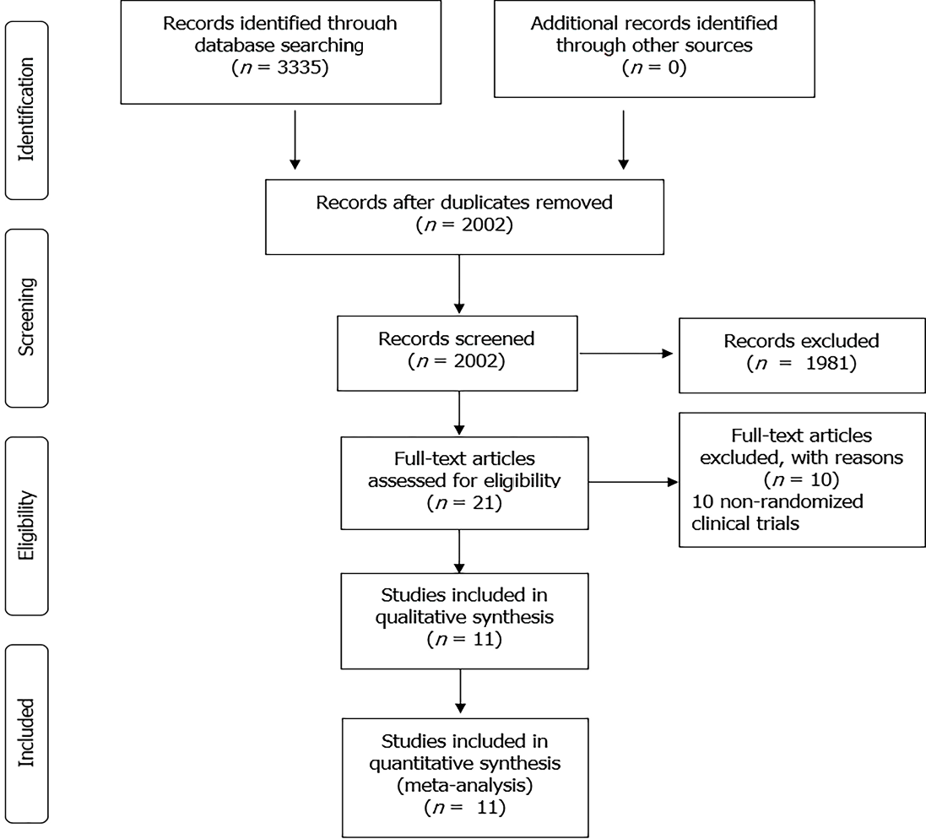
Figure 1 Results of the selection process according to the Preferred Reporting Items for Systematic Reviews and Meta-Analyses guidelines. Available from: https://prisma-statement.org//prismastatement/flowdiagram.aspx.

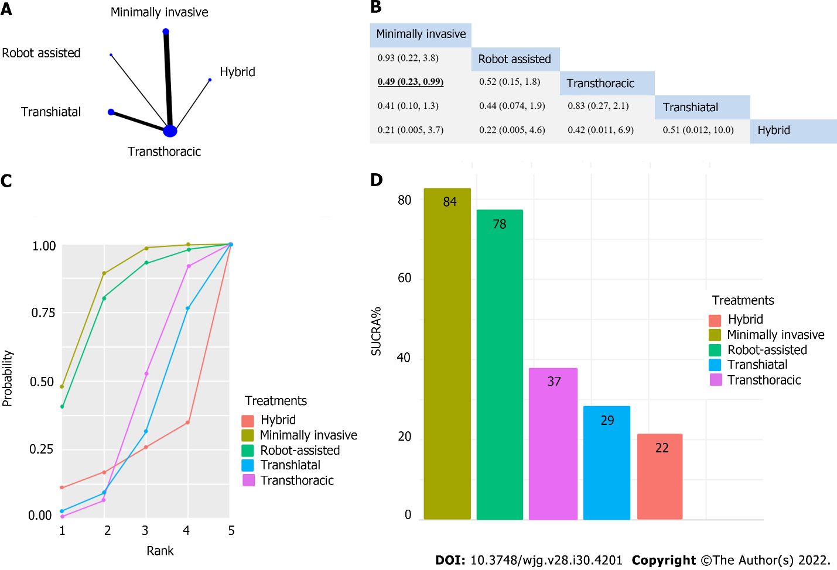
Figure 2 A significant difference was found considering pulmonary infection, which favored the minimally invasive intervention compared to transthoracic surgery. A: The network of eligible studies for pulmonary infection (the width of the lines is proportional to the number of trials comparing every pair of treatments, and the size of every circle is proportional to the number of randomly assigned participants [sample size]); B: League table of the analysis for pulmonary infection. Comparisons should be read from left to right. The values are presented in risk ratios, with corresponding credible interval. Significant result is in bold and underlined; C: Cumulative probability of treatment rank; D: Treatment rank in SUCRA% histogram.

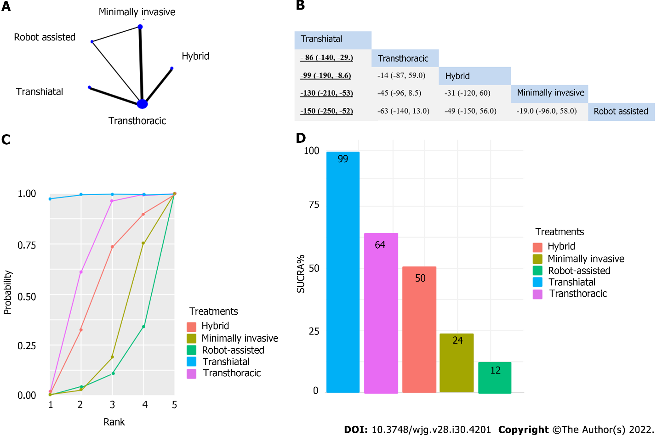
Figure 3 Operation time was significantly shorter for transhiatal approach compared to transthoracic surgery, hybrid intervention, minimally invasive technique, and robot-assisted esophagectomy. A: The network of eligible studies for operation time [the width of the lines is proportional to the number of trials comparing every pair of treatments, and the size of every circle is proportional to the number of randomly assigned participants (sample size)]; B: League table of the analysis for operation time. Comparisons should be read from left to right. The values are presented in weighted mean difference (minutes), with corresponding credible interval. Significant results are in bold and underlined; C: Cumulative probability of interventions rank; D: Intervention ranking in surface under the cumulative ranking (SUCRA)% histogram.

Table 1 Baseline characteristics of the included studies
Ref. | Year | Country | Design | Compared interventions | Number of patients | Male/female ratio | Age in yr, mean | Squamous cell cancer/adenocarcinoma ratio | Inclusion criteria
Straatman et al^{[25]} | 2012 | Netherlands, Spain, Italy | Multicenter | MI-TT | 59-56 | 43/16-46/17 | 62.3–61.8 | 24/35-19/36 | cT1-3, N0-1, M0
van der Sluis et al^{[26]} | 2019 | Netherlands | Single center | RA-TT | 54-55 | 46/8-42/13 | 64-65 | 13/41-12/43 | T1-4a, N0-3, M0
Mariette et al^{[27]} | 2019 | France | Multi center | H-TT | 103-104 | 88/15-175/32 | 59-61 (median) | 46/57-84/123 | T1-3, N0-1, M0
Guo et al^{[28]} | 2013 | China | Single center | MI-TT | 111-110 | 68/43-72/38 | 57.3-60.8 | No information | T1-3, N0-1, M0
Ma et al^{[29]} | 2018 | China | Single center | MI-TT | 47-97 | 36/11-83/14 | 61-59.3 | 43/0-91/2 | Resectable cancer
Jacobi et al^{[30]} | 1997 | Germany | Single center | TH-TT | 16-16 | No information | 54-55 | 13/3-13/3 | Resectable cancer
Goldminc et al^{[31]} | 1993 | Australia | Single center | TH-TT | 32-35 | 31/1-33/2 | 57.4-57.4 | 32/0-35/0 | Resectable squamous cell cancer
Chu et al^{[32]} | 1997 | China | Single center | TH-TT | 20-19 | 18/2-17/2 | 60.7-63.9 | No information | Lower third resectable cancer
Hulscher et al^{[33]} | 2002 | Netherlands | Multicenter | TH-TT | 106-114 | 92/14-97/17 | 69-64 | 0/106-0/114 | Resectable adenocarcinoma
Yang et al^{[35]} | 2016 | China | Single center | MI-TT | 120-120 | 82/38-87/33 | 62.5 -67.8 | 75/45-72/48 | T1-3, N0-1, M0
Paireder et al^{[34]} | 2018 | Austria | Single center | H-TT | 14-12 | 10/4-10/2 | 64.5-62.5 (median) | 4/10-1/11 | Siewert I-II, resectable squamous cell cancer
Number of patients, male/female ratio, age, and ratio of squamous cell cancer and adenocarcinoma are presented according to the compared interventional arms. H: hybrid esophagectomy; MIE: minimally invasive esophagectomy; RA: Robot assisted esophagectomy; TH: transhiatal esophagectomy;
TT: transthoracic esophagectomy.
Table 2 The results of the risk of bias assessment by each domain
Name of the first author | Randomization process | Deviation from intended intervention | Missing outcome data | Measurement of the outcome | Selection of the reported results | Overall
Straatman et al^{[25]} | Low risk | Low risk | Low risk | Low risk | Low risk | Low risk
van der Sluis et al^{[26]} | Low risk | Low risk | Low risk | Low risk | Low risk | Low risk
Mariette et al^{[27]} | Low risk | Low risk | Low risk | Low risk | Low risk | Low risk
Guo et al^{[28]} | Unclear risk | Low risk | Low risk | Low risk | Unclear risk | Unclear risk
Ma et al^{[29]} | Unclear risk | Unclear risk | Low risk | Low risk | Unclear risk | High risk
Jacobi et al^{[30]} | Unclear risk | Unclear risk | Low risk | Low risk | Unclear risk | High risk
Goldminc et al^{[31]} | Unclear risk | Unclear risk | Low risk | Low risk | Low risk | Unclear risk
Chu et al^{[32]} | Unclear risk | Unclear risk | Low risk | Low risk | Unclear risk | High risk
Hulscher et al^{[33]} | Low risk | Unclear risk | Low risk | Low risk | Unclear risk | Unclear risk
Yang et al^{[35]} | Unclear risk | Unclear risk | Low risk | Low risk | Unclear risk | High risk
Paireder et al^{[34]} | Low risk | Unclear risk | Low risk | Low risk | Unclear risk | Unclear risk
Risk of bias is indicated according to each domain of the Revised Cochrane risk-of-bias tool for randomized trials^{[23]}. By the assessment of overall risk of bias, low risk of bias was given in the case of low risk of bias by every domain; if one or two domains were assessed as unclear risk of bias, unclear overall risk of bias was given, and if at least three domains were accompanied with unclear risk of bias, the overall risk of bias was assessed as high risk of bias.

Published by Baishideng Publishing Group Inc
7041 Koll Center Parkway, Suite 160, Pleasanton, CA 94566, USA
Telephone: +1-925-3991568
E-mail: bpgoffice@wjgnet.com
Help Desk: https://www.f6publishing.com/helpdesk
https://www.wjgnet.com

© 2022 Baishideng Publishing Group Inc. All rights reserved.

