Name of Journal: World Journal of Gastroenterology
Manuscript NO: 82103
Manuscript Type: MINIREVIEWS

Review of lymphoma in the duodenum: An update of diagnosis and management

Iwamuro M et al. Lymphoma in the duodenum

Masaya Iwamuro, Takehiro Tanaka, Hiroyuki Okada

Masaya Iwamuro, Hiroyuki Okada, Department of Gastroenterology and Hepatology, Okayama University Graduate School of Medicine, Dentistry, and Pharmaceutical Sciences, Okayama 700-8558, Japan

Takehiro Tanaka, Department of Pathology, Okayama University Hospital, Okayama 700-8558, Japan

Author contributions: Iwamuro M designed the research study and wrote the paper; Tanaka T critically reviewed the manuscript for important intellectual content; Okada H approved the manuscript.

Corresponding author: Masaya Iwamuro, MD, PhD, Assistant Professor, Doctor, Department of Gastroenterology and Hepatology, Okayama University Graduate School of Medicine, Dentistry, and Pharmaceutical Sciences, 2-5-1 Shikata-cho, Kita-ku, Okayama 700-8558, Japan. pr145h2k@okayama-u.ac.jp

Received: December 5, 2022
Revised: February 11, 2023
Accepted: March 14, 2023
Published online: March 28, 2023

Abstract
The presentation, subtype, and macroscopic images of lymphoma vary depending on the site of the tumor within the gastrointestinal tract. We searched PubMed for publications between January 1, 2012 and October 10, 2022, and retrieved 130 articles relating to duodenal lymphoma. A further 22 articles were added based on the manual screening of relevant articles, yielding 152 articles for full-text review. The most predominant primary duodenal lymphoma was follicular lymphoma. In this review, we provide an update of the diagnosis and management of representative lymphoma subtypes occurring in the duodenum: Follicular lymphoma, diffuse large B-cell lymphoma, extranodal marginal zone lymphoma of mucosa-associated lymphoid tissue, mantle cell lymphoma, and T-cell lymphomas.

Key Words: Diagnosis; Diffuse large B-cell lymphoma; Duodenal neoplasms; Esophagogastroduodenoscopy; Follicular lymphoma; Gastrointestinal lymphoma

©The Author(s) 2023. Published by Baishideng Publishing Group Inc. All rights reserved.

Citation: Iwamuro M, Tanaka T, Okada H. Review of lymphoma in the duodenum: An update of diagnosis and management. World J Gastroenterol 2023; 29(12): 1852-1862
URL: https://www.wjgnet.com/1007-9327/full/v29/i12/1852.htm
DOI: https://dx.doi.org/10.3748/wjg.v29.i12.1852

Core Tip: Among cases of primary duodenal lymphoma, follicular lymphoma was the most predominant, followed by diffuse large B-cell lymphoma, extranodal marginal zone lymphoma of mucosa associated lymphoid tissue (MALT lymphoma), mantle cell lymphoma, and T-cell lymphomas. A watch and wait policy is acceptable for follicular lymphoma. Observation without treatment is also an option for MALT lymphoma. However, it should be noted that duodenal MALT lymphoma has a higher rate of transformation to diffuse large B-cell lymphoma than gastric MALT lymphoma. Diffuse large B-cell lymphoma, mantle cell lymphoma, and T-cell lymphomas generally require systemic treatment.

INTRODUCTION
Gastrointestinal lymphoma is a relatively rare tumor, accounting for 1%–8% of malignant neoplasms of the gastrointestinal tract^{[1–3]}. However, detection and management of gastrointestinal lymphoma lesions is important, as 30%–40% of extranodal lymphomas occur in the gastrointestinal tract^{[4]}. The lymphoma subtype, presentation, and macroscopic images vary depending on the site of the tumor in the gastrointestinal tract. Thus, understanding of the specific features is essential for gastroenterologists to ensure prompt diagnosis and appropriate management. The stomach is the most commonly involved site of lymphomas in the gastrointestinal tract, with the duodenum being less common. Analysis of the United States population based on the Surveillance, Epidemiology, and End Results (SEER) program revealed that the prevalence of primary gastric, small intestinal, and duodenal lymphomas is approximately in the ratio of 10:3:1^{[5]}. Recent studies have found that some subtypes of lymphoma that develop in the duodenum are distinct from those that develop in other parts of the gastrointestinal tract. Here, we review articles describing duodenal lymphoma published within the last 10 years and provide a summary update of contemporary diagnosis and management of the disease.

Search Strategy
We searched PubMed for all peer-reviewed articles from January 1, 2012 to October 10, 2022. No study design filters were used. Manual screening of additional relevant articles was performed using a reference list of selected articles meeting eligibility criteria. The search strategy used the keywords 'lymphoma' and 'duodenum'. The search was performed by the lead author (Iwamuro M). Criteria for article inclusion were (1) peer-reviewed articles describing cases of duodenal lymphoma; and (2) review articles, original articles, case series, and case reports. Exclusion criteria were (1) articles written in languages other than English; (2) animal and cell studies; and (3) the primary topic of study was not duodenal lymphoma. Eligible articles were evaluated in full.

Search Results
Figure 1 shows a flow diagram summarizing the identification, screening, eligibility, and exclusion processes of the literature search. The initial search returned 288 articles. Among these, lymphoma was not the subject in 42 articles. Meanwhile, in 36 articles, case(s) of lymphoma was described but the duodenum was not involved. Articles on animal and cell studies (n = 31), articles in which the primary topic was not duodenal lymphoma (n = 26), and articles written in language other than English (n = 23) were also excluded. After application of the exclusion criteria, 130 articles were retrieved from the initial PubMed search. A further 22 articles were added based on the manual screening of relevant articles. In total, 152 articles were used for full-text review.
Table 1 shows the results of the PubMed database literature search according to the lymphoma subtype. Follicular lymphoma was reported most frequently (48 articles), followed by diffuse large B-cell lymphoma (17 articles), extranodal marginal zone lymphoma of mucosa associated lymphoid tissue (MALT lymphoma) (9 articles), enteropathy-associated T-cell lymphoma (9 articles), mantle cell lymphoma (5 articles), plasmablastic lymphoma (4 articles), monomorphic epitheliotropic intestinal T-cell lymphoma (4 articles), Burkitt lymphoma (4 articles), and anaplastic large cell lymphoma (4 articles). Other rare subtypes of lymphoma occurring in the duodenum reported within the last 10 years were also included.

Prevalence of lymphoma subtypes in the duodenum
Analysis of the United States population based on the SEER program revealed a total of 1060 cases of primary duodenal lymphoma identified between 1998 and 2015^{[5]}. Among the primary duodenal lymphoma, the most frequent was follicular lymphoma (41.1%), followed by diffuse large B-cell lymphoma (32.8%), MALT lymphoma (13.8%), mantle cell lymphoma (2.7%), and T-cell lymphoma (2.6%). Meanwhile, diffuse large B-cell lymphoma was the most predominant subtype in the stomach (48.9%) and small intestine (jejunum and ileum, 54.9%), while follicular lymphoma was less frequent in the stomach (2.2%) and small intestine (23.0%). A population-based study in a Japanese prefecture included 350 cases of lymphoma involving the gastrointestinal tract, whether primarily or secondarily^{[6]}. The affected sites were the stomach (62.6%), large intestine (15.4%), small intestine (14.3%), duodenum (6.0%), esophagus (0.3%), and appendix (0.3%). The subtypes of duodenal lymphoma (n = 21) were follicular lymphoma (61.9%), followed by diffuse large B-cell lymphoma (14.3%), MALT lymphoma (14.3%), peripheral T-cell lymphoma (4.8%), and adult T-cell leukemia/lymphoma (4.8%).
In the following sections, we review recent advances and basic knowledge relating to the diagnosis and management of representative lymphoma subtypes occurring in the duodenum.

Follicular lymphoma
As described above, follicular lymphoma is the most common subtype of lymphoma occurring in the duodenum. The majority of cases are asymptomatic and are identified serendipitously during esophagogastroduodenoscopy examinations^{[7,8]}. Follicular lymphomas most frequently occur in the descending part of the duodenum. The typical macroscopic feature is multiple white granules^{[9]} (Figure 2). Magnified observation is useful when it is difficult to distinguish between minute lesions of this and other diseases. Follicular lymphoma is suspected if nodular white submucosal deposits or white villus enlargement are observed by magnified observation^{[10]} (Figure 3). Biopsy reveals small to medium-sized tumor cells that form follicular structures and diffusely invade into the villi. Immunostaining is essential for definitive diagnosis, and CD10, BCL6 and BCL2 are usually positive in follicular lymphoma^{[7]}. In addition, the t(14;18)(q32;q21) translocation of the immunoglobulin heavy chain gene and the BCL2 gene is characteristic of follicular lymphoma. Thus, fluorescence in situ hybridization analysis of chromosomal translocation provides complementary information for diagnosis.
Follicular lymphoma is an indolent lymphoma that grows slowly over years. A watch and wait policy is acceptable, provided that appropriate chemotherapy is initiated when the disease progresses and symptoms develop. Comparative study between patients with intestinal follicular lymphoma treated with rituximab-combined chemotherapy (n = 14) and those with watch and wait policy (n = 15) showed comparable outcomes^{[11–13]}. In addition, one prospective study of 31 patients with primary gastrointestinal follicular lymphoma revealed that spontaneous shrinkage or complete disappearance was observed in nine patients^{[14]}. These results confirm the suitability of follicular lymphoma management using the watch and wait policy. Radiation therapy is one option for duodenal lymphomas if the lesion is localized to the field of irradiation^{[15]}. However, duodenal lymphomas are often accompanied by jejunal and/or ileum lesions. Since the gastrointestinal lesions are sometimes negative by positron emission tomography or computed tomography scans^{[16]}, evaluation of the whole intestines with colonoscopy and small-intestinal endoscopy is essential when radiotherapy is considered^{[8]}. Recent research has revealed that circumferential location of follicular lesions (more than half of the circumference of the intestinal lumen) and fusion of follicular lesions (dense granular elevations with indistinct boundaries) are significant predictive factors for progression of clinical stage, extension of intestinal lesions, or transformation to diffuse large B-cell lymphoma^{[17]}. Patients with these endoscopic features may require surveillance in the short term.

Diffuse large B-cell lymphoma
Diffuse large B-cell lymphoma can occur in any part of the gastrointestinal tract, but it is often seen in the stomach and ileocecal region, and duodenal involvement is rare^{[18]}. Retrospective analysis of 126 patients with intestinal diffuse large B-cell lymphomas revealed that the ileocecal region was the most commonly involved (50.0%), followed by the small intestine (i.e., jejunum and/or ileum, 23.0%), duodenum (18.3%), colon (11.1%), and rectum (5.6%)^{[19]}. Diffuse large B-cell lymphoma lesions in the duodenum and large intestine tend to be secondarily involved, while those in the ileocecal region and small intestine are de novo neoplasms found in limited-stage disease^{[19]}. It has also been reported that in approximately 30% of cases, duodenal diffuse large B-cell lymphoma are accompanied by gastric lesions^{[19]}. On esophagogastroduodenoscopy, ulcerative and protruded lesions are typical morphology of duodenal diffuse large B-cell lymphoma^{[20]}. Particularly, an auriculate ulcer mound is characteristic of diffuse large B-cell lymphoma^{[21]} (Figure 4), although it is rarely seen in other lymphomas and cancers. Biopsies tend to consist of a diffuse proliferation of large B cells, with Ki-67 positivity generally greater than 40%.
Diffuse large B-cell lymphoma is an aggressive (intermediate-grade) lymphoma that progresses on a monthly basis. However, this disease often responds well to treatment and long-term remission can be expected. Neoplastic cells of diffuse large B-cell lymphoma often exist through the entire thickness of the gastrointestinal tract^{[18]}. Thus, patients should be counseled on the risk of intestinal perforation, bleeding, and stricture after the initiation of chemotherapy^{[22]}.

MALT lymphoma
MALT lymphoma is common in the stomach and occurs less frequently in the duodenum. Duodenal MALT lymphoma presents various macroscopic features (Figure 5). According to reports describing 13 cases of duodenal MALT lymphoma, nodular lesions were the predominant feature (58.3%), followed by ulcer (16.7%), flat depression (16.7%), and subepithelial tumor (8.3%)^{[23]}. Elevated lesions have also been described in case reports^{[24,25]}. Among these, nodular lesions showing white granular protrusions must be differentiated from follicular lymphoma^{[23,26]}. Endoscopic biopsy specimen predominantly shows small to medium-sized lymphoma cells, mixed with varying proportions of large cells. Lymphoepithelial lesions are infrequently observed in the duodenal MALT lymphoma^{[27]}. Immunostaining is essential for definitive diagnosis and differentiation from other B-cell lymphomas.
Although some of the duodenal MALT lymphoma lesions reportedly regress with H. pylori eradication therapy, the response rate is lower than that for gastric MALT lymphoma^{[23]}. Radiation therapy is indicated for limited-stage disease in which the disease is confined to the duodenum or limited to the regional lymph nodes^{[28,29]}. Systemic chemotherapy is administered for non-limited-stage disease. Observation without treatment is an option because MALT lymphoma generally spreads slowly, but it should be noted that duodenal MALT lymphoma has a higher rate of transformation to diffuse large B-cell lymphoma than gastric MALT lymphoma^{[23]}.

Mantle cell lymphoma
Mantle cell lymphoma forms multiple polypoid elevations throughout the gastrointestinal tract including the duodenum, and has been termed multiple lymphomatous polyposis^{[30–32]} (Figure 6). Multiple lymphomatous polyposis is a typical intestinal lesion of mantle cell lymphoma. However, although infrequently, other lymphomas can also present with this feature. We reviewed 35 cases of mantle cell lymphoma with gastrointestinal involvement and the involved sites were the stomach (74.3%), colon (57.1%), ileum (47.6%), rectum (47.6%), duodenum (34.3%), cecum (14.3%), and esophagus (5.7%)^{[33]}. Mantle cell lymphoma lesions in the intestines (from duodenum to rectum, n = 22) predominantly showed multiple lymphomatous polyposis (10 or more elevated lesions, 77.3%), followed by protruded (1–9 elevated lesions, 18.2%) and superficial lesions (4.5%). The duodenal lesions of mantle cell lymphoma often accompany erosion of the tumorous nodules^{[30,34]}. Endoscopic biopsy specimens consist of a homogeneous growth of small to medium-sized lymphoma cells with loose nodular structures in a diffuse pattern. As for other lymphomas, immunostaining is essential for definitive diagnosis. CD5, Cyclin D1, and SOX11 are often positive in mantle cell lymphoma^{[35]}.
Despite intensive chemotherapy regimens, mantle cell lymphoma generally remains incurable and is treatment-resistant with multiple relapses. Thus, prompt consultation with hematologists is required after the diagnosis^{[36]}.

T-cell lymphomas
In the latest version of WHO classification of hematolymphoid tumors of the digestive system, T-cell lymphomas have been classified under four major types: Enteropathy-associated T-cell lymphoma, monomorphic epitheliotropic intestinal T-cell lymphoma, intestinal T-cell lymphoma not otherwise specified (NOS), and indolent T-cell lymphoproliferative disorder of the gastrointestinal tract^{[36]}.
Enteropathy-associated T-cell lymphoma, formerly known as type I enteropathy-associated T-cell lymphoma, is the most prevalent among primary intestinal T-cell neoplasms. Lymphoma cells derive from intraepithelial lymphocytes in celiac disease patients^{[37,38]}. In particular, 30%–52% of refractory celiac disease type II transforms into an enteropathy-associated T-cell lymphoma within five years^{[39]}. Monomorphic epitheliotropic intestinal T-cell lymphoma, formerly known as type II enteropathy-associated T-cell lymphoma, derives from intraepithelial T lymphocytes and is typically not linked to celiac disease^{[40–44]}. Aggressive T-cell lymphoma that lacks the clinical and pathological features of enteropathy-associated T-cell lymphoma, monomorphic epitheliotropic intestinal T-cell lymphoma, anaplastic large cell lymphoma, or extranodal NK/T-cell lymphoma is now categorized as intestinal T-cell lymphoma NOS^{[45]}. Indolent T-cell lymphoproliferative disorder of the gastrointestinal tract represents clonal proliferation of T lymphocytes within the lamina propria, most commonly in the small intestine and colon^{[46]}. The prognosis of T-cell lymphomas is generally poor, except for indolent T-cell lymphoproliferative disorder that shows prolonged survival with persistent, chronic relapsing disease.

CONCLUSION
We reviewed relevant articles mainly published within the last 10 years associated with duodenal lymphomas and summarized updates of representative lymphoma subtypes. Though there is no doubt that endoscopic examinations play a major role in the diagnosis of duodenal lymphoma, understanding of each pathological subtype will improve the diagnosis and initial treatment response to the disease. We believe this review will be helpful for gastroenterologists and endoscopists who diagnose and treat patients with duodenal lymphoma.

REFERENCES
1 Nakamura S, Matsumoto T. Gastrointestinal lymphoma: recent advances in diagnosis and treatment. Digestion 2013; 87: 182-188 [PMID: 23635497 DOI: 10.1159/000350051]
2 Freeman C, Berg JW, Cutler SJ. Occurrence and prognosis of extranodal lymphomas. Cancer 1972; 29: 252-260 [PMID: 5007387 DOI: 10.1002/1097-0142(197201)29:1<252::aid-cncr2820290138>3.0.co;2-#]
3 Ghimire P, Wu GY, Zhu L. Primary gastrointestinal lymphoma. World J Gastroenterol 2011; 17: 697-707 [PMID: 21390139 DOI: 10.3748/wjg.v17.i6.697]
4 Bautista-Quach MA, Ake CD, Chen M, Wang J. Gastrointestinal lymphomas: Morphology, immunophenotype and molecular features. J Gastrointest Oncol 2012; 3: 209-225 [PMID: 22943012 DOI: 10.3978/j.issn.2078-6891.2012.024]
5 Zheng G, Wang Y, Zhao Y, Zheng Z. Clinicopathological Features, Treatment Strategy, and Prognosis of Primary Non-Hodgkin's Lymphoma of the Duodenum: A SEER Database Analysis. Can J Gastroenterol Hepatol 2020; 2020: 9327868 [PMID: 32399459 DOI: 10.1155/2020/9327868]
6 Fujishima F, Katsushima H, Fukuhara N, Konosu-Fukaya S, Nakamura Y, Sasano H, Ichinohasama R. Incidence Rate, Subtype Frequency, and Occurrence Site of Malignant Lymphoma in the Gastrointestinal Tract: Population-Based Analysis in Miyagi, Japan. Tohoku J Exp Med 2018; 245: 159-165 [PMID: 29998914 DOI: 10.1620/tjem.245.159]
7 Yoshino T, Chott A. Duodenal-type follicular lymphoma. The WHO classification of tumours editorial board, eds. WHO classification of tumours, digestive system tumours. Lyon: IARC, 2019: 383-385
8 Iwamuro M, Kondo E, Takata K, Yoshino T, Okada H. Diagnosis of follicular lymphoma of the gastrointestinal tract: A better initial diagnostic workup. World J Gastroenterol 2016; 22: 1674-1683 [PMID: 26819532 DOI: 10.3748/wjg.v22.i4.1674]
9 Iwamuro M, Okada H, Takata K, Nose S, Miyatani K, Yoshino T, Yamamoto K. Diagnostic accuracy of endoscopic biopsies for the diagnosis of gastrointestinal follicular lymphoma: a clinicopathologic study of 48 patients. Ann Diagn Pathol 2014; 18: 99-103 [PMID: 24513028 DOI: 10.1016/j.anndiagpath.2013.12.006]
10 Iwamuro M, Okada H, Takata K, Kawai Y, Kawano S, Nasu J, Kawahara Y, Tanaka T, Yoshino T, Yamamoto K. Magnified endoscopic features of duodenal follicular lymphoma and other whitish lesions. Acta Med Okayama 2015; 69: 37-44 [PMID: 25703169 DOI: 10.18926/AMO/53120]
11 Kamijo K, Shimomura Y, Yoshioka S, Yamashita D, Hara S, Ishikawa T. Clinical features and outcomes of duodenal-type follicular lymphoma: A single-center retrospective study. EJHaem 2022; 3: 379-384 [PMID: 35846028 DOI: 10.1002/jha2.384]
12 Tari A, Asaoku H, Takata K, Fujimori S, Tanaka S, Fujihara M, Koga T, Yoshino T. The role of "watch and wait" in intestinal follicular lymphoma in rituximab era. Scand J Gastroenterol 2016; 51: 321-328 [PMID: 26382560 DOI: 10.3109/00365521.2015.1087589]
13 Marks E, Shi Y. Duodenal-Type Follicular Lymphoma: A Clinicopathologic Review. Arch Pathol Lab Med 2018; 142: 542-547 [PMID: 29565210 DOI: 10.5858/arpa.2016-0519-RS]
14 Matysiak-Budnik T, Jamet P, Chapelle N, Fabiani B, Coppo P, Ruskoné-Fourmestraux A. Primary Gastrointestinal Follicular Lymphomas: A Prospective Study of 31 Patients with Long-term Follow-up Registered in the French Gastrointestinal Lymphoma Study Group (GELD) of the French Federation of Digestive Oncology (FFCD). Gut Liver 2022; 16: 207-215 [PMID: 35249892 DOI: 10.5009/gnl210300]
15 Schmatz AI, Streubel B, Kretschmer-Chott E, Püspök A, Jäger U, Mannhalter C, Tiemann M, Ott G, Fischbach W, Herzog P, Seitz G, Stolte M, Raderer M, Chott A. Primary follicular lymphoma of the duodenum is a distinct mucosal/submucosal variant of follicular lymphoma: a retrospective study of 63 cases. J Clin Oncol 2011; 29: 1445-1451 [PMID: 21383289 DOI: 10.1200/JCO.2010.32.9193]
16 Iwamuro M, Okada H, Takata K, Shinagawa K, Fujiki S, Shiode J, Imagawa A, Araki M, Morito T, Nishimura M, Mizuno M, Inaba T, Suzuki S, Kawai Y, Yoshino T, Kawahara Y, Takaki A, Yamamoto K. Diagnostic role of 18F-fluorodeoxyglucose positron emission tomography for follicular lymphoma with gastrointestinal involvement. World J Gastroenterol 2012; 18: 6427-36; discussion p.6434 [PMID: 23197888 DOI: 10.3748/wjg.v18.i44.6427]
17 Sumioka A, Oka S, Hirata I, Iio S, Tsuboi A, Takigawa H, Yuge R, Urabe Y, Boda K, Kohno T, Okanobu H, Kitadai Y, Arihiro K, Tanaka S. Predictive factors for the progression of primary localized stage small-bowel follicular lymphoma. J Gastroenterol 2022; 57: 667-675 [PMID: 35831477 DOI: 10.1007/s00535-022-01897-1]
18 Chan WC, Lai J, Nakamura S, Rosenwald A: Diffuse large B-cell lymphoma. The WHO classification of tumours editorial board, eds. WHO classification of tumours, digestive system tumours. Lyon: IARC, 2019: 402-405
19 Maeshima AM, Taniguchi H, Ito Y, Hatta S, Suzuki T, Yuda S, Makita S, Fukuhara S, Munakata W, Suzuki T, Maruyama D, Izutsu K. Clinicopathological characteristics of diffuse large B-cell lymphoma involving small and large intestines: an analysis of 126 patients. Int J Hematol 2019; 110: 340-346 [PMID: 31187439 DOI: 10.1007/s12185-019-02687-x]
20 Vetro C, Romano A, Amico I, Conticello C, Motta G, Figuera A, Chiarenza A, Di Raimondo C, Giulietti G, Bonanno G, Palumbo GA, Di Raimondo F. Endoscopic features of gastro-intestinal lymphomas: from diagnosis to follow-up. World J Gastroenterol 2014; 20: 12993-13005 [PMID: 25278693 DOI: 10.3748/wjg.v20.i36.12993]
21 Murakami D, Harada H, Amano Y. Auriculate Ulcers in Gastrointestinal Tract. Clin Gastroenterol Hepatol 2022; 20: A19 [PMID: 32911065 DOI: 10.1016/j.cgh.2020.09.013]
22 Vaidya R, Habermann TM, Donohue JH, Ristow KM, Maurer MJ, Macon WR, Colgan JP, Inwards DJ, Ansell SM, Porrata LF, Micallef IN, Johnston PB, Markovic SN, Thompson CA, Nowakowski GS, Witzig TE. Bowel perforation in intestinal lymphoma: incidence and clinical features. Ann Oncol 2013; 24: 2439-2443 [PMID: 23704194 DOI: 10.1093/annonc/mdt188]
23 Na HK, Won SH, Ahn JY, Kim GH, Jung KW, Lee JH, Kim DH, Choi KD, Song HJ, Lee GH, Jung HY, Kim HJ. Clinical course of duodenal mucosa-associated lymphoid tissue lymphoma: Comparison with gastric mucosa-associated lymphoid tissue lymphoma. J Gastroenterol Hepatol 2021; 36: 406-412 [PMID: 32573049 DOI: 10.1111/jgh.15157]
24 Yokota K, Namikawa T, Maeda M, Tanioka N, Iwabu J, Uemura S, Munekage M, Maeda H, Kitagawa H, Kobayashi M, Hanazaki K. Synchronous duodenal mucosa-associated lymphoid tissue lymphoma and gastric cancer. Clin J Gastroenterol 2021; 14: 109-114 [PMID: 32959165 DOI: 10.1007/s12328-020-01241-1]
25 Yokoyama T, Tanaka T, Harada S, Ueda T, Ejiri G, Sasaki S, Takeda M, Yoshimura A. A case of gastric and duodenal mucosa-associated lymphoid tissue lymphoma with multiple gastric cancers: a case report. Surg Case Rep 2021; 7: 30 [PMID: 33492581 DOI: 10.1186/s40792-020-01081-8]
26 Kim SJ, Kim HW, Choi CW, Ha JK, Hong YM, Park JH, Park SB, Kang DH. Duodenal mucosa-associated lymphoid tissue lymphomas: two cases and the evaluation of endoscopic ultrasonography. Clin Endosc 2013; 46: 563-567 [PMID: 24143321 DOI: 10.5946/ce.2013.46.5.563]
27 Nakamura S, Delabie J: Extranodal marginal zone lymphoma of mucosa-associated lymphoid tissue (MALT lymphoma) involving the digestive tract. The WHO classification of tumours editorial board, eds. WHO classification of tumours, digestive system tumours. Lyon: IARC, 2019: 378-382
28 Smith CD, Gupta S, Sinn Chin Y, Thompson SR. Long term outcomes of gastric mucosa-associated lymphoid tissue lymphoma treated with radiotherapy: A multi-center retrospective cohort study. Hematol Oncol 2023; 41: 71-77 [PMID: 36150219 DOI: 10.1002/hon.3078]
29 Kaddu-Mulindwa D, Thurner L, Christofyllakis K, Bewarder M, Kos IA. Management of Extranodal Marginal Zone Lymphoma: Present and Upcoming Perspectives. Cancers (Basel) 2022; 14 [PMID: 35740684 DOI: 10.3390/cancers14123019]
30 Yanai S, Nakamura S, Yamaguchi S, Kawasaki K, Ishida K, Sugai T, Umeno J, Esaki M, Matsumoto T. Gastrointestinal mantle cell lymphoma with isolated mass and multiple lymphomatous polyposis: report of two cases. Clin J Gastroenterol 2017; 10: 327-330 [PMID: 28451951 DOI: 10.1007/s12328-017-0740-5]
31 Fujita N, Ono Y, Sano A, Tanaka Y. Mantle Cell Lymphoma with Multiple Lymphomatous Polyposis. Intern Med 2022; 61: 591-592 [PMID: 34565780 DOI: 10.2169/internalmedicine.8287-21]
32 Gallivan C, Akbar A. Multiple lymphomatous polyposis: A presentation for mantle cell lymphoma. Clin Case Rep 2020; 8: 3038-3042 [PMID: 33363875 DOI: 10.1002/ccr3.3291]
33 Iwamuro M, Okada H, Kawahara Y, Shinagawa K, Morito T, Yoshino T, Yamamoto K. Endoscopic features and prognoses of mantle cell lymphoma with gastrointestinal involvement. World J Gastroenterol 2010; 16: 4661-4669 [PMID: 20872966 DOI: 10.3748/wjg.v16.i37.4661]
34 Zheng QF, Li JY, Qin L, Wei HM, Cai LY, Nong B. Gastrointestinal involvement by mantle cell lymphoma identified by biopsy performed during endoscopy: A case report. Medicine (Baltimore) 2018; 97: e9799 [PMID: 29419676 DOI: 10.1097/MD.0000000000009799]
35 Campo E, Seto M: Mantle cell lymphoma. The WHO classification of tumours editorial board, eds. WHO classification of tumours, digestive system tumours. Lyon: IARC, 2019: 408-410
36 Foukas PG, Bisig B, de Leval L. Recent advances upper gastrointestinal lymphomas: molecular updates and diagnostic implications. Histopathology 2021; 78: 187-214 [PMID: 33382495 DOI: 10.1111/his.14289]
37 Bhagat G, Chott A: Enteropathy-associated T-cell lymphoma. The WHO classification of tumours editorial board, eds. WHO classification of tumours, digestive system tumours. Lyon: IARC, 2019: 386-389
38 Hiraga H, Sakuraba H, Tanaka N, Watanabe R, Akemoto Y, Ota S, Kikuchi H, Sawaya M, Hiraga N, Chinda D, Hanabata N, Mikami T, Shimoyama T, Takahata T, Tanaka M, Fukuda S. A case of celiac disease with type I enteropathy-associated T-cell lymphoma in a Japanese male patient. Immunol Med 2019; 42: 142-147 [PMID: 31603739 DOI: 10.1080/25785826.2019.1673031]
39 Dieckman T, Schreurs M, Mahfouz A, Kooy-Winkelaar Y, Neefjes-Borst A, Bouma G, Koning F. Single-Cell Analysis of Refractory Celiac Disease Demonstrates Inter- and Intra-Patient Aberrant Cell Heterogeneity. Cell Mol Gastroenterol Hepatol 2022; 14: 173-192 [PMID: 35338007 DOI: 10.1016/j.jcmgh.2022.03.005]
40 Tan SY, de Leval L: Monomorphic epitheliotropic intestinal T-cell lymphoma. The WHO classification of tumours editorial board, eds. WHO classification of tumours, digestive system tumours. Lyon: IARC, 2019: 390-392
41 Olecki EJ, Rakszawski KL, Peng JS. Pancreatoduodenectomy for monomorphic epitheliotropic intestinal T-cell lymphoma with duodenal obstruction. BMJ Case Rep 2022; 15 [PMID: 35318206 DOI: 10.1136/bcr-2022-248948]
42 Ozaka S, Inoue K, Okajima T, Tasaki T, Ariki S, Ono H, Ando T, Daa T, Murakami K. Monomorphic epitheliotropic intestinal T-cell lymphoma presenting as melena with long-term survival: A case report and review of literature. World J Gastroenterol 2021; 27: 6501-6510 [PMID: 34720538 DOI: 10.3748/wjg.v27.i38.6501]
43 Kasinathan G. Monomorphic epitheliotropic intestinal T-cell lymphoma of the duodenum: an aggressive disease. Hematol Transfus Cell Ther 2021; 43: 518-520 [PMID: 32536535 DOI: 10.1016/j.htct.2020.04.005]
44 Fukushima M, Honda T, Komatsu N, Sasaki R, Ozawa E, Miuma S, Miyaaki H, Irie J, Okano S, Nakao K. Initial and advanced endoscopic findings of monomorphic epitheliotropic intestinal T-cell lymphoma in the duodenum: A case report. DEN Open 2022; 2: e118 [PMID: 35873525 DOI: 10.1002/deo2.118]
45 Bhagat G, Tan SY: Intestinal T-cell lymphoma NOS. The WHO classification of tumours editorial board, eds. WHO classification of tumours, digestive system tumours. Lyon: IARC, 2019: 393-394
46 Jaffe ES, Chan WC: Indolent T-cell lymphoproliferative disorder of the GI tract. The WHO classification of tumours editorial board, eds. WHO classification of tumours, digestive system tumours. Lyon: IARC, 2019: 395-396

Footnotes
Conflict-of-interest statement: All the authors report no relevant conflicts of interest for this article.

Open-Access: This article is an open-access article that was selected by an in-house editor and fully peer-reviewed by external reviewers. It is distributed in accordance with the Creative Commons Attribution NonCommercial (CC BY-NC 4.0) license, which permits others to distribute, remix, adapt, build upon this work non-commercially, and license their derivative works on different terms, provided the original work is properly cited and the use is non-commercial. See: https://creativecommons.org/Licenses/by-nc/4.0/

Provenance and peer review: Invited article; Externally peer reviewed.

Peer-review model: Single blind

Peer-review started: December 5, 2022
First decision: February 8, 2023
Article in press: March 14, 2023

Specialty type: Gastroenterology and hepatology
Country/Territory of origin: Japan
Peer-review report’s scientific quality classification
Grade A (Excellent): 0
Grade B (Very good): B
Grade C (Good): C
Grade D (Fair): 0
Grade E (Poor): 0

P-Reviewer: Di Meglio L, Italy; Yamada T, United States S-Editor: Fan JR L-Editor: A P-Editor: Fan JR

Figure Legends
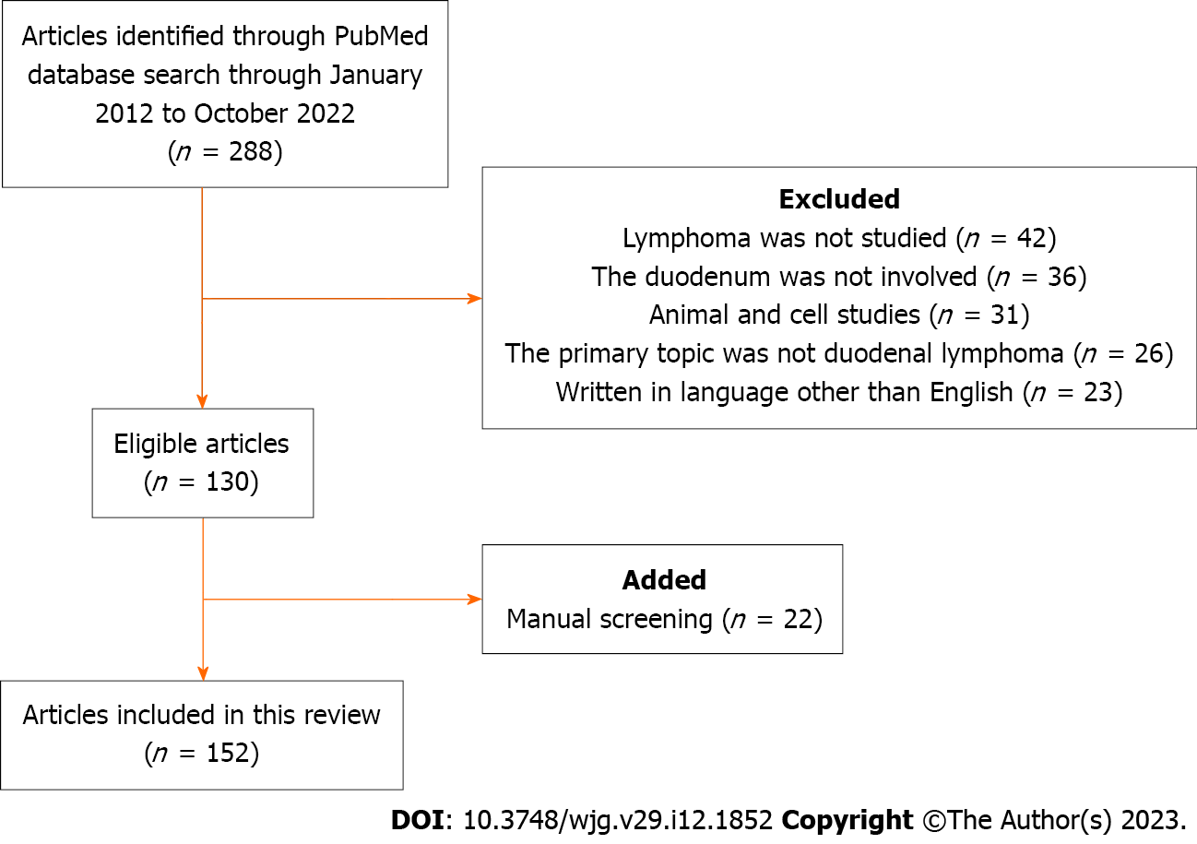
Figure 1 Flow diagram summarizing the identification, screening, eligibility, and exclusion processes of the literature search.

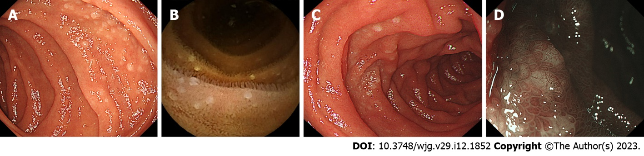
Figure 2 Representative endoscopic images of duodenal follicular lymphoma (Cases 1 and 2). A: Case 1. Esophagogastroduodenoscopy reveals typical feature of follicular lymphoma showing multiple whitish granules in the descending portion of the duodenum; B: Case 1. Video capsule enteroscopy shows follicular lymphoma lesions in the jejunum; C: Case 2. Another case of duodenal follicular lymphoma; D: Case 2. Magnifying observation with narrow band imaging shows white deposits.

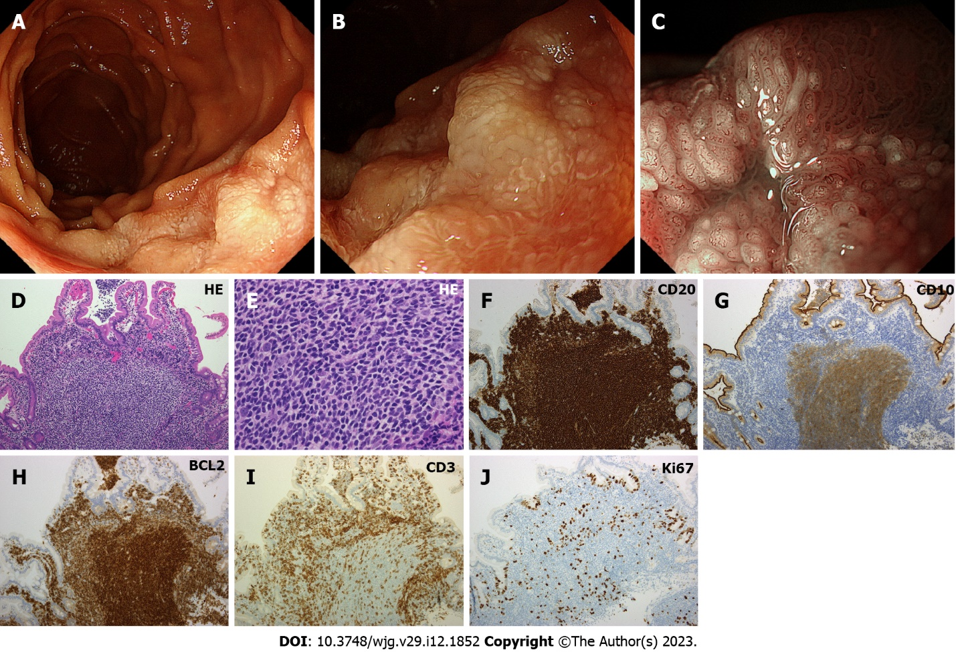
Figure 3 Representative endoscopic and pathological images of duodenal follicular lymphoma (Case 3). A: Esophagogastroduodenoscopy shows thick, white mucosa in the descending portion of the duodenum; B: Magnifying observation reveals enlarged whitish villi; C: Magnifying observation with narrow band imaging emphasizes enlarged villi with elongated vasculature on the surface; D–J: Pathological images of the biopsied specimen. Hematoxylin and eosin stain shows medium-sized tumor cells that form follicular structures and diffusely invade into the villi (D: × 10, E: × 40). Lymphoma cells are positive for CD20, CD10, and BCL2, while negative for CD3. Tumor cells are sparsely positive for Ki67. HE: Hematoxylin and eosin.

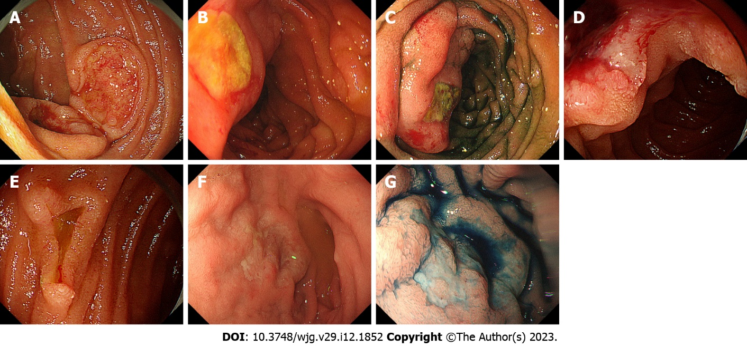
Figure 4 Representative endoscopic images of diffuse large B-cell lymphoma (Cases 4–7). A: Case 4. Esophagogastroduodenoscopy reveals duodenal lesions showing auriculate ulcer mounds; B and C: Case 5. A protruded, ulcerative lesion is seen in the duodenum; C: After indigo carmine spraying; D and E: Case 6. Multiple ulcerative lesions in the duodenum; F and G: Case 7. Irregular-shaped, shallow ulcers in the duodenum.

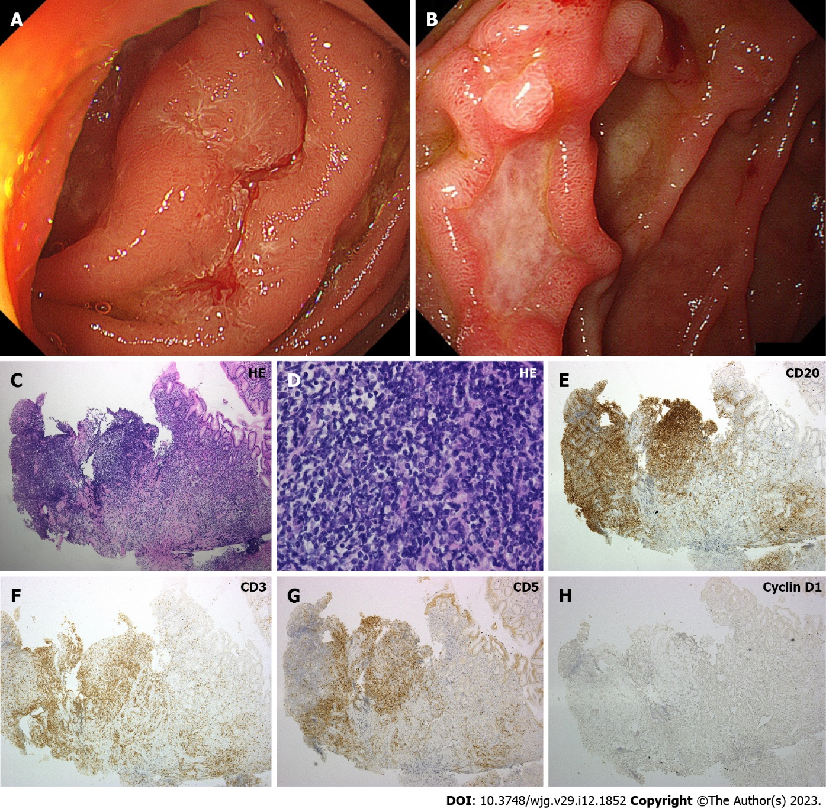
Figure 5 Representative endoscopic and pathological images of duodenal MALT lymphoma (Cases 8 and 9). A: Case 8. A protruded lesion mimicking hypertrophic folds is observed in the duodenum; B: Case 9. Esophagogastroduodenoscopy shows ulcerative tumor in the duodenum; C–H: Pathological images of Case 9. On hematoxylin and eosin stain, small to medium-sized lymphoma cells are predominant (C: × 10, D: × 40). Neoplastic cells are positive for CD20, while negative for CD3, CD5, and Cyclin D1. HE: Hematoxylin and eosin.

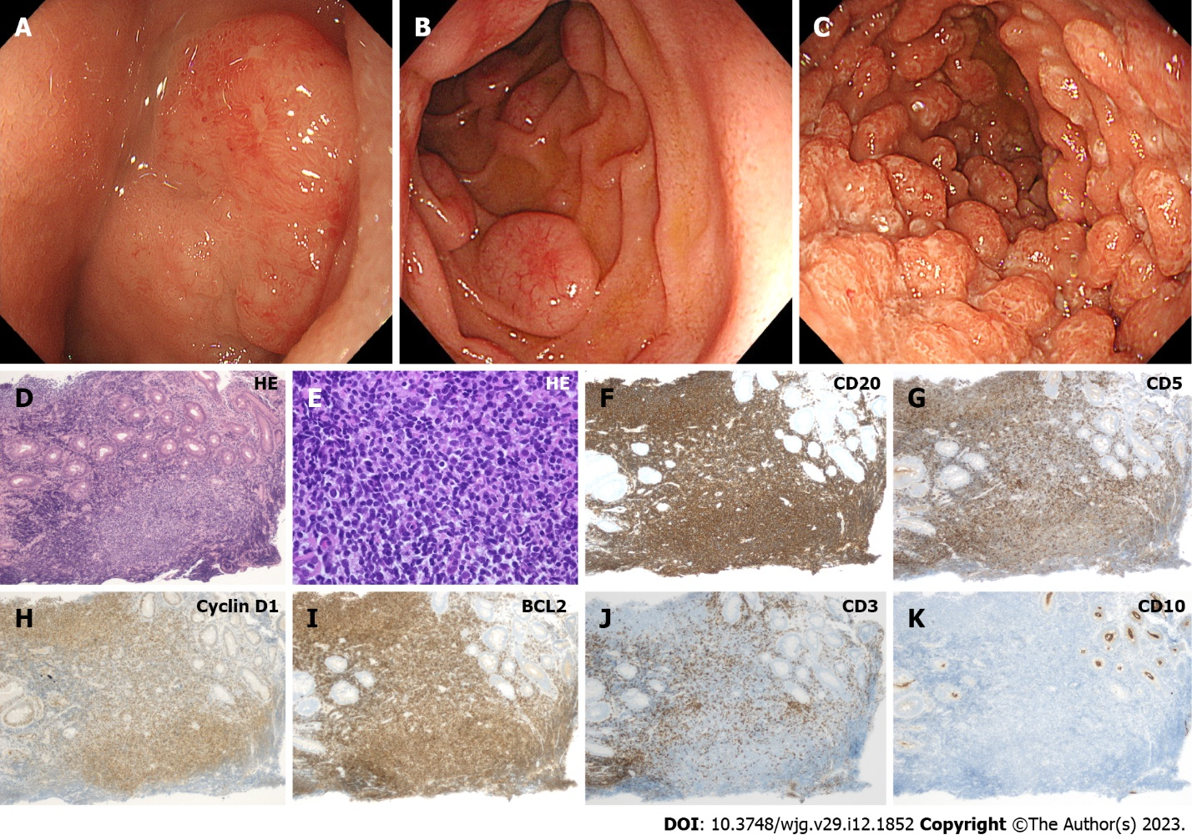
Figure 6 Representative endoscopic and pathological images of duodenal mantle cell lymphoma (Cases 10–12). A: Case 10. Elevated lesion with erosions on the surface in the duodenum; B: Case 11. Typical morphology of mantle cell lymphoma showing multiple lymphomatous polyposis in the duodenum. Subepithelial lesion-like protruded lesions accompanying dilated vasculature on the surface are seen; C: Case 12. Numerous, diffuse polypoid lesions in the duodenum; D–K: Pathological images of Case 12. Lymphoma cells retain a homogeneous pattern of cell size on hematoxylin and eosin stain (D: × 10, E: × 40). Cells are positive for CD20, CD5, Cyclin D1, BCL2, while negative for CD3 and CD10. HE: Hematoxylin and eosin.
Table 1 Literature search results
Lymphoma subtype | Number of articles
Follicular lymphoma | 48¹
Diffuse large B-cell lymphoma | 17¹
MALT lymphoma | 9¹
Enteropathy-associated T-cell lymphoma | 9
Mantle cell lymphoma | 5
Plasmablastic lymphoma | 4
Monomorphic epitheliotropic intestinal T-cell lymphoma | 4
Burkitt lymphoma | 4
Anaplastic large cell lymphoma | 4
Refractory celiac disease type II | 2
Peripheral T-cell lymphoma | 2
Marginal zone lymphoma | 2
Intravascular Lymphoma | 2
NK/T-cell lymphoma | 2
Post-transplant lymphoproliferative disease | 1
Mycosis fungoides | 1
Methotrexate-associated lymphoproliferative disorder | 1
Intestinal T-cell lymphoma | 1
Immunoproliferative small intestinal disease | 1
Extracavitary primary effusion lymphoma | 1
Cutaneous large B cell lymphoma | 1
Cutaneous aggressive T-cell lymphoma | 1
B-lymphoblastic lymphoma | 1
Non-Hodgkin lymphoma | 1
T cell lymphoma | 1
B cell lymphoma | 1
Aggressive B-cell lymphoma | 1
General review of lymphoma | 3
Subtype unspecified | 2
¹One article described follicular lymphoma and MALT lymphoma and another article described follicular lymphoma and diffuse large B-cell lymphoma.
MALT lymphoma: Extranodal marginal zone lymphoma of mucosa associated lymphoid tissue.

Published by Baishideng Publishing Group Inc
7041 Koll Center Parkway, Suite 160, Pleasanton, CA 94566, USA
Telephone: +19253991568
Email: bpgoffice@wjgnet.com
Help Desk: https://www.f6publishing.com/helpdesk
https://www.wjgnet.com

© 2023 Baishideng Publishing Group Inc. All rights reserved.

