Name of Journal: World Journal of Gastrointestinal Oncology
Manuscript NO: 65218
Manuscript Type: MINIREVIEWS

Liver tumors in children with chronic liver diseases

Sintusek P et al. Pediatric liver tumors

Palittiya Sintusek, Teerasak Phewplung, Anapat Sanpawat, Yong Poovorawan

Palittiya Sintusek, Anapat Sanpavat, Thai Pediatric Gastroenterology, Hepatology and Immunology Research Unit, Chulalongkorn University, Bangkok 10330, Thailand

Palittiya Sintusek, Department of Pediatrics, Division of Gastroenterology, Faculty of Medicine, King Chulalongkorn Memorial Hospital, Chulalongkorn University, Bangkok 10330, Thailand

Teerasak Phewplung, Department of Radiology, Faculty of Medicine, Chulalongkorn University, King Chulalongkorn Memorial Hospital, Bangkok 10330, Thailand

Anapat Sanpawat, Department of Pathology, Faculty of Medicine, Chulalongkorn University, Bangkok 10330, Thailand

Yong Poovorawan, Center of Excellence in Clinical Virology, Chulalongkorn University, Bangkok 10330, Thailand

Author contributions: Sintusek P reviewed the literature and wrote the manuscript; Phewplung T prepared, interpreted the imaging study, and provided the liver tumor images; Sanpavat A interpreted and prepared the histopathology images; Poovorawan Y edited the intellectual content in the manuscript; All authors approved the final manuscript.

Corresponding author: Palittiya Sintusek, MD, MSc, Associate Professor, Thai Pediatric Gastroenterology, Hepatology and Immunology Research Unit, Chulalongkorn University, 1873, Rama 4 Road, Pathumwan, Bangkok 10330, Thailand. palittiya.s@chula.ac.th

Received: March 1, 2021
Revised: April 27, 2021
Accepted: August 23, 2021
Published online:

Abstract
Liver tumors are rare in children, but the incidence may increase in some circumstances and particularly in chronic liver diseases. Most liver tumors consequent to chronic liver diseases are malignant hepatocellular carcinoma. Other liver tumors include hepatoblastoma, focal nodular hyperplasia, adenoma, pseudotumor, and nodular regenerative hyperplasia. Screening of suspected cases is beneficial. Imaging and surrogate markers of alpha-fetoprotein are used initially as noninvasive tools for surveillance. However, liver biopsy for histopathology evaluation might be necessary for patients with inconclusive findings. Once the malignant liver tumor is detected in children with cirrhosis, liver transplantation is currently considered the preferred option and achieves favorable outcomes. Based on the current evidence, this review focuses on liver tumors with underlying chronic liver disease, their epidemiology, pathogenesis, early recognition, and effective management.

Key Words: Liver tumor; Chronic liver disease; Children; Hepatocellular carcinoma; Liver cancer; Liver neoplasm

Sintusek P, Phewplung T, Sanpawat A, Poovorawan Y. Liver tumors in children with chronic liver diseases. World J Gastrointest Oncol 2021; In press

Core Tip: Liver tumors in children are rare, although children with underlying chronic liver diseases may present a higher risk. Early detection and timely management lead to a good prognosis and outcome. Recently, contrast enhanced ultrasound has been the preferred modality for surveillance to identify and classify the etiology of liver tumors. As the more frequent liver tumors in children with chronic liver diseases are mainly malignant, liver transplant should be considered as the first option to achieve favorable results. In addition, regular assessment is necessary in asymptomatic benign liver tumors with the potential for malignant transformation.

INTRODUCTION
Liver tumors are rare^{[1]} compared to other neoplasms in the pediatric population, and are mostly asymptomatic. However, most liver tumors are malignant neoplasms that necessitate timely management—especially in children who present with predisposing factors, including chronic liver diseases from genetic and metabolic origins. The most frequently described liver neoplasms in children with chronic liver diseases are hepatocellular carcinoma (HCC), hepatic adenoma (HA), focal nodular hyperplasia (FNH), hepatoblastoma (HB), pseudotumor, and nodular regenerative hyperplasia (NRH). The key preventative approach for liver tumors is not only specific management for the chronic liver disease itself but also tumor surveillance. As different tumors require different management approaches, tumor type identification is crucial. Collaboration among multicenter study groups, including the Children’s Oncology Group, the International Childhood Liver Tumor Study Group, the German Society for Pediatric Oncology and Hematology, and the Japanese Study Group for Pediatric Liver Tumors, are necessary to obtain meaningful data regarding natural history, management, and long-term prognosis of these tumors in children^{[2]}.

EPIDEMIOLOGY
Liver tumors are rare and account for approximately 1%–4% of tumors in children^{[3]} or 0.5–2.5 cases per million children per year^{[4-7]}. The incidence rates of liver tumors in children regardless of the presence of underlying chronic liver diseases are HB (37%), HCC (21%), benign vascular tumors (15%), sarcoma (8%), mesenchymal hamartoma (7%), FNH (5%), HA (2.5%), and other forms (4%)^{[8]}. In children with chronic liver diseases, the most common primary tumor is HCC. The incidence of HCC increases to 30%, as HCC may develop in children with a background of chronic liver diseases^{[8]}. Mother-to-child transmission of hepatitis B virus (HBV) infection and tyrosinemia are significant predisposing factors associated with HCC. The lifetime risk of developing HCC from chronic HBV infection is estimated to be 10%–25% or 100 times that of the normal population^{[9,10]} whereas the incidence of HCC from tyrosinemia is approximately 14%–75%^{[11-13]}. The prevalence of HCC associated with different liver diseases has been reported, and includes biliary atresia (BA) (1.3%)^{[11]}, progressive familial intrahepatic cholestasis (PFIC) type 2 or bile-salt excretory protein deficiency (5%–15%)^{[14]}, congenital portosystemic shunt (2.5%)^{[15]}, and Wilson’s disease (0.67%)^{[16]}. Liver adenoma has been reported to be more frequently associated with glycogen storage disease (GSD) type 1, but rarely in types 3 and 4, and has not been reported in type 6 or 9^{[15]}. Interestingly, the association between non-alcoholic fatty liver disease (NAFLD) with or without fibrosis and HCC has recently been reported in adults, raising concern and indicating the need for surveillance strategies for early lesion detection^{[17]}. Nonetheless, there has only been one case report describing NAFLD and HCC in a child^{[18]}. Moreover, apart from HCC, the prevalence of benign liver tumors such as FNH and NRH in children with chronic liver diseases has been underreported^{[8]}.

PATHOGENESIS AND CHARACTERISTICS OF LIVER TUMORS IN CHRONIC LIVER DISEASES
In the adult population, the pathogenesis of liver tumors in chronic liver diseases has been generally associated with a liver injury causing hepatocellular proliferation. However, up to 70% of pediatric HCC develops in normal liver tissue^{[19]}. Potential genetic factors predisposing liver tumor in children without chronic liver diseases include familial adenomatous polyposis (FAP), Fanconi anemia, ataxic telangiectasia, Beckwith-Wiedemann syndrome (BWS), trisomy 18, neurofibromatosis, and tuberous sclerosis, which will not be the discussed in this review. With regard to chronic liver diseases, the process of liver injury and inflammation may promote liver cell regeneration^{[20]}. If the injury continues or includes other predisposing factors, it could lead to liver cirrhosis and progression to liver neoplasm. Predisposing factors (Table 1) include the dysregulation of liver proliferation and promotion of telomere shortening^{[21]}. In addition, primary liver injury or liver injury secondary to oxidative stress could induce dysregulation of signaling pathways involving protumorigenic growth factors and cytokines^{[22]} such as insulin-like growth factor, hepatocyte growth factor, the wingless signaling pathway, transforming growth factor-α, epidermal growth factor, and transforming growth factor-β. For example, increasing oxidative stress resulting from an deficiency of antioxidant enzymes caused by the homozygous PiZZ mutation of α-1 antitrypsin could induce liver damage^{[23]} and rarely, HCC in children^{[24,25]}. Furthermore, procarcinogenic genetic factors such as p53 mutations leading to telomere-induced genomic instability are strongly associated with malignant liver neoplasm.
Infections from HBV and hepatitis C virus (HCV) may result in allelic deletions and p53 mutations, and are considered strong inducers of hepatocarcinogenesis leading to HCC^{[26]}. Toxic substances such as the accumulation of toxic metabolites in tyrosinemia type 1 disorder (including maleyl acetoacetate, fumaryl acetoacetate and succinyl acetone) may also lead to the development of liver neoplasm. Hence, the incidence of HCC in children is reportedly 13%–37%, when tyrosinemia is diagnosed beyond 2 years of age^{[27,28]}. Another example of a metabolic disturbance causing liver neoplasm is GSD type 1, and rarely type 4, in patients with poor dietary control. A decrease in tumor suppressor kinase-1 expression might explain the pathogenesis of adenoma. Interestingly, obesity is a well-known major risk factor for cancer involving a process of a low-grade, chronic inflammatory responses. Consequently, lipotoxicity from the ectopic deposition of fat in the liver may contribute to the development of liver neoplasm in the obese population with NAFLD^{[29]}. Moreover, cholestasis and bile salt accumulation, which may cause liver neoplasm due to an increased risk of liver tumors, has been reported in patients with BA and PFIC type 2 and 3^{[30,31]}. Several case reports have described HCC in infants with BA and cirrhosis at the age of 1 year^{[32]} and HB has been reported in three children diagnosed with congenital hepatic fibrosis and polycystic disease at the age of 2 years^{[7]}. Finally, it has been hypothesized that both intrahepatic and extrahepatic shunts are associated with neoplasms of the liver due to local hemodynamic instability^{[33]}.

CLINICAL MANIFESTATIONS AND CHARACTERISTICS OF LIVER TUMORS
Although children with liver tumors are commonly asymptomatic, some children present with tumor complications, including abdominal pain, fever, jaundice, cholangitis, anemia, fatigue, and portal hypertension. Specific sequelae can be commonly observed in individual tumors and include tumor bleeding in HA, lung and bone metastasis in HCC^{[7,34]}, and fever with thrombosis in HB^{[35]}. Liver tumors in chronic liver diseases are summarized in Table 2.

HB
HB is the most common malignant liver tumor in children aged less than 5 years^{[4]}. The majority of predisposing factors of HB include premature birth with very low birth weight and genetic diseases such as FAP, BWS, trisomy 21, Li-Fraumeni syndrome, congenital portosystemic shunt, GSD type 1 and 3, and tyrosinemia. Nonetheless, HB has a better prognosis compared with other malignant liver tumors, especially with early detection. In terms of risk stratification, the Children’s Hepatic Tumors International Collaboration identified younger age (< 1 year), PRETEXT classification I and II, and well-differentiated or fetal cell subtype could predict good outcomes^{[36]} (Figures 1 and 2).

HCC
Unlike HB, HCC is a rare malignant tumor in children. However, the incidence increases in patients with underlying chronic liver diseases or in the presence of a specific genetic syndrome. HBV and HCV are fatal causes of HCC in endemic areas of South Africa and Asian countries. Genetic and metabolic diseases that closely associated with HCC are tyrosinemia, and PFIC types 2 and 3. Because of the initial nonspecific symptoms, only 50% of cases present high levels of alpha-fetoprotein (AFP), most children have been diagnosed with more advanced disease with only a 20% possibility of complete removal of the tumor mass. Unfortunately, HCC is largely chemoresistant to therapy. If a tumor is unresectable but there is no evidence of extrahepatic metastasis, liver transplantation must be considered^{[8]}.

HA
HA is a spherical or ovoid, well-circumscribed tumor without vascular or bile duct involvement, and usually presents as a solitary mass (70%–80%). Multiple adenomas are commonly observed in GSD type 1^{[37]}, and might be associated with a high frequency of β-catenin mutations and a lack of hepatocyte nuclear factor-1 alpha inactivation^{[38]}. Other liver conditions involved include GSD type 3 and 4, tyrosinemia, galactosemia, and congenital or acquired portosystemic shunts^{[39,40]}. The regression of HA is possible if predisposing factors are eliminated. The tumor is usually complicated by rupture or hemorrhage (10%)^{[41]} especially if > 5 cm in size. Malignant transformation rarely occurs but requires long-term monitoring (Figures 3 and 4).

FNH
FNH comprises normal focal liver parenchymal with bile duct proliferation and vascular anomalies^{[42,43]}. As the hypothesis of FNH pathogenesis involves the response of liver cells to local vascular abnormalities^{[44]}, FNH is usually associated with portal vein agenesis or hypoplasia and the Budd-Chiari syndrome^{[45]}. This tumor is typically a single lesion less than 5-cm in size, located near the liver surface^{[46]}. Despite the homogenous normal liver, central scars or fibrous areas surrounding the large vessels are the main characteristics. This tumor is a true benign neoplasm and is usually asymptomatic. Moreover, the tumor may regress if the underlying vascular disturbance is corrected. However, a case of FNH in a child with biliary atresia and cirrhosis has been reported by our center (Figure 5).

NRH
NRH is defined as normal parenchyma with small diffuse regenerative nodules without or with minimal fibrosis. It is a very rare tumor that might be the result of microcirculatory disturbances. Vascular disorders leading to atrophic hepatocytes are followed by compensatory regeneration. Liver conditions related to NRH include chronic Budd-Chiari syndrome, human immunodeficiency virus, antiviral agents, congenital absence of the portal vein^{[47]}, and post-liver transplantation^{[48]}. Portal hypertension may occur in up to 50% of patients^{[49]}. Imaging of NRH is very similar to that observed in cirrhosis with nodule sizes usually between 1 and 3 mm. The absence or only presence of 0–1 fibrous septa in histopathology may distinguish NRH from cirrhosis^{[47,50]}. Long-term follow-up is recommended as malignant transformation has been reported^{[51]}, with a 5-year cumulative incidence of 4%^{[11]}.
Other hepatic lesions
Pseudotumor or giant regenerative nodule is an unusual benign hepatic lesion in the background of chronic liver disease or cirrhosis. The incidence of pseudotumor in children with BA is reportedly 3.8%^{[52]}. Well-formed tumors are rarely bleeding or necrotic. The tumor characterization is similar to FNH but with no central scars. A peripheral tumor capsule could distinguish the pseudotumor from HCC. The typical imaging features of this pseudotumor have not been well described. Computed tomography (CT)-guided biopsy is sometimes needed in inconclusive cases^{[53,54]}; however, needle-track seeding^{[55]} should be considered if the tumor is proven malignant. Pseudotumors should be included in the differential diagnosis of liver masses in children with chronic liver diseases or cirrhosis.
Dysplastic nodules are considered precancerous nodules present in chronically diseased livers. It is believed that these dysplastic nodules are responsible for the malignant transformation of nodules progressing towards HCC. Histological evaluation of the nodule reveals hepatic parenchyma with some degree of cellular atypia. Magnetic resonance imaging (MRI) studies, with special contrast agents such as extracellular contrast, hepatic-specific contrast, and reticuloendothelial contrast are the best techniques for the differential diagnosis of this small nodule from HCC^{[56]}.

SCREENING AND INVESTIGATION
Most liver tumors identified in chronic liver diseases are malignant. Although there is no international guidelines available that address the frequency for screening liver tumors in high-risk children, early detection might be necessary for timely management. HCC can develop very early, particularly in chronic liver diseases. A recent case report described the development of HCC in a 4-year-old child with vertical transmission of HBV infection^{[32]}. HCC and HB in infants with cirrhosis due to BA have been described as early as 1 year of age^{[31,32]}, and in a 2-year-old child with congenital hepatic fibrosis and autosomal recessive polycystic disease^{[7]}. However, children with tyrosinemia who are under medical management or those who have undergone liver transplantation, remain at low risk for developing HCC^{[13,57]}. Consequently, early and long-term surveillance is recommended.

AFP
In cases of underlying liver disease, screening with noninvasive modalities is suggested with AFP followed by imaging studies after risk stratification. AFP is the preferred tumor marker to evaluate liver masses with an increase of 90% for HB and 50% for HCC in children. However, young children present high baseline levels of AFP, which decrease over time to adult levels at 8 mo of age^{[58]}; thus, interpretation is challenging for infants at this age. An increase in normal AFP levels in some benign tumors and HB have also been evidenced^{[59,60]}. Hence, AFP alone is not recommended for the initial screening for liver tumors. Imaging as another screening modality is also required in parallel.

Imaging studies
Imaging modalities are the primary diagnostic investigations as they are less invasive and informative^{[33]}. Abdominal ultrasound (US), CT, and MRI are optional and depend on the availability of resources. Abdominal US is frequently used as this technique is non-radiating and rarely requires deep sedation or anesthesia. US with Doppler may provide additional tumor information including size, echogenicity, focality, border, vascular involvement, and presence of thrombi. A limitation is operator dependence. Recently, contrast enhanced US (CEUS) has been proposed to be a promising imaging modality as its performance is comparable to CT and MRI, and has a specificity of 98% for identifying benign liver lesions and a negative predictive value of 100%^{[61]}. This technique uses an US contrast agent such as SonoVue® that was approved for use in both adults and children by the United States Food and Drug Administration in 2016^{[62]}. CEUS should be considered for use as a follow-up measure in children with known hepatic diseases thus minimizing radiation exposure using a cost-effective approach^{[63,64]}. SonoVue® is reportedly safe in children^{[65]} and extensive data from a prospective multicenter study of 23188 adults showed the rate of adverse events was 0.125% and serious adverse occurred in 0.0086%^{[66]}. Although US could define the origin of the liver tumor, CT or MRI are able to more accurately describe tumor characteristics, particularly the tumor border and eventual extensions to adjacent organs or into vessels. MRI is the most sensitive imaging modality for regenerative and dysplastic nodules but is comparable with CT for HCC detection with a lower false positive rate than MRI^{[67]} (Table 3). Annual screening for liver tumors by imaging modalities in high-risk patients is reasonable. Once the tumor is detected and the size is < 3 cm, the American Association of the Study of Liver Disease and the European Association for the Study of the Liver recommend US screening at 3- to 6-mo intervals for adult patients^{[68]}, as this interval growth is the best indicator for malignant liver tumor transformation. There are no international guidelines for tumor surveillance in children and thus, many centers adopt adult guidelines instead.

Histopathology evaluation of liver tissue
Liver biopsy is considered an invasive procedure. The reported incidence of complications after percutaneous liver biopsy in children is 6.83%, of which 2.4% experience a major complication^{[69]}. However, liver biopsy for histopathology evaluation might be necessary in cases with inconclusive findings from imaging and with the surrogate marker AFP. Identification of the cytologic malignancy and hepatocellular differentiation are important for HCC diagnosis. In cases with inadequate liver samples or with no distinction between two diagnostic features of focal distribution in other areas or well-differentiated HCC in origin, it is extremely difficult to distinguish HCC from HA or dysplastic nodules. Special staining should be helpful if malignancy is not clearly evidenced. Markers favoring HCC over HA include glycipan-3 (GPC3), and loss of reticulin network by reticulin staining. In addition, markers favoring HCC over high-grade dysplastic nodules are GPC3, heat shock protein 70, glutamine synthetase, and cluster of differentiation 34 (diffuse staining) (Figure 6A-C)^{[70]}.
With regard to FNH, which is a truly benign lesion and does not require active management, differential diagnosis from HA and HCC is sometimes challenging. Atypical FNH lesions on imaging studies, in which no central scar pattern is present and there is delay in the wash-out period, may not allow differentiation from HCC. In liver biopsy, typical findings reveal benign hepatocytes separated by fibrous septa that typically contain large dystrophic vessels with eccentrically thickened walls and narrowed, often thrombosed, while lamina and the presence ductular reaction are more helpful to confirm FNH diagnosis^{[71]}. In addition, the diagnosis is aided by immunohistochemical staining for glutamine synthetase^{[72]}, which also presents a characteristic pattern in FNH (Figure 7A and B). Unlike the FNH pattern, HA in benign hepatocytes contains thin-walled arteries unaccompanied by bile ducts. The hepatocyte itself usually contains glycogen and fat that are sometimes entirely steatotic. If the hepatocytes present atypia with mitoses or an acinar growth pattern (pseudogranular), it is very challenging to differentiate from well-differentiated HCC. Immunohistochemistry staining indicating β-catenin activation will be useful if positive^{[71]}.

TREATMENT
Long-term follow-up and surveillance
Benign tumors such as HA and FNH may resolve if the primary liver disease is suitably managed. Nearly 40% of children with FNH with a confirmed liver biopsy have resolved lesions^{[73]}. Follow-up by US every 6–12 mo is suggested as complications (bleeding, necrosis or rupture) could occur in HA, although they are rarely observed in FNH.

Surgical removal
Surgical excision is the only curable modality for malignant liver tumors with a favorable outcome if early detection is achieved. Surgical removal is also indicated in symptomatic benign tumors such as bleeding HA. For FNH, which is a true benign tumor, tumor resection has been performed because of symptoms (48%), inability to rule out malignancy (31%), and rapid tumor growth (15%)^{[44]}.

Liver transplantation
Liver transplant is the mainstay treatment and is required in cases of unresectable malignant liver disease^{[74]}. Cisplatin-based chemotherapy prior to liver transplantation to achieve suitable margins for HB resection is under debate and requires additional data^{[75]}. For HCC, early transplantation should be considered at the earliest possible opportunity because of its chemo- and radio-resistance. In cases of benign liver tumor, liver transplantation might have a role in the presence of multiple tumors that are difficult to resect, if these tumors are at high risk of transformation, or in patients experiencing symptoms^{[76,77]} (Figure 8).

Other treatments
Transarterial chemoembolization and radiofrequency ablation are currently considered trial modalities in children with malignant tumors. This option might be considered in patients who are not eligible for tumor resection or liver transplantation^{[78,79]}.

CONCLUSION
Liver tumors in children with chronic liver disease are more common than expected. Early detection with noninvasive and highly specific diagnostic modalities are necessary as children require routine monitoring. Liver histopathology is required in equivocal cases. Treatment outcome is favorable with timely management even in cases of malignant tumor. Liver transplantation is the preferred treatment option. In cases of benign tumor, long-term follow-up and surveillance are encouraged as tumor transformation has also been evidenced.

ACKNOWLEDGEMENTS
The authors are very grateful to Dr. Chongsrisawat V, Dr. Prachuapthunyachart S, Dr. Tubjareon C, and all staff at the Division of Gastroenterology, Department of Pediatrics, Faculty of Medicine, Chulalongkorn University, Thailand, for their support and the best of care to our children with chronic liver diseases and liver tumors. Moreover, the authors would like to thank Miss Alisara Pittiyayon at Electricity Generating Authority of Thailand for the image in Figure 1.

REFERENCES
1 Austin MT, Leys CM, Feurer ID, Lovvorn HN 3rd, O'Neill JA Jr, Pinson CW, Pietsch JB. Liver transplantation for childhood hepatic malignancy: a review of the United Network for Organ Sharing (UNOS) database. J Pediatr Surg 2006; 41: 182-186 [PMID: 16410130 DOI: 10.1016/j.jpedsurg.2005.10.091]
2 Arthur Zimmermann. Liver Tumors of Childhood. In: Romil Saxena editor. Practical Hepatology Pathology: A Diagnostic Approach. 2nd ed. Philadelphia PE, 2018: 555-582
3 Meyers RL. Tumors of the liver in children. Surg Oncol 2007; 16: 195-203 [PMID: 17714939 DOI: 10.1016/j.suronc.2007.07.002]
4 Darbari A, Sabin KM, Shapiro CN, Schwarz KB. Epidemiology of primary hepatic malignancies in U.S. children. Hepatology 2003; 38: 560-566 [PMID: 12939582 DOI: 10.1053/jhep.2003.50375]
5 Stocker JT. Hepatic tumors in children. Clin Liver Dis 2001; 5: 259-281, viii-viix [PMID: 11218918 DOI: 10.1016/s1089-3261(05)70163-x]
6 Weinberg AG, Finegold MJ. Primary hepatic tumors of childhood. Hum Pathol 1983; 14: 512-537 [PMID: 6303939 DOI: 10.1016/s0046-8177(83)80005-7]
7 Finegold MJ, Egler RA, Goss JA, Guillerman RP, Karpen SJ, Krishnamurthy R, O'Mahony CA. Liver tumors: pediatric population. Liver Transpl 2008; 14: 1545-1556 [PMID: 18975283 DOI: 10.1002/lt.21654]
8 Ng K, Mogul DB. Pediatric Liver Tumors. Clin Liver Dis 2018; 22: 753-772 [PMID: 30266161 DOI: 10.1016/j.cld.2018.06.008]
9 Schmid I, von Schweinitz D. Pediatric hepatocellular carcinoma: challenges and solutions. J Hepatocell Carcinoma 2017; 4: 15-21 [PMID: 28144610 DOI: 10.2147/JHC.S94008]
10 McGlynn KA, Petrick JL, London WT. Global epidemiology of hepatocellular carcinoma: an emphasis on demographic and regional variability. Clin Liver Dis 2015; 19: 223-238 [PMID: 25921660 DOI: 10.1016/j.cld.2015.01.001]
11 Khanna R, Verma SK. Pediatric hepatocellular carcinoma. World J Gastroenterol 2018; 24: 3980-3999 [PMID: 30254403 DOI: 10.3748/wjg.v24.i35.3980]
12 Zeybek AC, Kiykim E, Soyucen E, Cansever S, Altay S, Zubarioglu T, Erkan T, Aydin A. Hereditary tyrosinemia type 1 in Turkey: twenty year single-center experience. Pediatr Int 2015; 57: 281-289 [PMID: 25223216 DOI: 10.1111/ped.12503]
13 Mayorandan S, Meyer U, Gokcay G, Segarra NG, de Baulny HO, van Spronsen F, Zeman J, de Laet C, Spiekerkoetter U, Thimm E, Maiorana A, Dionisi-Vici C, Moeslinger D, Brunner-Krainz M, Lotz-Havla AS, Cocho de Juan JA, Couce Pico ML, Santer R, Scholl-Bürgi S, Mandel H, Bliksrud YT, Freisinger P, Aldamiz-Echevarria LJ, Hochuli M, Gautschi M, Endig J, Jordan J, McKiernan P, Ernst S, Morlot S, Vogel A, Sander J, Das AM. Cross-sectional study of 168 patients with hepatorenal tyrosinaemia and implications for clinical practice. Orphanet J Rare Dis 2014; 9: 107 [PMID: 25081276 DOI: 10.1186/s13023-014-0107-7]
14 Pawlikowska L, Strautnieks S, Jankowska I, Czubkowski P, Emerick K, Antoniou A, Wanty C, Fischler B, Jacquemin E, Wali S, Blanchard S, Nielsen IM, Bourke B, McQuaid S, Lacaille F, Byrne JA, van Eerde AM, Kolho KL, Klomp L, Houwen R, Bacchetti P, Lobritto S, Hupertz V, McClean P, Mieli-Vergani G, Shneider B, Nemeth A, Sokal E, Freimer NB, Knisely AS, Rosenthal P, Whitington PF, Pawlowska J, Thompson RJ, Bull LN. Differences in presentation and progression between severe FIC1 and BSEP deficiencies. J Hepatol 2010; 53: 170-178 [PMID: 20447715 DOI: 10.1016/j.jhep.2010.01.034]
15 Romano F, Stroppa P, Bravi M, Casotti V, Lucianetti A, Guizzetti M, Sonzogni A, Colledan M, D'Antiga L. Favorable outcome of primary liver transplantation in children with cirrhosis and hepatocellular carcinoma. Pediatr Transplant 2011; 15: 573-579 [PMID: 21797955 DOI: 10.1111/j.1399-3046.2011.01528.x]
16 Pfeiffenberger J, Mogler C, Gotthardt DN, Schulze-Bergkamen H, Litwin T, Reuner U, Hefter H, Huster D, Schemmer P, Członkowska A, Schirmacher P, Stremmel W, Cassiman D, Weiss KH. Hepatobiliary malignancies in Wilson disease. Liver Int 2015; 35: 1615-1622 [PMID: 25369181 DOI: 10.1111/liv.12727]
17 Goyal NP, Schwimmer JB. The Progression and Natural History of Pediatric Nonalcoholic Fatty Liver Disease. Clin Liver Dis 2016; 20: 325-338 [PMID: 27063272 DOI: 10.1016/j.cld.2015.10.003]
18 Nobili V, Alisi A, Grimaldi C, Liccardo D, Francalanci P, Monti L, Castellano A, de Ville de Goyet J. Non-alcoholic fatty liver disease and hepatocellular carcinoma in a 7-year-old obese boy: coincidence or comorbidity? Pediatr Obes 2014; 9: e99-e102 [PMID: 24302697 DOI: 10.1111/j.2047-6310.2013.00209.x]
19 Varol Fİ. Pediatric Hepatocellular Carcinoma. J Gastrointest Cancer 2020; 51: 1169-1175 [PMID: 32856229 DOI: 10.1007/s12029-020-00494-w]
20 Angelico R, Grimaldi C, Saffioti MC, Castellano A, Spada M. Hepatocellular carcinoma in children: hepatic resection and liver transplantation. Transl Gastroenterol Hepatol 2018; 3: 59 [PMID: 30363724 DOI: 10.21037/tgh.2018.09.05]
21 Zhang Y, Shen J, Ming-Whei, Lee YP, Santella RM. Telomere length in hepatocellular carcinoma and paired adjacent non-tumor tissues by quantitative PCR. Cancer Invest 2007; 25: 668-677 [PMID: 18058461 DOI: 10.1080/07357900701561024]
22 Fu Y, Chung FL. Oxidative stress and hepatocarcinogenesis. Hepatoma Res 2018; 4 [PMID: 30761356 DOI: 10.20517/2394-5079.2018.29]
23 Marcus NY, Blomenkamp K, Ahmad M, Teckman JH. Oxidative stress contributes to liver damage in a murine model of alpha-1-antitrypsin deficiency. Exp Biol Med (Maywood) 2012; 237: 1163-1172 [PMID: 23104507 DOI: 10.1258/ebm.2012.012106]
24 Torres-Durán M, Lopez-Campos JL, Barrecheguren M, Miravitlles M, Martinez-Delgado B, Castillo S, Escribano A, Baloira A, Navarro-Garcia MM, Pellicer D, Bañuls L, Magallón M, Casas F, Dasí F. Alpha-1 antitrypsin deficiency: outstanding questions and future directions. Orphanet J Rare Dis 2018; 13: 114 [PMID: 29996870 DOI: 10.1186/s13023-018-0856-9]
25 Ismail H, Broniszczak D, Kaliciński P, Markiewicz-Kijewska M, Teisseyre J, Stefanowicz M, Szymczak M, Dembowska-Bagińska B, Kluge P, Perek D, Kościesza A, Dzik E, Lembas A, Teisserye M. Liver transplantation in children with hepatocellular carcinoma. Do Milan criteria apply to pediatric patients? Pediatr Transplant 2009; 13: 682-692 [PMID: 19496985 DOI: 10.1111/j.1399-3046.2009.01062.x]
26 Qu JH, Zhu MH, Lin J, Ni CR, Li FM, Zhu Z, Yu GZ. Effects of hepatitis B virus on p53 expression in hepatoma cell line SMMU-7721. World J Gastroenterol 2005; 11: 6212-6215 [PMID: 16273653 DOI: 10.3748/wjg.v11.i39.6212]
27 Weinberg AG, Mize CE, Worthen HG. The occurrence of hepatoma in the chronic form of hereditary tyrosinemia. J Pediatr 1976; 88: 434-438 [PMID: 173827 DOI: 10.1016/s0022-3476(76)80259-4]
28 van Spronsen FJ, Thomasse Y, Smit GP, Leonard JV, Clayton PT, Fidler V, Berger R, Heymans HS. Hereditary tyrosinemia type I: a new clinical classification with difference in prognosis on dietary treatment. Hepatology 1994; 20: 1187-1191 [PMID: 7927251]
29 Baffy G, Brunt EM, Caldwell SH. Hepatocellular carcinoma in non-alcoholic fatty liver disease: an emerging menace. J Hepatol 2012; 56: 1384-1391 [PMID: 22326465 DOI: 10.1016/j.jhep.2011.10.027]
30 Dabare C, Le Marshall K, Leung A, Page CJ, Choong PF, Lim KK. Differences in presentation, progression and rates of arthroplasty between hip and knee osteoarthritis: Observations from an osteoarthritis cohort study-a clear role for conservative management. Int J Rheum Dis 2017; 20: 1350-1360 [PMID: 28493422 DOI: 10.1111/1756-185X.13083]
31 Taat F, Bosman DK, Aronson DC. Hepatoblastoma in a girl with biliary atresia: coincidence or co-incidence. Pediatr Blood Cancer 2004; 43: 603-605 [PMID: 15382280 DOI: 10.1002/pbc.20115]
32 Lopez-Terrada DL, Finegold MJ. Liver tumors. In: Walker AW, Durie PR, Hamilton JR, Walker-Smith JA, Watkins JB, eds. Pediatric Gastrointestinal Disease: Pathophysiology, Diagnosis, Management. 5th ed. St. Louis, MO: C.V. Mosby; 2008: 911-926
33 Chiorean L, Cui XW, Tannapfel A, Franke D, Stenzel M, Kosiak W, Schreiber-Dietrich D, Jüngert J, Chang JM, Dietrich CF. Benign liver tumors in pediatric patients - Review with emphasis on imaging features. World J Gastroenterol 2015; 21: 8541-8561 [PMID: 26229397 DOI: 10.3748/wjg.v21.i28.8541]
34 Pizzo P, Poplack D. Pediatric liver tumors. [Chapter: 28]. 6th edition. Philadelphia: Lippincott Williams and Wilkins; 2011
35 von Schweinitz D. Management of liver tumors in childhood. Semin Pediatr Surg 2006; 15: 17-24 [PMID: 16458842 DOI: 10.1053/j.sempedsurg.2005.11.004]
36 Czauderna P, Haeberle B, Hiyama E, Rangaswami A, Krailo M, Maibach R, Rinaldi E, Feng Y, Aronson D, Malogolowkin M, Yoshimura K, Leuschner I, Lopez-Terrada D, Hishiki T, Perilongo G, von Schweinitz D, Schmid I, Watanabe K, Derosa M, Meyers R. The Children's Hepatic tumors International Collaboration (CHIC): Novel global rare tumor database yields new prognostic factors in hepatoblastoma and becomes a research model. Eur J Cancer 2016; 52: 92-101 [PMID: 26655560 DOI: 10.1016/j.ejca.2015.09.023]
37 Flejou JF, Barge J, Menu Y, Degott C, Bismuth H, Potet F, Benhamou JP. Liver adenomatosis. An entity distinct from liver adenoma? Gastroenterology 1985; 89: 1132-1138 [PMID: 2412930]
38 Calderaro J, Labrune P, Morcrette G, Rebouissou S, Franco D, Prévot S, Quaglia A, Bedossa P, Libbrecht L, Terracciano L, Smit GP, Bioulac-Sage P, Zucman-Rossi J. Molecular characterization of hepatocellular adenomas developed in patients with glycogen storage disease type I. J Hepatol 2013; 58: 350-357 [PMID: 23046672 DOI: 10.1016/j.jhep.2012.09.030]
39 Rebouissou S, Bioulac-Sage P, Zucman-Rossi J. Molecular pathogenesis of focal nodular hyperplasia and hepatocellular adenoma. J Hepatol 2008; 48: 163-170 [PMID: 17997499 DOI: 10.1016/j.jhep.2007.10.003]
40 Resnick MB, Kozakewich HP, Perez-Atayde AR. Hepatic adenoma in the pediatric age group. Clinicopathological observations and assessment of cell proliferative activity. Am J Surg Pathol 1995; 19: 1181-1190 [PMID: 7573676 DOI: 10.1097/00000478-199510000-00008]
41 Brancatelli G, Federle MP, Vullierme MP, Lagalla R, Midiri M, Vilgrain V. CT and MR imaging evaluation of hepatic adenoma. J Comput Assist Tomogr 2006; 30: 745-750 [PMID: 16954922 DOI: 10.1097/01.rct.0000224630.48068.bf]
42 International Working Party.. Terminology of nodular hepatocellular lesions. Hepatology 1995; 22: 983-993 [PMID: 7657307 DOI: 10.1016/0270-9139(95)90324-0]
43 Herman P, Pugliese V, Machado MA, Montagnini AL, Salem MZ, Bacchella T, D'Albuquerque LA, Saad WA, Machado MC, Pinotti HW. Hepatic adenoma and focal nodular hyperplasia: differential diagnosis and treatment. World J Surg 2000; 24: 372-376 [PMID: 10658075 DOI: 10.1007/s002689910059]
44 Scalori A, Tavani A, Gallus S, La Vecchia C, Colombo M. Risk factors for focal nodular hyperplasia of the liver: an Italian case-control study. Am J Gastroenterol 2002; 97: 2371-2373 [PMID: 12358258 DOI: 10.1111/j.1572-0241.2002.05796.x]
45 Kumagai H, Masuda T, Oikawa H, Endo K, Endo M, Takano T. Focal nodular hyperplasia of the liver: direct evidence of circulatory disturbances. J Gastroenterol Hepatol 2000; 15: 1344-1347 [PMID: 11129233]
46 Horton KM, Bluemke DA, Hruban RH, Soyer P, Fishman EK. CT and MR imaging of benign hepatic and biliary tumors. Radiographics 1999; 19: 431-451 [PMID: 10194789 DOI: 10.1148/radiographics.19.2.g99mr04431]
47 Reshamwala PA, Kleiner DE, Heller T. Nodular regenerative hyperplasia: not all nodules are created equal. Hepatology 2006; 44: 7-14 [PMID: 16799965 DOI: 10.1002/hep.21258]
48 Devarbhavi H, Abraham S, Kamath PS. Significance of nodular regenerative hyperplasia occurring de novo following liver transplantation. Liver Transpl 2007; 13: 1552-1556 [PMID: 17969192 DOI: 10.1002/Lt.21142]
49 Hartleb M, Gutkowski K, Milkiewicz P. Nodular regenerative hyperplasia: evolving concepts on underdiagnosed cause of portal hypertension. World J Gastroenterol 2011; 17: 1400-1409 [PMID: 21472097 DOI: 10.3748/wjg.v17.i11.1400]
50 Ames JT, Federle MP, Chopra K. Distinguishing clinical and imaging features of nodular regenerative hyperplasia and large regenerative nodules of the liver. Clin Radiol 2009; 64: 1190-1195 [PMID: 19913129 DOI: 10.1016/j.crad.2009.07.015]
51 Mahamid J, Miselevich I, Attias D, Laor R, Zuckerman E, Shaoul R. Nodular regenerative hyperplasia associated with idiopathic thrombocytopenic purpura in a young girl: a case report and review of the literature. J Pediatr Gastroenterol Nutr 2005; 41: 251-255 [PMID: 16056109 DOI: 10.1097/01.mpg.0000180029.73272.45]
52 Liu YW, Concejero AM, Chen CL, Cheng YF, Eng HL, Huang TL, Chen TY, Wang CC, Wang SH, Lin CC, Yong CC, Yang CH, Jordan AP, Jawan B. Hepatic pseudotumor in long-standing biliary atresia patients undergoing liver transplantation. Liver Transpl 2007; 13: 1545-1551 [PMID: 17969188 DOI: 10.1002/Lt.21320]
53 Stocker JT, Ishak KG. Focal nodular hyperplasia of the liver: a study of 21 pediatric cases. Cancer 1981; 48: 336-345 [PMID: 7237404 DOI: 10.1002/1097-0142(19810715)48:2<336::aid-cncr2820480220>3.0.co;2-s]
54 Esquivel CO, Gutiérrez C, Cox KL, Garcia-Kennedy R, Berquist W, Concepcion W. Hepatocellular carcinoma and liver cell dysplasia in children with chronic liver disease. J Pediatr Surg 1994; 29: 1465-1469 [PMID: 7844722 DOI: 10.1016/0022-3468(94)90145-7]
55 Liu YW, Chen CL, Chen YS, Wang CC, Wang SH, Lin CC. Needle tract implantation of hepatocellular carcinoma after fine needle biopsy. Dig Dis Sci 2007; 52: 228-231 [PMID: 17151805 DOI: 10.1007/s10620-006-9354-3]
56 Bertino G, Ardiri A, Demma S, GiuseppeCalvagno S, Toro A, Basile E, Campagna D, Ferraro G, Frazzetto E, Proiti M, Malaguarnera G, Bertino N, Malaguarnera M, Malaguarnera M, Amaradio MD, Pricoco G, Di Carlo I. Rare benign tumors of the liver: still rare? J Gastrointest Cancer 2014; 45: 202-217 [PMID: 24510731 DOI: 10.1007/s12029-014-9580-4]
57 Larochelle J, Alvarez F, Bussières JF, Chevalier I, Dallaire L, Dubois J, Faucher F, Fenyves D, Goodyer P, Grenier A, Holme E, Laframboise R, Lambert M, Lindstedt S, Maranda B, Melançon S, Merouani A, Mitchell J, Parizeault G, Pelletier L, Phan V, Rinaldo P, Scott CR, Scriver C, Mitchell GA. Effect of nitisinone (NTBC) treatment on the clinical course of hepatorenal tyrosinemia in Québec. Mol Genet Metab 2012; 107: 49-54 [PMID: 22885033 DOI: 10.1016/j.ymgme.2012.05.022]
58 Wu JT, Book L, Sudar K. Serum alpha fetoprotein (AFP) levels in normal infants. Pediatr Res 1981; 15: 50-52 [PMID: 6163129 DOI: 10.1203/00006450-198101000-00012]
59 De Ioris M, Brugieres L, Zimmermann A, Keeling J, Brock P, Maibach R, Pritchard J, Shafford L, Zsiros J, Czaudzerna P, Perilongo G. Hepatoblastoma with a low serum alpha-fetoprotein level at diagnosis: the SIOPEL group experience. Eur J Cancer 2008; 44: 545-550 [PMID: 18166449 DOI: 10.1016/j.ejca.2007.11.022]
60 Meyers RL, Rowland JR, Krailo M, Chen Z, Katzenstein HM, Malogolowkin MH. Predictive power of pretreatment prognostic factors in children with hepatoblastoma: a report from the Children's Oncology Group. Pediatr Blood Cancer 2009; 53: 1016-1022 [PMID: 19588519 DOI: 10.1002/pbc.22088]
61 Jacob J, Deganello A, Sellars ME, Hadzic N, Sidhu PS. Contrast enhanced ultrasound (CEUS) characterization of grey-scale sonographic indeterminate focal liver lesions in pediatric practice. Ultraschall Med 2013; 34: 529-540 [PMID: 24132647 DOI: 10.1055/s-0033-1355785]
62 Schinkel AF, Kaspar M, Staub D. Contrast-enhanced ultrasound: clinical applications in patients with atherosclerosis. Int J Cardiovasc Imaging 2016; 32: 35-48 [PMID: 26206524 DOI: 10.1007/s10554-015-0713-z]
63 Westwood M, Joore M, Grutters J, Redekop K, Armstrong N, Lee K, Gloy V, Raatz H, Misso K, Severens J, Kleijnen J. Contrast-enhanced ultrasound using SonoVue® (sulphur hexafluoride microbubbles) compared with contrast-enhanced computed tomography and contrast-enhanced magnetic resonance imaging for the characterisation of focal liver lesions and detection of liver metastases: a systematic review and cost-effectiveness analysis. Health Technol Assess 2013; 17: 1-243 [PMID: 23611316 DOI: 10.3310/hta17160]
64 Romanini L, Passamonti M, Aiani L, Cabassa P, Raieli G, Montermini I, Martegani A, Grazioli L, Calliada F. Economic assessment of contrast-enhanced ultrasonography for evaluation of focal liver lesions: a multicentre Italian experience. Eur Radiol 2007; 17 Suppl 6: F99-106 [PMID: 18376463 DOI: 10.1007/s10406-007-0234-5]
65 Piskunowicz M, Kosiak W, Batko T, Piankowski A, Połczyńska K, Adamkiewicz-Drożyńska E. Safety of intravenous application of second-generation ultrasound contrast agent in children: prospective analysis. Ultrasound Med Biol 2015; 41: 1095-1099 [PMID: 25701526 DOI: 10.1016/j.ultrasmedbio.2014.11.003]
66 Piscaglia F, Bolondi L; Italian Society for Ultrasound in Medicine and Biology (SIUMB) Study Group on Ultrasound Contrast Agents. The safety of Sonovue in abdominal applications: retrospective analysis of 23188 investigations. Ultrasound Med Biol 2006; 32: 1369-1375 [PMID: 16965977 DOI: 10.1016/j.ultrasmedbio.2006.05.031]
67 Mueller BU L-TD, Finegold MJ. Tumors of the liver. In: Pizzo PA, Poplack DG, eds. Principles and Practice of Pediatric Oncology. 5th ed. Philadelphia, PA: Lippincott-Williams & Wilkins; 2006: 887-904
68 Shneider BL, Suchy FJ, Emre S. National and regional analysis of exceptions to the Pediatric End-Stage Liver Disease scoring system (2003-2004). Liver Transpl 2006; 12: 40-45 [PMID: 16382460 DOI: 10.1002/Lt.20662]
69 Scheimann AO, Barrios JM, Al-Tawil YS, Gray KM, Gilger MA. Percutaneous liver biopsy in children: impact of ultrasonography and spring-loaded biopsy needles. J Pediatr Gastroenterol Nutr 2000; 31: 536-539 [PMID: 11144439 DOI: 10.1097/00005176-200011000-00015]
70 Pierre Bedossa, Valerie Paradis. Hepatocellular Carcinoma. In: Romil Saxena editor. Practical Hepatology Pathology: A Diagnostic Approach. 2nd ed. Philadelphia: Elsevier, 2018: 529-543
71 Paulette Bioulac-Sage NF, Charles Paul Balabaud. Benign Hepatocellular Tumors. In: Romil Saxena editor. Practical Hepatology Pathology: A Diagnostic Approach. 2nd ed. Philadelphia: Elsevier, 2018: 507-527
72 Bioulac-Sage P, Laumonier H, Rullier A, Cubel G, Laurent C, Zucman-Rossi J, Balabaud C. Over-expression of glutamine synthetase in focal nodular hyperplasia: a novel easy diagnostic tool in surgical pathology. Liver Int 2009; 29: 459-465 [PMID: 18803590 DOI: 10.1111/j.1478-3231.2008.01849.x]
73 Lautz T, Tantemsapya N, Dzakovic A, Superina R. Focal nodular hyperplasia in children: clinical features and current management practice. J Pediatr Surg 2010; 45: 1797-1803 [PMID: 20850623 DOI: 10.1016/j.jpedsurg.2009.12.027]
74 McAteer JP, Goldin AB, Healey PJ, Gow KW. Surgical treatment of primary liver tumors in children: outcomes analysis of resection and transplantation in the SEER database. Pediatr Transplant 2013; 17: 744-750 [PMID: 23992390 DOI: 10.1111/petr.12144]
75 Trobaugh-Lotrario AD, Meyers RL, O'Neill AF, Feusner JH. Unresectable hepatoblastoma: current perspectives. Hepat Med 2017; 9: 1-6 [PMID: 28203111 DOI: 10.2147/HMER.S89997]
76 Wellen JR, Anderson CD, Doyle M, Shenoy S, Nadler M, Turmelle Y, Shepherd R, Chapman WC, Lowell JA. The role of liver transplantation for hepatic adenomatosis in the pediatric population: case report and review of the literature. Pediatr Transplant 2010; 14: E16-E19 [PMID: 19490491 DOI: 10.1111/j.1399-3046.2008.01123.x]
77 Sundar Alagusundaramoorthy S, Vilchez V, Zanni A, Sourianarayanane A, Maynard E, Shah M, Daily MF, Pena LR, Gedaly R. Role of transplantation in the treatment of benign solid tumors of the liver: a review of the United Network of Organ Sharing data set. JAMA Surg 2015; 150: 337-342 [PMID: 25714928 DOI: 10.1001/jamasurg.2014.3166]
78 Ye J, Shu Q, Li M, Jiang TA. Percutaneous radiofrequency ablation for treatment of hepatoblastoma recurrence. Pediatr Radiol 2008; 38: 1021-1023 [PMID: 18535824 DOI: 10.1007/s00247-008-0911-0]
79 Zhang J, Xu F, Chen K, Zhou S, Li H, Niu C, Tan X. An effective approach for treating unresectable hepatoblastoma in infants and children: Pre-operative transcatheter arterial chemoembolization. Oncol Lett 2013; 6: 850-854 [PMID: 24137424 DOI: 10.3892/ol.2013.1444]
80 Imseis EM, Bynon JS, Thornhill C. Case of hepatocellular carcinoma in a patient with hereditary tyrosinemia in the post-newborn screening era. World J Hepatol 2017; 9: 487-490 [PMID: 28396719 DOI: 10.4254/wjh.v9.i9.487]
81 Bahador A, Dehghani SM, Geramizadeh B, Nikeghbalian S, Bahador M, Malekhosseini SA, Kazemi K, Salahi H. Liver Transplant for Children With Hepatocellular Carcinoma and Hereditary Tyrosinemia Type 1. Exp Clin Transplant 2015; 13: 329-332 [PMID: 24679101 DOI: 10.6002/ect.2013.0158]
82 van Spronsen FJ, Bijleveld CM, van Maldegem BT, Wijburg FA. Hepatocellular carcinoma in hereditary tyrosinemia type I despite 2-(2 nitro-4-3 trifluoro- methylbenzoyl)-1, 3-cyclohexanedione treatment. J Pediatr Gastroenterol Nutr 2005; 40: 90-93 [PMID: 15625434 DOI: 10.1097/00005176-200501000-00017]
83 Esquivel CO, Mieles L, Marino IR, Todo S, Makowka L, Ambrosino G, Nakazato P, Starzl TE. Liver transplantation for hereditary tyrosinemia in the presence of hepatocellular carcinoma. Transplant Proc 1989; 21: 2445-2446 [PMID: 2540570]

Footnotes
Conflict-of-interest statement: Authors declare no conflict of interests for this article.

Open-Access: This article is an open-access article that was selected by an in-house editor and fully peer-reviewed by external reviewers. It is distributed in accordance with the Creative Commons Attribution NonCommercial (CC BY-NC 4.0) license, which permits others to distribute, remix, adapt, build upon this work non-commercially, and license their derivative works on different terms, provided the original work is properly cited and the use is non-commercial. See: http://creativecommons.org/Licenses/by-nc/4.0/

Manuscript source: Invited manuscript

Peer-review started: March 1, 2021
First decision: April 19, 2021
Article in press:

Specialty type: Gastroenterology and Hepatology
Country/Territory of origin: Thailand
Peer-review report’s scientific quality classification
Grade A (Excellent): 0
Grade B (Very good): B
Grade C (Good): 0
Grade D (Fair): 0
Grade E (Poor): 0

P-Reviewer: Liu BX S-Editor: Zhang H L-Editor: Filipodia P-Editor:
Figure Legends
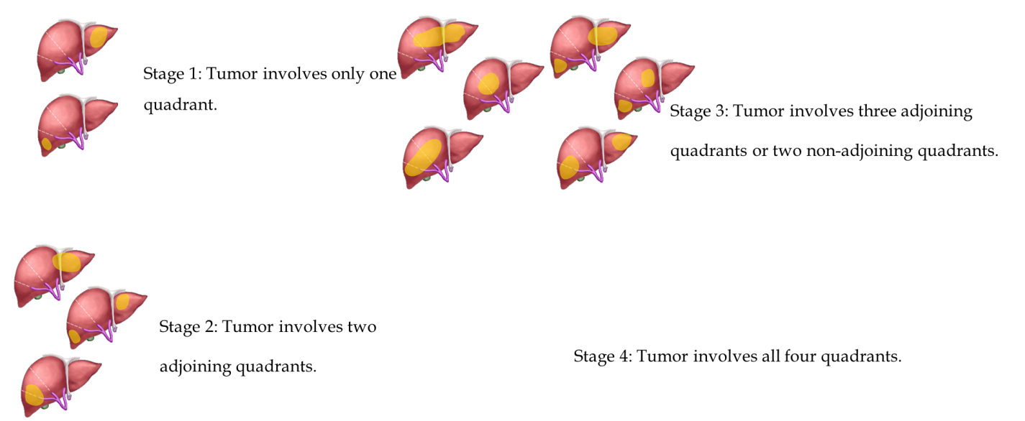
Figure 1 Definition of the pretreatment extent of disease or PRETEXT classification for the malignant liver tumor.
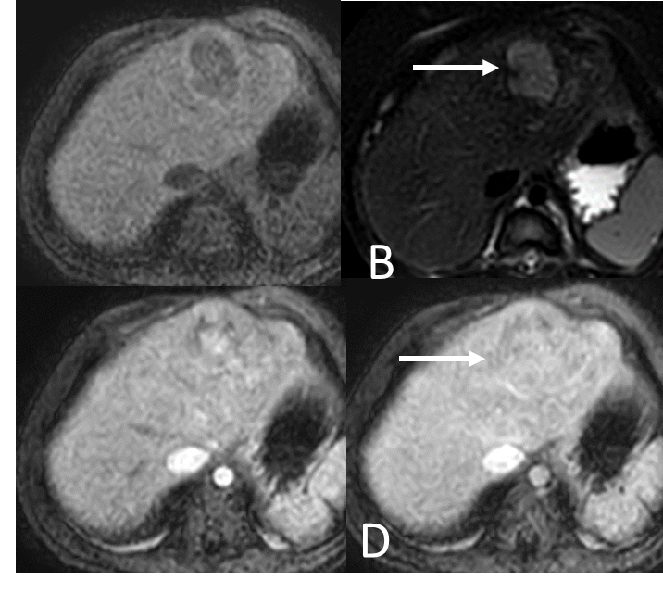
Figure 2 Magnetic resonance images of a 2-year-old boy with underlying abernethy malformation presenting with an incidentally identified liver mass with pathological tissue diagnosed hepatoblastoma. A: Mass showing well-defined hypointense liver parenchyma on T1W and; B: Hyperintense parenchyma on T2W images; C: This mass revealed heterogeneous arterial hyperenhancement; and D: Venous enhancement after the administration of gadolinium-based contrast agent.
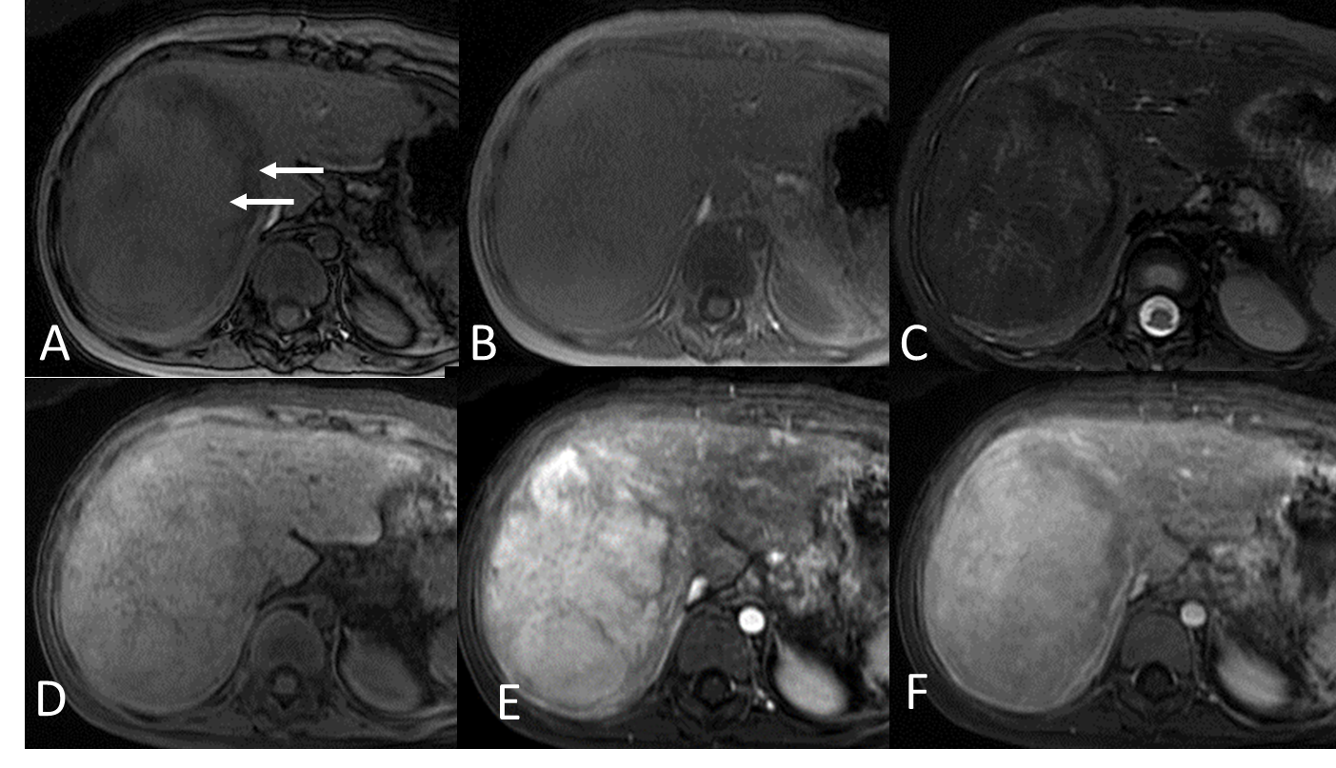
Figure 3 Magnetic resonance images of a 10-year-old girl with extrahepatic hypertension from portal vein thrombosis status post-splenectomy and proximal splenorenal shunt with developing liver mass with pathological tissue diagnosis of hepatic adenoma. A: Axial dual gradient echo opposed-phase images revealed a heterogeneous drop in signal intensity (arrows); B: Axial dual gradient echo in the in-phase image revealing the heterogeneous microscopic fat in the mass; C: Heterogeneously mild hyperintense mass in T2-weighted (T2W) image; D: Iso-to-slightly hyperintense mass in the T1W image; E: Intense arterial hyperenhancement after gadolinium-based contrast administration; F: Heterogeneous venous enhancement after gadolinium-based contrast administration.
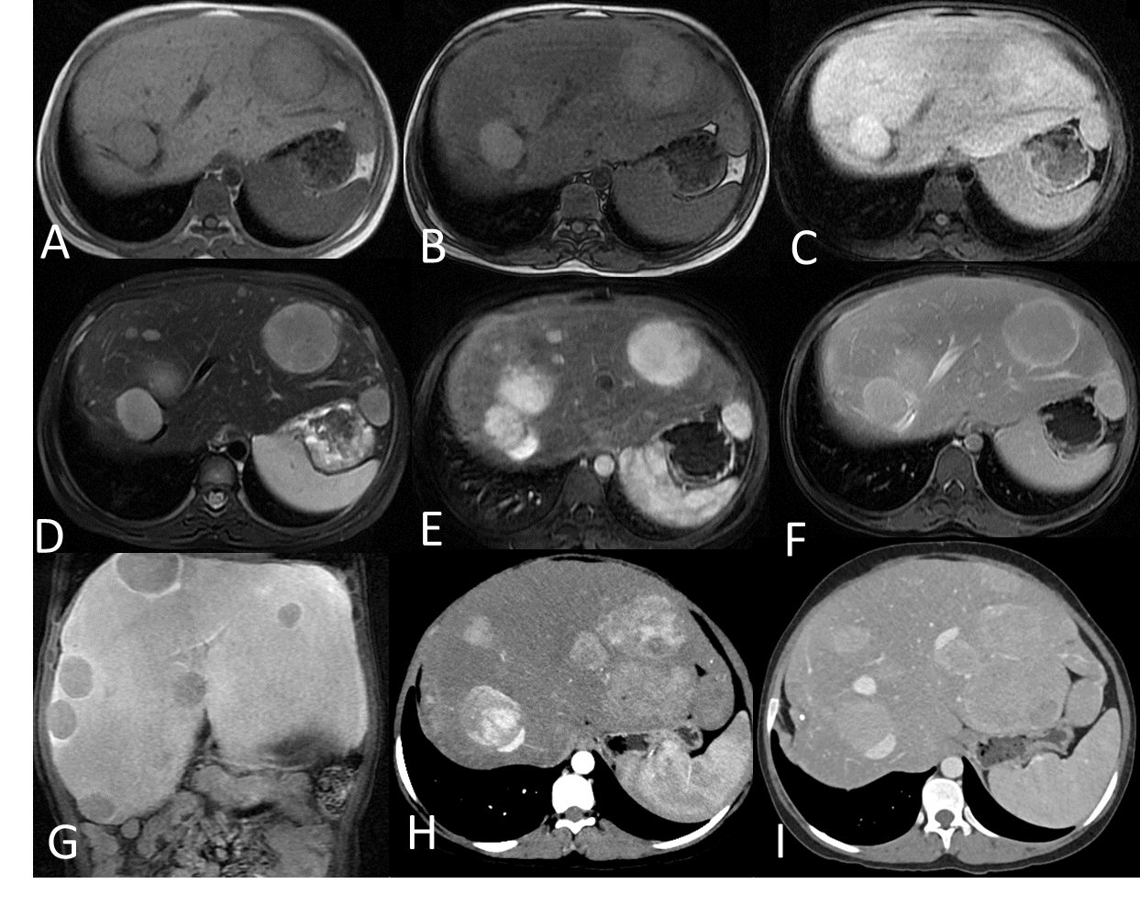
Figure 4 Magnetic resonance images of a 15-year-old girl with underlying GSD type 1 (A-G) and at the 5-yr follow-up, computed tomography was performed (H-I). One of the identified nodules presented histopathological findings compatible with hepatic adenoma. A and B: Axial dual gradient echo images showing several slightly hyperintense nodules in both hepatic lobes on the background of diffuse hepatic steatosis with dropout in signal intensity of liver parenchyma on contrast-phase images (A) as compared to in-phase images (B); C: Hypointense nodules on the T1-weighted (T1W) image; D: Hyperintense nodules on the T2W image; E-G: Intense arterial hyperenhancement of nodules (E), iso-to mild venous enhancement (F) and hypointense nodules on delayed hepatobiliary phases at 20 min (G) after injection with gadolinium-base hepatocyte specific contrast agent; H: Intense arterial hyperenhancement and increased in size of the nodules; I: Slight hyperenhancement in the venous phase.
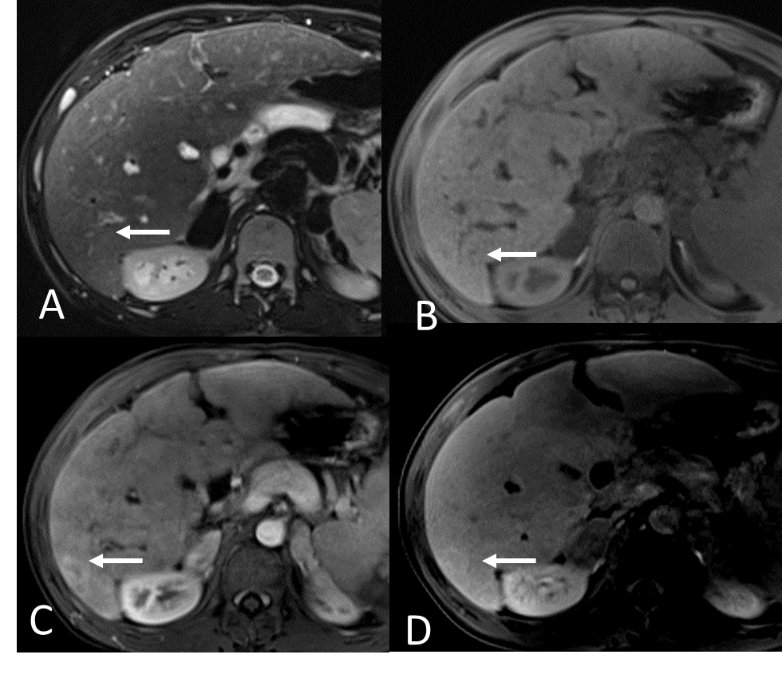
Figure 5 Pre-operative magnetic resonance images of a 13-year-old boy with biliary atresia identified liver nodule (arrows) before liver transplantation. The histopathological findings of the nodule were compatible with FNH. A: Isointense nodule on the T2W image; B: Iso-to-slightly hyperintense nodule on the T1W image; C: Arterial hyperenhancement of the nodule and; D: Persisted delayed enhancement on delayed hepatobiliary phase at 30 min after the administration of gadolinium-based hepatocyte specific contrast agent.
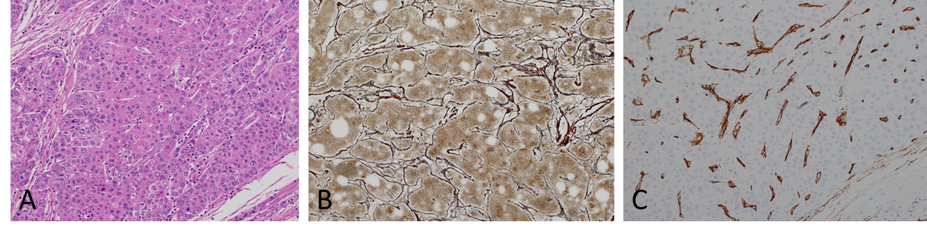
Figure 6 Histopathology from liver tumor demonstrates hepatocellular carcinoma. A: Hematoxylin and eosin staining shows tumor cells in a trabecular pattern. The cell plates are three cells thick or wider in most of this tumor; B: Reticulin staining highlights loss of normal cord architecture; C: Cluster of differentiation 34 immunostaining highlights the increased vascularity of hepatocellular carcinoma.
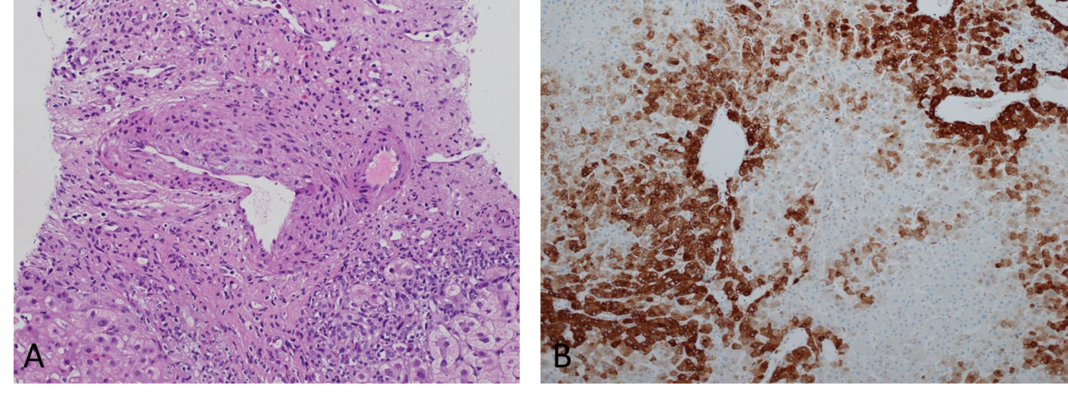
Figure 7 Histopathology of the liver tumor demonstrates focal nodular hyperplasia. A: Hematoxylin and eosin staining reveals a muscular vessel with irregular wall thickness, and ductular reaction; B: Glutamine synthetase immunostaining of focal nodular hyperplasia shows increased overall staining in a map-like pattern.
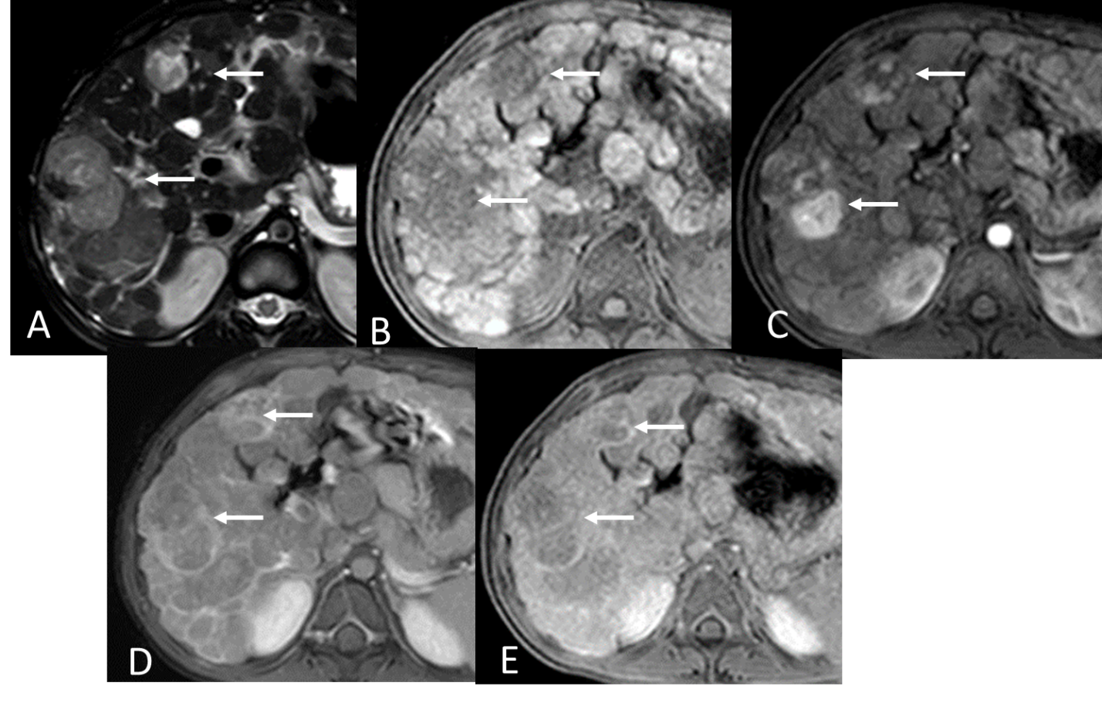
Figure 8 Magnetic resonance images of a 7-yr-old boy with tyrosinemia type I and renal Fanconi syndrome presenting nodules with histopathologic findings indicative of hepatocellular carcinoma. He underwent liver transplantation with favorable outcome and no evidence of tumor recurrence after a 1-yr follow-up. A: Multiple hyperintense nodules in T2-weighted (T2W) image; B: Hypointense nodules on the T1W image on the background of macronodular cirrhotic liver; C: Heterogeneous venous “wash-out” enhancement of the nodules; and D: Delayed capsular enhancement after administration of gadolinium-based contrast agent.
Table 1 Predisposing factors in developing hepatic tumors in chronic liver diseases
Predisposing factors
Oxidative stress
Dysregulation of protumorigenic growth factors and cytokines
Genetic factors: p53 mutation, telomere shortening, homozygous PiZZ mutation, tumor suppressor kinase-1 expression
Hepatocarcinogenesis: HBV, HCV, HIV
Toxic substances: Tyrosinemia type I (maleyl acetoacetate, fumaryl acetoacetate and succinyl acetone), PFIC type 2 and 3 (bile salt)
Metabolic disturbance: Glycogen storage disease type 1 and 4, obesity and NAFLD
Vascular disruption: Congenital absence of portal vein, noncirrhotic portal hypertension, Budd-Chiari syndrome
HBV: Hepatitis B virus; HCV: Hepatitis C virus; HIV: Human immunodeficiency virus; NAFLD: Non-alcoholic fatty liver disease; PFIC: Progressive familial intrahepatic cholestasis.
Table 2 Liver tumors identified in chronic liver diseases
Liver disease and main pathogenesis | Tumor type
Genetic or metabolic syndromes
Hereditary tyrosinemia type 1^{[80-83]} | HCC
GSD type 1, 3, 4 | HA, HCC, HB
Alagille syndrome | HCC, regenerative nodule
Other familial cholestatic syndromes | HCC
NAFLD | HCC
α-1 antitrypsin deficiency | HCC
Infections
HBV | HCC
HCV | HCC
Vascular
Abernethy | FNH, HCC, HA
Noncirrhotic portal hypertension | NRH
Congenital portosystemic shunt | HCC, HB
Cirrhosis and cholestatic conditions
Biliary atresia | HCC, FNH, pseudotumor
Autoimmune hepatitis | HCC
Wilson disease | HCC
Congenital hepatic fibrosis | HCC
Cryptogenic cirrhosis | HCC
FNH: Focal nodular hyperplasia; GSD: Glycogen storage disease; HA: Hepatic adenoma; HB: Hepatoblastoma; HBV: Hepatitis B virus; HCC: Hepatocellular carcinoma; HCV: Hepatitis C virus; NAFLD: Non-alcoholic fatty liver disease; NRH: Nodular regenerative hyperplasia.
Table 3 Typical imaging appearances of liver tumors
Tumors | US with doppler | CT | MRI
HB | Well circumscribed hyperechoic or heterogenous echogenic lesion | Hypoattenuating lesion in non-contrast image with heterogeneous arterial and venous enhancement | T1W; hypointense
 |  |  | T2W; hyperintense
 |  |  | Heterogeneous arterial and venous enhancement
HCC | Variable from hypo-, iso-, or hyperechoic from internal fat, necrosis or hemorrhage | Well- or poorly defined, hypoattenuating lesion with arterial hyperenhancement and venous “wash-out” with/without delayed capsular enhancement | T1W; hypointense
 |  |  | T2W; hyperintense
 |  |  | Early arterial enhancement and wash-out with relative low signal intensity on venous and delayed phases
 |  | Tumor thrombus enhancement in portal vein | Delayed capsular enhancement
FNH | Homogenous, well-circumscribed | Homogeneous, well-circumscribed iso- to slightly hypoechoic lesion | T1W; iso- to slightly hypointense with hypointense scar
 |  |  | T2W; iso- to slightly hyperintense with hyperintense scar
 |  | Hypoattenuating scar | Enhancement pattern same as CT
 | Internal color flow in the central scar extending to the periphery in a spoke-wheel pattern | Arterial and early portal venous enhancement and becomes isoattenuating to liver in the late portal venous and delayed phases | Normal or increased uptake on delayed hepatobiliary phases of the hepatocyte specific contrast agent
Adenoma | Hyperechoic lesion in the normal liver | Well-circumscribed hypoattenuating lesion with hyperattenuation if hemorrhaging | T1W; hyperintense
 |  |  | T2W; hyperintense
 |  |  | Fat component; Signal dropout on opposed-phase or fat suppression images
 | Hypoechoic lesion in the background of diffuse fatty infiltration or glycogen storage | Intense arterial enhancement and isoattenuating in venous and delayed phases | Peripheral pseudocapsular enhancement
 |  |  | Enhancement pattern same as CT
NRH | Multiple tiny and typically isoechoic lesions, difficult to detect. | Slightly hypo- or isoattenuating lesion to liver | T1W; homogenous and slightly hyperintense.
 |  |  | T2W; variable
 |  | Isoattenuation to liver in both arterial and portal venous phases | Enhancement in portal phase like normal liver parenchyma
CT: Computed tomography; FNH: Focal nodular hyperplasia; HB: Hepatoblastoma; HCC: Hepatocellular carcinoma; MRI: Magnetic resonance imaging; NRH: Nodular regenerative hyperplasia; US: Ultrasonography.

