Name of Journal: World Journal of Gastroenterology
Manuscript NO: 86868
Manuscript Type: ORIGINAL ARTICLE

Retrospective Cohort Study
Development and validation of a nomogram for preoperative prediction of tumor deposits in colorectal cancer

Zheng HD et al. Nomogram for predicting TDs

Hui-Da Zheng, Yun-Huang Hu, Kai Ye, Jian-Hua Xu

Hui-Da Zheng, Yun-Huang Hu, Kai Ye, Jian-Hua Xu, Department of Gastrointestinal Surgery, The Second Affiliated Hospital of Fujian Medical University, Quanzhou 362000, Fujian Province, China

Author contributions: Zheng HD designed/planned the study and wrote the paper; Zheng HD, Hu YH and Ye K acquired and analyzed data and performed computational modeling; Xu JH participated in discussion of related data; All authors read and approved the final manuscript.

Supported by Fujian Province Science and Technology Innovation Joint Fund Project, No. 2021Y9029.

Corresponding author: Jian-Hua Xu, MD, Chief Physician, Dean, Research Dean, Surgeon, Surgical Oncologist, Department of Gastrointestinal Surgery, The Second Affiliated Hospital of Fujian Medical University, No. 950 Donghai Street, Fengze District, Quanzhou 362000, Fujian Province, China. xjh630913@126.com

Received: July 11, 2023
Revised: September 21, 2023
Accepted: September 28, 2023
Published online:

Abstract
BACKGROUND
Based on the clinical data of colorectal cancer (CRC) patients who underwent surgery at our institution, a model for predicting the formation of tumor deposits (TDs) in this patient population was established.

AIM
To establish an effective model for predicting TD formation, thus enabling clinicians to identify CRC patients at high risk for TDs and implement personalized treatment strategies.

METHODS
CRC patients (n = 645) who met the inclusion criteria were randomly divided into training (n = 452) and validation (n = 193) cohorts using a 7:3 ratio in this retrospective analysis. Least absolute shrinkage and selection operator regression was employed to screen potential risk factors, and multivariable logistic regression analysis was used to identify independent risk factors. Subsequently, a predictive model for TD formation in CRC patients was constructed based on the independent risk factors. The discrimination ability of the model, its consistency with actual results, and its clinical applicability were evaluated using receiver-operating characteristic curves, area under the curve (AUC), calibration curves, and decision curve analysis (DCA).

RESULTS
Thirty-four (7.5%) patients with TDs were identified in the training cohort based on postoperative pathological specimens. Multivariate logistic regression analysis identified female sex, preoperative intestinal obstruction, left-sided CRC, and lymph node metastasis as independent risk factors for TD formation. The AUCs of the nomogram models constructed using these variables were 0.839 and 0.853 in the training and validation cohorts, respectively. The calibration curve demonstrated good consistency, and the training cohort DCA yielded a threshold probability of 7%-78%.

CONCLUSION
This study developed and validated a nomogram with good predictive performance for identifying TDs in CRC patients. Our predictive model can assist surgeons in making optimal treatment decisions.

Key Words: Colorectal cancer; Tumor deposits; Nomogram

Zheng HD, Hu YH, Ye K, Xu JH. Development and validation of a nomogram for preoperative prediction of tumor deposits in colorectal cancer. World J Gastroenterol 2023; In press

Core Tip: This article retrospectively analyzed the risk factors for tumor deposits (TDs) in colorectal cancer (CRC) and established a nomogram that included female sex, preoperative intestinal obstruction, left-sided CRC, and lymph node metastasis. This model enabled clinicians to identify high-risk populations for TDs in CRC patients and implement personalized treatment strategies.

INTRODUCTION
Colorectal cancer (CRC) is the third most common cancer worldwide, with over 1 million new cases each year, making it the second leading cause of cancer death^{[1]}. The current management of CRC is based on the tumor, lymph node, and metastasis (TNM) staging system. Initially developed to predict cancer prognosis, this system has evolved and now serves as the basis for determining treatment strategies and enrolling patients in clinical studies^{[2]}. The TNM system has evolved continuously throughout scientific advancements, and its latest edition, the 8th edition of the TNM classification, was published in 2017^{[3]}. However, the current TNM staging system exhibits limited ability to evaluate prognosis and clinical outcomes for patients with stage III CRC^{[4]}. To improve the accuracy of staging systems in CRC, it is important to consider several key prognostic markers, including lymphatic invasion, neural invasion, and tumor deposits (TDs)^{[5]}. TDs are defined as isolated tumor lesions found in the fat around the colon or rectum or adjacent mesentery (colon mesentery fat) far from the edge of tumor infiltration without evidence of residual lymphatic tissue^{[6]}. Previous studies have shown that TDs are associated with early metastasis and poor prognosis^{[6,7]}. No consensus has been reached on whether TDs should be considered positive lymph nodes in the TNM staging of CRC, leading to modifications and changes in the TNM staging system over time. Since 1997, TDs have been considered in the TNM classification^{[8]}. In the 7th and 8th versions of the TNM staging systems, the presence of TDs without any positive lymph nodes is classified as "N1c"^{[9]}. Some studies suggest that TDs may indicate a worse prognosis than lymph node metastasis, highlighting the importance of recognizing the role of TDs in prognostic assessment within the TNM staging system^{[6,10,11]}.
Limited research has investigated preoperative risk factors associated with TDs, particularly in the development of reliable predictive models. As a result, accurately assessing the presence of TDs before surgery remains challenging. This study aimed to address that gap by constructing a nomogram that can accurately and effectively predict the likelihood of TDs in patients with CRC. The nomogram aimed to identify individuals at high risk of recurrence, providing valuable insights for personalized treatment strategies and ultimately enhancing prognosis.

MATERIALS AND METHODS
Patients
This retrospective study was conducted at a single center and received approval from the Ethics Committee of the Second Affiliated Hospital of Fujian Medical University (2023-266). The study included a total of 645 patients diagnosed with CRC who underwent surgery between July 2019 and October 2022. The inclusion criteria were as follows: (1) Pathological confirmation of CRC; (2) undergoing surgical treatment; and (3) CRC being the primary malignant tumor. The exclusion criteria were as follows: (1) Presence of distant metastasis; (2) history of treatment with preoperative neoadjuvant radiotherapy and chemotherapy; and (3) incomplete clinical data.

The definition of TDs: TDs are characterized by the presence of tumor cells within the adipose tissue surrounding the colon or rectum, situated at a distance from the leading edge of tumor invasion. Importantly, there is no indication of residual lymph node tissue within the lymphatic drainage region of the tumor^{[12]}. As shown in Figure 1, we found nodular formations consisting of tumor cell extensions in the surrounding structures of the colon and rectum, which do not appear to meet the criteria for classification as lymph nodes.

Variables
In the present study, certain variables were reclassified based on specific criteria. Age was divided into two groups: ≤ 64 years old and > 64 years old. Sex was categorized as male and female. Body mass index records were classified as ≤ 25 and > 25. Tumor size was grouped as ≤ 3 cm and > 3 cm. The tumor site was divided into the right side (cecum, ascending colon, hepatic flexure, and transverse colon) and the left side (splenic flexure, descending colon, sigmoid colon, and rectum). Tumor circumference was categorized as ≤ 1/2 bowel circumference and > 1/2 bowel circumference. T staging was classified as T1-2 and T3-4. N staging was grouped as N0 and N1-2. The degree of differentiation was divided into "highly differentiated/moderately differentiated" and "poorly differentiated/undifferentiated" stages. The cutoff values for certain variables were determined using receiver-operating characteristic (ROC) curves and the Youden index^{[13]}. For instance, the preoperative carcinoembryonic antigen (CEA) level variables were divided into ≤ 5 ng/mL and > 5 ng/mL based on the cutoff value. Similarly, the carbohydrate antigen 19-9 (CA199) level variables were categorized as ≤ 18 U/mL and > 18 U/mL. The tumor size variables were grouped as ≤ 3 cm and > 3 cm. The preoperative neutrophil-to-lymphocyte ratio was divided into ≤ 3 and > 3. Other variables, such as preoperative intestinal obstruction, hypertension, diabetes, smoking history, and previous surgery history, were classified as "yes" or "no" based on their presence or absence in the patients' medical records.

Statistical analysis
Before conducting the statistical analysis, we randomly divided the 645 patients into two cohorts: A training cohort and a validation cohort, using a 7:3 ratio. The statistical analysis was performed using IBM SPSS software (version 27.0). For normally distributed measurement data, t tests were employed, while the Mann-Whitney U test was used for nonnormally distributed measurement data. Chi-square tests were conducted to analyze count data. Least absolute shrinkage and selection operator (LASSO) regression, incorporating Lambda's penalty coefficient, was employed to reduce the regression coefficient of variables to zero. Variables with zero regression coefficients were excluded, while those without zero regression coefficients were recognized as being associated with TDs. Multivariate logistic analysis was performed on the selected variables to determine the most relevant variable, which formed the basis for developing a nomogram. The validation cohort was utilized to assess the predictive ability of the developed nomogram, including discrimination and calibration. Calibration curves were generated to illustrate any potential disparities between the training cohort and the validation cohort, encompassing both the original and recalibrated nomograms. The discriminative ability of the model was evaluated through ROC curve analysis, with the area under the curve (AUC) serving as a measure. The predictive ability of the final model was evaluated by comparing the observed incidence of TDs. Additionally, decision curve analysis (DCA) was performed to assess the clinical application value of the model, calculating the net benefit under various risk threshold probabilities. R version 4.2.1 software was used for statistical analysis of the predictive models, with a P value < 0.05 considered indicative of statistical significance.

RESULTS
Clinicopathologic characteristics
A total of 645 CRC patients who met the eligibility criteria were included in this study and randomly divided into a training cohort (452 individuals) and a validation cohort (193 individuals). Among the patients, 375 were male and 273 were female, indicating a higher proportion of males (57.7%). Preoperative intestinal obstruction was present in 73 cases, while 572 cases showed no symptoms of bowel obstruction. Tumors were located on the left side in 487 patients and on the right side in 158 patients. Additionally, 239 patients had tumors occupying ≤ 1/2 of the intestinal canal circumference; 137 patients had a maximum tumor diameter of ≤ 3 cm, while 508 patients had a diameter > 3 cm. Pathological staging revealed T1-2 in 109 cases and T3-4 in 536 cases. Lymph node metastasis (pN1-2) was observed in 294 patients, while 83 patients had no lymph node metastasis (pN0). Moreover, 41 patients had poor differentiation, and 604 patients had moderate and good differentiation. All patients were divided into two groups based on the presence of TDs: The TD group (n = 51) and the non-TD group (n = 594).
Upon analyzing the clinical baseline characteristics of the included patients, significant differences were observed in sex, preoperative intestinal obstruction, tumor size, serum CEA level, serum CA199 level, pathological T stage, pathological N stage, and differentiation degree (P < 0.05). However, no significant differences were observed in other factors. The basic demographics and clinicopathological characteristics can be found in Table 1.

Predictor selection and identification
In the training cohort, we employed the LASSO regression algorithm to perform feature selection. This approach helps minimize the impact of multicollinearity and offers strong predictability and stability. We selected features based on the partial likelihood binomial deviance reaching its minimum value (Figure 2A). Consequently, eight variables with nonzero coefficients were retained in the LASSO regression (Figure 2B). These variables were considered significantly associated with TDs. The identified variables included sex, preoperative intestinal obstruction, diabetes, tumor location, tumor size, serum CEA level, pathological N stage, and degree of differentiation.
To further investigate their predictive significance, we conducted a multivariate logistic regression analysis using these eight variables. The results demonstrated that sex (female) [odds ratio (OR) = 2.404; 95% confidence interval (CI) = 1.249-4.626; P = 0.009], preoperative intestinal obstruction (OR = 3.119; 95%CI = 1.427-6.818; P = 0.004), tumor location (left side) (OR = 2.511; 95%CI = 1.088-5.795; P = 0.031), and pathological N stage (OR = 29.658; 95%CI = 7.051-124.744; P < 0.001) were all significant predictors of TDs. The detailed results of the multivariate logistic regression analysis can be found in Table 2.

Construction and evaluation of the nomogram
A nomogram was developed based on the four independent risk factors identified through multivariable logistic regression analysis (Figure 3). Each risk factor was assigned a specific score to calculate the total risk score for predicting TDs in CRC patients. The risk score for lymph node metastasis had the highest weightage (100 points), followed by preoperative symptoms of bowel obstruction (40 points). By summing the scores of the four risk factors, the total risk score can be obtained, indicating the likelihood of TDs in the patient.
To assess the predictive accuracy of the nomogram, ROC curves were generated, yielding an AUC of 0.839 for the training cohort and 0.853 for the validation cohort (Figure 4). These values indicated that the nomogram had good predictive ability. The calibration curves (Figure 5) demonstrated excellent agreement between the predicted TDs and the actual observations in both the training and validation cohorts.
Furthermore, the DCA curve was plotted for the training cohort (Figure 6). The curve showed that within a threshold probability range of 7% to 78%, using this predictive model to identify the presence of TDs in CRC patients can lead to net clinical benefits.

DISCUSSION
CRC, as one of the most common malignant tumors worldwide, has attracted significant attention in clinical and scientific research in recent years^{[1]}. Notably, the prognosis of CRC patients has become a key area of concern for clinical practitioners. With research progress achieved on prognostic factors, emerging evidence suggests that tumor pathological characteristics play a crucial role in the prognosis of CRC patients^{[14]}. Among these characteristics, TNM staging is widely recognized as the most crucial prognostic indicator^{[15]}. The significance of TDs has grown in subsequent revisions of the TNM classification, with their inclusion in TNM-8 and classification as "N1c" when accompanied by lymph node negativity^{[9,16]}. Importantly, in the 8th edition of TNM, tumor nodules with venous, lymphatic vessel, or perineural infiltration are considered distinct entities^{[7]}. An increasing body of literature suggests that TDs carry a worse prognosis than N1 or N2 involvement^{[7,11,16,17]}. Therefore, accurately predicting the presence of TDs in CRC patients before surgery holds immense value in guiding personalized staging, preoperative treatment decisions, and prognosis assessment. Currently, limited research exists on the risk factors associated with TDs in CRC patients. Most studies have focused on comparing TDs with the prognosis of lymph node metastasis, and only a few have established effective clinical prediction models. Our study included comprehensive baseline and pathological information and incorporated patient symptoms such as intestinal obstruction. This approach enhanced the sensitivity and specificity of the model, enabling clinicians to identify high-risk populations for TDs in CRC patients and implement personalized treatment strategies.
Nomograms are valuable tools for predicting outcomes in clinical practice. They provide a visual representation of the impact of various predictors on the outcome, offering a practical and intuitive explanation of their influence^{[18]}. In our study, we developed a nomogram to predict the risk of TDs in CRC patients. The nomogram was constructed based on important clinical characteristics identified through LASSO regression and multivariate logistic regression. The calibration curve demonstrated high agreement between the predicted and observed TD incidence, indicating reliable prediction performance. Moreover, the AUC values exceeded 0.8 for both the training and validation cohorts, indicating good prediction model accuracy and discrimination.
Previous studies have reported that the incidence rate of TDs in CRC patients is approximately 10%^{[19]}, which is slightly higher than that in the present study. The exploration of clinical risk factors for TDs in CRC patients remains limited. However, there have been some notable studies in this field. Hong et al^{[20]} investigated predictive factors for TDs in rectal cancer using a radiomics signature and developed a predictive model based on imaging features. They identified tumor location and two imaging features (D*, α) as accurate predictors of TDs. Chen et al^{[19]} extracted data from the Surveillance, Epidemiology, and End Results database and found that poor tumor differentiation, positive CEA, higher T staging, tumor location, and increased lymph node metastasis were risk factors for TDs in CRC patients. In our study, we conducted intergroup comparisons and identified age, preoperative intestinal obstruction, tumor size, serum CEA, serum CA199, pathological T stage, pathological N stage, and degree of differentiation as factors associated with TDs, which aligns with the aforementioned research. However, after applying LASSO regression and multivariable logistic regression, we determined that tumor location (left side), preoperative intestinal obstruction, female sex, and N stage were independent predictive variables. Notably, the association between sex and TDs has not been extensively explored, and our finding of a higher risk of TDs in female patients has not yet been documented. This may suggest that female patients are more susceptible to lymph node metastasis^{[21]}, but further investigation is required to clarify this relationship. We also found a significant correlation between tumor location and TDs, with the left side being prone to TDs, especially in rectal cancer cases. This discrepancy in TD location can be attributed to variations in lymphatic vessel involvement and lymph node metastasis between left-sided and right-sided colon cancers^{[19,22]}. CRC patients often experience intestinal obstruction at advanced stages, sometimes requiring emergency surgery or the placement of an intestinal stent^{[23]}. Previous studies have indicated that preoperative intestinal obstruction in CRC patients is associated with elevated CEA levels, poorly differentiated tumors, advanced T stage, left-sided primary tumor location, and nerve invasion, which may explain the significant association between preoperative intestinal obstruction and TDs^{[24-26]}. Furthermore, a higher number of lymph node metastases increases the likelihood of TDs, potentially due to the involvement of peripheral nerves, lymphatic vessels, and blood vessels^{[19]}. The fifth edition of TNM staging distinguished between TDs and lymph node metastasis based on size, classifying all nodules with a diameter larger than 3 mm as lymph node metastasis, thus highlighting the strong relationship between TDs and lymph nodes^{[27]}.
The current TNM staging only considers TDs in the absence of lymph node metastasis, which may not fully reflect the important role of TDs in prognosis and may lead to incorrect treatment strategies^{[3,9]}. Liang et al^{[11]} conducted a large retrospective study with a large sample size and found that TDs were an independent prognostic factor for gastric cancer patients after radical resection, suggesting that TDs should be included in the N staging system. In Liu et al's study^{[28]}, after combining TDs and lymph node metastasis, it was observed that the prognosis of N1 patients with TD positivity was similar to that of N2 patients, while the prognosis of N2 patients with TD positivity was much worse than that of N2 patients without TDs. The researchers believe that in the presence of lymph node metastasis, TDs should also be considered in the TNM system. However, when evaluating the role of TDs, ignoring the number of TDs does not seem to be a correct decision^{[14]}. A previous multicenter study demonstrated a significant correlation between the number of TDs and prognosis, with patients with ≥ 4 TDs experiencing a significantly worse prognosis than those with < 4 TDs under the same conditions^{[7]}. In summary, it is necessary to fully evaluate the prognosis of CRC patients, regardless of the presence or absence of lymph node metastasis, by considering TDs and their quantity.
In conclusion, our study integrated preoperative predictive factors into a model and achieved favorable results supported by a sufficient sample size and robust testing efficacy. However, there are some limitations to consider. First, this study has a retrospective design, which may introduce inherent biases. Second, the absence of imaging data for the preoperative predictors is a limitation, and future prospective cohort studies incorporating radiomics signatures may help support our findings.

CONCLUSION
In summary, our study identified female sex, preoperative intestinal obstruction, left-sided CRC, and lymph node metastasis as predictors of TDs in CRC. Assessing these factors before surgery is crucial for accurately determining the presence of TDs. Consideration of the impact of these predictors on clinical decision-making and patient prognosis, especially for high-risk individuals, is essential for making informed decisions and obtaining optimal outcomes.

ARTICLE HIGHLIGHTS
Research background
Colorectal cancer (CRC) poses a serious threat to human life and health. Previous studies have shown that tumor deposits (TDs) are significantly associated with early metastasis and poor prognosis. However, research on related risk factors is limited, and accurate prediction of TDs remains challenging. We developed a model based on preoperative clinical and pathological features to accurately predict the likelihood of TDs in CRC patients.

Research motivation
At present, the diagnosis of TDs in CRC requires postoperative pathology, which is passive for clinicians. If TDs can be accurately identified before patients receive treatment, it is of great importance for evaluating clinical staging, selecting reasonable treatment plans, and judging the prognosis of CRC patients.

Research objectives
To develop and validate a nomogram with good predictive ability for the preoperative prediction of TDs in patients with CRC.

Research methods
We retrospectively collected the data of 645 eligible patients with CRC. SPSS 27.0 and R (version 4.2.1) were used for statistical analysis, and a prediction model for TDs in CRC patients was established.

Research results
A total of 51 patients with CRC had TDs in this study. The areas under the curve of the training cohort and the validation cohort were 0.839 and 0.853, respectively. The model showed good accuracy and discrimination ability and has broad clinical practicability. The results of this study suggest the value of preoperative indicators in predicting TDs in CRC patients and can assist in guiding clinical decision making.

Research conclusions
This nomogram based on preoperative indicators can effectively predict the preoperative TD status of CRC.

Research perspectives
In the future, we will try to apply radiomics combined with clinical indicators to construct a model to predict the status of TDs in CRC patients.

REFERENCES
1 Sung H, Ferlay J, Siegel RL, Laversanne M, Soerjomataram I, Jemal A, Bray F. Global Cancer Statistics 2020: GLOBOCAN Estimates of Incidence and Mortality Worldwide for 36 Cancers in 185 Countries. CA Cancer J Clin 2021; 71: 209-249 [PMID: 33538338 DOI: 10.3322/caac.21660]
2 Quirke P, Williams GT, Ectors N, Ensari A, Piard F, Nagtegaal I. The future of the TNM staging system in colorectal cancer: time for a debate? Lancet Oncol 2007; 8: 651-657 [PMID: 17613427 DOI: 10.1016/S1470-2045(07)70205-X]
3 Delattre JF, Selcen Oguz Erdogan A, Cohen R, Shi Q, Emile JF, Taieb J, Tabernero J, André T, Meyerhardt JA, Nagtegaal ID, Svrcek M. A comprehensive overview of tumour deposits in colorectal cancer: Towards a next TNM classification. Cancer Treat Rev 2022; 103: 102325 [PMID: 34954486 DOI: 10.1016/j.ctrv.2021.102325]
4 Moon JY, Lee MR, Ha GW. Prognostic value of tumor deposits for long-term oncologic outcomes in patients with stage III colorectal cancer: a systematic review and meta-analysis. Int J Colorectal Dis 2022; 37: 141-151 [PMID: 34595585 DOI: 10.1007/s00384-021-04036-z]
5 Wu W, Zeng S, Zhang X, Liu P, Qiu T, Li S, Gong P. The value of tumor deposits in evaluating colorectal cancer survival and metastasis: a population-based retrospective cohort study. World J Surg Oncol 2022; 20: 41 [PMID: 35189906 DOI: 10.1186/s12957-022-02501-9]
6 Bouquot M, Creavin B, Goasguen N, Chafai N, Tiret E, André T, Flejou JF, Parc Y, Lefevre JH, Svrcek M. Prognostic value and characteristics of N1c colorectal cancer. Colorectal Dis 2018; 20: O248-O255 [PMID: 29894583 DOI: 10.1111/codi.14289]
7 Cohen R, Shi Q, Meyers J, Jin Z, Svrcek M, Fuchs C, Couture F, Kuebler P, Ciombor KK, Bendell J, De Jesus-Acosta A, Kumar P, Lewis D, Tan B, Bertagnolli MM, Philip P, Blanke C, O'Reilly EM, Shields A, Meyerhardt JA. Combining tumor deposits with the number of lymph node metastases to improve the prognostic accuracy in stage III colon cancer: a post hoc analysis of the CALGB/SWOG 80702 phase III study (Alliance)(☆). Ann Oncol 2021; 32: 1267-1275 [PMID: 34293461 DOI: 10.1016/j.annonc.2021.07.009]
8 von Winterfeld M, Hoffmeister M, Ingold-Heppner B, Jansen L, Tao S, Herpel E, Schirmacher P, Dietel M, Chang-Claude J, Autschbach F, Brenner H, Bläker H. Frequency of therapy-relevant staging shifts in colorectal cancer through the introduction of pN1c in the 7th TNM edition. Eur J Cancer 2014; 50: 2958-2965 [PMID: 25281526 DOI: 10.1016/j.ejca.2014.09.002]
9 Lord A, Brown G, Abulafi M, Bateman A, Frankel W, Goldin R, Gopal P, Kirsch R, Loughrey MB, Märkl B, Moran B, Puppa G, Rasheed S, Shimada Y, Snaebjornsson P, Svrcek M, Washington K, West N, Wong N, Nagtegaal I. Histopathological diagnosis of tumour deposits in colorectal cancer: a Delphi consensus study. Histopathology 2021; 79: 168-175 [PMID: 33511676 DOI: 10.1111/his.14344]
10 Wu WX, Zhang DK, Chen SX, Hou ZY, Sun BL, Yao L, Jie JZ. Prognostic impact of tumor deposits on overall survival in colorectal cancer: Based on Surveillance, Epidemiology, and End Results database. World J Gastrointest Oncol 2022; 14: 1699-1710 [PMID: 36187391 DOI: 10.4251/wjgo.v14.i9.1699]
11 Liang Y, Wu L, Liu L, Ding X, Wang X, Liu H, Meng J, Xu R, He D, Liang H. Impact of extranodal tumor deposits on prognosis and N stage in gastric cancer. Surgery 2019; 166: 305-313 [PMID: 31221435 DOI: 10.1016/j.surg.2019.04.027]
12 Jhuang YH, Chou YC, Lin YC, Hu JM, Pu TW, Chen CY. Risk factors predict microscopic extranodal tumor deposits in advanced stage III colon cancer patients. World J Gastroenterol 2023; 29: 1735-1744 [PMID: 37077516 DOI: 10.3748/wjg.v29.i11.1735]
13 Böhning D, Holling H, Patilea V. A limitation of the diagnostic-odds ratio in determining an optimal cut-off value for a continuous diagnostic test. Stat Methods Med Res 2011; 20: 541-550 [PMID: 20639268 DOI: 10.1177/0962280210374532]
14 Arrichiello G, Pirozzi M, Facchini BA, Facchini S, Paragliola F, Nacca V, Nicastro A, Canciello MA, Orlando A, Caterino M, Ciardiello D, Della Corte CM, Fasano M, Napolitano S, Troiani T, Ciardiello F, Martini G, Martinelli E. Beyond N staging in colorectal cancer: Current approaches and future perspectives. Front Oncol 2022; 12: 937114 [PMID: 35928863 DOI: 10.3389/fonc.2022.937114]
15 Chen K, Collins G, Wang H, Toh JWT. Pathological Features and Prognostication in Colorectal Cancer. Curr Oncol 2021; 28: 5356-5383 [PMID: 34940086 DOI: 10.3390/curroncol28060447]
16 Li X, An B, Zhao Q, Qi J, Wang W, Zhang D, Li Z, Qin C. Impact of tumor deposits on the prognosis and chemotherapy efficacy in stage III colorectal cancer patients with different lymph node status: A retrospective cohort study in China. Int J Surg 2018; 56: 188-194 [PMID: 29936197 DOI: 10.1016/j.ijsu.2018.06.029]
17 Pu H, Pang X, Fu J, Zheng R, Chen Y, Zhang D, Fang X. Significance of tumor deposits combined with lymph node metastasis in stage III colorectal cancer patients: a retrospective multi-center cohort study from China. Int J Colorectal Dis 2022; 37: 1411-1420 [PMID: 35595975 DOI: 10.1007/s00384-022-04149-z]
18 Park SY. Nomogram: An analogue tool to deliver digital knowledge. J Thorac Cardiovasc Surg 2018; 155: 1793 [PMID: 29370910 DOI: 10.1016/j.jtcvs.2017.12.107]
19 Chen J, Zhang Z, Ni J, Sun J, Ren W, Shen Y, Shi L, Xue M. Predictive and Prognostic Assessment Models for Tumor Deposit in Colorectal Cancer Patients With No Distant Metastasis. Front Oncol 2022; 12: 809277 [PMID: 35251979 DOI: 10.3389/fonc.2022.809277]
20 Hong Y, Song G, Jia Y, Wu R, He R, Li A. Predicting tumor deposits in patients with rectal cancer: Using the models of multiple mathematical parameters derived from diffusion-weighted imaging. Eur J Radiol 2022; 157: 110573 [PMID: 36347167 DOI: 10.1016/j.ejrad.2022.110573]
21 Naito A, Iwamoto K, Ohtsuka M, Imasato M, Nakahara Y, Mikamori M, Furukawa K, Moon J, Asaoka T, Kishi K, Akamatsu H. Risk Factors for Lymph Node Metastasis in Pathological T1b Colorectal Cancer. In Vivo 2021; 35: 987-991 [PMID: 33622893 DOI: 10.21873/invivo.12341]
22 Xiong X, Wang C, Cao J, Gao Z, Ye Y. Lymph node metastasis in T1-2 colorectal cancer: a population-based study. Int J Colorectal Dis 2023; 38: 94 [PMID: 37055602 DOI: 10.1007/s00384-023-04386-w]
23 Zahid A, Young CJ. How to decide on stent insertion or surgery in colorectal obstruction? World J Gastrointest Surg 2016; 8: 84-89 [PMID: 26843916 DOI: 10.4240/wjgs.v8.i1.84]
24 Katoh H, Yamashita K, Wang G, Sato T, Nakamura T, Watanabe M. Prognostic significance of preoperative bowel obstruction in stage III colorectal cancer. Ann Surg Oncol 2011; 18: 2432-2441 [PMID: 21369738 DOI: 10.1245/s10434-011-1625-3]
25 Nozawa H, Morikawa T, Kawai K, Hata K, Tanaka T, Nishikawa T, Sasaki K, Shuno Y, Kaneko M, Hiyoshi M, Emoto S, Murono K, Sonoda H, Fukayama M, Ishihara S. Obstruction is associated with perineural invasion in T3/T4 colon cancer. Colorectal Dis 2019; 21: 917-924 [PMID: 31017742 DOI: 10.1111/codi.14655]
26 Lv X, Yu H, Gao P, Song Y, Sun J, Chen X, Wang Y, Wang Z. A nomogram for predicting bowel obstruction in preoperative colorectal cancer patients with clinical characteristics. World J Surg Oncol 2019; 17: 21 [PMID: 30658652 DOI: 10.1186/s12957-019-1562-3]
27 Ueno H, Nagtegaal ID, Quirke P, Sugihara K, Ajioka Y. Tumor deposits in colorectal cancer: Refining their definition in the TNM system. Ann Gastroenterol Surg 2023; 7: 225-235 [PMID: 36998291 DOI: 10.1002/ags3.12652]
28 Liu F, Zhao J, Li C, Wu Y, Song W, Guo T, Chen S, Cai S, Huang D, Xu Y. The unique prognostic characteristics of tumor deposits in colorectal cancer patients. Ann Transl Med 2019; 7: 769 [PMID: 32042785 DOI: 10.21037/atm.2019.11.69]

Footnotes
Institutional review board statement: The study was reviewed and approved for publication by our Institutional Reviewer.

Informed consent statement: As the study used anonymous and pre-existing data, the requirement for the informed consent from patients was waived.

Conflict-of-interest statement: All the Authors have no conflict of interest related to the manuscript.

Data sharing statement: The datasets used and/or analyzed during the current study are available from the corresponding author on reasonable request.

STROBE statement: The authors have read the STROBE Statement-checklist of items, and the manuscript was prepared and revised according to the STROBE Statement-checklist of items.

Open-Access: This article is an open-access article that was selected by an in-house editor and fully peer-reviewed by external reviewers. It is distributed in accordance with the Creative Commons Attribution NonCommercial (CC BY-NC 4.0) license, which permits others to distribute, remix, adapt, build upon this work non-commercially, and license their derivative works on different terms, provided the original work is properly cited and the use is non-commercial. See: https://creativecommons.org/Licenses/by-nc/4.0/

Provenance and peer review: Unsolicited article; Externally peer reviewed.

Peer-review model: Single blind

Peer-review started: July 11, 2023
First decision: September 18, 2023
Article in press:

Specialty type: Gastroenterology and hepatology
Country/Territory of origin: China
Peer-review report’s scientific quality classification
Grade A (Excellent): A
Grade B (Very good): B
Grade C (Good): 0
Grade D (Fair): 0
Grade E (Poor): 0

P-Reviewer: Camacho S, Mexico; Ekine-Afolabi B, United Kingdom S-Editor: Qu XL L-Editor: P-Editor:
Figure Legends
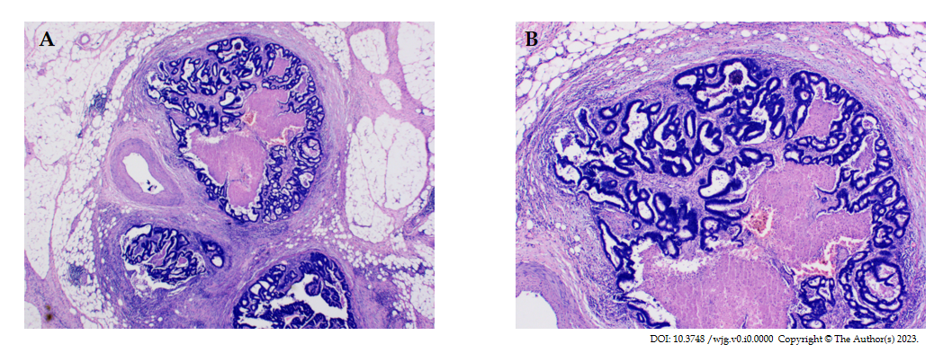
Figure 1 Hematoxylin-eosin staining of tumor deposits. A: Magnification (× 20); B: Magnification (× 40).
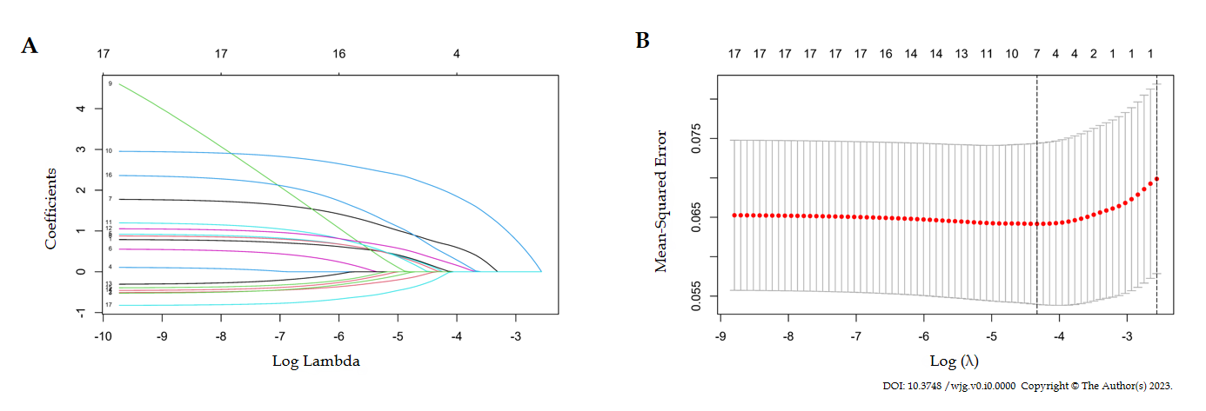
Figure 2 The Lasso regression method is used to screen for predictable variables. A: The coefficient distribution of 17 baseline features; B: In Lasso regression, 10-fold cross-validation was used to select predictive variables using the minimum criterion (solid line on the left).
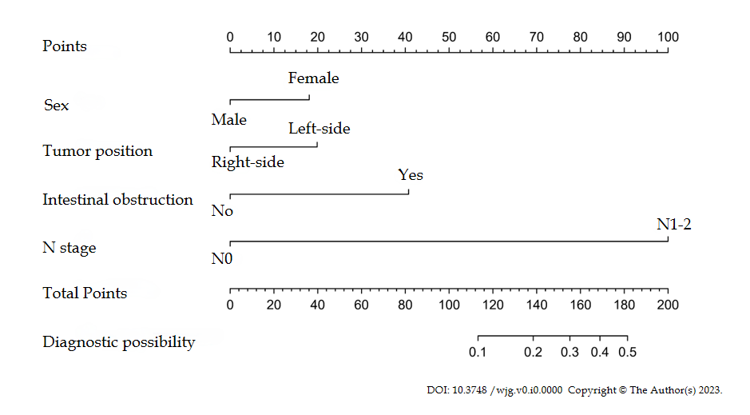
Figure 3 A nomogram was used to predict the risk of tumor deposits in colorectal cancer patients. The predictors included sex, tumor position, preoperative intestinal obstruction, and lymph node metastasis.

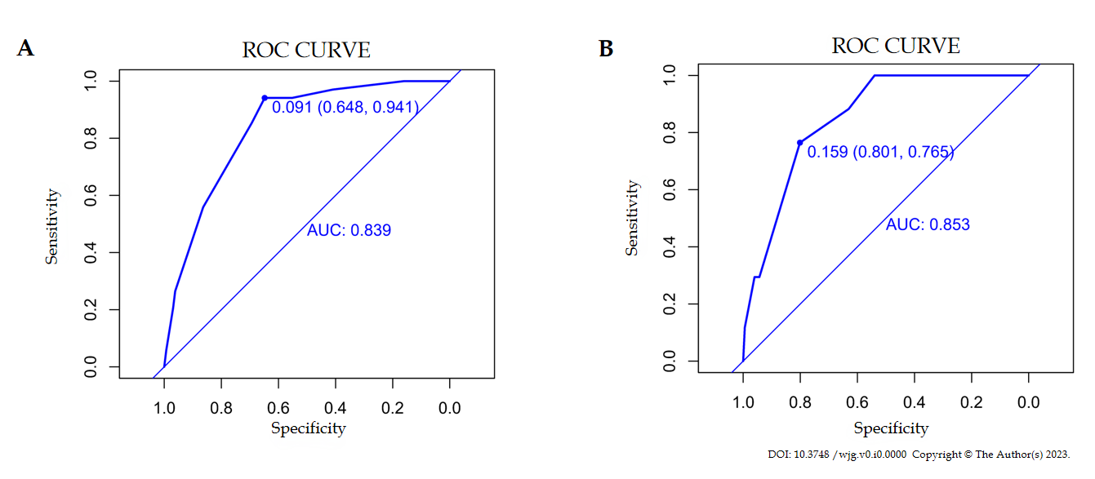
Figure 4 The receiver-operating characteristic curves of the nomogram for predicting tumor deposits. A: Receiver operating characteristic (ROC) curve for the nomogram based on the training cohort. The area under the curve (AUC) is 0.839; B: ROC curve for the nomogram based on the validation cohort. The AUC is 0.853. ROC: Receiver operating characteristic; AUC: Area under the curve.
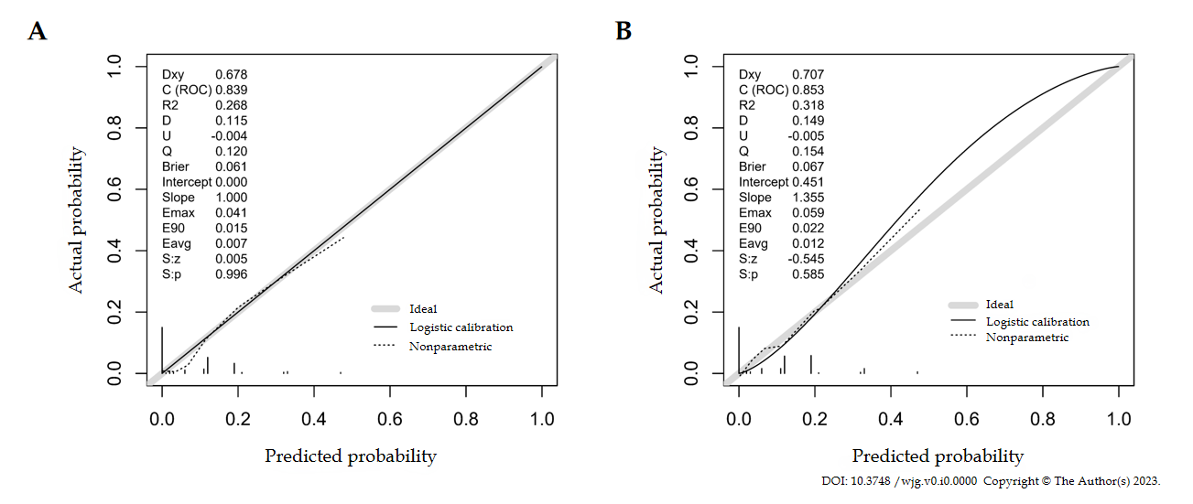
Figure 5 Calibration curve for the nomogram in the cohort. A: Calibration curve of the training cohort; B: Calibration curve of the validation cohort. ROC: Receiver operating characteristic.
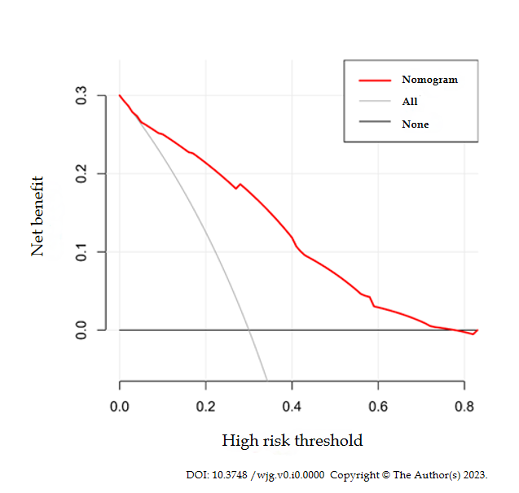
Figure 6 Decision curve analysis of the nomogram. The Y-axis represents net income, and the red line represents the risk nomogram. When the threshold probability is > 7% and < 78%, this predictive model can achieve net clinical benefits.
Table 1 Characteristics of patients, n (%)
Variables | No TD | TD | Total | P value
Age (yr) |  |  |  | 0.906
≤ 64 | 321 (54.0) | 28 (54.9) | 349 (54.1)
> 64 | 273 (46.0) | 23 (45.1) | 296 (45.9)
Sex |  |  |  | 0.029
Male | 350 (58.9) | 22 (43.1) | 372 (57.7)
Female | 244 (41.1) | 29 (56.9) | 273 (42.3)
Preoperative obstruction |  |  |  | < 0.001
No | 535 (90.1) | 37 (72.5) | 572 (88.7)
Yes | 59 (9.9) | 14 (27.5) | 73 (11.3)
Hypertension |  |  |  | 0.106
No | 440 (74.1) | 43 (84.3) | 483 (74.9)
Yes | 154 (25.9) | 8 (15.7) | 162 (25.1)
Diabetes |  |  |  | 0.459
No | 522 (87.9) | 43 (84.3) | 565 (87.6)
Yes | 72 (12.1) | 8 (15.7) | 80 (12.4)
BMI (kg/m²) |  |  |  | 0.970
≤ 25 | 502 (84.5) | 43 (84.3) | 545 (84.5)
>25 | 92 (15.5) | 8 (15.7) | 100 (15.5)
Smoking history |  |  |  | 0.581
No | 533 (89.7) | 47 (92.2) | 580 (89.9)
Yes | 61 (10.3) | 4 (7.8) | 65 (10.1)
Abdominal surgery |  |  |  | 1.000
No | 542 (91.2) | 47 (92.2) | 589 (91.3)
Yes | 52 (8.8) | 4 (7.8) | 56 (8.7)
Tumor position |  |  |  | 0.236
Right | 149 (25.1) | 9 (17.6) | 158 (24.5)
Left | 445 (74.9) | 42 (82.4) | 487 (75.5)
Occupied intestinal circumference |  |  |  | 0.139
≤ 1/2 | 225 (37.9) | 14 (27.5) | 239 (37.1)
> 1/2 | 369 (62.1) | 37 (72.5) | 406 (62.9)
Tumor size (cm) |  |  |  | 0.015
≤ 3 | 133 (22.4) | 4 (7.8) | 137 (21.2)
> 3 | 461 (77.6) | 47 (92.2) | 508 (78.8)
NLR |  |  |  | 0.925
≤ 3 | 423 (71.2) | 36 (70.6) | 459 (71.2)
> 3 | 171 (28.8) | 15 (29.4) | 186 (28.8)
CA-199 (U/mL) |  |  |  | 0.037
≤ 18 | 400 (67.3) | 27 (52.9) | 427 (66.2)
> 18 | 194 (32.7) | 24 (47.1) | 218 (33.8)
CEA (ng/mL) |  |  |  | 0.01
≤ 5 | 355 (59.8) | 21 (41.2) | 376 (58.3)
> 5 | 239 (40.2) | 30 (58.8) | 269 (41.7)
T stage |  |  |  | 0.003
T0-T2 | 108 (18.2) | 1 (2.0) | 109 (16.9)
T3-T4 | 486 (81.8) | 50 (98.0) | 536 (83.1)
N stage |  |  |  | < 0.001
N0 | 349 (58.8) | 2 (3.9) | 351 (54.4)
N1-N2 | 245 (41.2) | 49 (96.1) | 294 (45.6)
Differentiation |  |  |  | 0.011
Poor | 33 (5.6) | 8 (15.7) | 41 (6.4)
Well/moderate | 561 (94.4) | 43 (84.3) | 604 (93.6)
TD: Tumor deposit; BMI: Body mass index; NLR: Neutrophil-to-lymphocyte ratio; CEA: Carcinoembryonic antigen; CA-199: Carbohydrate antigen 199.

Table 2 The multivariate logistic regression results
Variables | Odds ratio | 95% CI | P value
Sex
Male | 1
Female | 2.404 | 1.249-4.626 | 0.009
Preoperative obstruction
No | 1
Yes | 3.119 | 1.427-6.818 | 0.004
Diabetes
No | 1
Yes | 1.485 | 0.602-3.663 | 0.391
Tumor position
Right | 1
Left | 2.511 | 1.088-5.795 | 0.031
Tumor size (cm)
≤ 3 | 1
> 3 | 2.631 | 0.867-7.977 | 0.088
CEA
≤ 5 | 1
> 5 | 1.889 | 0.983-3.632 | 0.056
N stage
N0 | 1
N1-N2 | 29.658 | 7.051-124.744 | < 0.001
Differentiation
Poor | 1
Well/moderate | 0.476 | 0.179-1.260 | 0.135
CEA: Carcinoembryonic antigen; CI: Confidence interval.

