Name of Journal: World Journal of Gastroenterology
Manuscript NO: 74249
Manuscript Type: CASE REPORT

Early gastric cancer presenting as a typical submucosal tumor cured by endoscopic submucosal dissection: A case report

Cho JH et al. EGC presenting as a submucosal tumor

Joon Hyun Cho, Si Hyung Lee

Joon Hyun Cho, Si Hyung Lee, Division of Gastroenterology and Hepatology, Department of Internal Medicine, Yeungnam University College of Medicine, Daegu 42415, South Korea

Author contributions: Cho JH and Lee SH were responsible for the design of this report, the acquisition of clinical data, and writing and revision of the manuscript.

Corresponding author: Si Hyung Lee, MD, Professor, Division of Gastroenterology and Hepatology, Department of Internal Medicine, Yeungnam University College of Medicine, 170 Hyeonchung-ro, Nam-gu, Daegu 42415, South Korea. dr9696@gmail.com

Received: December 18, 2021
Revised: March 12, 2022
Accepted: May 27, 2022
Published online:

Abstract
BACKGROUND
Submucosal tumor (SMT)-like gastric cancer is rare, and almost all cases undergo curative surgical treatment because the submucosal layer is usually deeply invaded by tumor cells or because histopathologic types of SMT-like gastric cancer are undifferentiated or poorly differentiated. No report has been issued on an SMT-like gastric cancer cured by endoscopic resection alone or on changes in the endoscopic features of this type of tumor over several years.

CASE SUMMARY
We describe an exceptional case of a 53-year-old male with a 1.5 cm-sized SMT-like lesion covered by normal-appearing mucosa discovered by esophagogastroduodenoscopy (EGD) at the gastric antrum. Endoscopic ultrasound (EUS) visualized a homogeneous, well-circumscribed hypoechogenic lesion arising from the second sonographic layer with associated subtle obliteration of the third sonographic layer. Initial endoscopic biopsy was negative for neoplasm. The patient refused to undergo an invasive procedure and was subsequently lost to follow-up. Three years after initial detection, EGD revealed the lesion had become markedly erythematous, and at 4 years after initial EGD it had increased in size to 1.8 cm and developed a central ulcer and a heterogeneous EUS echo. Finally, endoscopic submucosal dissection (ESD) was performed, and histopathologic examination revealed a moderately differentiated adenocarcinoma had minutely invaded the submucosal layer (invasion depth 169 μm) but without lymphovascular invasion and with negative resection margins. Fortunately, no additional surgical treatment was required. He has been followed for 4 years after ESD without any evidence of local or distant recurrence.

CONCLUSION
This report describes an extremely rare case of early gastric cancer presenting as SMT that was cured by ESD after a treatment delay of 4 years and the endoscopic changes that occurred during this period. The report highlights the importance of considering the possibility of gastric cancer when SMT is encountered in clinical practice.

Key Words: Subepithelial lesion; Submucosal tumor; Early gastric cancer; Adenocarcinoma; Endoscopic mucosal dissection; Case report

Cho JH, Lee SH. Early gastric cancer presenting as a typical submucosal tumor cured by endoscopic submucosal dissection: A case report. World J Gastroenterol 2022; In press

Core Tip: We experienced an exceptionally rare case of early gastric cancer presenting as submucosal tumor (SMT) that was successfully treated by endoscopic submucosal dissection (ESD) alone, although the procedure was performed four years after first detection due to patient refusal and follow-up loss. The present case cautions that SMT-like gastric cancer should be included in the differential diagnosis when a hypoechogenic mass is detected in the 2nd or 3rd layer by endoscopic ultrasound, regardless of size and the absence of findings suggesting malignancy. When diagnosis is uncertain, invasive techniques such as diagnostic endoscopic mucosal resection or ESD, which can potentially be used for therapeutic purposes, should be considered and close follow-up is recommended.

INTRODUCTION
Gastric carcinoma is an epithelial tumor exposed to the mucosal surface that occurs in lamina propria with variable gross findings. However, cases of gastric carcinoma with features of submucosal tumor (SMT) are rarely encountered in routine clinical settings and reportedly account for only 0.2% to 0.62% of all resected gastric cancers^{[1]}. The majority of patients with gastric adenocarcinoma resembling SMT are not indicated for endoscopic resection or offered non-curative resection after endoscopic resection. Submucosal layer is deeply invaded by tumor cells, even in cases of early gastric cancer (EGC)^{[2]}, and histopathologically, most adenocarcinomas presenting as SMTs are undifferentiated or poorly differentiated^{[3,4]}, and as a result, almost all undergo curative surgical treatment. Accordingly, no case has been reported on SMT-like gastric cancer cured by endoscopic resection alone. In addition, no report has been issued on changes in the endoscopic features of this type of tumor over several years. Here, we report an exceptionally rare case of EGC presenting as SMT that was cured by endoscopic submucosal dissection (ESD) and describe changes in the endoscopic features of this tumor over a period of 4 years.

CASE PRESENTATION
Chief complaints
A 53-year-old male Korean patient was referred to our institution for further evaluation and treatment of a gastric SMT discovered by esophagogastroduodenoscopy (EGD) during a routine medical check-up.

History of present illness
The patient had no abdominal pain or related discomfort.

History of past illness
He had a history of abdominal surgery due to duodenal ulcer perforation 30 years previously.

Personal and family history
The patient had diabetes that was being treated with oral hypoglycemic agents. He was a smoker (30 pack-years) and social-alcohol drinker and had no significant family history.

Physical examination
Physical examination was unremarkable, and his abdomen was soft, nontender, and nondistended with no palpable mass.

Laboratory examinations
Laboratory tests, which included tests for common serum tumor markers such as CEA and CA 19-9, revealed no abnormalities.

Imaging examinations
At initial EGD, an SMT-like elevated lesion of diameter 15-mm was observed at the great curvature side of the proximal part of the gastric antrum (Figure 1A). The lesion was covered with normal-appearing mucosa without any erosion, ulcer, or mucosal erythema. Mild-atrophic gastritis, confined to antrum, was observed in background mucosa. Endoscopic ultrasound (EUS; GF-UM2000, Olympus, Tokyo, Japan) demonstrated a 15 mm × 7 mm homogeneous, well-circumscribed hypoechogenic lesion arising from the second sonographic layer with associated subtle obliteration of the third sonographic layer (Figure 2A). The EUS appearance of the lesion was suggestive of a gastric neuroendocrine tumor (NET) or ectopic pancreas. Initial biopsy specimens were negative for neoplasm. Computed tomography (CT) of the abdomen showed a 15 mm protruding intraluminal mass at the gastric antrum and no evidence of lymph node enlargement or distant metastasis (Figure 3). After this initial work-up, endoscopic resection of the lesion was planned for definitive histopathologic examination and treatment. However, the patient declined any invasive procedure and was subsequently lost to follow-up.

Further diagnostic work-up
About 3 years after initial EGD, he underwent a national health screening examination at our hospital, and the previously noted gastric SMT was detected again by EGD. The lesion showed no change in size as compared with its size 3 years previously, but marked erythema of overlying mucosa was observed (Figure 1B). Endoscopic biopsy was performed, but specimens were negative for neoplasm. During consultation regarding his health examination results, he was recommended for further evaluation and treatment at the gastroenterology department but again refused and was lost to follow-up.
About a year later, he revisited our hospital with mild indigestion. Follow-up EGD then revealed the SMT-like lesion had enlarged (to a greatest diameter of approximately 18 mm) and that a 5 mm central ulcer had developed on the top of the lesion (Figure 1C). EUS also demonstrated an 18 mm × 9 mm homogeneous, well-circumscribed hypoechogenic mass arising from the second sonographic layer with associated subtle obliteration of the third sonographic layer (Figure 2B). Echogenicity at this time was slightly more heterogeneous than that observed by initial EUS. CT of the abdomen showed no evidence of lymph node enlargement or distant metastasis, and endoscopic biopsy specimens taken from the lesion revealed tubular adenoma with high-grade dysplasia.

FINAL DIAGNOSIS
The patient was then admitted for further endoscopic treatment. A serum anti-Helicobacter pylori (H. pylori) IgG assay was negative on the day of endoscopic examination. ESD of the lesion was performed, and histopathologic examination of the resected specimen revealed moderately differentiated adenocarcinoma that invaded the submucosal layer (depth of invasion 169 μm) with no lymphovascular invasion (Figure 4).

TREATMENT
Furthermore, resection margins were all negative for cancer. Also, rapid urease test and Giemsa staining were negative for H. pylori infection.

OUTCOME AND FOLLOW-UP
His post-ESD course was uneventful, and he has since been followed up at our outpatient department for 4 years without any evidence of local or distant recurrence. The latest follow-up EGD performed (approximately 3.5 years after ESD) showed only post-ESD scarring (Figure 1D).

DISCUSSION
This case report is meaningful for the following reasons. First, to the best of our knowledge, this is the first case report of SMT-like gastric cancer cured by ESD alone, and this result was obtained even though ESD was performed four years after initial detection. Second, this case report describes the natural course of SMT-like gastric cancer and the endoscopic changes that occurred after a treatment delay of 4 years. Furthermore, unlike previous reports, mucosa overlying the SMT appeared completely normal when the tumor was first detected.
Gastric cancer usually derives from the lamina propria layer and has macroscopic appearances ranging from well-defined protuberant to diffuse infiltrating. Approximately 95% of gastric cancers are adenocarcinomas^{[5]} but only rarely appear in the form of SMT. According to the literature^{[2]}, fewer than 0.5% of gastric cancer cases present as SMT. However, when an SMT-like lesion is encountered in clinical practice, the possibility of gastric cancer should be carefully considered and the lesion differentiated from other submucosal lesions, such as gastric NET^{[6]}, leiomyoma, lymphoma, gastrointestinal stromal tumor (GIST), lipoma, ectopic pancreas, and other unusual manifestations, such as metastatic carcinoma^{[7]} and gastric glomus tumor^{[8]}, which require completely different treatment strategies.
Pathologic diagnoses of reported cases of gastric cancer presenting as SMT include gastric adenocarcinoma^{[9]}, gastric mucinous adenocarcinoma^{[10,11]}, and gastric lymphoepithelioma-like carcinoma^{[12]}. The most common histopathologic type is undifferentiated to poorly differentiated adenocarcinoma, which constitutes 68.8% to 71.4% of these cancers^{[3,4]}. The mechanism of SMT-like gastric cancer development is obscure, but several pathologic mechanisms have been suggested. These mechanisms include the biologic tendencies of poorly differentiated adenocarcinomas to exhibit invasion of a deeper layer at an early stage, marked lymphocyte infiltration around tumors^{[1]}, the production of large amounts of mucin by mucinous adenocarcinoma^{[10,11]}, substantial amounts of surrounding fibrosis due to repetitive inflammation, abundant edematous fibrosis^{[13]}, and adenocarcinomas arising from a submucosal heterotopic gastric gland^{[9,14]}, which have been recognized as aberrant lamina propria components associated with repeated erosion and regeneration. These factors may facilitate a predominance of submucosal growth and penetration of muscularis mucosa during the early stage of carcinogenesis and contribute to a macroscopic appearance indistinguishable from SMT. However, the tumor in our case had a moderately differentiated histology, which was not in line with any of these mechanisms.
Although the diagnosis of SMT-like gastric cancer is usually difficult due to a deep tumor location and non-specific and overlapping imaging features, some EGD characteristics of SMT-like gastric cancer have been reported. In particular, SMT with central ulceration or depression has been described as common for SMT-like gastric cancer^{[10,14-16]}. Erythematous surface change is another reported characteristic^{[14,15]}. Fujiyoshi et al^{[16]} concluded that a small SMT (3-5 cm) with a central ulcer or irregular erythematous change should raise suspicion of malignancy. However, since our case originally appeared as SMT with completely normal overlying mucosa, we suspected SMT originating from the second or third layer rather than cancer. However, EGD at 3 and 4 years after initial detection of the SMT-like lesion, showed erythematous change and central ulceration. Interestingly, definite changes were observed in the endoscopic features of the tumor 4 years after initial detection, but it was not possible to determine when these morphologic changes occurred precisely due to follow-up loss.
Histological diagnosis of gastric SMT by endoscopic biopsy is often difficult and detailed imaging usually fails to provide sufficient evidence to differentiate benign and malignant tumors. Furthermore, endoscopic biopsy specimens, even those taken from a central ulcer, may be unhelpful^{[17]}, and when a tumor is completely covered with normal mucosa, it is extremely difficult to obtain an adequate sample of the underlying lesion. In the present case, negative results for neoplasm were reported for biopsies performed during EGD on overlying normal mucosa at initial presentation and on overlying erythematous mucosa 3 years later.
EUS is useful for evaluating gastric SMT. Findings that suggest malignant SMT include^{[18]} a size > 3 cm or > 5 cm, rapid growth, heterogeneous echogenicity, and irregular margins, whereas GIST or leiomyoma may present as a homogeneous, well-demarcated, submucosal mass with smooth margins. However, these imaging characteristics are non-specific, and EUS images alone are insufficient for accurate diagnosis. More invasive techniques such as EUS-guided fine-needle aspiration or biopsy and endoscopic mucosal resection may aid differential diagnoses^{[18]}. In our patient, initial EUS depicted a 15 mm-sized well-circumscribed homogeneous mass, which did not suggest malignant SMT. However, EUS performed 4 years later showed the mass had increased in size to 18 mm and had slightly more heterogeneous echogenicity.
Gastric cancers resembling SMT are characterized by a predominance of submucosal or sometimes deeper invasion into the gastric wall^{[2]}, which suggests they are likely to be more advanced and pose a greater risk of metastasis than ordinary gastric cancers of similar size^{[13]}. Furthermore, most adenocarcinomas presenting as SMTs are of the undifferentiated or poorly differentiated histopathologic types^{[3,4]}, and thus, in almost all case reports, SMT-like gastric cancer, even when small, has been treated in the same way as advanced gastric cancer. Although ESD can potentially be used for therapeutic purposes, the pathologic results of most specimens resected by ESD indicate non-curative resection, and thus, additional gastrectomy with lymphadenectomy is required^{[19]}. To date, no case report of cure by endoscopic resection has been published in the English literature. However, in the present case, ESD was performed to provide a definitive histopathologic diagnosis and a treatment strategy, and additional surgery was not needed, based on a final pathologic report that the tumor was not poorly differentiated, did not invade deep submucosa, and had negative lateral and deep margins.

CONCLUSION
The present case emphasizes that although SMT-like gastric cancer is rare, it should be included in the differential diagnosis when a hypoechogenic mass is visualized in the 2nd or 3rd layer by EUS, regardless of lesion size and the absence of findings suggesting malignancy. In addition, if diagnosis is uncertain, the use of techniques more aggressive than EUS alone, such as diagnostic endoscopic mucosal resection or ESD, which can potentially be used for therapeutic purposes, should be considered and close follow-up is recommended.

REFERENCES
1 Umehara Y, Kimura T, Okubo T, Sano Y, Nakai K, Oi S, Higashi Y, Funai K. Gastric carcinoma resembling submucosal tumor. Gastric Cancer 1999; 2: 191-193 [PMID: 11957095 DOI: 10.1007/s101200050045]
2 Ishiguro S, Tsukamoto Y, Kasugai T, Yasuhara Y, Tsuji N, Fujii Y, Nishizawa Y, Yamato N. Characteristic feature of the gastric carcinoma with submucosal tumor like appearance. Stomach Intest 2003; 38: 1519-1526
3 Takemoto N, Baba T. Kaku Y, Takekoshi T, Maruyama M, Takahashi T, Kato H, Yanagisawa A. Radiologic diagnosis of gastric cancer morphologically mimicking submucosal tumor. Stomach Intest 1995; 30: 759-768 [DOI: 10.11641/pdensks.53.0_156]
4 Mitsunaga A, Futami S, Murata Y, Suzuki A. Uchida KJ, Nemoto Y, Ikeda I, Nakamura S, Murata Y, Suzuki H. Endoscopic diagnosis of the gastric cancer showing the features of a submucosal tumor. Stomach Intest 1995; 30: 769-776 [DOI: 10.1055/s-2007-1001465]
5 Nagini S. Carcinoma of the stomach: A review of epidemiology, pathogenesis, molecular genetics and chemoprevention. World J Gastrointest Oncol 2012; 4: 156-169 [PMID: 22844547 DOI: 10.4251/wjgo.v4.i7.156]
6 Gheorghe AV, Rimbas M, Ginghina O, Spanu A, Voiosu TA. An atypical type I gastric neuroendocrine tumor. Rom J Intern Med 2017; 55: 253-256 [PMID: 28710883 DOI: 10.1515/rjim-2017-0029]
7 Inagaki C, Suzuki T, Kitagawa Y, Hara T, Yamaguchi T. A case report of prostate cancer metastasis to the stomach resembling undifferentiated-type early gastric cancer. BMC Gastroenterol 2017; 17: 93 [PMID: 28784100 DOI: 10.1186/s12876-017-0655-0]
8 Handa Y, Kano M, Kaneko M, Hirabayashi N. Gastric Glomus Tumor: A Rare Cause of Upper Gastrointestinal Bleeding. Case Rep Surg 2015; 2015: 193684 [PMID: 26697255 DOI: 10.1155/2015/193684]
9 Manabe S, Mukaisho KI, Yasuoka T, Usui F, Matsuyama T, Hirata I, Boku Y, Takahashi S. Gastric adenocarcinoma of fundic gland type spreading to heterotopic gastric glands. World J Gastroenterol 2017; 23: 7047-7053 [PMID: 29097877 DOI: 10.3748/wjg.v23.i38.7047]
10 Yu BC, Lee WK. Two cases of mucinous adenocarcinoma of the stomach mistaken as submucosal tumor. J Korean Surg Soc 2013; 84: 118-122 [PMID: 23396274 DOI: 10.4174/jkss.2013.84.2.118]
11 Yoo CH, Park SJ, Park MI, Moon W, Kim HH, Lee JS, Song JY, Jang HK. Submucosal tumor-like early-stage mucinous gastric carcinoma: a case study. Korean J Gastroenterol 2013; 62: 122-125 [PMID: 23981947 DOI: 10.4166/kjg.2013.62.2.122]
12 Takahashi T, Otani Y, Yoshida M, Furukawa T, Kameyama K, Akiba Y, Saikawa Y, Kubota T, Kumai K, Kuramochi S, Mukai M, Ishii H, Kitajima M. Gastric cancer mimicking a submucosal tumor diagnosed by laparoscopic excision biopsy. J Laparoendosc Adv Surg Tech A 2005; 15: 51-56 [PMID: 15772477 DOI: 10.1089/Lap.2005.15.51]
13 Ohara N, Tominaga O, Uchiyama M, Nakano H. A case of advanced gastric cancer resembling submucosal tumor of the stomach. Jpn J Clin Oncol 1997; 27: 423-426 [PMID: 9438007 DOI: 10.1093/jjco/27.6.423]
14 Hashimoto R, Hamamoto H, Omori Y, Tanuma T. Early gastric cancer on submucosal heterotopic gastric glands. Gastrointest Endosc 2017; 85: 851-852 [PMID: 27179691 DOI: 10.1016/j.gie.2016.05.002]
15 Teraishi F, Uno F, Kagawa S, Fujiwara T, Gouchi A, Tanaka N. Advanced gastric adenocarcinoma mimicking a submucosal tumor. Endoscopy 2007; 39 Suppl 1: E191-E192 [PMID: 17614044 DOI: 10.1055/s-2007-966403]
16 Fujiyoshi A, Kawamura M, Ishitsuka S. Gastric adenocarcinoma mimicking a submucosal tumor: case report. Gastrointest Endosc 2003; 58: 633-635 [PMID: 14560759]
17 Tio TL, Tytgat GN, den Hartog Jager FC. Endoscopic ultrasonography for the evaluation of smooth muscle tumors in the upper gastrointestinal tract: an experience with 42 cases. Gastrointest Endosc 1990; 36: 342-350 [PMID: 2210274 DOI: 10.1016/s0016-5107(90)71061-9]
18 Papanikolaou IS, Triantafyllou K, Kourikou A, Rösch T. Endoscopic ultrasonography for gastric submucosal lesions. World J Gastrointest Endosc 2011; 3: 86-94 [PMID: 21772939 DOI: 10.4253/wjge.v3.i5.86]
19 Kim HI, Shim KN, Yoon SY, Song EM, Cho WY, Kim SE, Jung HK, Jung SA. A case of early gastric adenocarcinoma resembling subepithelial tumor. Korean J Helicobacter Up Gastrointest Res 2013; 13: 60-63 [DOI: 10.7704/kjhugr.2013.13.1.60]

Footnotes
Informed consent statement: Informed written consent was obtained from the patient regarding the publication of this report and accompanying images.

Conflict-of-interest statement: The authors have no conflict of interest to declare.

CARE Checklist (2016) statement: The authors have read the CARE Checklist (2016), and the manuscript was prepared and revised according to the CARE Checklist (2016).

Open-Access: This article is an open-access article that was selected by an in-house editor and fully peer-reviewed by external reviewers. It is distributed in accordance with the Creative Commons Attribution NonCommercial (CC BY-NC 4.0) license, which permits others to distribute, remix, adapt, build upon this work non-commercially, and license their derivative works on different terms, provided the original work is properly cited and the use is non-commercial. See: https://creativecommons.org/Licenses/by-nc/4.0/

Provenance and peer review: Unsolicited article; Externally peer reviewed.
Peer-review model: Single blind

Peer-review started: December 18, 2021
First decision: March 10, 2022
Article in press:

Specialty type: Gastroenterology and hepatology
Country/Territory of origin: South Korea
Peer-review report’s scientific quality classification
Grade A (Excellent): 0
Grade B (Very good): B
Grade C (Good): C, C
Grade D (Fair): 0
Grade E (Poor): 0

P-Reviewer: Jin X, China; Kawabata H, Japan; Zhang H, China A-Editor: Yao QG, China S-Editor: Yan JP L-Editor: A P-Editor: Yan JP
Figure Legends
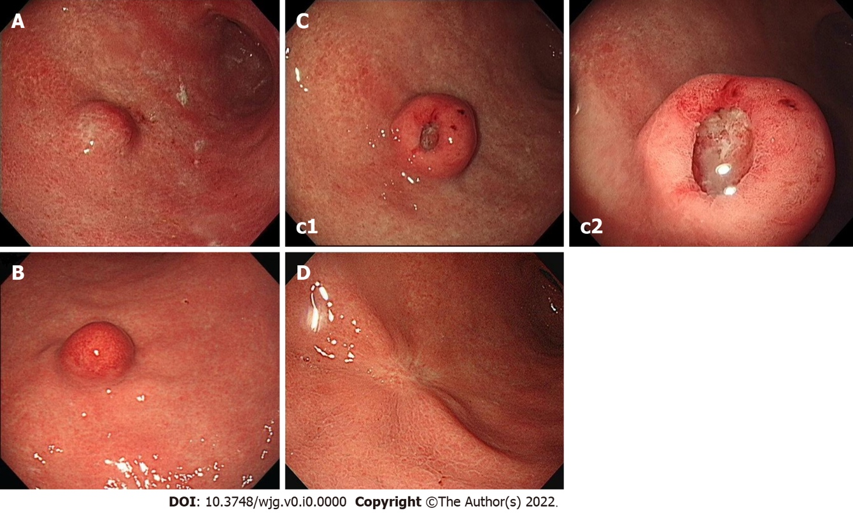

Figure 1 Endoscopy images. A: Initial endoscopic image showing a 15 mm-sized submucosal tumor-like elevated lesion with normally appearing mucosa at the great curvature side of the proximal part of gastric antrum; B: Endoscopic image obtained 3 years later showing the tumor had not changed in size but that marked erythema had developed on overlying mucosa; C: Endoscopic image (c2 shows a higher magnification image of the mass) obtained 4 years after initial examination [immediately before endoscopic submucosal dissection (ESD)] showing the tumor had increased in size to 18 mm and developed a 5-mm-sized central ulcer and overlying reddish mucosa of fine granularity; D: Endoscopic image obtained approximately 2.5 years after ESD showing post-ESD scarring.

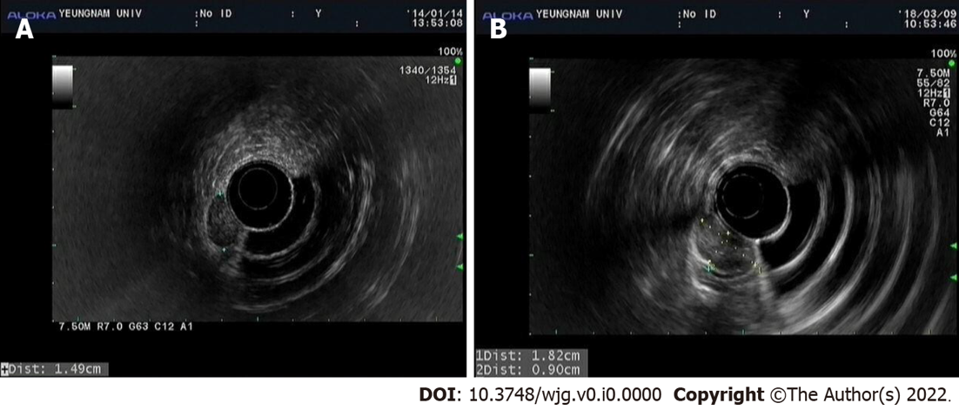

Figure 2 Endoscopic ultrasound images. A: Initial endoscopic ultrasound (EUS) image showing a well-circumscribed homogeneous and hypoechogenic mass measuring about 15 mm × 7 mm originating from the second sonographic layer with associated subtle obliteration of the third sonographic layer; B: EUS image obtained 4 years after the initial examination showing a well-circumscribed, hypoechogenic mass of greater size (18 mm × 9 mm) with slightly more heterogeneous echogenicity, and that the mass originated from the second sonographic layer with associated subtle obliteration of the third sonographic layer.

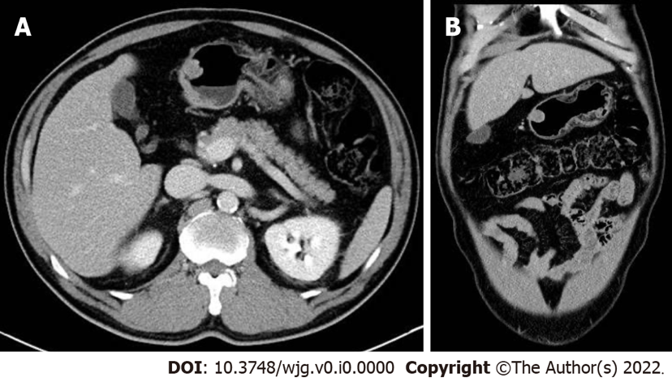

Figure 3 Abdominal computed tomography images. Initial axial (A) and coronal (B) computed tomography images showing a 15 mm protruding intraluminal mass at gastric antrum.

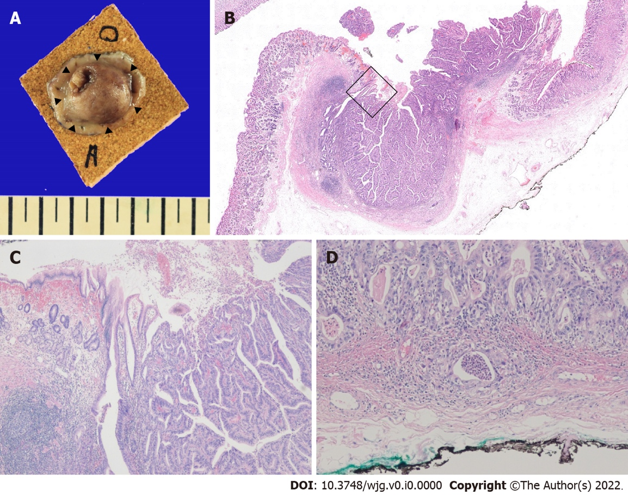

Figure 4 Pathology of the endoscopically resected lesion. A: Gross appearance of the resected lesion, which had negative lateral margins. The black triangles indicate the border of the cancerous region; B: Hematoxylin & eosin stained section showing gastric wall mucosal layer elevation by the adenocarcinoma, central erosion, and exposed tumor cells (original magnification × 10); C: Microscopic finding of the boxed area in Figure B showing the periphery of the tumor mass, which demonstrated moderately differentiated adenocarcinoma (original magnification × 40); D: Microscopic finding of the vertical resection margin showing penetration of the muscularis mucosa and minute invasion of submucosa (depth of invasion 169 μm) by tumor cells (original magnification × 100).

