Name of Journal: World Journal of Gastroenterology
Manuscript NO: 42408
Manuscript Type: MINIREVIEWS

Diversity of Saccharomyces boulardii CNCM I-745 mechanisms of action against intestinal infections

Czerucka D et al. Saccharomyces boulardii CNCM I-745 and infection

Dorota Czerucka, Patrick Rampal

Patrick Rampal, Dorota Czerucka, Department of Human Health, Division of Ecosystems and Immunity, Center Scientific of Monaco, Monaco MC98000, Monaco

ORCID number: Dorota Czerucka (0000-002-7631-3316); Patrick Rampal (0000-0003-3565-7937).

Author contributions: Czerucka D wrote the paper; Rampal P provided the input in writing the paper and revised the manuscript.

Conflict-of-interest statement: Dorota Czerucka has served as speaker, a consultant for Biocodex, and has received research funding from Biocodex SA. Patrick Rampal has served as speaker, a consultant for Biocodex.

Open-Access: This article is an open-access article which was selected by an inhouse editor and fully peer-reviewed by external reviewers. It is distributed in accordance with the Creative Commons Attribution non Commercial (CC BY-NC4.0) license, which permits others to distribute, remix, adapt, build upon this work non-commercially, and license their derivative works on different terms, provided the original work is propely cited and the use is non-commercial. See: htpp//cretivecommons.org/licenses/by-nc/4.0/

Manuscript source: Unsolicited manuscript

Corresponding authors: Dorota Czerucka, PhD, Senior Researcher, Senior Scientist, Department of Human Health, Division of Ecosystems and Immunity, Center Scientific of Monaco, 8 Quai Antoine 1er, Monaco MC98000, Monaco. dczerucka@centrescientifique.mc
Telephone: +212-377-97774435
FAX: +212-377-98988674

Received: September 29, 2018
Peer-review started: September 29, 2018
First decision: November 7, 2018
Revised: March 21, 2019
Accepted: March 29, 2019
Article in press: March 30, 2019
Published online: May 14, 2019

Abstract
The yeast Saccharomyces boulardii CNCM I-745 is one of the probiotics recommended for the prevention of antibiotic-associated diarrhea. Studies conducted in vivo and in vitro demonstrated that in the case of infectious diseases there are two potential sites of action of Saccharomyces boulardii CNCM I-745: (1) An action on enteropathogenic microorganisms (adhesion of bacteria and their elimination or an effect on their virulence factors: Toxins, lipopolysaccharide, etc.); and (2) a direct action on the intestinal mucosa (trophic effects, effects on epithelial reconstitution, anti-secretory effects, anti-inflammatory, immunomodulators). Oral administration of Saccharomyces boulardii CNCM I-745 to healthy subjects does not alter their microbiota. However, in the case of diseases associated with the use of antibiotics or chronic diarrhea, Saccharomyces boulardii CNCMI-745 can restore the intestinal microbiota faster. The interaction of Saccharomyces boulardii CNCMI-745 with the innate immune system have been recently demonstrated thus opening up a new therapeutic potential of this yeast in the case of diseases associated with intestinal infections but also other pathologies associated with dysbiosis such as inflammatory diseases.

Key words: Saccharomyces boulardii CNCM I-745; Probiotics; Yeast; Intestinal infection; Mechanism

© The Author(s) 2019. Published by Baishideng Publishing Group Inc. All rights reserved.

Core tip: The efficacy of lyophilized probiotic yeast Saccharomyces boulardii CNCM I-745 was clinically demonstrated with controlled studies of intestinal infections associated with antibiotics and acute diarrhea in children. This review summerizes scientific data describing the mechanism of Saccharomyces boulardii protection against infection and emphazises the diversity of potential mechanism of action that this probiotic yeast can have against pathogenic microorganisms. More recently, effects on the recovery of the intestinal microbiota as well as on the immune system have been demonstrated, thus opening up a new therapeutic potential of this yeast.

Czerucka D, Rampal P. Diversity of Saccharomyces boulardii CNCM I-745 mechanisms of action against intestinal infections. World J Gastroenterol 2019; 25(18): 2188-2203
URL: https://www.wjgnet.com/1007-9327/full/v25/i18/2188.htm
DOI: https://dx.doi.org/10.3748/wjg.v25.i18.2188

INTRODUCTION
Probiotics are living microorganisms that when administered in adequate amounts have a beneficial effect on the host. Most are bacteria, the best known of which are strains of Lactobacillus spp., and Bifidobacterium spp. However, there is a non-bacterial microorganism classified as a probiotic agent: this is the yeast Saccharomyces boulardii (S. boulardii) CNCM I-745 (Figure 1). S. boulardii was discovered by the French microbiologist Henri Boulard in 1920 during a visit to Indochina. The microbiologist noted that people who drank a decoction prepared from the outer skin of the lychee and mangosteen fruits did not develop diarrhea. He isolated the causative agent and named it S. boulardii. The initial strain was deposited at the National Collection of Microorganism Culture (CNCM) at the Institut Pasteur under the reference CNCM I-745. As a yeast, S. boulardii CNCM I-745 differs from bacterial probiotics in size, cell wall composition, antibiotic resistance and metabolic properties^{[1,2]}. S. boulardii CNCM I-745 is the first identified yeast that has been studied for use as a probiotic in human medicine. This strain responds to a manufacturing process and a mode of conditioning that preserves the characteristics of the initial strain and its viability. The probiotic actions demonstrated by this strain of yeast are not extrapolatable to other strains. The aim of this review is to synthesize the experimental studies that have been carried out with the yeast S. boulardii strain CNCM I-745 in order to understand its mechanism of action against pathogenic microorganisms.

CLINICAL DATA IN THE CASE OF INFECTIOUS DIARRHEA
S. boulardii strain CNCM I-745 is prescribed in adults and children for the prevention and treatment of diarrhea, including antibiotic and post-antibiotic diarrhea associated with Clostridium difficile (C. difficile). Three prospective, randomized, double-blind, placebo-controlled clinical trials demonstrated the efficacy of S. boulardii CNCM I-745 in preventing diarrhea associated with antibiotic therapy in adults^{[3-5]}. In children, two studies showed that S. boulardii CNCM I-745 has a preventive effect in diarrhea associated with antibiotics^{[6,7]}; the second study also demonstrated a curative effect. A recently published meta-analysis^{[8]} analyzed data from 21 randomized studies comprising a total of 4780 adult or child patients that received antibiotics. The results of this study support those of the first meta-analysis conducted in 2005^{[9]} and show an efficacy of S. boulardii CNCM I-745 in the pediatric and adult population regardless of the type of antibiotic prescribed. When considering studies that reveal a significant benefit of the administration of S. boulardii strain CNCM I-745, an early treatment with the yeast during antibiotic therapy appears to be an essential factor with the administration of S. boulardii strain CNCM I-745 for the entire duration of antibiotic treatment. Several clinical studies show the effectiveness of S. boulardii CNCM I-745 in relapsing colitis and C. difficile diarrhea^{[10-12]}. There are several studies evaluating S. boulardii CNCM I-745 in patients with gastroenteritis that may be due to a viral, bacterial, or parasitic infection. A 2012 meta-analysis of 11 randomized controlled trials found that S. boulardii decreased the duration of diarrhea and hospitalization due to gastroenteritis in all countries examined^{[13-18]}.
Tourists traveling to countries with warm climates, particularly in tropical or subtropical regions, are at high risk of diarrhea. In 80% to 85% of cases, diarrhea is due to pathogenic bacteria [Escherichia coli (E. coli), enteropathogenic, Campylobacter jejuni, Shigella, Salmonella, Yersinia enterocolitica]. Viruses [Norwalk or Rotavirus (RV)] and parasites [Entamoeba histolytica (E. histolytica), Giardia lamblia, Cyclospora, Cryptosporidium] are less frequently the causative pathogen. In many cases, the cause can not be determined. Two randomized controlled studies were conducted with S. boulardii CNCM I-745 with a total of four treatment arms with different doses. Kollaritsch et al^{[19]} analyzed the results from 1231 Austrian travelers that were randomized into 2 arms, receiving S. boulardii CNCM I-745 at two different doses (250 and 500 mg daily) or a placebo for 3 wk. This treatment was started 5 d prior to the trip and continued throughout the trip. In the placebo group, the rate of diarrhea was 43% while it was 34% for the traveler receiving 250 mg of S. boulardii CNCM I-745 and 32% for those receiving the highest dose. No side effects have been reported^{[19]}. In a second study by Kollaritsch et al^{[20]} conducted with 3000 Austrian tourists, travelers received either a dose of S. boulardii CNCM I-745 (250 mg or 1 g per day) or a placebo. The treatment was initiated 5 days prior to departure and continued throughout the trip (for a mean duration of 3 wk). Patients that received a placebo had a higher frequency of diarrhea (39% vs 34% for the low dose and 29% for the high dose, P < 0.05).

PRECLINICAL-STUDIES: EFFECTS ON ENTEROPATHOGENIC MICROORGANISMS
Several studies using animal or cellular models have shown that S. boulardii CNCM I-745 has a beneficial effect against infections by various pathogenic bacteria such as C. difficile, Vibrio cholerae, Salmonella, Shigella, E. coli, viruses (RV) and finally, pathogenic yeasts, for example C. albicans. S. boulardii CNCM I-745 acts either directly on bacterial toxins or on the pathogen, and can also act directly on the intestinal mucosa of the host and modulate the response to infection (Figure 2). The protective action of S. boulardii CNCM I-745 with respect to an infection often results from the complementary effect of several mechanisms.

Anti-toxin activity
Vibrio cholerae: The first studies on the mechanism of action of S. boulardii CNCM I-745 with respect to pathogenic bacteria focused on the Vibrio cholerae. In 1986, Vidon et al^{[21]} demonstrated, in vivo, that the administration of S. boulardii CNCM I-745 to ligated jejunal loop in rats that had been innoculated with cholera toxin (CT) significantly reduced the fluid and sodium secretion induced by CT. This effect has been confirmed in models of intestinal epithelial cells^{[22,23]}. The action of S. boulardii CNCM I-745 (Figure 3A) is associated with a decrease in CT-induced cAMP. It requires live yeasts and it is associated to a protein factor present in the culture supernatant of S. boulardii CNCM I-745. This protein factor, at 120 kDa, acts directly on enterocytes by inhibiting the cAMP-induced secretion of chloride (Cl⁻) triggered by CT, and also by other cAMP-agonists like Vaso-intestinal peptide or the LabileT toxin (LT) of E. coli^{[22,23]}. Another study shows that S. boulardii CNCM I-745 can attach CT to its cell wall, which is another mechanism of action against this toxin^{[24]}.

Clostridium difficile: The mechanism of action of S. boulardii CNCM I-745 with respect to C. difficile infections has been the most studied. The administration of S. boulardii CNCM I-745 significantly reduces the mortality induced by C. difficile colitis in clindamycin-treated hamsters^{[25]} and mice inoculated either by C. difficile^{[26]} or by toxins A and B produced by the bacteria^{[27]}. A recent study demonstrated the protective effect of S. boulardii CNCM I-745 against different ribotypes of C. difficile that are associated with outbreaks^{[28]}. Among the various mechanisms of action proposed (action on the bacterium or its toxins see Figure 3B), the direct action of S. boulardii CNCM I-745 on toxins A and B of C. difficile and their receptors is the most supported. In fact, the injection of toxin A into the ileal loop does not induce inflammatory diarrhea if the animal has been previously treated with S. boulardii CNCM I-745 or its supernatant^{[29]}. In vitro studies have shown that the culture supernatant of S. boulardii CNCM I-745 inhibits the adhesion of toxin A to its receptor^{[30]}. A 54kDa protease identified in this supernatant can degrade C. difficile toxins A and B and their receptors^{[29,30]}. The inflammation associated with C. difficile colitis is due to the activation of pro-inflammatory pathways by toxins A and B: nuclear translocation of NF-κB factor and activation by phosphorylation of MAP kinases that induce cytokine synthesis. The culture supernatant of S. boulardii CNCM I-745 inhibits interleukin 8 (IL-8) synthesis as well as nuclear translocation of NF-κB and inhibits toxin A-induced phosphorylation of ERK1/ 2 and JNK in epithelial cells^{[31]}. In addition to acting on toxins and their receptors, the mechanism of action of S. boulardii CNCM I-745 with respect to C. difficile infections appears to involve modulation of the immune system. In fact, S. boulardii CNCM I-745 increases the level of circulating anti-toxin A IgA in mice that have been stimulated with inactivated toxin A^{[32]}.

Bacillus anthracis: Bacillus anthracis, the etiological agent of anthrax, infects the host by three routes of entry: Cutaneous (most common), digestive and inhalation. The virulence factors are the capsule responsible for sepsis and two toxins responsible for toxemia. The toxins are composed of three peptides: The protective antigen (PA) and two enzymatic factors. The PA binds to cell-surface receptors and, after endocytosis, injects into the cytosol the two enzymatic factors: The lethal factor (LF) and the edematogenic factor. The lethal toxin (LT) formed by the combination of PA with LF is a 90 kDa protein with metalloprotease activity that specifically cleaves MEK-2 protein kinase. This toxin affects actin filaments in endothelial and epithelial cells and triggers morphological changes that result in the opening of tight junctions. Incubating cells with S. boulardii CNCM I-745 prior to exposure to LT toxin maintains the structure of the actin fibers and junctions^{[33]}. Furthermore, the cleavage of MEK-2 is delayed in the presence of S. boulardii CNCM I-745. The yeast acts directly on the LT subunits by cleaving the PA antigen and attaching the antigen and LF to its surface. These results suggest the use of S. boulardii CNCM I-745 as a preventive agent for B. anthracis infection.

Action on pathogenic bacteria
Enteropathogenic E. coli and enterohaemorrhagic E. coli: Among pathogenic E. coli, enteropathogenic coli (EPEC) cause infectious diarrhea in developing countries, while enterohaemorrhagic coli (EHEC), that produce the shiga-like toxin, are involved in foodborne infections in industrialized countries. The adhesion of these bacteria to the intestinal mucosa is a crucial step in their pathogenicity. After contact with the mucosa, these bacteria inject effector proteins into the host through the type III secretion system. These effector proteins induce changes in the structure of tight junctions, stimulate the activation of MAP kinases and the factor NF-κB and, consequently, activate the synthesis of IL-8. Studies on monolayers of polarized human epithelial cells (Figure 4) showed that incubation with S. boulardii CNCM I-745 prevents the increase in intestinal permeability induced by EPEC and EHEC infection^{[34,35]}. In addition, the structure of the tight junctions is maintained in these infected cells after exposure to the yeast. In EHEC-infected cells, S. boulardii CNCM I-745 inhibits phosphorylation of the myosin light chain that is directly involved in maintaining the integrity of tight junctions. S. boulardii CNCM I-745 also has an anti-inflammatory effect that inhibits the activation of mitogen-activated protein kinases, the nuclear translocation of NF-κB, and, consequently, the synthesis of IL-8^{[34,35]}. In a mouse model infected with Citrobacter rodentium (the equivalent of EPEC in rodents) S. boulardii CNCM I-745 decreases the flux of mannitol and improves the histological score of infected animals^{[36]}. In vivo the yeast acts directly on the expression of the virulence factors of the bacterium: Tir (Translocated receptor intimin), a factor directly involved in the adhesion of bacteria to the surface of enterocytes, and EspB, an effector protein injected into the host cell by the type III secretion system. Another study shows that S. boulardii CNCM I-745 can act on bacterial factors, in this case lipopolysaccharide (LPS) of E. coli. Buts et al^{[37]} reported that S. boulardii CNCM I-745-synthesized phosphatase could de-phosphorylate E. coli O55B5 LPS. Injection to rats of LPS exposed to phosphatase purified from S. boulardii CNCM I-745 resulted in a reduction in circulating TNF-compared to the level induced by untreated LPS.

Salmonella enterica Typhimurium and Shigella flexneri: Ingestion of food contaminated with Salmonella enterica Serovar Typhimurium (hereafter referred to as Salmonella typhimurium) results in diarrhea. Salmonella typhimurium are invasive bacteria that use several entry routes into the mucosa: Microfold cells, enterocytes and a specific population of dendritic cells (DC). These bacteria are also able to induce a pro-inflammatory response by activating the MAP kinase and NF-κB pathways. Inoculation of S. boulardii CNCM I-745 to gnotoxenic or conventional mice infected with Salmonella typhimurium or Shigella flexneri protects against mortality (Shigella flexeneri) or reduces the severity of intestinal lesions (Salmonella typhimurium)^{[38]}. This protective effect is not related to a reduction in the level of intestinal population of these bacteria. In the case of Salmonella infection, the protective effect of S. boulardii CNCM I-745 has been confirmed in a conventional mouse model and a mouse model with intestinal flora impaired by antibiotic treatment^{[39,40]}. In treated animals, mortality and translocation of S. typhimurium to the liver and spleen were reduced. In vitro, S. boulardii CNCM I-745 decreases enterocyte invasion by S. typhimurium, which is correlated with decreased activation of the Rac pathway, a pathway directly used duirng invasion by these bacteria (Figure 5)^{[39]}. S. typhimurium, like E. coli, are peritrichous bacteria with flagella that give them the ability to swim. Mutants devoid of flagellum are immobile and not invasive. A recent study showed that S. boulardii CNCM I-745 modifies the motility of bacteria by a steric effect and also by chemotaxis, decreasing the invasiveness of S. typhimurium^{[41]}. In polarized T84 cells, S. boulardii CNCM I-745 maintains the structure of tight junctions in infected monolayers. In addition, in this model, the yeast prevents the activation of NF-κB and MAP kinase pathways and the synthesis of IL-8, which are associated with cell infection. The maintenance of tight junctions and the anti-inflammatory effect of S. boulardii CNCM I-745 were also confirmed in the case of Shigella infection^{[42]}. The adhesion of E. coli and Salmonella to S. boulardii CNCM I-745 cell walls was reported in an earlier study^{[43]} and has recently been confirmed in vitro and in vivo for S. typhimurium by scanning and confocal microscopy^{[39,40]}. Salmonella adherent to the yeast wall was visualized by confocal microscopy on sections of caecum (Figure 6). The adhesion constitutes one of the mechanisms of action of S. boulardii CNCM I-745. By imaging bioluminescent S. typhimurium, it was shown that in vivo S. boulardii CNCM I-745 modifies bacterial propagation in the gut of living mice during the first hours of infection. The yeast accelerates the spread of Salmonella along the digestive tract with the bacteria being detected in the feces as early as 6 h after the onset of infection. In addition, the administration of S. boulardii CNCM I-745 modifies the site-dependent (ileum vs caecum) pro and anti-inflammatory responses at the early stages of infection^{[40]}.

Helicobacter pylori: Helicobacter pylori (H. pylori) is major causative agent of gastritis, peptidic ulcer disease and is strongly associated with gastric cancer and lymphoma of the gastric mucosa-associated lymphoid tissue. Currently recommended treatments for the eradication of H. pylori is standart triple therapy combining two antibiotics with a proton pump inhibitor. This therapy produces excellent cure rates but present side effects such as (diarrhoe, nausea/vomoting and even C. difficile infection) and emergence of antibiotic-resistant strains. Introduction of probiotics, especially S. boulardii as adjuvent treatment show promising results in reducing side effect^{[44,45]}. Investigation on S. boulardii’s mechanism of action demonstrated that this yeast prevents binding of H. pylori on duodenal cells, whereas bacterial probiotical strains do not. It may be linked with S. boulardii neuramidase activity that modifies H. pylori binding site on the duodenal cells^{[46]}. In a murine model of Helicobacter infection using a close species of H. pylori (H. suis), S. boulardii decreased the Helicobacter bacterial load, inhibited the formation of lymphoid follicles and reduced expression levels of inflammatory cytokines and chemokines in the stomach. It also increased the production of anti-helicobacter specific IgA and sIgA and beta-defensin in the small intestine after the infection^{[47]}.

Action on other pathogenic microorganims
Candida albicans: Candida albicans (C. albicans) is the most commonly isolated opportunistic pathogenic fungus in humans, responsible for localized and systemic infections. The prevention of C. albicans infections is one of the first effects attributed to S. boulardii CNCM I-745^{[48]}. In the gnotoxenic mouse, continued administration of S. boulardii CNCM I-745 precludes the implantation of a strain of C. albicans in the gastrointestinal tract^{[49]}. Two studies in immunocompromised mice and rats indicate that S. boulardii CNCM I-745 also reduces the translocation of C. albicans to mesenteric lymph nodes (MLN)^{[50,51]}. In a mouse model of dextran sulfate sodium- induced colitis, S. boulardii CNCM I-745 reduced both inflammation and intestinal colonization by C. albicans^{[52]}. The antagonistic effects of S. boulardii CNCM I-745 on C. albicans have recently been demonstrated in vitro^{[53]}. S. boulardii CNCM I-745 has an inhibitory effect on the filamentous growth of C. albicans, as well as its adhesion and the formation of biofilm on different surfaces. The same authors identified the active compound as capric acid, an AGCC synthesized by S. boulardii CNCM I-745, which reduces the virulence of C. albicans^{[54]}. In vitro, S. boulardii CNCM I-745 decreases the adhesion of C. albicans to Caco-2 and Intestin 407 cells, and inhibits IL-8 expression^{[55]}. S. boulardii CNCM I-745 also shows an anti-inflammatory effect in intraepithelial lymphocytes, of a mouse model, that were exposed to C. albicans^{[56]}. In the presense of the yeast, the authors observed an increase in the anti-inflammatory cytokines IL-4 and IL-10, and a decrease in the pro-inflammatory cytokine IL-1.

Rotavirus: Rotavirus (RV) infection is the most frequent and severe form of acute gastroenteritis in infants and children worldwide, and frequently requires hospitalization. RV infects mature enterocytes of the small intestinal villi, inducing broad functional and structural damage. In humans, RV causes watery diarrhea that results from a combination of osmotic and secretory effects. The non-structural protein 4 (NSP4) produced by RV plays a key role in secretory diarrhea by inducing a redox imbalance, resulting in the secretion of chloride by intestinal epithelial cells. In Caco-2 cells infected with the viral strain SA11, the secretion of chloride is induced in association with an increase in reactive oxygen species^{[57]}. The supernatant of S. boulardii CNCM I-745 reduces oxidative stress in these cells and strongly inhibits RV-induced chloride secretion. These results were confirmed on human intestinal biopsies exposed to NSP4. S. boulardii CNCM I-745, via a soluble metabolite, prevents oxidative stress and inhibits NSP4-induced chloride secretion^{[57]}.

Entamoeba histolytica: Amoebiasis ranks third among the most deadly parasitic diseases in the world. About 10% of the world's population is infected with amoeba parasites of the genus Entamoeba, the most pathogenic of which is E. histolytica. It is a protozoan that can surround itself with a thin shell to form a cyst a few microns in diameter. When these cysts are ingested, they germinate in the small intestine to give rise to the vegetative form, the trophozoites, which enter the large intestine, proliferate and re-encysted. It is in this form that E. histolytica is expeled in feces and is likely to contaminate other people. If the infection remains generally asymptomatic, the parasite can, however, cause painful and bloody diarrhea (amoebic dysentery), ulcers, and, in the more severe forms, lead to abscesses in the liver, lungs and brain. In young rats, infection with this species can produce lesions similar to those observed in humans. A model of caecal amoebiasis in rat was used to study the effect of S. boulardii CNCM I-745 on the development of lesions^{[58]}. In this model, young rats infected with E. histolytica were treated with S. boulardii CNCM I-745. In the yeast treated group the number of sick pups was significantly lower and the macroscopic appearance of the lesions on the cecum, as well as the presence of amoebae, was decreased. The lesions were similar to those of the control animals, but their healing process was accelerated. In addition, S. boulardii CNCM I-745 showed no amoebicidal activity. The antagonistic effect of the yeast has been explained in vitro by competition between the yeast and amoebae at binding sites on erythrocytes^{[59]}.

EFFECT ON MUCOSA THAT CAN BE IMPLICATED IN THE ANTI-PATHOGENIC EFFECT ANTI-SECRETORY EFFECTS
Intestinal fluid secretion is driven by active Cl⁻ secretion creating the electro-chemical gradient for paracellular Na+ secretion and the osmotic driving force for transcellular water secretion. Cl⁻ is transported into the cell at the basolateral membrane by a Na⁺/K⁺/Cl⁻ cotransporter which is driven by Na⁺ and Cl⁻ concentration gradients produced by Na⁺K⁺-ATPase and basolateral K⁺ channels. The electrochemical gradient drives Cl⁻ secretion across the luminal membrane by two Cl⁻ channels: (1) The cAMP-activated channel CFTR; and (2) the Ca²⁺⁻activated channel. These channels are an attractive target for potentially antidiarrheal therapeutics. The effect of S. boulardii CNCM I-745 on these channels has been the subject of several studies using pharmacological agents. The first study conducted in the jejunum of pigs or in tissue from animals treated with S. boulardii CNCM I-745, shows a decrease in Cl⁻ secretion induced by a phosphodiesterase inhibitor: Theophylline^{[60]}. Another study performed in vitro reports that S. boulardii CNCM I-745 inhibits the secretion induced by receptor (vasointestinal peptide or prostaglandin E2) or non-receptor (forskolin) c-AMP mediated Cl⁻ secretion, thus demonstrating that S. boulardii CNCM I-745 can directcly affect adenylate cyclase activity^{[22]}. In the same study S. boulardii CNCM I-745 showed decreased Ca²⁺-stimulated Cl⁻ secretion induced by carbachol. These inhibitory effects on Cl⁻ secretion have been reproduced with bacterial toxin: For exemple in the case of CT or LT-toxin produce by Enterotoxigenic E. coli, which induces secretory diarrhea primarely by activating cAMP-activated Cl⁻ secretion. The authors demonstrate that the culture supernatant of S. boulardii CNCM I-745 exerts an anti-secretory effect, suggesting the existence of a factor secreted by the yeast that could act on the cAMP dependent Cl⁻ secertion^{[23]}. The anti-secretory effect of S. boulardii CNCM I-745 on the secretion of Cl⁻ was also suggested in a rat model exposed to prostaglandin-2^{[61]}. However in this model, S. boulardii CNCM I-745 stimulates the absorption of Cl⁻ in the jejunum and colon. S. boulardii CNCM I-745 exerted an antisecretory effect in other models that did not involve Cl⁻ channels. In a rat study, prophylactic administration of S. boulardii CNCM I-745 showed a potent effect on castor oil-induced secretory diarrhea in a dose-dependent manner^{[62]}. This effect is significantly inhibited by L-arginine, suggesting the involvement of the nitric oxide pathway. Finally, S. boulardii CNCM I-745 also has an effect on short chain fatty acid (SCFA) synthesis: Butyrate, acetate and propionate, which play a role in the absorption of water and electrolytes. Treatment with clindamycin decreases the daily production of acetate, propionate and butyrate in pigs^{[63]}. Simultaneous administration of S. boulardii CNCM I-745 and the antibiotic maintains acetate and propionate at their initial levels. In another study performed on patients receiving exclusive enteral nutrition, treatment with S. boulardii CNCM I-745 reduced fecal SCFA concentrations to normal, particularly for butyrate^{[64]}. This property may account in part to the anti-diarrheal and anti-inflammatory effects of S. boulardii CNCM I-745.
One of the roles of the intestinal epithelium is to prevent microorganisms present in the intestinal lumen from accessing the tissues. Immune exclusion is the process by which microorganisms are prevented from crossing the intestinal barrier. This is done through tight junctions that provide a mechanical barrier and the combination of mucus-containing fluid and secreted IgA that allows the sequestration of microorganisms. Finally, the intestinal immune system also plays a crucial role in eliminating pathogenic bacteria that evade immune exclusion. In previous sections of this review we saw that S. boulardii CNCM I-745 was able to maintain the structure of tight junctions in monolayers of infected cells. The effect of S. boulardii CNCM I-745 on IgA is the subject of one of the first studies on the mechanism of action of this yeast. This study showed that S. boulardii CNCM I-745 induces an increase in the concentration of secretory IgA in the intestinal fluid and an increase in the secretory component of the polymeric immunoglobulin receptor in cryptic cells of the intestinal mucosa in young rats 14 d after weaning^{[65]}. This effect appears transient, as another study done on adult rats shows that after 21 d of administration of S. boulardii CNCM I-745 the yeast has no effect on IgA secretion, intestinal mucosal or circulating lymphocyte populations^{[66]}. The effect of S. boulardii CNCM I-745 on IgA was confirmed in C. difficile infections, and furthermore, administration of the yeast to mice exposed to inactivated toxin A increases the level of circulating anti-toxin A IgA^{[32]}. More recently, in vitro and in vivo studies showed a direct action of S. boulardii CNCM I-745 on cells of the innate immune system (Figure 7). DC plays a key role in the balance between immunity and tolerance, and participate in the activation of lymphocytes. A recent study found that S. boulardii CNCM I-745 modulates the properties of DC after treatment with amoxicillin^{[67]}. Membrane markers of antigen activity (MHC-II and CD86) are upregulated in DC of female rats treated with the antibiotic. In the presence of the yeast, these antigens are negatively regulated and the intestinal flora regains its equilibrium more quickly after stopping antibiotic treatment. This study suggests that S. boulardii CNCM I-745 exerts a modulatory effect on the specific immune response to microbial antigens. This has been confirmed on human DC isolated from the blood of healthy subjects exposed to LPS, which induces DC activation^{[68]}. The authors show that a < 3 kD fraction of the culture supernatant of S. boulardii CNCM I-745 decreases the expression of co-stimulatory CD40 and CD80 molecules and the chemokine receptor CCR7 (a receptor that causes chemotactic migration to secondary lymphoid organs) induced by LPS. This fraction also decreases the secretion of pro-inflammatory cytokines (TNF and IL-6) and stimulates the secretion of IL-10 in DC. In addition, S. boulardii CNCM I-745 decreases DC-induced T cell activation^{[68]}. In another study, the same group demonstrated that supernatant of S. boulardii CNCM I-745 may modify the profile of DC (CD40 and CD80 co-factors, CCR7 and cytokine profile) in the blood of patients with Crohn's Disease or ulcerative colitis^{[69]}. In addition, this supernatant inhibits the Th1 polarization of lymphocytes and induces the secretion of IL-8 and TGF, two cytokines involved in the reconstitution of the epithelium. Recently our group demonstrated that in a model of Salmonella-infected mice, S. boulardii CNCM I-745 decreases the DC population expressing CD103⁺ that migrate to the MLN and are responsible for the bacterial translocation to MLN. The yeast also acts on another population of macrophage which express the fractalkine receptor CX3CR1 (CX3CR1^{hi} MΦs) and are present in the Lamina Propria (LP). Thanks to extensions between epithelial junctions, this population of highly phagocytic cells recognize intra-luminal antigens, including pathogenic bacteria. They phagocyte them, and unlike CD103⁺DCs do not migrate into the MLN but are locally induced in the LP activated T lymphocytes. The population of these CX3CR1^{hi} MΦs increases in S. boulardii CNCM I-745-treated mice infected with Salmonella. The increase in this population comes from the expansion of circulating pro-inflammatory monocytes (mono Ly6C^{hi}, CX3CR1^{int}) that are recruited in the bone marrow. These results could be confirmed in vitro on cells isolated from the bone marrow of mice treated or not with S. boulardii CNCM I-745 and then infected. In the presence of the yeast, monocytes differentiate to CX3CR1^{hi} MΦs and their ability to phagocyte Salmonella increases significantly. These results demonstrate that S. boulardii CNCM I-745 can act on the immune response during the early phase of infection^{[70]}. The CX3CR1^{hi} MΦs has been involved in tolerance to the microbiota. In mice with induced dysbiosis and treated with antibiotics, the population of CX3CR1^{hi} MΦs decreases. Administration of S. boulardii CNCM I-745 during antibiotic therapy increases the population of CX3CR1^{hi} MΦs. The impact of this increase on the reconstitution of intestinal flora remains to be demonstrated.

EFFECTS ON THE INTESTINAL MICROBIOTA
Several studies conducted in humans and mice show that S. boulardii CNCM I-745 has no effect on the intestinal microbiota of healthy subjects, however, in some diseases there is an effect on intestinal dysbiosis (Table 1). In a model of amoxicillin-treated mice, antibiotic treatment increased the Enterobacteriaceae and Bacteroides populations and decreased Clostridium coccoides and Eubacterium rectale. Treatment with S. boulardii CNCM I-745 did not influence changes in the gut microbiota during antibiotic treatment but accelerated the return to normal that occurred after 10 days in these mice versus 22 d in untreated mice^{[67,71]}. Swidsinski et al^{[72]} developed an innovative technique based on in situ hybridization (FISH) of stool samples collected by coring, which enables quantitatively assessing microbiota in the mucus, in the germinal reserve area and in the central fermentation area. This technique was used to compare and localize bacterial populations in healthy subjects and patients with idiopathic chronic diarrhea treated or not with S. boulardii CNCM I-745. Stools from healthy subjects are characterized by, a mucus layer of 5-60 m with homogeneous fluorescence, high concentrations of three usual bacterial groups (Bacteroides, Roseburia and Faecalibacterium prausnitzii) and low concentrations of occasional bacterial groups. In patients with diarrhea, the authors observed a thickening of the protective mucous layer, mucous layer incorporation in the stool, a reduced concentration of usual bacteria, an inhibition of the metabolism with appearance of areas devoid of hybridization signal and a stratification with increased levels of the occasional bacteria. Treatment with S. boulardii CNCM I-745 has no effect on the microbiota of healthy subjects, but the microbiological and clinical symptoms of diarrhea are reversible after treatment with the yeast. S. boulardii CNCM I-745 reduces the thickness of the mucus layer and increases the concentration of two usual bacterial groups: Bacteroides and Roseburia. Yeast treatment also decreases the abundance of the occasional bacterium Akkermansia muciniphila.
In a recent study using the same technique (corning and FISH), Swidsinski et al^{[73]} investigated the effect of S. boulardii CNCM I-745 on the reconstitution of intestinal flora after antibiotic treatment in patients with vaginal infection. In this study a group of patients was treated with metronidazole and ciprofloxacin, a second group received yeast during antibiotic treatment and a third group was treated with yeast after antibiotic therapy. Antibiotic treatment significantly decreased the number of bacteria in the dominant group (Clostridium cocoides, Eubacterium rectum, Faecalibacterium prausnitzii, etc.) mainly located in the fermentation zone. Treatment with S. boulardii CNCM I-745 during antibiotic therapy increased these populations and post-antibiotic treatment allowed these populations to return to normal. Identification of bacteria in the stool by bacterial 16S RNA sequencing confirmed that S. boulardii CNCM I-745 did not alter the microbiota composition of healthy subjects^{[73]}. In patients treated with amoxicillin, there was a decrease in Ralstonia and an increase in Parabacteroides and Escherichia/Shigella in the fecal microbiota. In the group treated with S. boulardii CNCM I-745 and antibiotic, changes in the composition of the microbiota are significantly attenuated. A summary of the effect of S. boulardii CNCM I-745 on antibiotic-associated dysbiosis is presented in Figure 8. These results suggest that an optimal use of S. boulardii CNCM I-745 would be to administer it during and after antibiotic therapy. More and Swidsinski^{[75]} recently published a review that summarizes all preclinical and clinical data on the effect of S. boulardii CNCM I-745 on intestinal microbiota associated and not associated with mucus.

CONCLUSION
S. boulardii strain CNCM I-745 is a probiotic yeast that by virtue of being a eukaryote differs from other probiotic strains, which are of bacterial origin (prokaryote). The research shows a great diversity in its mode of action and types of targets: pathogens, pathogenic toxins, gut microbiota and intestinal epithelium. Two main mechanisms were demonstrated: the first one is a large capacity of the wall to fix bacteria and toxins which facilitates their elimination during intestinal transit and the second one is the synthesis by this yeast of several active factors. These factors include high molecular weight proteins, some of which have antisecretory effects, others act as proteases that degrade toxins or their receptors. Factors of small size and protein or non-protein nature that exhibit anti-secretory or anti-inflammatory activities are also involved in its action. Finally, S. boulardii CNCM I-745 acts on different components that maintain the intestinal barrier: Tight junctions that regulate permeability; reconstitution of the microbiota after antibiotic therapy; and, activation of innate immunity which stimulates innate defenses of the host during infection. The optimization of the use of this probiotic in infections requires a better knowledge of the different mechanisms of action.

REFERENCES
1 Czerucka D, Piche T, Rampal P. Review article: Yeast as probiotics -- Saccharomyces boulardii. Aliment Pharmacol Ther 2007; 26: 767-778 [PMID: 17767461 DOI: 10.1111/j.1365-2036.2007.03442.x]
2 Neut C, Mathieux S, Dubreuil LJ. Antibiotic susceptibility of probiotics strains: Is it reasonable to combine probiotics with antibiotics? Méd Malad infect 2017; 47:477-483 [DOI: 10.1016/j.medmal.2017.07.001]
3 Surawicz CM, Elmer GW, Speelman P, McFarland LV, Chinn J, van Belle G. Prevention of antibiotic-associated diarrhea by Saccharomyces boulardii: A prospective study. Gastroenterology 1989; 96: 981-988 [PMID: 2494098 DOI: 10.1016/0016-5085(89)91613-2]
4 McFarland LV, Surawicz CM, Greenberg RN, Elmer GW, Moyer KA, Melcher SA, Bowen KE, Cox JL. Prevention of beta-lactam-associated diarrhea by Saccharomyces boulardii compared with placebo. Am J Gastroenterol 1995; 90: 439-448 [PMID: 7872284]
5 Adam J, Barret A, Barret-Bellet C. Essais cliniques contrôlés en double insu de l'Ultra-Levure lyophilisée. Etude multicentrique par 25 médecins de 388 cas. Méd Chirurg Dig 1976; 5: 401-405
6 Kotowska M, Albrecht P, Szajewska H. Saccharomyces boulardii in the prevention of antibiotic-associated diarrhoea in children: A randomized double-blind placebo-controlled trial. Aliment Pharmacol Ther 2005; 21: 583-590 [PMID: 15740542 DOI: 10.1111/j.1365-2036.2005.02356.x]
7 Shan LS, Hou P, Wang ZJ, Liu FR, Chen N, Shu LH, Zhang H, Han XH, Han XX, Cai XX, Shang YX, Vandenplas Y. Prevention and treatment of diarrhoea with Saccharomyces boulardii in children with acute lower respiratory tract infections. Benef Microbes 2013; 4: 329-334 [PMID: 24311316 DOI: 10.3920/BM2013.0008]
8 Szajewska H, Kołodziej M. Systematic review with meta-analysis: Saccharomyces boulardii in the prevention of antibiotic-associated diarrhoea. Aliment Pharmacol Ther 2015; 42: 793-801 [PMID: 26216624 DOI: 10.1111/apt.13344]
9 Szajewska H, Mrukowicz J. Meta-analysis: Non-pathogenic yeast Saccharomyces boulardii in the prevention of antibiotic-associated diarrhoea. Aliment Pharmacol Ther 2005; 22: 365-372 [PMID: 16128673 DOI: 10.1111/j.1365-2036.2005.02624.x]
10 Surawicz CM, McFarland LV, Elmer G, Chinn J. Treatment of recurrent Clostridium difficile colitis with vancomycin and Saccharomyces boulardii. Am J Gastroenterol 1989; 84: 1285-1287 [PMID: 2679049]
11 McFarland LV, Surawicz CM, Greenberg RN, Fekety R, Elmer GW, Moyer KA, Melcher SA, Bowen KE, Cox JL, Noorani Z. A randomized placebo-controlled trial of Saccharomyces boulardii in combination with standard antibiotics for Clostridium difficile disease. JAMA 1994; 271: 1913-1918 [PMID: 8201735 DOI: 10.1001/jama.1994.03510480037031]
12 Surawicz CM, McFarland LV, Greenberg RN, Rubin M, Fekety R, Mulligan ME, Garcia RJ, Brandmarker S, Bowen K, Borjal D, Elmer GW. The search for a better treatment for recurrent Clostridium difficile disease: Use of high-dose vancomycin combined with Saccharomyces boulardii. Clin Infect Dis 2000; 31: 1012-1017 [PMID: 11049785 DOI: 10.1086/318130]
13 Dinleyici EC, Kara A, Ozen M, Vandenplas Y. Saccharomyces boulardii CNCM I-745 in different clinical conditions. Expert Opin Biol Ther 2014; 14: 1593-1609 [PMID: 24995675 DOI: 10.1517/14712598.2014.937419]
14 Villarruel G, Rubio DM, Lopez F, Cintioni J, Gurevech R, Romero G, Vandenplas Y. Saccharomyces boulardii in acute childhood diarrhoea: A randomized, placebo-controlled study. Acta Paediatr 2007; 96: 538-541 [PMID: 17306006 DOI: 10.1111/j.1651-2227.2007.00191.x]
15 Dinleyici EC, Eren M, Ozen M, Yargic ZA, Vandenplas Y. Effectiveness and safety of Saccharomyces boulardii for acute infectious diarrhea. Expert Opin Biol Ther 2012; 12: 395-410 [PMID: 22335323 DOI: 10.1517/14712598.2012.664129]
16 Kurugöl Z, Koturoğlu G. Effects of Saccharomyces boulardii in children with acute diarrhoea. Acta Paediatr 2005; 94: 44-47 [PMID: 15858959 DOI: 10.1111/j.1651-2227.2005.tb01786.x]
17 Billoo AG, Memon MA, Khaskheli SA, Murtaza G, Iqbal K, Saeed Shekhani M, Siddiqi AQ. Role of a probiotic (Saccharomyces boulardii) in management and prevention of diarrhoea. World J Gastroenterol 2006; 12: 4557-4560 [PMID: 16874872 DOI: 10.3748/wjg.v12.i28.4557]
18 Htwe K, Yee KS, Tin M, Vandenplas Y. Effect of Saccharomyces boulardii in the treatment of acute watery diarrhea in Myanmar children: A randomized controlled study. Am J Trop Med Hyg 2008; 78: 214-216 [PMID: 18256417 DOI: 10.4269/ajtmh.2008.78.214]
19 Kollaritsch H, Kremser P, Wiedermann G, Schneider O. Prevention of traveler's diarrhea: Comparison of different non antibiotic preparation. Travel Med Int 1989; 9-17
20 Kollaritsch H, Holst H, Grobara P, Wiedermann G. [Prevention of traveler's diarrhea with Saccharomyces boulardii. Results of a placebo controlled double-blind study]. Fortschr Med 1993; 111: 152-156 [PMID: 8486328]
21 Vidon N, Huchet B, Rambaud JC. [Influence of Saccharomyces boulardii on jejunal secretion in rats induced by cholera toxin]. Gastroenterol Clin Biol 1986; 10: 13-16 [PMID: 3956910]
22 Czerucka D, Rampal P. Effect of Saccharomyces boulardii on cAMP- and Ca2+ -dependent Cl- secretion in T84 cells. Dig Dis Sci 1999; 44: 2359-2368 [PMID: 10573387 DOI: 10.1023/A:1026689628136]
23 Czerucka D, Roux I, Rampal P. Saccharomyces boulardii inhibits secretagogue-mediated adenosine 3',5'-cyclic monophosphate induction in intestinal cells. Gastroenterology 1994; 106: 65-72 [PMID: 8276210 DOI: 10.1016/S0016-5085(94)94403-2]
24 Brandão RL, Castro IM, Bambirra EA, Amaral SC, Fietto LG, Tropia MJ, Neves MJ, Dos Santos RG, Gomes NC, Nicoli JR. Intracellular signal triggered by cholera toxin in Saccharomyces boulardii and Saccharomyces cerevisiae. Appl Environ Microbiol 1998; 64: 564-568 [PMID: 9464394 DOI: 10.1016/j.cattod.2009.07.111]
25 Toothaker RD, Elmer GW. Prevention of clindamycin-induced mortality in hamsters by Saccharomyces boulardii. Antimicrob Agents Chemother 1984; 26: 552-556 [PMID: 6517545 DOI: 10.1128/AAC.26.4.552]
26 Corthier G, Dubos F, Ducluzeau R. Prevention of Clostridium difficile induced mortality in gnotobiotic mice by Saccharomyces boulardii. Can J Microbiol 1986; 32: 894-896 [PMID: 3815159 DOI: 10.1139/m86-164]
27 Corthier G, Lucas F, Jouvert S, Castex F. Effect of oral Saccharomyces boulardii treatment on the activity of Clostridium difficile toxins in mouse digestive tract. Toxicon 1992; 30: 1583-1589 [PMID: 1488767 DOI: 10.1016/0041-0101(92)90030-9]
28 Koon HW, Su B, Xu C, Mussatto CC, Tran DH, Lee EC, Ortiz C, Wang J, Lee JE, Ho S, Chen X, Kelly CP, Pothoulakis C. Probiotic Saccharomyces boulardii CNCM I-745 prevents outbreak-associated Clostridium difficile-associated cecal inflammation in hamsters. Am J Physiol Gastrointest Liver Physiol 2016; 311: G610-G623 [PMID: 27514478 DOI: 10.1152/ajpgi.00150.2016]
29 Pothoulakis C, Kelly CP, Joshi MA, Gao N, O'Keane CJ, Castagliuolo I, Lamont JT. Saccharomyces boulardii inhibits Clostridium difficile toxin A binding and enterotoxicity in rat ileum. Gastroenterology 1993; 104: 1108-1115 [PMID: 8462799 DOI: 10.1016/0016-5085(93)90280-P]
30 Castagliuolo I, LaMont JT, Nikulasson ST, Pothoulakis C. Saccharomyces boulardii protease inhibits Clostridium difficile toxin A effects in the rat ileum. Infect Immun 1996; 64: 5225-5232 [PMID: 8945570 DOI: 10.1016/S0928-8244(96)00073-9]
31 Chen X, Kokkotou EG, Mustafa N, Bhaskar KR, Sougioultzis S, O'Brien M, Pothoulakis C, Kelly CP. Saccharomyces boulardii inhibits ERK1/2 mitogen-activated protein kinase activation both in vitro and in vivo and protects against Clostridium difficile toxin A-induced enteritis. J Biol Chem 2006; 281: 24449-24454 [PMID: 16816386 DOI: 10.1074/jbc.M605200200]
32 Qamar A, Aboudola S, Warny M, Michetti P, Pothoulakis C, LaMont JT, Kelly CP. Saccharomyces boulardii stimulates intestinal immunoglobulin A immune response to Clostridium difficile toxin A in mice. Infect Immun 2001; 69: 2762-2765 [PMID: 11254650 DOI: 10.1128/IAI.69.4.2762-2765.2001]
33 Pontier-Bres R, Rampal P, Peyron JF, Munro P, Lemichez E, Czerucka D. The Saccharomyces boulardii CNCM I-745 strain shows protective effects against the B. anthracis LT toxin. Toxins (Basel) 2015; 7: 4455-4467 [PMID: 26529015 DOI: 10.3390/toxins7114455]
34 Czerucka D, Dahan S, Mograbi B, Rossi B, Rampal P. Saccharomyces boulardii preserves the barrier function and modulates the signal transduction pathway induced in enteropathogenic Escherichia coli-infected T84 cells. Infect Immun 2000; 68: 5998-6004 [PMID: 10992512 DOI: 10.1128/IAI.68.10.5998-6004.2000]
35 Dahan S, Dalmasso G, Imbert V, Peyron JF, Rampal P, Czerucka D. Saccharomyces boulardii interferes with enterohemorrhagic Escherichia coli-induced signaling pathways in T84 cells. Infect Immun 2003; 71: 766-773 [PMID: 12540556 DOI: 10.1128/IAI.71.2.766-773.2003]
36 Wu X, Vallance BA, Boyer L, Bergstrom KS, Walker J, Madsen K, O'Kusky JR, Buchan AM, Jacobson K. Saccharomyces boulardii ameliorates Citrobacter rodentium-induced colitis through actions on bacterial virulence factors. Am J Physiol Gastrointest Liver Physiol 2008; 294: G295-G306 [PMID: 18032474 DOI: 10.1152/ajpgi.00173.2007]
37 Buts JP, Dekeyser N, Stilmant C, Delem E, Smets F, Sokal E. Saccharomyces boulardii produces in rat small intestine a novel protein phosphatase that inhibits Escherichia coli endotoxin by dephosphorylation. Pediatr Res 2006; 60: 24-29 [PMID: 16690953 DOI: 10.1203/01.pdr.0000220322.31940.29]
38 Rodrigues AC, Nardi RM, Bambirra EA, Vieira EC, Nicoli JR. Effect of Saccharomyces boulardii against experimental oral infection with Salmonella typhimurium and Shigella flexneri in conventional and gnotobiotic mice. J Appl Bacteriol 1996; 81: 251-256 [PMID: 8810053 DOI: 10.1111/j.1365-2672.1996.tb04325.x]
39 Martins FS, Dalmasso G, Arantes RM, Doye A, Lemichez E, Lagadec P, Imbert V, Peyron JF, Rampal P, Nicoli JR, Czerucka D. Interaction of Saccharomyces boulardii with Salmonella enterica serovar Typhimurium protects mice and modifies T84 cell response to the infection. PLoS One 2010; 5: e8925 [PMID: 20111723 DOI: 10.1371/journal.pone.0008925]
40 Pontier-Bres R, Munro P, Boyer L, Anty R, Imbert V, Terciolo C, André F, Rampal P, Lemichez E, Peyron JF, Czerucka D. Saccharomyces boulardii modifies Salmonella typhimurium traffic and host immune responses along the intestinal tract. PLoS One 2014; 9: e103069 [PMID: 25118595 DOI: 10.1371/journal.pone.0103069]
41 Pontier-Bres R, Prodon F, Munro P, Rampal P, Lemichez E, Peyron JF, Czerucka D. Modification of Salmonella Typhimurium motility by the probiotic yeast strain Saccharomyces boulardii. PLoS One 2012; 7: e33796 [PMID: 22442723 DOI: 10.1371/journal.pone.0033796]
42 Mumy KL, Chen X, Kelly CP, McCormick BA. Saccharomyces boulardii interferes with Shigella pathogenesis by postinvasion signaling events. Am J Physiol Gastrointest Liver Physiol 2008; 294: G599-G609 [PMID: 18032477 DOI: 10.1152/ajpgi.00391.2007]
43 Gedek BR. Adherence of Escherichia coli serogroup O 157 and the Salmonella typhimurium mutant DT 104 to the surface of Saccharomyces boulardii. Mycoses 1999; 42: 261-264 [PMID: 10424093 DOI: 10.1046/j.1439-0507.1999.00449.x]
44 Duman DG, Bor S, Ozütemiz O, Sahin T, Oğuz D, Iştan F, Vural T, Sandkci M, Işksal F, Simşek I, Soytürk M, Arslan S, Sivri B, Soykan I, Temizkan A, Beşşk F, Kaymakoğlu S, Kalayc C. Efficacy and safety of Saccharomyces boulardii in prevention of antibiotic-associated diarrhoea due to Helicobacterpylori eradication. Eur J Gastroenterol Hepatol 2005; 17: 1357-1361 [PMID: 16292090 DOI: 10.1097/00042737-200512000-00015]
45 Cindoruk M, Erkan G, Karakan T, Dursun A, Unal S. Efficacy and safety of Saccharomyces boulardii in the 14-day triple anti-Helicobacter pylori therapy: A prospective randomized placebo-controlled double-blind study. Helicobacter 2007; 12: 309-316 [PMID: 17669103 DOI: 10.1111/j.1523-5378.2007.00516.x]
46 Sakarya S, Gunay N. Saccharomyces boulardii expresses neuraminidase activity selective for α2,3-linked sialic acid that decreases Helicobacter pylori adhesion to host cells. APMIS 2014; 122: 941-950 [PMID: 24628732 DOI: 10.1111/apm.12237]
47 Yang L, Tian ZB, Yu YN, Zhang CP, Li XY, Mao T, Jing X, Zhao WJ, Ding XL, Yang RM, Zhang SQ. Saccharomyces boulardii administration can inhibit the formation of gastric lymphoid follicles induced by Helicobacter suis infection. Pathog Dis 2017; 75 [PMID: 28115360 DOI: 10.1093/femspd/ftx006]
48 Guilbaub JF. Traitement des candidoses digestives et cutanéo-muqueuses par l'Ultra-levure à haute dose. Vie méd 1975; 8: 628-630
49 Ducluzeau R, Bensaada M. [Comparative effect of a single or continuous administration of "Saccharomyces boulardii" on the establishment of various strains of "candida" in the digestive tract of gnotobiotic mice]. Ann Microbiol (Paris) 1982; 133: 491-501 [PMID: 6762128 DOI: 10.1016/0141-4607(82)90006-3]
50 Berg R, Bernasconi P, Fowler D, Gautreaux M. Inhibition of Candida albicans translocation from the gastrointestinal tract of mice by oral administration of Saccharomyces boulardii. J Infect Dis 1993; 168: 1314-1318 [PMID: 8228371 DOI: 10.1093/infdis/168.5.1314]
51 Algin C, Sahin A, Kiraz N, Sahintürk V, Ihtiyar E. Effectiveness of bombesin and Saccharomyces boulardii against the translocation of Candida albicans in the digestive tract in immunosuppressed rats. Surg Today 2005; 35: 869-873 [PMID: 16175469 DOI: 10.1007/s00595-005-3049-9]
52 Jawhara S, Poulain D. Saccharomyces boulardii decreases inflammation and intestinal colonization by Candida albicans in a mouse model of chemically-induced colitis. Med Mycol 2007; 45: 691-700 [PMID: 17885943 DOI: 10.1080/13693780701523013]
53 Krasowska A, Murzyn A, Dyjankiewicz A, Łukaszewicz M, Dziadkowiec D. The antagonistic effect of Saccharomyces boulardii on Candida albicans filamentation, adhesion and biofilm formation. FEMS Yeast Res 2009; 9: 1312-1321 [PMID: 19732158 DOI: 10.1111/j.1567-1364.2009.00559.x]
54 Murzyn A, Krasowska A, Stefanowicz P, Dziadkowiec D, Łukaszewicz M. Capric acid secreted by S. boulardii inhibits C. albicans filamentous growth, adhesion and biofilm formation. PLoS One 2010; 5: e12050 [PMID: 20706577 DOI: 10.1371/journal.pone.0012050]
55 Murzyn A, Krasowska A, Augustyniak D, Majkowska-Skrobek G, Łukaszewicz M, Dziadkowiec D. The effect of Saccharomyces boulardii on Candida albicans-infected human intestinal cell lines Caco-2 and Intestin 407. FEMS Microbiol Lett 2010; 310: 17-23 [PMID: 20629753 DOI: 10.1111/j.1574-6968.2010.02037.x]
56 Fidan I, Kalkanci A, Yesilyurt E, Yalcin B, Erdal B, Kustimur S, Imir T. Effects of Saccharomyces boulardii on cytokine secretion from intraepithelial lymphocytes infected by Escherichia coli and Candida albicans. Mycoses 2009; 52: 29-34 [PMID: 18627477 DOI: 10.1111/j.1439-0507.2008.01545.x]
57 Buccigrossi V, Laudiero G, Russo C, Miele E, Sofia M, Monini M, Ruggeri FM, Guarino A. Chloride secretion induced by rotavirus is oxidative stress-dependent and inhibited by Saccharomyces boulardii in human enterocytes. PLoS One 2014; 9: e99830 [PMID: 24918938 DOI: 10.1371/journal.pone.0099830]
58 Rigothier MC, Maccario J, Vuong PN, Gayral P. [Effects of Saccharomyces boulardii yeast on trophozoites of Entamoeba histolytica in vitro and in cecal amebiasis in young rats]. Ann Parasitol Hum Comp 1990; 65: 51-60 [PMID: 2221756 DOI: 10.1051/parasite/1990652051]
59 Rigothier MC, Maccario J, Gayral P. Inhibitory activity of saccharomyces yeasts on the adhesion of Entamoeba histolytica trophozoites to human erythrocytes in vitro. Parasitol Res 1994; 80: 10-15 [PMID: 8153119 DOI: 10.1007/BF00932617]
60 Schroeder B, Winckler C, Failing K, Breves G. Studies on the time course of the effects of the probiotic yeast Saccharomyces boulardii on electrolyte transport in pig jejunum. Dig Dis Sci 2004; 49: 1311-1317 [PMID: 15387362 DOI: 10.1023/B:DDAS.0000037828.05100.52]
61 Krammer M, Karbach U. Antidiarrheal action of the yeast Saccharomyces boulardii in the rat small and large intestine by stimulating chloride secretion. Z Gastroenterol 1993; 31:73-77
62 Girard P, Pansart Y, Lorette I, Gillardin JM. Dose-response relationship and mechanism of action of Saccharomyces boulardii in castor oil-induced diarrhea in rats. Dig Dis Sci 2003; 48: 770-774 [PMID: 12741470 DOI: 10.1023/A:1022801228938]
63 Breves G, Faul K, Schröder B, Holst H, Caspary WF, Stein J. Application of the colon-simulation technique for studying the effects of Saccharomyces boulardii on basic parameters of porcine cecal microbial metabolism disturbed by clindamycin. Digestion 2000; 61: 193-200 [PMID: 10773725 DOI: 10.1159/000007757]
64 Schneider SM, Girard-Pipau F, Filippi J, Hebuterne X, Moyse D, Hinojosa GC, Pompei A, Rampal P. Effects of Saccharomyces boulardii on fecal short-chain fatty acids and microflora in patients on long-term total enteral nutrition. World J Gastroenterol 2005; 11: 6165-6169 [PMID: 16273644 DOI: 10.3748/wjg.v11.i39.6165]
65 Buts JP, Bernasconi P, Vaerman JP, Dive C. Stimulation of secretory IgA and secretory component of immunoglobulins in small intestine of rats treated with Saccharomyces boulardii. Dig Dis Sci 1990; 35: 251-256 [PMID: 2302983 DOI: 10.1007/bf01536771]
66 Jahn HU, Ullrich R, Schneider T, Liehr RM, Schieferdecker HL, Holst H, Zeitz M. Immunological and trophical effects of Saccharomyces boulardii on the small intestine in healthy human volunteers. Digestion 1996; 57: 95-104 [PMID: 8786007 DOI: 10.1159/000201320]
67 Collignon A, Sandré C, Barc MC. [Saccharomyces boulardii modulates dendritic cell properties and intestinal microbiota disruption after antibiotic treatment]. Gastroenterol Clin Biol 2010; 34 Suppl 1: S71-S78 [PMID: 20889009 DOI: 10.1016/S0399-8320(10)70024-5]
68 Thomas S, Przesdzing I, Metzke D, Schmitz J, Radbruch A, Baumgart DC. Saccharomyces boulardii inhibits lipopolysaccharide-induced activation of human dendritic cells and T cell proliferation. Clin Exp Immunol 2009; 156: 78-87 [PMID: 19161443 DOI: 10.1111/j.1365-2249.2009.03878.x]
69 Thomas S, Metzke D, Schmitz J, Dörffel Y, Baumgart DC. Anti-inflammatory effects of Saccharomyces boulardii mediated by myeloid dendritic cells from patients with Crohn's disease and ulcerative colitis. Am J Physiol Gastrointest Liver Physiol 2011; 301: G1083-G1092 [PMID: 21903765 DOI: 10.1152/ajpgi.00217.2011]
70 Ibanez L, Pontier-Bres R,Larbret F, Rekima A, Verhasselt V, Blin-Wakkach C, Czerucka D. Saccharomyces boulardii strain CNCM I-745 modifies the mononuclear response in the small intetine of mice following Salmonella Typhimurium infection. Front Immunol 2019; In press
71 Barc MC, Charrin-Sarnel C, Rochet V, Bourlioux F, Sandré C, Boureau H, Doré J, Collignon A. Molecular analysis of the digestive microbiota in a gnotobiotic mouse model during antibiotic treatment: Influence of Saccharomyces boulardii. Anaerobe 2008; 14: 229-233 [PMID: 18511310 DOI: 10.1016/j.anaerobe.2008.04.003]
72 Swidsinski A, Loening-Baucke V, Verstraelen H, Osowska S, Doerffel Y. Biostructure of fecal microbiota in healthy subjects and patients with chronic idiopathic diarrhea. Gastroenterology 2008; 135: 568-579 [PMID: 18570896 DOI: 10.1053/j.gastro.2008.04.017]
73 Swidsinski A, Loening-Baucke V, Schulz S, Manowsky J, Verstraelen H, Swidsinski S. Functional anatomy of the colonic bioreactor: Impact of antibiotics and Saccharomyces boulardii on bacterial composition in human fecal cylinders. Syst Appl Microbiol 2016; 39: 67-75 [PMID: 26723852 DOI: 10.1016/j.syapm.2015.11.002]
74 Kabbani TA, Pallav K, Dowd SE, Villafuerte-Galvez J, Vanga RR, Castillo NE, Hansen J, Dennis M, Leffler DA, Kelly CP. Prospective randomized controlled study on the effects of Saccharomyces boulardii CNCM I-745 and amoxicillin-clavulanate or the combination on the gut microbiota of healthy volunteers. Gut Microbes 2017; 8: 17-32 [PMID: 27973989 DOI: 10.1080/19490976.2016.1267890]
75 Moré MI, Swidsinski A. Saccharomyces boulardii CNCM I-745 supports regeneration of the intestinal microbiota after diarrheic dysbiosis - a review. Clin Exp Gastroenterol 2015; 8: 237-255 [PMID: 26316791 DOI: 10.2147/CEG.S85574]

P-Reviewer: Sakarya S, Serce O S-Editor: Yan JP
L-Editor: A E-Editor: Zhang YL

Specialty type: Gastroenterology and hepatology
Country of origin: Monaco
Peer-review report classification
Grade A (Excellent): 0
Grade B (Very good): 0
Grade C (Good): C, C
Grade D (Fair): 0
Grade E (Poor): 0

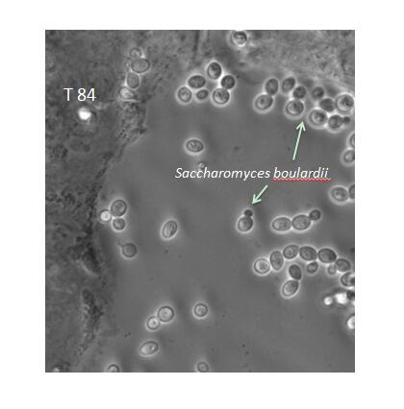
Figure 1 Transmission microscopy image showing Saccharomyces boulardii CNCM I-745 on a culture of human epithelial cells (T84 lineages). (Source: Pontier-Bres R and Czerucka D). The arrows indicate budding yeast located either in the spaces between the cells or near the cell walls and the formation of a protective barrier.

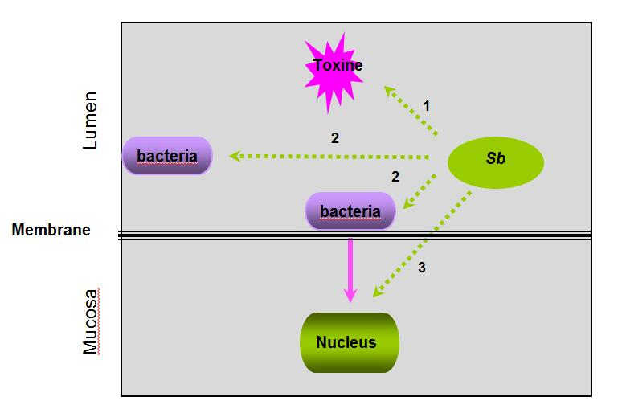
Figure 2 The hypothesized targets of Saccharomyces boulardii CNCM I-745 during bacterial infections: Saccharomyces boulardii CNCM I-745 may act directly on toxins “1”, on pathogenic bacteria “2” or on host cells “3”. Sb: Saccharomyces boulardii CNCM I-745.

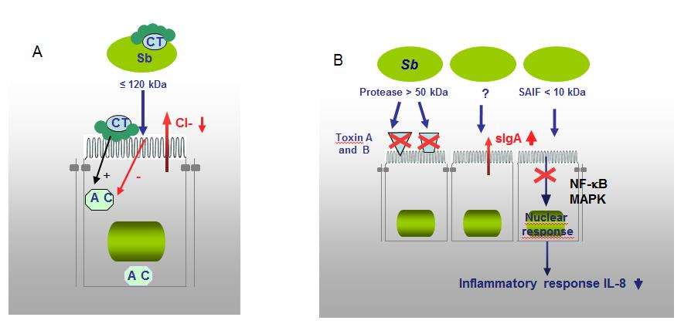
Figure 3 Demonstrated mechanism of Saccharomyces boulardii CNCM I-745 action against bacterial toxins. A: Saccharomyces boulardii (S. boulardii) CNCM I-745 produces a 120 kDa protein that inhibits adenylate cyclase and cholera toxin (CT)-induced chloride secretion. S. boulardii CNCM I-745 can also bind to CT; B: S. boulardii CNCM I-745 secretes a protease (> 54kDa) that lyses C. difficile toxins A and B and their receptors and a protein (< 10 kDa) that inhibits the signaling pathways involved in interleukin 8 synthesis. AC: Adenylate cyclase; CT: Cholera toxin; S. boulardii: Saccharomyces boulardii; Sb: Saccharomyces boulardii CNCM I-745; IL-8: Interleukin 8.

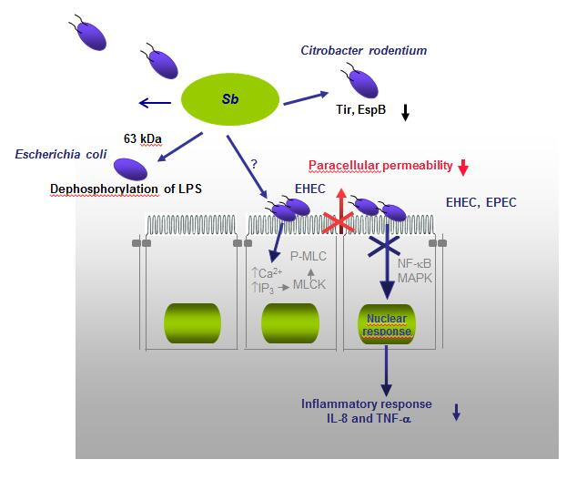
Figure 4 The protective mechanisms against enteropathogenic Escherichia coli (enteropathogenic coli, enterohaemorrhagic coli and Citrobacter rodentium). They include an effect on the mucosa with Saccharomyces boulardii (S. boulardii) CNCM I-745 inhibiting the pathways involved in opening tight junctions (phosphorylation of myosin light chain kinase), inhibition of activation pathways of mitogen-activated protein kinases and NF-κB that are involved in the synthesis of Interleukin 8, and finally a direct effect of S. boulardii CNCM I-745 on bacteria (dephosphorylation of lipopolysaccharide of Escherichia coli and modification of the expression of pathogenicity factors of Citrobacter rodentium). EHEC: Enterohaemorrhagic coli; EPEC: Enteropathogenic coli; LPS: Lipopolysaccharide; MAPK: Mitogen-activated protein kinase; MLCK: Myosin light chain kinase; P-MLC: Phosphorylation of myosin light chain; S. boulardii: Saccharomyces boulardii; IL-8: Interleukin 8; TNF-α: Tumor necrosis factor α; Sb: Saccharomyces boulardii CNCM I-745.

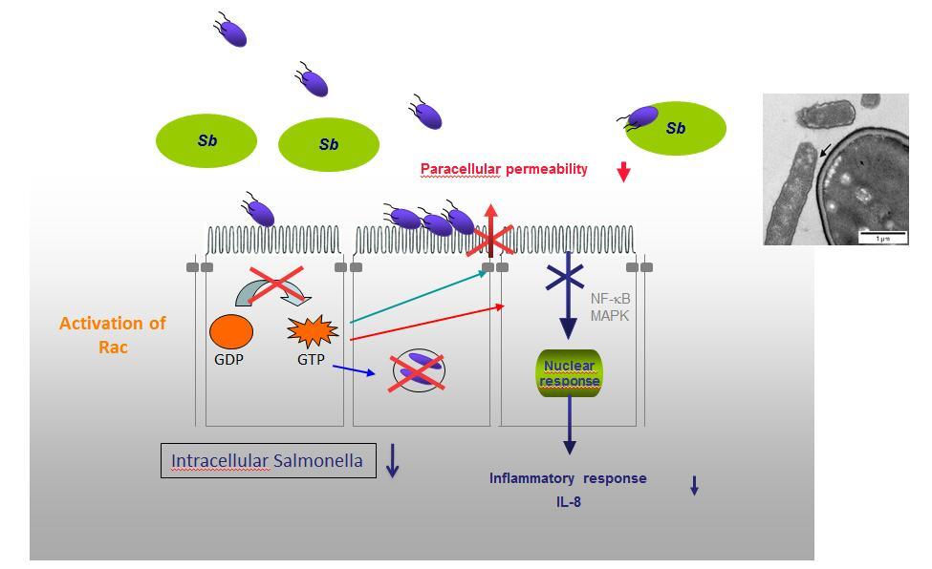
Figure 5 The mechanisms of protection against enteroinvasive bacteria (Salmonella and Shigella). In the case of Salmonella, there is a decrease in the activation of the small GTPase pathway and consequently a decrease in the number of intracellular bacteria and the maintence of tight junctions. Saccharomyces boulardii (S. boulardii) CNCM I-745 also induces inhibition of mitogen-activated protein kinases and NF-κB activation pathways that are involved in interleukin 8 synthesis. And finally, a direct effect of S. boulardii CNCM I-745 on bacteria with the modification of their motility and the adhesion of Salmonella to S. boulardii CNCM I-745. IL-8: Interleukin 8; MAPK: Mitogen-activated protein kinase; Sb: Saccharomyces boulardii CNCM I-745; S. boulardii: Saccharomyces boulardii.

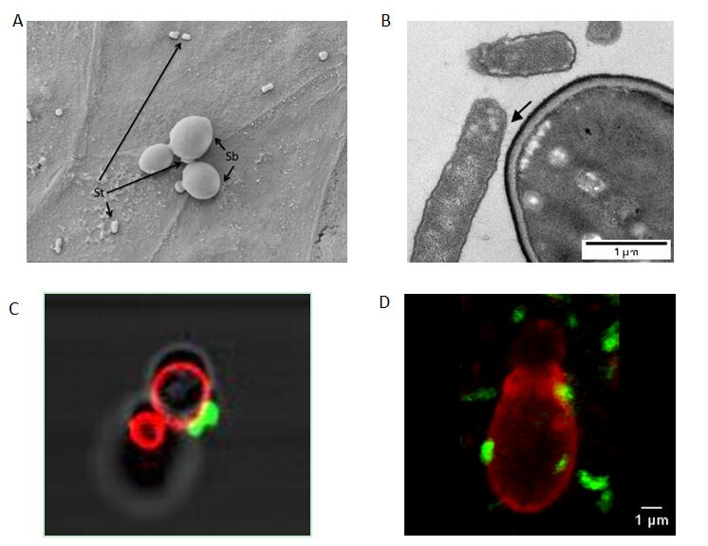
Figure 6 Scanning electron microscopy image showing Saccharomyces boulardii CNCM I-745 and Saccharomyces typhimurium on a monolayer of T84 polarized cells. A and B: Electron microscopy image showing Saccharomyces typhimurium (S. typhimurium) adhesion to Saccharomyces boulardii (S. boulardii) CNCM I-745; C and D: Confocal microscopy images showing S. typhimurium (Fluorescein IsoThioCyanate labelling), which adheres to S. boulardii CNCM I-745 (rhodamine labeling) in vitro (C) and in vivo on mouse cecum sections (D). Photos A and B: D. Czerucka¹, P. Gounon², P. Rampal¹; C and D: D. Czerucka¹, R. Pontier-Bres¹, P. Rampal¹ (¹CSM, Monaco, microscopy Platform Cote d’Azur, MICA; ²University of Nice-Sophia-Antipolis). S. boulardii: Saccharomyces boulardii; Sb: Saccharomyces boulardii; St: Saccharomyces typhimurium; S. typhimurium: Saccharomyces typhimurium.

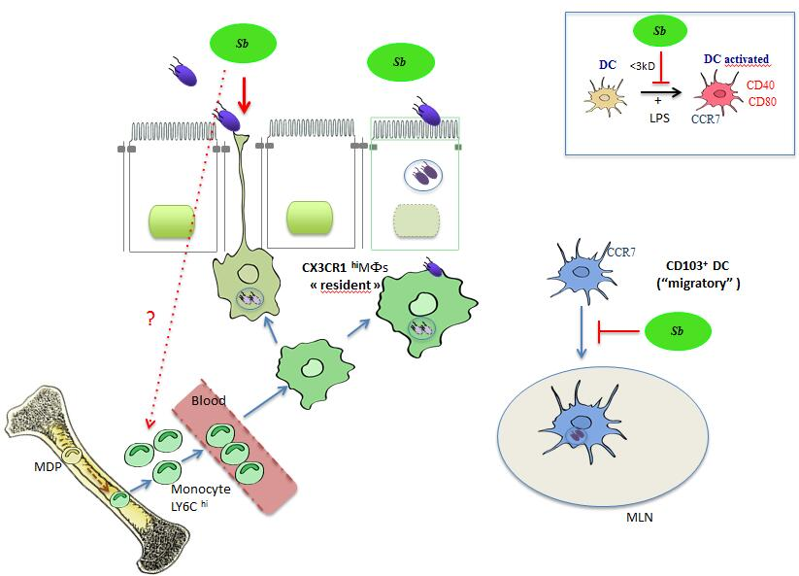
Figure 7 Effect of Saccharomyces boulardii CNCM I-745 on intestinal mononuclear phagocytes: Dendritic cells expressing CD103 (CD103⁺DC) and macropahge expressing the fractalkine receptor (CX3CR1MΦs). CD103⁺DC which expresses the CCR7 on their surface phagocytes the Salmonella (ST) and migrate to the mesenteric lymph nodes (MLN). CX3CR1MΦs which have a high phagocytosis capacity, include bacteria, do not migrate, but remain in the LP where they stimulate T lymphocytes. These MΦs are able to form extensions that pass between the epithelial cells and capture the antigens in the intestinal lumen, among other pathogenic bacteria such as ST. Saccharomyces boulardii (S. boulardii) CNCM I-745 induces the recruitment of CX3CR1MΦs and promotes phagocytosis of ST by these cells. S. boulardii CNCM I-745 effects the expansion of Ly6C inflammatory monocytes, which are the precursors of CX3CR1 DCs in the bone marrow. In addition, S. boulardii CNCM I-745 reduces the number of ST that migrate to MLN by decreasing the number of migratory DCs. In vitro studies have shown that S. boulardii CNCM I-745 can modify lipopolysaccharide activation of migratory DCs. This effect would be due to a molecule of low molecular weight (< 3 kDa) present in S. boulardii CNCM I-745 conditioned medium^{[64]}. S. boulardii: Saccharomyces boulardii; Sb: Saccharomyces boulardii; ST: Salmonella; MLN: Mesenteric lymph nodes; DCs: Dendritic cells; LPS: Lipopolysaccharide.
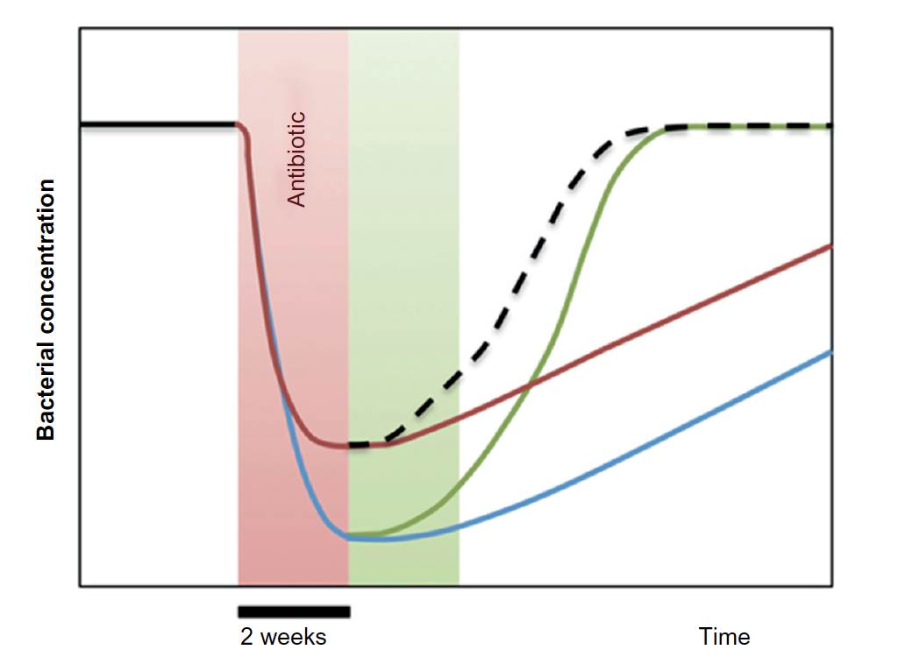
Figure 8 Diagram illustrating the impact of Saccharomyces boulardii CNCM I-745 on dysbiosis during antibiotic therapy. A 2-wk treatment with antibiotics (red zone of the graph) induces a sudden decrease in the dominant bacterial populations of the microbiota (blue curve). Treatment with Saccharomyces boulardii (S. boulardii) CNCM I-745 during antibiotic therapy (red curve) reduces the sudden decrease in bacterial populations. When S. boulardii CNCM I-745 is administered after antibiotic therapy (green zone of the graph, green curve) the yeast accelerates the restoration of the intestinal flora to its initial level. An optimal use of yeast would be administration during and after antibiotic therapy, which is presented by the hatched curve resulting from the red and green curve (from reference^{[75]}). S. boulardii: Saccharomyces boulardii.

Table 1 Effets of Saccharomyces boulardii CNCM I-745 on gut microbiota in various diseases
Disease | Technique | Alteration of the microbiota | Effet of S.boulardii CNCM I-745 | Ref.
Antibiotic treatment (mice) | FISH and  cytometry | Increase in Enterobacteriaceae and Bacteroides  Drastic decrease in Clostridium cocoides and Eubacterium rectale | Rapid return to normal for :  Bacteroides, Clostridium cocoides  Eubacterium rectale, Prevotella  Porphyromonas | [67,71]
Chronic diarrhea (humans) | Coring and FISH | Increase in Bifidobacerium  Eubacterium cylindrodes, Clostridium histolyticus et  Decrease in Bacteroides et Roseburia | Decrease in Bacteroides and  Roseburia | [72]
Antibiotic  Treatment  (humans) | Sequencing | Increase in Parabacteroides and  Escherichia/Shigella  Decrease in Ralstonia | Reduces microbiota variations due to antibiotic treatment | [74]
Antibiotic  Treatment  (women¹) | Corning and FISH | Decrease in dominant microbiota:Clostridium cocoides, Eubacterium rectale, Bacteroides, Roseburia and Faecalibacterium prausnitzii. | Group A/Sb: Increase in  Bacteroides, Roseburia and Faecalibacterium prausnitzii  Groupe Sb-A: Rapid return to normal | [73]
FISH: Fluorescence in situ hybridation; A/Sb: Group of patients concomitantly treated with antibiotics and Saccharomyces boulardii CNCM I-745 ; Sb-A: Group of patientstreated with Saccharomyces boulardii CNCM I-745 after antibiotic treatment; S.boulardii; Saccharomyces boulardii. ¹Patients with vaginal infections.

