Name of Journal: World Journal of Gastrointestinal Oncology
Manuscript NO: 53482
Manuscript Type: Review

efficacy of mesenchymal stem cells in the treatment of gastrointestinal malignancies

Li JN et al. MSCs for gastrointestinal malignancies

Jian-Nan Li, Wei Li, Lan-Qing Cao, Ning Liu, Kai Zhang

Jian-Nan Li, Wei Li, Kai Zhang, Department of General Surgery, The Second Hospital of Jilin University, Changchun 130041, Jilin Province, China

Lan-Qing Cao, Department of Pathology, The Second Hospital of Jilin University, Changchun 130041, Jilin Province, China

Ning Liu, Department of Central Laboratory, The Second Hospital of Jilin University, Changchun 130041, Jilin Province, China

Author contributions: Li JN, Li W and Cao LQ performed literature research; Li JN, Li W and Liu N wrote the manuscript and performed the revision and approval of the final version; Zhang K designed research, coordinated and corrected the writing of the paper; Li JN and Li W contributed equally to this study.

Corresponding author: Kai Zhang, MD, PhD, Chief Doctor, Professor, Department of General Surgery, The Second Hospital of Jilin University, 218 Ziqiang Street, Changchun 130041, Jilin Province, China. zhang_kai@jlu.edu.cn

Received: January 2, 2020
Revised: March 3, 2020
Accepted: March 26, 2020
Published online:

Abstract
Mesenchymal stem cells (MSCs), which are a kind of stem cell, possess an immune privileged nature, tumour homing features, and multi-lineage differentiation ability. MSCs have been studied in many fields, such as tissue engineering, nervous system diseases, and cancer treatment. In recent years, an increasing number of researchers have focused on the effects of MSCs on various kinds of tumours. However, the concrete anticancer efficacy of MSCs is still controversial. Gastrointestinal (GI) malignancies are the major causes of cancer-related death worldwide. The interactions of MSCs and GI cancer cells in specific conditions have attracted increasing attention. In this review, we introduce the characteristics of MSCs and analyse the effects of MSCs on GI malignancies, including gastric cancer, hepatoma, pancreatic cancer, and colorectal cancer. In addition, we also provide our perspectives on why MSCs may play different roles in GI malignancies and further research directions to increase the treatment efficacy of MSCs on GI malignancies.

Key words: Mesenchymal stem cells; Gastrointestinal malignancies; Gastric cancer; Hepatoma; Pancreatic cancer; Colorectal cancer

Li JN, Li W, Cao LQ, Liu N, Zhang K. efficacy of mesenchymal stem cells in the treatment of gastrointestinal malignancies. World J Gastrointest Oncol 2020; In press

Core tip: Mesenchymal stem cells (MSCs) possess immune privileged nature, tumor homing feature, and multi-lineage differentiation ability. Gastrointestinal (GI) malignancies are the major causes of cancer-related death worldwide. The interactions of MSCs and GI cancer cells in specific conditions have attracted more and more attentions. In this review, we would like to introduce the characteristics of MSCs and analyse the effects of MSCs on GI malignancies. In addition, we also provide our perspectives on the reason why MSCs may play different roles in GI malignancies and further research directions to increase the treatment efficacy of MSCs on GI malignancies.

Introduction
Gastrointestinal (GI) malignancies, which mainly include stomach, liver, pancreas, small intestine, colon, and rectal cancers, are the major causes of cancer-related death worldwide^{[1,2]}. Based on a survey conducted by the American Cancer Society, there were approximately 328030 new GI malignancy cases and 165640 GI malignancy-related deaths in the United States in 2019^{[3]}. In China, GI malignancies account for 35% of cancer-related deaths, which is much higher than that in the United States and the United Kingdom^{[4]}. Surgery, radiotherapy, chemotherapy, irreversible electroporation, cryotherapy, molecular targeted therapy, immunity therapy, etc., have been the main treatment methods for GI malignancies in recent years^{[5-8]}. Despite advances in treatment methods, there are still a large number of patients suffering from GI malignancies every year. Furthermore, many patients with GI malignancies are diagnosed at the late stage of the disease, which limits the treatment efficacy and shortens their survival time. Therefore, it is important and necessary to find other promising treatment methods for the treatment of GI malignancies.
Cancer stem cells (CSCs) are a kind of cancer cell with the characteristics of stem cells that are self-renewing and heterogeneous^{[9]}. In addition, CSCs may not be a single stasis population, but they are diverse and malleable^{[9,10]}. Because of these characteristics, CSCs play a vital role in the development, recurrence, and drug resistance of tumours^{[11]}. However, CSCs possess one or more abnormal signalling pathways that target whether tumour proliferation or invasion can be inhibited^{[9,12,13]}. In this review, we aim to summarize the efficacy of mesenchymal stem cells (MSCs) in the treatment of GI malignancies. Therefore, the detailed characteristics of CSCs and their roles in cancer treatment will not be further described in this review.
With the discovery of human body stem cells, researchers have focused on stem cell treatments. Stem cell treatments are being explored widely for their promising potential to treat various tumours. Among many kinds of stem cells, MSCs are mostly used in anticancer studies^{[14,15]}. MSCs have an immune-privileged nature, the ability to migrate to tumour cells, and multi-lineage differentiation^{[16,17]}, which make them a kind of biological agent for tumour inhibition. In this review, we introduce the characteristics of MSCs and summarize the effects of MSCs on GI malignancies. Table 1 shows the effect of MSCs in the treatment of GI malignancies.

MSCs
Stem cells were first discovered in 1963 and have been widely implicated in the treatment of various diseases^{[18]}. Stem cells are homogeneous and capable of self-proliferation and renewal. Based on their sources, stem cells can be divided into four categories: embryonic stem cells, capable of self-renewal and differentiating into different tissues^{[19,20]}; foetal stem cells, which exist in foetal tissues and have the potential for multi-differentiation^{[21]}; adult stem cells, which are partially oriented, are present in specific stromal tissues and can be derived from bone marrow, muscle, adipose tissue, synovium, periosteum, etc.^{[22,23]}; and cord blood stem cells, including hematopoietic stem cells and MSCs which are mostly derived from bone marrow^{[24]}.
Among these stem cells, the most commonly used for anticancer research is MSCs. MSCs are adult stem cells that were first discovered in the bone marrow. MSCs have the potential for multi-directional differentiation. They can differentiate into bone, cartilage, adipocytes, etc.^{[25]}. In addition, MSCs possess an immune-privileged nature, can migrate to injured tissues and tumour sites, and are easy to culture and store in vitro^{[25,26]}.
It has also been reported that MSCs can differentiate into hepatocytes, epithelial cells, and nerve cells, which are endodermal and ectodermal derived^{[27,28]}. In a study conducted by Doan et al ^{[29]}, MSCs differentiated into endothelial-like cells that produced capillary-like structures and took up low-density lipoprotein. Liu et al^{[30]} found that MSCs could differentiate into neural stem cells and immature neurons. The multi-directional differentiation feature of MSCs makes them important in tissue regeneration.
The immune privilege nature is another feature of MSCs. As early as 2000, Liechty et al^{[31]} transplanted MSCs into sheep and found that MSCs could survive in many tissues of the animals for as long as 13 months. In their opinion, the fact that MSCs could survive in heterogeneous bodies was related to their unique immune regulation function. Some researchers believe that MSCs can inhibit the proliferation of T and NK cells and regulate the activity of B and dendritic cells^{[32]}. As reported in some other studies, the immunosuppressive effect of MSCs is associated with the local immunosuppressive microenvironment formed by bioactive molecules that are secreted after cell contact^{[33]}. Importantly, MSCs express the surface markers of major histocompatibility (MHC) I but hardly express the surface markers MHC II. Meanwhile, MSCs do not express the co-stimulatory molecules CD40, CD80, or CD8^{[34]}. Despite the low expression of MHC I, MSCs cannot activate secondary signals of the immune response, which will result in the absent response status of T cells due to the lack of co-stimulatory factors^{[34]}. Low expression of MHC I molecules can protect MSCs from natural killer cell-mediated cytotoxicity. If MSCs cannot express MHC I molecules, MSCs will be attacked by natural killer cells, leading to the death of MSCs^{[35]}. This innate immune tolerance of MSCs is a necessary condition to achieve allogeneic transplantation.
MSCs possess a migration tendency toward tumour tissues, which has aroused the interest of many researchers. In 1999, Maestroni et al^{[36]} first found that MSCs could migrate to tumour sites. MSCs can interact with tumour cells in many ways to promote or inhibit tumour growth. In a study, researchers found that bone marrow-derived MSCs (BMSCs) released a variety of soluble factors that inhibited the growth of lung cancer and melanoma in mice^{[36]}. The migration tendency of MSCs has been confirmed in pancreas, ovarian, lung, colon, rectum, and breast cancers, among others^{[37-39]}. However, the mechanism by which tumours promote MSC migration is unclear and may be related to the biological characteristics of the tumour microenvironment. High concentrations of inflammatory chemotaxis factors and growth factors within the tumour microenvironment are thought to be the main reasons for integrating MSCs into the tumour stroma (Figure 1A). Because of chronic inflammation in tumour tissues, MSCs are promoted to release various soluble factors, such as epidermal growth factor, vascular endothelium growth factor-A, fibroblast growth factor, platelet-derived growth factor, matrix-derived growth factor-1α, interleukin-8, interleukin-6, and transforming growth factor-β (Figure 1B)^{[27,40,41]}. These factors also result in the migration tendency of MSCs towards tumour sites.
MSCs can secrete different molecules in distinct microenvironments to interact with tumour cells for the homing, growth, and stemness of tumours (Figure 1B). Whether MSCs promote or inhibit tumour formation depends on multiple factors. Different sources of MSCs have different effects on tumours. One study showed that umbilical cord blood-derived MSCs inhibited the growth of brain tumours, while adipose tissue-derived MSCs promoted brain tumour growth. Furthermore, adipose tissue-derived MSCs also promote the growth of gastric cancer, breast cancer and ovarian cancer^{[42]}. Another study demonstrated that allogeneic MSCs were transplanted into the body to promote the transition of melanoma cells into malignant tumours^{[43]}. Some researchers also believe that different types of tumour cells have different responses to MSCs^{[44]}.
Currently, an increasing number of researchers have indicated that MSCs with no modification can prevent tumour growth in vitro and in vivo in mice. This may result from the factors released by MSCs that have antitumour effects^{[36,45]}. MSCs have also been modified to overexpress specific genes to secrete therapeutic molecules for cancer treatment^{[27]}. In addition, based on the migration tendency and immune privileged nature, MSCs can also be applied as agent carriers to kill cancer cells^{[46,47]}.

MSCs for gastric cancer
The effect of MSCs in the treatment of gastric cancer remains controversial. This section summarizes the studies that applied MSCs for gastric cancer study and analyses their effect on tumour progression.
In some studies, it was reported that BMSCs benefited the angiogenesis of tumours, thus facilitating tumour growth^{[48]}. Previous studies have shown that BMSCs could promote breast, prostate, and liver tumour growth and increase the proliferation of Saos-2 osteosarcoma via increasing angiogenesis or other signalling pathways^{[49-51]}. In a study performed by Mu et al^{[52]}, BMSCs were found to suppress the cell viability of SGC-7901 gastric cancer cells by regulating the expression of apoptosis molecules (e.g., Bax/Bcl-2, p53) and promoting the release of tumour necrosis factor (TNF)-α. This study indicated the important roles of BMSCs in the development of gastric cancer cells. Zhang et al^{[53]} obtained similar results to some research. They found that human BMSCs (hBMSCs) inhibited the proliferation and migration and activated the apoptosis of SGC-7901 gastric cancer cells by upregulating the TNF-α/JNK pathway^{[53]}. Androgen reversed the BMSC-induced gastric cancer inhibition effect. In another study, researchers found that hBMSC-conditioned medium enhanced the viability of gastric cancer cells (MGC-803 and BGC-823) and promoted tumour development in a xenograft gastric cancer model via increasing the expression of c-Myc^{[54]}. Qi et al^{[55]} found that hBMSC-derived exosomes increased the viability of SGC-7901 gastric cancer cells by activating the Hedgehog signalling pathway. The exosomes of hBMSCs were transfected with miRNA-221 to promote oncogenic activity in gastric cancer in one study^{[56]}. The exosomes of BMSCs acted as a kind of vehicle that might perform tumour homing and immunosuppressive effects during cancer treatment. Nishimura et al^{[57]} found that hBMSCs could induce an advantageous tumour microenvironment that benefited gastric cancer progression. Other studies also obtained similar results that BMSCs could result in gastric cancer development^{[58]}. It is shown that BMSCs possess different effects on the development of gastric cancer. This may be because of that different gastric cancer cell lines have been applied in above discussed studies. Different cancer cell lines have different features, such as cell malignancy, invasiveness, proliferative capacity, and surface markers. As a result, BMSCs have shown different results towards different gastric cancer cell lines.
Human amniotic MSCs (hAMSCs) and human umbilical cord MSCs (hUCMSCs) are two other types of promising stem cells used in clinical applications. The effects of hAMSCs and hUCMSCs on gastric cancer were first analysed by Hou et al^{[59]}. The authors found that hUCMSCs not only inhibited the proliferation of BGC-823 gastric cancer cells but also prevented tumour migration. In a gastric cancer xenograft mouse model, hUCMSCs indeed inhibited tumour progression. However, hAMSCs enhanced the proliferation and migration of gastric cancer cells in their study. The authors concluded that, compared with hAMSCs, hUCMSCs were safe for the treatment of gastric cancer^{[59]}. However, in another study, the researchers found that hUCMSCs enhanced the proliferation and migration of HGC-27 and SGC-7901 gastric cancer cells^{[60]}. They fused hUCMSCs and gastric cancer cells and found that the hybrid cells strongly expressed CD44 and CD133. Furthermore, the heterotypic hybrids promoted gastric tumour growth in mice (Figure 2). In comparison of the studies conducted by Hou et al^{[59]} and Xue et al^{[60]}, we can also find that MSCs may exhert different effects towards different cancer cell lines. BGC-823 and HGC-27 cell lines mixed with hUCMSCs were subcutaneously injected into nude mice in Hou et al^{[59]}’s and Xue et al^{[60]}’s studies, respectively. However, hUCMSCs inhibited the tumour formation in Hou’s study, while promoted the tumour growth in Xue et al^{[60]}’s study. Zhang et al^{[53]} and Xue et al^{[60]} investigated the effects of hBMSCs and hUCMSCs towards SGC-7901 gastric cancer cells, respectively. However, they obtained opposite results in which BMSCs inhibited the cell viability, but hUCMSCs promoted the cell growth. This demonstrates that different types of MSCs may have different biological features towards GI malignancies.
Because of the tumour homing effect, MSCs have been used as vehicles to load oxygen or other agents to treat gastric cancer. In a study, researchers transfected haemoglobin genes into BMSCs to supply oxygen to the MKN-45 and SGC-7901 gastric cancer cells^{[61]}. The hypoxic microenvironment in gastric cancer was averted, and the chemotherapy efficacy towards the tumour cells increased. They concluded that BMSCs may be an efficient vehicle to improve the hypoxic microenvironment within tumour tissues and increase chemotherapy or radiotherapy treatment efficacy. Zhu et al^{[62]} loaded transgenic LIGHT in hUCMSCs to target tumours. LIGHT is a member of the TNF receptor family and possesses antitumour effects. In this study, the area of tumour necrosis was larger in the MSC-LIGHT group than that in the MSC group. They concluded that hUCMSCs could be an efficient vehicle to carry the LIGHT gene for gastric cancer treatment. You et al^{[63]} transfected the cytosine deaminase (CD) gene into human MSCs (hMSCs) and found that CD-producing BMSCs could convert 5-fluorocytosine to 5-fluorouracil, which significantly inhibited the development of gastric tumours. In these studies^{[61-63]}, the authors applied MSCs as carriers for suicide genes for the treatment of gastric cancer and found that these modified MSCs prevented the development of tumor cells. However, the interaction between primitive MSCs and tumours were not investigated clearly.

MSCs for hepatoma
MSCs can inhibit or promote hepatoma progression in specific conditions, which is similar to that of gastric cancer.
By TNF-related apoptosis-inducing ligand (TRAIL) transfection, MSCs can activate death receptor (DR) 5 in hepatoma cells (HepG2), thus inducing the apoptosis of cancer cells^{[64]}. The number of apoptotic tumour cells is positively correlated with the expression level of TRAIL on MSCs. However, evidence to confirm whether MSCs can express TRAIL and activate DR on the surface of tumour cells in vivo is lacking. At the same time, the in vivo expression level and condition of TRAIL are still insufficient. Liu et al^{[65]} established a controllable TRAIL expression adenovirus vector and transfected it into murine MSCs. TRAIL was controllably expressed in the presence of doxycycline, and secreted TRAIL suppressed the viability of human hepatoma cells (SMMC-7402). In this study, MSC-mediated TRAIL expression was artificially controlled. However, the controlled TRAIL expression in vivo and its safety within the human body need further investigation.
Previous studies have indicated that MSCs could achieve hepatoma cell inhibition by regulating the Wnt signalling pathway. In a study, H7402 and HepG2 hepatoma cells were cocultured with human fetus MSCs^{[66]}. The malignant phenotypes of H7402 and HepG2 cells were inhibited, and the expression of β-catenin, Bcl-2, c-Myc, and PCNA was decreased. The researchers concluded that MSCs could inhibit hepatoma development in vivo and in vitro by inhibiting the Wnt pathway. In another study, researchers established a liver cancer model in mice using a chemically induced method^{[67]}. The administration of murine BMSCs (mBMSCs) to mice suppressed tumour progression via downregulation of the Wnt signalling pathway. Serhal et al^{[68]} found that human adipose-derived MSCs could inhibit the growth of liver tumours by overexpressing P53 and RB and suppressing the expression of c-Myc and human telomerase reverse transcriptase (hTERT). Other studies have also shown that MSCs prevent hepatoma growth via the Wnt signalling pathway^{[67,69]}.
Other studies also reported that MSCs could induce the apoptosis of hepatoma. Seyhoun et al^{[70]} combined sorafenib and human fetus MSCs for the treatment of liver cancer. In another study, hUCMSCs alone inhibited the proliferation of tumour cells by suppressing the expression of Ki-67, prevented tumour angiogenesis by downregulating CD34, and induced the apoptosis of tumour cells^{[71]}.
The regulation of metabolic levels may be another way for MSCs to inhibit hepatoma growth. Qiao et al^{[72]} found that hMSCs depressed H7402 proliferation by downregulating the mRNA level of NF-κB. However, the further concrete mechanism of the hepatoma inhibition effect of MSCs at the metabolic level is still unclear. In another study, the researchers applied portal vein embolization and hBMSC infusion for the treatment of postsurgical patients with liver cancer^{[73]}. Compared with the control group, the treatment efficacy of embolization and hBMSC infusion was higher. This may be because stem cells can be affected by growth-promoting factors in the liver microenvironment, such as hepatocyte growth factor and epidermal growth factor, resulting in liver regeneration^{[74]}. Unfortunately, we cannot conclude that MSCs directly participate in the inhibition of liver cancer cells or reduce the recurrence rate.
Because MSCs have the ability to migrate to tumour tissues, many researchers have applied MSCs as a tool for loading antitumour components, including various cytokines, suicide genes, radioactive substances, etc., to achieve tumour treatment. In a study, mBMSCs were adenovirally engineered to secrete interleukin-12 (IL-12) and injected subcutaneously to prevent the formation of hepatoma^{[75]}. They found that mBMSCs could express IL-12 and inhibit tumour formation efficiently. However, the specific mechanism is unknown, and there is no study on whether MSCs migrate to other parts of the body. Niess et al^{[76]} transfected the thymidine kinase suicide gene into mBMSCs and injected the modified MSCs into a liver cancer mouse model. It was found that such MSCs can be enriched in the tumour site, and the quality of the tumour was reduced compared with the control group after the suicide gene was activated by the promoter. Unfortunately, this study did not perform safety analysis in vivo, and it is not known whether suicide gene-modified MSCs have a negative impact on other parts of the body. Yoon et al^{[46]} infected MSCs with hepatoma carcinoma-targeted oncolytic adenovirus. The modified MSCs homed to the hepatoma site and resulted in the accumulation of a large number of virions that lysed the tumour cells and led to the inhibition of tumour growth. In another study, mBMSCs were engineered with vectors expressing IFN-gamma and IL-10^{[77]}. The combination of these two kinds of cytokines in MSCs significantly suppressed the viability of hepatoma cells. However, these studies only focused on the tumour homing effects of MSCs, the safety evaluation of MSCs application should be further studied.
Some researchers also hold the opinion that MSCs promote the progression of hepatoma, and the possible reasons include that MSCs participate in the formation of tumour stroma, promote the expression of transforming growth factor β, and enhance tumour angiogenesis. In a study, researchers co-cultured hBMSCs with MHCC97-H hepatoma cells and found that the proliferation of hepatoma cells increased and the invasion ability decreased^{[78]}. Consistent with the in vitro results, the in vivo experiments in nude mice showed that the tumour volume increased rapidly with the administration of hBMSCs, but the lung metastasis rate decreased. The authors pointed out that this may be related to the fact that MSCs participated in the formation of the local tumour matrix, which was conducive to tumour colonization. However, Yan et al^{[79]} showed that liver cancer associated MSCs can not only promote the growth of liver cancer cells but also enhance distant metastasis. They first discovered the presence of MSCs in liver cancer tissues. The enhancement effect of MSCs on hepatoma cells may be related to the secretion of S100A4, which can increase the expression of miR-155, thus downregulating the cell signal transduction inhibitor SOCS1 and activating STAT3 signalling. In comparison of the studies performed by Qian et al^{[66]} and Li et al^{[78]}, we can find that different types of MSCs may play different roles in tumor growth. In addition, the animal modeling methods, animal species, and administration routes of MSCs may affect the roles of MSCs in the development of GI malignancies. In Qian’s^{[66]} study, SCID mice were subcutaneously injected with human liver cancer cells (H7402 cell line) and human fetus MSCs. In Li’s^{[78]} study, MHCC97-H cells were subcutaneously injected into nude mice and hBMSCs were intravenously injected three times a week.
Interestingly, Zong et al^{[80]} found that mBMSCs could play different roles in different stages of hepatoma. In the initial stage of liver cancer, MSCs can suppress tumour growth by reducing DNA damage and the levels of reactive oxygen species (ROS) and exhibit anti-fibrosis and anti-inflammatory effects. However, for the progressive stage of liver cancer, MSCs could promote the proliferation of cancer cells by enhancing the epithelial-mesenchymal transition of the tumour cells (Figure 3).

MSCs for pancreatic cancer
Because of the anti-inflammatory and tumour homing effects, MSCs have also been applied for the study of pancreatic cancer (PC)^{[14]}. However, the treatment efficacy is still controversial, and the specific mechanism is poorly understood.
Many studies have reported the prevention effect of naïve MSCs in PC. Doi et al^{[81]} co-cultured UCMSCs and PAN02 PC cell lines and found that the PC cells were arrested at the G0/G1 phase; thus, the proliferation of the tumour cells was inhibited. The in vivo studies showed that UCMSC treatment significantly reduced the peritoneal tumour burden and increased the survival time of mice. Kidd et al^{[82]} injected hBMSCs or hBMSCs expressing interferon (IFN)-β intraperitoneally into mice with PC. The authors found that MSCs alone could exert antitumour effects on PANC-1 cells and that MSCs could also act as vehicles for IFN-β transportation for further tumour inhibition.
Based on the tumour homing characteristics, MSCs can also be applied as carriers to load cytokines and genes for PC treatment. Shang et al^{[83]} found that a low expression level of miR-1231 in blood was correlated with the pathological stage of PC, which indicated the inhibitory role of miR-1231 in PC growth. As a result, they transfected miR-1231 into the exosomes of hBMSCs and found that the modified exosomes restricted the development of PC (Figure 4). In another study, hBMSC exosomal miR-126-3p was developed and tested to inhibit the proliferation, invasion, and metastasis of PC cells^{[84]}. Han et al^{[85]} designed a kind of TRAIL-secreting hMSC in which photochemical internalization was applied to enhance the entrapping and transfection efficacy into MSCs. Photochemical internalization increased TRAIL expression in MSCs, and the tumour homing effect enhanced tumour targeting, which resulted in a significant tumour apoptosis effect. Brini et al^{[86]} obtained MSCs from human gingival interdental papilla and applied gingival-derived MSCs as vehicles to transport paclitaxel to CFPAC-1 cells. Zischek et al^{[87]} transfected mBMSCs with the suicide gene thymidine kinase (TK), which is driven by chemotactic cytokines. These mBMSCs resulted in 50% PC growth and reduced the tumour metastasis rate. Even though, MSCs can be used as vehicles in PC treatment, the primitive effects of MSCs towards PC were not clearly demonstrated^{[83-87]}.
Contrary to the reports that support the anticancer effect of MSCs, some studies hold the opinion that MSCs can promote pancreatic cancer progression. In one study, researchers found that the coexistence of pancreatic ductal adenocarcinoma (PDAC) and MSCs upregulated the expression of amphiregulin (AREG) and MMP-3 in cancer cells and MSCs, respectively^{[88]}. This phenomenon resulted in enhanced tumour invasion. Blockage of AREG expression prevented the MSC-induced PDAC progression effect. Because of the inflammatory nature of PC, increasing the expression of inflammatory cytokines within the tumour microenvironment may lead to the development of cancer. In one study, the researchers found that MSCs could promote the secretion of TNF-α and IFN-γ, thus leading to the invasion of PC cells^{[89]}. Mathew et al^{[90]} found that MSCs within tumour tissues could promote tumour growth by alternating macrophage polarization.

MSCs for colorectal cancer
colorectal cancer (CRC) ranks as the third most common cancer leading to cancer-related modalities worldwide. Due to their anti-inflammatory and tumour homing properties, MSCs have also been studied in CRC studies. However, the controversial treatment efficacy of MSCs on CRC induces concerns for further research.
MSCs are widely used as vehicles to carry agent or specific genes for the treatment of CRC. Xu et al^{[17]} transfected miR-16-5p into the exosomes of BMSCs and found that exosomes inhibited the proliferation, invasion, and migration and increased the apoptosis of CRC cells by decreasing the expression of integrin alpha 2. The in vivo study demonstrated that BMSC-derived exosomes transfected with miR-16-5p significantly suppressed CRC growth. Chen et al^{[91]} found that the expression of miR-4461 was lower in CRC tissues than in normal tissues and that the expression of COPB2 was negatively correlated with miR-4461 because miR-4461 targeted COPB2. The authors transfected miR-4461 genes into hBMSC-derived exosomes and found that exosomes could downregulate the expression of COPB2, thus inhibiting the proliferation of CRC cells. Many other studies also transfected MSCs with suicide genes or loaded MSCs with tumour killing agents for CRC treatment^{[92-95]}.
Similar to many other kinds of cancer, MSCs can also interact with cancer cells extensively and promote CRC development. Chen et al^{[96]} investigated TNF-α-preactivated hBMSCs in the growth of CRC cells. The authors found that TNF-α-preactivated MSCs could secrete high levels of CCL5, which binds with its receptor in CRC cells, thus enhancing the proliferation, invasion, migration, and epithelial-mesenchymal transition of cancer cells. The tumour-promoting effect of TNF-α-preactivated MSCs is associated with the upregulation of the beta-catenin signalling pathway. Oh et al^{[97]} co-cultured hBMSCs and CRC cells and found that the proliferation and invasion of CRCs were increased with the upregulation of TGF-β1 and downregulation of p53. In one study, the authors showed that mBMSCs could increase C26 CRC growth in vivo^{[98]}. The tumour-promoting effect of MSCs could be further enhanced by inflammatory cytokines (TNF-α and IFN-γ), which are common in the tumour microenvironment. Inflammation-prestimulated MSCs could increase the tumour angiogenesis effect. Wu et al^{[99]} found that high expression levels of C-C chemokine receptor type 5 (CCR5) were associated with the poor prognosis of CRC patients. Strong CCR5 expression has been confirmed in many CRC cell lines and within the cytoplasm of BMSCs. The authors co-cultured HCT116 cells with BMSCs and found that the proliferation of CRC cells was significantly promoted, especially in HCT116 cells with high CCR5 expression (Figure 5). Further in vivo studies also indicated that BMSCs promoted CRC progression via CCR5. In a study performed by Wu et al^{[100]}, nude mice were intraperitoneally injected with HCT116 cells suspended in hBMSCs concentrated medium. The authors found that MSCs performed a tumor-promoting effect. Wang et al^{[101]} established xenograft tumour model by injecting the flanks of nude mice with CRC cells (SW480, LS174T, HT29) mixed with hBMSCs. The results indicated that hBMSCs could promote the growth of CRC.
Interestingly, some researchers pointed out that the effects of MSCs on CRC might depend on the malignancy of cancer cells and the expression levels of polypyrimidine tract-binding protein 1 (PTBP1). Fu et al^{[102]} found that hBMSCs increased the progression of the low malignancy CRC cell line HT29 but showed no obvious effect on the high malignancy CRC cell line HCT 116. The expression level of PTBP1 was decreased in HT29 cells co-cultured with MSCs. Upregulation of PTBP1 decreased the MSC-induced invasion of HT29 cells. In this study, the researchers indicated that MSCs can play different roles for cancer cells with different malignancy. In addition, MSCs are dominated by cancer cells with high malignancy and cannot perform significant changes on the cancer cells. Some researchers also thought that adipose tissue-derived MSCs might play different roles in different kinds of CRC cell lines. Iplik et al^{[103]} co-cultured adipose derived MSCs with HT29, HCT116, and RKO. After 48 hours of incubation, the expression level of caspase 3 decreased in RKO and HT29 cells but increased in HCT116 cells. Their results indicated that adipose tissue-derived MSCs significantly induced apoptotic cell death in HCT116 cells compared with the other cell lines. In another study, Kang et al^{[104]} reviewed studies concerning the effects of MSCs on inflammatory bowel disease (IBD). Based on the interaction effects and paracrine actions, MSCs have shown therapeutic properties towards IBD. The authors also anticipate that the treatment of CRC treatment by MSCs holds promise due to the tumour homing and inflammation inhibition effects. Prakash et al^{[105]} also summarized MSC treatment for IBD in both animal and clinical studies. The authors further focused on the therapeutic effects of MSCs on IBD-induced CRC.

CONCLUSION
Recent studies have shown that there are still controversies regarding the effects of MSCs on the proliferation and invasion of GI malignancies. The reasons why MSCs may play different roles in GI malignancies are summarized here: (1) The types of MSCs used in previous studies are different (e.g., hBMSCs, hAMSCs, hUCMSCs, foetal epithelium MSCs, porcine MSCs, murine MSCs). Different MSCs possess different biological features. (2) Different types of GI cancer cells have been applied, such as SGC-7901, MGC-803, BGC-823, HGC-27, MKN-45, MKN-7, etc., for gastric cancer studies. Different cancer cell lines affect the experimental results in terms of cell malignancy, invasiveness, proliferative capacity, and surface markers. (3) The administration routes of MSCs for GI malignancies are different. These routes mainly include intravenous administration ahead of the animal model, intravenous administration post the animal model, and direct injection into the tumour body. And (4) The animal models, modelling methods, and animal species are different. Nude mice are commonly used in most studies, but the occurrence and development of tumours are closely related to the immune status of the body. We cannot observe the effects of MSCs on the immune system due to immunodeficiency in nude mice.
Concerning the current research, an increasing number of researchers have turned their attention to modified MSCs, which have been applied as carriers for agent and gene therapy. The main methods for modifying MSCs include the transfection of various suicide genes and the transportation of many therapeutic agents. Nevertheless, it should be noted that most of the inherent properties and biological characteristics of MSCs are not changed. The effects of primitive MSCs and tumours are not uniform, and the interaction between primitive MSCs and tumours and the detailed mechanisms need to be further studied, especially regarding the safety of MSCs in vivo.
Great progress has been made in anticancer studies that applied modified MSCs as gene or agent carriers. However, most researchers mainly focus on the tumour homing effects of MSCs but do not consider the fact that a small amount of MSCs can be present in other parts of the body. When foreign genes are transfected, the expression products may have an effect on normal tissues. As a result, studies that can enhance the tumour homing effects of MSCs while decreasing their accumulation in other parts are necessary. In addition, recent studies investigating the effects of MSCs on GI malignancies were mainly performed in cancer cells and/or animal models. Clinical trials are important and are needed to clearly demonstrate the safety and concrete treatment efficacy of MSCs on GI malignancies.

References
1 Irún P, Lanas A, Piazuelo E. Omega-3 Polyunsaturated Fatty Acids and Their Bioactive Metabolites in Gastrointestinal Malignancies Related to Unresolved Inflammation. A Review. Front Pharmacol 2019; 10: 852 [PMID: 31427966 DOI: 10.3389/fphar.2019.00852]
2 Thapa N, Shatzel J, Deloughery TG, Olson SR. Direct oral anticoagulants in gastrointestinal malignancies: is the convenience worth the risk? J Gastrointest Oncol 2019; 10: 807-809 [PMID: 31392062 DOI: 10.21037/jgo.2019.02.07]
3 Siegel RL, Miller KD, Jemal A. Cancer statistics, 2019. CA Cancer J Clin 2019; 69: 7-34 [PMID: 30620402 DOI: 10.3322/caac.21551]
4 Feng RM, Zong YN, Cao SM, Xu RH. Current cancer situation in China: good or bad news from the 2018 Global Cancer Statistics? Cancer Commun (Lond) 2019; 39: 22 [PMID: 31030667 DOI: 10.1186/s40880-019-0368-6]
5 Rao D, Parakrama R, Augustine T, Liu Q, Goel S, Maitra R. Immunotherapeutic advances in gastrointestinal malignancies. NPJ Precis Oncol 2019; 3: 4 [PMID: 30729176 DOI: 10.1038/s41698-018-0076-8]
6 Gottumukkala S, Tumati V, Hrycushko B, Folkert M. Endoluminal and Interstitial Brachytherapy for the Treatment of Gastrointestinal Malignancies: a Systematic Review. Curr Oncol Rep 2017; 19: 2 [PMID: 28110462 DOI: 10.1007/s11912-017-0561-1]
7 Myint ZW, Goel G. Role of modern immunotherapy in gastrointestinal malignancies: a review of current clinical progress. J Hematol Oncol 2017; 10: 86 [PMID: 28434400 DOI: 10.1186/s13045-017-0454-7]
8 Nimako GK, Wintrob ZA, Sulik DA, Donato JL, Ceacareanu AC. Synergistic Benefit of Statin and Metformin in Gastrointestinal Malignancies. J Pharm Pract 2017; 30: 185-194 [PMID: 26811340 DOI: 10.1177/0897190015627255]
9 Desai A, Yan Y, Gerson SL. Concise Reviews: Cancer Stem Cell Targeted Therapies: Toward Clinical Success. Stem Cells Transl Med 2019; 8: 75-81 [PMID: 30328686 DOI: 10.1002/sctm.18-0123]
10 Supuran CT, Alterio V, Di Fiore A, D' Ambrosio K, Carta F, Monti SM, De Simone G. Inhibition of carbonic anhydrase IX targets primary tumors, metastases, and cancer stem cells: Three for the price of one. Med Res Rev 2018; 38: 1799-1836 [PMID: 29635752 DOI: 10.1002/med.21497]
11 Ayob AZ, Ramasamy TS. Cancer stem cells as key drivers of tumour progression. J Biomed Sci 2018; 25: 20 [PMID: 29506506 DOI: 10.1186/s12929-018-0426-4]
12 Cui M, Yao X, Lin Y, Zhang D, Cui R, Zhang X. Interactive functions of microRNAs in the miR-23a-27a-24-2 cluster and the potential for targeted therapy in cancer. J Cell Physiol 2020; 235: 6-16 [PMID: 31192453 DOI: 10.1002/jcp.28958]
13 Yu SS, Cirillo N. The molecular markers of cancer stem cells in head and neck tumors. J Cell Physiol 2020; 235: 65-73 [PMID: 31206697 DOI: 10.1002/jcp.28963]
14 Chopra N, Choudhury S, Bhargava S, Wajid S, Ganguly NK. Potentials of "stem cell-therapy" in pancreatic cancer: An update. Pancreatology 2019; 19: 1034-1042 [PMID: 31668563 DOI: 10.1016/j.pan.2019.09.016]
15 Galland S, Stamenkovic I. Mesenchymal stromal cells in cancer: a review of their immunomodulatory functions and dual effects on tumor progression. J Pathol 2019; Online ahead of print [PMID: 31608444 DOI: 10.1002/path.5357]
16 Zhuang L, Xia W, Hou M. Co‑culturing with hypoxia pre‑conditioned mesenchymal stem cells as a new strategy for the prevention of irradiation‑induced fibroblast‑to‑myofibroblast transition. Oncol Rep 2019; 42: 1781-1792 [PMID: 31485596 DOI: 10.3892/or.2019.7293]
17 Xu Y, Shen L, Li F, Yang J, Wan X, Ouyang M. microRNA-16-5p-containing exosomes derived from bone marrow-derived mesenchymal stem cells inhibit proliferation, migration, and invasion, while promoting apoptosis of colorectal cancer cells by downregulating ITGA2. J Cell Physiol 2019; 234: 21380-21394 [PMID: 31102273 DOI: 10.1002/jcp.28747]
18 Becker AJ, McCulloch EA, Till JE. Cytological demonstration of the clonal nature of spleen colonies derived from transplanted mouse marrow cells. Nature 1963; 197: 452-454 [PMID: 13970094 DOI: 10.1038/197452a0]
19 Dou X, Zhao Y, Li M, Chen Q, Yamaguchi Y. Raman imaging diagnosis of the early stage differentiation of mouse embryonic stem cell (mESC). Spectrochim Acta A Mol Biomol Spectrosc 2020; 224: 117438 [PMID: 31377684 DOI: 10.1016/j.saa.2019.117438]
20 Stoddard-Bennett T, Pera RR. Stem cell therapy for Parkinson's disease: safety and modeling. Neural Regen Res 2020; 15: 36-40 [PMID: 31535640 DOI: 10.4103/1673-5374.264446]
21 Gauthier-Fisher A, Kauffman A, Librach CL. Potential use of stem cells for fertility preservation. Andrology 2019; Online ahead of print [PMID: 31560823 DOI: 10.1111/andr.12713]
22 Han W, Singh NK, Kim JJ, Kim H, Kim BS, Park JY, Jang J, Cho DW. Directed differential behaviors of multipotent adult stem cells from decellularized tissue/organ extracellular matrix bioinks. Biomaterials 2019; 224: 119496 [PMID: 31557592 DOI: 10.1016/j.biomaterials.2019.119496]
23 Severn CE, Eissa AM, Langford CR, Parker A, Walker M, Dobbe JGG, Streekstra GJ, Cameron NR, Toye AM. Ex vivo culture of adult CD34⁺ stem cells using functional highly porous polymer scaffolds to establish biomimicry of the bone marrow niche. Biomaterials 2019; 225: 119533 [PMID: 31610389 DOI: 10.1016/j.biomaterials.2019.119533]
24 Mohr A, Zwacka R. The future of mesenchymal stem cell-based therapeutic approaches for cancer - From cells to ghosts. Cancer Lett 2018; 414: 239-249 [PMID: 29175461 DOI: 10.1016/j.canlet.2017.11.025]
25 Pajarinen J, Lin T, Gibon E, Kohno Y, Maruyama M, Nathan K, Lu L, Yao Z, Goodman SB. Mesenchymal stem cell-macrophage crosstalk and bone healing. Biomaterials 2019; 196: 80-89 [PMID: 29329642 DOI: 10.1016/j.biomaterials.2017.12.025]
26 Keshtkar S, Azarpira N, Ghahremani MH. Mesenchymal stem cell-derived extracellular vesicles: novel frontiers in regenerative medicine. Stem Cell Res Ther 2018; 9: 63 [PMID: 29523213 DOI: 10.1186/s13287-018-0791-7]
27 Javan MR, Khosrojerdi A, Moazzeni SM. New Insights Into Implementation of Mesenchymal Stem Cells in Cancer Therapy: Prospects for Anti-angiogenesis Treatment. Front Oncol 2019; 9: 840 [PMID: 31555593 DOI: 10.3389/fonc.2019.00840]
28 Kim EJ, Kim N, Cho SG. The potential use of mesenchymal stem cells in hematopoietic stem cell transplantation. Exp Mol Med 2013; 45: e2 [PMID: 23306700 DOI: 10.1038/emm.2013.2]
29 Doan CC, Le TL, Hoang NS, Doan NT, Le VD, Do MS. Differentiation of umbilical cord lining membrane-derived mesenchymal stem cells into endothelial-like cells. Iran Biomed J 2014; 18: 67-75 [PMID: 24518546 DOI: 10.6091/ibj.1261.2013]
30 Liu Y, Liu L, Ma X, Yin Y, Tang B, Li Z. Characteristics and neural-like differentiation of mesenchymal stem cells derived from foetal porcine bone marrow. Biosci Rep 2013; 33: e00032 [PMID: 23458182 DOI: 10.1042/BSR20120023]
31 Liechty KW, MacKenzie TC, Shaaban AF, Radu A, Moseley AM, Deans R, Marshak DR, Flake AW. Human mesenchymal stem cells engraft and demonstrate site-specific differentiation after in utero transplantation in sheep. Nat Med 2000; 6: 1282-1286 [PMID: 11062543 DOI: 10.1038/81395]
32 Hong HS, Kim YH, Son Y. Perspectives on mesenchymal stem cells: tissue repair, immune modulation, and tumor homing. Arch Pharm Res 2012; 35: 201-211 [PMID: 22370775 DOI: 10.1007/s12272-012-0201-0]
33 Shi Y, Su J, Roberts AI, Shou P, Rabson AB, Ren G. How mesenchymal stem cells interact with tissue immune responses. Trends Immunol 2012; 33: 136-143 [PMID: 22227317 DOI: 10.1016/j.it.2011.11.004]
34 Jeon Y, Lee MS, Cheon YP. Decreased contact inhibition in mouse adipose mesenchymal stem cells. Dev Reprod 2012; 16: 329-338 [PMID: 25949108 DOI: 10.12717/DR.2012.16.4.329]
35 Stabile H, Nisti P, Morrone S, Pagliara D, Bertaina A, Locatelli F, Santoni A, Gismondi A. Multifunctional human CD56 low CD16 low natural killer cells are the prominent subset in bone marrow of both healthy pediatric donors and leukemic patients. Haematologica 2015; 100: 489-498 [PMID: 25596273 DOI: 10.3324/haematol.2014.116053]
36 Maestroni GJ, Hertens E, Galli P. Factor(s) from nonmacrophage bone marrow stromal cells inhibit Lewis lung carcinoma and B16 melanoma growth in mice. Cell Mol Life Sci 1999; 55: 663-667 [PMID: 10357234 DOI: 10.1007/s000180050322]
37 Smith CL, Chaichana KL, Lee YM, Lin B, Stanko KM, O'Donnell T, Gupta S, Shah SR, Wang J, Wijesekera O, Delannoy M, Levchenko A, Quiñones-Hinojosa A. Pre-exposure of human adipose mesenchymal stem cells to soluble factors enhances their homing to brain cancer. Stem Cells Transl Med 2015; 4: 239-251 [PMID: 25646527 DOI: 10.5966/sctm.2014-0149]
38 Seicean A, Petrusel L, Seicean R. New targeted therapies in pancreatic cancer. World J Gastroenterol 2015; 21: 6127-6145 [PMID: 26034349 DOI: 10.3748/wjg.v21.i20.6127]
39 Fakiruddin KS, Baharuddin P, Lim MN, Fakharuzi NA, Yusof NA, Zakaria Z. Nucleofection optimization and in vitro anti-tumourigenic effect of TRAIL-expressing human adipose-derived mesenchymal stromal cells. Cancer Cell Int 2014; 14: 122 [PMID: 25469108 DOI: 10.1186/s12935-014-0122-8]
40 Dwyer RM, Khan S, Barry FP, O'Brien T, Kerin MJ. Advances in mesenchymal stem cell-mediated gene therapy for cancer. Stem Cell Res Ther 2010; 1: 25 [PMID: 20699014 DOI: 10.1186/scrt25]
41 Lourenco S, Teixeira VH, Kalber T, Jose RJ, Floto RA, Janes SM. Macrophage migration inhibitory factor-CXCR4 is the dominant chemotactic axis in human mesenchymal stem cell recruitment to tumors. J Immunol 2015; 194: 3463-3474 [PMID: 25712213 DOI: 10.4049/jimmunol.1402097]
42 Lim EJ, Suh Y, Yoo KC, Lee JH, Kim IG, Kim MJ, Chang JH, Kang SG, Lee SJ. Tumor-associated mesenchymal stem-like cells provide extracellular signaling cue for invasiveness of glioblastoma cells. Oncotarget 2017; 8: 1438-1448 [PMID: 27903965 DOI: 10.18632/oncotarget.13638]
43 Djouad F, Plence P, Bony C, Tropel P, Apparailly F, Sany J, Noël D, Jorgensen C. Immunosuppressive effect of mesenchymal stem cells favors tumor growth in allogeneic animals. Blood 2003; 102: 3837-3844 [PMID: 12881305 DOI: 10.1182/blood-2003-04-1193]
44 Galderisi U, Giordano A, Paggi MG. The bad and the good of mesenchymal stem cells in cancer: Boosters of tumor growth and vehicles for targeted delivery of anticancer agents. World J Stem Cells 2010; 2: 5-12 [PMID: 21607110 DOI: 10.4252/wjsc.v2.i1.5]
45 Nakamura K, Ito Y, Kawano Y, Kurozumi K, Kobune M, Tsuda H, Bizen A, Honmou O, Niitsu Y, Hamada H. Antitumor effect of genetically engineered mesenchymal stem cells in a rat glioma model. Gene Ther 2004; 11: 1155-1164 [PMID: 15141157 DOI: 10.1038/sj.gt.3302276]
46 Yoon AR, Hong J, Li Y, Shin HC, Lee H, Kim HS, Yun CO. Mesenchymal Stem Cell-Mediated Delivery of an Oncolytic Adenovirus Enhances Antitumor Efficacy in Hepatocellular Carcinoma. Cancer Res 2019; 79: 4503-4514 [PMID: 31289131 DOI: 10.1158/0008-5472.CAN-18-3900]
47 Zendedel E, Atkin SL, Sahebkar A. Use of stem cells as carriers of oncolytic viruses for cancer treatment. J Cell Physiol 2019; Online ahead of print [PMID: 30770550 DOI: 10.1002/jcp.28320]
48 Wu Y, Chen L, Scott PG, Tredget EE. Mesenchymal stem cells enhance wound healing through differentiation and angiogenesis. Stem Cells 2007; 25: 2648-2659 [PMID: 17615264 DOI: 10.1634/stemcells.2007-0226]
49 Zhang T, Lee YW, Rui YF, Cheng TY, Jiang XH, Li G. Bone marrow-derived mesenchymal stem cells promote growth and angiogenesis of breast and prostate tumors. Stem Cell Res Ther 2013; 4: 70 [PMID: 23763837 DOI: 10.1186/scrt221]
50 Jing Y, Han Z, Liu Y, Sun K, Zhang S, Jiang G, Li R, Gao L, Zhao X, Wu D, Cai X, Wu M, Wei L. Mesenchymal stem cells in inflammation microenvironment accelerates hepatocellular carcinoma metastasis by inducing epithelial-mesenchymal transition. PLoS One 2012; 7: e43272 [PMID: 22952657 DOI: 10.1371/journal.pone.0043272]
51 Tu B, Du L, Fan QM, Tang Z, Tang TT. STAT3 activation by IL-6 from mesenchymal stem cells promotes the proliferation and metastasis of osteosarcoma. Cancer Lett 2012; 325: 80-88 [PMID: 22743617 DOI: 10.1016/j.canlet.2012.06.006]
52 Mu LS, Su W, Lin Y, Yu WT, Su HL, Yu X, Qin CK. Androgen attenuates antitumor effects of gastric cancer cells by bone marrow mesenchymal stem cells via restricting the JNK signaling activation. Transl Cancer Res 2019; 8: 917-927 [DOI: 10.21037/tcr.2019.06.04]
53 Zhang L, Zheng JT, Liu YJ, Li LQ. Androgen regulates apoptosis-related signaling pathway to reverse bone marrow-derived mesenchymal stem cells (BMSCs)-induced SGC-7901 cell death. Int J Clin Exp Med 2017; 10: 16154-16162
54 Chen B, Yu J, Wang Q, Zhao Y, Sun L, Xu C, Zhao X, Shen B, Wang M, Xu W, Zhu W. Human Bone Marrow Mesenchymal Stem Cells Promote Gastric Cancer Growth via Regulating c-Myc. Stem Cells Int 2018; 2018: 9501747 [PMID: 30186330 DOI: 10.1155/2018/9501747]
55 Qi J, Zhou Y, Jiao Z, Wang X, Zhao Y, Li Y, Chen H, Yang L, Zhu H, Li Y. Exosomes Derived from Human Bone Marrow Mesenchymal Stem Cells Promote Tumor Growth Through Hedgehog Signaling Pathway. Cell Physiol Biochem 2017; 42: 2242-2254 [PMID: 28817816 DOI: 10.1159/000479998]
56 Ma M, Chen S, Liu Z, Xie H, Deng H, Shang S, Wang X, Xia M, Zuo C. miRNA-221 of exosomes originating from bone marrow mesenchymal stem cells promotes oncogenic activity in gastric cancer. Onco Targets Ther 2017; 10: 4161-4171 [PMID: 28860826 DOI: 10.2147/OTT.S143315]
57 Nishimura K, Semba S, Aoyagi K, Sasaki H, Yokozaki H. Mesenchymal stem cells provide an advantageous tumor microenvironment for the restoration of cancer stem cells. Pathobiology 2012; 79: 290-306 [PMID: 22688186 DOI: 10.1159/000337296]
58 Quante M, Tu SP, Tomita H, Gonda T, Wang SS, Takashi S, Baik GH, Shibata W, Diprete B, Betz KS, Friedman R, Varro A, Tycko B, Wang TC. Bone marrow-derived myofibroblasts contribute to the mesenchymal stem cell niche and promote tumor growth. Cancer Cell 2011; 19: 257-272 [PMID: 21316604 DOI: 10.1016/j.ccr.2011.01.020]
59 Meng MY, Li L, Wang WJ, Liu FF, Song J, Yang SL, Tan J, Gao H, Zhao YY, Tang WW, Han R, Zhu K, Liao LW, Hou ZL. Assessment of tumor promoting effects of amniotic and umbilical cord mesenchymal stem cells in vitro and in vivo. J Cancer Res Clin Oncol 2019; 145: 1133-1146 [PMID: 30805774 DOI: 10.1007/s00432-019-02859-6]
60 Xue J, Zhu Y, Sun Z, Ji R, Zhang X, Xu W, Yuan X, Zhang B, Yan Y, Yin L, Xu H, Zhang L, Zhu W, Qian H. Tumorigenic hybrids between mesenchymal stem cells and gastric cancer cells enhanced cancer proliferation, migration and stemness. BMC Cancer 2015; 15: 793 [PMID: 26498753 DOI: 10.1186/s12885-015-1780-1]
61 Zhou YL, Li YM, He WT. Oxygen-laden mesenchymal stem cells enhance the effect of gastric cancer chemotherapy in vitro. Oncol Lett 2019; 17: 1245-1252 [PMID: 30655891 DOI: 10.3892/ol.2018.9670]
62 Zhu X, Su D, Xuan S, Ma G, Dai Z, Liu T, Tang D, Mao W, Dong C. Gene therapy of gastric cancer using LIGHT-secreting human umbilical cord blood-derived mesenchymal stem cells. Gastric Cancer 2013; 16: 155-166 [PMID: 22850801 DOI: 10.1007/s10120-012-0166-1]
63 You MH, Kim WJ, Shim W, Lee SR, Lee G, Choi S, Kim DY, Kim YM, Kim H, Han SU. Cytosine deaminase-producing human mesenchymal stem cells mediate an antitumor effect in a mouse xenograft model. J Gastroenterol Hepatol 2009; 24: 1393-1400 [PMID: 19486256 DOI: 10.1111/j.1440-1746.2009.05862.x]
64 Sun XY, Nong J, Qin K, Lu H, Moniri MR, Dai LJ, Warnock GL. MSC(TRAIL)-mediated HepG2 cell death in direct and indirect co-cultures. Anticancer Res 2011; 31: 3705-3712 [PMID: 22110190]
65 Liu Z, Ma H, Shi J, Zhang YX, Liu YX, Zheng DX. [Killing effects of controllable expression of tumor necrosis factor-related apoptosis-inducing ligand from mesenchymal stem cells on hepatocellular carcinoma cells]. Zhonghua Yi Xue Za Zhi 2011; 91: 544-548 [PMID: 21418858]
66 Qiao L, Xu Z, Zhao T, Zhao Z, Shi M, Zhao RC, Ye L, Zhang X. Suppression of tumorigenesis by human mesenchymal stem cells in a hepatoma model. Cell Res 2008; 18: 500-507 [PMID: 18364678 DOI: 10.1038/cr.2008.40]
67 Abdel aziz MT, El Asmar MF, Atta HM, Mahfouz S, Fouad HH, Roshdy NK, Rashed LA, Sabry D, Hassouna AA, Taha FM. Efficacy of mesenchymal stem cells in suppression of hepatocarcinorigenesis in rats: possible role of Wnt signaling. J Exp Clin Cancer Res 2011; 30: 49 [PMID: 21545718 DOI: 10.1186/1756-9966-30-49]
68 Serhal R, Saliba N, Hilal G, Moussa M, Hassan GS, El Atat O, Alaaeddine N. Effect of adipose-derived mesenchymal stem cells on hepatocellular carcinoma: In vitro inhibition of carcinogenesis. World J Gastroenterol 2019; 25: 567-583 [PMID: 30774272 DOI: 10.3748/wjg.v25.i5.567]
69 Wu N, Zhang YL, Wang HT, Li DW, Dai HJ, Zhang QQ, Zhang J, Ma Y, Xia Q, Bian JM, Hang HL. Overexpression of hepatocyte nuclear factor 4α in human mesenchymal stem cells suppresses hepatocellular carcinoma development through Wnt/β-catenin signaling pathway downregulation. Cancer Biol Ther 2016; 17: 558-565 [PMID: 27124543 DOI: 10.1080/15384047.2016.1177675]
70 Seyhoun I, Hajighasemlou S, Muhammadnejad S, Ai J, Nikbakht M, Alizadeh AA, Hosseinzadeh F, Mirmoghtadaei M, Seyhoun SM, Verdi J. Combination therapy of sorafenib with mesenchymal stem cells as a novel cancer treatment regimen in xenograft models of hepatocellular carcinoma. J Cell Physiol 2019; 234: 9495-9503 [PMID: 30362607 DOI: 10.1002/jcp.27637]
71 Yuan Y, Zhou C, Chen X, Tao C, Cheng H, Lu X. Suppression of tumor cell proliferation and migration by human umbilical cord mesenchymal stem cells: A possible role for apoptosis and Wnt signaling. Oncol Lett 2018; 15: 8536-8544 [PMID: 29805590 DOI: 10.3892/ol.2018.8368]
72 Qiao L, Zhao TJ, Wang FZ, Shan CL, Ye LH, Zhang XD. NF-kappaB downregulation may be involved the depression of tumor cell proliferation mediated by human mesenchymal stem cells. Acta Pharmacol Sin 2008; 29: 333-340 [PMID: 18298898 DOI: 10.1111/j.1745-7254.2008.00751.x]
73 Fürst G, Schulte am Esch J, Poll LW, Hosch SB, Fritz LB, Klein M, Godehardt E, Krieg A, Wecker B, Stoldt V, Stockschläder M, Eisenberger CF, Mödder U, Knoefel WT. Portal vein embolization and autologous CD133+ bone marrow stem cells for liver regeneration: initial experience. Radiology 2007; 243: 171-179 [PMID: 17312278 DOI: 10.1148/radiol.2431060625]
74 Stappenbeck TS, Miyoshi H. The role of stromal stem cells in tissue regeneration and wound repair. Science 2009; 324: 1666-1669 [PMID: 19556498 DOI: 10.1126/science.1172687]
75 Chen XC, Wang R, Zhao X, Wei YQ, Hu M, Wang YS, Zhang XW, Zhang R, Zhang L, Yao B, Wang L, Jia YQ, Zeng TT, Yang JL, Tian L, Kan B, Lin XJ, Lei S, Deng HX, Wen YJ, Mao YQ, Li J. Prophylaxis against carcinogenesis in three kinds of unestablished tumor models via IL12-gene-engineered MSCs. Carcinogenesis 2006; 27: 2434-2441 [PMID: 16854952 DOI: 10.1093/carcin/bgl069]
76 Niess H, Bao Q, Conrad C, Zischek C, Notohamiprodjo M, Schwab F, Schwarz B, Huss R, Jauch KW, Nelson PJ, Bruns CJ. Selective targeting of genetically engineered mesenchymal stem cells to tumor stroma microenvironments using tissue-specific suicide gene expression suppresses growth of hepatocellular carcinoma. Ann Surg 2011; 254: 767-74; discussion 774-5 [PMID: 22042469 DOI: 10.1097/SLA.0b013e3182368c4f]
77 Wang H, Wang J, Shi X, Ding Y. Genetically engineered bone marrow-derived mesenchymal stem cells co-expressing IFN-γ and IL-10 inhibit hepatocellular carcinoma by modulating MAPK pathway. J BUON 2017; 22: 1517-1524 [PMID: 29332347]
78 Li GC, Ye QH, Xue YH, Sun HJ, Zhou HJ, Ren N, Jia HL, Shi J, Wu JC, Dai C, Dong QZ, Qin LX. Human mesenchymal stem cells inhibit metastasis of a hepatocellular carcinoma model using the MHCC97-H cell line. Cancer Sci 2010; 101: 2546-2553 [PMID: 20942864 DOI: 10.1111/j.1349-7006.2010.01738.x]
79 Yan XL, Jia YL, Chen L, Zeng Q, Zhou JN, Fu CJ, Chen HX, Yuan HF, Li ZW, Shi L, Xu YC, Wang JX, Zhang XM, He LJ, Zhai C, Yue W, Pei XT. Hepatocellular carcinoma-associated mesenchymal stem cells promote hepatocarcinoma progression: role of the S100A4-miR155-SOCS1-MMP9 axis. Hepatology 2013; 57: 2274-2286 [PMID: 23316018 DOI: 10.1002/hep.26257]
80 Zong C, Zhang H, Yang X, Gao L, Hou J, Ye F, Jiang J, Yang Y, Li R, Han Z, Wei L. The distinct roles of mesenchymal stem cells in the initial and progressive stage of hepatocarcinoma. Cell Death Dis 2018; 9: 345 [PMID: 29497038 DOI: 10.1038/s41419-018-0366-7]
81 Doi C, Maurya DK, Pyle MM, Troyer D, Tamura M. Cytotherapy with naive rat umbilical cord matrix stem cells significantly attenuates growth of murine pancreatic cancer cells and increases survival in syngeneic mice. Cytotherapy 2010; 12: 408-417 [PMID: 20345214 DOI: 10.3109/14653240903548194]
82 Kidd S, Caldwell L, Dietrich M, Samudio I, Spaeth EL, Watson K, Shi Y, Abbruzzese J, Konopleva M, Andreeff M, Marini FC. Mesenchymal stromal cells alone or expressing interferon-beta suppress pancreatic tumors in vivo, an effect countered by anti-inflammatory treatment. Cytotherapy 2010; 12: 615-625 [PMID: 20230221 DOI: 10.3109/14653241003631815]
83 Shang S, Wang J, Chen S, Tian R, Zeng H, Wang L, Xia M, Zhu H, Zuo C. Exosomal miRNA-1231 derived from bone marrow mesenchymal stem cells inhibits the activity of pancreatic cancer. Cancer Med 2019; 8: 7728-7740 [PMID: 31642612 DOI: 10.1002/cam4.2633]
84 Wu DM, Wen X, Han XR, Wang S, Wang YJ, Shen M, Fan SH, Zhang ZF, Shan Q, Li MQ, Hu B, Lu J, Chen GQ, Zheng YL. Bone Marrow Mesenchymal Stem Cell-Derived Exosomal MicroRNA-126-3p Inhibits Pancreatic Cancer Development by Targeting ADAM9. Mol Ther Nucleic Acids 2019; 16: 229-245 [PMID: 30925451 DOI: 10.1016/j.omtn.2019.02.022]
85 Han J, Hwang HS, Na K. TRAIL-secreting human mesenchymal stem cells engineered by a non-viral vector and photochemical internalization for pancreatic cancer gene therapy. Biomaterials 2018; 182: 259-268 [PMID: 30142525 DOI: 10.1016/j.biomaterials.2018.08.024]
86 Brini AT, Coccè V, Ferreira LM, Giannasi C, Cossellu G, Giannì AB, Angiero F, Bonomi A, Pascucci L, Falchetti ML, Ciusani E, Bondiolotti G, Sisto F, Alessandri G, Pessina A, Farronato G. Cell-mediated drug delivery by gingival interdental papilla mesenchymal stromal cells (GinPa-MSCs) loaded with paclitaxel. Expert Opin Drug Deliv 2016; 13: 789-798 [PMID: 26986001 DOI: 10.1517/17425247.2016.1167037]
87 Zischek C, Niess H, Ischenko I, Conrad C, Huss R, Jauch KW, Nelson PJ, Bruns C. Targeting tumor stroma using engineered mesenchymal stem cells reduces the growth of pancreatic carcinoma. Ann Surg 2009; 250: 747-753 [PMID: 19826249 DOI: 10.1097/SLA.0b013e3181bd62d0]
88 Saito K, Sakaguchi M, Maruyama S, Iioka H, Putranto EW, Sumardika IW, Tomonobu N, Kawasaki T, Homma K, Kondo E. Stromal mesenchymal stem cells facilitate pancreatic cancer progression by regulating specific secretory molecules through mutual cellular interaction. J Cancer 2018; 9: 2916-2929 [PMID: 30123360 DOI: 10.7150/jca.24415]
89 Zhou HS, Su XF, Fu XL, Wu GZ, Luo KL, Fang Z, Yu F, Liu H, Hu HJ, Chen LS, Cai B, Tian ZQ. Mesenchymal stem cells promote pancreatic adenocarcinoma cells invasion by transforming growth factor-β1 induced epithelial-mesenchymal transition. Oncotarget 2016; 7: 41294-41305 [PMID: 27191496 DOI: 10.18632/oncotarget.9319]
90 Mathew E, Brannon AL, Del Vecchio A, Garcia PE, Penny MK, Kane KT, Vinta A, Buckanovich RJ, di Magliano MP. Mesenchymal Stem Cells Promote Pancreatic Tumor Growth by Inducing Alternative Polarization of Macrophages. Neoplasia 2016; 18: 142-151 [PMID: 26992915 DOI: 10.1016/j.neo.2016.01.005]
91 Chen HL, Li JJ, Jiang F, Shi WJ, Chang GY. MicroRNA-4461 derived from bone marrow mesenchymal stem cell exosomes inhibits tumorigenesis by downregulating COPB2 expression in colorectal cancer. Biosci Biotechnol Biochem 2020; 84: 338-346 [PMID: 31631786 DOI: 10.1080/09168451.2019.1677452]
92 Kalimuthu S, Zhu L, Oh JM, Lee HW, Gangadaran P, Rajendran RL, Baek SH, Jeon YH, Jeong SY, Lee SW, Lee J, Ahn BC. Regulated Mesenchymal Stem Cells Mediated Colon Cancer Therapy Assessed by Reporter Gene Based Optical Imaging. Int J Mol Sci 2018; 19: [PMID: 29584688 DOI: 10.3390/ijms19041002]
93 Yang L, Zhang Y, Cheng L, Yue D, Ma J, Zhao D, Hou X, Xiang R, Cheng P. Mesenchymal Stem Cells Engineered to Secrete Pigment Epithelium-Derived Factor Inhibit Tumor Metastasis and the Formation of Malignant Ascites in a Murine Colorectal Peritoneal Carcinomatosis Model. Hum Gene Ther 2016; 27: 267-277 [PMID: 26756933 DOI: 10.1089/hum.2015.135]
94 Salehi N, Peng CA. Mesenchymal stem cell as delivery carrier for prodrug gene therapy against colorectal cancer cell. Cancer Res 2015; 75: 18-22 [DOI: 10.1158/1538-7445.AM2015-5352]
95 Salehi N, Peng CA. Anticancer Effectiveness of Mesenchymal Stem Cells Transfected With Thymidine Phosphorylase for Colorectal Cancer Cells. Mol Ther 2015; 23: S92-S92 [DOI: 10.1016/S1525-0016(16)33840-0]
96 Chen K, Liu Q, Tsang LL, Ye Q, Chan HC, Sun Y, Jiang X. Human MSCs promotes colorectal cancer epithelial-mesenchymal transition and progression via CCL5/β-catenin/Slug pathway. Cell Death Dis 2017; 8: e2819 [PMID: 28542126 DOI: 10.1038/cddis.2017.138]
97 Oh IR, Raymundo B, Kim M, Kim CW. Mesenchymal stem cells co-cultured with colorectal cancer cells showed increased invasive and proliferative abilities due to its altered p53/TGF-β1 levels. Biosci Biotechnol Biochem 2020; 84: 256-267 [PMID: 31601153 DOI: 10.1080/09168451.2019.1676692]
98 Liu Y, Han ZP, Zhang SS, Jing YY, Bu XX, Wang CY, Sun K, Jiang GC, Zhao X, Li R, Gao L, Zhao QD, Wu MC, Wei LX. Effects of inflammatory factors on mesenchymal stem cells and their role in the promotion of tumor angiogenesis in colon cancer. J Biol Chem 2011; 286: 25007-25015 [PMID: 21592963 DOI: 10.1074/jbc.M110.213108]
99 Nishikawa G, Kawada K, Nakagawa J, Toda K, Ogawa R, Inamoto S, Mizuno R, Itatani Y, Sakai Y. Bone marrow-derived mesenchymal stem cells promote colorectal cancer progression via CCR5. Cell Death Dis 2019; 10: 264 [PMID: 30890699 DOI: 10.1038/s41419-019-1508-2]
100 Wu XB, Liu Y, Wang GH, Xu X, Cai Y, Wang HY, Li YQ, Meng HF, Dai F, Jin JD. Mesenchymal stem cells promote colorectal cancer progression through AMPK/mTOR-mediated NF-κB activation. Sci Rep 2016; 6: 21420 [PMID: 26892992 DOI: 10.1038/srep21420]
101 Wang J, Wang Y, Wang S, Cai J, Shi J, Sui X, Cao Y, Huang W, Chen X, Cai Z, Li H, Bardeesi AS, Zhang B, Liu M, Song W, Wang M, Xiang AP. Bone marrow-derived mesenchymal stem cell-secreted IL-8 promotes the angiogenesis and growth of colorectal cancer. Oncotarget 2015; 6: 42825-42837 [PMID: 26517517 DOI: 10.18632/oncotarget.5739]
102 Fu X, Xie F, Gong F, Yang Z, Lv X, Li X, Jiao H, Wang Q, Liu X, Yan L, Xiao R. Suppression of PTBP1 signaling is responsible for mesenchymal stem cell induced invasion of low malignancy cancer cells. Biochim Biophys Acta Mol Cell Res 2018; 1865: 1552-1565 [PMID: 30327198 DOI: 10.1016/j.bbamcr.2018.08.002]
103 Iplik ES, Ertugrul B, Kozanoglu I, Baran Y, Cakmakoglu B. An answer to colon cancer treatment by mesenchymal stem cell originated from adipose tissue. Iran J Basic Med Sci 2018; 21: 465-468 [PMID: 29922425 DOI: 10.22038/IJBMS.2018.26152.6420]
104 Kang J, Zhang L, Luo X, Ma X, Wang G, Yang Y, Yan Y, Qian H, Zhang X, Xu W, Mao F. Systematic Exposition of Mesenchymal Stem Cell for Inflammatory Bowel Disease and Its Associated Colorectal Cancer. Biomed Res Int 2018; 2018: 9652817 [PMID: 30687760 DOI: 10.1155/2018/9652817]
105 Prakash MD, Miller S, Randall-Demllo S, Nurgali K. Mesenchymal Stem Cell Treatment of Inflammation-Induced Cancer. Inflamm Bowel Dis 2016; 22: 2694-2703 [PMID: 27753693 DOI: 10.1097/MIB.0000000000000900]

Footnotes
Conflict-of-interest statement: There is no conflict of interest associated with any of the senior author or other coauthors contributed their efforts in this manuscript. All the Authors have no conflict of interest related to the manuscript.

Open-Access: This article is an open-access article that was selected by an in-house editor and fully peer-reviewed by external reviewers. It is distributed in accordance with the Creative Commons Attribution NonCommercial (CC BY-NC 4.0) license, which permits others to distribute, remix, adapt, build upon this work non-commercially, and license their derivative works on different terms, provided the original work is properly cited and the use is non-commercial. See: http://creativecommons.org/licenses/by-nc/4.0/

Manuscript source: Invited Manuscript

Peer-review started: January 2, 2020
First decision: February 18, 2020
Article in press:

Specialty type: Oncology
Country of origin: China
Peer-review report classification
Grade A (Excellent): 0
Grade B (Very good): B, B
Grade C (Good): 0
Grade D (Fair): D
Grade E (Poor): 0

P-Reviewer: Memeo R, Miloso M, Tanabe S S-Editor: Gong ZM L-Editor: E-Editor:

Table 1 The effect of mesenchymal stem cells in the treatment of gastrointestinal malignancies in vitro and in vivo
Tumor type | MSCs type | Cell lines | Animal study | Tumor growth | Functional mechanism | Ref.
Gastric cancer | hBMSCs | SGC-7901 | No | Promotion | Direct effects | [52]
 | hBMSCs | SGC-7901 | No | Inhibition | Direct effects | [53]
 | hBMSCs | MGC-803 and BGC-823 | Yes | Promotion | Direct effects | [54]
 | hBMSCs | SGC-7901 | No | Promotion | Direct effects | [55]
 | hBMSCs | BGC-823 and SGC-7901 | No | Promotion | Homing effects | [56]
 | hBMSCs | MKN-7 | No | Promotion | Direct effects | [57]
 | mBMSCs | NA | Yes | Promotion | Direct effects | [58]
 | hUCMSCs | BGC-823 | Yes | Inhibition | Direct effects | [59]
 | hAMSCs | BGC-823 | Yes | Promotion | Direct effects | [59]
 | hUCMSCs | HGC-27, SGC-7901 | Yes | Promotion | Direct effects | [60]
 | BMSCs | MKN-45, SGC-7901 | No | Inhibition | Homing effects | [61]
 | hUCMSCs | SGC-7901 | No | Inhibition | Homing effects | [62]
 | hMSCs | MKN-45 | Yes | Inhibition | Homing effects | [63]
Liver cancer | murine MSCs | HepG2 | No | Inhibition | Direct effects | [64]
 | murine MSCs | SMMC-7402 | No | Inhibition | Homing effects | [65]
 | Human fetus MSCs | H7402, HepG2 | Yes | Inhibition | Direct effects | [66]
 | BMSCs | NA | Yes | Inhibition | Direct effects | [67]
 | Adipose derived MSCs | HepG2, PLC-PRF-5 | No | Inhibition | Direct effects | [68]
 | Human fetus MSCs | HepG2 | Yes | Inhibition | Direct effects | [70]
 | hUCMSCs | BEL7402 | No | Inhibition | Direct effects | [71]
 | hMSCs | H7402 | No | Inhibition | Direct effects | [72]
 | BMSCs | NA | No | Inhibition | Direct effects | [73]
 | mBMSCs | Human HCC cells | Yes | Inhibition | Homing effects | [75]
 | mBMSCs | Human HCC cells | Yes | Inhibition | Homing effects | [76]
 | hMSCs | Human HCC cells | Yes | Inhibition | Homing effects | [46]
 | mBMSCs | HepG2 | Yes | Inhibition | Homing effects | [77]
 | hBMSCs | MHCC97-H | Yes | Promotion | Direct effects | [78]
 | Liver cancer associated MSCs | MHCC97L | Yes | Promotion | Direct effects | [79]
 | mBMSCs | NA | Yes | Inhibition for initial stage  Promotion for progressive stage | Direct effects | [80]
Pancreatic  cancer | Rat UCMSCs | PANC02 | Yes | Inhibition | Direct effects | [81]
 | hBMSCs | PANC-1 | Yes | Inhibition | Direct effects | [82]
 | hBMSCs | BxPC-3, MIA PaCa-2 | Yes | Inhibition | Homing effects | [83]
 | hBMSCs | NA | Yes | Inhibition | Homing effects | [84]
 | hMSCs | MIA PaCa-2 | Yes | Inhibition | Homing effects | [85]
 | gingival derived MSCs | CFPAC-1 | No | Inhibition | Homing effects | [86]
 | mBMSCs | PANC02 | Yes | Inhibition | Homing effects | [87]
 | BMSCs | BxPC-3 | No | Promotion | Direct effects | [88]
 | hMSCs | PANC-1 and BxPC-3 | No | Promotion | Direct effects | [89]
 | Carcinoma associated MSCs | 13442 cells | Yes | Promotion | Direct effects | [90]
Colorectal cancer | BMSCs | Caco-2, SW480, SW620, LoVo, HT29 | Yes | Inhibition | Homing effects | [17]
 | hBMSCs | HCT116, SW480 | No | Inhibition | Homing effects | [91]
 | mBMSCs | CT26 | Yes | Inhibition | Homing effects | [92]
 | mBMSCs | CT26 | Yes | Inhibition | Homing effects | [93]
 | hBMSCs | HT29, SW1116, Caco-2, Lovo | Yes | Promotion | Direct effects | [96]
 | hBMSCs | NA | No | Promotion | Direct effects | [97]
 | mBMSCs | C26 | Yes | Promotion | Direct effects | [98]
 | BMSCs | HCT116 | Yes | Promotion | Direct effects | [99]
 | hBMSCs | HCT116, Lovo | Yes | Promotion | Direct effects | [100]
 | hBMSCs | SW480, LS174T, HT29 | Yes | Promotion | Direct effects | [101]
 | hBMSCs | HT29, HCT116 | Yes | Promotion for HT29  Inhibition for HCT116 | Direct effects | [102]
 | Adipose derived MSCs | RKO, HT29, HCT116 | No | Promotion for RKO and HCT29  Inhibition for HCT116 | Direct effects | [103]
MSCs: mesenchymal stem cells; hBMSCs: human bone marrow-derived mesenchymal stem cells; mBMSCs: murine one marrow-derived mesenchymal stem cells; hUCMSCs: human umbilical cord mesenchymal stem cells; hAMSCs: human amniotic mesenchymal stem cells; hMSCs: human mesenchymal stem cells; mBMSCs: murine bone marrow-derived mesenchymal stem cells; NA: not applicable.
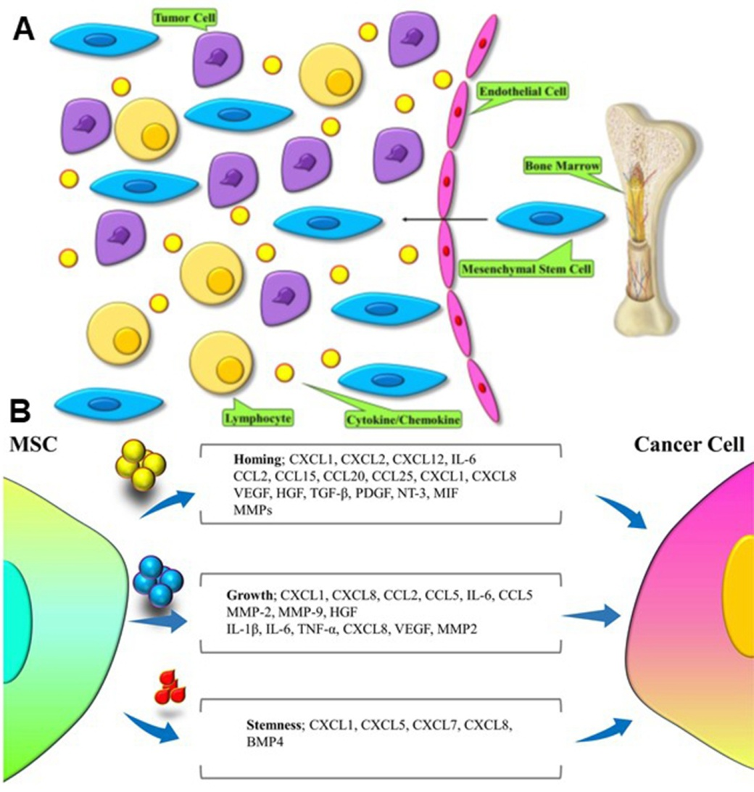
Figure 1 Interactions between mesenchymal stem cells and cancer cells^{[27]}. A: Tumor microenvironment release certain molecules to recruit mesenchymal stem cells (MSCs) to tumor. B: MSCs secret different molecules in distinct microenvironment to interact with tumor cells for homing, growth, and stemness of tumors. MSC: mesenchymal stem cell.

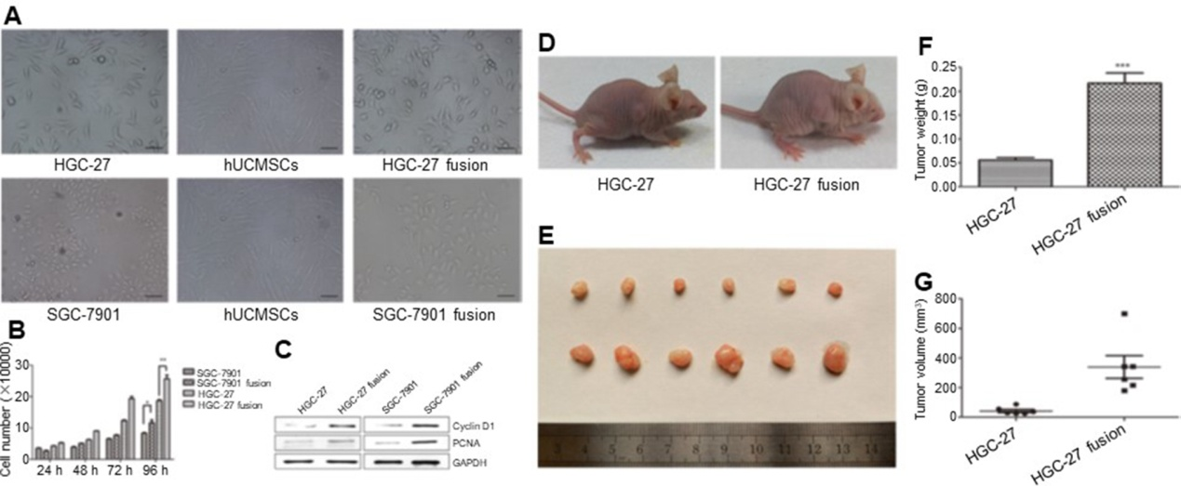
Figure 2 The effects of hybrids (HGC-27 or SGC-7901 fused with mesenchymal stem cells) on gastric cancer^{[60]}. A: The morphology of the two gastric cancer cell lines, hUCMSCs, HGC-27 fusion, and SGC-7901 fusion; B: The growth of the parental and hybrid cells was determined by cell counting assay; C: The expression of PCNA and CyclinD1 proteins in different groups; D: Representative images of the gastric tumor bearing mice; E: The images of the tumor tissues; F: Tumor weight; and G: Tumor volume. hUCMSCs: human umbilical cord mesenchymal stem cells; PCNA: proliferating cell nuclear antigen.

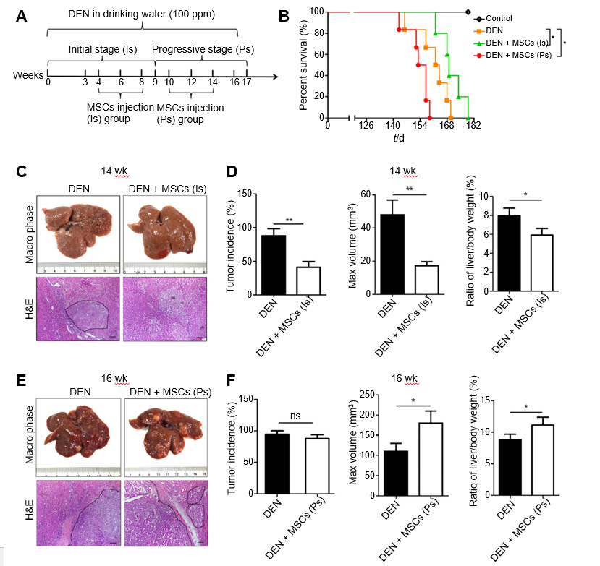
Figure 3 The effects of mesenchymal stem cells on liver cancer in different stages^{[80]}. A: The experimental protocol. Rats were administrated N-diethylnitrosamine (DEN) in drinking water for 14 wk. DEN + mesenchymal stem cells (MSCs) (Is) group was transplanted MSCs (1 × 10⁶) by intravenous injection at 4th, 6th, 8th week, and DEN + MSC (Ps) group was transplanted MSCs (1 × 10⁶) as the same method at the 10th, 12th, 14th week, respectively. B: The rat percent survival in different groups. C: The macro phase and H&E images of liver in DEN and DEN + MSCs (Is) groups at 14 wk after DEN treatment. D: Tumor incidence, tumor max volume, and ratio of liver/body weight in DEN and DEN+MSCs (Is) groups at 14th week. E: The macro phase and H&E images of liver in DEN and DEN + MSCs (Ps) groups at 16 weeks after DEN treatment. F: Tumor incidence, tumor max volume, and ratio of liver/body weight in DEN and DEN + MSCs (Ps) groups at 16th week. DEN: N-diethylnitrosamine; MSCs: mesenchymal stem cells; Is: initial stage; Ps: progressive stage; H&E: hematoxylin-eosin.

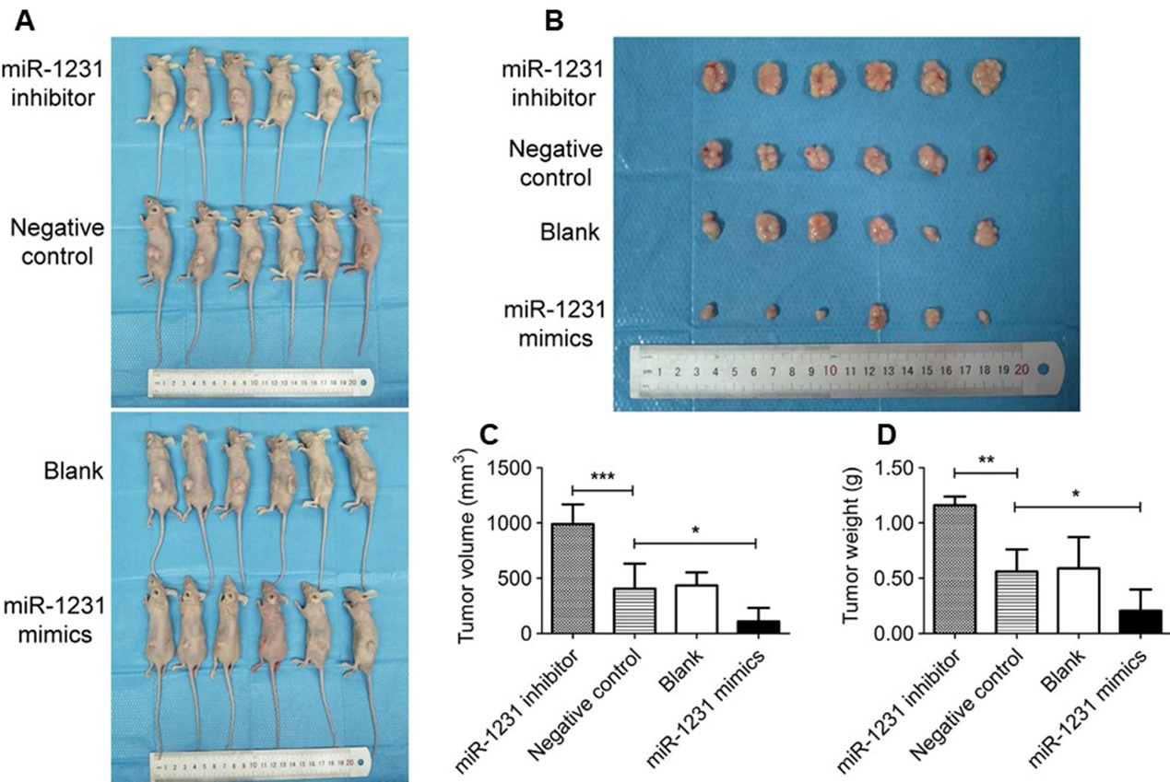
Figure 4 Exosomes derived from human bone marrow-derived mesenchymal stem cells inhibited the development of pancreatic cancer^{[83]}. A: Images of the tumor bearing mice in different groups; B: Images of resected tumors; C: Tumor volume; and D: Tumor weight.

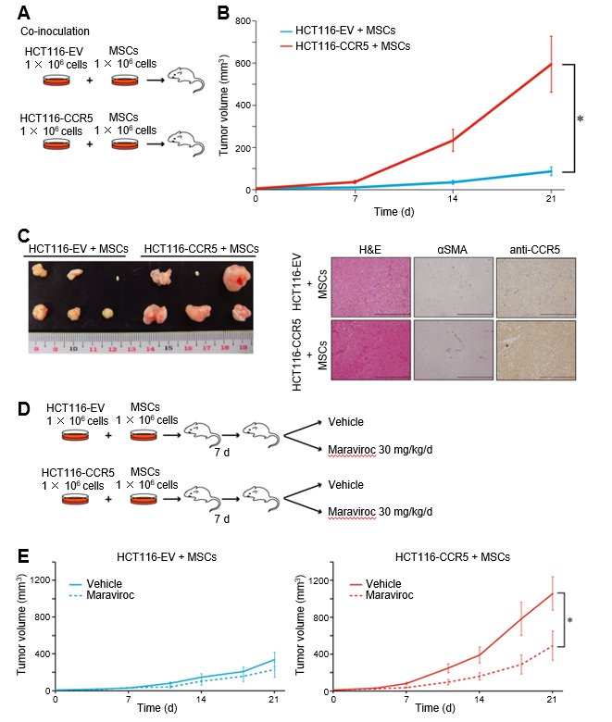
Figure 5 Mesenchymal stem cells promote colorectal cancer progression via CCR5^{[99]}. A: Scheme of co-inoculation mice model. HCT116-EV, HCT116 cells transfected with empty vector; HCT116-CCR5, HCT116 cells transfected with CCR5. B: Tumor volume curves in HCT116-EV and HCT116-CCR5 co-cultured with MSCs. C: Representative images of tumors and histological findings in HCT116-EV + MSCs and HCT116-CCR5 + MSCs groups. D: Scheme of treatment procedure. E: Tumor volume curves in HCT116-EV + MSCs and HCT116-CCR5 + MSCs groups. Dotted lines show treatment group with maraviroc 30 mg/kg/d, and solid lines show control group with vehicles.

