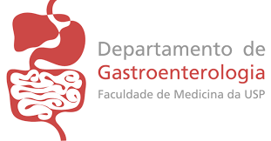

Declaration

The Gastroenterology Department Ethics Committee and the Hospital das Clínicas Scientific Board has evaluated and approved the present review work:

Doppler-guided hemorrhoidal dearterialization/THD: technical evolution and outcomes after 20 years

Authors: Marleny Novaes Figueiredo and Fábio Guilherme Campos

The present work deals with an interesting issue and its publication is very usefull for the Gastroenterology Department

