Name of Journal: World Journal of Orthopedics
Manuscript NO: 65448
Manuscript Type: SYSTEMATIC REVIEWS

Impact of enhanced recovery pathways on safety and efficacy of hip and knee arthroplasty: A systematic review and meta-analysis

Heymans MJ et al. CPKHA

Marion JLF Heymans, Nanne P Kort, Barbara AM Snoeker, Martijn GM Schotanus

Marion JLF Heymans, Zuyderland Academy, Zuyderland Medical Center, Sittard 6155 NH, Netherlands

Nanne P Kort, Department of Orthopedic Surgery, Cortoclinics, Schijndel 5482 WN, Netherlands

Barbara AM Snoeker, Department of Clinical Epidemiology, Biostatistics and Bioinformatics, Amsterdam Medical Center, University of Amsterdam, Amsterdam 1105 AZ, Netherlands

Martijn GM Schotanus, Department of Orthopaedic Surgery and Traumatology, Zuyderland Medical Center, Sittard-Geleen 6162 BG, Limburg, Netherlands

Martijn GM Schotanus, Care and Public Health Research Institute, Maastricht University Medical Centre, Faculty of Health, Medicine & Life Sciences, Maastricht 6229 ER, Limburg, Netherlands

Author contributions: Heymans MJ designed the study, gathered and analyzed the data, wrote the initial draft of the manuscript, and managed the study; Kort NP is initiator of pathway optimization; Snoeker BA ensured the accuracy of the data; Schotanus MG conceived the study, analyzed the data, and wrote the manuscript; Kort NP, Snoeker BA, and Schotanus MG revised the manuscript; and all authors read and approved the final manuscript.

Corresponding author: Marion JLF Heymans, MSc, Research Scientist, Zuyderland Academy, Zuyderland Medical Center, Dr H. van der Hoffplein 1, Sittard 6155 NH, Netherlands. m.heymans@zuyderland.nl

Received: March 25, 2021
Revised: August 25, 2021
Accepted: January 19, 2022
Published online:

Abstract
BACKGROUND
Over the past decades, clinical pathways (CPs) for hip and knee arthroplasty have been strongly and continuously evolved based on scientific evidence and innovation.

AIM
The present systematic review, including meta-analysis, aimed to compare the safety and efficacy of enhanced recovery pathways (ERP) with regular pathways for patients with hip and/or knee arthroplasty.

METHODS
A literature search in healthcare databases (Embase, PubMed, Cochrane Library, CINAHL, and Web of Science) was conducted from inception up to June 2018. Relevant randomized controlled trials as well as observational studies comparing ERP, based on novel evidence, with regular or standard pathways, prescribing care as usual for hip and/or knee arthroplasty, were included. The effect of both CPs was assessed for (serious) adverse events [(S)AEs], readmission rate, length of hospital stay (LoS), clinician-derived clinical outcomes, patient reported outcome measures (PROMs), and financial benefits. If possible, a meta-analysis was performed. In case of considerable heterogeneity among studies, a qualitative analysis was performed.

RESULTS
Forty studies were eligible for data extraction, 34 in meta-analysis and 40 in qualitative analysis. The total sample size consisted of more than 2 million patients undergoing hip or knee arthroplasty, with a mean age of 66 years and with 60% of females. The methodological quality of the included studies ranged from average to good. The ERP had lower (S)AE [relative risk (RR): 0.9, 95% confidence interval (CI): 0.8-1] and readmission rates (RR: 0.8, 95%CI: 0.7-1), and reduced LoS [median days 6.5 (0.3-9.5)], and showed similar or improved outcomes for functional recovery and PROMs compared to regular pathways. The analyses for readmission presented a statistically significant difference in the enhanced recovery pathway in favor of knee arthroplasties (P = 0.01). ERP were reported to be cost effective, and the cost reduction varied largely between studies (€109 and $20573). The overall outcomes of all studies reported using Grading of Recommendation, Assessment, Development and Evaluation, presented moderate or high quality of evidence.

CONCLUSION
This study showed that implementation of ERP resulted in improved clinical and patient related outcomes compared to regular pathways in hip and knee arthroplasty, with a potential reduction of costs.

Key Words: Hip arthroplasty; Knee arthroplasty; Joint arthroplasty; Clinical pathway; Enhanced recovery pathway; Systematic review; Meta-analysis

Heymans MJ, Kort NP, Snoeker BA, Schotanus MG. Impact of enhanced recovery pathways on safety and efficacy of hip and knee arthroplasty: A systematic review and meta-analysis. World J Orthop 2022; In press

Core Tip: Enhanced recovery pathways for hip and knee arthroplasty help the patient and the multidisciplinary team to achieve the best possible results. Based on the results presented, it may help health care providers to make informed decisions regarding the optimization of currently used regular pathways. We strongly recommend orthopedic surgeons worldwide to keep up-to-date with the latest literature and to optimize their regular pathway with the latest evidence. This study involves an extensive literature search for care pathways for hip and knee arthroplasty, and the effects on multiple outcomes have been analyzed in terms of (serious) adverse events, readmissions, length of hospital stay, functional recovery, patient reported outcome measures, and costs.

INTRODUCTION
The numbers of hip and knee arthroplasties performed worldwide are growing as a result of the increased incidence of osteoarthritis^{[1-5]}. With the increasing life expectancy, hip and knee osteoarthritis will become a significant health issue in the upcoming years^{[6]} and thereby arthroplasty surgeries will increasingly be performed. Clinical pathways (CPs) have been introduced to improve the quality of hip and knee arthroplasty, by optimizing recovery, minimizing variation in care, and reducing costs^{[7,8]}. Due to scientific advancement, innovation, and novel technologies, CPs for hip and knee arthroplasty are continuously being changed. The enhanced recovery pathways (ERP) are based on novel evidence, while regular pathways are not necessarily based on the latest evidence. Because the optimizations in CPs are accomplished with an increase in costs, time, and resources^{[9]}, but might also be able to reduce costs in the long term^{[10]}, it is essential to gain knowledge on the actual benefits of the ERP. Therefore, we included all ERP studies for hip and knee arthroplasty and investigated the impact of the optimization process. This study, as far as we know, is the most extensive systematic review (SR) and meta-analysis on CPs for hip and knee arthroplasty.
The purpose of this SR and meta-analysis was to investigate the effect of enhanced recovery pathways compared to regular pathways for total hip arthroplasty (THA), total knee arthroplasty (TKA), and/or unicompartmental knee arthroplasty (UKA) on (serious) adverse events [(S)AEs], readmission rate, length of hospital stay (LoS), clinician-derived clinical outcomes (e.g., Knee- and Hip Society Scores), patient reported outcome measures (PROMs), and costs. This present SR and meta-analysis is complementary to previous reviews^{[1,11-18]}.

MATERIALS AND METHODS
A review protocol was developed according to the Preferred Items for Reporting Systematic Reviews and Meta-Analysis (PRISMA-P) statement^{[19]} and registered in PROSPERO, the International Prospective Register of Systematic Reviews, in September 2016 (CRD42016040210).

Literature search
A systematic literature search in five key healthcare databases was conducted (MH). Embase.com, PubMed, Wiley/Cochrane Library, Clarivate Analytics/Web of Science, and Ebsco/CINAHL were searched from inception until June 10, 2018. Three trial registers were searched to identify ongoing unpublished trials, including the World Health Organization portal, ClinicalTrials.gov, and PROSPERO. The first terms used, including all synonyms, were ‘knee arthroplasty’ or ‘hip arthroplasty’ combined with ‘clinical pathways’ or ‘enhanced recovery’ or ‘ambulatory care’ or ‘outpatients’. There was no restriction on language or publication type or date.

Eligibility criteria
Randomized controlled trials (RCTs) and observational studies written in English, comparing within the studies ERP with the foregoing regular pathway, including patients 18 years or older undergoing THA, TKA, and/or UKA, were included. At least one of the following outcomes needed to be evaluated for inclusion for one of the arthroplasties: (S)AEs, readmission rate, LoS, functional recovery, PROMs, and costs. Descriptive articles (e.g., historical articles) and studies investigating patients who underwent revision, fracture, or bilateral arthroplasty were excluded.

Study selection
The results of the literature search were collated and de-duplicated in RefWorks^{[20]}. All articles were screened on title and abstract independently by two reviewers (MH and MS). After retrieving and examining the full text of all potentially relevant articles, both reviewers indicated independently if the study should be included. Disagreements regarding study inclusion were resolved by consensus between the two reviewers.
One reviewer (MH) extracted and added data into Review Manager (RevMan)^{[21]} and the other (MS) verified the accuracy of the data; disagreements were resolved by discussion and if no agreement was reached, by the involvement of a third reviewer (BS).

Clinical pathways
We divided the CPs into ERP and regular pathways. It is challenging to get consensus on a definition for ERP^{[32]}, because of the different concepts of care under different health care systems. CPs with rapid or enhanced recovery, fast-track, day care, or outpatient surgery, including novel experimental evidence, are an updated version of the regular pathway and were defined as ERP. These pathways are continually evolving, aiming to improve the standard of care. Several factors may streamline these ERP, during the pre-, peri-, and/or post-operative stage. We used the definitions as stated by Galbraith et al^{[11]} for the specific elements of ERP. The regular pathways, maintaining the standard or non-optimized program and containing the previous evidence, prescribe care as usual. The regular pathways were considered to be the initial procedures. A pragmatic approach was chosen to distinguish between regular and enhanced. Results between ERP and regular pathways were compared for (S)AEs, LoS, functional recovery, PROMs, and costs.

Outcomes
The following data were extracted systematically from the included papers by both reviewers (MH and MS): Author, publication year, study design, procedure, clinical pathways, number of participants, patients’ characteristics, country, and outcomes. We determined AEs as patient events and wound disorders, surgical and/or prosthesis related^{[3]}. SAEs were reported as undesired medical events, not necessarily associated with the treatment^{[22]}. Classification as AE or SAE was analyzed together as one outcome measure in (S)AE. Readmission rate was registered as the number of readmissions related to the hip or knee surgery. LoS was evaluated as time in days between hospital admission and discharge. Clinical outcomes were assessed in terms of functional recovery and with the use of PROMs. Costs included only intramural hospital costs and were reported in the monetary unit of the study.

Risk of bias
For all included studies, a risk-of-bias (RoB) table was used to identify potential sources of bias with the use of the Cochrane Collaboration tool^{[23]} or the ROBINS-I tool^{[24]} for RCTs and non-randomized studies, respectively. Two authors (MH and MS) independently assessed the RoB. The outcomes of all studies were reported using Grading of Recommendation, Assessment, Development and Evaluation (GRADE)^{[25]}.

Statistical analysis
Outcomes were summarized using RevMan 5.3^{[21]}. We extracted all data used from the original studies. To quantify the statistical heterogeneity in the studies, the I² value was used. Only if studies were sufficiently clinically, methodologically, and statistically homogenous, the data were pooled in a meta-analysis. In case of considerable heterogeneity (> 75%), a qualitative analysis was performed^{[23]} and outcomes between included studies were described. In the situation where one of the sensitivity analyses showed no considerable heterogeneity (< 75%), a meta-analysis was performed on this outcome. For the meta-analysis, we used a random effects model and report relative risk (RR) with 95% confidence interval (CI). We present the results within forest plots, subdivided for type of arthroplasty (THA, TKA, and/or UKA). If no distinction between the different arthroplasties was possible, analysis for the combined group were included as a subgroup (THA and/or TKA and/or UKA). In a sensitivity analysis, we also combined (S)AE with a follow-up time of 30 d or more and readmission rate as one combined outcome, as they are interrelated in clinical practice. Studies for (S)AE with a follow-up time of 30 d or more were analyzed because of their clinical relevance. P-value ≤ 0.05 was considered statistically significant.

RESULTS
The full search strategies can be found in the Supplementary material (Databases and search strings). This systematic search identified 7901 references. The literature search and selection process are shown in Figure 1. After removal of duplicates, 4502 references remained for screening on title and abstract. Of these, 106 full-text articles were assessed for eligibility. No additional records were identified by checking reference lists. Eventually, 40 studies were included^{[3,7,26-63]}. A summary of the characteristics of these studies is given in Table 1.
We included five RCTs^{[7,28,30,35,38]}, six prospective cohort studies^{[31,33,37,41,50,52]}, thirteen retrospective cohort studies[36,42-44,46,51,53,54,57-59,62,63], five observational cohort studies^{[27,34,45,47,60]}, four case control studies^{[3,48,49,56]}, four comparative studies with prospective^{[32,61]} and retrospective designs for the standard CPs^{[39,55]}, and one each prospective pilot study^{[26]}, prospective follow-up study^{[29]}, and propensity score matched study^{[40]}. Nine articles studied THA^{[26,29,38,41,50,52,54,60,63]}, nineteen studied TKA[3,7,30-33,36,37,39,42,44,48,49,51,55,58,59,61,62], six studied UKA^{[3,43,45,48,55,56]}, and eleven studied both hip and knee arthroplasty[27,28,34,35,40,43,46,47,53,56,57]. Of the included studies, which were published between 1999 and 2018, eighteen were conducted in the United States[26,30,31,36,38,40,42-46,51,53-55,59,60,63], five in the Netherlands^{[3,27,48,50,56]}, three each in the United Kingdom^{[34,37,41]}, Germany^{[7,32,33]}, and Canada^{[35,49,61]}, two in Spain^{[29,57]}, and one each in Australia^{[28]}, Malaysia^{[39]}, Italy^{[58]}, New Zealand^{[47]}, Denmark^{[52]}, and Finland^{[62]}. The setting varied from a hospital[3,26,27,34,41,47,48,50,56,57,60-62] to a medical^{[36,40,42,43-46,53,54,59]} or orthopedic center^{[7,35,37,38,51,52,55,58,63]}, a tertiary^{[28,30,49]} or a university hospital^{[29,32,33,39]}, or a single institution^{[31]}.
The total sample size consisted of 2223534 patients undergoing hip or knee arthroplasty; 997765 patients were treated according to ERP compared with 1225769 patients with regular pathways (Table 1). Overall, more female patients were included (60.1%). Of 5095 (0.2%) patients, sex was not reported. The mean age was 65.1 years for patients with ERP and 66.5 years for those with regular pathways. The mean body mass index was similar for both CPs (30 kg/m²). In ERP, 25 studies applied enhanced elements during the pre-operative phases, mostly for education[27,32-36,41,47,50,52,57,61,62], 19 applied during the peri-operative phase, e.g., for pre-medication or neuraxial-regional anesthesia^{[3,26,34-37,41,47,50,57,58,60]}, and 35 during the postoperative phase, mostly for the rehabilitation program or early discharge home[3,7,26,27,29,31,32,35,36,38,40,42-49,51,54,55,57,59-61]. An overview of the pre-, peri-, and postoperative management during ERP is listed in Table 2.

Risk of bias
The methodological quality is presented in a RoB summary (Figures 2 and 3) and as percentages (Figures 4 and 5) for the RCTs and non-randomized studies, respectively. Blinding of participants and personnel was not possible because of the content of the CPs. Selection bias was unclear in three RCTs (60%) and blinding of outcome in two RCTs (40%). Fiven non-randomized studies were of high quality with a low RoB, whereas three were of low-quality with a serious RoB. All low-quality studies had bias due to confounding. A serious or critical bias in the selection of the reported results was found in the majority of studies (71%). In 31% of the studies, the outcome could have been influenced by knowledge of the applied CPs. Five studies reported missing data (14%), and four had bias due to selection of participants (11%). Overall, the methodological quality of the included studies ranged from average to good.

Heterogeneity
The studies varied clinically (e.g., patient characteristics and CPs) and methodologically. Different measurement tools were used, and outcome measures were reported in different ways across studies. Therefore, a meta-analysis was only feasible with studies that used the same measurement tools. For this study, data for the sensitivity analyses were pooled for (S)AEs and readmission rate. A qualitative analysis was performed for the results of LoS, functional recovery, PROMs, and costs.

(S)AEs and readmission rate
Thirty-five studies examined AEs, SAEs, or both[3,7,26,28-32,34-47,49-52,54,55,57-63] and 24 examined readmission rate[3,28,31,32,34,36,38,39,40,43-47,49,51-52,54,55,57,59,61-63]. The follow-up time varied from 8 d up to 24 mo postoperatively.
In the ERP, there were less (S)AEs (RR: 0.9; 95%CI: 0.8-1) and a lower readmission rate (RR: 0.8; 95%CI: 0.7-1) when compared to the regular pathways. The analyses for overall (S)AEs resulted in considerable heterogeneity (I² = 83%, P = 0.2). Studies of (S)AEs with a follow-up time of 30 d or more yielded an RR of 0.9 (95%CI: 0.8-1), with substantial heterogeneity (I² = 74%, P = 0.3) (Figures 6 and 7). Only the THA subgroup showed heterogeneity (I² = 89%, P = 0.7) while the TKA (I² = 21%, P = 0.2) and the combined groups (THA and TKA; I² = 47%, P = 0.1) were homogeneous.
The analyses for readmission rate were homogenous (I² = 48%, P = 0.2). The readmission rate in ERP was statistically significant different in favor of the knee arthroplasties without heterogeneity (TKA: I² = 15%, P = 0.01; UKA: I² = 0%, P = 0.01). The plots for readmission rate for THA, TKA, UKA, and the combined subgroups (THA and TKA) are shown in Figures 8 and 9.
Sensitivity analyses of (S)AEs together with readmission rate resulted in aa RR of 0.9 (95%CI: 0.7-1) with substantial heterogeneity (I² = 84%, P = 0.1). According to GRADE, there was moderate quality of evidence for (S)AE and readmission rate (Table 3).

Length of hospital stay
Thirty-eight studies described LoS^{[3,7,26-34,36-57,59-63]}. A reduced LoS was found in all ERPs, of which 20 studies reported a statistically significant reduction ranging between 0.5-10.1, 3.2-10.0, 2.8-7.1, and 2.6 d for the THA^{[29,41,50,52,60,63]}, TKA^{[7,30,32,36,37,39,62]}, the combined outcome of THA and TKA^{[27,28,34,47,53,57]}, and UKA^{[3]}, respectively. The overall median LoS reduced up to 6.5 d. For regular pathways, the median values were between 0.5 and 16 d and the mean values were between 1.5 to 19.5 d. All the analyzed arthroplasties showed high heterogeneity for LoS (> I² = 98%). The GRADE table shows high evidence for LoS (Table 3).

Clinician-derived outcome and PROMs
Functional recovery was assessed in 13 studies for THA^{[38,41,50]}, TKA^{[7,31,32,36,37,58,61]}, and the combined subgroup THA and TKA^{[27,28,35]}, respectively. The Harris Hip Score, Range of Motion, and scores from the American Knee Society were mostly reported. Four articles studied THA^{[38,41,50,52]}, six studied TKA^{[7,31,33,36,56,61]}, and three each studied UKA^{[3,48,56]} and both THA and TKA^{[27,35,47]} regarding the PROMs, using similar measurement types. The Western Ontario and McMaster Universities Osteoarthritis Index (WOMAC) questionnaire, EuroQual, Oxford Knee Score, and pain scales were mostly used as PROMs.
The follow-up time differed from the first postoperative day up to 24 mo postoperatively. In view of the clinician-derived outcomes and PROMs, the results in the ERP were similar or improved for THA^{[41,50,52]}, TKA^{[31-33,58,61]}, UKA^{[48]}, and the combined group THA and TKA^{[27]}, or were statistically significant better than those in the regular pathways for TKA^{[7,36,56]}, UKA^{[3]}, and the combined group THA and TKA^{[35,47]}. Moderate quality for functional recovery and PROMs is presented in GRADE (Table 3).

Costs
Nine observational studies analyzed costs^{[26,27,30,33,49,53,55,57,60]}. The reduction in LoS resulted in statistically significant cost savings for THA in an ERP compared to the regular pathways^{[26]}. Preadmission, physical therapy, and home care charges resulted in a saving for the combined group (THA and TKA) per patient^{[27]} and reduced hospital costs after TKA^{[30]}. Hospital costs were reduced significantly in patients operated for knee arthroplasty in an ERP because of the reduction in room costs, fewer laboratory tests, used medications, physical therapy, and meal costs^{[30,49,55]}. The cost reduction per patient for knee arthroplasty was in favor of the ERP^{[27,30,33,49,55,57]}, with a range between €109 and $20573. The cost savings per patient for hip arthroplasty was also higher for the ERP^{[26,27,57,60]} with a range between €581 and $2500. The ERP resulted in a statistically significant economic saving for both knee and hip arthroplasty^{[49,55,57,60]} without affecting complication rate^{[34]}, functional improvement, and satisfaction of the patient operated after THA or UKA^{[26,55]}. The individual cost/benefit relation was inferior only in one TKA study^{[33]}.

DISCUSSION
The most important findings of the present SR and meta-analysis were that the use of ERP yielded similar or improved outcomes for patients with hip and/or knee arthroplasty. In the ERP, there were less (S)AEs and a lower readmission rate when compared to the regular pathways. The readmission rate in the ERP was statistically significant different in favor of the knee arthroplasties without heterogeneity. There were improved results for clinician-derived outcomes and PROMs, reduced LoS, and saved costs compared to regular pathways.
Multiple enhancements can be taken during the pre-, peri-, or post-operative program, to upgrade a regular pathway to enhanced, with respect to local situations. Continuously looking for improvements is important for successful hip and/or knee CPs.

Explanation of findings
The overall methodological quality varied due to the inclusion of five RCTs and 35 observational studies. The studies were heterogeneous regarding patient populations, hospital resources and procedures, multi-disciplinary teams, surgical and anesthetic techniques, practice variation, and follow-up times. Most of the heterogeneity was probably due to methodological differences between the included studies. The included studies were published throughout the past 20 years, the view of hospital stays after an operation and discharge criteria have been changed over time. And, the obtained data came from different healthcare systems from different countries, from retrospective studies or from national registries. Nevertheless, even within all this practical and methodological variation, the outcomes indicated a positive effect in favor of ERP.
The results of the meta-analysis demonstrated less (S)AEs in patients following the ERP, with fewer readmissions compared to the regular pathways (P = 0.25). Substantial heterogeneity was present when AE and SAE were analyzed together and separately for the different arthroplasties (THA, TKA, and both combined). This heterogeneity was probably due to the lack of definition in primary studies. Also, not all studies made a distinction between AE and SAE. For further investigation, consensus on terminology is recommended. Compared to our findings, another study found statistically significant fewer complications for the ERP compared to the regular pathway^{[18]}. Because of the relative high risk of postoperative complications, careful patient selection for outpatient joint arthroplasty is crucial to obtain successful outcomes^{[42,44-46,54,63]}.
All studies showed a reduction in LoS after implementing ERP. In half of these studies, this reduction was statistically significant, which is in line with previous SRs^{[13,17,18]}. LoS can be influenced by preoperative patient education and patient expectations[11,27,28,31,36,37,41,48,57,62,64,65], training in home-based rehabilitation settings^{[3]}, and a positive influence from relatives^{[28,52,53]}. The discharge also influenced LoS from the hospital to a rehabilitation center or a center with care facilities instead of discharge to the home environment^{[28,32,33,47,50]}. The reduction of LoS allowed more joint replacements without additional bed capacity and could therefore have a potential positive economic effect^{[34]}.
Implementation of CPs for hip and knee arthroplasty were associated with similar or improved outcome for clinician-derived outcome and PROMs. These outcomes represent the best subjective measurement of clinical outcome^{[66]}. However, there is no single best outcome measurement tool after arthroplasty. Besides the positive results of PROMs, various scores are not capturing changes due to a lack of power as averse to a lack of change, e.g., floor and ceiling effects^{[67]}. It could therefore be that further improvement in one of the CPs was not detected. In order to characterize the objective changes in physical activity after arthroplasty in detail, activity monitoring can be used to capture changes over time and to detect potential objective differences^{[68,69]}.
This study indicated that patients in the ERP had a substantial reduction in hospital costs, mainly explained by the shorter stay. With a hip arthroplasty incidence of 468000, national cost savings of CP implementation would amount to greater than $1.2 billion annually in costs from a payer perspective in the United States^{[60]}. For joint arthroplasty, the mean hospital cost from 2002-2013 increased about 50%, as a result of rising total joint arthroplasties and prices of implants^{[53]}. Long waiting lists, the contribution to health expenditure growth since joint replacement is expensive interventions, and the increasing economic burden on public healthcare providers should also be taken into account^{[1,70]}. Besides, the improvement of CPs is accomplished with investment in training, knowledge, and adjustments to daily practice for the surgeon, nurse, and physiotherapist^{[3,58,71]}. Establishing the real cost and saving obtained by a CP can be complicated. Savings also depend on charge systems and reimbursement^{[55,57]}.

Strengths and limitations
Some limitations should be noted. Due to methodological as well as statistical heterogeneity, a meta-analysis could not be performed for most outcomes. In most of these studies, a high RoB was present, which could have overestimated our results. Selection bias occurred due to the lack of randomization. Performance bias was present because the staff and patients were not blinded to the CP strategy. Clinical bias during data collection was possible because data from large databases were used. Reporting bias is a problem in primary studies because of the selective reporting of outcomes.
Due to the high heterogeneity, it was only possible to perform a meta-analysis for (S)AEs and readmission rate for the different arthroplasties. Although a cut-off I² value of 75% has been chosen beforehand, we also present results that exceed this limit, to indicate the trend, e.g., (S)AEs with a follow-up of 30 d or more in the THA (I² = 89%, P = 0.7).
The lack of a clear definition for regular pathways and ERP makes it difficult to pool results and compare between large groups of studies. By pointing out the enhanced aspects, we tried to solve this limitation as much as possible.
The strengths of this review include an extensive literature strategy. All included studies compared outcomes from an enhanced recovery pathway with a regular pathway. Data from a large population of over 2 million patients were analyzed, including both hip and/or knee arthroplasty, with different follow-up times and outcome measures. Even, an update with the recent literature will provide comparable insights to continuously updating CPs to achieve the most optimal results for patients, professionals, and organizations.

CONCLUSION
Based on the present SR and meta-analysis, it can be concluded that ERPs for hip and/or knee arthroplasty can result in less SAEs with reduced readmission rate and length of stay, and similar or improved clinical outcomes and PROMs with financial benefits, when compared to regular pathways.

ARTICLE HIGHLIGHTS
Research background
Over the past 20 years, clinical pathways (CPs) for total knee and hip arthroplasty have been evolved and optimized. Based on novel evidence and new standards, at this moment we can safely discharge patients on the day of surgery. Whereas in the past, 2-wk bed rest was the standard.

Research motivation
A clinical pathway is a stochastic process that needs to be updated with the latest evidence so the hospital, orthopedic surgeon, and other staff involved in this multidisciplinary approach will be satisfied, with financial benefits for the hospital and improved outcome for the patients. Although, these days in modern medicine, orthopedic surgeons, nurses and hospital staff still needs to be convinced by these optimized CPs. For this reason, we did this systematic review and meta-analysis.

Research objectives
The aim of the present review was to compare the effect of enhanced recovery pathways with regular pathways for adult patients with elective hip and/or knee arthroplasty for (serious) adverse events [(S)AEs], readmission rate, length of hospital stay (LoS), clinician-derived clinical outcomes, patient reported outcome measures (PROMs), and costs.

Research methods
A systematic literature search was conducted in EMBASE, PubMed, Cochrane Library, Web of Science, and CINAHL. All relevant studies were considered for analysis based on the defined eligibility criteria. For the included studies, the risk of bias was assessed. Data for sensitivity analysis were pooled for (S)AE and readmission. A qualitative analysis was performed for the results of LoS, clinician-derived outcome, PROMs, and costs.

Research results
A total of 40 studies were included, 34 in meta-analysis and 40 in qualitative analysis, with data of more than 2 million patients. The meta-analysis presented less (S)AEs in patients following the enhanced recovery pathways (ERP), with fewer readmissions when compared to the regular pathways. The readmission rate was statistically different in favor for the knee arthroplasties without heterogeneity. A reduced LoS was found in all ERP, and in half of these studies, this reduction was statistically significant. The implementation of CPs for hip and knee arthroplasty was associated with similar or improved outcome for clinician-derived outcome and PROMs. ERP were reported to be cost effective. The overall outcomes of all studies reported using Grading of Recommendation, Assessment, Development and Evaluation, presented moderate or high quality of evidence.

Research conclusions
The implementation of ERP for hip and/or knee arthroplasty results in improved clinical and patient related outcomes with financial benefits, compared to regular pathways.

Research perspectives
Based on the results presented, we recommend orthopedic surgeons worldwide, to keep optimizing their standard pathway with the latest evidence. This paper highlights the importance that regular pathways for hip and knee arthroplasty continuously need to be updated according to the latest scientific evidence, which can result in improved clinical outcomes with financial benefits for patients, healthcare organizations, and hospital management. In this context, high-quality care for hip and/or knee arthroplasty can be achieved.

REFERENCES
1 Barbieri A, Vanhaecht K, Van Herck P, Sermeus W, Faggiano F, Marchisio S, Panella M. Effects of clinical pathways in the joint replacement: a meta-analysis. BMC Med 2009; 7: 32 [PMID: 19570193 DOI: 10.1186/1741-7015-7-32]
2 Jansen E, Brienza S, Gierasimowicz-Fontana A, Matos C, Reynders-Frederix-Dobre C, HateM SM. [Rehabilitation after total knee arthroplasty of hip and knee]. Rev Med Brux 2015; 36: 313-320 [PMID: 26591319]
3 Kort NP, Bemelmans YFL, Schotanus MGM. Outpatient surgery for unicompartmental knee arthroplasty is effective and safe. Knee Surg Sports Traumatol Arthrosc 2017; 25: 2659-2667 [PMID: 26130425 DOI: 10.1007/s00167-015-3680-y]
4 Singh JA. Epidemiology of knee and hip arthroplasty: a systematic review. Open Orthop J 2011; 5: 80-85 [PMID: 21584277 DOI: 10.2174/1874325001105010080]
5 Xu H, He ML, Xiao ZM, Cao Y. Hip resurfacing vs traditional total hip arthroplasty for osteoarthritis and other non‐traumatic diseases of the hip. Cochrane Database Syst Rev 2013; 12 [DOI: 10.1002/14651858.CD010851]
6 OECD. Health at a Glance 2017 OECD Indicators. [cited 2 February 2021]. Available from: https://www.oecd.org/social/health-at-a-glance-19991312.htm
7 den Hertog A, Gliesche K, Timm J, Mühlbauer B, Zebrowski S. Pathway-controlled fast-track rehabilitation after total knee arthroplasty: a randomized prospective clinical study evaluating the recovery pattern, drug consumption, and length of stay. Arch Orthop Trauma Surg 2012; 132: 1153-1163 [PMID: 22643801 DOI: 10.1007/s00402-012-1528-1]
8 Mabrey JD, Toohey JS, Armstrong DA, Lavery L, Wammack LA. Clinical pathway management of total knee arthroplasty. Clin Orthop Relat Res 1997: 125-133 [PMID: 9418629]
9 Vehmeijer SBW, Husted H, Kehlet H. Outpatient total hip and knee arthroplasty. Acta Orthop 2018; 89: 141-144 [PMID: 29202644 DOI: 10.1080/17453674.2017.1410958]
10 Larsen K, Hansen TB, Thomsen PB, Christiansen T, Søballe K. Cost-effectiveness of accelerated perioperative care and rehabilitation after total hip and knee arthroplasty. J Bone Joint Surg Am 2009; 91: 761-772 [PMID: 19339559 DOI: 10.2106/JBJS.G.01472]
11 Galbraith AS, McGloughlin E, Cashman J. Enhanced recovery protocols in total joint arthroplasty: a review of the literature and their implementation. Ir J Med Sci 2018; 187: 97-109 [PMID: 28623570 DOI: 10.1007/s11845-017-1641-9]
12 Hoffmann JD, Kusnezov NA, Dunn JC, Zarkadis NJ, Goodman GP, Berger RA. The Shift to Same-Day Outpatient Joint Arthroplasty: A Systematic Review. J Arthroplasty 2018; 33: 1265-1274 [PMID: 29224990 DOI: 10.1016/j.arth.2017.11.027]
13 Kim S, Losina E, Solomon DH, Wright J, Katz JN. Effectiveness of clinical pathways for total knee and total hip arthroplasty: literature review. J Arthroplasty 2003; 18: 69-74 [PMID: 12555186 DOI: 10.1054/arth.2003.50030]
14 Lovett-Carter D, Sayeed Z, Abaab L, Pallekonda V, Mihalko W, Saleh KJ. Impact of Outpatient Total Joint Replacement on Postoperative Outcomes. Orthop Clin North Am 2018; 49: 35-44 [PMID: 29145982 DOI: 10.1016/j.ocl.2017.08.006]
15 Murphy J, Pritchard MG, Cheng LY, Janarthanan R, Leal J. Cost-effectiveness of enhanced recovery in hip and knee replacement: a systematic review protocol. BMJ Open 2018; 8: e019740 [PMID: 29540418 DOI: 10.1136/bmjopen-2017-019740]
16 Pollock M, Somerville L, Firth A, Lanting B. Outpatient Total Hip Arthroplasty, Total Knee Arthroplasty, and Unicompartmental Knee Arthroplasty: A Systematic Review of the Literature. JBJS Rev 2016; 4 [PMID: 28060788 DOI: 10.2106/JBJS.RVW.16.00002]
17 Van Herck P, Vanhaecht K, Deneckere S, Bellemans J, Panella M, Barbieri A, Sermeus W. Key interventions and outcomes in joint arthroplasty clinical pathways: a systematic review. J Eval Clin Pract 2010; 16: 39-49 [PMID: 20367814 DOI: 10.1111/j.1365-2753.2008.01111.x]
18 Zhu S, Qian W, Jiang C, Ye C, Chen X. Enhanced recovery after surgery for hip and knee arthroplasty: a systematic review and meta-analysis. Postgrad Med J 2017; 93: 736-742 [PMID: 28751437 DOI: 10.1136/postgradmedj-2017-134991]
19 Shamseer L, Moher D, Clarke M, Ghersi D, Liberati A, Petticrew M, Shekelle P, Stewart LA; PRISMA-P Group. Preferred reporting items for systematic review and meta-analysis protocols (PRISMA-P) 2015: elaboration and explanation. BMJ 2015; 350: g7647 [PMID: 25555855 DOI: 10.1136/bmj.g7647]
20 RefWorks-COS P. L. ProQuest LLC. RefWorks. Ann Arbour: ProQuest LLC 2001
21 RTC Collaboration. Review Manager (RevMan) Version 5.3 2014
22 Centrale Commissie Mensgebonden Onderzoek, CCMO. [cited 2 February 2021]. Available from: https://www.ccmo.nl
23 Higgins JP, Green S. Cochrane handbook for systematic reviews of interventions. United States: John Wiley & Sons, 2011
24 Sterne JA, Hernán MA, Reeves BC, Savović J, Berkman ND, Viswanathan M, Henry D, Altman DG, Ansari MT, Boutron I, Carpenter JR, Chan AW, Churchill R, Deeks JJ, Hróbjartsson A, Kirkham J, Jüni P, Loke YK, Pigott TD, Ramsay CR, Regidor D, Rothstein HR, Sandhu L, Santaguida PL, Schünemann HJ, Shea B, Shrier I, Tugwell P, Turner L, Valentine JC, Waddington H, Waters E, Wells GA, Whiting PF, Higgins JP. ROBINS-I: a tool for assessing risk of bias in non-randomised studies of interventions. BMJ 2016; 355: i4919 [PMID: 27733354 DOI: 10.1136/bmj.i4919]
25 Higgins JPT, Thomas J, Chandler J, Cumpston M, Li TJ, Page MJ, Welch VA. Cochrane handbook for systematic reviews of interventions. In: Schünemann HJ, Oxman AD, Vist GE, Higgins JP, Deeks PG. Interpreting results and drawing conclusions. Oxford: Cochrane Collaboration, 2011 [DOI: 10.1002/9781119536604.ch15]
26 Bertin KC. Minimally invasive outpatient total hip arthroplasty: a financial analysis. Clin Orthop Relat Res 2005: 154-163 [PMID: 15930933 DOI: 10.1097/01.blo.0000157173.22995.cf]
27 Brunenberg DE, van Steyn MJ, Sluimer JC, Bekebrede LL, Bulstra SK, Joore MA. Joint recovery programme versus usual care: an economic evaluation of a clinical pathway for joint replacement surgery. Med Care 2005; 43: 1018-1026 [PMID: 16166871 DOI: 10.1097/01.mlr.0000178266.75744.35]
28 Dowsey MM, Kilgour ML, Santamaria NM, Choong PF. Clinical pathways in hip and knee arthroplasty: a prospective randomised controlled study. Med J Aust 1999; 170: 59-62 [PMID: 10026684 DOI: 10.5694/j.1326-5377.1999.tb126882.x]
29 Jimenez Muñoz AB, Duran Garcia ME, Rodriguez Perez MP, Sanjurjo M, Vigil MD, Vaquero J. Clinical pathway for hip arthroplasty six years after introduction. Int J Health Care Qual Assur Inc Leadersh Health Serv 2006; 19: 237-245 [PMID: 16875102 DOI: 10.1108/09526860610661455]
30 Ho DM, Huo MH. Are critical pathways and implant standardization programs effective in reducing costs in total knee replacement operations? J Am Coll Surg 2007; 205: 97-100 [PMID: 17617338 DOI: 10.1016/j.jamcollsurg.2007.03.009]
31 Kolisek FR, McGrath MS, Jessup NM, Monesmith EA, Mont MA. Comparison of outpatient versus inpatient total knee arthroplasty. Clin Orthop Relat Res 2009; 467: 1438-1442 [PMID: 19224306 DOI: 10.1007/s11999-009-0730-0]
32 Renkawitz T, Rieder T, Handel M, Koller M, Drescher J, Bonnlaender G, Grifka J. Comparison of two accelerated clinical pathways--after total knee replacement how fast can we really go? Clin Rehabil 2010; 24: 230-239 [PMID: 20156984 DOI: 10.1177/0269215509353267]
33 Krummenauer F, Guenther KP, Kirschner S. Cost effectiveness of total knee arthroplasty from a health care providers' perspective before and after introduction of an interdisciplinary clinical pathway--is investment always improvement? BMC Health Serv Res 2011; 11: 338 [PMID: 22168149 DOI: 10.1186/1472-6963-11-338]
34 Malviya A, Martin K, Harper I, Muller SD, Emmerson KP, Partington PF, Reed MR. Enhanced recovery program for hip and knee replacement reduces death rate. Acta Orthop 2011; 82: 577-581 [PMID: 21895500 DOI: 10.3109/17453674.2011.618911]
35 Gooch K, Marshall DA, Faris PD, Khong H, Wasylak T, Pearce T, Johnston DW, Arnett G, Hibbert J, Beaupre LA, Zernicke RF, Frank C. Comparative effectiveness of alternative clinical pathways for primary hip and knee joint replacement patients: a pragmatic randomized, controlled trial. Osteoarthritis Cartilage 2012; 20: 1086-1094 [PMID: 22796513 DOI: 10.1016/j.joca.2012.06.017]
36 Auyong DB, Allen CJ, Pahang JA, Clabeaux JJ, MacDonald KM, Hanson NA. Reduced Length of Hospitalization in Primary Total Knee Arthroplasty Patients Using an Updated Enhanced Recovery After Orthopedic Surgery (ERAS) Pathway. J Arthroplasty 2015; 30: 1705-1709 [PMID: 26024988 DOI: 10.1016/j.arth.2015.05.007]
37 Maempel JF, Walmsley PJ. Enhanced recovery programmes can reduce length of stay after total knee replacement without sacrificing functional outcome at one year. Ann R Coll Surg Engl 2015; 97: 563-567 [PMID: 26462116 DOI: 10.1308/rcsann.2015.0016]
38 Goyal N, Chen AF, Padgett SE, Tan TL, Kheir MM, Hopper RH Jr, Hamilton WG, Hozack WJ. Otto Aufranc Award: A Multicenter, Randomized Study of Outpatient versus Inpatient Total Hip Arthroplasty. Clin Orthop Relat Res 2017; 475: 364-372 [PMID: 27287858 DOI: 10.1007/s11999-016-4915-z]
39 Ismail A, Sulong S, Zafar A, Junid, Syed Mohamed Al-Junid Syed, Wan Norlida I, Maskon O, Husyairi H, Ismail S, Nor Hamdan Y, Faizal Amri H. Implementation of clinical pathways in Malaysia: Can clinical pathways improve the quality of care? Int Med J 2016; 23: 47-50
40 Lovecchio F, Alvi H, Sahota S, Beal M, Manning D. Is Outpatient Arthroplasty as Safe as Fast-Track Inpatient Arthroplasty? A Propensity Score Matched Analysis. J Arthroplasty 2016; 31: 197-201 [PMID: 27378634 DOI: 10.1016/j.arth.2016.05.037]
41 Maempel JF, Clement ND, Ballantyne JA, Dunstan E. Enhanced recovery programmes after total hip arthroplasty can result in reduced length of hospital stay without compromising functional outcome. Bone Joint J 2016; 98-B: 475-482 [PMID: 27037429 DOI: 10.1302/0301-620X.98B4.36243]
42 Arshi A, Leong NL, D'Oro A, Wang C, Buser Z, Wang JC, Jones KJ, Petrigliano FA, SooHoo NF. Outpatient Total Knee Arthroplasty Is Associated with Higher Risk of Perioperative Complications. J Bone Joint Surg Am 2017; 99: 1978-1986 [PMID: 29206787 DOI: 10.2106/JBJS.16.01332]
43 Basques BA, Tetreault MW, Della Valle CJ. Same-Day Discharge Compared with Inpatient Hospitalization Following Hip and Knee Arthroplasty. J Bone Joint Surg Am 2017; 99: 1969-1977 [PMID: 29206786 DOI: 10.2106/JBJS.16.00739]
44 Bovonratwet P, Ondeck NT, Nelson SJ, Cui JJ, Webb ML, Grauer JN. Comparison of Outpatient vs Inpatient Total Knee Arthroplasty: An ACS-NSQIP Analysis. J Arthroplasty 2017; 32: 1773-1778 [PMID: 28237215 DOI: 10.1016/j.arth.2017.01.043]
45 Bovonratwet P, Ondeck NT, Tyagi V, Nelson SJ, Rubin LE, Grauer JN. Outpatient and Inpatient Unicompartmental Knee Arthroplasty Procedures Have Similar Short-Term Complication Profiles. J Arthroplasty 2017; 32: 2935-2940 [PMID: 28602533 DOI: 10.1016/j.arth.2017.05.018]
46 Courtney PM, Boniello AJ, Berger RA. Complications Following Outpatient Total Joint Arthroplasty: An Analysis of a National Database. J Arthroplasty 2017; 32: 1426-1430 [PMID: 28034481 DOI: 10.1016/j.arth.2016.11.055]
47 Gwynne-Jones DP, Martin G, Crane C. Enhanced Recovery After Surgery for Hip and Knee Replacements. Orthop Nurs 2017; 36: 203-210 [PMID: 28538534 DOI: 10.1097/NOR.0000000000000351]
48 Hoorntje A, Koenraadt KLM, Boevé MG, van Geenen RCI. Outpatient unicompartmental knee arthroplasty: who is afraid of outpatient surgery? Knee Surg Sports Traumatol Arthrosc 2017; 25: 759-766 [PMID: 28229182 DOI: 10.1007/s00167-017-4440-y]
49 Huang A, Ryu JJ, Dervin G. Cost savings of outpatient versus standard inpatient total knee arthroplasty. Can J Surg 2017; 60: 57-62 [PMID: 28234591 DOI: 10.1503/cjs.002516]
50 Klapwijk LC, Mathijssen NM, Van Egmond JC, Verbeek BM, Vehmeijer SB. The first 6 weeks of recovery after primary total hip arthroplasty with fast track. Acta Orthop 2017; 88: 140-144 [PMID: 28079428 DOI: 10.1080/17453674.2016.1274865]
51 Klingenstein GG, Schoifet SD, Jain RK, Reid JJ, Porat MD, Otegbeye MK. Rapid Discharge to Home After Total Knee Arthroplasty Is Safe in Eligible Medicare Patients. J Arthroplasty 2017; 32: 3308-3313 [PMID: 28754579 DOI: 10.1016/j.arth.2017.06.034]
52 Larsen JR, Skovgaard B, Prynø T, Bendikas L, Mikkelsen LR, Laursen M, Høybye MT, Mikkelsen S, Jørgensen LB. Feasibility of day-case total hip arthroplasty: a single-centre observational study. Hip Int 2017; 27: 60-65 [PMID: 27791240 DOI: 10.5301/hipint.5000421]
53 Molloy IB, Martin BI, Moschetti WE, Jevsevar DS. Effects of the Length of Stay on the Cost of Total Knee and Total Hip Arthroplasty from 2002 to 2013. J Bone Joint Surg Am 2017; 99: 402-407 [PMID: 28244911 DOI: 10.2106/JBJS.16.00019]
54 Nelson SJ, Webb ML, Lukasiewicz AM, Varthi AG, Samuel AM, Grauer JN. Is Outpatient Total Hip Arthroplasty Safe? J Arthroplasty 2017; 32: 1439-1442 [PMID: 28065622 DOI: 10.1016/j.arth.2016.11.053]
55 Richter DL, Diduch DR. Cost Comparison of Outpatient Versus Inpatient Unicompartmental Knee Arthroplasty. Orthop J Sports Med 2017; 5: 2325967117694352 [PMID: 28451601 DOI: 10.1177/2325967117694352]
56 Schotanus M, Bemelmans Y, Kort N. Improved Health-Related Quality of Life after Knee Arthroplasty Following an Outpatient Surgery Pathway: an Observational Comparative Case Study. J Clin Trials 2017; 7 [DOI: 10.4172/2167-0870.1000327]
57 Wilches C, Sulbarán JD, Fernández JE, Gisbert JM, Bausili JM, Pelfort X. Fast-track recovery technique applied to primary total hip and knee replacement surgery. Analysis of costs and complications. Rev Esp Cir Ortop Traumatol 2017; 61: 111-116 [PMID: 28073671 DOI: 10.1016/j.recot.2016.10.002]
58 Castorina S, Guglielmino C, Castrogiovanni P, Szychlinska MA, Ioppolo F, Massimino P, Leonardi P, Maci C, Iannuzzi M, Di Giunta A, Musumeci G. Clinical evidence of traditional vs fast track recovery methodologies after total arthroplasty for osteoarthritic knee treatment. A retrospective observational study. Muscles Ligaments Tendons J 2017; 7: 504-513 [PMID: 29387645 DOI: 10.11138/mltj/2017.7.3.504]
59 Courtney PM, Froimson MI, Meneghini RM, Lee GC, Della Valle CJ. Can Total Knee Arthroplasty Be Performed Safely as an Outpatient in the Medicare Population? J Arthroplasty 2018; 33: S28-S31 [PMID: 29395721 DOI: 10.1016/j.arth.2018.01.003]
60 Featherall J, Brigati DP, Faour M, Messner W, Higuera CA. Implementation of a Total Hip Arthroplasty Care Pathway at a High-Volume Health System: Effect on Length of Stay, Discharge Disposition, and 90-Day Complications. J Arthroplasty 2018; 33: 1675-1680 [PMID: 29478678 DOI: 10.1016/j.arth.2018.01.038]
61 Gauthier-Kwan OY, Dobransky JS, Dervin GF. Quality of Recovery, Postdischarge Hospital Utilization, and 2-Year Functional Outcomes After an Outpatient Total Knee Arthroplasty Program. J Arthroplasty 2018; 33: 2159-2164.e1 [PMID: 29506929 DOI: 10.1016/j.arth.2018.01.058]
62 Pamilo KJ, Torkki P, Peltola M, Pesola M, Remes V, Paloneva J. Fast-tracking for total knee replacement reduces use of institutional care without compromising quality. Acta Orthop 2018; 89: 184-189 [PMID: 29160123 DOI: 10.1080/17453674.2017.1399643]
63 Toy PC, Fournier MN, Throckmorton TW, Mihalko WM. Low Rates of Adverse Events Following Ambulatory Outpatient Total Hip Arthroplasty at a Free-Standing Surgery Center. J Arthroplasty 2018; 33: 46-50 [PMID: 28927566 DOI: 10.1016/j.arth.2017.08.026]
64 Feng JE, Novikov D, Anoushiravani AA, Schwarzkopf R. Total knee arthroplasty: improving outcomes with a multidisciplinary approach. J Multidiscip Healthc 2018; 11: 63-73 [PMID: 29416347 DOI: 10.2147/JMDH.S140550]
65 Lazic S, Boughton O, Kellett CF, Kader DF, Villet L, Rivière C. Day-case surgery for total hip and knee replacement: How safe and effective is it? EFORT Open Rev 2018; 3: 130-135 [PMID: 29780620 DOI: 10.1302/2058-5241.3.170031]
66 Rolfson O, Malchau H. The use of patient-reported outcomes after routine arthroplasty: beyond the whys and ifs. Bone Joint J 2015; 97-B: 578-581 [PMID: 25922448 DOI: 10.1302/0301-620X.97B5.35356]
67 Giesinger K, Hamilton DF, Jost B, Holzner B, Giesinger JM. Comparative responsiveness of outcome measures for total knee arthroplasty. Osteoarthritis Cartilage 2014; 22: 184-189 [PMID: 24262431 DOI: 10.1016/j.joca.2013.11.001]
68 Bolink SA, Grimm B, Heyligers IC. Patient-reported outcome measures vs inertial performance-based outcome measures: A prospective study in patients undergoing primary total knee arthroplasty. Knee 2015; 22: 618-623 [DOI:10.1016/j.knee.2015.04.002]
69 Schotanus MGM, Bemelmans YFL, Grimm B, Heyligers IC, Kort NP. Physical activity after outpatient surgery and enhanced recovery for total knee arthroplasty. Knee Surg Sports Traumatol Arthrosc 2017; 25: 3366-3371 [PMID: 27492381 DOI: 10.1007/s00167-016-4256-1]
70 Kurtz SM, Ong KL, Schmier J, Mowat F, Saleh K, Dybvik E, Kärrholm J, Garellick G, Havelin LI, Furnes O, Malchau H, Lau E. Future clinical and economic impact of revision total hip and knee arthroplasty. J Bone Joint Surg Am 2007; 89 Suppl 3: 144-151 [PMID: 17908880 DOI: 10.2106/JBJS.G.00587]
71 Kehlet H, Thienpont E. Fast-track knee arthroplasty -- status and future challenges. Knee 2013; 20 Suppl 1: S29-S33 [PMID: 24034592 DOI: 10.1016/S0968-0160(13)70006-1]

Footnotes
Conflict-of-interest statement: One author (Kort NP) is a paid consultant for Stryker and Zimmer-Biomet. The other authors declare that they have no conflicts of interest to disclose.

PRISMA 2009 Checklist statement: The authors have read the PRISMA 2009 Checklist, and the manuscript was prepared and revised according to PRISMA 2009.

Open-Access: This article is an open-access article that was selected by an in-house editor and fully peer-reviewed by external reviewers. It is distributed in accordance with the Creative Commons Attribution NonCommercial (CC BY-NC 4.0) license, which permits others to distribute, remix, adapt, build upon this work non-commercially, and license their derivative works on different terms, provided the original work is properly cited and the use is non-commercial. See: http://creativecommons.org/Licenses/by-nc/4.0/

Provenance and peer review: Invited article; Externally peer reviewed
Peer-review model: Single blind

Peer-review started: March 25, 2021
First decision: July 28, 2021
Article in press:

Specialty type: Orthopedics
Country/Territory of origin: Netherlands
Peer-review report’s scientific quality classification
Grade A (Excellent): 0
Grade B (Very good): B
Grade C (Good): 0
Grade D (Fair): 0
Grade E (Poor): 0

P-Reviewer: Bondarenko S S-Editor: Wang JJ L-Editor: Wang TQ P-Editor:

Figure Legends
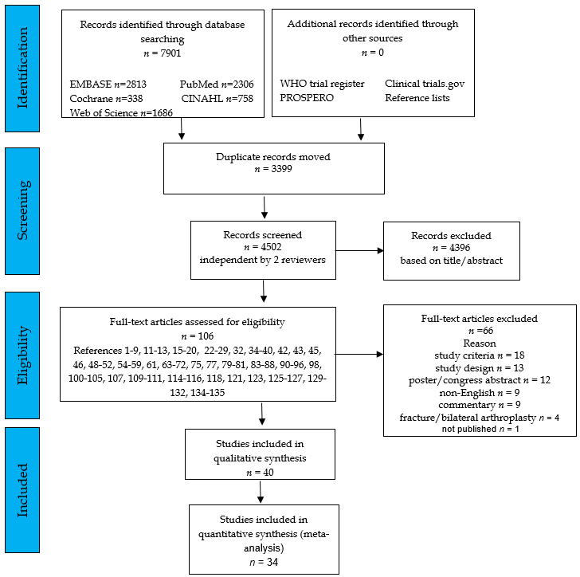
Figure 1 Flow diagram of the literature search and selection procedure. WHO: World Health Organization.
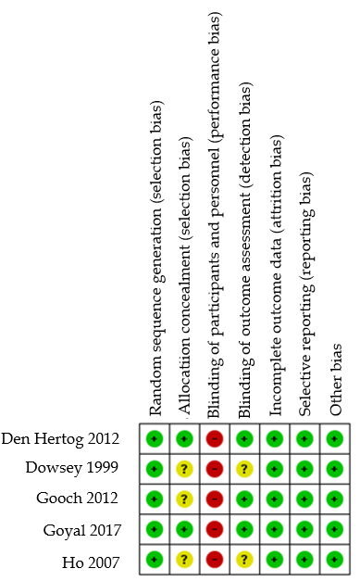
Figure 2 Cochrane risk of bias summary of the randomized controlled trials. Review authors’ judgements about each risk of bias item. Low RoB (green + symbol), high RoB (red - symbol), or unclear RoB (yellow - symbol) is shown.

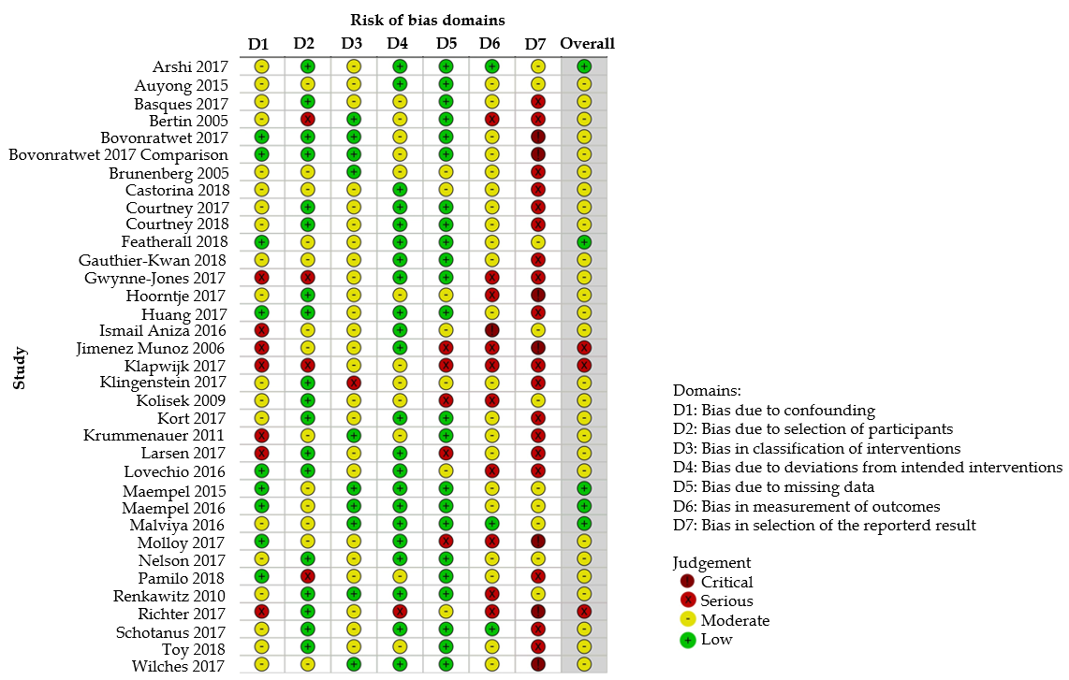
Figure 3 ROBINS-I bias assessment of the non-randomized studies. Review authors' judgements about each risk of bias domain.

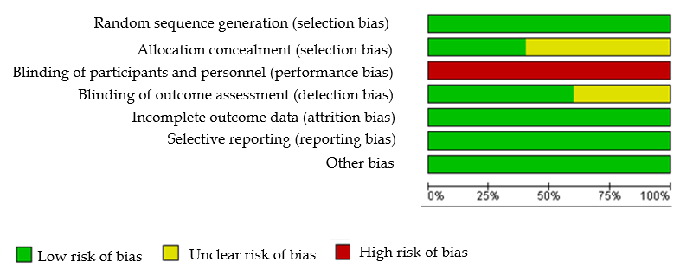
Figure 4 Cochrane RoB graph: Review authors' judgements about each risk of bias item presented as percentages across all included randomized studies.

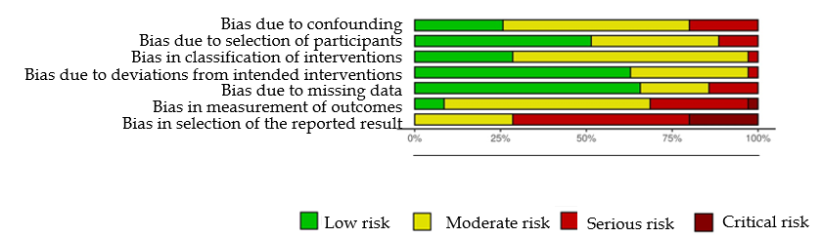
Figure 5 ROBINS-I weighted summary plot.

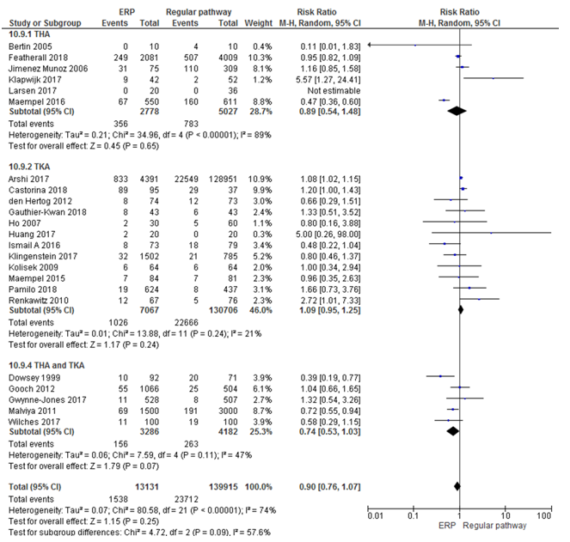
Figure 6 Forest plot with relative risk for each study and pooled relative risk with 95% confidence interval for (serious) adverse events with a follow-up time of 30 d or more for enhanced recovery pathways vs regular pathways for hip and knee arthroplasty. THA: Total hip arthroplasty; TKA: Total knee arthroplasty; CI: Confidence interval; ERP: Enhanced recovery pathways.

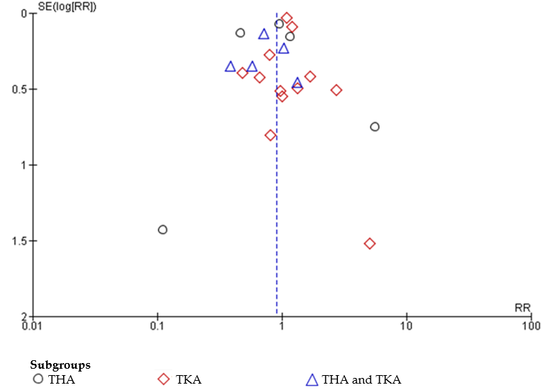
Figure 7 Funnel plot for the studies with described (serious) adverse events with a follow-up time of 30 d or more. THA: Total hip arthroplasty; TKA: Total knee arthroplasty; RR: Risk ratio.

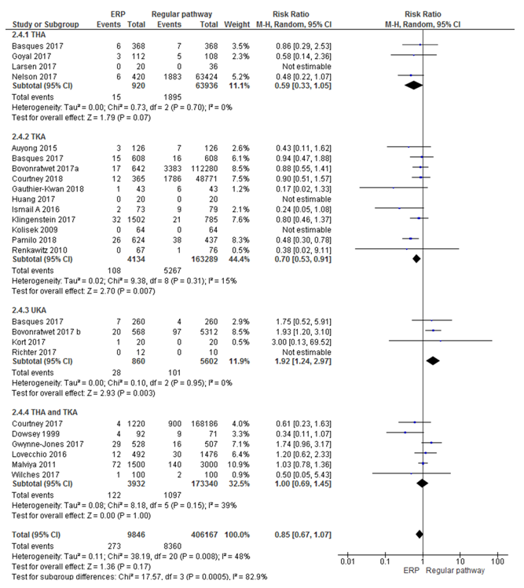
Figure 8 Forest plot with relative risk for each study and pooled relative risk with 95% confidence interval for readmission for enhanced recovery pathways vs regular pathways. THA: Total hip arthroplasty; TKA: Total knee arthroplasty; CI: Confidence interval; ERP: Enhanced recovery pathways.

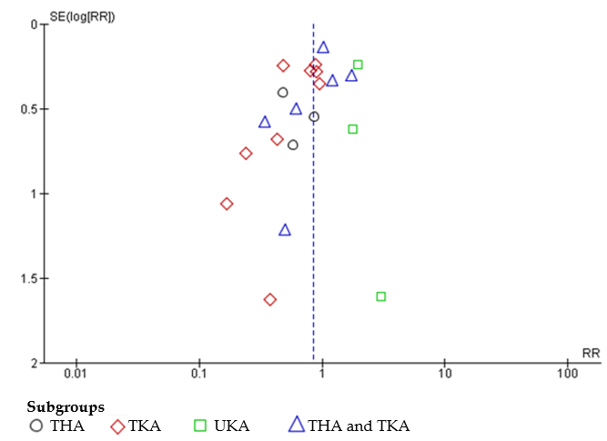
Figure 9 Funnel plot for the studies with described readmission. THA: Total hip arthroplasty; TKA: Total knee arthroplasty; UKA: Unicompartmental knee arthroplasty; RR: Risk ratio.

Table 1 Characteristics of the included studies, patient demographics, ERP versus regular pathways, and outcome
Author/year | Procedure | Study design | Country/setting | ERP/regular pathway | Number participants ERP/regular pathway | Participants characteristics  ERP/regular pathway | Outcome
Arshi et al^{[42]}; 2017 | TKA | Retrospective cohort | United States; Humana subset of the pearl-diver patient record database | Outpatient/inpatient | n = 133.342; 4.391/128.951 | Age: (70-74), modus 65-69; Men-women: (1.560-2.831)/(46.805-82.146) | LoS, (S)AE
Auyong et al^{[36]}; 2015 | TKA | Retrospective cohort | United States; Medical center | Updated ERAS/ERAS | n = 252; 126/126 | Age: 66.02 (10.02)/68.44 (9.98); Men-women: (44-82)/(41-85); BMI: 31.88 (7.629)/31.3 (6.562) | LoS, (S)AE, functional recovery, PROMs, readmission
Basques et al^{[43]}; 2017 | THA; TKA | Retrospective matched cohort | United States; NSQIP database | Same day/inpatient | n = 177.818, 1.236/176.582; THA: n = 63.360, 368/368; TKA: n = 110.410, 608/608; UKA: n = 4.048, 260/260 | Age: Most between 65-74; Men-women: (46.6%-53.4%)/(39.8%-60.2%); BMI: Most between 25-29.9 | LoS, (S)AE, readmission
Bertin et al^{[26]}; 2005 | THA | Pilot study, retrospectively chosen control group | United States; Hospital | Outpatient/existing protocol | n = 20; 10/10 | Age: 62/63; Men-women: (6-4)/(5-5); BMI: 30.024/29.64 | LoS, (S)AE, costs
Bovonratwet et al^{[44]}; 2017 | TKA | Retrospective cohort | United States; NSQIP database | Outpatient/inpatient | n = 112.922; 642/112.280 | Age: 64/67; Men-women: (265-377)/(41.821-70.459); BMI: 32/33 | LoS, (S)AE, readmission
Bovonratwet et al^{[45]}; 2017 | UKA | Cohort | United States; NSQIP database | Outpatient/inpatient | n = 5880; 568/5312 | Age: 62.9/63.7; Men-women: (284-284)/(2501-2811); BMI: 31.5/31.6 | LoS, (S)AE, readmission
Brunenberg et al^{[27]}; 2005 | THA; TKA | Before-after trial | Netherlands; University hospital | Joint recovery programme/usual care | n = 160; THA: n = 98, 48/50; TKA: n = 62, 30/32 | Age: 64.4 (28-87); THA: Age 63.38 (11.48)/ 65.4 (13.04), Men-women% (35.4-64.6)/(24-76); TKA: Age 64.9(9.43)/63.94 (12.6), Men-women % (33.3-66.7)/(31.3-68.7) | LoS, functional recovery; PROMs; costs
Castorina et al^{[58]}; 2017 | TKA | Retrospective observational cohort study | Italy; Orthopedics traumatology and rehabilitation unit | Fast track/traditional group | n = 132; 95/37 | Age: 71.1 (7.77)/74.62 (± 6.42) | Functional recovery; (S)AE
Courtney et al^{[46]}; 2017 | THA; TKA | Retrospective cohort | United States; NSQIP database | Outpatient/inpatient | n = 169.406; 1220/168.186 | Age: 63.1/65.9; Men-women: (539-681)/(67.687-100.499); BMI: 32.1/31.7 | LoS, (S)AE, readmission
Courtney et al^{[59]}; 2018 | TKA | Retrospective cohort | United States; NSQIP database | Outpatient/short stay/LOS ≥ 2 d | n = 49.136; 365/3033/45.738 |  | LoS, (S)AE, readmission
den Hertog et al^{[7]}; 2012 | TKA | Randomized prospective study | Germany; Hospital | Fast-track group/standard care re-habilitation | n = 147 (ITT), 74/73; n = 140 (PP), 71/69 | Age: 66.58 (8.21)/68.25 (7.91); Men-women: (23-51)/(20-53); BMI: 31.17 (5.82)/30.38 (6.05) | LoS, (S)AE, functional recovery, PROMs
Dowsey et al^{[28]}; 1999 | THA; TKA | Prospective randomized controlled study | Australia; Tertiary hospital | Clinical pathway/control | n = 163; 92/71 | Age: 64.2/68.2; Men-women: 56/107 | LoS, (S)AE, functional recovery, readmission
Featherall et al^{[60]}; 2018 | THA | Cohort | United States; Clinic | Full protocol/transition cohort/Pre-protocol | n = 6090; 2081/2009/2000 | Age: 63.77 (11.72)/64.09 (12.04)/64.03 (12.09); Men-women: (1033-1048)/(983-1026)/(960-1040); BMI: 30.13 (6.17)/ 29.93 (6.19)/ 30.09 (6.38) | LoS, (S)AE, cost
Gauthier-Kwan et al^{[61]}; 2018 | TKA | Prospective comparative cohort | Canada; Hospital | Outpatient/inpatient | n = 86; 43/43 | Age: 62.5 (50.4-75), 62.5 (51.2-74); Men-women: (29-14)/(22-21); BMI: 28.6 (23.7-35.8)/30.4 (23.5-41.6) | LoS, (S)AE, readmission, functional outcome, PROMs
Gooch et al^{[35]}; 2012 | THA; TKA | RCT | Canada; Bone and Joint Health Institute | New clinical pathway/standard care | n = 1570, 1066 (THA: 615; TKA: 451)/504 (THA: 278; TKA: 226) | Age: 69 (11.1)/69 (10.4); Men-women%: (39.6-60.4)/(40.1-59.9); BMI: 29.5 (5.6)/29.4 (5.4) | (S)AE, functional recovery, PROMs
Goyal et al^{[38]}; 2017 | THA | Prospective randomized study | United States; Two reconstruction centres | Outpatient/inpatient | n = 220; 112/108 | Age: 59.8 (8.5) (59.3) (27-74)/60.2 (8.9) (61) (34-74); Men-women: (59-53)/(58-50); BMI: 27.6 (4.1) (27.1) (18-38.4)/ 28.3 (4.7) (27.7) (18.4-39.9) | LoS, (S)AE, readmission, functional recovery, PROMs
Gwynne-Jones et al^{[47]}; 2017 | THA; TKA | Matched cohort study | New Zealand; Hospital | Post ERAS/pre ERAS | n = 1035, 528/507; THA: 318/314; TKA: 210/193 | THA: Age 68.3 (11.8)/66.8 (11.8), Men-women (146-172)/(146-168); TKA: Age 70.4 (8.9)/69.8 (9.0), Men-women: 107-103/83-110 | LoS, (S)AE, readmission, PROMs
Ho et al^{[30]}; 2007 | TKA | Randomized controlled trial; retrospective cost analysis | United States; Tertiary teaching hospital | Critical pathway/no uniform CP | n = 90; 3 cohorts: 30/30/30 | Age: 66/67/68; Men-women: (14-16)/(14-16)/(14-16); Weight: 89/91/88 | LoS, (S)AE, costs
Hoorntje et al^{[48]}; 2017 | UKA | Case control study | Netherlands; Hospital | Outpatient/fast-track | n = 40; 20/20 | Age: 62.2 (5.5)/63.8 (7.5); Men-women: (10-10)/(7-13); BMI: 27.8 (3.7)/30.5 (7.0) | LoS, PROMs
Huang et al^{[49]}; 2017 | TKA | Prospective case control study | Canada; Tertiary academic medical centre | Same day discharge/inpatient | n = 40; 20/20 | Age: 58.5 (5.6)/61.5 (5.9); Men-women: (14-6)/(14-6); BMI: 29.0 (3.7)/30.6 (5.3) | LoS, (S)AE, readmission, cost
Ismail A et al^{[39]}; 2016 | TKA | Non-randomized control trial | Malaysia; University hospital | CP/control | n = 152; 73/79 | Age: 66.1/64.7 | LoS, (S)AE, readmission
Jimenez Muñoz et al^{[29]}; 2006 | THA | Prospective follow-up study | Spain; University general hospital | After CP/prior CP | n = 487; 384/98; 309/75 | Not present | LoS, (S)AE
Klapwijk et al^{[50]}; 2017 | THA | Prospective cohort | Netherlands; Hospital | Outpatient/inpatient | n = 94; 42/52 | Age: 61 (41-78)/68 (48-82); Men-women: (17-25)/(21-31); BMI: 29 (20-35) /26 (18-39) | LoS, (S)AE, functional recovery, PROMs
Klingenstein et al^{[51]}; 2017 | TKA | Retrospective cohort | United States; Joint replacement centre | Short stay/traditional stay | n = 2287; 1502/785 | Age: 71.7 (5.4)/73.3 (6.1); Men-women%: (39-61)/(25-75); BMI ≥ 30 (%): 50/57 | LoS, (S)AE, readmission
Kolisek et al^{[31]}; 2009 | TKA | Prospective matched cohort | United States; Hospital | Outpatient/conventional inpatient stay | n = 128; 64/64 | Age: 55 (42-64)/55 (42-63); Men-women: (40-24)/(40-24); BMI: 30.8 (24.3-38)/30.8(24.2-37.8) | LoS, (S)AE, functional recovery, PROMs, readmission
Kort et al^{[3]}; 2017 | UKA | Case control study | Netherlands; Hospital | Outpatient/rapid recovery | n = 40; 20/20 | Age: 60.5 (5.65)/61.2 (5.15); Men-women: (13-7)/(11-9); BMI: 29.1 (3.85)/27.7 (3.27) | LoS, (S)AE, readmission, PROMs
Larsen et al^{[52]}; 2017 | THA | Observational cohort | Denmark; Orthopedic clinic | Day case (< 12 h)/standard 2-d | n = 56; 20/36 | Age: 64.6; Men-women: 15-5; BMI: 28.8 (23.8-33.7) | LoS, (S)AE, readmission, PROMs
Lovecchio et al^{[40]}; 2016 | THA; TKA | Propensity score matched study | United States; NSQIP database | Outpatient/fast-track inpatients | n = 1968, 492/1476; THA/TKA: (183-585)/(309-891) | Age: Most between 60 to 69; Men-women: (217-275)/(664-812); BMI between 25-30 | LoS, (S)AE, readmission
Maempel et al^{[41]}; 2016 | THA | Prospective cohort | United Kingdom; Hospital | ERP/traditional rehabilitation | n = 1161; 550/611 | Age: 64 (18-94)/66 (23-90); Men-women: (212-338)/(242-369); BMI: 30 (7)/29 (7) | LoS, (S)AE, functional recovery, PROMs
Maempel et al^{[37]}; 2015 | TKA | Non-randomized prospective cohort | United Kingdom; Arthroplasty clinic | ERP/traditional rehabilitation | n = 165; 84/81 | Age: 69.8 (8.9)/70.1 (10.5); Men-women: (42-42)/(37-44); BMI: 32.4 (22.6-46.6)/31.8 (20.5-41.9) | LoS, (S)AE, functional recovery
Malviya et al^{[34]}; 2011 | THA; TKA | Observational study | United Kingdom; Hospital | ERP/traditional pathway | n = 4500; 1500 (THA: 630; TKA: 870)/3000 (THA: 1368; TKA: 1632) | Age: 68/69; Men-women: (711-789)/(1482-1518) | LoS, (S)AE, readmission
Nelson et al^{[54]}; 2017 | THA | Retrospective cohort, data prospectively collected | United States; NSQIP database | Outpatient/inpatient | n = 63.844; 420/63.424 | Age: 62/65; Men-women: (222-198)/(28.587-34.833); BMI most between 25-30 | LoS, (S)AE, readmission
Pamilo et al^{[62]}; 2018 | TKA | Retrospective cohort | Finland; Finnish Hospital Discharge Register | Fast-track CP/non-fast-track | n = 4256, 2310/1946; Hospital A: 624/437 | Age and sex: No statistically significant difference between CP’s | LoS, (S)AE, readmission
Renkawitz et al^{[32]}; 2010 | TKA | Prospective parallel group design | Germany; Orthopaedic university medical centre | Optimized accelerated CP/standard CP | n = 143; 67/76 | Age: 67 (9)/68.1 (11.1); Men-women: (14-53)/(23-53); BMI: 31.4 (5.1)/30.7 (5.6) | LoS, (S)AE, readmission, functional recovery
Richter et al^{[55]}; 2017 | UKA | Retrospective chart review | United States; Surgical outpatient center | Outpatient/inpatient | n = 22; 12/10 | Age: 67.2 (9.2)/64.5 (9.8); Men-women: (7-5)/(8-2); BMI: 28.7 (5.1)/25.8 (8.1) | LoS, (S)AE, readmission, cost
Schotanus et al^{[69]}; 2017 | TKA; UKA | Case control study | Netherlands; Hospital | Outpatient/ERP | n = 361; 94/267 | Age: 63.4 (8.0)/68.4 (9.0); Men-women: (49-45)/(94-173); BMI: 28.25 (3.68)/29.49 (5.05) | LoS, PROMs
Toy et al^{[63]}; 2018 | THA | Retrospective cohort | United States; Ambulatory surgery centers | Later outpatient pathway/initial outpatient pathway | n = 145; 72/73 | Age: 55 (27-70); Men-women: 76-49; BMI: 29.7 (19.6-43) | LoS, (S)AE, readmission
Wilche et al^{[57]}; 2017 | THA; TKA | Retrospective review | Spain; Hospital | Fast-track recovery/conventional recovery | n = 200; THA: 50/50; TKA: 50/50 | Age: 69.24 (9.64)/73.07 (8.33); Men-women: (40-60)/(40-60) | LoS, (S)AE, readmission, cost
Age in years, mean ± SD (median) (range); Weight in kg. BMI: Body mass index; NSQIP: National Surgical Quality Improvement Program; THA: Total hip arthroplasty; TKA: Total knee arthroplasty; CP: Clinical pathway; UKA: Unicompartmental knee arthroplasty; Los: Length of hospital stay; (S)AE: (Serious) adverse events; PROMS: Patient reported outcome measures; ERP: Enhanced recovery pathways; ERAS: Enhanced Recovery After Orthopedic Surgery; RCT: Randomized controlled trial.

Table 2 Pre-, peri-, and post-operative management during enhanced recovery pathways
Author | Year | ERP |  |  | Preoperative |  |  |  |  | Peri-operative |  |  |  |  |  |  | Post-operative
 |  | Pre-operative | Peri-operative | Post-operative | Education | Outpatient consultation | Discharge planning | Physiotherapy | Pre-assessment outpatient clinic | Day of surgery admission | Pre-medication | Optimal hydration | Neuraxial-regional anaesthesia | Multimodal blood loss reduction | +/- peri articular injection | Avoid surgical drains | Multi-modal analgesia regimen | Day of surgery mobilisation | Venous thromboembolic prophylaxis | Rehabilitation programme | Early discharge home
Arshi et al^{[42]} | 2017 |  |  | X |  |  |  |  |  |  |  |  |  |  |  |  |  |  |  |  | X
Auyong et al^{[36]} | 2015 | X | X | X | X |  |  |  |  |  | X |  | X |  |  |  | X | X |  |  | X
Basques et al^{[43]} | 2017 |  |  | X |  |  |  |  |  |  |  |  |  |  |  |  |  |  |  |  | X
Bertin et al^{[26]} | 2005 | X | X | X |  |  |  | X |  |  | X |  | X |  |  |  |  |  |  | X | X
Bovonratwet et al^{[44]} | 2017 |  |  | X |  |  |  |  |  |  |  |  |  |  |  |  |  |  |  |  | X
Bovonratwet et al^{[45]} | 2017 |  |  | X |  |  |  |  |  |  |  |  |  |  |  |  |  |  |  |  | X
Brunenberg et al^{[27]} | 2005 | X |  | X | X |  |  |  | X |  |  |  |  |  |  |  |  |  |  | X
Castorina et al^{[58]} | 2017 | X | X | X |  |  |  |  |  |  |  |  | X |  |  |  | X
Courtney et al^{[46]} | 2017 |  |  | X |  |  |  |  |  |  |  |  |  |  |  |  |  |  |  |  | X
Courtney et al^{[59]} | 2018 |  |  | X |  |  |  |  |  |  |  |  |  |  |  |  |  |  |  |  | X
den Hertog et al^{[7]} | 2012 | X |  | X |  |  |  |  |  |  |  |  |  |  |  |  |  | X |  | X | X
Dowsey et al^{[28]} | 1999 |  | X | X
Featherall et al^{[60]} | 2018 | X | X | X |  |  |  |  | X |  |  |  |  |  | X |  | X |  |  | X
Gauthier-Kwan et al^{[61]} | 2018 | X | X | X | X |  |  |  |  |  | X |  | X |  |  |  | X |  |  | X | X
Gooch et al^{[35]} | 2012 | X | X | X | X | X | X | X |  |  | X |  | X |  |  |  |  | X |  | X
Goyal et al^{[38]} | 2017 |  |  | X |  |  |  |  |  |  |  |  |  |  |  |  | X |  |  |  | X
Gwynne-Jones et al^{[47]} | 2017 | X | X | X | X |  |  |  |  | X | X |  | X | X |  |  |  | X |  | X
Ho et al^{[30]} | 2007 | X | X
Hoorntje et al^{[48]} | 2017 | X | X | X |  |  |  |  |  |  |  | X |  |  |  |  |  |  |  | X | X
Huang et al^{[49]} | 2017 | X | X | X |  | X |  |  |  | X |  |  |  |  | X |  |  |  |  | X
Ismail A et al^{[39]} | 2016
Jimenez Muñoz et al^{[29]} | 2006 |  |  | X |  |  |  |  |  |  |  |  |  |  |  |  |  |  |  | X | X
Klapwijk et al^{[50]} | 2017 | X | X | X | X |  |  |  |  |  | X |  | X |  |  | X |  | X
Klingenstein et al^{[51]} | 2017 |  |  | X |  |  |  |  |  |  |  |  |  |  |  |  |  |  |  |  | X
Kolisek et al^{[31]} | 2009 | X |  | X |  |  |  |  |  |  |  |  |  |  |  |  |  | X |  | X | X
Kort et al^{[3]} | 2017 | X | X | X |  |  | X | X |  | X | X |  |  |  |  |  |  |  |  | X | X
Krummenauer et al^{[33]} | 2011 | X |  | X | X | X |  |  |  |  |  |  |  |  |  |  |  |  |  | X
Larsen et al^{[52]} | 2017 | X |  | X | X |  |  |  |  |  |  |  |  |  |  |  |  | X
Lovecchio et al^{[40]} | 2016 |  |  | X |  |  |  |  |  |  |  |  |  |  |  |  |  |  |  |  | X
Maempel et al^{[41]} | 2016 | X | X | X | X | X | X | X |  |  |  |  | X |  |  |  |  | X
Maempel et al^{[37]} | 2015 | X | X | X |  | X |  |  |  | X |  |  | X |  |  |  |  | X
Malviya et al^{[34]} | 2011 | X | X | X | X |  |  |  | X |  | X |  | X |  |  |  |  | X
Molloy et al^{[53]} | 2017
Nelson et al^{[54]} | 2017 |  |  | X |  |  |  |  |  |  |  |  |  |  |  |  |  |  |  |  | X
Pamilo et al^{[62]} | 2018 | X |  |  | X | X
Renkawitz et al^{[32]} | 2010 | X | X | X | X | X |  |  | X |  |  |  |  |  |  |  |  | X |  | X
Richter et al^{[55]} | 2017 |  |  | X |  |  |  |  |  |  |  |  |  |  |  |  |  |  |  |  | X
Schotanus et al^{[69]} | 2017 | X | X | X |  |  | X |  |  | X |  |  |  |  |  |  |  | X
Toy et al^{[63]} | 2018 | X |  |  |  | X
Wilches et al^{[57]} | 2017 | X | X | X | X |  |  |  | X |  | X | X | X | X |  |  |  | X |  | X
ERP: Enhanced recovery pathways.
Table 3 Grading of Recommendation, Assessment, Development and Evaluation evidence profile: Enhanced recovery pathways compared to regular pathways for hip and knee arthroplasty
Quality assessment |  |  |  |  |  |  | No of patients |  | Effect |  | Quality | Importance
No of studies | Design | Risk of bias | Inconsistency | Indirectness | Imprecision | Other considerations | (S)AE | Control | Relative (95% CI) | Absolute
Functional recovery (follow-up 24 mo)
12 | Randomised trials | No serious risk of bias | Serious¹ | No serious indirectness | No serious imprecision | None | 0/2289 (0%) | 0/1802 (0%) | Not pooled | Not pooled | Moderate | Important
 |  |  |  |  |  |  |  | 0% |  | Not pooled
PROMs (follow-up 24 mo; Better indicated by lower values)
15 | Randomised trials | No serious risk of bias | Serious² | No serious indirectness | No serious imprecision | None | 2966 | 2388 | - | Not pooled | Moderate | Important
LoS (follow-up 24 mo; Better indicated by lower values)
38 | Randomised trials | No serious risk of bias | No serious inconsistency | No serious indirectness | No serious imprecision | None | 997447 | 1573895 | - | MD 2.45 lower (3.42 to 1.48 lower) | High | Important
(S)AEs
34 | Randomised trials | No serious risk of bias | No serious inconsistency | Serious³ | No serious imprecision | None | 2103/18344 (11.5%) | 83989/540864 (15.5%) | RR 0.91 (0.78 to 1.06) | 14 fewer per 1000 (from 34 fewer to 9 more) | Moderate | Important
 |  |  |  |  |  |  |  | 11.7% |  | 11 fewer per 1000 (from 26 fewer to 7 more)
Readmission (follow-up 24 mo)
23 | Randomised trials | No serious risk of bias | No serious inconsistency | No serious indirectness | Serious⁴ | None | 273/9846 (2.8%) | 8360/406167 (2.1%) | RR 0.83 (0.65 to 1.07) | 3 fewer per 1000 (from 7 fewer to 1 more) | Moderate | Important
 |  |  |  |  |  |  |  | 2.7% |  | 5 fewer per 1000 (from 9 fewer to 2 more)
¹Different outcomes for functional recovery: HHS [with/without range of motion (ROM), pain], American Knee Society Score, ROM.
²Different patient reported outcome measures: SF-36, WOMAC, KATZ.
³No clear distinction between adverse event (AE) and serious AE.
⁴Wide confidence interval.
(S)AE: (Serious) adverse event; CI: Confidence interval; PROMS: Patient reported outcome measures; LoS: Length of hospital stay; RR: Relative risk.

