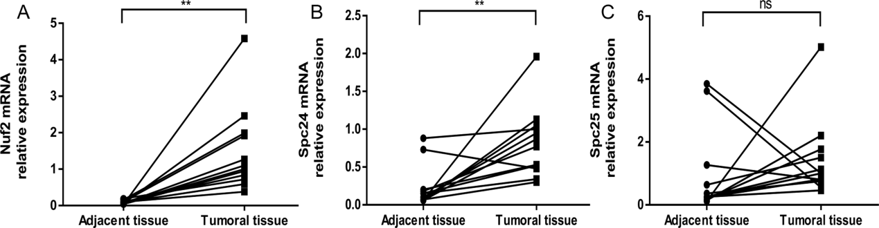
Supplementary Figure 1 qRT-PCR results on Nuf2, Spc24 and Spc25 mRNA expression. A: The expression levels of Nuf2 mRNA in hepatocellular cancer and paired adjacent tissue samples; B: The expression levels of Spc24 mRNA in hepatocellular cancer and paired adjacent tissue samples; C: The expression levels of Spc25 mRNA in hepatocellular cancer and paired adjacent tissue samples; GAPDH was used as an internal control. Statistical significance was assessed by paired t tests (**, P <0.01; ns, no significance).

