Name of journal: World Journal of Gastroenterology
ESPS Manuscript NO: 17718
Columns: ORIGINAL ARTICLE

retrospective study
Xanthogranulomatous cholecystitis: the difficulty in differential diagnosis of gallbladder cancer

Suzuki H et al. Differential diagnosis of Xanthogranulomatous cholecystitis

Hideki Suzuki, Satoshi Wada, Kenichiro Araki, Norio Kubo, Akira Watanabe, Mariko Tsukagoshi, Hiroyuki Kuwano

Hideki Suzuki, Satoshi Wada, Kenichiro Araki, Norio Kubo, Akira Watanabe, Mariko Tsukagoshi, Hiroyuki Kuwano, Department of General Surgical Science (Surgery I), Gunma University Graduate School of Medicine, Gunma University, Maebashi 371-8511, Japan

Author contributions: Kuwano H designed research; Wada S, Araki K and Kubo n performed research; Watanabe A and Tsukagoshi M analyzed data.

Institutional review board statement: This study is not a formal study with a protocol, therefore no submission was made the Hospital Ethics Review Board.

Informed consent statement: In this retrospective study, written informed consent was not provided by the participants, but the presented data are anonymized and risk of identification is low.

Conflict-of-interest statement: None of the authors of this manuscript have any conflicts of interest to declare.

Data sharing statement: Technical appendix, statistical code, and dataset available from the corresponding author at hidesuzuki044@gmail.com. Participants gave informed consent for data sharing.

Open-Access: This article is an open-access article which was selected by an in-house editor and fully peer-reviewed by external reviewers. It is distributed in accordance with the Creative Commons Attribution Non Commercial (CC BY-NC 4.0) license, which permits others to distribute, remix, adapt, build upon this work non-commercially, and license their derivative works on different terms, provided the original work is properly cited and the use is non-commercial. See: http://creativecommons.org/licenses/by-nc/4.0/

Correspondence to: Hideki Suzuki, MD, Department of General Surgical Science (Surgery I), Gunma University Graduate School of Medicine, Gunma University, 3-39-22 Showa-machi, Maebashi 371-8511, Japan. hidesuzuki044@gmail.com
Telephone: +81-272-208224
Fax: +81-272-208230

Received: March 20, 2015
Peer-review started: March 25, 2015
First decision: April 23, 2015
Revised: May 13, 2015
Accepted: July 18, 2015

Article in press:
Published online:

Abstract
Aim: To compare cases of Xanthogranulomatous cholecystitis (XGC) and advanced gallbladder cancer and discuss the different diagnoses and surgical options.

Methods: From April 2000 to December 2013, 6 patients received extended surgical resections. In the same period, 16 patients had proven gall bladder (GB) cancer, according to extended surgical resection. Subjects chosen for analysis in this study were restricted to cases of XGC with indistinct borders with the liver because it is often difficult to distinguish these patients from cases of advanced gallbladder cancer. We made a comparison of the clinical factors and computed tomography findings between XGC and advanced gallbladder cancer. The following clinical factors were retrospectively assessed: age, gender, symptoms, tumor marker. Because albumin and the neutrophil/lymphocyte ratio (NLR) are prognostic in several cancers, we compared serum albumin levels and the NLR between the two groups. The computerized tomography findings used for comparison between the two diseases in the gallbladder were the coexistence of gallstones, the pattern of gallbladder thickening (focal or diffuse), the presence of a hypoattenuated intramural nodule, and continuity of the mucosal line.

Results: Based on the preoperative image findings, we suspected GB carcinoma in all cases including XGC in this series. Additionally, we found by pathological examination that the group of patients with XGC contracted inflammatory disease after the operation. Patients with XGC have a tendency to have abdominal pain (4/6, 67%). However, there was no significant difference in clinical symptoms, including fever, between the two groups. Serum albumin and NLR were also the same in the two groups. Serum tumor markers, such as carcinoembryonic antigen (CEA) and carbohydrate antigen 19-9 (CA19-9), tended to increase in patients with GB cancer. However, there were also no significant differences identified for tumor markers. On the other hand, gallstones were more frequently observed in patients with XGC (5/6, 83%) than in the patients with GB cancer (4/12, 33%) (p = 0.0116). A hypoattenuated intramural nodule was found in 3 patients with XGC (3/6, 50%) but in only 1 patient with GB cancer (1/16, 6%) (p = 0.0024). The gallbladder thickness, continuous mucosal line, and bile duct dilatation showed no significant differences between XGC and GB cancer.

Conclusion: Although XGC is often difficult to differentiate from GB carcinoma, it is possible to obtain an accurate diagnosis from intraoperative careful gross observation, and several intraoperative frozen sections.

Key words: Xanthogranulomatous cholecystitis; advanced gallbladder cancer; differential diagnosis

© The Author(s) 2015. Published by Baishideng Publishing Group Inc. All rights reserved.

Core tip: Xanthogranulomatous cholecystitis (XGC) is a rare inflammatory disease of the gallbladder. Making a differential diagnosis between XGC and malignant gallbladder lesions is often difficult, especially in patients with severe proliferative fibrosis involving the gallbladder and surrounding organs. We made a comparison of the clinical factors and computed tomography findings between XGC and advanced gallbladder cancer. There were almost no significant differences between two groups. Although XGC is often difficult to differentiate from gall bladder carcinoma, there is a possibility to obtain accurate diagnosis from intraoperative careful gross observation and intraoperative several frozen sections could prevent extended resections.

Suzuki H, Wada S, Araki K, Kubo N, Watanabe A, Tsukagoshi M, Kuwano H. Xanthogranulomatous cholecystitis: the difficulty in differential diagnosis of gallbladder cancer. World J Gastroenterol 2015; In press

Introduction
Xanthogranulomatous cholecystitis (XGC) is a rare inflammatory disease of the gallbladder. The characteristic macroscopic findings of XGC include abnormal thickening of the wall and severe proliferative fibrosis with formation of multiple yellow-brown intramural nodules^{[1,2]}.
Although the mechanism that leads to this condition remains unclear, XGC is supposed to start as a biliary obstruction with acute or chronic cholelithiasis and increasing intra-gallbladder pressure. It is believed that this pressure provokes a rupture of the Rokitansky-Aschoff sinuses or mucosal ulcer with extravasation of bile in the interstitial tissues and consequent xanthogranulomatous inflammatory reaction^{[3,4]}. This inflammatory process is often extensive and may extend to adjacent organs, forming dense adhesions with a large mass of inflammatory tissue surrounding the gallbladder.
The clinical manifestations of XGC are usually acute or chronic cholecystitis. The main symptoms include right hypochondrial pain, radiating pain in the shoulder, fever, and nausea^{[5]}. However, some patients with XGC did not have these symptoms. As with the computed tomography (CT) findings, an enhanced continuous mucosal line in the CT features had an effect on the diagnosis for patients with XGC. Moreover, Uchiyama et al. insisted that the enhanced continuous mucosal line with gallstones was highly suggestive of XGC^{[6]}. However, despite the use of these imaging techniques, a differential diagnosis between XGC and malignant gallbladder lesions is often difficult to make, especially in patients with severe proliferative fibrosis involving the GB and surrounding organs.
In this study, we compared cases of XGC that had indistinct borders with the liver suggestive of gallbladder cancer and required extended surgical resections to cases of advanced gallbladder cancer that had invaded the liver. We discuss the different diagnostic and surgical options in cases of XGC with extensive involvement of extra-gallbladder organs.

MATERIALS AND METHODS
From April 2000 to December 2013, 6 XGC patients received extended surgical resections. In the same period, 16 patients had proven GB cancer, according to extended surgical resections at Gunma University Hospital, Department of Surgery 1. Subjects chosen for analysis in this study were restricted to cases of XGC with indistinct borders with the liver because it is often difficult to distinguish these patients from cases of advanced gallbladder cancer. Preoperative evaluation was carried out with ultrasonography (US), CT, magnetic resonance imaging, and FDG-PET. In addition, some patients underwent endoscope retrograde cholangiopancreatography (ERCP) and/or percutaneous transhepatic biliary drainage (PTCD) for diagnosis and/or biliary decompression. Based on these image findings, surgical treatment was performed following the guidelines for the management of biliary tract and ampullary carcinomas^{[7]}. The following clinical factors were retrospectively assessed: age, gender, and symptoms. Because albumin and the neutrophil/lymphocyte ratio (NLR) are prognostic in several cancers^{[8]}, we compared serum albumin levels and the NLR between the two groups. The NLR was calculated from a complete blood count in laboratory testing before the operation. Tumor markers CEA and CA19-9 were also serologically analyzed. The CT findings used for comparison between the two diseases in the gallbladder were the coexistence of gallstones, the pattern of gallbladder thickening (focal or diffuse), the presence of a hypoattenuated intramural nodule, and continuity of the mucosal line. Two radiologists evaluated these images independently and by consensus for the diagnosis.

Statistical method
Statistical computations were performed with JMP (SAS Institute, Cary, North Carolina, United States). Continuous variables were expressed as medians and were compared using the Wilcoxon test, whereas categorical variables were compared using Fisher’s exact test or the χ² test. A p-value of less than 0.05 indicates statistical significance.

Results
The clinical symptoms, laboratory findings, and CT findings are summarized in Table 1. Based on the preoperative image findings, we suspected GB carcinoma in all cases including XGC in this series. Additionally, we found by pathological examination that the group of patients with XGC contracted inflammatory disease after the operation.
Patients with XGC have a tendency to have abdominal pain (4/6, 67%). However, there was no significant difference in clinical symptoms, including fever, between the two groups. Serum albumin and NLR were also the same in the two groups. Serum tumor markers, such as carcinoembryonic antigen (CEA) and carbohydrate antigen 19-9 (CA19-9), tended to increase in patients with GB cancer. However, there were also no significant differences identified for tumor markers.
On the other hand, gallstones were more frequently observed in patients with XGC (5/6, 83%) than in the patients with GB cancer (4/12, 33%) (p = 0.0116). A hypoattenuated intramural nodule was found in 3 patients with XGC (3/6, 50%) but in only 1 patient with GB cancer (1/16, 6%) (p = 0.0024). The gallbladder thickness, continuous mucosal line, and bile duct dilatation showed no significant differences between XGC and GB cancer.

Case 1
A 70-year-old woman was admitted to our hospital with abnormal findings of abdominal CT during follow-up of rectal cancer after a low anterior resection. She had neither fever nor abdominal pain. On admission, laboratory data, including tumor markers, were nearly normal. A CT scan showed a large mass and stone (arrow) with suspected findings of hepatic invasion (Figure 1a). Moreover, CT findings detected an asymmetrically thickened gallbladder wall with homogenous enhancement that was continuous along the mucosal line and a submucosal hypoattenuated nodule (arrow) (Figure 1b). Positron emission tomography with fluorine-18-labeled fluoro-deoxyglucose (FDG-PET) showed increased uptake at the tumor site, and the maximum standardized uptake value (SUV) was 10.2 (arrow) (Figure 2). Assuming an advanced gallbladder carcinoma, we performed an extended right hepatectomy after portal vein embolization. Histologically, the gallbladder mucosa showed hyperplasia, but neither atypical cells nor malignant cells (arrow) (Figure 3a). The adjacent liver showed diffuse inflammatory infiltrates consisting of giant histiocytes and foamy histiocytes with clear lipid-containing cytoplasm (xanthoma cells), lymphocytes, and polymorphonuclear cells (Figure 3b).
The postoperative course was uneventful, and the patient was discharged on the 21st postoperative day.

Case 2
A 72-year-old man was found to be jaundiced during a medical examination. He was admitted to the local hospital for evaluation. An endoscopic retrograde cholangiography (ERC) demonstrated a filiform stenosis of the proximal common bile duct and bifurcation with left intrahepatic bile duct dilatation. The right hepatic branch was not visualized on the cholangiography (Figure 4). A complete sphincterotomy was performed with insertion of an internal stent drainage.
CT confirmed the hypodense mass at the hilum (Figure 5a) and intrahepatic bile duct dilatation caused by this tumor (Figure 5b). The patient was then transferred to our hospital with the diagnosis of advanced gallbladder cancer.
The tumor marker carbohydrate antigen 19-9 (CA19-9) and carcinoembryonic antigen (CEA) were not elevated, having laboratory values of 14 U/ml and 2.4 U/ml, respectively. However, FDG-PET demonstrated intense FDG activity at the hepatic hilum, which suggested gallbladder carcinoma (SUVmax 5.2) (Figure 6). Therefore, we diagnosed advanced gallbladder cancer and were planning to perform an extended right lobectomy with extirpation of the extrahepatic bile duct. During the operation, a hard and thickened gallbladder wall was identified at the hepatic hilum. A frozen section of the gallbladder was negative for carcinoma. However, as there were many intrahepatic stones and severe bile duct stenosis at the right bile duct bifurcation, we performed posterior hepatic resection with extirpation of the extrahepatic bile duct. Reconstruction was performed with a Roux-en-Y hepaticojejunostomy. Histologically, the gallbladder wall was markedly thickened with severe inflammation and fibrosis (Figure 7a). Large xanthoma cells with clear-to-foamy lipid-containing cytoplasm along with interspersed lymphocytes were invaded to the liver (Figure 7b). These findings are characteristic of xanthogranulomatous inflammation of the gallbladder. The patient suffered from cholangitis after the operation. However, he was cured by the conservative therapy and discharged approximately 2 months after the operation.

Discussion
Xanthogranulomatous cholecystitis (XGC) is a rare form of chronic cholecystitis that accounts for 1.3% to 5.2% of resected gallbladder specimens^{[4,9]}. The characteristic macroscopic findings of XGC include abnormal thickening of the gallbladder wall with poorly demarcated soft-to-firm, yellow-brown intramural nodules of various sizes with cholecystitis^{[2,5]}. Complications include gallbladder perforation, abscess formation, fistulous tracts to the duodenum, and extension of the inflammatory process to adjacent abdominal organs, such as the liver and transverse colon^{[10]}. These features that involve adjacent organs indicate that XGC develops aggressively, as does advanced GB cancer. Therefore, it is important to preoperatively differentiate XGC from advanced GB cancer to avoid unnecessary surgical treatment.
The clinical manifestations of XGC usually involves acute or chronic cholecystitis. The primary symptoms included right hypochondrial pain (93.9%), radiating shoulder and back pain (42.4%), fever (24.2%), nausea (33.3%), and vomiting (24.2%)^{[5]}. Abdominal pain, jaundice, and fever were more frequently observed in patients with XGC as compared to patients with GB cancer^{[11]}. However, these symptoms and signs are usually not helpful for differentiating these two conditions, except in advanced cases of malignancy presenting with weight loss or features of ascites or metastases. Despite the tendency for XGC patients in our cases to have abdominal pain, it is difficult to differentiate XGC from GB cancer based only upon symptoms.
Formation of XGC is supposed to start as biliary obstruction with acute or chronic cholecystitis and increasing intra-gallbladder pressure, followed by a granulomatous reaction. Although the pathogenesis of this granulation is not well understood, it has been postulated that obstruction of the gallbladder outflow leads to extravasation of bile into the gallbladder wall, with involvement of the Rokitansky-Aschoff sinuses, or extravasation through a small ulceration in the mucosa. This causes a granulation reaction that leads to the formation of intramural nodules^{[4,12]}. This inflammatory process is often extensive and may extend to adjacent organs, such as the liver, duodenum, and transverse colon. Dense adhesions with a large mass of inflammatory tissue surrounding the gallbladder then form. Our six cases of XGC had inflammatory reactions that extended to the liver and adhesions of the gallbladder to adjacent organs, such as the transverse colon and/or the duodenum; thus, we misdiagnosed them as advanced gallbladder cancer and performed extended radical surgery, including liver resection in all six cases.
Extravasated bile causes histiocytes to accumulate in an effort to phagocytose the insoluble cholesterol. A fibrous reaction and scarring result from the healing of the inflammatory reaction. Microscopically, the early stage of xanthogranulomatous cholecystitis is characterized by a large number of foamy histiocytes with clear lipid-containing cytoplasm and acute inflammatory cells, including lymphocytes, neutrophils, and plasma cells. In the later stage, a fibrous reaction occurs and extends to adjacent structures, such as the liver, omentum, duodenum, or colon^{[13]}. The low-attenuation appearance of XGC nodules at CT is due to the histiocytes that have phagocytosed the extravasated bile and bile lipids and then accumulated in the gallbladder wall. Kim et al. reported that intramural nodules were seen histologically in all patients with XGC but radiologically in only 53% (10/19)^{[14]}.
The imaging modalities are able to detect abnormalities of the gallbladder but are not always able to differentiate advanced GB cancer from XGC. The imaging characteristics of XGC closely resemble those of gallbladder carcinoma in terms of the thickening of the gallbladder wall and the tendency to involve neighboring organs. However, Uchiyama et al^{[6]} insisted that an enhanced continuous mucosal line had an effect on diagnosis for patients with XGC. Moreover, the presence of gallstones with these findings indicates a high likelihood of XGC. On the other, there is some debate as to the coexistence of stones with gallbladder cancer. In our cases, the patients with XGC were associated with a higher incidence of gallstones than the patients with GB carcinoma (p = 0.015). However, due to the limited number of cases, we couldn’t conclude whether the existence of a gallstone is helpful in the differential diagnosis between the XGC and the GB carcinoma. In cases of gallbladder carcinoma, the malignant process more greatly disrupts the mucosal layer and the underlying muscle layer. Reports from ultrasonography characterize XGC as a moderate-to-marked thickening of the GB wall with oval hypoechoic nodules^{[15,16]}. Kim et al^{[17]} reported that the combined ultrasonographic findings of diffuse wall thickening and intramural nodule formation are highly suggestive of a diagnosis of XGC. FDG-PET may identify characterizing lesions of the gallbladder^{[18]}. However, XGC shows a positive image due to FDG uptake by active inflammatory cells^{[19]}. In our two cases showing XGC, the SUV of the tumor was also high, so we could not differentiate GB cancer from XGC by the SUV value. Therefore, FDG-PET would be expected to give a false positive result with cholecystitis, including XGC. A recent case report demonstrated that XGC showed FDG uptake on positron emission tomography that mimicked that of GB carcinoma^{[20]}. FDG-PET may not be very useful for differentiating xanthogranulomatous cholecystitis from carcinoma, as inflammatory lesions also show too much FDG uptake.
XGC can be more easily mistaken for gallbladder cancer macroscopically than radiologically, especially in patients with XGC present with severe proliferative fibrosis involving the GB and surrounding organs. The combination of a gross check of the mucosa with frozen section examination, particularly in areas highly indicative of cancer, is more accurate for differentiating XGC from gallbladder cancer and for excluding the simultaneous presence of XGC and gallbladder cancer^{[21]}. On the other hand, in cases showing extensive invasion of extra-gallbladder organs, the surgical strategy should not be determined only by frozen section examination, since it can give false negative results^{[2,22,23]}. Moreover, it is estimated that XGC and gallbladder cancer coexist in up to 12% of cases^{[16]}. Therefore, even if a preoperative diagnosis is made with fine-needle aspiration cytology^{[24]}, it is important to be aware of the possible coexistence of XGC and cancer in the same gallbladder. Zhuang et al^{[25]} demonstrated that XGC is precancerous in nature, mainly depending on oncogenes such as BCL-2 and c-Myc but not via the pathway associated with anti-oncogenes. Therefore, in addition to several frozen section examinations, careful gross observation during operation is needed even if the pre-operative diagnosis is XGC
As for the treatment of XGC, we must show skepticism with advanced gallbladder cancer. If patients demonstrate features of XGC during preoperative examination, we need to perform fine-needle aspiration cytology of the gallbladder preoperatively^{[24]}. However, radiological differentiation from cancer can be extremely difficult in some cases with the presence of severe inflammation. In addition, although XGC is not believed to be a premalignant lesion, the frequency of XGC and gallbladder cancer coexistence is nearly 10%^{[4]}. Moreover, most of the reported cases with XGC and gallbladder cancer were discovered by histologic examination of the cholecystectomy specimen^{[3]}. We need careful gross observation during operation and several frozen section examinations to treat the XGC which extensively to the surrounding organs.
In conclusion, pseudotumoral XGC has puzzled surgeons in terms of a surgical treatment. Despite the use of modern imaging techniques, a differential diagnosis between XGC and malignant gallbladder lesions is often difficult. Even intraoperative differential diagnosis of XGC from gallbladder carcinoma remains a challenge when XGC is associated with tumor formation and adhesions to the adjacent organs. Since gallbladder carcinoma and XGC may coexist, radical resection, such as liver resection, is justified when malignancy cannot be completely excluded. However, in view of the small number of patients in this study, additional studies on a larger scale are warranted.

comments
Background
Xanthogranulomatous cholecystitis (XGC) is a rare inflammatory disease of the gallbladder. XGC is supposed to start as a biliary obstruction with acute or chronic cholelithiasis and increasing intra-gallbladder pressure. This pressure provokes a rupture of the Rokitansky-Aschoff sinuses or mucosal ulcer with extravasation of bile in the interstitial tissues and consequent xanthogranulomatous inflammatory reaction. This inflammatory process is often extensive and may extend to adjacent organs, forming dense adhesions with a large mass of inflammatory tissue surrounding the gallbladder. Making a differential diagnosis between XGC and malignant gallbladder lesions is often difficult, especially in patients with severe proliferative fibrosis involving the gallbladder and surrounding organs.

Research frontiers
XGC often mimic a gallbladder carcinoma, and may coexist with carcinoma, leading to a diagnostic dilemma. Characteristic pathological radiological and clinical features are sometimes similar to gallbladder carcinoma and contribute to considerable treatment inaccuracy.

Innovations and breakthroughs
Although XGC is often difficult to differentiate from gall bladder (gb) carcinoma, there is a possibility to obtain accurate diagnosis from intraoperative careful gross observation and intraoperative several frozen sections could prevent extended resections.

Applications
XGC with severe proliferative fibrosis involving the gallbladder and surrounding organs need carful intraoperative gross observation and intraoperative several frozen sections.

Terminology
The Xanthogranulomatous process is a form of acute and chronic inflammation characterized by a large number of foamy histiocytes with clear lipid-containing cytoplasma and acute inflammatory cells. In the later stage, a fibrous reaction occurs and extends to adjacent structures, such as the liver duodenum or colon.

Peer-review
XGC is a rare benign disease of the gallbladder. It is difficult to identify with gb cancer before operation. The author tries to make a summary. This article has a better clinical value and is designed reasonably.

REFERENCES
1 Benbow EW. Xanthogranulomatous cholecystitis. Br J Surg 1990; 77: 255-256 [PMID: 2182176]
2 Spinelli A, Schumacher G, Pascher A, Lopez-Hanninen E, Al-Abadi H, Benckert C, Sauer IM, Pratschke J, Neumann UP, Jonas S, Langrehr JM, Neuhaus P. Extended surgical resection for xanthogranulomatous cholecystitis mimicking advanced gallbladder carcinoma: A case report and review of literature. World J Gastroenterol 2006; 12: 2293-2296 [PMID: 16610041]
3 Benbow EW. Xanthogranulomatous cholecystitis associated with carcinoma of the gallbladder. Postgrad Med J 1989; 65: 528-531 [PMID: 2690047]
4 Roberts KM, Parsons MA. Xanthogranulomatous cholecystitis: clinicopathological study of 13 cases. J Clin Pathol 1987; 40: 412-417 [PMID: 3584484]
5 Yang T, Zhang BH, Zhang J, Zhang YJ, Jiang XQ, Wu MC. Surgical treatment of xanthogranulomatous cholecystitis: experience in 33 cases. Hepatobiliary Pancreat Dis Int 2007; 6: 504-508 [PMID: 17897914]
6 Uchiyama K, Ozawa S, Ueno M, Hayami S, Hirono S, Ina S, Kawai M, Tani M, Yamaue H. Xanthogranulomatous cholecystitis: the use of preoperative CT findings to differentiate it from gallbladder carcinoma. J Hepatobiliary Pancreat Surg 2009; 16: 333-338 [PMID: 19280109 DOI: 10.1007/s00534-009-0067-9]
7 Kondo S, Takada T, Miyazaki M, Miyakawa S, Tsukada K, Nagino M, Furuse J, Saito H, Tsuyuguchi T, Yamamoto M, Kayahara M, Kimura F, Yoshitomi H, Nozawa S, Yoshida M, Wada K, Hirano S, Amano H, Miura F. Guidelines for the management of biliary tract and ampullary carcinomas: surgical treatment. J Hepatobiliary Pancreat Surg 2008; 15: 41-54 [PMID: 18274843 DOI: 10.1007/s00534-007-1279-5]
8 McNamara MG, Templeton AJ, Maganti M, Walter T, Horgan AM, McKeever L, Min T, Amir E, Knox JJ. Neutrophil/lymphocyte ratio as a prognostic factor in biliary tract cancer. Eur J Cancer 2014; 50: 1581-1589 [PMID: 24630393 DOI: 10.1016/j.ejca.2014.02.015]
9 Yoshida J, Chijiiwa K, Shimura H, Yamaguchi K, Kinukawa N, Honda H, Tanaka M. Xanthogranulomatous cholecystitis versus gallbladder cancer: clinical differentiating factors. Am Surg 1997; 63: 367-371 [PMID: 9124762]
10 Lee KC, Yamazaki O, Horii K, Hamba H, Higaki I, Hirata S, Inoue T. Mirizzi syndrome caused by xanthogranulomatous cholecystitis: report of a case. Surg Today 1997; 27: 757-761 [PMID: 9306594]
11 Chang BJ, Kim SH, Park HY, Lim SW, Kim J, Lee KH, Lee KT, Rhee JC, Lim JH, Lee JK. Distinguishing xanthogranulomatous cholecystitis from the wall-thickening type of early-stage gallbladder cancer. Gut Liver 2010; 4: 518-523 [PMID: 21253302 DOI: 10.5009/gnl.2010.4.4.518]
12 Goodman ZD, Ishak KG. Xanthogranulomatous cholecystitis. Am J Surg Pathol 1981; 5: 653-659 [PMID: 7337158]
13 Pinocy J, Lange A, König C, Kaiserling E, Becker HD, Kröber SM. Xanthogranulomatous cholecystitis resembling carcinoma with extensive tumorous infiltration of the liver and colon. Langenbecks Arch Surg 2003; 388: 48-51 [PMID: 12690480 DOI: 10.1007/s00423-003-0362-x]
14 Kim PN, Lee SH, Gong GY, Kim JG, Ha HK, Lee YJ, Lee MG, Auh YH. Xanthogranulomatous cholecystitis: radiologic findings with histologic correlation that focuses on intramural nodules. AJR Am J Roentgenol 1999; 172: 949-953 [PMID: 10587127 DOI: 10.2214/ajr.172.4.10587127]
15 Lichtman JB, Varma VA. Ultrasound demonstration of xanthogranulomatous cholecystitis. J Clin Ultrasound 1987; 15: 342-345 [PMID: 3149963]
16 Parra JA, Acinas O, Bueno J, Güezmes A, Fernández MA, Fariñas MC. Xanthogranulomatous cholecystitis: clinical, sonographic, and CT findings in 26 patients. AJR Am J Roentgenol 2000; 174: 979-983 [PMID: 10749233 DOI: 10.2214/ajr.174.4.1740979]
17 Kim PN, Ha HK, Kim YH, Lee MG, Kim MH, Auh YH. US findings of xanthogranulomatous cholecystitis. Clin Radiol 1998; 53: 290-292 [PMID: 9585046]
18 Koh T, Taniguchi H, Yamaguchi A, Kunishima S, Yamagishi H. Differential diagnosis of gallbladder cancer using positron emission tomography with fluorine-18-labeled fluoro-deoxyglucose (FDG-PET). J Surg Oncol 2003; 84: 74-81 [PMID: 14502780 DOI: 10.1002/jso.10295]
19 Anderson CD, Rice MH, Pinson CW, Chapman WC, Chari RS, Delbeke D. Fluorodeoxyglucose PET imaging in the evaluation of gallbladder carcinoma and cholangiocarcinoma. J Gastrointest Surg 2004; 8: 90-97 [PMID: 14746840]
20 Makino I, Yamaguchi T, Sato N, Yasui T, Kita I. Xanthogranulomatous cholecystitis mimicking gallbladder carcinoma with a false-positive result on fluorodeoxyglucose PET. World J Gastroenterol 2009; 15: 3691-3693 [PMID: 19653352]
21 Zhang LF, Hou CS, Liu JY, Xiu DR, Xu Z, Wang LX, Ling XF. Strategies for diagnosis of xanthogranulomatous cholecystitis masquerading as gallbladder cancer. Chin Med J (Engl) 2012; 125: 109-113 [PMID: 22340475]
22 Aoki T, Tsuchida A, Kasuya K, Inoue K, Saito H, Koyanagi Y. Is frozen section effective for diagnosis of unsuspected gallbladder cancer during laparoscopic cholecystectomy? Surg Endosc 2002; 16: 197-200 [PMID: 11961639 DOI: 10.1007/s004640080207]
23 Rastogi A, Singh DK, Sakhuja P, Gondal R. Florid xanthogranulomatous cholecystitis masquerading as invasive gallbladder cancer leading to extensive surgical resection. Indian J Pathol Microbiol 2010; 53: 144-147 [PMID: 20090248 DOI: 10.4103/0377-4929.59209]
24 Krishnani N, Shukla S, Jain M, Pandey R, Gupta RK. Fine needle aspiration cytology in xanthogranulomatous cholecystitis, gallbladder adenocarcinoma and coexistent lesions. Acta Cytol 2000; 44: 508-514 [PMID: 10934941]
25 Zhuang PY, Zhu MJ, Wang JD, Zhou XP, Quan ZW, Shen J. Xanthogranulomatous cholecystitis: a clinicopathological study of its association with gallbladder carcinoma. J Dig Dis 2013; 14: 45-50 [PMID: 23134201 DOI: 10.1111/j.1751-2980.2012.00645.x]

P-Reviewer: Cariati A, Lee KG, Ma YH, Wang W, Xu Z S-Editor: Ma YJ L-Editor: E-Editor:

Table 1 clinical symptoms, laboratory findings, and computed tomography findings
 | Xanthogranulomatous cholecystitis (XGC) (n = 6) | GB carcinoma (n = 16) | p-value
Age (mean ± SD, yr) | 64.3 ± 9.7 | 67.9 ± 12.0 | 0.5148
Gender |  |  | 0.8558
Male | 4 | 8
Female | 2 | 8
Abdominal pain |  |  | 0.4806
presence | 4 | 8
absence | 2 | 8
Fever |  |  | 0.4726
Yes | 1 | 1
No | 5 | 15
Jaundice |  |  | 0.6707
Yes | 1 | 4
No | 5 | 12
Albumin (mean ± SD, mg/dl) | 3.8 ± 0.4 | 3.8 ± 0.3 | 0.8090
Nutrophil lymphocyte ratio  (mean ± SD) | 2.1 ± 0.9 | 2.4 ± 1.0 | 0.6280
CEA (mean ± SD) | 1.9 ± 0.6 | 3.1 ± 3.5 | 0.2205
CA19-9 (mean ± SD) | 232.7 ± 488.5 | 354.0 ± 737.1 | 0.6806
Cholecyst lithiasis |  |  | 0.0116
Yes | 5 | 4
No | 1 | 12
Diffuse gallbladder wall thickening (CT findings) |  |  | 0.1551
Yes | 3 | 3
No | 3 | 13
Continuous mucosal line (CT findings) |  |  | 0.0616
Yes | 3 | 2
No | 3 | 14
Intramural hypoattenuated nodule |  |  | 0.0024
Yes | 3 | 1
No | 3 | 15
Bile duct dilatation |  |  | 0.9035
Yes | 1 | 3
No | 5 | 13
XGC: Xanthogranulomatous cholecystitis; GB: gall bladder; CT: computed tomography.

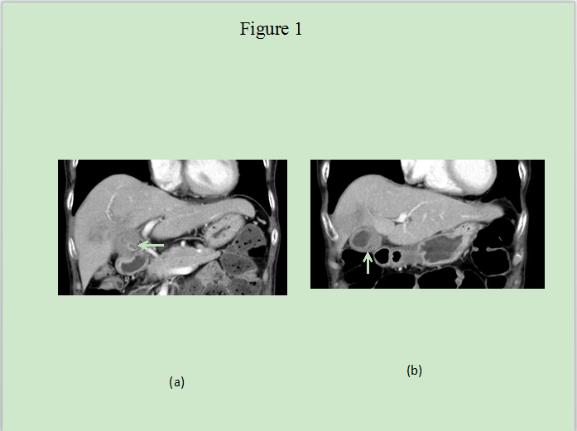
Figure 1 Computed tomography scan revealing a large mass and stone (arrow) with suspected findings of hepatic invasion (a) and asymmetric thickened gallbladder wall with homogeneous enhancement of a continuous mucosal line and submucosal hypoattenuated nodule (arrow) (b).

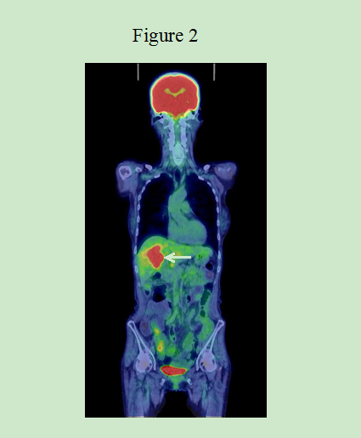
Figure 2 Fluorodeoxyglucose positron emission tomography showing abnormal accumulation in the hepatic hilum (SUVmax = 10.2).

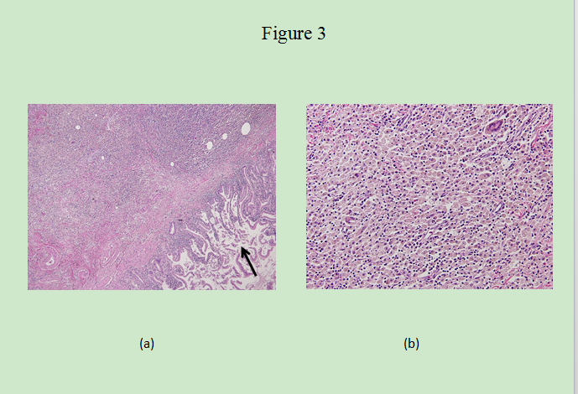
Figure 3 Histology of the gallbladder mucosa showing hyperplasia (a), HE × 200; the adjacent liver showing diffuse inflammatory infiltrate consisting of giant histiocytes and foamy histiocytes with clear lipid-containing cytoplasm, lymphocytes, and polymorphonuclear cells (b), HE × 400.

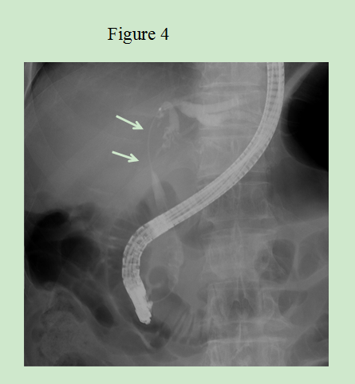
Figure 4 endoscopic retrograde cholangiography revealing a filiform stenosis of the proximal common bile duct and bifurcation. ERC: endoscopic retrograde cholangiography.

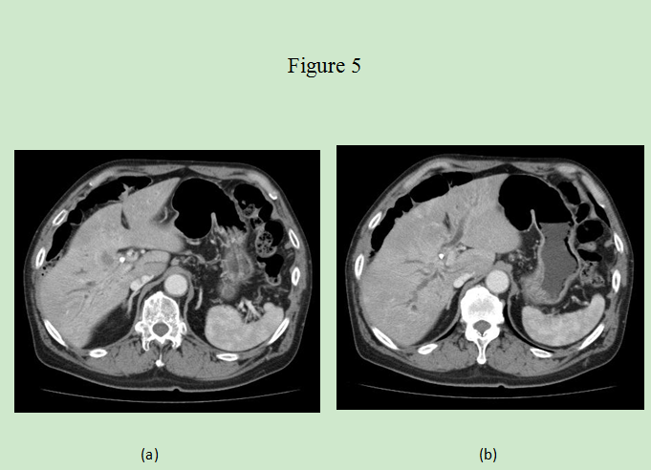
Figure 5 Computed tomography scan revealing a hypodense mass at the hilum (a) and intrahepatic bile duct dilatation due to this tumor (b).

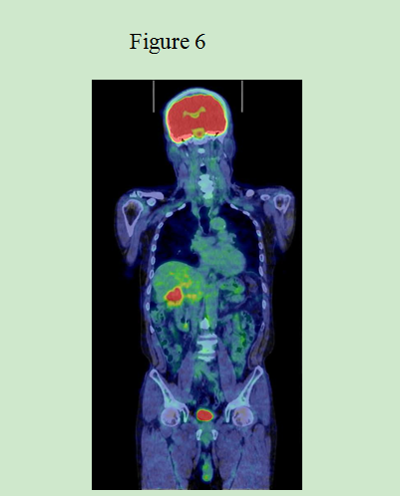
Figure 6 Fluorodeoxyglucose positron emission tomography showing abnormal accumulation at the hepatic hilum (SUVmax = 5.2).

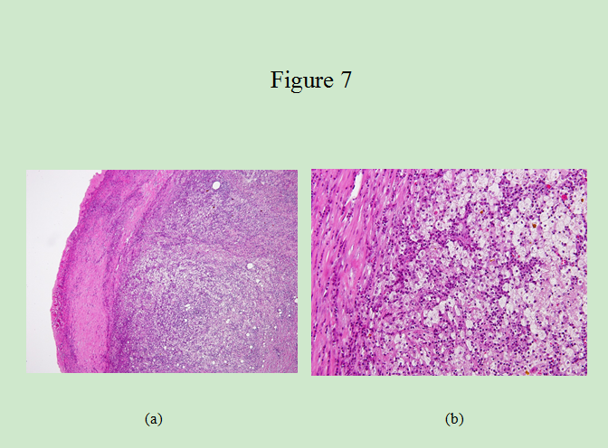
Figure 7 Microscopic examination revealing a gallbladder wall markedly thickened with severe inflammation and fibrosis (a), HE × 200; Large xanthoma cell with clear-to-foamy lipid-containing cytoplasm along with interspersed lymphocytes invading the liver (b), HE × 400.

