Name of Journal: World Journal of Gastroenterology
Manuscript NO: 41572
Manuscript Type: ORIGINAL ARTICLE

Basic Study
Piwi like RNA-mediated gene silencing 1 gene as a possible major player in gastric cancer

Araújo T et al. PIWIL1 gene in gastric cancer

Taíssa Araújo, André Khayat, Luciana Quintana, Danielle Calcagno, Ronald Mourão, Antônio Modesto, Juliana Paiva, Adhara Lima, Fabiano Moreira, Edivaldo Oliveira, Michel Souza, Moneeb Othman, Thomas Liehr, Sidney Santos, Paulo Assumpção

Taíssa Araújo, André Khayat, Luciana Quintana, Danielle Calcagno, Ronald Mourão, Antônio Modesto, Juliana Paiva, Adhara Lima, Fabiano Moreira, Sidney Santos, Paulo Assumpção, Núcleo de Pesquisas em Oncologia, Universidade Federal do Pará, Belém 66073-000, Brazil

Edivaldo Oliveira, Michel Souza, Laboratório de Cultura de Tecidos e Citogenética, Instituto Evandro Chagas, Belém 66087-082, Brazil

Moneeb Othman, Thomas Liehr, Institute of Human Genetics, Universitätsklinikum Jena, Jena 07747, Germany

ORCID number: Taíssa Araújo (0000-0002-1716-4445); André Khayat (000-0002-3451-6369); Luciana Quintana (0000-0003-3261-910X); Danielle Calcagno (0000-0002-4429-2573); Ronald Mourão (0000-0001-5582-4961); Antônio Modesto (0000-0003-1854-0358); Juliana Paiva (0000-0002-2082-2250); Adhara Lima (0000-0001-6315-2392); Fabiano Moreira (0000-0002-2799-3546); Edivaldo Oliveira (0000-0001-6315-3352); Michel Souza (0000-0003-1038-6448); Moneeb Othman (0000-0002-0743-1191); Thomas Liehr (0000-0003-1672-3054); Sidney Santos (0000-0002-8622-9417); Paulo Assumpção (0000-0003-3846-8445).

Author contributions: Araújo T and Khayat A contributed equally to this work; Araújo T and Khayat A performed the majority of experiments; Moreira F, Oliveira E and Souza M analyzed the data; Modesto A, Paiva J and Lima A performed the molecular investigations; Quintana L, Calcagno D and Mourão R participated equally in cell culture management; Othman M and Liehr T performed molecular cytogenetics experiments; Santos S and Assumpção P designed and coordinated the research; Araújo T , Khayat A and Quintana L wrote the paper.

Supported by Fundação Amazônia de Amparo a Estudos e Pesquisa (FAPESPA), No. 174/2014.

Conflict-of-interest statement: The authors declare that they have no conflicts of interest.

Data sharing statement: No additional data are available.

Open-Access: This article is an open-access article which was selected by an in-house editor and fully peer-reviewed by external reviewers. It is distributed in accordance with the Creative Commons Attribution Non Commercial (CC BY-NC 4.0) license, which permits others to distribute, remix, adapt, build upon this work non-commercially, and license their derivative works on different terms, provided the original work is properly cited and the use is non-commercial. See: http://creativecommons.org/licenses/by-nc/4.0/

Manuscript source: Unsolicited manuscript

Correspondence to: Paulo Assumpção, MD, MSc, PhD, Academic Research, Adjunct Professor, Surgical Oncologist, Núcleo de Pesquisas em Oncologia, Universidade Federal do Pará, Rua dos Mundurucus 4487, Belém 66073-000, Brazil. assumpcaopp@gmail.com
Telephone: +55-91-984171112

Received: August 14, 2018
Peer-review started: August 14, 2018
First decision: August 31, 2018
Revised: September 7, 2018
Accepted: October 5, 2018
Article in press:
Published online:

Abstract
AIM
To establish a permanent piwi like RNA-mediated gene silencing 1 (PIWIL1) gene knockout in AGP01 gastric cancer cell line using CRISPR-Cas9 system and analyze phenotypic modifications, as well as gene expression alterations.

METHODS
CRISPR-Cas9 system used was purchased from Dharmacon GE Life Sciences (Lafayette, CO, United States) and permanent knockout was performed according to manufacturer's recommendations. Wound-healing assay was performed to investigate the effect of PIWIL1 knockout on migration capability of cells and Boyden chamber invasion assay was performed to investigate the effect on invasion capability. For the gene expression analysis, a one-color microarrays-based gene expression analysis kit (Agilent Technologies, United States) was used according to the protocol provided by the manufacturer.

RESULTS
PIWIL1 gene knockout caused a significant decrease in AGP01 migration capacity as well as a significant decrease in cell invasiveness. Moreover, functional analysis based on grouping of all differentially expressed mRNAs identified a total of 35 genes (five up-regulated and 30 down-regulated) encoding proteins involved in cellular invasion and migration. According to current literature, nine of these 35 genes (DOCK2, ZNF503, PDE4D, ABL1, ABL2, LPAR1, SMAD2, WASF3 and DACH1) are possibly related to the mechanisms used by PIWIL1 to promote carcinogenic effects related to migration and invasion, since their functions are consistent with the changes observed (being up or down regulated after knockout).

CONCLUSION
Taken together, these data reinforce the idea that PIWIL1 plays a crucial role in the signaling pathway of gastric cancer, regulating several genes involved in migration and invasion processes; therefore, its use as a therapeutic target may generate promising results in the treatment of gastric cancer.

Key words: Gastric cancer; Piwi like RNA-mediated gene silencing 1; CRISPR-Cas9; Migration; Invasion

© The Author(s) 2018. Published by Baishideng Publishing Group Inc. All rights reserved.

Core tip: Piwi like RNA-mediated gene silencing 1 (PIWIL1) gene emerged as an interesting target for gastric cancer, as it is expressed in cancer, stem and germ cells, but it is absent in normal somatic tissue. Our results propose that PIWIL1 plays a crucial role in the signaling pathway of gastric cancer, regulating several genes involved in migration and invasion processes; therefore, its use as a therapeutic target may generate promising results in the treatment of gastric cancer.

Araújo T, Khayat A, Quintana L, Calcagno D, Mourão R, Modesto A, Paiva J, Lima A, Moreira F, Oliveira E, Souza M, Othman M, Liehr T, Santos S, Assumpção P. Piwi like RNA-mediated gene silencing 1 gene as a possible major player in gastric cancer. World J Gastroenterol 2018; In press

INTRODUCTION
Gastric cancer is a major contributor to global cancer burden, being the third leading cause of cancer death worldwide and in both genders^{[1]}. This type of cancer is thought to be consequence of a multi-step process, resulting from different genetic and epigenetic changes. Specifically, dysfunction of oncogenes and tumor suppressor genes contributes to this malignant disease, and many candidate genes have been implicated to serve as gastric cancer biomarkers^{[2]}.
In this context, the Piwi Like RNA-Mediated Gene Silencing 1 (PIWIL1) gene, located in 12q24.33, having 22 exons, became an attractive target for gastric cancer treatment. PIWIL1 protein is expressed at increased levels in cancer tissues, stem cells and germ cells, but it has been shown to be absent in normal somatic tissues. This means that it could be a potential target for therapy, since most non-cancer cells would not be affected by cytotoxic effects^{[3-7]}.
PIWIL1 plays a key role in tumor cell viability, migration and invasion, and its expression is associated with the maintenance of stem-like characteristics of tumors, which in turn contribute to more severe histological grade, advanced stage and worse clinical outcome[^{8-10]}.
Wang et al^{[11]} showed that expression of PIWIL1 in gastric cancer tissue was significantly higher than in adjacent-to-tumor tissue (tumor front). They also demonstrated that patients with a lower expression of PIWIL1 presented a significant better overall survival rate compared to patients with a higher expression levels. Additionally, the 5-year survival rate of patients with a higher expression level of PIWIL1 was significantly lower (36.5% vs 67.6%).
Liu et al^{[12]} reported that expression of PIWIL1 progressively increases during cancer development. The expression ratio in normal gastric tissues, atrophic gastritis, intestinal metaplasia and gastric cancers varied from 10% to 76%.
To further investigate the potential functions of the PIWIL1 gene, Liu et al^{[12]} also silenced PIWIL1 by antisense or shRNA and noted that suppression of this gene inhibited the growth of gastric cancer cells and induced G2/M arrest. Although relevant information regarding the possible role of PIWIL1 in gastric cancer carcinogenesis is provided by the current literature, the exact molecular mechanisms involved in this carcinogenic process remain unclear.
A recently introduced technology, based on the adaptive immune system of prokaryotes and known as type II clustered, regularly interspaced, short palindromic repeats (CRISPR)/associated protein (Cas), has been demonstrated to cleave double-stranded DNA and has emerged as a relevant genome editing tool^{[13-15]}.
This technology can be used both to perform permanent gene knockouts and the site-specific integration of a gene (knock-in)^{[16-19]}. Importantly, it allows for the permanent silencing of the target gene, and it also creates a stable and permanent cell line with the desired modification^{[14,16]}.
Here we applied CRISPR/Cas9 technology for the first time to knockout PIWIL1 gene in a gastric cancer cell line and analyzed its phenotypic modifications.

MATERIALS AND METHODS
Cell lines
The human gastric cancer cell line AGP01 was maintained in DMEM-F12 medium supplemented with 10% fetal bovine serum (FBS). The cell culture grew attached to a plastic flask in a monolayer in a humidified incubator maintained at 37 °C and 5% CO₂.
The AGP01 cell line was established by our research group in 2009^{[20]} from cancer cells present in the ascitis fluid of a female individual with intestinal gastric cancer, located at the antrum and the body region of the stomach and staged as T3N2M1. The cell line was tested and authenticated by conventional cytogenetics^{[20]}. Recently, AGP01 cell line tested by M-FISH and results are presented here.

24-color-FISH using all human whole chromosome painting (WCP) probes
24-color-FISH using simultaneously all human whole chromosome painting (WCP) probes was done as previously reported^{[21,22]}. A total of 20 metaphases was analyzed, using a fluorescence microscope (Axio Imager Z1 mot; Carl Zeiss AG) equipped with appropriate filter sets to discriminate between a maximum of five fluorochromes and the counterstain DAPI; the latter was used to induce a GTG like banding pattern. Image capturing and processing were carried out using ISIS imaging system (MetaSystems, Altlussheim, Germany).

Targeted knockout of PIWIL1 using the CRISPR-Cas9 system
The CRISPR-Cas9 system used was purchased from Dharmacon GE Life Sciences (Lafayette, CO, United States). First, 1 × 10⁴ AGP01 cells/well were seeded in DMEM-F12 medium to a 96-well plate for 24 h. Subsequently, transfection was performed using CR-0046-03-005 (Dharmacon GE Life Sciences, Lafayette, CO, United States) for 48 h. For the transfection procedure, a solution containing 1 µL of the crRNA (CRISPR RNAs) mixed with the tracrRNA (trans-activating small RNA), 2 µL of Cas9 and 7 µL of DMEM-F12 medium (for each well) was prepared first. In another tube, 0.4 µL of DharmafecDUO and 9.6 µL of DMEM-F12 medium (to each well) were added.
The solutions were then incubated for 5 min at room temperature before being combined. After combining, the solution was incubated for 20 min at room temperature, and finally, 80 µL of DMEM-F12 medium/10% FCS (per well) was added. At the end of the transfection, all contents (from each well) were transferred to a 24-well plate containing DMEM-F12 medium/10% FCS/1% pen-strep.
After 24 h, samples were treated with 6 µg/mL of puromycin for 72 h to select the resistant clones. Next, 40 cells were plated per well in a 6-well plate to isolate the clones by the filter paper method.
This method consists of using a cut and autoclaved piece of filter paper so that it, after being soaked in trypsin, can be positioned above a single colony of cells that has grown from an isolated cell, allowing for the collection of this clone. Subsequently, each clone grew in a separate well in a 6-well plate, so it could reach the confluence needed to perform DNA extraction and sequencing.

Sequencing
DNA was extracted using the Wizard Genomic DNA Purification Kit (Promega Corporation) according to the manufacturer's instructions. For PCR (polymerase chain reaction), specific primers targeting the binding region of the purchased crRNA were constructed using the online program Primer3 (Supplementary Table 1).
The quantities of the reagents used in the PCR for a final volume of 12 µL were as follows: 6.25 µL of nuclease-free H₂O, 0.5 µL of forward primer (10 ng/µL), 0.5 µL of reverse primer (ng/µL), 4.25 µL of GoTaq Colorless Master Mix 2× (Promega Corporation, Madison, United States) and 1 µL of DNA (10 ng/µL).
The conditions using the Mastercycler Gradient thermal cycler (Eppendorf, United States) were 1 cycle at 95 ˚C for 3 min for initial denaturation followed by 35 cycles: Denaturation at 94 ˚C for 2 min, primer annealing at 59 ˚C for 1 min and extension at 70 ˚C for 2 min, ending with 1 cycle at 70 ˚C for a final extension for 30 min.
For direct sequencing of the PCR product, the quantities of the reagents used for a final volume of 20 µL were as follows: 15 µl of nuclease-free water 0.5 µL of forward or reverse primer (10 ng/µL), 0.5 µL of Big Dye, 3 µL of Save Money and 1 µL of the PCR reaction. For this reaction, the ABI PRISM Big Dye Terminator 3.1 Cycle Sequencing Kit (Applied Biosystem, United States) was used.
The sequencing was performed using the Mastercycler Gradient (Eppendorf) thermal cycler according to the following 25-cycle thermocycling conditions: denaturation at 96 ˚C for 50 s, primer annealing at 59 ˚C for 1 min and extension at 60 ˚C for 4 min, ending with 1 cycle at 4 ˚C for 5 min.
After this procedure, a precipitation step was carried out in order to purify the product of the reaction before continuing. For this step, samples were washed with 70% isopropanol and 70% ethanol. Subsequently, sequencing was performed using the ABI prism 3500 DNA Sequencer (Applied Biosystem). The methodology used is based on the biochemical synthesis of the DNA strand by the Sanger method.

Sequencing analysis
Reference sequence for exon 15 in the PIWIL1 gene was obtained from the National Center for Biotechnology Information (NCBI) and compared with the DNA sequence of the modified cell line as well as the negative control (cell line without the gene knockout). To infer the effect of changes in protein synthesis, we applied Gene Runner v.3.05 (Hastings Software Inc. Hastings, NY, United States, http://www.generunner.com).

Wound-healing assay
Cells were grown in 12-well plates at a density of 2 × 10⁵ cells/well and maintained for 24 h in 5% CO₂ at 37 ˚C. After this period, cells were injured with a 10 μL tip in the center of each well. The medium was then removed to eliminate suspended cells, and wells were washed with 1 × PBS before fresh DMEM-F12 medium/10% FCS/1% pen-strep is added again.
The behavior of cells was observed and photographed immediately after injury and at 6 h, 12 h and 24 h after injury. All experiments were performed in triplicate.

Boyden chamber invasion assay
Boyden inserts (8 μm pores) (BD BiosciencesTM) were coated with 200 μL of Matrigel (10-13 mg/mL) in 12-well plates. Cells (2 × 10⁵) were seeded in the upper chamber in 1 mL of DMEM without FBS. In the lower chamberDMEM-F12 medium/10% FCS/1% pen-strep was added, functioning as a chemoattractant for the cells present in the upper chamber.
After 48 h, the remaining cells above the filter were removed by scraping with a sterile swab. The cells at the bottom of the filter were fixed with 4% paraformaldehyde and stained with Giemsa. Cells were photographed and analyzed using a light microscope and counted in optical fields (100 ×). All experiments were performed in triplicate.

Total RNA extraction
The mRNA extraction was performed using Promega’s Total RNA isolation system kit, according to the manufacturer's specifications. AGP01 and AGP01 PIWIL1 knockout cells were prepared for mRNA extraction. Samples were lysed with lysis buffer containing beta-mercaptoethanol and then diluted in RNA dilution buffer. The samples were centrifuged for 10 min at maximum speed. Then, 95% ethanol was added to ensure adequate membrane binding conditions.
The samples were then transferred to centrifuge columns where the RNA can bind the membrane of the column, facilitating washing to eliminate possible contaminants as well as favoring the extraction of high quality of total RNA.
At the end of the procedure, the RNA was diluted in 60 μL of nuclease-free water. The total RNA was quantified using a Nanodrop spectrophotometer ND-1000 UV-VIS version 3.2.1 (Nanodrop technology, DE, United States). The RNA quality was also evaluated by analyzing the A260/A280 ratio according to the manufacturer's specifications. Purified RNA was stored at -80 ˚C for the microarray expression assay.

Microarray expression
For the microarray assay, a one-color microarrays-based gene expression analysis kit (Agilent Technologies, United States) was used according to the protocol provided by the manufacturer. The gene expression profile was evaluated in both cell lines (AGP01 with and without PIWIL1 knockout).
The total RNA obtained during the extraction phase was used as the template for the synthesis of the first cDNA strand by reverse transcription using T7 RNA polymerase. Synthesis of the second cDNA strand was used as the template for the in vitro transcription reaction for cRNA production. The cRNA was then incorporated into the fluorochrome 3-cyanine (Cy-3) using the Low Input Quick Amp Labeling kit (Agilent Technologies) according to the protocol provided by the manufacturer. Thereafter, the cRNA purification process was carried out.
The cRNA was quantified by a spectrophotometer (pmol/L) where it was possible to analyze the absorbance ratio (260 nm/280 nm) and the cRNA (ng/µL) concentration in each sample. After, hybridization was performed for 17 h in hybridization chamber at 65 ºC at 10 rpm. After this period, the slide was washed and immediately scanned in the Agilent microarray (G4900DA).
The following setup was used to scan the microarray slides for one color: Scan region: 61 × 21.6 mm, 5 µm scan resolution, dye channel: green. Next, the images were obtained by using Feature Extraction v10.10 software, and the data were analyzed with GeneSpring GX 9.0 and IPathwayguide (ADVAITA Bioinformatics Company) programs. Gene identification followed a restriction criterion with a fold change > 2.

Differential expression and gene ontology enrichment analysis
To identify differentially expressed (DE) mRNAs, we compared the probes’ expression profiles before and after PIWIL1 knockout. Probes with a mean fold-change < 0.5 and a mean fold-change > 2 (|Log₂(fold-change)| > 1) were selected for differential analysis. Student’s t test was performed in 1222 selected probes, FDR adjustment^{[23]} was performed, and genes with an adjusted P-value < 0.05 were tagged as DE. For the volcano plot, the fold-change and the p-value of all probes were used, and probes were tagged as DE following the previous criteria. Gene ontology enrichment was performed using org.Hs.eg.db^{[24]} and Gostats^{[25]} R libraries. All graphical and statistical analyses were performed in the R platform (R Core Team, 2017Vienna, Austria. https://www.R-project.org/).

RESULTS
24-color-FISH using all human whole chromosome painting (WCP) probes
24-color-FISH using all human WCP probes revealed in AGP01 cell line a complex karyotype as follows: 63,XX,inv(1)(p12q43),der(1)(1pter->1p12::1q43->1p12::9p12->9pter),+der(1)t(1;12)(q21;q12),+del(1)(p12),+del(2)(p12),+der(2)t(2;8)(p12;q11.2),inv(3)(p21q13)x2,+inv(3)(p21q13),+der(3)t(3;5)(p14;q13),t(4;14)(p12;q11.2),dic(4;12)(p15;q12),+der(4)t(2;4)(p or q?;q12),del(5)(p13)x2,+der(5)x2,del(6)(q12)x2,+del(6)(p21),inv(7)(p12;q11.2),der(7),der(9)t(9;acro)(p21;p12),der(9)t(6;9)(p12;p12),t(13;13)(p10),der(15)(:q13->p11::p11->qter),-15,der(16)t(X;16)(q or p?;q23),+der(16)t(12;16)(q12;q23),21p+,t(22;22)(p10) (Figure 1).
From the analysis, we verified that the unique chromosome 12 (where PIWIL1 gene is located) remains intact, without translocations or derivative chromosomes. It is important to note that the monosomy of chromosome 12 agrees with the sequencing result, since the 7 bp insert sequence was observed in hemizygous status.

Targeted Knockout of the PIWIL1 gene using the CRISPR-Cas9 system
PIWIL1 gene knockout was successful, as being determined by Sanger sequencing. The latter revealed an insertion of 7 adenines in the PIWIL1 gene sequence (Figure 2), which caused a frameshift mutation that impaired protein synthesis.
Prediction of the encoded protein indicated a premature stop codon (Figure 3), suggesting that this insertion generates a truncated protein consisting of 573 amino acids (the wild-type contains 861) with a loss-of-function phenotype, which means that knockout was efficient.
Notably, the PIWIL1 knockout cell line remained viable and could be used for further experiments.

Wound-healing assay
The PIWIL1 gene knockout caused a significant decrease in AGP01 migration capacity after 24 h (P < 0.01, Figure 4), which is consistent with the fact that this protein is related to various pathways that regulate cell motility.

Boyden chamber invasion assay
Also, PIWIL1 gene knockout caused a significant decrease in AGP01 invasiveness (P < 0.001, Figure 5), which is also consistent with the fact that this protein is related to various pathways that regulate cell motility.

mRNA array and gene ontology enrichment
Differential analysis: By comparing expression profiles after PIWIL1 permanent knockout in the AGP01 cell line, a total of 251 mRNA were found to be differentially expressed (adjusted p-value < 0.05 and |Log2(Fold-Change)| > 1). 43 mRNA probes were up-regulated and 208 were down-regulated (Figure 6). The differentially expressed (DE) genes are described in Supplementary Table 2.
We performed a functional analysis by grouping all DE mRNAs. This approach revealed that a total of 35 genes (five up-regulated and 30 down-regulated) encoded proteins involved in invasion and migration cellular processes (Supplementary Figure 1; Supplementary Tables 3 and 4).
According to the current literature, nine of these 35 genes (DOCK2, ZNF503, PDE4D, ABL1, ABL2, LPAR1, SMAD2, WASF3 and DACH1) are possibly related to the mechanisms used by PIWIL1 to promote carcinogenic effects related to migration and invasion, since their functions are consistent with the changes observed (being up- or down-regulated after knockout).

DISCUSSION
Evidence indicating that PIWIL1 is an oncogene that regulates several cellular mechanisms important for the carcinogenic process of many types of cancers is rising in recent years. PIWIL1 seems to be especially implicated in proliferating activity of cancer cells^{[26,8,27,10]}.
Here we introduce a new gastric cell line, i.e., AGP01 and provide a first description of its karyotype. As usual for cancer cell lines there were slight changes from cell to cell concerning number of chromosomes or single cell chromosomal rearrangements^{[28]}. The here given karyotype was the most frequently observed one. Interestingly, inversions, dicentrics and reciprocal translocations of homologous acrocentric (#13, #15, #22) was observed. Overall, gain of following regions was present: #1, #3, large parts of #2 and #5, 8q11.2 to 8qter, 12pter to 12q12. Besides following regions were under-represented: 2pter to 2p12, 9pter to 9p12, 15q12 to 15qter. These imbalances are in concordance with the literature^{[29]}.
In AGP01 we performed for the first time an in vitro knockout experiment of PIWIL1 gene using CRISPR-Cas9 system. It could be shown that absence of this gene significantly impairs migration and invasion capacity of AGP01 cells. Thus of AGP01 cell line behaves like previously reported for gastric cancer cells^{[12]} or lung adenocarcinoma^{[26]}.Together, these studies suggest that PIWIL1 expression is strongly associated with an increased aggressiveness of cancer cells.
According to Wang et al^{[30]}, one of the mechanisms by which PIWIL1 regulates the migration and invasion of cancer cells is by promoting the expression of MMP2 and MMP9, two important metalloproteinases involved in the degradation of the extracellular matrix, thereby creating paths for the locomotion of cancer cells^{[31]}.
Additionally, Amaar et al^{[32]} demonstrated that the overexpression of PIWIL1 down-regulates the tumor suppressor gene IGFBP5, a member of the insulin-like growth factors binding protein family and whose expression is implicated in suppressing epithelial-mesenchymal transition and reducing the expression of E-cadherin and HIF1α, indicating that is it critically related to cancer progression^{[33,34]}.
Data obtained from our gene expression experiments also provided corroborating evidence that the PIWIL1 gene plays a key role in cancer cell migration and invasion because several genes involved in these cellular processes were observed differentially expressed when the cell lines before and after PIWIL1 knockout were compared.
Many studies have demonstrated the oncogenic activities of the DOCK2, ZNF503, PDE4D, ABL1, ABL2, LPAR1, SMAD2 and WASF3 genes and their relation to tumor aggressiveness in several types of cancer, including gastric cancer^{[35-58]}. Interestingly, PIWIL1 knockout led to a decreased expression of these genes as well as an increased expression of the tumor suppressor gene DACH1, demonstrating that PIWIL1 plays a crucial role in the pathway of development and progression of gastric cancer and is likely a promising candidate for therapeutic intervention.
Zhu et al^{[53]} reported that the overexpression of DACH1 impaired the proliferation and invasion ability of lung adenocarcinoma cells in vitro via the downregulation of PRX3, an oncoprotein required for the maintenance of mitochondrial function and tumorigenesis^{[59]}. DACH1 expression also inhibited epithelial-mesenchymal transition and metastasis by affecting TGF-β signaling and decreased proliferation of cancer cells by inducing cell cycle arrest at the G2/M phase^{[60,61]}.
Regarding the reported oncogenes, Rahrmann et al^{[37]} observed that PDE4D is overexpressed in human prostate cancer and demonstrated that the knockdown of this gene reduced the growth and migration of prostate cancer cells in vitro as well as the growth and proliferation rate of prostate cancer xenografts in vivo^{[38]}. Delyon et al^{[39]} demonstrated that PDE4D is also overexpressed in melanoma cell lines and pinpointed this gene as regulator of cell invasion by interacting with FAK through RACK1, constituting a signaling pathway that when activated promotes tumor progression and metastasis^{[43]}.
Recent studies have determined the role of ABL members from the tyrosine kinase family, ABL1 and ABL2, in the development of many types of solid tumors. These proteins induce the activation of actin polymerization machinery by modulating the expression of several MMPs to promote morphological changes, including the formation of membrane protrusions and altered cell adhesion. Consequently, activation of ABL1 and ABL2 in cancer cells promote enhanced proliferation, migration and invasion, as well as drug resistance^{[39-42]}.
DOCK2 (dedicator of cytokinesis) belongs to the DOCK family of proteins and is expressed in hematopoietic cells^{[44]}. According to Kulkarni et al^{[45]}, DOCK2 has been reported to activate Rac, which is known to regulate several crucial processes, including lymphocyte migration, activation and differentiation of T cells^{[46]}. Wang et al^{[47]} knocked out DOCK2 in a B-cell lymphoma cell line and observed a decrease in Rac1 expression. Additionally, the analysis of the growth curves of both cell lines demonstrated that the DOCK2 knockout grew less than DOCK2 as evidenced by the lower cell proliferation.
ZNF503 is expressed in the mammary gland and other tissues, and there is a high incidence of association between this gene deregulation and tumor aggressiveness in several kinds of tissues, such as lung, kidney and intestine^{[49]}. Shahi et al^{[48]} performed scratch and 3D Matrigel culture assays in two mammary epithelial cell lines to analyze the cell motility and migration. Both assays demonstrated that cell lines with ZNF503 knockout migrated less, did not close the gaps, and inhibited invasiveness when compared to the control cells. These data indicate that ZNF503 promotes cellular invasion and migration, and high levels of this gene are closely related with poor patient survival, breast cancer progression and increased metastasis.
Yu et al^{[50]} demonstrated that the LPAR1 (Lysophosphatidic Acid Receptor 1) gene is related to migration and invasion in ascites from ovarian cancer and is expressed at higher levels in metastatic cell lines when compared to non-metastatic cell lines. They also observed that the presence of high levels of LPA (lysophosphatidic acid) are directly connected to cell migration stimulation, and LPAR1 silencing reduced LPA-induced invasion. Additionally, in breast tumors, a higher expression of LPAR1 is related to a worse lung metastasis-free survival rate^{[51]}.
WASF3 (Wiskott-Aldrich syndrome protein family 3) is an important gene, which has C-terminal domains that are responsible for actin polymerization activation, playing a role in cell proliferation and migration. The WASF3 gene is normally overexpressed in several types of tumors, such as breast cancer, osteosarcoma and prostate cancer^{[52,53]}. In gastric cancer, little is known about this gene; however, since miRNAs and their targets are considered potential biomarkers for gastric cancer, Wang et al^{[54]} performed a luciferase assay and western blotting to investigate the relationship between miR-218 and WASF3. Their results demonstrated that overexpression of WASF3 harms miR-218 and results in the inhibition of cell proliferation and migration, suggesting that WASF3 is overexpressed in gastric cancer and induces cell proliferation and migration. Additionally, in qRT-PCR, WASF3 mRNA expression levels were higher when compared to normal gastric cell lines.
Smad2 is the first intracellular protein in the signaling cascade of the TGF-β1 signaling pathway, which is involved in the progression of gastric cancer. In advanced stages of cancer, TGF-β1 acts as an oncogene, regulating multiple cellular functions, including stimulation of proliferation, differentiation and the inhibition of apoptosis^{[55,57]}.
Interestingly, Lv et al^{[56]} observed that TGF-β1 levels in peritoneal lavage fluid are directly connected to peritoneal metastasis. Corroborating evidence was provided by Shinto et al^{[58]}, whose experiments demonstrated that p-Smad2 expression was higher in diffuse-type tumors and in peritoneal metastasis cases. Notably, the AGP01 cell line used to perform the PIWIL1 knockout in our study was obtained from a patient with peritoneal metastasis, and we found SMAD2 was overexpressed.
Taken together, these data reinforce the idea that PIWIL1 plays a crucial role in the signaling pathway of gastric cancer, regulating several genes involved in migration and invasion processes; therefore, its use as a therapeutic target may generate promising results in the treatment of gastric cancer, mainly in patients with peritoneal carcinomatosis, which is a condition associated with poor prognosis and a decreased overall survival.

ARTICLE HIGHLIGHTS
Research background
Gastric cancer (GC) remains a major public health problem, being the third highest incidence of death worldwide. Piwi like RNA-mediated gene silencing 1 (PIWIL1) is involved in regulation of a widespread biological process, as stem cell proliferation, embryogenesis, growth, and development, and has been found to be frequently overexpressed in various tumor types, including gastric cancer. Previous studies have demonstrated that PIWIL1 is implicated in improving tumor malignant behavior. PIWIL1 expression has been shown to be absent in normal somatic tissues, making it a very intriguing target for therapy. We attempted to investigate the role of PIWIL1 on the migration and invasion capacity of metastatic gastric cancer cells, using AGP01 cell line, as well as check the expression status of genes and proteins involved in these cellular processes, in order to elucidate de mechanisms by which PIWIL1 provokes tumorigenic effects and shed light on potential new strategies to target PIWIL1

Research motivation
Many aspects of gastric carcinogenesis remain elusive, and much effort has been made to improve the patient's prognosis. The PIWIL1 has been identified as a novel extremely highly expressed gene in many types of cancer and its expression in gastric cancer tissue is related to poorer overall survival, suggesting that high expression of PIWIL1 is associated with poor prognosis and it could be used as a predictive marker or even a target for therapy.
Although PIWIL1 has been correlated with worse outcome, the involved mechanisms remain unclear, and many hypotheses are being tested. Once upstream and downstream signaling pathway of PIWIL1 is elucidated, it will be possible to create new therapeutic strategies for gastric carcinogenesis, in order to improve overall health of patients affected by this disease.

Research objectives
We performed permanent knockout of PIWL1 gene to verify phenotypic modifications in AGP01 metastatic gastric cancer cell line, as well as alterations in expression level of mRNA and protein, in an attempt to better understand the mechanisms by which PIWIL1 promotes tumor malignant behavior. This research demonstrates the importance of studying PIWIL1 in gastric cancer, since data obtained through the achievement of our objectives showed that this protein has a crucial role in gastric carcinogenesis, promoting molecular and phenotypic alterations compatible with enhanced tumor aggressiveness. The elucidation of the role of PIWIL1 protein in cancer cell invasion and migration will pave the way for developing potential clinical interventions, aiming to control GC dissemination.

Research methods
We applied CRISPR/Cas9 technology to knockout PIWIL1 gene in a metastatic gastric cancer cell line, and analyzed its phenotypic modifications, as well as alterations in gene and protein expression. CRISPR-Cas9 technology was considered in 2015 as one of the most important technological advances of science. Mainly, it allows permanent silence of the target gene and also creates a stable and permanent cell line with the desired modification. By this way, multiple experiments can be carried on, including long term evaluation of the downstream events caused by the molecular alteration, as well as discovering potential pathways influenced by the studied gene. Therefore, after permanent knockout of PIWIL1 in AGP01 cell line, we analyzed phenotypic modifications by performing wound-healing and Boyden chamber invasion assays, to assess migration and invasion, respectively. Moreover, aiming to shed light on the molecular mechanisms used by PIWIL1 to make changes in the migration and invasion capability of cells, we carried out proteomic and microarray assays, using multidimensional protein identification technology (MudPIT) and a one-color microarrays-based gene expression analysis kit, respectively.

Research results
PIWIL1 gene knockout was successfully performed and confirmed by Sanger sequencing, which revealed an insertion of 7 adenines in the PIWIL1 gene sequence. In silico prediction of the encoded protein pointed to the appearance of a premature termination codon, suggesting that this insertion generates a truncated protein with a loss-of-function phenotype. PIWIL1 knockout promoted a significant decrease in cell migration and invasion capacity (P < 0.01 and P < 0.001, respectively), which is consistent with data present in literature demonstrating that this protein is implicated in several signaling pathways that regulate cell motility. By comparing expression profiles after PIWIL1 knockout, a total of 251 mRNA were found to be differentially expressed, with 43 up-regulated and 208 down-regulated mRNA. A functional analysis grouping all DE mRNAs demonstrated that 35 genes encoded proteins involved in invasion and migration cellular processes. After extensive review of data presented in literature, we selected nine of these 35 genes (DOCK2, ZNF503, PDE4D, ABL1, ABL2, LPAR1, SMAD2, WASF3 and DACH1) as possibly related to the mechanisms used by PIWIL1 to promote carcinogenic effects related to migration and invasion, since their functions are consistent with the changes observed (being up- or down-regulated after knockout). Additionally, the analysis of proteomic data revealed that PIWIL1 knockout caused modification in the expression of 27 proteins involved in epithelial-mesenchymal transition (EMT). Twenty-two oncoproteins related to EMT promotion, including FGFR1, PCNA, ACTN4, GSN and TUBB3, were expressed in AGP01 cell line before knockout and reduced to a level that were not detected by the technique after knockout. On the other hand, PIWIL1 knockout caused an increase in the expression of six proteins implicated in EMT suppression, such as ACSM3, ADGRG1 and ANPEP, that were absent in AGP01 before knockout. To the best of our knowledge, this is the first report describing molecular alteration compatible with phenotypic alterations after permanent knockout of PIWL1 in gastric cancer. Detailed mechanisms leading to PIWIL1 overexpression in cancer, as well as pathways by which this protein improves malignant phenotype should be further investigated.

Research conclusions
In the current study, we pioneering performed an in vitro knockout of PIWIL1 gene by using CRISPR-Cas9 system, and found that absence of this gene significantly impaired migration and invasion capacity of AGP01 cell line, besides modifying mRNA and protein expression of potential molecular targets involved in EMT process. The results of such experiment contributed for the understanding of the mechanisms used by PIWIL1 to promote alteration in migration and invasion capacity of gastric cells during tumorigenesis, and also revealed the participation of new players related to PIWIL1 expression, as FGFR1, PCNA, ACTN4, PDE4D and SMAD2. Our results demonstrated that knockout of PIWIL1 promotes several changes in cell phenotype, suggesting the critical role of PIWIL1 oncogene in gastric cancer, and confirmed the hypothesis that PIWIL1 expression provokes migration, invasiveness and EMT as potential mechanisms of improved tumor aggressiveness. The presented findings open new perspectives for molecular interventions in GC

Research perspectives
Definite silencing of PIWIL1 by CRISPR-Cas9 system resulted in robust findings favoring the discovery of new mechanisms involved in gastric carcinogenesis. The presented results must be validated by other researchers, and if confirmed, might lead to innovative interventions aiming to treat GC.
REFERENCES
1 Ferlay J, Soerjomataram I, Dikshit R, Eser S, Mathers C, Rebelo M, Parkin DM, Forman D, Bray F. Cancer incidence and mortality worldwide: sources, methods and major patterns in GLOBOCAN 2012. Int J Cancer 2015; 136: E359-E386 [PMID: 25220842 DOI: 10.1002/ijc.29210]
2 Wu HH, Lin WC, Tsai KW. Advances in molecular biomarkers for gastric cancer: miRNAs as emerging novel cancer markers. Expert Rev Mol Med 2014; 16: e1 [PMID: 24456939 DOI: 10.1017/erm.2013.16]
3 Assumpção CB, Calcagno DQ, Araújo TM, Santos SE, Santos ÂK, Riggins GJ, Burbano RR, Assumpção PP. The role of piRNA and its potential clinical implications in cancer. Epigenomics 2015; 7: 975-984 [PMID: 25929784 DOI: 10.2217/epi.15.37]
4 Navarro A, Tejero R, Viñolas N, Cordeiro A, Marrades RM, Fuster D, Caritg O, Moises J, Muñoz C, Molins L, Ramirez J, Monzo M. The significance of PIWI family expression in human lung embryogenesis and non-small cell lung cancer. Oncotarget 2015; 6: 31544-31556 [PMID: 25742785 DOI: 10.18632/oncotarget.3003]
5 Tan Y, Liu L, Liao M, Zhang C, Hu S, Zou M, Gu M, Li X. Emerging roles for PIWI proteins in cancer. Acta Biochim Biophys Sin (Shanghai) 2015; 47: 315-324 [PMID: 25854579 DOI: 10.1093/abbs/gmv018]
6 Siddiqi S, Matushansky I. Piwis and piwi-interacting RNAs in the epigenetics of cancer. J Cell Biochem 2012; 113: 373-380 [PMID: 21928326 DOI: 10.1002/jcb.23363]
7 Siddiqi S, Terry M, Matushansky I. Hiwi mediated tumorigenesis is associated with DNA hypermethylation. PLoS One 2012; 7: e33711 [PMID: 22438986 DOI: 10.1371/journal.pone.0033711]
8 Litwin M, Szczepańska-Buda A, Piotrowska A, Dzięgiel P, Witkiewicz W. The meaning of PIWI proteins in cancer development. Oncol Lett 2017; 13: 3354-3362 [PMID: 28529570 DOI: 10.3892/ol.2017.5932]
9 Li C, Zhou X, Chen J, Lu Y, Sun Q, Tao D, Hu W, Zheng X, Bian S, Liu Y, Ma Y. PIWIL1 destabilizes microtubule by suppressing phosphorylation at Ser16 and RLIM-mediated degradation of Stathmin1. Oncotarget 2015; 6: 27794-27804 [PMID: 26317901 DOI: 10.18632/oncotarget.4533]
10 Chen Z, Che Q, He X, Wang F, Wang H, Zhu M, Sun J, Wan X. Stem cell protein Piwil1 endowed endometrial cancer cells with stem-like properties via inducing epithelial-mesenchymal transition. BMC Cancer 2015; 15: 811 [PMID: 26506848 DOI: 10.1186/s12885-015-1794-8]
11 Wang Y, Liu Y, Shen X, Zhang X, Chen X, Yang C, Gao H. The PIWI protein acts as a predictive marker for human gastric cancer. Int J Clin Exp Pathol 2012; 5: 315-325 [PMID: 22670175]
12 Liu X, Sun Y, Guo J, Ma H, Li J, Dong B, Jin G, Zhang J, Wu J, Meng L, Shou C. Expression of hiwi gene in human gastric cancer was associated with proliferation of cancer cells. Int J Cancer 2006; 118: 1922-1929 [PMID: 16287078 DOI: 10.1002/ijc.21575]
13 Riordan SM, Heruth DP, Zhang LQ, Ye SQ. Application of CRISPR/Cas9 for biomedical discoveries. Cell Biosci 2015; 5: 33 [PMID: 26137216 DOI: 10.1186/s13578-015-0027-9]
14 Hsu PD, Lander ES, Zhang F. Development and applications of CRISPR-Cas9 for genome engineering. Cell 2014; 157: 1262-1278 [PMID: 24906146 DOI: 10.1016/j.cell.2014.05.010]
15 Jinek M, Chylinski K, Fonfara I, Hauer M, Doudna JA, Charpentier E. A programmable dual-RNA-guided DNA endonuclease in adaptive bacterial immunity. Science 2012; 337: 816-821 [PMID: 22745249 DOI: 10.1126/science.1225829]
16 Chen S, Sun H, Miao K, Deng CX. CRISPR-Cas9: from Genome Editing to Cancer Research. Int J Biol Sci 2016; 12: 1427-1436 [PMID: 27994508 DOI: 10.7150/ijbs.17421]
17 Kawahara A, Hisano Y, Ota S, Taimatsu K. Site-Specific Integration of Exogenous Genes Using Genome Editing Technologies in Zebrafish. Int J Mol Sci 2016; 17 [PMID: 27187373 DOI: 10.3390/ijms17050727]
18 Maeder ML, Gersbach CA. Genome-editing Technologies for Gene and Cell Therapy. Mol Ther 2016; 24: 430-446 [PMID: 26755333 DOI: 10.1038/mt.2016.10]
19 Travis J. Breakthrough of the Year: CRISPR makes the cut. Science Magazine 2015; Available from: URL: http://www.sciencemag.org/news/2015/12/and-science-s-breakthrough-year
20 Leal MF, Martins do Nascimento JL, da Silva CE, Vita Lamarão MF, Calcagno DQ, Khayat AS, Assumpção PP, Cabral IR, de Arruda Cardoso Smith M, Burbano RR. Establishment and conventional cytogenetic characterization of three gastric cancer cell lines. Cancer Genet Cytogenet 2009; 195: 85-91 [PMID: 19837275 DOI: 10.1016/j.cancergencyto.2009.04.020]
21 Liehr T, Heller A, Starke H, Rubtsov N, Trifonov V, Mrasek K, Weise A, Kuechler A, Claussen U. Microdissection based high resolution multicolor banding for all 24 human chromosomes. Int J Mol Med 2002; 9: 335-339 [PMID: 11891523]
22 Liehr T. The Standard FISH Procedure. Fluorescence In Situ Hybridization (FISH) - Application Guide. Berlin: Springer 2017; 109-118
23 Benjamini Y, Hochberg Y. Controlling the false discovery rate: a practical and powerful approach to multiple testing. J royal stat soc 1995; 57: 289-300
24 Carlson M. org.Hs.eg.db: Genome wide annotation for Human. 2017; R package version 3.5.0
25 Falcon S, Gentleman R. Using GOstats to test gene lists for GO term association. Bioinformatics 2007; 23: 257-258 [PMID: 17098774 DOI: 10.1093/bioinformatics/btl567]
26 Xie K, Zhang K, Kong J, Wang C, Gu Y, Liang C, Jiang T, Qin N, Liu J, Guo X, Huo R, Liu M, Ma H, Dai J, Hu Z. Cancer-testis gene PIWIL1 promotes cell proliferation, migration, and invasion in lung adenocarcinoma. Cancer Med 2018; 7: 157-166 [PMID: 29168346 DOI: 10.1002/cam4.1248]
27 Sun R, Gao CL, Li DH, Li BJ, Ding YH. Expression Status of PIWIL1 as a Prognostic Marker of Colorectal Cancer. Dis Markers 2017; 2017: 1204937 [PMID: 28634417 DOI: 10.1155/2017/1204937]
28 Bloomfield M, Duesberg P. Karyotype alteration generates the neoplastic phenotypes of SV40-infected human and rodent cells. Mol Cytogenet 2015; 8: 79 [PMID: 26500699 DOI: 10.1186/s13039-015-0183-y]
29 Gebhart E, Liehr T. Patterns of genomic imbalances in human solid tumors (Review). Int J Oncol 2000; 16: 383-399 [PMID: 10639584]
30 Wang X, Tong X, Gao H, Yan X, Xu X, Sun S, Wang Q, Wang J. Silencing HIWI suppresses the growth, invasion and migration of glioma cells. Int J Oncol 2014; 45: 2385-2392 [PMID: 25269862 DOI: 10.3892/ijo.2014.2673]
31 Rundhaug JE. Matrix metalloproteinases and angiogenesis. J Cell Mol Med 2005; 9: 267-285 [PMID: 15963249]
32 Amaar YG, Baylink DJ, Mohan S. Ras-association domain family 1 protein, RASSF1C, is an IGFBP-5 binding partner and a potential regulator of osteoblast cell proliferation. J Bone Miner Res 2005; 20: 1430-1439 [PMID: 16007340 DOI: 10.1359/JBMR.050311]
33 Wang J, Ding N, Li Y, Cheng H, Wang D, Yang Q, Deng Y, Yang Y, Li Y, Ruan X, Xie F, Zhao H, Fang X. Insulin-like growth factor binding protein 5 (IGFBP5) functions as a tumor suppressor in human melanoma cells. Oncotarget 2015; 6: 20636-20649 [PMID: 26010068 DOI: 10.18632/oncotarget.4114]
34 Güllü G, Karabulut S, Akkiprik M. Functional roles and clinical values of insulin-like growth factor-binding protein-5 in different types of cancers. Chin J Cancer 2012; 31: 266-280 [PMID: 22313597 DOI: 10.5732/cjc.011.10405]
35 Henry C, Llamosas E, Knipprath-Meszaros A, Schoetzau A, Obermann E, Fuenfschilling M, Caduff R, Fink D, Hacker N, Ward R, Heinzelmann-Schwarz V, Ford C. Targeting the ROR1 and ROR2 receptors in epithelial ovarian cancer inhibits cell migration and invasion. Oncotarget 2015; 6: 40310-40326 [PMID: 26515598 DOI: 10.18632/oncotarget.5643]
36 Henry CE, Llamosas E, Djordjevic A, Hacker NF, Ford CE. Migration and invasion is inhibited by silencing ROR1 and ROR2 in chemoresistant ovarian cancer. Oncogenesis 2016; 5: e226 [PMID: 27239958 DOI: 10.1038/oncsis.2016.32]
37 Rahrmann EP, Collier LS, Knutson TP, Doyal ME, Kuslak SL, Green LE, Malinowski RL, Roethe L, Akagi K, Waknitz M, Huang W, Largaespada DA, Marker PC. Identification of PDE4D as a proliferation promoting factor in prostate cancer using a Sleeping Beauty transposon-based somatic mutagenesis screen. Cancer Res 2009; 69: 4388-4397 [PMID: 19401450 DOI: 10.1158/0008-5472.CAN-08-3901]
38 Delyon J, Servy A, Laugier F, André J, Ortonne N, Battistella M, Mourah S, Bensussan A, Lebbé C, Dumaz N. PDE4D promotes FAK-mediated cell invasion in BRAF-mutated melanoma. Oncogene 2017; 36: 3252-3262 [PMID: 28092671 DOI: 10.1038/onc.2016.469]
39 Greuber EK, Smith-Pearson P, Wang J, Pendergast AM. Role of ABL family kinases in cancer: from leukaemia to solid tumours. Nat Rev Cancer 2013; 13: 559-571 [PMID: 23842646 DOI: 10.1038/nrc3563]
40 Wang J, Pendergast AM. The Emerging Role of ABL Kinases in Solid Tumors. Trends Cancer 2015; 1: 110-123 [PMID: 26645050 DOI: 10.1016/j.trecan.2015.07.004]
41 Gu JJ, Rouse C, Xu X, Wang J, Onaitis MW, Pendergast AM. Inactivation of ABL kinases suppresses non-small cell lung cancer metastasis. JCI Insight 2016; 1: e89647 [PMID: 28018973 DOI: 10.1172/jci.insight.89647]
42 Wang J, Rouse C, Jasper JS, Pendergast AM. ABL kinases promote breast cancer osteolytic metastasis by modulating tumor-bone interactions through TAZ and STAT5 signaling. Sci Signal 2016; 9: ra12 [PMID: 26838548 DOI: 10.1126/scisignal.aad3210]
43 Sulzmaier FJ, Jean C, Schlaepfer DD. FAK in cancer: mechanistic findings and clinical applications. Nat Rev Cancer 2014; 14: 598-610 [PMID: 25098269 DOI: 10.1038/nrc3792]
44 Tajiri H, Uruno T, Shirai T, Takaya D, Matsunaga S, Setoyama D, Watanabe M, Kukimoto-Niino M, Oisaki K, Ushijima M, Sanematsu F, Honma T, Terada T, Oki E, Shirasawa S, Maehara Y, Kang D, Côté JF, Yokoyama S, Kanai M, Fukui Y. Targeting Ras-Driven Cancer Cell Survival and Invasion through Selective Inhibition of DOCK1. Cell Rep 2017; 19: 969-980 [PMID: 28467910 DOI: 10.1016/j.celrep.2017.04.016]
45 Kulkarni K, Yang J, Zhang Z, Barford D. Multiple factors confer specific Cdc42 and Rac protein activation by dedicator of cytokinesis (DOCK) nucleotide exchange factors. J Biol Chem 2011; 286: 25341-25351 [PMID: 21613211 DOI: 10.1074/jbc.M111.236455]
46 Wu M, Small D, Duffield AS. DOCK2: A novel FLT3/ITD leukemia drug target. Oncotarget 2017; 8: 88253-88254 [PMID: 29179430 DOI: 10.18632/oncotarget.21390]
47 Wang L, Nishihara H, Kimura T, Kato Y, Tanino M, Nishio M, Obara M, Endo T, Koike T, Tanaka S. DOCK2 regulates cell proliferation through Rac and ERK activation in B cell lymphoma. Biochem Biophys Res Commun 2010; 395: 111-115 [PMID: 20350533 DOI: 10.1016/j.bbrc.2010.03.148]
48 Shahi P, Slorach EM, Wang CY, Chou J, Lu A, Ruderisch A, Werb Z. The Transcriptional Repressor ZNF503/Zeppo2 Promotes Mammary Epithelial Cell Proliferation and Enhances Cell Invasion. J Biol Chem 2015; 290: 3803-3813 [PMID: 25538248 DOI: 10.1074/jbc.M114.611202]
49 Shahi P, Wang CY, Lawson DA, Slorach EM, Lu A, Yu Y, Lai MD, Gonzalez Velozo H, Werb Z. ZNF503/Zpo2 drives aggressive breast cancer progression by down-regulation of GATA3 expression. Proc Natl Acad Sci USA 2017; 114: 3169-3174 [PMID: 28258171 DOI: 10.1073/pnas.1701690114]
50 Yu X, Zhang Y, Chen H. LPA receptor 1 mediates LPA-induced ovarian cancer metastasis: an in vitro and in vivo study. BMC Cancer 2016; 16: 846 [PMID: 27809800 DOI: 10.1186/s12885-016-2865-1]
51 Sahay D, Leblanc R, Grunewald TG, Ambatipudi S, Ribeiro J, Clézardin P, Peyruchaud O. The LPA1/ZEB1/miR-21-activation pathway regulates metastasis in basal breast cancer. Oncotarget 2015; 6: 20604-20620 [PMID: 26098771 DOI: 10.18632/oncotarget.3774]
52 Teng Y, Ghoshal P, Ngoka L, Mei Y, Cowell JK. Critical role of the WASF3 gene in JAK2/STAT3 regulation of cancer cell motility. Carcinogenesis 2013; 34: 1994-1999 [PMID: 23677069 DOI: 10.1093/carcin/bgt167]
53 Zhu Z, Chen W, Yin X, Lai J, Wang Q, Liang L, Wang W, Wang A, Zheng C. WAVE3 Induces EMT and Promotes Migration and Invasion in Intrahepatic Cholangiocarcinoma. Dig Dis Sci 2016; 61: 1950-1960 [PMID: 26971088 DOI: 10.1007/s10620-016-4102-9]
54 Wang G, Fu Y, Liu G, Ye Y, Zhang X. miR-218 Inhibits Proliferation, Migration, and EMT of Gastric Cancer Cells by Targeting WASF3. Oncol Res 2017; 25: 355-364 [PMID: 27642088 DOI: 10.3727/096504016X14738114257367]
55 Lv ZD, Wang HB, Li FN, Wu L, Liu C, Nie G, Kong B, Qu HL, Li JG. TGF-β1 induces peritoneal fibrosis by activating the Smad2 pathway in mesothelial cells and promotes peritoneal carcinomatosis. Int J Mol Med 2012; 29: 373-379 [PMID: 22139024 DOI: 10.3892/ijmm.2011.852]
56 Lv ZD, Na D, Ma XY, Zhao C, Zhao WJ, Xu HM. Human peritoneal mesothelial cell transformation into myofibroblasts in response to TGF-ß1 in vitro. Int J Mol Med 2011; 27: 187-193 [PMID: 21152863 DOI: 10.3892/ijmm.2010.574]
57 Wu Y, Li Q, Zhou X, Yu J, Mu Y, Munker S, Xu C, Shen Z, Müllenbach R, Liu Y, Li L, Gretz N, Zieker D, Li J, Matsuzaki K, Li Y, Dooley S, Weng H. Decreased levels of active SMAD2 correlate with poor prognosis in gastric cancer. PLoS One 2012; 7: e35684 [PMID: 22539990 DOI: 10.1371/journal.pone.0035684]
58 Shinto O, Yashiro M, Toyokawa T, Nishii T, Kaizaki R, Matsuzaki T, Noda S, Kubo N, Tanaka H, Doi Y, Ohira M, Muguruma K, Sawada T, Hirakawa K. Phosphorylated smad2 in advanced stage gastric carcinoma. BMC Cancer 2010; 10: 652 [PMID: 21110833 DOI: 10.1186/1471-2407-10-652]
59 Song IS, Jeong YJ, Jeong SH, Heo HJ, Kim HK, Bae KB, Park YH, Kim SU, Kim JM, Kim N, Ko KS, Rhee BD, Han J. FOXM1-Induced PRX3 Regulates Stemness and Survival of Colon Cancer Cells via Maintenance of Mitochondrial Function. Gastroenterology 2015; 149: 1006-1016.e9 [PMID: 26091938 DOI: 10.1053/j.gastro.2015.06.007]
60 Bu XN, Qiu C, Wang C, Jiang Z. Inhibition of DACH1 activity by short hairpin RNA represses cell proliferation and tumor invasion in pancreatic cancer. Oncol Rep 2016; 36: 745-754 [PMID: 27278537 DOI: 10.3892/or.2016.4843]
61 Yan W, Wu K, Herman JG, Brock MV, Zhou Y, Lu Y, Zhang Z, Yang Y, Guo M. Epigenetic silencing of DACH1 induces the invasion and metastasis of gastric cancer by activating TGF-β signalling. J Cell Mol Med 2014; 18: 2499-2511 [PMID: 24912879 DOI: 10.1111/jcmm.12325]
P-Reviewer: Chen Z, Kimura A, Matowicka-Karna J, Park WS S-Editor: Wang XJ
L-Editor: E-Editor:
Specialty type: Gastroenterology and hepatology
Country of origin: Brazil
Peer-review report classification
Grade A (Excellent): 0
Grade B (Very good): B
Grade C (Good): C, C
Grade D (Fair): D
Grade E (Poor): 0

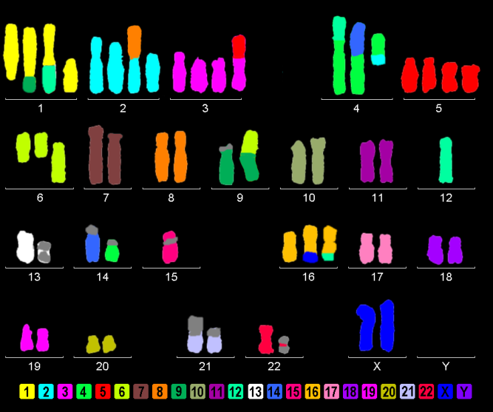
Figure 1 AGP01 cell line M-FISH showing several chromosomal changes, including the monosomy of chromosome 12, where the PIWIL1 gene is located.

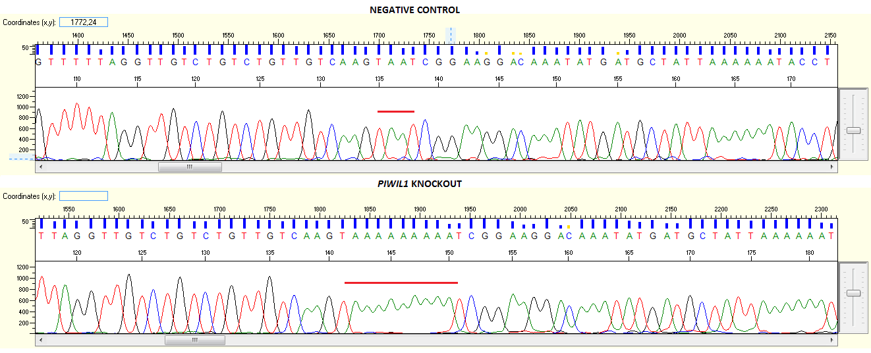Figure 2 Electropherograms showing the insertion of 7 adenines in the PIWIL1 gene sequence after using the CRISPR-Cas9 system (B) in comparison with the reference sequence of the negative control (A).

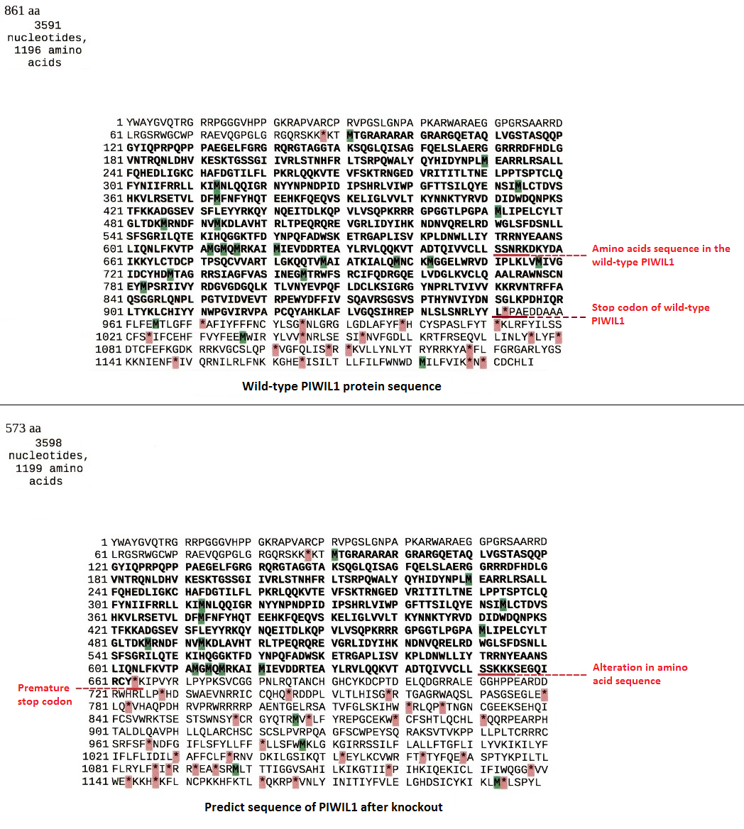
Figure 3 Amino acid sequences of the wild-type PIWIL1 protein and the PIWIL1 protein after the insertion of 7 adenines by the CRISPR-Cas9 system.

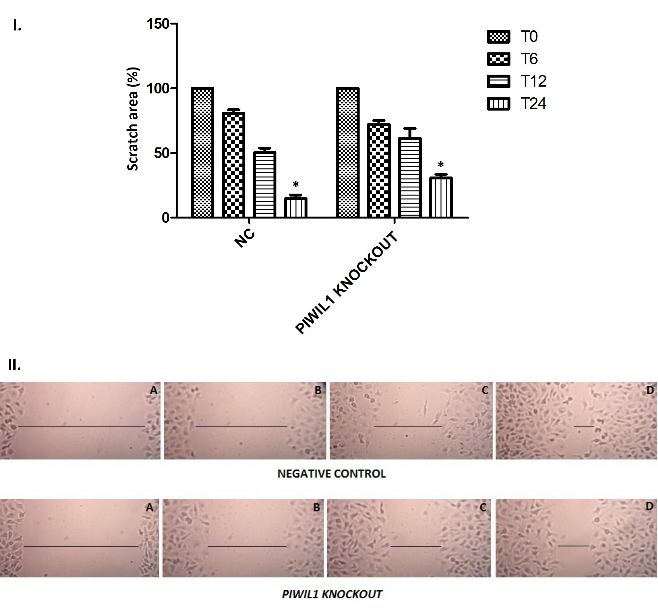
Figure 4 Analysis of the migration capacity of the AGP01 cell line with and without PIWIL1 gene knockout. T0: immediately after injury; T6: 6 h after injury; T12: 12 h after injury; T24: 24 h after injury. NC: Negative control. ªP < 0.01. Two-way ANOVA, Bonferroni post-test. Photomicrography of AGP01 cell migration. A: Immediately after injury; B: 6 h after injury; C: 12 h after injury; D: 24 h after injury. The black lines represent approximation of the edges over time, demonstrating the migration capacity of the cells.

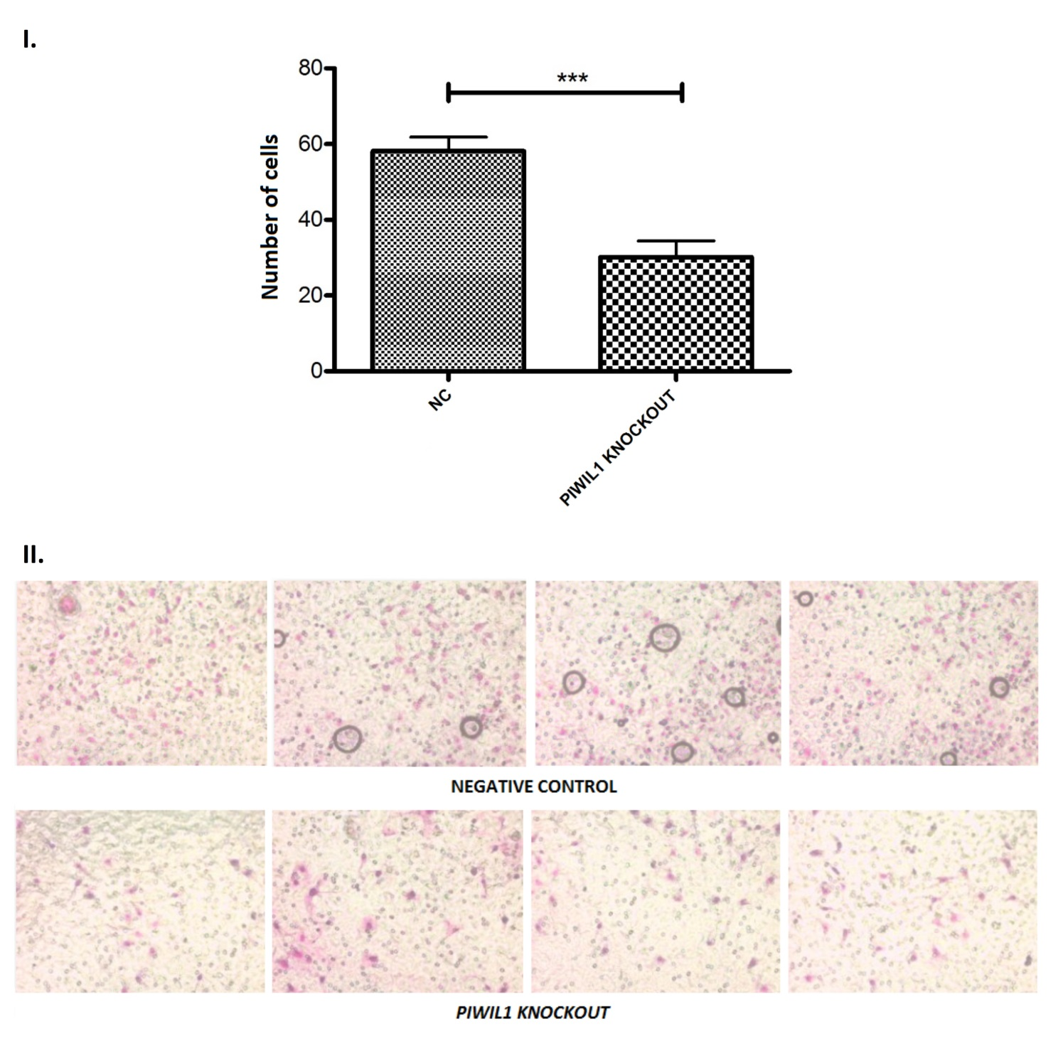Figure 5 Analysis of the invasion capacity of the AGP01 cell line with and without the PIWIL1 gene knockout. NC: Negative control. Statistically significant difference between groups by the t-test (^{c}P < 0.001). Photomicrography of the cell invasion assay demonstrating the decrease in the number of cells that invaded when PIWIL1 was knocked out.

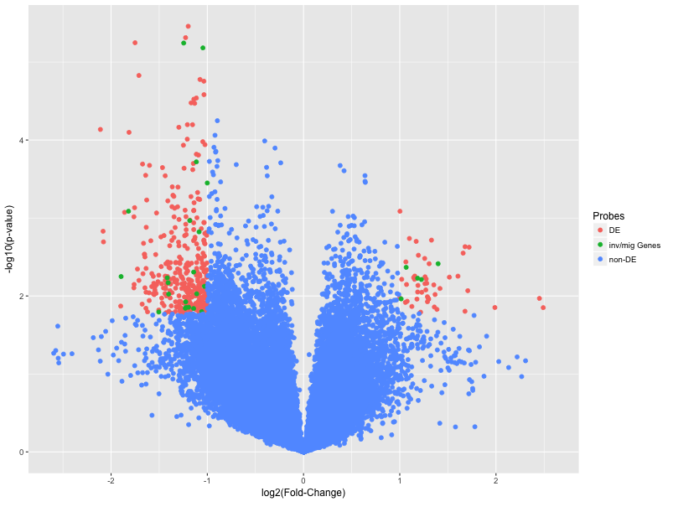Figure 6 Volcano plot comparing gene expression after PIWIL1 permanent knockout in the gastric cancer AGP01 cell line. Differentially expressed probes (adjusted P-value < 0.05 and |Log2(Fold-Change)| > 1) are on superior left and right areas (red). mRNAs involved in invasion and migration processes are in green.

